Evaluation of Trichoderma Isolates for management of Soybean Anthracnose caused by Colletotrichum truncatum

ABSTRACT: The present study evaluated the antagonistic potential of eight Trichoderma isolates against Colletotrichum truncatum, the causal agent of soybean anthracnose, under both in-vitro and in-vivo conditions. In-vitro screening was performed using the dual culture technique on Potato Dextrose Agar (PDA) in a Completely Randomized Design (CRD) with nine treatments, including one untreated control. All Trichoderma isolates significantly inhibited the mycelial growth of C. truncatum, with T. reesei-1 showing the highest inhibition (55.56%), followed by T. harzianum-2 (54.70%), T. harzianum-1 (51.71%) and T. reesei-3 (49.57%). In-vivo evaluation under greenhouse conditions revealed a substantial reduction in anthracnose incidence, with T. reesei-1 recording the lowest disease incidence (6.25%), compared to 76.25% in the pathogen control. The effective suppression of C. truncatum may be attributed to the production of antifungal metabolites and enhanced colonization efficiency by the Trichoderma isolates. The findings demonstrate that T. reesei-1 and T. harzianum-1 possess strong biocontrol potential and could serve as promising bioagents for the sustainable management of soybean anthracnose.
KEYWORDS: Soybean, Colletotrichum truncatum, Trichoderma, anthracnose, biocontrol
INTRODUCTION: Soybean (Glycine max L. Merr.) is one of the most important leguminous crops worldwide, valued for its high nutritional content and diverse uses in food, feed and industry (Kaul and Das, 1986). Despite its economic and nutritional importance, soybean production is greatly constrained by various diseases caused by fungi, bacteria and viruses. More than 100 pathogens have been reported to infect soybean, of which about 35 are economically important (Sinclair and Backman, 1989). Among these, anthracnose caused by Colletotrichum truncatum (Schwein.) Andrus & Moore has emerged as one of the most destructive diseases, infecting all aerial parts of the plant including stems, pods and seeds, leading to severe yield losses ranging from 10 to 30% (Sinclair, 1994). The pathogen exhibits high variability in its cultural and pathogenic characteristics, making its management difficult through conventional means such as resistant cultivars or chemical control. In recent years, biological control has gained prominence as an eco-friendly and sustainable approach to managing such pathogens. Among biological control agents, species of Trichoderma are well known for their antagonistic potential, rapid colonization and ability to suppress a wide range of plant pathogens through mechanisms such as mycoparasitism, antibiosis, competition for nutrients and space and the production of hydrolytic enzymes and secondary metabolites. Several in-vitro studies have demonstrated the effectiveness of different Trichoderma isolates in inhibiting the mycelial growth of pathogenic fungi, highlighting their potential as reliable biocontrol agents. Sharma and Kotasthane (2007) reported that T. harzianum and T. viride effectively inhibited the growth of C. truncatum through volatile and non-volatile metabolites, while Ramesh et al. (2018) found that T. asperellum showed strong antagonistic activity by overgrowing the pathogen colony and reducing its radial growth by more than 70%. The effectiveness of Trichoderma species has also been attributed to their production of lytic enzymes such as chitinases, β-1,3-glucanases and proteases that degrade the cell wall of pathogenic fungi (Vinale et al., 2008). Moreover, Kumar and Singh (2020) demonstrated that seed treatment with T. viride significantly reduced anthracnose incidence in soybean under field conditions. Considering the increasing importance of soybean anthracnose and the need for sustainable management strategies, the present investigation was undertaken to Evaluation of Trichoderma Isolates for management of Soybean Anthracnose caused by Colletotrichum truncatum.
METHODOLOGY: In-vitro and in-vivo experiment was conducted to evaluate the antagonistic potential of eight Trichoderma isolates against the target pathogen Colletotrichum truncatum. The isolates were obtained from the Department of Plant Pathology, JNKVV, Jabalpur, Madhya Pradesh. The study employed the dual culture technique on Potato Dextrose Agar (PDA) medium.

Cultural Variability of Trichoderma Isolates: The cultural variability of eight Trichoderma isolates was assessed on Potato Dextrose Agar (PDA) medium. Radial growth was recorded at 24, 48, 72, and 96 hours of incubation to evaluate their growth rate and colony expansion.
In-vitro evaluation of antagonistic potential: The experiment was conducted using the dual culture technique on PDA medium in a Completely Randomized Design (CRD) comprising nine treatments - eight Trichoderma isolates and one untreated control, each replicated three times. The treatments included T₁ – T. asperellum, T₂ – T. reesei-1, T₃ – T. harzianum-1, T₄ – T. harzianum-2, T₅ – T. reesei-2, T₆ – T. reesei-3, T₇ – T. reesei-4, T₈ – T. reesei-5 and T₉ – control (pathogen only). In each PDA plate, a 5 mm mycelial disc of Colletotrichum truncatum and an equal-sized disc of the respective Trichoderma isolate were placed on opposite sides of the plate, equidistant from the center, while control plates received only the pathogen. All plates were incubated in a BOD incubator maintained at 27 ± 2 °C and daily observations were recorded to monitor mycelial interaction and overgrowth. The radial growth of the pathogen was measured and the percentage inhibition of mycelial growth was calculated using the formula proposed by Vincent (1947):
$$PI \left(\%\right)=\frac{C-T}{C}×100$$
where PI represents the percent inhibition of mycelial growth, C is the colony diameter in the control plate (mm) and T is the colony diameter in the treatment plate (mm).

In-vivo evaluation under pot conditions

Preparation of pathogen inoculum: Colletotrichum truncatum was cultured on Potato Dextrose Agar (PDA) plates and incubated at 25 ± 1 °C for seven days to obtain actively growing mycelium and abundant conidia. The plates were flooded with sterile distilled water and the surface was gently scraped with a sterile glass rod to release conidia. The resulting suspension was filtered through a double-layered muslin cloth to remove mycelial debris and adjusted to approximately 1 × 10⁶ conidia ml⁻¹ using a haemocytometer. Surface-sterilized soybean seeds were then soaked in this conidial suspension for 30 minutes under aseptic conditions to ensure uniform coating, followed by shade-drying for 2-3 hours before sowing. Seeds soaked in sterile distilled water served as healthy controls.

Preparation of Trichoderma inocula: For mass multiplication of Trichoderma isolates, 100 g of moistened wheat bran was placed in 250 ml Erlenmeyer flasks and sterilized by autoclaving at 121 °C for one hour on three consecutive days. After cooling, each flask was inoculated with a homogenized suspension containing spores and mycelial fragments of seven days old Trichoderma cultures under aseptic conditions. The inoculated flasks were incubated at 27 ± 2 °C for 14 days under fluorescent light with approximately 70% relative humidity to promote optimum sporulation and growth. Once the substrate was completely colonized, it was air-dried under sterile conditions. The inoculum density was adjusted to 10⁵-10⁷ CFU g⁻¹ and 10 g of the prepared inoculum was thoroughly mixed with 1 kg of sterilized soil prior to sowing.

Potting and experimental setup
A sterilized soil mixture consisting of clay and peat moss in a 1:1 ratio was used for pot filling. The mixture was autoclaved at 121 °C for one hour on three consecutive days to eliminate contaminating microorganisms. Soybean seeds inoculated with C. truncatum were sown directly into the pots and Trichoderma inocula were applied according to the respective treatments. Untreated pathogen-inoculated pots served as infected controls, whereas uninfested and untreated pots served as healthy controls. The pot experiment was conducted following a Completely Randomized Design (CRD) with four replications per treatment.
Disease assessment
Disease incidence was recorded weekly based on anthracnose symptoms following a 0-5 rating scale adapted from Chandra et al. (1983), as detailed below:
List 1—Disease incidence recorded on anthracnose symptoms based on a 0-5 rating scale
Scale | % Disease Incidence | Symptom
0 | 0 | Healthy plants
1 | 10 | Few small leaf lesions on older leaves
2 | 25 | Yellowing and wilting of older leaves
3 | 50 | Wilting of some branches / stem lesions visible
4 | 75 | Wilting of all branches except apical shoot
5 | 100 | Complete wilting and plant death
The percentage of infected plants was calculated using the following formula:
$$Percent infection=\frac{H-T}{H}X100$$
where
H​ = Number of healthy plants in healthy control and
T​ = Number of healthy plants in treatment.
Additionally, Disease Severity Index (DSI) was calculated using the formula:
$$DSI\left(\%\right)= \frac{\sum{(score)}}{(maximum score×total plants)}X100$$

Statistical analysis
All data were analyzed under a completely randomized design (CRD). Treatment means were compared using Duncan’s Multiple Range Test (DMRT) at a 5% level of significance.

RESULT AND DISCUSSION: The present study demonstrated the strong antagonistic potential of eight Trichoderma isolates - T₁ (T. asperellum), T₂ (T. reesei-1), T₃ (T. harzianum-1), T₄ (T. harzianum-2), T₅ (T. reesei-2), T₆ (T. reesei-3), T₇ (T. reesei-4) and T₈ (T. reesei-5) against Colletotrichum truncatum under both laboratory and greenhouse conditions, confirming their efficacy as promising biocontrol agents for soybean anthracnose, which is consistent with previous reports on the in-vitro and in-vivo antifungal activity of Trichoderma species (Admassiea et al., 2017; Ngo et al., 2021). Significant variation was observed among the isolates in radial growth at different incubation periods. T. reesei-1 (T₂) exhibited the fastest growth, followed by T. harzianum isolates, while T. asperellum (Ch.) (T₁) showed the slowest growth. All isolates attained near full plate growth by 96 hours. Similar cultural variability among Trichoderma species has been reported earlier by Jambhulkar et al. (2024), Parihar et al. (2024) and Surma et al. (2025), who observed considerable morpho-cultural and genetic diversity among Trichoderma isolates from different crop rhizospheres, indicating that environmental adaptation and genetic variation significantly influence colony growth and morphology.
Under in-vitro conditions, all Trichoderma isolates significantly inhibited the mycelial growth of Colletotrichum truncatum, though the degree of inhibition varied among isolates. Among them, T₂ (T. reesei-1) recorded the maximum inhibition (55.56%), followed by T₄ (T. harzianum-2) (54.70%), T₃ (T. harzianum-1) (51.71%) and T₆ (T. reesei-3) (49.57%). This variation suggests differences in enzymatic and metabolic efficiency among isolates, consistent with earlier findings linking biocontrol efficacy to hydrolytic enzyme secretion, metabolite production and colonization efficiency (Begum et al., 2008; Jagtap et al., 2012; Kumar et al., 2009, 2013, 2014a, 2014b; Jain et al., 2017; Parihar et al., 2025). The superior performance of these isolates may be attributed to the production of antifungal metabolites such as gliotoxin, viridin and peptaibols, known to disrupt fungal cell membranes (Vinale et al., 2008). In contrast, T₁ (T. asperellum) showed the least inhibition (29.06%), indicating natural variability in bioefficacy among isolates. These findings align with previous studies reporting consistent antagonistic potential of Trichoderma spp. under in-vitro conditions (Kumar et al., 2016; Bansal et al., 2021; Dinkwar et al., 2023; Singh et al., 2023; Khare et al., 2025).
Under greenhouse conditions, a substantial reduction in anthracnose incidence was recorded in all treatments containing Trichoderma isolates compared to the pathogen control, two months after co-inoculation of the pathogen and bioagents. Among them, T₂ (T. reesei-1) exhibited the most effective suppression, recording only 6.25% disease incidence, followed by T₃ (T. harzianum-1) and T₆ (T. reesei-3) with 12.50% and 18.75%, respectively. The pathogen control showed the highest incidence (76.25%), confirming the aggressiveness of Colletotrichum truncatum in the absence of antagonists. Healthy controls and Trichoderma inoculations without the pathogen exhibited no disease symptoms, confirming their non-pathogenicity to soybean. These results corroborate earlier reports demonstrating the efficacy of Trichoderma spp. in suppressing Colletotrichum species across several crops (Padder & Sharma, 2011; Kumar & Sahu, 2014; Christmann et al., 2019; Ferreira et al., 2020; Mukhopadhyay et al., 2025). Overall, the findings highlight T₂ (T. reesei-1) and T₃ (T. harzianum-1) as potential bioagents for sustainable management of soybean anthracnose, consistent with previous reports across diverse Colletotrichum pathosystems.
CONCLUSION: The study revealed that Trichoderma spp. exhibited strong antagonistic activity against Colletotrichum truncatum, the pathogen responsible for soybean anthracnose. Significant cultural variability was observed among the Trichoderma isolates, indicating inherent physiological and genetic differences influencing their growth and antagonistic potential. Among the tested isolates, T. reesei (T₂) demonstrated the highest in-vitro inhibition of the pathogen and the greatest reduction in disease incidence under greenhouse conditions. These findings underscore the potential of T. reesei isolates as effective biocontrol agents for the sustainable management of soybean anthracnose and emphasize the need for their further evaluation under field conditions as part of integrated disease management strategies.

DISCLAIMER (ARTIFICIAL INTELLIGENCE): Author(s) hereby declare that NO generative AI technologies such as Large Language Models (ChatGPT, COPILOT, etc) and text-to-image generators have been used during writing or editing of this manuscript.

REFFERENCESS
Admassiea, M., Handisob, S., & Alemua, T. (2017). In vitro and In vivo Evaluation of Antagonistic Microbes against Pepper Anthracnose (Colletotrichum capsici (syd.) Bisby and Bfutler. International Journal of Environmental Sciences, 6(3), 87-93.
Bansal, A., Biswas, S. K., Baboo, D., & Singh, V. (2021). Efficacy of different Trichoderma spp. and Fungicides against late blight of potato caused by Phytophthora infestans (Mont.) de-Bary. IJCS, 9(2), 666-670.
Begum, M. M., Sariah, M., Puteh, A. B., & Abidin, M. Z. (2008). Pathogenicity of Colletotrichum truncatum and its influence on soybean seed quality.
Chandra, S., Raisada, M. and Gaur, A. K. S. 1983. Pathological variability in Fusarium oxysporum and F. solani. Indian Phytopathology. 36 (1): 36-40.
Christmann, P. E. T. P., Dalla Pria, M., Hennipman, H. S., & Godoy, A. R. (2019). In vitro control of Colletotrichum lindemuthianum by Trichoderma spp. and in vivo with alternative products. Int. J. Adv. Eng. Res. Sci, 6, 74-80.
Dinkwar GT, Yadav VK, Kumar A, Nema S and Mishra S. 2023. Compatibility of Fungicides with Potent Trichoderma Isolates. International Journal of Plant & Soil Science 35(18): 1934-1948.
Ferreira, F. V., Herrmann‐Andrade, A. M., Calabrese, C. D., Bello, F., Vázquez, D., & Musumeci, M. A. (2020). Effectiveness of Trichoderma strains isolated from the rhizosphere of citrus tree to control Alternaria alternata, Colletotrichum gloeosporioides and Penicillium digitatum A21 resistant to pyrimethanil in post‐harvest oranges (Citrus sinensis L.(Osbeck)). Journal of applied microbiology, 129(3), 712-727.
Jagtap, G. P., Gavate, D. S., & Dey, U. (2012). Control of Colletotrichum truncatum causing anthracnose/pod blight of soybean by aqueous leaf extracts, biocontrol agents and fungicides.
Jain, AK, Kumar A, Chouhan SS and Tripathi SK. 2017. Cultural characteristics and evaluation of Trichoderma isolates against Rhizoctonia solani Kühn causing banded leaf and sheath blight of Little Millet. Ann Plant Prot Sci 25(1): 140-143.
Jambhulkar, P. P., Singh, B., Raja, M., Ismaiel, A., Lakshman, D. K., Tomar, M., & Sharma, P. (2024). Genetic diversity and antagonistic properties of Trichoderma strains from the crop rhizospheres in southern Rajasthan, India. Scientific Reports, 14(1), 8610.
Kaul, A. K. and Das, M. L. 1986. Oilseeds in Bangladesh. Bangladesh Canada Agriculture Sector Team. Ministry of Agriculture, Govt. of the People’s Republic of Bangladesh, Dhaka. p.324
Khare, A. K., Kumar, A., Chouhan, A., Sharma, S., Shiv Ramakrishnan, R., Sharma, R., Jhariya, R., & Dubey, A. (2025). In-vitro efficacy of fungicides against Colletotrichum truncatum causing anthracnose of soybean. Journal of Advances in Biology & Biotechnology, 28(10), 1133–1141.
Kumar A and Sahu TK. 2014. Studies on substrate evaluation for mass multiplication of Trichoderma species and their plant growth promotion activity in tomato. Int J Plant Prot 7(2): 382-388.
Kumar A, Jain AK, Sahu TK, Singh TK and Shivcharan S. 2013. Exploration of potential biocontrol agent Trichoderma spp. from Madhya Pradesh against Fusarium oxysporum f. sp. ciceris causing wilt of chickpea. Environ Ecol, 31(2B): 877-882.
Kumar A, Jain AK, Singh J, Tripathi SK and Tiwari RK. 2016. In-vitro studies on cultural characterization of a repository of local isolates of Trichoderma spp. from Madhya Pradesh. Indian Phytopathology.69(4s):482-485.
Kumar A, Kumar S, Srivastava R and Sharma AK. 2009. Fungal biocontrol agents (BCAS) and their metabolites. In Agricultural Diversification: Problems and Prospects (Eds. by A.K. Sharma, S. Wahab and R. Srivastava). I. K. International, New Delhi, 44-56 pp.
Kumar A, Patel A, Singh SN and Tiwari RK. 2019. Effect of Trichoderma spp. in Plant Growth Promotion in Chilli. Int J Curr Microbiol Appl Sci 8(3): 1574-1581.
Kumar A, Sahu TK, Bhalla A and Solanki S. 2014a. Influence of Trichoderma spp. against Ustilaginoidea virens inciting false smut of rice. Environ Ecol 32(1): 163-168.
Kumar A, Sahu TK, Bhalla A, Jain AK. 2014b. Morphological characterization of Trichoderma harzianum from Madhya Pradesh. Annals of Plant Protection Sciences. 22(1): 190-239.
Kumar, A., & Singh, S. (2020). Seed treatment with Trichoderma viride reduces anthracnose incidence in soybean under field conditions. International Journal of Current Microbiology and Applied Sciences, 9(5), 1234–1242.
Mukhopadhyay, A., Mukherjee, S., Dutta, S., Kanthal, S., & Mondal, G. (2025). Evaluating the bioactivity of Trichoderma asperellum against Colletotrichum siamense and its growth-promoting effects on Aloe vera (Aloe barbadensis Mill.). European Journal of Plant Pathology, 172(2), 275-289.
Ngo, M. T., Van Nguyen, M., Han, J. W., Park, M. S., Kim, H., & Choi, G. J. (2021). In vitro and in vivo antifungal activity of sorbicillinoids produced by Trichoderma longibrachiatum. Journal of Fungi, 7(6), 428.
Padder, B. A., & Sharma, P. N. (2011). In vitro and in vivo antagonism of biocontrol agents against Colletotrichum lindemuthianum causing bean anthracnose. Archives of Phytopathology and Plant Protection, 44(10), 961-969.
Parihar, S., Saxena, H. O., Kumar, A., & Singh, S. (2025). In-vitro antagonistic activity of Trichoderma spp. isolated from forest soils of central India against Macrophomina phaseolina for identification of potential strain. Vegetos, 38(4), 1643-1649.
Parihar, S., Saxena, H. O., Singh, S., Kumar, A., & Chauhan, P. S. (2024). Characterisation and antagonistic potential of Trichoderma species isolated from forest soils of central India against Rhizoctonia solani. Tropical Agriculture, 101(2), 167-177.
Ramesh, K., Singh, P., & Kumar, A. (2018). Antagonistic activity of Trichoderma asperellum against Colletotrichum truncatum by overgrowing pathogen colonies. Journal of Plant Pathology, 100(2), 345–352.
Sharma, S., & Kotasthane, A. S. (2007). Effect of Trichoderma harzianum and T. viride against Colletotrichum truncatum. Indian Phytopathology, 60(1), 102–106.
Sinclair, J.B. 1994. Reducing losses from plant diseases. World Soybean Research Conference V. Abstracts 10 p
Sinclair, J.B. and Backman, P.A. 1989. Compendium of soybean disease. The American Phytopathological Society, 3rd Edn. viii+106pp
Singh, Y., Bhatt, J., Yadav, V. K., Kumar, A., Kharte, S., & Malempati, S. S. S. (2023). In vitro management of Fusarium wilt of linseed using phytoextract, fungicides and bioagents. Environment Conservation Journal, 24(4), 96–105.
Surma, S., M, M., Dar, M. S., Padder, B. A., Khan, I., Mushtaq, K., ... & Shah, M. D. (2025). Morpho-cultural and molecular characterization of trichoderma species from the northwestern himalayan apple rhizosphere of India. Scientific Reports, 15(1), 26320.
Vinale, F., Sivasithamparam, K., Ghisalberti, E. L., Marra, R., Barbetti, M. J., Li, H., ... & Lorito, M. (2008). A novel role for Trichoderma secondary metabolites in the interactions with plants. Physiological and molecular plant pathology, 72(1-3), 80-86.
Vincent J.M (1947): Distortion of fungal hyphae in the presence of certain inhibitors. Nature. 150: 850-853.

Table 1: Per cent inhibition in growth of Colletotrichum truncatum using different isolates of Trichoderma under in-vitro conditions
Treatment  No. | Fungal Antagonist | Radial growth (mm) |  |  |  | Percent growth inhibition
Treatment  No. | Fungal Antagonist | 24 hrs | 48hrs | 72hrs | 96hrs | Percent growth inhibition
T₁ | Trichoderma asperellum | 8.50 | 15.50 | 21.17 | 27.67 | 29.06
T₂ | Trichoderma reesei-1 | 8.17 | 15.00 | 17.33 | 17.33 | 55.56
T₃ | Trichoderma harzianum-1 | 9.17 | 15.83 | 18.00 | 18.83 | 51.71
T₄ | Trichoderma harzianum-2 | 8.83 | 14.83 | 17.50 | 17.67 | 54.70
T₅ | Trichoderma reesei-2 | 9.33 | 15.67 | 19.33 | 21.17 | 45.73
T₆ | Trichoderma reesei-3 | 8.67 | 16.00 | 19.67 | 19.67 | 49.57
T₇ | Trichoderma reesei-4 | 8.00 | 16.00 | 22.50 | 23.67 | 39.32
T₈ | Trichoderma reesei-5 | 8.50 | 15.17 | 20.67 | 22.00 | 43.59
 | Control | 10.33 | 17.50 | 31.33 | 39.00 | -
 | C.D. (5%) | 1.22 | 1.27 | 1.60 | 1.56
 | SE(m)± | 0.41 | 0.42 | 0.54 | 0.52

Table 2. Effect of different Trichoderma isolates on anthracnose (% disease incidence) in soybean under greenhouse conditions
Treatment | % Disease incidence
Infested control (C. truncatum) | 76.25 a
C. truncatum + T. reesei-5 (T₈) | 63.75 ab
C. truncatum + T. reesei-4 (T₇) | 56.25 ab
C. truncatum + T. reesei-2 (T₅) | 43.75 ab
C. truncatum + T. asperellum (T₁) | 37.50 b
C. truncatum + T. reesei-3 (T₆) | 18.75 bc
C. truncatum + T. harzianum-2 (T₄) | 15.00 bc
C. truncatum + T. harzianum-1 (T₃) | 12.50 bc
C. truncatum + T. reesei-1 (T₂) | 6.25 c
Healthy control | 0.00 c
T. asperellum (T₁) | 0.00 c
T. reesei (T₂) | 0.00 c
T. harzianum (T₃) | 0.00 c
T. harzianum (T₄) | 0.00 c
T. reesei (T₅) | 0.00 c
T. reesei (T₆) | 0.00 c
T. reesei (T₇) | 0.00 c
T. reesei (T₈) | 0.00 c

Table 3: Cultural variability among different isolates of Trichoderma on PDA after different incubation period
Isolate code | Fungal Antagonist | Radial growth (mm)
Isolate code | Fungal Antagonist | 24 hrs | 48hrs | 72hrs | 96hrs
T₁ | Trichoderma asperellum (Ch.) | 11.67 | 28.00 | 52.00 | 81.33
T₂ | Trichoderma reesei-1 | 29.00 | 57.00 | 83.33 | 85.00
T₃ | Trichoderma harzianum-1 | 26.33 | 52.00 | 81.67 | 85.00
T₄ | Trichoderma harzianum-2 | 24.33 | 46.67 | 75.67 | 85.00
T₅ | Trichoderma reesei-2 | 14.00 | 29.67 | 58.00 | 84.00
T₆ | Trichoderma reesei-3 | 19.67 | 42.33 | 71.00 | 85.00
T₇ | Trichoderma reesei-4 | 15.67 | 32.00 | 62.00 | 85.00
T₈ | Trichoderma reesei-5 | 15.67 | 36.00 | 66.00 | 85.00
 | C.D. (5%) | 2.62 | 2.83 | 2.76 | 1.29
 | SE(m)± | 0.87 | 0.94 | 0.91 | 0.43

Figure 1: Antagonistic efficacy of eight isolates of Trichoderma against Colletotrichum truncatum measured as radial growth after 24, 48, 72 and 96 hours of incubation period
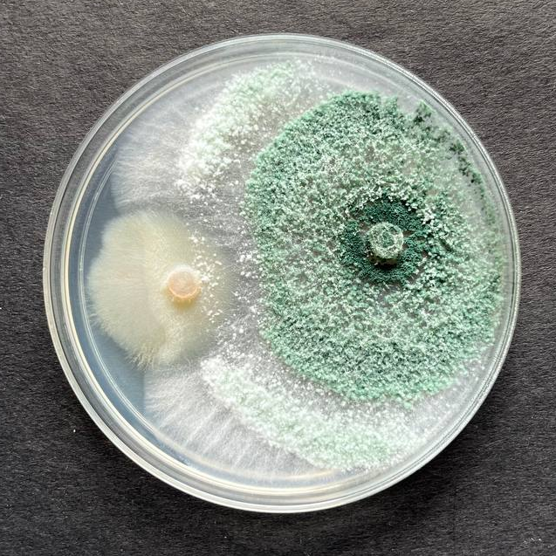  T1  T4  T2 | 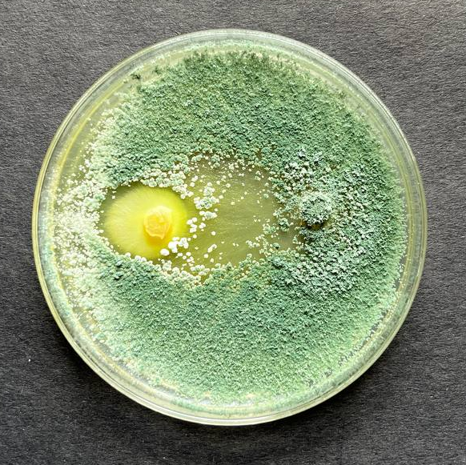 | 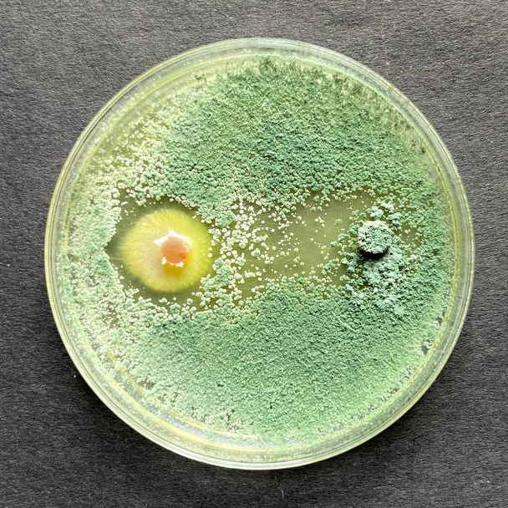  T6  T3
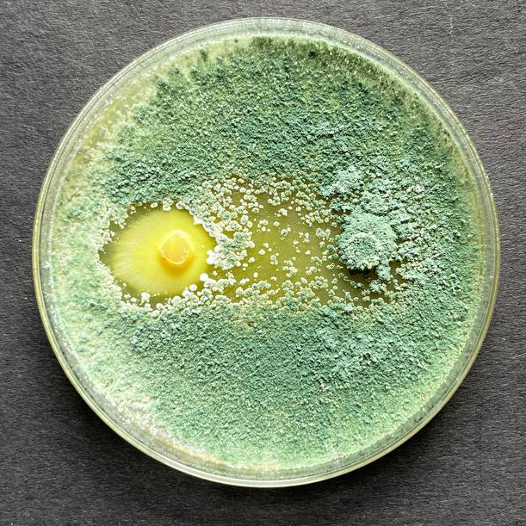 | 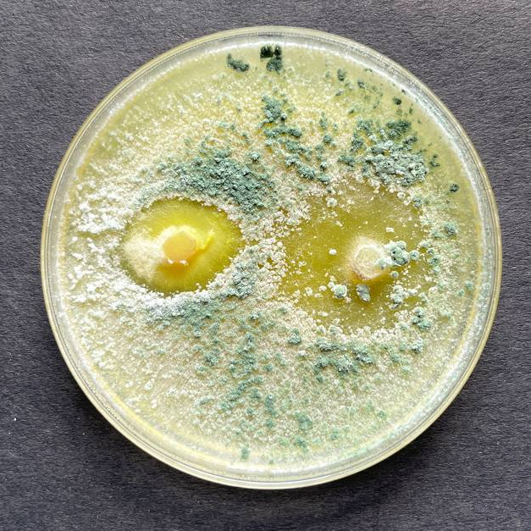  T8  T5 | 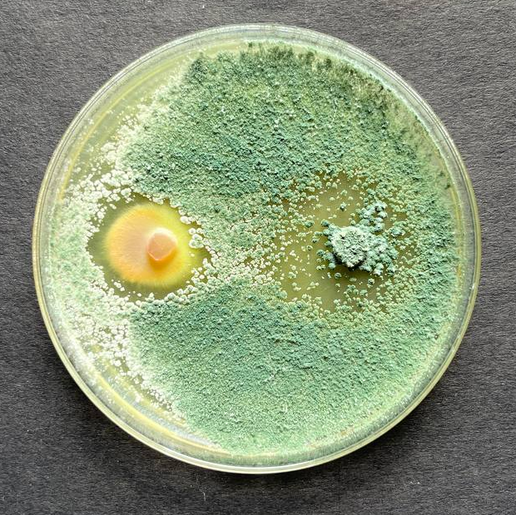  Control
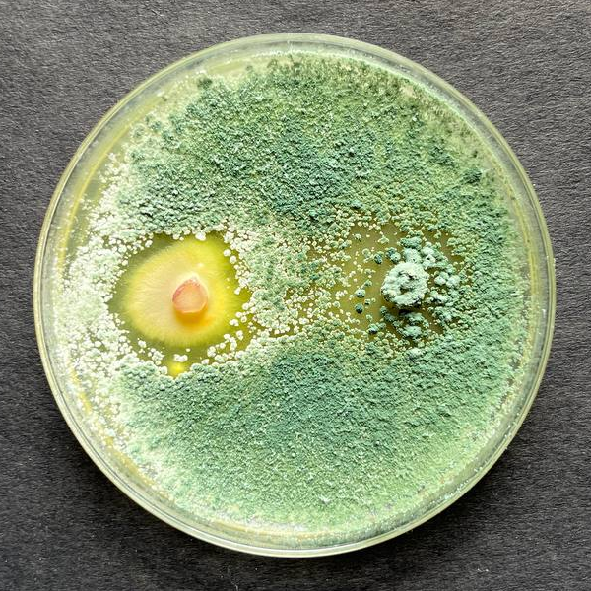  T7 | 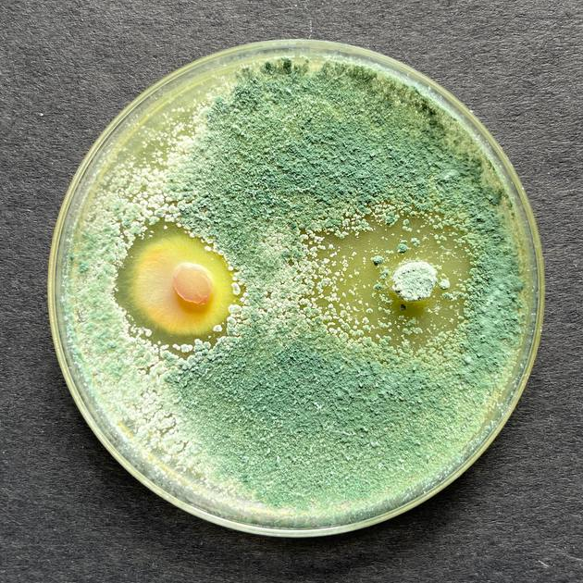 | 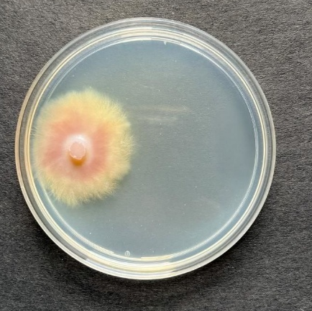
Plate 1: Dual culture assay of different species of Trichoderma with Colletotrichum truncatum

