Characterization of swollen shoot disease in rehabilitated cocoa plots in Gbazoa, Amaragui and Liliyo (Côte d’Ivoire)

Abstract
Objectives: The study carried out on swollen shoot disease in the Nawa region aimed to monitor the early progression of this disease in cocoa plantations rehabilitated using three innovative technologies. The goal was to reduce the damage caused by swollen shoot disease in cocoa production systems.
Methodology and Results: Quarterly data collection in each plot, using GPS and visual observation, made it possible to determine the epidemiological parameters of the swollen shoot disease. Newly infected cocoa trees were found in the immediate surroundings of infection foci, and the number of newly infected trees was proportional to the size of these foci. The highest prevalence and severity of the disease were observed in grafted trees on old orchards, with 1.28% and 1.55% respectively. The highest incidence was recorded in young grafted cocoa trees(1.26%).
Conclusion and Application of Results: This study characterized the evolution of cocoa swollen shoot disease in plots rehabilitated through innovative technologies. The findings revealed shortcomings during the replanting process, which weakened the effectiveness of disease control methods. These shortcomings highlight the need to respect replanting regulations in areas contaminated by swollen shoot disease and to use early detection tools for better disease management.
Keywords: swollen shoot, rehabilitated plots, epidemiology, incidence, prevalence, severity

- Introduction​
Côte d’Ivoire is the world’s leading cocoa producer, with an estimated production of 1.8 million tons in 2024 (Statista, 2024). Despite this strong performance, cocoa cultivation in the country faces continuous pressure from pests and diseases. Among these, cocoa swollen shoot virus disease (CSSVD) is the most damaging and has been affecting Côte d’Ivoire and other West African cocoa-producing countries since the 1930s. The main symptoms of swollen shoot disease include red streaks along the veins of young leaves, mosaic patterns on mature leaves, small rounded pods, and swelling of stems (Kouakou et al., 2011). The disease can cause significant yield losses and even the death of cocoa trees within five years after the first symptoms appear (Kébé, 2013). The recommended control method consists of cutting down infected trees and replanting in healthy environments using good agricultural practices (CNRA, 2016). However, the disease continues to spread, reaching new production areas and even rehabilitated plots (Aka et al., 2021). Understanding the epidemiological factors driving this spread is therefore crucial. The objective of this study is to characterize the study plots, assess the prevalence, severity, and incidence of swollen shoot disease, and determine its spatio-temporal evolution in rehabilitated cocoa farms.

- Materials and methods
  - Material
The materials used in this study consisted of plant material and technical equipment. The plant material included grafted cocoa seedlings in open field, grafted seedlings in nurseries, and hybrid cocoa plants. The technical equipment comprised a Garmin GPS device for locating the sites and cocoa trees, as well as paint spray cans used for marking trees in the field.
  - Methods
    - Study area
The study was conducted in the Nawa region, located in the south-western part of Côte d’Ivoire. Activities were carried out specifically in plots established in the localities of Gbazoa, Amaragui, and Diakitékro, which are situated respectively in the sub-prefectures of Grand-Zattry, Soubré, and Liliyo (Figure 1).
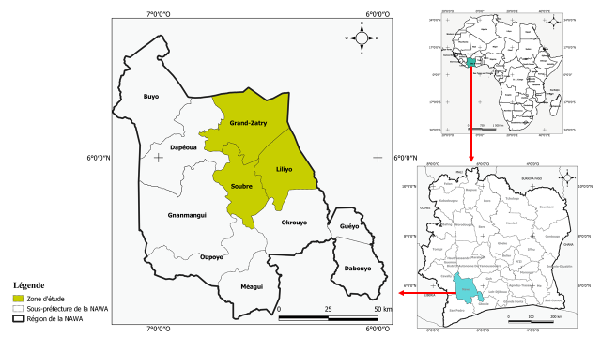
Figure 1 : Study area

    - Characterization of the Study Plots and Disease Symptoms
Each plot was characterized by determining its area, the number of cocoa trees present, the type of crops in neighboring plots, and by recording associated crops and shade trees grown alongside cocoa. Diseased cocoa trees were examined from the leaves down to the trunk to describe the characteristic symptoms of swollen shoot disease observed in the field.
2.2.3. Assessment of infection level and disease distribution in rehabilitated plots
The infection level of swollen shoot disease in the rehabilitated plots was determined based on prevalence, incidence, and the severity index.
Prevalence was defined as the proportion of diseased trees relative to the total number of trees in the plot:

(1)
$$P=\frac{nCi}{NC} x 100$$

Or : nCi : Number of infected cocoa trees; NC : Total number of cocoa trees in the plot
Incidence represented the proportion of newly infected trees during a given period relative to the total number of trees in the plot:
I= $\frac{Ci\left(tx\right)-Ci(t0)}{NC}$ X 100

(2)

Where: Ci ( tx ) : Number of infected cocoa trees at tx ; Ci ( t0 ) : Number of infected cocoa trees at t ₀ ; NC : Total number of cocoa trees in the trial.
Severity assessed the intensity of the disease within the plot. It was evaluated using a symptom severity scale ranging from 0 to 6, as defined by Padi (2013) and later modified:
0 = No symptom
1 = Red streaks on young leaves
2 = Reticulated mosaic
3 = Fern-like mosaic
4 = Stem swelling
5 = Die-back
6 = Death of the cocoa tree
The disease severity index (Is) in each experimental plot was calculated according to Kranz (1988):
(3)
Is = $\frac{∑(Xi.ni)}{N.Z}$ x 100

Where: Is : Disease severity index; x i : Severity i of the disease on the tree; n i : Number of trees of severity i ; N : Total number of trees observed; Z : Highest note on the scale, i.e. 6.
The geographical coordinates recorded in the field using GPS made it possible to produce distribution maps of swollen shoot disease within the rehabilitated plots.

- Results
  - Characterization of study plots
The study plots were located in areas already contaminated by swollen shoot disease. They bordered infected cocoa farms, and in most cases, there were no sanitary barriers such as buffer plants or safety distances separating them from infected neighboring plots. Within the plots, various associated crops and shade trees were present — some of which were potential hosts of the Cocoa Swollen Shoot Virus (CSSV) (Table 1).
Table 1 : Characteristics of the study plots
Technologies | Locations | Trees in the plot | Types of Neighboring Plots
GVV | Amaragui 1 | Palm tree, avocado tree, kola tree | Infected cocoa plantation
RPG | Grand- Zattry | Fraké , mango tree | Infected cocoa plantation, rubber tree
RPH | N' driagui | Teak, banana tree, palm tree | Cassava

  - Characteristic symptoms of swollen shoot disease in different localities
In each observed plot, one dominant symptom of swollen shoot disease was identified. In Amaragui (Soubré) plots, the most common symptoms were reticulated and fern-like mosaics on mature leaves. In Diakité Camp (Liliyo), red veins on young leaves were predominant. In Grand-Zattry, reticulated mosaics and red veins on young leaves were most frequent, while in N’driagui and Petit Bondoukou, stem swelling was dominant (Figure 3).
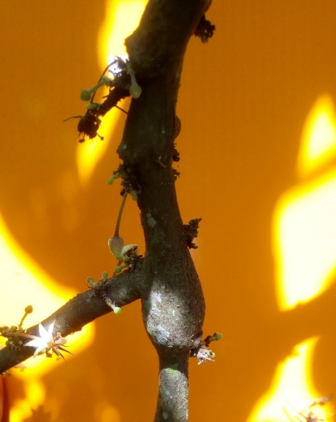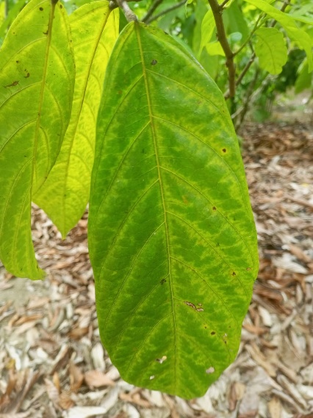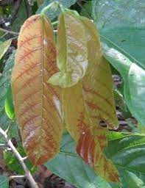
c
b
a
Figure 2: Symptoms of swollen shoot in rehabilitated plots A: Stem swelling; B: Fern mosaic; C: Red bands on young leaves

Level of Infection of Swollen Shoot Disease in Rehabilitated Plots
Figure 3 illustrates the prevalence, incidence and severity rate according to the 3 technologies adopted for replanting. The highest prevalence was recorded in GVV plots (1.28%) and the lowest in RPH plots (0.50%). The highest incidence occurred in RPG plots (1.26%), followed by GVV, while RPH recorded the lowest incidence (0.20%). ANOVA tests indicated that prevalence was not significantly affected by the technology (p = 0.058), whereas incidence differences were significant (p = 1.6 × 10⁻⁴). Severity ranged from 0.18% to 1.55%, influenced significantly by the technology (p < 0.05). The severity index was highest in GVV and lowest in RPH plots.

Figure 3: Prevalence, incidence and severity of swollen shoot according to technologies

  - Spatial distribution of swollen shoot disease in rehabilitated Plots
Swollen shoot disease was found to be widespread across all rehabilitated plots, regardless of the technology applied. Field observations indicated that the progression of the disease was closely associated with the number of infected cocoa trees recorded during the initial assessment. Plots with a higher number of infected trees at the first evaluation subsequently exhibited a greater number of new infections. Conversely, plots with fewer initial infections showed a lower rate of new cases during the second assessment (Figure 5).
Newly infected cocoa trees were predominantly located in the immediate vicinity of previously infected individuals, suggesting a localized spread pattern around primary infection foci. (Figures 4, 5, 6).
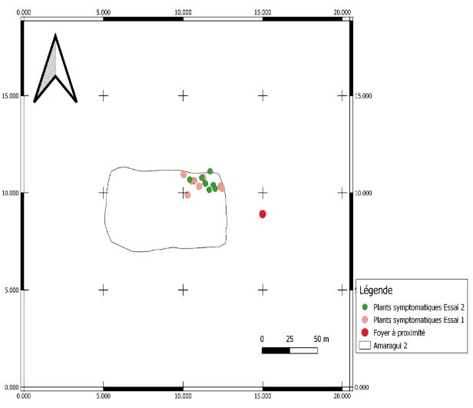
Figure 4: Geographic distribution map of swollen shoot in GVV plots

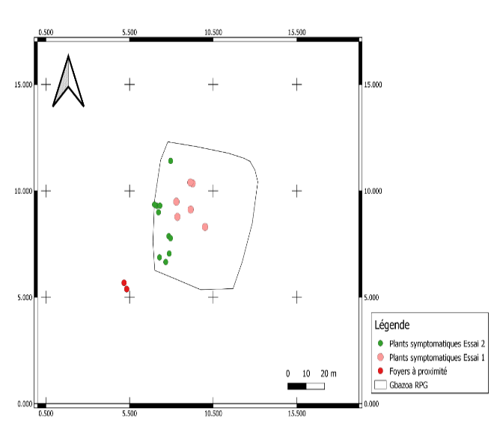
Figure 5: Geographic distribution map of swollen shoot in RPG plots
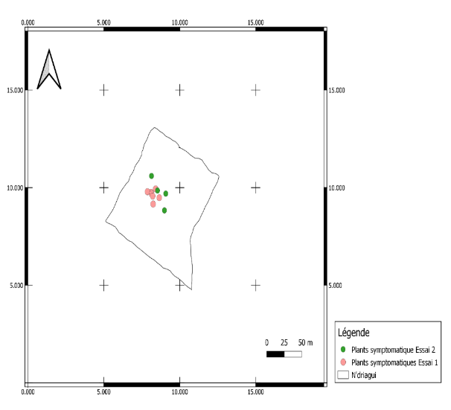
Figure 6: Geographic distribution map of swollen shoot in RPH plots
- Discussion
The results of the plot characterization focused on the vegetation cover and its surrounding environment. Most of the study plots were located adjacent to infected cocoa farms. These plots were contiguous, without any buffer plants or the recommended safety distance. The lack of compliance with this guideline was particularly observed in the localities of Soubré and Liliyo. This proximity to infected farms may explain the reinfection of rehabilitated plots by the swollen shoot disease. It is strongly recommended to establish barrier crops over a distance of 10 to 15 meters around new plantations. Such barriers help to slow the spread of mealybugs, the vectors of the Cocoa Swollen Shoot Virus (CSSV) (Babin et al., 2020). These plants act as biological traps, keeping mealybugs away from cocoa farms and reducing the risk of contamination (Kébé et al., 2016). The presence of associated crops and shade trees within rehabilitated plots was also observed. Among these, several are known natural hosts of CSSV, which may serve as new sources of reinfection for recently rehabilitated plots. Numerous crops and shade trees have been reported to naturally harbor the swollen shoot virus (Posnette et al., 1950; N’Guessan et al., 2013). Cola chlamydantha is even believed to be the original source of CSSV emergence in West Africa (Todd, 1951). According to Aka (2013), who studied alternative hosts of CSSV in Côte d’Ivoire, crops such as cassava, orange, kola, and papaya, commonly found within and around cocoa farms, are alternative hosts of the virus. This could partly explain the persistence of swollen shoot disease in rehabilitated plots. The higher disease parameters observed in RPG and GVV plots compared with RPH plots may be explained by two main factors: the grafting process and the resistance level of the cocoa trees depending on the technology used. In field and nursery grafting, some cocoa trees may have been already infected with CSSV. The tools used for grafting could have transmitted the virus to healthy trees, and disease symptoms appeared on grafted trees after a latency period. These results are consistent with the recommendations of Kébé et al. (2016), who advised against grafting in already contaminated areas and emphasized the need to use separate tools for maintaining infected and healthy cocoa plots. This situation highlights the importance of early CSSV detection before the appearance of visible symptoms to avoid contamination of grafted trees in both fields and nurseries. Some cocoa trees appear to be more tolerant to the disease than others, which may explain the observed differences in prevalence and incidence between hybrids and grafted trees. The tolerance of cocoa trees to swollen shoot disease has been confirmed by several authors, including Wegbe et al. (2012), who initiated a breeding program for CSSV-tolerant hybrids in Togo. Several combinations of parental clones were tested, leading to the identification of six high-yielding and tolerant hybrids: P7 × IMC67, IMC67 × P7, PA7 × P7, PA7 × P30, P7 × T60/887, and T60/887 × P7. These hybrids were evaluated based on disease prevalence and incidence, and their parents were later used to establish seed farms. Since 2005, the resulting seeds have been distributed for replanting and rehabilitating cocoa farms devastated by swollen shoot disease in Togo. Similarly, Padi et al. (2013) demonstrated varying levels of tolerance to CSSV among cocoa varieties, primarily based on disease severity. The results of this study also revealed that newly infected cocoa trees were located close to previously infected trees during the first survey. The number of trees infected during the second assessment was proportional to the number of trees infected in the first assessment. The proximity of newly infected trees to existing infection foci may be explained by the disease’s mode of transmission. According to Oro et al. (2012), who studied the epidemiology of swollen shoot disease in Togo, the virus spreads radially or through leap-type transmission within cocoa plots. This spread pattern is likely due to the movement of mealybug vectors across the farm, facilitated by human activities, as well as by wind and rain.
The proportional relationship between previously and newly infected cocoa trees helps explain the current control strategy used against swollen shoot disease, which recommends cutting down both infected trees and their asymptomatic neighbors depending on the size of the infection focus. The larger the infection focus, the greater the number of surrounding asymptomatic trees that must be removed (CNRA, 2016).

Conclusion
Swollen shoot disease in rehabilitated cocoa plots progresses significantly depending on the replanting technology used. The current control method shows limitations due to the lack of rapid detection tools. Integrating early detection systems will strengthen the management and containment of the disease in rehabilitated and newly established cocoa plantations.
References
Aka A. R. 2013. Alternative hosts of cocoa swollen shoot virus. International Workshop on Cocoa Swollen Shoot Disease, November 26–28, 2013 – N’SA Hotel Grand Bassam, Ivory Coast. French
CNRA, 2016: Effectively combating cocoa swollen shoot disease in Ivory Coast. Cocoa Fact Sheet No. 4 CNRA, 4p. French
Babin R, Oro ZF, Tahi GM, N’Guessan WP 2020. Replanting itinerary for a cocoa plantation destroyed by swollen shoot disease. Technical sheet. French
Cotterell, G.S. 1943. Swollen shoot virus. Rep. Centr. Res. Sta. Tafo, 1940, 42: pp. 51–55.
Domfeh O, Ameyaw GA, Dzahini-Obiatey HK, Ollennu LAA, Osei-Bonsu K, Acheampong K., Aneani F., Owusu-Ansah F., 2016. Use of immune crops as a barrier in the management of cacao swollen shoot virus disease (CSSVD) – long-term assessment. Plant Dis. 100, 1889-1893.
Dufour, B.; Djiekpor, E. K.; Paulin, D. and Cilas, C., 1993. Screening method for resistance to swollen shoot virus: Improvement of transmission by mealybugs. In: Proceedings of the 11th International Conference on Cocoa Research. Yamoussoukro, Côte d’Ivoire, pp. 243-244. French
ICRAF, 2021. Annual report 2021, Côte d’Ivoire. 54p.
Kouakou K, Kébé BI, Kouassi N, Anno AP, Aké S, Muller E. 2011. Impact of cocoa swollen shoot virus disease on cocoa production in a smallholder environment in Bazré (Côte d’Ivoire). Journal of Applied Biosciences, 43: pp. 2947–2957. French
Kouakou K, Kébé BI, Kouassi N, Aké S, Cilas C, Muller E. 2012. Geographical Distribution of Cacao Swollen Shoot Virus Molecular Variability in Côte d'Ivoire.
Kébé, 2013. Cocoa Swollen Shoot Disease. International Workshop on Swollen Disease. French
Kranz, J. (1988). Measuring plant disease. In: Kranz, J., Rotem, J. (eds): Experimental techniques in plant disease epidemiology. Springer, Berlin, pp. 35-50
N’guessan KF, Kouakou K, Aka AR, N’guessan WP, Tahi GM, Assiri AA, Koko LK, Kebe BI, 2013. Control of cocoa swollen shoot disease in Côte d’Ivoire. CNRA Technical report for the second half of 2012 (September 2012 – February 2013). French
Obodji A, N’Guessan WP, N’Guessan KF, Seri KB P, Aboua LRN, Kébé I, Aka R, 2016. Inventory of the mealybug species associated with the cocoa tree (Theobroma cacao L.) in four producing areas infected with swollen shoot disease in Côte d’Ivoire. Oro Z, Franck, Muller E, Bonnot F, Dufour BP, Wegbe K, Cilas C, 2012. Spatio-temporal analysis of the progression of Cacao Swollen Shoot Virus at the scale of cocoa plots. In: 17th International Conference on Cocoa Research, Yaounde, Cameroon, October 15-20, 2012. French
Padi F.K., Domfeh O, Takrama J. & Opoku S.Y. (2013). An evaluation of gains in breeding for resistance to the cocoa swollen shoot virus disease in Ghana, Crop Protection (51):24-31
Posnette, A.F., N.F. Robertson, and J.M. Todd. 1950. Virus diseases of cocoa in West Africa. V. Alternative host plants. Annals of Applied Biology 37, pp: 229–240.
Statista, 2024. World cocoa bean production by volume from 2016/2017 to 2023/2024, by country (in thousands of metric tons).

Wegbe K.1, Koudjega T.1, Ametefe K.E.1, Cilas C.2, and Dufour B., 2012. Selection of cocoa hybrids tolerant to swollen shoot for replanting diseased areas in Togo. 17th International Cocoa Research Conference (ICRC-COPAL) "Improving the profitability of small and medium-sized farms: the principal key to a global sustainable cocoa economy," 2012/10/15-20, Yaoundé, Cameroon. http://www.copal-cpa.org/icrc.ph

