Original Research Article
Assessing Prescriber Knowledge, Diagnostic Decision-Making, and Antimalarial Drug Use in the Management of Simple Malaria in Buea Health District, Cameroon

.
ABSTRACT

Malaria remains a leading cause of morbidity and mortality in Cameroon. The national policy, aligned with WHO guidelines, mandates parasitological confirmation via microscopy or Rapid Diagnostic Tests (RDTs) before treatment with Artemisinin-based Combination Therapy (ACT) for uncomplicated malaria. However, adherence to these guidelines is often suboptimal. This study assessed the critical determinants of malaria case management by evaluating prescriber knowledge, diagnostic decision-making, and antimalarial drug use patterns in the Buea Health District (BHD). A descriptive cross-sectional study was conducted over four months (February - June 2023) in 31 public and private health facilities. Data were collected from 63 healthcare prescribers using pre-tested, structured questionnaires. The findings reveal a significant gap between policy awareness and implementation. While all prescribers demonstrated universal awareness of ACTs, knowledge depth was uneven; nurses and midwives were largely familiar with only one or two ACTs compared to physicians, highlighting a cadre-specific training deficit. Fever was the predominant diagnostic cue (23.1%), and despite a high stated preference for confirmatory testing (85.7% for RDTs), persistent barriers like ACT stockouts (31.7%) and absence of trained personnel compromised this practice. Artemether-Lumefantrine was the preferred first-line treatment, yet its prescription adequacy was alarmingly low for children under five (53.7% for correct posology), pointing to a major challenge in pediatric dosing. The reliance on clinical symptoms and the use of non-ACTs due to stockouts or patient refusal not only leads to mismanagement of non-malarial fevers but also exerts unnecessary selective pressure for drug resistance. This study underscores that effective malaria control requires moving beyond policy dissemination to address systemic barriers. Strengthening supply chains for diagnostics and ACTs, implementing targeted, continuous training for all prescriber cadres—with emphasis on pediatric dosing—and enhancing community sensitization are essential strategies to bridge the gap between policy and practice in BHD.

Keywords: Malaria, Artemisinin-based Combination Therapy, prescriber knowledge, diagnostic practices,

1. INTRODUCTION

Malaria is a life-threatening disease caused by Plasmodium parasites and transmitted through the bite of infected female Anopheles mosquitoes. It remains one of the most severe global public health challenges. Despite significant progress in control and elimination efforts over the past two decades, the disease continues to exert a heavy toll, particularly in sub-Saharan Africa [1]. According to the World Health Organisation (WHO) report in 2022, there were an estimated 247 million malaria cases globally, resulting in 619,000 deaths. The African Region accounted for approximately 95% of all cases and 96% of deaths, with children under five representing about 80% of all malaria-related fatalities [2]. This disproportionate impact underscores malaria’s role as a primary driver of childhood mortality and a barrier to socioeconomic development [3].

Cameroon exemplifies this continental burden. Located in Central Africa, the country’s diverse ecological zones support year-round malaria transmission, with Plasmodium falciparum as the dominant species [4]. Cameroon is among the 11 high-burden malaria countries globally (WHO, 2022). In 2024, the country reported over 2 million cases annually, with 65% affecting children under five. Malaria accounts for 50% of hospitalizations and 19% of all deaths in priority districts [5, 6]. Although mortality rates declined by 9% between 2022 and 2023, incidence rose by 11.8%, indicating persistent transmission challenges [6].

The persistence of malaria in high-transmission settings like Cameroon is multifactorial. Contributing factors include self-medication, inappropriate drug use, and resistance to first-generation therapies such as chloroquine and sulfadoxine-pyrimethamine [7]. The continued use of monotherapies, despite official bans, facilitates the emergence of resistant strains. Artemisinin partial resistance—marked by delayed parasite clearance—has emerged in the Greater Mekong Subregion and was recently detected in East Africa [8, 9].

To address these challenges, the WHO developed the Global Technical Strategy (GTS) for Malaria 2016–2030, adopted during the 78th World Health Assembly. The GTS is built on three pillars: universal access to prevention, diagnosis, and treatment; acceleration toward elimination; and transforming surveillance into a core intervention [10]. A key shift under the first pillar is the move from presumptive treatment to a “test-before-treat” model, requiring parasitological confirmation via Rapid Diagnostic Tests (RDTs) or microscopy before treatment [10]. This approach reduces antimalarial misuse, preserves Artemisinin-based Combination Therapies (ACTs), and ensures appropriate care for non-malarial febrile illnesses [11].

For uncomplicated malaria, WHO recommends ACTs as first-line treatment. In Cameroon, Artesunate-Amodiaquine (ASAQ) and Artemether-Lumefantrine (AL) are the approved ACTs [12]. However, implementation has been inconsistent, with usage rates fluctuating between 20% and 51% from 2006 to 2012 [4].

Effective implementation of GTS and national guidelines depends on the knowledge, attitudes, and practices of healthcare providers. Prescribers are central to rational drug use. Yet, studies show persistent gaps. In Douala, 31.7% of prescribers did not wait for RDT results before prescribing antimalarials, citing logistical issues like stockouts [13]. Other studies report poor adherence to guidelines due to high patient loads, lack of trust in RDTs, and entrenched habits of presumptive treatment [14].

While urban centers like Douala, Yaoundé, and Bamenda have been studied, there is limited data from regions such as the Buea Health District. With its unique demographic and epidemiological profile, Buea requires localized evidence to inform interventions. Understanding prescriber knowledge, diagnostic decision-making, and drug use patterns in Buea is essential for evaluating policy implementation and identifying barriers to effective care. This study aims to assess these factors to support district and national efforts in improving malaria outcomes.

2. methodology

2.1 Study Design
A descriptive cross-sectional study was conducted to assess prescriber knowledge, diagnostic practices, and antimalarial drug use in the management of simple malaria.

The study was carried out in the Buea Health District (BHD), located in the South-West Region of Cameroon, over a four-month period from February-June 2023

2.2 Study Area

The Buea Health District is situated on the slopes of Mount Cameroon and has an estimated population of 169,746 inhabitants distributed across seven health areas: Bokwango, Buea Road, Bova, Muea, Tole, Molyko, and Buea Town. Administratively, the district comprises 35 health structures: 17 public and 18 private facilities. For this study, 31 of these facilities were included (15 public and 16 private), as two private institutions did not grant authorization and two public facilities were non-operational during the research period. The public health infrastructure includes: one 2nd-class referral hospital (Buea Regional Hospital), one 3rd-class hospital (Medicalised Health Centre, Muea), fifteen 4th-class health centers (e.g., Bova, Bokwango, Molyko, Tole).
The private sector complements this with five 2nd-class hospitals and 13 clinics.
A map of the Buea Health District is provided in Figure 1.

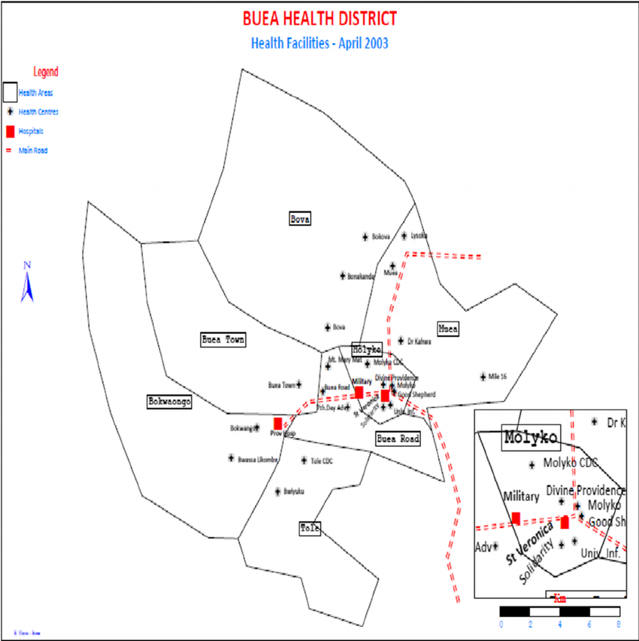
Figure 1: Map of Buea Health District [15]

2.3 Study Population and Sampling

The study involved healthcare prescribers: doctors (general practitioners and specialists), nurses, and midwives actively involved in patient consultation and prescription in the selected facilities. A pre-survey was conducted in each hospital to enumerate eligible prescribers. A total of 63 prescribers were recruited consecutively from the 31 participating health facilities, irrespective of their professional cadre.

Ethical approval was obtained from the Institutional Research Review Board of the University of Douala. Subsequent administrative authorization was secured from the Regional Delegation of Public Health and from the management of each participating health facility.

2.4 Data Collection Techniques

Data were collected using pre-tested, structured questionnaires. The questionnaire was administered to capture data on: Socio-demographic and professional characteristics., continuous ktraining received on malaria case management, Knowledge of malaria symptoms and Artemisinin-based Combination Therapy (ACT), diagnostic decision-making processes and influences and antimalarial prescription patterns for first and second intentions.
Questionnaires were either self-administered or completed via interviewer administration. Prescribers who took the questionnaire off-site were given a 72-hour window to return it.

2.5 Data Management and Statistical Analysis

Data were entered into Microsoft Excel 2013 and analyzed using SPSS software version 26. Descriptive statistics (frequencies, percentages) were used to summarize categorical variables. The Chi-square test was employed to compare qualitative variables. For quantitative variables, the Mann-Whitney U or Kruskal-Wallis tests were used as appropriate. To identify factors associated with key outcomes, a multivariate logistic regression analysis was performed. Variables showing an association (p < 0.05) in univariate analyses were included in the multivariate model to control for potential confounders. The strength of associations was reported as Odds Ratios (OR) with a 95% confidence interval. A p-value of less than 0.05 was considered statistically significant.

3. results

3.1 Socio-professional characteristics of Health personnel at the Buea Health District

The socio-professional profile of prescribers in the Buea Health District reveals a predominance of public sector staff, accounting for 60.3% of the total sample (Table 1). Nurses and midwives form the majority of prescribers (58.7%), with a slightly higher representation in public facilities (63.2%) compared to private ones (52.0%). General practitioners and specialists make up 41.3% overall, with private facilities showing a relatively higher proportion (48.0%) than public ones (36.8%) (Table 1).

Table 1. Socio-professional profile of prescribers in Buea health district
Variables | Sub-variables | Public Health N=38 (60.3%) | Private Health N=25 (39.7%) | Total N=63
Health Staff | General Practitioners & Specialists | 14 (36.8%) | 12 (48.0%) | 26 (41.3%)
Health Staff | Nurses & Midwives | 24 (63.2%) | 13 (52.0%) | 37 (58.7%)
Gender | Female | 32 (84.2%) | 17 (68.0%) | 49 (77.8%)
Gender | Male | 6 (15.8%) | 8 (32.0%) | 14 (22.2%)
Marital Status | Married | 22 (57.9%) | 14 (56.0%) | 36 (57.1%)
Marital Status | Single | 13 (34.2%) | 8 (32.0%) | 21 (33.3%)
Marital Status | Divorced | 3 (7.9%) | 3 (12.0%) | 6 (9.5%)
Level of Training | Pediatrician | 4 (10.5%) | 4 (16.0%) | 8 (12.7%)
Level of Training | General Practitioner | 10 (26.3%) | 8 (32.0%) | 18 (28.6%)
Level of Training | Nurse | 20 (52.6%) | 10 (40.0%) | 30 (47.6%)
Level of Training | Midwife | 4 (10.5%) | 3 (12.0%) | 7 (11.1%)
Working Experience | 7 months – <2 years | 8 (21.1%) | 5 (20.0%) | 13 (20.6%)
Working Experience | 2 years – <6 years | 12 (31.6%) | 7 (28.0%) | 19 (30.2%)
Working Experience | 6 years – <11 years | 5 (13.2%) | 6 (24.0%) | 11 (17.5%)
Working Experience | Above 11 years | 13 (34.2%) | 7 (28.0%) | 20 (31.7%)

Gender dynamics show a strong female majority among prescribers, representing 77.8% of the total, with public institutions having an even higher proportion (84.2%) compared to private ones (68.0%). Male prescribers are notably fewer, comprising just 22.2% overall (Table 1). Marital status data indicates that most prescribers are married (57.1%), followed by singles (33.3%) and a smaller proportion who are divorced (9.5%) (table 1).

In terms of professional training, nurses constitute the largest group (47.6%), followed by general practitioners (28.6%), midwives (11.1%), and pediatricians (12.7%) (Table 1). Regarding work experience, a significant portion of prescribers (31.7%) have over 11 years of experience, indicating a mature workforce. However, nearly half (50.8%) have less than six years of experience, suggesting ongoing generational renewal and potential training needs (Table 1).

3.2 Continuous education of healthcare providers on standard malaria case management

The findings on continuous training for malaria management among prescribers in the Buea Health District reveal a critical gap in targeted education for simple malaria cases (Table 2). While all prescribers (100%) across both public and private sectors report knowing the general algorithm for malaria management, none indicated specific knowledge focused solely on simple malaria (Table 2). Only 38.1% of prescribers (36.8% public, 40.0% private) reported familiarity with both uncomplicated and severe malaria protocols (Table 2).

Table 2. Continues training of prescribers for malaria management
Variables | Category | Public Health N=38 (60.3%) | Private Health N=25 (39.7%) | Total N=63
Know Algorithm for Malaria Management | Overall | 38 (100.0%) | 25 (100.0%) | 63(100.0%)
Know Algorithm for Malaria Management | Simple Malaria | 0 | 0 | 0
Know Algorithm for Malaria Management | Both | 14 (36.8%) | 10 (40.0%) | 24 (38.1%)
Training for Malaria Management | Overall | 19 (50.0%) | 19 (76.0%) | 38 (60.3%)
Training for Malaria Management | Simple | 0 | 0 | 0
Training for Malaria Management | Both | 9 (23.7%) | 12 (48.0%) | 21 (33.3%)
Training Received for Malaria Management | Overall | 13 (36.8%) | 20 (80.0%) | 58 (92.1%)
Training Received for Malaria Management | Training Structure | 11 (28.9%) | 8 (32.0%) | 19 (30.2%)
Training Received for Malaria Management | Health Structure | 2 (5.3%) | 3 (12.0%) | 5 (7.9%)
Training Received for Malaria Management | Ministry of Public Health | 1 (2.6%) | 2 (8.0%) | 3 (4.8%)
Training Received for Malaria Management | Lab plus Media | 3 (7.9%) | 7 (28.0%) | 10 (15.9%)

Training coverage shows a disparity between sectors: 76.0% of private sector prescribers reported receiving training compared to just 50.0% in the public sector, yielding an overall training rate of 60.3% (Table 2). However, none of the prescribers had received training focused exclusively on simple malaria. Only 33.3% (23.7% public, 48.0% private) had training covering both forms of malaria (Table 2). The source of training, 92.1% of prescribers reported having received some form of training, with private sector staff again showing higher uptake (80.0% vs. 36.8%) (Table 2). The most common training source was structured programs (30.2%), followed by Lab plus Media (15.9%), health structures (7.9%), and Ministry of Public Health (4.8%) (Table 2). Notably, Lab plus Media played a more prominent role in private sector training (28.0%) than in public (7.9%) (Table 2).

3.3 Knowledge of malaria symptoms and diagnosis

Figure 1 illustrates a comparative overview of malaria symptoms recognized by prescribers across public and private hospitals in the Buea Health District. Fever is universally acknowledged (93.65%), followed by headache and joint pain (both at 76.19%), though public prescribers consistently report higher recognition rates especially for joint pain (100%) and headache (90%) compared to their private counterparts (Figure 2). Gastrointestinal symptoms such as nausea, vomiting, and diarrhea show moderate awareness, with public prescribers again demonstrating greater recognition. Interestingly, asthenia and anorexia are more frequently cited by public staff, while “Other” symptoms show a sharp contrast: 62.5% recognition in public hospitals versus 39.68% in private (Figure 1).

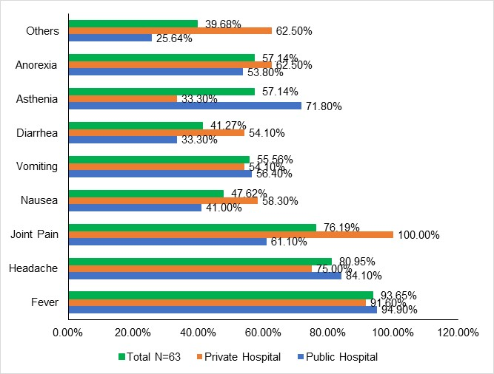
Figure 2: Symptoms of malaria known by prescribers

3.4 Knowledge of Artemisinin base Combination Therapy (ACT)

Table 3 reveals that all prescribers in the Buea Health District both general practitioners/specialists and nurses/midwives demonstrate universal awareness of Artemisinin-based Combination Therapy (ACT), with 100% reporting knowledge of at least one ACT. However, the depth of this knowledge varies significantly by cadre. While nearly half of all prescribers (49.2%) know two ACTs, only general practitioners and specialists report familiarity with three (35.5%) or more combinations (16.1%), whereas nurses and midwives are limited to one or two ACTs, with 43.8% knowing only one (Table 3).

Table 3. Prescriber’s knowledge on Artemisinin Combination Therapy (ACT)
Antimalarial | Variables | General practitioners and Specialists N=31(%) | Nurses and Midwives N=32(%) | Total n=63(%)
Knowledge ACT | Number ACT known | 31 (100.0) | 32 (100.0) | 63 (100.0)
Knowledge ACT | 1 | 2 (6.5) | 14 (43.8) | 16 (25.4)
Knowledge ACT | 2 | 13 (41.9) | 18 (56.3) | 31 (49.2)
Knowledge ACT | 3 | 11 (35.5) | 0 (0) | 11 (17.5)
Knowledge ACT | 4-5 | 5 (16.1) | 0 (0) | 11 (17.1)
ACT known | AL | 31 (100.0) | 24 (75.0) | 59 (93.7)
ACT known | ASAQ | 23 (74.2) | 21 (65.6) | 41 (65.1)
ACT known | DHA\PQP | 20 (64.51) | 1 (3.1) | 22 (33.3)
ACT known | DHA\PQP\TMTP | 1 (3.2) | 0 (0) | 0 (0)
ACT known | ATR\PQP | 2 (6.5) | 0 (0) | 0 (0)
ACT known | AT\MFQ | 1 (3.5) | 0 (0) | 0 (0)
ACT known | AT/SP | 2 (6.5) | 0 (0) | 0 (0)
Other antimalaria* | ASiv | 0 (0) | 4 (12.5) | 4 (6.3)
Other antimalaria* | AMim | 0 (0) | 1 (3.1) | 1 (1.6)
Other antimalaria* | SP | 0 (0) | 1 (3.1) | 1 (1.6)
Other antimalaria* | AM/Doxicycline | 0 (0) | 1 (3.1) | 1 (1.6)
Other antimalaria* | AS/HF | 1 (3.45) | 0 (0) | 1 (1.6)
* GP = General practitioners; AL= artemether/lumefantrine; ASAQ =artesunate/amodiaquine; DHA/PQP= dihydroartemisinin/piperaquine; DHA/PQP/TMTP= dihydroartemisinin/piperaquine/trimetroprine; ATR/PQP= arterolane/piperaquine; AT/MFQ= artemether/mefloquine; AT/SP= artemether/sulfadoxine-pyrimethamine; AS= artesunate injectable; AMim= intra muscular artemether; SP= sulfadoxine-pyrimethamine; AM/Doxicycile= artemether/doxicycline.

Artemether-Lumefantrine (AL) is the most widely recognized ACT, known by 93.7% of prescribers overall, followed by Artesunate-Amodiaquine (ASAQ) at 65.1% (Table 3). Notably, AL is universally known among general practitioners and specialists (100%) but slightly less among nurses and midwives (75%) (Table 3). More complex or less commonly used ACTs such as Dihydroartemisinin-Piperaquine (DHA/PQP) and its variants are predominantly known by physicians, with minimal recognition among nursing staff.

In terms of alternative antimalarial knowledge, nurses and midwives show limited awareness of non-ACT options such as ASiv, AMim, SP, AM/Doxycycline, and AS/HF, though these are recognized by only a small fraction (≤12.5%) (Table 3). General practitioners and specialists report minimal familiarity with these alternatives, suggesting that ACTs remain the dominant therapeutic reference.

3.5 Factors influencing malaria diagnosis among prescribers in the Buea Health District

Figure 2 highlights key factors influencing malaria diagnosis among prescribers in the Buea Health District. The most dominant diagnostic cue is fever as the first malaria sign (23.1%), followed closely by the recognition that Cameroon is an endemic zone (20.5%) (Figure 2). A notable proportion (15.4%) also rely on the presence of multiple malaria signs, reinforcing symptom clustering as a diagnostic trigger. Less influential factors include logistical and socioeconomic constraints such as lack of money for testing, absence of microscopy or lab technicians, and ease of prescription, each contributing 2.5% to 5.1% of diagnostic decisions (Figure 2).

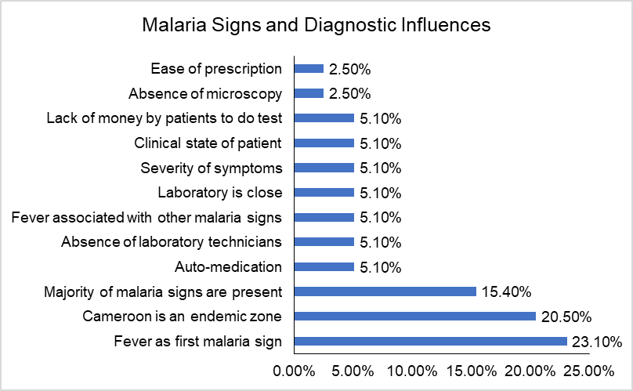
Figure 3: Malaria signs and diagnostic influences in the Buea health district

3.6 Diagnostic Test Waiting Practices Among Healthcare Providers before prescribing antimalarial

Figure 3 illustrates diagnostic test preferences among healthcare providers in the Buea Health District before prescribing antimalarial, comparing general practitioners and specialists (49.21%) with nurses and midwives (50.79%). A strong majority of both groups prefer to wait for Rapid Diagnostic Tests (RDTs), with 87.1% of physicians and 84.4% of nurses/midwives opting for this method resulting in an overall preference of 85.7% (Figure 3). Similarly, 83.9% of physicians and 75.0% of nurses/midwives wait for microscopy, totaling 79.4% across all prescribers (Figure 3).

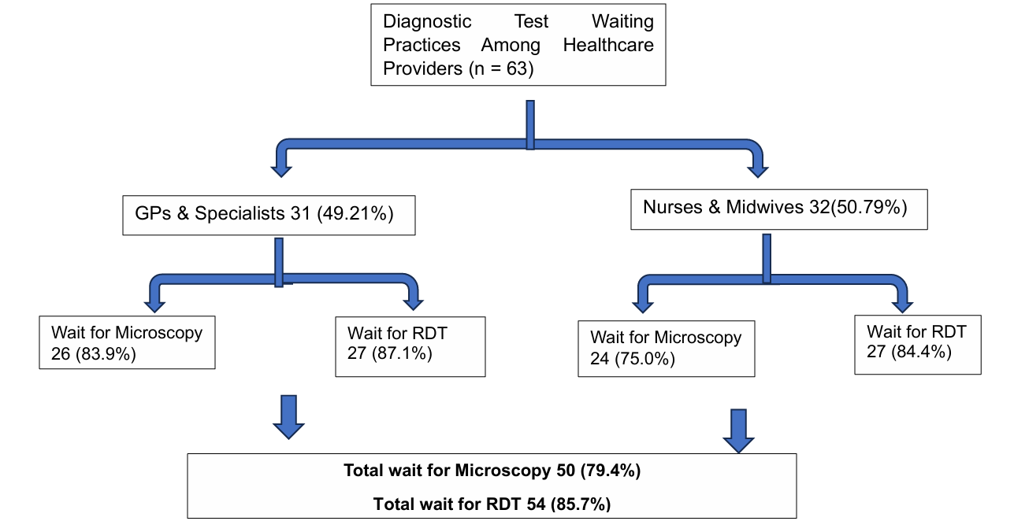
Figure 4: A flow chart of Diagnostic Test Waiting Practices Among Buea Healthcare Providers

Figure 4 outlines key barriers to the use of Rapid Diagnostic Tests (RDT), microscopy, or both in malaria diagnosis among healthcare providers. The most frequently cited obstacles affecting microscopy users (15%) and those relying on both methods (15%). the absence of personnel (15%) was also cited as one of the main obstacles, highlighting critical infrastructural and staffing gaps (Figure4). Other notable challenges include absence of reagents (6.67%) across all methods, work overload, and patients’ inability to pay, each contributing modestly to diagnostic delays. Interestingly, doubt about RDT accuracy was minimal (1.67%) (Figure 4).

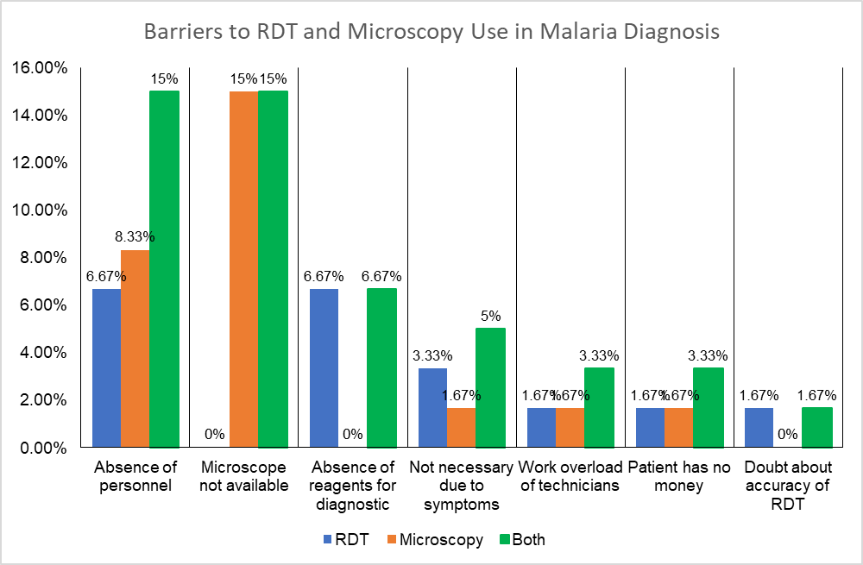
Figure 5: Barriers to RDT and Microscopy Use in Malaria Diagnosis in the Buea Healthcare

3.7 Antimalarial drug use for simple malaria treatment

Table 4 highlight antimalarial drug use in first intention reveals a strong and consistent preference for Artemisinin-based Combination Therapy (ACT) across all age groups and provider types. Over 80% of both general practitioners/specialists and nurses/midwives prescribed ACTs to children under 5, adolescents aged 5–18, and adults. The uniformity in ACT prescription rates between provider categories especially the near-identical figures for each age group (Table 4). Across all age groups, Artemether/Lumefantrine (AL) emerged as the most frequently prescribed ACT formulation, accounting for 68.3% of total prescriptions. Among children under 5 years, AL was administered by general practitioners and specialists in 67.7% of cases, closely mirrored by nurses and midwives at 68.8% (Table 4). This pattern held steady in older age brackets: for children aged 5–18 years, AL was prescribed in 64.5% of cases by GPs and 68.8% by nurses, while adult patients received AL in 64.5% and 68.8% of cases respectively (Table 4). ASAQ (Artesunate/Amodiaquine) follows distantly at 12.7%, while DHA/PQP (Dihydroartemisinin/Piperaquine) is rarely used, appearing in only 1.6% of cases (Table 4). Non-ACT antimalarials including Quinine (Q), Chloroquine (CQ), and Oral Quinine were prescribed in only 1.6% of cases each, and exclusively by general practitioners and specialists (Table 4).

Table 4. Antimalarial Prescription Patterns by Age Group and Provider Type for first intentions
Antimalarial | Age Group | GPs & Specialists (n = 31) | Nurses & Midwives (n = 32) | Total (n = 63)
ACT (any) | <5 years | 26 (83.9%) | 26 (81.3%) | 52 (82.5%)
ACT (any) | 5–18 years | 25 (80.6%) | 26 (81.3%) | 51 (81.0%)
ACT (any) | Adults | 25 (80.6%) | 26 (81.3%) | 51 (81.0%)
AL | <5 years | 21 (67.7%) | 22 (68.8%) | 43 (68.3%)
AL | 5–18 years | 20 (64.5%) | 22 (68.8%) | 42 (66.7%)
AL | Adults | 20 (64.5%) | 22 (68.8%) | 42 (66.7%)
ASAQ | <5 years | 4 (12.9%) | 4 (12.5%) | 8 (12.7%)
ASAQ | 5–18 years | 4 (12.9%) | 4 (12.5%) | 8 (12.7%)
ASAQ | Adults | 4 (12.9%) | 4 (12.5%) | 8 (12.7%)
DHA/PQP | <5 years | 1 (3.2%) | 0 (0.0%) | 1 (1.6%)
DHA/PQP | 5–18 years | 1 (3.2%) | 0 (0.0%) | 1 (1.6%)
DHA/PQP | Adults | 1 (3.2%) | 0 (0.0%) | 1 (1.6%)
Quinine (Q) | <5 years | 1 (3.2%) | 0 (0.0%) | 1 (1.6%)
Quinine (Q) | 5–18 years | 1 (3.2%) | 0 (0.0%) | 1 (1.6%)
Quinine (Q) | Adults | 1 (3.2%) | 0 (0.0%) | 1 (1.6%)
CQ (Chloroquine) | <5 years | 1 (3.2%) | 0 (0.0%) | 1 (1.6%)
CQ (Chloroquine) | 5–18 years | 1 (3.2%) | 0 (0.0%) | 1 (1.6%)
CQ (Chloroquine) | Adults | 1 (3.2%) | 0 (0.0%) | 1 (1.6%)
Oral Q | <5 years | 1 (3.2%) | 0 (0.0%) | 1 (1.6%)
Oral Q | 5–18 years | 1 (3.2%) | 0 (0.0%) | 1 (1.6%)
Oral Q | Adults | 1 (3.2%) | 0 (0.0%) | 1 (1.6%)
AL: artemether/lumefantrine, ASAQ: artesunate/amodiaquine, DHA/PQP: dihydroartemisinin/piperaquine, Q: quinine, AMim: intra muscular artemether, ASiv: intravenous artesunate, CQ: chloroquine, ACT: artemisinin-based combination therapy

Table 5 outlines antimalarial drug use in second intention, showing a clear dominance of Artemether/Lumefantrine (AL) across all age groups and provider types. AL was prescribed to 82.5% of patients under 5 years, 77.8% of those aged 5–10 years, and 88.9% of adolescents/adults, with nurses and midwives consistently favouring AL more than general practitioners in children under 5 (Table 5). ASAQ followed distantly, used uniformly at 12.7% across all age groups and providers. Other ACTs such as DHA/PQP and DHA/PQP/TMP were prescribed only by general practitioners, each accounting for just 1.6% of cases per age group (Table 5). Similarly, non-ACT alternatives like injectable artemisinin derivatives, quinine combinations, and Savarine were exclusively used by GPs and specialists, each representing 1.6% of prescriptions (Table 5).

Table 5. Antimalarial Drug Use by Age Group and Provider Type for second intention
Drug Category | Antimalarial | Age Group | GPs & Specialists (n = 31) | Nurses & Midwives (n = 32) | Total (n = 63)
ACTs | AL | <5 years | 22 (71.0%) | 30 (93.8%) | 52 (82.5%)
ACTs | AL | 5–10 years | 20 (64.5%) | 29 (90.6%) | 49 (77.8%)
ACTs | AL | Adolescents/Adults | 26 (83.9%) | 30 (93.8%) | 56 (88.9%)
ACTs | ASAQ | <5 years | 4 (12.9%) | 4 (12.5%) | 8 (12.7%)
ACTs | ASAQ | 5–10 years | 4 (12.9%) | 4 (12.5%) | 8 (12.7%)
ACTs | ASAQ | Adolescents/Adults | 4 (12.9%) | 4 (12.5%) | 8 (12.7%)
ACTs | DHA/PQP | <5 years | 1 (3.2%) | 0 (0.0%) | 1 (1.6%)
ACTs | DHA/PQP | 5–10 years | 1 (3.2%) | 0 (0.0%) | 1 (1.6%)
ACTs | DHA/PQP | Adolescents/Adults | 1 (3.2%) | 0 (0.0%) | 1 (1.6%)
ACTs | DHA/PQP/TMP | <5 years | 1 (3.2%) | 0 (0.0%) | 1 (1.6%)
ACTs | DHA/PQP/TMP | 5–10 years | 1 (3.2%) | 0 (0.0%) | 1 (1.6%)
ACTs | DHA/PQP/TMP | Adolescents/Adults | 1 (3.2%) | 0 (0.0%) | 1 (1.6%)
Other Drugs | AMin / ASiv / AM Syrup | <5 years | 1 (3.2%) | 0 (0.0%) | 1 (1.6%)
Other Drugs | AMin / ASiv / AM Syrup | 5–10 years | 1 (3.2%) | 0 (0.0%) | 1 (1.6%)
Other Drugs | AMin / ASiv / AM Syrup | Adolescents/Adults | 1 (3.2%) | 0 (0.0%) | 1 (1.6%)
Other Drugs | AL or Q | <5 years | 1 (3.2%) | 0 (0.0%) | 1 (1.6%)
Other Drugs | AL or Q | 5–10 years | 1 (3.2%) | 0 (0.0%) | 1 (1.6%)
Other Drugs | AL or Q | Adolescents/Adults | 1 (3.2%) | 0 (0.0%) | 1 (1.6%)
Other Drugs | Q or Q | <5 years | 1 (3.2%) | 0 (0.0%) | 1 (1.6%)
Other Drugs | Q or Q | 5–10 years | 1 (3.2%) | 0 (0.0%) | 1 (1.6%)
Other Drugs | Q or Q | Adolescents/Adults | 1 (3.2%) | 0 (0.0%) | 1 (1.6%)
Other Drugs | Savarine | <5 years | 1 (3.2%) | 0 (0.0%) | 1 (1.6%)
Other Drugs | Savarine | 5–10 years | 1 (3.2%) | 0 (0.0%) | 1 (1.6%)
Other Drugs | Savarine | Adolescents/Adults | 1 (3.2%) | 0 (0.0%) | 1 (1.6%)
AL: artemether/lumefantrine, ASAQ: artesunate/amodiaquine, DHA/PQP: dihydroartemisinin/piperaquine, Q: quinine, AMim: intra muscular artemether, ASiv: intravenous artesunate, ACT: artemisinin base combination therapy

3.8 Quality of antimalarial prescription use for simple malaria treatment

The results of this matrix clearly establish Artemether-Lumefantrine (AL) as the most consistently adequate first-intention antimalarial across all age groups (Table 6). AL achieved 100.0% posology adequacy and 98.3% duration adequacy among adults/adolescents, with strong performance also observed in children aged 5–10 years (72.5% posology, 66.7% duration) and those under 5 (53.7% posology, 58.9% duration) (Table 6). In contrast, ASAQ (Artesunate-Amodiaquine) showed moderate adequacy in younger children (46.3% posology, 39.3% duration) but dropped sharply in older age groups, with only 1.6% adequacy among adults/adolescents. Other ACTs like DHA/PQP, DHA/PQP/TMTP, and AS/MQ were rarely used and showed negligible adequacy.

Table 6. Reformatted Matrix: Adequacy of Antimalarial first line Treatment Regimens
Category | Antimalarial | Adequate Posology |  |  | Adequate Duration
Category | Antimalarial | Child 0-<5yrs | Child 5-10yrs | Adult/Adolescent | Child 0-<5yrs | Child 5-10yrs | Adult/Adolescent
ACT | AL | 22 (53.7%) | 37 (72.5%) | 55 (100.0%) | 33 (58.9%) | 36 (66.7%) | 62 (98.3%)
ACT | ASAQ | 19 (46.3%) | 13 (25.1%) | 1 (1.6%) | 22 (39.3%) | 18 (33.3%) | 1 (1.6%)
ACT | DHA/PQP | 0 | 1 (2.0%) | 0 | 1 (1.8%) | 1 (1.9%) | 0
ACT | DHA/PQP/TMTP | 0 | 0 | 0 | 0 | 0 | 0
ACT | AS/MQ | 0 | 0 | 0 | 0 | 0 | 0
Others | CQ | 0 | 0 | 0 | 0 | 0 | 0
Others | Oral Q | 0 | 2 (3.2%) | 0 | 2 (3.2%) | 2 (3.2%) | 0
Others | AL or AMim, AL or ASAQ, AL or DHA/PQP | 4 (6.3%) | 4 (6.3%) | 0 | 4 (6.3%) | 5 (6.3%) | 0
Others | ASAQ or AMim, ASAQ or DHA/PQP | 2 (3.2%) | 0 | 0 | 0 | 2 (3.2%) | 0
Others | ASAQ or CQ | 0 | 1 (1.6%) | 0 | 0 | 1 (1.6%) | 0
AL: artemether/lumefantrine; ASAQ: artesunate/amodiaquine; DHA/PQP: dihydroartemisinin/piperaquine; DHA/PQP/TMTP: dihydroartemisinnine/piperaquine/trimethoprime; AS/MFQ: artesunate/mefloquine; CQ: chloroquine; Oral Q: oral quinine; AMim: intramuscular artemether.

The second-intention antimalarial treatment data reveal a more varied and less consistent pattern of adequacy compared to first-line regimens (Table 7). Overall ACT use showed moderate adequacy, with posology adequacy ranging from 47.6% in children under 5 to 61.9% in adults/adolescents, and duration adequacy highest in adults/adolescents at 68.3% but notably low in children aged 5–10 (3.2%) (Table 6). Among individual ACTs, AL remained the most frequently adequate, especially in adults/adolescents (51.2%) for both posology and duration, though its use in children aged 5–10 showed zero adequacy for duration (Table 7). ASAQ and DHA/PQP were used more selectively, with DHA/PQP showing 100% posology adequacy in children under 5, but lower adequacy in other groups (Table 7). Non-ACT alternatives were marginal, with ASiv, AMim, and oral quinine showing up to 15.9% adequacy for duration in children, while Oral Q or Savarine appeared only in adults/adolescents with 7.9%–9.5% adequacy (Table 7).

Table 7. Reformatted Matrix: Adequacy of Antimalarial second line Treatment Regimens
Category | Antimalarial | Adequate Posology |  |  | Adequate Duration
Category | Antimalarial | Child 0-<5yrs | Child 5-10yrs | Adult/Adolescent | Child 0-<5yrs | Child 5-10yrs | Adult/Adolescent
ACT | ACT | 30 (47.6%) | 37 (58.7%) | 39 (61.9%) | 35 (55.6%) | 2 (3.2%) | 43 (68.3%)
ACT | AL | 13 (43.3%) | 17 (45.9%) | 20 (51.2%) | 19 (54.3%) | 0 (0.0%) | 22 (51.2%)
ACT | ASAQ | 10 (33.3%) | 9 (24.3%) | 6 (15.4%) | 11 (31.4%) | 0 (0.0%) | 5 (11.6%)
ACT | DHA/PQP | 7 (100%) | 9 (24.3%) | 11 (28.2%) | 5 (14.3%) | 2 (100%) | 14 (32.6%)
ACT | DHA/PQP/TMTP | 0 (0.0%) | 2 (5.4%) | 2 (5.1%) | 0 (0.0%) | 0 (0.0%) | 2 (4.7%)
Others | AL or oral Q | 1 (1.6%) | 1 (1.6%) | 0 (0.0%) | 1 (1.6%) | 0 (0.0%) | 0 (0.0%)
Others | ASiv, AMim, oral Q | 5 (7.9%) | 4 (6.3%) | 0 (0.0%) | 10 (15.9%) | 10 (15.9%) | 0 (0.0%)
Others | CQim | 0 | 0 | 0 | 0 | 0 | 0
Others | Oral Q or Salvarine | 0 | 0 | 5 (7.9%) | 0 | 0 | 6 (9.5%)
AL: artemether/lumefantrine, ASAQ: artesunate/amodiaquine, DHA/PQP: dihydroartemisinin/piperaquine, DHA/PQP/TMTP: dihydroartemisinnine/piperaquine/trimethoprime, ATR/PQP: arterolane/piperaquine, AS/MFQ: artesunate/mefloquine, AS/SP: artesunate/sulfadoxine/pyrimethamine, AS/HF: artesunate/halofantrine, Qiv: intravenous quinine, ASiv: intravenous artesunate, AMim: intramuscular artemether.

3.9 Reasons for using antimalarial other than ACT

Figure 5 highlights the multifaceted reasons why healthcare providers in Cameroon opt for antimalarial treatments other than ACTs when managing simple malaria cases. The most cited barrier is stockouts of ACTs, reported by 31.71% of respondents, underscoring persistent supply chain challenges. Patient refusal to take ACTs (14.63%) and the use of non-ACTs in severe cases (12.20%) reflect both behavioural and clinical decision-making factors. Medical contraindications such as allergy and first-trimester pregnancy each account for 9.76%, suggesting gaps in safe alternatives or provider confidence.

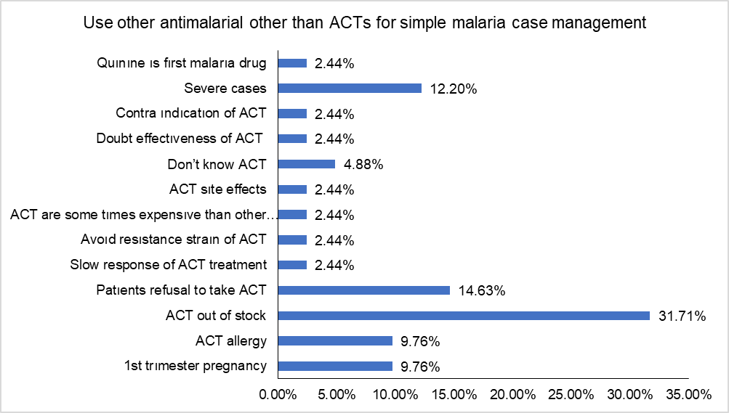
Figure 6: Reasons for using other antimalarial other than ACTs for simple malaria case management

4. DISCUSSION

The predominance of public sector staff and the high representation of nurses and midwives among malaria prescribers in the Buea Health District reflects broader national workforce trends and task-shifting policies aimed at addressing human resource shortages in Cameroon’s health system. According to Cameroon Malaria Indicator Survey, frontline malaria case management is often delegated to nurses and midwives, especially in peripheral and public health facilities, due to their accessibility and training in integrated management of childhood illnesses [16]. The slightly higher proportion of nurses in public facilities aligns with government staffing norms and the strategic deployment of mid-level providers to rural and semi-urban areas where malaria burden is high [17]. Conversely, the relatively greater presence of general practitioners and specialists in private facilities may be driven by urban concentration, better remuneration, and autonomy in clinical decision-making, as observed in WHO’s health workforce assessments across Sub-Saharan Africa [5]. These patterns underscore the importance of targeted training and supervision for nurses and midwives, who remain pivotal in implementing national malaria treatment guidelines at the community level.

The gender composition of malaria prescribers in the Buea Health District reflects broader trends of workforce feminization in Cameroon and Sub-Saharan Africa, particularly among nurses and midwives, as documented by WHO gender assessments. This pattern is shaped by historical training pathways and sociocultural expectations that position women in frontline care roles [17]. Marital status dynamics may further influence workforce retention, with married health workers often demonstrating greater stability in rural postings. The predominance of mid-level providers in professional training profiles supports Cameroon’s national task-shifting strategy to enhance malaria case management in decentralized settings. The coexistence of both experienced and early-career prescribers suggests a transitional workforce that requires ongoing mentorship and supervision to maintain adherence to national malaria treatment guidelines. These findings highlight the importance of gender-responsive policies and capacity-building efforts to sustain effective malaria care.

The training landscape for malaria case management in the Buea Health District reveals a concerning gap in targeted education for simple malaria, despite universal awareness of general treatment algorithms. This disconnects between broad algorithm familiarity and specific protocol knowledge reflects a national challenge in aligning prescriber competencies with the nuanced demands of malaria stratification. According to WHO’s malaria case management guidelines, effective control requires differentiated training for uncomplicated and severe malaria, especially at the primary care level where most cases are first encountered [18]. The private prescribers report higher uptake mirrors findings from PMI Cameroon’s operational assessments, which highlight uneven access to continuing education and reliance on external platforms like Lab plus Media for capacity building [17]. The limited role of the Ministry of Public Health in training delivery underscores the need for stronger institutional engagement and harmonization of training sources. These findings suggest that while structured programs are present, their content may lack specificity, particularly for simple malaria, which remains the most prevalent form in Cameroon’s endemic zones. Addressing this gap is essential for improving diagnostic accuracy, treatment adherence, and reducing overtreatment or misclassification in frontline settings.

The comparative symptom recognition data from the Buea Health District underscores notable disparities between public and private hospital prescribers in their clinical awareness of malaria presentations. Fever remains the most universally recognized symptom, aligning with national and global clinical guidelines that identify it as a cardinal sign of malaria [19]. However, the higher recognition rates of headache and joint pain among public prescribers suggest stronger adherence to integrated management protocols and possibly more frequent exposure to diverse clinical cases [17]. Gastrointestinal symptoms nausea, vomiting, and diarrhoea though moderately acknowledged, show greater recognition in public settings, reflecting findings from the 2022 Cameroon Malaria Indicator Survey that highlight variability in symptom interpretation across facility types [16]. These findings reinforce the need for harmonized clinical training and continuous professional development across both sectors to ensure equitable and comprehensive malaria case management.

The findings from Table 3 highlight a critical dimension of malaria case management in the Buea Health District: while universal awareness of Artemisinin-based Combination Therapy (ACT) among prescribers is encouraging, the depth and breadth of ACT knowledge remain uneven across professional cadres. This disparity mirrors national trends observed in the Littoral Region, where physicians demonstrated higher ACT prescription accuracy compared to nurses and laboratory technicians [20]. Artemether-Lumefantrine (AL), the most widely recognized ACT, aligns with Cameroon’s national treatment guidelines and WHO recommendations as the first-line therapy for uncomplicated malaria [20]. The limited familiarity with alternative ACTs such as Dihydroartemisinin-Piperaquine (DHA/PQP) among nurses and midwives suggests a need for targeted continuing education, especially as resistance patterns evolve and therapeutic options diversify. These findings reinforce the importance of differentiated training strategies and regular updates to prescriber knowledge, as emphasized in Cameroon’s pharmaceutical regulatory framework and post-policy assessments.

The results highlight fever as the dominant diagnostic cue for malaria in the Buea Health District, closely followed by recognition of Cameroon as an endemic malaria zone, reflecting common diagnostic approaches in malaria-endemic regions [5, 17]. The reliance on multiple malaria signs by prescribers supports the disease’s known symptom clustering, which improves clinical suspicion accuracy in resource-limited settings [21]. Logistical and socioeconomic factors such as financial constraints for testing, absence of microscopy or trained lab personnel, and ease of prescribing certain treatments also influence diagnostic decisions. This aligns with documented challenges across Sub-Saharan Africa where limited diagnostic infrastructure and economic barriers often compel clinicians to rely on presumptive diagnosis, potentially resulting in misdiagnosis or overtreatment [5, 22]. These findings underscore the critical need to enhance diagnostic capacity and address socioeconomic barriers in malaria management in endemic regions.

The results in Figure 3 highlight a strong preference among healthcare providers in the Buea Health District for using Rapid Diagnostic Tests (RDTs) prior to prescribing antimalarials, with general practitioners and specialists and nurses and midwives favouring this method, reflecting the increasing adoption of RDTs in malaria-endemic and resource-limited settings due to their ease of use and rapid results [5, 22]. Similarly, microscopy remains widely used, with by physicians and nurses/midwives reportedly waiting for results, which aligns with microscopy's role as the gold standard diagnostic tool despite its limitations, such as dependency on skilled personnel and infrastructure [23]. Identifies key barriers to diagnosis, notably the absence of trained personnel and shortages of reagents, echoing challenges documented in many malaria-endemic regions where infrastructural gaps and workforce shortages hinder optimal diagnostic services [22, 24]. Additional barriers including work overload and patients' inability to pay highlight socioeconomic factors influencing diagnostic delays. The minimal doubt about RDT accuracy underscores growing confidence in RDT reliability, a positive trend emphasized in recent literature advocating expanded access and training for enhanced malaria case management in endemic regions [5].

The results from Tables 4 and 5 reveal a strikingly consistent preference for Artemisinin-based Combination Therapies (ACTs) as first- and second-intention treatments for simple malaria across all age groups and healthcare provider categories in the Buea Health District. Artemether/Lumefantrine (AL) dominates prescribing patterns for first-intention prescriptions and second-intention use, with near-identical rates between general practitioners/specialists and nurses/midwives across pediatric, adolescent, and adult populations. This uniformity reflects strong adherence to national and WHO guidelines recommending AL as a first-line therapy due to its proven efficacy and safety profile [25]. The limited use of ASAQ and DHA/PQP may be attributed to supply chain constraints, provider familiarity, or regional formulary preferences, despite evidence supporting their comparable therapeutic efficacy [26]. The marginal use of non-ACTs such as quinine and chloroquine, exclusively by physicians, suggests residual reliance on legacy treatments in specific clinical scenarios, possibly severe or recurrent cases. These findings align with recent Cameroonian trials and meta-analyses confirming AL’s high cure rates and tolerability, reinforcing its central role in malaria case management [25, 26].

The matrix results presented in Tables 6 and 7 confirm Artemether-Lumefantrine (AL) as the most consistently adequate first-intention antimalarial across all age groups in the Buea Health District, with exceptional posology and duration adequacy among adults/adolescents, and strong performance in children aged 5–10 and under 5. These findings align with WHO’s 2025 malaria treatment guidelines, which recommend AL as the preferred ACT due to its favorable pharmacokinetics, tolerability, and high cure rates [27]. The limited adequacy of ASAQ, particularly in older age groups, reflects concerns about age-specific dosing complexity and adverse effects, as reported by Niba et al [25] in their evaluation of treatment adherence in Cameroon. Second-intention regimens showed greater variability, with AL still leading in adequacy among adults/adolescents but showing zero duration adequacy in children aged 5–10, suggesting gaps in pediatric dosing practices or formulation availability. DHA/PQP demonstrated isolated adequacy in children under 5 (posology), consistent with findings by Fitri et al. [23], who highlighted its efficacy but limited field use due to cost and access. Non-ACT alternatives such as injectable artemisinin derivatives and oral quinine were marginal and used primarily in fallback scenarios, with low adequacy rates. These results underscore the need for targeted training and supply chain reinforcement to improve ACT dosing accuracy and duration adherence, especially in pediatric populations.

Figure 5 reveals critical systemic and behavioural factors influencing healthcare providers’ deviation from Artemisinin-based Combination Therapies (ACTs) in the management of uncomplicated malaria in Cameroon. The leading reason for ACT stockouts reported by respondents echoes longstanding supply chain vulnerabilities documented in national surveys and operational research [2, 16]. Such shortages compromise guideline adherence and increase reliance on less effective or outdated regimens. Patient refusal further complicates treatment decisions, reflecting gaps in health literacy and community trust, as highlighted by Marwa et al. [26] in their study on ACT acceptability. The use of non-ACTs in severe cases aligns with clinical protocols prioritizing injectable artesunate or quinine in life-threatening presentations [27], though it also suggests potential misclassification of case severity. Notably, medical contraindications such as allergy and first-trimester pregnancy underscore the need for clearer provider guidance and safer alternatives, especially given limited options for pregnant women in early gestation [23]. These findings collectively point to the importance of strengthening ACT availability, enhancing provider training, and improving patient engagement to ensure rational malaria treatment.

5. Conclusion

Malaria treatment in the Buea Health District is shaped by workforce distribution, training gaps, and diagnostic practices. Nurses and midwives dominate public facilities, while physicians are more common in private ones with better training access. Although ACT awareness is universal, knowledge depth varies. Fever is the main diagnostic cue, with RDTs and microscopy widely favoured. Artemether-Lumefantrine is the most consistently adequate antimalarial, while alternatives are rarely used. Systemic barriers like stockouts and contraindications highlight the need for better training, supply chains, and patient education.

Ethical approval (where ever applicable)

The study was conducted in strict adherence to ethical principles. Written informed consent (or assent for minors with guardian consent) was obtained from all participants after a detailed explanation of the study's purpose, procedures, benefits, and risks. All data collected were kept confidential; participant identifiers were removed and replaced with codes known only to the research team. The data were used solely for the purpose of this research and were securely stored and destroyed upon the study's completion.

COMPETING INTERESTS DISCLAIMER:
Authors have declared that they have no known competing financial interests OR non-financial interests OR personal relationships that could have appeared to influence the work reported in this paper.

References

- World Health Organization. (2023). World malaria report 2023. Geneva: WHO. https://www.who.int/publications/i/item/9789240070004 Accessed 6th October 2025
- World Health Organization. (2022). World malaria report 2022. Geneva: WHO. https://www.who.int/publications/i/item/9789240064898 Accessed 6th October 2025
- Gallup, J. L., & Sachs, J. D. (2001). The economic burden of malaria. American Journal of Tropical Medicine and Hygiene, 64(1_suppl), 85–96. https://doi.org/10.4269/ajtmh.2001.64.85
- Antonio-Nkondjio, C., Ndo, C., & Atangana, J. (2016). Review of malaria situation in Cameroon: Technical and operational challenges for control and elimination. Parasites & Vectors, 9, 225. https://doi.org/10.1186/s13071-016-1525-5
- World Health Organization. (2024). Malaria 2024 Cameroon country profile. Geneva: WHO. https://www.who.int/publications/m/item/malaria-2024-cmr-country-profile
- Severe Malaria Observatory. (2024). Malaria in Cameroon: Statistics & facts. https://www.severemalaria.org/countries/cameroon Accessed 1st October 2025
- Hanboonkunupakarn, B., & White, N. J. (2016). The threat of antimalarial drug resistance. Trends in Parasitology, 32(3), 187–196. https://doi.org/10.1016/j.pt.2015.11.010
- Uwimana, A., Umulisa, N., Venkatesan, M., Svigel, S. S., Zhou, Z., Munyaneza, T., ... & Mwesigwa, J. (2020). Emergence and clonal expansion of artemisinin-resistant Plasmodium falciparum in Rwanda. Nature Medicine, 26(10), 1602–1608. https://doi.org/10.1038/s41591-020-1005-2
- Balikagala, B., Fukuda, N., Ikeda, M., Katuro, O. T., Yamauchi, M., Opio, W., ... & Mita, T. (2021). Evidence of artemisinin-resistant malaria in Africa. New England Journal of Medicine, 385(13), 1163–1171. https://doi.org/10.1056/NEJMoa2101746
- World Health Organization. (2015). Global technical strategy for malaria 2016–2030. Geneva: WHO. https://doi.org/10.1016/S0140-6736(15)60776-0
- Hopkins, H., Bruxvoort, K. J., Cairns, M. E., Chandler, C. I., Leurent, B., Ansah, E. K., ... & Whitty, C. J. (2017). Impact of diagnostic testing on malaria treatment practices in Africa. BMJ Global Health, 2(2), e000304. https://doi.org/10.1136/bmjgh-2017-000304
- National Malaria Control Program. (2014). National malaria control guidelines. Yaoundé: Ministry of Public Health.
- Newby, G., Bennett, A., Larson, E., Cotter, C., & Gosling, R. (2023). Malaria case management in sub-Saharan Africa: A review of prescriber practices. The Lancet Global Health, 11(5), e678–e690. https://doi.org/10.1016/S2214-109X(23)00045-2
- Zurovac, D., Talisuna, A. O., & Snow, R. W. (2014). Mobile phone text messaging: Tool for malaria control in Africa. Malaria Journal, 13, 1–10. https://doi.org/10.1186/1475-2875-13-1
- Egbe T.O., Omeichu A., Halle-Ekane G.E., Tchente C.N., Egbe E-N. & Oury J-F. (2015). Prevalence and outcome of teenage hospital births at the buea health district, South West Region, Cameroon. Reproductive Health, 12:118. https://doi.org/10.1186/s12978-015-0109-5
- National Institute of Statistics (NIS), National Malaria Control Programme (NMCP), and ICF. 2023. Cameroon Malaria Indicator Survey 2022. Key Indicators Report. Yaounde, Cameroon, and Rockville, Maryland, USA: NIS, NMCP, and ICF.
- PMI Cameroon Malaria Profile (2024). Available: https://mesamalaria.org/wp-content/uploads/2025/04/CAMEROON_Malaria_Profile_PMI_FY_2024.pdf Accessed 03/10/2025
- World Health Organization (WHO) (2012). Case management guide for participants. WHO Library Cataloguing-in-Publication Data
- Zefack, J.T., Awatboh, F., Yankam, B.M., Che D.S., Adanze N.C., Kibu O.D., Ajamah F., Ndive C.A. & Tiayah P.F. (2025). Malaria burden and social determinants in Cameroon. Discov Public Health 22, 434. https://doi.org/10.1186/s12982-025-00833-x
- Kuete, T., Mvoa E.E., Yinyang J., Priso A.E., Chamabe P.C.G., Mpondo E.M., Ekobo A.S. (2016) Pattern of Uncomplicated MalariaTreatment and Antimalarial Prescription Practices among Health Workers in theLittoral Region of Cameroon: An Assessment Ten Years Post-Malaria Treatment Policy Change. Pharmacology & Pharmacy, 7, 217-225. http://dx.doi.org/10.4236/pp.2016.76028
- Parsel SM, Gustafson SA, Friedlander E, Shnyra AA, Adegbulu AJ, Liu Y, Parrish NM, Jamal SA, Lofthus E, Ayuk L, Awasom C, Henry CJ, McArthur CP. (2017). Malaria over-diagnosis in Cameroon: diagnostic accuracy of Fluorescence and Staining Technologies (FAST) Malaria Stain and LED microscopy versus Giemsa and bright field microscopy validated by polymerase chain reaction. Infectious Diseases of Poverty, 4;6(1):32. http://dx.doi.org/10.1186/s40249-017-0251-0.
- Ngalame AL, Watching D, Kibu OZ, Zeukóo EM, Nsagha DS (2024) Assessment of the diagnostic performance of the SD Bioline Malaria antigen test for the diagnosis of malaria in the Tombel health district, Southwest region of Cameroon. PLoS ONE 20(3): e0298992. https://doi.org/10.1371/journal.pone.0298992
- Fitri L.E., Widaningrum T., Prabowo M.H., Endharti A.T., Winaris N., Nugraha R.Y.B. (2022). Malaria diagnostic update: From conventional to advanced method. Journal of Clinical Laboratory Analysis, 36: e24314. https://doi.org/10.1002/jcla.24314
- Pucca MB, de Sousa TN, Cardoso de Melo GC and Viana GMR (2024) Editorial: Challenges for diagnosis, treatment, and elimination of malaria. Frontiers in Tropical Diseases 5:1394693. https://doi.org/10.3389/fitd.2024.1394693
- Niba P.T.N., Nji A.M., Ali I.M., Akam L.F., Dongmo C.H., Chedjou J.P.K., Fomboh C.T., Nana W.D., Oben O.L.A., Selly-Ngaloumo A.A. et al. (2022). Effectiveness and safety of artesunate amodiaquine versus artemether–lumefantrine for home-based treatment of uncomplicated Plasmodium falciparum malaria among children 6–120 months in Yaoundé, Cameroon: a randomized trial. BMC Infectious Diseases, 22:166. https://doi.org/10.1186/s12879-022-07101-2
- Marwa K, Kapesa A, Baraka V, Konje E, Kidenya B, Mukonzo J., Kamugisha E., Swedberg G. (2022) Therapeutic efficacy of artemether-lumefantrine, artesunate amodiaquine and dihydroartemisinin-piperaquine in the treatment of uncomplicated Plasmodium falciparum malaria in Sub-Saharan Africa: A systematic review and meta-analysis. PLoS ONE 17(3): e0264339. https://doi.org/10.1371/journal. pone.0264339
- World Health Organization (2025). WHO guidelines for malaria, 13 August 2025. World Health Organization. http://dx.doi.org/https://doi.org/10.2471/B09514. License: CC BY-NC-SA 3.0 IGO

