Holding Time – The impact on Unfiltered Fresh Frozen Plasma

Abstract
Ensuring the safety and quality of transfusion products is critical in transfusion medicine. Leucocytes in blood products can cause adverse reactions and increase the risk of transfusion-related complications, making it essential to minimize their presence before transfusion. Elevated leucocyte counts have been observed in unfiltered fresh frozen plasma (FFP) units derived from whole blood processed after a short holding time—the interval between blood collection and component separation. Adequate protein concentration is also a key quality parameter for plasma. This study evaluated 100 non-filtered FFP units processed after a short holding time (SHT) and compared them to 100 units processed after an overnight, long holding time (LHT). Volume of the units was also assessed. Residual leucocyte counts (RLC) and protein concentrations (PC) were measured and analysed statistically. Longer holding times were associated with lower RLC and higher PC. Statistical process control (SPC) indicated that the SHT process was borderline to incapable in maintaining consistent product quality, even after outlier adjustment. These findings suggest that current short holding times may compromise plasma standardization. Re-evaluation of the minimum holding time is recommended to optimize leucocyte reduction and protein retention in FFP.

Keywords: Fresh frozen plasma; holding time; residual leucocytes; plasma proteins; leucoreduction; transfusion safety.

- Introduction

Therapeutic efficacy and patient safety are very important aspects of transfusion. The therapeutic value of fresh frozen plasma (FFP) is mostly determined by its protein content, especially coagulation factors. Patient safety is mainly ensured by eliminating pathogens in the unit by phagocytosis or pathogen inactivation techniques, and lowering the residual leucocyte count to a minimum, according to the followed guidelines such as those set by the European Directorate for the Quality of Medicines & HealthCare (EDQM)(1). Several factors and steps throughout the process of blood product production can influence the final quality of the product, and therefore the therapeutic efficacy and safety. One of these factors is holding time, which is the time between whole blood collection and product separation (Yousif, Sammut et al. 2025). This time allows leucocytes to phagocytose any bacteria present and to degrade and inactivate, thus minimizing the possibility of transfusion-related infection transmission and immunological reactions. Holding time has its benefits but also has its downside. In the case of plasma, long holding times have been found to increase the degradation of coagulation factors necessary for patients receiving FFP transfusion, particularly Factor VIII which is the most labile. Thus, the right duration of holding time is crucial to balance residual leucocyte count (RLC) and total protein concentration (PC)(2–6). This has highlighted the importance of investigating the relationship between holding time and different parameters including RLC and total PC, on which there is limited research, especially with regards to RLCs in plasma. By comparing units with a Short Holding Time (SHT) and Long Holding Time (LHT), this relationship, if present, can be identified and further investigated to determine whether the standard protocols should be reconsidered to enhance the safety, effectiveness and clinical use of FFP(2).

- Methodology

  - Experimental Design
Donations from anonymous blood donors were collected at the donation centre. A total of 100 FFP units processed after a short holding time (~3hr) were tested for RLC and PC. Data from an additional 100 units processed after an overnight holding time were obtained from the quality control laboratory for comparison. The study design is summarized in Figure 1. Volumes of all units were recorded.

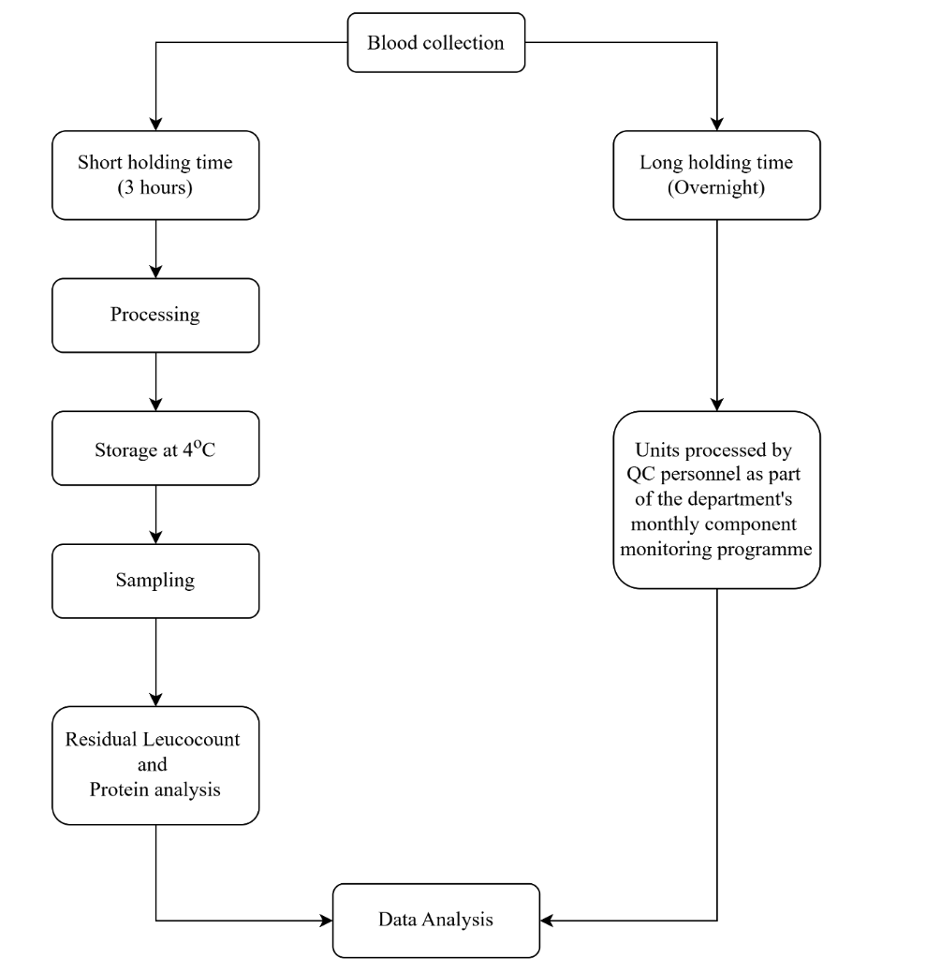
Figure 1: Experimental design

  - Sample preparation and analysis

Plasma bags processed the previous day were weighed and volumes were calculated after correcting for bag weight and plasma density. Units were mixed according to standard procedures, and plasma was aspirated with sterile syringes. Aliquots were transferred to clot-activator vacutainers for protein analysis (which were sent to external laboratory for analysis) and to glass tubes for leucocyte enumeration. Leucocyte counts were obtained using the BD Leucocount™ Kit and FACSCanto™ II flow cytometer. Counts were expressed as absolute leucocyte concentration (×10⁹/L) and tested as per the manufacturer’s instructions.

Data Analysis

Statistical Analysis

Data were organized in Excel and analysed using SPSS (Version 29.0). Descriptive statistics (mean, standard deviation) were calculated for RLC and total PC. Outliers were identified using Z-scores, with values exceeding ±3 considered extreme. Normality of distributions was assessed with the Shapiro–Wilk test. RLC data were non-normally distributed and means were compared between cohorts using the Mann–Whitney U test. Independent-samples t-tests were used only to obtain descriptive statistics (mean and SD). PC data followed a normal distribution. Equality of variances was first assessed with Levene’s test, after which means were compared using the independent-samples t-test. A significance threshold of p < 0.05 was applied throughout.

Statistical Process Control
In addition to statistical analyses, statistical process control (SPC) was applied to assess whether the holding time procedure was stable and within control. SPC monitors variation in a process over time and identifies deviations requiring corrective action, thereby ensuring consistent product quality. Parameters were assigned levels of criticality according to process capability, with classification based on the potential impact on product efficacy and patient safety (Figure 2). The process capability index was then calculated to determine whether the procedure was capable, borderline, or incapable. Process capability was evaluated using the process capability index (Cpk) since RLC and PC are one-sided parameters (only an upper or lower limit). The relationship between Cpk values, parameter criticality, and SPC outcomes is presented in Table 1.

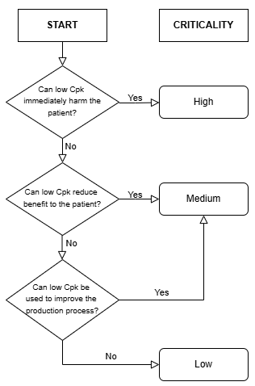
Figure 2: Criticality classification (Adapted from Beckman et al.(7))

Table 1: Determining Cpk Bandings from Criticality and Cpk Measurements (Adopted from Beckman(7))
Specification type | Cpk values
Two sided | >1.47 | 1.30 - 1.46 | 1.10 – 1.29 | 0.86 – 1.09 | 0.54 – 0.85 | 0.39 – 0.53 | <0.39
One sided | >1.40 | 1.23 – 1.39 | 1.03 – 1.22 | 0.77 – 1.02 | 0.43 – 0.76 | 0.21 – 0.42 | <0.21
Parameter criticality | Cpk banding
High | Capable |  | Borderline | Incapable
Medium | Capable |  |  |  | Borderline | Incapable
Low | Capable |  |  |  |  | Borderline | Incapable

- Results
Data were organized by parameter and holding time. Each holding time cohort—SHT and LHT—consisted of 100 FFP units. The parameters assessed were plasma volume, RLC, and PC, resulting in six groups: SHT volume, LHT volume, SHT RLC, LHT RLC, SHT PC, and LHT PC.

Normality of the distributions was evaluated using the Shapiro–Wilk test, which is appropriate for sample sizes under 300, such as those in this study.

Volume
The mean volume between the two holding time cohorts was calculated and compared. As shown in Table 2 the SHT cohort had a lower mean unit volume of 276ml, whilst that of the LHT cohort was 283ml, with a difference of 7ml.
Table 2: Mean volumes and Standard Deviation
Legend: FFP - Fresh frozen plasma, SHT - short holding time, LHT - long holding time.
 | N | Mean FFP unit Volume (mL) | Standard Deviation
SHT | 100 | 276 | 13.706
LHT | 100 | 283 | 13.176

Table 3 displays the normality test results for the volume parameter of the SHT and LHT cohorts. The resulting p-value for the SHT cohort was 0.179. This exceeded the 0.05 level of significance and the null hypothesis, which assumed a normal data distribution, was accepted and therefore determined that the set of volumes for this cohort followed a normal distribution. The resulting p-value for the LHT cohort was 0.043, which was just below the 0.05 criterion, therefore indicating that this cohort had a non-normal distribution of volumes.

Table 3: Test of Normality
Legend: FFP - Fresh frozen plasma; SHT - Short holding time; LHT - Long holding time.
 | Shapiro-Wilk
 | Statistic | df | p-value
SHT | 0.982 | 100 | 0.179
LHT | 0.974 | 100 | 0.043

Residual Leucocyte Counts

As shown in Table 4, the mean RLC of units with a SHT was more than double that of those within the LHT cohort. However, both means were still below the maximum acceptable value of 0.1x10⁹ cells/L according to the EDQM.
Table 4: Descriptive Statistics
Legend: RLC - Residual leucocyte count, SHT - short holding time, LHT - long holding time.
 | N | Mean RLC (x10⁹/L) | Standard Deviation
SHT | 100 | 0.029 | 0.040
LHT | 100 | 0.013 | 0.013

The calculated Z scores were used to produce the histograms shown in Figures 3 and 4, which visually demonstrated that both cohorts had a non-normal distribution of values. In fact, it is evident that both graphs are right-skewed. The same distribution would be observed if the Z score were to be replaced by the RLC of each unit. A threshold of +/- 3 was set to distinguish between statistically normal values, which are within a Z score of +/-3 and outliers which are outside of those limits.

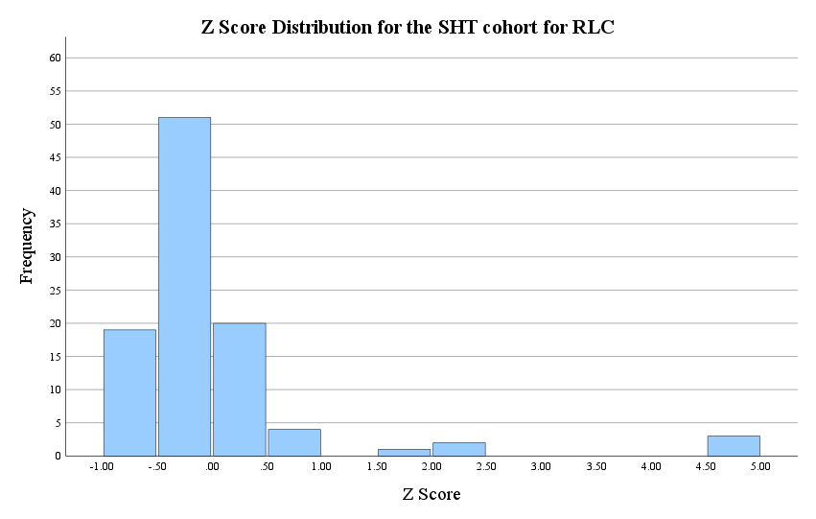
Figure 3: Z-score distribution (SHT)
Legend: RLC - Residual leucocyte count, SHT - short holding time.

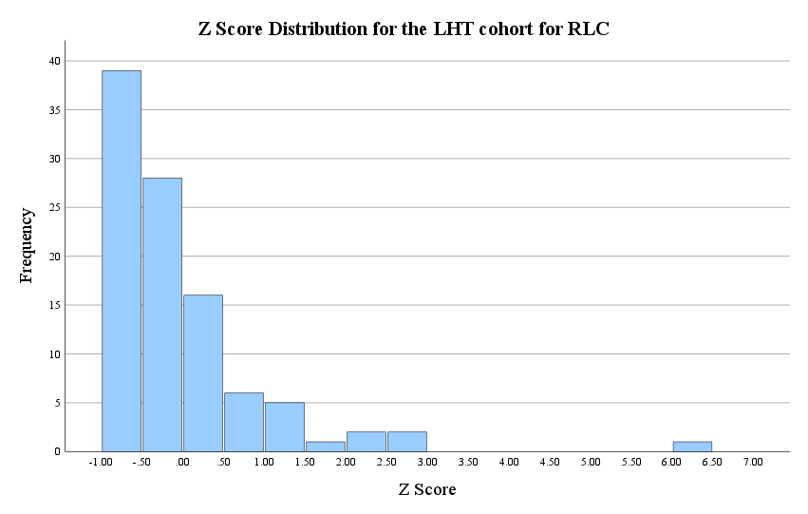
Figure 4: Z-score Distribution (LHT)
Legend: RLC - Residual leucocyte count, LHT - long holding time.
The probability that the Z score exceeded the threshold of -/+3 by chance was calculated using the function NORM.S.DIST in excel and resulted to be 0.0027 (0.00135 x 2), or 2 in 1000. This probability is measured by calculating the area under the graph of the unshaded areas as shown in Figure 5 on both ends of the curve.
The fact that in 100 observations, 3 Z scores exceeded 3 (3%) for units with a SHT indicates that they are outliers. For units with a LHT, only 1 outlier was identified in 100 observations (1%). These outliers can be seen on the far right of the histograms in Figures 3 and 4. All other values were within the Z score values of -3 and 3.

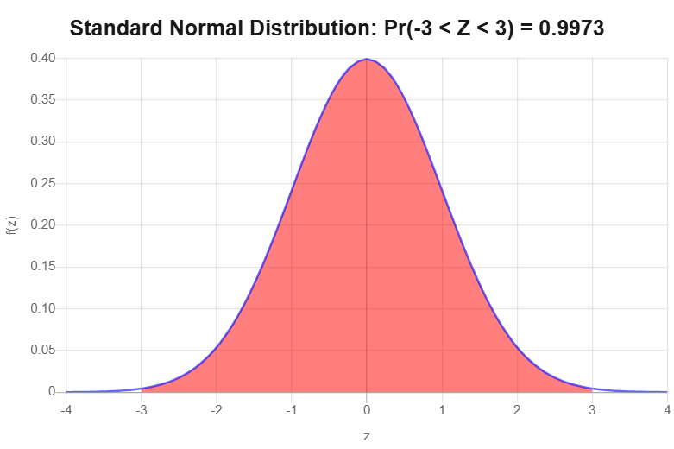
p-value = 0.00135
p-value = 0.00135
Figure 5: Normal Distribution Curve
Normal distribution curve to demonstrate how the probability that values will have a Z-score above or below a certain threshold, in this case +/-3 is calculated. These outliers would be found in the unshaded areas. The total probability would be the p-value multiplied by 2 to add both ends of the curve, thus 0.0027 (0.00135 x 2) in this case.
As can be seen in Table 5, the p-values for both RLC cohorts resulted to be <0.001 with regards to RLC. Since the p-values were less than the 0.05 level of significance, the null hypothesis, which assumed a normal data distribution, was rejected and this confirmed that both cohorts followed a non-normal distribution.

Table 5: Test of Normality
The p-value obtained was <0.001 for both cohorts, therefore smaller than the 0.05 level of significance, showing that both data distributions were non-normal.
Legend: RLC - Residual leucocyte count, SHT - Short holding time, LHT - Long holding time.
 | Shapiro-Wilk
 | Statistic | df | p-value
SHT | 0.535 | 100 | <0.001
LHT | 0.691 | 100 | <0.001

The Mann-Whitney test also showed a p-value of <0.05 when comparing the two cohorts as can be seen in Table 6. Therefore, in this case, the null hypothesis which stated that there is an insignificant difference between the means, was rejected. Hence, there is a significance statistical difference between the means of the two cohorts.

Table 6: Mann-Whitney Test
The p-value of <0.001 determined that there was a significant difference between the means of the two holding time cohorts with regards to RLC.
Legend: RLC - Residual leucocyte count
U-value | 3058
p-value | <0.001

The error bar graph in Figure 6 displays the 95% confidence interval for the actual mean RLC for short and long holding times respectively. The fact that the two confidence intervals, represented by the whiskers in the figure, do not overlap, indicates that the mean RLC for units with a SHT is significantly larger than the corresponding mean RLC for the LHT cohort. The lower limit for the SHT cohort is larger than the higher limit of the LHT cohort as shown by the whiskers on the graph. It can also be noted that the SHT bar is much higher, showing that there was a wider range of values, whereas the LHT cohort had more consistent values within a smaller range.

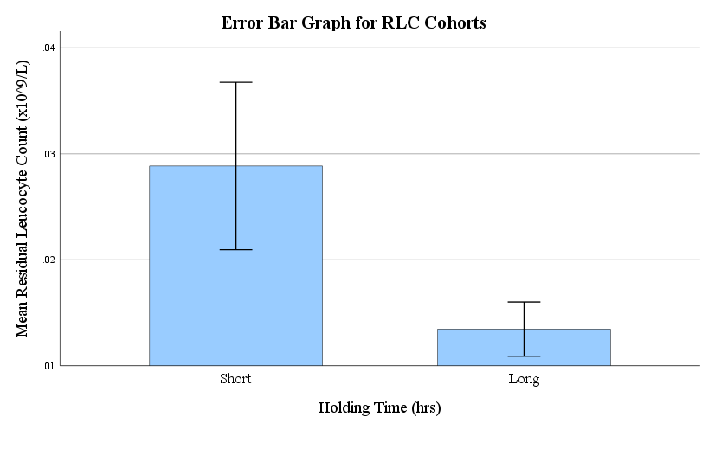
Figure 6: Error bar graph of RLC cohorts
This graph allows comparison of the means of two cohorts and visualises the range of values.
Legend: RLC - Residual leucocyte count

Protein Concentrations
From the results displayed in Table 7, it can be noted that the mean PC of the two cohorts differed by 2.03g/L, with the LHT cohort having a higher concentration of 62.55g/L and that of the SHT cohort being 60.52g/L.
Table 7: Descriptive Statistics
Legend: PC - protein concentration, SHT - short holding time, LHT - long holding time.
 | N | Mean PC(g/L) | Standard Deviation
SHT | 100 | 60.52 | 3.57
LHT | 100 | 62.55 | 2.76

As demonstrated by the histogram in Figure 7, the Z score values showed a normal data distribution for the SHT cohort. Figure 8 shows a less normal distribution for the LHT cohort. For both cohorts, all values were within a Z score of +/‐3. The same histogram would be obtained if the Z score was to be replaced by the PC of each FFP unit.
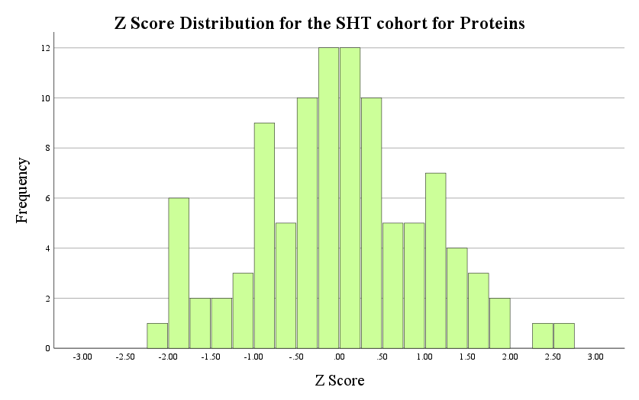
Figure 7: Distribution of Z-scores
Legend: SHT - short holding time.

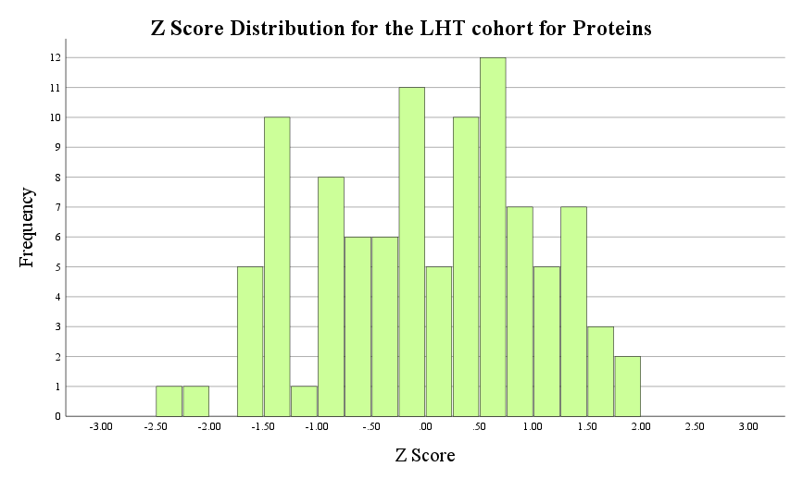
Figure 8: Distribution of Z-scores
Legend: LHT - long holding time.

Shapiro-Wilk Test for Proteins
With regards to PC, when testing normality, the p-value for the SHT cohort resulted to be 0.744. On the other hand, the p-value for the LHT cohort resulted to be 0.051 as can be seen in Table 8. Both p-values exceeded the 0.05 level of significance, and therefore the null hypothesis which stated that the data distribution is normal was accepted for both cohorts. However, it was noted that the LHT cohort had a borderline normality since the p-value just passed the 0.05 level of significance by 0.001.
Table 8: Test of Normality
Legend: SHT - Short holding time, LHT - Long holding time
 | Shapiro-Wilk
 | Statistic | df | p-value
SHT | 0.991 | 100 | 0.744
LHT | 0.975 | 100 | 0.051

The p-value of the Levene’s test for equality of variances was 0.071 (Table 9). This value is greater than the 0.05 level of significance. Therefore, the null hypothesis which stated that there is no statistical difference between the two standard deviations was accepted, indicating that the standard deviations of the two cohorts are similar.
Table 9: Levene’s test

F-value | 3.287
p-value | 0.071

The p-value for the independent samples T-test resulted to be less than 0.05 (<0.001), as shown in Table 10, thus the null hypothesis which stated that there is no statistical difference between the means of the two independent groups was rejected. Therefore, indicating that there is a statistical difference between the means of the two cohorts with regards to PC.
Table 10: Independent Samples T-test

T-value | 4.479
p-value | <0.001

Figure 9 displays the 95% confidence interval for the actual mean PC for short and long holding times respectively. The two confidence intervals do not overlap, indicating that the mean PC for units with a LHT is significantly larger than the corresponding mean PC for the SHT cohort. The lower limit for the LHT is larger than the higher limit of the SHT as can be seen by the whiskers on the graph. The two bars can be seen to be of similar height, showing that there was a similar range of values.

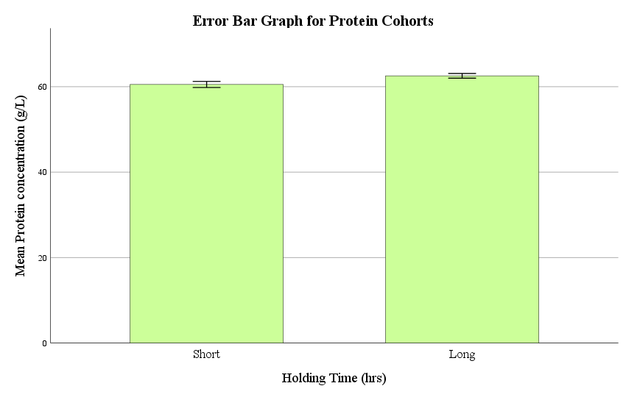
Figure 9: Error bar graph of protein cohort means

- Statistical Process Control
According to statistical process control classification, leucocytes are classified as a critical parameter since high levels put the patient in immediate harm due to the development of unwanted transfusion reactions. On the other hand, since plasma is not transfused for its total protein properties, a lower dose of protein would not put the patient at risk, thus this parameter is classified as having a low criticality level. The plasma volume is also considered to be of low criticality, as the indications for plasma transfusion are very limited and the plasma product is mostly used in conjunction with other blood components during massive blood loss or as a replacement fluid in plasma exchange therapies. Using the parameter criticality and calculated Cpk values, the capability outcome could be determined. These results have been compiled in Table 11.

Table 11: SPC Capabilities
The calculated Cpk value of each cohort for unit volume, RLC and protein concentration is represented in this table, together with the determined capability outcome, based on the Cpk value and criticality.
Legend: Cpk – Capability index k/process capability index, RLC – Residual leucocyte count, OOS – out of specifications.
 | Parameter | Criticality | Mean | SD | Cpk | Capability outcome
Short Holding Time | Volume | Low | 276.17 | 13.71 | 0.68 | Capable
Short Holding Time | Leucocytes | High | 0.03 | 0.04 | 0.50 | Incapable
Short Holding Time | Leucocytes (no OOS) | High | 0.02 | 0.02 | 1.17 | Borderline
Short Holding Time | Proteins | Low | 60.52 | 3.57 | 0.98 | Capable
Long Holding Time | Volume | Low | 282.72 | 13.18 | 0.71 | Capable
Long Holding Time | Leucocytes | High | 0.01 | 0.01 | 9.55 | Capable
Long Holding Time | Proteins | Low | 62.55 | 2.76 | 1.52 | Capable

Also shown in Table 11, when considering the volumes of FFP units, the capability outcome was capable for both cohorts. This is also true for PC. On the other hand, the capability outcome for the RLC of units with a SHT, was incapable. The process however was capable for units with an LHT.
Out of specification (OOS) values were removed from the SHT cohort for RLC to assess the influence of outliers. When this was done, the process capability changed from incapable to borderline.

- Discussion
FFP is a vital transfusion product which is indicated in cases of complex coagulopathies, severe bleeding, Vitamin K deficiency, and burns amongst others. As with other blood products, FFP is required to be of optimal quality for transfusion to ensure that the product has a therapeutic effect, and any unwanted adverse transfusion reactions are avoided for the safety of the patient. According to the EDQM non-filtered FFP must have a RLC of <0.1x10⁹ cells/L and a total PC of ≥50g/L(1). These parameters are subject to variations due to various factors such as temperature, storage conditions, blood separation techniques and holding time which varies between units and is currently limited to 3 to 20 hours(1,8). This period between the collection of a blood donation and its separation is necessary for phagocytosis of any microorganisms by the bactericidal action of leucocytes, and leucocyte degradation and inactivation.
Thus, the aim of this study was to investigate whether there is a statistical correlation between holding time and RLC, as well as holding time and PC on which no relative data is available in relation to holding time. In addition, the study also aimed to determine if good procedural control is maintained by monitoring of SPC. The determination of a correlation between holding time and the RLC and PC parameters would enable further standardisation of whole blood processing. The objectives to establish this, were to measure and compare RLCs and PCs in a cohort of 100 units with a SHT and a cohort of another 100 units with a LHT. The LHT cohort refers to units collected, left overnight and processed the following day. SHT are units collected and processed on the same day with a standing time of approximately 3 – 4 hours. The FFP unit volume, RLC, and PC were measured for each unit of the two cohorts.
The volumes of FFP units varied between 251mL and 306mL, with the mean of the LHT cohort being higher by 7mL than that of the SHT cohort. The volume of a unit may be influenced by various factors including the automated separator used to derive the plasma component and centrifugation speed when separating the whole blood components(1). Unfortunately, no literature which relates SHT and LHT in terms of volumes was discovered.
FFP unit volumes differed by 7ml between the two cohorts, with that of the LHT cohort being higher. A higher number of FFP units with elevated RLCs were identified in the SHT cohort, which also had a wider variation of values. From this cohort of 100 units, 3 were identified as statistical outliers, and overall, a total of 5 units exceeded the minimum acceptable RLC of <0.1x10⁹ cells/L, making the difference between cohorts due to a SHT more significant. All units from the LHT cohort had acceptable RLCs, although a single unit was identified as an outlier statistically. The mean RLC of the SHT cohort was more than double that of the LHT cohort. PCs were all found to be adequate in both cohorts, however there was a statistical difference between the mean PCs of the two cohorts.
Using a standard normal distribution curve, the probability of a unit having a Z-score exceeding ±3 is 0.27% (2 in 1000). Applied to a sample of 1000 units, this predicts approximately 2 outliers. In the SHT cohort of 100 units, 3 outliers (3%) were observed—substantially higher than expected. By contrast, the long holding time LHT cohort also of 100 units had only 1 outlier (1%), which, while slightly above the expected rate, was three times fewer than in the SHT cohort. These findings indicate that shorter holding times may be associated with increased variability and a higher likelihood of units exceeding acceptable leucocyte limits.
The data collected showed that when comparing mean RLCs the two cohorts were found to be statistically different using the Mann Whitney test (p = <0.001), with the mean of the SHT cohort being larger (0.029x10⁹ cells/L) than that of the LHT cohort (0.013x10⁹ cells/L) by more than twice as much. The presence of OOS values most likely had some influence on the mean value since the data set was right-skewed, but the fact that more units with an elevated RLC were identified in the SHT cohort showed that the holding time did in fact have an influence on this parameter and this was consistent with the findings of the local establishment.
Various factors influencing transfusion products have been studied in the past few decades, however, there has been very little if any research specifically on the influence that holding time has on the RLC in plasma (5,8–14) There was a similar study carried out by van der Meer et al. (13) where this correlation between RLC and holding time was tested in whole blood and leucodepleted red cell concentrates. RLCs were measured at different holding times and were found to increase with a longer holding time prior to whole blood processing(13,14), whereas the findings in the current study showed that the mean RLCs decreased with time, most likely due to leucocyte degradation. However, it must be considered that in the study by van der Meer et al. (13) this parameter was tested in other blood products and not FFP. Additionally, the blood products were leucodepleted prior to testing, unlike the current study which used non-filtered FFP.
With regards to PCs, although no outliers were identified and all PCs were above the minimum limit set by the EDQM (that is ≥50g/L), the means of the two cohorts were also deemed to have a statistical difference according to the p-value obtained from the independent samples T-test (p = <0.001). Since the LHT cohort had a larger mean value (62.55g/L) than that of the SHT (60.52g/L) this would indicate that a longer holding time resulted in a slightly higher mean PC.
Unlike RLCs, proteins in plasma products have been more extensively studied, however such studies did not test total PCs, but rather specific proteins, mainly coagulation factors(10,12). Lu et al. (9) tested and compared a number of parameters in units with a holding time of up to 8 hours and others with an overnight holding time (24 hours) in the three main blood products (red blood cells, pooled platelet concentrates and plasma). Minor variations were found in the levels of coagulation factors tested (FII, FVII, FV, FIX, FX, and FXI; fibrinogen; and von Willebrand factor) in frozen plasma, except for FVIII which lost around 20% of its activity with an overnight hold at room temperature. Thus, apart from FVIII, other proteins were still at acceptable concentrations even after a 24-hour holding time(9). This finding correlates with the current study since the total PC was at acceptable values in units with a SHT and was still at acceptable values in units with a LHT (up to 20 hours). Although contrary to current literature evidence, the mean PC in the current study was higher for units with a LHT.
Several studies (4,5,10,11) have investigated the changes in coagulation factor levels with changes in holding time. Like the previous study mentioned, most proteins and coagulation factors were found to be at acceptable levels even after a holding time of 24 hours, but like many research studies they highlight a decrease in the levels of FVIII. This decline in FVIII is now well known and may not always have clinical relevance(14). In fact, FVIII is considered as a great indication of product quality by the EDQM since its level is known to decrease with time. Cardigan et al. (4) also tested the activated partial thromboplastin time, fibrinogen, FVIII, protein C, protein S and prothrombin and unlike other coagulation factors that were tested, the results showed that these were slightly but significantly reduced when comparing an 8-hour to a 24-hour holding time. Thus, most proteins degrade with time, some being more sensitive than others. In the current study the mean total PC, however, was found to be higher with a longer holding time.
The SPC results showed that processes for volume and PCs were within control for both the cohorts. The process for RLCs of the cohort on the other hand was incapable. When recalculated with OOS excluded, the results further showed the influence of the OOS values. The capability outcome of RLCs in the SHT cohort was improved from incapable to borderline. Thus, it can be concluded that even without OOS values, the RLCs of the units in the SHT cohort may not always be within process control in future measurements as the capability outcome was still borderline. The fact that the process for RLCs did not become capable was most likely due to the wide range of values of this cohort. SPC results for RLC consolidate the need for monitoring of FFP units having a SHT. The LHT cohort immediately showed a capable outcome for all parameters, confirming that the values were consistently within process control.

- Limitations
Although informative, this study had its limitations. Undoubtedly the larger the sample size, the more accurate and reliable results are in any study. Having a small sample size of 100 unit per cohort limits the accuracy of the conclusion made by this study. Nonetheless, it still provides essential data and sets a good foundation for more extensive research if required.
Another limitation of this study was related to the FFP units tested in the two cohorts. Although ideal, it would not be feasible for the same units to be used for both SHT and LHT. Hence the units of the SHT cohort were derived from whole blood units that were different from the 100 units of the LHT cohort. Using the same units for both cohorts would allow the observation of how the RLC and PC change with time in the same unit, however the holding time is defined as the time between whole blood collection and its separation into the main blood components. Thus, units with a SHT would have already been processed and therefore cannot be put back together and tested after an LHT. In addition, the FFP product is not very stable and testing the unit twice would require keeping the product at higher temperatures for longer than recommended since it is ideally frozen as soon as possible to maintain the levels of coagulation factors, particularly FXIII. Hence, this would likely result in lower PCs as certain labile proteins start to degrade after a few hours(1,15).
The limited literature available on the influence of holding time on the parameters involved in this study made it challenging to compare the findings obtained. Although, these hinted towards being consistent with the findings of the local establishment. In addition, studies found in the available literature opted to investigate coagulation factors and not total PC, making it difficult to determine how the total PC results relate to these studies.

- Further work
There are endless possible studies to perform on non-filtered FFP and how holding time and other factors impact the different components of this blood product.
Firstly, involving a larger number of FFP units would improve the accuracy and credibility of the results gathered and the conclusions or assumptions made. This is crucial when trying to have continuous improvement of protocols and ensure that the changes made based on collected data will indeed result in the desired outcome.
The holding time in hours of each unit can be estimated in addition to dividing the units into two cohorts with short and long holding time. This would make parameter changes with increasing holding time more evident by plotting graphs. This can be estimated by recording the number of hours between the time of whole blood donation and the time when the final FFP product was obtained.
Measuring individual proteins, especially coagulation factors at different holding times in addition to PC can be used to evaluate how the level of each protein is affected.

- Conclusion
The results collected from this study suggest that prior to whole blood processing, holding time impacts the RLC and PC in non-filtered FFP units, hence the aim of this study was reached since a relationship was identified. With an increased holding time of whole blood, RLCs in FFP were found to decrease, whilst PCs increased. As identified by the local establishment, units with an elevated RLC were also observed in the SHT cohort of this study. Thus, it may be recommended that the current minimum holding time of 3 hours, should be increased to reduce the risks of having units which do not meet quality requirements and having to discard them. However, a qualification procedure should be established to determine the optimal range of holding time duration required to obtain FFP units with low RLC levels and adequate PCs.
To maintain low RLCs regardless of holding time, incorporating a leucoreduction step after processing of FFP could also be considered, but as for increasing the holding time, a rigorous and robust qualification plan would need to be employed including assessing any related risks and subsequent mitigation measures.
Apart from ensuring that blood product requirements are met, and recipients are safeguarded from undesired and avoidable transfusion reactions, a LHT has other benefits. Extending the minimum holding time would enable better operational flexibility due to the working hours of the blood establishment (Thomas 2010), and better management of workflow since whole blood would not need to be processed within a few hours, but can be left for longer, thus time can be spent on other high priority tasks.

Consent
It is not applicable.

Ethical Approval
University of Malta Faculty of Research Ethics Committee (FREC) approval number FHS- 2024-00108.

References
1. European Directorate for the Quality of Medicines & HealthCare (EDQM) [cited 2025 Aug 13]. Guide to the preparation, use and quality assurance of blood components - European Directorate for the Quality of Medicines & HealthCare - EDQM. Available from: https://www.edqm.eu/en/blood-guide
2. Yousif D, Sammut M, Zammit V. Holding Time Optimisation in Fresh Frozen Plasma: A Critical Factor Worth Investigating. International Blood Research & Reviews. 2025 Sep 6;16(4):1–10.
3. Serrano K, Scammell K, Weiss S, Culibrk B, Levin E, Gyöngyössy-Issa M, et al. Plasma and cryoprecipitate manufactured from whole blood held overnight at room temperature meet quality standards. Transfusion. 2010 Feb;50(2):344–53.
4. Cardigan R, Van der Meer PF, Pergande C, Cookson P, Baumann-Baretti B, Cancelas JA, et al. Coagulation factor content of plasma produced from whole blood stored for 24 hours at ambient temperature: results from an international multicenter BEST Collaborative study. Transfusion. 2011 Jan;51 Suppl 1:50S-57S.
5. Moroff G, AuBuchon JP, Pickard C, Whitley PH, Heaton WA, Holme S. Evaluation of the properties of components prepared and stored after holding of whole blood units for 8 and 24 hours at ambient temperature. Transfusion. 2011 Jan;51 Suppl 1:7S-14S.
6. Thibault L, Beauséjour A, de Grandmont MJ, Lemieux R, Leblanc JF. Characterization of blood components prepared from whole-blood donations after a 24-hour hold with the platelet-rich plasma method. Transfusion. 2006 Aug;46(8):1292–9.
7. Beckman N, Nightingale MJ, Pamphilon D. Practical guidelines for applying statistical process control to blood component production. Transfus Med. 2009 Dec;19(6):329–39.
8. van der Meer PF, de Korte D. The effect of holding times of whole blood and its components during processing on in vitro and in vivo quality. Transfus Med Rev. 2015 Jan;29(1):24–34.
9. Lu FQ, Kang W, Peng Y, Wang WM. Characterization of blood components separated from donated whole blood after an overnight holding at room temperature with the buffy coat method. Transfusion. 2011 Oct;51(10):2199–207.
10. Alhumaidan H, Cheves T, Holme S, Sweeney J. Stability of coagulation factors in plasma prepared after a 24-hour room temperature hold. Transfusion. 2010 Sep;50(9):1934–42.
11. Dogra M, Sidhu M, Vasudev R, Dogra A. Comparative analysis of activity of coagulation Factors V and VIII and level of fibrinogen in fresh frozen plasma and frozen plasma. Asian J Transfus Sci. 2015;9(1):6–8.
12. Kretzschmar E, Kruse F, Greiss O, Paunovic D, Kallweit T, Trobisch H. Effects of extended storage of whole blood before leucocyte depletion on coagulation factors in plasma. Vox Sang. 2004 Oct;87(3):156–64.
13. van der Meer PF, de Wildt-Eggen J. The effect of whole-blood storage time on the number of white cells and platelets in whole blood and in white cell-reduced red cells. Transfusion. 2006 Apr;46(4):589–94.
14. Thomas S. Ambient overnight hold of whole blood prior to the manufacture of blood components. Transfus Med. 2010 Dec;20(6):361–8.
15. Gaudard M, Boissier E, Talon L, Douxfils J, Sapin AF, Sinegre T, et al. Stability of coagulation parameters in plasma samples at room temperature after one freeze/thaw cycle. Int J Lab Hematol. 2022 Jun;44(3):610–8.

