Case Report

Endodontic approach to a mandibular second molar with extensive pulp calcification and periapical abscess

.
ABSTRACT

Introduction: Endodontic treatment is a means of restoring dental function and preventing tooth loss. Several factors lead to the need for endodontic treatment, including periapical lesions, pulp calcifications, and acute apical abscess (a dental condition involving an inflammatory and infectious process).
Presentation of Case: A patient was referred for endodontic treatment of tooth 37, presenting with extensive calcification in the pulp chamber and mesial canal, as observed on radiographs, in addition to an acute periapical abscess. The examination also revealed bone rarefaction with well-defined boundaries around two roots, which fuse from the middle to the apical third, causing external resorption in both and affecting both canals. In the first intervention, the distal canal was located, which drained substantially. In the second intervention, medication was administered and an attempt was made to locate the mesial canal, and a new CT scan was requested for this purpose. In the third intervention, the mesial canal was located with the aid of an operating microscope and ultrasound. The treatment was completed without complications, and the canals were sealed with cotton and Intermediate Restorative Material (IRM). After two years of follow-up, the patient was asymptomatic and functional, rehabilitated with a fiberglass post and prosthetic crown, and bone repair of the periapical lesion.
Conclusion: Knowledge and technology together can make a difference in more complex cases, stopping pain and preventing premature tooth loss in patients, while also ensuring longevity for dental structures.

Keywords: Tooth Calcification; Dental Pulp Calcification; Periapical Abscess; Endodontics.

1. INTRODUCTION

The success of endodontic therapy depends on several correct/careful actions throughout the process, such as the correct coronal opening; some errors made at this stage can lead to failure or even make the treatment without the possibility of a good prognosis (Siqueira Jr & Rôças, 2009), access to the canals themselves, canal enlargement, cleaning and shaping of the canals and their obturation, providing the most hermetic seal possible. (Siqueira Jr & Rôças, 2009).
Canal mineralization is a common complication in endodontic treatment, characterized by radiographic loss of the pulp space and yellowish coloration in the coronal portion of the tooth (McCabe & Dummer, 2012), it occurs when the pulp is damaged, leading to the formation of mineralized tissue in the canals (Oginni et al., 2009). This condition may be associated with factors such as caries, dental restorations, gum problems, physiological aging, injuries, trauma, and orthodontic movements. The formation of these calcifications still generates debate about its processes (Berès et al., 2016). The precise process of canal obstruction through calcification is presumed to be related to problems in the neurovascular supply of the pulp after an injury, as stated by Robertson (1996); and McCabe and Dummer (2012), who in their studies, found that more than 25% of traumatized anterior teeth developed pulp obliteration.
Calcification can be identified through periapical radiographs and computed tomography scans. And in other cases, it may be related to pulp necrosis and the presence of periapical lesions, making treatment more complex. Periapical lesions have a multifactorial etiology, being influenced by factors such as bacterial infections resulting from untreated caries, periodontitis, or dental trauma; whether from sports injuries, falls, bruxism, or even chemical irritation due to improper procedures.
Dental trauma can accelerate the formation and deposition of mineralized tissue in the root canal, potentially leading to complete closure of the canal lumen in radiographic images. According to Andreasen (1987) and Marcano-Caldera (2018), pulp obliteration is caused by dentin deposition due to failures in the neurological regulation of odontoblast secretory activity during the pulp repair process after trauma. The parasympathetic system in the pulp follows the trigeminal nerve and inhibits the stimulating activity of the sympathetic system in the secretory function of odontoblasts. With trauma and damage to the parasympathetic system, there is an overproduction of dentin by the sympathetic system, leading to partial or total obliteration of the pulp cavity, a process that depends on the vitality of the pulp to occur (Ferreira et al., 2012; Wang, Wang & Qin, 2019). There are several treatment options to consider, depending on the signs and symptoms presented by the patient (McCabe & Dummer, 2012). When there are no signs of periodontal involvement, endodontic treatment is not indicated (Lara-Mendes et al., 2018). In cases of pulp necrosis, endodontic treatment should be performed. However, root canal obliteration presents clinical challenges, which can result in coronal and/or radicular perforations that negatively affect the prognosis of the treatment, making it a highly complex therapy (Estrela et al., 2018; Lara-Mendes et al., 2018). Pettiette et al. (2013) suggests the use of microscopes and other forms of magnification, as well as burs and chelating agents, provided they are used with caution.
With the increasing adoption of Cone Beam Computed Tomography (CBCT), intraoral scanning, and virtual planning, new guided techniques have been used for clinical cases of pulp calcification (Buchgreitz et al., 2019). Studies conducted on endodontic treatment guided by CBCT show promising results, suggesting that CBCT is more accurate compared to 2D radiographs and is an essential tool in the planning and execution of endodontic treatment, according to Lara-Mendes et al. (2018) and Connert et al. (2018).
Successful endodontic treatments include adequate cleaning and obturation of the root canals; they are essential to avoid recurrences. In this context, ultrasound and its controlled wear allow the removal of pulp deposits, the improvement of coronal access, and the activation of irrigation; Just as the surgical microscope and its magnification of the operating area and illumination of the work field for visualization of canals and possible obstructions have increased the predictability of these procedures, guaranteeing excellent clinical results (Kim S, Baek S., 2004). The use of these elements has facilitated the removal of mineralized dentin from the pulp chamber; in addition to the use of 3D printed guides, known as Endoguides, which have improved location and access, reducing errors (Nabavi & Latifian, 2025).
Given the above, this study aims to present a clinical case of a complication, in order to highlight the use of ultrasound mechanisms associated with tomographic examinations for its resolution. It also aims to contribute to the scientific community's understanding of anatomical alterations and their complications in general, associating the use of technologies for the resolution of complex cases.

2. CASE REPORT

A 40-year-old male patient presented to the emergency department of the Dental Clinic at the University of Fortaleza complaining of spontaneous, throbbing pain in tooth 37 for three days. The patient also reported that he had sought treatment at another emergency department the previous day, where an attempt to access the root canals was made. However, the root canals could not be located, and the pain persisted. Intraoral clinical examination revealed extensive temporary restorations and edema in the sulcus. Percussion and palpation tests were positive, and periodontal probing showed results consistent with periodontal health. The cold vitality test was negative. Initial periapical radiographic examination revealed periapical bone rarefaction in the affected tooth (Figure 1). Partial calcification of the root canals and wear of the pulp chamber floor were also observed in an attempt to locate the canal orifices. Based on the combination of clinical and radiographic findings, the diagnosis for this case was pulp necrosis and acute periapical abscess.
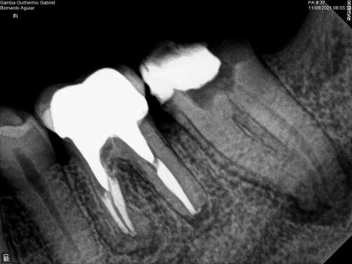
Figure 1. Canal calcification and periapical lesion of tooth 37
Souce: Author’s own.

The proposed treatment plan was a new intervention to locate the canals for debridement, cleaning, and decompression. In a subsequent appointment, the endodontic treatment would continue with the creation of space for a post and rehabilitation with a fiberglass post and prosthetic crown. The patient agreed to the treatment and signed a free and informed consent form (appendix I). The patient was informed of the need for subsequent rehabilitation with a prosthetic crown after the completion of the treatment, to ensure greater clinical longevity of the endodontic procedure.
With the patient's agreement, the routine of preoperative care was initiated, with a mouthwash of 0.12% chlorhexidine digluconate for one minute. Then, anesthesia was performed using the inferior alveolar nerve block technique, with papillary supplementation via the lingual and vestibular sides. Articaine hydrochloride 4% with epinephrine in a 1:100,000 ratio (Nova DFL, Rio de Janeiro, RJ, Brazil) was used as an anesthetic. After anesthesia, all temporary restorative material was removed with a high-speed spherical diamond bur. Subsequently, the surgical field was isolated with a rubber dam (Madeitex; São José dos Campos, SP, Brazil), an Ostby arch (Angelus; Santa Izabel, Londrina, PR, Brazil), and a number 201 isolation clamp (KSK; Nova DFL, Rio de Janeiro, RJ, Brazil).
Due to the difficulty in locating the canals during access, a surgical operating microscope (Alliance; São Carlos, SP, Brazil) was used, which allowed for better illumination and magnification of the surgical field. Using a microscope at 10x magnification and an E6D ultrasound tip (Helse; Santa Rosa de Viterbo, SP, Brazil) coupled to a Satelec Booster ultrasound device (Acteon; Indaiatuba, SP, Brazil), attempts were made to locate the canal orifices. Despite the magnification and controlled, precise wear of the ultrasound, it was only possible to find the distal canal, which immediately began to drain spontaneously and throbbing (Figure 2).

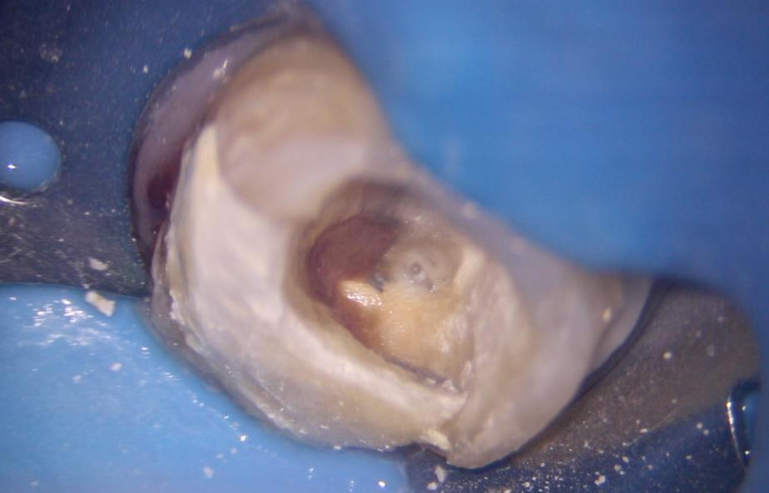
Drenagem canal distal
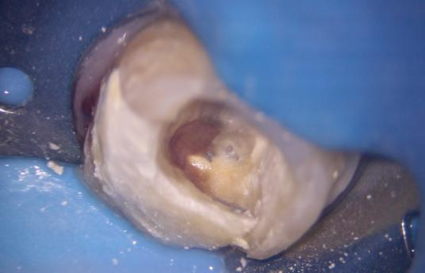

Figure 2. Distal canal draining
Source: Author’s own

The canal was neutralized with irrigation using 2.5% sodium hypochlorite and explored using a special #10 file (Dentsply Sirona). A glide path was created and foraminal patency of the canal was obtained with #15.03 and #25.01 Logic files (Easy Equipamentos; Belo Horizonte, MG, Brazil). After 40 minutes of intense irrigation, the canal stopped draining. During this period, attempts were made to locate the mesial canal using an E2D ultrasonic insert (Helse; Santa Rosa de Viterbo, SP, Brazil), without success. Therefore, the patient was asked to undergo a high-resolution cone-beam computed tomography (CBCT) scan using a Veraview X800 (J. Morita MFG. Corp; Kyoto, Japan) for research and planning to locate the mesial canal. To conclude the emergency session, intracanal medication was inserted - Ultracal XS (Ultradent; Indaiatuba, SP, Brazil) - and sealed with a temporary IRM restorative (Dentsply Sirona) (Figure 3). Systemic medication prescribed was Amoxicillin 500mg every 8 hours for 7 days; Ibuprofen 600mg every 8 hours for up to 3 days; and Dipyrone 1g every 8 hours in case of pain.

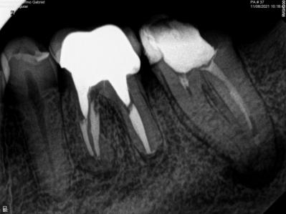
Figure 3. Radiograph with intracanal medication of Ultracal.
Source: Author’s own.

After the CBCT scan was performed, the second consultation session began. With the DICOM file obtained, it was possible to locate the lumen of the mesial canal at 15.49 mm, using the crest of the mesial cusp as a reference point (Figure 4).

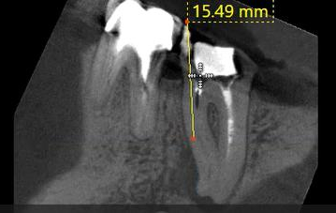
Figure 4. Tomographic image indicating the location of the mesial canal at 15.49 mm.
Source: Author’s own.

In the first intervention, a depth of 11.11 mm was achieved (Figure 5 - A), leaving 4.38 mm to be worn down until reaching the canal lumen (Figure 5 - B).
B
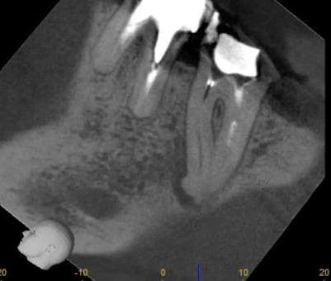
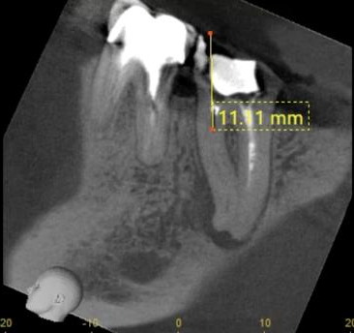
A
Figure 5 - A. Tomographic image indicating the depth of 11.11 mm reached in the 1st intervention. Figure 5 - B. Tomographic image indicating the remaining depth of 4.38 mm to reach the canal lumen.
Source: Author’s own

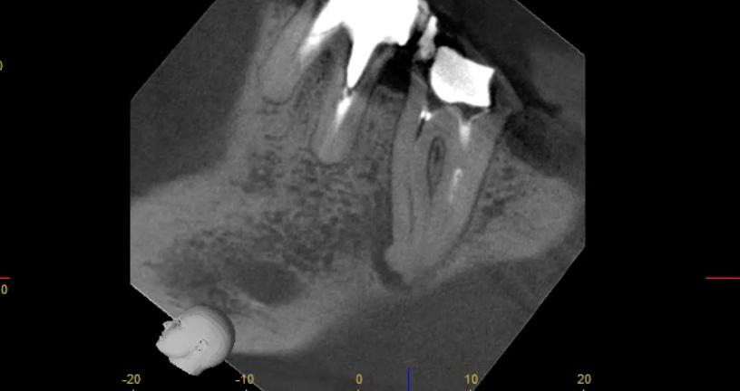
4,28mm
4,28mm
4,28mm

During the anatomical study, the presence of only one canal in the mesial root was observed, and it was found to have apical resorption (Figure 6).
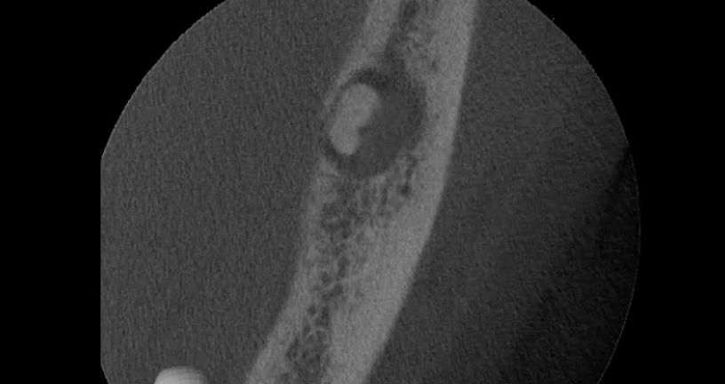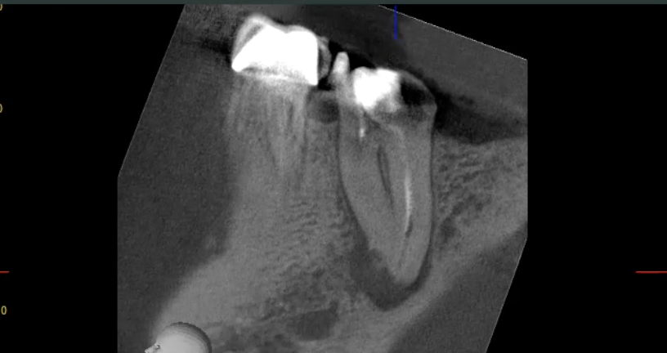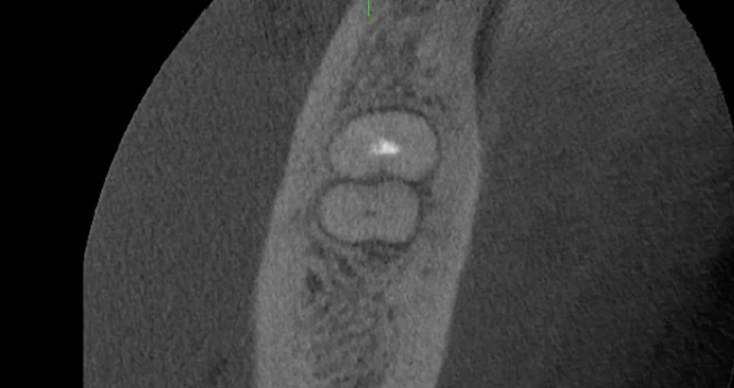
resorption

resorption
mesial canal

Figure 6. Tomographic image indicating a mesial canal and the presence of apical resorption.
Source: Author’s own.

With this information, the E5 ultrasonic insert (Helse; Santa Rosa de Viterbo, SP) was selected for controlled dentin wear. To verify how much depth the insert needed to wear down, a mark was made on its surface 15.49 mm from its tip with a ballpoint pen (Figure 7).

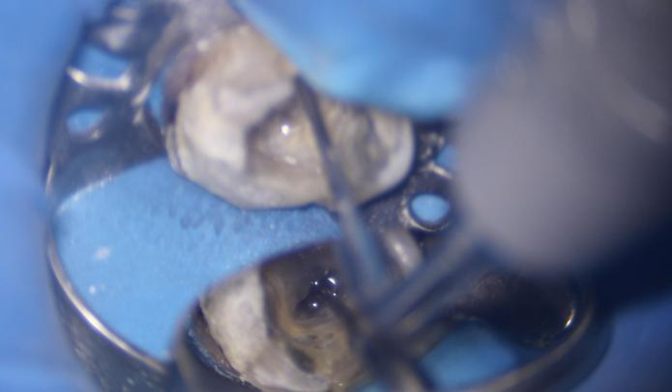

E5 insert marking

Figure 7. Image of the E5 ultrasonic insert marking at 15.49 mm.
Source: Author’s own.

Marcação no inserto E5
This procedure lasted approximately 30 minutes until the marking was achieved. Subsequently, using a special #10 file (Dentsply Sirona), exploration and odontometry were performed with the aid of a Root ZX II apex locator (J. Morita MFG. Corp; Kyoto, Kyoto, Japan). A confirmatory radiograph was then taken (Figure 8).

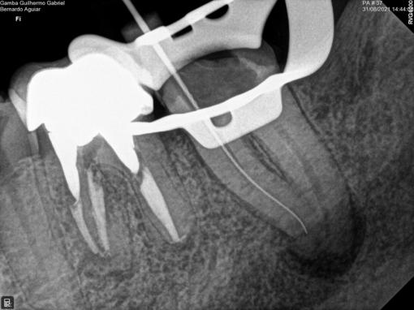
Figure 8. Odontometry radiograph indicating the location of the canal.
Source: Author’s own.
Marcação no inserto E5

After confirming the location of the canal, irrigation was performed with 2.5% sodium hypochlorite and the glide path was created using #15.03 and #25.01 Logic files (Easy Equipamentos; Belo Horizonte, MG, Brazil). The shaping of both the mesial and distal canals was performed with a #30.10 Prodesign S file (Easy Equipamentos; Belo Horizonte, MG) in the cervical third and a #25.05 Logic file (Easy Equipamentos; Belo Horizonte, MG) in the canal body. A #40.03 Logic file (Easy Equipamentos; Belo Horizonte, MG, Brazil) was also used in the distal canal. All instrumentation was performed with patency 1 mm beyond the foramen.
To maximize root canal decontamination, the irrigating solution was agitated using the PUI (Passive Ultrasonic Irrigation) technique with the E1 Irrisonic ultrasonic insert (Helse; Santa Rosa de Viterbo, SP, Brazil). Agitation followed a protocol of 3 cycles of 20 seconds each, with solution replacement between each cycle. The technique was performed with 17% EDTA (Ethylenediaminetetraacetic acid (Biodinâmica, Ibiporã, PR, Brazil)) followed by three more cycles with 2.5% sodium hypochlorite. Finally, 10 mL of sterile distilled water was added to each canal. Subsequently, a cone test was performed using gutta-percha Medium cones (Dentsply Sirona). Obturation was performed using the single cone technique with AH Plus cement (Dentsply Sirona). Space was created for the placement of an intraradicular retainer in the distal canal (Figure 9), using the Fip thermoplasticizer (Wak’s; Campo Belo, São Paulo, SP, Brazil). Approximately 5 mm of obturation was left to ensure adequate apical seal. Coronal sealing was performed with cotton at the canal orifices and IRM temporary restorative material (Dentsply Sirona). The patient was given instructions and referred for placement of a fiberglass post and prosthetic crown.
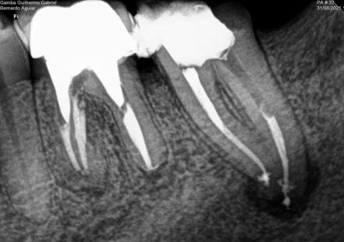
Figure 9. Obturation radiograph.
Source: Author’s own.

Eight months after the completion of endodontic treatment, a follow-up appointment was scheduled. The patient presented with no signs or symptoms, and tooth 37 had been prosthetically restored. Masticatory function and gingival tissue were in perfect health. The periapical radiograph showed evidence of bone repair of the periapical lesion (Figure 10).

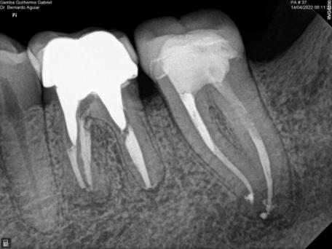
Figure 10. Radiographic confirmation of apical bone repair.
Source: Author’s own.

For a better assessment of bone neoformation, the patient was asked to undergo a new CBCT scan 2 years after the end of endodontic treatment. This scan revealed complete bone repair, with the formation of an apical lamina dura (Figure 11).

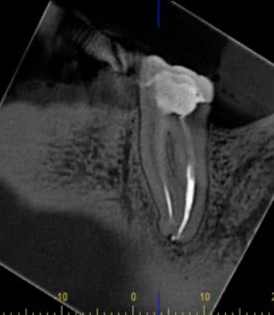
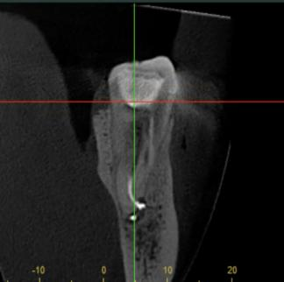

Figure 11. Tomographic image from 2 years ago indicating bone repair and lamina dura formation.
Source: Author’s own.

3. discussion

Initially, the process of pulp calcification in multi-rooted teeth, such as lower molars, can result in significant narrowing or even complete closure of the root canal lumen. This makes access to the canals more complicated, increasing the difficulty in performing endodontic therapy, especially when there is a concomitant periapical abscess, which aggravates the clinical picture and increases the need for precise and efficient intervention (Robertson et al., 1996).
The presence of periapical abscesses indicates an inflammatory or infectious condition that must be treated urgently, as it can result in intense pain, edema, and even the spread of infection to other adjacent tissues (Siqueira Jr & Rôças, 2013). The endodontic approach to cases like this requires the use of advanced resources. The use of magnification tools is essential for locating calcified canals. Studies show that magnification, combined with illumination, significantly improves the visibility of the canal orifices and allows for safer instrumentation, reducing the risk of perforations or deviations (Coaguila-Llerena et al., 2017; Legatti et al., 2024). In addition, dental ultrasound, with tips suitable for working in calcified canals, offers a safe and efficient alternative in assisting with calcification removal, facilitating access to the canal system and allowing for adequate protection, which is crucial in cases of periapical abscesses (Valdivia et al., 2015).
Another aspect that deserves highlighting is the importance of cone-beam computed tomography (CBCT), which allows for a three-dimensional visualization of dental structures, including root canals and the extent of the abscess. This technology allows for a more precise assessment of canal morphology and calcification severity, guiding treatment planning with greater safety and clinical predictability (Neves, Barbosa & Crusoé-Rebello, 2013). In the case of a lower molar, the anatomical complexity of the canals can be significantly exacerbated by calcification, making CBCT an almost necessary tool for diagnosis and defining the most appropriate clinical strategy (Caputo et al., 2015).
In addition, it is important to emphasize that the prognosis for teeth with severe calcifications can be guarded, especially when there is active infection. In many cases, the success of endodontic treatment depends on the professional's ability to locate and unblock the canals affected by calcification, as well as ensuring complete infection and adequate isolation of the canals to prevent abscess recurrence (Alberdi et al., 2025). However, studies indicate that, despite calcification, not all teeth develop necrosis or severe periapical complications, which reinforces the need for an individualized assessment of each case (Chaves et al., 2022).
Therefore, the endodontic approach demonstrated in this study, of a lower second molar with extensive pulp calcification and periapical abscess, involved a combination of high-precision imaging techniques and technologies. The use of microscopy, ultrasound, and CBCT, combined with professional clinical experience, significantly increased the success rate of this treatment, minimizing the risk of complications and ensuring effective resolution of the periapical infection.
In the present clinical case, the initial periapical radiographic examination allowed the identification of periapical bone rarefaction in the tooth in question, in addition to observing partial calcification of the root canals and wear of the pulp chamber in an attempt to locate the canal entrances. With the CBCT scan, it was possible to identify the lumen of the mesial canal. Fortunately, the use of ultrasound and CBCT was sufficient to locate and remove the calcification that was preventing treatment of the tooth's root canal. Therefore, the treatment adopted for teeth with suspected pulp calcifications, similar to the tooth reported in question, should include a tomographic examination to ensure an accurate diagnosis and proper treatment planning.

4. Conclusion

In light of the above, we can conclude that knowledge combined with technology can make a difference in more complex cases like the one described in this report, alleviating pain, preventing premature tooth loss in patients, and contributing to the longevity of dental structures.

Consent

All authors declare that ‘written informed consent was obtained from the patient (or other approved parties) for publication of this case report and accompanying images. A copy of the written consent is available for review by the Editorial office/Chief Editor/Editorial Board members of this journal.

References

- Alberdi, J. C., Troiano, I., Troiano, M. A., Sanchez, P. M., & Alves, F. R. F. (2025). Effective Management of Calcified Root Canals Using Static-guided Access: A Case Series. European Endodontic Journal, 10(1), 73.
- Andreasen, F. M., Zhjie, Y., Thomsen, B. L., & Andersen, P. K. (1987). Occurrence of pulp canal obliteration after luxation injuries in the permanent dentition. Dental Traumatology, 3(3), 103-115.
- Andreasen, J. O., & Andreasen, F. M. (2001). Text and color atlas of dental trauma. In Text and color atlas of dental trauma (pp. 770-770).
- Berès, F., Isaac, J., Mouton, L., Rouzière, S., Berdal, A., Simon, S., & Dessombz, A. (2016). Comparative physicochemical analysis of pulp stone and dentin. Journal of endodontics, 42(3), 432-438.
- Buchgreitz, J., Buchgreitz, M., & Bjørndal, L. (2019). Guided root canal preparation using cone-beam computed tomography and optical surface scanning: an observational study of pulp space obliteration and bur depth in 50 patients. International Endodontic Journal, 52 (5), 559-568.
- Caputo, B. V., Ribeiro, R. A., Noro Filho, G. A., Dutra Corrêa, M., Zambrana, J. R., Salgado, D. M. R., ... & Costa, C. (2015). Morphological evaluation of roots and canals of molars and premolars using cone beam computed tomography. Brazilian Oral Research, 29, 519.
- Chaves, H. D. S., Moreira, T. P. C., Figueiredo, B., Macedo, I. F. A., Ferreira, I. D. C., Maia, C. A., ... & Nascimento, W. M. (2022). Pulp calcification in traumatized teeth–a literature review. Research, Society and Development, 11(7).
- Connert, T., Zehnder, M. S., Amato, M., Weiger, R., Kühl, S., & Krastl, G. (2018). Microguided Endodontics: a method to achieve minimally invasive access cavity preparation and root canal location in mandibular incisors using a novel computer‐guided technique. International endodontic journal, 51(2), 247-255.
- Coaguila-Llerena, E. H., Córdova, F., Garré, L., & Faria, G. (2018). Endodontic microscopy applied to severe calcification of the dental pulp: case report. Revista de Odontologia da UNESP, 46(Special), 0-0.
- Estrela, C., Decurcio, D. D. A., Rossi-Fedele, G., Silva, J. A., Guedes, O. A., & Borges, Á. H. (2018). Root perforations: a review of diagnosis, prognosis and materials. Brazilian oral research, 32, e73.
- Ferreira, D. A. B., Costa, L. B. M., Melgaço, J. L. B., & Basto, J. V. (2012). Pulp changes with aging. Endodontics: a contemporary view. São Paulo: Editora Santos, 203-211.
- Lara-Mendes, S. T., Camila de Freitas, M. B., Machado, V. C., & Santa-Rosa, C. C. (2018). A new approach for minimally invasive access to severely calcified anterior teeth using the guided endodontics technique. Journal of endodontics, 44(10), 1578-1582.
- Legatti, J. O. N., Aguilar, M. M. R., Coelho, V. B., de Cristófaro Almeida, G., & Guimarães, L. C. (2023). Technologies in the endodontic treatment of calcified canals: Case report. Research, Society and Development, 12(8), e10112842596-e10112842596.
- Kim, S., & Baek, S. (2004). The microscope and endodontics. Dental Clinics, 48(1), 11-18.
- Marcano‐Caldera, M., Mejía‐Cardona, J. L., Parra Sánchez, J. H., Méndez de la Espriella, C., Covo Morales, E., Sierra Varón, G., ... & Sigurdsson, A. (2018). Knowledge about emergency dental trauma management among school teachers in Colombia: a baseline study to develop an education strategy. Dental Traumatology, 34(3), 164-174.
- McCabe, P. S., & Dummer, P. M. H. (2012). Pulp canal obliteration: an endodontic diagnosis and treatment challenge. International endodontic journal, 45(2), 177-197.
- Nabavi, S., & Latifian, E. (2025). Guided Endodontic Technique in Mandibular Incisors with Pulp Canal Obliteration: A Case Report. Iranian Endodontic Journal, 20(1), e21.
- Neves, F. S., Barbosa, J. P., & Crusoé-Rebello, I. (2013). Use of cone beam computed tomography in endodontics. Clinical and Research in Dentistry-UNITAU, 5(1), 58-64.
- Pettiette, M. T., Zhong, S., Moretti, A. J., & Khan, A. A. (2013). Potential correlation between statins and pulp chamber calcification. Journal of endodontics, 39(9), 1119-1123.
- Siqueira Jr, JF, & Rôças, IN (2009). Diversidade da microbiota endodôntica revisitada. Jornal de pesquisa odontológica, 88 (11), 969-981.
- Siqueira Jr, J. F., & Rôças, I. N. (2013). Microbiology and treatment of acute apical abscesses. Clinical microbiology reviews, 26(2), 255-273.
- Robertson, A., Andreasen, F. M., Bergenholtz, G., Andreasen, J. O., & Norén, J. G. (1996). Incidence of pulp necrosis subsequent to pulp canal obliteration from trauma of permanent incisors. Journal of endodontics, 22(10), 557-560.
- Oginni, A. O., Adekoya‐Sofowora, C. A., & Kolawole, K. A. (2009). Evaluation of radiographs, clinical signs and symptoms associated with pulp canal obliteration: an aid to treatment decision. Dental Traumatology, 25(6), 620-625.
- Valdivia, J. E., Pires, M. M. P., Beltran, H. S., & Machado, M. E. D. L. (2015). Importance of using ultrasound in endodontic access of teeth with pulp calcification. Dental Press Endod, 5(2), 67-73.
- Wang, G., Wang, C. & Qin, M. (2019). Um estudo retrospectivo da sobrevivência de 196 dentes permanentes reimplantados em crianças. Dent Traumatol. 35(4-5), 251-258.

