Original Research Article

Effect of different surface on the repair bond strength of resin composite subjected to artificially accelerated aging: An in vitro study

ABSTRACT

Aim:
This in vitro study aimed to evaluate and compare the surface roughness and shear bond strength (SBS) of aged composite repairs using three surface pretreatment methods—diamond bur (DP), tungsten carbide bur (TC), and air abrasion (AA)—in combination with two universal adhesives: Prime & Bond Universal (PBU) and Single Bond Universal (SBU).
Methodology:
Seventy-two composite discs were fabricated and aged by thermocycling. Specimens were randomly divided into three groups (n=24) based on surface pretreatment: Group A (DP), Group B (TC), and Group C . Surface roughness (Ra) was assessed using a profilometer on half the specimens from each group. All specimens were then acid-etched and further subdivided based on the adhesive used (SBU or PBU, n=12 each). Neo Spectra ST was bonded over the treated surface using a cylindrical mold and light-cured. SBS testing was conducted using a UTM , and failure modes were analyzed under stereomicroscope.
Results:
Surface roughness values varied across treatment groups, with air abrasion showing the highest Ra, followed by TC and DP. SBS results indicated that surface pretreatment significantly influenced bonding efficacy. SBU demonstrated slightly higher SBS compared to PBU across most surface treatments. The highest SBS was observed in the group treated with DP combined with SBU (C2), suggesting a synergistic effect between mechanical and chemical bonding. Mixed failure modes were most common.
Conclusion:
Diamond point, followed by air abrasion application of Single Bond Universal yielded the most favorable outcomes, indicating superior micro-mechanical interlocking and chemical adhesion.

Keywords:Aged composite repair, universal adhesives, surface pretreatment.

1. INTRODUCTION
Composite restorations have emerged as a foundational element in contemporary dental practice, valued for their capacity to restore both the structural integrity and aesthetic appearance of damaged teeth along with mimicking the natural properties of enamel and dentin, offering a recovery solution that not only preserves tooth structure but also enhances its functionality. These materials consist of a resin matrix (RM), inorganic filler particles (FP), and a silane coupling agent (SCA). However, their longevity is challenged by oral environmental factors, resulting in failures such as fractures, caries, marginal leakage, and discoloration. According to Pilo et al., the annual failure rates of composite restorations range from 0.9% to 9.4%, with an average of 1–3%, depending on factors such as operator skill, material selection, and patient habits.¹
Complete replacement often involves the removal of additional sound tooth structure, increasing the risk of pulpal irritation and weakening the tooth, whereas repair preserves the existing restoration and minimizes iatrogenic damage.² Repair is a conservative, cost-effective alternative, yet the process lacks standardized protocols.³ So the aim of the study was to evaluate and compare the effect on bond strength of composite resin subjected to aging after the repair procedure using different surface pre-treatments and two universal adhesives namely, Single Bond Universal (3M ESPE USA) and Prime & Bond Universal (Dentsply Sirona). The null hypotheses tested were that there was no effect of surface roughness on repair bond strength of aged composite and that there was no difference between the repair bond strength when two different universal adhesives were used

2. material and methods

Specimen Preparation:
A total of 72 composite resin specimens were fabricated using a custom-made metallic mold (2 mm thick, 6 mm diameter). Uncured resin composite was placed into the molds, covered with Mylar strips, and photo-cured for 20 seconds on each side. Post-curing, all specimens were examined under a stereomicroscope (40× magnification), and those with surface irregularities were discarded. Aging was induced via thermocycling (10,000 cycles between 5°C and 55°C, 30-second dwell time). Subsequently, specimens were rinsed for 20 seconds and stored in distilled water at 37°C for 24 hours before surface treatment.

Surface Pre-treatments:
Specimens were air-dried and randomly assigned to three groups (n=24 each) based on the surface conditioning method used:

Group A – Diamond Point (DP): Surfaces roughened using an extra-fine diamond point in a high-speed turbine under water cooling. Five strokes were applied per specimen with minimal pressure. Burs were replaced after every five samples.
Group B – Tungsten Carbide Bur (TC): Surfaces roughened using a 30-fluted TC bur under water cooling. Ten strokes were applied per specimen with minimal pressure, and burs replaced after every five specimens.
Group C – Air Abrasion (AA): Specimens were sandblasted with 50 µm aluminum oxide particles from a 10 mm distance at a 90° angle.
Surface Roughness Measurement:
From each group, 12 specimens were evaluated for surface roughness using a contact profilometer. Measurements were taken at three different points on each specimen, and the average Ra (µm) value was recorded as a representation of the surface roughness post-treatment. SR testing used a contact profilometer (Mitutoyo Surftest SJ 201, Tokyo, Japan) .

Repair Procedure:
All specimens were acid-etched with 37% phosphoric acid for 15 seconds, rinsed, and air-dried. Each group was subdivided into two subgroups (n=12 each) based on the adhesive used. {Prime & Bond Universal (PBU) & Single Bond Universal (SBU)}
Adhesives were applied following manufacturer protocols and light-cured for 20 seconds. A metallic hollow cylinder mold was placed on each pretreated surface, and fresh composite resin (Neo Spectra ST, shade A3) was packed and cured for 20 seconds. All specimens were stored in distilled water at 37°C for 24 hours before bond strength testing.
Group A1 : DP+ PBU
Group A2 :DP+SBU
Group B1:TC+PBU
Group B2:TC+SBU
Group C1:AA+PBU
Group C2 :AA+SB
Shear Bond Strength (SBS) Testing:
SBS was evaluated using a Universal Testing Machine. A chisel-shaped blade applied shear force at the bonded interface at a crosshead speed of 0.5 mm/min until failure. Failure forces were recorded in Newtons (N) and converted to Megapascals (MPa) using the formula:
MPa = Force (N) / Surface Area (mm²)
Failure modes were examined under a stereomicroscope at 40× magnification to classify the type of failure (adhesive, cohesive, or mixed).
3. results and discussion

In this study, seventy-two aged composite specimens were fabricated using Filtek Z350 XT and thermocycled for 10,000 cycles to simulate aging.
Specimens were divided into three groups based on surface pretreatment: Group A (Diamond Point, DP), Group B (Tungsten Carbide bur, TC), and Group C (Air Abrasion, AA), with 24 specimens in each. Each group was further subdivided into two subgroups (n=12) based on the adhesive used: Prime & Bond Universal (PBU) and Single Bond Universal (SBU), followed by repair using Neo Spectra ST. Surface roughness (SR) was highest in DP (1.10 µm), followed by AA (1.02 µm), and lowest in TC (0.83 µm), with statistically significant differences (p < 0.001).
Shear bond strength (SBS) results showed the highest values in Group A2 (DP+SBU, 34.77 MPa), followed by Group C2 (AA+SBU, 24.53 MPa), while the lowest was in Group B1 (TC+PBU, 10.62 MPa). For both adhesives, DP showed superior SBS, while TC showed the least. SBU generally outperformed PBU across all surface treatments. Intergroup comparison revealed that SBU provided significantly higher SBS than PBU in TC and AA groups, though the difference was not significant in the DP group. Overall, DP pretreatment with SBU yielded the best repair bond strength among all tested combinations.

GRAPH 1: COMPARISON OF SURFACE ROUGHNESS AMONG THREE METHODS
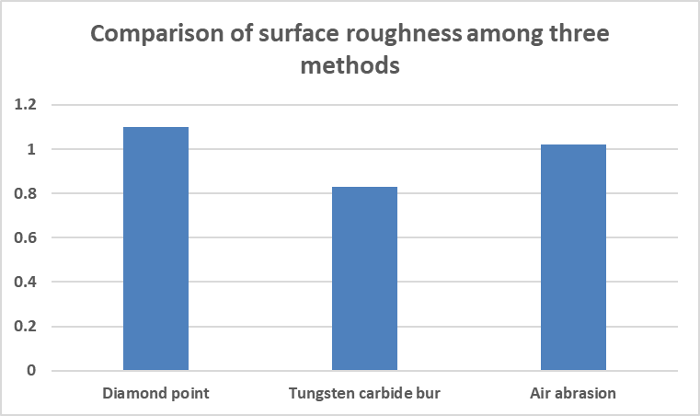

GRAPH 2 :COMPARISON OF SHEAR BOND STRENGTH OF SINGLE BOND UNIVERSAL ADHESIVE AMONG THREE METHODS

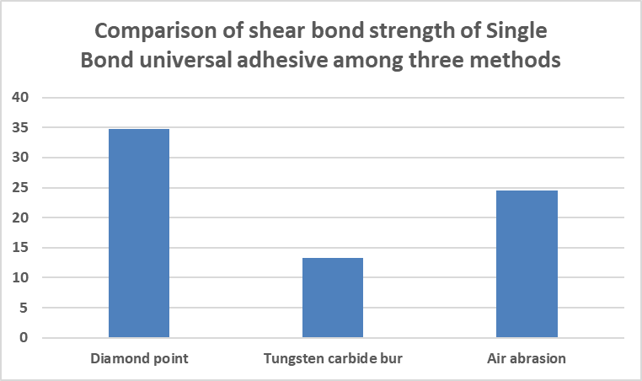

GRAPH 3 : COMPARISON OF SHEAR BOND STRENGTH OF PRIME & BOND UNIVERSAL ADHESIVE AMONG THREE METHODS
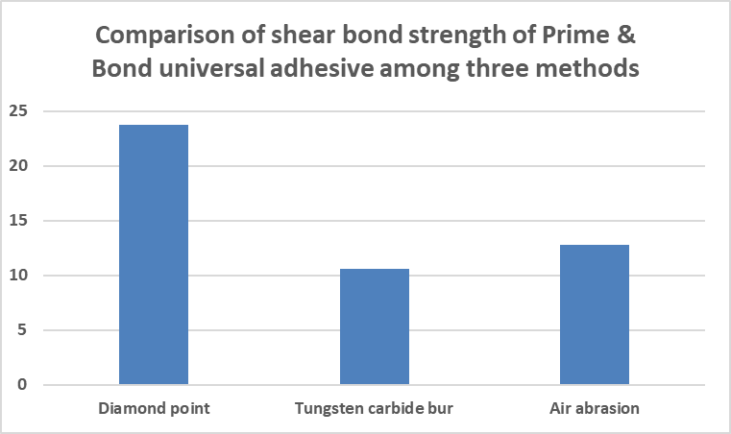

GRAPH 4 :COMPARISON OF SHEAR BOND STRENGTH OF SINGLE BOND UNIVERSAL ADHESIVE AND PRIME & BOND UNIVERSAL ADHESIVE IN EACH METHOD

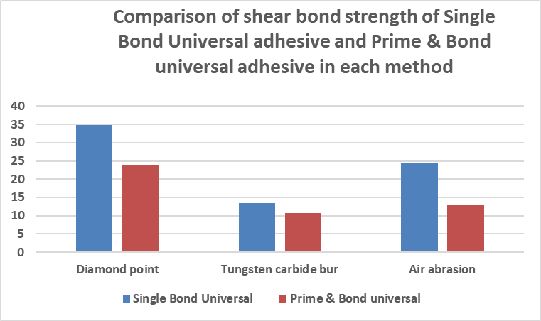

TABLE 1 : COMPARISON OF SHEAR BOND STRENGTH OF PRIME & BOND UNIVERSAL ADHESIVE AMONG THREE METHODS

Group | Mean | SD | χ² value | p-value
Diamond point | 23.76 | 17.11 | 7.588 | 0.001*
Tungsten carbide bur | 10.62 | 5.00 | 7.588 | 0.001*
Air abrasion | 12.80 | 1.96 | 7.588 | 0.001*
Kruskal Wallis test; * indicates a significant difference at p≤0.01
This table compares the shear bond strength of Prime & Bond universal adhesive among the three methods. The highest shear bond strength of Prime & Bond universal adhesive was seen in diamond points and the lowest in the tungsten carbide group. The difference in the shear bond strength of Prime & Bond universal adhesive among the three methods was significant.
TABLE 2 : COMPARISON OF SHEAR BOND STRENGTH OF PRIME & BOND UNIVERSAL ADHESIVE AMONG THREE METHODS

Group | Mean | SD | χ² value | p-value
Diamond point | 23.76 | 17.11 | 7.588 | 0.001*
Tungsten carbide bur | 10.62 | 5.00 | 7.588 | 0.001*
Air abrasion | 12.80 | 1.96 | 7.588 | 0.001*
Kruskal Wallis test; * indicates a significant difference at p≤0.01

This table compares the shear bond strength of Prime & Bond universal adhesive among the three methods. The highest shear bond strength of Prime & Bond universal adhesive was seen in diamond points and the lowest in the tungsten carbide group. The difference in the shear bond strength of Prime & Bond universal adhesive among the three methods was significant.

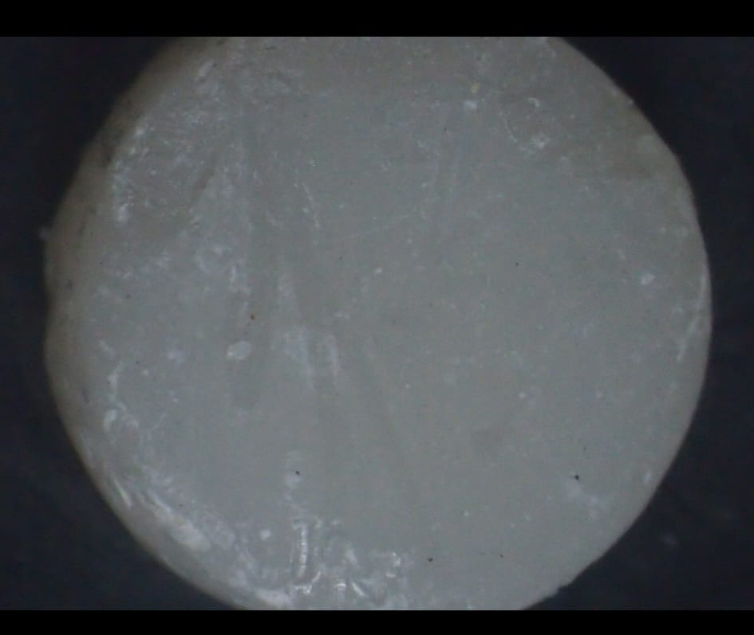
FIGURE 1: FRACTURED SPECIMEN SHOWING ADHESIVE FAILURE

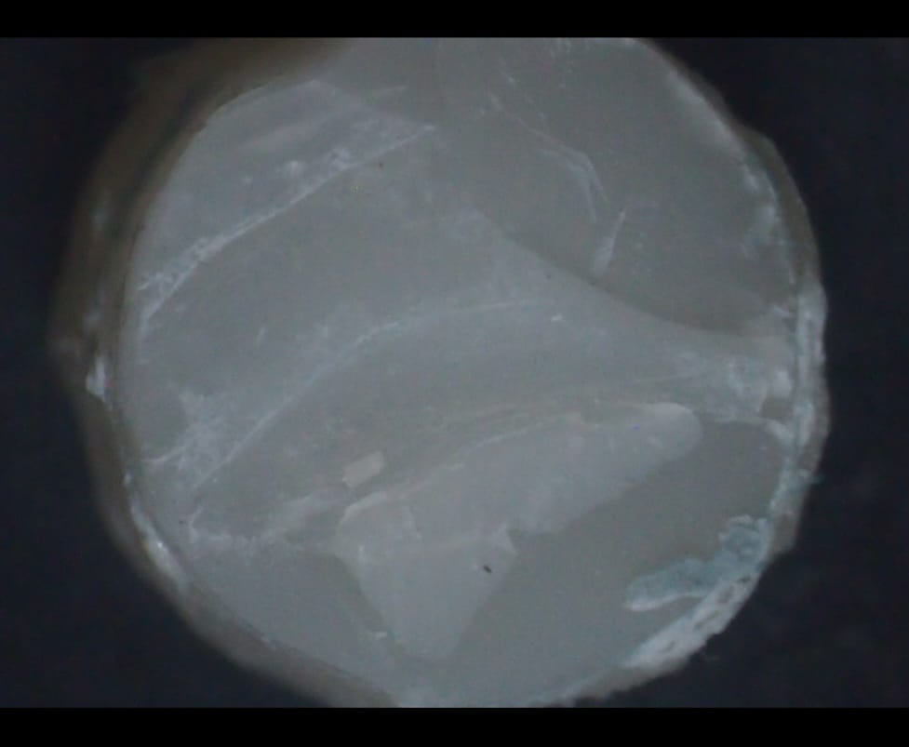
FIGURE 2: FRACTURED SPECIMEN SHOWING COHESIVE FAILURE
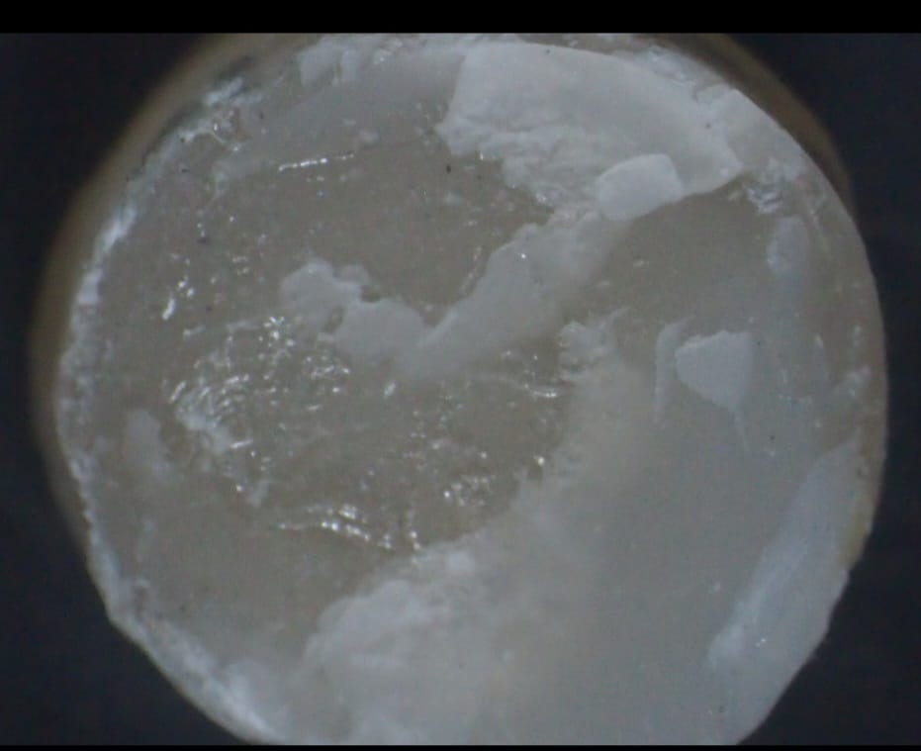

FIGURE 3: FRACTURED SPECIMEN SHOWING MIXED FAILURE

DISCUSSION
The longevity and stability of composite resin restorations are crucial in modern dental practice. These resins degrade over time due to environmental influences like moisture, temperature variations, and mechanical forces. This degradation affects the bond strength (BS) between aged and new composite materials, making repair techniques crucial^{.4}
Polymer degradation through hydrolysis, driven by solvents in the oral environment, reduces composite hardness (plasticization). Solvents diffuse into the polymer network, disrupting polymer chains and reducing cross-links. This degradation releases monomers and filler particles, undermining restoration durability, resulting in pores, facilitating the leaching of residuals. TEGDMA is the most commonly released monomer, along with quartz and silicon particles, and matrix cracking. Polymerization leaves unreacted monomers and methacrylate groups, especially in bis-GMA-based composites with 54% to 85% conversion rates.⁵
Acidic degradation of resin composites remains underexplored, though strong acids can dissolve filler particles, especially in composites with larger fillers. This underscores the rationale for selecting nanofilled composites in this study.
Filtek Z350 XT is a nano-filled composite featuring a range of filler particle sizes for high filler loading, ensuring durability and a smooth, polished surface. The material contains TEGDMA, UDMA, bis-GMA, and bis-EMA, with some TEGDMA replaced by PEGDMA to reduce polymerization shrinkage. Neo Spectra ST is a light-cured, radiopaque, nano-ceramic universal composite with advanced SphereTEC filler technology, used in both direct and indirect restorations.
Aging composites simulates oral degradation and helps assess RBS. Thermocycling is a widely used in vitro method. Özcan et al. (2009)6 emphasized its superiority in simulating composite aging. Parameters like temperature, dwell time, and cycle count affect SBS test outcomes. Rinastiti et al. (2010)⁷ showed that 5000 cycles affect BS, and Gale et al. (1999)⁸ equated 11,000 cycles to one year of clinical use. Accordingly, this study used 11,000 thermal cycles. (Ugurlu et al .2022)⁹
Early and late composite repairs are clinically relevant, but no consensus exists on optimal protocols due to variable test conditions. Composite repair depends on hydrolysis, adhesive compatibility, and surface condition. ST enhances RBS by increasing surface roughness (SR) for micromechanical interlocking. Common methods include DP, TC burs, AA, laser, and sandblasting.¹⁰ This study used DP, TC bur, and AA.
Diamond burs are favored for accessibility and ease of use. They create macro- and micro-retentive features, improving micromechanical bonding (Ahmadizenouz et al., 2016)¹¹. TC burs, with their multi-fluted design (6–13 blades), provide uniform abrasion and controlled material removal (Ferraris et al., 2014).¹² AA using aluminum oxide yields more homogeneous retention and increases surface energy and wettability for better adhesive interaction (Eram et al., 2023).¹³
Modern adhesives, especially those with high 2-HEMA content, improve wetting, enabling deeper penetration into aged substrates. Solvents like alcohol and acetone assist in dehydration. 2-HEMA's amphiphilic nature supports chemical bonding during light polymerization. Bonding systems, once polymerized, can physically intertwine with the old composite matrix, strengthening the bond even without direct chemical reactions.¹⁴
PBU (Dentsply Sirona) is a HEMA-free, acetone- and water-based universal adhesive. Universal adhesives simplify procedures while maintaining durability. They show bond strengths comparable to older systems. SBU (3M ESPE) contains methacrylate monomers and 11-MDP, which chemically bond with calcium and resist biodegradation. SBU is effective on zirconia through phosphate ester bonding. Some contain pre-hydrolyzed silane for enhanced hydrolytic stability.
Silanes enhance wettability and bonding by linking silica fillers and methacrylate groups. They have silanol groups for silica bonding and organo-functional groups for copolymerization.¹⁵
Bur grit size, speed, and operator technique influence SR. This treatment removes superficial contaminants, revealing fresh filler and resin for bonding. Söderholm et al. (1991)¹⁶ emphasized that surface irregularity significantly influences BS more than intermediate resin use. Effective wetting of textured surfaces is critical for bonding.¹⁷
DP showed the highest SR, followed by AA, and then TC bur. Statistical analysis confirmed that DP had significantly higher SR than TC and AA (p < 0.001). Diamond bur's superior SR may stem from its ability to expose more filler particles and create more macroretentive features. These findings align with Brosh et al. (1997)¹⁸ and Tabatabaei et al. (2004)¹⁹.
AA using alumina particles provides consistent micromechanical retention, modifying the surface to enhance bonding. However, homogeneous surfaces may not always yield optimal retention, as noted by Neto et al. (2023)²⁰.In the present study, the AA group exhibited greater surface roughness compared to the TC bur, enhancing adhesion by increasing the bonding surface area and reducing surface tension. Silica-modified aluminum oxide particles embedded into the composite improved surface energy and formed a silicate ceramic layer, consistent with findings by Batista et al. (2015).²¹ This process also promoted triboplasma formation, creating SiO₂-rich islands and facilitating both mechanical and chemical anchorage, though AA may leave smear debris that hinders bonding strength (BS) if not removed. In contrast, TC burs yielded smoother surfaces due to their cutting mechanics, which were less conducive to micro-mechanical retention, as also reported by Ehrman et al. (2019)²² and Ferraris et al. (2014).¹²
Results showed higher SBS values for Single Bond Universal-treated groups versus Prime and Bond Universal. Post-SBS testing, fracture surfaces were analyzed under 40x magnification using a stereo microscope (Eren et al., 2019).¹⁷

The highest shear bond strength (SBS) was observed in the DP group, followed by AA and TC (Yesilyurt et al .2009).²³ Single Bond Universal (SBU) generally outperformed Prime and Bond Universal (PBU), likely due to the presence of silane coupling agents in SBU. While PBU has lower film thickness, this study indicated viscosity may not significantly influence composite repair strength.When a high-viscosity composite is applied to a roughened surface, achieving mechanical interlocking becomes challenging. Therefore, it is generally recommended to apply a low-viscosity adhesive before the repair to enhance bonding efficiency and achieve superior repair bond strength. But still, PB showed lesser SBS values despite of having lower film thickness leads our investigation to the inference that viscosity might not be the differentiating factor when it comes to composite repair. This aligned with the findings of the study by OH et al.(Oh HK et al .2020).²⁴ Failure mode analysis showed mixed failures, with DP showing more cohesive failures and TC more adhesive failures. Despite limitations of in-vitro design, these findings support composite repair through proper surface treatment and adhesive selection. Another limitation could be due to inability fully replicate the complex forces encountered in a clinical setting,inadequate simulation of oral degradation due to various stimuli by thermocycling.Future advancements in adhesive technology and composite formulations may provide improved solutions for long-term restoration success, ultimately benefiting both clinicians and patients. Establishing standardized clinical guidelines for composite repair will ensure consistent outcomes and enhance the longevity of dental restorations.

4. Conclusion
The diamond point exhibited the highest surface roughness values, followed by air abrasion, while the tungsten carbide bur produced the lowest. When repaired with Prime and Bond Universal, the diamond point showed the highest shear bond strength (SBS), whereas the tungsten carbide bur showed the lowest. A similar trend was observed with Single Bond Universal, where the diamond point again demonstrated superior SBS values. Overall, Single Bond Universal yielded higher SBS values compared to Prime and Bond Universal in the intergroup comparison.

References

- Pilo R, Brosh T, Geron V, Levartovsky S, Eliades G. Effect of silane reaction time on the repair of a nanofilled composite using tribochemical treatment. J Adhes Dent. 2016;18(2):125-34. doi: 10.3290/j.jad.a35907. PMID: 27042705.
- Blum IR, Özcan M. Reparative dentistry: possibilities and limitations. Curr Oral Health Rep. 2018;5(4):264–9. doi:10.1007/s40496-018-0191-1.
- Sharif MO, Catleugh M, Merry A, Tickle M, Dunne S, Brunton P, Aggarwal V, Chong LY. Replacement versus repair of defective restorations in adults: resin composite. Cochrane Database Syst Rev. 2014;(2):CD005971. doi:10.1002/14651858.CD005971.pub3
- Demarco FF, Cenci MS, Montagner AF, de Lima VP, Correa MB, Moraes RR, Opdam NJM. Longevity of composite restorations is definitely not only about materials. Dent Mater. 2023;39(1):1–12. doi:10.1016/j.dental.2022.11.009.
- Drummond JL. Degradation, fatigue, and failure of resin dental composite materials. J Dent Res. 2008;87(8):710–9. doi:10.1177/154405910808700802.
- Özcan M, Cura C, Brendeke J. Effect of aging conditions on the repair bond strength of a microhybrid and a nanohybrid resin composite. J Adhes Dent. 2009;12(6):451-9. doi: 10.3290/j.jad.a17857.
- Rinastiti M, Özcan M, Siswomihardjo W, Busscher HJ. Effects of surface conditioning on repair bond strengths of non-aged and aged microhybrid, nanohybrid, and nanofilled composite resins. Clin Oral Investig. 2011 Oct;15(5):625-33. doi: 10.1007/s00784-010-0426-6. Epub 2010 May 25. PMID: 20499119; PMCID: PMC3172408.
- Gale M, Darvell B. Thermal cycling procedure for laboratory testing of dental restorations. J Dent. 1999;27(2):89-99. doi: 10.1016/S0300-5712(98)00037-2.
- Ugurlu, M., Husain, N. A. H. & Özcan, M. Repair of Bulk-Fill and Nanohybrid Resin Composites: Effect of Surface Conditioning, Adhesive Promoters, and Long-Term Aging. Materials 15, (2022).
- da Costa TR, Serrano AM, Atman AP, Loguercio AD, Reis A. Durability of composite repair using different surface treatments. Journal of Dentistry. 2012 Jun 1;40(6):513-21.
- Ahmadizenouz G, Esmaeili B, Taghvaei A, Jamali Z, Jafari T, Amiri Daneshvar F, Khafri S. Effect of different surface treatments on the shear bond strength of nanofilled composite repairs. J Dent Res Dent Clin Dent Prospects. 2016 Winter;10(1):9-16. doi: 10.15171/joddd.2016.002. Epub 2016 Mar 16. PMID: 27092209; PMCID: PMC4831615.
- Ferraris F, Conti A. Superficial roughness on composite surface, composite-enamel and composite-dentin junctions after different finishing and polishing procedures. Part II: roughness with polishers treatment after carbide and diamond finishing and differences between enamel composite vs body composite. International Journal of Esthetic Dentistry
- Eram A, Vinay Kr R, K N C, Keni LG, Shetty DD, Zuber M, Kumar S, S P. Air-Abrasion in Dentistry: A Short Review of the Materials and Performance Parameters. J Biomed Phys Eng. 2024 Feb 1;14(1):99-110. doi: 10.31661/jbpe.v0i0.2310-1670. PMID: 38357598; PMCID: PMC10862117.
- Abdelkhalek E, Hamama HH, Mahmoud SH. HEMA-free versus HEMA-containing adhesive systems: a systematic review. Systematic Reviews. 2025 Jan 21;14(1):17.
- Zakir M, Ashraf U, Tian T, Han A, Qiao W, Jin X, Zhang M, Tsoi JK, Matinlinna JP. The role of silane coupling agents and universal primers in durable adhesion to dental restorative materials-a review. Current Oral Health Reports. 2016 Sep;3(3):244-53.
- SÖDERHOLM KJ, ROBERTS MJ. Variables influencing the repair strength of dental composites. European Journal of Oral Sciences. 1991 Apr;99(2):173-80.
- Eren, D., Doǧan, C. A. & Bektaş, Ö. Ö. Effect of Different Surface Treatments and Roughness on the Repair Bond Strength of Aged Nanohybrid Composite. Photobiomodul Photomed Laser Surg 37, 473–482 (2019)
- Brosh T, Pilo R, Bichacho N, Blutstein R. Effect of combinations of surface treatments and bonding agents on the bond strength of repaired composites. J Prosthet Dent. 1997 Feb;77(2):122-6. doi: 10.1016/s0022-3913(97)70224-5. PMID: 9051597.
- HASANI TM, Alizade Y, Taalim S. Effect of various surface treatment on repair strength of composite resin.
- Neto H, Leite J, Medeiros J, Campos D, Muniz I, Andrade A, et al. Scoping review: Effect of surface treatments on bond strength of resin composite repair. J Dent. 2023;140:104737. doi: 10.1016/j.jdent.2023.104737.
- Batista GR, Kamozaki MB, Gutierrez NC, Caneppele TM, Rocha Gomes Torres C. Effects of Different Surface Treatments on Composite Repairs. J Adhes Dent. 2015 Aug;17(5):421-6. doi: 10.3290/j.jad.a35013. PMID: 26525006.
- Ehrmann E, Medioni E, Brulat-Bouchard N. Finishing and polishing effects of multiblade burs on the surface texture of 5 resin composites: microhardness and roughness testing. Restor Dent Endod. 2018 Nov 26;44(1):e1. doi: 10.5395/rde.2019.44.e1. PMID: 30834223; PMCID: PMC6387893
- Yesilyurt C, Kusgoz A, Bayram M, Ulker M. Initial repair bond strength of a nano-filled hybrid resin: effect of surface treatments and bonding agents. J Esthet Restor Dent. 2009;21(4):251-60. doi: 10.1111/j.1708-8240.2009.00271.x. PMID: 19689724.
- Oh HK, Shin DH. Effect of adhesive application method on repair bond strength of composite. Restorative Dentistry & Endodontics. 2021 Aug;46(3):e32. DOI: 10.5395/rde.2021.46.e32. PMID: 34513638; PMCID: PMC84110

