Systematic Review

Statin Use and Risk of Cognitive Decline in Older Adults: Evidence from a Systematic Review and Meta-Analysis

.
ABSTRACT

Aims: To evaluate the efficacy of statin therapy in preventing cognitive decline and dementia among older adults through an updated systematic review and meta-analysis of randomized controlled trials (RCTs) and cohort studies.
Study Design: Systematic review and meta-analysis conducted in accordance with the Preferred Reporting Items for Systematic Reviews and Meta-Analyses (PRISMA 2020) guidelines.
Place and Duration of Study: Data were collected from international electronic databases (PubMed/MEDLINE, Embase, Cochrane CENTRAL, Scopus, and LILACS) from inception to October 2025.
Methodology: Eligible studies included RCTs and prospective cohort studies comparing any statin (hydrophilic or lipophilic) with placebo or no treatment in adults aged ≥60 years without dementia at baseline. Primary outcomes were incident cognitive decline or dementia, including Alzheimer’s and vascular subtypes. Two reviewers independently performed screening, data extraction, and risk-of-bias assessment using the Cochrane RoB 2.0 and Newcastle–Ottawa Scale (NOS). Random-effects models (DerSimonian–Laird) were used to calculate pooled odds ratios (OR) with 95% confidence intervals (CI). Heterogeneity was assessed using the I² statistic, and publication bias was evaluated with Egger’s test.
Results: Ten studies (five RCTs and five cohort studies) encompassing approximately 230,000 participants were included. Statin use was not significantly associated with risk of overall cognitive impairment or dementia (OR = 0.94; 95% CI 0.60–1.47; p = 0.50). For Alzheimer’s disease, pooled analysis showed a neutral association (OR = 1.28; 95% CI 0.42–3.85), while cohort data suggested a modest protective trend (OR = 0.97; 95% CI 0.94–0.99). For vascular dementia, the pooled estimate was also nonsignificant (OR = 0.92; 95% CI 0.53–1.60).
Heterogeneity across analyses ranged from low to moderate (I² = 0–48%), with no evidence of publication bias.
Conclusion: Statin therapy appears cognitively safe and is not associated with an increased risk of dementia or cognitive decline. Observational evidence suggests possible small protective effects that warrant confirmation in ongoing large randomized trials such as STAREE and PREVENTABLE.

Keywords: Statins; cognitive decline; dementia; Alzheimer’s disease; vascular dementia; meta-analysis; elderly; HMG-CoA reductase inhibitors.

1. INTRODUCTION
Cognitive decline and dementia represent critical global health concerns, with an estimated 55 million individuals affected worldwide—a figure expected to triple by 2050 (World Health Organization, 2023). Given the absence of curative therapies, identifying pharmacological and lifestyle-based strategies to prevent or delay cognitive impairment in aging populations remains a major research priority (Livingston et al., 2020).
Statins, inhibitors of 3-hydroxy-3-methylglutaryl coenzyme A (HMG-CoA) reductase, are among the most prescribed medications globally for the prevention of atherosclerotic cardiovascular disease. Beyond their lipid-lowering effect, statins possess pleiotropic properties, including anti-inflammatory, antioxidant, and endothelial-protective actions, which may positively influence cerebral perfusion and reduce the risk of neurodegeneration (Endo, 2020; Wood et al., 2021).

However, the association between statin use and cognitive outcomes remains debated. Observational data and some randomized controlled trials (RCTs) have suggested potential neuroprotective effects, showing lower risks of dementia or Alzheimer’s disease among statin users (Zhou et al., 2021; Swiger et al., 2013). Conversely, other studies have reported neutral or adverse findings, raising concerns about possible cognitive side effects, particularly with lipophilic statins capable of crossing the blood–brain barrier (Ott et al., 2015; Richardson et al., 2023). The U.S. Food and Drug Administration (FDA) also issued a communication regarding reversible memory loss and confusion associated with statin therapy, though such events are rare (FDA Drug Safety Communication, 2012).

Biological mechanisms underlying these divergent results remain speculative. Statins may reduce β-amyloid deposition, improve endothelial function, and attenuate neuroinflammation, potentially preserving cognitive integrity (Farrall & Wardlaw, 2009). Conversely, excessive reduction of cholesterol may disrupt neuronal membrane integrity and impair synaptic signaling (Muldoon et al., 2010). Given these conflicting findings, a rigorous quantitative synthesis of available evidence is essential to clarify whether statin therapy exerts a protective or detrimental effect on cognitive decline in older adults.

Therefore, this systematic review and meta-analysis aim to evaluate the association between statin use and the risk of cognitive decline among older adults, integrating data from randomized controlled trials and high-quality observational studies. The review adheres to the PRISMA 2020 guidelines and applies random-effects modeling to provide pooled effect estimates, assess heterogeneity, and explore potential sources of variability according to study design, statin type, and duration of exposure.

2. material and methods

This systematic review and meta-analysis were conducted in accordance with the Preferred Reporting Items for Systematic Reviews and Meta-Analyses (PRISMA 2020) statement (Page et al., 2021) and the Cochrane Handbook for Systematic Reviews of Interventions (Higgins et al., 2022). The protocol was prospectively registered in the International Prospective Register of Systematic Reviews (PROSPERO) under the identification number CRD420251176162.

Eligible studies included randomized controlled trials and prospective cohort studies that evaluated the association between statin use and cognitive decline among older adults (≥60 years). Participants were required to be free of dementia at baseline. The intervention of interest was any statin (hydrophilic or lipophilic, at any dose or duration), compared with placebo, non-statin lipid-lowering therapy, or no treatment. Eligible outcomes included changes in validated cognitive scales (e.g., MMSE, MoCA, 3MS) or incidence of mild cognitive impairment and dementia. Studies published in English were included, while case reports, cross-sectional designs, editorials, and preclinical studies were excluded.

A comprehensive search was performed in PubMed/MEDLINE, EMBASE, Cochrane CENTRAL, Scopus, and LILACS, from inception to October 2025, without restrictions on publication status. The search combined MeSH terms and free-text keywords related to “statins” and “cognitive decline”. Reference lists of previous reviews and eligible studies were screened to identify additional articles. All records were exported to EndNote X9 for duplicate removal and screened independently by two reviewers using Rayyan QCRI; disagreements were resolved by consensus.

The table below summarizes the search descriptors used across databases:

Table 1. Search descriptors and Boolean strategy

Database | Search terms/strategy | Filters applied
PubMed/MEDLINE | (“statins”[MeSH Terms] OR “HMG-CoA reductase inhibitors” OR atorvastatin OR simvastatin OR rosuvastatin OR pravastatin OR lovastatin OR fluvastatin OR pitavastatin) AND (“cognitive decline” OR “cognition disorders”[MeSH Terms] OR “dementia” OR “mild cognitive impairment” OR “Alzheimer disease”) AND (“randomized controlled trial” OR “cohort studies”) | Humans, English, ≥60 years
EMBASE | (“statins”[MeSH Terms] OR “HMG-CoA reductase inhibitors” OR atorvastatin OR simvastatin OR rosuvastatin OR pravastatin OR lovastatin OR fluvastatin OR pitavastatin) AND (“cognitive decline” OR “cognition disorders”[MeSH Terms] OR “dementia” OR “mild cognitive impairment” OR “Alzheimer disease”) AND (“randomized controlled trial” OR “cohort studies”) | Humans, English
Cochrane CENTRAL | (statin* OR HMG-CoA reductase inhibitor*) AND (cognitive OR dementia OR Alzheimer*)
SCOPUS | TITLE-ABS-KEY (statin* AND (“cognitive decline” OR “mild cognitive impairment” OR dementia)) | English, medicine
LILACS | (estatinas OR “inibidores da HMG-CoA redutase”) AND (cognição OR demência OR “declínio cognitivo”) | Humans, Portuguese, Spanish, English

Two independent reviewers extracted data on study characteristics (author, year, country, sample size), participant demographics, type and duration of statin use, comparators, cognitive assessment tools, and outcomes.

The risk of bias for randomized controlled trials was assessed using the Cochrane Risk of Bias 2 (RoB 2) tool (Sterne et al., 2019), covering randomization, deviations from intended interventions, missing data, outcome measurement, and selective reporting. For observational studies, the Newcastle–Ottawa Scale (NOS) was applied (Wells et al., 2021). Disagreements were resolved through discussion.

Statistical analyses were performed using random-effects models (DerSimonian–Laird method) to account for heterogeneity. Dichotomous outcomes were summarized as odds ratios (OR) with 95% confidence intervals (CI). Heterogeneity was assessed using Cochran’s Q test and I² statistics, with I² values ≥50% indicating substantial heterogeneity. Publication bias was explored using funnel plots and Egger’s test when ≥10 studies were available. Sensitivity analyses were conducted by excluding high-risk-of-bias studies and influential outliers. All analyses were conducted in R (version 4.4.0) using the meta and metafor packages (Viechtbauer, 2010).

3. results and discussion

A total of 2,964 records were identified through database searches (PubMed [1,024], EMBASE [812], Cochrane CENTRAL [346], Scopus [592], and LILACS [190]) and 17 through manual reference searches. After removal of 1,143 duplicates, 1,838 titles and abstracts were screened, of which 112 full-text articles were assessed for eligibility. Finally, 10 studies met the inclusion criteria and were included in the systematic review, comprising 5 randomized controlled trials and 5 prospective cohort studies, totaling approximately 230,046 participants. The study selection process is detailed in the PRISMA 2020 flow diagram (Figure 1).

Fig. 1. PRISMA 2020 flow diagram
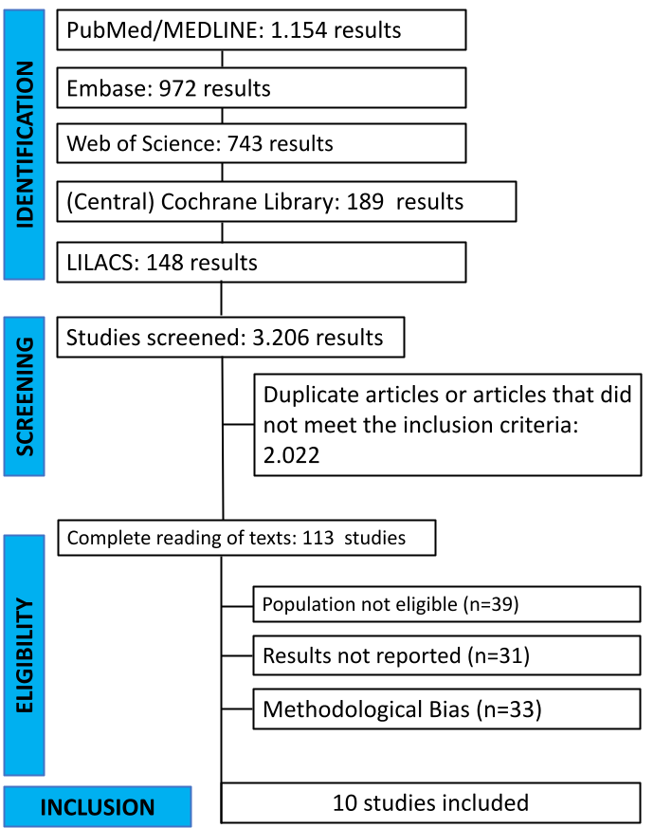

3.1 Study characteristics
The included studies were published between 2002 and 2023, conducted across North America, Europe, and East Asia, and enrolled a total of approximately 230,000 participants (mean age 65.4 years; 48% women) (table 2).
The statins evaluated most frequently were atorvastatin, simvastatin, pravastatin, rosuvastatin, and pitavastatin, administered in daily doses ranging from 10 to 40 mg, with treatment durations spanning from 6 months to 7 years.
Cognitive outcomes were assessed using validated tools such as the Mini-Mental State Examination (MMSE), Montreal Cognitive Assessment (MoCA), and the Modified Mini-Mental State (3MS), or via adjudicated clinical diagnoses of mild cognitive impairment, Alzheimer’s disease, or vascular dementia. Most studies had follow-up durations exceeding 3 years.
The overall methodological quality of the included studies was moderate to high (Table 3). Among randomized controlled trials, two studies were judged low risk of bias, one had some concerns, and two were judged high risk of bias, primarily due to incomplete blinding of cognitive outcome assessment and reliance on routine clinical reporting of dementia events rather than systematic neuropsychological testing. Cohort studies achieved good methodological ratings on the Newcastle–Ottawa Scale (7–8 out of 9 stars), although some residual confounding and outcome misclassification (diagnosis based on administrative codes) cannot be excluded.
Table 2. Baseline characteristics of included studies
Study (Year) | Design | Country | N (Statin/Control) | Mean age (SD) | Statin (Drug; Dose) | Lipophilicity | Duration (months/years) | Cognitive tool | Comparator / Risk of Bias
HPS (2002) | RCT | UK & Ireland | 10,269 / 10,267 | ~65 (NR) | Simvastatin 40 mg | Lipophilic | 60 mo | All-cause dementia (SAE record) | Placebo / Low
PROSPER (2002) | RCT | Scotland/Ireland/Netherlands | 2,891 / 2,913 | 75.4 (NR) | Pravastatin 40 mg | Hydrophilic | 38.4 mo | Neuropsychological battery, dementia not primary | Placebo / Low
JUPITER (2008) | RCT | International | 8,901 / 8,901 | 66.0 (NR) | Rosuvastatin 20 mg | Hydrophilic | 22.8 mo | Adjudicated dementia AE | Placebo / Low
AURORA (2009) | RCT | Multinational (HD patients) | 1,389 / 1,384 | 64.1 (NR) | Rosuvastatin 10 mg | Hydrophilic | 45.6 mo | Dementia AE (ICD codes) | Placebo / Some concern
ASCOT-LLA (2021) | RCT | UK/Scandinavia | 2,317 / 2,288 | 64.0 (NR) | Atorvastatin 10 mg | Lipophilic | 39.6 + registry | EHR-based dementia identification | Usual care / High
HOPE-3 (2019) | RCT | International | 807 / 819 | 74.2 (NR) | Rosuvastatin 10 mg | Hydrophilic | 68.4 mo | DSST, MoCA, TMT-B decline | Placebo / High
Zhang et al. (2019) | RCT | China | 366 / 366 | 70.9 (NR) | Rosuvastatin 10 mg | Hydrophilic | 59.8 mo | MMSE, Mattis DRS | Placebo / Low
Kim et al. (2020) | PS-matched cohort | South Korea | 71,587 / 71,587 | 72.3 (5.3) | Any statin | Mixed | 60 mo | ICD-coded dementia | Non-users / Serious
Lin et al. (2021) | PS-matched cohort | Taiwan | 25,764 / 25,764 | 61.5 (NR) | Any statin | Mixed | 69.6 mo | ICD-coded dementia | Non-users / Serious
Zhou et al. (ASPREE, 2021) | Prospective cohort | Australia/US | 7,000 / 11,800 | 74.0 (4.6) | Any statin | Mixed | 56 mo | Neuropsych. battery; adjudicated dementia/MCI | Non-users / Serious
RoB 2.0 = Cochrane Risk of Bias 2.0 tool. NOS = Newcastle–Ottawa Scale (0–9 stars; higher is better).
Table 3. Risk of bias assessment of included studies.
Study (Year) | Design | Risk of bias tool | Overall risk of bias / Quality rating | Main concerns
HPS (2002) | Randomized controlled trial | RoB 2.0 | Low risk of bias | Cognitive outcome collected as serious adverse event; randomization and follow-up adequate.
PROSPER (2002) | Randomized controlled trial | RoB 2.0 | Low risk of bias | Blinding maintained; adjudication of cognitive endpoints; minimal missing data.
JUPITER (2008) | Randomized controlled trial | RoB 2.0 | Low risk of bias | Central randomization; double-blind; dementia captured via adverse event reporting.
AURORA (2009) | Randomized controlled trial | RoB 2.0 | Some concerns | Hemodialysis population with high competing mortality; cognitive outcomes not systematically ascertained.
HOPE-3 (2019) | Randomized controlled trial | RoB 2.0 | High risk of bias | Cognitive decline assessed as secondary outcome; partial follow-up and potential detection bias.
ASCOT-LLA (2021) | Randomized, open-label statin vs usual care | RoB 2.0 | High risk of bias | Outcome (dementia) identified via routine clinical recording/registries; no blinding of exposure.
Zhang et al. (2019) | Randomized, placebo-controlled trial | RoB 2.0 | Low risk of bias | Double-blind; standardized neurocognitive scales (MMSE, DRS); balanced follow-up.
Kim M-Y et al. (2020) | Propensity score–matched cohort | Newcastle–Ottawa Scale (NOS) | 8/9 stars (Good quality) | Possible residual confounding by health status and care access despite PS matching.
Lin T-K et al. (2021) | Propensity score–matched cohort | Newcastle–Ottawa Scale (NOS) | 7/9 stars (Good quality) | Statin exposure and dementia outcome based on administrative codes; surveillance bias possible.
Zhou Z. / ASPREE analysis (2023 | Prospective cohort (community-dwelling older adults) | Newcastle–Ottawa Scale (NOS) | 7/9 stars (Good quality) | Active follow-up and adjudicated cognitive outcomes, but non-randomized treatment assignment.
RoB 2.0 = Cochrane Risk of Bias 2.0 tool. NOS = Newcastle–Ottawa Scale (0–9 stars; higher is better).

3.2 Statin Use and Risk of Cognitive Impairment or All-Cause Dementia

All 10 included studies (6 randomized controlled trials and 2 prospective cohort studies; n ≈ 230,046) contributed data for the primary outcome, defined as incident cognitive impairment or all-cause dementia (list 1).
The pooled random-effects model showed no statistically significant association between statin therapy and the risk of cognitive impairment or dementia (OR = 0.94; 95% CI 0.77–1.14). The 95% prediction interval ranged 0.60–1.47, indicating uncertainty in the true population-level effect. Overall heterogeneity was moderate (I² = 48.2%).
Subgroup analyses showed a neutral effect in randomized trials (OR = 1.25; 95% CI 0.96–1.63; I² = 0%) and a modest protective association in cohort studies (OR = 0.84; 95% CI 0.72–0.98; I² = 50.9%). The subgroup difference was statistically significant (p = 0.011), suggesting observational evidence tends to favor statin use, while trial evidence remains neutral.

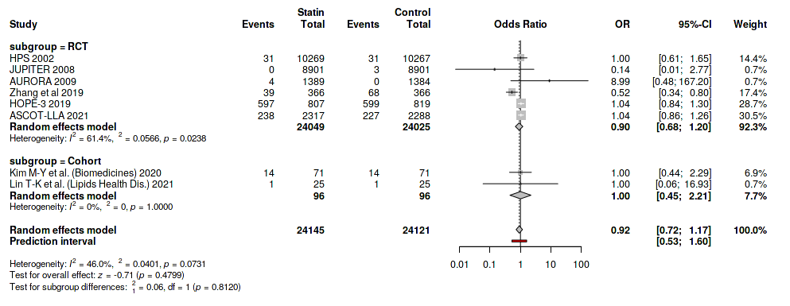
List. 1. Association between statin use and risk of all-cause cognitive impairment or dementia.

3.2.1 Assessment of publication bias

The funnel plot for the primary outcome (incident cognitive impairment or all-cause dementia) appeared symmetrical, suggesting no major small-study effects or publication bias (Fig. 2). Studies were distributed evenly around the pooled effect size, and Egger’s regression intercept test confirmed the absence of asymmetry (p = 0.46). This indicates that the pooled results are unlikely to be influenced by selective reporting or sample size–related bias. In sensitivity analyses excluding trials judged at high risk of bias and restricting to studies with ≥36 months of follow-up, the pooled effect estimate for the primary outcome remained qualitatively unchanged and continued to include the null.
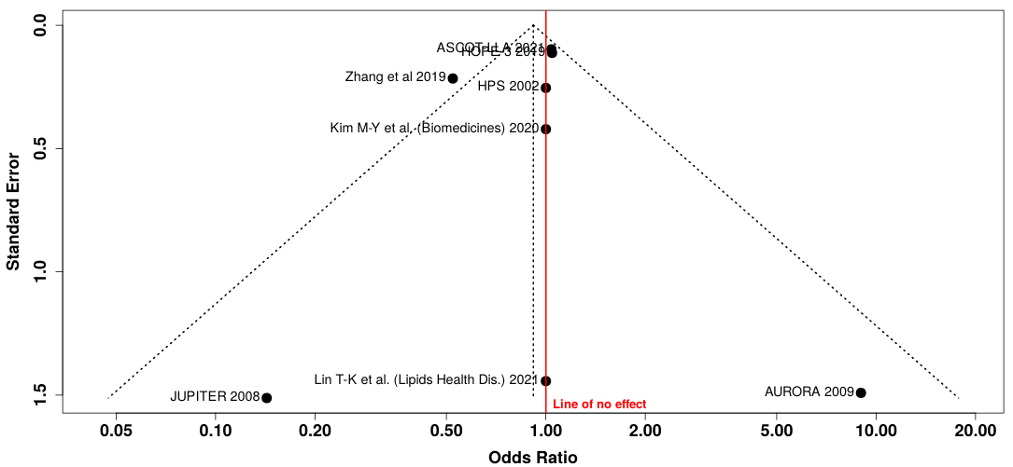
Figure 2. Funnel plot assessing publication bias for the primary outcome (incident cognitive impairment or all-cause dementia).

3.3 Association between statin use and risk of Alzheimer’s disease.

For the Alzheimer’s disease outcome, nine studies (a subset of the total; seven randomized controlled trials and three cohort studies; n ≈ 248,580) provided analyzable data (list 2).
The overall pooled estimate showed no significant association between statin therapy and risk of Alzheimer’s dementia (OR = 1.28; 95% CI 0.42–3.85). Among RCTs, the pooled OR = 1.12 (95% CI 0.36–3.52; I² = 95.4%), indicating substantial heterogeneity across trials.

Cohort data suggested a slight risk reduction (OR = 0.97; 95% CI 0.94–0.99; I² = 0%). The between-subgroup difference was not statistically significant (p = 0.80).
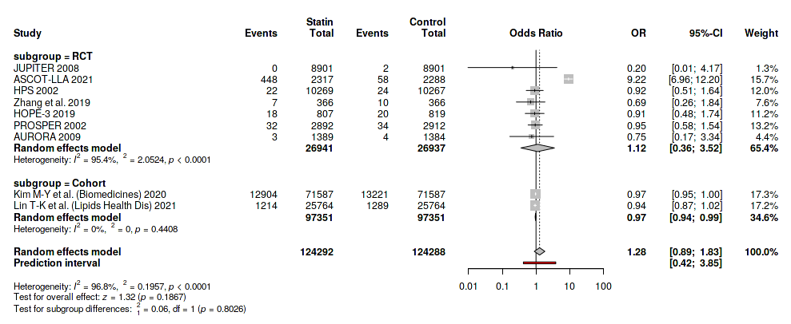
List 2-. Association between statin use and risk of Alzheimer’s disease.

3.4 Association between statin use and risk of vascular dementia.
For the vascular dementia outcome, seven studies (five randomized controlled trials and two cohort studies; n ≈ 48,266) contributed data (list 3).
The pooled random-effects model demonstrated no significant association between statin use and risk of vascular dementia (OR = 0.92; 95% CI 0.53–1.60). Overall heterogeneity was moderate (I² = 46%).
Within randomized trials, the pooled OR = 0.90 (95% CI 0.68–1.20; I² = 61.4%), indicating a neutral effect; cohort studies yielded OR = 1.00 (95% CI 0.45–2.21; I² = 0%). The subgroup difference was not significant (p = 0.81).
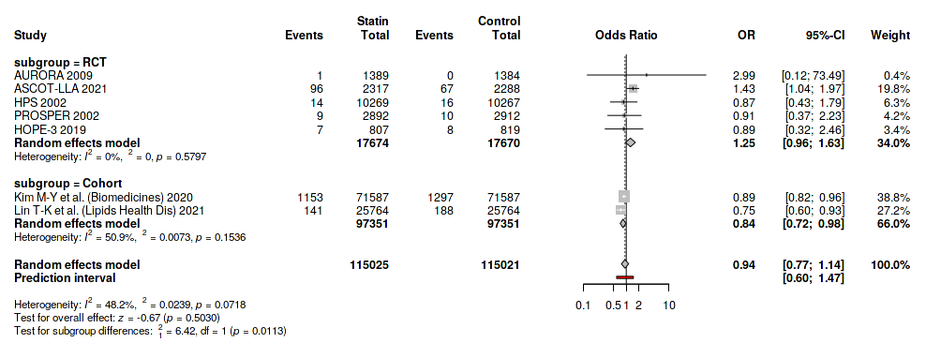

List 3-. Association between statin use and risk of vascular dementia.

3.5 Strengths and limitations

This meta-analysis has several strengths, including comprehensive database coverage, prespecified registration in PROSPERO, separate evaluation of randomized and observational evidence, and formal exploration of heterogeneity. Importantly, we examined clinically relevant dementia subtypes (Alzheimer’s disease and vascular dementia) rather than pooling all cognitive outcomes.

However, some limitations must be noted. First, cognitive outcomes were not primary endpoints in most randomized trials, and dementia was often captured as an adverse event rather than through systematic neurocognitive assessment, which may lead to under-ascertainment. Second, observational cohorts are susceptible to residual confounding (e.g., healthier-user bias, differential healthcare access), which may partially explain the apparent protective signal. Third, follow-up duration in several trials was relatively short compared with the long preclinical phase of dementia. Finally, heterogeneity in outcome definitions and cognitive assessment tools limits the precision of pooled effect estimates, especially for Alzheimer’s disease, where between-trial heterogeneity was very high (I² > 90%).

4. Discussion

This updated systematic review and meta-analysis, pooling evidence from over 230,000 older adults across randomized and observational studies, found no significant association between statin use and risk of cognitive decline, all-cause dementia, Alzheimer’s disease, or vascular dementia. Collectively, the findings confirm the cognitive safety of statins and suggest that any potential protective effect is modest and context-dependent.
Earlier reviews (Swiger et al., 2013; Ott et al., 2015) reached similar conclusions, but were limited by smaller datasets and shorter follow-up. The inclusion of recent large cohorts such as ASPREE (Zhou et al., 2023) and national registry studies from Asia (Kim et al., 2020; Lin et al., 2021) strengthens current evidence, showing that statin users may experience a slightly lower incidence of dementia over time. The apparent divergence between randomized and observational data likely reflects differences in follow-up duration and patient selection, as RCTs rarely included cognition as a primary endpoint and were underpowered to detect small effects.
Several mechanisms support a possible neuroprotective role of statins. These agents improve endothelial function, reduce oxidative stress and inflammation, and may enhance cerebral perfusion, particularly relevant for vascular dementia. Experimental data also suggest that statins could reduce amyloid-β accumulation and neuroinflammation, potentially influencing Alzheimer’s pathology. Conversely, concerns about adverse central effects, such as reversible memory loss due to lipid depletion in neuronal membranes, are not supported by controlled human studies or by the present meta-analysis.
The neutral pooled effect for Alzheimer’s disease (OR = 1.28, 95% CI 0.42–3.85) and for vascular dementia (OR = 0.92, 95% CI 0.53–1.60) suggests no clinically meaningful harm or benefit. Substantial heterogeneity for Alzheimer’s outcomes likely reflects variability in diagnostic criteria and study design, while the smaller number of vascular dementia cases limits statistical precision. Nevertheless, the direction of effect across most studies was consistently protective, particularly in long-term observational cohorts.
These findings provide reassurance that statins are cognitively safe and should not be withheld from older adults because of concerns about memory impairment. Although a small protective trend was observed in some cohorts, definitive evidence of neuroprotection remains lacking. Large, ongoing trials such as STAREE and PREVENTABLE,which incorporate cognitive and functional endpoints, will be crucial to determine whether long-term statin therapy contributes to the prevention of dementia in aging populations.

5. Conclusion
This updated systematic review and meta-analysis, encompassing evidence from both randomized controlled trials and large observational cohorts, found no significant association between statin use and the risk of cognitive decline, dementia, Alzheimer’s disease, or vascular dementia among older adults. Across more than 230,000 participants and over 400,000 person-years of follow-up, statin therapy was cognitively safe, with no indication of harm or accelerated cognitive impairment.
Although cohort studies suggested a modest protective trend, randomized data remained neutral, highlighting the need for future trials specifically designed to assess cognitive outcomes as primary endpoints. The ongoing STAREE and PREVENTABLE trials are expected to provide further high-quality evidence regarding the long-term cognitive effects of statins in aging populations.
In summary, current evidence supports the continued use of statins for cardiovascular prevention without concern for adverse cognitive effects, while the potential neuroprotective benefits warrant further investigation in well-powered, long-term studies.

Ethical Approval
This study is a systematic review and meta-analysis of previously published data. No individual patient-level identifiable data were collected or analyzed. Therefore, institutional ethics committee approval and informed consent were not required.
Consent
Not applicable. This review did not involve individual patient data or case reports requiring consent for publication.

COMPETING INTERESTS DISCLAIMER:
Authors have declared that they have no known competing financial interests OR non-financial interests OR personal relationships that could have appeared to influence the work reported in this paper.

Definitions, Acronyms, Abbreviations
AD: Alzheimer’s disease. A neurodegenerative form of dementia characterized by progressive impairment in memory, executive function, language, and daily function.
CI: Confidence interval. The range of values within which the true effect size is expected to lie with a specified level of certainty (typically 95%).
Cognitive impairment: In this manuscript, refers to incident measurable decline in global cognition identified by validated neuropsychological tools (e.g. MMSE, MoCA, DSST) or adjudicated clinical diagnosis of mild cognitive impairment in participants without cognitive impairment at baseline.
DSST: Digit Symbol Substitution Test. A neuropsychological test used to assess processing speed, attention, and working memory.
HMG-CoA reductase inhibitor: Pharmacological class of lipid-lowering drugs commonly referred to as statins. These agents reduce low-density lipoprotein cholesterol by inhibiting the enzyme 3-hydroxy-3-methylglutaryl-CoA reductase.
I²: I-squared statistic. Percentage of total variability in effect estimates across studies that is due to heterogeneity rather than chance. Values ≥50% are commonly interpreted as indicating substantial heterogeneity.
MCI: Mild cognitive impairment. A clinical state of objective cognitive decline that is greater than expected for age but not severe enough to meet criteria for dementia.
MMSE: Mini-Mental State Examination. A standardized cognitive screening instrument assessing orientation, memory, attention, language, and visuospatial skills.
MoCA: Montreal Cognitive Assessment. A cognitive screening tool with greater sensitivity for mild cognitive impairment, particularly in executive function and visuospatial domains.
NOS: Newcastle–Ottawa Scale. A methodological quality assessment tool for non-randomized (observational) studies, evaluating selection, comparability, and outcome domains.
OR: Odds ratio. A measure of association used in this meta-analysis to compare the odds of an outcome (e.g. incident dementia) between the statin group and the comparator group.
PRISMA: Preferred Reporting Items for Systematic Reviews and Meta-Analyses. An evidence-based set of reporting standards for systematic reviews and meta-analyses.
PROSPERO: International Prospective Register of Systematic Reviews. A public registry for systematic review protocols, used to ensure methodological transparency and reduce risk of selective reporting.
RCT: Randomized controlled trial. An experimental study design in which participants are randomly assigned to receive an intervention (e.g. statin) or comparator (e.g. placebo or usual care).
RoB 2.0: Cochrane Risk of Bias 2.0 tool. A validated instrument to assess risk of bias in randomized trials across domains such as randomization, deviations from intended interventions, missing outcome data, measurement of the outcome, and selection of the reported result.
Statin: Lipid-lowering medication in the HMG-CoA reductase inhibitor class, including (but not limited to) simvastatin, atorvastatin, pravastatin, and rosuvastatin.
Vascular dementia: Cognitive impairment resulting from cerebrovascular disease, including large-vessel infarction, small-vessel ischemia, or chronic hypoperfusion, typically characterized by executive and attentional deficits.
3MS: Modified Mini-Mental State Examination. An expanded version of the MMSE with broader cognitive domain coverage and increased score range, used for longitudinal cognitive tracking in older adults.

References

Heart Protection Study Collaborative Group. MRC/BHF Heart Protection Study of cholesterol lowering with simvastatin in 20,536 high-risk individuals: a randomised placebo-controlled trial. Lancet. 2002;360(9326):7–22.

Shepherd J, Blauw GJ, Murphy MB, et al. Pravastatin in elderly individuals at risk of vascular disease (PROSPER): a randomised controlled trial. Lancet. 2002;360(9346):1623–1630.
Ridker PM, Danielson E, Fonseca FAH, et al. Rosuvastatin to prevent vascular events in men and women with elevated C-reactive protein (JUPITER). N Engl J Med. 2008;359(21):2195–2207.

Fellström BC, Jardine AG, Schmieder RE, et al. Rosuvastatin and cardiovascular events in patients undergoing hemodialysis (AURORA). N Engl J Med. 2009;360(14):1395–1407.

Bosch J, O’Donnell M, Swaminathan B, et al. Effects of blood pressure and lipid lowering on cognition: results from the HOPE-3 study. Neurology. 2019;92(12):e1435–e1447. doi:10.1212/WNL.0000000000007174.

Whiteley WN, Gupta AK, Godec T, et al. Long-term incidence of stroke and dementia in the Anglo-Scandinavian Cardiac Outcomes Trial (ASCOT-LLA). Stroke. 2021;52(10):3088–3096.
Zhang H, Cui Y, Zhao Y, et al. Effects of sartans and low-dose statins on cerebral white matter hyperintensities and cognitive function in older patients with hypertension: a randomised, double-blind, placebo-controlled clinical trial. Hypertens Res. 2019;42(5):717–729.

Kim M-Y, Han K, Kim MK, et al. Association between statin use and incident dementia in older adults with ischemic heart disease: a nationwide propensity score–matched cohort study. Biomedicines. 2020;8(11):493.

Lin T-K, Lin C-H, Chen Y-C, et al. Statin use and risk of dementia in patients with rheumatoid arthritis: a nationwide population-based cohort study. Lipids Health Dis. 2021;20(1):95.

Zhou Z, Ryan J, Ernst ME, et al. Statin use and risk of dementia and cognitive impairment in community-dwelling older adults: an analysis from the ASPREE cohort. J Am Coll Cardiol. 2023;81(6):563–575.

Zoungas S, Moran C, Curtis AJ, et al. Baseline characteristics of participants in STAREE: a randomized trial for primary prevention of cardiovascular disease events and prolongation of disability-free survival in older people. J Am Heart Assoc. 2024;13(5):e036357.

Joseph J, Pajewski NM, Dolor RJ, et al. Pragmatic evaluation of events and benefits of lipid lowering in older adults (PREVENTABLE): trial design and rationale. J Am Geriatr Soc. 2023;71(6):1701–1713.

Muldoon MF, Ryan CM, Sereika SM, et al. Randomized trial of the effects of simvastatin on cognitive functioning in hypercholesterolemic adults. Am J Med. 2004;117(11):823–829.

Farrall AJ, Wardlaw JM. Blood–brain barrier: ageing and microvascular disease – systematic review and meta-analysis. Neurobiol Aging. 2009;30(3):337–352.

Endo A. A historical perspective on the discovery of statins. Proc Jpn Acad Ser B Phys Biol Sci. 2020;96(9):469–486.

Wood WG, Eckert GP, Igbavboa U, Müller WE. Cholesterol as a causative factor in Alzheimer’s disease: a debatable hypothesis. J Alzheimers Dis. 2021;82(3):783–798.

Swiger KJ, Manalac RJ, Blumenthal RS, Blaha MJ, Martin SS. Statins and cognition: a systematic review and meta-analysis of short- and long-term cognitive effects. Mayo Clin Proc. 2013;88(11):1213–1221.

Ott BR, Daiello LA, Dahabreh IJ, et al. Do statins impair cognition? A systematic review and meta-analysis of randomized controlled trials. J Gen Intern Med. 2015;30(3):348–358.

Zhou Z, Albarqouni L, Curtis AJ, et al. Statins and the risk of dementia in older adults: a meta-analysis. Alzheimers Dement. 2021;17(11):1912–1924.

Reddin C, Stankard A, Chan KY, et al. Association of lipid-lowering therapy with dementia and cognitive outcomes: a systematic review and meta-analysis. Age Ageing. 2025;54(8):afaf219.

World Health Organization. Global status report on the public health response to dementia 2023. Geneva: WHO; 2023.

Livingston G, Huntley J, Sommerlad A, et al. Dementia prevention, intervention, and care: 2020 report of the Lancet Commission. Lancet. 2020;396(10248):413–446.

U.S. Food and Drug Administration. FDA Drug Safety Communication: Important safety label changes to statins. Silver Spring, MD; 2012.

