Teledentistry in Oral Lesion Screening: A Retrospective Observational Study Using the TeleEstomato-MG Platform

ABSTRACT

Aims: This study explores the experience of using the TeleEstomato-MG application, developed for teledentistry, between November 2022 and September 2024, aimed at the diagnosis and management of oral lesions. Teledentistry, a subset of telehealth, enabled asynchronous consultations, providing essential support to communities with limited access to specialized services.
Study design: This study is characterized as a retrospective descriptive observational study, carried out through documentary analyses of teleconsultations.
Place and Duration of Study: School of Dentistry, Federal University of Alfenas, between November 2022 and September 2024.
Methodology: A total of 263 asynchronous teleconsultations were recorded, demonstrating the feasibility and importance of this model of care in oral health. Patient data were extracted from the Google Glide platform, automatically generated in Microsoft Excel, and then a simple descriptive analysis of the case reports with the recorded epidemiological data was performed.
Results: The analyzed sample revealed a predominance of male patients (52.1%) with an average age of 53 years. Lesions on the tongue were the most prevalent (27.4%), followed by lesions on the lips (17.8%). The early detection of malignant oral lesions was emphasized, considering the importance of accurate diagnoses for the management of oral pathologies. The analysis of diagnostic hypotheses indicated that 75.6% of cases were benign lesions of other natures, while 13.7% were classified as potentially malignant oral disorders and 10.7% as malignant oral lesions.
Conclusion: The results suggest that the TeleEstomato-MG application proved effective in triaging and accelerating the diagnosis of oral lesions, facilitating access to dental care and promoting collaboration among professionals. Teledentistry emerges as a valuable tool in primary care, contributing to democratizing access to oral health services.

Keywords: Teledentistry. Oral lesions. Telehealth. Remote diagnosis.

1. INTRODUCTION

The COVID-19 pandemic created an unexpected scenario of isolation, imposing significant barriers to healthcare systems worldwide. In this context, the impossibility of direct contact between dentists and patients highlighted the need for solutions to ensure continuity of care (Ghai, 2020; Kochhar et al., 2020). Teledentistry, a subset of telehealth, emerged as a response to this demand, using digital technologies for remote consultations, which can be classified as synchronous (via videoconference) or asynchronous (through photographic records) (Flores et al., 2020; Minervini et al., 2022; Uhrin et al., 2023). During this period, this approach was fundamental in providing continuous basic care, especially to residents of rural areas and oncology patients (Cardozo, 2022; Firincioglulari & Orhan, 2021; Flores-Hidalgo et al., 2023).
Telehealth has been widely investigated in studies focused on improving disease surveillance and offering remote multidisciplinary consultations to patients with limited access, standing out as a low-cost and effective alternative (Dailah, 2022; Paixão et al., 2022). In leading oncology healthcare centers in the United States, this practice is promoted as a valuable tool for initial screening and early cancer diagnosis (Brenner & Hearing, 2008; Dailah, 2022; Nguyen et al., 2023).
Oral pathology can benefit significantly from telehealth, as this tool can provide accurate diagnoses, reducing the time between diagnosis and treatment (Ilhan et al., 2022). This directly impacts the early detection of oral lesions such as oral cancer and expands access to specialized dental care (Flores-Hidalgo et al., 2023; Nguyen et al., 2023). Diagnosing oral lesions can be challenging due to their variable clinical presentation and the similarities between potentially malignant and benign lesions, which complicate differential diagnosis (Nguyen et al., 2023; Uhrin et al., 2023). Early detection and monitoring of potentially malignant oral lesions can prevent their progression to oral cancer (Firincioglulari & Orhan, 2021; Uhrin et al., 2023). In this sense, teledentistry is essential for the early diagnosis of malignant lesions, enabling faster interventions and increasing the effectiveness of oral cancer treatment (Flores et al., 2020).
Based on the presented scientific literature and the scarcity of studies reporting the experience of using teledentistry linked to primary care, the aim of this article is to describe the asynchronous use of the TeleEstomato-MG application between November 2022 and August 2024, as well as to assess, identify, and manage oral lesions through this technology.

2. MATERIAL AND METHODS
This study is characterized as a retrospective descriptive observational study, in which cases submitted between November 2022 and September 2024 through the TeleEstomato-MG application from the macro-region of southern Minas Gerais (Brazil), covering 24 municipalities, were selected. Developed to accelerate the diagnosis of oral lesions, the application also aims to guide therapeutic management, thus contributing to better prognosis and quality of life for patients.
Before submitting a teleconsultation request, professionals registered in the application completed a form that included information such as full name, age, sex, city, profession, specialty, and level of care. For case submission, professionals performed a clinical examination containing the patient’s initials, age, sex, location and description of the lesion, as well as symptoms, medical history, medication use, presence of harmful habits, and photographs or radiographs of the areas of interest (Figure 1A and Figure 1B).
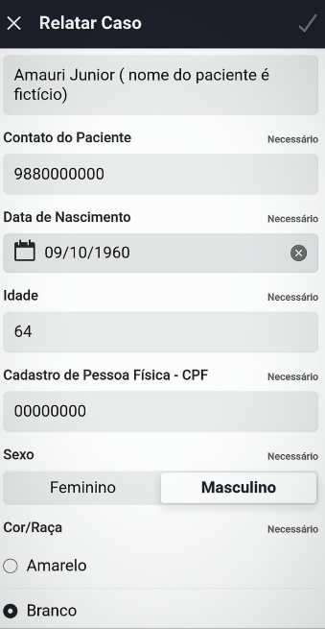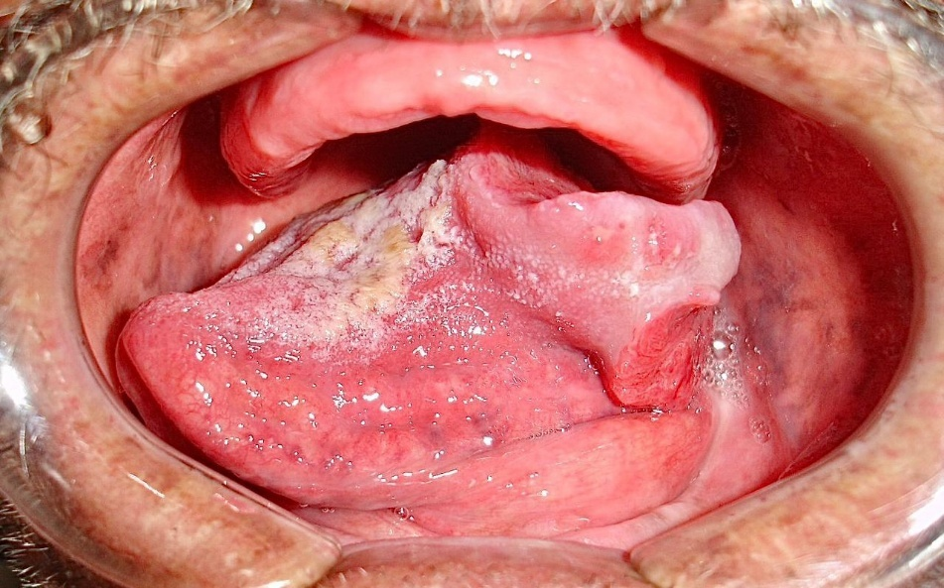
Figure 1: A: Submission of a case report through the TeleEstomato-MG application. B: Photograph of the case submitted by the teleconsultation requester via the TeleEstomato-MG application, with a diagnostic hypothesis of squamous cell carcinoma.

The collected variables include information related to the case reports. The data encompass the total number of cases recorded during the mentioned period, the distribution of patients by age and sex, harmful habits, lesion location, diagnostic hypotheses proposed both by the requesting professionals and the teleconsultants, and, finally, the final diagnosis.

3. RESULTS AND DISCUSSION
The present study analyzed the experience of a remote diagnostic support service in teledentistry, using the TeleEstomato-MG platform, between November 2022 and September 2024. A total of 263 asynchronous teleconsultations were recorded, demonstrating the feasibility and importance of this care model in oral health, especially in contexts where access to specialists is limited (Cardozo, 2022; Ilhan et al., 2022). It is known that 85% of dentists face difficulties in detecting, diagnosing, and treating oral lesions. The introduction of teledentistry platforms can help meet this demand (Almubarak, 2022). The high usability rates of TeleEstomato-MG indicate great potential to effectively bridge this gap.
A cross-sectional observational study conducted by Quites et al. and published in the journal Saúde em Debate aimed to analyze the actions of Primary Health Care (PHC) in response to the COVID-19 pandemic in municipalities of Minas Gerais, from the perspective of managers and coordinators. The results showed that telehealth emerged as a promising strategy when implemented in PHC, contributing to improved access, problem-solving capacity, comprehensiveness, and scope of care, in addition to optimizing the monitoring of individuals with chronic diseases (Quites et al., 2023). In this sense, the TeleEstomato-MG application, based on asynchronous teleconsultations that included images and demographic profiles of patients, made it possible to conduct the sample analysis, since the visual information of the lesions is crucial for consultants’ decision-making (Czerniski, Mordekovich & Basile, 2022; Gurgel-Juarez et al., 2022; Lin et al., 2021; Quites et al., 2023).
The demographic analysis revealed a predominance of male patients (52.1%, n=137), while 47.9% (n=126) were female, with an average age of 53 years. This age and gender distribution is significant, as oral lesions tend to be more common in middle-aged individuals and in the male population, reflecting trends observed in previous studies (Bajracharya et al., 2017). Furthermore, the racial composition of the sample showed that 70% (n=184) of participants were White, consistent with studies by Cunha JLS et al. (2023) and Daroit NB et al. (2023). This predominance may be related to the fact that darker skin exhibits more effective melanin production, providing greater protection against malignant proliferation of epidermal cells, as illustrated in Figure 2 (Brenner & Hearing, 2008; Cunha et al., 2023; Daroit, 2023).
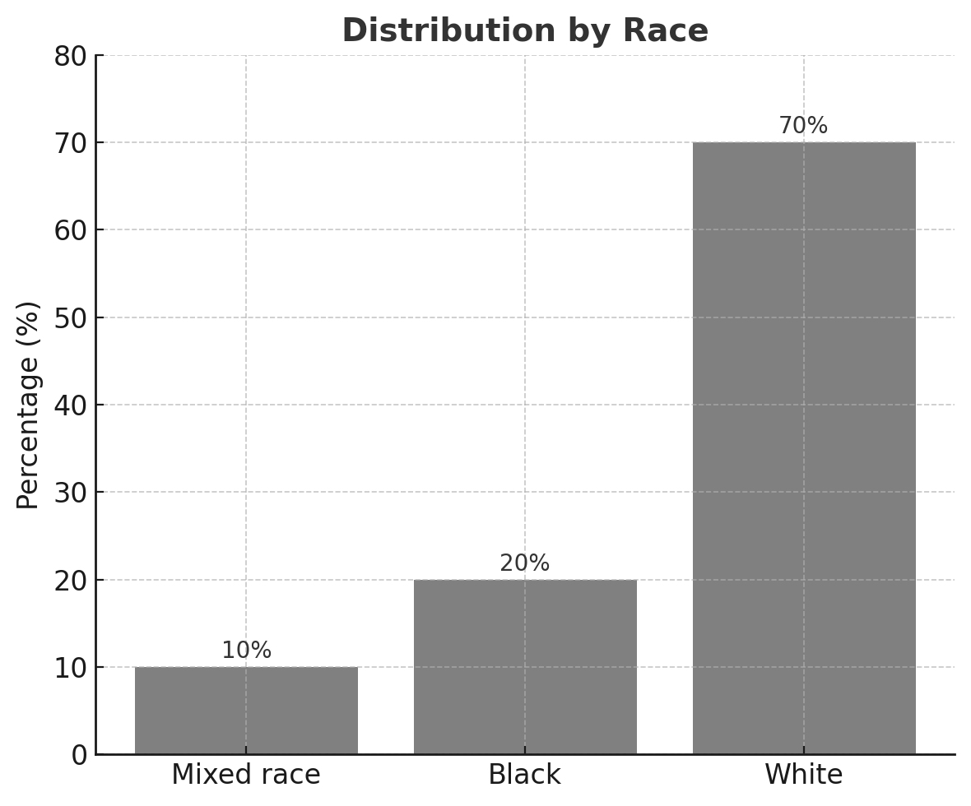
Figure 2. Distribution of patients by race.
Data on patients’ habits and behaviors are particularly alarming. Tobacco use was reported in 16.3% (n=43) of cases, and the combination of tobacco with alcohol consumption in 5% (n=13), corroborating evidence that associates these factors with an increased risk of developing malignant oral lesions (Collins et al., 2021; Mehrotra et al., 2010). Other habits were also documented, including former smokers (6%, n=16), combination of former smokers and alcohol users (0.38%, n=1), alcohol users (6%, n=16), former alcohol users (2.28%, n=6), and illicit drug use (0.38%, n=1). The absence of information regarding habits in 63.66% (n=167) of cases highlights a significant barrier in collecting essential data for accurate diagnoses.
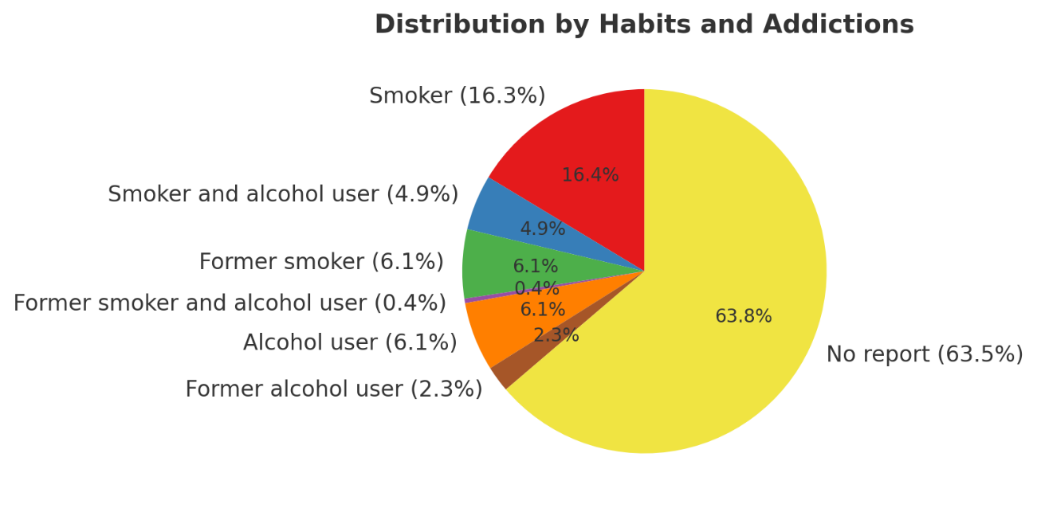

Figure 3. Chart of distributions by habits and addictions. It is noteworthy that most requesters did not provide this information.
The analysis of the anatomical location of the lesions revealed the following distribution in descending order: tongue lesions (27.4%, n=72), lips (17.8%, n=47), buccal mucosa (14.5%, n=38), and other types of lesions (14.4%, n=38). The palate accounted for 12.6% (n=33), and the alveolar ridge for 5.7% (n=15). Lesions on the gingiva and floor of the mouth occurred with a frequency of 3.42% (n=9) each, while intraosseous lesions were rare (0.38%, n=1). The high prevalence of lesions in easily visible regions highlights the importance of early diagnosis, which can be facilitated by the use of telehealth technologies (Gupta et al., 2023) (Figure 4).
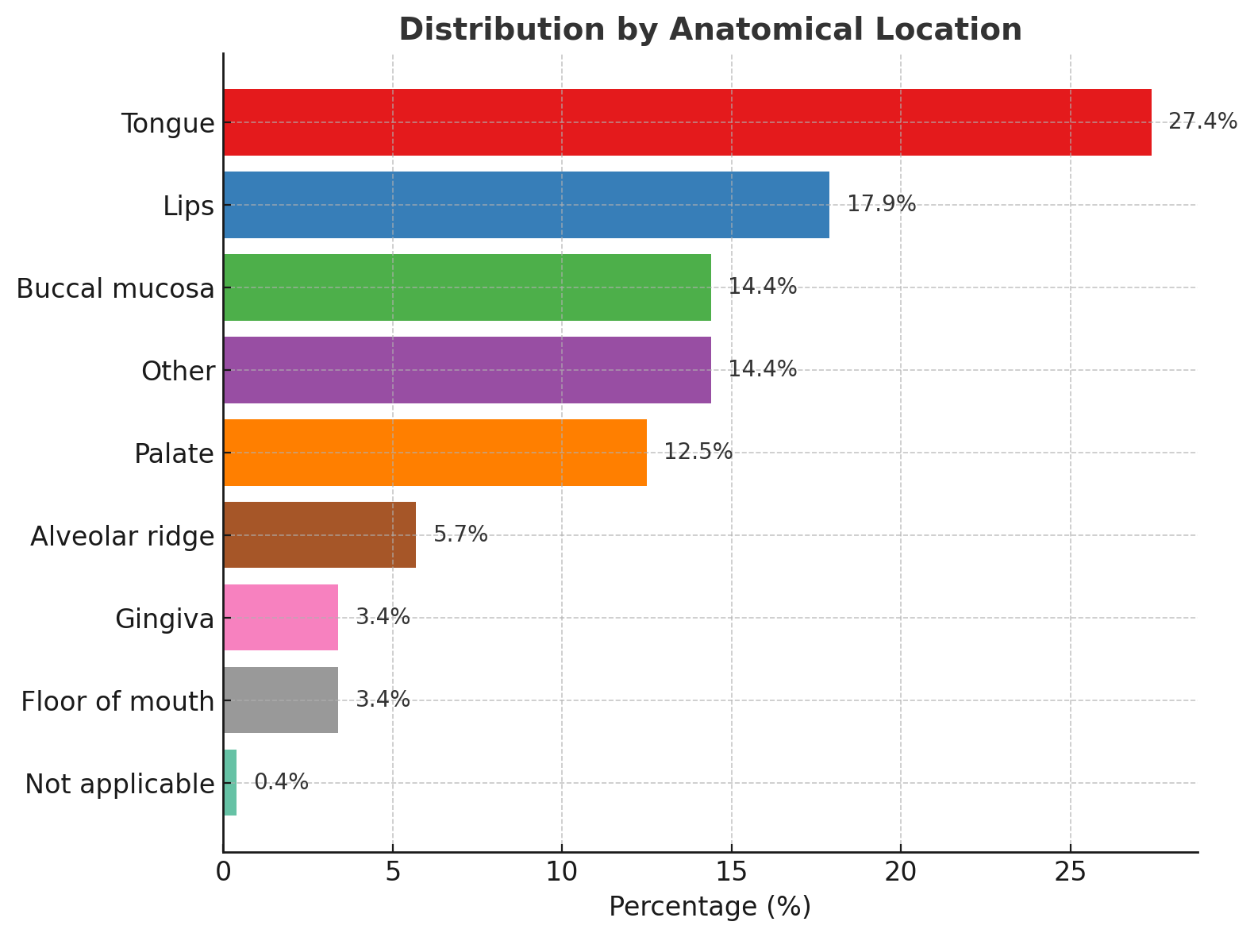

Figure 4. Distribution of lesions by anatomical location. The tongue was the most frequently affected site, followed by the lips, buccal mucosa, and palate.

Additionally, the diagnostic suspicions reported by the requesting dentists were analyzed. Lesions of other natures accounted for 75.6% (n=199), potentially malignant oral disorders for 13.7% (n=36), and malignant neoplasms for 9.5% (n=25). This distribution of suspicions is consistent with a multicenter study conducted by Cunha JLS et al., which identified that the most common oral lesions in elderly patients were reactive lesions, followed by malignant neoplasms, with 29.8% of the cases analyzed presenting this type of cancer. Among them, 83.4% were diagnosed with squamous cell carcinoma, the most prevalent type of oral cancer (see Figure 5) (Cunha et., 2023).
al., 2023).
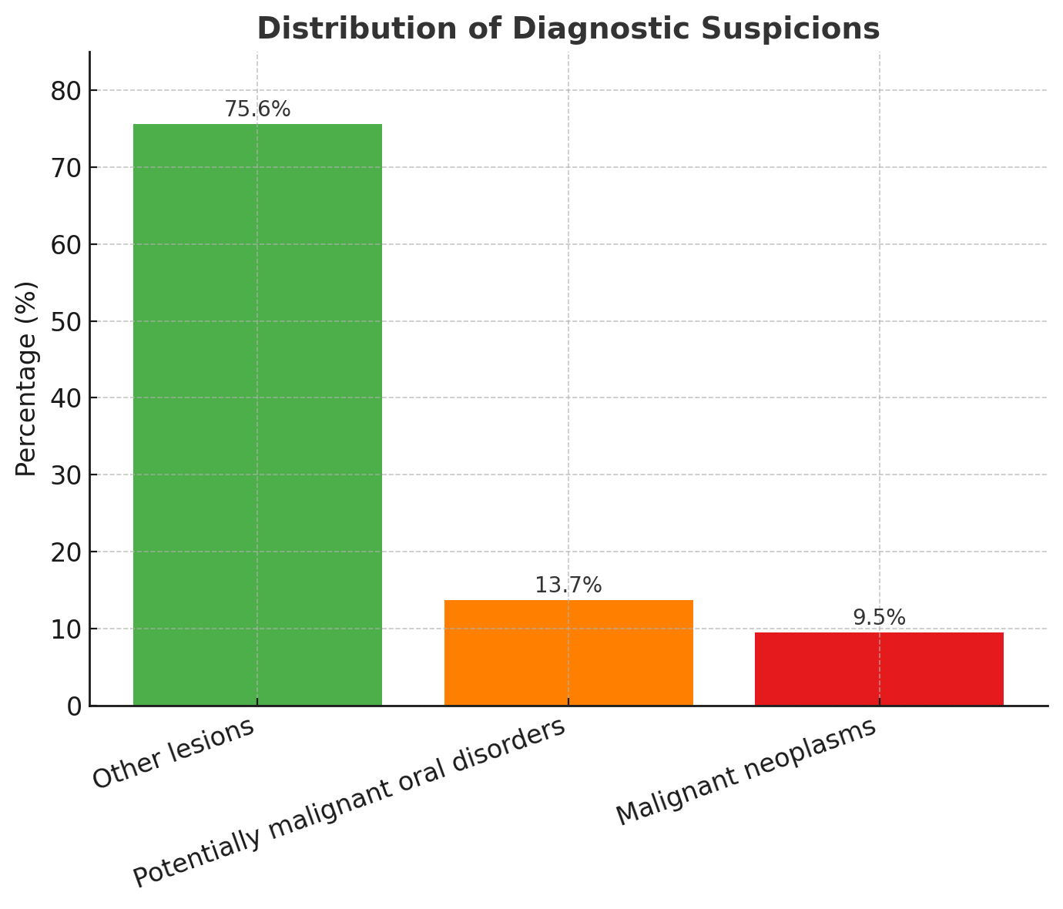

Figure 5. Distribution of diagnostic suspicions. The majority of cases were classified as other lesions, while a smaller proportion corresponded to potentially malignant disorders and malignant neoplasms.
Studies show that diagnoses made by teleconsultant specialists demonstrate levels of accuracy comparable to those performed by in-person specialists, particularly regarding potentially malignant oral lesions and cancer (Da Silva et al., 2021; Dailah, 2022; Nguyen et al., 2023). The aim of these applications is to provide access to the entire population, optimize referrals to healthcare centers, and enhance collaboration among professionals and healthcare units (Dos Santos et al., 2024; Khoury & Sultan, 2020).
However, some barriers in teleconsultation requests have been identified, mainly related to the absence of information about the duration of lesion evolution and medication use. The platform encourages professionals to provide these details, as they are crucial for an accurate diagnosis by the teleconsultant (Cardozo, 2022).

4. CONCLUSION

The contribution of specialized healthcare professionals is essential for the screening of oral lesions, as it provides strategies that enable dentists to accelerate diagnoses and ensure immediate referrals when necessary. The TeleEstomato-MG application proved effective in outlining the demographic profile of the assisted population, mapping the regions affected by lesions, and identifying patients’ harmful habits. These data allowed the establishment of significant correlations among these variables. Thus, it can be concluded that recent studies highlight telehealth as an effective tool for diagnosing, planning, and monitoring dental treatments. This approach is revolutionizing care in primary healthcare, hospitals, and remote areas, promoting democratized access to free and high-quality dentistry, and should be further encouraged.

Ethical Approval
This study was conducted in accordance with the ethical principles governing research involving human subjects. All data were anonymized, with no possibility of identifying patients or professionals. The project was approved by the Research Ethics Committee of the Federal University of Alfenas (UNIFAL-MG), under approval number 5.641.950. This framework ensures the confidentiality and integrity of the data, in compliance with applicable ethical and legal guidelines, including the Brazilian General Data Protection Law (Law No. 13.709/2018).

Consent for Publication
All authors declare that written informed consent was obtained from the patient (or their legal representative) for the publication of this case report and accompanying images.

COMPETING INTERESTS DISCLAIMER:
Authors have declared that they have no known competing financial interests OR non-financial interests OR personal relationships that could have appeared to influence the work reported in this paper.

REFERENCES

Almubarak, H. (2022). The Potential Role of Telemedicine in Early Detection of Oral Cancer. Journal of Pharmacy and Bioallied Sciences, 14(1), 19–23. DOI 10.4103/jpbs.jpbs_641_21

Bajracharya, D., Gupta, S., Ojha, B., & Baral, R. (2017)Prevalência de lesões da mucosa oral em um hospital odontológico de atendimento terciário de Kathmandu. J Nepal Med Assoc , 56(207), 362–366. DOI 10.1590/S1413-81232010000800028

Brenner, M., & Hearing, V. J. (2008). The protective role of melanin against UV damage in human skin. Photochemistry and Photobiology, 84(3), 539-549. DOI 10.1111/j.1751-1097.2007.00226.x

Cardozo, I., da Silva, V. C., Perdoncini, N., & Torres-Pereira, C. C. (2022). Telehealth in Oral Medicine: of an experience from public health care in a southern Brazilian state. Original Research Stomatology, 36, 0031. DOI 10.1590/1807-3107bor-2022.vol36.0031

Collins, J. R., Brache, M., Ogando, G., Veras, K., & Rivera, H. (2021) . Prevalence of oral mucosal lesions in an adult population from eight communities in Santo Domingo, Dominican Republic. Acta Odontol. Latinoam, 34(3), 249–256. DOI 10.54589/aol.34/3/249

Cunha, J. L. S., Cavalcante, I. L., Rodrigues, A. B. R., de Sousa-Catão, N. E., Cruz, V. M. S., & Turatti, E., et al. (2023). A retrospective multicenter study of oral and maxillofacial lesions in older people. Brazilian Oral Research, 37, e098. DOI 10.1590/1807-3107BOR-2023.VOL37.0098

Czerninski, R., Mordekovich, N., & Basile, J. (2022). Factors important in the correct evaluation of oral high-risk lesions during the telehealth era. Journal of Oral Pathology and Medicine, 51(8), 747–754. DOI 10.1111/jop.13343
Da Silva, H. E. C., Santos, G. N. M., Leite, A. F., Mesquita, C. R. M., de Souza-Figueiredo, P. T., & dos Reis, P. E. D., et al. (2021). The role of teledentistry in oral cancer patients during the COVID-19 pandemic: an integrative literature review. Supportive Care in Cancer Springer Science and Business Media Deutschland GmbH. 29(12), 7209-7223. DOI 10.1007/s00520-021-06398-0

Dailah, H. G.(2022). Mobile Health (mHealth) Technology in Early Detection and Diagnosis of Oral Cancer-A Scoping Review of the Current Scenario and Feasibility. Journal of Healthcare EngineeringHindawi Limited. 2022. DOI 10.1155/2022/4383303

Daroit, N. B., Martins, L. N., Garcia, A. B.,Haas, A. N., Maito, F. L. D. M., & Rados, P. V. (2023). Oral cancer over six decades: a multivariable analysis of a clinicopathologic retrospective study. Brazilian Dental Journal, 34(5), 115–124. DOI 10.1590/0103-6440202305264

Dos Santos, R. T. N., Faria, C. A. B., Martins, N. F., de Sousa, D. J. L. G., Azevêdo, A. B. F., & da Silva, W. R., et al. (2024). Use of digital strategies in the diagnosis of oral squamous cell carcinoma: a scoping review. PeerJ, 12(5). DOI 10.7717/peerj.17329

Firincioglulari, M., Orhan, K. (2021). Teledentistry as a Supportive Tool for Dentists in Diagnosing MRONJ in Northern Cyprus. BioMed Research International, 2021. DOI 10.1155/2021/5657152

Flores, A. P. C., Lazaro, S. A., Molina-Bastos, C. G., Guattini, V. L. de O., Umpierre, R. N., & Gonçalves, M. R. et al. (2020). Teledentistry in the diagnosis of oral lesions: A systematic review of the literature. Journal of the American Medical Informatics Association. Oxford University Press, 27(7), 1166-1172. DOI 10.1093/jamia/ocaa069

Flores-Hidalgo, A., Collie, J., King, S., Grant, F. T., Beasley, N. E., & Beasley, N. E., et al. (2023).The use of teledentistry in clinical oral and maxillofacial pathology practice: an institutional experience. Frontiers in Oral Health, 4, 1063973. DOI 10.3389/froh.2023.1063973

Ghai, S. (2020). Teledentistry during COVID-19 pandemic. Diabetes and Metabolic Syndrome: Clinical Research and Reviews, 14(5), 933–935. DOI 10.1016/j.dsx.2020.06.029
Gupta, A., Shrestha, P., Poudyal, S., Kumar, S., Lamichhane, R. S., & Acharya, S. K. et al. (2023). Prevalence and Distribution of Oral Mucosal Lesions and Normal Variants among Nepalese Population. BioMed Research International, 2023. DOI 10.1155/2023/9375084

Gurgel-Juarez, N., Torres-Pereira, C., Haddad, A. E., Sheehy, L., Finestone, H., & Mallet, K. et al. (2022). Accuracy and effectiveness of teledentistry: a systematic review of systematic reviews. Evidence-Based DentistrySpringer Nature. DOI 10.1038/s41432-022-0257-8

Ilhan, B., Bayrakdar, I. S., Baydar, O., & Guneri, P. (2022). Is It Time to Consider Implementation of Telemedicine in Current Oral Health Care Services? Disaster Medicine and Public Health Preparedness, 16(2), 423–424. DOI 10.1017/dmp.2020.503

Khoury, Z. H., & Sultan, A. S. (2020). Tele-Oral Oncology: Reinvigorating Telemedicine in Oral Cancer Care. Journal of Cancer & Allied Specialties, 6(1). DOI 10.37029/jcas.v6i1.335

Kochhar, A. S., Bhasin, R., Kochhar, G. K., & Dadlani, H. (2020). Provision of continuous dental care for oral oncology patients during & after COVID-19 pandemic. Oral OncologyElsevier Ltd, 106. DOI 10.1016/j.oraloncology.2020.104785

Lin, I., Datta, M., Laronde, D. M., Rosin, M. P., & Chan, B. (2021). Intraoral Photography Recommendations for Remote Risk Assessment and Monitoring of Oral Mucosal Lesions. International Dental JournalElsevier Inc, 71(5), 384-389. DOI 10.1016/j.identj.2020.12.020

Mehrotra, R., Thomas, S., Nair, P., Pandya, S., Singh, M., & Nigam, N. S. et al. (2010). Prevalence of oral soft tissue lesions in Vidisha. BMC Research Notes, 3(23). DOI 10.1186/1756-0500-3-23

Minervini, G., Russo, D., Herford, A. S., Gorassini, F., Meto, A., & D'Amico, C. et al. (2022). Teledentistry in the Management of Patients with Dental and Temporomandibular Disorders. BioMed Research International Hindawi Limited. DOI 10.1155/2022/7091153

Nguyen, J., Yang, S., Melnikova, A., Abouakl, M., Lin, K., & Takesh, T. et al. (2023). Novel Approach to Improving Specialist Access in Underserved Populations with Suspicious Oral Lesions. Current Oncology, 30(1), 1046–1053. DOI 10.3390/curroncol30010080

Paixão, L. C., Ferreira, E. F., Ribeiro-Sobrinho, A. P., & Martins, R. C. (2022). National analysis of dental teleconsulting of the Brazilian Telehealth Program. Brazilian oral research, 36, e110. DOI 10.1590/1807-3107bor-2022.vol36.0110

Quittes, H. F. O., Silva, T. C., Viegas, S. M. F., Gontijo, T. L., Oliveira, V. C., Guimarães, E. A. A. (2023). Estratégias de enfrentamento na Atenção Primária à Saúde na pandemia de Covid-19 em Minas Gerais, Brasil. Saúde em Debate, 47(139), 818–829. DOI 10.1590/0103-1104202313907

Uhrin, E., Domokos, Z., Czumbel, L M., Kói, T., Hegyi, P., & Hermann, P. et al. (2023). Teledentistry: A Future Solution in the Diagnosis of Oral Lesions: Diagnostic Meta-Analysis and Systematic Review. Telemedicine and e-Health Mary Ann Liebert Inc, 29(11), 1591-1600. DOI 10.1089/tmj.2022.0426

