Case report

Use of Interpositional Arthroplasty with Temporal Muscle Flap in a Patient with Post-Traumatic Bilateral TMJ Ankylosis

Abstract:
Temporomandibular joint (TMJ) ankylosis is a severe condition that leads to joint destruction, resulting in mandibular hypomobility and impairments in speech, mastication, and oral hygiene. According to the literature, the most common causes of TMJ ankylosis are local infections and facial trauma. Post-trauma physiotherapy plays a crucial role in minimizing or preventing its occurrence. Ankylosis can be classified based on its location, the type of tissue involved, and the extent of fusion. Management of this condition involves the complete removal of the ankylotic tissue, TMJ reconstruction, and correction of mandibular deformities using various approaches, including gap arthroplasty, interpositional arthroplasty, and TMJ reconstruction with autogenous or alloplastic materials. This article presents the case of a patient who sustained facial trauma and subsequently developed bilateral TMJ ankylosis due to the improper execution of conservative treatment protocols for condylar fracture. The treatment involved interpositional arthroplasty using a temporal muscle flap and bilateral coronoidectomy. These techniques successfully restored mouth opening, reestablished TMJ function, and improved the patient’s quality of life.

Keywords: Ankylosis; Temporomandibular Joint; Arthroplasty.

Introduction:

Temporomandibular joint ankylosis (TMJA) is a condition characterized by the replacement of the temporomandibular joint (TMJ) with scar tissue, primarily following local trauma. This condition significantly compromises mandibular function, affecting speech, oral hygiene, and, in advanced cases, leading to severe facial disfigurement (1,2). Moreover, TMJA can cause disturbances in facial growth, with both physical and psychological repercussions (2).
The classification of TMJ ankylosis is based on its location (intra-articular or extra-articular), the type of tissue involved (bony, fibrous, or fibro-osseous), and the extent of fusion (complete or incomplete) (3,4). According to Sawhney (5), the diagnosis of TMJA is established based on clinical and radiological features. Common clinical findings include restricted mouth opening, facial asymmetry, chin deviation toward the affected side, mandibular retrusion, and bony prominence anterior to the tragus. Radiological findings include mandibular condyle deformity, partial or complete loss of the joint space, and abnormal bone formation surrounding the TMJ. In severe cases, there may be a complete loss of TMJ anatomy, with the joint being replaced by a bony mass extending from the mandibular ramus to the zygomatic arch (5). Furthermore, TMJA is classified into four types based on the pathological changes observed (Types I, II, III, and IV).
Trauma is the primary cause of TMJA, accounting for 13% to 100% of cases. However, local or systemic infections (10-40%), neoplasms, degenerative diseases, and complications from previous TMJ surgeries are also associated with ankylosis (1,2). Children under 10 years of age are at a higher risk for post-traumatic ankylosis (6), although the condition can occur at any age. TMJA is more frequent in males than in females and typically presents unilaterally, with bilateral cases being less common (2).
The management of TMJA is challenging and, in most cases, requires surgical intervention (1). Various approaches have been described in the literature, including gap arthroplasty, interpositional gap arthroplasty, and joint reconstruction with autogenous grafts or alloplastic materials (2,7). Currently, gap arthroplasty with interpositional grafting is considered the most effective primary surgical modality for TMJA (4,8). Several materials can be used for interpositional grafting following bone resection, such as temporal muscle flaps (7). To prevent re-ankylosis, factors such as an adequately sized gap, the appropriate choice of interpositional material, and proper execution of postoperative physiotherapy are essential considerations (4,9). This study aims to present the use of interpositional arthroplasty with a temporal muscle flap in the treatment of a patient with post-traumatic bilateral TMJA. In this case, postoperative physiotherapy, which is fundamental for recovering mouth opening and lateral movement, was not adequately performed, contributing to the progression of ankylosis.

Case report:
A 54-year-old male patient presented to the Oral and Maxillofacial Surgery and Traumatology service with complaints of difficulty in eating, bilateral temporomandibular joint (TMJ) pain, and restricted mouth opening limited to 11 mm (Fig. 1). The patient reported a history of facial trauma approximately two years prior, which was managed conservatively with treatment for bilateral condylar fractures and osteosynthesis of a left mandibular body fracture, identified through panoramic radiography.
To obtain a more detailed assessment of the joint region, a computed tomography (CT) scan was requested, revealing a fused bony mass extending from the condylar region to the zygomatic arch on both sides (Fig. 2). Based on clinical and tomographic findings, the diagnosis was bilateral condylar ankylosis classified as Type II according to Sawhney’s classification, due to the presence of bony fusion with condylar remodeling and preservation of the medial pole.
The patient underwent surgery under general anesthesia with fiberoptic-assisted nasotracheal intubation (Fig. 3). The proposed surgical technique involved interpositional arthroplasty using a pedicled temporal muscle flap and bilateral coronoidectomy, performed through a modified preauricular approach as described by Al-Kayat and Bramley (10) on both sides (Fig. 4). Following exposure, an osteotomy of the lateral portion of the bony mass was performed using a piezoelectric surgical device, while the medial portion of the ankylotic mass was further sectioned using a chisel and mallet. After the bone mass was excised, the condyle was reshaped using a spherical bur. Once adequate mouth opening (30 mm) was confirmed, a bilateral coronoidectomy was performed to release potential adhesions. Upon completion of the osteotomies, mandibular opening and closing movements were tested to ensure proper function. The temporal muscle flap was then rotated over the bilateral zygomatic arch (Fig. 5). Layered sutures were performed to close the surgical sites.
As an immediate postoperative outcome, an intraoperative mouth opening of 40 mm was achieved (Fig. 6). Physiotherapy was initiated during hospitalization, with weekly sessions continued for six months. The patient was followed up weekly for six months, biweekly up to one year, and is currently two years postoperatively, with no signs of recurrence. His mouth opening has stabilized at 37 mm, with preserved mandibular movements and no complaints of pain (Fig. 7).

Discussion:
Temporomandibular joint ankylosis (TMJA) represents a significant challenge in Oral and Maxillofacial Surgery, as it compromises mandibular function and can result in severe aesthetic and functional sequelae. This study underscores the importance of an accurate diagnostic evaluation, highlighting computed tomography (CT) as the preferred imaging modality for characterizing bony alterations and enabling proper surgical planning (2,11).
According to Sawhney, TMJ ankylosis is classified into four types (5,11). Type I represents fibro-osseous ankylosis, characterized by fibrous adhesions within and around the joint, limiting mandibular movement, with the condyle appearing flattened and in close approximation to the articular fossa, reducing joint space. Type II also presents a flattened condyle in close contact with the glenoid fossa, but with lateral surface fusion to the bone. Type III is characterized by bony fusion between the mandibular ramus and the zygomatic arch, whereas in Type IV, the entire TMJ architecture is completely replaced by bone, with fusion of the condyle, sigmoid notch, and coronoid process to the zygomatic arch and glenoid fossa (5). The use of computed tomography is essential for an accurate diagnosis and, consequently, an appropriate therapeutic decision (11). In the present case, CT allowed the classification of the patient's condition as Type II TMJA, as radiographic examinations alone were insufficient for a comprehensive assessment of the joint pathology.
Treatment varies depending on the stage of the disease and the patient’s age. In most cases, surgical intervention is necessary to release the ankylotic structures. The main therapeutic objectives include the removal of ankylotic tissue, TMJ reconstruction, and correction of mandibular deformities using techniques such as gap arthroplasty, interpositional arthroplasty, and reconstruction with autogenous or alloplastic materials (1,4,8). In this case, interpositional arthroplasty with a pedicled temporal muscle flap was chosen due to its ease of use, reliable vascular supply, and lower complication rates (1,7).
This technique offers several advantages over other surgical approaches:
- Prevention of Re-Ankylosis: The temporal muscle flap prevents direct contact between bony segments, minimizing the risk of recurrence (1,4). Other interpositional materials, such as cartilage, adipose tissue, or alloplastic materials, have higher risks of mechanical failure, rejection, or resorption (2,7).
- Biological Viability: The proximity of the temporal muscle to the TMJ allows for a single surgical access, reducing operative time and morbidity. Additionally, its rich vascularization minimizes the risk of rejection (1,6). Alloplastic materials require additional precautions due to the risk of infection, while autogenous grafts, such as fascia lata or costal cartilage, necessitate a second surgical site, increasing operative time and surgical trauma (7).
- Functional Restoration: The temporal muscle provides superior elasticity and adaptability compared to metallic prostheses, facilitating TMJ functional restoration. Metallic prostheses may limit joint mobility, especially in young patients, whereas cartilage or bone grafts have a lower capacity for dynamic functional integration (1,2,7).
- Cost-Effectiveness: The use of an autogenous graft reduces additional costs associated with external materials, prolonged hospitalization, and complications, making it a viable and effective alternative (1,6).

Postoperative rehabilitation is crucial for the successful management of TMJ ankylosis. Physiotherapy plays a fundamental role in restoring joint mobility, preventing new adhesions, and reducing the risk of recurrence (4,9). Early initiation of exercises is essential to recover functions such as mastication, speech, and oral hygiene, significantly improving the patient's quality of life (2,6). Techniques such as progressive stretching, muscle strengthening, and mandibular excursive movements are widely recommended to optimize recovery (1,8). Furthermore, the patient’s active participation in the rehabilitation process, combined with continuous follow-up by a multidisciplinary team, is critical for maintaining long-term surgical outcomes (2,7).
In the reported case, the failure of the initial intervention may be attributed to multiple factors, including the absence of a proper physiotherapy protocol. However, in the second approach, the combination of interpositional arthroplasty with a rigorous rehabilitation program initiated during hospitalization ensured a satisfactory recovery. The patient’s adherence to physiotherapy was essential in maintaining the range of mouth opening and preventing new adhesions. Regular follow-up allowed for the early detection of any limitations, ensuring stability of the results. After two years, the absence of recurrence reinforces the importance of a well-structured rehabilitation plan and adherence to treatment for the long-term success in the management of TMJ ankylosis.

Conclusion:
Interpositional arthroplasty with a temporal muscle flap has proven to be an effective therapeutic option for TMJ ankylosis, offering favorable functional outcomes and low recurrence rates. The choice of treatment should be individualized, considering the patient's clinical presentation, the surgeon's experience, and the available resources. Additionally, postoperative physiotherapy plays a crucial role in maintaining surgical outcomes by preventing the formation of new adhesions and ensuring the recovery of mandibular mobility. The success of treatment relies not only on the surgical technique but also on the patient’s commitment to rehabilitation and the support provided by a multidisciplinary team. A well-structured physiotherapy protocol, initiated early in the postoperative period, can optimize functional outcomes and significantly improve the patient's long-term quality of life.

Figure captions:
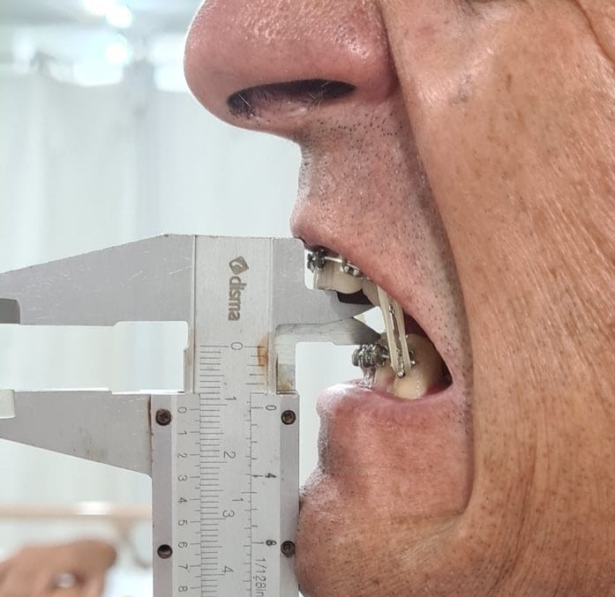
Figure 1: Preoperative mouth opening restricted to 11 mm.
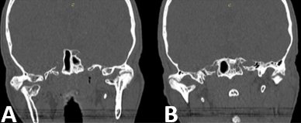
Figure 2: Coronal CT scans showing an ankylotic mass in bilateral TMJs.
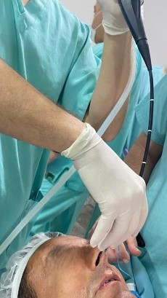
Figure 3: Nasotracheal intubation assisted by a fiberscope.
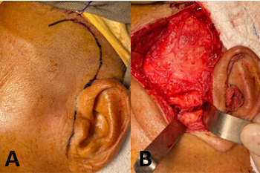
Figure 4: Al-Kayat approach. A) Incision marking; B) Surgical access with exposure of the temporal muscle.
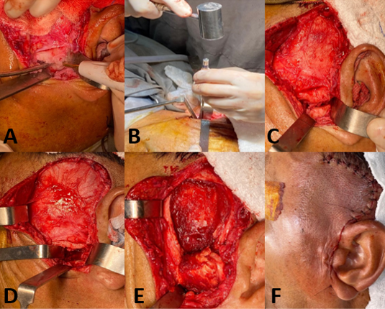
Figure 5: Intraoperative procedure. A) Osteotomy of the bony block using a piezoelectric surgical device; B) Medial osteotomy performed with the aid of a chisel and mallet; C) Completed osteotomy; D) Gap obtained after removal of the ankylotic block; E) Rotation of the temporal muscle flap; F) Intradermal suture in the preauricular region and simple suture in the temporal region.
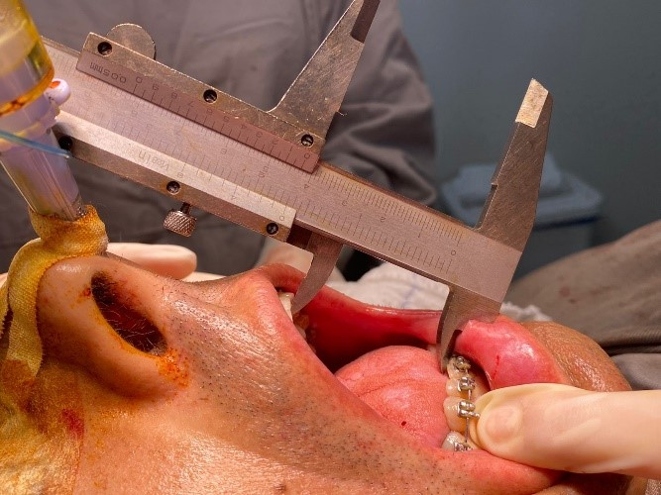
Figure 6: Intraoperative mouth opening of 40 mm.
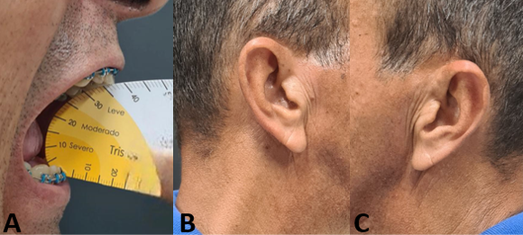
Figure 7: Two-year postoperative follow-up. A) Mouth opening of 37 mm; B) Scar appearance on the right side; C) and on the left side.

References:
- Su-Gwan K. Treatment of temporomandibular joint ankylosis with temporalis muscle and fascia flap. Int J Oral Maxillofac Surg. 2001;30(3):189-193. doi:10.1054/ijom.2001.0047
- Al-Moraissi EA, El-Sharkawy TM, Mounair RM, El-Ghareeb TI. A systematic review and meta-analysis of the clinical outcomes for various surgical modalities in the management of temporomandibular joint ankylosis. Int J Oral Maxillofac Surg. 2015;44(4):470-482. doi:10.1016/j.ijom.2014.10.017
- Rowe NL. Ankylosis of the temporomandibular joint. J R Coll Surg Edinb. 1982;27(2):67-79.
- Bayat M, Badri A, Moharamnejad N. Treatment of temporomandibular joint ankylosis: gap and interpositional arthroplasty with temporalis muscle flap. Oral Maxillofac Surg. 2009;13(4):207-212. doi:10.1007/s10006-009-0174-4
- Sawhney CP. Bony ankylosis of the temporomandibular joint: follow-up of 70 patients treated with arthroplasty and acrylic spacer interposition. Plast Reconstr Surg. 1986;77(1):29-40.
- Shivakotee S, Menon CS, Sham ME, Kumar V, Archana S. TMJ Ankylosis Management: Our Experience. J Maxillofac Oral Surg. 2020;19(4):579-584. doi:10.1007/s12663-019-01293-y
- Huang IY, Lai ST, Shen YH, Worthington P. Interpositional arthroplasty using autogenous costal cartilage graft for temporomandibular joint ankylosis in adults. Int J Oral Maxillofac Surg. 2007;36(10):909-915. doi:10.1016/j.ijom.2007.05.009
- Kaban LB, Perrott DH, Fisher K. A protocol for management of temporomandibular joint ankylosis. J Oral Maxillofac Surg. 1990;48(11):1145-1152. doi:10.1016/0278-2391(90)90529-b
- Functional restoration by gap arthroplasty in temporomandibular joint ankylosis Roychoudhury, Ajoy et al. Oral Surgery, Oral Medicine, Oral Pathology, Oral Radiology and Endodontics, Volume 87, Issue 2, 166 - 169
- Al Kayat A, Bramley P. A modified pre-auricular approach to the temporomandibular joint and malar arch. Br J Oral Surg 1979: 17(2):91-103.
- He L, Zhang Z, Xiao E, He Y, Zhang Y. Pathogenesis of traumatic temporomandibular joint ankylosis: a narrative review. J Int Med Res. 2020 Nov;48(11):300060520972073. doi: 10.1177/0300060520972073. PMID: 33213251; PMCID: PMC7686630.

