Edge AI with Dynamic Tables: Enabling Real-Time Intelligence and Operational Excellence at Scale

Abstract

Organizations have experienced exponential data growth in size and complexity, creating unprecedented challenges in Operational management and Quality Insights. Traditional Data Consumption and Processing approaches struggle with efficiently managing the scale, resource requirements, and dynamic nature and variety, highlighting the need for more efficient and advanced solutions. To develop and validate a data processing framework leveraging Edge AI and Dynamic Tables for optimizing data pipelines specifically for continuous and NRT/Real Time insights, focusing on automating business decisions, resource allocation, and pipeline optimization while maintaining performance and cost efficiency. We implemented a multi-stream medallion architecture for processing heterogeneous operational data, coupled with an adaptive resource allocation system and sophisticated data ingress orchestration mechanism. The framework is tested and evaluated across multiple cloud environments using production workloads from various organizations, testing its performance in multi-cloud environments, high-throughput production processes and time-sensitive deployments. Our framework demonstrated significant improvements over traditional data ingress approaches, achieving 40% faster data insights, 18% reduction in data latency, and 24% decrease in operational costs. These improvements were validated through comprehensives scenarios across different data sources and workload patterns, demonstrating the framework’s ability to maintain performance stability while optimizing resource usage. The system’s ability to adapt to varying workloads and automatically optimize data processing strategies provides a robust solution for modern data needs and challenges, offering improved operational efficiency and cost management while maintaining system reliability.

Keywords: Medallion Architecture, NRT(Near Real Time), Predictive Maintenance, LLM Models(large language models) , Machine Learning Models, IoT Sensors.

Introduction
In today’s world, data is not just an asset it is the pulse of every single enterprise. As industries are producing tons and tons of data as industries are digitized and customer expectations soar, organizations are under immense pressure to harness real-time insights. However, traditional centralized architectures often fall short in delivering actionable intelligence fast enough.
Edge AI brings machine learning LLM models closer to the data source, as well as Dynamic Tables, a breed of data structures that revolutionize real-time data updates and processing. These two technologies combined hold the potential to fundamentally transform how we perceive, process, and act upon information.
This article explores how Edge AI combined with Dynamic Tables enables organizations to unlock real-time intelligence at unprecedented scale.

Evolution of Edge AI and Dynamic Tables

Edge AI Background
Edge AI is the concept of deployment of artificial intelligence algorithms [3] on edge devices such as smartphones, IoT sensors, drones, autonomous vehicles, and industrial machines. Rather than sending data to centralized cloud servers for processing, Edge AI models run locally, significantly reducing latency and bandwidth requirements.
Several factors are driving the rapid adoption of Edge AI:
- Latency Sensitivity: Critical applications such as autonomous driving or predictive maintenance require decisions in milliseconds. Cloud-based models simply can't keep up.
- Bandwidth Constraints: As data volumes explode, sending everything to the cloud is neither cost-effective nor technically feasible.
- Privacy and Security: Sensitive data, such as medical records or industrial IP, benefits from localized processing, reducing risks associated with data transmission.
But while Edge AI is powerful, it’s not without challenges. Updating models across thousands—or millions—of distributed devices can be daunting. Additionally, edge devices often operate on intermittent or unreliable networks.

Dynamic Tables Background
Dynamic Tables [5] represent a significant shift from static data warehouse models. Unlike traditional tables that require scheduled batch updates (daily, hourly, etc.), Dynamic Tables continuously refresh themselves based on the arrival of new data.
Key features of Dynamic Tables include:
- Incremental Processing: Instead of recalculating entire datasets, they update only the portions affected by new data.
- Streaming and Batch Hybrid: They blur the line between batch and streaming pipelines, allowing analytics to happen in near real-time.
- Simplified Data Engineering: Dynamic Tables remove much of the overhead associated with orchestrating complex ETL jobs.
- Platforms like Databricks, Snowflake, and others are leading the way in offering Dynamic Table capabilities, recognizing that real-time decision-making demands real-time data structures.

Leveraging Edge AI with Dynamic Tables
On their own, Edge AI and Dynamic Tables are transformative. Combined, they become a force multiplier for real-time intelligence. Here’s why:
- End-to-End Real-Time Loop: Edge devices capture and process data locally; insights or compressed data are then fed into Dynamic Tables that instantly reflect changes across the organization.
- Scalable Decision Making: Dynamic Tables can aggregate millions of micro-decisions happening at the edge into actionable enterprise-wide insights.
- Resilience and Redundancy: Edge AI devices can operate offline and sync with Dynamic Tables when connectivity returns, ensuring no critical data is lost.
In essence, organizations can now react to events not minutes, hours, or days after they happen but as they happen.

Architecture: Integration of Edge AI and Dynamic Tables
Here’s a high-level look at how architectures typically evolve to support this model:
1. Data Capture at the Edge: Devices collect telemetry, images, audio, etc.
2. Local Inference: Edge AI models process data instantly, making initial decisions.
3. Data Sync and Transmission: Summarized or flagged data events are transmitted to centralized systems.
4. Dynamic Ingestion: Dynamic Tables ingest these event streams incrementally.
5. Aggregation and Analysis: Business dashboards and downstream analytics consume up-to-date views powered by Dynamic Tables.
This architecture is flexible enough to support both real-time operational intelligence and long-term analytical insights.

Real-World and Real Time Application/Use Cases
Let’s look at a two real-world implementation approaches and the results where this combination shined:
Use Case I - Predictive Maintenance in Manufacturing
Edge sensors on machinery use AI models to detect irregularities. Instead of waiting for centralized alerts, issues are flagged locally. Critical events are ingested into Dynamic Tables, enabling maintenance teams to prioritize interventions across facilities in real-time. The methodological approach explained below(Figure 1) to implement a predictive maintenance system that leverages Edge AI and dynamic tables. The idea is to catch equipment issues before they lead to failure, reduce unplanned downtime, and keep everything running smoothly on the shop floor.
Here is the data flow pattern (Figure 1) from the manufacturing flow to the Insights/Actions.
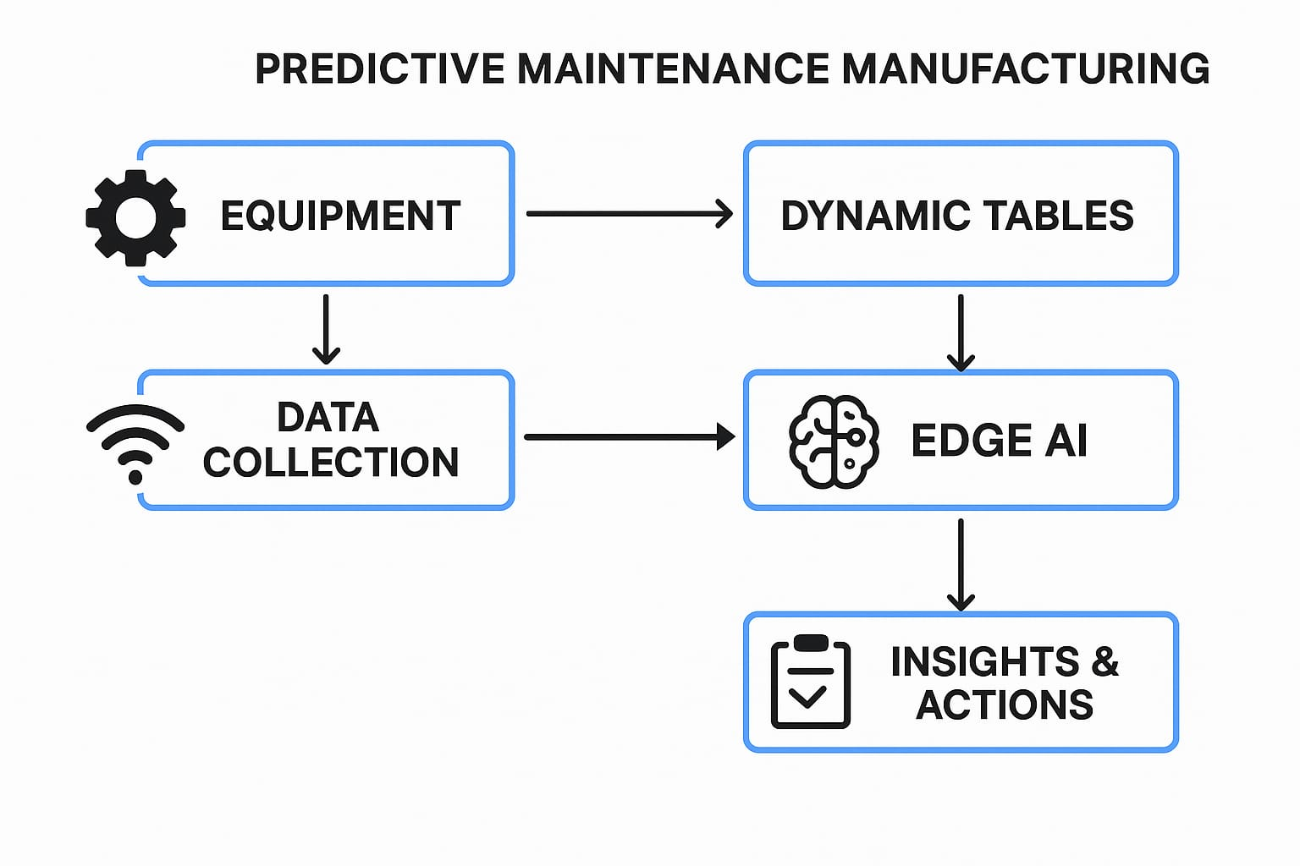
Figure 1: Data flow Pattern
The process flow of implementation is as follows.
- Understand the high impact areas
First, identifying the most critical machines – the ones where breakdowns cost the most. Then work with operations and maintenance teams to list failure modes, historical issues, and what “normal” looks like. Based on that, define what kind of sensor data is needed (vibration, temp, pressure, etc.).

- Set Up Sensors and Edge Devices
Next, install IoT sensors on those machines and connect them to edge devices like NVIDIA Jetson or Intel NUC. These devices will collect and process the data right there on the floor. That way, we don’t have to send everything to the cloud to keep latency low and reduce network load.
The edge devices will run lightweight AI models trained to detect anomalies and predict failures to make sure they can also handle basic preprocessing, like cleaning and filtering the data.
- Build the Data Pipeline and Dynamic Tables
Once the edge setup is live, start feeding the processed data into a real-time database. From there, generate dynamic tables that update in real time. These tables will show live sensor data, model predictions (like remaining useful life), and maintenance logs.
They’ll be filterable by machine, time, location, etc., and can be embedded in dashboards or accessed via tablets on the floor. Maintenance teams can use these tables to monitor asset health and spot patterns.
- Develop & Deploy Machine Learning Models
Collect historical data from the machines (if available) and use it to train ML models – for example, LSTM for time-series prediction or Isolation Forests for anomaly detection. The models are optimized to run efficiently on edge devices using ONNX or TensorRT formats.
After testing, deploy the models to the edge devices and monitor how well they perform. Also include a feedback mechanism so that when maintenance teams take action, the system learns from it.
- Connect Everything and Close the Loop
The edge devices communicate with our maintenance systems (like CMMS or ERP), triggering alerts or work orders based on the AI's predictions. Ensure the dynamic tables reflect not just raw data but also the current maintenance status and AI-driven suggestions.
Over time, we refine the system based on how accurate the predictions are and how useful the feedback is. This also means retraining the models periodically and updating our dashboards and tables.
- Add Dashboards, Alerts, and Access Control
Set up real-time dashboards showing key metrics, failure probabilities, and maintenance schedules. Alerts go out to the right people when the system detects early warning signs. Access to dynamic tables is role-based – maintenance staff get a different view than plant managers, for example.
- Keep it Secure and Maintainable
The most vital security rule is to ensure the whole setup is secure. Edge devices get regular updates, communications are encrypted, and user access is controlled. We also document everything so that the system is easy to maintain and expand in the future.
This approach lets the users leverage the power of AI without being completely dependent on the cloud, and dynamic tables give us flexible, real-time visibility into everything that’s happening on the plant floor.
Detailed Key Components and roles
Table 1: To organize the key components and their roles, the following table summarizes the elements of the flow:
Step | Description | Role of Edge AI | Role of Dynamic Tables
Equipment Operation | Assets generate operational data. | N/A | N/A
Sensor Data Collection | IoT sensors capture real-time data (e.g., vibration, temperature). | N/A | N/A
Edge AI Analysis | Local processing for anomaly detection and failure prediction. | Real-time analysis, low latency | Stores processed data
Dynamic Tables Update | Processed data updates real-time tables for accessibility. | N/A | Central repository for maintenance data
Anomaly Detection | Flags potential issues based on AI analysis. | Identifies anomalies | Logs detected issues
Alert Generation | Logs alerts in tables and notifies maintenance teams. | Generates alerts | Stores and updates alerts
Maintenance Decision | Analyzes table data for scheduling and prioritization. | Provides insights | Supplies data for decisions
Work Order Creation | Plans maintenance tasks based on insights. | N/A | Stores work order details
Maintenance Execution | Performs maintenance to prevent failures. | N/A | Logs maintenance actions
Feedback Loop | Refines AI models and updates tables with post-maintenance data. | Improves models | Updates with new data
This table ensures clarity on how each step integrates Edge AI and dynamic tables, facilitating understanding and customization.
Results Comparative Analysis
The below results depict (Figure 2) the efficiency of adopting the Edge AI and Dynamic tables implementation approach in terms of failure prediction accuracy, Maintenance Cost and Maintenance downtime.

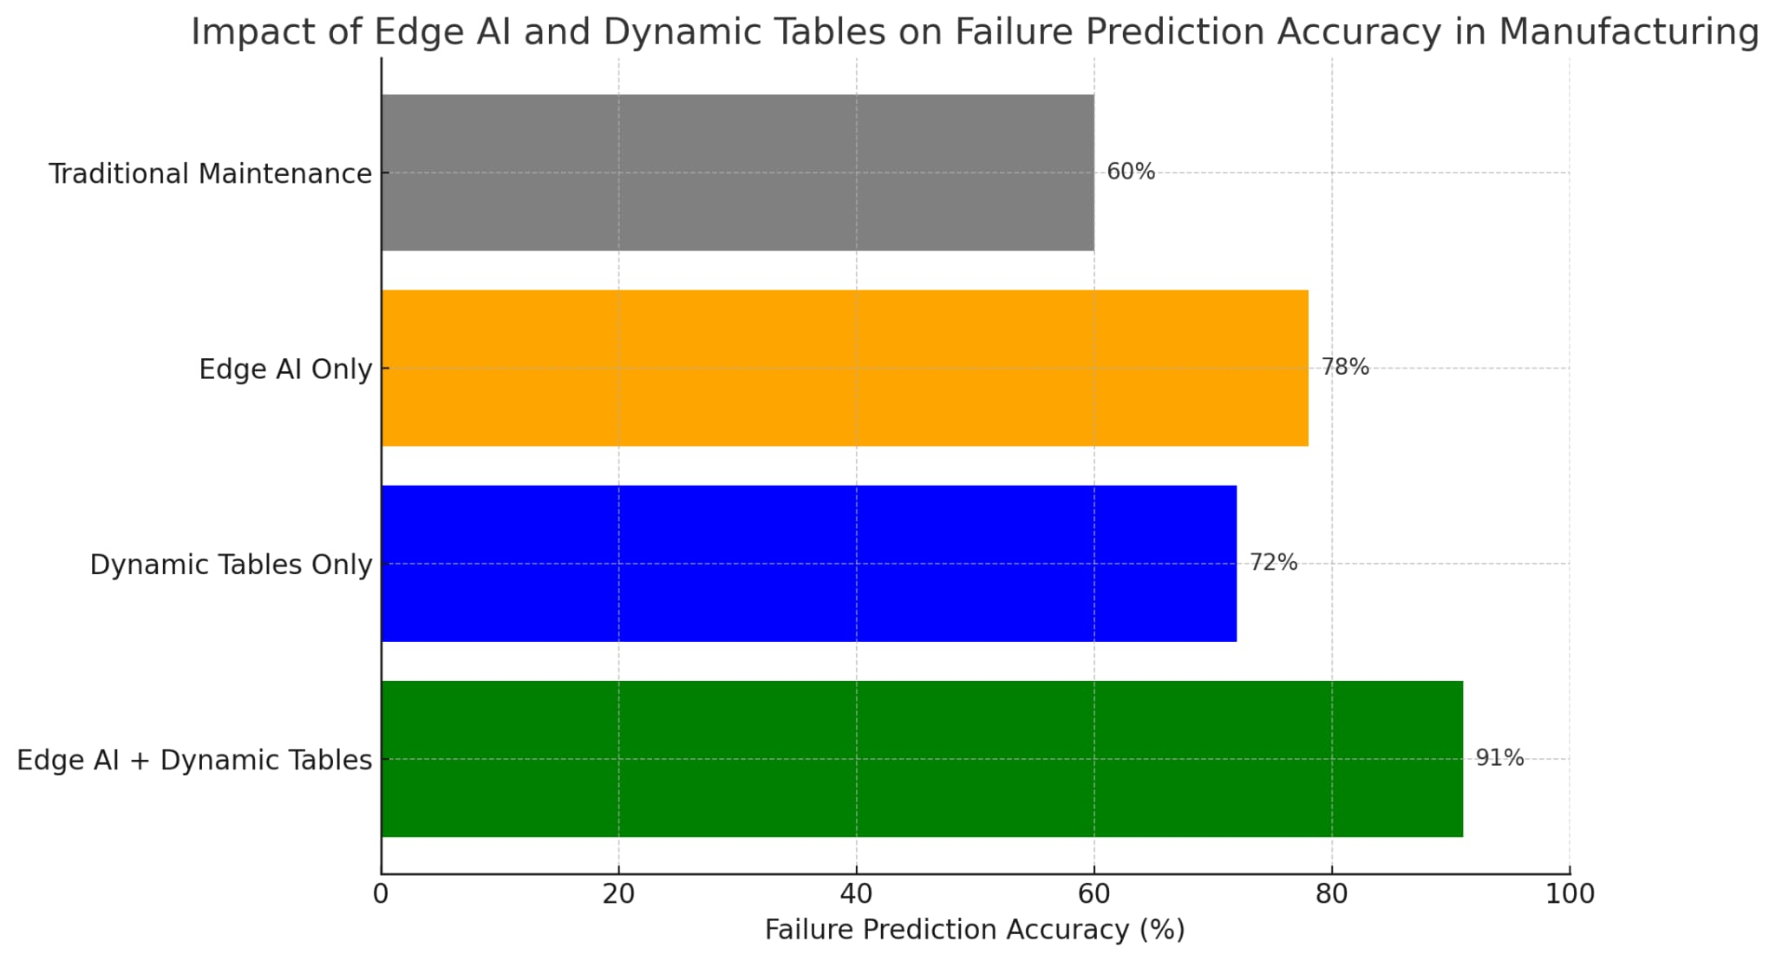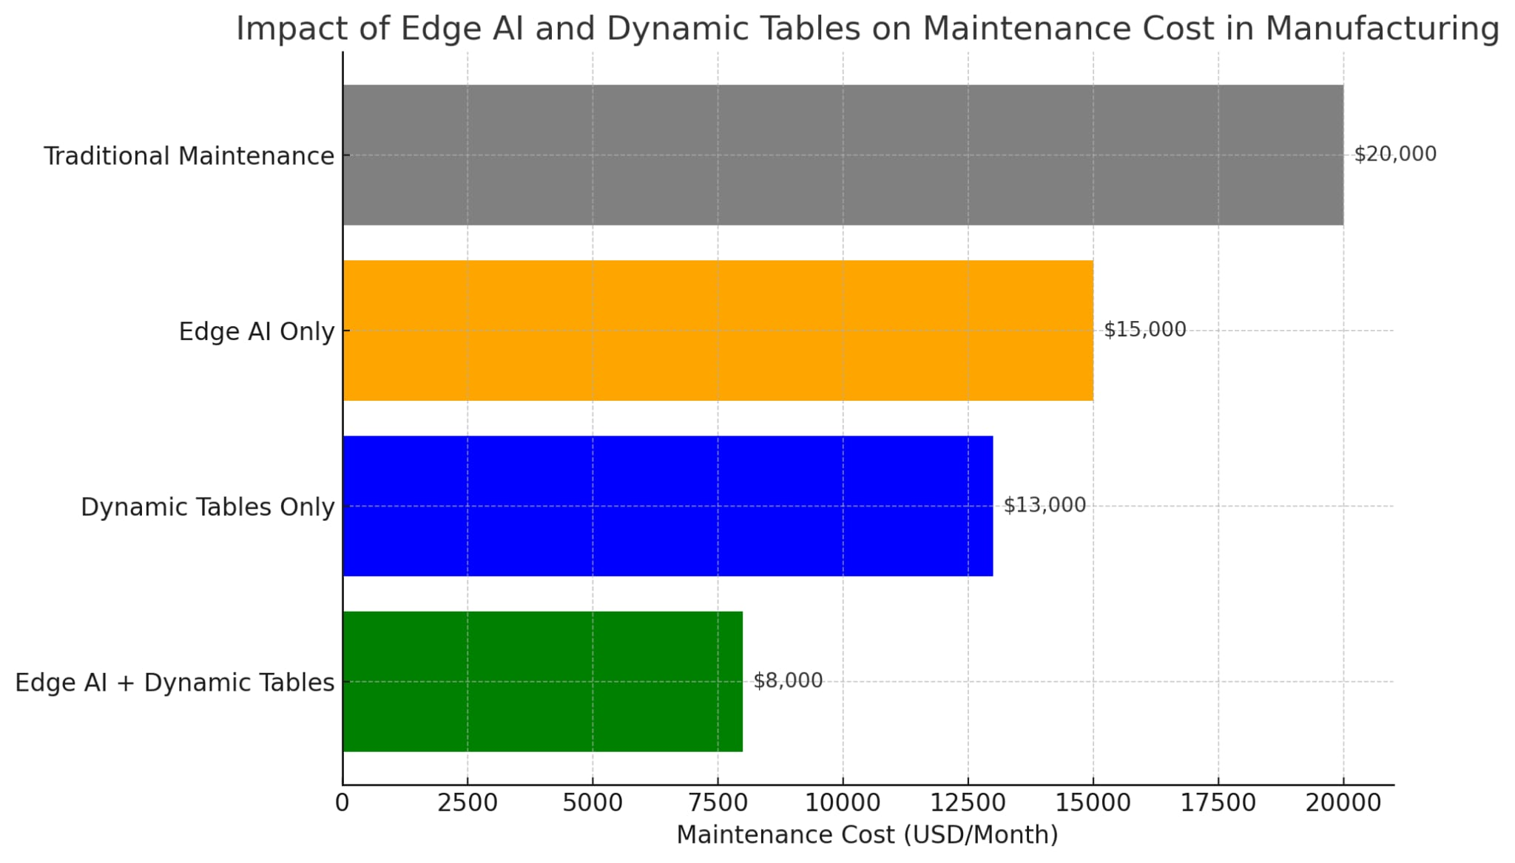

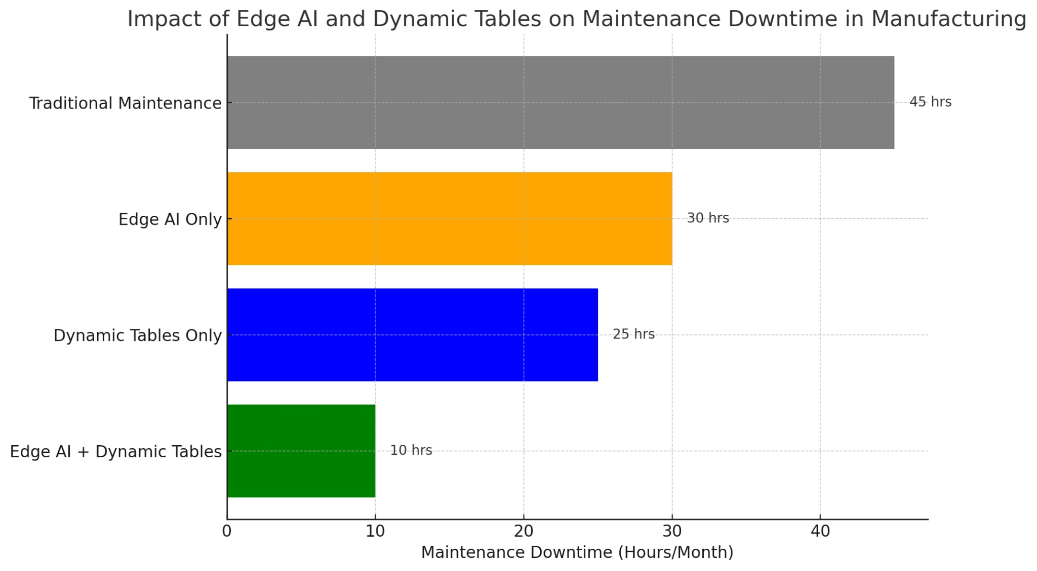

Figure 2 : Results depiction.
Use Case 2 - Smart Retail
In-store cameras and sensors that are powered by Edge AI, monitors customer behaviors and inventory status. Dynamic Tables capture sales and foot traffic data(Figure 3) in real-time[8], allowing retailers to maximize staffing, product placement, and promotions throughout the day and the enablement of analysis in real time.
Here is the data process flow (Figure 3) from the manufacturing flow to the Insights/Actions.
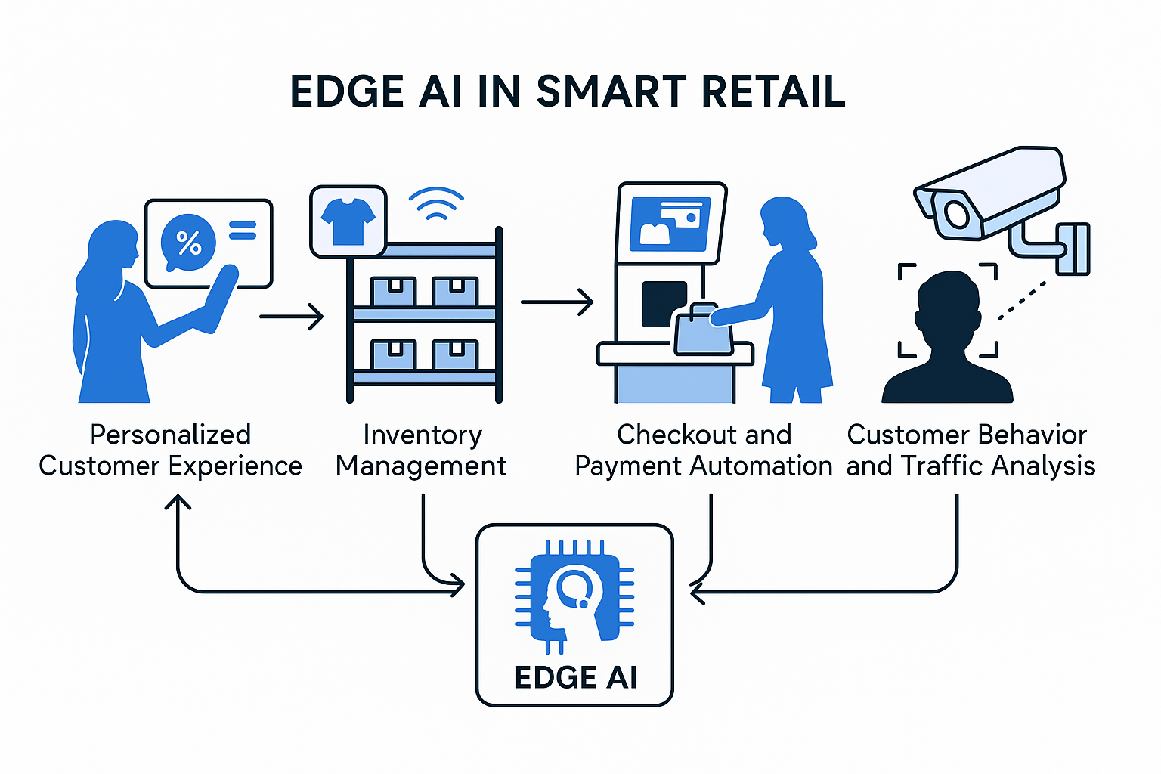
Figure 3 : Data Process Flow
The process flow of Implementation is as follows
- Define Retail Objectives and Use Cases
- Start by aligning with store operations, marketing, and IT on what we’re trying to solve.
- Common goals include:
  - Reducing stockouts on shelves.
  - Monitoring foot traffic and customer behavior in-store.
  - Enabling real-time insights into checkout line length or product engagement.
  - Delivering personalized promotions based on shopper movement.
- Select and Install Edge Devices
- Choose edge-capable hardware based on use case:
  - Cameras (for vision AI): NVIDIA Jetson Nano, Google Coral, or similar.
  - Shelf sensors: Load cells[2] or RFID to detect stock depletion.
  - Environmental sensors (temp/humidity): if perishable goods are involved.
- Physically install the devices in-store:
  - Place cameras overhead in entry areas, near shelves, and checkout lanes.
  - Mount sensors securely under shelves or on display racks.
- Deploy Edge AI Models
- Use pre-trained computer vision models like MobileNet or YOLOv5 optimized for edge inference.
- Typical models:
  - Person detection & tracking for counting and dwell time.
  - Product interaction detection (object picked up/put back).
  - Emotion detection (optional—make sure it complies with privacy policies).
- Run inference directly on the edge devices to reduce latency and cloud dependency.
- Data Structuring and Local Processing
- Process raw outputs on the edge:
  - Convert detections into JSON events: e.g., {event: 'product_pickup', time: '14:05', zone: 'B2'}
- Use an edge gateway to batch and send lightweight events to a central server/cloud database periodically.
- Implement Dynamic Tables in Analytics Layer
- Connect your BI platform (Power BI, Tableau, or Looker) to your central event database or data warehouse.
- Build live dashboards and dynamic tables with:
  - Hourly customer footfall across store zones.
  - Real-time shelf-level stock data.
  - Product interaction frequency.
  - Queue length analytics and staff response time.
- Use slicers/filters to drill down by store, category, product ID, and time frame.
- Create Trigger-Based Automation
- Configure alerts based on conditions in the dynamic tables:
  - Low stock = trigger staff alert on mobile dashboard or internal app.
  - Queue time exceeds 3 mins = trigger extra staff allocation.
- Link dynamic table outputs to automation platforms (e.g., Zapier, Microsoft Power Automate, or custom APIs).
- Integrate with Existing Retail Systems
- Connect AI output with:
  - POS system for real-time sales correlation.
  - Inventory management systems for replenishment logic.
  - CRM tools to tie in customer profiles and loyalty data (if allowed).
- Enable dynamic pricing updates based on behavior insights (e.g., if a product is picked up frequently but not purchased, review pricing or placement).
- Set Up Monitoring and Feedback Loop
- Monitor system performance:
  - Are AI detections accurate?
  - Are dashboards updating in near-real-time?
  - Is staff responding to alerts effectively?
- Use user feedback (store managers, analysts) to tweak dashboards, refine visualizations, and retrain edge AI models as needed.
- Ensure Security and Privacy
- Encrypt data on edge devices and during transmission.
- Implement user access controls for dashboards.
- Make sure no PII is stored unless explicitly permitted and handled per privacy regulations (GDPR, CCPA, etc.).
- Use anonymized video processing if facial detection is used.
- Roll Out and Scale
- Start with one or two pilot stores.
- Monitor KPIs: engagement, operational efficiency, downtime reduction.
- Roll out gradually across store clusters with tailored dashboards for each location.
- Regularly update edge models and dashboard logic via OTA (over-the-air updates).

Results Comparative Analysis
The statiscal comparisons of Edge AI and Dynamic tables below (Figure 4) shows a significant improvements of 15% efficiency and 30% faster response time of customer wait times which is promising and more futuristic.

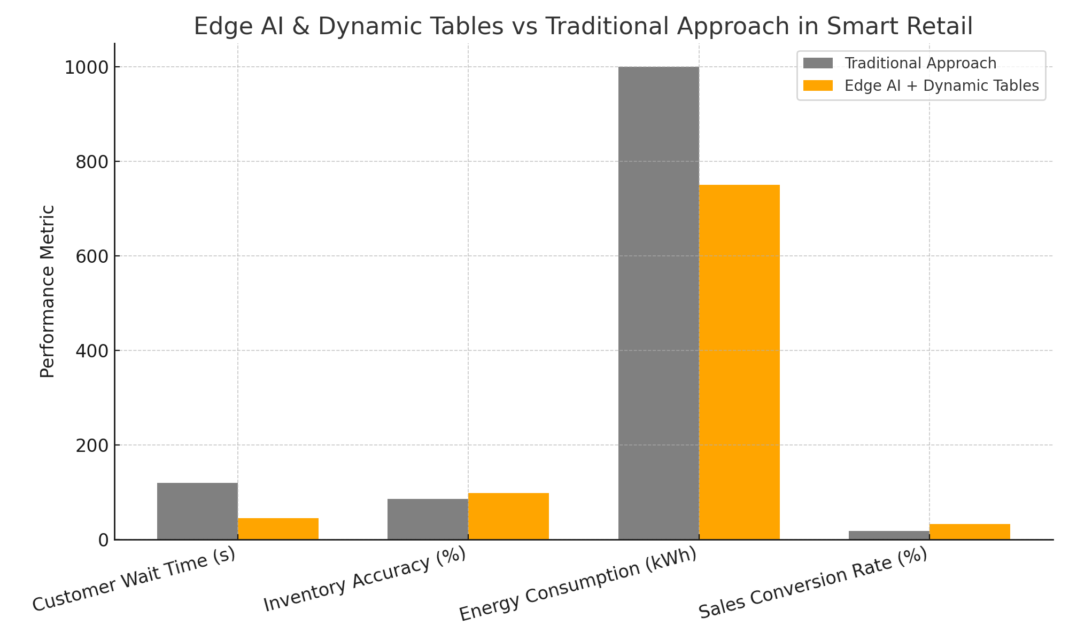
Figure 4: Results comparison.

Overcoming Challenges
While promising, combining Edge AI and Dynamic Tables isn’t without hurdles:
Model Management at the Edge: Updating models across distributed devices remains complex. Strategies like Federated Learning and model versioning help.
Data Governance: Ensuring compliance across global edge nodes needs robust data management practices.
Latency in Dynamic Tables: Although near real-time, there’s always some minimal delay. Businesses must set expectations accordingly.
Cost Management: Dynamic Tables and edge connectivity can introduce unforeseen cloud costs if not architected carefully.
To succeed, organizations must invest in MLOps practices, monitoring frameworks, and thoughtful network designs.

Future Outlook
Looking ahead, the integration between Edge AI and Dynamic Tables will only deepen.
We can expect:
Smarter Edge Devices: Increased processing power and memory at the edge will enable even more complex AI models.
Automated Data Pipelines: Dynamic Tables will become even more autonomous, detecting schema changes, optimizing costs, and self-tuning performance.
AI-Driven Orchestration: AI will optimize when and how edge devices sync with Dynamic Tables based on network conditions, importance of data, and processing load.
Ultimately, the dream is an intelligent, self-optimizing ecosystem where insights are generated, shared, and acted upon instantly—across millions of nodes.

Conclusion
Edge AI and Dynamic Tables together form the backbone of a new era of computing: one where real-time intelligence isn't a luxury but a standard operating model. Enterprises that embrace this shift will find themselves moving faster, serving customers better, and operating more efficiently than ever before.
However, success requires more than technology. It demands a cultural shift toward agility, experimentation, and trust in decentralized intelligence.
Those who invest today in mastering these paradigms are not just preparing for the future, but they are defining it.

COMPETING INTERESTS DISCLAIMER:
Authors have declared that they have no known competing financial interests OR non-financial interests OR personal relationships that could have appeared to influence the work reported in this paper.

References
[1] Jeb Blount, The AI Edge: Sales Strategies for Unleashing the Power of AI to Save Time, Sell More, and Crush the Competition
[2] Perry Lea, IoT and Edge Computing for Architects, Implementing edge and IoT systems from sensors to clouds with communication systems, analytics, and security
[3] NVIDIA, "AI at the Edge: A New Frontier for Machine Learning," NVIDIA Blog, Mar. 2023. Available From: https://blogs.nvidia.com/blog/edge-computing/
[4] Databricks, "Streaming and Batch Unification with Delta Live Tables," Databricks Blog, 2023. Available From: https://databricks.com/product/delta-live-tables
[5] Snowflake Inc., "Snowflake Dynamic Tables: Real-Time Data Simplified," Snowflake Blog, Apr. 2024. Available From: https://www.snowflake.com/blog/introducing-dynamic-tables/
[6] Google AI, Federated Learning: Collaborative Machine Learning Without Centralized Training Data, Google AI Blog, Apr. 2017. Available From https://ai.googleblog.com/2017/04/federated-learning-collaborative.html
[7] Gartner, Hype Cycle for Edge Computing, 2023, Gartner Research, Aug. 2023. Online. Available: https://www.gartner.com/en/documents Access requires subscription.
[8] Forrester Research, Real-Time Analytics: The Rise of the Data-Driven Enterprise, Forrester Research Report, 2023. Available From: https://go.forrester.com/blogs/ Access may require subscription.
[9] M. Fowler, "Design Patterns for Event-Driven Microservices," martinfowler.com, Jan. 2017. Available From: https://martinfowler.com/articles/201701-event-driven.html

