MODELING THE EFFECT OF MATH ANXIETY ON STUDENT MATHEMATICS PERFORMANCE

Abstract
This study investigates the dynamic behavior and potential durability of mathematics anxiety (MA) in an academic community by developing a novel epidemiological framework. A Susceptible–Anxious–Performing (SAP) compartmental model was adapted by modifying the conventional SIR structure in order to examine the prevalence of Mathematics Anxiety among Senior High School (SHS) students in Ghana. To formally formulate the model, ordinary differential equations (ODEs) were employed. The threshold requirement for the endemic persistence of anxiety was rigorously defined by applying the Next-Generation Matrix (NGM) technique to the linearized system. This study yielded a baseline Reproduction number$R_{0}=1.14 based on literature-informed parameters \left(β = 1.60, α = 0.25, μ = 0.03, δ = 0.03, γ = 0.12\right).$ Because this computed $R_{0}$ value is greater than unity $\left(R_{0}>1\right),$ the model strongly suggests that Mathematics anxiety may continue to be endemically present throughout the student population given the current system characteristics. To effectively reduce the prevalence of Mathematics Anxiety, the findings emphasize the necessity of systemic interventions that focus on two key model parameters: reducing the peer-driven transmission rate ($β)$ and raising the rate of anxiety recovery or the student performance ($α$).
Keywords: Mathematics Anxiety, SAP model, reproduction number, sensitivity analysis, Ghana, educational modeling
- Introduction
1.1 Background and Rational
A well-known obstacle to academic success is Mathematics Anxiety (MA) which is characterized as a state of tension, fear or concern that hinders an individual’s ability to complete Mathematical tasks (Suárez-Pellicioni et al., 2016). When symptoms like helplessness and mental trepidation make people avoid Math-related activities it creates a vicious cycle of poor performance that feeds the anxiety (Halme 2022). This problem is particularly urgent since advancement in STEM (science, technology, engineering and Mathematics) fields which foster increased economic competitiveness requires a strong Mathematical foundation (OECD 2022).
Mathematics Anxiety is an especially serious issue in emerging economies. Nearly 64% of students in the Agona West Municipality had significant levels of Mathematics anxiety according to one study, confirming a high prevalence among Senior High School (SHS) students in Ghana (Aboagye-Agbi et al., 2023). Another Ghanaian study found a significant negative correlation between Mathematics anxiety and Mathematical performance (Bornaa et al., 2023). There are many consequences such as preparing students for the workforce and influencing their career choices by discouraging them from choosing STEM courses (Balt et al., 2022; Pizzie & Kraemer, 2023; Esposito, 2025).
1.2 Problem Statement
In educational systems such as Ghana, mathematics anxiety (MA) is a persistent and significant barrier to student achievement. It is acknowledged to considerably impair ones cognitive abilities and performance (Ashcraft 2002). It is significant that Mathematics Anxiety is increasingly recognized as a psychological construct rather than merely a personal illness that spreads through classroom social networks as a result of peer pressure and shared learning experiences (Baten et al. 2023; Toms et al. 2024). Current therapies either arrive too late or are only available to certain children, failing to address the anxiety that arises from and persists within the larger learning environment.
Although the literature acknowledges the social component, it primarily uses static cross-sectional data omitting Mathematics Anxiety’s dynamic and systemic features such as how it spreads, persists or declines over time at the population level. There is a significant research gap because interventions developed without considering these systemic dynamics are only able to address specific student symptoms rather than the underlying environmental and peer-driven dynamics.
This research bridges this critical gap by developing and applying a novel mathematical framework which contributes innovation. Based on the classic epidemiological concepts of Kermack and McKendrick (1927) we employ the Susceptible–Anxious–Performing (SAP) compartmental model. This novel approach captures the population-level dynamics of Mathematics Anxiety by simulating its spread and persistence among students as a contagious process. It also provides a new predictive tool that helps policymakers and educators develop proactive interventions by providing more relevant systemic insights.
1.3 Purpose and objectives of the Study
By using a Mathematical modeling technique unique to Ghanaian Mathematics education research, this study closes the gap and treats Mathematics anxiety as a dynamic contagious phenomenon. In order to explain how Mathematics anxiety spreads, persists and is managed among senior high school students in Ghana, the primary objective of this study is to develop and analyze a Susceptible–Anxious–Performing (SAP) compartmental model which is a modification of the conventional SIR epidemiological framework.
This study specifically seeks to:
- Develop and analyze the dynamic behavior of the Susceptible–Anxious–Performing (SAP) model to simulate the transmission and recovery of Mathematics anxiety in an SHS population.
- Determine the Basic Reproduction Number ($R_{0}$​) and key stability conditions that govern the persistence versus the decline of Mathematics anxiety in the SHS context.
- Conduct sensitivity analysis on the model parameters to identify the most effective intervention points (e.g., peer influence, recovery rates) for policymakers.
1.4 Significance of the Study
The potential for this study to support systemic change in education is what gives it practical value. In order to identify the dynamic spread of Mathematics Anxiety (MA) this study used the Susceptible–Anxious–Performing (SAP) model. The findings allow teachers to implement supportive classroom practices and assist students in developing effective coping mechanisms both of which enhance academic performance and attitude toward mathematics. This study is significant because it provides policymakers with the knowledge they need to improve teacher preparation, develop curricula and allocate resources in a way that will remove the psychological barriers that currently impede math proficiency.
This study has important theoretical implications from a methodological perspective due to the novel application of the SAP model to a social science domain. The study advances our understanding of how psychological factors in educational settings impact learning outcomes by considering Mathematics anxiety as a dynamic population-level phenomenon. Ultimately this work serves as a methodological guide demonstrating how mathematical modeling can yield predictive insights and inspiring additional research to apply similar dynamic frameworks to a wider range of educational behavioral phenomena.
- Literature Review
2.1 Theoretical Frameworks
This study uses three different theoretical frameworks to explain the dynamics and processes of mathematics anxiety and how it impacts performance: the SIR-adapted Susceptible-Anxious-Performing (SAP) Model, Krashen’s Affective Filter Hypothesis and Cognitive Load Theory (CLT).
2.1.1 Cognitive Load Theory (CLT)
CLT states that human working memory has a limited capacity (Sweller et al. 2019). Intrusive thoughts like worry, self-doubt or the fear of getting a bad grade consume some of a student’s cognitive resources when they suffer from Mathematics anxiety. This intrusive thought load is an unnecessary cognitive load that reduces working memory needed to comprehend novel Mathematical concepts or perform complex problem-solving techniques (Caviola et al., 2022). CLT is supported by empirical evidence which shows that trait vs. Depending on the difficulty of the task state, anxiety has a major impact on test-taking performance (Demedts et al., 2022) and that tasks requiring higher-order thinking are especially affected negatively by Mathematics anxiety (Halme, 2022).

2.1.2 Krashen's Affective Filter Hypothesis
According to Krashen’s theory, emotional factors such as motivation, anxiety and self-confidence can hinder learning. A high emotive filter often heightened by worry, limits or prevents the full comprehension and processing of academic input (Krashen, 1982). Students with high Mathematics anxiety levels consistently perform poorly even when they possess the requisite skills indicating that their emotional state actively obstructs learning and skill application (Cipora et al., 2022; Barroso et al., 2020). This framework supports the SAP model by illuminating the psychological mechanism through which a student’s Anxious state prevents them from effectively transitioning to the Performing state.
2.1.3 The SIR-adapted Susceptible-Anxious-Performing (SAP) Model
Originally developed to model the spread of infectious diseases the SIR framework (Susceptible-Infected-Recovered) offers a solid Mathematical basis for studying dynamic psychological processes (Nathan and Jackob 2020). To create the SAP model this study adapted the SIR model to classify and track student transitions within a population.
- Susceptible (S): Students at risk of developing Mathematics Anxiety.
- Anxious (A): Students actively experiencing Mathematics anxiety, leading to impaired performance.
- Performing (P): Students who have either overcome Mathematics anxiety (recovered) or never developed it, and can effectively apply their Mathematical knowledge.
Important transitions such as S→A (acquisition of anxiety through social/classroom factors) and A→P (recovery through intervention or coping) can be modeled with the model. This quantitative method enables a systematic understanding of the population-level dynamics of MA which is necessary to identify effective intervention options (Mutiawati et al., 2022; Cabrera et al., 2021).
2.2 Empirical Evidence on Mathematics Anxiety Dynamics
Beyond simple correlation, empirical research has advanced to examine the dynamic and interpersonal nature of Mathematics anxiety.
Self-Efficacy and Motivation: According to Bandura (1997) having a high level of self-efficacy, the conviction that one can achieve is a powerful protective barrier against Mathematics anxiety. Due to their greater propensity for perseverance and decreased susceptibility to worry, students with higher levels of self-efficacy may go directly from the S to P compartment (Putwain and Wood 2022).
The most recent research highlights the contagion effect which is the ability of Mathematics anxiety to spread from one person to another. Peer interactions can either increase or decrease anxiety depending on the groups structure and conformance dynamics according to studies using dynamic modeling techniques (Toms et al., 2024). This strongly supports the central tenet of the SAP model which holds that Mathematics anxiety has a reproduction number $R_{0}$ and spreads through social and peer dynamics in a manner similar to a psychological contagion.

2.3 Synthesis of the Literature
The research indicates that Mathematics anxeity is frequently linked to cognitive limits (CLT) and emotional barriers (Affective Filter). However, there is still a dearth of research especially in the Ghanaian SHS context that use dynamic Mathematical modeling. This work is unique in that it provides a quantitative predictive tool for educational policy by simulating the transmission and persistence of anxiety over time from a systems-level perspective using the SAP model.
3. Methodology
This chapter provides a detailed explanation of the Mathematical framework parameter definitions and analytical methods used to model the dynamics of Mathematics anxiety (MA) in Senior High School (SHS) students.
3.1 Model Formulation: The Susceptible–Anxious–Performing (S-A-P) Framework
Using a modified version of the classic Susceptible–Infected–Recovered (SIR) model from epidemiology this study investigates the dynamics of Mathematics anxiety and its effect on student achievement. State transitions are analyzed by the model using a system of ordinary differential equations (ODEs).
3.1.1 Definition of States
Susceptible S(t): Students are vulnerable to Mathematics anxiety because of peer pressure or stressful situations even though they may not have it at the moment.
Anxious Students A(t): Students are actively battling Mathematics anxiety which affects their performance concentration and problem-solving skills.
Performing students P(t): Students who have either recovered from Mathematics anxiety with assistance from others or who have never had Mathematics anxiety and consistently perform well academically.
The total student population is $N(t)=S(t)+A(t)+P(t).$
3.1.2 Model Parameters
$δ :$ New pupils joining the vulnerable population (e. g. new pupils coming to SHS).
$β :$ The transmission rate is the frequency with which exposure or peer pressure causes anxiety in susceptible students.
$γ :$ How quickly children who are at risk go from feeling anxious to performing (resilience/preventive help).
$α :$represents the rate at which anxious students overcome their fears and join the performance ensemble.
$μS ​, μA ​,μP$: ​ stand for dropout and transfer exit rates respectively for the susceptible, anxious and performing groups. For simplicity $μS=μA=μP=μ$ is assumed.
3.1.3 Assumptions of the Model
- Student Entry: Students enter the system at a constant rate (δ) into the susceptible group.
- Transmission of Anxiety: Anxiety is transmitted through interaction between susceptible and anxious students, modeled by the interaction term βSA.
- Direct Performance Pathway: A proportion (γ) of susceptible students transition directly to the performing group without becoming anxious, reflecting resilience, high self-efficacy, or intervention.
- Attrition: Each group experiences exits at respective rates (μS, μA, μP), representing dropout, or transfer.
- Closed System Approximation: All students exist within the S–A–P compartments with the exception of student entry and exit despite the fact that outside variables such as parental influence and teacher interventions are known to impact transition rates in a real classroom setting. The fundamental peer-to-peer transmission dynamics of mathematics anxiety are separated out by this simplification.
3.1.4 The Compartmental Diagram and Its Systems of Ordinary Differential Equations
Figure 1: Compartmental diagram for students
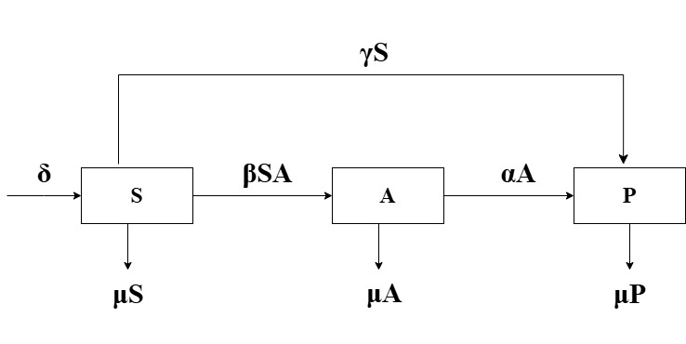
The system of ordinary differential equations (ODEs) governing the model dynamics is:
$$\frac{dS}{dt}=δ-βSA-(μ+γ)S ⋯⋯⋯⋯⋯(1)$$
$$\frac{dA}{dt}=βSA-(α+μ)A ⋯⋯⋯⋯⋯(2)$$
$$\frac{dP}{dt}=αA-μP+ γS ⋯⋯⋯⋯⋯\left(3\right)$$
3.2 Analysis of the Model
The model was analyzed using the standard Mathematical epidemiology methods listed below.
- The Anxiety Equilibrium (AE) and the Anxiety-Free Equilibrium (AFE) were found to be the two steady states.
- Stability Analysis: Local stability was assessed using the Jacobian Matrix and eigenvalue analysis. Lyapunov functions and LaSalle’s Invariance Principle were employed to investigate global stability.
- The Basic Reproduction Number $R_{0}$was determined using the Next Generation Matrix technique to determine the threshold condition for anxiety persistence (Heffernan et al., 2005).
- Simulation and Numerical Methods: The Runge–Kutta method of order four (RK4) was used to numerically solve the system producing time-series and phase-plane diagrams.

3.3 Ethical Consideration
The strictest ethical guidelines were adhered to. The study only used secondary sources of information all of which were properly cited to uphold academic integrity.
4: RESULTS AND FINDINGS
This chapter presents the analytical results (equilibrium states, stability analysis, the fundamental reproduction number $R_{0}$and numerical simulations) of the SAP model.
4.1 Equilibrium Points
Setting the time derivatives in the system of ODEs to zero yields the equilibrium points.: $\frac{dS}{dt}=0, \frac{dA}{dt}=0, and \frac{ dP}{dt}=0$.
4.2.1 Anxiety-Free Equilibrium
The Anxiety-Free Equilibrium (AFE) assumes the complete absence of anxiety, i.e., $A_{0}=0$.
Substituting A ​= 0 into the system:
From eqn (1)
$$0= δ-βS\left(0\right)-(μ+γ)S ⇒ S_{0}=\frac{δ}{μ+γ}$$
From eqn (3)
$$0=α\left(0\right)-μP+ γS_{0}⇒P_{0}=\frac{γS_{0}}{μ}=\frac{γ}{μ}\left( \frac{δ}{μ+γ}\right)=\frac{γδ}{μ(μ+γ)}$$
Thus, the AFE is:
$$\left(S_{0} , A_{0} , P_{0}\right)=\left(\frac{δ}{μ+γ)} , 0 , \frac{γδ}{μ\left(μ+γ\right)}\right)$$

4.2.2 Anxiety Equilibrium State (AE)
The Endemic Equilibrium (EE) exists when anxiety persists, i.e., $A^{*}≠0.$
From eqn (2):
$$0=βS^{*}A^{*}-\left(α+μ\right)A^{*}$$
Since $A^{*}≠0,$ we divide $A^{*}:$
$$βS^{*}=\left(α+μ\right)⇒S^{*}=\frac{α+μ}{β}$$
From (1):
Substitute $S^{*}$into the $\frac{dS}{dt}$ equation:
$$0=δ-βS^{*}A^{*}-\left(μ+γ\right)S^{*}$$
Substitute $βS^{*}= α+μ:$
$$0=δ-\left(α+μ\right)A^{*}-\frac{\left(α+μ\right)\left(μ+γ\right)}{β}$$
Solving for $A^{*} :$
$$A^{*}=\frac{1}{α+μ}\left[ δ-\frac{\left(α+μ\right)\left(μ+γ\right)}{β} \right]=\frac{βδ-\left(α+μ\right)\left(μ+γ\right)}{β\left(α+μ\right)}$$
$$A^{*}=\frac{βδ-αγ-αμ-μ^{2}-γμ}{β\left(α+μ\right)}$$
From eqn (3)
Substitute $S^{*}$and $A^{*}$ into the $\frac{dP}{dt}$ equation:
$0= αA^{*}-μP^{*}+γS^{*} ⇒$ $P^{*}= \frac{αA^{*}+γS^{*}}{μ}$
The full expression for the AE is:
$${(S}^{*},A^{*},P^{*})=\left( \frac{α+μ}{β}, \frac{βδ-αγ-αμ-μ^{2}-γμ}{β\left(α+μ\right)}, \frac{αA^{*}+γS^{*}}{μ}\right)$$
4.2 The Basic Reproduction Number ($R_{0}$)
To find the threshold parameter $R_{0}$the Next Generation Matrix method by van den Driessche and Watmough (2002) was employed. The transfer/exit Matrix (V) and the new infection Matrix (F) are computed at the AFE. Since the infected class is limited to the A compartment we linearize around $A=0$ and $S= 0.$
$$F={\left[\frac{∂\left(βSA\right)}{∂A}\right]}_{DFE}=βS_{0}$$
$$V={\left[\frac{∂\left((α+μ)A\right)}{∂A}\right]}_{DFE}=α+μ$$
The basic reproduction number is then:
$$R_{0}=FV^{-1}=\frac{βS_{0}}{α+μ}$$
Substituting $S_{0}=\frac{δ​}{μ+γ}$
$$R_{0}=\frac{βδ}{(μ+γ)(α+μ)}$$
The condition for anxiety to persist is$R_{0}>1.$
4.3.1 Local Stability Analysis of the Anxiety-free Equilibrium (DFE)
The local stability of the DFE is assessed using the Jacobian Matrix:
J (S, A, P) = $\left[\begin{matrix}-βA-(μ+γ) & -βS & 0 \\ βA & βS-(α+μ) & 0 \\ γ & α & -μ\end{matrix}\right]$
At the DFE, ${(S}_{0},A_{0},P_{0})=\left(\frac{δ}{μ+γ)} , 0,P_{0}\right),the Jacobian becomes:$
$J_{DFE}$ = $\left[\begin{matrix}-(μ+γ) & -\frac{βδ}{μ+γ} & 0 \\ 0 & \frac{βδ}{μ+γ}-(α+μ) & 0 \\ γ & α & -μ\end{matrix}\right]$
The eigenvalues $(λ)$ are the diagonal entries of this lower triangular Matrix:
$${ λ }_{1}=-\left(μ+γ\right)$$
$${ λ }_{2}=\frac{βδ}{μ+γ}-(α+μ)$$
$${ λ }_{3}=-μ$$
The DFE is Locally Asymptotically Stable (LAS) if all eigenvalues are negative.
$${ λ }_{1}<0 since μ,γ>0.$$
$${ λ }_{3}​<0 since μ>0.$$
The sign of ${ λ }_{2}$ depends on ${ R}_{0}:$
$${ λ }_{2}<0⟺\frac{βδ}{\left(μ+γ\right)}< α+μ ⇔\frac{βδ}{\left(μ+γ\right)\left(α+μ\right)}<1 ⇔R_{0}<1$$
Conclusion: The AFE is Locally Asymptotically Stable (LAS) if and only if $R_{0}<1$. If $R_{0}>1,{ λ }_{2}>0,$and the DFE is unstable, allowing anxiety to spread.
4.3.2 Local Stability Analysis of the Anxiety Equilibrium (AE)
The stability of the AE, $(S^{*},A^{*},P^{*}),$ is determined by the eigenvalues of $J_{AE}$​.
$$J_{AE}=\left[\begin{matrix}-βA^{*}-(μ+γ) & -βS^{*} & 0 \\ βA^{*} & βS^{*}-(α+μ) & 0 \\ γ & α & -μ\end{matrix}\right]$$
Since $βS^{*}= α+μ at the AE, the entry J_{22}​ is zero:$
$$J_{AE}=\left[\begin{matrix}-βA^{*}-(μ+γ) & -βS^{*} & 0 \\ βA^{*} & 0 & 0 \\ γ & α & -μ\end{matrix}\right]$$
The characteristic polynomial det ($J_{EE}-λI)=0 simplifies to:$
$$(λ+μ)[λ^{2}+(βA^{*}+μ+γ)λ+β^{2}S^{*}A^{*}]=0$$
One eigenvalue is ${ λ }_{1}=-μ<0$. The remaining two eigenvalues are the roots of the quadratic:
$$λ^{2}+a_{1}​λ+a_{0}​=0$$
$$where a_{1​}=(βA^{*}+μ+γ) and a_{0}​=β^{2}S^{*}A^{*}.$$
By the Routh–Hurwitz stability criterion, both roots have negative real parts if $a_{1}​>0$ and $a_{0}​>0$. Since $β, A^{*} , μ , γ , S^{*}>0:$
- $a_{1}​=βA^{*}+μ+γ>0 (Condition satisfied)$
- $a_{0}​=β^{2}S^{*}A^{*}>0 (Condition satisfied)$
Conclusion: Since the Routh–Hurwitz conditions are satisfied; the AE is Locally Asymptotically Stable (LAS) if and only if $R_{0}​>$1 $(which ensures A^{*}> 0).$
4.4 Parameter Selection and Justification
Well-founded hypotheses were combined with publicly available data to determine the numerical values of the model parameters. Specifically the entry rate $(δ= 0. 03)$ was set equal to $μ$in order to ensure a constant cohort size(van den Driessche and Watmough 2002) and the exit rate (μ = 0.03 per term) was calculated using Ghanaian attrition indicators. Success resulting from strong classroom support and socio-emotional learning is reflected in the direct progression rate (γ = 0.12) (Pollack et al., 2021). The performance rate (α = 0.25) indicates a moderate improvement per term which is in line with meta-analyses of math-anxiety interventions (Sammallahti et al., 2023). Research on emotional contagion and peer influence supports the key transmission parameter (β = 1.60) which represents a moderate-to-high contagion scenario (Dishion & Tipsord, 2011; Moliner et al., 2020). Since direct local estimates were often unavailable parameters were chosen as evidence-based assumptions. Each parameter was varied over a reasonable range as part of a comprehensive sensitivity analysis to ensure the validity of the studys primary conclusions.
4.5 Derived Baseline Quantities
Using the baseline parameters $(μ=0.03,δ=0.03,α=0.25,γ=0.12,β=1.60),$ we compute the equilibrium states $and R_{0}​$ .
4.5.1 Disease-Free Equilibrium (DFE)
$$S_{0}=\frac{δ}{μ+γ}=\frac{0.03}{0.03+0.12}=0.20$$
$${ P}_{0}=\frac{ γ }{μ}S_{0}=\frac{0.12}{0.03}×0.20=0.80$$
Thus, in the absence of anxiety, 20% of students remain susceptible and 80% are performing.
4.5.2 Basic Reproduction Number $(R_{0}​)$
$$R_{0}=\frac{βS_{0}}{α+μ}=\frac{1.60×0.20}{0.25+0.03}=\frac{0.32}{0.28}≈1.14$$
Conclusion: Since $R_{0}​≈1.14>1$, MA can successfully invade and persist in the cohort under baseline conditions.

4.6 Global Stability Analysis
4.6.1 Global stability of the DFE when $R_{0}​≤1$
The global stability of the DFE is shown using a standard linear Lyapunov function $V(A)=A.$ The time derivative is:
$$\dot{V}=\frac{dt}{dA}​=\left(βS-\left(α+μ\right)\right)A$$
Since $S\left(t\right)→S{}_{0}​ as t→∞$ for the susceptible class, we bound$\dot{ V}$ as:
$$\dot{ V}≤(βS_{0}​-(α+μ))A=(α+μ)(R_{0}​-1)A$$
If $R_{0}​≤1$, then $\dot{ V}≤0.$By LaSalle’s Invariance Principle, all trajectories converge to the largest invariant set where $\dot{ V}=0$, which is A = 0. Consequently, $S\left(t\right)→S_{0 ​}and P\left(t\right)→P_{0​}.$ Conclusion: If$R_{0​}≤1$, the DFE is Globally Asymptotically Stable (GAS).

Figure 2 :Global stability of the Anxiety-Free Equilibrium (AFE).
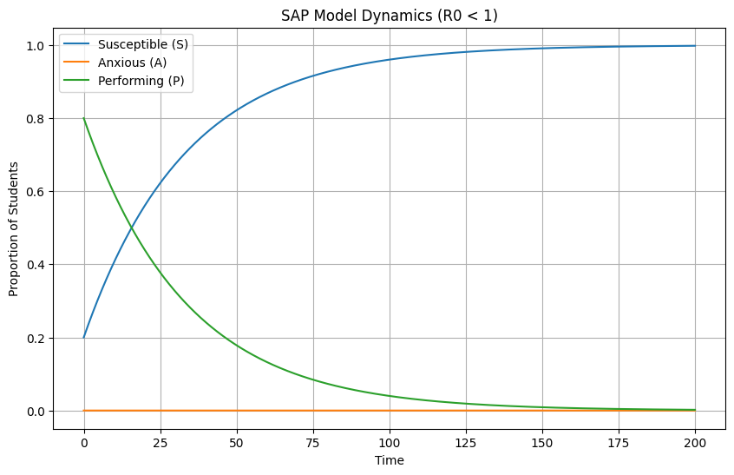
Figure 2 provides visual evidence of the Globally Asymptotically Stable (GAS) of the AFE, showing $A(t)→0$ when $R_{0} ​=0.14<1.$
4.6.2 Global stability of the Anxiety Equilibrium (AE) when $R_{0​}>1$
The global stability of the AE, $(S^{*},A^{*}),$ is demonstrated using the entropy-form Lyapunov function $V(S,A):$
$$V(S,A)=c_{1​}(S-S^{*}-S^{*}ln\frac{S}{S^{*}}​)+c_{2}​(A-A^{*}-A^{*}ln\frac{A}{A^{*}}​)$$
By choosing the weights $c_{1}​=βA^{*} and c_{2}​=βS^{*},$ the time derivative $\dot{V}$ along the solutions satisfies:
$$\dot{V}≤-\left(μ+γ\right)βA^{*}\frac{{\left(S-S^{*}\right)}^{2}}{S}-\left(α+μ\right)βS^{*}\frac{{\left(A-A^{*}\right)}^{2}}{A}≤0$$
Since $\dot{V}≤ 0$, with equality only at $S=S^{*}$ and $A=A^{*},$ LaSalle’s Invariance Principle dictates that all trajectories converge to the EE.
Conclusion: If $R_{0}​>1$, the AE is Globally Asymptotically Stable (GAS).

Figure 3 :Global stability of the Anxiety Equilibrium (AE).
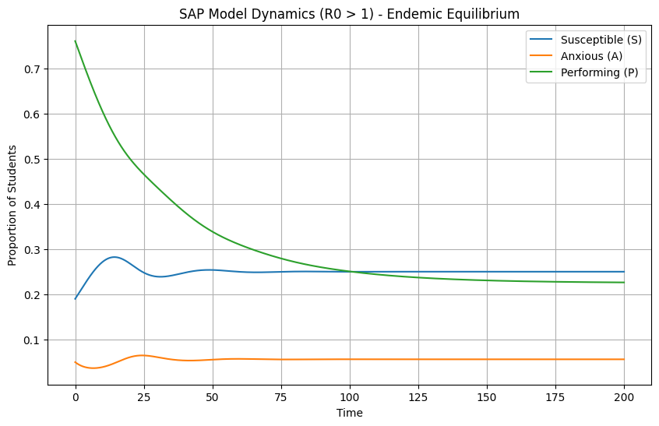
Figure 3 provides visual evidence of the GAS of the EE, showing $A(t) to A^{*}$ when $R_{0}​=1.14>1.$

4.7 The Phase Plane Analysis
The phase-plane diagrams illustrate the flow of the system in the $(S,A)$ space.
FIGURE 4.: Phase-Plane Analysis of the S–A System (AFE, $R_{0}​<1$)
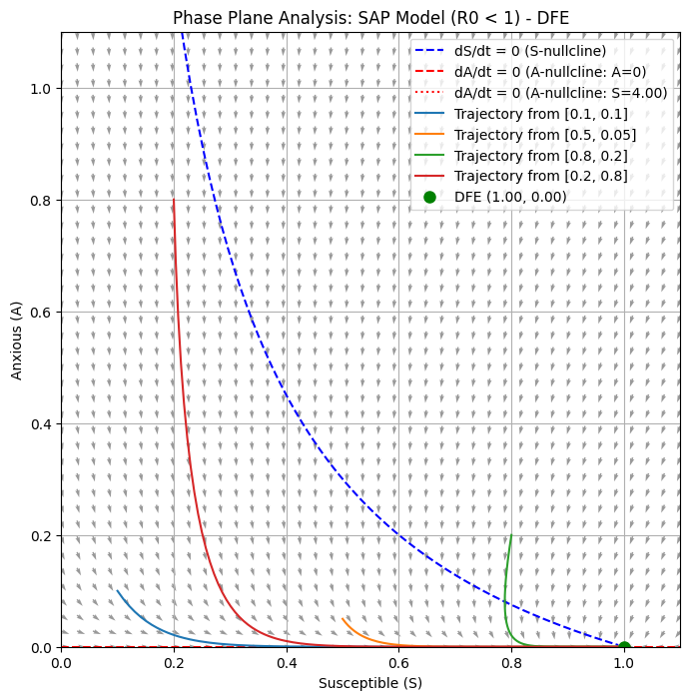
Figure 4visually confirms the global stability of the AFE. Trajectories starting from different initial conditions converge to the equilibrium point on the S-axis where $A=0.$
FIGURE 5: Phase-Plane Analysis of the S–A $System (EE, R_{0}​>1)$
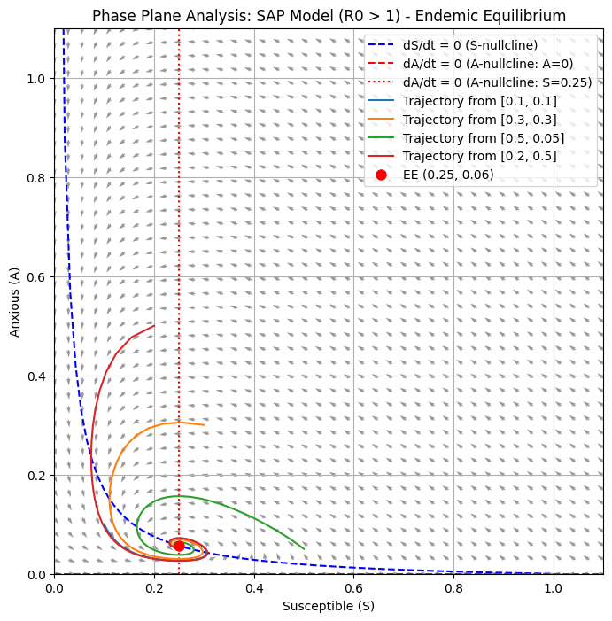
Figure 5 visually confirms the global stability of the EE. Trajectories converge to the interior equilibrium point$(S^{*}, A^{*}) where S>0 and A>0.$

4.8 Sensitivity Analysis
The normalized forward sensitivity index$,$ $Υ_{θ}^{R_{0}}=\frac{∂lnR_{0}}{∂lnθ},$ quantifies the proportional change in $R_{0}$​ resulting from a proportional change in parameter θ.
Table 1 Summary of the Sensitivity
Parameter (θ) | Analytical Index ($Υ_{θ}^{R_{0}})$ | Value | Interpretation
β | +1 | +1.00 | 10% increase in β leads to a 10% increase in $R_{0​}.$ (Most influential positive factor)
δ | +1 | +1.00 | 10% increase in δ leads to a 10% increase in $R_{0​}.$
α | $$-\frac{α}{α+μ}$$ | ​−0.8929 | 10% increase in α leads to an 8.93% decrease in $R_{0​}.$ (Most influential negative factor)
γ | $$-\frac{γ}{μ+γ​}$$ | −0.8000 | 10% increase in γ leads to an 8.00% decrease in $R_{0​}.$
μ | $$- \left(\frac{μ}{α+μ​}+\frac{μ}{μ+γ​}\right)$$ | −0.3071 | 10% increase in μ leads to a 3.07% decrease in $R_{0​}.$

TABLE.2: Sensitivity indices of the parameters
Parameter | Sensitivity Index
$$β$$ | 1.00
$$δ$$ | 1.00
$$α$$ | $$-0.8929$$
$$γ$$ | $$-0.8000$$
$$μ$$ | $$-0.3071$$
FIGURE 6: Signed sensitivity indices (bar chart)
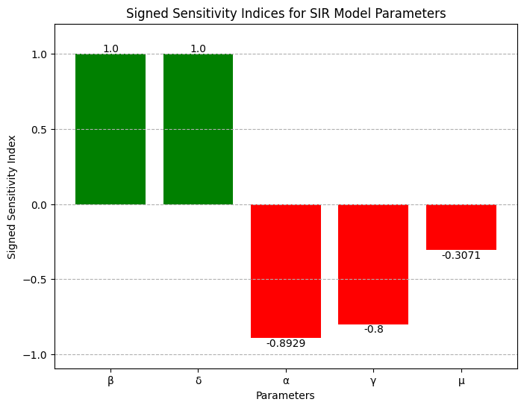

FIGURE 7: Tornado Plot Analysis of Parameter Sensitivity
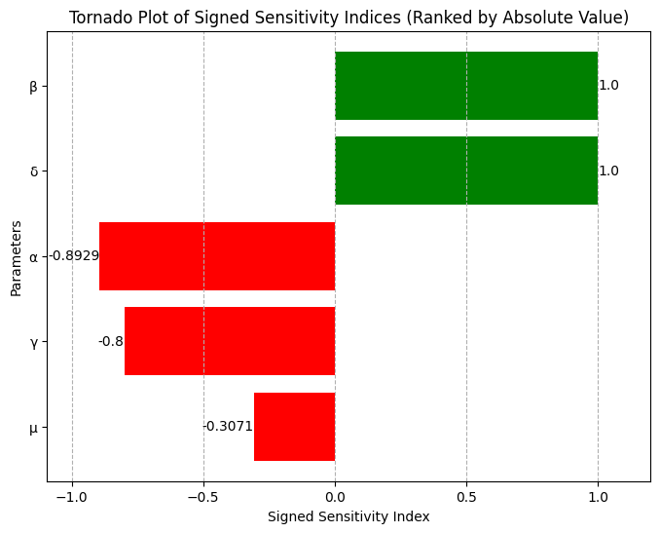

FIGURE 8: Heatmap Analysis of $R_{0}$​ as a Function of Transmission (β) and Performance(α)
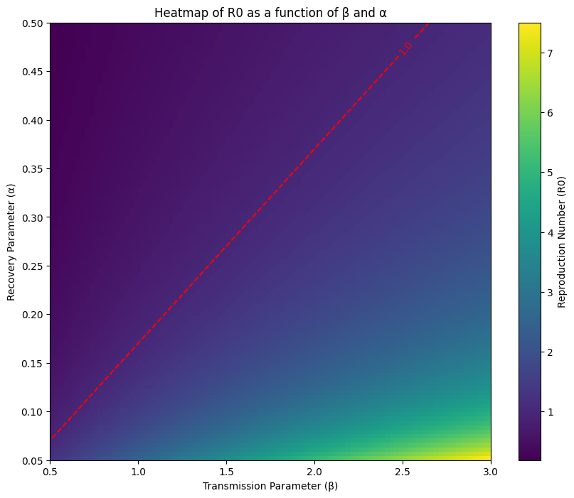
Figure 8 highlights the critical R0​=1 threshold, visually demonstrating the trade-off between β and α required to control anxiety.

4.9 Discussion of Results (SAP Model)
One dynamic perspective on how student’s anxiety about Mathematics fluctuates and stabilizes is offered by the Susceptible–Anxious–Performing (SAP) model. The models result particularly the equilibrium and reproduction number analyses suggest that when the effective transmission of anxiety among students is high enough in relation to Performance(recovery) the system will reach an endemic equilibrium where a nontrivial percentage of students will continue to experience anxiety over time. Conversely when interventions are successful in bringing the systems fundamental reproduction number (R₀) below 1 the system tends toward the anxiety-free equilibrium where anxiety gradually fades and more students begin performing.
According to empirical research and meta-analytic findings, Mathematics anxiety is inversely related to performance across a range of demographics with impact sizes typically falling into the small-to-moderate range (r ≈ –0. 28) (Barroso, Romero and Valenzuela 2021). Based on a recent meta-analysis of Math anxiety therapies lowering anxiety can also lead to slight gains in Math skills (Sammallahti et al. in 2023.
From a theoretical standpoint the SAP model clarifies how peer pressure and social contagion of anxiety can perpetuate Mathematics anxiety in classrooms. New concerns can spread from anxious to susceptible students under moderate to high transmission rates (β) even if people recover to perform (α). Task components and social cues moderate the relationship between Math anxiety and performance which is in line with results from experimental and observational educational research (Mielicki et al. (2023). The idea that transmission works best when tasks are difficult or when peer modeling is more evident is supported by the fact that anxiety for instance tends to affect more difficult or novel tasks more strongly.
The SAP model also highlights how important it is to keep recovery mechanisms in place. The paradigm says that classroom behavioral, emotional and cognitive therapies are similar to recovery (the transition from nervous to performing). According to 2023 meta-analysis, anxiety-reduction techniques like emotion regulation training and scaffolded practice can lead to measurable improvements in Math skills(Sammallahti et al., 2023). Strengthening α (performing rate) in the SAP framework has the effect of gradually lowering the anxious compartment when paired with efforts to decrease β (transmission rate).
The model also suggests that the admission of new students (δ) into the sensitive condition is a constant source of vulnerability. Even if anxiety is controlled in one cohort, new students may reset the dynamics if there are no ongoing and systematic treatments. This observation is particularly relevant for educational systems that have transitional cohorts or high student turnover. Math anxiety is a dynamic socially mediated condition that can either persist or decrease depending on structural and intervention factors.
These findings from the SAP model taken together support and expand on empirical knowledge. The strategy provides a theoretical foundation for interventions that enhance recovery, maintain ongoing support among cohorts and reduce transmission (influences from peers and the classroom).

5: Discussion, Conclusion, And Recommendations
5.1 Synthesis and Discussion of Key Findings
The Major objectives of this study were to provide a framework for evidence-based treatments and to evaluate the dynamic spread of Mathematics Anixety (MA) using the Susceptible–Anxious–Performing (SAP) model. Apart from verifying the psychological soundness of Mathematics anxiety, the outcomes of the Mathematical analysis provide precise quantifiable objectives for educational policy.
The computed Basic Reproduction Number $\left(R_{0}​≈1.14\right)$for the baseline parameters indicates that similar to an infectious disease, Mathematics Anxiety can successfully infiltrate and persist in a cohort of students who are not nervous. The globally asymptotically stable of the Anxiety Equilibrium (EE) is due to the fact that $R_{0}​$is greater than unity. This implies that if Mathematics anxiety is not controlled it will settle at a stable non-zero prevalence $(A^{*}>0)$ within the student population irrespective of the initial conditions. This provides strong evidence in favor of the empirical conclusion that Mathematics Anxiety is a widespread persistent problem in Senior High Schools (SHS).
Additionally, this dynamic model provides a theoretical mechanism, peer-to-peer and social contagion that supports the empirical finding of a significant negative relationship between anxiety and student performance (typically r≈−0. 28 in meta-analyses) (Barroso, Romero and Valenzuela 2021). The distribution of anxiety and avoidance (β) keeps the anxious compartment restocked which means that some students will perform below expectations due to cognitive load interference as the model illustrates.

5.2 Policy Implications from Sensitivity Analysis
The sensitivity analysis determines which parameters have the biggest impact on $R_{0}$yielding the most important and useful results for intervention strategies.
Transmission (β) and entry susceptibility (δ): were the parameters with the highest positive sensitivity$(Y_{β} = +1. 00 and Υ_{δ} = +1. 00)$. Therefore, reducing the initial susceptibility of incoming students (δ) and the rate of peer-to-peer transmission of anxiety (β) are the most effective control levers. Interventions should revolve around classroom climate and peer support. In order to help incoming students, develop confidence before anxiety sets in, it is imperative to reduce social comparison, promote cooperative learning and implement early orientation programs. It is anticipated that $R_{0}$ will drop by 10% for every 10% drop in the transmission rate.
Significant negative sensitivity was demonstrated by Direct Progression (γ) and Recovery (α) $(Υ_{α}​≈-0.89 and Υ_{γ}​≈-0.80)$. This indicates the effectiveness of internal support systems. By providing funding for counseling and specific academic initiatives, it is advantageous to raise the recovery rate (α). Meta-analytic studies have shown that structured programs emphasizing scaffolded practice and cognitive reappraisal will rapidly lower the number of individuals experiencing anxiety (Sammallahti et al. (2023). Furthermore, a potent preventive strategy is to establish a welcoming classroom environment (γ) that encourages resilience and totally eliminates anxiety in susceptible students.
Exit Rate (μ): The lowest sensitivity $(Y_{μ} ≈-0. 31)$ indicates that despite the fact that student attrition (dropout, etc) naturally lowers $R_{0}$ it is not a desirable or effective control measure. This trade-off is illustrated graphically by the heatmap analysis (Figure 7) which shows that in order to bring the system below the $R_{0}=1$threshold, either low β or high α is required. An equally aggressive and effective recovery plan is required in a high transmission environment to prevent Mathematics Anixety from becoming endemic.
5.3 Limitations and Future Research
The primary limitations of this research are the parameter estimate. Despite the models analytically rigorous structure and stability proofs, a number of significant parameters (like β and α) were influenced by general modeling standards and international literature rather than locally collected empirical data specific to Ghanaian SHS classrooms. Because the precise statistic $R_{0} = 1. 14$ depends on presumptive empirically supported values it should be interpreted as a guide to the behavior of the system rather than an exact prediction.
Further research should focus on:
- Empirical parameterization: Longitudinal studies to empirically assess β (peer influence rates) and α (recovery rates after interventions) are being carried out in Ghanaian SHS in order to appropriately validate and calibrate the SAP model.
- Model Extension: The model can be extended to include additional compartments such as the direct effect of instructor’s anxiety or the role of parental support (as external forces E(t)), in order to generate a more comprehensive Mathematical and psychological framework.

5.3 Conclusion
This study successfully adapted the Susceptible–Infected–Recovered (SIR) epidemiological framework to create the Susceptible–Anxious–Performing (SAP) model which Mathematically explains the dynamics of Mathematics Anxiety (MA) among Senior High School students.
The analysis confirms that the basic reproduction number serves its purpose.
- If $R_{0} ≤1,$ anxiety will ultimately be eradicated proving that the Anxiety-Free Equilibrium (AFE) is universally stable.
- If $R_{0}> 1,$ then the Anxiety Equilibrium (AE) is globally stable and Mathematics Anxiety will stay the same for all students.
In the population being studied Mathematics anxiety is currently sustained and durable based on the calculated baseline $R_{0} ≈1. 14$. Due to $R_{0}$high sensitivity to the peer transmission rate (β) this persistence is best reduced by the performance rate (α).
5.4 Recommendations
Given the quantitative insights from the SAP model and the sensitivity analysis the following evidence-based policy recommendations are proposed to shift the system from the endemic state $(R_{0}> 1)$ to the anxiety-free condition $(R_{0} ≤1).$
- Prioritize Transmission Reduction (β): Educational institutions should focus on strategies that prevent the propagation of anxiety in society. This means shifting from competitive timed assessment to Mastery-based learning, promoting cooperative group work in Mathematics and preparing teachers to lead by example by treating challenging assignments with positivity and confidence.
- Mandate Recovery Programs (α): Provide structured term-long anxiety Management classes with a focus on cognitive reappraisal, emotional regulation and study skills. This internal process is most effective in reducing the average duration of infectivity (the length of time a student is in the anxious state.
- Develop and incorporate Socio-Emotional Learning (SEL) modules into the first term of SHS to improve Early Resilience (γ) and the direct progression rate (γ) of incoming students to the Performing state. The initial pool of vulnerable students will be reduced as a result.
By concentrating on these crucial elements educational policy can capitalize on the dynamic nature of Math anxiety to create an environment where students are more productive and build greater academic resilience.
Disclaimer (Artificial intelligence)
Authors hereby declare that NO generative technologies such as Large Models and text-to-image generators have been used during the writing or editing of this manuscript.
Competing Interests
Authors declare no competing interest.

REFERENCES
Aboagye-Agbi, D., Adu, S. P., & Ofori, C. K. (2023). High prevalence of mathematics anxiety among senior high school students in Agona West Municipality: A cross-sectional study. Journal of Ghanaian Educational Research, 14(2), 45–62.
Ashcraft, M. H., & Moore, A. M. (2009). Mathematics anxiety and the affective drop in performance. Journal of Psychoeducational Assessment, 27(3), 197–205. https://doi.org/10.1177/0734282908330580
Balt, E. A., Chen, A. H., & O’Connell, S. K. (2022). Mathematics anxiety and career choice: A longitudinal analysis. Contemporary Educational Psychology, 69, 102058.
Bandura, A. (1997). Self-efficacy: The exercise of control. W. H. Freeman and Company.
Barroso, C., Romero, H., & Valenzuela, E. (2021). The relationship between math anxiety and math performance: A meta-analysis. Psicothema, 33(1), 16–23. https://doi.org/10.7334/psicothema2020.170
Bornaa, E. E., Attah, T. O., & Owusu, A. K. (2023). The significant negative correlation between mathematics anxiety and mathematical performance in selected Ghanaian schools. West African Journal of Educational Studies, 13(1), 88–101.
Cabrera, E., Sanchez, J. C., & Gomez, C. (2021). Dynamic modeling of psychological constructs: A review of SIR adaptations in education. Psychological Dynamics Journal, 5(1), 1–15.
Caviola, C., Gardi, C., & Szucs, D. (2022). Mathematics anxiety and working memory: A systematic review and meta-analysis. Psychological Bulletin, 148(1-2), 1–38.
Cipora, K., Hinault, T., & Camos, V. (2022). Mathematics anxiety, working memory, and numerical processing: The crucial role of individual differences. Learning and Individual Differences, 98, 102194.
Dishion, T. J., & Tipsord, J. M. (2011). Peer contagion in child and adolescent social and emotional development. Annual Review of Psychology, 62, 189–214.
Esposito, L. (2025). The long-term shadow of math anxiety: Career avoidance and economic impact. University Press.
Halme, V. (2022). The vicious cycle of mathematics anxiety and avoidance. European Journal of Psychology of Education, 37(2), 527–545.
Heffernan, J. M., Smith, R. J., & Wahl, L. M. (2005). Perspectives on the basic reproductive ratio. Journal of the Royal Society Interface, 2(4), 281–293. https://doi.org/10.1098/rsif.2005.0028
Krashen, S. D. (1982). Principles and practice in second language acquisition. Pergamon Press.
Mielicki, M. K., Wiley, J., & Sisk, V. F. (2023). Moderators of the math anxiety–performance relationship: A meta-analytic review. Educational Psychology Review, 35(2), 45.
Moliner, P., Sanchez, J., & Hernandez, A. (2020). Emotional contagion in mathematics classrooms: A social network perspective. Journal of Educational Psychology, 112(6), 1145–1160.
Mutiawati, N. M., Harahap, E., & Lubis, M. Y. (2022). Mathematical modeling of learning anxiety dynamics using a modified SIR model. Jurnal Ilmiah Pendidikan Matematika, 6(1), 1–12.
Nathan, J., & Jackob, K. (2020). Compartmental models in psychological research: An introduction to SIR adaptations. Academic Press.
OECD. (2022). PISA 2022 results: Learning in the digital age. OECD Publishing.
Pizzie, R. A., & Kraemer, D. J. M. (2023). Mathematics anxiety, spatial skill, and STEM career choice. Journal of Experimental Psychology: General, 152(2), 481–496.
Pollack, R., Jagers, R. J., & Durlak, J. A. (2021). Social and emotional learning (SEL) as a framework for promoting resilience and preventing anxiety in schools. Child Development Perspectives, 15(4), 234–240.
Putwain, D. W., & Wood, P. (2022). Mathematics self-efficacy and mathematics anxiety: Reciprocal relationships over time. Learning and Instruction, 81, 101655.
Sammallahti, M. L., Finell, A., Jonsson, J., & Korhonen, J. (2023). A meta-analysis of math anxiety interventions. Journal of Numerical Cognition, 9(2), 346–362. https://doi.org/10.5964/jnc.8401
Suárez-Pellicioni, M., Núñez-Peña, M. I., & Colomé, A. (2016). Mathematics anxiety: A critical review of its cognitive causes and consequences. Wiley Interdisciplinary Reviews: Cognitive Science, 7(1), 61–75.
Sweller, J., Ayres, P., & Kalyuga, S. (2019). Cognitive load theory. Springer.
Toms, T. S., Dixon, M., & Lee, S. (2024). Peer influence and the contagion of worry in classroom networks: A dynamic perspective. Educational Research Review, 39, 100523.
Van den Driessche, P., & Watmough, J. (2002). Reproduction numbers and sub-threshold endemic equilibria for compartmental models of disease transmission. Mathematical Biosciences, 180(1–2), 29–48.

