Original Research Article

Characterizing Xanthomonas axonopodis pv. dieffenbachiae, the Bacterial Blight Pathogen of Taro

ABSTRACT
Taro, a versatile crop grown under diverse and adverse climatic conditions, is susceptible to several fungal, bacterial, and viral pathogens. Among these, bacterial leaf blight caused by Xanthomonas axonopodis pv. dieffenbachiae (Xad) is a major disease, leading to severe damage and significant losses to crop growth and yield. The disease primarily affects the foliage, resulting in reduced productivity. The bacterial isolates were Gram-negative, small rod-shaped cells and exhibited close similarity to Florida strains, as confirmed through morphological characterization, biochemical tests, pathogenicity assays, molecular analysis, and field emission scanning electron microscopy. Timely and accurate identification of the pathogen is critical for implementing effective management strategies and enabling prompt application of control measures.
Keywords: Taro, Xanthomonas axonopodis pv. dieffenbachia, Bacterial blight, Characterization, Biochemical, Molecular

INTRODUCTION
Taro (Colocasia esculenta L. Schott), a major tropical tuber crop of the family Araceae (Lebot, 2020), ranks fifth among global root and tuber crops, producing about 17.72 million tonnes worldwide (FAOSTAT, 2022). Its corms and leaves are widely consumed and are rich in carbohydrates, fibre, proteins, vitamins, and essential minerals (Huang et al., 2000). In addition to its nutritional value, aroids possess notable medicinal properties (Babu et al., 2010). It can be grown under diverse climates and saline soils, thriving where few other crops can (Grubben and Denton, 2004), making it a crop of significant socioeconomic value, particularly in smallholder farming systems.
Taro productivity and quality are adversely affected by both abiotic and biotic stresses, with pathogenic fungal, bacterial, and viral being the primary biotic constraints. Major diseases include: Phytophthora leaf blight caused by Phytophthora colocasiae (Misra et al., 2011; Nath et al., 2015); Corm rot incited by fungi such as Aspergillus niger, Fusarium solani, F. oxysporum, and Sclerotium rolfsii (Ugwuoke et al., 2008); Corm soft rot caused by Pectobacterium spp. (Amodu and Akpa, 2012); Viral diseases including Dasheen mosaic virus (DsMV), Colocasia bobone disease virus (CBDV), Taro bacilliform virus (TaBV), Taro vein chlorosis virus (TaVCV), and Taro reovirus (TaRV) (Pearson et al., 1999; Devitt et al., 2001; Yang et al., 2003); and Bacterial leaf blight caused by Xanthomonas axonopodis pv. dieffenbachiae (Xad) (Asthana, 1946; Tomlinson, 1987; Opara et al., 2013).
Bacterial leaf blight caused by Xanthomonas axonopodis pv. dieffenbachiae (Xad) is one of the most destructive diseases. The pathogen leads to severe foliar lesions, reduced photosynthetic efficiency, stunted growth, and in severe cases, plant death, resulting in substantial yield losses. Characterization of Xanthomonas axonopodis pv. dieffenbachiae (Xad) is essential for accurate identification, understanding pathogenicity, and developing effective disease management, including the development of resistant taro cultivars.
MATERIAL AND METHODS
Isolation of the causal organism and pathogenicity tests
Symptomatic Colocasia leaves exhibiting characteristic features of bacterial blight (BB) (Plate 1) were obtained from the Experimental Farm for Horticultural Crops, AAU, Jorhat, cleansed under running tap water to remove dirt particles, and subsequently air-dried. The Infected sections, along with adjoining normal tissue, were excised into small pieces and surface sterilized using 0.1% HgCl₂ for one minute, followed by three thorough rinses with sterile distilled water. The excised tissues were transferred to a Petri dish containing approximately 3.0 ml of sterile distilled water, finely macerated with sterile blades, and left to stand for 10 minutes. The resulting suspension was streaked onto sterilized nutrient agar plates, which were incubated in an inverted position at 28 ± 2 °C for 2–3 days and examined for the appearance of well-separated, characteristic yellow bacterial colonies typical of Xanthomonas spp. Pure cultures were obtained after sub-culturing twice and stored at 4ºC for further use. The 24-hour cultures of the bacterial isolate were standardized to an optical density of 0.3 at 600 nm using a spectrophotometer, corresponding to approximately 10⁸ cfu/ml.
Two-month-old susceptible Colocasia cv. Piyaji Kachu (Luikham et al., 2024) were used to confirm the pathogenicity through the sand paper technique (Eddin et al., 2005) (Plate 2) with a bacterial concentration of 10⁸ cfu/ml. A plant inoculated with sterile distilled water served as a control. Inoculated plants/ leaves were covered with transparent polyethene bags for 24 hours to ensure post post-inoculation period of high favourable humidity (Pohronezny et al., 1990) (Plate 3).
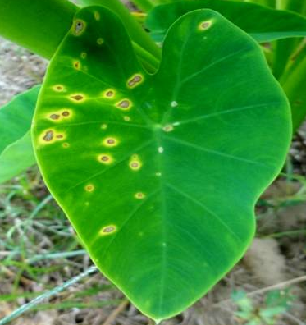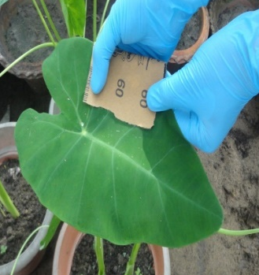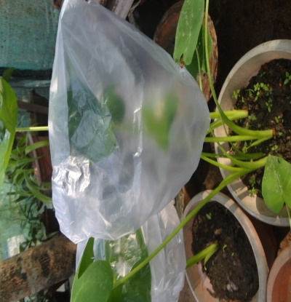
Plate 1. Typical symptoms of bacterial blight
Plate 2. Inoculation through sand paper technique
Plate 3. Maintaining the optimal humidity

Biochemical tests
A series of biochemical assays was conducted to characterize the isolated bacterium following standard procedures described earlier. The biochemical evaluations included Gram staining (Bradbury et al., 1970), the Potassium Hydroxide (KOH) string test (Suslow et al., 1982), catalase production (Hayward, 1992), gelatin liquefaction assay (Schaad et al., 2001), starch hydrolysis test (Schaad et al., 2001), oxidase reaction test (Kovács, 1956), indole production assay (Schaad et al., 2001), arginine dihydrolase activity test (Schaad et al., 2001), and citrate utilization using Simmons’ citrate medium (Schaad et al., 2001).
Electron Microscopy
Field Emission Scanning Electron Microscopy (FESEM) was performed at CSIR-NEIST, Jorhat, Assam, India, to determine the morphological characteristics of the isolated bacterium. Sample preparation followed the procedures of Hayat (2000) and Dey et al. (1989), with minor modifications. A 24-hour broth culture was centrifuged at 10,000 rpm for 7 min, and the pellet was fixed in 2.5% glutaraldehyde overnight at 4 °C. The fixed sample was washed three times (15 mins each) with 0.1 M sodium cacodylate buffer at 4 °C. Dehydration was performed at 4 °C through a graded acetone series (30%, 50%, 70%, 80%, 90%, and 100%), each concentration applied for 15 min for two changes. The dehydrated pellet was immersed in tetramethyl silane (TMS) for 5–10 min (two changes) at 4°C and air-dried at room temperature (25–27 °C). The dried specimen was mounted on aluminium stubs and sputter-coated with gold (~35 nm) in a Quorum Q 150R S Rotary Pumped Coater. Imaging was performed using a Carl Zeiss ΣIGMA FESEM, and Cell dimensions were measured using ImageJ software (Schneider et al., 2012).
Molecular characterization of the isolated bacterium
16s rDNA gene-based molecular characterization was performed to reveal the phylogenetic relationship with other known bacterial strains.
Genomic DNA was extracted from the bacterium isolate following a modified method of Cardinal et al. (1997). A loopful of an isolate was inoculated into nutrient broth and incubated at 28 ± 2 °C until the optical density reached 1.0 at 600 nm. 1.5 mL of culture was centrifuged at 12,000 rpm for 5 min, and the pellet was resuspended in 200 µL lysis buffer (100 mM Tris-acetate, pH 8.8; 20 mM sodium acetate; 1 mM EDTA; 1% SDS) and mixed thoroughly. 100 µL 5 M NaCl was added, vortexed, and the mixture incubated at −20 °C for 20 min. Following centrifugation at 12,000 rpm for 10 min at room temperature, the supernatant was extracted with an equal volume of phenol: chloroform: isoamyl alcohol (24:24:1) until a milky emulsion was formed and centrifuged at 12,000 rpm for 10 min. The top aqueous phase was collected and further purified with an equal volume of chloroform: isoamyl alcohol (24:1) and centrifuged again at 12000 rpm for 10 min at 4°C. The supernatant was mixed with double the volume of chilled 70% ethanol and incubated at −20 °C overnight. The pellet was recovered by centrifugation at 12000 rpm for 10 min at 4°C, washed with 70% ethanol, air-dried, and dissolved in 30–50 µL TE buffer (1 mM Tris-HCl, 1 mM EDTA). 3 µL RNase was added, incubated at 35 °C for 30 min, and stored at −20 °C for further use.
DNA quality was evaluated by 1% agarose gel electrophoresis in 1× TBE buffer with ethidium bromide. Samples (4 µl) were mixed with 2 µl 6× loading dye and 6 µl sterile water, loaded alongside a 100 kb ladder, and run at 60 V until the dye migrated one-third of the gel. DNA integrity was visualized under a UV transilluminator. Purity and concentration were determined spectrophotometrically (A260/A280) using UV-vis spectrophotometer, with a ratio of ~1.8 indicating high purity; >1.8 suggested RNA contamination, and <1.8 indicated protein presence. The yield (ng/µl) was estimated by measuring absorbance at 260 nm.
Polymerase Chain Reaction (PCR) amplification of 16S rDNA was performed using an Applied Biosystems 2720 Thermal Cycler with primers U16SF (5′-AGAGTTTGATCMTGGCTCAG-3′) and U16SR (5′-TACGGYTACCTTGTTACGACTT-3′). Each 10 µl reaction contained 1 µl DNA template, 0.5 µl of each primer (20 pM), 5 µl EmeraldAmp GT PCR Master Mix, and 3 µl sterile water. Cycling conditions were 94°C for 3 min; 35 cycles of 94°C for 30 s, 55°C for 1 min, 72°C for 1.5 min; and 72°C for 7 min. Amplified DNA (10 µl) was loaded onto 2.5% agarose gel containing 10 mg/ml ethidium bromide, along with 2 µl of a 100 bp DNA ladder as a molecular weight marker, and electrophoresed at 120 V until the dye front reached the gel end. DNA bands were visualized under a UV transilluminator (AlphaImager® EP, Alpha Innotech), and images were digitally recorded. Amplified sequences of 16S rDNA were obtained at BioServe Biotechnologies (India) Pvt. Ltd., assembled with CodonCode Aligner, analyzed via NCBI BLAST, and phylogenetic trees constructed in MEGA7 using the Neighbour-Joining method.
RESULT AND DISCUSSION
Isolation of the causal organism and pathogenicity tests
The bacterial isolate from symptomatic Colocasia exhibited light yellow, circular, smooth, convex, opaque, and entire colonies on nutrient agar (Plate 4). Morphological and cultural characteristics were consistent with previous reports. Pohronezny et al. (1985) described Xad as Gram-negative rods producing yellow, mucoid colonies on SNA and YDC media. Similarly, Opara et al. (2013) reported that Xad associated with taro bacterial blight was Gram-negative, with convex, mucoid colonies exhibiting yellow to creamy or pale-yellow pigmentation.
Pathogenicity of the bacterial isolate, evaluated using the sand paper method, demonstrated its virulence on healthy Colocasia (cv. Piyachi kochu) leaves, causing necrotic lesions with yellow halos within 3 days post-inoculation (Plate 5A), whereas control leaves remained symptomless (Plate 5B). Similar symptoms were observed on Colocasia esculenta and Xanthosoma sp. when a bacterial suspension (10⁹ cfu/ml) was applied to wounded and unwounded leaves under high humidity at 25–27°C (Tomlinson, 1987).
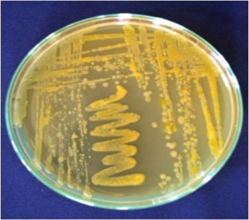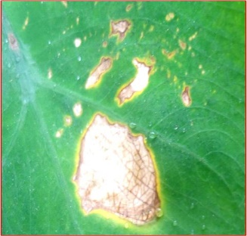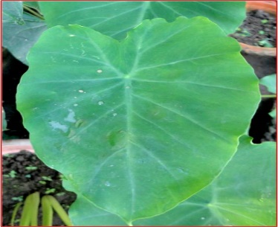
A
B
Plate 4. Pure culture of Xanthomonas axonopodis pv. dieffenbachiae
Plate 5. Pathogenecity test of Xanthomonas axonopodis pv. dieffenbachiae
A. Sand paper method
B. Control plant (without symptoms)
Biochemical tests
The outcomes of the biochemical assays presented in Table 1 and Plate 6 indicated that the isolate is oxidase-negative, citrate- and KOH-positive, capable of starch hydrolysis, and able to reduce nitrate to molecular nitrogen through denitrification, while failing to generate indole from tryptophan. The isolate produced arginine dihydrolase, catalase, and caseinase, indicating strong hydrolytic activity. It also exhibited gelatinase (proteolytic enzyme) production, as demonstrated by its ability to liquefy gelatin.
Table 1: Biochemical characteristics of Xanthomonas axonopodis pv. dieffenbachiae
Biochemical characters
Arginine hydrolase | Caseinase | Catalase | Citrate | Denitrification | Gelatin hydrolysis | Indole | KOH | Oxidase | Starch hydrolysis
-ve | +ve | +ve | +ve | +ve | +ve | -ve | +ve | -ve | -ve

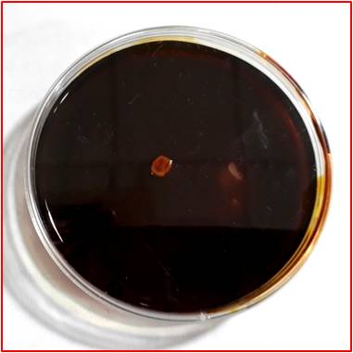
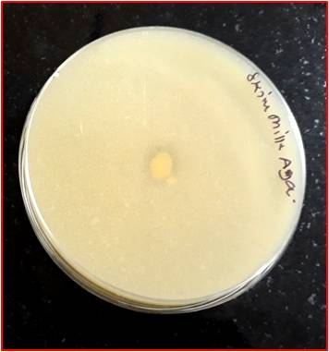
D
C
E
A
B
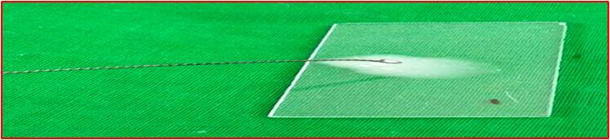
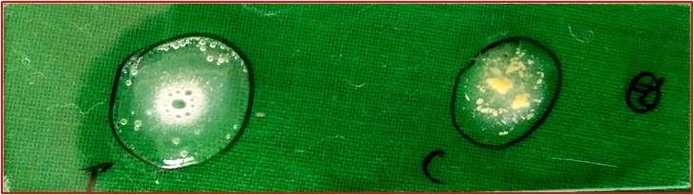
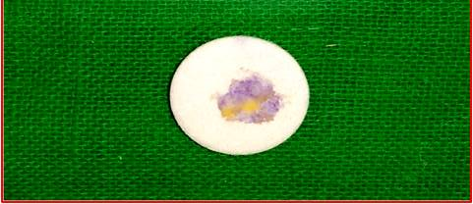

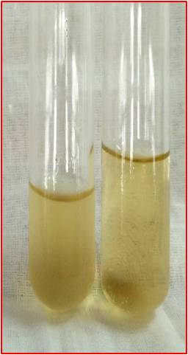
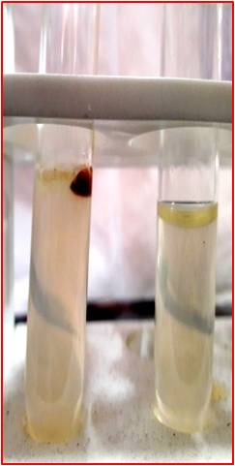
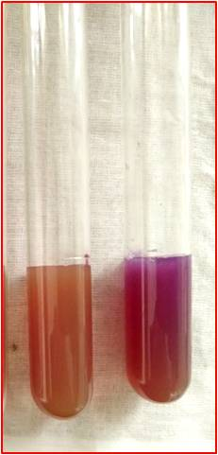
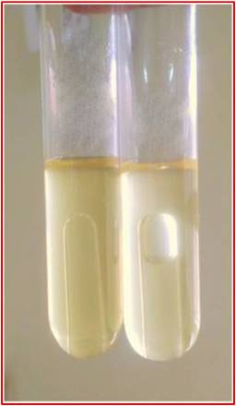
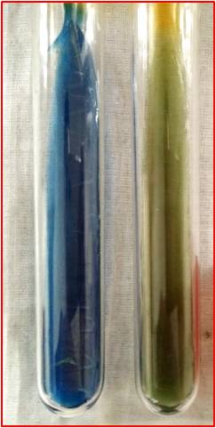
I
J
H
F
G

Plate 6. Biochemical attributes of Xanthomonas axonopodis pv. dieffenbachiae
A. Starch hydrolysis B. Caseinase test C. Oxidase test D. Catalase production
test E. KOH string test F. Citrate Test G. Arginine dihydrolase test H. Nitrate
reduction test I. Indole test J. Gelatin hydrolysis

Light microscopy at 40× magnification showed that the isolate comprised short, rod-shaped cells that retained the counterstain, confirming a Gram-negative reaction (Plate 7).
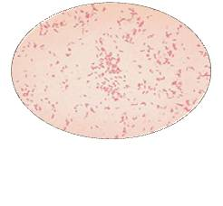
Plate 7. Microphotograph of X. axonopodis pv. dieffenbachiae
The biochemical and Gram-reaction results obtained in the present study are consistent with earlier reports by Pohronezny et al. (1985), Brown and Asemota (2009), and Opara et al. (2013). These authors described Xanthomonas axonopodis pv. dieffenbachiae as Gram-negative, rod-shaped bacteria that are catalase-positive, capable of producing hydrogen sulfide from peptone, able to liquefy gelatin, positive for starch hydrolysis, and able to hydrolyze aesculin. They further reported that the pathogen is oxidase and catalase-negative, does not ferment glucose, does not produce indole, shows negative urease activity, and reduces nitrite or ammonia. Additionally, the bacterium produces acid from glucose, arabinose, mannose, and cellobiose, but does not utilize asparagine.
Electron microscopy of the bacterial isolate
The Field Emission Scanning Electron Microscope (FESEM) micrograph of the Xanthomonas axonopodis pv. dieffenbachiae isolate, documented for the first time, was used to confirm its cellular morphology. The cells appeared as short rods measuring 572.26–614.21 nm in width and 1071.05–1275.23 nm in length (Plate 8). Comparable rod-shaped morphology of Xanthomonas spp. has also been reported by Mew et al. (1984), Tostes et al. (2014), Vicente et al. (2017), and Huang et al. (2018).
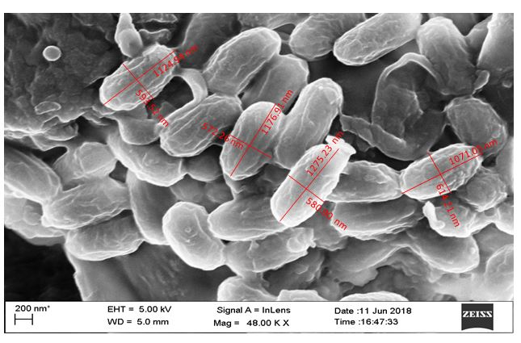
Plate 8. Scanning electron micrograph showing the cellular morphology of Xanthomonas axonopodis pv. dieffenbachiae at 48.00 kX magnification.
Molecular characterization of the isolate
The extracted genomic DNA exhibited high purity and was free from RNA contamination. Spectrophotometric analysis indicated a 260/280 ratio of 1.82, with a DNA yield of 2119.5 ng/µl. As noted by Desjardins and Conklin (2010), reliable evaluation of nucleic acid quality requires simultaneous consideration of 260/280 and 260/230 ratios together with the overall spectral profile, and pure DNA generally shows a 260/280 ratio of ~1.8.
The amplified products of the 16s rDNA fragment using the primer set U16SF and U16SR produced a clean amplicon of ~1500 bp fragments (Fig. 1).
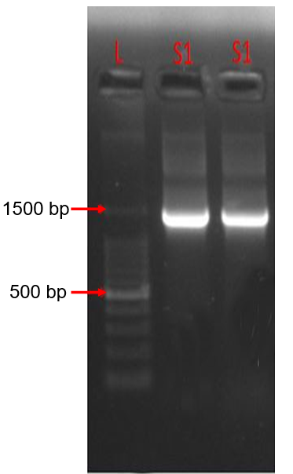
Fig. 1. Agarose gel electrophoresis showing amplification of bacterial DNA.
L: 100 bp ladder; S1: bacterial isolate.
The 16S rDNA sequence obtained from BioServe Biotechnologies (India) was assembled into a contig using CodonCode Aligner software, and the consensus sequence was generated in FASTA format. This FASTA sequence was subsequently subjected to similarity analysis using BLAST on the NCBI database. Phylogenetic analysis was carried out in MEGA7 using the Neighbour-Joining method to construct the phylogenetic tree (Fig. 2). Nucleotide BLAST analysis of the partial 16S rDNA sequence of Xanthomonas axonopodis pv. dieffenbachiae isolated from Jorhat (Xad Jorhat) was compared with ten known accessions retrieved from NCBI (Table 2). The isolate showed the highest similarity (98%) with Xad strains 05-220 and 05-113 from Florida, USA. This was followed by strains X481, X1705, X1708, and LMG8664 (97%) from the same region, as well as the XADK strain from Kerala, India. The lowest similarity (92%) was observed with strains CE4 and CE6 from Northwest Nigeria. The phylogenetic tree further supports these findings, clearly indicating that the Jorhat isolate clusters closely with the Florida strains, confirming their close genetic relatedness. The Xad strains were grouped into two major phylogenetic clusters, within which the Jorhat isolate was positioned alongside the Florida and Kerala isolates. The findings suggest that geographic grouping of Xad isolates is not a robust method for taxonomic classification.
These results align with previous studies. Donahoo et al. (2013), in a comparative analysis of 175 Xad strains from ten Araceae hosts, reported clear genetic variation, with isolates from Anthurium, Xanthosoma, and Philodendron forming distinct phylogenetic clusters. Likewise, Constantin et al. (2017) revised the X. axonopodis species complex using average nucleotide identity, DNA–DNA hybridization, and phenotypic traits, and grouped 25 Xad strains along with 88 related strains into four major phylogenetic clusters.
Table 2. Nucleotide BLAST results of 16s rDNA partial sequences of Xanthomonas axonopodis pv. dieffenbachiae (Xad) isolated from Jorhat with known accessions
Sl. No. | Strain | Place description | Max. identity (%) | Accession No.
1 | 05-220 | Florida, USA | 98 | EU203153.1
2 | 05-113 | Florida, USA | 98 | EU203151.1
3 | X481 | Florida, USA | 97 | AY576646.1
4 | X1705 | Florida, USA | 97 | AY576643.1
5 | X1708 | Florida, USA | 97 | AY576644.1
6 | LMG8664 | Florida, USA | 97 | AY576639.1
7 | XADK | Kerala, India | 97 | KM576803.1
8 | 05-185 | Florida, USA | 96 | EU203152.1
9 | CE6 | North West Nigeria | 92 | KT758341.1
10 | CE4 | North West Nigeria | 92 | KT758340.1

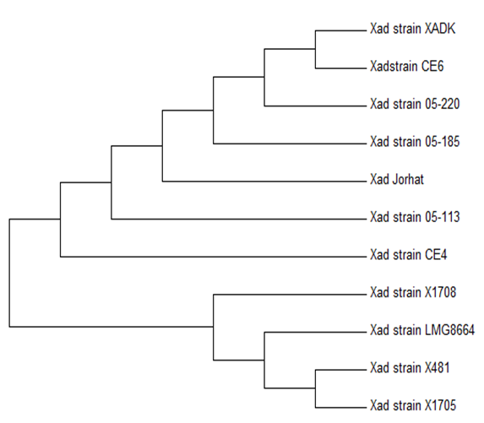
Fig. 2. DENDOGRAM DEPICTING THE POLYMORPHIC CHARACTERIZATION OF THE BACTERIAL ISOLATE (Xad JORHAT) WITH OTHER OTHER Xad STRAIN BY MAXIMUM LIKELIHOOD METHOD
CONCLUSION
The pathogen isolated from Colocasia plants suspected of bacterial blight was identified as Xanthomonas axonopodis pv. dieffenbachiae (Xad), as confirmed through colony and morphological characteristics, biochemical assays, pathogenicity tests, molecular analysis, and field emission scanning electron microscopy. The bacterial isolates were Gram-negative, small rod-shaped cells and showed close similarity to the Florida isolates, further indicating that geographic grouping is not a reliable criterion for taxonomic classification.

Disclaimer (Artificial intelligence)
Author(s) hereby declare that NO generative AI technologies such as Large Language Models (ChatGPT, COPILOT, etc.) and text-to-image generators have been used during the writing or editing of this manuscript.
REFERENCES
Amodu, U. S. & Akpa, A. D. (2012). Determination of the relative susceptibility of roots and tubers to the soft rot bacteria (Pectobacterium spp.). New Clues in Sciences. 2: 97-103.
Asthana, R.P. (1946). Bacterial leaf-spot on Arum. Current Science. 15 (12): 356-356.
Babu, B., Hegde, V., Makeshkumar, T., & Jeeva, M. L. (2010). Rapid detection and identification of potyvirus infecting Colocasia esculenta (L.) Schott by reverse transcription-polymerase chain reaction. Journal of Root Crops. 36: 88-94.
Bradbury, J. F. (1970) Isolation and preliminary study of bacteria from plants. PANS Pest Articles & News Summaries. 16(4):632-637.
Brown, V. M., & Asemota, H. (2009). X. Campestris pv. dieffenbachiae, the Causative Agent of Common Leaf Blight Disease in Dasheen (Colocasia sp.) and Cocoyam (Xanthosoma sp.). Journal of Biotech Research. 1(1):1-12.
Cardinal, M. J., Meghrous, J., Lacroix, C., & Simard, R.E. (1997). Isolation of Lactococcus lactis strains producing inhibitory activity against Listeria. Food Biotechnology. 11(2): 129-146.
Constantin, E. C., Haegeman, A., Van Vaerenbergh, J., Baeyen, S., Van Malderghem, C., Maes, M. & Cottyn, B. (2017). Pathogenicity and virulence gene content of Xanthomonas strains infecting Araceae, formerly known as Xanthomonas axonopodis pv. dieffenbachiae. Plant Pathology. 66(9): 1539-1554.
Desjardins, P., & Conklin, D. (2010). Nanodrop microvolume quantitation of nucleic acids. Journal of Visualized Experiments. 45: 2565.
Devitt, L. C., Hafner, G., Dale, J. L., & Harding, R. M. (2001). Partial characterisation of a new dsRNA virus infecting taro. In Abstracts: 1st Australian Virology Group Meeting. Fraser Island.
Dey, S., Basu Baul, T. S., Roy, B., & Dey, D. (1989). A new rapid method of air-drying for scanning electron microscopy using tetra-methyl silane. Journal of Microscopy, 156, 259–261.
Donahoo, R. S., Jones, J. B., Lacy, G. H., Stromberg, V. K., & Norman, D. J. (2013). Genetic analyses of Xanthomonas axonopodis pv. dieffenbachiae strains reveal distinct phylogenetic groups. Phytopathology. 103(3): 237-244.
Eddin, K. S., Marimuthu, T., Ladhalakshmi, D., Rabindran, R., & Velazhahan, R. (2005). A simple inoculation technique for evaluation of cotton genotypes for resistance to bacterial blight caused by Xanthomonas axonopodis pv. malvacearum. Journal of Plant Diseases and Protection, 112, 321–328.
FAOSTAT. (2022). [URL: http://www. fao. org/faostat/en/-data/QC. Food and agriculture organization of the United Nations (FAO)].
Grubben, G. J. H., & Denton, O. A. (2004). Vegetable Plant resources of Tropical Africa 2. PROTA Foundation, Wageningen, Netherlands/ Backhuys Publishes Leiden, Netherlands/ CTA, Wageningen, Netherlands. 217– 221.
Hayat, M. A. (2000). Principles and techniques of electron microscopy: Biological applications (4th ed.). Cambridge University Press.
Hayward, A. C. 1992. Identification of Pseudomonas solanacearum. In: SAVERNET Bacterial Wilt Training Course held on October 5 to November 16 AVRDC, p 101.
Huang, A. S., Titchenal, C. A., & Meilleur, B. A. (2000). Nutrient composition of taro corms and breadfruit. Journal of food composition and analysis. 13 (5): 859-864.
Huang, D., Shao, Z. Z., Yu, Y., Cai, M. M., Zheng, L. Y., Li, G. Y., et al. (2018). Identification, characteristics and mechanism of 1-deoxy-N-acetylglucosamine from deep-sea Virgibacillus dokdonensis MCCC 1A00493. Marine drugs. 16(2): 52.
Kovacs, N (1956). Identification of Pseudomonas pyocyanea by the Oxidase Reaction. Nature 178, 703. https://doi.org/10.1038/178703a0
Lebot, V. (2020). Tropical root and tuber crops: Cassava, sweet potato, yams and aroids (2nd ed.). CABI. Kindle edition.
Luikham, S., Bora, L. C., Chinir, J., Alam. S., & Luiram, S. (2024). “Screening Taro Germplasm Against Bacterial Blight Incited by Xanthomonas axonopodis pv. dieffenbachia”. Journal of Advances in Biology and Biotechnology, 27 (11),932-43. https://doi.org/10.9734/jabb/2024/v27i111677.
Mew, T. W., Mew, I. C., & Huang J. S. (1984). Scanning electron microscopy of virulent and avirulent strains of Xanthomonas campestris pathovar oryzae on rice Oryzae sativa leaves. Phytopathology. 74: 635-641.
Misra, R. S., Mishra, A. K., Sharma, K., Jeeva, M. L., & Hegde, V. (2011). Characterisation of Phytophthora colocasiae isolates associated with leaf blight of taro in India. Archives of Phytopathology and Plant Protection. 44(6): 581-591.
Nath, V. S., Rajitha, M., Darveekaran, S. S., Hegde, V. M., Jeeva, M. L., Misra, R. S., et al. (2015). Identification of Phytophthora colocasiae genes differentially expressed during infection on taro (Colocasia esculenta). Physiological and Molecular Plant Pathology. 89: 78-86.
Opara, E., Njoku, T. C., & Isaiah, C. (2013). Potency of some plant extracts and pesticides on bacterial leaf blight diseases of cocoyam (Colocasia esculenta) in Umudike, South Eastern Nigeria. Greener Journal of Agricultural Sciences. 3(5): 312-319.
Pearson, M. N., Jackson, G. V. H., Saelea, J., Morar, S. G. (1999) Evidence for two rhabdoviruses in taro (Colocasia esculenta) in the Pacific region. Australasian Plant Pathology. 28(3): 248–253.
Pohronezny, K., Dankers W., Schaffer B., Valenzuela H., & Moss M. A. (1990). Marginal necrosis and intercostal leaf spots of cocoyam infected by Xanthomonas campestris pv. dieffenbachiae. Plant Disease, 74(8), 573-577.
Pohronezny, K., Volin, R. B., & Dankers, W. (1985). Bacterial leaf spot of cocoyam (Xanthosoma caracu), incited by Xanthomonas campestris pv. dieffenbachiae in Florida. Plant Disese. 69(2): 170-173.
Schaad, N. W., Jones, J. B., & Chun, W. (2001). Laboratory Guide for Identification of Plant Pathogenic Bacteria (3rd ed.). APS Press, St. Paul, MN.
Schneider, C. A., Rasband, W. S., & Eliceiri, K. W. (2012). NIH Image to ImageJ: 25 years of image analysis. Nature Methods, 9(7), 671–675.
Suslow, T. V., Schroth, M. N., Isaka, M (1982). Application of rapid method for gram differentiation of plant pathogenic and saprophytic bacteria without staining. Phytopathology. 72(1):917-918.
Tomlinson, D. L. (1987). A bacterial leaf disease of taro (Colocasia esculenta) caused by xanthomonas campestris in papua new guinea. Tropical Pest Management. 33(4): 353-355.
Tostes, G. D. O., Araujo, J. S. D. P., Farias, A. R. G., Frade, D. Â. R., & Olivares, F. L. (2014). Detection and cellular localization of Xanthomonas campestris pv. viticola in seeds of commercial 'Red Globe'grapes. Tropical Plant Pathology. 39(2): 134-140.
Ugwuoke, K. I., Onyeke, C. C., & Tsopmbeng, N. G. R. (2008). The efficacy of botanical protectants in the storage of Cocoyam (Colocasia esculenta (L) Schott). Agro-Science. 7(2): 93-98.
Vicente, J. G., Rothwell, S., Holub, E. B., & Studholme, D. J. (2017). Pathogenic, phenotypic and molecular characterisation of Xanthomonas nasturtii sp. Nov. and Xanthomonas floridensis sp. Nov., new species of Xanthomonas associated with watercress production in Florida. International journal of systematic and evolutionary microbiology. 67(9): 3645–3654.
Yang, I. C., Hafner, G. J., Dale, J. L., & Harding, R. M. (2003) Genomic characterisation of Taro bacilliform virus. Archives of Virology 148, 937–949. doi: 10.1007/s00705-002-0969-1.

