Original Research Article

An ongoing diphtheria epidemic in Guinea: epidemiological and microbiological study from 2023 to 2025

Abstract
Objectives: This study describes the epidemiological and microbiological characteristics of suspected and confirmed cases between 2023 and 2025, to guide surveillance, prevention, and management.
Study type: A descriptive cross-sectional study was conducted in six affected health regions.
Study location and duration: All oropharyngeal or nasopharyngeal swabs meeting WHO definitions of suspected cases were centralized at the bacteriology laboratory of the National Institute of Public Health between 2023 and 2025
Methods: Bacterial identification was performed by culture on selective media and using the Corne API, and antibiotic susceptibility testing was interpreted according to CA-SFM/EUCAST 2023 standards.
Results: Of 997 samples received, 914 were included. The median age of the patients was 7 years (IQR: 3–15 years), with a predominance of children aged 0–4 years (33.9%). The Kankan region accounted for 68.4% of reported cases. Culture was positive in 17.9% of cases (n = 164). Corynebacterium diphtheriae biovar mitis was the predominant strain (80.5%), followed by C. pseudodiphtheriticum (12.8%) and C. diphtheriae biovar gravis (6.1%). The C. diphtheriae strains showed complete susceptibility to erythromycin but high resistance to β-lactams and tetracyclines. Only one death was reported (case fatality rate of 0.1%).
Conclusion: The diphtheria epidemic in Guinea is characterized by persistent transmission, primarily affecting young children, with a high geographic concentration. The results support the use of macrolides as first-line therapy, the restriction of tetracyclines and cotrimoxazole, and highlight the need to strengthen childhood vaccination and microbiological surveillance.

Keywords: diphtheria, Corynebacterium diphtheriae, epidemic, Guinea, antibiogram, vaccination.

Introduction
Diphtheria is an acute bacterial disease caused primarily by Corynebacterium diphtheriae, a Gram-positive bacterium capable of producing a highly pathogenic toxin. This toxin causes severe inflammation of the airways, often marked by the formation of a characteristic pseudomembranous membrane that can obstruct the airways (Murphy, 1996; Sharma et al., 2019). It is potentially fatal but preventable by vaccination. Transmission occurs mainly through direct contact or via the airborne route using respiratory droplets. It can affect all age groups, but unvaccinated children are most at risk (WHO, n.d.).
In the WHO US and Indian regions, diphtheria outbreaks occurred between 2018 and 2019, with 1,904 suspected cases including 164 deaths in Venezuela, 808 probable cases including 107 deaths in Haiti, and 1,907 suspected cases including 98 deaths (ReliefWeb, 2019; Sharma et al., 2019; Truelove et al., 2020a).
Since 2023, West Africa has faced a resurgence of diphtheria, with notable outbreaks in Nigeria and Guinea (WHO, n.d., n.d.). In Guinea, in the Kankan region, between July and October, 538 cases were reported, including 18 confirmed cases and 58 deaths (overall case fatality rate of 11%), predominantly affecting children under 5 years of age. These data are part of a multi-country context documented by WHO/AFRO (WHO, n.d.). Faced with this re-emergence, Guinea had to respond in a context of suboptimal vaccination coverage, with a DTP/DTP3 vaccination rate of 36% in the affected area (Kankan region), as well as difficulties accessing the affected areas. The situation evolved rapidly, and the epidemic spread to other regions, notably Faranah, Mamou, and Conakry. This weakness in vaccination coverage has led to the implementation of targeted vaccination around clusters of confirmed cases to curb the spread, although national vaccination coverage remains suboptimal for adequate herd protection (Leadon, 2024; OMS, 2024; WHO, n.d.).
From a microbiological perspective, recent studies report the predominance of C. diphtheriae lineages affiliated with the mitis biovar as responsible for diphtheria cases (Benamrouche et al., 2016) and the coexistence of diverse genomic profiles within the same territory (Hennart et al., 2020). Furthermore, the concomitant detection of non-diphtheria species, particularly C. pseudodiphtheriticum, in suspect samples is frequently observed (Weil et al., 2021).
Despite warnings, published data incorporating spatiotemporal distribution, demographic profiles, and microbiological characterization, including antibiograms, remain limited for Guinea. This study aims to describe, for the period 2023–2025, the epidemiology of suspected and confirmed cases, as well as the microbiological profile of isolates, to inform surveillance, vaccination, and antibiotic therapy strategies adapted to the local context.
Materials and Methods
Study setting and site
The Republic of Guinea, whose capital is Conakry, is a coastal country located in West Africa. It is bordered to the northwest by Guinea-Bissau, to the north by Senegal and Mali, to the east by Côte d'Ivoire, to the south by Liberia and Sierra Leone, and to the west by the Atlantic Ocean. Its area is 245,857 km² and its population is 10,599,848 (2014 General Population and Housing Census). Guinea has eight (8) administrative regions (Conakry, Boké, Faranah, Kankan, Kindia, Labé, Mamou, and N'zérékoré), including the city of Conakry, which has special status. The organizational structure of the health system mirrors the country's administrative divisions, with 8 health regions and 39 health districts. The study took place in six health regions of Guinea affected by the diphtheria epidemic (Conakry, Faranah, Kankan, Kindia, Labé, and Mamou). To ensure uniformity of diagnostic methods, traceability of results, and inter-regional comparability, all samples were centralized and analyzed at the bacteriology laboratory of the National Institute of Public Health (INSP) of Guinea, the national reference center for confirming diphtheria cases and a cornerstone of the national response.
Type of study
This is a descriptive cross-sectional study of diphtheria cases occurring between July 18, 2023, and August 19, 2025.
Study population
The study population consisted of all patients identified as suspected cases of diphtheria in areas affected by the epidemic in Guinea.
Selection criteria
Inclusion:
The study included all patients, without age restriction, for whom the samples were compliant and who met the definition of suspected cases of diphtheria.
Not included:
Samples for which the transport time limit was not met, or which were not accompanied by a complete notification form were not included in the study.
Definition of a suspected case of diphtheria (World Health Organization, 2025)
A suspected case of diphtheria is defined as any person presenting with pharyngitis, rhinopharyngitis, tonsillitis, or laryngitis.
- AND adherent pseudo-membrane of the pharynx, nasal cavities, tonsils and/or larynx
- OR absence of pseudo-membrane, but epidemiological link (particularly through contact) with a suspected or confirmed case.
Laboratory procedures
Suspected patients were identified at existing diphtheria treatment facilities across the country, and the samples were then sent to the INSP bacteriology laboratory for biological confirmation. Sample transport was carried out in accordance with applicable standards.
This involved a throat swab taken with a sterile swab, placed in a tube containing Amies transport medium or physiological saline, and then sent to the laboratory within 24 or 72 hours. The conformity of the samples was systematically checked upon arrival.
Bacteriological isolation
The compliant samples were inoculated onto specific culture media:
- Potassium tellurite agar 3.5% (GST): This medium allows for the differentiation and selective isolation of Corynebacterium diphtheriae while inhibiting the growth of other bacteria. The plates were incubated at 37°C for 24 to 72 hours to observe the formation of suspicious colonies.
- Colombian agar (GC) with 5% sheep blood: used to promote the growth of fastidious strains, this medium also allows observation of morphological characteristics. The plates were incubated at 37°C for 18 to 24 hours.
The suspect colonies were examined under a microscope to observe the V-shaped morphology typical of corynebacteria. Specific identification of C. diphtheriae species and biovars was performed using the API Coryne gallery (BioMérieux®), which allows for strain identification based on their biochemical profile.
Antibiogram and antibiotic sensitivity tests
The antibiotic susceptibility of the isolates was determined by the disk diffusion method on Mueller-Hinton agar enriched with horse blood, using 11 antibiotics (penicillin G, ampicillin, cefotaxime, meropenem, ciprofloxacin, erythromycin, clindamycin, doxycycline, tetracycline, rifampicin, and trimethoprim/sulfamethoxazole). Antibiotic disks were applied to the inoculated agar plates and then incubated at 37°C for 18 to 24 hours to observe the zones of inhibition. The diameters of these zones were measured and interpreted according to the recommendations of the CA-SFM/EUCAST 2023 guidelines of the French Society for Microbiology's Antibiotic Susceptibility Testing Committee, version 1.0. This reference framework defines standardized criteria for antibiotic sensitivity and resistance, ensuring comparability of results on an international scale.
Data collection
The data was collected using a form and then entered into an input mask designed in Microsoft Excel. The data collected included: order number, national notification code, laboratory code, age, sex, health region, health district, patient origin, ward, type of sample, date of collection, date of receipt, bacterial culture result, final patient status (alive/deceased), and the list of antibiotics.
Data analysis
The collected data underwent cleaning and were then analyzed using R 4.5.1. Quantitative data were expressed as mean ± standard deviation, and qualitative data as counts and percentages. The results were presented in tables and figures. For the temporal distribution, we established an epidemic curve of diphtheria cases reported by epidemiological week.
Ethical considerations
The study was conducted in accordance with ethical standards, including those of CIOMS 2016, the Declaration of Helsinki, and the regulatory guidelines in force in Guinea. All samples were collected following informed consent procedures, ensuring that participants, and in the case of minors, their legal guardians, were informed of the possibility of their use and storage for scientific research purposes. Participant data were anonymized to maintain confidentiality, and the information collected was used solely for epidemiological monitoring, given the urgency of the epidemic.
Results
A total of 997 samples were received at the INSP bacteriology laboratory during the study period. Of these, 83 samples (8.3%) were rejected due to non-compliance criteria, while 914 samples were deemed eligible and included in the analyses.
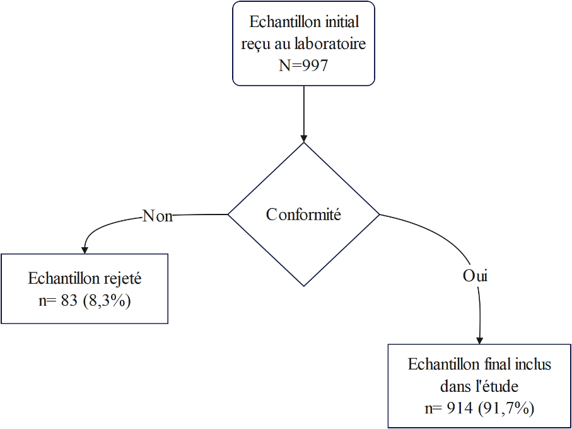

Figure 1 : Study inclusion diagram
Characteristics of suspected diphtheria cases received at the laboratory
Table 1 presents the profile of suspected diphtheria cases received at the laboratory. The sex distribution showed a slight female predominance, with 59% females versus 41% males, resulting in a female-to-male ratio of 1.43. The median age was 7 years, with an interquartile range of 3 to 15 years. The 0–4-year age group was the most represented at 33.9 %, followed by the 5–8-year age group at 27.7 %.
The geographical distribution revealed a major concentration of reported cases in the Kankan health region (68.4%), followed by Conakry (10.5%) and Mamou (8.3%). The other regions reported marginal cases, with 4.5% in Boké, 3.7% in Faranah, 3.5% in Kindia, and only 1.1% in Labé.
Regarding the samples, almost all were oropharyngeal (99.8%), while nasopharyngeal swabs were rare (0.2%). Microbiologically, 17.9 % of cultures were positive, compared to 82.1% negative. Among the positive diphtheria cases, Corynebacterium diphtheriae mitis (n=132; 80.5%) was the most frequently isolated bacterial strain, followed by Corynebacterium pseudodiphteriticum (n=21; 12.8%) and Corynebacterium diphteriae gravis (n=10; 6.1%). Corynebacterium biovar G (n=1; 0.6%) was rare in the positive isolates.
Finally, in our series, the patient's condition was generally favorable: 913 patients (99.9%) were alive and only one death was reported, corresponding to a case fatality rate of 0.1%.

Table I : Sociodemographic, clinical and microbiological characteristics of suspected diphtheria cases received at the INSP laboratory, 2023-2025
Characteristic | N = 914 | %
Sex
Female | 539 | 59.0
Male | 375 | 41.0
Age [median (Q1 – Q3)] | 7 (3 – 15)
Health region
Kankan* | 625 | 68.4
Conakry | 96 | 10.5
Mamou | 76 | 8.3
Boké | 41 | 4.5
Faranah | 34 | 3.7
Kindia | 32 | 3.5
Lab | 10 | 1.1
Sample type
Oropharyngeal | 912 | 99.8
Nasopharyngeal | 2 | 0.2
Age range
0-4 years | 310 | 33.9
5-9 years old | 253 | 27.7
10-17 years old | 163 | 17.8
18 and over | 188 | 20.6
Results of the culture
Positive | 164 | 17.9
Negative | 750 | 82.1
Patient's final condition
Deceased | 1 | 0.1
Alive | 913 | 99.9
Result of culture with identified germs (n= 164)
Corynebacterium diphtheriae mitis | 132 | 80.5
Corynebacterium pseudodiphtheriticum | 21 | 12.8
Corynebacterium diphtheriae gravis | 10 | 6.1
Corynebacterium diphtheriae Group G | 1 | 0.6
*In the Kankan health region, the Siguiri health district accounted for the majority of cases
Epidemiology of suspected diphtheria cases
Figure 1 presents the epidemiological curve of diphtheria cases reported to the INSP bacteriology laboratory. The curve shows alternating periods of outbreaks and periods without reported cases between 2023 and 2025. In 2023, the first cases appeared in the second half of the year, with a peak of 30 cases per week, followed by a return to zero. The year 2024 was marked by several successive waves, some reaching nearly forty cases per week, interspersed with brief periods without cases. In 2025, the number of reported cases observed at the beginning of the year was low, with a drop in cases from week 9 to week 13. Transmission resumed in the second quarter with peaks of between twenty and thirty cases per week, but of a smaller magnitude than the peaks of 2024.
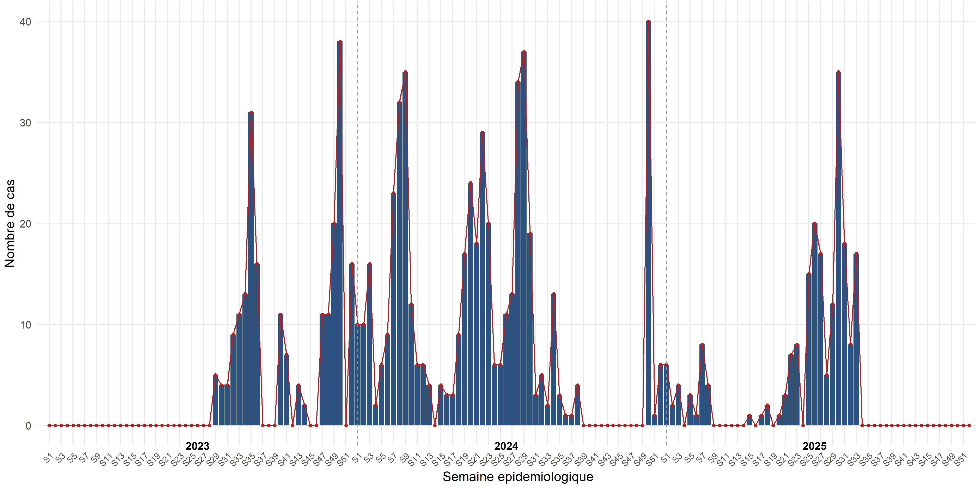
Figure 2 : Weekly epidemiological curve of meningitis cases reported to the INSP laboratory, 2023-2025
Results of positive cropping according to sociodemographic characteristics
Table 2 describes the positive isolates by sex, age group, and health region. A total of 164 isolates were identified in the laboratory. Among the C. diphtheriae mitis strains, the sex distribution was almost balanced (52% female, 48% male), with a predominance in children aged 0–4 years (46%) and a high concentration of cases in the Kankan region (85%). The C. diphtheriae gravis strains originated exclusively from Kankan (n=10; 100%), primarily affecting children aged 0–4 years (60%). The single isolate of group G was identified in a girl aged 0–4 years residing in Conakry. Finally, the cases of C. pseudodiphteriticum mainly concerned female subjects (62%), with a more diverse age distribution: 29% in the 0–4 year and 10–17-year age groups, and a heterogeneous geographical origin, notably Boké (43%), Kankan (24%), Kindia (14%) and Faranah (14%).
Table II : Distribution of positive cultures by sex, age group and health region at the laboratory of the National Institute of Public Health, 2023–2025
 | Corynebacterium diphtheriae |  | Other Corynebacterium
Characteristic | mitis  n = 132 | climbed  n = 10 | group G  n = 1 | pseudodiphteriticum  n = 21
Sex
Female | 68 (52%) | 7 (70%) | 1 (100%) | 13 (62%)
Male | 64 (48%) | 3 (30%) | 0 (0%) | 8 (38%)
Age range
0-4 years | 61 (46%) | 6 (60%) | 1 (100%) | 6 (29%)
5-9 years old | 45 (34%) | 2 (20%) | 0 (0%) | 5 (24%)
10-17 years old | 20 (15%) | 2 (20%) | 0 (0%) | 6 (29%)
18 and over | 6 (4.5%) | 0 (0%) | 0 (0%) | 4 (19%)
Health region
Boké | 2 (1.5%) | 0 (0%) | 0 (0%) | 9 (43%)
Conakry | 8 (6.1%) | 0 (0%) | 1 (100%) | 1 (4.8%)
Faranah | 5 (3.8%) | 0 (0%) | 0 (0%) | 3 (14%)
Kankan | 112 (85%) | 10 (100%) | 0 (0%) | 5 (24%)
Kindia | 4 (3.0%) | 0 (0%) | 0 (0%) | 3 (14%)
Mamou | 1 (0.8%) | 0 (0%) | 0 (0%) | 0 (0%)

Antibiogram of positive isolates
Table 3 presents the antibiotic susceptibility of isolated strains. Of the 164 cultures positive for Corynebacterium, 60 isolates (36.6%) were tested for antibiotics. Antibiotic susceptibility testing of the Corynebacterium diphtheriae strains showed marked resistance to penicillin G, ampicillin, cefotaxime, and meropenem, with resistant strain proportions ranging from 50% to 64% for the gravis and mitis biovars. Susceptibility to ciprofloxacin was generally low, with many strains exhibiting intermediate susceptibility (100% for gravis and 89% for mitis). In contrast, complete susceptibility to erythromycin (100% sensitivity) was observed in all tested isolates. Clindamycin, rifampicin, and trimethoprim/sulfamethoxazole retained variable activity, with resistance rates ranging from 9% to 44%. The highest resistance rates were observed against tetracyclines (doxycycline, tetracyclin), to which 86% to 100% of C. diphtheriae strains were resistant. Ciprofloxacin exhibited an intermediate resistance profile (susceptible at high doses).
Regarding non-diphtheria species, C. pseudodiphtheriticum was distinguished by frequent resistance to cotrimoxazole (n=6; 100%) , clindamycin (n=3; 50%) , rifampicin (n=3; 50%) , and erythromycin (n=3; 50%) , but retained sensitivity to ampicillin, cefotaxime, meropenem, and tetracyclines (doxycycline and tetracycline), with 100% of strains susceptible to each. An intermediate profile (sensitive to high doses) was observed for penicillin G.
Table III : Antibiotic susceptibility profile of isolated strains (gravis, mitis, pseudodiphtheriticum) at the INSP laboratory, 2023-2025
 | Characteristic |  | Corynebacterium diphtheriae |  |  |  | Other Corynebacterium
 |  |  | gravis  (n = 10) |  | mitis  (n = 44) |  | Group G  (n = 0) |  | pseudodiphteriticum  (n = 6)
 | Penicillin G
I |  | 5 (50%) |  | 15 (34%) |  | 0 (NA%) |  | 6 (100%)
R |  | 5 (50%) |  | 28 (64%) |  | 0 (NA%) |  | 0 (0%)
S |  | 0 (0%) |  | 1 (2%) |  | 0 (NA%) |  | 0 (0%)
 | Ampicillin
 | R |  | 5 (50%) |  | 28 (64%) |  | 0 (NA%) |  | 0 (0%)
 | S |  | 5 (50%) |  | 16 (36%) |  | 0 (NA%) |  | 6 (100%)
 | Cefotaxime
 | R |  | 5 (50%) |  | 28 (64%) |  | 0 (NA%) |  | 0 (0%)
 | S |  | 5 (50%) |  | 16 (36%) |  | 0 (NA%) |  | 6 (100%)
 | Meropenem
 | R |  | 5 (50%) |  | 24 (55%) |  | 0 (NA%) |  | 0 (0%)
 | S |  | 5 (50%) |  | 20 (45%) |  | 0 (NA%) |  | 6 (100%)
 | Ciprofloxacin
 | I |  | 10 (100%) |  | 39 (89%) |  | 0 (NA%) |  | 4 (67%)
 | R |  | 0 (0%) |  | 4 (9%) |  | 0 (NA%) |  | 2 (33%)
 | S |  | 0 (0%) |  | 1 (2%) |  | 0 (NA%) |  | 0 (0%)
 | Erythromycin
 | R |  | 0 (0%) |  | 0 (0%) |  | 0 (NA%) |  | 3 (50%)
 | S |  | 10 (100%) |  | 44 (100%) |  | 0 (NA%) |  | 3 (50%)
 | Clindamycin
 | R |  | 1 (10%) |  | 1 (2%) |  | 0 (NA%) |  | 3 (50%)
 | S |  | 9 (90%) |  | 43 (98%) |  | 0 (NA%) |  | 3 (50%)
 | Doxycycline
 | R |  | 10 (100%) |  | 38 (86%) |  | 0 (NA%) |  | 0 (0%)
 | S |  | 0 (0%) |  | 6 (14%) |  | 0 (NA%) |  | 6 (100%)
 | Tetracycline
 | R |  | 10 (100%) |  | 38 (86%) |  | 0 (NA%) |  | 0 (0%)
 | S |  | 0 (0%) |  | 6 (14%) |  | 0 (NA%) |  | 6 (100%)
 | Rifampicin
 | R |  | 1 (10%) |  | 4 (9%) |  | 0 (NA%) |  | 3 (50%)
 | S |  | 9 (90%) |  | 40 (91%) |  | 0 (NA%) |  | 3 (50%)
 | Trimethoprim/Sulfamethoxazole
 | R |  | 3 (30%) |  | 19 (44%) |  | 0 (NA%) |  | 6 (100%)
 | S |  | 7 (70%) |  | 24 (56%) |  | 0 (NA%) |  | 0 (0%)

The results show high resistance of diphtheria complex strains to tetracycline and doxycycline, with resistance rates ranging from 85% to 100% depending on the species. Trimethoprim/sulfamethoxazole is also ineffective, with up to 100% resistance in C. diphtheriae gravis and C. pseudodiphtheriticum. Clindamycin exhibits variable resistance: low in C. diphtheriae mitis (≈10%), moderate in C. diphtheriae gravis (≈25%), and more pronounced in C. pseudodiphtheriticum (≈50%). Regarding macrolides, resistance to erythromycin remains low in C. diphtheriae mitis but reaches approximately 50% in C. pseudodiphtheriticum. On the other hand, β-lactams (Penicillin G, ampicillin, cefotaxime) as well as Imipenem retain excellent efficacy, with 0% resistance observed.
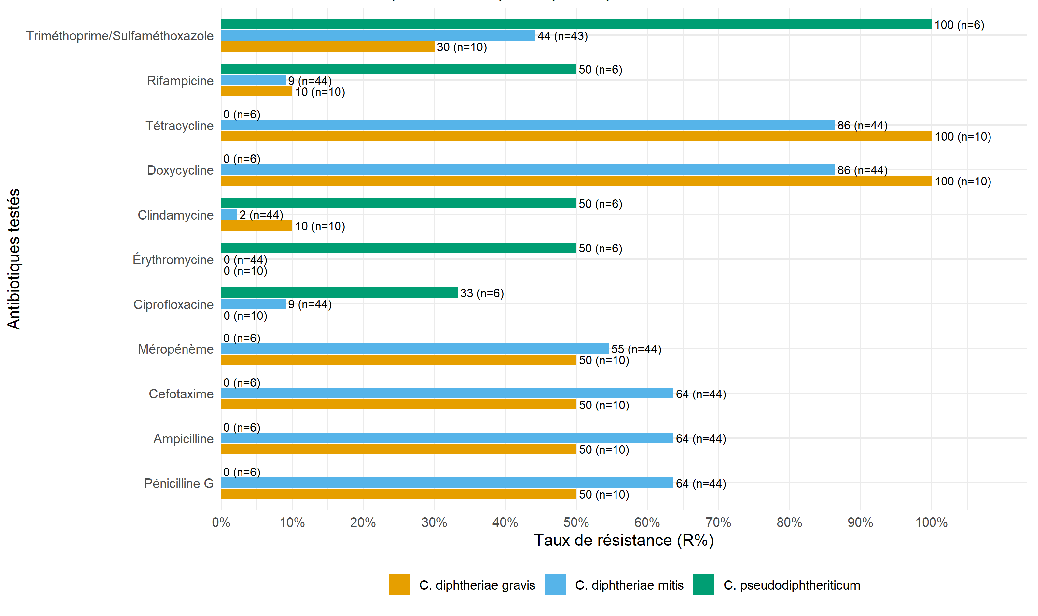

Fig 3: Resistance rates by antibiotic and by species

Discussion
This study revealed the presence of C. diphtheriae as the causative agent of the epidemic re-emergence observed in Guinea and highlights its epidemiological and microbiological characteristics. Epidemiologically, children under 10 years of age, particularly those aged 0–4, represent the majority of cases, which is consistent with immunodeficiency or exposure. increased in these age groups. The geographic concentration in the Kankan region (primarily Siguiri) indicates a focus with limited spread to other regions, justifying public health interventions, including catch-up vaccination, awareness campaigns, and strengthened detection. The study highlights discontinuous but persistent diphtheria transmission between 2023 and 2025, with more intense outbreaks in 2024 (peaks reaching 40 cases/week) and a smaller resurgence in the second quarter of 2025. This pattern, alternating between peaks and periods without reporting, is similar to the outbreaks recently reported in Europe in migrant reception centers described by Hoefer et al ., which emphasize the alternation of episodes of amplification and remission over the months ( 2025). These observations align with the WHO report on regional outbreaks in 2023–2024, particularly in Nigeria and Guinea, highlighting the importance of vaccination and treatment combining antitoxin and appropriate antibiotic therapy (Alege et al., 2025; Gaiya et al., 2024; Truelove et al., 2020b; WHO, n.d.).
From a microbiological standpoint, the predominance of the mitis biovar that we observed is consistent with the Algerian series from 1992–2015 by Benamrouche et al . , where mitis represented 77.7% of the isolates tested (2016); the clonal diversity in South Africa described by du Plessis et al . for the period 2015–2023 confirms multiple co-circulating (2025). The presence of C. pseudodiphtheriticum (12.8%) underscores the importance of isolation and identification to distinguish diphtheria infections from non-diphtheria Corynebacterium, which are potentially involved in similar respiratory cases, as indicated by Weil et al. in their study (2021).
Antibiogram profiles for C. diphtheriae highlight macrolides as active (erythromycin 100% S), frequent non-sensitivity to the tested β -lactams and high resistance to tetracyclines. These results are consistent with several series: Benamrouche et al. In Algeria, sensitivity to erythromycin was observed, but low sensitivity rates to penicillin G (57.3%), cefotaxime (56.1%), and tetracycline (71.3% non-sensitive) (2016). In South Africa, du Plessis et al. reported a category EUCAST “Intermediate” to penicillin (98%) and sensitivity (99%) to erythromycin (2025), which is consistent with our data and supports macrolides as first-line antibiotic therapy in our setting, as recommended by the WHO 2024 guidelines (National Institute for Communicable Diseases (NICD), n.d.; WHO, 2024). For C. pseudodiphtheriticum, our series shows uniform susceptibility to third generation β-lactams and carbapenems, as well as to tetracyclines, and consistent resistance to trimethoprim/sulfamethoxazole, with partial susceptibility to erythromycin and clindamycin. In an African context, Reddy et al. in South Africa (2021) reported a strain susceptible to penicillin, cefotaxime, and ciprofloxacin; this profile is similar to that of β-lactams in our study, although penicillin showed an intermediate profile. in all isolates. However, our results contrast with those found by Neemuchwala et al. where penicillin was found to be sensitive in 95.8% of cases, and Trimethoprim/Sulfamethoxazole resistant in only 12.5% of cases (2018). This reflects a variability in the sensitivity phenotypes of C. pseudodiphtheriticum depending on the contexts and the antimicrobial sensitivity tests.
Corynebacterium diphtheria. diphtheriae and β - lactams/cyclines for other Corynebacterium non-diphtheritic, particularly C. pseudodiphtheriticum, suggest the need to avoid Trimethoprim/Sulfamethoxazole, especially for C. pseudodiphtheriticum and to secondarily adapt treatments to the local profile of sensitivity tests and improve the vaccination profile in the most vulnerable.
Conclusion
Analysis of diphtheria cases in Guinea (2023-2025) reveals discontinuous but persistent transmission, concentrated among children under ten years of age and in the Kankan region, specifically in the Siguiri health district. C. diphtheriae biovar mitis was predominant, while the presence of C. pseudodiphtheriticum underscores the importance of rigorous microscopic identification. Susceptibility profiles confirm the efficacy of erythromycin against C. diphtheriae, in contrast to frequent non-susceptibility to β-lactams and tetracyclines. For C. pseudodiphtheriticum, third-generation β-lactams and tetracyclines remain active, but persistent resistance to trimethoprim/sulfamethoxazole should limit their use. These results argue for the priority use of macrolides, the adaptation of treatments to local profiles and the strengthening of childhood vaccination to prevent and cope with recurrent outbreaks.
Boundaries
This study is limited by underreporting and heterogeneity in surveillance data, weak biological confirmation (culture), and the absence of sequencing, which exposes it to a risk of misclassifying cases. Its generalizability is restricted, given that the data were dominated by Kankan, where transmission was discontinuous, but also due to modest laboratory staffing and incomplete clinical information, which, given the descriptive nature of the study, precludes any robust causal inferences.
Data Availability
The data used in this study can be obtained from the corresponding author upon reasonable request.
Ethical Aspects
The study was conducted in accordance with applicable national and international guidelines (Declaration of Helsinki, CIOMS 2016). The data was anonymized and used exclusively for epidemiological surveillance purposes.
Consent for publication
Not applicable. No personally identifiable information is reported.
References
Alege, A., Ibrahim, O.R., Ibraheem, R.M., Aladesua, O., Lugga, A.S., Yahaya, Y.Y., Sanda, A., Suleiman, B.M., 2025. Clinical presentation and predictors of hospital mortality of diphtheria in Nigeria, July 2023 to April 2024: a single-center study. BMC Infectious Diseases 25, 8. https://doi.org/10.1186/s12879-024-10401-4
Benamrouche, N., Hasnaoui, S., Badell, E., Guettou, B., Lazri, M., Guiso, N., Rahal, K., 2016. Microbiological and molecular characterization of Corynebacterium diphtheriae isolated in Algeria between 1992 and 2015. Clinical Microbiology and Infection 22, 1005.e1-1005.e7. https://doi.org/10.1016/j.cmi.2016.08.013
du Plessis, M., Mikhari, R., de Gouveia, L., Duma, N., Lovelock, T., Lawrence, C., Mahabeer, P., Mahabeer, Y., Govender, N., Nzenze, S., Featherston, J., Moodley, M., Moyes, J., Walaza, S., Cohen, C., von Gottberg, A., 2025. Corynebacterium diphtheriae Infections, South Africa, 2015–2023. Emerg Infect Dis 31, 417–426. https://doi.org/10.3201/eid3103.241211
Gaiya, D.D., Ozioko, P.C., Entonu, M.E., Umeasiegbu, C.U., 2024. Diphtheria outbreak in Nigeria: what we know now. Infect Prev Pract 6, 100345. https://doi.org/10.1016/j.infpip.2024.100345
Hennart, M., Panunzi, L.G., Rodrigues, C., Gaday, Q., Baines, S.L., Barros-Pinkelnig, M., Carmi-Leroy, A., Dazas, M., Wehenkel, A.M., Didelot, X., Toubiana, J., Badell, E., Brisse, S., 2020. Population genomics and antimicrobial resistance in Corynebacterium diphtheriae. Genome Medicine 12, 107. https://doi.org/10.1186/s13073-020-00805-7
Hoefer, A., Seth-Smith, H., Palma, F., Schindler, S., Freschi, L., Dangel, A., Berger, A., D’Aeth, J., Cordery, R., Delgado-Rodriguez, E., Gruner, E., Flury, D., Hinic, V., Kofler, J., Lienhard, R., Mariman, R., Nolte, O., Schibli, A., Toubiana, J., Traugott, M., Jacquinet, S., Indra, A., Fry, N.K., Palm, D., Sing, A., Brisse, S., Egli, A., 2022 European Diphtheria Consortium, 2025. Corynebacterium diphtheriae Outbreak in Migrant Populations in Europe. N Engl J Med 392, 2334–2345. https://doi.org/10.1056/NEJMoa2311981
Leadon, C., 2024. Guinea: An almost-forgotten disease makes a resurgence in West Africa [WWW Document]. MSF UK. URL https://prezly.msf.org.uk/guinea-an-almost-forgotten-disease-makes-a-resurgence-in-west-africa (accessed 9.23.25).
Murphy, J.R., 1996. Corynebacterium Diphtheriae, in: Baron, S. (Ed.), Medical Microbiology. University of Texas Medical Branch at Galveston, Galveston (TX).
National Institute for Communicable Diseases (NICD), n.d. Diphtheria. URL https://www.nicd.ac.za/diseases-a-z-index/diphtheria/ (accessed 11.3.25).
Neemuchwala, A., Soares, D., Ravirajan, V., Marchand-Austin, A., Kus, J.V., Patel, S.N., 2018. In Vitro Antibiotic Susceptibility Pattern of Non-diphtheriae Corynebacterium Isolates in Ontario, Canada, from 2011 to 2016. Antimicrob Agents Chemother 62, e01776-17. https://doi.org/10.1128/AAC.01776-17
OMS, 2024. Prise en charge clinique de la diphtérie : lignes directrices, 2 février 2024 28.
Reddy, K., Gericke, S., Rabie, H., Pienaar, C., Maloba, M., 2021. Exudative pharyngitis and Corynebacterium pseudodiphtheriticum: A case report and review of the literature. S Afr J Infect Dis 36, 225. https://doi.org/10.4102/sajid.v36i1.225
ReliefWeb, 2019. Mise à jour épidémiologique : Diphtérie dans les Amériques (18 mars 2019) [WWW Document]. URL https://reliefweb.int/report/haiti/epidemiological-update-diphtheria-americas-18-march-2019 (accessed 9.24.25).
Sharma, N.C., Efstratiou, A., Mokrousov, I., Mutreja, A., Das, B., Ramamurthy, T., 2019. Diphtheria. Nat Rev Dis Primers 5, 81. https://doi.org/10.1038/s41572-019-0131-y
Truelove, S.A., Keegan, L.T., Moss, W.J., Chaisson, L.H., Macher, E., Azman, A.S., Lessler, J., 2020a. Clinical and Epidemiological Aspects of Diphtheria: A Systematic Review and Pooled Analysis. Clin Infect Dis 71, 89–97. https://doi.org/10.1093/cid/ciz808
Truelove, S.A., Keegan, L.T., Moss, W.J., Chaisson, L.H., Macher, E., Azman, A.S., Lessler, J., 2020b. Clinical and Epidemiological Aspects of Diphtheria: A Systematic Review and Pooled Analysis. Clin Infect Dis 71, 89–97. https://doi.org/10.1093/cid/ciz808
Weil, L.M., Williams, M.M., Shirin, T., Lawrence, M., Habib, Z.H., Aneke, J.S., Tondella, M.L., Zaki, Q., Cassiday, P.K., Lonsway, D., Farrque, M., Hossen, T., Feldstein, L.R., Cook, N., Maldonado-Quiles, G., Alam, A.N., Muraduzzaman, A.K.M., Akram, A., Conklin, L., Doan, S., Friedman, M., Acosta, A.M., Hariri, S., Fox, L.M., Tiwari, T.S.P., Flora, M.S., 2021. Investigation of a Large Diphtheria Outbreak and Cocirculation of Corynebacterium pseudodiphtheriticum Among Forcibly Displaced Myanmar Nationals, 2017-2019. J Infect Dis 224, 318–325. https://doi.org/10.1093/infdis/jiaa729
WHO, n.d. Diphtheria-Guinea [WWW Document]. URL https://www.who.int/emergencies/disease-outbreak-news/item/2023-DON492 (accessed 9.20.25a).
WHO, n.d. Diphtheria-Nigeria [WWW Document]. URL https://www.who.int/emergencies/disease-outbreak-news/item/2023-DON485 (accessed 9.16.25b).
World Health Organization, 2025. Diphtheria outbreaks/ Comprehensive guidance for the public health preparedness and response in the WHO African Region | WHO | Regional Office for Africa [WWW Document]. URL https://www.afro.who.int/publications/diphtheria-outbreaks-comprehensive-guidance-public-health-preparedness-and-response (accessed 11.3.25).

