Original Research Article
Seasonal Dynamics of Multidrug-Resistant Escherichia coli and Potential for Bacteriophage Based Biocontrol in Mumbai Wastewater

ABSTRACT
Aims: The global emergence of multidrug-resistant (MDR) pathogens poses a severe threat to public health, with wastewater treatment plants (WWTPs) emerging as critical reservoirs for the dissemination of antibiotic resistance. This study investigated the seasonal prevalence of MDR Escherichia coli strains in six different WWTPs across Mumbai and isolated bacteriophages against them, exploring the potential of bacteriophages as a sustainable biocontrol strategy.
Study Design: A cross-sectional study was conducted over 12 months to analyze seasonal trends of MDR E. coli and isolate corresponding bacteriophages from wastewater.
Place and Duration of Study: Samples were collected from six WWTPs across Mumbai, India, over a 12-month period.
Methodology: A total of 106 E. coli strains were isolated from wastewater samples. Among them, 86 (81.1%) were identified as multidrug-resistant based on resistance to more than three antibiotics. Seasonal distribution and resistance profiles were analyzed statistically. Bacteriophages were isolated and characterized for plaque morphology and host range using the enrichment and double-layer agar methods.
Results: The occurrence of MDR E. coli showed a distinct seasonal trend, peaking during winter (48%), followed by summer (28%) and monsoon (24%), indicating the influence of climatic and environmental factors. Statistical analysis confirmed that the variation in seasonal prevalence was significant (χ² = 8.11, df = 2, p < 0.05). Resistance profiles varied across seasons and antibiotic classes, with β-lactam resistance notably reduced during the monsoon, possibly due to environmental dilution or degradation. Penicillin G and erythromycin maintained high resistance across all seasons. Bacteriophages were successfully isolated against 55 of the 86 MDR E. coli strains. Characterization of the phage isolates revealed varied but often multi-strain host ranges, and lytic activity was confirmed through clear plaque formation.
Conclusion: This study provides critical insights into the seasonal dynamics of MDR E. coli in urban wastewater and establishes the potential of bacteriophages as effective tools for controlling antibiotic-resistant bacteria. Integrating environmental surveillance with phage-based interventions may contribute significantly to mitigating the global antibiotic resistance crisis.

Key Words: Multidrug-Resistant Escherichia Coli, Wastewater Treatment Plants, Seasonal Variation, Antibiotic Resistance, Bacteriophage Isolation, Phage Biocontrol, Mumbai Wastewater

- INTRODUCTION
Wastewater treatment plants (WWTPs) serve as critical hubs where effluents from diverse sources such as agriculture, industry, hospitals, and households are collected and treated (Wengenroth et al., 2021). These wastewaters carry a complex mixture of pollutants, toxic substances, and a diverse array of microorganisms, including antibiotic-resistant bacteria (Nimonkar et al., 2019). The widespread and often indiscriminate use of antibiotics in human and veterinary medicine, as well as agriculture, has led to their continuous release into municipal wastewater systems, ultimately contaminating the natural environment (Rizzo et al., 2013). This constant influx of antibiotics into wastewater has created a hotspot for the emergence and dissemination of antibiotic-resistant bacteria (ARB), particularly within WWTPs, where high bacterial densities and diverse antibiotic residues converge (Bergeron et al., 2015).
The development of antibiotic resistance in bacteria is facilitated by multiple mechanisms. One important factor is the prolonged exposure to low, sub inhibitory levels of antibiotics, which causes the natural acquisition of resistance genes (Teshome et al., 2020). In addition, the horizontal transfer of antibiotic resistance genes (ARGs) through plasmids, transposons, integrons, and other mobile genetic elements (Barbosa et al., 2021; Nimonkar et al., 2019) adds to the spread of resistance rapidly. Unfortunately, conventional wastewater treatment processes are often insufficient to completely remove biological contaminants, including bacteria, viruses, protozoa, and, more critically, antibiotic-resistant bacteria (Hembach et al., 2019; Wengenroth et al., 2021). As a result, WWTPs have become significant reservoirs and potential dissemination points for antibiotic resistance, posing a serious threat to public health.
Antibiotic-resistant strains are no longer restricted to hospital settings; they are increasingly prevalent in community environments, where they can spread rapidly. Escherichia coli (E. coli), a near-ubiquitous inhabitant of the gastrointestinal tracts of humans and animals, plays a pivotal role in the spread of resistance within communities (Purohit et al., 2019) with enterotoxigenic Escherichia coli (ETEC), enterohemorrhagic Escherichia coli (EHEC)/ Shiga toxin-producing Escherichia coli (STEC), enteroinvasive Escherichia coli (EIEC), enteropathogenic Escherichia coli (EPEC), and enteroaggregative Escherichia coli (EAEC) (Mueller & Tainter CR, 2023). A longitudinal study in Norway repeatedly detected ESBL-producing E. coli ST131 and ST648 in wastewater that are globally important high-risk clones. ST131 is a major uropathogen associated with multidrug-resistant urinary and bloodstream infection, while ST648 is increasingly linked to zoonotic and environmental transmission, both carrying key resistant genes blaCTX-M-15 (Paulshus et al., 2019). A recent study revealed that hospital and community wastewater contain ExPEC lineages identical to globally disseminated strains such as ST131, ST10, ST38, ST295, ST744, and ST69, all of which carried diverse resistance and virulence genes, highlighting WWTPs as key environmental reservoirs for clinically important MDR E. coli clones (Davidova-Gerzova et al., 2023). According to the Centre for Disease Dynamics, Economics & Policy (CDDEP, 2021), multiple variants of genes encoding extended-spectrum beta-lactamase (ESBL)—conferring resistance to penicillin, cephalosporins, and monobactams have now spread globally, with a particularly high prevalence in E. coli (Sriram et al., 2021). The presence of resistant commensal E. coli in healthy individuals was first reported over 40 years ago (Smith, H. W. & Halls, 1966), and today, E. coli is listed by the World Health Organization (WHO) as a critical priority pathogen for research and the development of new antibiotics (WHO, 2016). Recent studies have also highlighted the persistence of uropathogenic E. coli in treated wastewater effluents, suggesting that these strains have adapted to survive conventional treatment processes (Zhi et al., 2020)
In the face of this growing crisis, bacteriophages (phages)—viruses that specifically infect bacteria—have emerged as a promising alternative to traditional antibiotics. Phages have co-evolved with bacteria for billions of years, equipping them with the unique ability to target and lyse their bacterial hosts with high specificity (Clokie et al., 2011). This specificity makes them ideal candidates for controlling problematic bacteria without disrupting the broader microbial community. With an estimated global population exceeding 10³¹, phages represent one of the most abundant biological entities on Earth, offering a vast and largely untapped resource for combating antibiotic resistance (Suttle, 2005). Lytic phages, in particular, hold significant potential as they can target antibiotic efflux pumps or other resistance-related proteins, providing a novel approach to tackling multidrug-resistant (MDR) pathogens (Chan et al., 2013).
This study investigates the seasonal dynamics of MDR E. coli in WWTPs across Mumbai and explores the isolation and host specificity of bacteriophages isolated from the same environment. By characterizing phages effective against MDR E. coli, the study aims to contribute to the development of sustainable, phage-based strategies for mitigating the spread of antibiotic resistance in urban wastewater systems.
- MATERIAL AND METHODS
  - Study Area and Sample Collection
Wastewater samples were collected over 12 months December 2022 to November 2023, from six major wastewater treatment plants (WWTPs) operated by the Municipal Corporation of Greater Mumbai (MCGM) serving diverse urban and industrial zones across Mumbai. Sampling was conducted seasonally (winter: December- January; summer: April–May; monsoon: July–August) to assess temporal variations in bacterial prevalence and resistance patterns. One-litre grab samples were collected in sterile, pre-labelled containers following standard protocols (APHA, 2017; Davidova-Gerzova et al., 2023) from crucial collection points of the plants as suggested by the plant operators, kept at 4°C, and processed within 4 hours of collection to ensure viability.
  - Sample Processing and Bacterial Isolation
The collected wastewater samples were initially filtered through coarse filter paper and Whatman No. 1 to remove particulate debris. The filtrate was then subjected to serial decimal dilutions (10⁻¹ to 10⁻⁶) using sterile 0.85% saline solution. From each dilution, 100 μL was plated onto Mac Conkey agar (HiMedia) and Eosin Methylene Blue (EMB) agar using the spread plate technique. The plates were incubated aerobically at 37±0.5°C for 24-48 hours. Colonies showing characteristic morphology, i.e., pink colonies on Mac Conkey agar and metallic green sheen on Eosin methylene blue agar (EMB agar), were selected as presumptive E. coli (M. Sundar et al., 2009). Following incubation, distinct bacterial colonies were subcultured to obtain pure isolates and subsequently subjected to Gram staining. Biochemical characterization was carried out according to standard protocols, and taxonomic identification was performed using criteria outlined in Bergey’s Manual of Systematic Bacteriology.
  - Antibiotic Susceptibility Testing and MDR Identification
Antibiotic resistance profiles of IMViC-confirmed E. coli isolates were determined using the Kirby-Bauer disk diffusion method (Hudzicki, 2012a) following Clinical and Laboratory Standards Institute (CLSI, 2023) guidelines. A total of 16 antibiotics representing six major classes (Table No.1) were tested using commercially available discs (Himedia, India). The selection and interpretation of antibiotics were based on M100 Performance Standards for Antimicrobial Susceptibility Testing, 33rd Edition (M100ED33, 2023)
Table 1: Antimicrobial susceptibility profiles and interpretative zone diameter criteria (CLSI, 2023)
Sr. No | Antimicrobial Agent | Symbol | Disc content | Interpretative Criteria
 |  |  |  | Sensitive (mm or more) | Intermediate (mm) | Resistant (mm or less)
1 | Ampicillins | AMP | 10 mcg | 17 | 14-16 | 13
2 | Penicillin–G | P | 10 units | ND | ND | ND
3 | Amoxicillin | AMX | 30 mcg | 18 | 14-17 | 13
4 | Cefixime | CFM | 5 mcg | 19 | 16-18 | 15
5 | Kanamycin | K | 30 mcg | 18 | 14-17 | 13
6 | Streptomycin | S | 10 mcg | 15 | 12-14 | 11
7 | Gentamicin | GEN | 10 mcg | 15 | 13-14 | 12
8 | Amikacin | AK | 30 mcg | 17 | 15-16 | 14
9 | Azithromycin | AZM | 15 mcg | 13 | ND | 12
10 | Erythromycin | E | 15 mcg | ND | ND | ND
11 | Tetracycline | TE | 30 mcg | 15 | 12-14 | 11
12 | Ciprofloxacin | CIP | 5 mcg | 26 | 22-25 | 21
13 | Trimethoprim | TR | 5 mcg | 16 | 11-15 | 10
14 | Chloramphenicol | C | 30 mcg | 18 | 13-17 | 12
15 | Nitrofurantoin | N | 300 mcg | 17 | 15-16 | 14
16 | Meropenem | MRP | 10 mcg | 23 | 20-22 | 19
*Zone of inhibition diameters in mm. Interpretative criteria based on CLSI guidelines (2023). 'ND' = Not Defined; interpretive breakpoints not established in standard guidelines.
Bacterial suspensions were adjusted to 0.5 McFarland standard (≈1×10⁸ CFU/mL) in sterile saline and swabbed on Mueller-Hinton agar (MHA; HiMedia) plates. Antibiotic disks were aseptically placed and incubated at 37±1°C for 16-18 hours. The diameters of inhibition zones around the disc were measured and interpreted according to CLSI (2023) breakpoints. Multidrug resistance (MDR) was defined as resistance to ≥3 antibiotics acting on 3 different pathway classes (Hudzicki, 2012; Magiorakos et al., 2012). MDR isolates were maintained on agar slants stored at 4 °C (sealed and overlaid with sterile mineral oil), ensuring viability and minimizing desiccation during periods of non-use.
  - Enrichment, isolation, and purification of bacteriophages against MDR E. coli strains isolated from WWTPs.
500 mL of wastewater samples were collected from the same collection points of the plants as suggested by the plant operators, in sterile containers, transported to the lab under cold chain conditions using ice packs and maintained at 4 °C, ensuring processing within 4hours. To remove large particulate matter, samples were centrifuged at 6,000 × g for 10 minutes at 4 °C. The resulting supernatant was then filtered through 0.22 μm pore-size PES membranes (Merck Millipore, USA) to eliminate bacterial cells and other debris. For phage enrichment, 1 mL of log-phase MDR E. coli culture (OD₆₀₀ = 0.8, approximately 1 × 10⁸ CFU/mL) was mixed with 10 mL of filtrate. The mixture was incubated overnight at 37°C with shaking at 150 rpm. Following enrichment, the lysate was clarified by centrifugation (6,000 × g, 10 min) and re-filtered through 0.22 µm membranes. Phage isolation was performed using the double-agar overlay technique(Andrew M. Kropinski, 2009). Briefly, serial ten-fold dilutions of the enriched lysate were mixed with fresh log-phase host culture and 0.75% molten soft agar, and overlaid onto tryptic soy agar (TSA) base plates. The plates were incubated at 37 °C for 18–24 hours. Plaques appearing on the bacterial lawn were selected and subjected to three successive rounds of plaque purification to ensure clonality and removal of contaminating phages (Clokie et al., 2011). Final phage stocks were prepared in SM buffer (50 mM Tris-HCl, 100 mM NaCl, 8 mM MgSO₄, pH 7.5) with the addition of 1% chloroform and stored at 4°C for further analysis.
  - Bacterial Lysis Efficiency Assessment
The lytic activity of isolated phages was evaluated against all MDR E. coli strains using a modified spot assay protocol (Haines et al., 2021). Bacterial cultures in the exponential growth phase (OD600 = 0.8) were mixed with 7 ml of molten semi-solid agar (0.7% w/v) and uniformly layered onto tryptic soy agar plates. Phage suspensions were spotted as 10 μL spots onto the bacterial lawn surface. Following overnight incubation at 37°C, plates were examined for zones of bacterial clearance. Lytic activity was scored qualitatively, with (+) indicating complete clearing and (-) representing no observable lysis. Each phage-host combination was tested in triplicate, and the entire assay was repeated twice to ensure reproducibility.
  - Data Analysis
All experiments were conducted in triplicate to ensure reproducibility and accuracy. For antimicrobial susceptibility testing (AST), the mean diameter of the zone of inhibition (mm) from the three independent replicates was calculated and interpreted according to CLSI (2023) breakpoints. Descriptive statistics, including means and percentages, were used to summarize the antibiotic resistance profile, plaque counts, and seasonal distribution patterns of MDR E. coli isolates. To assess seasonal variation in the prevalence of MDR E. coli, Chi-square (χ²) analysis was employed. Bar charts and heat maps were employed to visually represent resistant trends and host-phage interaction profiles. All statistical analyses were performed using GraphPad Prism version 8.0 (GraphPad Software, USA), and graphical visualizations (bar charts, heat maps) were generated using GraphPad Prism and Microsoft Excel.

- results and discussion
  - Distribution of MDR E. coli Isolates by Season in Mumbai WWTPs
A total of 106 bacterial isolates were initially recovered from the wastewater plants across Mumbai. These isolates were subjected to Gram staining and standard biochemical tests (IMViC), through which Escherichia coli was confirmed. Of the confirmed E. coli isolates, 86 (81.1%) were found to be multidrug resistant (MDR), exhibiting resistance to more than three classes of antibiotics. The distribution across seasons was as follows: winter (n = 41, 47.67%), summer (n = 24, 27.91%), and monsoon (n = 21, 24.42%). Chi-square analysis revealed a statistically significant variation in seasonal distribution (χ² = 8.11, df = 2, p < 0.05), suggesting that seasonal factors may influence the prevalence of MDR E. coli in wastewater environments. A graphical representation of the seasonal distribution is shown in Figure 1.

Figure 1:Seasonal distribution of multidrug-resistant (MDR) Escherichia coli isolates recovered from wastewater treatment plants in Mumbai
Three interrelated processes are responsible for the noticeably increased prevalence of MDR E. coli in the winter. First, prescription records show that community incidence of respiratory infections increases during the cooler season, resulting in two to three times higher incoming loads of macrolides, fluoroquinolones, and β-lactams in municipal sewers than during the summer (Coutu et al., 2013). Second, Mumbai's winter is a hydraulically “dry" season i.e. lower domestic flows allow for little dilution of these drug residues, which concentrate bacteria and antibiotics in the influent. Third, low water temperatures slow the metabolic activity of activated sludge microorganisms and, consequently, the biotransformation of antibiotics. According to comprehensive surveys conducted in China, the temperature-driven decrease in removal efficiency causes effluent antibiotic concentrations to be of an order of magnitude higher in the winter than in the spring or summer (Dong et al., 2024). Collectively, sustained selective pressure in the reactors and in the receiving waters thus favours the proliferation of resistant strains; similar winter peaks in water-borne MDR bacteria have been documented in rivers of central-Indian. Conversely, the monsoon brings intense rainfall that hydraulically dilutes municipal wastewater, shortens the hydraulic-retention time of aeration within basins, and physically washes biomass from sewer sediments. (Diwan et al., 2018a)
A heat map visualization (Figure 2) was generated to illustrate the seasonal variations in resistance profiles of MDR E. coli isolates against a panel of antibiotics, with the intensity of resistance, expressed in percentage, varying markedly across the three sampled seasons—winter, summer, and monsoon.
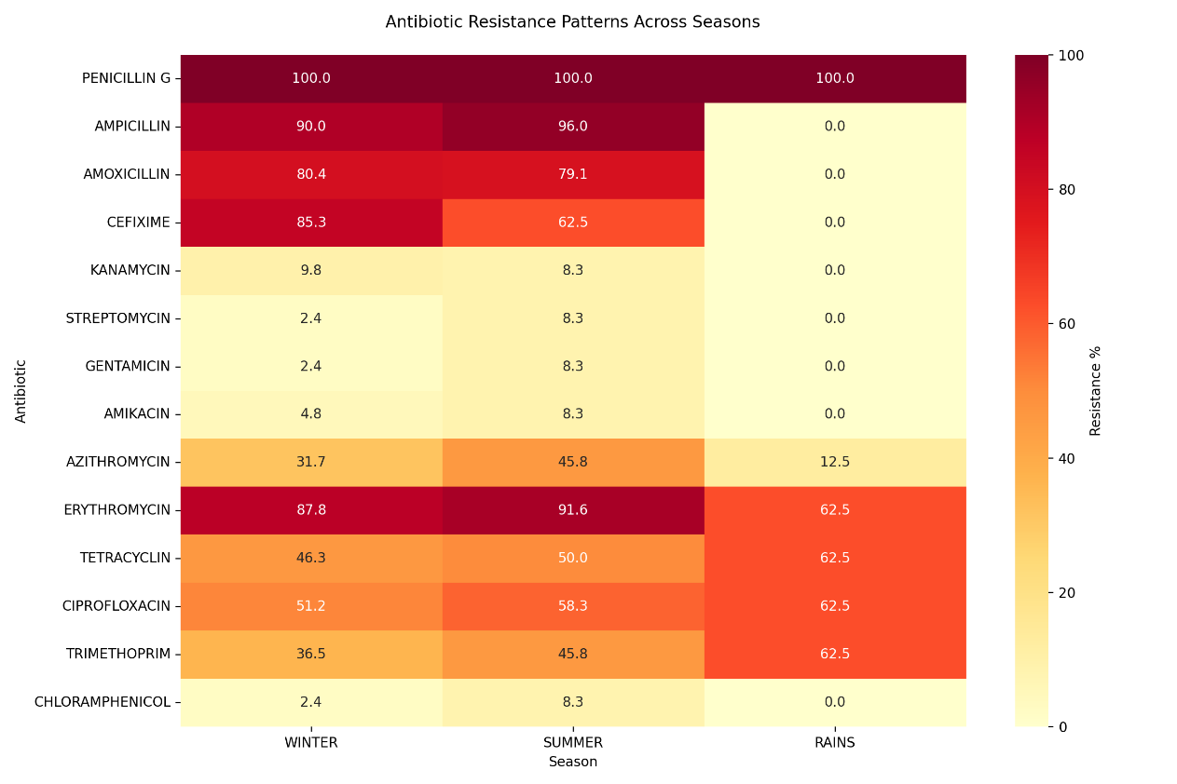
MONSOON
Figure 2: Heat map depicting the resistant pattern across the season
Interestingly, Penicillin G showed complete and constant resistance (100%) in every season, highlighting its limited effectiveness against MDR strains in wastewater settings. The year-round high level of erythromycin resistance, which peaked in the summer (91.6%) and decreased in the monsoon (62.5%), also suggests that resistant strains are persistent due to environmental factors or ongoing selection pressure.
On the other hand, during the monsoon season, resistance to several antibiotics, including Amoxicillin, Cefixime, Ampicillin, and Azithromycin, drastically decreased, with the β-lactams showing no resistance at all. This seasonal reduction may reflect changes in environmental conditions, antibiotic degradation rates, or microbial dynamics influenced by heavy rainfall and dilution in wastewater systems. Comparable near-complete penicillin or ampicillin resistance has been reported in European and Asian plants, where >50 % of effluent isolates carried β-lactamase genes despite treatment. Jendrzejewska & Karwowska (2022) reported that the drop in amoxicillin, ampicillin and cefixime resistance observed during the monsoon is consistent with rain-driven dilution and a faster abiotic degradation of β-lactams in warm, well-oxygenated waters, and such a phenomenon was also documented for river catchments receiving monsoon runoff (Diwan et al., 2018b).
All 3 seasons exhibited moderate-to-high resistance to ciprofloxacin and tetracycline, which was consistent with international surveys that show fluoroquinolone- and tetracycline-resistance genes (e.g., qnr, tet) to be amongst the most prevalent classes in biosolids (Kaplan et al., 2013). Both the increased environmental stability of these compounds under high moisture levels and their widespread use as a treatment for water-borne infections during India's rainy season could be responsible for the monsoon-season spike. The stepwise rise in trimethoprim resistance observed dropped from winter months (36.5 %) to monsoon months (62.5 %), aligning with recent metagenomics evidence showing that diverse dfrB variants accumulate in wastewater microbiomes (Kneis et al., 2023). The use of aminoglycosides in clinical treatment is frequently limited due to their side effects and hazardous potential, making their pollution of the aquatic environment mostly linked with their use in veterinary medicine (Tahrani et al., 2016). Aminoglycoside resistance stayed consistently low in our dataset (< 10 % for amikacin, gentamicin, and streptomycin). This mirrors worldwide wastewater surveys showing that aminoglycoside-resistance genes make up only a minor share of the municipal resistome, far below the contributions from β-lactam, macrolide, and fluoroquinolone class (Mutuku et al., 2022)
Altogether, the data support the idea that WWTPs are dynamic reservoirs where patterns of antibiotic resistance vary depending on physicochemical processes, influent drug loads, and climatic factors. While more stable compounds (fluoroquinolones, tetracyclines) persist or even get enriched, while heavy monsoon flows seem to dilute both bacterial counts and some labile antibiotics, temporarily reducing β-lactam resistance. Therefore, ongoing, seasonally-resolved surveillance is essential for risk assessment and WWTP management, particularly in tropical areas with noticeable wet-dry cycles.
  - Enrichment, isolation, and purification of bacteriophages
Out of a total of 86 multidrug-resistant (MDR) Escherichia coli isolates from wastewater treatment plants (WWTPs), bacteriophages were successfully enriched and isolated against 55 (63.9%) strains. The initial enrichment process clearly indicated successful phage propagation by producing clear plaques on bacterial lawns.
Following isolation procedures, phages producing clear distinct and well-defined plaques were selected and further purified. Selection of turbid plaques were avoided as they are often associated with temperate (lysogenic) phages or incomplete bacterial lysis which typically reflects suboptimal bactericidal activity, reducing reliability in downstream assays. (Gordillo Altamirano & Barr, 2021; Panteleev et al., 2025). Plaques from purified bacteriophages consistently exhibited clear morphology, ranging from 1 to 5 mm in diameter, characterized by sharp, well-defined edges indicative of potent lytic activity. Representative plaque morphology is presented in Fig.3.

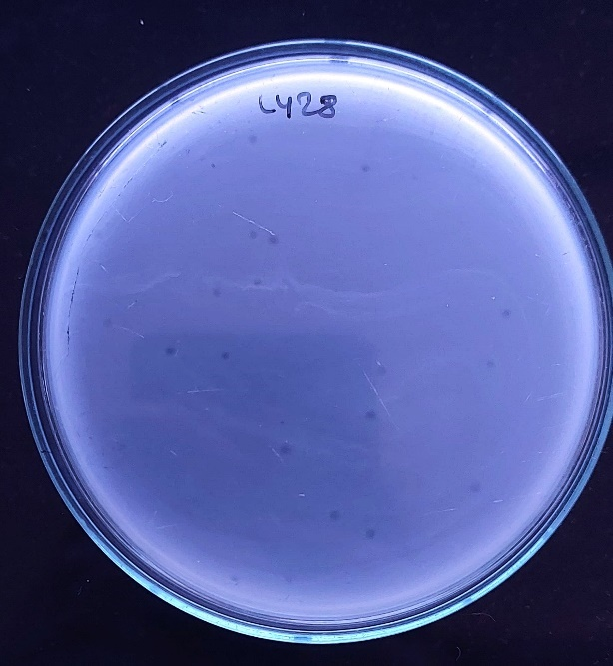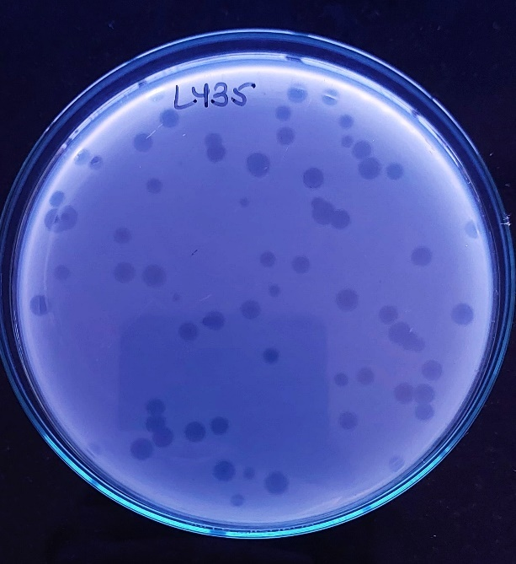
B
A
Figure 3: Representative plaque morphologies of isolated bacteriophages infecting multidrug-resistant Escherichia coli. Two distinct plaque types are shown, characterized by differences in size (A: smaller plaque, approximately 1mm in size; B: larger clear plaques, approximately 5mm)

Successive cycles of single-plaque isolation using a compatible host and propagation yielded bacteriophage stocks with uniform plaque characteristics and reproducible lytic efficacy. Final purified bacteriophage titres reached approximately 10⁶ to 10¹⁰ PFU/ML, demonstrating their virulence and suitability for further characterization. With bacteriophages active against over half of the targeted MDR E. coli isolates, these results demonstrate the efficacy of the enrichment, isolation, and purification process and point to their potential use in biological control of antibiotic-resistant bacteria in wastewater environments.
  - Bacterial Lysis Efficiency Assessment
Host specificity testing of 55 bacteriophage lysates against 86 multidrug-resistant (MDR) Escherichia coli isolates revealed a distinct pattern of limited host-range activity. Broad host-range phages (or polyvalent phages) are defined by their ability to infect multiple bacterial genera or strains, in contrast to monovalent narrow-host-range phages restricted to one strain (Chung et al., 2023). The highest observed lysis was approximately 13.95%, indicating that even the most effective lysates were able to infect no more than 10–11 isolates. Notably, a small subset of lysates (approx. 10) demonstrated intermediate host range activity, lysing 8-10 different MDR E. coli isolates. In contrast, several lysates exhibited activity against only a single bacterial isolate, further highlighting the strain-specific nature of the bacteriophage-host interactions. The host range of a phage is influenced by not only by its own genotype, morphological features and bacterial host but also by the environmental conditions under which their interactions occurs (Holtappels et al., 2023). This observation is consistent with prior research on environmental coliphages, where a majority of isolated sipho and podoviruses were found to infect only one or a few strains within a test panel, even when derived from the same source environment (Korf et al., 2019). The fine-scale diversity in intracellular immunity systems and outer-membrane receptors is responsible for the strain specificity. Although single-phage coverage is limited by this level of precision, it is beneficial for targeted biocontrol because it reduces collateral damage on non-target microbiota (Maffei et al., 2021). This host range study was essential to identify broad-spectrum candidates suitable for biocontrol applications in heterogeneous wastewater environments.
A heat map (Figure 4) was generated to visualize the lysis profile of each phage lysate against the panel of isolates, where blue indicates successful lysis and red denotes no lysis.
A summary of the lysate lytic activity distribution is provided in Table 2. These findings underscore the high degree of specificity among the isolated phages, suggesting their potential for precision-targeted applications against select MDR E. coli strains in wastewater environments.
Table 2 Distribution of bacteriophage lysates based on percentage of MDR E. coli isolates lysed
Infection Range (%) | No. of Lysates
1.0 – 2.5% | 15
2.6 – 5.0% | 14
5.1 – 8.0% | 11
8.1 – 10.0% | 8
10.1 – 12.5% | 6
>12.5% | 1

The data highlights the necessity of logically put together cocktails that blend complementary host-range profiles from an application perspective. Experiments in batch reactors have already demonstrated that customized phage mixtures can reduce the number of viable antibiotic-resistant bacteria in livestock WWTP effluent by 1-2 log₁₀ in a matter of hours without the introduction of chemical by-products (Pallavali et al., 2023). Therefore, the panel of phages isolated here, all of which have high production titres and confirmed lytic activity, makes up a useful seed library for creating such precision cocktails meant to reduce MDR E. coli in waste water stream.

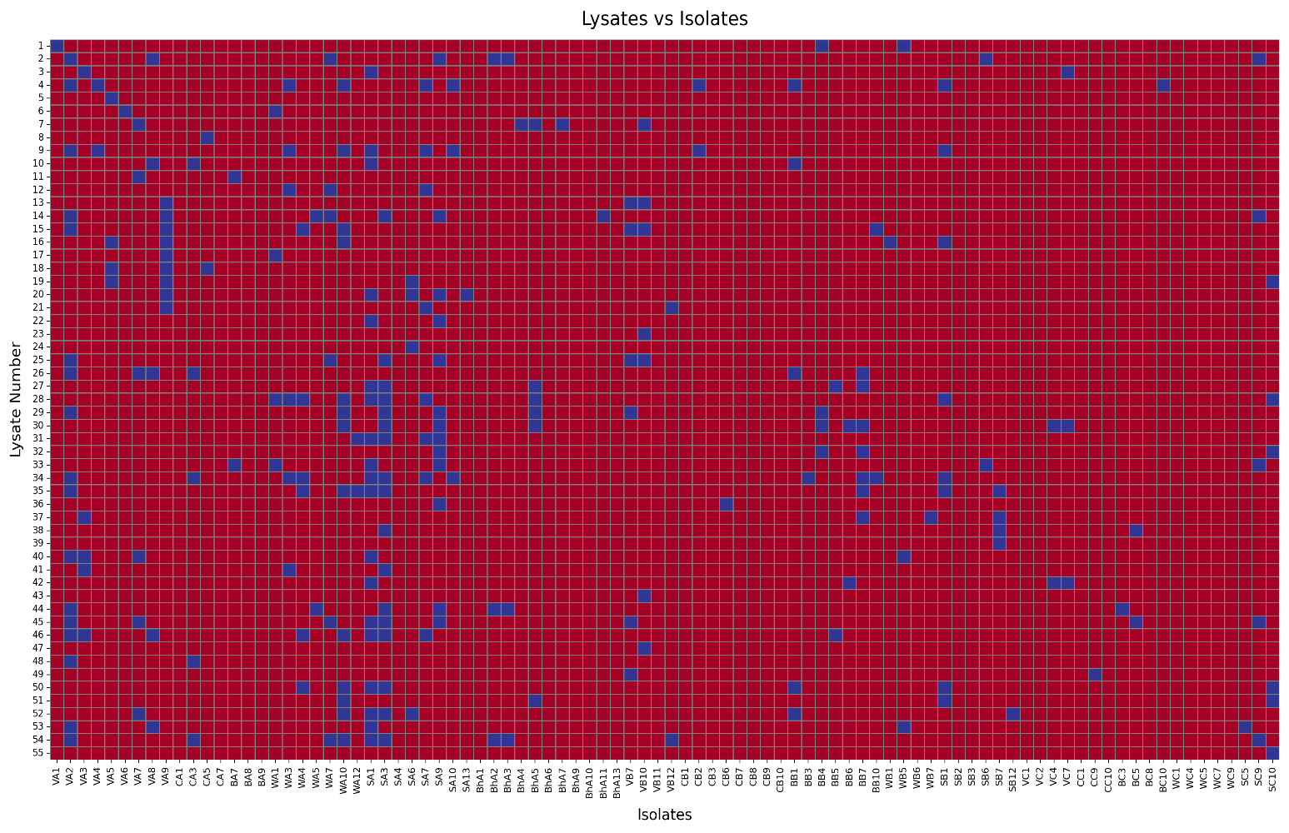
Figure 4: Heat map representing the lytic activity of 55 bacteriophage lysates against 86 multidrug-resistant Escherichia coli isolates. Each row corresponds to a phage lysate, and each column to a bacterial isolate. Blue squares indicate successful lysis (susceptible isolate), while red squares denote no lysis (resistant isolate). The heat map illustrates the host specificity patterns of the isolated phages.
- Conclusion
This study underscores the role of wastewater treatment plants (WWTPs) as reservoirs and potential dissemination hubs for multidrug-resistant (MDR) Escherichia coli, especially under varying seasonal conditions. A significantly higher prevalence of MDR E. coli was recorded during the winter months, likely influenced by reduced dilution, lower metabolic activity in treatment systems, and higher antibiotic loads in influent wastewater. Antibiotic resistance patterns varied across seasons, with β-lactam resistance notably decreasing during the monsoon, while resistance to fluoroquinolones, tetracyclines, and macrolides remained persistently high.
The successful isolation of lytic bacteriophages against more than half of the MDR E. coli strains demonstrates their potential as environmentally relevant biocontrol agents. However, the host range analysis revealed that most phages exhibited narrow specificity, with only a few showing moderate to broad-spectrum lytic activity. This specificity is advantageous for precision targeting but also necessitates further development of tailored phage cocktails to maximize efficacy in diverse microbial communities.
Together, these findings support the implementation of phage-based approaches alongside conventional treatment to mitigate antimicrobial resistance (AMR) dissemination from WWTPs. Future studies should focus on genomic characterization of isolated phages, formulation of phage cocktails, evaluation in simulated or real-scale treatment environments, and long-term monitoring of resistance reduction post-phage application. Integrating seasonal surveillance with phage therapy could form a robust framework for AMR management in wastewater ecosystems, particularly in tropical urban settings like Mumbai. This study thus validates both the seasonal surveillance of resistance in WWTPs and the use of indigenous phages as potential biocontrol agents.

- REFERENCES:
Andrew M. Kropinski, A. M. T. E. W. E. L. and R. P. J. (2009). Bacteriophages (M. R. J. Clokie & A. M. Kropinski, Eds.; Vol. 501). Humana Press. https://doi.org/10.1007/978-1-60327-164-6
Barbosa, V., Morais, M., Silva, A., Delerue-Matos, C., Figueiredo, S. A., & Domingues, V. F. (2021). Comparison of antibiotic resistance in the influent and effluent of two wastewater treatment plants. AIMS Environmental Science, 8(2), 101–116. https://doi.org/10.3934/environsci.2021008
Bergeron, S., Boopathy, R., Nathaniel, R., Corbin, A., & LaFleur, G. (2015). Presence of antibiotic resistant bacteria and antibiotic resistance genes in raw source water and treated drinking water. International Biodeterioration and Biodegradation, 102, 370–374. https://doi.org/10.1016/j.ibiod.2015.04.017
Chan, B. K., Abedon, S. T., & Loc-Carrillo, C. (2013). Phage cocktails and the future of phage therapy. In Future Microbiology (Vol. 8, Issue 6, pp. 769–783). https://doi.org/10.2217/fmb.13.47
Chung, K. M., Liau, X. L., & Tang, S. S. (2023). Bacteriophages and Their Host Range in Multidrug-Resistant Bacterial Disease Treatment. In Pharmaceuticals (Vol. 16, Issue 10). Multidisciplinary Digital Publishing Institute (MDPI). https://doi.org/10.3390/ph16101467
Clokie, M. R. J., Millard, A. D., Letarov, A. V., & Heaphy, S. (2011). Phages in nature. Bacteriophage, 1(1), 31–45. https://doi.org/10.4161/bact.1.1.14942
Coutu, S., Rossi, L., Barry, D. A., Rudaz, S., & Vernaz, N. (2013). Temporal Variability of Antibiotics Fluxes in Wastewater and Contribution from Hospitals. PLoS ONE, 8(1). https://doi.org/10.1371/journal.pone.0053592
Davidova-Gerzova, L., Lausova, J., Sukkar, I., Nesporova, K., Nechutna, L., Vlkova, K., Chudejova, K., Krutova, M., Palkovicova, J., Kaspar, J., & Dolejska, M. (2023). Hospital and community wastewater as a source of multidrug-resistant ESBL-producing Escherichia coli. Frontiers in Cellular and Infection Microbiology, 13. https://doi.org/10.3389/fcimb.2023.1184081
Diwan, V., Hanna, N., Purohit, M., Chandran, S., Riggi, E., Parashar, V., Tamhankar, A. J., & Stålsby Lundborg, C. (2018a). Seasonal variations in water-quality, antibiotic residues, resistant bacteria and antibiotic resistance genes of Escherichia coli isolates from water and sediments of the Kshipra River in Central India. International Journal of Environmental Research and Public Health, 15(6). https://doi.org/10.3390/ijerph15061281
Diwan, V., Hanna, N., Purohit, M., Chandran, S., Riggi, E., Parashar, V., Tamhankar, A. J., & Stålsby Lundborg, C. (2018b). Seasonal variations in water-quality, antibiotic residues, resistant bacteria and antibiotic resistance genes of Escherichia coli isolates from water and sediments of the Kshipra River in Central India. International Journal of Environmental Research and Public Health, 15(6). https://doi.org/10.3390/ijerph15061281
Dong, Z., Hu, J., Wang, P., Han, G., & Jia, Z. (2024). Antibiotics in Wastewater Treatment Plants in Tangshan: Perspectives on Temporal Variation, Residents’ Use and Ecological Risk Assessment. Water (Switzerland), 16(11). https://doi.org/10.3390/w16111627
Gordillo Altamirano, F. L., & Barr, J. J. (2021). Screening for lysogen activity in therapeutically relevant bacteriophages. Bio-Protocol, 11(8). https://doi.org/10.21769/BioProtoc.3997
Haines, M. E. K., Hodges, F. E., Nale, J. Y., Mahony, J., van Sinderen, D., Kaczorowska, J., Alrashid, B., Akter, M., Brown, N., Sauvageau, D., Sicheritz-Pontén, T., Thanki, A. M., Millard, A. D., Galyov, E. E., & Clokie, M. R. J. (2021). Analysis of Selection Methods to Develop Novel Phage Therapy Cocktails Against Antimicrobial Resistant Clinical Isolates of Bacteria. Frontiers in Microbiology, 12(March), 1–15. https://doi.org/10.3389/fmicb.2021.613529
Hembach, N., Alexander, J., Hiller, C., Wieland, A., & Schwartz, T. (2019). Dissemination prevention of antibiotic resistant and facultative pathogenic bacteria by ultrafiltration and ozone treatment at an urban wastewater treatment plant. Scientific Reports, 9(1), 1–12. https://doi.org/10.1038/s41598-019-49263-1
Holtappels, D., Alfenas-Zerbini, P., & Koskella, B. (2023). Drivers and consequences of bacteriophage host range. In FEMS Microbiology Reviews (Vol. 47, Issue 4). Oxford University Press. https://doi.org/10.1093/femsre/fuad038
Hudzicki, J. (2012a). Kirby-Bauer Disk Diffusion Susceptibility Test Protocol Author Information. American Society For Microbiology, December 2009, 1–13. https://www.asm.org/Protocols/Kirby-Bauer-Disk-Diffusion-Susceptibility-Test-Pro
Hudzicki, J. (2012b). Kirby-Bauer Disk Diffusion Susceptibility Test Protocol Author Information. American Society For Microbiology, December 2009, 1–13.
Jendrzejewska, N., & Karwowska, E. (2022). Bacterial Resistance to β-Lactam Antibiotics in Municipal Wastewater: Insights from a Full-Scale Treatment Plant in Poland. Microorganisms, 10(12). https://doi.org/10.3390/microorganisms10122323
Kaplan, E., Ofek, M., Jurkevitch, E., & Cytryn, E. (2013). Characterization of fluoroquinolone resistance and qnr diversity in Enterobacteriaceae from municipal biosolids. Frontiers in Microbiology, 4(JUN). https://doi.org/10.3389/fmicb.2013.00144
Kneis, D., Lemay-St-Denis, C., Cellier-Goetghebeur, S., Elena, A. X., Berendonk, T. U., Pelletier, J. N., & Heß, S. (2023). Trimethoprim resistance in surface and wastewater is mediated by contrasting variants of the dfrB gene. ISME Journal, 17(9), 1455–1466. https://doi.org/10.1038/s41396-023-01460-7
Korf, I. H. E., Meier-Kolthoff, J. P., Adriaenssens, E. M., Kropinski, A. M., Nimtz, M., Rohde, M., van Raaij, M. J., & Wittmann, J. (2019). Still something to discover: Novel insights into Escherichia coli phage diversity and taxonomy. Viruses, 11(5). https://doi.org/10.3390/v11050454
M. Sundar, M., G.S., N., Das, A., Bhattachar, S., & Suryan, S. (2009). Isolation of Host-Specific Bacteriophages from Sewage Against Human Pathogens. Asian Journal of Biotechnology, 1(4), 163–170. https://doi.org/10.3923/ajbkr.2009.163.170
M100 Performance Standards For Antimicrobial Susceptibility Testing, 33rd Edition,M100ED33. (2023). CLSI.
Maffei, E., Shaidullina, A., Burkolter, M., Heyer, Y., Estermann, F., Druelle, V., Sauer, P., Willi, L., Michaelis, S., Hilbi, H., Thaler, D. S., & Harms, A. (2021). Systematic exploration of Escherichia coli phage-host interactions with the BASEL phage collection. PLoS Biology, 19(11). https://doi.org/10.1371/journal.pbio.3001424
Magiorakos, A. P., Srinivasan, A., Carey, R. B., Carmeli, Y., Falagas, M. E., Giske, C. G., Harbarth, S., Hindler, J. F., Kahlmeter, G., Olsson-Liljequist, B., Paterson, D. L., Rice, L. B., Stelling, J., Struelens, M. J., Vatopoulos, A., Weber, J. T., & Monnet, D. L. (2012). Multidrug-resistant, extensively drug-resistant and pandrug-resistant bacteria: An international expert proposal for interim standard definitions for acquired resistance. Clinical Microbiology and Infection, 18(3), 268–281. https://doi.org/10.1111/j.1469-0691.2011.03570.x
Mueller, M., & Tainter CR. (2023). Escherichia coli Infection. [Updated 2023 Jul 13]. In: StatPearls [Internet]. Treasure Island (FL): StatPearls Publishing; 2025 Jan-. https://www.ncbi.nlm.nih.gov/books/NBK564298/
Mutuku, C., Gazdag, Z., & Melegh, S. (2022). Occurrence of antibiotics and bacterial resistance genes in wastewater: resistance mechanisms and antimicrobial resistance control approaches. In World Journal of Microbiology and Biotechnology (Vol. 38, Issue 9). Springer Science and Business Media B.V. https://doi.org/10.1007/s11274-022-03334-0
Nimonkar, Y. S., Yadav, B., Talreja, P., Sharma, A., Patil, S., Saware, S. S., Ranade, D. R., & Prakash, O. (2019). Assessment of the Role of Wastewater Treatment Plant in Spread of Antibiotic Resistance and Bacterial Pathogens. Indian Journal of Microbiology, 59(3), 261–265. https://doi.org/10.1007/s12088-019-00793-2
Pallavali, R., Shin, D., & Choi, J. (2023). Phage-Based Biocontrol of Antibiotic-Resistant Bacterium Isolated from Livestock Wastewater Treatment Plant. Water (Switzerland), 15(8). https://doi.org/10.3390/w15081616
Panteleev, V., Kulbachinskiy, A., & Gelfenbein, D. (2025). Evaluating phage lytic activity: from plaque assays to single-cell technologies. In Frontiers in Microbiology (Vol. 16). Frontiers Media SA. https://doi.org/10.3389/fmicb.2025.1659093
Paulshus, E., Thorell, K., Guzman-Otazo, J., Joffre, E., Colque, P., Kühn, I., Möllby, R., Sørum, H., & Sjöling, Å. (2019). Repeated Isolation of Extended-Spectrum-Lactamase-Positive Escherichia coli Sequence Types 648 and 131 from Community Wastewater Indicates that Sewage Systems Are Important Sources of Emerging Clones of Antibiotic-Resistant Bacteria. https://doi.org/10.1128/AAC.00823
Purohit, M. R., Lindahl, L. F., Diwan, V., Marrone, G., & Lundborg, C. S. (2019). High levels of drug resistance in commensal E. coli in a cohort of children from rural central India. Scientific Reports, 9(1), 1–11. https://doi.org/10.1038/s41598-019-43227-1
Rizzo, L., Fiorentino, A., & Anselmo, A. (2013). Advanced treatment of urban wastewater by UV radiation: Effect on antibiotics and antibiotic-resistant E. coli strains. Chemosphere, 92(2), 171–176. https://doi.org/10.1016/j.chemosphere.2013.03.021
Smith, H. W. & Halls, S. (1966). Observations on Infective Drug Resistance in Britain. BMJ, 1(January), 266–269. https://doi.org/https://dx.doi.org/10.1136%2Fbmj.1.5482.266
Sriram, A., Kalanxhi, E., Kapoor, G., Craig, J., Ruchita Balasubramanian, S. B., Criscuolo, N., Hamilton, A., Klein, E., Tseng, K., Boeckel, T. Van, & Laxminarayan, R. (2021). The State of the World’s Antibiotics in 2021: A Global Analysis of Antimicrobial Resistance and Its Drivers. The Center for Disease Dynamics, Economics & Policy, 1–115. https://cddep.org/blog/posts/the-state-of-the-worlds-antibiotics-report-in-2021/
Suttle, C. A. (2005). Viruses in the sea. In Nature (Vol. 437, Issue 7057, pp. 356–361). Nature Publishing Group. https://doi.org/10.1038/nature04160
Tahrani, L., Van Loco, J., Mansour, H. Ben, & Reyns, T. (2016). Occurrence of antibiotics in pharmaceutical industrial wastewater, wastewater treatment plant and sea waters in Tunisia. Journal of Water and Health, 14(2), 208–213. https://doi.org/10.2166/wh.2015.224
Teshome, A., Alemayehu, T., Deriba, W., & Ayele, Y. (2020). Antibiotic Resistance Profile of Bacteria Isolated from Wastewater Systems in Eastern Ethiopia. Journal of Environmental and Public Health, 2020. https://doi.org/10.1155/2020/2796365
Wengenroth, L., Berglund, F., Blaak, H., Chifiriuc, M. C., Flach, C. F., Pircalabioru, G. G., Joakim Larsson, D. G., Marutescu, L., van Passel, M. W. J., Popa, M., Radon, K., Husman, A. M. de R., Rodríguez-Molina, D., Weinmann, T., Wieser, A., & Schmitt, H. (2021). Antibiotic resistance in wastewater treatment plants and transmission risks for employees and residents: The concept of the aware study. Antibiotics, 10(5). https://doi.org/10.3390/antibiotics10050478
WHO. (2016). Antimicrobial resistance and its containment in India.
Zhi, S., Stothard, P., Banting, G., Scott, C., Huntley, K., Ryu, K., Otto, S., Ashbolt, N., Checkley, S., Dong, T., Ruecker, N. J., & Neumann, N. F. (2020). Characterization of water treatment-resistant and multidrug-resistant urinary pathogenic Escherichia coli in treated wastewater. Water Research, 182, 115827. https://doi.org/10.1016/j.watres.2020.115827

