Original Research Article

Antibiotic-resistant Listeria spp. isolated from faeces of dairy cattle in selected areas of Bangladesh

.
ABSTRACT

The aim of this study was to investigate the epidemiology and antibiogram of Listeria species isolated from dairy cattle of Bangladesh. Faecal samples (300) were collected aseptically from randomly selected dairy farms of Dhaka, Barisal, and Mymensingh divisions (100 from each) of Bangladesh from July 2023 to June, 2024. The samples were primarily enriched in to Listeria enrichment broth and isolated on to Polymyxin Acriflavin Lithium-chloride Ceftazidime Esculin Mannitol (PALCAM) agar. The presumptive colonies with morphological characteristics of Listeria was observed as black or black-green colony surface with a black halo and sunken center (1-2mm in diameter). The identification of Listeria spp. were performed according to morphology, cultural and biochemical properties. The identified Listeria spp. were then subjected to antibiotic sensitivity test. The overall prevalence of Listeria spp. from faecal sample of dairy cattle was 9.33% whereas prevalence of 8.00%, 9.00%, and 11.00% were observed for Dhaka, Barisal, and Mymensingh, respectively. Ampicillin, amoxicillin, and amoxycillin/clavulanic acid (each of 96.43%) were more resistant to the isolated Listeria spp. followed by erythromycin (89.29%) and tetracycline (85.29%) while, gentamicin, and meropenem (96.43%) followed by ciprofloxacin (71.43%), and ceftriaxone (60.71%) were sensitive to the isolated Listeria spp. Therefore, care should be taken to prevent the development of multidrug resistant Listeria spp. in dairy cattle.

Keywords: Antibiotic sensitivity, dairy cattle, foodborne pathogen, Listeria spp., occurrence
1. INTRODUCTION
Listeria monocytogenes is a major foodborne zoonotic pathogen that causes listeriosis in humans, manifesting as gastroenteritis, meningitis, septicemia, and fetal abortion in severe situations. The clinical severity depends upon various factors such as host immune status, and immunocompromised host, pregnant woman, neonates, and older adults are disproportionately at higher risks (Reda et al., 2016; Phraephaisarn et al., 2017; Abdeen et al., 2021). Even with proper treatment, invasive listeriosis has a staggering case fatality rate of 20-30% (Sarfraz et al., 2017; Şanlıbaba, 2018).
The vast environmental reservoirs of L. monocytogenes —including soil, water, sewage, animal feed, plants, and feces—enable it to get into the food chain easily via multi-point contamination from farm to fork (Sauders et al., 2012). The ubiquitous nature of L. monocytogenes helps it to persist in environment and grow in and psychrotrophic condition. They enable it to survive and multiply even at refrigeration temperatures. This broad ecological niche supplies repeat cycles of contamination between environmental reservoirs, animal carriers, and food products (Sarker and Ahmed, 2015; Manjur et al., 2016). Dairy cattle farms are a significant reservoir and have L. monocytogenes genotypes directly linked with human outbreaks (Rocha et al., 2013; Haley et al., 2015). Asymptomatic fecal shedding in healthy cattle continues the transmission of the pathogen in farm settings, providing a constant source of contamination (Borucki et al., 2004; Nightingale et al., 2005; Castro et al., 2018).
The emergence of antimicrobial resistance in L. monocytogenes further adds this public health risk substantially (Keet and Rip, 2021). Resistance mechanisms are chromosomal mutations, horizontal gene transfer through conjugation, and plasmid-mediated genes (Poros-Gluchowska and Markiewicz, 2003). The improper use of antimicrobials in human medicine and agriculture has driven the development of resistance, rendering classical therapeutic practices less effective (Rahimi et al., 2012; Scenihr, 2009; Friedman et al., 2016; Bloom et al., 2017). Alarmingly, multi-drug resistant Listeria isolates have been recovered from foods and environmental samples, evoking the threat of treatment failures (Sarker and Ahmed, 2015; Manjur et al., 2016; Abdeen et al., 2021).
Despite the reported risk, very few overall epidemiological data are available for L. monocytogenes in Bangladesh. Shourov et al., (2020) recovered Listeria spp. from 13.2% of cattle farm environmental samples and identified their antibiotic resistance patterns. Islam et al., (2016) provided a prevalence rate of 16.66% for L. monocytogenes in beef, 8.33% in chicken, and 8.33% in chevon. Therefore, more research is needed to explore the current prevalence and antibiotic resistance pattern of Listeria species distribution in Bangladesh. The present study aimed to explore the phenotypic pattern of antimicrobial resistance of Listeria spp. in food animals of Bangladesh.

2. material and methods
Sources and collection of samples
Three hundred (300) faecal samples were collected aseptically from randomly selected dairy farms of Dhaka, Barisal, and Mymensingh divisions (100 from each) of Bangladesh from July 2023 to June, 2024. All samples were collected by using sterile polythene bags in a view to prevent extraneous contamination. The collected samples were transferred to the to the laboratory of the department of Microbiology and Parasitology, Sher-e-Bangla Agricultural University (SAU), Dhaka-1207 using ice box and process by following standard procedure for further examination.
Isolation and identification of Listeria species from faecal sample of cattle
The isolation of Listeria species was performed according to the International Organization for Standardization (ISO 11290–1:2017) with minor modification (ISO, 2017). At first, sample was taken into Listeria enrichment broth (Hi-media, India) and incubated for 48 hrs at 30°C to enrich growth. After that, a loop-full of Listeria enriched broth was streaked onto Polymyxin Acriflavin Lithium-chloride Ceftazidime Esculin Mannitol (PALCAM) agar (Hi-media, India) plates for 24–48 h at 37 °C. It was noted that Listeria selective enrichment supplement was added during the preparation of PALCAM agar. The presumptive colonies with morphological characteristics of Listeria was observed as black or black-green colony surface with a black halo and sunken center (1-2mm in diameter) (Scotter et al., 2001). The purified colonies were preserved by sterile buffered glycerin (20%) at −20°C. The identification of Listeria spp. Were performed according to morphology (gram staining and motility), cultural (PALCAM agar) and biochemical (dextrose, lactose, rhamnose, mannitol, xylose and arabinose fermentation, oxidase, nitrate reduction, hydrogen sulfide, indole production, methyle red, Voges–Proskauer, and catalase tests) properties.
Antibiotic sensitivity tests of isolated Listeria species
Antibiotic sensitivity tests were performed using disc diffusion test following the method described by Kirby-Bauer with slight modification (Bauer et al., 1966; CLSI, 2017). Briefly, 0.1ml of bacterial suspension (1x10⁸ CFU/mL) corresponding to (0.5 McFarland) were plated on Mueller-Hinton agar supplemented with 5% defibrinated sheep blood and the plate were left for 5 min to dry. Antibiotic discs were place apart onto the surface of the inoculated plates aseptically with the help of a sterile forceps and will incubate at 35ºC±2 for 24-48hrs. The following antibiotics of veterinary and medical importance were used for disc diffusion test ampicillin (AMP), 10 μg; amoxicillin (AMX), 30 μg; amoxicillin–clavulanic acid (AMC), 20/10 μg; ceftriaxone (CTR), 30μg; ciprofloxacin (CIP), 5 μg; nalidixic acid (NA), 30 μg; erythromycin (E), 15 μg; gentamicin (GEN), 10 μg; tetracycline (TE), 30 μg; and meropenem (MEM), 10 μg. After incubation, all the plates were examined and the diameters of the zone of inhibition were measured. Then these diameters were interpreted with the standard diameters provided by the CLSI and recorded as sensitive (S), intermediate (I) and resistant (R) (CLSI, 2017).

Statistical Analysis
The data obtain from this study will be analyzed using Minitab 17 program (Minitab Ltd., UK). Significant difference among the variables will be calculated using Pearson’s Chi-square test. The statistical significance was declared at p < 0.05.

3. results and discussion
Isolation and identification of Listeria species from dairy cattle
Out of 300 samples, sixty-five (65) isolates were selected based on their growth pattern on the PALCAM agar, selective media for Listeria spp. (Figure 1). Typical Listeria spp. colonies appeared as black or black-green in color with a black halo and sunken center with a growth diameter of 1–2mm on PALCAM agar, which is in line with the previous researches (Islam et al., 2016; Faruk et al., 2023).
28 isolates were further identified as Listeria spp. by applying gram staining procedure and screening through the motility and biochemical tests. They were Gram positive short rod or coccobacilli under microscope (Figure 1). They showed tumbling motility, ferment dextrose, and lactose, but did not ferment mannitol, and arabinose. Additionally, they showed negative reaction in oxidase, nitrate reduction, hydrogen sulfide, and indole production tests, while exhibiting positive reaction in MR-VP, and catalase test. However, xylose and rhamnose fermentations were varied among the isolates (Table 1).
Critical Analysis of Isolation Efficiency and Methodological Considerations
About 21.67% (65 out of 300) were presumptively identified as Listeria spp. and 43.08% (28 out of 65), isolates proved to be positive for Listeria spp. It highlights the selectivity of PALCAM agar and the complexity of Listeria identification as it effectively enriches for Listeria-like organisms, but allow other bacteria with similar growth characteristics such as Enterococcus species or other Gram-positive bacteria to proliferate, thus loosing absolute septicity. These phenomena may have contributed to the 56.92% (37 out of 65) false-positive result (Figure 2).
The inherent limitations must be critically evaluated. Isolation only by phenotypic methods is cost-effective and accessible in resource-limited settings but establishing Listeria characteristics and distinguishing between pathogenic L. monocytogenes and non-pathogenic species such as L. innocua or L. welshimeri is not definitive. This uncertain level of species represents a significance risk assessment and public health consequences, as their pathogenic potential varies technically within the genus.
Prevalence and Epidemiological Significance in Listeria spp.
The ultimate prevalence of Listeria spp. in dairy cattle feces was 9.33% (95% CI: 6.5–13.0%, n= 28/300), which decrease at the lower end of reported universal ranges. Regionally, prevalence was 8.00% in Dhaka (95% CI: 4.1–13.9%), 9.00% in Barisal (95% CI: 4.8–15.2%), and 11.00% in Mymensingh (95% CI: 6.2–18.5%) (Table 2). Although the relative difference between Mymensingh and Dhaka was 37.5%, chi-square analysis showed no statistically significant association between sampling location and Listeria detection (χ² = 0.679, df = 2, p = 0.712) due to random sampling error rather than true epidemiological differences (Table 2). Furthermore, the prevalence was lower than the previously reported studies in Bangladesh, 20% prevalence in cow dung and 13.2% in farm environments found by Shourav et al., (2020); 30% prevalence in raw milk and 40% in raw poultry meat were observed by Faruk et al., (2023). But similar prevalence in meat (11.11%) samples was reported by Islam et al., (2016). Due to differences in sample type, methodological approaches, or seasonal and temporal variations in bacterial shedding these inconsistencies may be assigned, while here observation of lower prevalence could also reflect improvements in farm-level hygiene and biosecurity.
Antibiotic resistant pattern of Listeria spp. isolated from dairy cattle
The antibiotic susceptibility testing revealed alarming resistance patterns across multiple antibiotic classes (Table 3). The isolated Listeria spp. demonstrated extremely high resistance to ampicillin (96.43%, 27/28), amoxicillin (96.43%, 27/28), and amoxicillin-clavulanic acid (96.43%, 27/28). High resistance was also observed against erythromycin (89.29%, 25/28) and tetracycline (85.71%, 24/28). Moderate resistance was noted for nalidixic acid (50.00%, 14/28) and ceftriaxone (21.43%, 6/28), while lower resistance was observed for ciprofloxacin (14.29%, 4/28). In contrast, the isolates showed high susceptibility to gentamicin (96.43%, 27/28) and meropenem (96.43%, 27/28), followed by ciprofloxacin (71.43%, 20/28) and ceftriaxone (60.71%, 17/28).
For understanding the resistance burden, analysis of resistance by antibiotic class was done (Table 4). The highest resistance was observed in the penicillin class with or without β-lactam Inhibitor (96.43%), followed by macrolides (89.29%) and tetracyclines (85.71%). Moderate resistance was noted in quinolones (50.00% for nalidixic acid, though only 14.29% for ciprofloxacin, while cephalosporins showed lower resistance (21.43%). Notably, aminoglycosides and carbapenems maintained full susceptibility (0% resistance).
The findings of this study align with and complement previous reports on Listeria antimicrobial resistance in Bangladesh. High resistance rates to penicillin (100%), amoxicillin (100%), ampicillin (91.7%), erythromycin (91.7%), and tetracycline (75.0%) from cattle farm environments was reported by Shourav et al. (2020). Similarly, Faruk et al., (2023), reported 100% resistance to ampicillin and erythromycin in L. monocytogenes isolated from milk and poultry meat. In this study, the resistance rate of ampicillin (96.43%) and erythromycin resistance (89.29%) are similar to these figures which demonstrate an alarming and potentially declining continued trend of aminopenicillin as well as macrolide resistance in livestock setting Bangladesh. Temporal changes comparison over time showed an alarming trend: the resistance to first line drugs (ampicillin and erythromycin) has always been around 90% or higher over years in all the Bangladesh studies compared.
4. Conclusion
This study reveals the prevalence of Listeria spp. 9.33% in dairy cattle feces across three major divisions of Bangladesh. Isolated Listeria spp. exhibited near-universal resistance to penicillin with or without β-lactam Inhibitor (ampicillin, amoxicillin, and amoxicillin-clavulanic acid: 96.43%), macrolides (erythromycin: 89.29%), and tetracyclines (85.71%). These findings indicate probable multi-drug resistance patterns and severely limited therapeutic options for listeriosis treatment. Immediate implementation of antimicrobial stewardship programs, including prescription-only policies, enhanced farm biosecurity measures, coupled with routine resistance monitoring and One Health-based intervention strategies integrating veterinary, agricultural, and public health sectors, are essential to safeguard both animal and human health. Future research should prioritize species specific-molecular characterization of resistance genes and clonal lineages to elucidate transmission dynamics and inform evidence-based control strategies in Bangladesh's dairy sector.

Consent

Not applicable.

Ethical approval

Not applicable.

References
Abdeen, E. E., Mousa, W. S., Harb, O. H., Fath-Elbab, G. A., Nooruzzaman, M., Gaber, A., ... & Abdeen, A. (2021). Prevalence, antibiogram and genetic characterization of Listeria monocytogenes from food products in Egypt. Foods, 10(6), 1381.
Abdeen, E., Ntshanka, Z., & Mudau, F. N. (2021). Occurrence and Molecular Characterization of Multidrug-Resistant Listeria monocytogenes Isolated from Fresh Vegetables in South Africa. Microorganisms, 9(11), 2309.
Bauer AW. Antibiotic susceptibility testing by a standardized single diffusion method. Am. J. Clin. Pathol.. 1966;45:493-6.
Bloom, G., Merrett, G. B., Wilkinson, A., Lin, V., & Paulin, S. (2017). Antimicrobial resistance and universal health coverage. BMJ global health, 2(4).
Borucki, M. K., Gay, C. C., Reynolds, J., McElwain, K. L., Kim, S. H., Call, D. R., & Knowles, D. P. (2005). Genetic diversity of Listeria monocytogenes strains from a high-prevalence dairy farm. Applied and Environmental Microbiology, 71(10), 5893-5899.
Castro, V. S., Ortega Polo, R., Figueiredo, E. E. D. S., Bumunang, E. W., McAllister, T., King, R., et al. (2018). Study of bacterial community composition and correlation with environmental variables. Frontiers in Microbiology, 9, Article 1377.
CLSI. Performance standards for antimicrobial susceptibility testing. 27th ed. CLSI supplement M100. Wayne, PA: Clinical and Laboratory Standards Institute. Performance standards for antimicrobial susceptibility testing. 27th ed. CLSI supplement M100. Wayne, PA: Clinical and Laboratory Standards Institute. 2017; 27(1): 1–248.
Faruk, M.O., Ema, F.A., Islam, M.A. and Khatun, M.M. (2023) Prevalence, molecular detection and antimicrobial susceptibility of Listeria monocytogenes isolated from milk, poultry meat and meat products, Food Research 7 (5) : 308 – 317.
Friedman, N. D., Temkin, E., & Carmeli, Y. (2016). The negative impact of antibiotic resistance. Clinical Microbiology and Infection, 22(5), 416-422.
Haley, B. J., Sonnier, J., Schukken, Y. H., Karns, J. S., & Van Kessel, J. A. S. (2015). Diversity of Listeria monocytogenes within a US dairy herd, 2004–2010. Foodborne Pathogens and Disease, 12(10), 844-850.
Islam, M.S., Husna, A.A., Islam, M.A. and Khatun, M.M. (2016). Prevalence of Listeria monocytogenes in beef, chevon and chicken in Bangladesh. American Journal of Food Science and Health, 2(4), 39-44.
ISO. ISO 11290–1:2017 Microbiology of the food chain—Horizontal method for the detection and enumeration of Listeria monocytogenes and of Listeria spp.—Part 1: Detection method. In: ISO. 2017;1–35.
Keet, R., & Rip, D. (2021). Listeria monocytogenes isolates from Western Cape, South Africa exhibit resistance to multiple antibiotics and contradicts certain global resistance patterns. AIMS Microbiology, 7(1), 40-58.
Manjur, M. S. E., Siddique, S., & Ahmed, S. (2016). Multi-drug resistant pathogenic Listeria monocytogenes in surface water and soil samples of Dhaka city. Bangladesh Journal of Microbiology, 33(1-2), 39-42.
Nightingale, K. K., Windham, K., & Wiedmann, M. (2005). Evolution and molecular phylogeny of Listeria monocytogenes isolated from human and animal listeriosis cases and foods. Journal of Bacteriology, 187(16), 5537–5551.
Phraephaisarn, C. (2017). DEVELOPMENT OF MOLECULAR TECHNIQUE FOR RISK ASSESSMENT AND RISK MANAGEMENT OF Listeria monocytogenes AND L. innocua IN FROZEN COOKED CHICKEN PLANT.
Poros-Gluchowska, J., & Markiewicz, Z. (2003). Antimicrobial resistance of Listeria monocytogenes. Acta Microbiologica Polonica, 52(2), 113-129.
Rahimi, E., & Ameri, M. (2011). Antimicrobial resistance patterns of Campylobacter spp. isolated from raw chicken, turkey, quail, partridge, and ostrich meat in Iran. Food Control, 22(8), 1165-1170.
Reda, F. M., Abd El-Moez, S. I., Ahmed, A. A. E., & Abbas, T. A. (2016). Molecular detection of Listeria species isolated from raw milk with special reference to virulence determinants and antimicrobial resistance in Listeria monocytogenes. Journal of Animal Health and Production, 10(4), 492-505.
Rocha, P. R. D. A., Lomonaco, S., Bottero, M. T., Dalmasso, A., Dondo, A., Grattarola, C., ... & Casalone, C. (2013). Ruminant rhombencephalitis-associated Listeria monocytogenes strains constitute a genetically homogeneous group related to human outbreak strains. Applied and environmental microbiology, 79(9), 3059-3066.
Şanlıbaba, P., Tezel, B. U., & Çakmak, G. A. (2018). Detection of Listeria spp. in raw milk and dairy products retailed in Ankara. Gıda, 43(2), 273-282.
Sarfraz, M., Ashraf, Y., & Ashraf, S. (2017). A review: prevalence and antimicrobial susceptibility profile of listeria species in milk products. Matrix Science Medica, 1(1), 3-9.
Sarker, R. and Ahmed, S. (2015). Prevalence and antimicrobial susceptibility of Listeria spp. in dairy food products and water samples in Dhaka, Bangladesh. Journal of Life Sciences, 9, 152-158.
Sauders, B. D., Overdevest, J., Fortes, E., Windham, K., Schukken, Y., Lembo, A., & Wiedmann, M. (2012). Diversity of Listeria species in urban and natural environments. Applied and environmental microbiology, 78(12), 4420-4433.
Scientific Committee on Emerging and Newly Identified Health Risks (SCENIHR). (2009). Assessment of the Antibiotic Resistance Effects of Biocides. European Commission, 19 January 2009.
Scotter SL, Langton S, Lombard B, Schulten S, Nagelkerke N, Rollier P, Lahellec C. Validation of ISO method 11290 part 1—detection of Listeria monocytogenes in foods. International Journal of Food Microbiology. 2001 Mar 20;64(3):295-306.
Shourav, A.H., Hasan, M. and Ahmed, S. (2020). Antibiotic susceptibility pattern of Listeria spp. isolated from cattle farm environment in Bangladesh. Journal of Agriculture and Food Research 2 (2020) 100082.

Table1. Motility and biochemical properties of the isolated Listeria spp.
Parameters |  | Properties
Motility |  | Tumbling motility
Sugar Fermentation | Dextrose | +ve
Sugar Fermentation | Lactose | +ve
Sugar Fermentation | Mannitol | -ve
Sugar Fermentation | Arabinose | -ve
Sugar Fermentation | Xylose | ±ve
Sugar Fermentation | Rhamnose | ±ve
Methyl Red (MR) |  | +ve
Voges–Proskauer (VP) |  | +ve
Indole |  | -ve
Catalase |  | +ve
Oxidase |  | -ve
Nitrate reduction |  | -ve
H₂S production |  | -ve
+ve = positive; -ve = negative; ±ve= variable

Table 2. Statistical comparison of prevalence of Listeria spp.
Division | Positive/Total | Prevalence (%) | 95% CI | χ² | p-value
Dhaka | 8/100 | 8.00 | 4.09-13.95 | 0.679 | 0.712
Barisal | 9/100 | 9.00 | 4.75-15.25 | 0.679 | 0.712
Mymensingh | 11/100 | 11.00 | 6.15-18.46 | 0.679 | 0.712
Overall | 28/300 | 9.33 | 6.47-13.01 | 0.679 | 0.712

Table 3. Antibiotic sensitivity and resistance patterns of isolated Listeria spp.
Name of antibiotics used | Antibiotic sensitivity and resistant patterns
Name of antibiotics used | S  No. (%) | I  No. (%) | R  No. (%)
Ampicillin | 0 (0.00) | 1 (3.57) | 27 (96.43)
Amoxicillin | 0 (0.00) | 1 (3.57) | 27 (96.43)
Amoxycillin/  Clavulanic acid | 0 (0.00) | 1 (3.57) | 27 (96.43)
Ceftriaxone | 17 (60.71) | 5 (17.86) | 6 (21.43)
Ciprofloxacin | 20 (71.43) | 4 (14.29) | 4 (14.29)
Nalidixic acid | 12 (42.86) | 2 (7.14) | 14 (50.00)
Erythromycin | 2 (7.14) | 1 (3.57) | 25 (89.29)
Gentamicin | 27 (96.43) | 1 (3.57) | 0 (0.00)
Tetracycline | 2 (7.14) | 2 (7.14) | 24 (85.71)
Meropenem | 27 (96.43) | 1 (3.57) | 0 (0.00)
Legends: No. = Number, % = Percentage, S = sensitive, I = intermediate sensitive, R = resistant.
Table 4. Class-specific antibiotic resistance profile.
Antibiotic Class | Antibiotics Tested | Resistant Isolates (%) | Interpretation
Penicillin | Ampicillin, Amoxicillin | 27/28 (96.43) | Critical resistance
Penicillin and β-lactam Inhibitor | Amoxicillin-Clavulanic acid | 27/28 (96.43) | Critical resistance
Macrolides | Erythromycin | 25/28 (89.29) | Very high resistance
Tetracyclines | Tetracycline | 24/28 (85.71) | Very high resistance
Quinolones (1st gen) | Nalidixic acid | 14/28 (50.00) | Moderate resistance
Fluoroquinolones | Ciprofloxacin | 4/28 (14.29) | Low resistance
Cephalosporins | Ceftriaxone | 6/28 (21.43) | Low-moderate resistance
Aminoglycosides | Gentamicin | 0/28 (0.00) | Full susceptibility
Carbapenems | Meropenem | 0/28 (0.00) | Full susceptibility

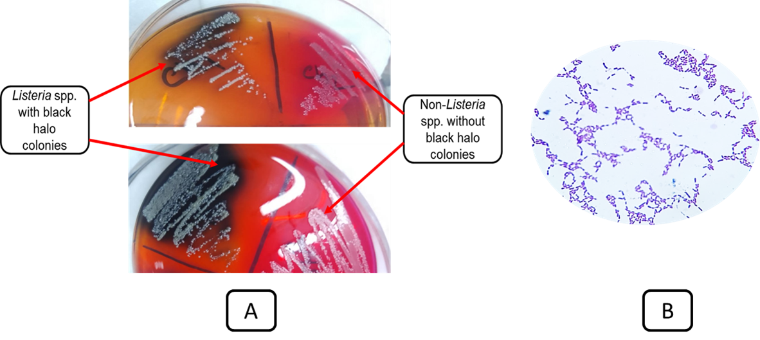

Figure 1. Listeria spp. showed black or black-green colony surface with a black halo on PALCAM agar (A) and Gram-positive short rod or coccobacilli appearance in Gram staining (B).

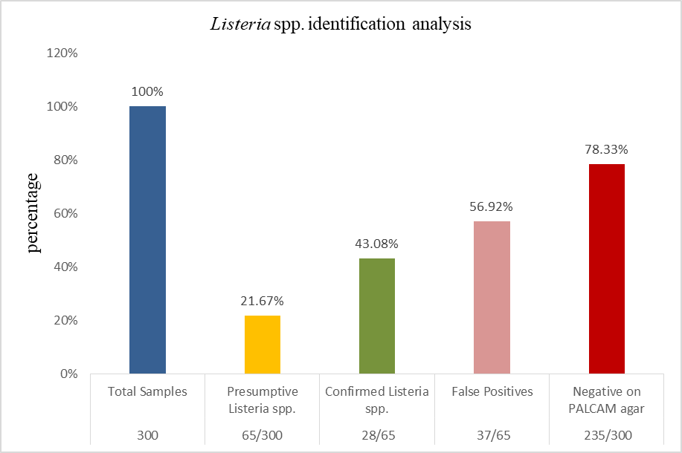

Figure 2: Listeria spp. identification analysis.

