Original Research Article

Aspergillus spp. diversity and aflatoxin contamination of cereal and legume seeds in storage in Cameroon

Abstract
In cereal and legume grains, the presence of Aspergillus spp. and their aflatoxins induce huge economic losses, health problems and environmental problems during storage. Aspergillus spp. cause losses of up to 25% of world agricultural production, and 50% in developing countries. The aim of this work is to identify Aspergillus spp. isolated from maize, soybean, rice and peanut grains in storage, while examining their aflatoxin contamination levels. To this end, 25 composite samples of each grain were systematically collected from the five agro-ecological zones (AEZ) of Cameroon. Morphological characterization of Aspergillus spp. isolates was carried out using various specific culture media. Aflatoxin determination was carried out using standard aflatoxin extraction and ELISA strip quantification. The results show that, of the 100 composite samples collected, 99% were contaminated by a wide variety of molds, with a prevalence of 334/745 or 44.83% of Aspergillus spp. Of the Aspergillus spp. isolates obtained, 21.85% were derived from peanuts, 27.84% from rice, 21.56% from maize and 28.74% from soybeans. Aspergillus prevalence varied with agro-ecological zones (AEZs), and the most affected zones were AEZ V with 31.73% Aspergillus spp. isolates, and AEZ III with 28.14% Aspergillus spp. isolates. Aspergillus diversity according to AEZs shows that section Flavi is the most represented with 33 % of isolates, successively followed by sections Nigri, Fumigati, Terrei, Candidi and Circumdati with 27 %, 16 %, 6 %, 6 % and 6 % respectively. Examination of the total aflatoxin contamination levels of the various grains showed that, irrespective of the foodstuffs and AEZs, aflatoxin contamination was 100%. However, the highest mean concentration of aflatoxin was recorded in AEZ V (9.63 µg/kg). By commodity, samples of maize (9.46 µg/kg) followed by rice (8.92 µg/kg) showed the highest aflatoxin levels in Cameroon. In addition, all the aflatoxin levels in the four foodstuffs exceeded the current regulatory thresholds.
Key words: Variety; Aspergillus spp; aflatoxins; Various grains; storage.

1. Introduction
In developing countries, food security remains one of the most important sustainable development objectives. In Cameroon, the production and storage of foodstuffs such as maize, soybean, rice and peanuts is one of the means used to achieve this objective. Due to their nutritional importance, these commodities represent the bulk of the diet of humans and animals [1]. Throughout the Central African region, and particularly in Cameroon, inadequate environmental conditions and storage practices provide optimal conditions for mold growth and mycotoxin accumulation in these foodstuffs [2]. The development of mold on foodstuffs can have a number of implications, leading to food spoilage (change in appearance, taste, cost, smell, etc.). Among the most frequently incriminated molds, the Aspergillus genus is by far the most prevalent.
Aspergillus is a cosmopolitan group of molds first described by Antonio Micheli in 1729 [3,4]. The identification of Aspergillus was initially based on morphological characteristics grouping macro and micro characteristcis that provided a general concept of the different species [5] later, molecular features provided more precise species information [6]. The genus Aspergillus belongs to the phylum Ascomycetes, class Eurotiomycetes, order Eurotiales, and family Eurotiaeae [7,8]. Identification based on macro-characteristics includes colony color and texture, presence of exudates and sclerotia formation. Micro-characteristics include conidial head shape, seriation, vesicle shape and diameter, stipe length, width, texture and color, conidial size, shape, texture and color, sclerotia size for those that formed it [9]. Aspergillus are classified into sections on the basis of seriation, and the shape of the conidial head, which is globose or star-shaped [10].
This fungal genus is particularly feared for the aflatoxins it produces. Indeed, aflatoxins are a major concern for human and animal health, and especially for the significant economic losses they cause [11,12]. Recent studies have shown that aflatoxin exposure through various sources is linked to growth disorders in humans and animals [13,14,15]. Aflatoxins are liver toxins known to inhibit nucleic acid and protein synthesis [16]. Reduced immune function, hepatotoxicosis, hemorrhage, teratogenesis and mutagenesis are associated with aflatoxicosis [17]. Rodrigues et al., [18] surveyed the presence of mycotoxins in animal feed in the Middle East, West and Central Africa, including Israel, Jordan, Lebanon, Syria Yemen Nigeria, Sudan, Egypt, Algeria, Kenya, Ghana and South Africa, revealing that 98% of ingredients used in feed formulation are positive for aflatoxins. In Cameroon, Ngoko et al., [2,19] also found that foodstuffs are also highly susceptible to fungal infections, which tend to increase with storage time. Since then, there is a need to renew the database on different Aspergillus spp. inventories of cereals and legumes in storage in the different agro-ecological zones of Cameroon and their related mycotoxin. Therefore, the objective of this study was to identify Aspergillus spp. isolated from stored maize, soybean, rice and groundnut while examining aflatoxin contamination in the five agro-ecological zones of Cameroon.
2. Materials and methods
2.1 Study areas
The study was carried out in Cameroon's five agro-ecological zones (AEZs I, II, III, IV and V). Agroecological Zone I (AEZ I), is the Sudano-Sahelian zone. The climate is characterized by monomodal rainfall, and an average temperature of 31 ˚C with a maximum temperature between 40 and 45˚C. The high Guinean savannah zone (AEZ II) is characterized by a Guinean-type climate with bimodal rainfall. Average temperatures range from 20 to 26˚C. The Western Highlands zone (AEZ III) is characterized by a Cameroonian-type climate marked by two seasons of unequal length, with average temperatures below 19 ˚C and abundant rainfall. The Dense Rainforest zone with monomodal rainfall (AEZ IV) is characterized by a very humid and hot Cameroonian climate, a variant of the equatorial climate. Temperatures vary between 22 and 29 ˚C. The bimodal rainforest zone (AEZ V), characterized by a Guinean-type climate with average temperatures of 25 ˚C and rainfall of 1500-2000 mm per year [20]. Fivesites per AEZ were sampled per agroecological zone, i.e. a total of 25 sites for the five (Fig. 1).
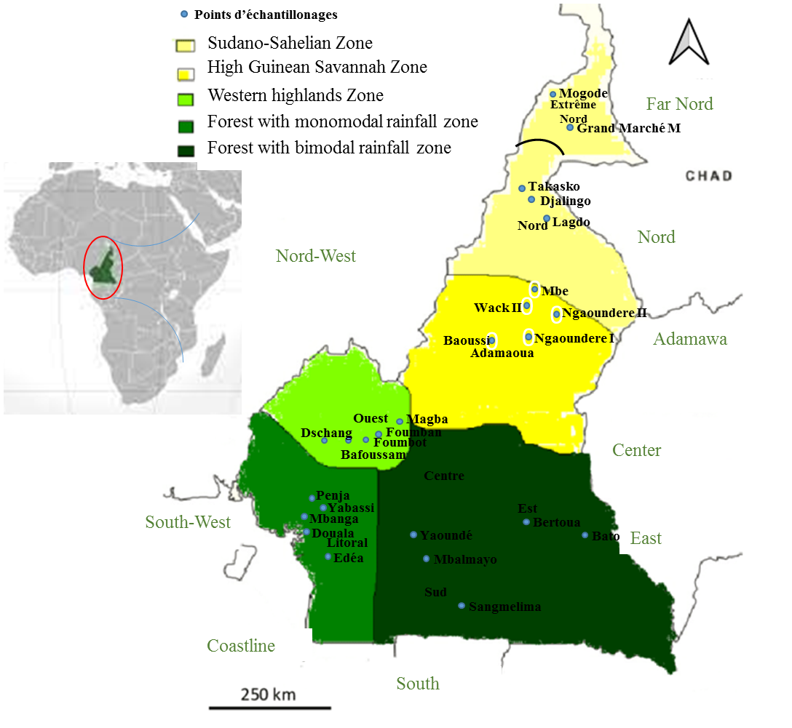
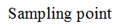

Fig. 1. Sampling sites
2.2 Grain sampling
Cereal and legume grains were collected in the five agro-ecological zones of Cameroon. In each agroecological zone, maize, rice, soybean and peanut grain samples were collected in five localities. In each locality, an average of 25 samples of each commodity were collected and pooled into a composite sample for a total of five samples of each grain per agroecological zone. Sampling was carried out in accordance with Commission Regulation (EC) N°401/2006 of February 23, 2006. Five kg of samples of each grain or legume were taken from 50 or 100 kg bags (i.e. 100 g) at 5 different points in each of the 10 or 20 bags in different corners of the store. At the end of sampling, a total of 100 composite samples of 100 kg each were collected from the five agro-ecological zones. These were placed in sterile BIOHAZARD plastic sampling bags and transported to the laboratory for analysis.
2.3 Seeds mositure content
The relative humidity of the seeds was determined from a 100 g sample of each specimen placed in the oven at 75°C and maintained for 3 minutes. The samples were removed from the oven and reweighed. The operation is repeated until the sample weight no longer varies. Finally, the grains are left to cool, then weighed to obtain the dry weight. The moisture content of the grains (in %) was calculated according to the formula used by ISTA, [21].
$\% relative humidity=\frac{initial grain weight - final grain weight x100}{initial grain weight}$
2.4 Determination of Aflatoxin content in grains
2.4.1 Aflatoxin extraction
For the extraction of aflatoxins (AFs), twenty (20) grams of each sample were ground and introduced into 100 mL of a 9:1 acetonitrile-potassium chloride mixture containing 4% potassium chloride. The pH of this mixture was adjusted to 1.5 using a chloridric acid solution, and the mixture was stirred with an orbital shaker for 20 minutes. Finally, the grindate was filtered under vacuum on Whatman paper No. 4 [22].
2.4.2 Aflatoxin purification
In a 500 mL beaker, 50 mL filtrate and 100 mL hexane were introduced for degreasing and the mixture was stirred for 10 minutes, then left to stand and the upper phase consisting of hexane was removed. The operation is repeated a second time by adding 50 mL hexane and the lower (aqueous) phase is recovered. Next, 50 mL of chloroform is added to the aqueous phase, and the whole is stirred and left to stand to observe a two-phase separation. The lower phase (chloroform) is recovered. This step is then repeated twice on the same aqueous phase, this time adding 2 x 25 mL chloroform as extraction solvent. The different phases were then combined and the chloroform removed at 40°C under vacuum in a rotary evaporator. After this step, 2 mL of methanol are added to the residue, and the solution is stirred and filtered through filter paper. In the final step, the filtrate is dried under nitrogen gas and the residues dissolved in 500 µL of methanol [22]. This solution is used for the ELISA assay of AFs.
2.4.3 Aflatoxin determination by ELISA technique
Aflatoxin levels in the various filtrates were determined using an enzyme-linked immunosorbent assay (RIDAQUICK SCAN®) in accordance with the manufacturer's instructions and the protocols defined by the laboratory. For around 80 samples, aflatoxin levels were measured by Myco-Foss on ELISA strips.
2.5 Molc caracterisation
2.5.1 Mold isolation
Ten (10) g of the surface of each sample is disinfected in 10% bleach, followed by 90% ethanol, for one minute. After rinsing twice with sterile distilled water, the grains are dried with sterile filter paper and seeded under aseptic conditions, using sterile forceps, in Petri dishes containing sterile potato dextrose agar (PDA) medium and sterile coco extract agar (CEA) medium (5 petri dishes for each medium). The combination is incubated at 28 ± 4°C for 4 to 6 days [23,24].
The infection rate of the grains and the number of samples contaminated by the different genera and species were recorded. The degree of contamination is expressed as a percentage of contaminated grains and samples according to the following formula [24]:
%PC=
NTG
NGC

%GC = Percentage of contaminated Grains; NGC = Number of contaminated Grains; NTG = Total number of Grains.
2.5.2 Identification of molds on culture media
Macroscopic and microscopic characterization was used to identify mods. Macroscopic examination were carried out on pures cultures observed with the naked eye or a magnifying glass. Culture characteristics studied were colony color (obverse and reverse) and variation over time, color and color change of the medium, surface texture and odor [25,26]. In addition to PDA medium, dichloran 18% glycerol agar (DG18); Czapeck agar (CZA); corn yerst agar (CYA); malt extract agar (MEA) and coco extract agar (CEA) were used for specific mold identification. Cultural characteristics on CYA, CZA and MEA media were compared with those described by Samson et al., [27]. Microscopic examination was carried out using fresh preparations. Observation was carried out at x100 and x400 magnification. Isolated molds were identified according to the following microscopic criteria: hyphae with or without septation, conidiophore characteristics, morphology and structure of spores or conidia, diameter of conidia and diameter of vesicles [25,10].
2.6 Statistical analysis of data
The raw data obtained in the course of this work were organized using Microsoft Excel version 2016. Data were subjected to analysis of variance (ANOVA) using R software version 4.2.2. Data normality (Shapiro-Wilk test, P ˃ 0.05) and variance homogeneity (Levene test ; P ˃ 0.05) were checked. The Kruskal-Wallis test was used to compare means when the data did not conform to the normal distribution, and in the opposite case, the Tukey HSD test was used (P ˂ 0.05). Principal component analysis (PCA) between physical parameters and grain aflatoxin content was performed to see the existing relationship using R software.
3. Results
3.1 Total aflatoxin levels in sampled grains
All foodstuffs collected in the five AEZs were contaminated with aflatoxins. However, what ever the types of considered grains the aflatoxin content average was higher in AEZ V (9.63 ± 5.13µg/kg) and lower in AEZ IV (5.94 ± 0.77µg/kg). The highest total aflatoxin content were 14.06 ± 0,57µg/kg for soybeans, 16.33 ± 2,76µg/kg for maize, 17.26 ± 0,45µg/kg for rice and 10.60 ± 0.52 µg/kg for peanuts grains respectively in AEZ II, AEZ I and in AEZ V. While the lowest values of aflatoxin content were 4.86 ± 0.23 µg/kg for soybeans, 5.00 ± 0.00 µg/kg for maize, 5.06 ± 0.12 µg/kg for rice and 5.50 ± 0.50 µg/kg for peanuts grains in AEZs I, V, IV and II respectively (Table I).
Our result showed that aflatoxin content in each grain type were significantly different from one AEZ to another. Also, in each of the five AEZ, there was a significant difference between the aflatoxin content evaluated in the four grains type.
Foodstuff | AEZ I | AEZ II | AEZ III | AEZ IV | AEZ V | P-value
soybeans | 4.86 ± 0.23^{b,C} | 14.06 ± 2.76^{a,A} | 6.50 ± 0.43^{b,A} | 6.20 ± 1.10^{b,A} | 5.17 ± 0.20^{b,A} | 0.05
maize | 16.33 ± 0.57^{a,A} | 6.73 ± 0.25^{c,A} | 12.39 ± 0.18^{b,A} | 6.36 ± 0.68^{c,A} | 5.50 ± 0.50^{c,A} | 0.014
Rice | 6.60 ± 0.26^{c,B} | 7.47 ± 0.50b^{c,A} | 8.00 ± 0.52^{b,A} | 5.06 ± 0,12^{d,A} | 17.26 ± 0.45^{a,A} | 0.011
Peanut | 5.73 ± 0.30b^{c,BC} | 5.00 ± 0.00^{c,A} | 5.36 ± 0.55b^{c,A} | 6.06 ± 0.12^{b,A} | 10.60 ± 0.52^{a,A} | 0.017
P-value | 0.015 | 0.12 | 0.15 | 0.16 | 0.62
Table I. Comparison of average aflatoxin levels in the various foodstuffs sampled according to agro-ecological zones
AEZ= Agro-Ecological Zone. Numbers in the same row followed by the same lower-case letter are not significantly different at the 5% level. The same applies to numbers in the same colunn followerd by the same capital letter
3.2 Variation of seeds mositure content according to agro-ecological zones
Grain relative humidity (RH) varies according to foodstuffs and AEZ. For rice, moisture content varies from 13.7% (AEZ I) to 16.96% (AEZ V). In maize, it varies from 13.46% (AEZ IV) to 15.23% (AEZ I). Similarly, the rate varies from 13.03% (AEZ V) to 14.7 (AEZ II) in soybeans and from 13.16% (AEZ III) to 14.86% (AEZ V) in groundnuts. In terms of AEZs, the highest mositure content was obtained in AEZ V (14.72), followed by AEZ III (14.65). On the other hand, the lowest mositure content value was recorded in AEZ IV (13.72). It should be noted, however, that there were significant differences in mositure content between the AEZs for any grains. Simlarly, there is no significant difference between foodstuffs within the same AEZ, except in zons 3 and 5. However, Rice (16.96%) followed by maize (16.33%) had the highest levels (Table II).
Table II. Comparison of seeds mositure content by agroecological zone
AEZs | AEZ I | AEZ II | AEZ III | AEZ IV | AEZ V | p-value
Rice | 13.7±0.17^{c,B} | 15.21±0.99^{b,A} | 15.1±0.36^{b,B} | 13.37±0.14^{c,A} | 16.96±0.15^{a,A} | 0.0122
Maize | 15.23±0.35^{a,A} | 13.9±0.1^{b,A} | 16.33±0.15^{a,A} | 13.46±0.5^{b,A} | 14.03±0.68^{b,BC} | 0.0227
Soybeans | 13.7±0.17^{ab,B} | 14.7±1.01^{a,A} | 14.0±0.1^{a,C} | 14.14±0.7^{a,A} | 13.03±0.15^{b,C} | 0.0601
Peanut | 13.67±0.38^{c,B} | 13.48±0.07^{bc,A} | 13.16±0.21^{c,D} | 13.9±0.1^{ab,A} | 14.86±0.32^{a,B} | 0.0218
p-value | 0.08162 | 0.407 | 0.01556 | 0.3176 | 0.01879

AEZ= Agro-Ecological Zone. Numbers in the same row followed by the same lower-case letter are not significantly different at the 5% level. The same applies to numbers in the same colunn followerd by the same capital letter.
3.3 Correlation between seeds mositure content, temperature and total aflatoxin content of grains
The correlation test between grain relative humidity, storage temperature and total aflatoxin content in grains shows a positive correlation between relative humidity and total aflatoxin content. Total aflatoxin content in the various commodities is strongly correlated with grain relative humidity, with correlation values of 0.92 for rice, 0.77 for maize, 0.95 for Peanut and 0.80 for soybeans. These results also show a positive correlation between total aflatoxin content and grain storage temperature, as is the case for rice (0.70), Peanut (0.63) and a little corn (0.45). The absence of any correlation in soybeans suggests that this parameter indirectly influences aflatoxin levels. The total aflatoxin content of grains (Fig. 2).
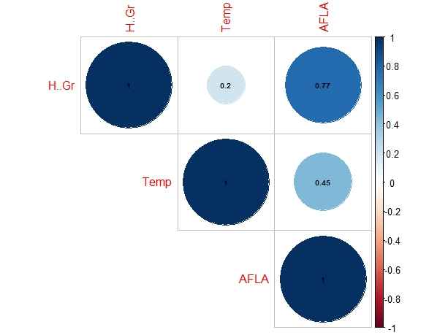
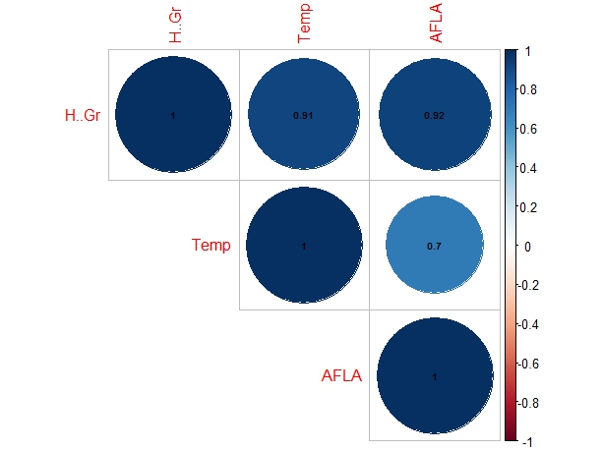
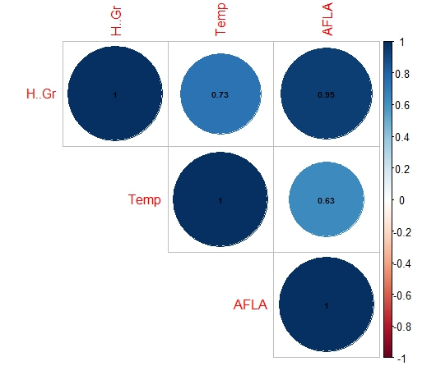
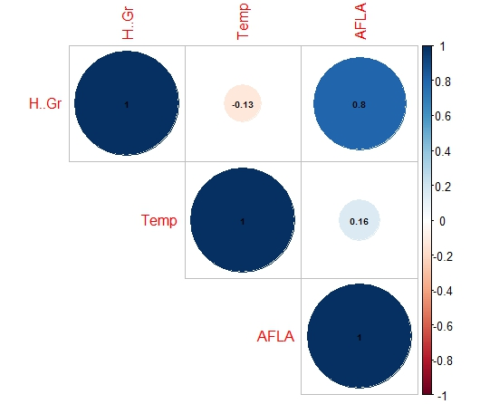
Maize
Rice
Peanut
Soybeans

Fig. 2 : Correlation between mositure content, temperature and total aflatoxin content of grain.
3.4 Principal component analysis between studied parameters
Principal component analysis (PCA) of relative humidity, temperature and total aflatoxin content as a function of AEZ indicates a good representation of the variables and a good rate of information restitution on axes 1 and 2, with restitution rates of 99.8% for rice, 94% for maize, 96.6% for Peanut and 94.8% for soybeans. Axis 1 of the PCA contributes 89.9% for rice, 66.3% for maize, 84.9% for Peanut and 59.9% for soybeans to the variations in the system studied, and is represented by total aflatoxin content and relative grain moisture. As a result, the latter measures the direct link between the two variables in relation to grain storage temperature for each commodity. Moreover, these results show that in some AEZs, these variables are more represented than in others. Axis 2 of the PCA contributes 9.9% for rice, 27.7% for maize, 13.7% for groundnuts and 34.9% for soybeans to the variations in the system studied, and is represented by total aflatoxin content and grain storage temperature. This shows the level of direct linkage between the two variables in relation to grain relative humidity for each commodity. (Fig. 3.)
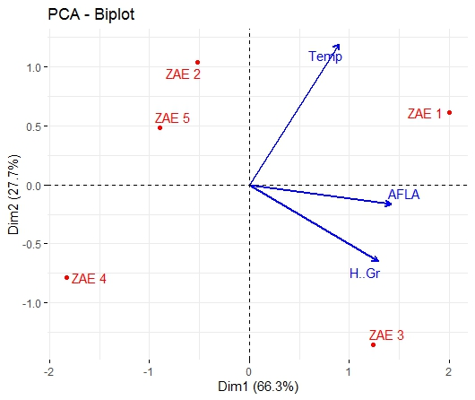
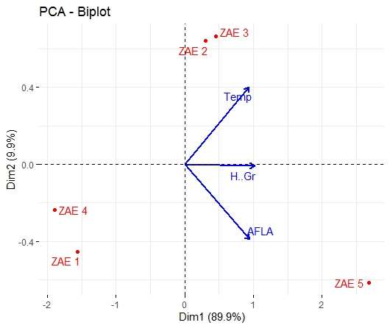
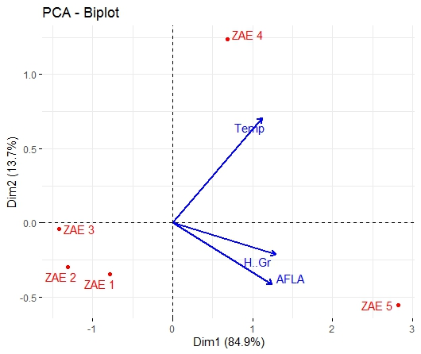
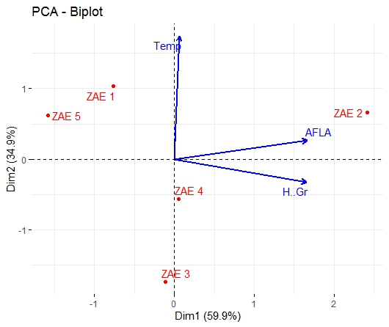
Maize
Rice
Peanut
Soybeanss

Fig. 3. Principal component analysis between total aflatoxin levels, mositure content, storage temperature and ZAEs (ZAE= agroécological zone)
3.5 Grain contamination rates by Aspergillus spp.
The rate of moulds contamination of foodstuffs has generally been estimated at 98.75%. more specifically, this contamination rate is 100% for Maize, rice ans peanuts. Soybean, on the other hand, recorded a contamination rate of 95% (Table III).
Table III. Moulds contamination of grains
Commodities | Number of samples | Number of contaminated samples | Contamination rate (%)
Maize | 25 | 25 | 100
Soybean | 25 | 24 | 96
Rice | 25 | 25 | 100
Peanuts | 25 | 25 | 100
Total | 100 | 99 | 99

3.6 Prevalences of Aspergillus spp. isolates on foodstuffs from different agro-ecological zones (AEZ)
A total of 745 mold isolates was derrived from the collected samples. The microscopic and macroscopic characteristics of the isolates enabled them to be grouped into 21 genera, namely: Aspergillus, Metharizium, Fusarium, Rhizopus, Penicillium, Trichoderma, Alternaria, Apophysomyces, Botrytis, Basidiobolus, Paecilomyces, Conidiobolus, Bipolaris, Mucor, Cunningamella, Curvularia, Epicoccum, Gliocladium, Lichteimia, Pithomyces and Syncephalastrum. The genus Apergillus was predominant, with a prevalence of 44.83%. Of the Aspergillus isolates obtained, 21.85% were from peanut, 27.84% from rice, 21.56% from maize and 28.74% from soybean. The number of Aspergillus also varied not only between grain types within an AEZ, but also between AEZ within grain types. But in general, the frequency of appearance of Aspergillus has been higher in the AEZ III, while it was lowest in the AEZ IV (Table IV).

Table IV. Distribution of 745 mold isolates by agro-ecological zone
agro-ecological zone | Foods commodities | Number of mold isolates | Number of isolates of Aspergillus spp. | Frequency of appearance
Zone I | Peanut | 14 | 04 | 2.41 %
Zone I | Soybeans | 31 | 10 | 32.25%
Zone I | Rice | 35 | 18 | 10.84 %
Zone I | Maize | 19 | 8 | 42.11 %
Zone I | Total | 99 | 40 | 40.4 %
Zone II | Peanut | 42 | 19 | 11.44 %
Zone II | Soybeans | 27 | 18 | 66.66%
Zone II | Rice | 13 | 03 | 1.81 %
Zone II | Maize | 33 | 15 | 45.45 %
Zone II | Total | 115 | 55 | 47.82%
Zone III | Peanut | 49 | 24 | 14.46 %
Zone III | Soybeans | 32 | 20 | 75%
Zone III | Rice | 70 | 26 | 15.66 %
Zone III | Maize | 36 | 24 | 66.66%
Zone III | Total | 187 | 94 | 50.26%
Zone IV | Peanut | 22 | 06 | 3.61 %
Zone IV | Soybeans | 20 | 8 | 40 %
Zone IV | Rice | 30 | 13 | 7.83 %
Zone IV | Maize | 33 | 12 | 36.36%
Zone IV | Total | 105 | 39 | 37.14%
Zone V | Peanut | 38 | 20 | 52.63 %
Zone V | Soybeans | 75 | 40 | 53.33%
Zone V | Rice | 76 | 33 | 43.42 %
Zone V | Maize | 50 | 13 | 26 %
Zone V | Total | 239 | 106 | 44.35%
TOTAL |  | 745 | 334 | 44.83%

3.7 Prevalence of average numbers of Aspergillus spp. isolates by agro-ecological zone
Analysis of the prevalence of Aspergillus spp. by AEZ revealed a significant difference (p-value =3.719e-07) between AEZ V and all other AEZs except AEZ III. AEZ V is the most attacked (5.4), followed by AEZ III (4.7). AEZ IV recorded the lowest prevalence (1.95). (Fig.4).
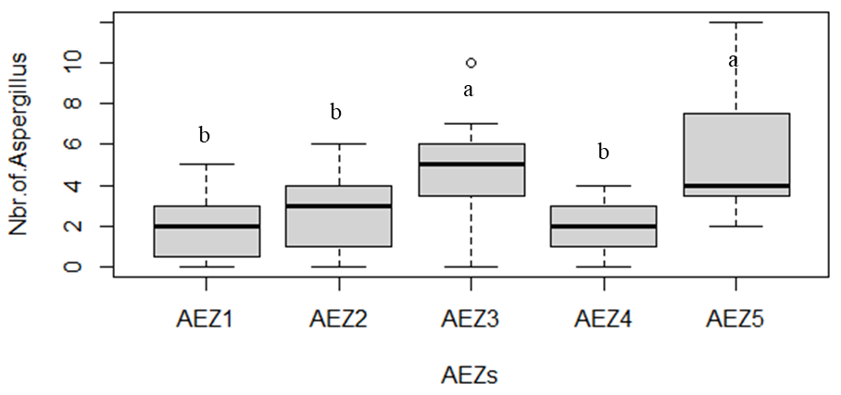
Fig. 4. Prevalence and average number of Aspergillus spp. isolates by agro-ecological zone (AEZ)
3.8 Prevalence of average numbers of Aspergillus spp. isolates by foodstuff and agro-ecological zone (AEZ)
All foodstuffs collected in the five AEZs were attacked by molds. However, the prevalence of the average number of Aspergillus spp. isolates showed a significant difference between foodstuff and AEZ. The highest number of Aspergillus spp. isolates (8.00) was recorded on soybeans from AEZ V. In maize, the number of Aspergillus spp. isolates is highest in AEZ III (4.8) and lowest in AEZ II (1.6). In rice, the number was higher in AEZ V (7) than in AEZ II (0.6). The number of Aspergillus spp. isolates in peanuts was 4.8 in AEZ III and 4 in AEZ V. Overall, Aspergillus spp. prevalence in Cameroonwas highest and approximately similar in soybean (3.85) rice (3.84) and groundnut (3.72) (Table V).
Table V. Prevalence of the average number of Aspergillus spp. isolates in foodstuff by agro-ecological zone (AEZ)
Number of Aspergillus in 10 grains
Foodstuff | AEZ1 | AEZ2 | AEZ3 | AEZ4 | AEZ5 | P-value
Maïs | 2.13 ±1.50^{b,B} | 3.33 ±1.8^{b,A} | 5.13 ±1.30^{a,A} | 2.73 ±1.48^{b,A} | 2.93 ±0.96^{b,B} | 0.0001
Soja | 2.27 ±1.58^{b,B} | 3.87 ±1.06^{b,A} | 4.33 ±3.56^{b,A} | 2.07 ±1.03^{b,AB} | 8.33 ±3.5^{a,A} | 9.222e-07
Riz | 3.93 ±1.16^{c,A} | 0.93 ±0.70^{d,B} | 5.53 ±1.60^{b,A} | 2.93 ±0.70^{c,A} | 7.33 ±1.05^{a,A} | 2.486e-12
Arachides | 1.13 ±0.92^{b,B} | 4.13 ±1.85^{a,A} | 5.13 ±0.92^{a,A} | 1.60 ±0.74^{b,B} | 4.33 ±0.82^{a,B} | 4.525e-10
P-value | 6.016e-05 | 2.757e-06 | 0.18 | 0.0008 | 2.222e-08
AEZ= Agro-Ecological Zone. Numbers in the same row followed by the same lower-case letter are not significantly different at the 5% level. The same applies to numbers in the same colunn followerd by the same capital letter
3.9 Characterization of Aspergillus Spp. biodiversity in the five agro-ecological zones of Cameroon.
Macroscopic and microscopic characterization of Aspergillus from different specific media revealed the presence of 18 morphotypes which were grouped into 7 sections, including section Flavi ; section Nigri ; section Fumigati; section Circumdati ; section Candidi ; section Nidulent and section Terrei.
3.9.1 Flavi Section
They are characterized by yellow-green to brown conidial heads and sclerotia. On CYA, colonies are granular, flat, light yellow-green. Heads are biseriate, with occasional phialides on the vesicle. Conidiophores are hyaline and rough. Conidia are globose to subglobose (Table VI). This section regroup amoung Aspergillus species found : A. parasiticus B, A. flavus, A. parasiticus A, A. nomius, A. oryzae, A tamarri (Fig. 5, 6, 7, 8, 9, 10).
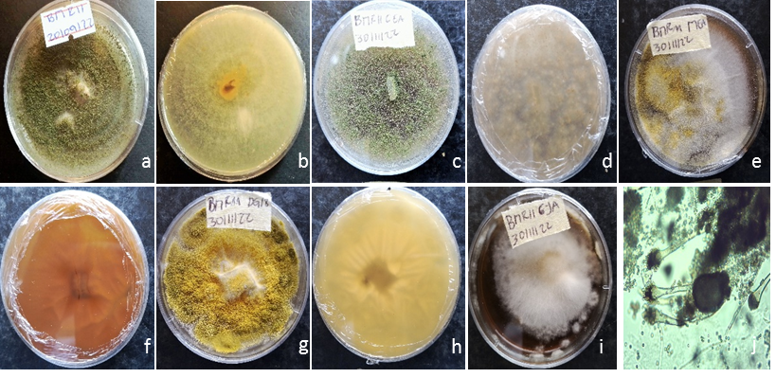

Fig. 5. Isolate BMR11, on PDA (a & b), on CEA (c & d), on MEA (e & f), on DG18 (g & h), on CYA (i) ; microscopy (j) Aspergillus parasiticus B

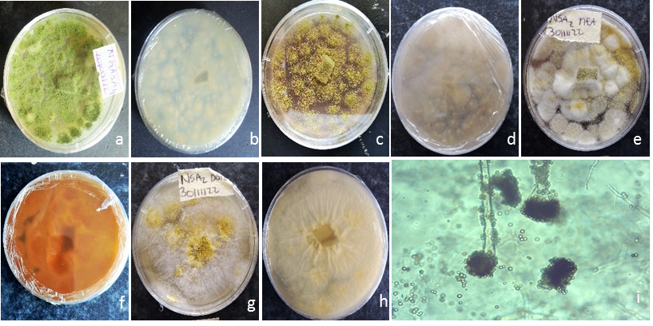

Fig. 6. Isolate NSA2, on PDA (a & b), on CEA (c & d), on MEA (e & f), on DG18 (g & h) ; microscopy (i) Aspergillus flavus

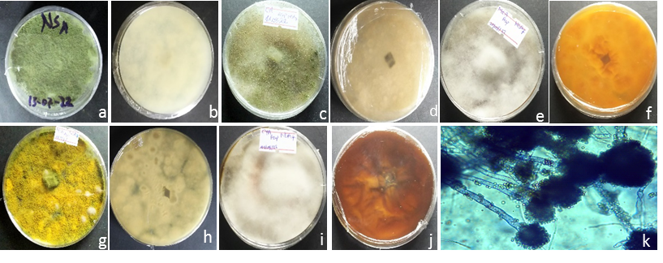
Fig. 7. Isolate NSA7, on PDA (a & b), on CEA (c & d), on MEA (e & f), on DG18 (g & h), on CYA (i & j) ; microscopy (k) Aspergillus parasiticus A

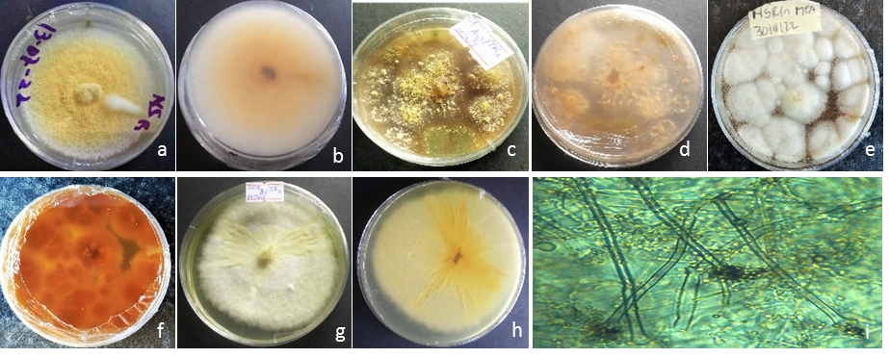
Fig. 8. Isolate NSR1, on PDA (a & b), on CEA (c & d), on DG8 (e & f), on MEA (g & h) ; microscopy (i) Aspergillus Aspergillus nomius

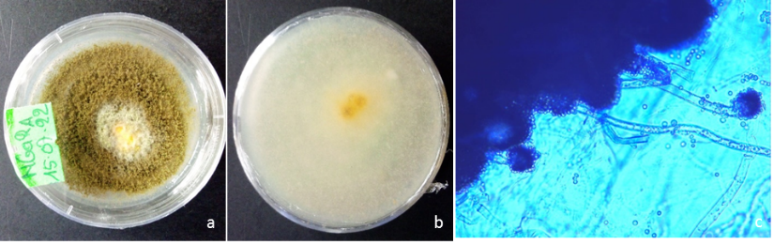

Fig. 9. Isolate NGA2A5, on PDA (a & b) ; microscopy (c) A. oryzae

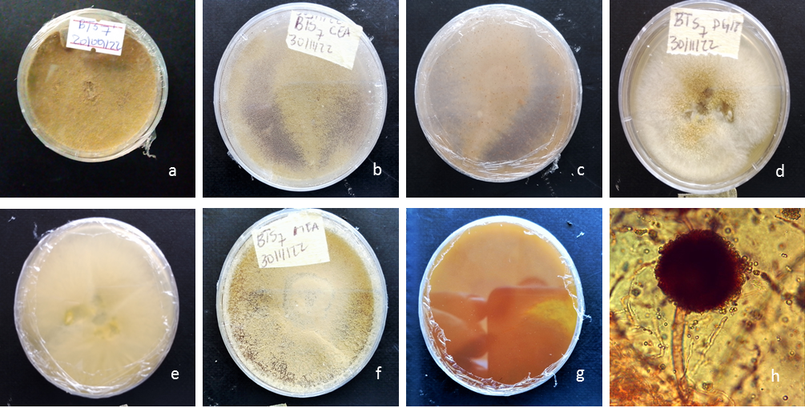

Fig. 10. Isolate BTS7, on PDA (a), on CEA (b & c), on DG18 (d & e), on MEA (f & g) ; microscopy (h) A. tamari

3.9.2 Nigri section
Nigri section of Aspergillus are characterized by black or almost black, biserial conidial heads 3mm in diameter and 15 to 20µm long. The vesicles are spherical to pyriform and the stipes smooth and hyaline. On CYA, colonies are smooth, flat, dark brown to black. Heads are biseriate with some phialides on the metules. Conidiophores are hyaline and rough. Conidia were globose to subglobose (Table VI). Figs. 11, 12, 13, 14 and 15 represente Aspergillus found in this study and belonged to Nigri section
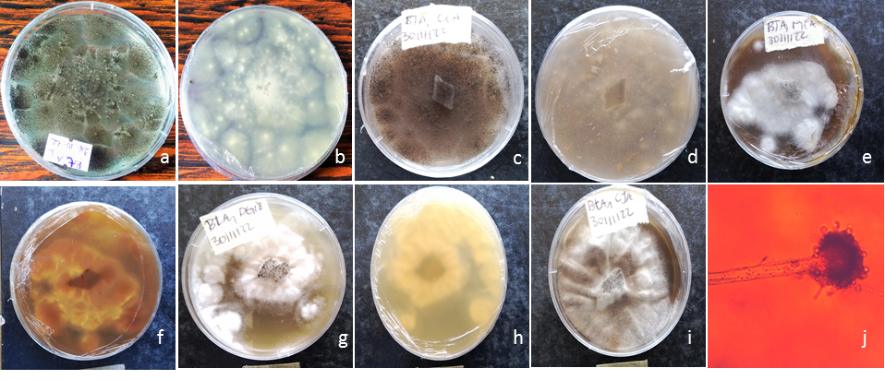
Fig. 11. Isolate BTA1, on PDA (a & b), on CEA (c & d), on MEA (e & f), on DG18 (g & h), on CYA (i) ; microscopy (j) Aspergillus niger

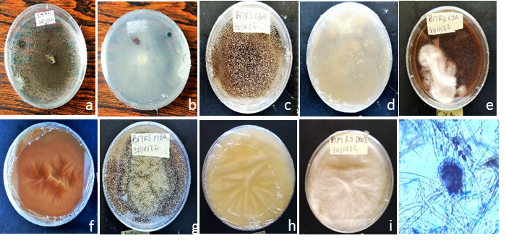

Fig. 12. Isolate BMR5, on PDA (a & b), on CEA (c & d), on CYA (e & f), on MEA (g & h), (i) ; on DG18 microscopy (j) A. aculeatus A

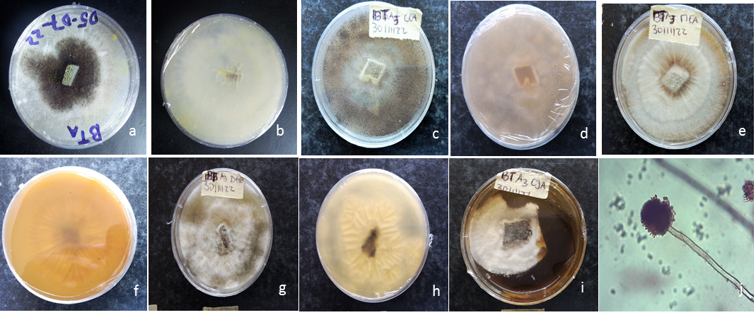

Fig. 13. Isolate BTA3, on PDA (a&b), on CEA (c&d), on MEA (e & f), on DG18 (g & h), on CYA (i) ; microscopy (j) A. carbonarius

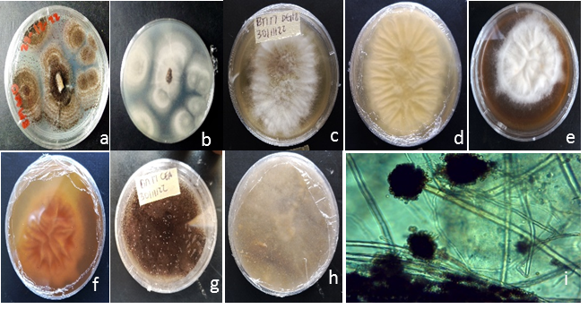

Fig. 14. Isolate NGAA2, on PDA (a & b ) on DG18 (c& d), on CYA (e & f), on CEA (g & h); microscopy (i) A. japonicus

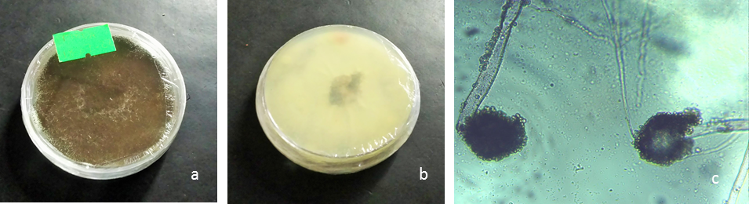
Fig. 15. Isolate MBE A5, sur PDA (a & b) ; microscopy (c) A. aculeatus B

3.9.3 Fumigati section
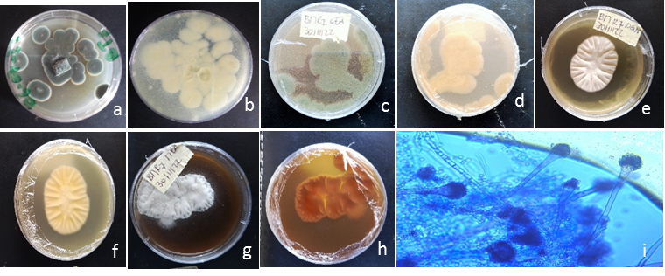
Aspergillus of the Fumigati section are characterized by blue-green, uniseriate conidial heads. The vesicles are conical with a row of phialides. Stipes are short, smooth and hyaline. On CYA, colonies are blue-green with dense, smooth, hyaline conidiophores. Heads are uniseriate. Conidiophores are hyaline and rough. Conidia are globose to subglobose and rough (Table VI). Aspergillus of Fumigati section found in this study are represented in Figs. 16, 17 and 18.

Fig. 16. Isolate BMR7 on PDA (a & b) ; on CEA (c& d) ; on DG18 (e& f) ; on MEA ( g& h) ; microscopy ( i) A. fumigatus

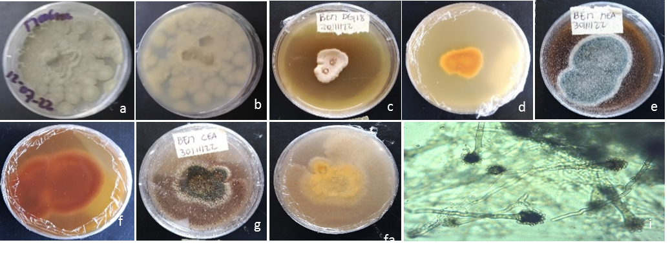

Fig. 17. Isolate BEMA3 on PDA (a & b) ; on DG18 (c & d) ; on MEA (e & f) ; on CEA (g & h) ; microscopy ( i) A novofumigatus

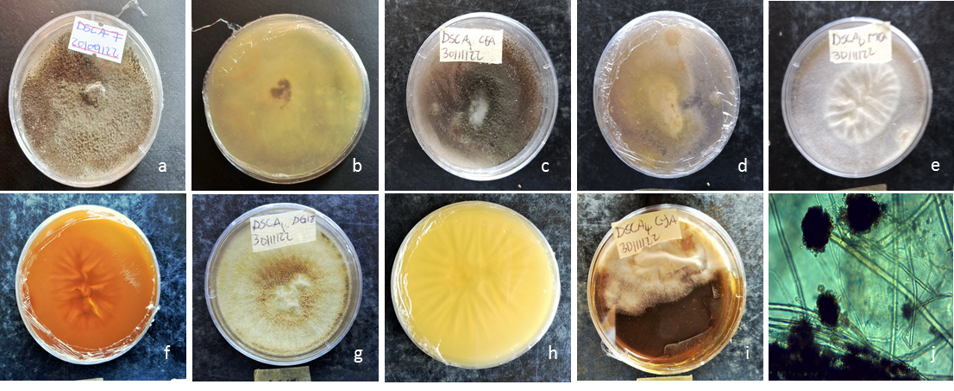

Fig. 18. Isolate DSGA7, on PDA (a & b), on CEA (c & d), on MEA (e & f), on DG18 (g&h), on CYA (i) ; microscopy (j) A. duricaulis

3.9.4 Terrei section
The Terrei section of Aspergillus are characterized by biseriate conidial heads of buff to brown color. The metules are as long as the phialides. Stipes are short, smooth and hyaline. On CYA, colonies are buff to sandy-brown with smooth, hyaline conidiophores. Heads are biseriate and compact. Conidiophores are hyaline and smooth. Conidia are globose to ellipsoidal (Table VI). Our result showed one species with the characteristic of Terrei section (Fig. 19).
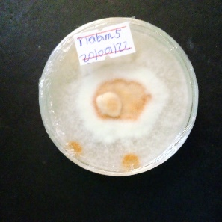
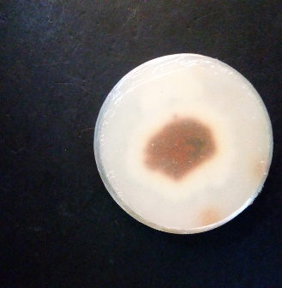
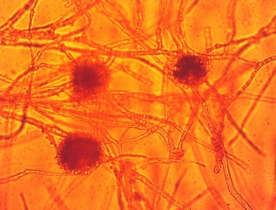
a
b
c
Fig. 19. Isolate MBAR5, on PDA (a & b) ; microscopy (c) A terreus

3.9.5 Candidi section
this section is characterized by white, biserial or uniserial conidial heads. Vesicles are subglobose to globose and may be covered with phialides. Colonies were white with colorless mycelia and straw-colored undersides. Conidiophores are smooth and hyaline. Heads are biseriate or uniseriate. Conidiophores are hyaline and smooth. Conidia are globose, between 2 and 3 µm in diameter (Table VI). Our result showed one species with the characteristic of Candidi section (Fig. 20).
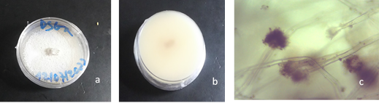
Fig. 20. Isolate DSGR2 , on PDA (a & b) ; microscopy (c) A candidus

3.9.6 Nidulant section
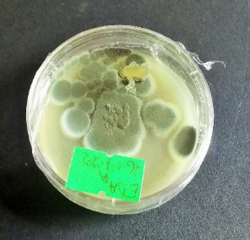
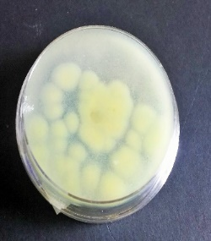
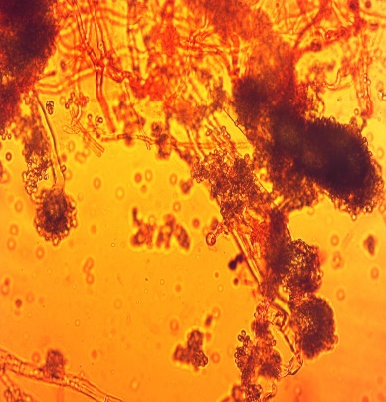
The Nidulante section is Aspergillus are characterized by green colonies with white and brown margins on the reverse. Biseriate conidial heads. Metules are shorter than phialides. Conidiophore stipes are short, smooth and hyaline. On PDA, colonies are dark green with white outlines. Conidiophores are smooth and hyaline. Heads are biserial. Conidia are spherical and smooth, ranging from 3 to 4µm in diameter (Table VI). Fig. 21 is A Nidulans belonging to Nidulant section and isolated in this study
b
a
c

Fig. 21. Isolate EDAR12, on PDA (a & b) ; microscopy (c) A Nidulans

3.9.7 Circumdati section
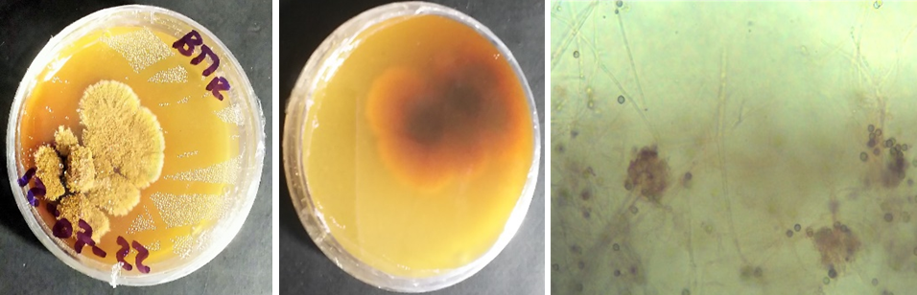
Aspergillus of Circumdati section are characterized by young to ochraceus-colored, biseriate conidial heads. The vesicles are globose and completely covered by phialides. Stipes are long, rough and hyaline. On PDA, the colony is orange or cinnamon, 40-50 mm in diameter, with an orange-yellow underside. Conidiophores are rough and hyaline. Heads are biseriate and compact. Conidial heads are very large (60 to 80 µm), globose (Table VI). Aspergillus ochraceus found during our isolation is one of the Circumdati section (Fig. 22).
c
b
a

Fig. 22. Isolate BMR6, on PDA (a & b) ; microscopy (c) A. ochraceus

Table VI Macrosciopic and microscopic characteristic of main Aspegillus isolated
Species | Colony size on PDA (mm) | Colony Texture | Conidiophore | Head type | Vesicle shape | Vesicle diameter (µm) | Conidiophore length (µm) | Color / Texture/ Shape | Conidial size (µm)
Section Flavi
A. parasiticus A | 25 - 40 | Smooth | Unpa H | uni et bi | P/G | 24 - 30 | 350-700 | yg/r/G | 4 - 5.8
A. parasiticus B | 30 - 60 | Rough | Unpa H | uni et bi | P/G | 19 - 35 | 350-700 | g/r/G | 3 - 7
A. tamarii | 45 - 55 | Rough | Unpa H | bi | G | 26 - 43 | 500-700 | g/G | 3 - 5
A. flavus | 50 - 55 | Rough | Unpa H | uni et bi | R | 18 - 36 | 200-650 | yg/r/G | - - 5
A. oryzae | 40-55 | Rough | Unpa H | uni et bi | G | 20-35 | 250-650 | w/yg | 3-5
A. nomius | 45-55 | Rough | Unpa H | uni | S/G | 2.-40 | 200-500 | y/w | 3,5-4,5
Section Fumigati
A. duricaulis | 40 - 60 | Smooth | Unpa H | uni | P to Clab | 10 - 26 | 270-600 | g/r/G | 2 - 3.5
A. fumigatus | 24 - 40 | Smooth | Unpa H | uni | Spathulate to Clavate | 19 - 31 | 250-650 | g/r/G | 2 - 3
A. novofumigatus (A) | 25 - 30 | Smooth | Unpa H | uni | P/R | 21 - 29 | 300-600 | g/s/G | 4 - 7
Section Nigri
A. carbonarius | 40 - 60 | Smooth | Unpa H | bi | Umbrella Shaped | 41 - 60 | 850-2400 | b/r/G | 6 - 10
A. aculeatus (A) | 37 - 49 | Smooth | Unpa H | uni | G/S | 48 - 74 | 770-2300 | b/r/G | 4 - 5
A. aculeatus (B) | 50 - 60 | Smooth | Unpa H | Uni | G | 45 - 73 | 800-2000 | b/r/G | 4 - 5
A. niger | 45 - 55 | Smooth | Unpa H | bi | S/G | 37 - 52 | 800-2500 | b/r/G | 4 - 6
A. japonicus | 45 - 50 | Smooth | Unpa H | uni | G/Elliptical | 29 - 45 | 550-750 | b/s/G | 3 - 5
Section Circumdati
A. ochraceaus | 25 - 30 | Rough | Unpa H | bi et uni | G | 26 - 55 | 200-450 | g/s/G | 2.5 - 4
Section Nodulant
A. nidulans | 45 - 55 | Smooth | Unpa H | bi | Spathulate/P | 9 - 16 | 190-350 | g/s/S | 3 - 4
Section Candidi
A. candidus | 32 - 40 | Smooth | Unpa H | uni | SG/G | 17 - 30 | 150-300 | w/s/G | 2 - 3
Section Terrei
A.terreus | 20-40 | Smooth | Unpa H | bi | G/Elliptical | 18-28 | 120-290 | w/b | 1.5-2.5
The size of the colonies is after 7 days of incubation ; Unpa H = Unpartitioned Hyphae, Seriation ; uni = Uiseriate, bi = Biseriate ; P = Pyriform, G = Globose, R = Radiate, yg = Yellow Green, g = Green b = Brown, Orange, w = White, r = Rough, s = Smooth, G = Globose, E = Elliptical, S = Spherical, S/C = Short Columnar, L/C = Long Columnar, S/G = Subglobose.

3.10 Frequency of occurrence of Aspergillus sections in Cameroon
Our results showed a variation in the frequency of the different Aspergillus sections. Globally whatever the AEZs takeng to account, different sections occurred in descending order Flavi section with the frequence of 33% > Nigri section with 27%, > Fumigati section with 16% then Candidi, Terrei, Nidulent and Circumdati sections with the frequence of 6%) for each one (Fig. 23).

Fig. 23. Frequency of occurrence of Aspergillus spp. sections, all Zones combined
4. Discussion
Determination of aflatoxin levels in rice, maize, soybean and peanut samples from the various AEZs showed that 100% of these samples were contaminated with aflatoxins, with average levels ranging from 4.86 - 14.06 µg/kg, 5.50 - 16.33 µg/kg, 5.06 - 17.26 µg/kg, and 5 - 10.6 µg/kg respectively in soybean, maize, rice and peanut. These levels are higher than those observed by Kana et al., [28] (2013) in peanut meal intended for poultry feed formulation. In other hand, our results are lower than in Rodrigues et al. [18] (2011), who reported that between February and October 2009, around 94% of maize in Nigeria and the border region of Cameroon was contaminated with aflatoxin, with an average concentration of 80.3 µg/kg. Our results also contrast with those of Kaaya and Kyamuhangire, [29] (2006) who recorded 88%, 78% and 69% of aflatoxin-contaminated maize with mean levels of 30, 22 and 12.8 µg/kg respectively in the mid-altitude wet zone, mid-altitude dry zone and highland zone of Uganda. It is irrefutably clear that total aflatoxin levels varied not only by commodity, but also by AEZ.
The results also show a variation in aflatoxin levels according to grain type. On the one hand, this could be explained by the fact that the composition of a substrate on which an aflatoxin-producing mold grows either positively or negatively influences aflatoxin biosynthesis. Liu et al, [30] (2016) have shown that fatty substrates such as peanut favor the biosynthesis of aflatoxin B1 in contrast to defatted substrates such as rice. In contrast, Liu et al, [30] (2016) showed that rice is one of the cereals in which aflatoxin levels are often the lowest. The results obtained show maize and rice samples to be the most contaminated, with no significant differences compared to soybean. These results can also be explained by the composition of rice, which is richer in sugars than peanuts. According to Achaglinkame et al., [31] (2017) ; Wang et al., [32] (2019), simple sugars such as glucose, sucrose, fructose and maltose favor aflatoxin production, unlike peptone, sorbose and lactose.
Our study also shows that aflatoxin levels in foodstuff are correlated with temperature and with the relative humidity of the grains. The results show moisture levels of 13.7% (AEZ I) to 16.96% (AEZ V) in rice ; 13.46% (AEZ IV) to 15.23% (AEZ I) in maize ; from 13.03% (AEZ V) to 14.7% (AEZ II) in soybeans and from 13.16% (AEZ III) to 14.86% (AEZ V) in peanuts, offering a range of 13.03 to 16.96% ideal for aflatoxin production. This differs from the range (11.7 to 17.7%) obtained by Kana et al., [28] (2013) in peanut meal intended for poultry feed formulation. On the other hand, these authors had shown that high relative humidity levels were the cause of high aflatoxin levels in peanut meal intended for animal feed formulation in three AEZ s in Cameroon. The high aflatoxin contamination of rice grains is also thought to be due to the long storage period before shipment to importing countries such as Cameroon, since most of the rice consumed by Cameroonians is imported.
Variations in concentrations between AEZ can be explained by the fact that aflatoxin synthesis is influenced by climatic factors such as relative air humidity and temperature. The work of Muga et al., [33] (2019) is highly evocative on this subject, as in their work on factors that can influence aflatoxin biosynthesis, they demonstrated that factors such as temperature, relative air humidity and CO₂ concentration significantly influence aflatoxin biosynthesis. It should also be noted that, in addition to the aforementioned factors which could explain these differences in concentrations between commodities and AEZ, there are also storage conditions and even the age of the grains [34] (Jaibangyang et al., 2021).
Isolations showed that out of 100 grain samples, 99% reported very high mold contamination, with a predominance of Aspergillus spp. This high percentage had also been observed in Congo and South Africa by Ilunga et al., [35] (2014) on peanuts and in Ethiopia by Assaye et al., [36] (2016) on maize. This high presence of Aspergillus spp. in grains in storage in Cameroon could be explained by the fact that the climate is conducive for mold development. Indeed, Cameroon's relatively warm and humid climate is highly conducive to mold development. Yazdi et al., [37] (2006) have shown that mould infection of grains begins in the field and continues in storage. The prevalence of Aspergillus spp. was 44%. This can be explained by the fact that the total fungal flora of stored grains in tropical countries is essentially made up of highly sporulating molds, with great power of dissemination, of which Aspergillus is one of the most frequent genera. This predominance was also reported by Nyongesa et al., (2015).
Characterization showed a predominance of isolates from section Flavi, followed by those from section Nigri, section Fumigati, section Terrei and finally section Candidi. Nyongesa et al., [38] (2015), working on the diversity of Aspergillus spp. from maize in the field and in storage in Kenya, showed a predominance of section Flavi followed by section Nigri and Penicillium. They also report that each section not only has its own degree of dissemination, but also of resistance to environmental conditions and competition. Similarly, Zahng et al., [39] (2016) put forward the argument of high capacity for dissemination and resistance to environmental conditions to explain the near ubiquity of molds of the genus Mucor in air and agricultural soils. The results obtained would find justification in this assertion, as individuals belonging to certain sections are found in almost all food samples from the various AEZs, while others appear to be specific to certain AEZs.
It's also important to note that in this study, we found abundance and diversity to differ between the AEZs and localities sampled. This could be explained by the fact that climatic factors such as temperature and humidity, which are specific to each zone or region, influence both the abundance and diversity of Asperigillus in a given area. In other words, the number and activity of fungal populations change from one region to another. Moreover, in its 2021 report, the Council for Agricultural Science and Technology [41] (CAST) points out that grain infection rates depend on the year's climatic and harvesting conditions. Furthermore, according to Ngoko et al., [2] (2001) and Lanyasunya et al., [40] (2005), storage conditions as humidity, temperature and ventilation system have a major influence on mold development during storage in Cameroon and Kenya respectively. This study also shows that, contrary to the work of Liu et al., [30] (2016), which positions rice as one of the grains least likely to be colonized by molds, maize and peanuts were the least contaminated by Aspergillus spp. As Miller [42] (1995) concluded, this high contamination of rice compared to groundnuts, soybeans and maize, would be due to the long storage time of rice in exporting countries before export to rice-importing countries. In fact, around 2/3 of the rice consumed in Cameroon is imported, mainly from Asia where shipments destined for export are generally stored in warehouses for a long period before taking the long road (months) to importing countries, following the First In First Out (FIFO) method.
5. Conclusion
Ultimately, the aim of this study was to identify Aspergillus spp. isolated from maize, soybean, rice and groundnut in storage, and examining their aflatoxin contamination in the five agro-ecological zones of Cameroon. The results show that 745 mold speciemens were isolated from 21 genera, namely : Aspergillus, Metharizium, Fusarium, Rhizopus, Penicillium, Trichoderma, Alternaria, Apophysomyces, Botrytis, Basidiobolus, Paecilomyces, Conidiobolus, Bipolaris, Mucor, Cunningamella, Curvularia, Epicoccum, Gliocladium, Lichteimia, Pithomyces and Syncephalastrum. The prevalence of the Apergillus genus was 44.83%, with 21.85% from peanuts, 27.84% from rice, 21.56% from corn and 28.74% from soybeans. Among Aspergillus spp. the Flavi section represented 33%, the Nigri section 27%, the Fumigati section 16% and the Nidulant (6%), Candidi (6%), Terrei (6%) and Circumdati (6%) sections were the least represented. The aflatoxin assay showed a contamination rate of 100%. However, AEZ V (9.63 µg/kg) recorded the highest average content, and zone IV (5.94 µg/kg) the lowest. Among foodstuffs, aflatoxin levels were highest in corn samples (9.46 µg/kg), followed by rice (8.92 µg/kg). On the other hand, aflatoxin levels were lower in peanut samples at 6.55 µg/kg. In addition, all the levels in the 04 foodstuffs were above the threshold levels stipulated in current regulations.

References
[1] Cruz J. F., hounhouigan D.J., Havard M., Ferré T., 2019. La transformation des grains.
Collection Agriculture tropicale en poche, Quae, Presses agronomiques de Gembloux,
Wageningen. 182 p + cahier quadri 16 p.
[2] Ngoko, Z.; Marasas, W.F.O.; Rheeder, J.P.; Shephard, G.S.; Wingfield, M.J.; Carwell, K.F.
Fungal infection and mycotoxin contamination of maize in the Humid Forest and Western Highlands of Cameroon. Phytoparasit 2001, 29 (4), 1–9.
[3] Ainsworth, G.C. (1976) Introduction to the History of Mycology. Cambridge University Press, Cambridge. Alberts, A.W. (1998) Discovery, Biochemistry and Biology of Lovastatin. American Journal of Cardiology, 62, 10J-15J
[4] Klich, M. A. (2007). Aspergillus flavus : The major producer of aflatoxin. Mol. Plant Pathol., 8 : 713–722.
[5] McClenny, N. (2005) Laboratory Detection and Identification of Aspergillus Species by Microscopic Observation and Culture: The Traditional Approach. Journal of Medical Mycology, 43, S125-S128.
[6] Hong, S.-Y., Roze, L. V., Wee, J. & Linz, J.E. (2013) Evidence that a transcription factor regulatory network coordinates oxidative stress response and secondary metabolism in aspergilli. MicrobiologyOpen, 2, 144–60.
[7] El Khoury, A., Atoui, A., Rizk, T., Lteif, R., Kallassy, M. & Lebrihi, A. (2011) Differentiation between Aspergillus flavus and Aspergillus parasiticus from pure culture and aflatoxin-contaminated grapes using PCR-RFLP analysis of aflR-aflJ intergenic spacer. Journal of food science, 76, 247–253.
[8] Samson, R.A., Visagie, C.M., Houbraken, J., Hong, S.-B., Hubka, V., Klaassen, C.H.W., Perrone, G., Seifert, K.A., Susca, A., Tanney, J.B., Varga, J., Kocsubé, S., Szigeti, G., Yaguchi, T. & Frisvad, J.C. (2014) Phylogeny, identification and nomenclature of the genus Aspergillus. Studies in Mycology, 78, 141–73.
[9] Klich, M.A. (2002) Identification of Common Aspergillus Species. Centraal bureau voor Schim, Utrecht.
[10] Samson, R.A., Hoekstra, E.S. and Frisvad, J.C. (2004a). Introduction to Food and Airborne Fungi. 7th Edition, Centraalbureau voor Schimmelcultures, Utrecht.
[11] Bryden, W.L. Mycotoxin contamination of the feed supply chain: Implication for animal
productivity and feed security. Anim. Feed Sci. Technol. 2012, 173, 134–158.
[12] Oguz, H. Detoxification of aflatoxin in poultry feed: a review from experimental trials. Lohmann Inf. 2012, 47 (2), 45–56.
[13] Bryden, W.L. Mycotoxins in the food chain: human health implications. Asia Pacif. J. Clin. Nutr. 2007, 16 (Suppl. 1), 95–101.
[14] Shuaib faisal, M.B.; Ehiri, J.; Abdullahi, A.; Williams, J.H.; Jolly, P.E. Reproductive health
effects of aflatoxins: A review of the literature. Reproduct. Toxicol. 2010, 29, 262–270.
[15] Khlangwiset, P.; Shephard, G.S.; Wu, F. Aflatoxins and growth impairment: A review. Crit. Rev. Toxicol. 2011, 41 (9), 740–755.
[16] Sumit, R.; Kim, J.E.; Coulombe, R., Jr. Aflatoxin B1 in poultry: Toxicology, metabolism and prevention. Res. Vet. Sci. 2010, 89, 325–331.
[17] Otim, M.O.; Mukiibi-Muka, G.; Christensen, H.; Bisgaard, M. Aflatoxicosis, infectious bursal disease and immune response to Newcastle disease vaccination in rural chickens. Avian Pathol. 2005, 34 (4), 319–323.
[18] Rodrigues, I.; Handl, J.; Binder, E.M. Mycotoxin occurrence in commodities, feeds and feed ingredients sourced in Middle East and Africa. Food Addit. Contam. B Surveill. 2011, 4, 168–179.
[19] Ngoko, Z.; Daoudou; Imele, H.; Kamga, P.T.; Mendi, S.; Mwangi, M.; Bandyopadhyay, R.; Marasas, W.F.O. Fungi and mycotoxin associated with food commodities in Cameroon. J. Appl. Biosci. 2008, 6, 164–168.
[20] SAILD. 2021. l’agroécologie au service de la diversité alimentaire: Cas d’école en zones sahélienne et forestière du Cameroun. Available at: http://www.saild.org/wp content/uploads/2021/10/ Lagroecologie-au-service-de-la-diversite-alimentaire.pdf.
[21] ISTA. International Rules for Seed Testing [Règles internationales pour les essais de semences]. 2005. Edition 2005. Association internationale d'essais de semences, Bassersdorf, Switzerland.
[22] Nguyen, P-A., Strub, C., Fontana, A., & Schorr-Galindo, S. Crop molds and
mycotoxins : alternative management using biocontrol. Biological control, 2016, doi :
http://dx.doi.org/10.1016/j.biocontrol.
[23] Samson, R.A., Identification of food –borne Penicillium, Aspergillus and Fusarium species. 1991. In ACIAR proceedings No 36, Bangkok, Thailand, 23-26 April pp. 39-45.
[24] Mathew S., Thomas G and Tufail A., 2011. An Evaluation of the fungi isolated from sub-epidermal region of post-harvested stored wheat grains. Nepal.J.Biotechnol., Microbiol. p :131–138.
[25] Guiraud, J.P., Microbiologie alimentaire. Technique et ingénierie. Série Agroalimentaire. 1998. Dunod. Paris : 652 p.
[26] Samson R.A., Houbraken J.A.M.P., Kuijpers A.F.A., Frank J.M., Frisvad J.C., New ochratoxin A or sclerotium producing species in Aspergillus section Nigri. 2004b. Studies in Mycology, 50 : 45-61.
[27] Samson R.A., Noonim P., Meijer M., Houbraken Frisvad J.C., Varga, J., 2007. Diagnostic tools to identify black aspergillii. Studies in mycology, 59 : 129-145.
[28] Kana, J. R., Gnonlonfin, B. G. J., Harvey, J., Wainaina, J., Wanjuki, I., Skilton, R. A., et al. (2013). Assessment of aflatoxin contamination of maize, peanut meal and poultry feed mixtures from different agroecological zones in Cameroon. Toxins, 5(5) : 884–894.
[29] Kaaya, A.N.; Kyamuhangire, W. The effect of storage time and agroecological zone on mould incidence and aflatoxin contamination of maize from traders in Uganda. Int. J. Food Microbiol. 2006, 110, 217–223.
[30] Liu, J., Sun, L., Zhang, N., Zhang, J., Guo, J., Li, C., et al. (2016). Effects of nutrients in substrates of different grains on aflatoxin B1 production by Aspergillus flavus. BioMed
Research International. doi.org/10.1155/2016/7232858.
[31] Achaglinkame M.A., Opoku N., & Amagloh F.K., 2017. Aflatoxin contamination in cereals and legumes to reconsider usage as complementary food ingredients for Ghanaian infants. rev. Jou. of Nutri. & Intermedi Metab., 10 : 1-7.
[32] Wang, P., Chang, P. K., Kong, Q., Shan, S., & Wei, Q. (2019). Comparison of aflatoxin production of Aspergillus flavus at different temperatures and media : Proteome analysis based on TMT. International Journal of Food Microbiology., 34 : 108-313. https://doi.org/10.1016/j.ijfoodmi- cro.2019.108313
[33] Muga, F. C., Marenya, M. O., & Workneh, T. S. (2019). Effect of temperature, relative humidity and moisture on aflatoxin contamination of stored maize kernels. Bulgarian Journal of Agricultural Science, 25 : 271–277.
[34] Jaibangyang, S., Nasanit, R., & Limtong, S. (2021). Effects of temperature and relative
humidity on Aflatoxin B1 reduction in corn grains and antagonistic activities against Aflatoxin producing Aspergillus flavus by a volatile organic compound-producing yeast,
Kwoniellaheveanensis DMKU-CE82. BioControl, 1-11.
[35] Ilunga Kamika, Pamella Mngqawa, John P. Rheeder, Snow L. Teffo & David R. Katerere , Food Additives & Contaminants: Part B (2014): Mycological and aflatoxin contamination of peanuts sold at markets in Kinshasa, Democratic Republic of Congo, and Pretoria, South Africa, Food Additives & Contaminants: Part B: Surveillance, DOI: 10.1080/19393210.2013.858187
[36] Assaye MA, Gemeda N, Weledesemayat GT (2016) Aspergillus species and Aflatoxin Contamination of Pre and Post-Harvest Maize Grain in West
Gojam, Ethiopia. J Food Sci Nutr 2: 013
[37] Yazdi, M. T., Zarrini, G., Mohit, E., Faramarzi, M.A., Setayesh, N., Sedighi, N., et al. (2006). Mucor hiemalis : A new source for uricase production. World J. Microbiol. Biotechnol., 22 : 325–330.
[38] Nyongesa, B. W., Okoth, S., & Ayugi, V. (2015). Clé d'identification des espèces de Aspergillus Isolées du maïs et du sol de Nandi Comté, École des sciences biologiques, Université de Nairobi, Kenya. Advances in Microbiology, 5 : 205-229.
[39] Zhang, B.J. (2016). Occurrence regularity and prevention-control measures of Mucor on
production of Lentinusedodes. North. Hortic., 19 : 208–209.
[40] Lanyasunya, T.P.; Wamae, L.W.; Musa, H.H.; Olowofeso, O.; Lokwaleput, I.K. The risk of mycotoxins contamination of dairy feed and milk on smallholder dairy farms in Kenya. Pakist. J. Nutri. 2005, 4 (3), 162–169.
[41] CAST. (2021). Mycotoxins : Risks in Plant, Animal and Human Systems ; Report No. 139 ; Council for Agricultural Science and Technology : Ames, IA, USA, 2003. Available online : https://www.cast-science.org/publication/mycotoxins-risks-in-plant-animal-and-human systems/ (accessed on 12 December 2021).
[42] Miller, J. D. (1995). Mycotoxins. In International Institute of Tropical Agriculture, Mycotoxins in Food in Africa Workshop, 6–10 November 1995, Benin. Available at:
http://www.fao.org/inaction/ inpho/library/detail/en/c/361/.

