EPIDEMIOLOGICAL INSIGHTS OF CANINE PYOMETRA IN JABALPUR

Abstract
The present study investigated the incidence, epidemiological patterns and clinical characteristics of canine pyometra in Jabalpur, focusing on breed, age and seasonal predispositions as well as diagnostic features associated with disease severity. Female dogs presenting to the Veterinary Clinical Complex, Jabalpur and selected clinics with clinical signs suggestive of pyometra were evaluated through physical examination and transabdominal ultrasonography. The overall incidence of pyometra was 9.15 percent among small animal gynaecological cases, confirming its significance as a major reproductive disorder. Middle-aged to older bitches, particularly those aged 7–9 years, were most susceptible and Labradors, Pomeranians and Beagles constituted the most affected breeds. Closed-cervix pyometra accounted for the majority of cases and more than half the animals presented with severe disease, indicating delayed clinical recognition. A seasonal rise in cases during February, October and March corresponded with the post-oestrus period, supporting the influence of progesterone dominance in predisposing the uterus to infection. The findings highlight the need for early screening, improved owner awareness and timely therapeutic intervention to reduce pyometra-related complications.
Keywords: Pyometra, Incidence, Transabdominal ultrasonography

INTRODUCTION
Pyometra is a life-threatening reproductive disorder of female dogs, characterised by uterine infection and systemic illness resulting from hormonal imbalance and secondary bacterial invasion. It commonly affects middle-aged to older female dogs following repeated oestrous cycles, during which prolonged progesterone exposure that induces cystic endometrial hyperplasia and reduces the uterine defence mechanisms which form conducive environment for the bacterial invasion leading to pyometra. It is characterised by pus discharge, vomiting, inappetence, polydipsia and distended abdomen. Although early detection is important, still many cases are presented late because the clinical signs are non-specific, resulting in advanced disease and a higher risk of complications. So, understanding the incidence, epidemiological factors and clinical presentation of pyometra within a regional canine population is essential for improving diagnostic efficiency and therapeutic decision-making. In this context, the present study was undertaken to determine the incidence pattern of pyometra in Jabalpur, to assess the breed, age and season-related predispositions and also the clinical, ultrasonographic and pathological features associated with varying disease severity.
MATERIALS
This study was carried out on female dogs presented to the Veterinary Clinical Complex (VCC), Jabalpur and selected private clinics with clinical signs suggestive of pyometra, including purulent or mucopurulent vaginal discharge, abdominal distension, polydipsia, vomiting and inappetence (Plate 01). Preliminary diagnosis was made through physical and gynaeco-clinical examination and was confirmed by transabdominal ultrasonography (Plate 02 & 03). Following confirmation, the incidence of pyometra was analysed in relation to total clinical cases and gynaeco-clinical cases at the VCC using standard prevalence formulas. Each case was further evaluated age-wise and month-wise to identify susceptible age groups and seasonal trends. Based on clinical findings and ultrasonography, cases were classified as open- or closed-cervix pyometra and the severity of pyometra was graded as mild, moderate and severe based on clinical signs as well as ultrasonographic uterine changes. Mild cases showed no cysts and minimal anechoic content, moderate cases presented few small cysts with mild hyperplasia and moderate fluid accumulation while severe cases exhibited multiple or large cysts, pus pockets, irregular uterine walls and marked endometrial hypertrophy with hyperechoic contents.
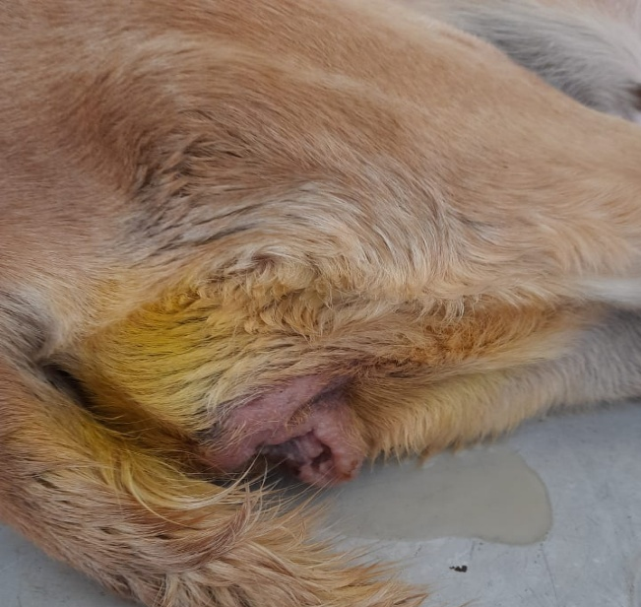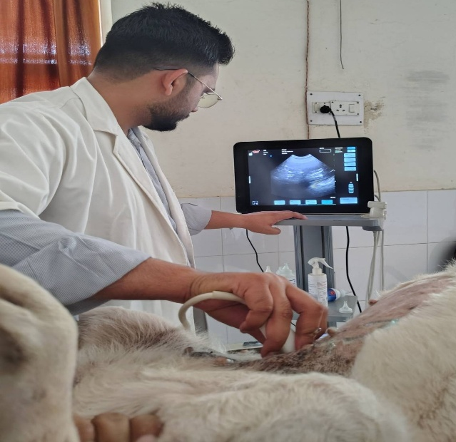
Plate 01: Pus Discharge from vagina in female dog
Plate 02: Trans-abdominal ultrasonography of dog suffering from pyometra

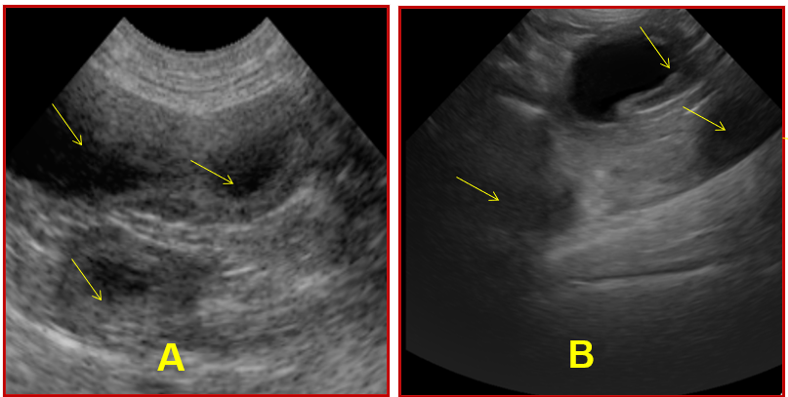
Plate 03 (A & B): Multiple anechoic sac (Arrow) in uterus in female dog suffering from pyometra

RESULT
The present study on canine pyometra conducted at the VCC, Jabalpur, revealed a variable incidence pattern among clinical cases, indicating the widespread occurrence of the disease in reproductively active female dogs. Trans-abdominal ultrasonography provided valuable diagnostic insights, revealing uterine enlargement, luminal fluid accumulation and echo textural changes characteristic of pyometra.
Incidence of canine pyometra
The incidence of canine pyometra was studied from August 2024 to July 2025 among the total cases presented to the Veterinary Clinical Complex (VCC), Jabalpur. The analysis included the incidence of canine pyometra among total clinical cases as well as within gynaecological cases to determine its relative clinical burden. Further, breed-wise incidence was also evaluated to identify commonly affected breeds in the region. The type of pyometra, whether open or closed cervix, was recorded among all confirmed cases. Month-wise distribution was assessed to observe seasonal trends, while age-wise incidence in female dogs was analysed to determine the most affected age groups. Additionally, cases were categorised as mild, moderate and severe pyometra based on clinical severity and transabdominal ultrasonography findings to understand the pattern of disease presentation. The results of these observations are discussed below.
Incidence of canine pyometra among total small animal gynaecological cases
During the study period, a total of 14,173 clinical cases were presented, out of which 103 cases of pyometra were diagnosed, yielding an overall incidence of 0.73% among all hospital cases. When the data were confined to gynaecological cases (n = 1138), the incidence of pyometra increased markedly to 9.05%, indicating its substantial contribution to reproductive disorders. Among small animal gynaecological cases (n = 1125), canine pyometra constituted 103 cases, corresponding to an incidence of 9.15%. This condition emerged as one of the most prevalent reproductive disorders in small animals, second only to pregnancy diagnosis (68.27%). Other gynaecological conditions recorded included transmissible venereal tumor (7.02%), pseudopregnancy (3.82%), mismating (3.64%), paraphimosis (1.69%), vaginal prolapse (1.16%) and miscellaneous cases (3.64%) (Table 01).
Table 01: Incidence of various small animal gynaecological cases (n = 1125)
Small animal gynaecological cases | Incidence
Small animal gynaecological cases | n=1125 | Percentage (%)
Canine pyometra | 103 | 09.15
Transmissible veneral tumor | 79 | 07.02
Mismating | 41 | 03.64
Pseudopregnancy | 43 | 03.82
Paraphimosis | 19 | 01.69
Vaginal prolapse | 13 | 01.16
Pregnancy diagnosis | 768 | 68.27
Others | 41 | 03.64
Breed-wise distribution of canine pyometra
During the study period, 103 cases of canine pyometra were documented and their breed-wise distribution were studied (Table 02). The findings revealed that Labrador Retrievers exhibited the highest susceptibility to pyometra, accounting for 28 cases (27.20%), followed by Pomeranians with 18 cases (17.50%) and Beagles with 15 cases (14.60%). German Shepherds constituted 13 cases (12.60%), while non-descript dogs represented 10 cases (9.70%). Other affected breeds included Saint Bernards (6.80%), Boxers (4.90%) and Golden Retrievers (3.90%), with a few cases observed in other breeds (2.90%).
Table 02: Breed-wise distribution of canine pyometra at VCC
Breed | Incidence
Breed | n =103 | Percentage (%)
Labrador | 28 | 27.20
Pomeranian | 18 | 17.50
Beagle | 15 | 14.60
German Shepherd | 13 | 12.60
Non-descript | 10 | 09.70
Saint Bernard | 07 | 06.80
Boxer | 05 | 04.90
Golden Retriever | 04 | 03.90
Other | 03 | 02.90
Distribution of canine pyometra based on the basis of cervical patency
The distribution of canine pyometra cases according to cervical patency is presented in Table 03. Out of a total of 103 cases, 65 cases (63.11%) were identified as closed-cervix pyometra, while 38 cases (36.89%) exhibited an open cervix. The findings indicate that closed-cervix pyometra was more prevalent than the open type in the present study.

Table 03: Distribution of canine pyometra based on the basis of cervical patency
Type of Pyometra | Incidence
Type of Pyometra | Cases (n=103) | Percentage (%)
Open cervix | 38 | 36.89
Closed cervix | 65 | 63.11
The higher incidence of the closed-cervix form may be attributed to the accumulation of purulent exudate within the uterine lumen, leading to marked uterine distension and systemic illness. In contrast, the open-cervix type often allows drainage of the exudate through the cervix, resulting in comparatively milder systemic signs and earlier clinical presentation.
Month-wise distribution of incidence of canine pyometra
The month-wise distribution of canine pyometra cases recorded during the study period from August 2024 to July 2025 (Table 04). Out of a total of 103 cases, the highest number of pyometra cases was observed in February (14.56%), followed by October (10.67%) and March (10.67%). Moderate incidences were recorded during November (9.70%) and April (9.70%), while the lowest occurrence was noted in July (2.91%).
Table 04: Month-wise distribution of incidence of canine pyometra
Month & Year |  | Incidence
 |  | Cases (n=103) | Percentage (%)
2024 | Aug. | 07 | 06.70
2024 | Sep. | 09 | 08.73
2024 | Oct. | 11 | 10.67
2024 | Nov. | 10 | 09.70
2024 | Dec. | 06 | 05.82
2025 | Jan. | 07 | 06.79
2025 | Feb. | 15 | 14.56
2025 | Mar. | 11 | 10.67
2025 | Apr. | 10 | 09.70
2025 | May. | 08 | 07.76
2025 | Jun. | 06 | 05.82
2025 | Jul. | 03 | 02.91
Age-wise distribution of incidence of canine pyometra
Analysis of the data revealed that the occurrence of pyometra was highest among bitches aged 7–9 years (44.66%), followed by those aged 10 years and above (27.18%). Moderate incidence was observed in the 4–6 years age group (20.39%), whereas the lowest incidence (7.77%) was noted in bitches below 3 years of age (Table 05).
Table 05: Age-wise distribution of incidence of canine pyometra
Age Group  (years) | Incidence
Age Group  (years) | Cases (n=103) | Percentage (%)
< 3 | 08 | 07.77
4 – 6 | 21 | 20.39
7 – 9 | 46 | 44.66
≥ 10 | 28 | 27.18
This pattern indicates that middle-aged to older bitches are more susceptible to developing pyometra, likely due to repeated exposure to progesterone during successive oestrous cycles, leading to cystic endometrial hyperplasia and reduced uterine clearance mechanisms. The low incidence in younger animals may be attributed to fewer hormonal cycles and better uterine resistance.
Distribution of canine pyometra on the basis of severity
The ultrasonographic evaluation of 103 canine pyometra cases revealed varying degrees of uterine involvement, which were classified as mild, moderate, or severe based on the extent of cystic changes, endometrial thickening and echogenic uterine contents (Table 06 & Plate 04). Among these, the severe form of pyometra was most prevalent, accounting for 51.40% of cases and was characterized by large or multiple cysts, pronounced endometrial hypertrophy and the presence of hyperechoic pus pockets within the uterine lumen. Moderate cases represented 31.10%, showing minor hyperplastic changes and moderate accumulation of anechoic material, whereas mild cases comprised 17.50%, exhibiting minimal uterine changes with clear or scant fluid content. The predominance of severe pyometra indicates that most animals were presented at an advanced stage of the disease, likely due to delayed clinical recognition or late referral for ultrasonographic examination.
Table 06: Distribution of canine pyometra on the basis of severity
Severity of Pyometra | Ultrasonographic Features | Incidence
Severity of Pyometra | Ultrasonographic Features | Cases  (n=103) | Percentage %
Mild | No cysts, normal endometrium, minimal anechoic content | 18 | 17.50
Moderate | Few / small cysts, minor hyperplasia, moderate anechoic content | 32 | 31.10
Severe | Large / multiple cysts, endometrial hypertrophy, pus pockets, hyperechoic contents | 53 | 51.40

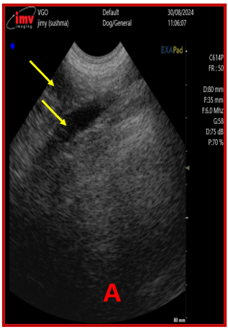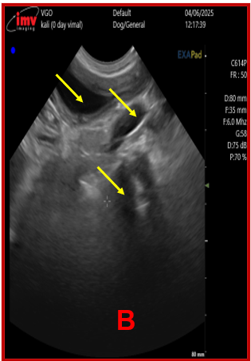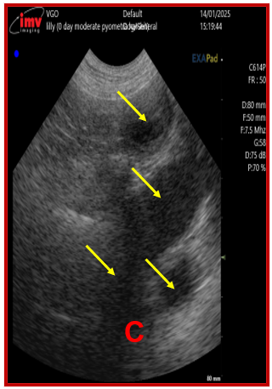
Plate 04: Ultrasonographic pictures of uterus depicting mild (A), moderate (B) and severe (C) pyometra in female dogs
DISCUSSION
The present study recorded an incidence of 9.15% of pyometra among total small animal gynaecological cases, confirming its status as one of the most prevalent reproductive disorders in female dogs. Similar findings were reported by Kumar et al. (2019) at T.V.C.C., Jabalpur (16.61%) and Achary et al. (2024) (15.54%), reflecting the regional consistency of pyometra as a significant clinical concern. Comparatively lower incidence rates were noted by Devarajan et al. (2024) (3.20%), possibly due to larger sample size and differing case intake protocols. The observed variation among studies may be attributed to differences in breed distribution, managemental practices, hormonal exposure and reproductive status of animals presented at referral hospitals.
Month-wise distribution in the present study revealed a higher incidence during February, October and March, corresponding to the post-oestrus or early anoestrus phase in most female dogs, when progesterone levels remain elevated. Such hormonal dominance suppresses uterine immunity and promotes cystic endometrial hyperplasia, predisposing the uterus to secondary bacterial infection. These findings align with the reports of Sethi et al. (2020a), who observed most pyometra cases 16–60 days post-oestrus and support the hormonal basis of the disease’s temporal occurrence. The mild seasonal pattern seen here also reflects the breeding cycle of dogs in central India, where post-monsoon and winter months coincide with higher oestrus activity.
Age-wise analysis indicated that bitches aged 7–9 years (44.66%) and those above 10 years (27.18%) were most affected, while only 7.77% of cases occurred below 3 years of age. This age-related susceptibility is consistent with earlier reports by Smith (2006), who noted an average onset at 9.36 years and by dos Anjos et al. (2021) and Rautela and Katiyar (2019), who found peak prevalence between 6 and 8 years. The higher incidence in older animals is attributed to cumulative progesterone exposure, repeated pseudopregnancies and reduced uterine contractility with age. Similar observations by Achary et al. (2024) and Mohan et al. (2023) reinforce the notion that pyometra is predominantly a disease of mature bitches following multiple oestrous cycles.
In the present investigation, closed-cervix pyometra (63.11%) was more prevalent than the open type (36.89%), contrary to Lee et al. (2016), who found open pyometra to be more common (61.8%). The predominance of closed-cervix pyometra in this study may reflect delayed clinical presentation or referral bias, as animals with open cervix discharge are often treated earlier at local clinics. The closed type is clinically more severe due to pus accumulation and systemic toxemia, as also noted by Hagman (2018). These findings emphasize the need for early diagnosis using ultrasonography to prevent systemic complications.
The severity-wise categorization revealed that severe pyometra accounted for 51.40% of cases, followed by moderate (31.10%) and mild (17.50%). This predominance of advanced cases suggests delayed detection and progression of disease prior to referral, a trend also observed by several researchers too. Severe cases in this study showed pronounced endometrial hypertrophy and hyperechoic pus pockets, confirming the degenerative and inflammatory pathogenesis described by Xavier et al. (2024). Such findings highlight the importance of regular reproductive monitoring and owner awareness in preventing severe disease outcomes.
Breed-wise analysis demonstrated that Labrador Retrievers (27.20%), Pomeranians (17.50%) and Beagles (14.60%) were most affected. This aligns with the breed predispositions reported by Bostrom (2018), Chouksey (2022) and Devarajan et al. (2024), who identified Labradors and smaller breeds like Spitz and Pugs as highly susceptible. Genetic factors, breed-specific hormonal responses and managemental practices likely contribute to this predisposition. Studies by Egenvall et al. (2001) and Arendt et al. (2021) have also demonstrated breed-linked genetic susceptibility, including ABCC4 gene polymorphisms associated with pyometra risk in Golden Retrievers.
Overall, the present findings reaffirm that canine pyometra remains a major reproductive health issue, particularly in middle-aged to older bitches and popular breeds like Labradors and Pomeranians. The predominance of closed-cervix and severe forms underscores the importance of early ultrasonographic screening and prophylactic ovariohysterectomy in high-risk animals. The observed seasonal clustering around post-oestrus months further supports the endocrine basis of the disease, consistent with the classical concept of cystic endometrial hyperplasia–pyometra complex described by Dow (1959) and refined by Hagman (2018).
CONCLUSION
The present investigation confirms that canine pyometra is a major reproductive disorder in female dogs, with an incidence of 9.15 percent among small animal gynaecological cases at the VCC, Jabalpur. Also middle-aged to older female dogs, particularly those 7–9 years old, showed the highest susceptibility and among all the affected animals Labradors were the most frequently affected breed followed by Pomeranians and Beagles. Closed-cervix pyometra was more prevalent than the open type and more than half of the cases were classified as severe pyometra, suggesting delayed detection and presentation of animals in an advanced stage of the disease. The month-wise pattern, showed higher occurrence in February followed by October and March, further supports the role of post-oestrus progesterone dominance in increasing susceptibility to uterine infection. Overall, the findings underscore the need for early reproductive screening, owner awareness and timely intervention to reduce the severity and complications associated with pyometra in dogs.
DISCLAIMER (ARTIFICIAL INTELLIGENCE)
Author(s) hereby declares that no generative AI technologies such as Large Language Models (ChatGPT, COPILOT, etc) and text-to-image generators have been used during writing or editing of this manuscript.
COMPETING INTERESTS
Authors have declared that no competing interests exist.
REFERENCES
Achary, H.K., Rath, P.K., Panda, S.K., Mishra, B.P., Jena, B. & Mishra, R. (2024). Pathomorphological, haemato-biochemical and diagnostic imaging studies in canine pyometra. Indian Journal of Animal Research, 58(1): 135-140. DOI: 10.18805/IJAR.B-4806.
Anjos, M.S.D., Bittencourt, R.F. & Biscarde, C.E.A. (2021). Canine pyometra: interferences of age and type in blood count and serum biochemistry. Brazilian Journal of Veterinary Science, 28(3): 167-173. DOI: 10.4322/rbcv.2021.031.
Arendt, M., Ambrosen, A., Fall, T., Kierczak, M., Tengvall, K., Meadows, J.R. & Hagman, R. (2021). The ABCC4 gene is associated with pyometra in golden retriever dogs. Scientific Reports, 11(1): 16647. DOI: 10.1038/s41598-021-95936-1.
Boström, N. J. N. (2018). A retrospective study of prognostic markers in female dogs diagnosed with pyometra. Master Thesis. Lithuanian University of Health Sciences Veterinary Academy, Kaunas.
Chouksey, S. (2022). Comparative efficacy of therapeutic protocols for management of canine pyometra. M.V.Sc. Thesis (Veterinary Gynaecology and Obstetrics), Nanaji Deshmukh Veterinary Science University, Jabalpur (M.P.).
Devarajan, N., Becha, B.B., Jayakumar, C., Unnikrishnan, M.P. & Venugopal, S.K. (2024). Occurrence of pyometra among dogs—a retrospective study. Journal of Indian Veterinary Association, 22(3): [page numbers not given]. DOI: 10.55296/JIVA/22.3.2024.100-107.
Dow, C. (1959). The cystic endometrial hyperplasia–pyometra complex in the bitch. Journal of Comparative Pathology, 69(4): 237–250.
Egenvall, A., Hagman, R., Bonnett, B.N., Hedhammar, A., Olson, P. & Lagerstedt, A.S. (2001). Breed risk of pyometra in insured Swedish bitches. Theriogenology, 55(1): 89–106. (
Hagman, R. (2018). Pyometra in small animals. Veterinary Clinics of North America: Small Animal Practice, 48(4): 639–666.
Kumar, P., Shukla, S.N. & Shrivastava, M.J. (2019). An incidence of cystic endometrial hyperplasia–pyometra complex in female dogs. Pharma Innovation Journal, 8(6): 522–526.
Lee, J.A., Kim, I.H., Hwang, D.Y. & Kang, H.G. (2016). Ultrasonography, affected age, hematology and clinical signs according to open or closed cervix in dogs with pyometra. Journal of Veterinary Clinics, 33(6): 362–367.
Rautela, R. & Katiyar, R. (2019). Review on canine pyometra, oxidative stress and current trends in diagnostics. Asian Pacific Journal of Reproduction, 8: 45–55.
Sethi, G.P.S., Gandotra, V.K., Honparkhe, M., Singh, A.K. & Ghuman, S.P.S. (2020a). Association of age, breed, estrus and mating history in occurrence of pyometra. Journal of Entomology and Zoology Studies, 8(2): 852–855.
Xavier, R.G.C., Santana, C.H., da Silva, P.H.S., Paraguassu, A.O., Nicolino, R.R., Freitas, P.M.C. & Silva, R.O.S. (2024). Association between bacterial pathogenicity, endometrial histological changes and clinical prognosis in canine pyometra. Theriogenology, 214: 118–123.

