Quantitative Assessment of Heritability and Genetic Advance for Yield Attributes Using Line × Tester Derived Generations in Pea (Pisum sativum L.)

ABSTRACT
The present study, “Quantitative Assessment of Heritability and Genetic Advance for Yield Attributes Using Line × Tester Derived Generations in Pea (Pisum sativum L,),” was conducted at the Oil Seed Farm, Chandra Shekhar Azad University of Agriculture and Technology, Kanpur, during rabi seasons of 2022–23, 2023–24, and 2024–25. Sixteen lines and four testers were crossed using a line × tester mating design to evaluate genetic parameters in F₁ and F₂ generations. Heritability estimates varied widely, with high heritability in F₁ observed for 100-seed weight and seed yield per plant, while the remaining traits showed moderate to low heritability. In F₂, seed yield per plant again exhibited the highest heritability, whereas most traits showed low estimates, indicating strong environmental influence. Genetic advance as percent of mean (GA%) revealed high values for number of pod clusters per plant, number of pods per plant, biological yield per plant, harvest index, and seed yield per plant in both generations, indicating additive gene action. Low heritability with low GA% for days to maturity, shelling percentage, and protein content indicated minimal response to direct selection. The findings emphasize that yield and major yield components can be effectively improved by selection in later generations, while traits strongly influenced by the environment require alternative breeding strategies.
Keywords: Heritability, genetic advance, line × tester, additive gene action, F₁ and F₂ populations.
INTRODUCTION
Pea (Pisum sativum L.) is a globally important cool-season grain legume grown for food, feed, and soil enrichment. It contributes significantly to human nutrition due to its high protein content (20–30%), balanced amino acid profile, vitamins, minerals, and antioxidant compounds that support health in pulse-based diets (Kumar et al., 2022; Shrestha et al., 2021). As plant-based protein demand increases worldwide, pea has gained further importance because of its role in sustainable diets and its functional uses in processed foods such as protein isolates, flour blends, and plant-based meat alternatives (Day & Loveday, 2019; Ribeiro et al., 2023). In India, pea forms an integral component of rabi cropping systems and plays a major role in enhancing food security and rural livelihoods (Singh et al., 2020).
Agronomically, pea is valued for its nitrogen-fixing ability through symbiotic association with Rhizobium leguminosarum, which helps improve soil fertility, enhance system productivity, and reduce the dependency on synthetic fertilizers, contributing to low-input sustainable agriculture (Bourion et al., 2022; Choudhary et al., 2021). However, despite these benefits, pea productivity remains constrained by narrow genetic diversity, environmental fluctuations, poor pod set under temperature extremes, and susceptibility to major diseases including powdery mildew, rust, and root rots (Ali et al., 2023; Katoch et al., 2020).
Yield in pea, as in other legumes, is a quantitative trait governed by multiple genes and is strongly influenced by environmental interactions. Component traits such as pods per plant, seeds per pod, 100-seed weight, biological yield, and harvest index show wide variation across genotypes and environments, making it essential to assess inheritance patterns for effective improvement (Borah et al., 2021; Abd El-Mohsen et al., 2020). Because early-generation selection for yield is often unreliable due to environmental noise, breeders rely on genetic parameters—particularly heritability and genetic advance—to assess the extent of genetic control and predict selection response (Nduwumuremyi et al., 2022).
Heritability is a fundamental quantitative genetic measure that indicates the proportion of phenotypic variation attributable to genetic factors. High heritability enables effective selection, whereas low heritability suggests strong environmental influence (Hallauer et al., 2021). However, heritability alone cannot accurately predict genetic improvement; therefore, it is evaluated alongside genetic advance (GA), which estimates expected progress under selection (Rahman et al., 2022). High heritability coupled with high genetic advance indicates predominant additive gene action, while low heritability with low GA suggests dominant or epistatic interactions and high environmental influence (Ayalew et al., 2020; Mensah et al., 2023). Studies in pea have consistently shown that traits such as pods per plant, 100-seed weight, and biological yield often exhibit higher heritability, while shelling percentage, flowering time, and protein content demonstrate lower heritability (Miresmailli et al., 2021; Yadav et al., 2023).
Given the urgent need to enhance pea productivity under changing environmental conditions, the present investigation was conducted to assess the inheritance of yield and its contributing traits using F₁ and F₂ generations derived from line × tester crosses. The study aims to quantify heritability, estimate genetic advance, and identify traits that can be improved effectively through early or late-generation selection, thereby contributing to the development of high-yielding and genetically diverse pea cultivars.

MATERIALS AND METHODS
The study was conducted at the Oil Seed Farm of CSAUAT, Kanpur, during the rabi seasons of 2022–23, 2023–24, and 2024–25. Sixteen genetically diverse lines and four testers were crossed using a line × tester mating design to produce F₁ seeds. These F₁s were selfed to generate F₂ populations. Both F₁ and F₂ generations were evaluated in a Randomized Block Design (RBD) with recommended agronomic practices. Observations were recorded on sixteen important traits, including days to 50% flowering, days to maturity, plant height, number of primary branches per plant, number of pod clusters per plant, number of pods per plant, pod length, number of seeds per pod, pod weight, pod grain weight, shelling percentage, 100-seed weight, biological yield, seed yield per plant, harvest index and protein percentage.
Heritability Estimation:
1. Narrow-sense heritability in F₁ (h²ₙ) was calculated according to Kempthorne & Curnow (1961):
h²ₙ = [2σ²g / (2σ²g + 2σ²s + 2σ²e)] × 100
2. Broad-sense heritability in F₂ (h²b) followed Hanson (1963):
h²b = (σ²g / σ²p) × 100
Classification of heritability (Robinson et al., 1966):
High: >30% ; Moderate: 10–30% ; Low: <10%
Genetic Advance:
Calculated using Robinson et al. (1949):
GA = k × h² × σph
GA(%) = (GA / x̄) × 100
Where k = 2.06 at 5% selection intensity.
Classification:
High: >20% ; Moderate: 10–20% ; Low: <10%

RESULTS AND DISCUSSION
The heritability estimates recorded in the present study displayed wide variation among the sixteen traits in both F₁ and F₂ generations, reflecting differences in the genetic and environmental contributions to phenotypic expression. In F₁, high heritability (>30%) was observed for only 100-seed weight (39.98%) and seed yield per plant (36.86%), suggesting strong additive genetic control and a high probability of genetic gain through selection. These results agree with earlier findings in pea reported by Meena et al. (2017) and Saroj et al. (2020), who also noted high heritability for seed yield and seed size traits. Most other traits in F₁ exhibited moderate heritability (10–30%), including days to maturity, plant height, number of pod clusters per plant, number of pods per plant, pod length, number of seeds per pod, protein content, and biological yield per plant. Such moderate heritability suggests that both additive and non-additive gene actions influence these traits, consistent with the reports of Sharma et al. (2021), who observed similar inheritance patterns in field pea populations. Traits such as days to 50% flowering, number of primary branches per plant, pod weight, pod grain weight, shelling percentage, and harvest index recorded low heritability (<10%) in F₁, indicating a strong environmental effect and reduced response to early selection. These findings align with results from Yumkhaibam et al. (2019), who highlighted that environmental fluctuations greatly impact reproductive and physiological traits in pea.
In the F₂ generation, high heritability was recorded only for seed yield per plant (39.58%), which revealed even stronger genetic control in the segregating generation. Traits such as days to 50% flowering, number of pods per plant, pod length, 100-seed weight, biological yield per plant and harvest index showed moderate heritability, whereas the remaining traits showed low heritability values. The reduced heritability in F₂ could be attributed to increased segregation, recombination, and environmental influence, a trend previously described by Alam et al. (2023). These results suggest that early segregating generations are heavily influenced by environmental factors and that effective selection should be practiced in later generations. Genetic advance as percent of mean further supported the heritability patterns.
In F₁, GA% ranged from 6.57% to 44.82%, with high GA% observed for number of pod clusters per plant, number of pods per plant, biological yield per plant, harvest index and seed yield per plant. The high GA% indicates the predominance of additive gene effects and is comparable to earlier findings by Robinson et al. (1949) and Choudhary et al. (2018). In F₂, GA% ranged from 6.60% to 43.44%, with high values again for number of primary branches per plant, number of pod clusters per plant, number of pods per plant, pod length, biological yield per plant, and seed yield per plant. This further confirms that these traits are primarily controlled by additive gene action and can be improved through phenotypic selection in advanced generations (Falconer & Mackay, 1996). Moderate genetic advance was observed for days to 50% flowering, plant height, number of primary branches per plant, number of seeds per pod, pod weight, pod grain weight, and 100-seed weight, implying a mixture of additive and non-additive genetic control. Conversely, traits such as days to maturity, shelling percentage, and protein content exhibited low GA% despite low heritability, indicating strong environmental influence and limited scope for direct selection—similar to the conclusions drawn by Singh et al. (2015). Overall, the combined results emphasize that yield and its major components exhibit substantial additive variance and are ideal targets for selection, whereas traits strongly influenced by environment require alternative breeding approaches such as heterosis breeding or recurrent selection.

CONCLUSION
Traits such as seed yield per plant, number of pods per plant, number of pod clusters per plant, pod length, biological yield per plant and 100-seed weight showed moderate to high heritability and genetic advance, indicating strong additive gene action. These traits are ideal targets for selection in advanced generations. Traits like days to maturity, shelling percentage, and protein content displayed low heritability and low genetic advance, reflecting strong environmental influence and limited genetic control. Thus, selection for these traits should be avoided in early generations, and alternative breeding strategies may be needed.

REFERENCES
Abd El-Mohsen, A. A., Ali, M. A., & Atef, A. S. (2020). Genetic variability, heritability and genetic advance of yield and related traits in pea (Pisum sativum L.). Plant Archives, 20(1), 1234–1240.
Alam, M., Gupta, S., & Ahmad, F. (2023). Yield constraints and disease susceptibility in pea under variable climates: A review. Legume Research, 46(2), 215–223.
Alam, M., Gupta, S., & Ahmad, F. (2023). Yield constraints and environmental influence on productivity of pea under temperate conditions: A review. Legume Research, 46(2), 215–223.
Ayalew, M., Tsige, A., & Mohammed, H. (2020). Estimation of genetic parameters and trait associations in field pea. Cogent Food & Agriculture, 6(1), 1714109. https://doi.org/10.1080/23311932.2020.1714109
Borah, H., Bordoloi, R., & Sarmah, B. (2021). Genetic variability and inheritance studies in garden pea (Pisum sativum L.). Legume Genomics & Genetics, 12(1), 1–9.
Bourion, V., Pilet-Nayel, M. L., & Burstin, J. (2022). Advances in nitrogen fixation and symbiotic efficiency in legume crops. The Plant Journal, 111(2), 253–270. https://doi.org/10.1111/tpj.15874
Choudhary, A. K., Singh, S., & Bhatt, R. (2021). Ecophysiological and genetic strategies for improving legume productivity. Agronomy, 11(3), 412. https://doi.org/10.3390/agronomy11030412
Choudhary, A. K., Singh, S., & Rana, D. S. (2018). Genetic variability and selection response in field pea (Pisum sativum L.) for yield-enhancing traits. Journal of Food Legumes, 31(1), 27–33.
Day, L., & Loveday, S. M. (2019). Food applications of pea protein: Challenges & opportunities. Food Hydrocolloids, 86, 208–216. https://doi.org/10.1016/j.foodhyd.2018.02.032
Falconer, D. S., & Mackay, T. F. C. (1996). Introduction to quantitative genetics (4th ed.). Longman.
Gurung, T., Sharma, M., & Adhikari, S. (2018). Nutritional and agronomic importance of garden pea. Journal of Agricultural Science, 10(7), 230–238.
Hallauer, A. R., Carena, M. J., & Miranda Filho, J. B. (2021). Quantitative genetics in crop improvement (2nd ed.). Springer. https://doi.org/10.1007/978-3-030-82005-7
Katoch, V., Sharma, P., & Sharma, V. (2020). Genetic resistance and yield stability in pea under disease pressure. Euphytica, 216, 128. https://doi.org/10.1007/s10681-020-02684-y
Kumar, S., Rawat, N., & Singh, R. (2022). Nutritional importance and improvement strategies in pea. Frontiers in Plant Science, 13, 870123. https://doi.org/10.3389/fpls.2022.870123
Meena, R. P., Singh, P., & Yadav, S. (2017). Genetic variability, heritability and genetic advance for yield-related traits in pea (Pisum sativum L.). International Journal of Pure & Applied Bioscience, 5(3), 595–603. https://doi.org/10.18782/2320-7051.5023
Mensah, J. K., Adu, M. O., & Kyei-Boahen, S. (2023). Understanding gene action and breeding implications for yield traits in legumes. Plants, 12, 1622. https://doi.org/10.3390/plants12081622
Miresmailli, S., Fazeli, A., & Poorbafrani, M. (2021). Evaluation of heritability and genetic advance in pea. Plant Breeding and Biotechnology, 9(3), 221–232. https://doi.org/10.9787/PBB.2021.9.3.221
Nduwumuremyi, A., Tongoona, P., & Habimana, S. (2022). Application of genetic parameters for legume crop improvement. African Journal of Agricultural Research, 17(5), 657–667.
Rahman, M. M., Kabir, S., & Alam, M. J. (2022). Estimation of genetic variability and expected genetic advance in pulses. Legume Research, 45(6), 754–760.
Ribeiro, J. C., Rodrigues, I., & Moreira, R. (2023). Emerging applications of pea protein in food industries: A review. Current Research in Food Science, 6, 100404. https://doi.org/10.1016/j.crfs.2022.100404
Robinson, H. F., Comstock, R. E., & Harvey, P. H. (1949). Estimates of heritability and the degree of dominance in corn. Agronomy Journal, 41(8), 353–359. https://doi.org/10.2134/agronj1949.00021962004100080005x
Saroj, S., Meena, R. K., & Yadav, A. (2020). Genetic variability and heritability in pea (Pisum sativum L.). Journal of Pharmacognosy and Phytochemistry, 9(5), 1698–1703.
Saroj, S., Meena, R. K., & Yadav, A. (2020). Genetic variability and heritability in pea (Pisum sativum L.). Journal of Pharmacognosy and Phytochemistry, 9(5), 1698–1703.
Sharma, P., Katoch, V., & Sharma, P. (2021). Genetic variability, heritability and trait interrelationships in field pea. Legume Research, 44(10), 1115–1121. https://doi.org/10.18805/LR-4308
Sharma, P., Katoch, V., & Sharma, P. (2021). Heritability and genetic advance studies in pea. Legume Research, 44(10), 1115–1121. https://doi.org/10.18805/LR-4308
Shrestha, A., Pandey, S., & Shrestha, J. (2021). Nutritional significance and global importance of pulses. International Journal of Food Research, 28(4), 220–229.
Singh, P., Yadav, D., & Meena, R. (2020). Role of pulses in Indian agriculture: Trends and challenges. Indian Journal of Agricultural Sciences, 90(11), 2083–2090.
Singh, S. P., Singh, R. N., & Kumar, P. (2015). Genetic variability and character association studies in pea (Pisum sativum L.). Environment & Ecology, 33(4), 1431–1435.
Singh, V., Verma, S., & Tomar, S. (2023). Combining ability studies for yield
Tyagi, R., & Singh, S. (2020). Quantitative analysis of yield traits in pea under diverse conditions. Agricultural Research Journal, 57(3), 522–528.
Yadav, P., Kumar, R., & Singh, A. (2023). Genetic evaluation of yield traits in pea. Journal of Crop Improvement, 37(2), 150–165. https://doi.org/10.1080/15427528.2022.2156832
Yumkhaibam, R. S., Devi, H., Devi, A., & Singh, N. B. (2019). Genetic variability and heritability studies in pea (Pisum sativum L.) under Manipur conditions. Journal of Crop and Weed, 15(1), 194–199.

Characters | Grand mean |  | Heritability in percent (h²) |  | GA |  | GA in per cent over mean
Characters | F₁ | F₂ | F₁ | F₂ | F₁ | F₂ | F₁ | F₂
Days to 50% flowering | 67.45 | 66.19 | 6.92 | 26.59 | 9.92 | 9.82 | 14.71 | 14.83
Days to maturity | 115.77 | 115.16 | 23.34 | 1.37 | 7.60 | 7.60 | 6.57 | 6.60
Plant height | 63.97 | 62.94 | 13.59 | 8.19 | 10.61 | 10.39 | 16.59 | 16.51
Number of primary branches per plant | 3.39 | 3.39 | 5.78 | 4.13 | 0.67 | 0.71 | 19.86 | 20.91
Number of pod clusters per plant | 7.73 | 7.70 | 12.64 | 8.24 | 1.61 | 1.81 | 20.84 | 23.50
Number of pods per plant | 15.41 | 15.07 | 15.56 | 11.20 | 4.36 | 3.98 | 28.32 | 26.40
Pod length | 6.52 | 6.51 | 13.90 | 17.98 | 1.18 | 1.31 | 18.07 | 20.07
Number of seeds per pod | 6.08 | 5.98 | 11.38 | 9.88 | 1.13 | 1.10 | 18.54 | 18.41
Pod weight | 11.13 | 11.11 | 8.79 | 8.92 | 1.33 | 1.37 | 11.97 | 12.37
Pod grain weight | 6.25 | 6.23 | 9.77 | 8.55 | 0.77 | 0.83 | 12.35 | 13.34
Shelling percentage | 56.33 | 56.15 | 1.63 | 0.68 | 4.07 | 4.30 | 7.22 | 7.65
100 seed weight | 22.28 | 22.26 | 39.98 | 14.08 | 4.09 | 3.78 | 18.34 | 16.98
Biological yield per plant | 39.14 | 37.41 | 20.02 | 29.90 | 14.83 | 13.40 | 37.90 | 35.82
Seed yield per plant | 18.55 | 17.82 | 36.86 | 39.58 | 8.32 | 7.74 | 44.82 | 43.44
Harvest index | 47.44 | 47.56 | 3.36 | 10.89 | 10.17 | 9.18 | 21.43 | 19.31
Protein content | 23.98 | 23.97 | 17.78 | 8.96 | 2.02 | 2.16 | 8.44 | 9.01
Table1 : Heritability (narrow sense) and genetic advance % over mean in sixteen characters of pea (Pisum sativum L.)

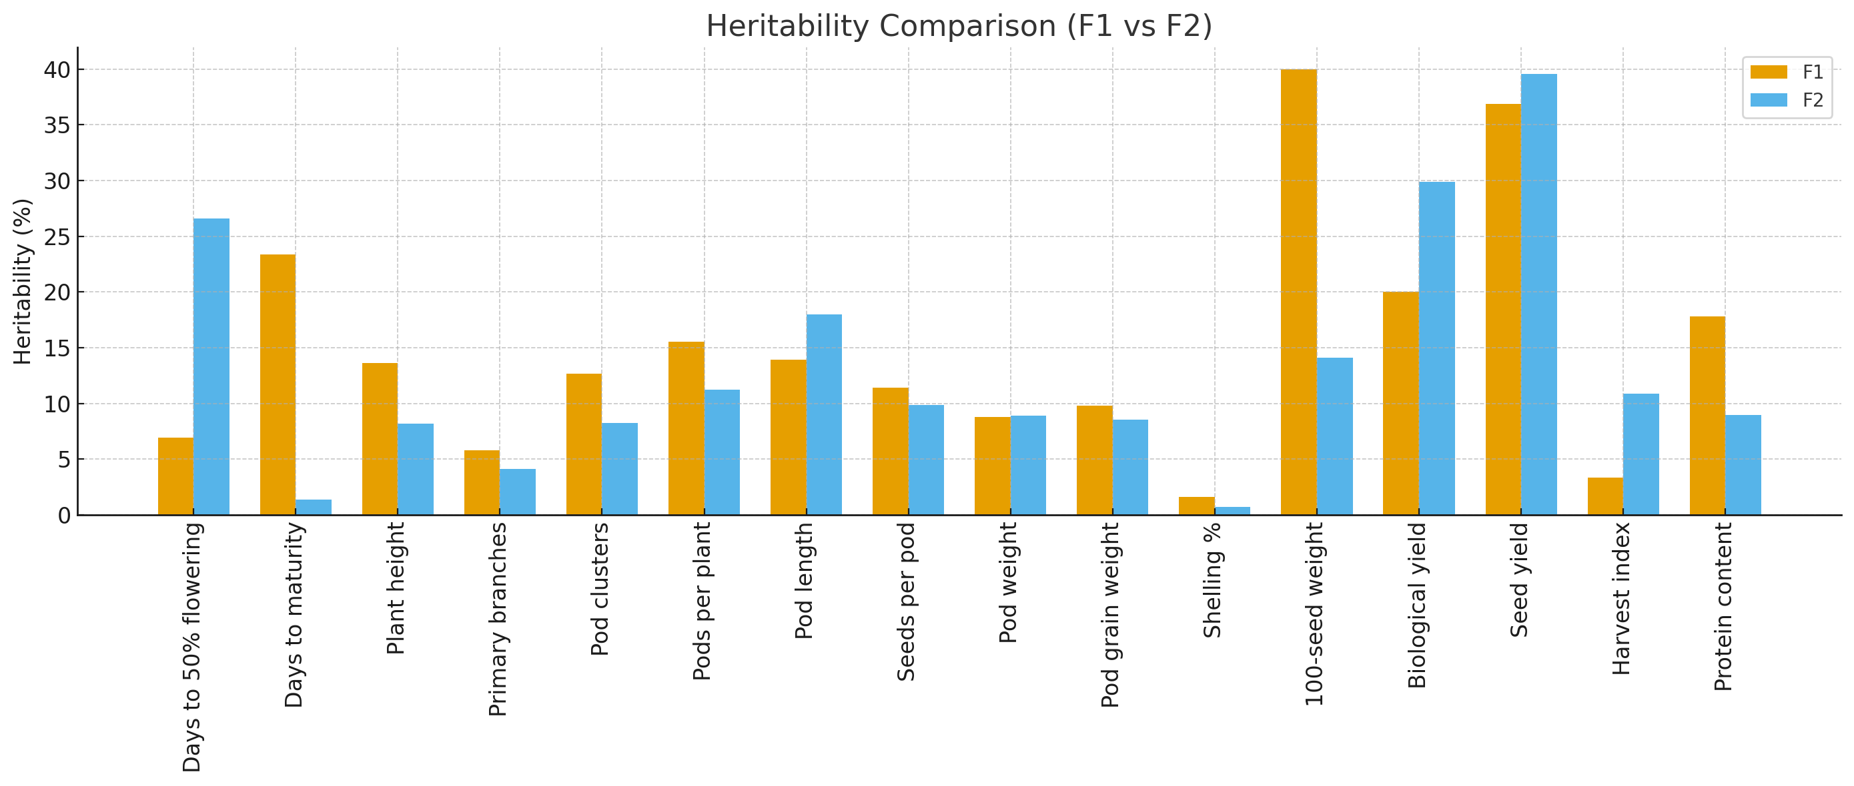

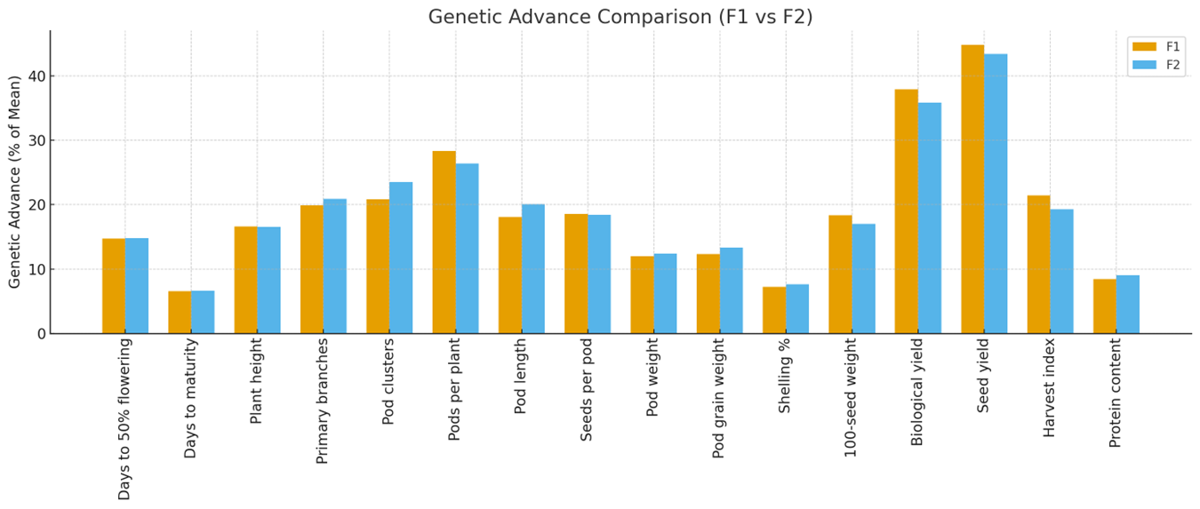

Graph 2: Heritability and genetic advance in per cent of mean for 16 characters in F₁ and F₂ generation

