Biochemical Characterisation of Exotic Jackfruit (Artocarpus heterophyllus Lam.) varieties

Abstract
A study entitled “Characterization of selected exotic jackfruit (Artocarpus heterophyllus Lam.) varieties” was conducted at the Department of Fruit Science, College of Agriculture, Vellayani, Thiruvananthapuram, from November 2024 to July 2025. Fifteen exotic jackfruit varieties were identified from South Kerala, covering the districts of Thiruvananthapuram, Kollam, Alappuzha, and Kottayam. No systematic study has been conducted so far regarding the evaluation of exotic jackfruit varieties under Kerala conditions. Therefore, this study focused on the biochemical characters, including TSS, Acidity, reducing sugars, non reducing sugars, total sugars and total carotenoid content present in these varieties. The J 33 variety had a high TSS of 40.7°Brix, while Thailand Red and J 13 varieties had the highest acidity level of 0.64%. The Thailand Red variety exhibited the highest reducing sugar level (8.33%), and total sugar content was found to be high in J 33 variety (17.92%). The Red Jack variety had the highest carotenoid content of 4430.13 μg/100g. The results obtained were subjected to statistical analysis using Principal Component Analysis (PCA). The results indicate that the exotic jackfruit varieties possess distinct advantages and further exploration and utilisation of these varieties is essential for promoting commercial cultivation.
Keywords: Exotic jackfruit; biochemical analysis; total sugars; total carotenoids.
- Introduction
Jackfruit (Artocarpus heterophyllus Lam.) is a tropical, climacteric species native to the Western Ghats of India (Das and Saha, 2020). India is widely regarded as the primary centre of origin of jackfruit and remains the world’s second-largest producer. Within India, the species holds particular prominence in Kerala, where it is designated the state fruit and occupies the largest area under cultivation. Jack fruit bears the largest fruits among the edible fruits and gives more yield than any other fruit tree. Jackfruit exhibits notable tolerance to many pests and diseases and performs well under elevated temperatures and intermittent drought, conferring strong climate resilience. Under threat from climate change, jackfruit can provide a potential solution to countries facing problems with food security, as it is available during off-seasons also. Jackfruit is a multipurpose fruit used both as a dessert and as a vegetable at various maturity stages, with nearly all plant parts having utility. The edible portion is energy-dense and supplies antioxidants, provitamin A carotenoids, vitamin C, and minerals such as potassium, calcium, sodium, zinc, and iron (Ranasinghe et al., 2019). Seeds milled into flour provide protein, starch, and dietary fibre and represent an abundant, low-cost nutrient source. A broad portfolio of value-added products can be derived from the fruit, including jam, jelly, nectar, squash, confectionery, flour, noodles, papad, chips, and ice cream (Elevitch and Manner, 2006). Jackfruit also displays high photosynthetic capacity and can contribute to increases in soil organic carbon. The timber is valued and reputed to be termite-resistant, while leaves and processing residues serve as nutritious fodder for cattle and goats. Along with the traditional cultivars, certain exotic varieties are gaining importance in recent times. Most of the exotic varieties have wide variation in fruit quality and suitability to grow in homestead systems (Sunderraj and Ranganathan, 2018). Unlike traditional jackfruit varieties, most of the exotic varieties are of dwarf stature, early bearing and have year-round production, so, can be grown commercially (Aliya, 2023). The paper discusses the biochemical characters of fifteen exotic jackfruit varieties, namely Vietnam Red, Vietnam Early, Vietnam Super Early, Thailand Red, Thailand Pink, J 33, J 13, Combodian Orange, White Jack, Pink Jack, Red Jack, Seedless, Gumless, Dang Surya, and Honeydew.
- Materials and methods
The study was carried out at the Department of Fruit Science, College of Agriculture, Vellayani, Thiruvananthapuram, between November 2024 and July 2025. Fifteen exotic jackfruit varieties were sourced from four districts of southern Kerala—Thiruvananthapuram, Kollam, Alappuzha, and Kottayam. The research methodology encompassed a survey and the collection of information on the varieties and fruits were collected for biochemical analysis. Subsequent assessments were conducted during the fruiting stage, when fruit samples were obtained for biochemical evaluations.
  - Determination of Total Soluble Solids (°Brix), Ascorbic Acid, Acidity, Total Sugar and Reducing Sugar
Total soluble solids (TSS) of the fruit pulp were determined using a digital refractometer (Atago: 0–53%) and expressed as degrees Brix (°Brix). Fruit pulp acidity (AY) was measured according to the AOAC method [1]. The ascorbic acid (AA) content was also estimated following the AOAC procedure [1], with the results reported in mg per 100 g of pulp. Total sugars (TS) and reducing sugars (RS) were quantified in the pulp using the Lane and Eynon method.
2.3. Total Carotenoids (µg 100g-1)
Total carotenoids present in the fruit pulp were estimated by the method suggested by Ranganna et al. (1991)
2.4 Statistical Analysis
Principal component analysis (PCA) is a multivariate technique that helps identify patterns and trends within datasets, facilitating a comprehensive exploration of the data. R-based web application GRAPES was used for Principal Component Analysis (Gopinath et al., 2020). Avani and Bauri (2018) reported considerable genetic diversity among jackfruit genotypes through PCA analysis. The first principal component (PC-1) accounted for the highest variation at 32.48%, while PC-2 and PC-3 also contributed significantly, each with Eigen values greater than 2. PC-1 captured the largest portion of morphological variability, characterized by 10 traits with positive loadings and six with negative loadings.
- RESULTS AND DISCUSSION
  - Total Soluble Solids (°Brix)
The total soluble solids (TSS) among the fifteen exotic varieties ranged from 21.0 to 40.7 °Brix, with a mean value of 29.54 °Brix and a coefficient of variation of 0.22%. The highest TSS was recorded in variety J33, while the lowest was observed in variety J13.
  - Acidity (%)
The acidity among the varieties ranged from 0.210 to 0.64%. The highest values were recorded in Thailand Pink and J13, while the lowest were noted in Vietnam Red and Pink Jack. The mean acidity was 0.43%, with a coefficient of variation of 0.29%. The TSS-to-acidity ratio varied between 32.81 and 167.62.
3.3 Ascorbic acid (mg 100g-1)
Considerable variation was found in the ascorbic acid content of the exotic varieties, ranging from 7.69 to 20.19 mg/100 g. The maximum content was recorded in White Jack and Dang Surya, whereas the minimum was observed in Vietnam Red. On average, the ascorbic acid level was 13.69 mg/100 g, with a coefficient of variation of 0.32%. The results were on par with the the study conducted by Ibrahim et al. (2013) revealed considerable variation in the TSS (18.80–27.37%), total sugars (11.84–17.01%), vitamin C content (17.82–31.55 mg/100g), and acidity (0.037–0.075% as citric acid) among different jackfruit cultivars collected from various districts of Rajasthan.
  - Total sugar (%)
The total sugar content of the exotic varieties ranged from 10.94 to 17.92 %. The highest value was observed in J33 variety whereas the lowest total sugar content was observed in J13 variety. The mean value of total sugars was found to be 14.17% with a coefficient of variation of 0.16%.
3.5. Reducing sugar (%)
Reducing sugar content of the exotic varieties ranged from 3.11 to 8.33%. The highest concentration was recorded in Thailand Red, while the lowest was observed in J13. The average reducing sugar level was 6.22%, with a coefficient of variation of 0.24%.
3.6 Non-reducing sugar (%)
The non-reducing sugar content in the exotic jackfruit varieties ranged from 4.990 to 13.350 %. The highest non-reducing sugar content was found in J33 variety and the lowest in the Vietnam red variety. The mean value of the non-reducing sugar content was 7.96 % with a coefficient of variation of 0.78%.
  - Total carotenoids (µg 100g-1)
The carotenoid content was found to be higher in orange-red fleshed jackfruit varieties as compared to yellow fleshed varieties. The maximum concentration (4430.13 µg/100 g) was recorded in Red Jack, while the minimum (209.56 µg/100 g) occurred in White Jack. The mean carotenoid content was 1684.95 µg/100 g, with a coefficient of variation of 0.78%. A study conducted by Balamaze et al. (2019) to assess the variation in physico-chemical properties among orange, yellow and white flaked jackfruit varieties reported significant differences among varieties in terms of ascorbic acid (AA), carotenoids, total soluble solids (TSS), TSS: acid ratio, colour, and texture. Orange flakes showed the highest carotenoid and TSS content, along with a relatively high TSS: acid ratio. Yellow flakes exhibited intermediate values across most parameters but had significantly lower AA content compared to the other varieties, while white flakes had the lowest TSS and carotenoid levels.
Table 1. Biochemical parameters of exotic jackfruit varieties.
Sl.No | Varieties | TSS (°Brix) | Acidity (%) | Ascorbic acid (mg/100g)
1 | Vietnam Red | 25.6 | 0.21 | 7.69
2 | Vietnam Early | 22.7 | 0.53 | 9.09
3 | Vietnam Super Early | 36.5 | 0.42 | 13.28
4 | Thailand Red | 27 | 0.34 | 16.16
5 | Thailand Pink | 22.7 | 0.64 | 12.09
6 | J 33 | 40.7 | 0.42 | 11.56
7 | J 13 | 21 | 0.64 | 8.57
8 | Cambodian Orange | 31.6 | 0.42 | 15.53
9 | White jack | 26.1 | 0.48 | 19.99
10 | Pink jack | 35.2 | 0.21 | 18.32
11 | Red jack | 24.8 | 0.42 | 20.19
12 | Seedless | 24.6 | 0.51 | 11.66
13 | Gumless | 34.8 | 0.42 | 8.69
14 | Dang surya | 38.5 | 0.37 | 19.99
15 | Honeydew | 31.3 | 0.42 | 12.51

Table 2. Biochemical parameters of exotic jackfruit varieties
Sl.No | Varieties | Reducing sugar (%) | Non-reducing sugar (%) | Total sugars (%) | Total carotenoids (µg 100g-1)
1 | Vietnam Red | 7.14 | 4.99 | 12.13 | 829.54
2 | Vietnam Early | 4.78 | 6.38 | 11.16 | 408.19
3 | Vietnam Super Early | 6.28 | 9.03 | 15.31 | 1055.51
4 | Thailand Red | 8.33 | 9.05 | 17.38 | 3231.88
5 | Thailand Pink | 4.88 | 6.16 | 11.04 | 1729.68
6 | J 33 | 6.54 | 11.38 | 17.92 | 2707.59
7 | J 13 | 3.11 | 7.83 | 10.94 | 230.92
8 | Cambodian Orange | 8.06 | 8.90 | 16.96 | 1041.39
9 | White jack | 7.26 | 6.52 | 13.78 | 209.56
10 | Pink jack | 6.61 | 8.15 | 14.76 | 1964.87
11 | Red jack | 6.86 | 6.75 | 13.61 | 4430.13
12 | Seedless | 4.32 | 8.16 | 12.48 | 732.86
13 | Gumless | 5.02 | 10.56 | 15.58 | 2102.08
14 | Dang Surya | 6.72 | 8.82 | 15.54 | 3680.24
15 | Honeydew | 7.35 | 6.68 | 14.03 | 919.88
Table 3. Summary statistics for exotic jackfruit varieties
Descriptives | TSS (°Brix) | Acidity (%) | Ascorbic Acid (mg/100g) | Reducing Sugar (%) | Non reducing sugar (%) | Total sugars (%) | Total carotenoids (μg/100g)
Minimum value | 21.000 | 0.210 | 7.690 | 3.110 | 4.990 | 10.940 | 209.560
Maximum value | 40.7000 | 0.640 | 20.190 | 8.330 | 13.350 | 17.920 | 4430.130
Range | 19.70 | 0.43 | 12.50 | 5.22 | 6.39 | 6.98 | 4220.57
Mean | 29.54 | 0.43 | 13.69 | 6.22 | 7.96 | 14.17 | 1684.95
SE (M) | 1.64 | 0.03 | 1.14 | 0.38 | 0.45 | 0.60 | 339.22
Standard deviation | 6.37 | 0.12 | 4.42 | 1.48 | 1.74 | 2.31 | 1313.81
CV (%) | 0.22 | 0.29 | 0.32 | 0.24 | 0.22 | 0.16 | 0.78

Statistical analysis
Fig 1. Scree plot of PCA on biochemical parameters
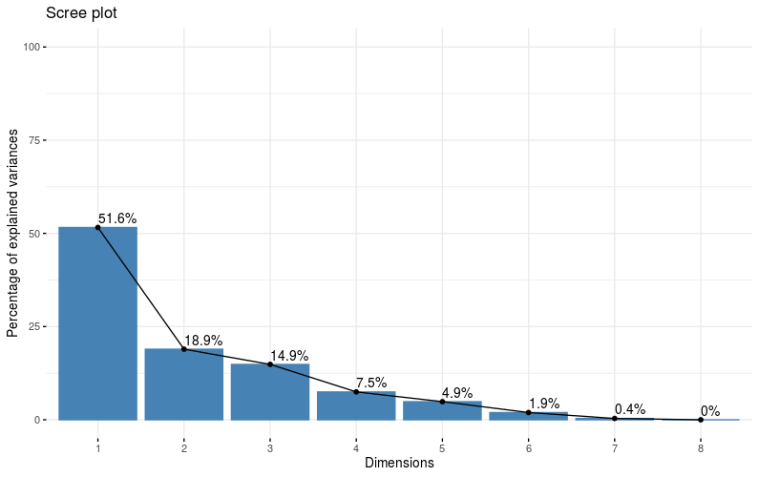
Fig. 2 PCA Biplot based on biochemical parameters
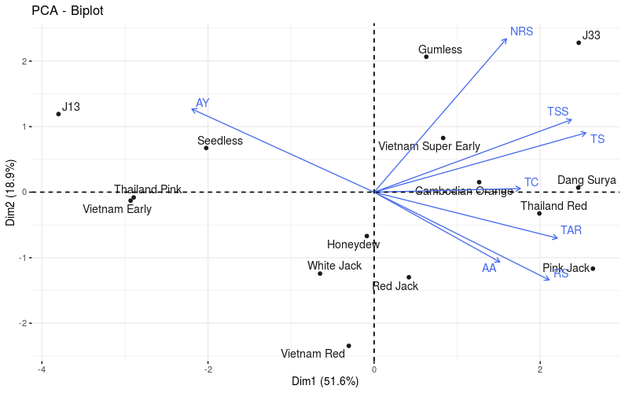
AY-Acidity, TSS- Total soluble solids, TS- Total sugars, NRS- Non reducing sugars, AA- Ascorbic acid, TAR- TSS-Acidity ratio, RS- Reducing sugars
The PCA biplot shows that TSS, TS, TAR, RS and AA have positive contributions to PC1 while AY has a negative contribution to PC1. Exotic varieties such as J 33, Pink Jack, Dang Surya, Thailand Red and Cambodian Orange have higher values for TSS, TS, TAR, RS and AA, whereas J13, Seedless, Thailand Pink and Vietnam Early have higher values of AY. TSS peaked for the J33 variety (40.7 ºBrix) while maximum acidity was found in Thailand Pink and J13 varieties (0.64%). Vietnam Red and Pink Jack exhibited the least acidity (0.21). Pink Jack variety had the highest TSS-acidity ratio (167.62), followed by Vietnam Red (121.90). Ascorbic acid content was high in White Jack and Dang Surya (20.19 mg/100g). Among the biochemical parameters, J33 had the highest percentage of non-reducing sugar (11.38 %) as well as total sugars (17.92%) and the Red Jack variety had the highest total carotenoid content (4430.13 μg/100g).
Conclusion
The analysis of the results of the study showed that seven exotic varieties can be grouped as elite varieties based on their economic characters. The varieties classified as elite were Vietnam Super Early, J 33, Thailand Red, Red Jack, Gumless, Cambodian Orange and Dang Surya. Therefore, Further exploration and utilization of these varieties is essential for identifying superior genotypes, promoting commercial cultivation, conserving promising varieties, developing value-added products, and improving the economic potential of exotic jackfruit varieties.
References
- Aliya, K., 2023. A Study of Jackfruit and its Impact on Kerala Economy. In: A.V.K. Vazhakkad, ed. Anthology of MESMAC Humanities Papers. Vazhayoor, Malappuram: SAFI Institute of Advanced Study, pp. 32–38. ISBN 978-93-5811-420-1.
- AOAC (Association of Official Analytical Chemists) Official Methods of Analysis.(14 th Ed.). Association of Official Analytical Chemists Inc, Virginia.1984; 1141.
- Avani, P. and Bauri, F.K. 2018. Morphological Variations among Different Jackfruit Genotypes. Int. J. Curr. Microbiol. App. Sci. 7(11): 3042-3048. doi: https://doi.org/10.20546/ijcmas.2018.711.349
- Balamaze, J., Muyonga, J.H. and Byaruhanga, Y.B., 2019. Physico-chemical characteristics of selected jackfruit (Artocarpus heterophyllus Lam.) varieties.
- Das, K. and Saha, A., 2020. Jackfruit (Artocarpus heterophyllus Lam.), a potential fruit crop of Tripura and exploring its nutritional benefits. J Med Plants, 8, pp.101-103.
- DeGraaf, R.M. and Sendak, P.E. 2006. Native and naturalized trees of New England and adjacent Canada. A field guide. University press of New England, London, p. 13.
- Dey, B. and Baruah, K., 2019. Morphological characterization of jackfruit (Artocarpus heterophyllus lam.) of Assam India. Int. J. Curr. Microbiol. App. Sci, 8(11), pp.1005-1016.
- Elevitch, C.R. and Manner, H.I., 2006. Artocarpus heterophyllus (jackfruit). Species profiles for Pacific Island agroforestry, 10(1).
- Gopinath, P. P., Parsad, R., Joseph, B., and Adarsh, V. S. 2020. GRAPES: General R shiny Based Analysis Platform Empowered by Statistics. https://www.kaugrapes.com/home. version 1.0.0. DOI:10.5281/zeno do.4923220.
- Ibrahim, M., Islam, M.S., Helali, M.O.H., Alam, A.K.M.S., and Shafique, M.Z. 2013. Morphological fruit characters and nutritional food value of different jackfruit (Artocarpus heterophyllus Lam.) cultivars in Rajshahi region of Bangladesh. Bangladesh. J. Sci. Ind. Res. 48(4): 287-292.
- Mathew, J.J., 2017. Morphological diversity, nutritional quality and value addition of jackfruit (artocarpus... heterophyllus) in kerala. Place of publication not identified: GRIN Publishing.
- Prakash, O., Kumar, R., Mishra, A. and Gupta, R., 2009. Artocarpus heterophyllus (Jackfruit): an overview. Pharmacognosy reviews, 3(6), p.353.
- Rai, M., Nath, V., Das, B., Rai, A. and Kumar, M., 2003. Evaluation of jackfruit genotypes for yield and quality attributes under eastern Indian condition. The Orissa Journal of Horticulture, 31(1), pp.1-5.
- Ranasinghe, R.A.S.N., Maduwanthi, S.D.T. and Marapana, R.A.U.J., 2019. Nutritional and health benefits of jackfruit (Artocarpus heterophyllus Lam.): a review. International journal of food science, 2019(1), p.4327183.
- Ranganna, S. 1991. Manual of Analysis of Fruit and Vegetable Products. (2nd Edn.), Tata M.C., Graw Hill Pub. Co. Ltd., New Delhi.
- Sundarraj, A.A. and Ranganathan, T.V., 2018. Jackfruit taxonomy and waste utilization. Vegetos-An International Journal of Plant Research, 31(1), pp.67-73.

