“Assessment of Turmeric varieties for Southern Dry zone-VI of Karnataka”

ABSTRACT
Station trials were conducted at ICAR KVK Chamarajanagar to assess the suitability of IISR Pratibha during 2019-2024. It was found that IISR Pratibha was high yielding (36 t/ha) and good quality (>5% curing, > 20% Curcumin) variety, had 34.51% higher rhizome yield than existing local check Salem local variety. IISR Pratibha was recorded with 31.15% and 30.05% higher fresh rhizome yield in multi location (2022-23) and farm trials (2023-24) than Salem local respectively. This confirms the suitability of the variety to Southern Dry Zone-VI of Karnataka. To disseminate the variety front line demonstrations (2020-25) were conducted and found well accepted by farmers with 30.0% higher rhizome yield in all the season. Meanwhile large scale seed production (2020-25) at PPP mode resulted production of 10,87,581 kg’s of IISR Pratibha distribution among farmers by involving different agencies. This accounts to direct spread of IISR Pratibha to an area of >1359 - 1500 acres. IISR Pratibha is suitable for doubling the farmers income concept. The infusion of variety in to farmer’s level is evident through improving productivity of turmeric in the district (4.1t/ha) (2023-24). Overall IISR Pratibha had change marketing dynamics of turmeric in the district.

KEY WORDS: Station trials, Multi location trials, Farm trials, Fresh rhizome yield, Curing, Curcumin, IISR Pratibha, Salem local, Productivity, Large scale seed production.
INTRODUCTION
High yielding, good quality turmeric (Curcuma longa L) varieties are a much sought after commodity by the spices industry sector. It is estimated that value added products such as Curcumin, Essential oils etc. constitute about 25-30 per cent of the total export of spices at present. The present paper describes the achievement in identify, endorse and spread the suitable high yielding & good quality variety to the locality. Chamarajanagara district is known for turmeric cultivation (>9,750 ha) (Anon, 2023), there was a wide gap in productivity compared to national & state scenario (Anon 2021 & Anon 2024).The main reasons are majority of the growers (>95%) are using local varieties viz., Salem local, Kadapa local, Erode local etc., which are low yielding (15 to 20 t/ha fresh rhizome) and low quality (Curing 16-18% & Curcumin 2-2.5%) (Vinay et al., 2023) ones.
Other area of concern is farmers are not aware of improved, high yielding and good quality varieties of turmeric. Even quality seed rhizomes are not available to farmers in required quantity. Erratic rainfall; shortage of quality irrigation water; non availability of good quality organic manure due to decrease in cattle population, decrease in fertile land for cultivation, increase in problematic soil patches like saline and alkaline soils and non availability of skilled labourers for timely agricultural operations and faulty agriculture operations are also a major constraint in getting the quality turmeric product (Biswajith sahoo et al., 2023; Anon, 2021).
In view of these factors ICAR KVK, Chamarajanagar has intervened through several participatory research & extension activities. Main emphases was given to popularize the high yielding and good quality improved variety viz., IISR Pratibha (source IISR Calicut), which directly influences the production and productivity of the crop.

List 1: Comparison of National, State and District productivity of Turmeric crop.

Sl no | Year | Chamarajanagar district  Productivity (t/ha) | National Productivity (mt/ha) | Karnataka state Productivity  (t/ha)
1 | 2020-21 | 3.90 | 5.65 | -
2 | 2021-22 | 4.00 | 5.10 | 5.67
3 | 2022-23 | 3.70 | - | 6.10
4 | 2023-24 | 4.10 | - | 6.26
Source: Turmeric Outlook Report 2021 & ANGRAU Turmeric outlook-June-May 2023-24
IISR Pratibha: is an improved variety released from IISR, Calicut, Kerala. Having high fresh rhizome yield (36-38t/ha) potential with good quality (Curing- >20.0%; Curcumin->5.0 %). Bold rhizomes are reddish yellow in colour, duration is 240-250 days. (Reshma, H. M. and Vishwanath, Y.C ., 2020).
Larger volume and commercial importance of the crop, necessitates to promote IISR Pratibha though station trials, multi location trials, farm trials, front line demonstrations and large scale seed production in PPP mode. This directly influences the production and productivity of the crop and changes the crop marketing dynamics.

MATERIAL METHODS
To confirm the suitability of IISR Pratibha to Southern Dry zone –VI of Karnataka, Station trials (2019-2025), Multi location trials (MLT) (2022-23) and Farm trials (2023-24) were conducted.
Station trials were conducted at ICAR KVK Chamarajanagar with 05 Turmeric varieties namely; 02 improved varieties (IISR Pratibha and IISR Allepy supreme,) and 03 Control varieties Salem local, Kadapa local and Erode local were tried with the following methodologies;
Replications: 04
Design: RCBD
Plot size: 3.20m X 1.8 m = 5.76m²
Spacing: 45 cm X 30 cm
Nutrient management: FYM -10t/ha; 150:125:250kg NPK/ha
The observations was made on Plant height (cm) at 210 DAS; Number of leaves per plant at 210 DAS, Number of clumps per plant at 210 DAS, Leaf length at 210 DAS, Leaf width at 210 DAS, fresh rhizome yield (t/ha), duration, Curcumin content, Curing percentage, Seed rhizome characters and occurrence of pest and disease.
Chart 1: Scale for disease scoring (%)
Disease Score  (0 –9) | Description | Response
0 | No symptom of discolouration | Immune
1 | Less than 1% discolouration | Resistant
3 | 1 to 5 % discolouration | Moderately Resistant
5 | 6 to 25 % discolouration | Moderately Susceptible
7 | 26 to 50 % discolouration | Susceptible
9 | 51 % to 100% discolouration | Highly Susceptible
Source: IISR, Kozhikode, Kerala.
Chart 2: Scale for Pest infestation (%)
Pest Score  (10 –100) | Description
<10 | Highly tolerant
10-20 | Tolerant
20-35 | Moderately tolerant
30-50 | Susceptible
>50 | Highly susceptible
Source: IISR, Kozhikode, Kerala.
Selection was made for higher fresh rhizome yield and good quality.
Multi location trails were conducted at Chamarajanagar, Mandya and Konehalli of Tumkuru districts (Southern Dry zone –VI of Karnataka) by following methodologies similar to the station trials. Data on Fresh rhizome yield (t/ha), Fresh rhizome yield (g/pl) was recorded.
Farm trials were conducted at Chamarajnagar (15 trials), Hassan (5 trials) and Mysore (5 trials) districts by comparing between IISR Pratibha and Salem local at farmers field. Each trial was conducted at an area of 500m². The POP of Turmeric crop is followed for crop management (Anon 2012). Data on Vegetative growth, Fresh rhizome yield (t/ha), Curing(%) etc was recorded.
Front line demonstrations (40 No’s) and Large scale seed production at PPP mode done by involving 3 FPO’s (Souharda FPO Ankanashettipura, HFPCL Udigala, HFPCL Kamagere) of 350 farmers. The POP of Turmeric crop is followed for crop management (Anon 2012).
Fresh rhizome yield per hectare (t): The yield per plot was multiplied by 10000 (1 ha area) and then divided by both plot area and 1000 (kg/tonne) to arrive at fresh rhizome projected yield per hectare (t/ha). Net plot fresh rhizome yield data was used for computing fresh rhizome yield per hectare.
Curing percentage Dry recovery shall be recorded from the boiled and sun-dried rhizome (moisture 11 – 12 %) from one kilogram of fresh rhizome. The boiling process was continued for about 45 to 60 minutes by which rhizomes become soft and emit a typical odour. The dry weight was recorded after sun drying and curing percentage was worked out.

Curing percentage = | Dry weight of rhizome after curing (kg) | × 100
Curing percentage = | Fresh weight of rhizome taken (kg) | × 100

Statistical analysis: Data on various characters studied during investigation were subjected to an analysis of various (F-test) as per the method suggested by Gomez and Gomez (2010) and Panse and Sukhatme (1967). Wherever statistical significance was observed, critical (CD) at 0.05 level of probability was worked out for comparison. The results were presented and discussed in the text at this probability level.

RESULTS AND DISCUSSION
The preliminary yield evaluation of the two varieties and three control local varieties at Chamarajanagar revealed significant differences among the entries (Table1). Over all 34.51% higher yield was recorded with IISR Pratibha (34.88 t/ha) over Salem local (25.93t/ha). Consistent higher yield was evident with IISR Pratibha over control local varieties in all the seasons. IISR Allepy supreme (32.07t/ha) was on par with Pratibha (Sasikumar et al.,, 1996), while least yield was observed with Salem local (25.93t/ha).

Table 1: Performance of Turmeric varieties in station trial at Chamarajanagar
Varieties | Fresh rhizome yield (t/ha) |  |  |  |  |  |  | Percentage increase in yield
Varieties | 2019-20 | 2020-21 | 2021-22 | 2022-23 | 2023-24 | 2024-25 | Average yield (t/ha) | Percentage increase in yield
IISR Pratibha | 34.87 | 33.21 | 35.28 | 36.80 | 34.72 | 34.44 | 34.88 | 34.51
Salem local* | 27.15 | 24.15 | 24.56 | 26.85 | 25.90 | 26.99 | 25.93
IISR Allepy supreme | 33.25 | 31.82 | 33.85 | 31.90 | 30.36 | 31.28 | 32.07
Kadapa local | 30.25 | 25.42 | 26.75 | 24.49 | 20.89 | 26.10 | 26.10
Erode local | 29.45 | 28.82 | 29.15 | 27.42 | 21.60 | 26.06 | 26.06
Mean | 31.01 | 28.68 | 29.92 | 29.49 | 26.60 | 28.97
S.EM± | 1.05 | 0.98 | 1.09 | 1.21 | 1.39 | 0.75
CD @5% | 3.34* | 3.42* | 3.53* | 3.72* | 4.28* | 2.20*
CV (%) | 9.52 | 8.76 | 10.58 | 8.20 | 10.41 | 6.31
*Check

- The data clearly shows the superiority of IISR Pratibha over local entries, this may be due to adoptability of IISR Pratibha to Chamarajanagar conditions. While IISR Pratibha was characterized by smooth, reddish yellow rhizomes and small, stout upward growing primary fingers (with broad terminal end and tapering base) arranged laterally on either side of the mother rhizomes, shorter finger nodes, more than one prominent mother rhizomes and almost nil tertiary fingers.
- The salient features like duration, quality and seed parameters of different turmeric varieties are given in Table 02. IISR Pratibha and Alleppy supreme had 5.13 and 5.40% Curcumin respectively; Allepy supreme surpassed all the varieties with respect to Curcumin content, followed by IISR Pratibha (Chandu et al., 2024). Least Curcumin was recorded with Kadapa local (2.58%), control varieties recorded low Curcumin viz., Salem local (2.70%), Erode local (2.83%).

- IISR Pratibha and Allepy supreme were almost consistent having mean dry recovery of 20.16 and 21.25 per cent respectively. Other entries had curing of < 18 percent, was low with erode local (16.54%). As Curing and Curcumin contents are quality parameters, the superiority of improved varieties is due to genetic factor, it reflects the genetic capacity of the varieties and management practices.
- Both IISR Pratibha (248.83 days) and Allepy supreme (249.16 days) are approximately 20-25 days earlier than the local varieties. Both are long duration varieties taking 248-249 days for maturity under Chamarajanagar conditions. Seed germination (95%) and seed dormancy (60 days) is quite similar to all the entries. The average seed weight is also similar approximately 40g (Table 2).
- Consistent high curing, Curcumin and earliness of IISR Pratibha and Allepy supreme denote the superiority of improved varieties over local ones. Variation of turmeric varieties was confirmed by Aarthi et al (2020).

Table 02: Salient features of turmeric varieties in station trial at Chamarajanagar (Pooled data)
Varieties | Duration  (no.of days) | Curing percentage | Curcumin content (%) | Seed quality paremeters
 |  |  |  | Planting material | Average seed weight (g) | Seed Dormancy Period (Days) | Seed Germination (%)
IISR Pratibha | 248.83 | 20.16 | 5.13 | Rhizomes | 41.70 | 57.00 | 95.00
Salem local* | 267.16 | 17.27 | 2.70 | Rhizomes | 39.50 | 60.00 | 95.00
IISR Allepy supreme | 249.16 | 21.25 | 5.49 | Rhizomes | 40.25 | 60.00 | 95.00
Kadapa local | 269.50 | 16.74 | 2.58 | Rhizomes | 42.50 | 60.00 | 95.00
Erode local | 271.83 | 16.54 | 2.83 | Rhizomes | 40.50 | 60.00 | 95.00
*Check
- (Curcumin content values are data obtained from Analytical laboratory CFTRI, Mysore)

Other important agronomic features of different turmeric varieties presented in Table 3. Similar to fresh rhizome yield trait, IISR Pratibha excelled with plant height @ 210 DAS (128.50 cm), Number of clumps @ 210 DAS (5.25), Leaf number per plant (14.65), Number of mother rhizome (3.12), Number of primary fingers (8.25) and primary rhizome length (10.15cm). Least was observed with control local varieties Kadapa local and Erode local. It was evident that improved varieties have more number of mother rhizomes compared to local ones (Dinakar et al., 2012).

- Table 3: Salient agronomic features of Turmeric varieties in Station trail (Pooled data)

Entries | Plant height (cm) @ 210DAS | Number clumps/ plant @ 210DAS | Leaf number /plant @ 210DAS | Leaf length (cm) @ 210DAS | Leaf width (cm) @ 210DAS | No. Of mother rhizomes | No of finger rhizomes (Primary) | Length of finger rhizomes (cm)
IISR Pratibha | 128.50 | 5.25 | 14.65 | 47.50 | 16.25 | 3.12 | 8.25 | 10.15
Check: Salem Local* | 112.55 | 4.85 | 13.56 | 40.25 | 16.12 | 1.35 | 6.12 | 7.16
IISR Allepy supreme | 124.25 | 5.18 | 14.21 | 48.10 | 16.25 | 3.05 | 7.95 | 9.25
Kadapa local | 105.20 | 4.32 | 12.62 | 45.65 | 14.25 | 2.41 | 5.24 | 7.10
Erode local | 110.72 | 4.75 | 12.18 | 43.74 | 14.60 | 1.85 | 5.10 | 7.31
- Disease scoring and pest infestation of Turmeric varieties were done to assess the tolerance of different varieties at the field level (Table 4). The pooled data of different season clearly denotes that IISR Pratibha is moderately resistant for Leaf spot (4.99%) & Leaf blotch (4.50%) diseases, and moderately susceptible for Rhizome rot incidence (8.75%) (Table 4), followed by Allepy supreme which is moderately susceptible (7.46%, 6.50% & 12.33% for leaf spot, blotch and rhizome rot respectively) (Singh, A.K. 2013).
- Control varieties were moderately susceptible for all the three diseases respectively in all the season. Among control varieties Erode local had highest incidence of diseases viz., 23.03%, 23.80% & 23.00% leaf spot, blotch and rhizome rot respectively, is moderately susceptible. The susceptibility of local controls because they are grown in a larger area, cultivating since many years.

Table 04: Disease scoring and pest infestation of Turmeric varieties in station trial at Chamarajanagar (Pooled data)
Varieties | Disease scoring (%) |  |  | Pest infestation (%)
Varieties | Leaf spot disease incidence (%) | Leaf blotch disease incidence (%) | Rhizome rot disease incidence (%) | Pseudostem borer infestation (%) | Sucking Pest infestation (%)  (Number of thrips/3 leaves/clumps)
IISR Pratibha | 4.99 | 4.50 | 8.75 | 4.18 | 4.65
Salem local* | 18.53 | 19.02 | 18.22 | 11.34 | 6.97
IISR Allepy supreme | 7.46 | 6.50 | 12.33 | 5.87 | 7.73
Kadapa local | 21.58 | 23.70 | 22.83 | 13.61 | 9.58
Erode local | 23.03 | 23.80 | 23.00 | 14.30 | 8.69
*Check
The data on pest infestation at station trails clearly shows that IISR Pratibha is highly tollerant to pseudo stem borer infestation (4.18%) and sucking pest infestation (4.65%), as low incidence of pest occurrence was noticed. Salem local, Kadapa local and Erode local varieties were tollerant to pseudostem borer infestation and sucking pest incidence (Table 4).

Table 5: DUS Characters of IISR Pratibha and Salem local varieties
# | Characteristics | IISR Pratibha | Salem local
1 | Plant: Pseudo stem habit | Compact | Compact
2 | Plant :Height (cm) | Medium | Medium
3 | Plant: No. of shoots | Few | Few
4 | Plant :Number of leaves on main shoot | Intermediate | Intermediate
5 | Plant: Leaf disposition | Semi-erect | Semi-erect
6 | Leaf : Petiole length(cm) | Intermediate | Intermediate
7 | Leaf : Lamina length(cm) | Long | Long
8 | Leaf : Lamina width (cm) | Broad | Medium
9 | Leaf : Colour on dorsal side | Green | Green
10 | Leaf: Colour on ventral Side | Green | Green
11 | Leaf: Venation pattern | Distant | Distant
12 | Leaf : Margin | Wavy | Wavy
13 | Pseudo stem : Anthocyanin colouration | Absent | Absent
14 | Rhizome : Habit | Compact | Compact
15 | Rhizome : Shape | Curved | Curved
16 | Rhizome : Number of mother rhizomes | Two - Three | Two - Three
17 | Rhizome : Internode pattern | Close | Close
18 | Rhizome: Status of tertiary Rhizome | Present | Present
19 | Rhizome: Inner core Colour | Reddish yellow | Yellow
20 | Duration (Number of days) | Long | Long
21 | Dry recovery (%) | High | Medium
Source: IISR, Kozhikode Kerala.
DUS characterization is important to understand the distinctiveness of the varieties; Table 5 features DUS characters of IISR Pratibha and Salem local. Salem local is a check variety cultivating in larger area in Chamarajanagar district. Similarity in majority of DUS traits were noticed except Leaf : Lamina width (cm), Rhizome: Inner core Colour and Dry recovery (%). Even both the varieties are long duration one still IISR Pratibha is one month earlier than Salem local (Table 2) Aarthi et al (2018).
Multi location testing of two varieties and three control local varieties were conducted at Chamarajanagara, Mandya and Konehalli during 2022-23, the data revealed significant differences among the entries for fresh rhizome yield at all the locations (Table 6).
Table 6: Performance of Turmeric varieties at different locations of Southern Dry Zone 6 during Kharif 2022-23 for Fresh rhizome yield (t/ha).
Sl. No. | Entries | Chamarajanagara | Mandya | Konehalli | Mean  (t/ha) | % increase over local Check
1 | IISR Pratibha | 36.80 | 35.13 | 33.04 | 34.99 | 31.15
2 | Check: Salem Local* | 26.85 | 27.36 | 25.85 | 26.68
3 | IISR Allepy supreme | 31.90 | 29.94 | 30.68 | 30.84
4 | Kadapa local | 24.49 | 25.90 | 22.59 | 24.32
5 | Erode local | 27.42 | 25.54 | 23.30 | 25.42
 | Mean | 29.49 | 28.77 | 27.08
 | CD (0.05 ) | 3.72* | 5.06* | 3.03*
 | CV (%) | 8.20 | 11.42 | 7.29
 | S.EM± | 1.21 | 1.64 | 0.98
*Check
IISR Pratibha had higher fresh rhizome yield 36.80, 35.13 & 33.04 t/ha at Chamarajanagar, Mandya & Konehalli respectively, followed by IISR Allepy supreme. Overall there was a 31.15% higher yield was recorded compared to local check Salem local. While least yield was recorded with Kadapa local (24.32 t/ha). The result confirms that IISR Pratibha is suitable for cultivation in Southern dry zone-VI of Karnataka.
The rhizome yield per plant (g) (Table 07) clearly shows that IISR Pratibha is highly adoptable to Southern dry zone VI conditions, as it was recorded with highest fresh rhizome yield per plant (700.03g) followed by IISR Allepy supreme (601.30g/pl), while least was observed with Kadapa local (318.06 g/pl). Local check variety Salem local recorded mean yield of 380.47g/pl, shows consistent lower yield (365.60; 441.72 & 334.10 g/pl at Chamarajanagar, Mandya and Konehalli respectively) compared to IISR Pratibha (744.30; 757.80 & 598.00 g/pl at Chamarajanagar, Mandya and Konehalli respectively).

Table 07: Performance of Turmeric varieties at different locations of Southern Dry Zone 6 during kharif 2022-23 for Fresh rhizome yield per plant (g).

Sl. No. | Entries | Chamarajanagara | Mandya | Konehalli | Mean  (g/pl)
1 | IISR Pratibha | 744.30 | 757.80 | 598.00 | 700.03
2 | Check: Salem Local* | 365.60 | 441.72 | 334.10 | 380.47
3 | IISR Allepy supreme | 666.80 | 634.30 | 502.80 | 601.30
4 | Kadapa local | 308.10 | 370.50 | 275.60 | 318.06
5 | Erode local | 346.70 | 393.05 | 266.00 | 335.25
 | Mean | 486.30 | 519.50 | 395.30
 | CD (0.05 ) | 133.21* | 122.38* | 83.66*
 | CV (%) | 17.78 | 15.29 | 13.77
 | S.EM± | 43.23 | 39.72 | 27.21
*Check
- Fresh rhizome yield is a superior trait, uniform results is highly favorable. However the trait expression may differ due to various factors including environment, genotype and the management (Alam, M.A. et al., 2024). With this results twentyfive farm trails were conducted at Southern dry zone-VI of Karnataka, mainly to acknowledge the adoptability and suitability of IISR Pratibha over Salem local.

Chart 3:
# | Agency | Number of trials
1 | Karnataka state Department of Horticulture, Chamarajnagar | 05
2 | Extension Education Unit-Nagenahalli, Mysore | 05
3 | ICAR KVK Chamarajanagar | 10
4 | ICAR KVK Hassan | 05
Total |  | 25

It was clearly evident that IISR Pratibha is superior to Salem local with respect to fresh rhizome yield and Curing (Table8, 8A, 8B & 8C). Other than yield agronomic traits like vegetative growth of the plant is also high in IISR Pratibha compared to local check. IISR Pratibha approximately 20 to 30 days earlier than Salem local.

Table 08: Performance of IISR Pratibha over Salem local at Farm Trials conducted by Karnataka state Department of Horticulture, Chamarajnagar during Kharif 2023-24
Observations | Nagaraju  S/o Nanjundegowda, Lokkanahalli |  | Mahendran, P  S/o Ponnnuswamy, Doddamalapura |  | Harish kumar, S/o Mahadeva, Lokkanahalli |  | Mahendra, V. S/o Veluswamy, Andipalya |  | Naveen kumar S/o Raju,  Andipalya |  | Mean
Observations | IISR Pratibha | Salem local | IISR Pratibha | Salem local | IISR Pratibha | Salem local | IISR Pratibha | Salem local | IISR Pratibha | Salem local | IISR Pratibha | Salem local
Plant height (cm) @ 210 DAS | 118.42 | 106.16 | 124.65 | 112.24 | 121.57 | 109.14 | 120.77 | 107.74 | 118.12 | 106.25 | 120.76 | 108.30
Number of leaves/pl @ 210 DAS | 14.62 | 9.74 | 15.82 | 9.65 | 12.08 | 9.15 | 12.12 | 10.68 | 14.29 | 9.85 | 13.78 | 9.81
Number of clumps/pl @ 210 DAS | 5.55 | 5.00 | 5.82 | 4.65 | 5.30 | 4.52 | 5.38 | 4.35 | 5.53 | 4.65 | 5.51 | 4.63
Plant diameter (cm) @ 210 DAS | 12.17 | 10.05 | 12.75 | 9.12 | 12.28 | 10.25 | 11.85 | 9.22 | 12.68 | 10.35 | 12.31 | 9.79
Duration (Days) | 245 | 265 | 250 | 265 | 248 | 265 | 245 | 265 | 245 | 265 | 246.60 | 265.00
Fresh rhizome yield (t/ha) | 33.45 | 24.28 | 28.17 | 21.65 | 30.76 | 24.18 | 35.15 | 28.72 | 30.23 | 22.18 | 31.43 | 24.20
Percent increase in yield | 37.76 | - | 30.11 | - | 27.21 | - | 22.38 | - | 36.29 | - | 30.37 | -
Curing (%) | 20.12 | 17.45 | 19.15 | 16.14 | 20.50 | 17.65 | 20.00 | 17.00 | 20.25 | 17.50 | 20.00 | 17.14
*Check
Table 8 clearly shows the superiority of IISR Pratibha over Salem local for fresh rhizome yield, over all 30.37% higher yield was recorded with IISR Pratibha. In all the five trials conducted at Chamarajanagar by Karnataka state Department of Horticulture, Chamarajnagar IISR Pratibha had shown good growth and yield characters. This shows the adoptability of the variety to Chamarajanagar conditions. IISR Pratibha had consistent 20.00% curing in the farm trails conducted by KSDH (Kadam et al., 2023).

Table 8A: Performance of IISR Pratibha over Salem local at Farm Trials conducted by EEU-Nagenahalli, Mysore during Kharif 2023-24
observations | Thammaiah, Aarasana koppalu, KR Nagara Tq |  | Jayaprakash, Karimuddanahalli, Hunsuru Tq |  | Karuna, Dharmapura, Hunsuru Tq |  | Anil, Devgalli, Hunsuru Tq |  | Yashoda Karimuddanahalli, Hunsuru Tq |  | Mean
observations | IISR Pratibha | Salem local | IISR Pratibha | Salem local | IISR Pratibha | Salem local | IISR Pratibha | Salem local | IISR Pratibha | Salem local | IISR Pratibha | Salem local
Plant height (cm) @ 210 DAS | 116.00 | 101.96 | 117.82 | 103.50 | 118.28 | 103.34 | 117.86 | 103.04 | 117.54 | 103.20 | 117.50 | 103.00
Number of leaves/pl @ 210 DAS | 27.60 | 22.40 | 25.00 | 21.40 | 25.20 | 22.00 | 25.40 | 22.00 | 24.80 | 22.00 | 25.60 | 21.96
Number of clumps/pl @ 210 DAS | 6.20 | 4.80 | 6.20 | 4.60 | 6.40 | 4.60 | 6.60 | 4.60 | 6.60 | 4.20 | 6.40 | 4.56
Plant diameter (cm) @ 210 DAS | 13.02 | 9.34 | 13.44 | 9.30 | 13.42 | 9.18 | 13.42 | 9.16 | 13.52 | 9.12 | 13.36 | 9.22
Duration (Days) | 245 | 265 | 245 | 265 | 245 | 265 | 245 | 265 | 245 | 265 | 245.00 | 265.00
Fresh rhizome yield (t/ha) | 34.00 | 26.40 | 32.00 | 25.00 | 32.50 | 25.50 | 34.00 | 26.50 | 34.50 | 26.80 | 33.40 | 26.04
Percent increase in yield | 28.78 | - | 28.00 | - | 27.45 | - | 28.30 | - | 28.73 | - | 28.26 | -
Curing (%) | 20.50 | 17.50 | 20.00 | 16.75 | 20.00 | 17.00 | 20.00 | 17.50 | 20.00 | 17.50 | 20.10 | 17.25
*Check
EEU, Nagenahalli conducted 05 farm trials by involving farmers of Mysore district, where it was recorded 28.26% higher yield with IISR Pratibha over Salem local. The table 8A clearly gives an insight of consistency of IISR Pratibha and suitablility to Mysore regions of Karnataka.

Table 8B: Performance of IISR Pratibha over Salem local at Farm Trials conducted by ICAR KVK Chamarajanagar during Kharif 2023-24
observations | Praksh s/o Nagaraju, Andipalya |  | Yoganandan, S/o Ponnuswamy, Doddamalapura |  | Somanna, s/o senni Gowndar, Lokkanahalli |  | Chejai, s/o Dinna chejai, Lokkanahalli |  | Nataraj, S/O kuppuswamy, Kowdalli |  | Girish Shetrahundi, Gundlupete
observations | IISR Pratibha | Salem local | IISR Pratibha | Salem local | IISR Pratibha | Salem local | IISR Pratibha | Salem local | IISR Pratibha | Salem local | IISR Pratibha | Salem local
Plant height (cm) @ 210 DAS | 118.25 | 105.25 | 121.75 | 112.45 | 123.75 | 112.45 | 120.75 | 108.55 | 119.42 | 103.12 | 123.25 | 108.65
Number of leaves/pl @ 210 DAS | 15.25 | 9.42 | 14.10 | 8.45 | 14.62 | 10.21 | 16.15 | 10.82 | 14.93 | 11.15 | 14.12 | 9.64
Number of clumps/pl @ 210 DAS | 5.85 | 5.02 | 5.20 | 4.85 | 6.10 | 5.23 | 5.85 | 4.72 | 5.61 | 4.15 | 5.65 | 4.72
Plant diameter (cm) @ 210 DAS | 13.75 | 9.45 | 12.15 | 8.74 | 14.83 | 10.15 | 12.75 | 9.14 | 12.28 | 9.35 | 12.87 | 9.35
Duration (Days) | 245 | 260 | 250 | 262 | 248 | 262 | 247 | 261 | 245 | 252 | 245 | 255
Fresh rhizome yield (t/ha) | 30.15 | 22.45 | 32.42 | 25.17 | 29.61 | 20.60 | 30.74 | 21.82 | 34.83 | 23.77 | 29.18 | 22.63
Percent increase in yield | 34.29 | - | 28.80 | - | 43.73 | - | 40.87 | - | 46.52 | - | 28.94 | -
Curing (%) | 20.50 | 17.50 | 20.00 | 17.00 | 20.50 | 17.50 | 20.75 | 17.25 | 20.00 | 17.00 | 20.25 | 17.75
*Check
ICAR KVK Chamarajanagar conducted ten trials across the district, found that IISR Pratibha is highly adoptable turmeric variety to the region. Table 8B clearly shows that IISR Pratibha is far superior to Salem local with good vegetative and fresh rhizome yield characters. It was recorded 35.66% higher yield than the Salem local. Similar results obtained at Hassan district also (table 8C) (Kadam et al., 2023).

observations | Solem Raj, amachavaadi, Chamarajanagar |  | Laksmi Narayana s/o Rangaswamy, Mangala |  | Nagendraswamy, Kotamballi, Chamarajanagar |  | Tamil selvan s/o Ponnuswamy, Lokkanahalli |  | Mean
observations | IISR Pratibha | Salem local | IISR Pratibha | Salem local | IISR Pratibha | Salem local | IISR Pratibha | Salem local | IISR Pratibha | Salem local
Plant height (cm) @ 210 DAS | 120.25 | 110.42 | 125.75 | 113.14 | 122.77 | 110.45 | 124.24 | 108.51 | 122.02 | 109.29
Number of leaves/pl @ 210 DAS | 14.28 | 9.45 | 14.08 | 10.15 | 14.12 | 10.35 | 14.19 | 10.25 | 14.58 | 8.98
Number of clumps/pl @ 210 DAS | 5.00 | 4.15 | 5.10 | 4.12 | 5.68 | 4.32 | 5.51 | 4.23 | 5.55 | 4.55
Plant diameter (cm) @ 210 DAS | 12.55 | 9.57 | 13.28 | 10.05 | 12.85 | 9.64 | 12.08 | 9.35 | 12.93 | 9.45
Duration (Days) | 250 | 255 | 248 | 255 | 247 | 260 | 245 | 260 | 245 | 260
Fresh rhizome yield (t/ha) | 34.14 | 25.78 | 30.28 | 20.74 | 33.38 | 26.45 | 36.25 | 27.18 | 32.09 | 23.65
Percent increase in yield | 32.42 | - | 45.99 | - | 26.20 | - | 33.37 | - | 35.66 | -
Curing (%) | 20.75 | 17.50 | 20.50 | 17.25 | 20.25 | 17.50 | 20.50 | 17.50 | 20.40 | 17.37
*Check
Chart 4:

Table 8C: Performance of IISR Pratibha over Salem local at Farm Trials conducted by ICAR, KVK Hassan during Kharif 2023
observations | Siddalingeshwara, B. S/o Nanjappa, Doddabommenahalli,Hassan |  | Padmanabha s/o Raghu Ramaiaha Mallarajapatna, Hassan |  | Harish s/o Nanjegowda, Doddabommenahalli,Hassan |  | Nanjappa, s/o Yallappa  Doddabommenahalli,Hassan |  | Asha w/o Shivakumar Doddabommenahalli,Hassan |  | Mean
observations | IISR Pratibha | Salem local | IISR Pratibha | Salem local | IISR Pratibha | Salem local | IISR Pratibha | Salem local | IISR Pratibha | Salem local | IISR Pratibha | Salem local
Plant height (cm) @ 210 DAS | 109.15 | 93.60 | 98.61 | 77.43 | 95.31 | 81.56 | 106.61 | 94.25 | 102.82 | 90.57 | 102.50 | 87.48
Number of leaves/pl @ 210 DAS | 23.42 | 16.57 | 19.85 | 13.52 | 18.91 | 13.28 | 22.18 | 17.37 | 21.64 | 15.96 | 21.20 | 15.34
Number of clumps/pl @ 210 DAS | 5.80 | 4.05 | 4.10 | 3.45 | 4.01 | 2.51 | 5.26 | 3.68 | 4.95 | 3.01 | 4.82 | 3.34
Plant diameter (cm) @ 210 DAS | 11.89 | 5.41 | 10.26 | 7.62 | 12.01 | 9.42 | 11.37 | 6.01 | 10.95 | 6.83 | 11.29 | 7.05
Duration (Days) | 240.00 | 255.00 | 245.00 | 258.00 | 242.00 | 260.0 | 240.00 | 254.00 | 250.00 | 262.00 | 243.40 | 257.80
Fresh rhizome yield (t/ha) | 35.43 | 26.98 | 31.89 | 24.32 | 30.89 | 25.81 | 33.86 | 25.43 | 32.83 | 27.15 | 32.98 | 25.93
Percent increase in yield | 31.31 | - | 31.12 | - | 19.68 | - | 33.14 | - | 20.92 | - | 27.18 | -
Curing (%) | 20.00 | 17.00 | 20.00 | 16.50 | 20.00 | 17.00 | 20.00 | 17.00 | 20.00 | 17.00 | 20.00 | 16.90
*Check
Over all the farm trial results depicts the superiority of IISR Pratibha over Salem local. Out of 25 trials conducted at Chamarajanagar, Mysore and Hassan area high yield was noticed in all the farm trials by IISR Pratibha.

Table 9. Overall performance of IISR Pratibha over Salem local at Farm Trials in Zone 6 for Fresh rhizome yield (t/ha) during Kharif 2023
District / Organization | No. of locations | IISR Pratibha | Salem local (check) | % Increase over Salem local
KSDH, Chamarajanagar | 5/5 | 31.43 | 24.20 | 29.87
EEU, NGH | 5/5 | 33.40 | 26.04 | 28.26
KVK, Chamarajanagar | 10/10 | 32.10 | 23.66 | 35.66
KVK, Hassan | 5/5 | 32.98 | 25.94 | 27.18
 | 25/25 | 32.47 | 24.96 | 30.08
Overall Percent Increase over check |  |  |  | 30.08

Table 09 gives overall performance of IISR Pratibha over Salem local for fresh rhizome yield (t/ha) at farm trials in Southern Dry Zone -6 of Karnataka , it clearly shows that IISR Pratibha is better than Salem local with respect to fresh rhizome yield. Overall 30.08% higher yield was obtained with IISR Pratibha over existing check variety Salem local. This clearly gives an insight that IISR Pratibha is highly adoptable to Chamarajanagar, Mysore and Hassan region (Vinay et al., 2023).

Table 10. Overall superiority of IISR Pratibha over Salem local for mean fresh rhizome yield (t/ha)

Trials | Mean fresh rhizome yield (t/ha) |  | % superiority over Salem local
Trials | IISR Pratibha | Salem local  (Check) | % superiority over Salem local
Station Trials (2019-2024) | 34.88 | 25.93 | 34.51
MLT (2022-23) | 34.99 | 26.68 | 31.14
Farm Trials (2023-24) | 32.47 | 24.96 | 30.08
Mean | 34.11 | 25.85 | 31.95

Table 10 shows that overall performance of IISR Pratibha and Salem local in Zone -6 over a period of time through Station trials, MLT’s and Farm trials. It is clearly shows that IISR Pratibha is consistently high yielder, superior to Salem local. Overall it was recorded 31.95% higher yield than Salem local. The table clearly denotes the consistency and suitability of IISR Pratibha for Zone-VI of Southern dry zone. By adopting this promising variety production and productivity can be improved (Gupta et al 2015; Sasikumar, B. et al., 2004).
Front line Demonstrations were conducted through ICAR KVK Chamarajanagar to disseminate the variety IISR Pratibha to farmer’s level. It was observed that in all the demonstrations IISR Pratibha excelled both vegetative and yield attributes. Over all 30.00% higher yield was recorded with good curing and per day productivity. IISR Pratibha almost 1 month earlier than Salem local for harvest (Chaturvedi et al., 2024).

Table 11: Superiority of IISR Pratibha over Salem local at Chamarajanagar in Front line Demonstrations.
Observations | 2019-20 |  | 2022-23 |  | 2023-24 |  | 2024-25
Observations | IISR Pratibha | Salem local | IISR Pratibha | Salem local | IISR Pratibha | Salem local | IISR Pratibha | Salem local
Plant height (cm) at final stage of the crop | 131.18 | 106.12 | 125.15 | 115.21 | 132.50 | 118.40 | 120.72 | 118.20
Number of clumps per plant | 6.5 | 5.71 | 6.15 | 5.82 | 6.00 | 5.91 | 6.25 | 6.00
Fresh rhizome yield  ( t/ha) | 35.28 | 24.56 | 33.25 | 26.72 | 36.72 | 28.15 | 34.72 | 26.40
Percentage increase in yield over local cv. | 30.38 | - | 24.43 | - | 30.44 | - | 31.51 | -
Duration (Days) | 235.00 | 264 | 242 | 265 | 245 | 270 | 242 | 271
Number of days shorter than the local cv. | 29.00 | - | 23.00 | - | 25.00 | - | 25.00 | -
Curing (%) | 21.00 | 19.62 | 20.25 | 18.50 | 20.00 | 18.00 | 20.00 | 18.50
Cured rhizome yield (t/ha) | 7.40 | 4.82 | 6.73 | 4.94 | 7.34 | 5.06 | 6.94 | 4.88
Cost of cultivation (Rs./ha) | 1,42,500 | 1,28,750 | 1,52,250 | 1,40,750 | 1,50,800 | 1,40,000 | 1,55,600 | 1,40,000
Gross income (Rs./ha) | 3,70,000 | 2,41,000 | 4,03,800 | 2,96,400 | 4,40,400 | 3,03,600 | 4,16,400 | 2,92,800
Net income (Rs./ha) | 2,27,500 | 1,12,250 | 2,51,550 | 1,55,650 | 2,89,600 | 1,63,600 | 2,60,800 | 1,52,800
B:C ratio | 3.41 | 2.22 | 2.65 | 2.10 | 2.92 | 2.16 | 2.67 | 2.09
Per day productivity (kg/day) | 150.12 | 93.03 | 138.54 | 100.83 | 149.87 | 104.25 | 143.47 | 97.41
Curcumin content (%) | 5.12 | 2.80 | - | - | 5.05 | 2.86 | - | -

Similar demonstrations were conducted and reported by Kamal Kant et al (2020) Bhagalpur District of Bihar and Abhimanyu Chaturvedi et al (2024) in Tirap District of Arunachal Pradesh, found that higher net income and B:C ratio over farmer practice (Meena et al., 2021).
Consistently > 25% higher fresh rhizome yield is always considered as significant for consideration of the variety for adoption / promotion. IISR Pratibha will be a game changer in Turmeric industry in Chamarajanagar. As high yield with good curing and higher Curcumin will always attract industry utility in near future. Presently companies like Synthate, Arishina life sciences, CCGD, Guvaidan, Tata and Plant lipids are majorly involving in procurement of IISR Pratibha for curcumin extraction. Synthate and Arishina life sciences has initiated contract farming of IISR Pratibha turmeric variety at 1200 acres and 350 acres respectively during 2021-22 at Gundlupet area. This is the change we noticed in changing the crop dynamics through OFT, Demonstration’s and technology education of KVK. Consistent efforts of KVK have benefitted both farmers and industries.

Table 12: Seed production (Kg’s) of improved turmeric variety IISR Pratibha (PPP mode) at Chamarajanagar district

Different agencies | 2020-21 | 2021-22 | 2022-23 | 2023-24 | 2024-25 | Total (Kg’s)
KVK Chamarajanagar | 1300 | 3500 | 1550 | 2850 | 1500 | 10,700
FLD farmers | - | - | 30500 | 32500 | 42500 | 1,05,500
Farmers-Scientist participatory mode | 52620 | 55750 | 36500 | 18520 | 65500 | 2,28,890
Large scale demonstrations
CBA: Kamadhenu Arishina Belegarara Sangha Haradanahalli. | 33150 | 36175 | 25150 | 24525 | 23750 | 1,42,750
Souharda HFPCL, Ankanashettipura | 39750 | 42745 | 42500 | 21850 | 24750 | 1,71,595
HFPCL, Udigala | 28150 | 36750 | 27500 | 12250 | 14580 | 1,19,230
HFPCL, Gundlupet | 36450 | 45741 | 24500 | 13500 | 12250 | 1,32,441
HFPCL, Kollegala | 23250 | 32500 | 45750 | 29250 | 45725 | 1,76,475
Total | 2,14,670 | 2,53,161 | 2,33,950 | 1,55,245 | 2,30,555 | 10,87,581

By looking in to the adoptability of the IISR Pratibha and suitability of the technology large scale seed production activities are initiated in PPP mode
by involving turmeric growers of FPO’s at Chamarajanagar district. The table 12 clearly shows volume of quality seed rhizome produced and disseminated to other farmers over a period of 05 years. This clearly shows the potentiality and performance of IISR Pratibha at diversified conditions (Kumar et al., 2017). By considering the volume of quality seed rhizome produces, it was estimated that direct spread of 1300-1500 acres through KVK interventions. Apart from it was estimated that IISR Pratibha was spread over >4500 ha area at farmer level indirectly by private seed distributors and growers sharing the seed materials to neighbouring farmers etc. IISR Pratibha is suitable for doubling the farmers income concept. The infusion of variety in to farmer’s level is evident through improving productivity of turmeric in the district. Presently the productivity has reached 4.1 t/ha (2023-24).

An estimation gives approximately 1,50,000/ha- additional income to farmer, which accounts 67.50 Crores additional income per year generated by farmers by replacing a variety.

CONCLUSION
Chamarajanagar is known for turmeric cultivation, lower productivity is the major concern needs to be addressed. Suitable varieties which are consistently high yielder with good quality was conformed through station trials, multi location trials and farm trials. Over all it was confirmed that IISR Pratibha is far superior than Salem local with respect to vegetative growth, fresh rhizome yield and quality (both curing and Curcumin content). Overall IISR Pratibha recorded 31.05% higher yield than Salem local. The trials confirm the adoptability of IISR Pratibha for Southern Dry zone-VII of Karnataka. Seed production through PPP mode change the dynamics of the crop, it spread in a larger area and benefitted larger number of farmers. The adoption of variety in a larger scale is conformed through improving the productivity in the area in the last five years.

REFERENCES
- ABHIMANYU CHATURVEDI. A., CHANDRAMANI SINGHB, P.H. AND GERIK BAGRA., 2024, Yield Gap Analysis and Impact of Demonstration on Turmeric in Tirap District of Arunachal Pradesh, India. European Journal of Medicinal Plants.35 (6):150-155.

- ALAM, M.A., SRABANTI ROY., MD. ATIKUR RAHMAN., MD. RIAZUL ISLAM., MD. MUSHFIQUR RAHMAN., ABU JAFOR OBAIDULLAH., MD. NASIRUL FARID., MD. MARFUR RAHMAN., MD. RAFIQUL ISLAM., SHAILENDRA NATH MOZUMDER., RIYADH S ALMALKI., AHMED GABER AND AKBAR HOSSAIN. 2024, Study on the genetic variability and adaptability of turmeric (Curcuma longa L) genotypes for development of desirable cultivars. Plos one.01-22. https://doi.org/10.1371/journal.pone.0297202.

- ANONYMOUS., 2012, Package of practice of Horticulture crops, UHS, Bagalkote, pp:173-175.

- ANONYMOUS., 2021, Turmeric Outlook Report 2021.

- ANONYMOUS., 2023, ANGRAU Turmeric outlook report-June-May 2023-24.

- ANONYMOUS., 2024, Annual report of Department of Horticulture, ZP, Chamarajanagar.

- AARTHI S, SURESH J, PRASATH D. 2018. Morphological characterization of Indian turmeric (Curcuma longa L.) genotypes using DUS descriptor. J Plant. Crops. 46(3):173-179.
- AARTHI, S.; SURESH, J.; LEELA, N.K.; PRASATH, D. 2020. Multi environment testing reveals genotype-environment interaction for curcuminoids in turmeric (Curcuma longa L.). Ind. Crops Prod. 145, 112090.

- BISWAJITH SAHOO., DIGVIJAYA SING DHAKRE., ANINDITA SAHA AND SUBHA LAXMI SAHOO.2023, Perceived Constraints of Organic Turmeric Farmers in Kandhamal District of Odisha. Indian Journal of Extension Education. 59 (1):107-111.

- CHANDU,G.S., SRINIVAS, P., NEERAJA PRABHAKAR, B. AND DR. SATHISH, G. 2024. Evaluation of yield, dry recovery percentage and curcumin content of different turmeric (Curcuma longa L.) varieties suitable to Telangana state. International Journal of Advanced Biochemistry Research. 8(9): 1099-1102.

- CHATURVEDI. A., CHANDRAMANI SINGH, B. AND GERIK BAGRA., 2024, Yield Gap Analysis and Impact of Demonstration on Turmeric in Tirap District of Arunachal Pradesh, India. European Journal of Medicinal Plants. 35(6):150-155.

- DINKAR, M., SINGH, J. AND CHAURASIA,P.C. 2012, Evaluation of turmeric (Curcuma longa l.) genotypes for yield and quality attributing traits under agro-climatic conditions of Chhattisgarh plains. Journal of Plant Development Sciences. 4(4): 639-644.

- GOMEZ, K.A. AND GOMEZ, A.A. 2010, Statistical procedures for Agricultural Research, Willey India P vt. Ltd., New Delhi.

- GUPTA, A.K., MISHRA, R., SAIKIA, D., SHANKER, K., NEGI, A.S., TANDON, S., KALRA, A., LAL, R.K. DHAWAN, O.P., SHASANY, A.K., ZAIM, M., KUMAR, S., TOMAR, V.K.S., SRIVASTAVA, A., UJJAGIR, R. AND KHWAJA,S. 2015.Registration of a high rhizome and high curucminoid yielding variety of Turmeric (Curcuma longa L) CIM-Pitamber. Journal of Medicinal and Aromatic Plant Sciences. 37(1-4):49-54.

- KADAM, J.H., KHAPARE, L.S., JADHAV, R.M. AND SHIRKE,G.D.,2023. Evaluation of Turmeric Cultivars for Curcumin under Konkan Condition, Maharashtra, India. Indian Journal of Ecology. 50(5):1440-1442.

- KAMAL KANT., GHANSHYAM, S. K., GUPTA, S. K., PATHAK, A. B. PATEL., SANOJ KUMAR., AMIT KUMAR, R., VISHWAKARMA. AND R. K. SOHANE., 2020. Effect of Varietal Replacement Demonstration on the Yield and Economics of Turmeric (Curcuma longa) cv. Rajendra Sonia in Bhagalpur District of Bihar, India. International Journal of Current Microbiology and Applied Sciences. 9(2): 1842-1848.

- KUMAR, M. A. B., YOGESH, G. S., NAV,I S. S., NARESH, N.T. AND CHANDRAKALA HANAGI. 2017, Varietal Performance of Turmeric (Curcuma Longa L.) in Chamarajanagar District of Karnataka. Journal of Krishi Vigyan, 2017, 6(1) : 217-220.

- MEENA, M.L., PUSHPA SINGH., KUNDLU.M.S., 2021, FLD turmeric (Rajendra soniya) in Muzzaffarpur, Bihar Adoption Horizantal spread and satisfaction level. Indian Journal of Extension Education. 57;(4).

- PANSE, V. G. AND SUKHATME, P. V., 1967, Statistical methods for agricultural workers. ICAR, New Delhi, pp.145.

- RESHMA, H.M. AND VISHWANATH, Y.C., 2020, Journal of Pharmacognosy and Phytochemistry 2020; 9(4): 1198-1203.

- SASIKUMAR, B., JOHNSON, K. GEORGE, AND JOHN ZACHARIAH.T., 1996, IISR Prabha and IISR Pratibha- two new high yielding and high quality turmeric (Curcuma Longa L) varieties. Journal of Spices & Aromatic crops. 5(1):41-48.

- SASIKUMAR, B., JOHNSON GEORGE, K., SAJI, K.V. AND JOHN ZACHARIAH.T., 2004, Two new high yielding high curcumin turmeric (Curcuma Longa L) varieties IISR Kedaram and IISR Alleppey Supreme. Journal of Spices & Aromatic crops. 14(1):71-74.

- SINGH, A.K. 2013, Evaluation of turmeric (Curcuma longa L.) genotypes for yield attributes, yield and reaction to foliar diseases. Journal of Spices and Aromatic Crops. 22 (2) : 238–240.

- VINAY, G.M., DIVYA, H.V., PRASAD, Y.P. AND RAJANNA, J.G., 2023, Introduction of turmeric (Curcuma longa) high yielding cultivar IISR Prathibha in Mysore district of Karnataka, India. The Pharma Innovation Journal 2023; 12(7): 1413-1416.

PHOTOGRAPHS
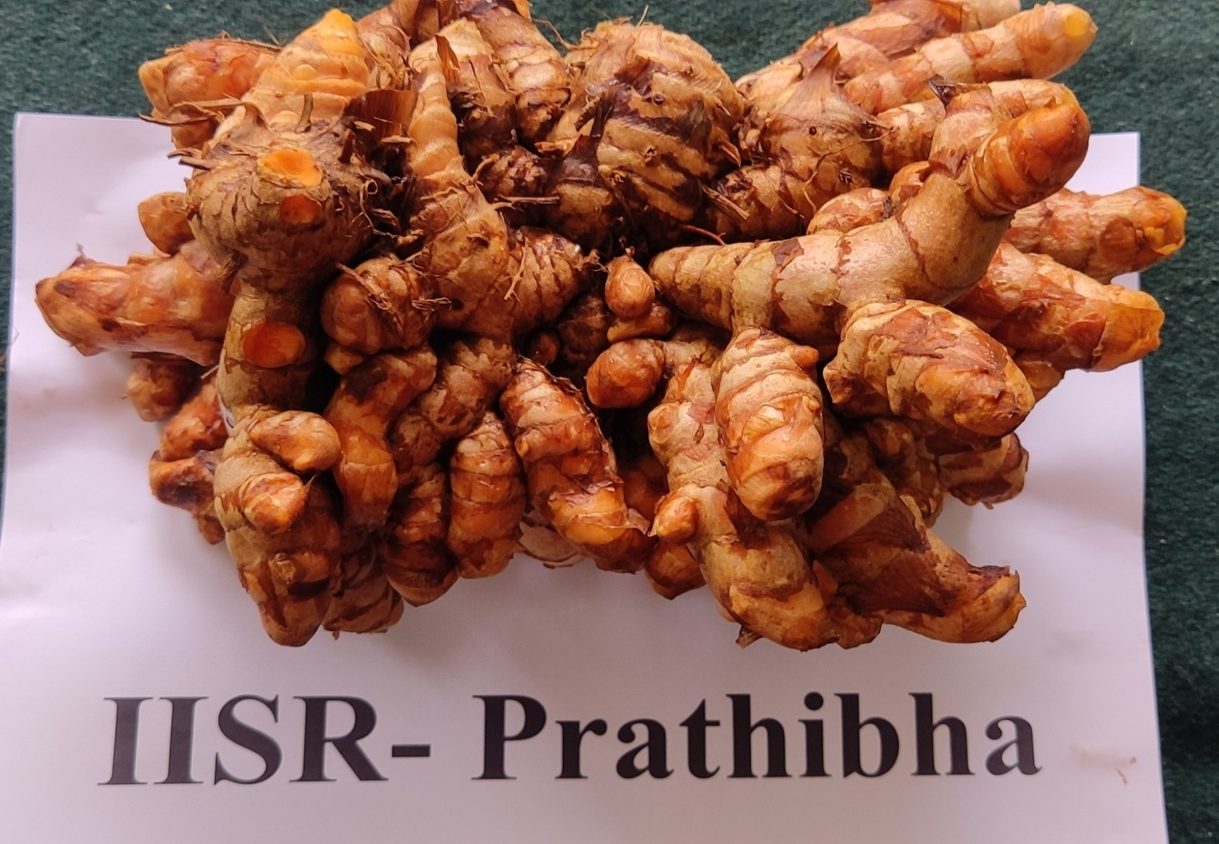

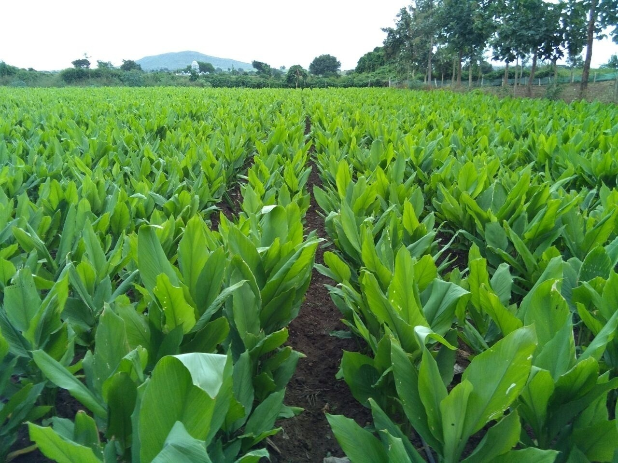

Fig 1: IISR Pratibha field view and Rhizome

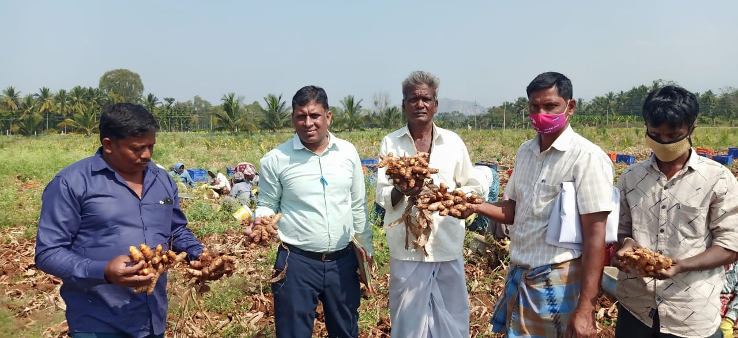

Fig 2: IISR Pratibha Seed production block at Nagavalli, Chamarajanagar
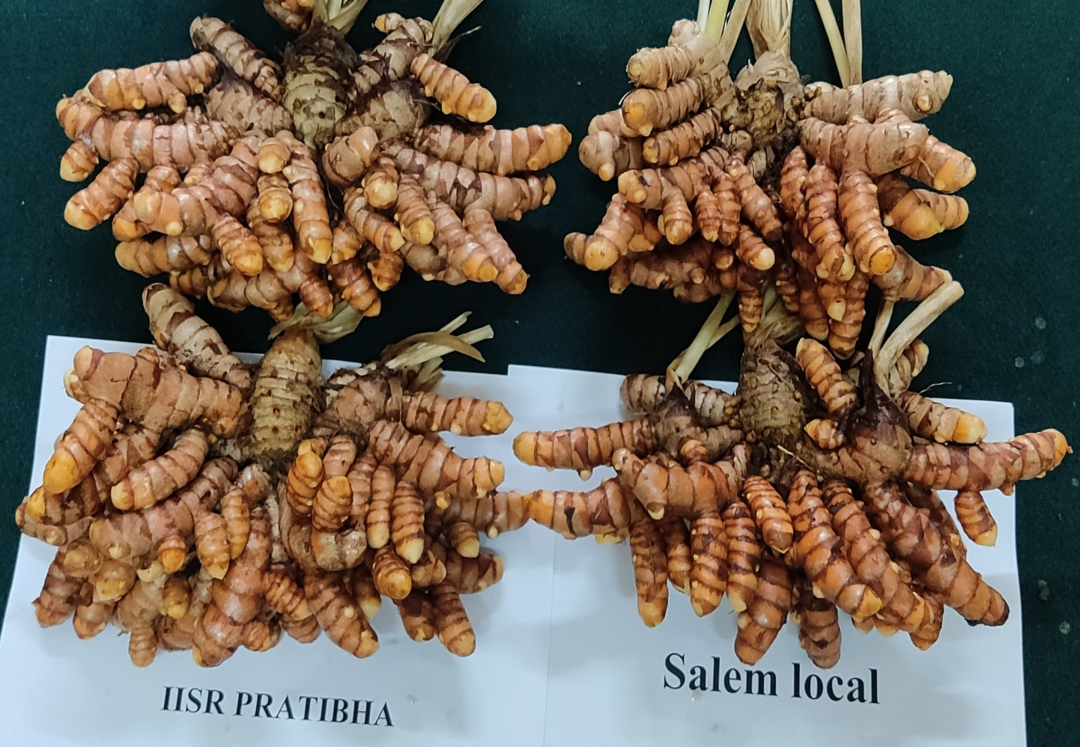

Fig 3: Comparision of IISR Pratibha v/s Salem local rhizomes

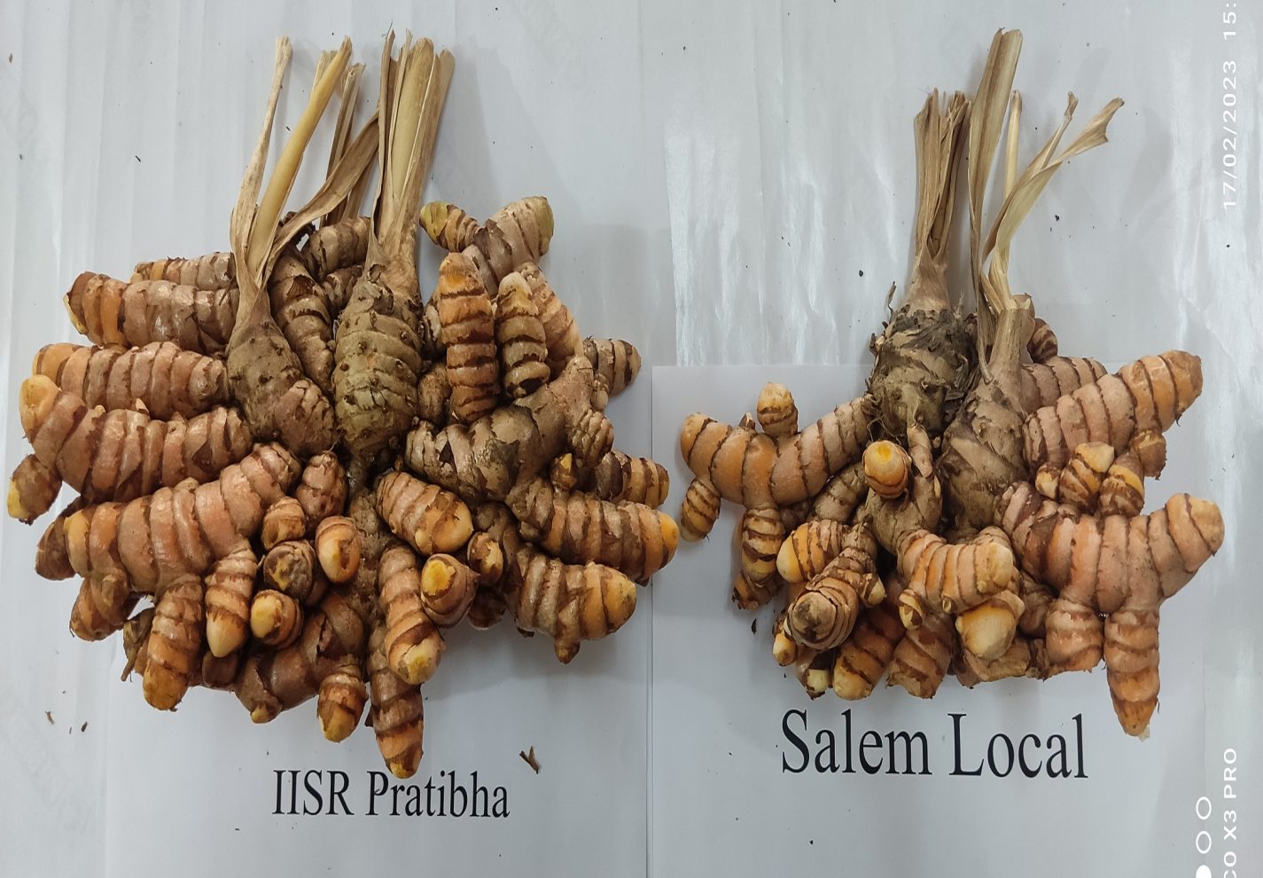

Fig 4:Comparision of IISR Pratibha v/s Salem local rhizomes
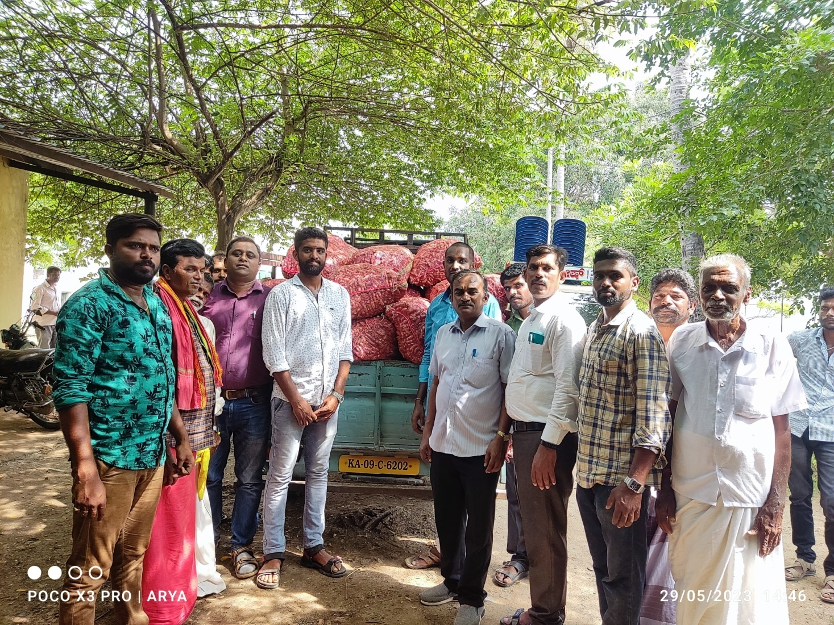

Comparision of IISR Pratibha v/s Salem local rhizomes

Fig 5: IISR Pratibha seed distributed to farmers through FLD

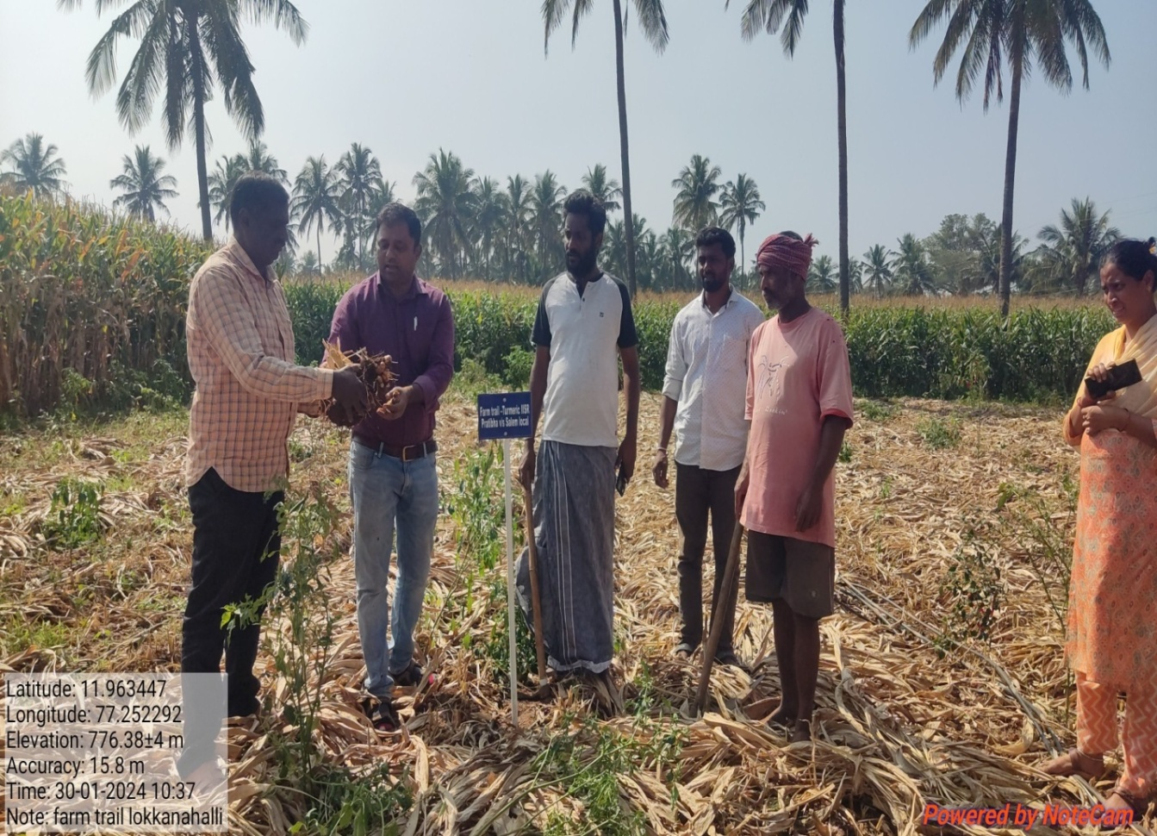

Fig 6: IISR Pratibha seed production block visit by Horticulture department officials
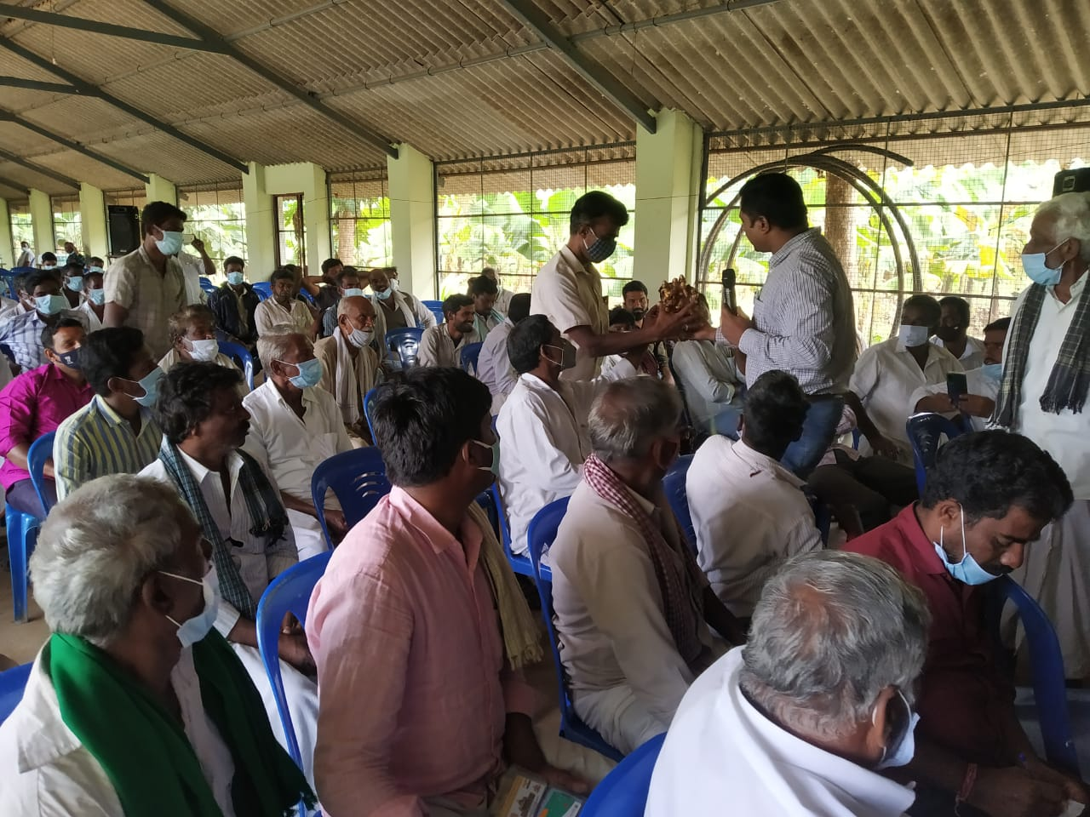

Fig 7: Capacity building programme

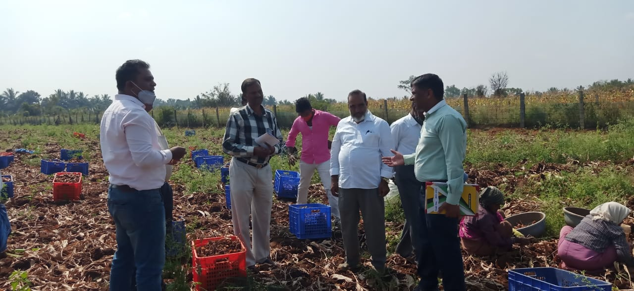

Fig 8: IISR Pratibha seed production block
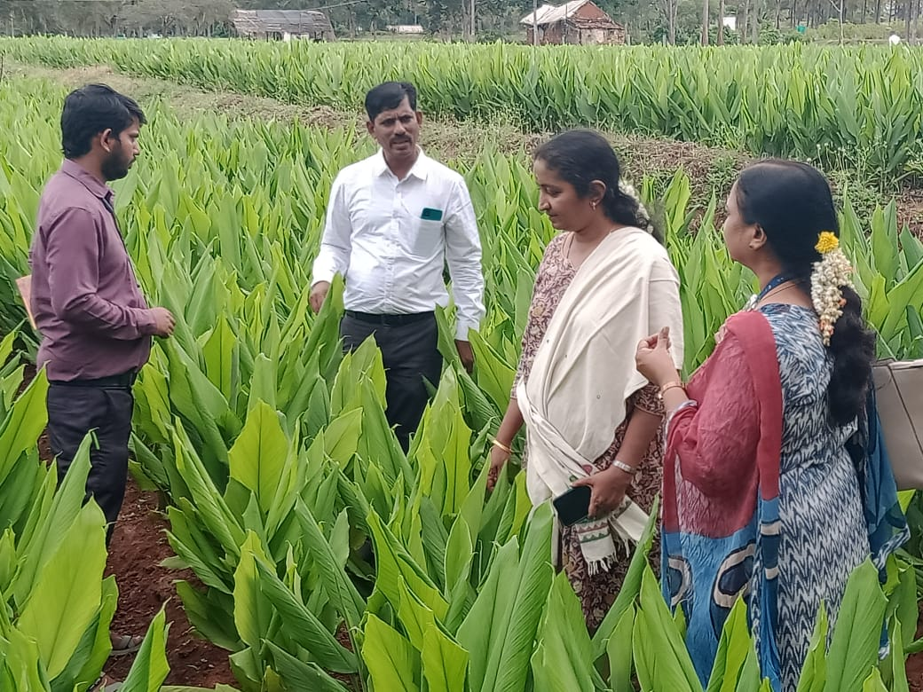

Fig 9: IISR Pratibha seed production block visit by NABARD officials

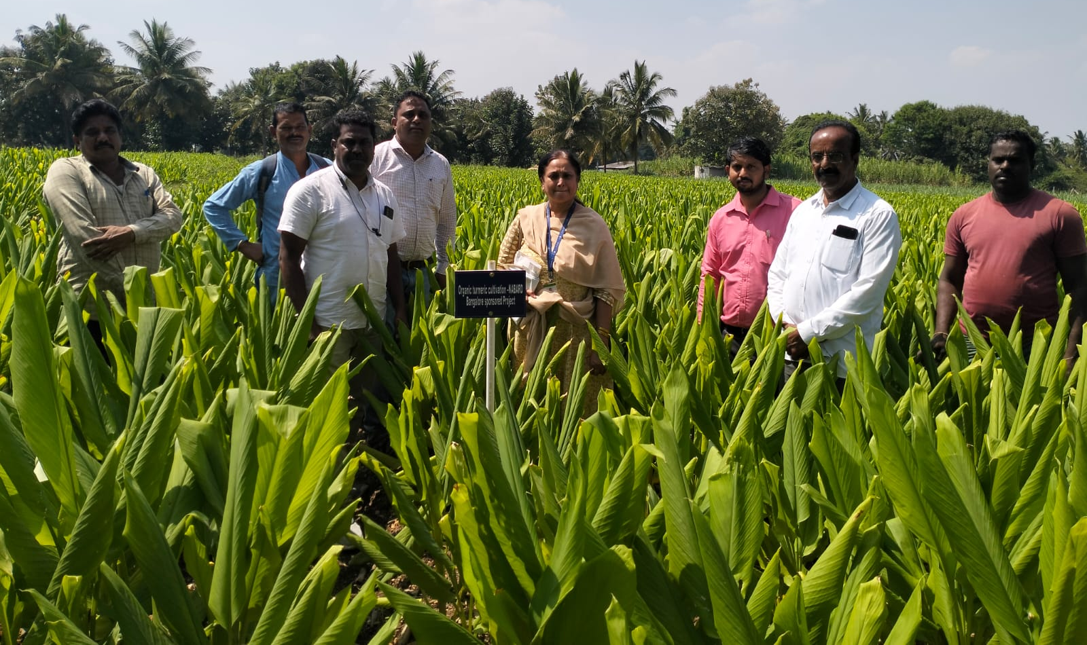

Fig 10: IISR Pratibha seed production block visit by Horticulture department officials
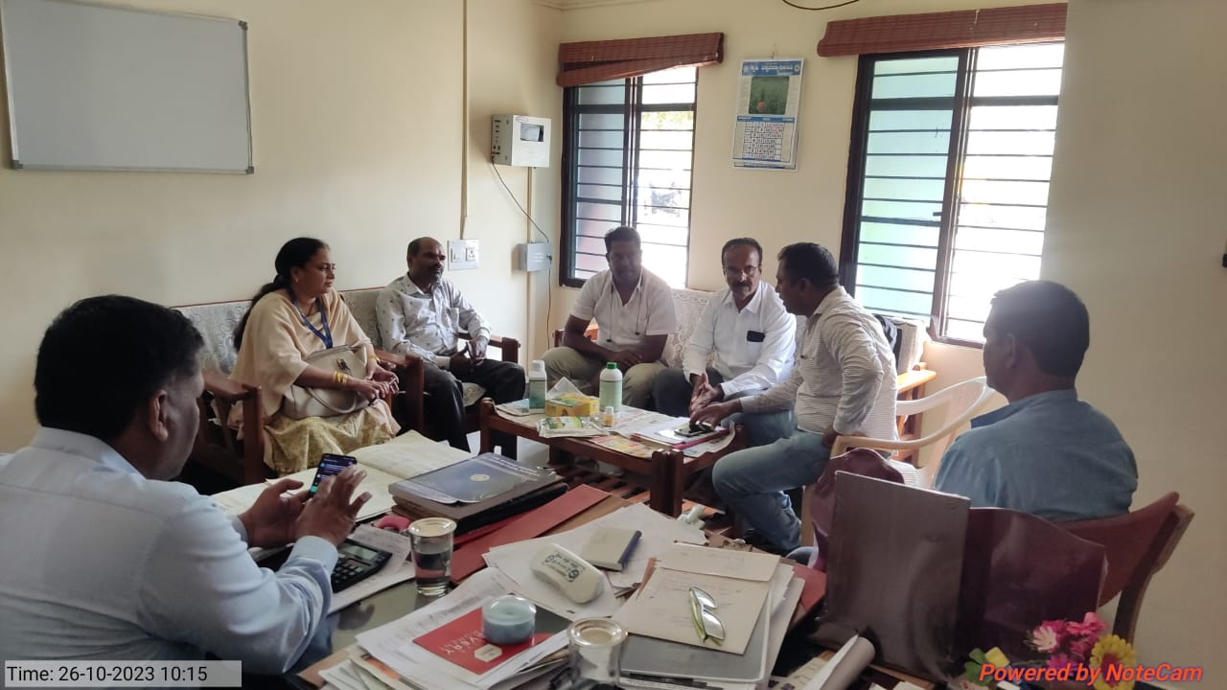

Fig 11: Meeting with Horticulture department officials regarding seed production activities

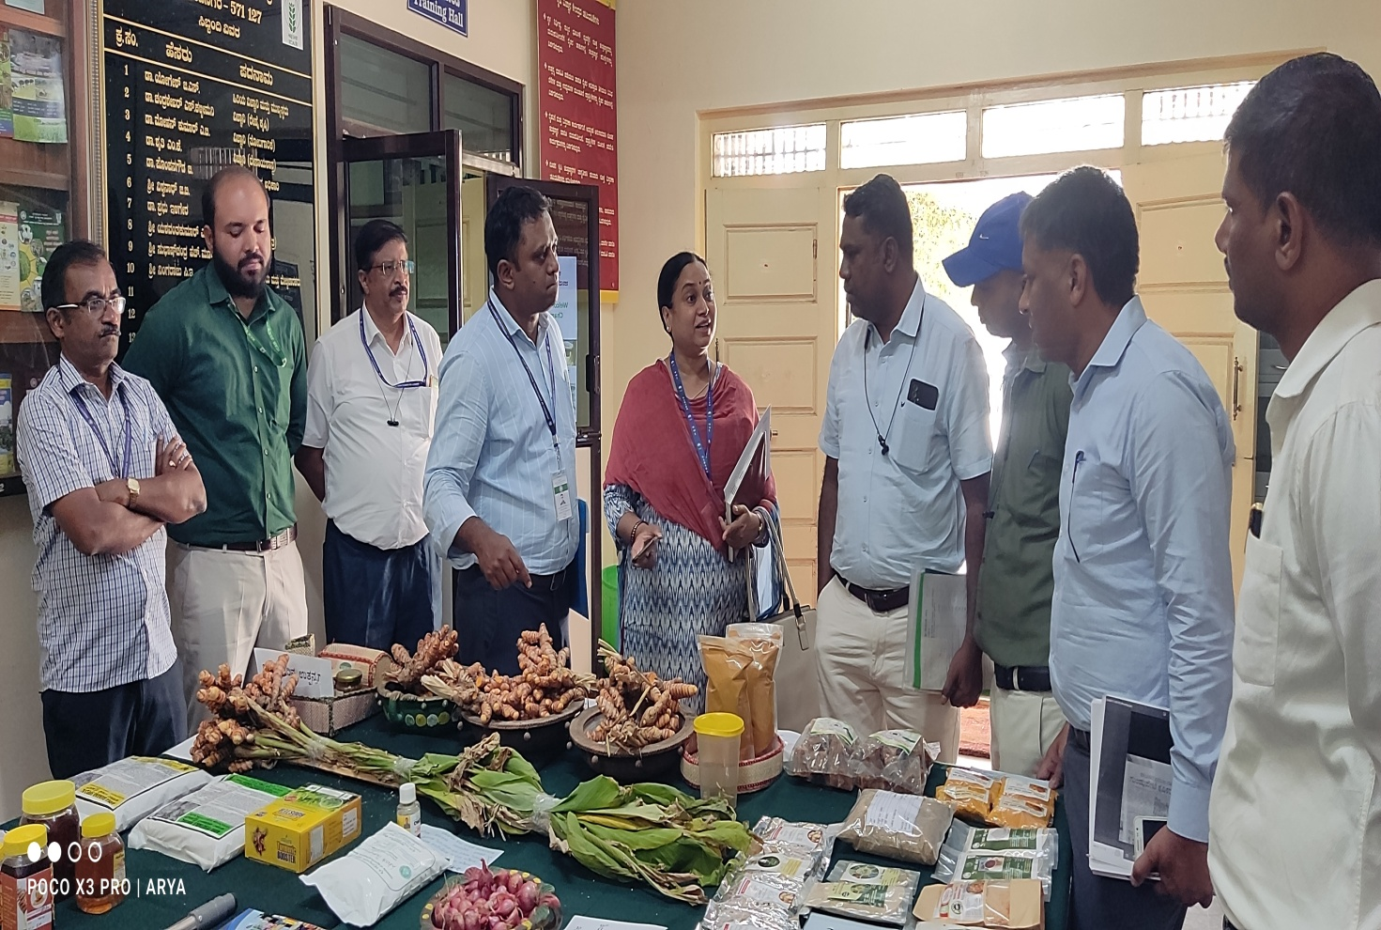

Fig 12: Exhibition of IISR Pratibha to Horticulture department officials
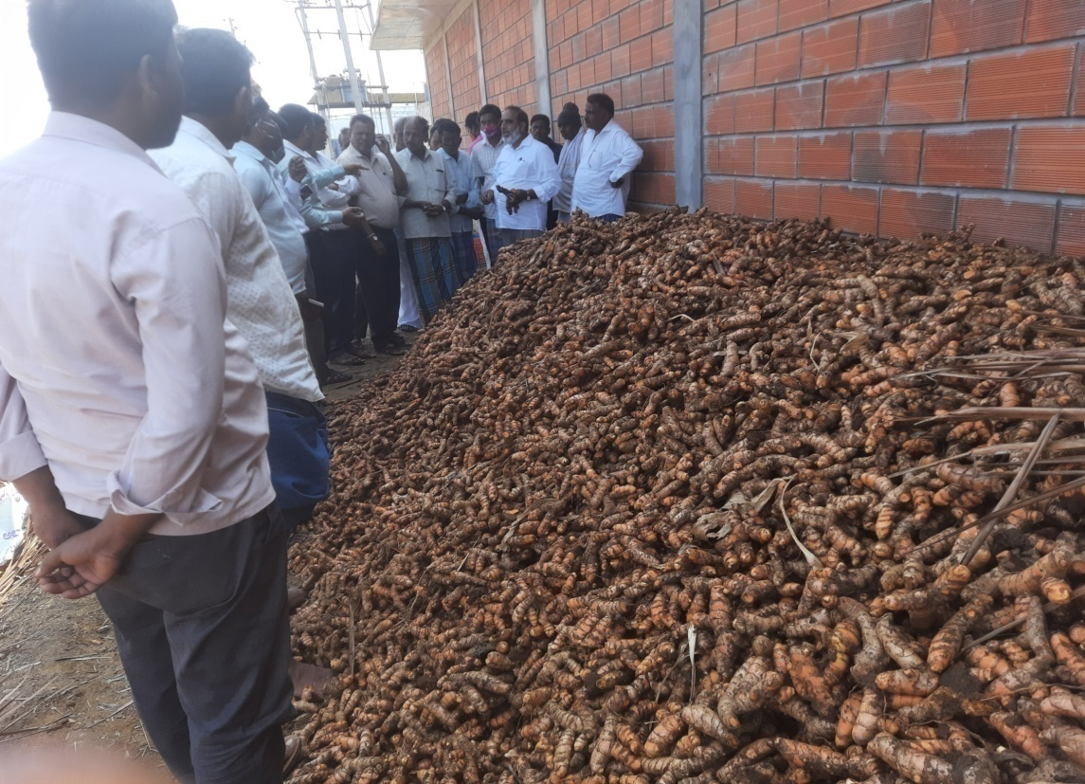

Fig 13: IISR Pratibha seed production block

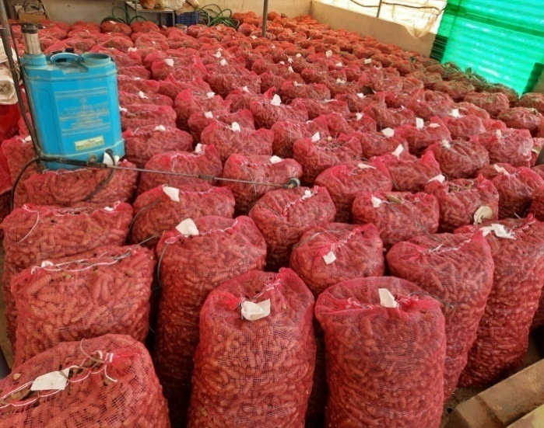

I
FIg 14: ISR Pratibha seed storage
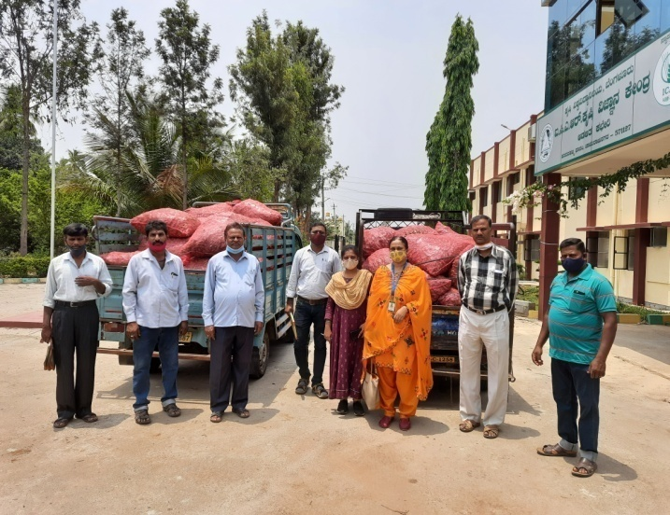

Fig 19: ISR Pratibha seed distribution to Souharda FPO Ankanashettipura

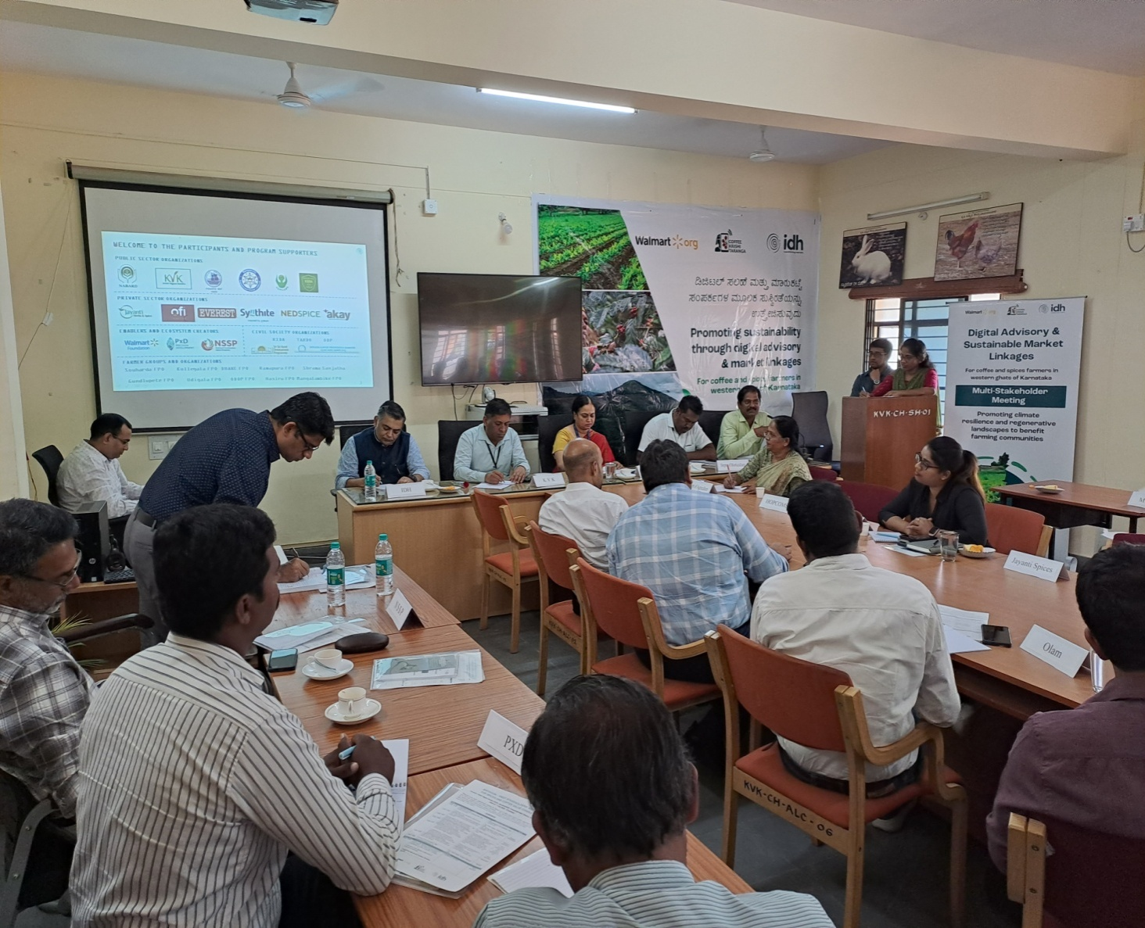

Fig 20: Buyer sellers meet- for promotion of IISR Pratibha turmeric

