Oral Trichomoniasis in Black Kites (Milvus migrans) and Domestic pigeons (Columba livia domestica): Clinical Manifestations and Therapeutic Strategies

ABSTRACT
Oral trichomoniasis, caused by Trichomonas gallinae, is a common protozoal infection in black kites and domestic pigeons. This study examined 200 birds (140 black kites, 60 pigeons) for clinical signs, lesions, and treatment outcomes. The infection rate was higher in pigeons (75%) than in black kites (17.8%). Clinical signs included dehydration (68.57%), anorexia (64.29%), and oropharyngeal lesions (55.71%), with pigeons showing more severe symptoms, including neurological signs. Necropsy revealed caseous necrosis in the oral cavity and digestive tract, with lesion severity linked to mortality. Metronidazole was more effective, achieving 100% recovery in mild cases and 75% in moderate cases, whereas Sulfamethoxazole-Trimethoprim showed limited efficacy. Early detection and prompt treatment are essential to reducing mortality.
Key words: Trichomonas gallinae, Black kite, Domestic pigeon, Oral lesions, Metronidazole, Sulfamethoxazole-Trimethoprim

INTRODUCTION
Trichomoniasis, caused by Trichomonas gallinae, is a widespread protozoal disease primarily affecting pigeons, doves, and raptors. The infection targets the upper digestive tract, often leading to severe oropharyngeal lesions, malnutrition, and mortality (Borji et al., 2011). While Columbiformes serve as the primary reservoirs, raptors typically acquire the parasite by preying on infected birds, a condition commonly referred to as "Frounce" (Mesa et al., 1961). The disease manifests as caseous plaques or "canker" in the oral cavity and oesophagus, which can obstruct the digestive tract, causing starvation and death. Despite its long history in pigeons and doves, trichomoniasis has gained recognition as an emerging threat in wild bird populations, with periodic outbreaks reported in Europe and North America (Chavatte et al., 2019; Robinson et al., 2010). Young birds are particularly susceptible, often succumbing to severe infections before developing immunity. While antiprotozoal treatments such as metronidazole, ronidazole, and carnidazole have been widely used, drug resistance and inconsistent efficacy in wild birds pose significant challenges (Boal et al., 1993; Miller et al., 2017). Research has predominantly focused on domestic pigeons due to their accessibility, leaving gaps in understanding its prevalence and impact in raptors such as black kites. This study aims to bridge this gap by evaluating the clinical features, lesion distribution, and therapeutic responses in black kites and domestic pigeons, contributing valuable insights to avian medicine and conservation efforts.
The present study was undertaken with statutory approvals to ensure compliance with ethical and legal guidelines. Permission was granted by the Wildlife Warden and the Principal Chief Conservator of Forests, Wildlife, Gujarat State, under Approval No. WLP/RTC/TE-1/C/710-11/2023-24 for the study period 2023–24. All research activities were carried out in compliance with the guidelines and regulations outlined by the approving authorities.
MATERIALS AND METHODS
The research work was conducted at the Department of Veterinary Clinical Medicine in collaboration with Jivdaya Charitable Trust (JCT), Panjarapole, Ahmedabad.
Collection of samples
Samples were collected from rescued birds admitted to Jivdaya Charitable Trust, Panjarapole, Ahmedabad, most of which had been found injured or exhibiting signs of morbidity, such as lethargy and reluctance to fly. A total of 200 birds were screened for Trichomonas infection during the study period, out of these, 36 birds (18 black kites and 18 domestic pigeons) were randomly selected for the therapeutic study.
Pathological Criteria for the Description of Lesions
Birds were observed for clinical signs such as poor body condition, difficulty in swallowing, regurgitation, loss of appetite, and abnormal head or neck movements, including circling or head rotation. Physical examinations included evaluation of feather condition and detection of oral plaques, lesions, or crop distension.
Gross lesions in the oropharyngeal cavity were classified based on size, depth, and anatomical location for both live and dead birds, according to the criteria described by Martínez-Herrero et al. (2020) (Table.1).
Table 1: Classification of lesions in oropharyngeal trichomoniasis (Martínez-Herrero et al., 2020)
Criteria | Mild | Moderate | Severe
Size | Lesions <50% of tracheal opening | Lesions 50–100% of tracheal opening | Lesions >100% of tracheal opening
Depth | Superficial lesions, easily removable necrotic material | Deep lesions with necrotic material extending into soft tissues | Very deep lesions extending to cartilage and/or bone
Location | Choanal slit or tip of tongue | Beak angle, palate, infundibular cleft, or eye | oesophagus, crop, base of tongue, or skull
The categorization was as follows:
- Size: size of the lesions in relation to the tracheal opening and classified as mild, moderate, or severe, based on the extent of involvement in the oropharyngeal cavity. Lesions were classified as mild when they measured less than 50% of the size of the tracheal opening, moderate when they measured between 50% and 100% of its size, and severe when they measured larger than 100% of the tracheal opening.
- Depth: Lesions were classified based on the extent of necrosis, ranging from superficial to deep, often extending into underlying tissues like cartilage or bone.
- Anatomical Location: Lesions were categorized based on their location in the oropharyngeal cavity, with critical areas like the oesophagus, crop, or skull considered severe due to their association with potentially fatal outcomes.
Overall, consistency was noted among the three criteria, though discrepancies occurred in some cases. Cases were categorized as moderate if at least one criterion was moderate and none were severe. Cases where at least one criterion was severe and the others moderate were classified as severe. In instances of significant inconsistency (one mild, one moderate, and one severe), the cases were categorized as moderate (Martínez-Herrero et al., 2020).
Diagnostic Methods
- Hanging Drop Method: Fresh oral swabs were microscopically examined for motile T. gallinae trophozoites.
- PCR Confirmation: DNA was extracted from oral swabs and subjected to PCR amplification targeting the ITS1-5.8S-ITS2 region of T. gallinae.
Treatment Protocol
The therapeutic management of Trichomonas infection was carried out with standard therapies. Trichomonas positive 24 infected birds (12 kites and 12 pigeons) were randomly divided into four groups (Groups A, B, C, and D) for therapeutic management, each consisting of six birds. Six kites and six pigeons were selected as healthy controls, as shown in table 2. Supportive therapy in the form of parenteral fluid, analgesic/anti-inflammatory, vitamin-B complex, antioxidants-vitamin C was given as per the requirement of bird.

Table 2: Protocols for therapeutic management of trichomonas infection for 5 days
Treatment | Dose | Healthy  Control |  | Trichomonas Positive Therapeutic groups
Treatment | Dose | Black kite | Pigeon | Pigeon |  | Black kite
Treatment | Dose | (n=6) | (n=6) | A  (n=6) | B  (n=6) | C  (n=6) | D  (n=6)
Metronidazole | 30 mg/kg BW BID P/O for 5 days | -----
Sulphamethoxazole -trimethoprim | 30 mg/kg BW BID P/O for 5 days | -----
Efficacy assessment was done by monitoring the birds for their appetite to feed and water, persistence or disappearance of oropharyngeal lesions and grading of oral lesion was done as severe/more (+++), moderate (++), mild/less (+) and absent (-).
Estimation of parasite concentration in the throat swabs at day 0 and day 7 was done for confirmation on the presence/ absence of parasites, if any. Throat swab for parasite was counted as high (+++), medium (++), less (+) and absent.
RESULTS AND DISCUSSION
A total of 200 birds (140 black kites and 60 domestic pigeons) were screened for Trichomoniasis, out of them 70 birds were found positive by the gold standard test PCR with an overall prevalence of 35.00 per cent. In pigeon, the prevalence was recorded as high as 75.00 per cent (45/60) and in black kite, it was 17.86 per cent (25/140). Statistically, the percentage prevalence of Trichomoniasis in domestic pigeon was highly significant (p <0.001) by Chi square analysis.
Clinical signs and lesions of trichomonas infection
Among the 70 birds examined, dehydration was the most prevalent sign (68.57%), followed by ruffled feathers and anorexia (64.29% each). Oropharyngeal lesions were seen in 55.71 per cent of birds, with mild (24.29%), moderate (17.14%), and severe (11.43%) forms, while 44.29 per cent showed no visible lesions, indicating that trichomoniasis can occur even without characteristic signs. Body condition varied, with 67.14 per cent of birds maintaining a normal condition despite infection, though 32.86 per cent were emaciated. Other notable signs included regurgitation, drooling of saliva, and puffed-up mouth appearance, with pigeons exhibiting a higher prevalence overall. Neurological symptoms such as head rotation and torticollis (17.14% and 11.43%, respectively) and ocular signs like oedematous eyes and discharge (11.43% and 8.57%, respectively) were less frequent. The higher prevalence and severity of signs in pigeons, known reservoirs of Trichomonas gallinae, compared to Black kites, which likely acquire the infection through predation, highlight species-specific differences in disease dynamics.
Figure 1 & 2: Moderate oropharyngeal lesions in oral cavity of domestic pigeon and Black kite affected with trichomoniasis
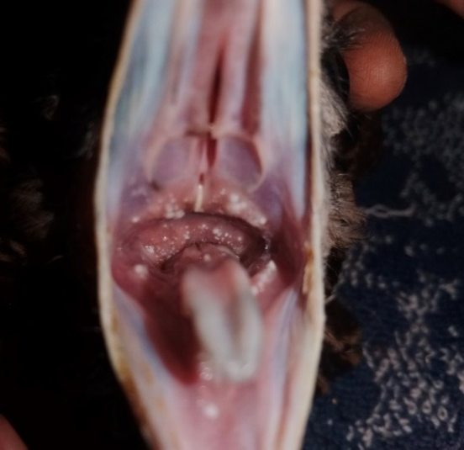
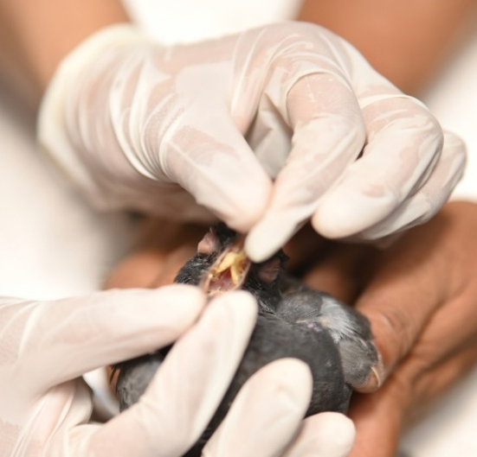

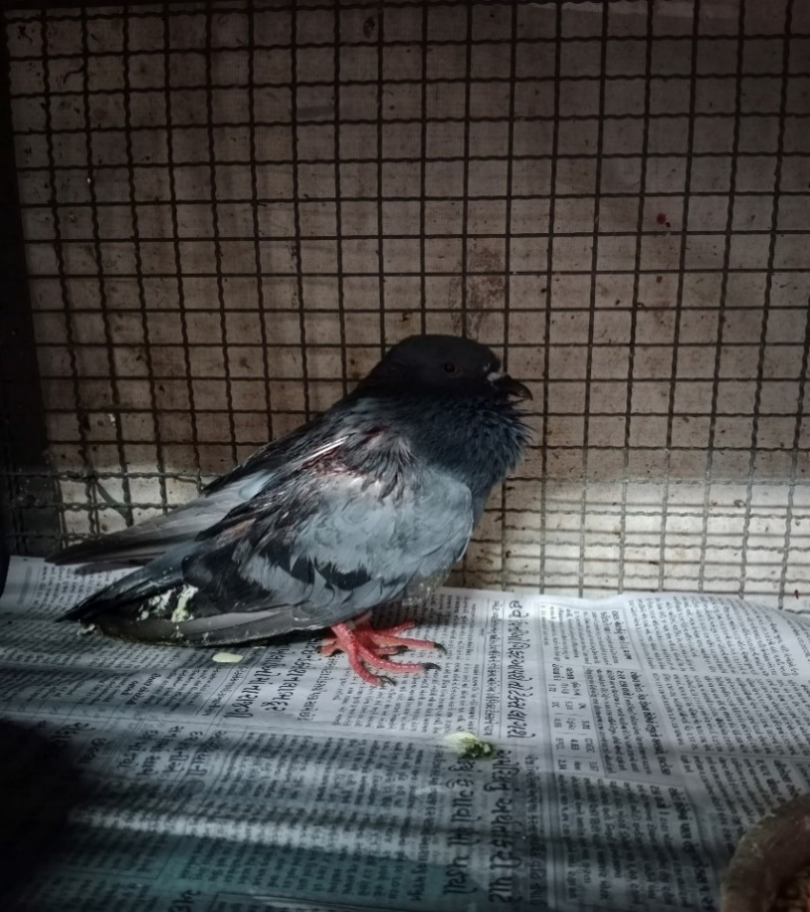  Fig.4.12 Purulent ocular discharge in black kite |  | 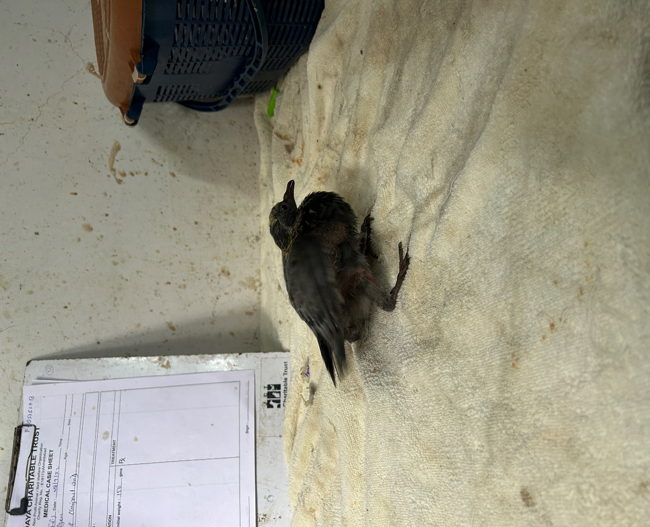  Fig.4.12 Purulent ocular discharge in black kite
Figure 3: Ruffled feathers in adult domestic pigeon affected with trichomoniasis |  | Figure 4: Pendulous crop in squab affected with trichomoniasis
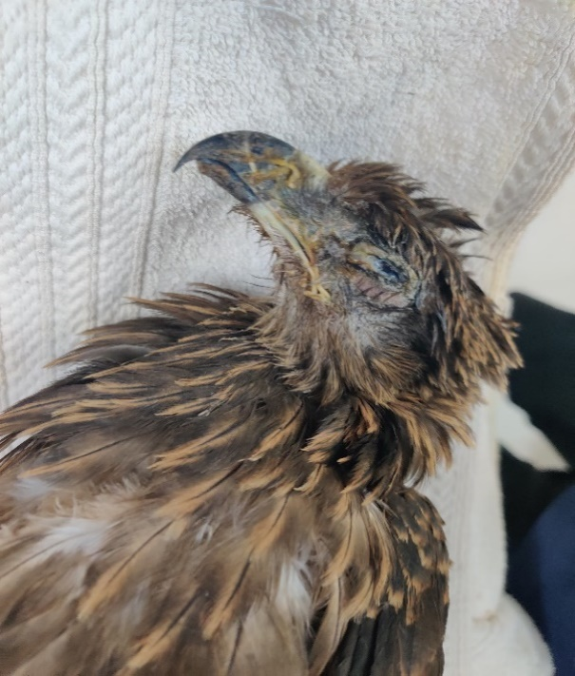 |  | 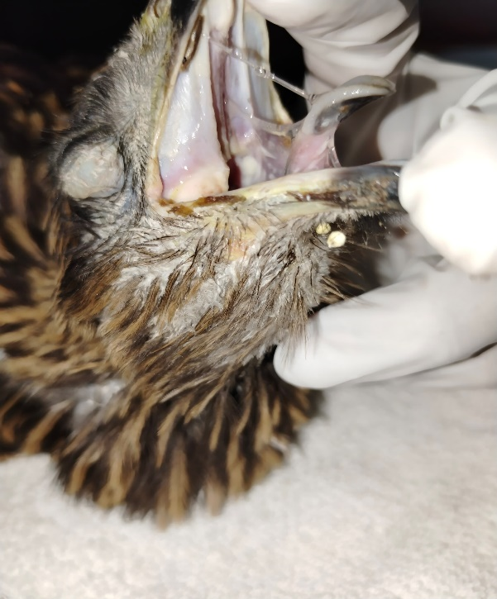
Figure 5: Purulent ocular discharge in black kite affected with trichomoniasis |  | Figure 6: Swollen neck in black kite affected with trichomoniasis

Clinical Presentation of Trichomonas Infection Based on Severity of Lesions
In present study among the 45 pigeons and 25 black kites diagnosed Trichomonas positive but lesions were observed in 25 pigeons and 17 black kites. Gross lesions in the oropharyngeal cavity were classified based on size, depth, and anatomical location for both live and dead birds, according to the criteria described by Martínez-Herrero et al. (2020) (Table. 3)
Table 3: Clinical Presentation of trichomonas infection based on severity of lesions domestic pigeon (Columba livia domestica) and black kite (Milvus migrans)
Species | Severity | Depth | Anatomical Location | Cases (%) | Mortality (%)
Pigeons (n=25) | Mild | Superficial | Choanal slit/tongue | 12 (48%) | 03 (25%)
 | Moderate | Deep | Upper/Lower jaw | 08 (32%) | 03 (37.5%)
 | Severe | Very deep | Oesophagus/  crop | 05 (20%) | 04 (80%)
Black Kites (n=17) | Mild | Superficial | Choanal slit/tongue | 06 (35.3%) | 02 (33.33%)
 | Moderate | Deep | Upper/Lower jaw | 03 (17.6%) | 02 (66.67%)
 | Severe | Very deep | Oesophagus | 08 (47.1%) | 07 (87.5%)
In the present study, the relationship between lesion severity and mortality in pigeons and black kites was analysed, revealing a clear increase in mortality as the severity of the lesions worsened. Pigeons with mild lesions had a 25 per cent mortality rate, moderate lesions resulted in 37.5 per cent mortality, and severe lesions led to 80 per cent mortality. Similarly, black kites with mild lesions showed 33.33 per cent mortality, moderate lesions led to 66.67 per cent mortality, and severe lesions resulted in 87.5 per cent mortality.
These findings indicate a strong correlation between severity of lesions and mortality across both species, with the mortality rate increasing significantly as lesion severity escalated, especially in severe lesions affecting the oesophagus and crop.

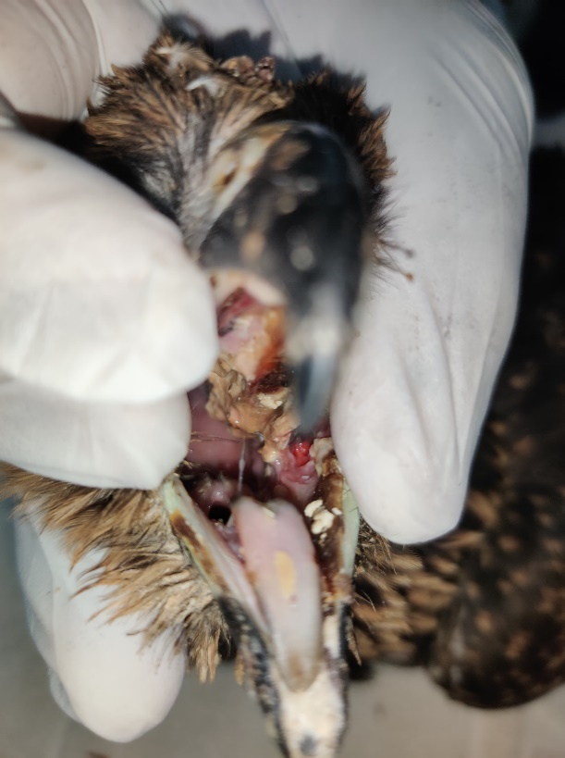 |  | 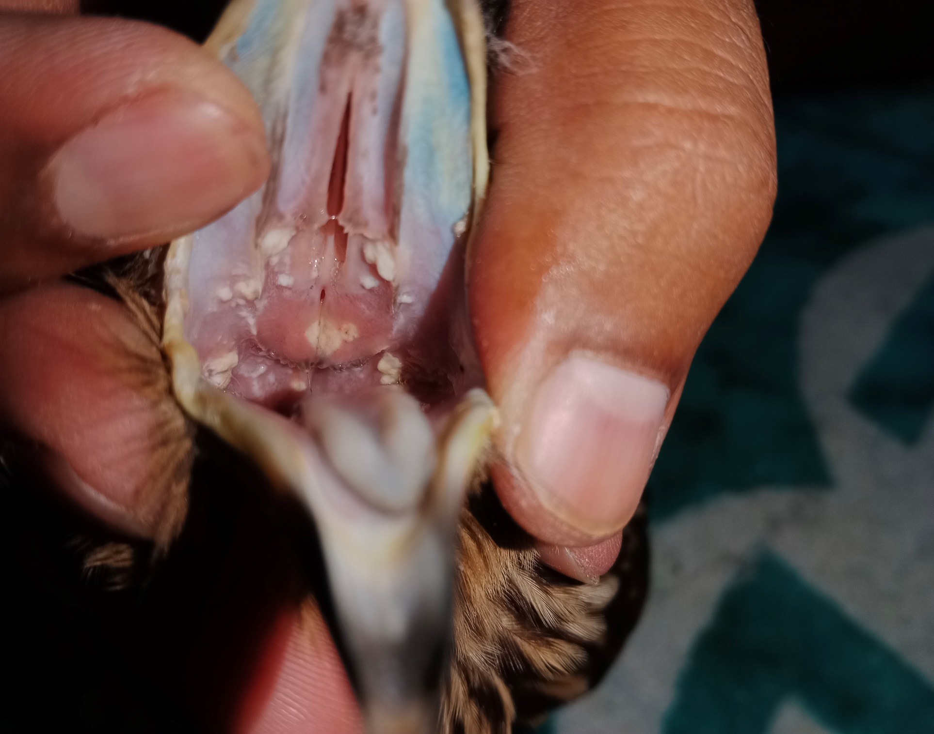
Figure 6: Very deep severe caseous necrotic lesions at upper jaw and base of the tongue in black kite affected with trichomoniasis |  | Figure 7: Multifocal moderate oropharyngeal lesions in oral cavity of black kite affected with trichomoniasis
a |  | 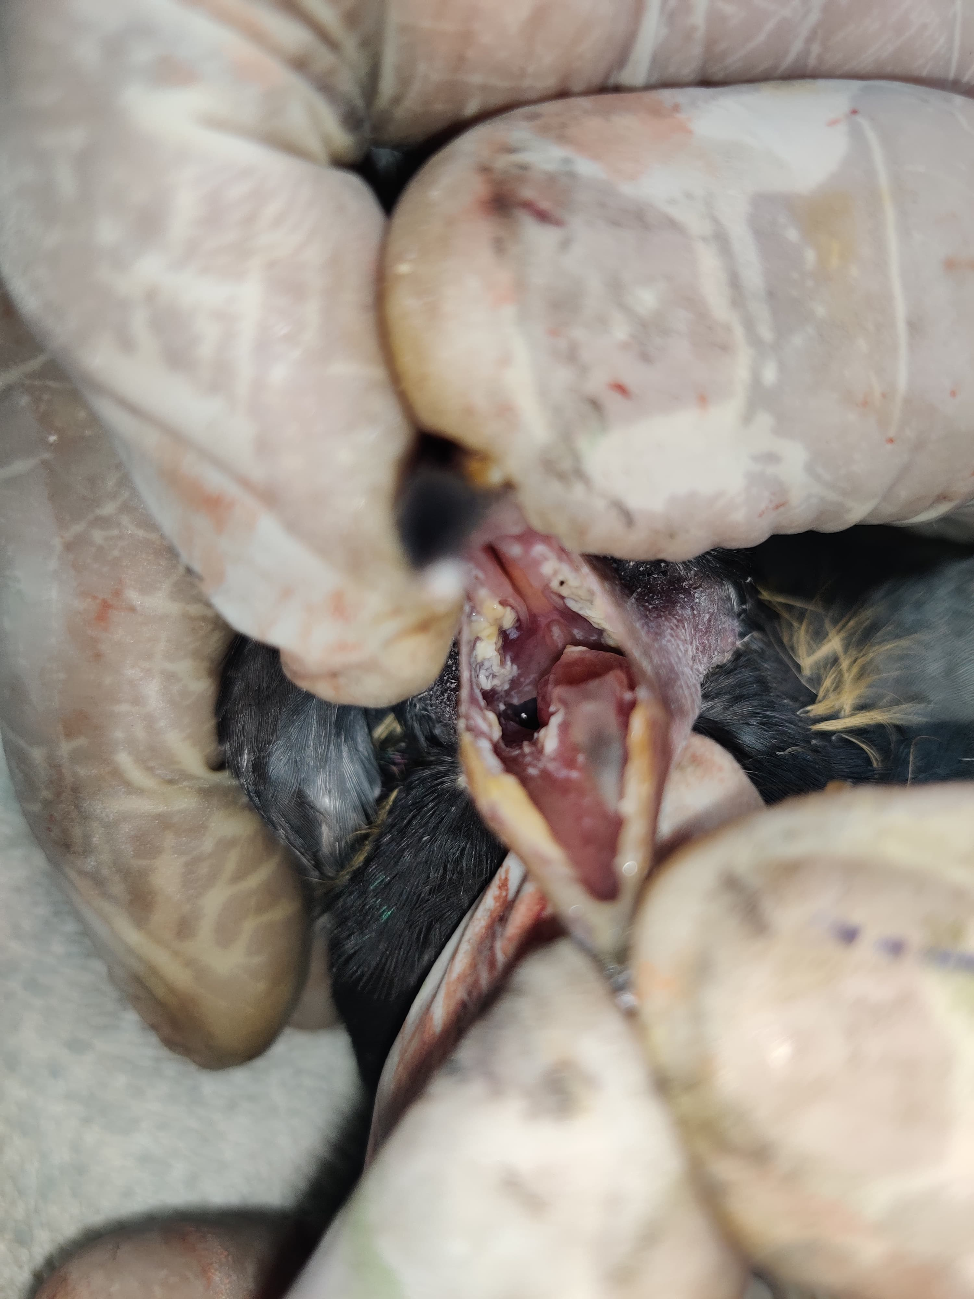  b
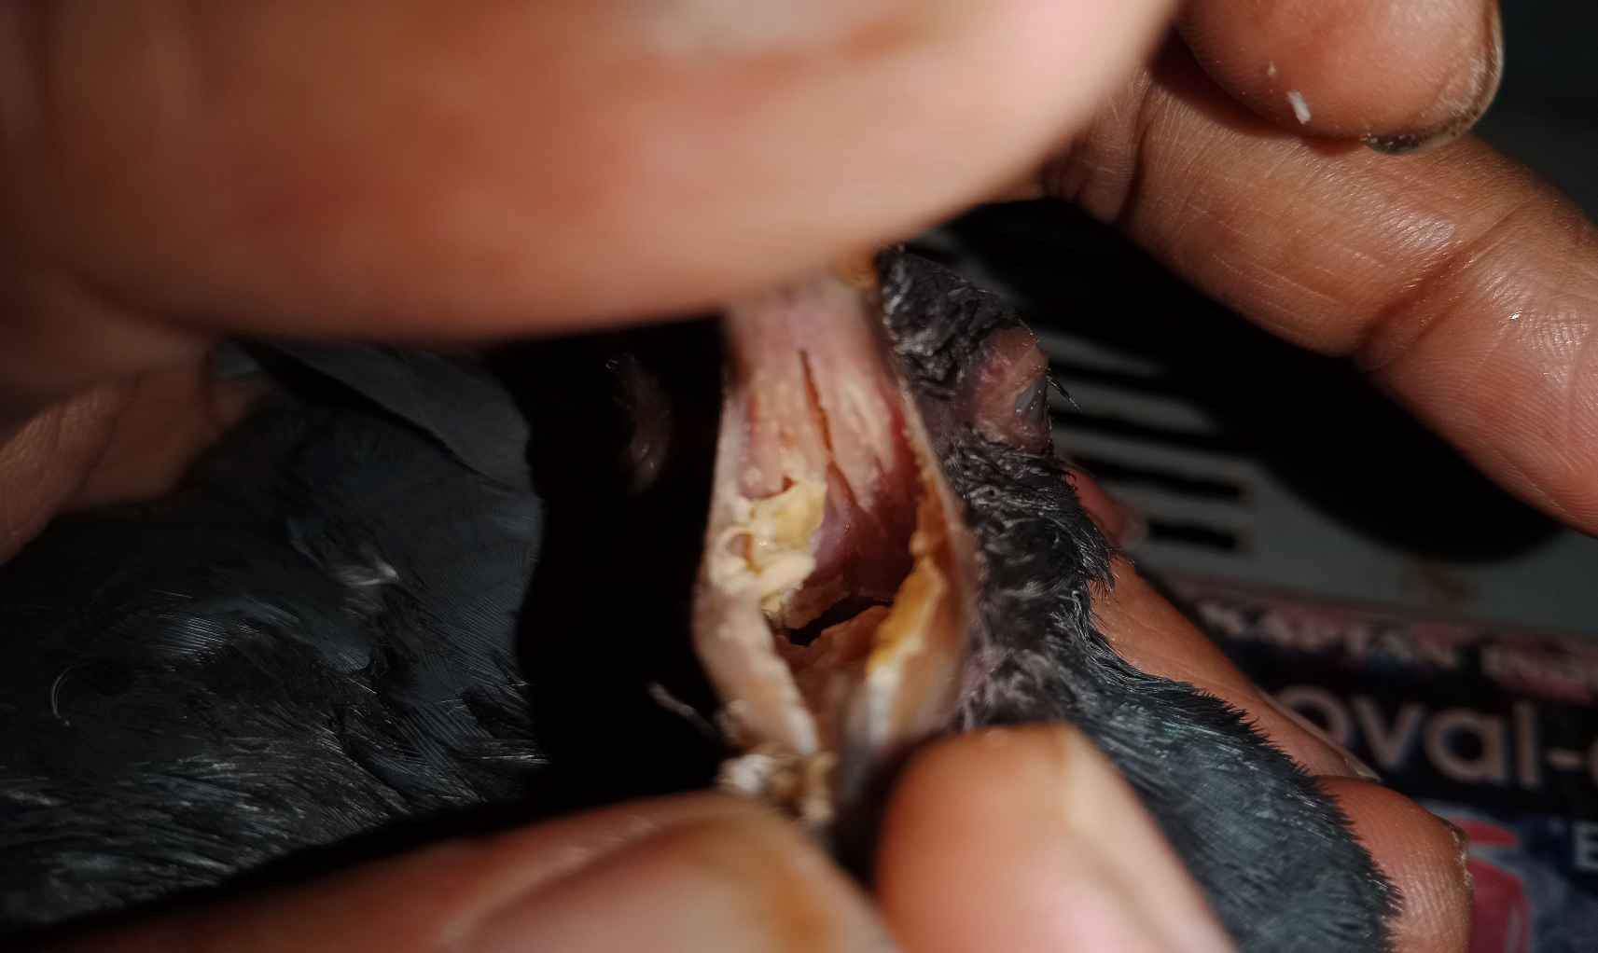
Figure 8 (a, b): Multifocal severe caseous oropharyngeal lesions in oral cavity of domestic pigeons affected with trichomoniasis

THERAPEUTIC MANAGEMENT
The therapeutic efficacy of Metronidazole and Sulfamethoxazole-Trimethoprim was evaluated in Trichomonas-positive pigeons and black kites (Tables 4 and 5). In pigeons treated with Metronidazole (Group A), mild cases achieved complete recovery by Day 5, with lesion grades and parasite loads reducing to absent (-), resulting in 100% efficacy. Moderate cases showed partial recovery, with lesion grades improving to absent (-) and efficacy reaching 75%. Severe cases exhibited some improvement, with lesion grades reducing from severe (+++) to moderate (++), but complete recovery was not achieved, yielding an efficacy of 50%.
Similarly, black kites treated with Metronidazole (Group C) showed excellent outcomes in mild cases, achieving 100% efficacy. Moderate cases improved partially, with lesion grades reducing to mild (+), yielding an efficacy of 75%. Severe cases showed limited improvement, with lesion grades reducing slightly and parasite loads decreasing, resulting in 50% efficacy in some cases, while others showed no improvement.
In pigeons treated with Sulfamethoxazole-Trimethoprim (Group B), mild cases showed partial recovery, with lesion grades reducing to absent (-) and an efficacy of 50%. However, severe and most moderate cases showed no improvement, with lesion grades remaining at moderate to severe (++/+++), showing its ineffectiveness. Similarly, black kites treated with Sulfamethoxazole-Trimethoprim (Group D) showed minimal efficacy, with mild cases achieving partial or complete recovery (50–100% efficacy), but moderate and severe cases exhibited no significant improvement, highlighting the limited utility of this drug.
Table: 4 Therapeutic efficacy of metronidazole (Group A) and Sulfamethoxazole-Trimethoprim (Group B) in treatment of trichomoniasis in domestic pigeon
 | Bird No. | Severity | Day 1 | Day 5 | Lesion Grade (Day 1) | Lesion Grade (Day 5) | Recovery | Efficacy (%)
A | 1 | Severe | +++ | + | +++ | ++ | Partial | 50
A | 2 | Moderate | ++ | - | ++ | - | Partial | 75
A | 3 | Mild | + | - | + | - | Complete | 100
A | 4 | Severe | +++ | ++ | +++ | +++ | None | 0
A | 5 | Moderate | ++ | + | ++ | + | Partial | 50
A | 6 | Mild | + | - | + | - | Complete | 100
B | 1 | Moderate | ++ | ++ | ++ | + | None | 0
B | 2 | Moderate | ++ | + | ++ | + | Partial | 50
B | 3 | Mild | + | - | + | - | Partial | 75
B | 4 | Severe | +++ | ++ | +++ | +++ | None | 0
B | 5 | Moderate | ++ | ++ | ++ | ++ | None | 0
B | 6 | Mild | + | - | + | - | Partial | 50
Table 5: Therapeutic efficacy of metronidazole (Group C) and Sulfamethoxazole-Trimethoprim (Group D) in treatment of trichomoniasis in black kite
Group | Bird No. | Severity | Day 1 | Day 5 | Lesion Grade (Day 1) | Lesion Grade (Day 5) | Recovery | Efficacy (%)
C | 1 | Severe | +++ | - | +++ | ++ | Partial | 50
C | 2 | Moderate | ++ | - | ++ | + | Partial | 75
C | 3 | Mild | + | - | + | - | Complete | 100
C | 4 | Severe | +++ | ++ | +++ | +++ | None | 0
C | 5 | Moderate | ++ | ++ | ++ | ++ | None | 0
C | 6 | Mild | + | - | + | - | Complete | 100
D | 1 | Severe | +++ | +++ | +++ | +++ | None | 0
D | 2 | Moderate | ++ | + | ++ | + | Partial | 50
D | 3 | Mild | + | - | + | - | Complete | 100
D | 4 | Moderate | ++ | ++ | ++ | ++ | None | 0
D | 5 | Moderate | ++ | ++ | ++ | ++ | None | 0
D | 6 | Mild | + | - | + | - | Partial | 50

Several studies supported the efficacy of Metronidazole against Trichomonas spp., with Saikia et al. (2016) and Biswas et al. (2010) reporting 100% efficacy in both in vitro and in vivo conditions. Our findings corroborate these results, demonstrating 100% recovery in mild cases and partial improvement in moderate cases in pigeons and black kites. However, severe infections showed a limited response, suggesting the need for extended treatment.
Overall, Metronidazole demonstrated superior efficacy in both pigeons and kites, particularly in mild to moderate cases, achieving partial or complete recovery. However, its efficacy in severe infections remained limited, suggesting that extending the duration of treatment or exploring combination therapies may improve outcomes. Sulfamethoxazole-Trimethoprim was less effective, primarily benefiting mild cases, with minimal or no impact on moderate and severe infections. Mortality in severe cases further limited its utility.
CONCLUSION
Dehydration, anorexia, and oropharyngeal lesions were common signs of infection, with pigeons showing more severe symptoms, including regurgitation, drooling, and neurological signs like head rotation. The severity of lesions correlated strongly with mortality in both domestic pigeons and black kites, with higher mortality rates in birds with severe lesions, highlighting the importance of early diagnosis and intervention. Metronidazole was more effective than Sulfamethoxazole-Trimethoprim in treating Trichomonas infections, leading to significant recovery in both haematological parameters and lesion severity, especially in mild to moderate cases. However, its limited efficacy in severe cases suggests that extending the treatment duration or exploring combination therapies may improve outcomes, offering a more comprehensive therapeutic approach for severe infections.

REFERENCES
Biswas, P G.; Begum, N.; Mamun, M.A.A.; Bari, M. A. and Mondal, M. M. H. (2010). Efficacy of herbal and commercially available antiprotozoal drugs on pigeon trichomoniasis. International Journal of Biological Research., 2(11): 29-33.
Boal, C. W., Mannan, R. W., & Hudelson, K. S. (1993). Trichomoniasis in Cooper's hawks (Accipiter cooperii) in Arizona. Journal of Wildlife Diseases, 29(2), 364-366. https://doi.org/10.7589/0090-3558-34.3.590.
Borji, H.; Razmi, G. H. and Movassaghi, A.H. (2011). Prevalence and pathological lesion of Trichomonas gallinae in pigeons of Iran. Journal of Parasitic Diseases., 35(2):186-189.
Chavatte, J.M.; Philippe, G.; Esperet, D.; Place, G.; Cavalier, F. and Lardau, I. (2019). An outbreak of trichomoniasis in European green finches Chloris chloris and European gold finches Carduelis Carduelis Wintering in Northern France. Parasitology, 26: 21.
Martínez-Herrero, M. D. C., Sansano-Maestre, J., Ortega, J., González, F., López-Márquez, I., Gómez-Muñoz, M. T., & Garijo-Toledo, M. M. (2020). Oral trichomonosis: Description and severity of lesions in birds in Spain. Veterinary Parasitology, 283, 109196. https://doi.org/10.1016/j.vetpar.2020.109196
McDougald, L. R. (1992). Other protozoan diseases in the intestinal tract, In: Diseases of Poultry. Hofstad, M.S. (Ed.), 8th Edition, Panima Educational Book Agency, New Delhi, India, pp. 723-725.
Mesa, C.P.; Stabler, R.M. and Berthrong. M. (1961). Histopathological changes in the domestic pigeon infected with Trichomonas gallinae (Jones' barn strain. Avian Diseases., 5: 48-60.
Miller, E. A., Njaa, B. L., & Thomasy, S. M. (2017). Emerging infectious diseases in pigeons and doves. Veterinary Clinics of North America: Exotic Animal Practice, 20(2), 365-375. https://doi.org/10.1016/j.cvex.2017.01.011
Robinson, R.A; Lawson, B.; Toms, M.P; Peck, K.M.; Kirkwood, J.K. Chantrey, J. (2010). Emerging infectious disease leads to rapid population declines of common British birds. PLoS ONE, 5:122-125.
Saikia, M. (2016). Studies on protozoa infection of domestic pigeon (Columba livia domestica) in Assam. M.V.Sc. Thesis, Assam Agricultural University, Khanapra, Guwahati-22.
Stabler, R.M. (1948a). Protection in pigeon against virulent Trichomonas gallinae acquired by infection with milder strains. Journal of Parasitology., 34: 150-153.
Stabler, R.M. (1948b). Variations in virulence of strains of Trichomonas gallinae in pigeons. Journal of Parasitology., 34(2):147-149.

