In-situ Identification of a person through Mobile DNA Analysis

Abstract
Mobile DNA analysis aims to enable rapid, on-site genetic profiling by integrating the processes of DNA extraction, amplification, separation, and detection into portable, automated systems that can function effectively outside traditional laboratory environments. Traditional forensic DNA analysis is often time-consuming and centralized, leading to processing delays and laboratory backlogs. There is a growing need for faster, field-deployable systems capable of delivering reliable DNA results in real time for applications in law enforcement, border security, disaster victim identification, outbreak response, and humanitarian operations. Traditional forensic DNA analysis is often time-consuming and centralized, leading to processing delays and laboratory backlogs. There is a growing need for faster, field-deployable systems capable of delivering reliable DNA results in real time for applications in law enforcement, border security, disaster victim identification, outbreak response, and humanitarian operations. The implementation of mobile DNA technologies has demonstrated significant reductions in turnaround time and improved efficiency in forensic and biological analyses. These systems have proven effective in generating accurate, database-compatible genetic profiles in field conditions, helping reduce laboratory workloads while maintaining data reliability and legal admissibility. Mobile DNA analysis represents a transformative advancement bridging the gap between traditional laboratory-based profiling and real-time field operations. Its advantages include speed, portability, and real-time data generation; however, challenges such as high costs, environmental limitations, restricted sample types, and concerns over data security and ethical governance must be addressed for its widespread adoption. Overall, this innovation marks a paradigm shift in forensic and genomic applications, promoting faster and more accessible human identification and genetic analysis.
Key word; DNA, STR markers, ANDE, Rapid HIT id system, oxford nanopore sequencing

Introduction
DNA analysis has become an indispensable tool in forensic science, human identification, biomedical research, and public security applications. Since the 1990s, traditional DNA profiling using Short Tandem Repeat (STR) markers has been regarded as the gold standard for human identification due to its high discriminatory power, reproducibility, and international acceptance. (Padmanabhan & Sainath, 2022)
In conventional DNA profiling workflows, DNA is first extracted from biological samples, quantified, and then amplified through multiplex PCR. The amplified fragments are analysed using capillary electrophoresis to produce a unique STR profile, which can be compared with national or international databases such as CODIS. In contrast, rapid and mobile DNA analysis technologies—such as the ANDE Rapid DNA System, Rapid HIT ID, and Oxford Nanopore Minion—integrate DNA extraction, amplification, separation, and detection within automated, cartridge-based or portable sequencing platforms. These systems can process samples like buccal swabs and generate complete genetic profiles in under two hours with minimal technical expertise.(Kayser & de Knijff, 2011)
Rapid DNA and portable sequencing platforms have demonstrated the ability to produce reliable, database-compatible STR profiles or sequencing data in field conditions. These systems significantly reduce turnaround time, alleviate forensic laboratory backlogs, and provide actionable results in time-sensitive situations such as border security checks, disaster victim identification, and outbreak monitoring.(Politza et al., 2024)
Traditional STR-based laboratory analysis is highly accurate and legally validated but demands sophisticated infrastructure, trained personnel, and long processing times of 24 to 72 hours, making it unsuitable for real-time decision-making. Modern mobile DNA analysis systems, on the other hand, emphasize speed, portability, and automation, enabling genetic profiling directly at the point of need. However, they also face challenges such as higher operational costs, limited sample compatibility, environmental sensitivity, and ethical and legal concerns regarding data security and admissibility. Despite these challenges, mobile DNA analysis represents a paradigm shift toward decentralized, on-site genetic testing—combining the reliability of traditional STR methods with the efficiency of modern rapid systems.(Jobling & Gill, 2004)

Traditional DNA Analysis Using STR Markers
Short Tandem Repeats (STRs) are highly polymorphic regions in the human genome consisting of short sequences of 2–6 base pairs repeated in tandem. The number of repeat units varies greatly among individuals, making STRs powerful genetic markers for human identification. Traditional DNA analysis using STR markers follows a multi-step laboratory-based process. Initially, DNA is extracted from biological materials such as blood, saliva, hair roots, or other tissue samples. The extracted DNA is then quantified to ensure sufficient quality and concentration for downstream applications. Polymerase Chain Reaction (PCR) is subsequently employed to amplify multiple STR loci simultaneously using fluorescently labelled primers, a process known as multiplex PCR. Following amplification, the resulting fragments are separated according to size using capillary electrophoresis (CE), during which an electric field drives DNA fragments through a polymer-filled capillary, and a laser excites the fluorescent dyes attached to the primers. The emitted fluorescence is detected, generating an electropherogram that displays distinct peaks corresponding to the allele sizes at each STR locus. These allele calls are then compiled into a DNA profile unique to the individual.

(Fig 1: Procedure of DNA Extraction)

STR-based DNA analysis has become the gold standard in forensic genetics due to its high discriminatory power, reproducibility, and compatibility with national DNA databases such as CODIS (Combined DNA Index System).(Luo et al., 2024) Its advantages include the ability to analyse highly degraded samples, high sensitivity requiring only nanogram amounts of DNA, and standardized loci sets that allow for inter-laboratory comparisons. However, traditional STR analysis has certain limitations: the process is time-intensive, often requiring 24–72 hours from sample to result; it requires specialized laboratory infrastructure and trained personnel; and complex or mixed DNA samples can present interpretation challenges. Despite these limitations, STR analysis remains the cornerstone of forensic DNA typing and continues to be widely used for criminal investigations, paternity testing, missing person identification, and disaster victim identification worldwide.(Nwawuba Stanley et al., 2020)

Modern Techniques
- ANDE Rapid DNA System
The ANDE Rapid DNA system is a fully automated platform designed to perform rapid Short Tandem Repeat (STR) profiling for forensic and human identification purposes. The system is composed of four integrated components: the ANDE swab, the consumable chip, the ANDE 6C instrument, and the automated Expert System. Together, these components allow for sample-to-result DNA analysis with minimal operator intervention.
Chip Types and Functions
There are two types of consumable chips used in the ANDE system: the A-Chip and the I-Chip.
The A-Chip processes up to five buccal swab samples and, when used in combination with the ANDE instrument and Expert System, has received NDIS (National DNA Index System) approval for searching and uploading DNA profiles to CODIS, provided that buccal samples are processed in accredited laboratories.
The I-Chip was developed for casework and disaster victim identification (DVI) samples. It is a single-use, disposable consumable that incorporates all necessary reagents, buffers, materials, and waste containment required to perform fully automated STR analysis of up to four samples. A key difference between the two chips is that the I-Chip integrates a sample concentration module downstream of the purification module, enabling concentration of DNA prior to PCR amplification. This results in a lower limit of detection for the I-Chip, making it more suitable for challenging forensic samples.
Both chips contain preloaded reagents specifically optimized for the system’s microfluidic environment, including DNA purification reagents, Flex Plex PCR reagents, separation polymer, and buffers. This ensures consistent, balanced, and precise results across different sample types.(Ragazzo et al., 2020)
Flex Plex Assay
The ANDE system employs the Flex Plex assay, which was developed to ensure compatibility with DNA databases worldwide. This assay includes 23 autosomal STR loci (D1S1656, D2S1338, D2S441, D3S1358, D5S818, D6S1043, D7S820, D8S1179, D10S1248, D12S391, D13S317, D16S539, D18S51, D19S433, D21S11, D22S1045, FGA, CSF1PO, Penta E, TH01, VWA, TPOX, and SE33), three Y-chromosomal STR loci (DYS391, DYS570, and DYS576), and the Amylogenic marker for sex determination.(Carney et al., 2019)
Operation and Data Analysis
Operation of the ANDE system is fully automated. Once the chip containing samples is inserted into the ANDE 6C instrument and the door is closed, processing begins automatically. The workflow includes DNA purification, multiplex PCR amplification, electrophoretic separation, and laser-based detection of the amplified STR fragments. The system’s Expert System software automatically analyses and interprets the data, providing rapid feedback regarding the quality and usability of the STR profiles for database enrolment and searching. Although the system is designed for automation, the output files are available for optional review by a qualified DNA analyst, ensuring compliance with forensic standards (Fig.2). (Laurin et al., 2023).

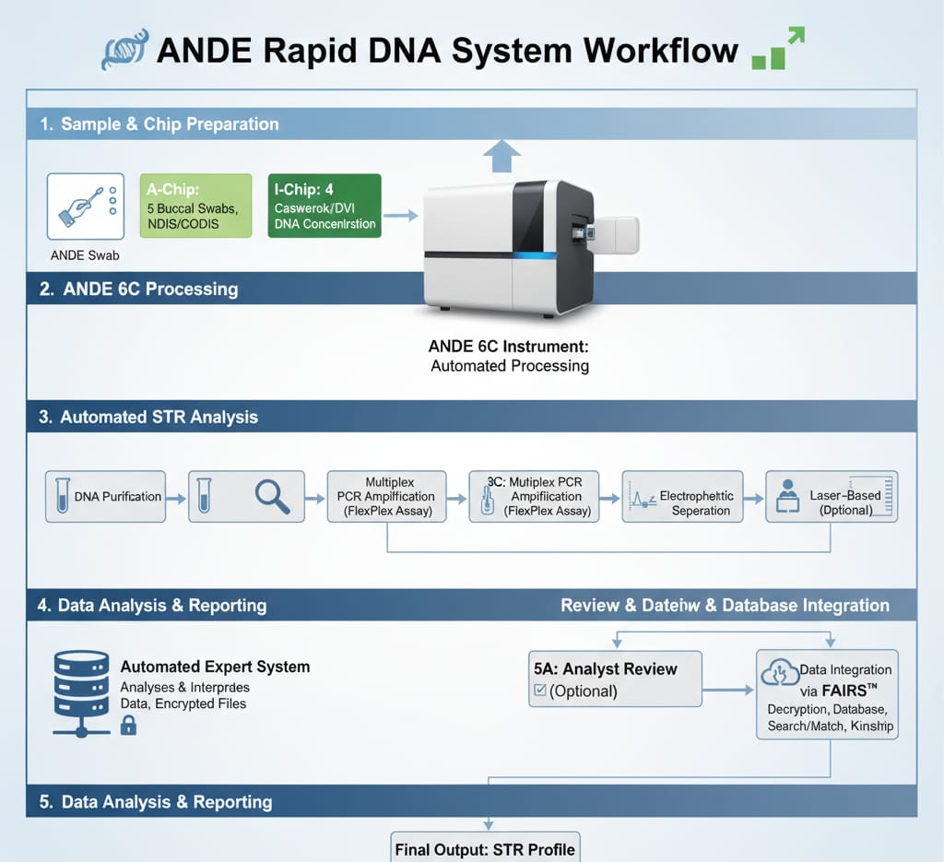

(Fig 2: Procedure of ANDE Rapid DNA Identification System)

Data Security and Database Integration
All output files generated by the ANDE system are encrypted for security. These files can be exported and decrypted using FAIRS™ (Forensic Analysis Infrastructure and Reporting System), a multi-functional, multi-tiered software package. FAIRS not only supports decryption and review but also integrates functions such as database generation and management, search and match capabilities, and kinship determination.(Chen et al., 2017)

2. Rapid HIT ID system
The Rapid HIT ID system is an advanced, fully automated rapid DNA analysis platform developed by Thermo Fisher Scientific to generate DNA profiles in approximately 90 minutes.(Salceda et al., 2017) Unlike conventional DNA profiling, which requires extensive laboratory infrastructure and trained personnel, the Rapid HIT ID integrates all stages of the DNA workflow—including extraction, amplification, separation, and detection—within a single-use cartridge. This closed, sample-to-answer system enables the direct processing of biological materials, most commonly buccal swabs, with minimal human intervention. Its portability and ease of use make it suitable for deployment outside traditional forensic laboratories, including police booking stations, border security checkpoints, disaster victim identification sites, and military operations. The generated STR profiles are compatible with established national databases such as CODIS, allowing for rapid identification and investigative leads. While the system offers significant advantages in terms of speed, efficiency, and reducing laboratory backlogs, it is primarily optimized for reference samples and may be less effective with degraded or mixed crime scene samples. Furthermore, considerations regarding cost, legal admissibility, and ethical implications of rapid DNA testing continue to influence its widespread adoption. Overall, the Rapid HIT ID system represents a transformative tool in forensic science and law enforcement, bridging the gap between field-based identification and traditional laboratory analysis (Fig.3). (Buscaino et al., 2018)
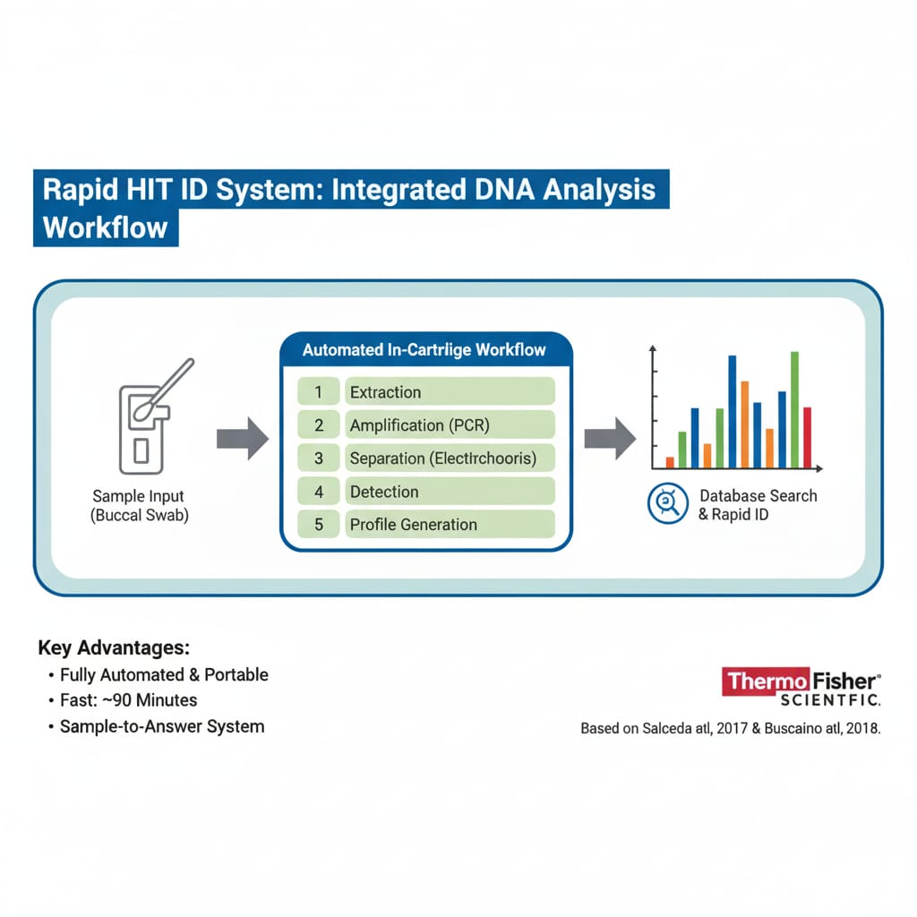

(Fig 3: Procedure of Rapid HIT ID System)

3. Oxford Nanopore Minion
The Oxford Nanopore Minion is a portable DNA sequencing platform that operates on the principle of Nanopore sequencing, in which single DNA or RNA molecules pass through protein Nanopore embedded in a membrane, causing characteristic disruptions in ionic current that are interpreted in real time to determine the nucleotide sequence.(Eisenstein, 2012) In practice, extracted DNA is prepared with adapter molecules, loaded onto a flow cell, and drawn through the Nanopore where electrical signal variations are translated into base sequences by specialized software, allowing rapid and long-read sequencing outside traditional laboratories. The major advantages of the Minion include its pocket-sized portability, low infrastructure requirements, real-time data generation, capacity to read very long DNA fragments, and suitability for field-based applications such as forensic identification, outbreak tracking, and disaster victim analysis (Jain et al., 2016). However, the system also presents limitations, including relatively higher raw error rates compared to short-read sequencing platforms, dependence on careful sample preparation, environmental sensitivity of flow cells, and the need for computational support to process large data outputs. Despite these challenges, the Minion represents a significant advancement in mobile DNA analysis, enabling genomics to be performed in remote, time-sensitive, or resource-limited environments (Fig.4). (Mulero et al., 2008)
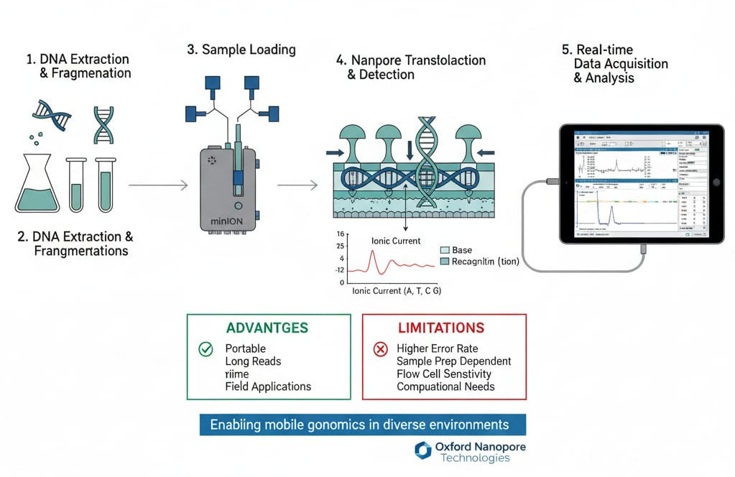

(Fig 4: Procedure of Oxford Nanopore Minion)

Comparison between the techniques
A comparative statement of the referred procedures have been compared and their advantages and shortfalls are mentioned in the Table 1
Table 1: Comparison between the techniques
Feature | ANDE Rapid DNA System | Rapid HIT ID System | Oxford Nanopore MinION
Manufacturer | ANDE Corporation | Thermo Fisher Scientific | Oxford Nanopore Technologies
Technology | Capillary Electrophoresis (CE) of STRs (PCR-based) | Capillary Electrophoresis (CE) of STRs (PCR-based) | Nanopore Sequencing (Current-based base calling)
Output Type | STR Allele Profile (Length-based) | STR Allele Profile (Length-based) | DNA/RNA Sequence (Base-by-base)
Result time | Approx. 90-120 minutes | Approx. 90 minutes | Real-time; Total run time is variable
Forensic Loci | Flex Plex (23 Auto-somal STRs, 3 Y-STRs, Amelogenin) | STR Loci (CODIS compatible) | Sequence-based typing (Full sequence data for STRs, SNPs, mtDNA)
Consumable & Capacity | Disposable A-Chip (up to 5 samples) or I-Chip (≤4 samples) | Single-use Cartridge | Flow Cell (Variable number of Nanopore/reads)
Sensitivity | I-Chip includes a DNA concentration module (Lower LOD) | Optimized for high-quality reference samples (Buccal Swabs) | Highly dependent on DNA input quality and preparation
Portability | Portable | Portable | Pocket-sized/Handheld
Primary Application | Reference Sample Screening; DVI/Casework (I-Chip) | High-throughput Reference Sample Processing (e.g., Booking Stations) | Mobile Genomics, Full Sequence Analysis, Outbreak Tracking

Advantages
Mobile DNA analysis provides significant benefits over traditional laboratory-based profiling, particularly in terms of speed and accessibility. It can generate complete DNA profiles within 60–120 minutes, compared to the 24–72 hours needed for conventional methods. Portable platforms such as the ANDE System, Rapid HIT ID, and Oxford Nanopore Minion allow on-site testing at crime scenes, police booking stations, disaster sites, and border checkpoints, reducing delays caused by sample transport. These systems are automated and user-friendly, requiring minimal technical expertise, which enables rapid decision-making in the field. By handling routine reference samples outside central laboratories, they also help reduce forensic backlogs. Importantly, STR profiles produced by rapid systems are compatible with databases such as CODIS, ensuring utility in global investigations. With additional applications in outbreak monitoring, wildlife forensics, and humanitarian operations, mobile DNA analysis combines speed, portability, and versatility, making it a transformative tool for real-time identification.(Ko et al., 2018)
Limitations
Despite its many advantages, mobile DNA analysis also faces several limitations that affect its widespread adoption. Most rapid systems are optimized for reference samples such as buccal swabs and show reduced efficiency with degraded, mixed, or trace forensic samples, which often require traditional laboratory confirmation. The cost of consumable cartridges and instruments remains relatively high, limiting routine use in many regions. Technical challenges such as sensitivity to environmental conditions, reagent stability, and the need for regular calibration can also restrict deployment in harsh or remote settings. While nanopore sequencing platforms offer real-time long-read data, they have higher raw error rates compared to established laboratory methods. Furthermore, legal and ethical issues including database integration, admissibility of results in court, and concerns about data privacy and misuse pose significant challenges. Thus, while mobile DNA technologies are transformative for rapid identification, they currently serve best as complementary tools rather than replacements for conventional forensic laboratory analysis.(Ram, 2016)

Application
Mobile DNA analysis has found significant real-world applications in forensic science, where rapid and reliable identification is often critical. Law enforcement agencies employ rapid DNA systems at police booking stations to quickly generate STR profiles from arrestees, allowing immediate comparison with national databases such as CODIS for links to unsolved crimes. In disaster victim identification (DVI), portable systems like the ANDE Rapid DNA System enable on-site processing of remains, expediting the identification of victims and assisting in timely family notification. Border security and immigration authorities also use mobile DNA testing to verify claimed biological relationships and detect human trafficking cases. At crime scenes, portable DNA platforms can provide preliminary profiles that help investigators rapidly eliminate suspects or establish investigative leads without waiting for laboratory turnaround. In addition, nanopore sequencing devices such as the Oxford Nanopore Minion extend forensic applications to the analysis of complex or degraded samples, wildlife forensics, and pathogen detection in bioterrorism investigations. These real-world uses demonstrate how mobile DNA analysis enhances the speed and efficiency of forensic processes, providing actionable results directly in the field and strengthening both criminal justice and humanitarian efforts.(Yang et al., 2014)
Future direction
The future of mobile DNA analysis lies in improving sensitivity, reliability, and affordability to expand its use beyond reference samples to complex forensic casework. Advances in microfluidics, sequencing chemistry, and AI-driven data interpretation are expected to enhance accuracy while reducing error rates. Greater portability, handy but bold for field conditions, and integration with secure cloud-based databases will support wider deployment in policing, border security, and humanitarian missions. At the same time, developments in nanopore and next-generation sequencing may allow mobile platforms to deliver comprehensive genomic insights, including degraded or mixed samples, directly in the field. Strengthening legal frameworks, ethical safeguards, and standardization across jurisdictions will also be crucial for broader forensic acceptance.(Tan et al., 2013)

Conclusion
Mobile DNA analysis represents a major advancement in forensic science by bridging the gap between traditional laboratory-based STR profiling and rapid, field-deployable technologies. Systems such as Rapid HIT ID, ANDE, and Oxford Nanopore Minion demonstrate the potential to deliver reliable genetic profiles within hours, enabling timely decision-making in law enforcement, border security, disaster victim identification, and humanitarian operations. While challenges remain in terms of cost, sensitivity to complex samples, and legal or ethical considerations, ongoing technological improvements and regulatory frameworks are expected to strengthen their reliability and acceptance. Ultimately, mobile DNA analysis is not a replacement but a powerful complement to traditional forensic methods, with the potential to transform the speed, efficiency, and accessibility of human identification worldwide.(Shapiro, 2010)

References
Buscaino, J., Barican, A., Farrales, L., Goldman, B., Klevenberg, J., Kuhn, M., Lin, F., Nguyen, P., Salceda, S., Schueren, R., Smith, C., Troup, C., Tsou, D., Vangbo, M., & King, D. (2018). Evaluation of a rapid DNA process with the RapidHIT® ID system using a specialized cartridge for extracted and quantified human DNA. Forensic Science International: Genetics, 34, 116–127. https://doi.org/https://doi.org/10.1016/j.fsigen.2018.02.010
Carney, C., Whitney, S., Vaidyanathan, J., Persick, R., Noel, F., Vallone, P. M., Romsos, E. L., Tan, E., Grover, R., Witkowski, R. S., French, J. L., & Selden, R. F. (2019). Developmental validation of the ANDETM rapid DNA system with FlexPlexTM assay for arrestee and reference buccal swab processing and database searching. Forensic Science International: Genetics, 40(June 2018), 120–130. https://doi.org/10.1016/j.fsigen.2019.02.016
Chen, S., Martinez, A. M., Webb, G. I., & Wang, L. (2017). Sample-Based Attribute Selective An de for Large Data. IEEE Transactions on Knowledge and Data Engineering, 29(1), 172–185. https://doi.org/10.1109/TKDE.2016.2608881
Eisenstein, M. (2012). Oxford Nanopore announcement sets sequencing sector abuzz. In Nature biotechnology (Vol. 30, Issue 4, pp. 295–296). https://doi.org/10.1038/nbt0412-295
Jain, M., Olsen, H. E., Paten, B., & Akeson, M. (2016). The Oxford Nanopore MinION: delivery of nanopore sequencing to the genomics community. Genome Biology, 17(1), 239. https://doi.org/10.1186/s13059-016-1103-0
Jobling, M. A., & Gill, P. (2004). Encoded evidence: DNA in forensic analysis. Nature Reviews Genetics, 5(10), 739–751. https://doi.org/10.1038/nrg1455
Kayser, M., & de Knijff, P. (2011). Improving human forensics through advances in genetics, genomics and molecular biology. Nature Reviews. Genetics, 12(3), 179–192. https://doi.org/10.1038/nrg2952
Ko, S. Y., Sassoubre, L., & Zola, J. (2018). Applications and challenges of real-Time mobile DNA analysis. HotMobile 2018 - Proceedings of the 19th International Workshop on Mobile Computing Systems and Applications, 2018-Febru, 1–6. https://doi.org/10.1145/3177102.3177114
Laurin, N., Boulianne, H., & Frégeau, C. (2023). Comparative analysis of two Rapid DNA technologies for the processing of blood and saliva-based samples. Forensic Science International: Genetics, 67. https://doi.org/10.1016/j.fsigen.2023.102928
Luo, F., Chen, C., Wan, Z., Kang, Z., Yan, Q., Li, Y., Wang, X., Wang, S., Wang, Z., Mi, X., Li, P., Ma, N., Sun, M., & Liu, Y. (2024). CODIS: Benchmarking Context-Dependent Visual Comprehension for Multimodal Large Language Models. Proceedings of the Annual Meeting of the Association for Computational Linguistics, 1, 10639–10659. https://doi.org/10.18653/v1/2024.acl-long.573
Mulero, J. J., Chang, C. W., Lagacé, R. E., Wang, D. Y., Bas, J. L., McMahon, T. P., & Hennessy, L. K. (2008). Development and validation of the AmpFlSTR MiniFiler PCR Amplification Kit: a MiniSTR multiplex for the analysis of degraded and/or PCR inhibited DNA. Journal of Forensic Sciences, 53(4), 838–852. https://doi.org/10.1111/j.1556-4029.2008.00760.x
Nwawuba Stanley, U., Mohammed Khadija, A., Bukola, A. T., Omusi Precious, I., & Ayevbuomwan Davidson, E. (2020). Forensic DNA Profiling: Autosomal Short Tandem Repeat as a Prominent Marker in Crime Investigation. The Malaysian Journal of Medical Sciences : MJMS, 27(4), 22–35. https://doi.org/10.21315/mjms2020.27.4.3
Padmanabhan, A. S., & Sainath, S. (2022). A Critical Examination of the Ethical and Legal implications of the use of DNA Databases in Criminal Investigation.
Politza, A. J., Liu, T., Kshirsagar, A., Dong, M., Ahamed, M. A., & Guan, W. (2024). Development and validation of a portable device for lab-free versatile nucleic acid extraction. BioTechniques, 76(10), 505–515. https://doi.org/10.1080/07366205.2024.2427544
Ragazzo, M., Melchiorri, S., Manzo, L., Errichiello, V., Puleri, G., Nicastro, F., & Giardina, E. (2020). Comparative Analysis of ANDE 6C Rapid DNA Analysis System and Traditional Methods. Genes, 11(5). https://doi.org/10.3390/genes11050582
Ram, N. (2016). Inside the Cell: The Dark Side of Forensic DNA. Journal of Law and the Biosciences, 3(2), 426–435. https://doi.org/10.1093/jlb/lsw012
Salceda, S., Barican, A., Buscaino, J., Goldman, B., Klevenberg, J., Kuhn, M., Lehto, D., Lin, F., Nguyen, P., Park, C., Pearson, F., Pittaro, R., Salodkar, S., Schueren, R., Smith, C., Troup, C., Tsou, D., Vangbo, M., Wunderle, J., & King, D. (2017). Validation of a rapid DNA process with the RapidHIT(®) ID system using GlobalFiler(®) Express chemistry, a platform optimized for decentralized testing environments. Forensic Science International. Genetics, 28, 21–34. https://doi.org/10.1016/j.fsigen.2017.01.005
Shapiro, J. A. (2010). Mobile DNA and evolution in the 21st century. Mobile DNA, 1(1), 4. https://doi.org/10.1186/1759-8753-1-4
Tan, E., Turingan, R. S., Hogan, C., Vasantgadkar, S., Palombo, L., Schumm, J. W., & Selden, R. F. (2013). Fully integrated, fully automated generation of short tandem repeat profiles. Investigative Genetics, 4(1), 16. https://doi.org/10.1186/2041-2223-4-16
Yang, Y., Xie, B., & Yan, J. (2014). Application of Next-generation Sequencing Technology in Forensic Science. Genomics, Proteomics & Bioinformatics, 12(5), 190–197. https://doi.org/https://doi.org/10.1016/j.gpb.2014.09.001

