Original Research Article
Validation of SSR Markers Linked to Anaerobic Germination QTLs and Genetic Diversity Assessment in Deepwater Rice (Bao) of Assam

ABSTRACT

Aims:
This study aimed to validate previously reported SSR markers linked to quantitative trait loci (QTLs) associated with anaerobic germination (AG) tolerance and to assess the genetic diversity among indigenous deepwater rice (Bao) cultivars of Assam for use in flood-resilient breeding programs.
Study Design:
Thirty-one Bao cultivars, along with two AG-tolerant controls (Ma Zhan Red and Khao Hlan On) and one susceptible control (IR-64), were evaluated under controlled anaerobic germination conditions and genotyped using 38 QTL-linked SSR markers.
Methodology:
Genomic DNA was extracted and quantified from 7-day-old seedlings. PCR amplification with selected SSR markers was used to detect polymorphism, and the binary data were analyzed through DARwin 5.0 to construct a genetic dendrogram. Phenotypic AG data were correlated with SSR profiles using simple linear regression analysis to identify significant marker-trait associations.
Results:
Among 38 SSRs tested, 19 amplified two alleles, 16 produced three alleles, and three markers (RM253, RM327, RM5793) generated four alleles, revealing substantial polymorphism. Cluster analysis grouped the 38 genotypes into three major clusters, clearly differentiating tolerant and susceptible lines. Thirteen Bao germplasms exhibited varying degrees of AG tolerance under 10 cm submergence, with Rangdha Kekua Bao (80%) and Rangoli (50%) performing comparably to tolerant controls. Regression analysis confirmed two markers—RM553_170 (linked to qAG9 on chromosome 9) and RM5378_160 (linked to qAG5 on chromosome 2)—as significantly associated (p ≤ 0.05) with the AG trait.
Conclusion:
The validation of RM553 and RM5378 as AG-linked markers provides reliable molecular tools for screening and improving anaerobic germination tolerance in rice breeding. Bao germplasms such as Rangdha Kekua Bao and Rangoli represent valuable genetic resources for the development of direct-seeded and flood-tolerant rice cultivars.

Keywords: Anaerobic germination, Bao rice, SSR markers, QTL validation, deepwater rice, genetic diversity, Assam, marker-trait association.)

1. INTRODUCTION

Flooding during or shortly after planting is a major challenge for direct-seeded rice (DSR) systems, leading to poor crop establishment in lowland and deepwater rice ecosystems (Ismail, 2013). To address this, it’s essential to have rice seeds that can germinate and establish seedlings in low-oxygen or oxygen-free conditions—this ability is known as anaerobic germination (AG) tolerance. Such tolerance is critical for promoting the adoption of DSR and stabilizing rice production in areas prone to flooding (Ghosal et al., 2019). Anaerobic germination is a complex physiological trait that supports the growth of seedlings and elongation of coleoptiles without oxygen. It involves precise coordination of carbohydrate mobilisation, anaerobic energy metabolism (like glycolysis and fermentation), and hormonal signalling (Bailey-Serres & Chang, 2005; Lee, 2014). Because multiple genes and environmental factors influence AG tolerance, breeding efforts have focused on mapping quantitative trait loci (QTLs) and validating these markers for introgression into elite rice varieties (Septiningsih et al., 2013; Baltazar et al., 2019). Researchers have identified several donor landraces with strong AG performance, such as Khao Hlan On and Ma-Zhan Red, which have been pivotal in QTL mapping. Multiple QTLs related to AG have been found on chromosomes 1, 2, 3, 5, 7, 9, and 11 in various mapping populations (Angaji et al., 2010; Septiningsih et al., 2013; Hsu & Tung, 2015). Notably, the identification of the qAG-9-2 locus, linked to the OsTPP7 gene that encodes trehalose-6-phosphate phosphatase, marked a significant step forward. Functional studies showed that OsTPP7 enhances T6P turnover and starch mobilization during germination in low-oxygen environments, thereby improving AG tolerance (Kretzschmar et al., 2015; Aung et al. in 2023). These discoveries highlight the potential to translate validated QTLs into practical breeding tools to enhance AG in elite varieties (Jeong et al., 2020). Additionally, local deepwater rice landraces, known as “Bao” in Assam, India, have adapted to extended flooding and represent an underutilised source of alleles for flood-related traits, including AG tolerance. While global QTL studies offer valuable insights, it’s essential to validate marker-trait associations in locally adapted germplasm before applying them in marker-assisted selection (MAS), as allelic effects can vary across different genetic backgrounds and environmental conditions (Baltazar et al., 2019; Ghosal et al., 2019). Simple sequence repeat (SSR) markers that flank AG QTL intervals are handy for preliminary validation because they are widely recognised for marker-trait association studies in rice and are both codominant and cost-effective (McCouch et al., 2002). By employing controlled AG phenotyping and assessing the allelic distribution of QTL-linked SSRs among Bao landraces, we can (i) identify promising local donor accessions, (ii) confirm marker-trait associations in a novel genetic context, and (iii) facilitate MAS or pre-breeding efforts to develop flood-resilient direct-seeded rice varieties suitable for Assam and similar agroecosystems.In this study, we validated a panel of SSR markers chosen from the main AG QTL intervals identified from tolerant donors (Ma-Zhan Red and Khao Hlan On) across a collection of Assamese Bao landraces. We assessed the genetic diversity among these landraces and correlated their SSR allelic profiles with their AG performance under controlled submergence conditions.

2. material and methods

Experimental Site and Duration
The experiment took place in the Department of Agricultural Biotechnology at Assam Agricultural University (AAU) in Jorhat, Assam, India. Controlled germination tests and molecular analyses were carried out in the department's laboratory under controlled conditions.
Plant Materials
We evaluated a total of 31 indigenous Bao (deepwater) rice landraces from Assam. For this study, we included two checks known for their tolerance to anaerobic germination (AG)—Ma Zhan Red and Khao Hlan On—as well as one susceptible check, IR-64. The Bao germplasm was collected from local farmers in flood-prone areas of Assam, while the tolerant and susceptible control varieties were sourced from the International Rice Research Institute (IRRI) in the Philippines (Rajpoot, 2017; Angaji et al., 2010; Septiningsih et al., 2013).

Anaerobic Germination Assay
To start the experiment, seeds were surface-sterilized using a solution of 70% ethanol for 1 minute, followed by 2 minutes in 0.1% mercury chloride. After this treatment, the seeds were rinsed thoroughly with sterile distilled water. The sterilized seeds were then placed on moist blotting paper in Petri dishes and incubated at a temperature of 35 °C for 24 hours to allow for uniform imbibition. Once pre-germinated, the seeds were transferred to plastic trays filled with 10 cm of deionized water to create anaerobic conditions, and these trays were kept at 28 ± 2 °C under natural light. For comparison, control trays with aerobic conditions were maintained on moist filter paper without submerging the seeds. After 9 days of sowing (DAS), we recorded the germination percentage and the elongation of the coleoptiles. A seed was deemed to have germinated when the coleoptile had emerged above the seed coat. We calculated the anaerobic germination percentage (AG%) according to standard procedures.
Genomic DNA Extraction and Quality Assessment
Genomic DNA was extracted from seedlings that were 7 days old using a modified method based on cetyltrimethylammonium bromide (CTAB) as described by Singh et al. in 2003. To begin the process, about 5 grams of young leaf tissue were ground in liquid nitrogen and then homogenized in a CTAB extraction buffer. This buffer contained 100 mM Tris-HCl (pH 8.0), 50 mM EDTA, 500 mM NaCl, 1% CTAB, and 0.2% β-mercaptoethanol. After homogenization, the DNA was purified using a chloroform:isoamyl alcohol mixture in a 24:1 ratio and then precipitated with absolute ethanol. The resulting pellet was washed with 70% ethanol, allowed to air dry, and finally re-dissolved in TE buffer consisting of 10 mM Tris-HCl, 1 mM EDTA (pH 8.0). To remove any RNA contamination, we treated the solution with RNase A at a concentration of 10 µg/mL at 37 °C for 30 minutes. To confirm the integrity of the extracted DNA, we performed 0.8% agarose gel electrophoresis and quantified the DNA using a NanoDrop 1000 spectrophotometer from Thermo Scientific. We evaluated DNA purity based on the A260/A280 ratio, ensuring that only samples with ratios between 1.8 and 2.0 were utilized for SSR genotyping, following the guidelines from Rajpoot (2017) and Sambrook & Russell (2001).
SSR Marker Selection and PCR Amplification
A total of 38 simple sequence repeat (SSR) markers associated with quantitative trait loci (QTLs) related to anaerobic germination tolerance were selected from the tolerant donor varieties Ma Zhan Red and Khao Hlan On (Angaji et al., 2010; Septiningsih et al., 2013; Kretzschmar et al., 2015). These markers were chosen based on their phenotypic variance (R² values) and their physical locations within the QTL intervals. Primer sequences were sourced from the Gramene database and were synthesised commercially by Sigma-Aldrich, USA. PCR was performed in 10 µL reactions containing:
1× Taq buffer, 1 mM MgCl₂, 0.2 mM dNTPs, 20 pM each of forward and reverse primer, 0.5 U Taq DNA polymerase (Takara, Japan), and 10 ng of template DNA.
Amplifications were carried out in a thermal cycler (Bio-Rad, USA) following this program:
- Initial denaturation: 94 °C for 3 min
- 35 cycles of:
  - Denaturation at 94 °C for 30 s
  - Annealing at 55 ± 2 °C for 30 s (depending on primer Tm)
  - Extension at 72 °C for 1.5 min
- Final extension: 72 °C for 5 min
- Hold: 4 °C
Gel Electrophoresis and Visualisation
PCR products were run on 3.5% agarose gels made with 1× TBE buffer (Tris-Borate-EDTA) and stained with ethidium bromide at a concentration of 0.5 µg/mL. The electrophoresis process was carried out at 80 V for 45 minutes. To visualize the results, we used a Gel Doc XR System from Bio-Rad (USA) to capture photographs of the gels. We estimated the sizes of the alleles using a 100 bp DNA ladder from Genei (India) (Rajpoot, 2017; Panaud et al., 1996).
Data Scoring and Cluster Analysis
We recorded clear and consistent SSR bands, scoring them as 1 for presence and 0 for absence, to create a binary data matrix. Using DARwin v5.0 software, we calculated genetic dissimilarity coefficients and constructed a Neighbor-Joining (NJ) dendrogram to evaluate the genetic relationships among the Bao genotypes and control samples (Perrier & Jacquemoud-Collet, 2006).
Marker–Trait Association Analysis
We analyzed the relationship between phenotypic AG data and SSR allelic profiles using simple linear regression analysis (SPSS v16.0, IBM Corp., USA). To quantify how much of the phenotypic variance each marker could explain, we calculated the coefficient of determination (R²) based on the method described by Collard et al. (2005). Any markers that showed a significant association (p ≤ 0.05) were deemed to be linked to the AG trait.
Statistical Analysis
All experiments were carried out in triplicate. We calculated the mean percentages of AG and their standard errors, then assessed significant differences between genotypes using one-way ANOVA. For the marker-trait association, we followed the methods outlined by Angaji et al. (2010) and Septiningsih et al. (2013) for the regression analyses.

3. results and discussion

Selection of Putative QTL-linked SSR Markers
A total of 38 SSR primers were selected based on previously reported QTLs associated with anaerobic germination (AG) tolerance in rice. These markers were chosen considering their phenotypic variation (R² values) and physical positions within major QTL intervals. The selected QTLs were derived from two AG-tolerant donor varieties, Ma Zhan Red and Khao Hlan On (Table 1). The R² values for these QTLs ranged from 1.19% to 33.49%, with the highest variation explained by qAG9-2 on chromosome 9, linked with marker RM24161.
Isolation and Quality Assessment of Genomic DNA
High-quality genomic DNA was successfully isolated from 31 Bao cultivars and three controls (two tolerant and one susceptible). The DNA purity was confirmed using NanoDrop spectrophotometry, with A260/A280 ratios between 1.9 and 2.1, indicating minimal protein contamination. Quantitative differences among samples are illustrated in Fig. 1, and agarose gel electrophoresis profiles confirmed intact genomic DNA.
Polymorphism and Allelic Diversity among Germplasms
Amplification using 38 SSR markers revealed distinct polymorphic patterns among the Bao cultivars. Of the markers utilized, 19 produced two alleles, 16 yielded three alleles, and 3 markers (RM253, RM327, RM5793) generated four alleles. Representative gel images illustrating allelic variation across the genotypes are provided. Hierarchical clustering based on the scored SSR data resulted in an unrooted Neighbor-Joining tree (DARwin 5.0), grouping the 38 genotypes into three major clusters (Fig. 2). Cluster I included 14 germplasms, Cluster II consisted of 13 genotypes (notably Ma Zhan Red and Khao Hlan On), and Cluster III comprised five Bao cultivars, including Rangdha Kekua Bao. The clustering pattern clearly demonstrated genetic differentiation between tolerant and susceptible genotypes.
Evaluation of Anaerobic Germination Trait
We evaluated the performance of different germplasms under anaerobic conditions with a water depth of 10 cm. Out of the 38 varieties tested, 13 managed to germinate and grow their coleoptiles long enough to break through the water's surface within 9 days after sowing. The standout was the tolerant cultivar Rangdha Kekua Bao, which had an impressive germination percentage of 80%. Rangoli followed this at 50%, which is similar to the tolerant control varieties, Ma Zhan Red and Khao Hlan On. A few other varieties, such as India Bao, Rangi-2, and Borjul, showed moderate tolerance, while Dhusuri, Bedal, and Madel exhibited a poor response to anaerobic germination (Fig. 3).
Marker–Trait Association Analysis
A simple linear regression analysis was conducted to examine the relationship between phenotypic AG data and SSR allelic profiles. The results showed significant associations (p ≤ 0.05) for two specific alleles: RM553_170, which is linked to qAG9, and RM5378_160, associated with qAG5. Together, these alleles explained about 2% of the phenotypic variance in AG, reinforcing their potential connection to this trait (see Fig. 4 and Table 1). This suggests that RM553 and RM5378 could serve as useful SSR markers for the initial screening of AG tolerance in Bao rice germplasm. However, the relatively low overall association frequency (2%) implies that AG tolerance is likely influenced by multiple genes, indicating that more in-depth investigations with higher-density markers are needed.
Discussion
The present investigation evaluated the allelic diversity and marker–trait associations of anaerobic germination (AG) tolerance among indigenous deepwater (Bao) rice germplasm of Assam using SSR markers linked to reported AG-QTLs. The study also assessed the genetic diversity among tolerant and susceptible genotypes to identify potential donor lines for breeding flood-resilient direct-seeded rice varieties.
Validation of QTL-Linked SSR Markers
In the Bao germplasm panel, two markers—RM553, associated with qAG9, and RM5378, linked to qAG5—showed a significant relationship with anaerobic germination (AG) tolerance (p ≤ 0.05). This aligns with previous findings that identified quantitative trait loci (QTLs) on chromosomes 2, 5, and 9, which are responsible for AG tolerance in varieties like Ma-Zhan Red and Khao Hlan On (Septiningsih et al., 2013; Hsu & Tung, 2015). Notably, RM553 is closely associated with the OsTPP7 gene, which encodes a trehalose-6-phosphate phosphatase. This gene plays a crucial role in enhancing starch mobilization and energy supply in low-oxygen environments (Kretzschmar et al., 2015). Further analyses of OsTPP7’s function and haplotypes have solidified its importance in promoting coleoptile growth and seedling establishment under anaerobic conditions (Aung et al., 2023). Interestingly, the relatively small proportion of variance explained by individual SSRs suggests that AG tolerance is influenced by multiple genes, a finding supported by recent genome-wide studies that identified numerous small-effect loci scattered throughout the rice genome (Verma and Sandhu, 2024). Therefore, while RM553 and RM5378 can be effective diagnostic markers for initial screening, combining several QTLs will be essential to develop stable AG tolerance in breeding programs.
Genetic Diversity and Cluster Analysis
Cluster analysis utilizing SSR allele data classified the 38 rice genotypes into three distinct clusters, effectively distinguishing between tolerant, moderately tolerant, and susceptible lines. This genetic stratification underscores significant allelic diversity within the Bao germplasm and reinforces the distinctiveness of Assam landraces when compared to known tolerant donors. Such diversity represents a valuable reservoir of novel alleles that could enhance established AG QTLs. Similar findings have emerged in population-based studies, which demonstrated strong genetic differentiation between deepwater rice and lowland ecotypes (Rohilla et al., 2025).
Phenotypic Response under Anaerobic Stress
Thirteen different Bao cultivars demonstrated visible germination and coleoptile growth even when submerged at a depth of 10 cm. Among them, Rangdha Kekua Bao and Rangoli stood out with high agronomic performance percentages of 80% and 50%, respectively, which is on par with the tolerant varieties Khao Hlan On and Ma-Zhan Red. This variation in anaerobic germination tolerance among landraces aligns with what Godwin Gilbert et al. (2023) found, highlighting the potential of local germplasm to provide adaptive alleles for establishing growth in waterlogged conditions. Physiological research shows that the tolerant varieties have higher α-amylase activity and make better use of carbohydrates during germination when oxygen is limited (Hirano et al., 2023). The results indicate that these Bao cultivars may carry advantageous genetic traits, both known and unknown, that influence starch mobilization and coleoptile growth.
Implications for Breeding and Marker-Assisted Selection (MAS)
The SSR markers RM553 and RM5378 have been validated and, when combined with high-performing Bao lines, offer a promising approach for marker-assisted selection (MAS) programs aimed at introducing flood-tolerance traits into high-yielding but vulnerable rice varieties. Since phenotyping for flood tolerance is both labor-intensive and specific to environmental conditions, using molecular screening in the early generations presents a more cost-effective strategy. However, the relatively modest R² values indicate that it's essential to combine MAS with phenotypic or genomic selection methods to effectively capture the benefits of multiple loci. By integrating flood-tolerant Bao germplasm into breeding processes, we can expedite the creation of direct-seeded rice cultivars that are better suited for the flood-prone areas in Northeast India.
Limitations and Future Prospects
Although the present study confirmed marker–trait associations for two loci, further validation across multi-environment trials and larger germplasm panels is necessary. SSR markers, while useful for initial screening, have limited genome coverage; future studies employing SNP-based high-density genotyping and expression profiling could uncover additional minor QTLs and candidate genes involved in AG tolerance. Moreover, integrating transcriptomic data may identify transcription factors (e.g., OsDREB6) implicated in anaerobic coleoptile elongation (Rice Journal, 2025).
Tables should be explanatory enough to be understandable without any text reference. Double spacing should be maintained throughout the table, including table headings and footnotes. Table headings should be placed above the table. Footnotes should be placed below the table with superscript lowercase letters. Sample table format is given below.

Table 1. SSR markers selected from two anaerobic germination (AG)-tolerant rice germplasms (Khao Hlan On and Ma Zhan Red) based on respective coefficient of determination (R²) values obtained from composite interval mapping (CIM) and interval mapping (IM).
QTL | Chr. | Flanking markers | Peak marker | CIM R² (%) | IM R² (%)
Ma Zhan Red
qAG2 | 2 | RM263 – RM5378 | RM263 / RM5378 | 9.3 | 7.4
qAG5 | 5 | RM5361 | RM5361 | 11.8 | 5.6
qAG6 | 6 | RM204 – RM402 | RM253 | 1.5 | 11.3
qAG7.1 | 7 | RM3583 | RM5436 | 26.7 | 30.3
qAG7.2 | 7 | RM7338 – RM346 | RM5793 | – | 19.0
qAG7.3 | 7 | RM234 | RM3753 | – | 9.6
qAG9 | 9 | RM553 | RM553 | 1.7 | –
qAG12 | 12 | RM313 | RM28562 | 5.3 | –
Khao Hlan On
qAG-1-1 | 1 | RM582 – RM10713 | RM10694 / RM582 | 1.19 | 6.99
qAG-1-2 | 1 | RM11125 – RM104 | RM3475 / RM11701 | 2.83 | 17.89
qAG-2-1 | 2 | RM327 – RM6318 | RM6318 / RM327 | 4.91 | 3.71
qAG-3-1 | 3 | RM7097 – RM520 | RM520 | 2.78 | 18.19
qAG-7-1 | 7 | RM5606 | – | – | 9.9
qAG-7-2 | 7 | RM21868 – RM172 | RM478 | 9.58 | 19.43
qAG-8-1 | 8 | RM210 – RM149 | RM5485 / RM149 | 1.5 | 5.07
qAG-9-1 | 9 | RM5526 | RM23877 | 3.26 | 23.58
qAG-9-2 | 9 | RM3769 | RM24161 | 20.59 | 33.49

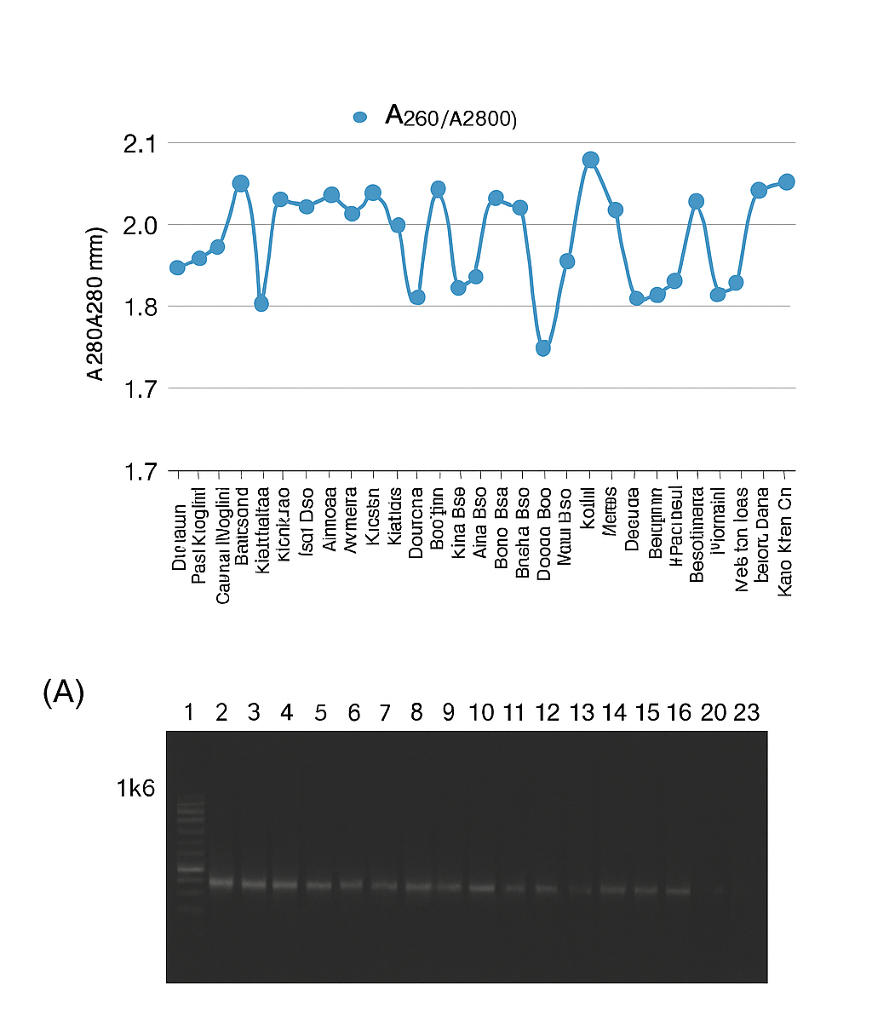

Fig. 1. (A) Histogram showing the DNA purity (A₂₆₀/A₂₈₀ ratio) and quantification (ng µL⁻¹) of genomic DNA extracted from 34 rice genotypes. Most samples showed A₂₆₀/A₂₈₀ values between 1.8 and 2.0, indicating high-quality DNA suitable for PCR amplification and SSR marker analysis.
(B) Agarose gel electrophoresis (0.8%) profile of the same DNA samples showing intact, high-molecular-weight DNA without visible degradation. Lanes 1–34 represent individual rice genotypes and the lanes marked “1 kb” denote the molecular-weight ladder.

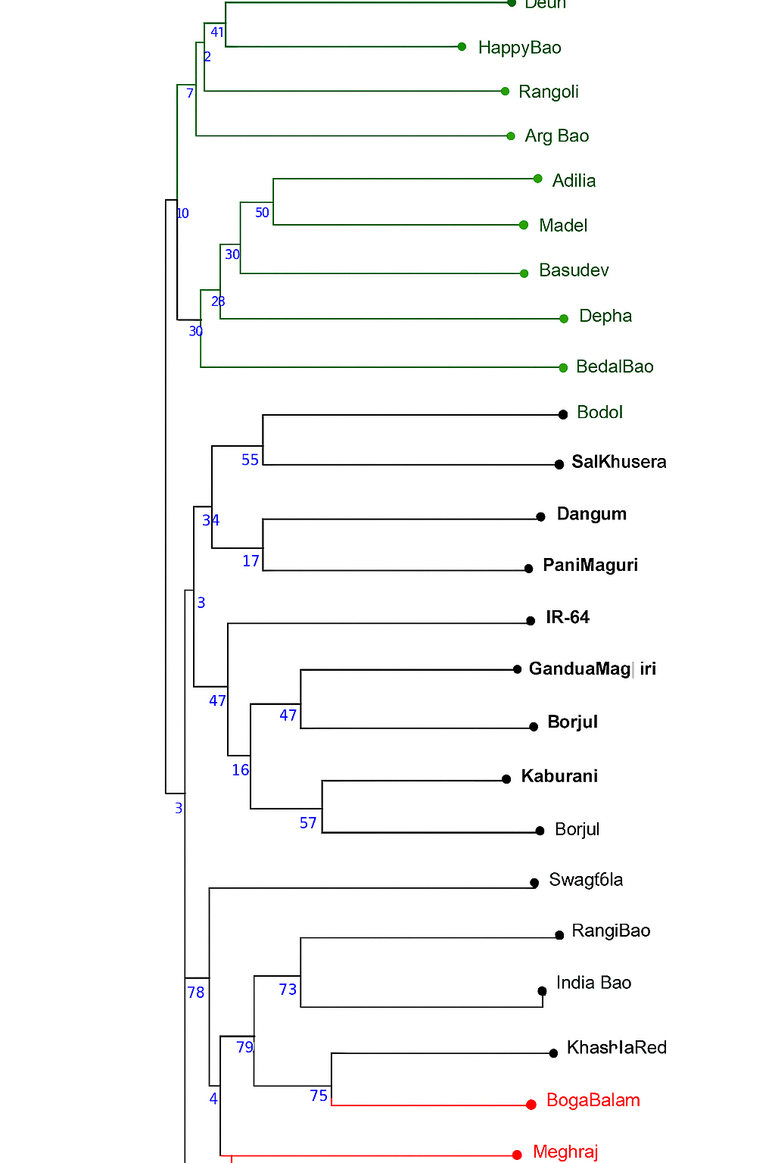

Fig. 2 Dendrogram showing the genetic clustering of 36 Bao rice cultivars based on SSR markers linked to quantitative trait loci (QTLs) associated with anaerobic germination (qAG). The tree was constructed using the Unweighted Pair Group Method with Arithmetic Mean (UPGMA) based on Nei’s genetic distance. The genotypes were grouped into three major clusters, represented in green, black, and red, corresponding to distinct genetic lineages. Cultivars such as Rangdha Kekua Bao, Tarak Kekua Bao, and Bodoi-2 formed a distinct subcluster (red) associated with higher anaerobic germination tolerance, whereas susceptible lines clustered separately. The clustering pattern reflects clear genetic differentiation among tolerant, moderately tolerant, and susceptible Bao landraces.
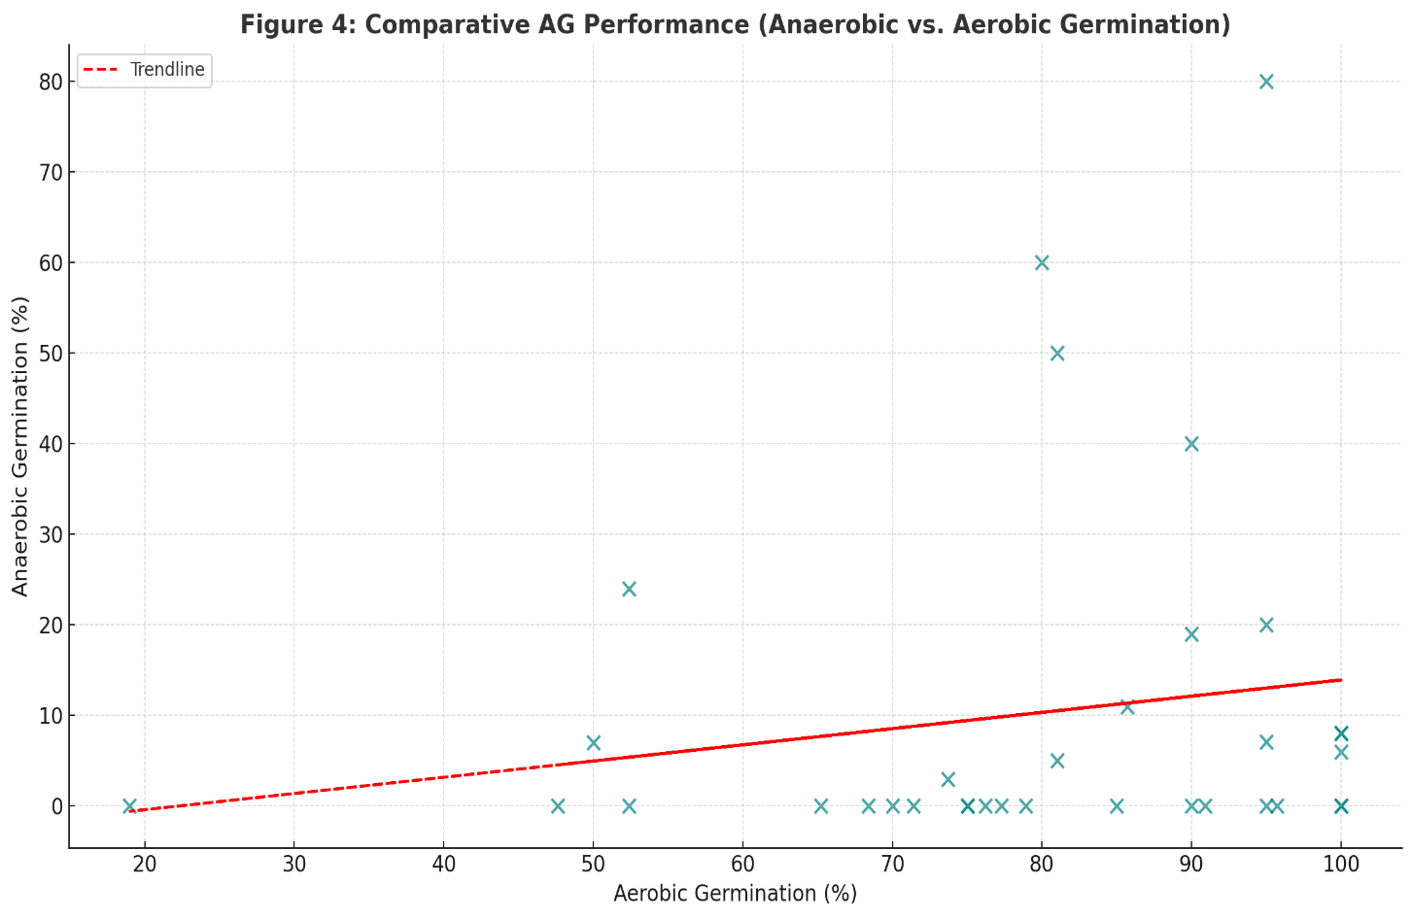
Fig. 3 : Comparative AG Performance (Anaerobic vs. Aerobic Germination) a scatter plot comparing the anaerobic and aerobic germination percentages for various rice cultivars. The red dashed line represents the trendline showing the overall relationship between aerobic and anaerobic germination performance.
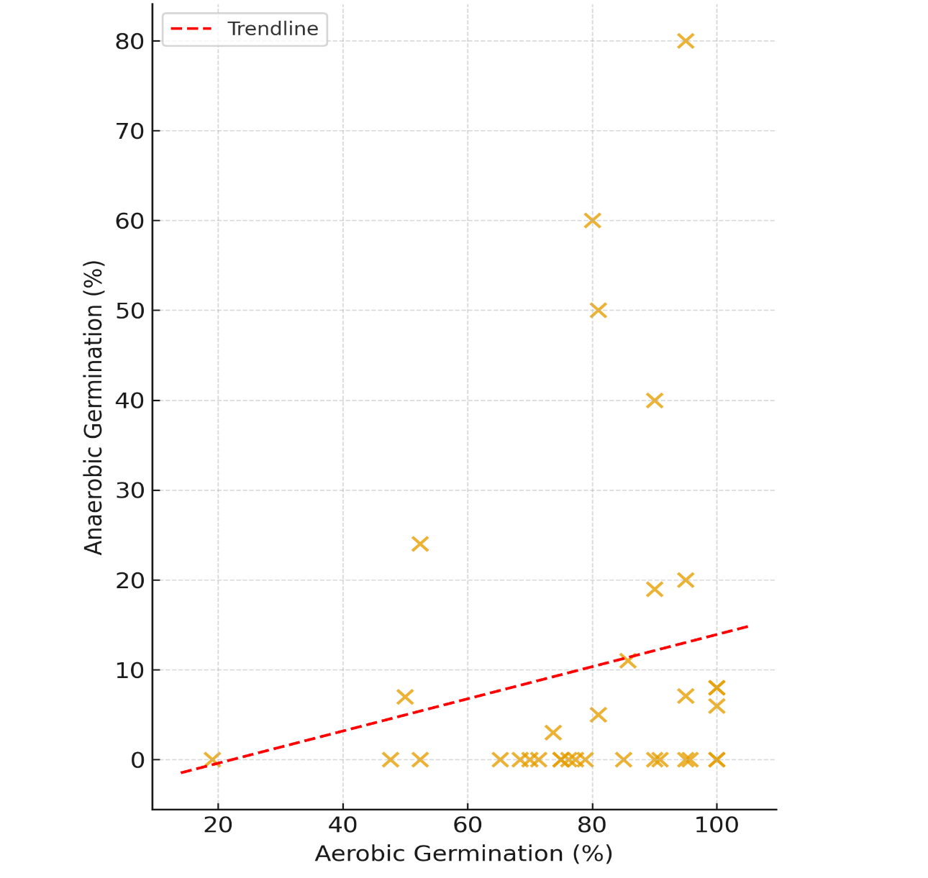
Fig. 4. Comparative germination performance and marker regression analysis under aerobic and anaerobic conditions. Scatter plot showing the relationship between aerobic and anaerobic germination percentages among 34 rice germplasms. The red dashed line represents the linear regression trendline, indicating consistency in the overall germination response between the two conditions.

4. Conclusion

This study successfully validated specific simple sequence repeat (SSR) markers associated with quantitative trait loci (QTLs) related to tolerance for anaerobic germination (AG) and assessed the genetic diversity among the indigenous deepwater rice (Bao) landraces of Assam. By using 38 QTL-linked SSR markers, the research provided valuable insights into the molecular variation connected to AG tolerance and confirmed the presence of allelic diversity within the Bao germplasm. The genotypic analysis effectively categorized the rice varieties into tolerant, moderately tolerant, and susceptible groups, revealing considerable genetic variation among the deepwater rice population in Assam. Phenotypic evaluations carried out under 10 cm of submergence showed that several Bao cultivars displayed different levels of AG tolerance. Notably, Rangdha Kekua Bao (with an 80% germination rate) and Rangoli (50% germination) performed similarly to tolerant controls (Khao Hlan On and Ma Zhan Red), suggesting they have adaptive alleles that help them establish under low-oxygen conditions. In contrast, varieties like Dhusuri, Bedal, and Madel showed poor germination under stress, indicating a range of genetic responses to AG within this collection. Regression-based analyses identified two SSR markers—RM553 (associated with qAG9 on chromosome 9) and RM5378 (linked to qAG5 on chromosome 2)—that were significantly correlated with AG tolerance traits (p ≤ 0.05). These markers, especially RM553, which is closely associated with the OsTPP7 gene known to enhance energy efficiency and carbohydrate mobilization in anaerobic conditions, could serve as effective tools for early molecular screening of AG tolerance. While these genetic loci accounted for a modest amount of phenotypic variance individually, their consistent link to AG tolerance supports their potential use in marker-assisted selection (MAS). The genetic diversity observed among the Bao landraces highlights their promise as valuable sources of novel alleles for coping with abiotic stress. The unique genetic characteristics of the Assam landraces, as revealed by cluster analysis, offer exciting opportunities for use in breeding programs focused on developing flood-resilient and direct-seeded rice (DSR) varieties. Such advancements could help reduce reliance on transplanting, cut production costs, and improve crop establishment in the flood-prone regions of Northeast India. Overall, this study lays the groundwork for molecular breeding and pre-breeding initiatives aimed at enhancing tolerance to anaerobic germination. By combining validated SSR markers (RM553 and RM5378) with phenotypic selection, the development of high-yielding, flood-tolerant rice cultivars that are well-suited to local agricultural conditions can be accelerated. Future research should aim to fine-map additional QTLs, validate these markers across broader germplasm panels and environments, and utilize SNP- or haplotype-based genomic tools to uncover the comprehensive genetic architecture of AG tolerance. Through the fusion of traditional germplasm utilization and modern molecular techniques, the indigenous Bao rice of Assam can play a significant role in creating sustainable rice production systems that are resilient to the challenges posed by early-season flooding.]

Consent (where ever applicable)

Not applicale

Ethical approval (where ever applicable)

No human participants and/or animals were involved in this research.

References

Ismail A.M. (2013). Flood-tolerant rice: Progress and prospects. Plant and Cell Physiology, 54(4): 1–10.

Ghosal S., Verma V.K., Sandhu N., Singh A., et al. (2019). Phenotyping, QTL identification, and interaction analysis for anaerobic germination in rice. Rice, 12: 22.

Bailey-Serres J., Chang R. (2005). Sensing and signaling in response to oxygen deprivation in plants and other organisms. Annals of Botany, 96(3): 507–518.

Lee K.W. (2014). Metabolic adaptation to sugar and O₂ deficiency for anaerobic germination. Plant, Cell and Environment, 37(2): 1–10.

Angaji S.A., Septiningsih E.M., Mackill D.J., Ismail A.M. (2010). QTLs associated with tolerance of flooding during germination in rice (Oryza sativa L.). Euphytica, 172: 159–168. https://doi.org/10.1007/s10681-009-0014-5

Septiningsih E.M., Ignacio J.C.I., Sendon P.M.D., Sanchez D.L., Ismail A.M., Mackill D.J. (2013). QTL mapping and confirmation for tolerance of anaerobic conditions during germination derived from the rice landrace Ma-Zhan Red. Theoretical and Applied Genetics, 126: 1357–1366. https://doi.org/10.1007/s00122-013-2057-1

Hsu S.K., Tung C.W. (2015). Genetic mapping of anaerobic germination-associated QTLs controlling coleoptile elongation in rice. Rice, 8: 1–12. https://doi.org/10.1186/s12284-015-0072-3

Kretzschmar T., Pelayo M.A.F., Trijatmiko K.R., et al. (2015). A trehalose-6-phosphate phosphatase enhances anaerobic germination tolerance in rice. Nature Plants, 1: 15124. https://doi.org/10.1038/nplants.2015.124

Aung K.M., Htut Z.W., Akter S., et al. (2023). Genomic landscape of the OsTPP7 gene in its haplotype context and functional implications for anaerobic germination in rice. Frontiers in Plant Science, 14: 1225445. https://doi.org/10.3389/fpls.2023.1225445

Jeong J.M., Park J., Lee H., et al. (2020). QTL mapping and effect confirmation for anaerobic germination tolerance derived from a japonica weedy rice landrace. Plant Breeding, 139: 83–92. https://doi.org/10.1111/pbr.12753

Baltazar M.D., Ignacio J.C.I., Thomson M.J., et al. (2019). QTL mapping for tolerance to anaerobic germination in rice from IR64 and the aus landrace Kharsu 80A. Rice, 12: 13. https://doi.org/10.1186/s12284-019-0290-y

McCouch S.R., Temnykh S., Xu Y., et al. (2002). Development and mapping of SSR markers for rice. Theoretical and Applied Genetics, 104: 884–899.

Verma V.K., Sandhu N. (2024). Understanding anaerobic germination in direct-seeded rice: Genetic architecture and breeding implications. BMC Plant Biology, 24: 5901. https://doi.org/10.1186/s12870-024-05901-z

Rohilla M., Saikia H., Barua P., et al. (2025). The private life of deepwater rice: Unraveling exclusive adaptations and germplasm resources. Plant Genetic Resources Journal, 25(2): 1–10.

Godwin Gilbert R., Mathew S., Devi R.K., et al. (2023). Genetic variability for anaerobic germination tolerance in rice (Oryza sativa L.). Electronic Journal of Plant Breeding, 14(3): 4940–4949.

Hirano K., Hori K., Ueguchi-Tanaka M., et al. (2023). Molecular mechanisms regulating coleoptile elongation under anaerobic germination in rice. Plants, 12(7): 1565. https://doi.org/10.3390/plants12071565

Rice Journal. (2025). Genome-wide association meta-analysis identifies OsDREB6 as a key regulator of anaerobic coleoptile elongation in rice. Rice, 18: 51. https://thericejournal.springeropen.com/articles/10.1186/s12284-025-00812-5

Collard B.C.Y., Jahufer M.Z.Z., Brouwer J.B., Pang E.C.K. (2005). An introduction to markers, quantitative trait loci (QTL) mapping and marker-assisted selection for crop improvement: The basic concepts. Euphytica, 142(1–2): 169–196.

Panaud O., Chen X., McCouch S.R. (1996). Development of microsatellite markers and characterization of simple sequence length polymorphism (SSLP) in rice (Oryza sativa L.). Molecular and General Genetics, 252(5): 597–607.

Perrier X., Jacquemoud-Collet J.P. (2006). DARwin Software, CIRAD, Montpellier, France. Available at: http://darwin.cirad.fr

Rajpoot S. (2017). Validation of selected SSR markers of QTLs associated with anaerobic germination trait in deepwater rice (Bao) of Assam [Master’s Thesis]. Assam Agricultural University, Jorhat, India.

Sambrook J., Russell D.W. (2001). Molecular Cloning: A Laboratory Manual, 3rd Ed. Cold Spring Harbor Laboratory Press, Cold Spring Harbor, NY, USA.

Singh R.K., Mahato A.K., Sharma S.K. (2003). Standardization of a rapid CTAB DNA extraction protocol and its validation in various plant species. Indian Journal of Biotechnology, 2(4): 434–439..

