Review Article

SUSTAINABLE NUTRIENT MANAGEMENT IN HYDROPONICS SYSTEM: A REVIEW OF ORGANIC AND SYNTHETIC NUTRIENT SOLUTION.

Abstract
Hydroponics, a soilless method of crop cultivation, has emerged as an innovative solution to address challenges of land scarcity, water limitations, and the need for year-round food production. Central to its success is sustainable nutrient management, which governs plant growth, yield, and environmental performance. This review critically examines strategies for nutrient supply in hydroponic systems, focusing on the comparison between organic and synthetic nutrient solutions. Organic sources, including compost teas, seaweed extracts, fish hydrolysates, and vermicompost leachates, promote resource recycling, microbial diversity, and stress resilience but often suffer from inconsistent composition, slower nutrient release, and microbial contamination risks. Synthetic solutions, composed of precisely formulated inorganic salts, ensure rapid uptake, uniformity, and high productivity but raise concerns regarding energy-intensive manufacture, runoff, and ecological impacts. Sustainable practices—such as nutrient recycling, integrated nutrient management, bio-stimulants, and precision dosing technologies—are discussed as pathways to improve efficiency and reduce environmental footprints. Future research directions emphasize sensor-based precision nutrient delivery, advanced organic formulations, life cycle assessments, and policy support to encourage adoption. By balancing productivity with ecological responsibility, hydroponic nutrient management can underpin resilient, climate-smart agriculture and contribute to global food security.
Keywords: Hydroponics; Nutrient management; Organic nutrient solutions; Synthetic nutrient solutions; Sustainable agriculture; Life cycle assessment; Precision farming; Controlled environment agriculture

Introduction
Hydroponics, a revolutionary plant-growing method, could revolutionise agriculture and solve some of the world's biggest challenges, including overpopulation, desertification, climate change, and arable land depletion. Aztec chinampas and Babylon's Hanging Gardens grew crops in water channels and floating gardens (Park & Williams, 2024). The scientific field of hydroponics didn't arise until the 1930s, when William Frederick Gericke proved plants could grow in nutrient-rich fluids without soil. In the 21st century, controlled-environment agriculture (CEA), vertical farming, and urban food systems depend on hydroponics, which maximises productivity per unit area while minimising land use. Hydroponic methods use 90% less water than traditional farming because they recirculate fertiliser solutions and reduce evaporation. They offer dense planting patterns and three-dimensional layouts, making them perfect for urban rooftop gardens, greenhouses, and vertical indoor farms (Fathidarehnijeh et al., 2023). Htyg5Hydroponic agriculture's controlled atmosphere permits year-round growth, stable yields, and reduced vulnerability to climatic hazards, improving food security in environmentally or demographically challenged locations. Without soil, soil-borne pests, weeds, and diseases don't exist, therefore cleaner production procedures and less chemical pesticides and herbicides are utilised. Hydroponic farming requires nutrient solution formulation, delivery, and monitoring since the amount, balance, and availability of critical elements in the aqueous medium affect plant development, physiology, and marketable production (Szekely & Jijakli, 2022). Effective fertiliser management helps maintain pH and electrical conductivity (EC), minimise nutrient deficits and antagonisms, and reduce losses that could pollute surface or groundwater. Incompetent management can cause osmotic stress, nutrient lockup, and environmental contamination, threatening sustainability and profitability. Both types of hydroponic fertiliser solutions have pros and cons.
Organic formulations use renewable sources such compost extracts, vermicompost leachates, fish hydrolysates, and seaweed concentrates (Upendri et al., 2021). These fertilisers close nutrient loops, reduce industrial fertilisers' environmental impact, and promote root microbial activity. However, their composition depends on source materials, they mineralise slowly, and improper processing might introduce microbial contamination, limiting their scalability. In contrast, water-soluble inorganic salts supply nitrogen, phosphorus, potassium, calcium, magnesium, sulphur, and other micronutrients in highly concentrated, readily usable synthetic solutions. They excel in commercial hydroponics because they properly adjust EC, pH, and nutrient ratios. This helps producers optimise plant performance during different growth periods and produce higher-quality yields. However, synthetic fertiliser manufacture uses a lot of energy and nonrenewable feedstocks, and wastewater can salinise or eutrophicate soil if not properly controlled.
Sustainability is attracting researchers and farmers to integrated approaches that use synthetic and organic inputs, bio-stimulant technologies, nutrient recycling, automation, artificial intelligence, and real-time sensing to fine-tune nutrient delivery. In this context, this evaluation compares organic and synthetic hydroponic fertiliser solutions, assessing their efficiency, environmental impact, economic viability, and synergies. It critically evaluates sustainable nutrient management in these settings. The study will summarise evidence, highlight innovations, and identify knowledge gaps to help agronomists, horticulturists, and legislators optimise hydroponic nutrient use while protecting natural resources and promoting climate-smart, resource-efficient food production.

Hydroponic Systems
Hydroponics uses various fertiliser delivery, water circulation, and plant support systems. Each method has merits and cons, but they all depend on careful fertiliser solution control for healthy plant growth and big harvests. Popular approaches include Nutrient Film Technique. A thin layer of nutritional solution runs via small, slightly sloping channels (Ali et al., 2024). This dries some roots and exposes others to air for efficient nutrition uptake and oxygenation. However, pump failures or obstructions leave roots liable to drying out quickly, making this configuration insecure. Another popular method is deep water culture (DWC), which suspends plant roots in vast amounts of nutrient-rich oxygenated water. Diffusers or air stones give dissolved oxygen for healthy roots. Simple, fast-growing DWC is ideal for leafy greens because it doesn't transmit infections. However, pH, EC, and dissolved oxygen must be monitored to avoid imbalances.
The Ebb and Flow (Flood and Drain) system cycles aeration and nutrients. Plants are placed in perlite or expanded clay containers and flooded with nutritional solution periodically. Misflushing can create salt buildup or waterlogging in the medium, yet this technique offers varied crops and operational flexibility. Modern aeroponics suspends plant roots in an enclosed chamber and mists them with a thin nutritional solution aerosol (Catota-Ocapana et al., 2025). This maximises oxygen exposure and nutrient absorption, accelerating growth and reducing water use. High-value crops and small spaces benefit from aeroponics, although it is expensive, requires accurate misting equipment, and is more susceptible to system disturbances. However, wick hydroponics is the simplest. By capillary action, absorbent wicks carry nutritional solution from a reservoir to the developing substrate. The passive, affordable wick system is suitable for educational or hobby-scale production, but only for low-demand plants like herbs. Nutrient leaching, synthetic fertiliser overuse, and spent solution disposal can compromise resource efficiency and environmental integrity, thus it's necessary to address these variables beyond design criteria. Nutrient delivery sustainability is also significant (Mielcarek et al., 2024). Modern methods emphasise sterilising and recycling solutions, using organic nutrient sources to reduce synthetic fertilisers, and automating and real-time monitoring systems to optimise dissolved oxygen, pH, and electrolyte concentrations while minimising waste. Hybrid systems that combine design features can increase crop resilience and fertiliser delivery. NFT channels with aeroponic misting or DWC reservoirs with biofilters are examples. Long-term soilless agriculture sustainability requires engineering solutions and sustainable nutrient techniques. Hydroponic systems are determined by crop kind, scale, resources, and environmental responsibility.
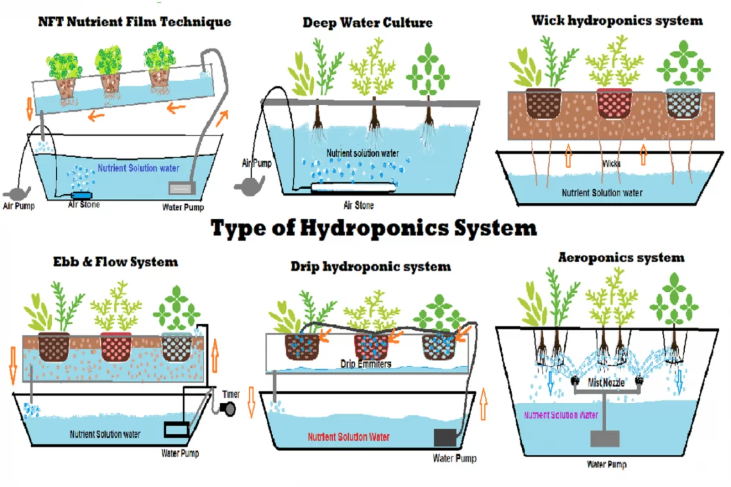
Figure 1: Different hydroponic systems with nutrient solution circulation.

Nutrient Management in Hydroponics
Managing nutrients is very important for plant health, crop yield, and the general efficiency of a hydroponic system. This is because plants can't get macro- and micronutrients from dirt; they can only get them from a perfectly balanced water solution. The key to success in hydroponics is careful and constant tracking to avoid deficiencies or toxicities and to keep the right levels of nutrients, pH, electrical conductivity (EC), and the proportions of each element. Nutrient concentrations have a direct effect on many physiological processes, such as photosynthesis, enzyme activation, osmotic regulation, and reproductive growth. While macronutrients like nitrogen, phosphorus, potassium, calcium, magnesium, and carbon are needed in large amounts, micronutrients like iron, manganese, zinc, copper, boron, and molybdenum are important but only need small amounts (Asaduzzaman et al., 2022). If a plant doesn't get enough of a certain element, it could have problems like chlorosis, slow growth, bad fruit set, or other issues. If it gets too much, it can get diseases like tip burn in leafy greens or osmotic stress. Between the vegetative and reproductive stages, growers often change the formulations and change the amounts of nutrients in them to match. For example, after working on nitrogen to make leaves bigger, they might add more potassium and phosphorus to help plants flower and fruit. Nutrient levels should be fine-tuned to fit the type of crop, its stage of growth, the temperature, and the amount of light it gets.
The concentration and pH of the water are very important for how well nutrients breakdown and how much the roots can take in. Two examples of nutrient lockout are phosphorus precipitating at very low pH levels and iron not dissolving at higher pH levels. Most hydroponic plants do best in a slightly acidic range of 5.5 to 6.5, where both major and minor nutrients are still available to the plants. It is important to keep the pH steady so that deficiencies can't go unnoticed, even when the nutrients are available. One way to do this is to use buffered solutions, test the solution often, or use automatic pH-control devices (Reza et al., 2025). Electrical conductivity (EC) is also very important because it shows the total concentration of dissolved salts and is a measure of nutritional health. EC needs for leafy greens like lettuce can be between 1.5 and 2.0 mS/cm, while EC needs for growing plants like tomatoes and peppers can be between 2.5 and 3.0 mS/cm. Too much or too little EC, on the other hand, can hurt the way roots work, which makes plants lose nutrients and grow more slowly. A plant's metabolism is also affected by the balance or ratio of its nutrients. For example, too much potassium can make it harder for the plant to absorb magnesium, too much nitrogen can encourage vegetative growth instead of fruiting, and an imbalance between calcium and boron can lead to problems like blossom end rot. It is suggested that dynamic nutrient management be used to lessen the effects of these relationships. To do this, formulations must be slowly changed based on how the crop grows, the solution analysis, and cues from the surroundings. Fertilisation that isn't done right hurts more than just the health and profitability of crops.
Over-fertilization can make receiving waters more eutrophic or salty, while chronic underfeeding lowers yields and market acceptance, which makes the system less stable.
These problems can be solved with monitoring and control technologies that are becoming more and more important in modern hydroponics. Inline sensors and probes measure EC, pH, temperature, dissolved oxygen, and sometimes specific ion concentrations. They send data continuously to computers or cloud platforms (Nirmal& Ahmad, S. (2024). Automated dosing systems change doses of acid, base, or nutrient stock in real time to keep solutions stable with little help from people. The most advanced systems use AI and IoT to look at sensor data along with environmental factors like CO₂ levels, humidity, and light strength. This lets them guess how fast nutrients will be absorbed and come up with or use methods to fix imbalances before they happen. Thanks to these improvements in technology, large-scale hydroponic farming is now both affordable and good for the environment. This is because it is more precise, requires less work, and saves resources.

Organic Nutrient Solutions
It is a step towards gardening that is better for the earth to use organic fertiliser solutions in hydroponic tanks. Organic fertilisers are being looked at as an alternative to manmade ones because of the growing need for healthy farming around the world. Organic fertilisers that come from living things are things like fish waste, seaweed, compost, and vermicompost. Rajaseger et al. (2023) say that these ways not only make plants stronger and better for the environment, but they also give plants important nutrients. Even though these solutions could make sustainable hydroponic farming better, they come with problems like slower nutrient release, unpredictable makeup, and the risk of microbial contamination. Compost tea is made by letting aged compost soak in water for a while. It is one of the most popular ways to use organic fertiliser. There are a lot of humic compounds, good microbes, and soluble nutrients in compost drinks. They not only give plants nutrients like nitrogen, phosphorus, and potassium, but they also add good bacteria to the soil, which makes roots healthier. Another important source is extract from seaweed, usually Ascophyllum nodosum or a related species. There are chemicals in kelp that help plants grow. These include auxins, gibberellins, and cytokinins. They are just as useful as the nutrients the plant itself has, especially the micronutrients and potassium. These chemicals help plants handle stress better and improve their root structure and ability to absorb nutrients.
Fish hydrolysates are another famous organic food that are made by breaking down fish waste with enzymes. Fish hydrolysates, which are high in trace elements, nitrogen, and phosphorus, help root zone bacteria stay healthy and plants grow strong. In the same way, worm drinks and vermicompost leachates both have humic and fulvic acids as well as soluble nutrients. By changing cellular processes, these make it easier for plants to absorb nutrients and make them more resistant to damage. For hydroponic gardening, different sources offer different nutritional values and possible advantages. Formulations made with molasses, bone meal products, and plant-based hydrolysates are a few examples. There are many good things about hydroponics with organic fertiliser solutions (Ahmed et al., 2021). They cut down on the need for manmade fertilisers, which are bad for the environment because they use a lot of energy to make and give off gases into the air. By using by-products from farming and fishing, organic nutrition options cut down on waste and support the idea of a circular economy. Eutrophication caused by organic runoff is not as harmful to aquatic environments as eutrophication caused by synthetic fertilisers. Also, plants are better able to handle abiotic conditions like drought, high heat, and salt because many organic sources contain bioactive chemicals. For example, seaweed products make you more resistant by making antioxidant enzymes work better. Adding helpful microbes to hydroponic systems through compost teas and vermicompost leachates can help fight root infections and improve the cycling of nutrients.
There are still some bad things about using organic vitamin products despite all of these good points. There is a big problem with nutrients not always being available right away. This is because bacteria have to break down many organic molecules before plants can use them. It may take longer for things that people want a lot, like tomatoes or lettuce, to grow quickly because of this wait. Another worry is that organic materials' nutritional value can change based on where they come from, how they are processed, and how they are kept. One way this can happen is when different kinds of food are used to make compost tea. Things can get even worse if you don't properly handle organic solutions. Microbes can get into them. Then, these bacteria can bring pathogens that are bad for plants into the hydroponic system (Richa et al., 2020). Because of these restrictions, it is hard to make organic food choices that can be used on a big scale. More than one study has looked into whether organic ingredients could be used in hydroponic systems. One example is that tests on lettuce and green plants have shown that nutrient solutions based on seaweed can make antioxidants work better while giving the same results as synthetic fertilisers. Also, solutions made from fish hydrolysate can help green leafy plants grow well, though they don't work as well as solutions made by people. This shows that leachates from vermicompost can help plants take in nutrients better, especially when they are stressed out. Nutrient solutions that aren't natural may give better results right now than natural ones. Organic nutrient solutions, on the other hand, show potential in niche markets that care a lot about things like food safety, nutritional quality, and the environment.
Table 1: Comparison of common organic nutrient sources and their N-P-K values.
Organic Nutrient Source | Typical N-P-K (%) | Key Features
Compost Tea | 1.0 – 1.5 – 1.0 | Contains humic substances and beneficial microbes; variable composition.
Seaweed Extract | 1.0 – 0.2 – 2.0 | Rich in potassium, trace minerals, and plant growth regulators.
Fish Hydrolysate | 5.0 – 2.0 – 2.0 | High in nitrogen and trace elements; promotes vegetative growth.
Vermicompost Leachate | 2.0 – 1.0 – 1.5 | Contains soluble nutrients, humic acids, and beneficial microbes.
Bone Meal Extract | 3.0 – 15.0 – 0.0 | Excellent phosphorus source; slow release.

Synthetic Nutrient Solutions
Synthetic fertiliser solutions are used a lot in modern hydroponic farming. Instead of organic inputs, these products use water-soluble inorganic salts to provide the right macro- and micronutrients in a way that is easy to access. Because they are consistent, reliable, and can give plants quick reactions, they are the fertiliser of choice in industrial hydroponics around the world. The carefully controlled makeup of synthetic nutrients makes sure that plants get the right food as they grow, which increases crop production and makes it more consistent (Almheiri, 2024). These man-made nutrient products have both micronutrients and macronutrients. Three main macronutrients are needed a lot: nitrogen (N), phosphorus (P), and potassium (K). Nitrogen is usually found as nitrate (NO₃) or ammonium (NH₄) salts. It is an important part of plant growth, protein synthesis, and chlorophyll production. Phosphorus is usually given as monopotassium phosphate (KHPO₄). It is needed for root growth, flowering, and energy transfer through ATP. It controls osmosis, makes plants more resistant to disease, and is needed for seeds and fruits to grow. Sodium comes in the form of potassium nitrate (KNO₊) or potassium sulphate (K₂SO₄). The mixtures also have secondary macronutrients like magnesium (Mg), calcium (Ca), and sulphur (S). Adding calcium in the form of calcium nitrate helps roots and cell walls stay healthy and strong. Magnesium is an important part of photosynthesis, and sulphur helps make proteins and amino acids. Chlorophyll is made of magnesium sulphate.
It doesn't matter that micronutrients are very small in hydroponics; they are still very important. Some examples of these are iron (Fe), manganese (Mn), zinc (Zn), copper (Cu), boron (B), and molybdenum (Mo). Chelated forms of these elements, such as Fe-EDDHA or Fe-DTPA, are often found in man-made nutrition products. With this, they stay soluble and easy to get even if the pH level changes. This keeps plants from running out of nutrients even in recycling systems where nutrient lockout is possible. Due to the balanced macro- and micronutrients in synthetic formulations, growers can adjust the amount of nutrients given to meet the needs of different crops, stages of growth, and weather conditions (Wahab et al., 2023). One of the best things about manmade nutrient solutions is that they give you precise control over how nutrients are given. Consistency is important for high-value crops like peppers, tomatoes, cabbage, and cucumbers. Synthetic formulations provide it, unlike organic sources whose make-up can change. Plants can take in the salts right away because they are fully soluble. This speeds up growth and increases yields. One of the benefits is that nutrients are easy to get. With synthetic solutions, farmers can also meet the physiological needs of plants at different stages of growth by giving them the right amount of nutrients for maximum output. In the vegetative phase, nitrogen is good for leafy veggies, but potassium and phosphorus are more important for fruiting plants.
But synthetic nutrition options have some problems that make them less useful than they are helpful. The most important thing is how they affect the world. Runoff of nitrates and phosphates from fertiliser solutions can pollute water sources and make nearby ecosystems more acidic if they are not properly controlled. Also, the chemical industry depends a lot on making synthetic fertiliser, which uses a lot of energy and creates greenhouse gases (Renganathan et al., 2025). Nitrogen fertilisers made with the Haber-Bosch method use a lot of fossil fuels, so this is especially true for those. Growing plants in controlled hydroponic systems can be risky because nutrients can build up and cause problems if the solutions aren't changed or recycled often. Hydroponic farming tests done in the real world show that manmade fertiliser solutions work well for growing lots of crops. For instance, lettuce grown in regulated hydroponic systems with balanced synthetic formulations makes a lot more than lettuce grown in dirt. The faster turnover cycles allow for several harvests each year (Ortiz, 2020). Synthetic solutions that have been optimised for tomato farming have shown promise for industrial growers, with higher yields and better fruit quality and uniformity. Peppers and cucumbers grown in deep water culture (DWC) or nutrient film technique (NFT) systems have also benefited from manufactured solutions because they make nutrients available all the time. These examples show why synthetic formulas are the best for large-scale hydroponics in industrial greenhouses and vertical farms, where dependability and productivity are very important.
Table 2: Typical synthetic nutrient solution composition for lettuce or tomato hydroponics.
Nutrient | Concentration (mg/L) | Source Compound
Nitrogen (N) | 150–200 | Calcium nitrate, potassium nitrate
Phosphorus (P) | 40–60 | Monopotassium phosphate
Potassium (K) | 200–300 | Potassium nitrate, potassium sulfate
Calcium (Ca) | 150–200 | Calcium nitrate
Magnesium (Mg) | 40–60 | Magnesium sulfate
Sulfur (S) | 60–80 | Magnesium sulfate, potassium sulfate
Iron (Fe) | 2.0–3.0 | Fe-EDDHA / Fe-DTPA
Manganese (Mn) | 0.5–1.0 | Manganese sulfate
Zinc (Zn) | 0.05–0.1 | Zinc sulfate
Copper (Cu) | 0.05–0.1 | Copper sulfate
Boron (B) | 0.3–0.5 | Boric acid
Molybdenum (Mo) | 0.05–0.1 | Ammonium molybdate

Comparative Analysis: Organic vs Synthetic
When you put organic and manmade fertilisers next to each other in hydroponic systems, you can see that there is a big clash between production and sustainability. It is easy to get ionic forms that are used to make synthetic nutrient solutions. These solutions help plants like lettuce, tomato, and onion grow faster and produce more than their organic counterparts. For even growth, this helps the plant grow quickly. They can be trusted for large-scale business processes that need to be stable and predictable because of this. They also let you precisely control the concentration of nutrients, electrical conductivity (EC), and pH. In spite of this, using chemically made fertilisers raises long-term worries about their impact on the environment. A lot of the time, these fertilisers come from nonrenewable resources like natural gas and minerals that are dug. This can cause these resources to run out, water bodies to become more acidic from runoff, and greenhouse gas emissions from making the fertilisers (Palmitessa et al., 2024). On the other hand, organic nutrient solutions are better for the environment and work better with circle farming methods because they are made from things that can be used again and again, like fish hydrolysates, seaweed extracts, compost teas, and vermicompost leachate. In some cases, they can make plants more resistant to stress by promoting good microbial interactions in the root zone. They can also help lower chemical residues and release, which limits damage to the environment. That being said, organic methods can have some problems. For example, they don't always have the same mix of nutrients, nutrients may take longer to become available because microbes have to mineralise them, and bacteria can get into them if they aren't processed properly. Because of these issues, organic hydroponic systems can't match the productivity and scalability of synthetic ones (Salas-Sanjuán et al., 2023). This is especially a problem in business settings where consistency and efficiency are important. Organic solutions are better for the environment, but they are harder to use on a big scale because they cost more to get, process, and check for quality. Synthetic options are cheaper and offer a more stable return on investment in the short term. New hybrid techniques add small amounts of synthetic nutrients to organic inputs to make them more sustainable. These techniques combine the benefits of organic systems for long-term use with the predictability of synthetic systems for output. This connects the two. These combined methods give hydroponics hope by addressing environmental issues and making sure crops do well. They could also lead to nutrient management systems in controlled environment farms that are sustainable and can make money.
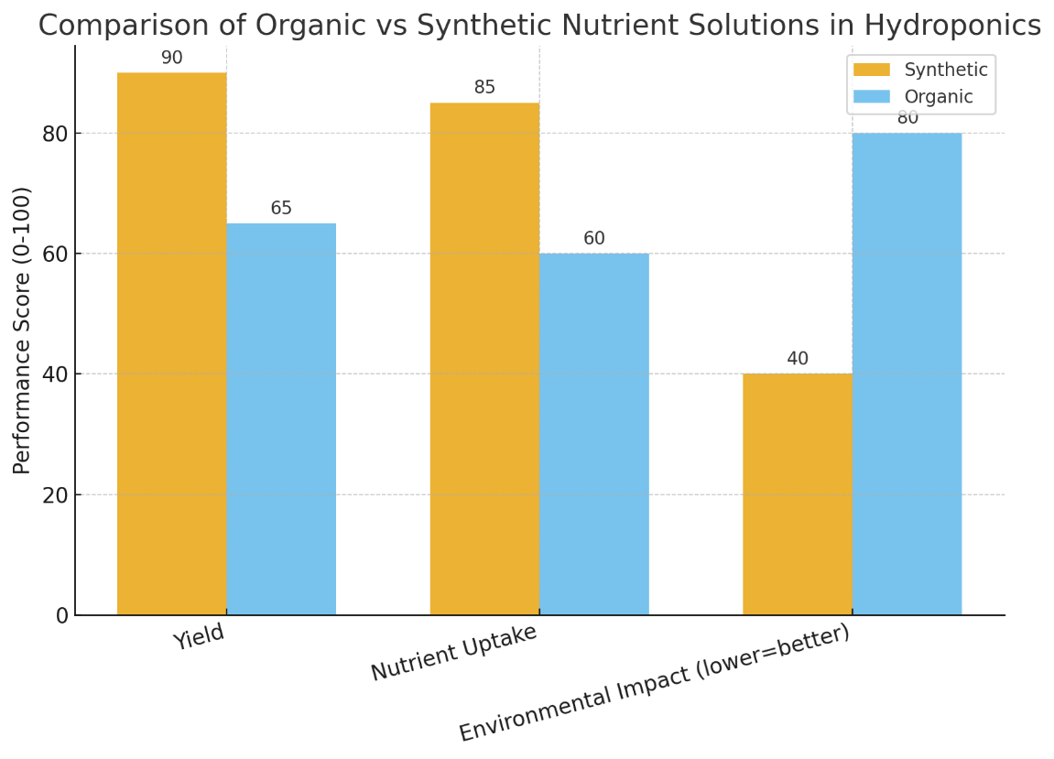
Figure 2: Bar chart comparing yield, nutrient uptake, and environmental impact between organic and synthetic solutions.

Sustainable Practices in Hydroponic Nutrient Management
Sustainability is very important in hydroponic farming because the nutrients used come from natural resources that are limited. To keep hydroponics environmentally and economically viable as demand grows around the world, it is important to use tactics that reduce waste, cut down on chemicals, and promote long-term resource efficiency. Researchers are looking into a number of ways to make hydroponic farming more practical. Some of these are reusing nutrient solutions, using bio-stimulants, integrating nutrient management, and reducing the amount of chemicals that are added (Thapa et al., 2024). Recycling and reusing fertiliser solutions is a great way to help the environment. When runoff gets into natural water bodies, it can damage the environment and waste resources. This is why most traditional hydroponic systems dump nutrient-rich water that hasn't been used after a few rounds. Closed-loop hydroponic systems regularly check and change the amount of nutrients, pH, and electrical conductivity to avoid this issue and make solutions last longer. Ion-selective sensors and reverse osmosis filters are examples of advanced technology that can help growers recover and replenish nutrients effectively. These technologies minimise the loss of nutrients and cut water use by up to 90%. Recycling is good for both the earth and the bottom line because it stops waste and lowers the cost of making things.
Integrated nutrient management (INM) is another method that is good for the environment because it uses both natural and manufactured fertilisers. With INM, you can depend less on industrial fertilisers without losing the nutrients that plants need. Mineral salts are mixed with things like fish hydrolysates, waste extracts, or seaweed-based mixtures. This mixed approach combines the short-term nutrient release benefits of synthetics with the long-term resilience benefits of organics (Miller et al., 2020). The result is higher yields and better sustainability. In addition, it helps a variety of microbes live in the root zone. This helps the cycle of nutrients and makes plants stronger against natural problems like salt and drought. It's possible that bio-stimulants and microbial inoculants could also help with sustainable hydroponic control of nutrients. Bio-stimulants, such as humic acids, amino acid mixtures, and plant growth-promoting rhizobacteria (PGPR), can help plants take in nutrients more efficiently, grow roots more quickly, and stay healthy in general. They do not need a lot of outside help. When bacteria inoculants like Bacillus and Azospirillum species are used, they fix nitrogen and dissolve phosphorus, so no extra nutrients are needed. These biological methods reduce the need for chemical fertilisers by making plants more resistant and productive (Junge et al., 2025).
The end goal of hydroponic systems is to use less chemicals so they can last longer. Farmers can use chemical fertilisers more efficiently with the help of precision agriculture technologies like real-time nutrient mapping, automated dosing systems, and monitoring based on artificial intelligence (Rehman et al., 2024). This makes it less likely that too much will be used, which saves money and is better for the environment. Biodegradable chelating agents and low-impact nutrient ratios are being studied, which will lead to more long-lasting ways to handle nutrients. Finally, for long-term success in hydroponic nutrient management, a multifaceted plan that includes new technologies, biological treatments, and smart use of resources is needed. If recycling systems, integrated fertiliser management, bio-stimulants, and less chemical sources are added to hydroponics, it can become a more sustainable and resource-efficient way to grow food that doesn't hurt the environment.

Future Prospects and Research Directions
Going forward, the best way to deal with nutrients in hydroponics will be to use cutting-edge technology, new inputs, and careful assessments of the surroundings. This will help the system work better while also being better for the earth. Sensors, AI, and IoT technologies that let farmers precisely control nutrients are about to change hydroponic farming. AI programs can guess what nutrients each plant will need based on where it is in its growth cycle and what it is exposed to. If you have smart devices that check the pH, electrical conductivity, dissolved oxygen, and nutrient levels all the time, you can make changes right away. These ways give you the most nutrients, the least amount of waste, more steady yields, and a lower chance of toxic buildup or nutrient leaching. Making new organic nutrient solutions more stable, soluble, and safe for microbes is another direction that could be taken. More and more research is being done on how to get nutrients for plants from long-term sources, such as algae, food waste, and waste that has been fermented. New developments in biotechnology and enzyme processes could make the mineralisation of organic materials happen faster. This would let nutrients be released quickly, just like man-made methods, but with the environmental benefits of organics. With these changes, organic hydroponics might be able to work better in places that care about the climate and value high-quality foods.
To find out how sustainable hydroponic systems are as a whole, they need to be given a full life cycle assessment (LCA). For every system design and nutrient management system, an LCA should look at how much water is used, how much energy is put in, how much greenhouse gas is created, and how much nutrients are got back. So you can choose methods that work well and are good for the environment, it is helpful to compare natural, man-made, and mixed options. We can make the system even more stable by using circular economy ideas, such as recycling nutrients from trash in the ocean or food waste digestates. Last but not least, laws and rewards must back hydroponic practices in order for them to last. Green nutrient management approval processes, tax breaks, and grants from the government could help people act on their ideas more quickly and creatively. One way to get farmers to share the best ways to do things more quickly is to set up programs that build their skills and build ties between the government and the private sector. If the government backs hydroponics, the environment is studied, and technology improves, it could become a popular, long-lasting, and useful way to grow.

Conclusion
For hydroponic farming systems to be as effective and eco-friendly as possible, they need to handle their fertiliser in a way that doesn't harm the environment. Plant health depends on four things: the amount of nutrients, the pH, how well the plant conducts electricity, and the balance of these factors. To keep these values stable, it's also important to use both monitoring and automation. Getting nutrients from natural or man-made sources both has their pros and cons. Organics help recycle resources, lower chemical residues, and make plants more immune to stress, while synthetics can make a lot of things. But they don't work as well and it takes longer for nutrients to get to the plant. It's very important to understand that we need to find a balance between productivity and sustainability. In industrial hydroponics, synthetic treatments are used most of the time because they work well. However, it is important to be aware that they use a lot of energy to make and may hurt the environment. But in order to get consistent results at scale, organic inputs need to be changed even more, even though they are better for the environment. To find a fair solution to these problems, hybrid methods that mix organic additions with limited amounts of synthetic salts look like they have the most potential. We still don't fully understand some things, even though we've come a long way. More study needs to be done on standardising organic formulations, making nutrient recovery technologies better, and doing full life cycle assessments for a wide range of systems and crops. Long-term field studies that look at the environmental and economic impacts of combined projects are necessary to help people come up with the best ways to do things. Hydroponics could be a long-term solution for growing food if we encourage new ideas for nutrients, make our technology more accurate, and make rules that help the business grow.
Reference
- Park, Y., & Williams, K. A. (2024). Organic hydroponics: A review. Scientia Horticulturae, 324, 112604.
- Fathidarehnijeh, E., Nadeem, M., Cheema, M., Thomas, R., Krishnapillai, M., & Galagedara, L. (2023). Current perspective on nutrient solution management strategies to improve the nutrient and water use efficiency in hydroponic systems. Canadian Journal of Plant Science, 104(2), 88-102.
- Szekely, I., & Jijakli, M. H. (2022). Bioponics as a promising approach to sustainable agriculture: A review of the main methods for producing organic nutrient solution for hydroponics. Water, 14(23), 3975.
- Upendri, H. F. L., & Karunarathna, B. (2021). Organic nutrient solution for hydroponic system. Academia Letters, 1893, 1-10.
- Ali, A., Niu, G., Masabni, J., Ferrante, A., & Cocetta, G. (2024). Integrated nutrient management of fruits, vegetables, and crops through the use of biostimulants, soilless cultivation, and traditional and modern approaches—A mini review. Agriculture, 14(8), 1330.
- Catota-Ocapana, P., Minaya-Andino, C., Astudillo, P., & Pichoasamin, D. (2025). Smart control models used for nutrient management in hydroponic crops: A systematic review. IEEE Access.
- Mielcarek, A., Kłobukowska, K., Rodziewicz, J., Janczukowicz, W., & Bryszewski, K. Ł. (2024). Water nutrient management in soilless plant cultivation versus sustainability. Sustainability, 16(1), 152.
- Asaduzzaman, M., Niu, G., & Asao, T. (2022). Nutrients recycling in hydroponics: opportunities and challenges toward sustainable crop production under controlled environment agriculture. Frontiers in Plant Science, 13, 845472.
- Reza, M. N., Lee, K. H., Karim, M. R., Haque, M. A., Bicamumakuba, E., Dey, P. K., ... & Chung, S. O. (2025). Trends of soil and solution nutrient sensing for open field and hydroponic cultivation in facilitated smart agriculture. Sensors, 25(2), 453.
- Nirmal, S., & Ahmad, S. (2024). Innovative approaches to sustainable water and nutrient management in soilless crop cultivation. Int. J. Res. Adv. Agri. Sci, 3(1), 13-22.
- Rajaseger, G., Chan, K. L., Tan, K. Y., Ramasamy, S., Khin, M. C., Amaladoss, A., & Haribhai, P. K. (2023). Hydroponics: current trends in sustainable crop production. Bioinformation, 19(9), 925.
- Ahmed, Z. F., Alnuaimi, A. K., Askri, A., & Tzortzakis, N. (2021). Evaluation of Lettuce (Lactuca sativa L.) production under hydroponic system: Nutrient solution derived from fish waste vs. Inorganic nutrient solution. Horticulturae, 7(9), 292.
- Richa, A., Touil, S., Fizir, M., & Martinez, V. (2020). Recent advances and perspectives in the treatment of hydroponic wastewater: a review. Reviews in Environmental Science and Bio/Technology, 19(4), 945-966.
- Almheiri, M. S. (2024). ORGANIC-BASED NUTRIENT SOLUTIONS FOR SUSTAINABLE VEGETABLE PRODUCTION IN A ZERO-RUNOFF SOILLESS GROWING SYSTEM.
- Wahab, P. E. M., Che-Othman, M. H., & Al-Tawaha, A. R. M. (2023). Managing Nitrogen Toxicity in the Soilless Culture System: A Review. Journal of Tropical Plant Physiology, 15(2), 10-10.
- Renganathan, P., Astorga-Eló, M., Gaysina, L. A., Puente, E. O. R., & Sainz-Hernández, J. C. (2025). Nitrogen Fixation by Diazotrophs: A Sustainable Alternative to Synthetic Fertilizers in Hydroponic Cultivation. Sustainability, 17(13), 5922.
- Ortiz, J. C. R. (2020). Nutritive Solutions Formulated from Organic Fertilizers. In Urban Horticulture-Necessity of the Future. IntechOpen.
- Palmitessa, O. D., Signore, A., & Santamaria, P. (2024). Advancements and future perspectives in nutrient film technique hydroponic system: a comprehensive review and bibliometric analysis. Frontiers in Plant Science, 15, 1504792.
- Salas-Sanjuán, M. C., Ruíz-Zubiate, J. L., Valenzuela, J. L., & Campos, A. X. (2023). Nutrient Solution from Aqueous Extracts as an Alternative to Fertigation in Hydroponic. Horticulturae, 9(12), 1281.
- Thapa, U., Hansda, N. N., Kundu, S., Giri, A., Tamang, D., & Rahaman, A. O. (2024). Advancements in hydroponic systems: a comprehensive review. Archives of Current Research International, 24(11), 317-328.
- Miller, A., Adhikari, R., & Nemali, K. (2020). Recycling nutrient solution can reduce growth due to nutrient deficiencies in hydroponic production. Frontiers in Plant Science, 11, 607643.
- Junge, R., Schmautz, Z., & Milliken, S. (2025). Toward nutrient cycling from organic waste streams for soilless cultivation. Current Opinion in Food Science, 61, 101257.
- Rehman, S. U., Aprile, A., De Castro, F., Negro, C., Migoni, D., Benedetti, M., ... & Fanizzi, F. P. (2024). Assessing the effectiveness of vermi-liquids as a sustainable alternative to inorganic nutrient solutions in hydroponic agriculture: a study on diplotaxis muralis. Agronomy, 14(6), 1310.

