Original Research Article
In Vitro Germination and Seedling Development of Mangosteen Influenced by GA₃ and Sucrose Levels

.
ABSTRACT

Mangosteen (Garcinia mangostana L.) is an important tropical fruit crop of the family Clusiaceae, prized for its unique flavour, high market value and medicinal properties. However, large scale propagation of mangosteen is constrained by slow growth, seed recalcitrance, poor rooting and low seedling vigour, making conventional propagation inefficient. The present investigation aimed to standardize the in vitro seed germination and seedling production protocol to enhance seedling vigour. The study was conducted at the College of Agriculture, Vellayani, using freshly extracted mangosteen seeds cultured on Murashige and Skoog (MS) medium of full and half strength each supplemented with varying concentrations of sucrose (1-3%) and gibberellic acid (GA₃; 0.2–1 ppm). The experiment consisted of twelve treatments with three replications. Observations on germination percentage, number of days taken for germination, seedling vigour index (SVI I and II) and growth parameters were recorded after 30 days of inoculation. Significant variations were observed among the treatments for all parameters studied. The treatment T₁₂ (½ MS + 2% sucrose + 1 ppm GA₃) exhibited the highest germination percentage (95.24%), earliest germination (12.33 days) and maximum vigour indices (SVI I: 1383.81; SVI II: 44.48). This treatment also recorded superior shoot (5.73 cm), root (7.13 cm), and leaf (4.77 cm) lengths compared to other treatments. During hardening plantlets from T₁₂ maintained vigorous growth and achieved a 95% survival rate in a coirpith vermiculite mixture confirming successful sucrose concentration and GA₃ supplementation which significantly enhanced in vitro germination, seedling vigour, and survival in mangosteen. The optimized in vitro germination and seedling production protocol offers an efficient method for large scale propagation and conservation of elite mangosteen germplasm.

Keywords: Mangosteen, MS medium, Gibberellic acid, In vitro germination, Seedling vigour.

INTRODUCTION
Mangosteen (Garcinia mangostana L.) is an important tropical fruit crop belong to the family Clusiaceae. It is a slow-growing evergreen tree native to South East Asia, particularly the Malay Archipelago (Osman and Milan, 2016). This fruit is widely cultivated in Malaysia, Thailand, the Philippines, Sri Lanka and Indonesia. In India, the fruit is commercially grown in Kerala, Tamil Nadu, Karnataka, Maharashtra, and Goa (Tripathi, 2019). It is a high value fruit crop with a sweet and tangy flavour, rich in vitamins, xanthones, antioxidants, antimicrobial, and anti cancerous properties. Mangosteen is an economically important crop having demand in nutraceutical and pharmaceutical industries (Zamarudin et al., 2023). The fruit contains white edible pulp surrounded by seeds and is well known for its sweet acidic taste and pleasant aroma (EL-Kenawy et al., 2018). Because of its unique taste and superior quality it is popularly known as the “queen of fruits” and one of the finest fruits in the world.

Mangosteen seeds are naturally apomictic which means the offsprings are genetically identical to the parent plant. This form of asexual reproduction is considered a natural method of vegetative propagation (Mansya et al., 2013). Mangosteen however, has several limitations associated with physiological constraints. It includes inefficient photosynthetic activity, reduced cell division within the shoot apical meristem, limited seed yield, slow seedling development and poorly developed root system. Tissue culture techniques offer an alternative to overcome these limitations by enabling the production of uniform and high quality seedlings and reliable shoot proliferation and successful rooting (Mansya et al., 2010; Harahap et al., 2014).

Plant tissue culture involves a range of techniques used to grow plant cells, tissues, or organs under controlled conditions. It has several advantages for plant propagation, including the ability to rapidly produce a large number of plants in a short period, reduced space requirements compared to conventional methods, and continuous year-round production of seedlings (Chaudhari, 2023). Success in tissue culture is influenced by several factors such as choice of explant, appropriate basal medium, maintenance of sterile conditions, and concentration of plant growth regulators. Among the basal media MS (Murashige and Skoog) medium is one of the most widely used in plant tissue culture. Strict aseptic conditions are essential to prevent contamination, which can inhibit or destroy cultured tissues (Murashige & Skoog, 1962).

Tissue culture mainly depends on the plant growth regulators to direct organogenesis and embryogenesis, which helps to promote the growth of shoots, roots and callus. Among them gibberellic acid (GA₃) is particularly important during early stages of growth, as it can substitute for light and temperature requirements during seed germination. In addition to enhancing germination. GA₃ promotes shoot elongation and improves rooting (Andini et al., 2019). The objective of the present study was to standardize the in vitro seed germination and seedling production protocol to enhance seedling vigour.

2. materialS and methods
2.1 Explant collection and Surface sterilization

The present study was conducted at the Department of Fruit Science and the Department of Plant Biotechnology, College of Agriculture, Vellayani, Kerala Agriculture University during the period 2024-2025. Freshly extracted seeds from mature mangosteen fruits were used as explants. The culture medium used was Murashige and Skoog (MS) medium, supplemented with sucrose and solidifying agent agar. Gibberellic acid (GA3) was used as a plant growth regulator. For surface sterilization, ethanol (both 70% and 100%), a fungicide (Bavistin) and detergents (Tween-80) were used. Freshly harvested seeds were initially washed thoroughly under running tap water to remove the mucilage and adhering pulp. After that to reduce the seed born fungal infection the seeds were pretreated with 1% Bavistin solution for 20 minutes. This was followed by washing thoroughly in distilled water and then immersing in tween-80 (detergent solution) for 3-5 minutes. The seeds were rinsed thoroughly three to four times with distilled water. Surface sterilization was carried out under a laminar airflow chamber by immersing in 1% sodium hypochlorite for 15 minutes, followed by double rinsing in sterile distilled water. Finally, the seeds were treated with 70% alcohol for 20 seconds and then the seed coats were carefully removed using sterilized forceps and scalpels under aseptic conditions.

2.2 Culture establishment

The surface sterilized mangosteen seeds were inoculated aseptically into jam bottles containing MS medium half and full strength, each supplemented with varying concentrations of sucrose and gibberellic acid (GA₃) as per the treatment. The experiment was conducted with twelve treatments and three replications (Table 1). Cultures were incubated in a controlled environment chamber maintained at 24°C using an air conditioning system. Illumination was provided by fluorescent lamps with a light intensity of 3000-3200 lux, following a 16-hour photoperiod per day.

2.3 Observation recorded

The observations were recorded on various growth and developmental parameters including germination percentage, number of days taken for germination, shoot length, shoot number, root length, root number, leaf length, leaf number, seedling vigour index I and seedling vigour index II. The measurements were taken on the 30th day after inoculation.

2.4 Statistical analysis

The experiment was carried out using a Completely Randomized Design. The data were subjected to analysis of variance (ANOVA) and the critical difference (CD) values at a 5% level of significance (p = 0.05) were computed using RAISINS statistical software (Hisham et al., 2025).

3. results and discussion
3.1 Germination characteristics of mangosteen seedlings

3.1.1 Germination percentage: The germination percentage of in vitro cultured mangosteen seeds showed significant variation among treatments. As presented in Table 2, the treatment T₁₂ (½ MS Media (2% sucrose) + GA 1 ppm) recorded the highest germination percentage of (95.24%). In contrast, the treatment T₂ (MS Media (2% sucrose)) exhibited significantly lower germination rate (52.38%). The marked improvement in germination observed with GA₃ supplementation indicates that gibberellic acid is vital for initiating germination by enhancing activities and metabolic processes within the seed (Dewi, 2015). These results are consistent with previous observations of Hossain et al. (2023) in papaya. San et al. (2014) reported increased germination rates in stone fruits such as apricot, peach, and wild cherry when treated with GA3.

3.1.2 Days taken for germination: The earliest seed germination was in T₁₂ (½ MS Media (2% sucrose and 1 ppm GA₃) with an average of 12.33 days, while T₃ required the longest period of 21.00 days for germination. The treatments had a significant effect on the number of days taken for seed germination. The inclusion of GA₃ in the culture medium effectively reduced the germination period, highlighting its role in accelerating the metabolic processes associated with seed germination. Mangosteen seeds cultured in ½ MS medium supplemented with GA₃ exhibited early germination compared to the control (Andini et al., 2019). Similarly Sukmadjaja (2005) reported sandal wood seeds germinated in fewer days when cultured on ½ MS medium supplemented with 0.5 mg/L GA3.

3.1.3 Seedling vigour index (SVI I and SVI II): The highest SVI I value (1383.81) was recorded in T₁₂, while the lowest value (385.24) was recorded in T₂, which was statistically on par with T₁, T₃, T₄ and T₇. For SVI II the maximum value (44.48) was obtained in T₁₂, which was on par with T₆ (41.67) whereas the minimum (10.86) was recorded in T₁. The superior vigour observed in GA3 and sucrose enriched treatments indicates the positive influence of these components on enhancing overall seedling performance under in vitro conditions. These results agree with Andini et al. (2019) who found that GA₃ (0.5–1 ppm) enhanced in vitro germination and seedling vigour in mangosteen. Similarly in papaya, GA₃ supplementation increased SVI-I (7.11) and SVI-II (512.55), indicating its positive effect on seedling strength and uniformity (C et al., 2022 ).

3.2 Growth parameters of mangosteen seedlings at the time of planting out
The influence of various treatments on growth parameters after one month of inoculation was evaluated by recording shoot length, root length, leaf length and leaf number at the time of plant out from the cultured media and are presented in table 3.

3.2.1 Seedling shoot height: In the present study, the highest mean shoot length (5.73 cm) was recorded in T₁₂ (½ MS Media (2% sucrose) + GA 1 ppm) and the lowest shoot length (2.60 cm) was recorded in T₅ (½ MS Media (2% sucrose)) which was statistically on par with T₇ (2.90 cm) and T₁₂ (3.00 cm). These results indicate that sucrose concentration and GA₃ supplementation positively influence elongation in mangosteen seedlings. GA₃ promotes stem elongation by stimulating cell division and elongation, which collectively enhance shoot growth and development; consistent with earlier works in mangosteen and other species (Syahfitri, 2020; Arianto, 2018).

3.2.2 Seedling root length: Significant differences were also observed in root development among the treatments. The highest average root length (3.87 cm) was recorded in T₁₂ (½ MS Media (2% sucrose) + GA 1 ppm). The lowest value (1.43 cm) was exhibited in the control. Gibberellins play a crucial role in promoting root elongation by enhancing cell division and elongation in the root meristem, as well as by activating enzymes essential for early growth in line with previous studies in Garcinia indica, nutmeg and other species (Arianto, 2018; Srivastava et al., 2022).

3.2.3 Leaf number and Leaf length: Leaf length significantly varied among treatments, with longest leaf length (4.77 cm) in T₁₂ (½ MS + 2% sucrose + 1 ppm GA₃) which was on par with T₈ (4.10 cm), while the shortest leaves (2.00 cm) were recorded in T₂ (MS Media (2% sucrose)). While the leaf number doesn’t exhibit significant variation among the treatments, these findings align with earlier reports highlighting the role of gibberellins in overall leaf growth and development in mangosteen and fruit crops (Andini, 2019; C et al., 2022).

3.3 Growth parameters of seedlings of mangosteen in different media after one month of hardening

The effect of different treatments on root development was assessed by measuring the root length of the seedlings and the ANOVA results are presented in Table 4.

In the present study, variations in medium composition and growth regulator concentration significantly influenced root, shoot and leaf development of mangosteen seedlings during the hardening phase. Among the treatments, T₁₂ (½ MS medium + 2% sucrose + GA₃ 1 ppm) consistently showed superior performance, producing the longest roots (7.17 cm), longest shoot length (7.10 cm), longest leaves (6.17 cm) and leaf number (4.00) all of which were statistically on par with T₁₀ and T₈ for respective traits. In contrast the shortest roots (2.83 cm), shoots (4.10 cm), leaves (3.27 cm) and number of leaves (1.67) were observed in T₄, T₂ and T₁. These findings clearly demonstrate that reduced salt strength in combination with optimized sucrose levels and GA₃ supplementation effectively promoted root elongation, shoot growth and leaf development during acclimatization, thereby enhancing overall seedling vigour.

The hardening phase further facilitated both survival and gradual vegetative growth of mangosteen seedlings, indicating successful acclimatization to ex vitro conditions. The moderate yet consistent improvements in shoot, root and leaf growth reflect inherently slow growth habit and progressive adaptation capacity of the species. Overall, the findings highlight the importance of a well optimized hardening phase in ensuring physiological stability and sustained development of in vitro raised mangosteen seedlings.

3.4 Survival percentage

The present study exhibited 80.9 % (T₆) to 95.24 % (T₁₂) survival rate of mangosteen plantlets after one month of hardening in coir pith compost and vermiculite mixture demonstrating the effectiveness of the acclimatization protocol. Similar survival success has been reported in earlier studies (Chaudhury and Malik, 2020; Shinde et al., 2022) emphasizing the importance of well controlled hardening phase for the successful establishment of in vitro raised plants.
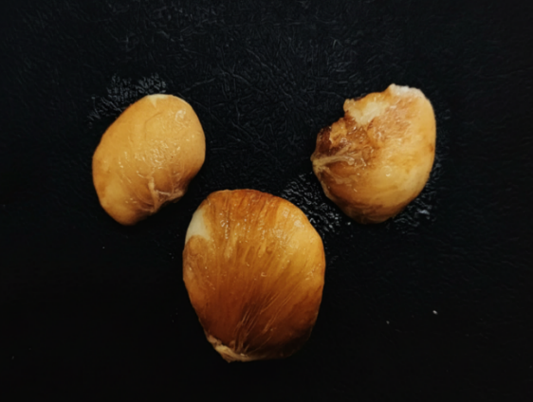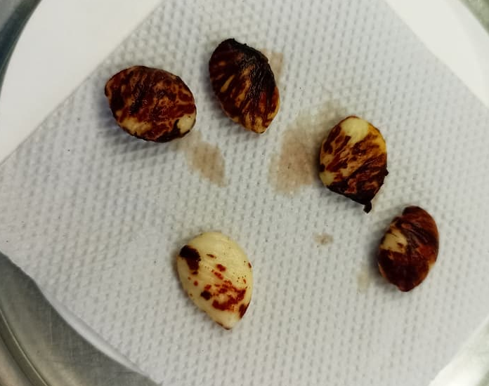
b
a

Fig. 1. Explant used in in vitro seedling production (a) mangosteen seeds (b) sterilized mangosteen seeds
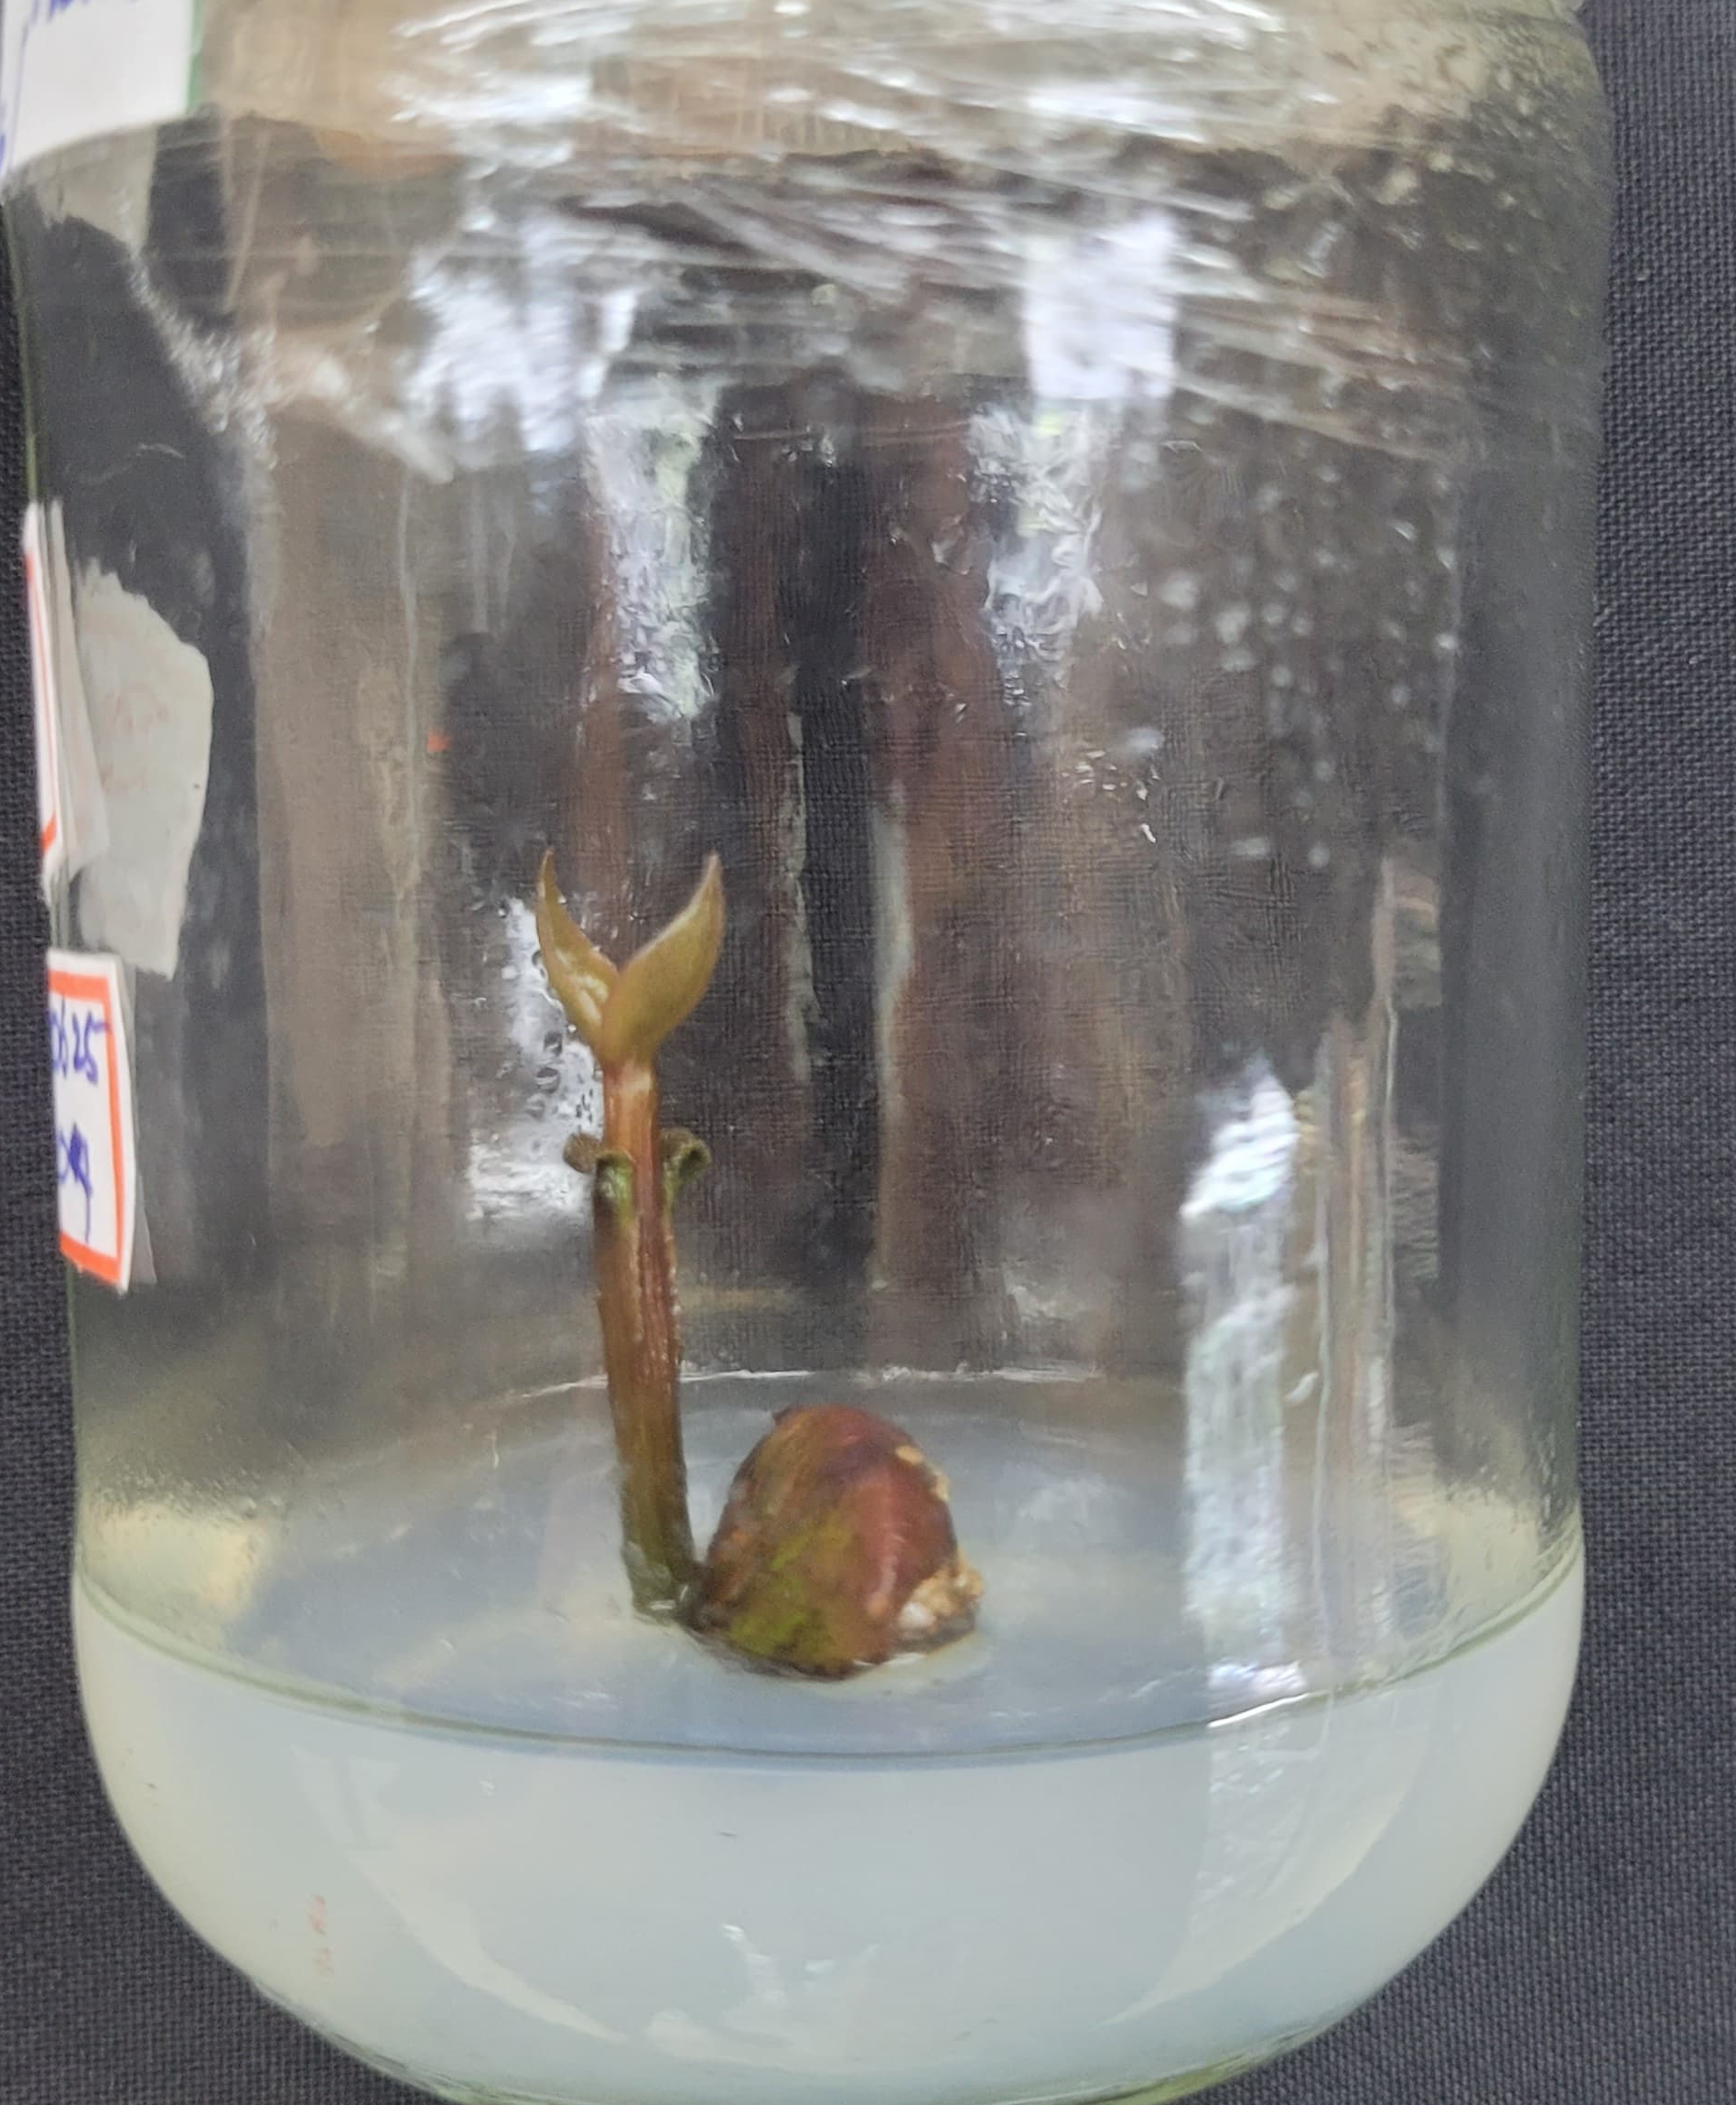
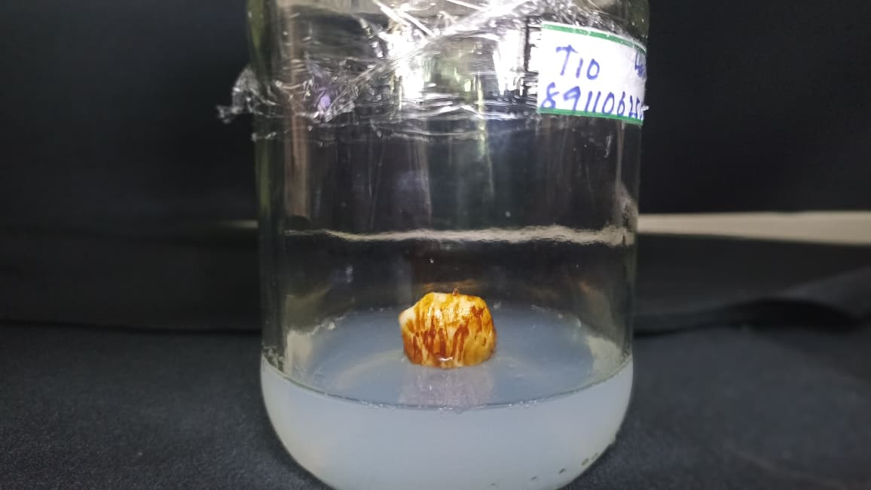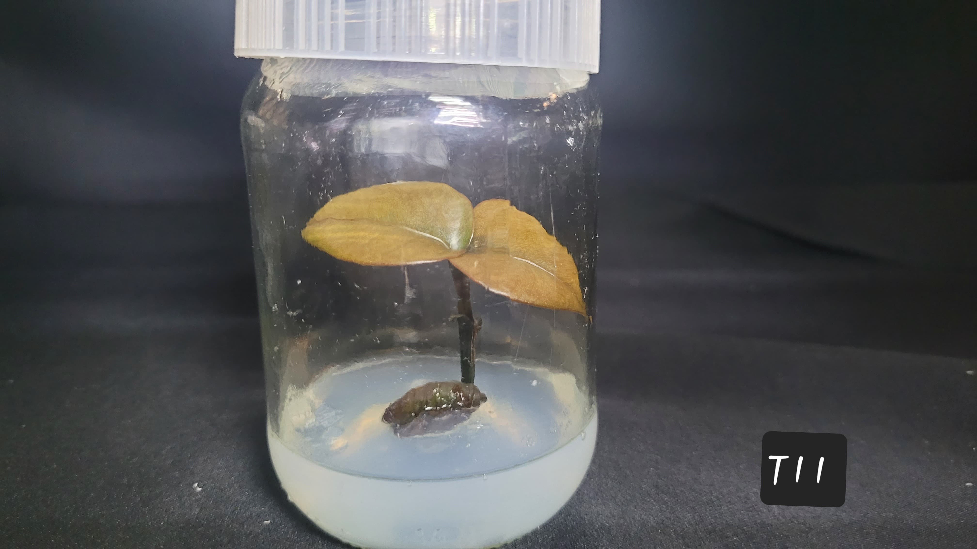
c
bc
a

Fig. 2. Different stages of in vitro germination of mangosteen seeds (a) Explant on the day of inoculation (b) Two weeks after inoculation (c) One month after inoculation

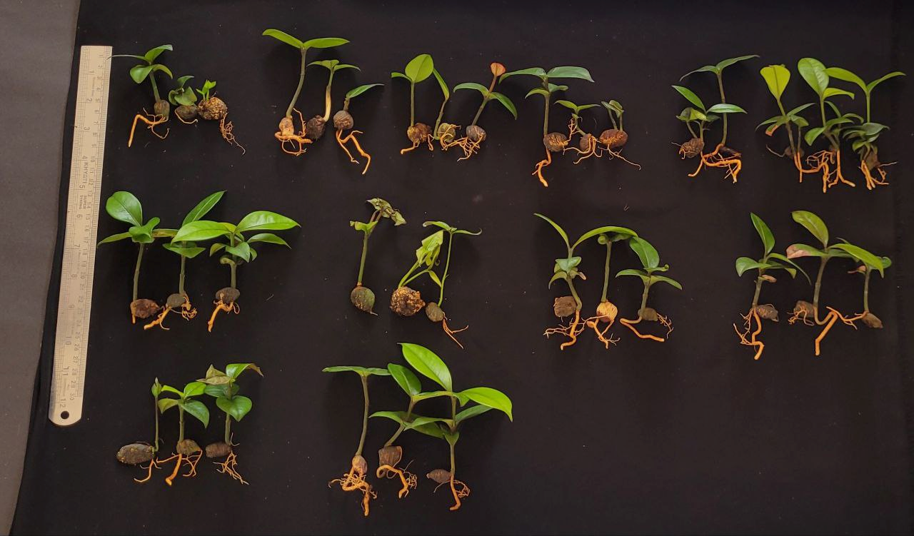

Fig. 3. In vitro produced mangosteen seeds one month after hardening
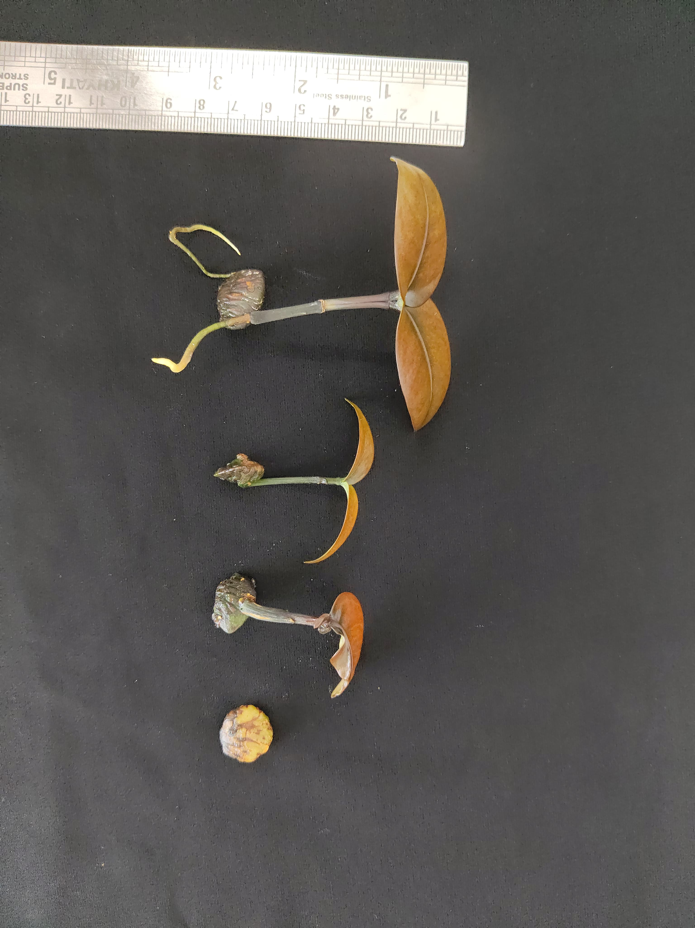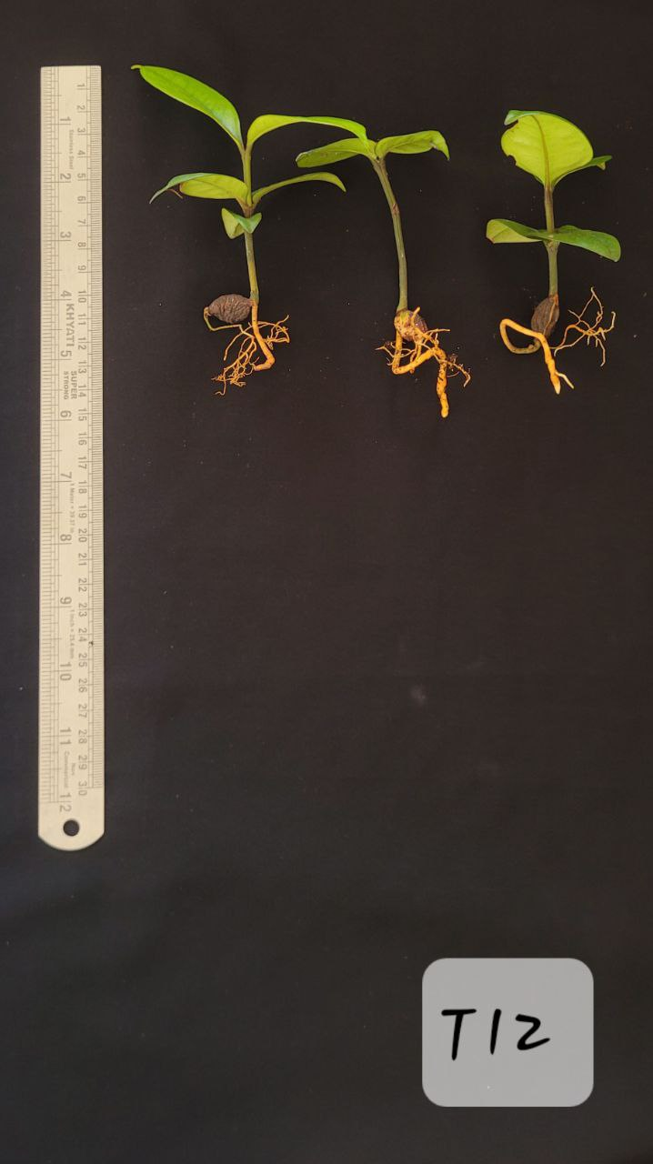
a
b

Fig. 3. Best treatment T₁₂ (½ MS Media (2% sucrose) + GA 1 ppm) (a) at the time of plant out (b) One month after hardening

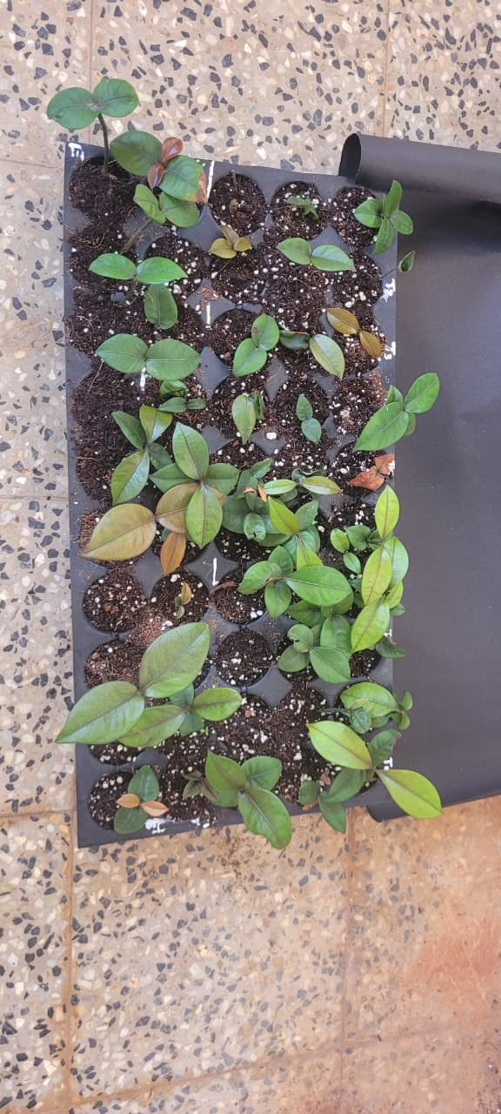
Fig. 4. Hardened plantlets in portrays filled with coir pith compost

Table 1. Treatment combinations for in vitro seedling production

Treatments
T₁ | MS Media (3% sucrose)
T₂ | MS Media (2% sucrose)
T₃ | MS Media (1% sucrose)
T₄ | ½ MS Media (3% sucrose)
T₅ | ½ MS Media (2% sucrose)
T₆ | ½ MS Media (2% sucrose)
T₇ | MS Media (2% sucrose) + GA 0.2 ppm
T₈ | MS Media (2% sucrose) + GA 0.5 ppm
T₉ | MS Media (2% sucrose) + GA 1 ppm
T₁₀ | ½ MS Media (2% sucrose) + GA 0.2 ppm
T₁₁ | ½ MS Media (2% sucrose) + GA 0.5 ppm
T₁₂ | ½ MS Media (2% sucrose) + GA 1 ppm

Table 2. Germination characteristics of mangosteen seeds under different treatment media.

Treatments |  | Number of days taken for germination | Germination percentage | Seedling Vigour Index I | Seedling Vigour Index II
T₁ | MS Media (3% sucrose) | 19.33 ± 0.58^{b} | 52.38 ± 8.25^{d} | 472.86 ± 86.65^{ef} | 10.86 ± 2.29^{g}
T₂ | MS Media (2% sucrose) | 13.67 ± 0.58e | 52.38 ± 8.25^{d} | 385.24± 45.09^{f} | 16.19 ± 3.80^{fg}
T₃ | MS Media (1% sucrose) | 21.00 ± 1.00ª | 61.90 ± 8.25^{cd} | 477.14±72.11^{ef} | 16.29 ± 4.60^{fg}
T₄ | ½ MS Media (3% sucrose) | 15.67 ± 0.58^{d} | 61.90 ± 8.25^{cd} | 486.67±41.44^{ef} | 25.38 ± 1.25de
T₅ | ½ MS Media (2% sucrose) | 14.00 ± 1.00e | 61.90 ± 8.25^{cd} | 550.48 ± 79.25de | 19.62 ± 5.31^{ef}
T₆ | ½ MS Media (1% sucrose) | 17.33 ± 0.58^{c} | 80.95 ± 8.25^{b} | 994.76 ± 89.90^{b} | 41.67 ± 6.16^{ab}
T₇ | MS Media (2% sucrose) + GA 0.2 ppm | 16.33 ± 0.58^{cd} | 66.67 ± 8.25^{c} | 472.38 ± 73.97^{ef} | 36.38 ± 4.05^{bc}
T₈ | MS Media (2% sucrose) + GA 0.5 ppm | 17.33 ± 0.58^{c} | 61.90 ± 8.25^{cd} | 663.33 ± 75.54^{d} | 15.90 ± 2.72^{fg}
T₉ | MS Media (2% sucrose) + GA 1 ppm | 18.67 ± 0.58^{b} | 71.43 ± 0.00^{bc} | 816.67 ± 14.87^{c} | 34.52 ± 2.97^{c}
T₁₀ | ½ MS Media (2% sucrose) + GA 0.2 ppm | 16.00 ± 1.00^{d} | 80.95 ± 8.25^{b} | 1088.10 ±85.22^{b} | 28.19 ± 1.57^{d}
T₁₁ | ½ MS Media (2% sucrose) + GA 0.5 ppm | 14.33 ± 0.58e | 66.67 ± 8.25^{c} | 524.76 ± 44.29e | 16.76 ± 0.97^{fg}
T₁₂ | ½ MS Media (2% sucrose) + GA 1 ppm | 12.33 ± 0.58^{f} | 95.24 ± 8.25ª | 1383.81±125.0ª | 44.48 ± 4.81ª
SE(m) |  | 0.41 | 4.56 | 43.17 | 2.16
CD(0.05) |  | 1.19 | 13.31 | 126 | 6.3

Table 3. Growth parameters of seedlings of mangosteen in different media after one month of inoculation

Treatments |  | Shoot length | Root length | Leaf length | Leaf number
T₁ | MS Media (3% sucrose) | 3.00 ± 0.20^{def} | 1.43 ± 0.40^{d} | 2.73 ± 0.64^{def} | 2.33 ± 0.58
T₂ | MS Media (2% sucrose) | 4.17 ± 0.25^{c} | 2.47 ± 1.06^{bc} | 2.00 ± 0.10^{f} | 2.33 ± 0.58
T₃ | MS Media (1% sucrose) | 3.27 ± 0.21de | 2.13 ± 0.32^{cd} | 3.53 ± 0.46^{bc} | 2.67 ± 0.58
T₄ | ½ MS Media (3% sucrose) | 4.13 ± 0.15^{c} | 1.83 ± 0.65^{cd} | 2.73 ± 0.74^{def} | 2.00 ± 0.00
T₅ | ½ MS Media (2% sucrose) | 2.60 ± 0.36^{f} | 2.67 ± 0.76^{bc} | 3.13 ± 0.61^{cde} | 2.33 ± 0.58
T₆ | ½ MS Media (1% sucrose) | 4.73 ± 0.45^{b} | 3.30 ± 0.85^{ab} | 2.97 ± 0.38^{cde} | 3.00 ± 0.00
T₇ | MS Media (2% sucrose) + GA 0.2 ppm | 2.90 ± 0.26^{ef} | 1.97 ± 0.15^{cd} | 2.57 ± 0.49^{ef} | 2.67 ± 0.58
T₈ | MS Media (2% sucrose) + GA 0.5 ppm | 4.50 ± 0.30^{bc} | 3.43 ± 0.59^{ab} | 4.10 ± 0.10^{ab} | 2.33 ± 0.58
T₉ | MS Media (2% sucrose) + GA 1 ppm | 3.40 ± 0.26^{d} | 2.10 ± 0.79^{cd} | 2.80 ± 0.26^{cde} | 2.33 ± 0.58
T₁₀ | ½ MS Media (2% sucrose) + GA 0.2 ppm | 4.97 ± 0.25^{b} | 3.40 ± 0.36^{ab} | 3.40 ± 0.56^{bcd} | 2.00 ± 0.00
T₁₁ | ½ MS Media (2% sucrose) + GA 0.5 ppm | 4.10 ± 0.26^{c} | 2.50 ± 0.35^{bc} | 3.97 ± 0.21^{b} | 2.00 ± 0.00
T₁₂ | ½ MS Media (2% sucrose) + GA 1 ppm | 5.73 ± 0.25ª | 3.87 ± 0.35ª | 4.77 ± 0.25ª | 2.67 ± 0.58
SE (m) |  | 0.16 | 0.35 | 0.26 | 0.27
CD (0.05) |  | 0.47 | 1.03 | 0.76 | -

Table 4. Growth parameters of seedlings of mangosteen in different media after one month of hardening

Treatments |  | Root Length | Shoot length | Leaf Length | Leaf Number
T₁ | MS Media (3% sucrose) | 3.57 ± 0.21^{ef} | 4.10 ± 0.36^{f} | 3.27 ± 0.31^{g} | 3.00 ± 1.00^{abc}
T₂ | MS Media (2% sucrose) | 3.77 ± 0.25de | 5.37 ± 0.15^{d} | 4.00 ± 0.26^{ef} | 1.67 ± 0.58^{d}
T₃ | MS Media (1% sucrose) | 4.37 ± 0.51de | 4.50 ± 0.20^{ef} | 4.07 ± 0.32^{ef} | 1.67 ± 0.58^{d}
T₄ | ½ MS Media (3% sucrose) | 2.83 ± 0.35^{f} | 4.70 ± 0.26e | 3.70 ±0.70^{fg} | 2.67 ± 1.15^{bcd}
T₅ | ½ MS Media (2% sucrose) | 4.50 ± 1.18^{d} | 3.43 ± 0.42^{g} | 4.37 ± 0.31de | 2.00 ± 0.00^{cd}
T₆ | ½ MS Media (1% sucrose) | 5.80 ± 0.26^{bc} | 5.87 ± 0.15^{bcd} | 4.40 ± 0.30de | 2.33 ± 0.58^{cd}
T₇ | MS Media (2% sucrose) + GA 0.2 ppm | 4.27 ± 0.25de | 4.37 ± 0.21^{ef} | 3.53 ± 0.42^{fg} | 2.00 ± 0.00^{cd}
T₈ | MS Media (2% sucrose) + GA 0.5 ppm | 5.83 ± 0.38^{bc} | 6.00 ± 0.50^{bc} | 5.67 ± 0.15^{ab} | 4.00 ± 0.00ª
T₉ | MS Media (2% sucrose) + GA 1 ppm | 4.43 ± 0.60^{d} | 4.70 ± 0.20e | 3.93 ± 0.32^{ef} | 2.33 ± 0.58^{cd}
T₁₀ | ½ MS Media (2% sucrose) + GA 0.2 ppm | 6.60 ± 0.26^{ab} | 6.17 ± 0.12^{b} | 5.37 ± 0.38^{bc} | 3.67 ± 0.58^{ab}
T₁₁ | ½ MS Media (2% sucrose) + GA 0.5 ppm | 5.50 ± 0.30^{c} | 5.53 ± 0.47^{cd} | 4.83 ± 0.55^{cd} | 3.67 ± 0.58^{ab}
T₁₂ | ½ MS Media (2% sucrose) + GA 1 ppm | 7.17 ± 0.31ª | 7.10 ± 0.20ª | 6.17 ± 0.25ª | 4.00 ± 0.00ª
SE(m) |  | 0.28 | 0.17 | 0.22 | 0.35
CD (0.05) |  | 0.81 | 0.50 | 0.64 | 1.01

Table 5. Effect of treatments on seedling survival percentage of mangosteen after four weeks of hardening

Treatments |  | Survival percentage
T1 | MS Media (3% sucrose) | 90.48 ± 8.25
T2 | MS Media (2% sucrose) | 85.71 ± 14.29
T3 | MS Media (1% sucrose) | 85.71 ± 0.00
T4 | ½ MS Media (3% sucrose) | 90.48 ± 8.25
T5 | ½ MS Media (2% sucrose) | 85.71 ± 0.00
T6 | ½ MS Media (2% sucrose) | 95.24 ± 8.25
T7 | MS Media (2% sucrose) + GA 0.2 ppm | 90.48 ± 8.25
T8 | MS Media (2% sucrose) + GA 0.5 ppm | 80.95 ± 8.25
T9 | MS Media (2% sucrose) + GA 1 ppm | 85.71 ± 0.00
T10 | ½ MS Media (2% sucrose) + GA 0.2 ppm | 85.71 ± 0.00
T11 | ½ MS Media (2% sucrose) + GA 0.5 ppm | 80.95 ± 8.25
T12 | ½ MS Media (2% sucrose) + GA 1 ppm | 95.24 ± 8.25
SE(m) |  | 4.35
CD (0.05) |  | -

CONCLUSION

The study evaluated the in vitro seed germination and seedling production for mangosteen (Garcinia mangostana L.) using MS medium with varying sucrose and gibberellic acid (GA₃) concentrations. Among the treatments ½ MS medium supplemented with 2% sucrose and 1 ppm GA₃ (T₁₂) proved most effective recording the highest germination percentage (95.24%), superior seedling vigour and enhanced root, shoot and leaf development. The treatment T₁₂ also resulted in a 95% survival rate during hardening, indicating effective acclimatization of in vitro raised seedlings. These findings demonstrate that reduced salt strength combined with GA₃ supplementation significantly improves seed germination, growth and establishment of mangosteen. This can be a reliable method for large scale production of uniform, vigorous planting material and provides a foundation for future research on genetic improvements and conservation of mangosteen germplasm.

REFERENCES
Andini, A., Dzaroini, R. A., & Resmisari, R. S. (2019). The Effect of Gibberellic Acid (GA3) On The In Vitro Seed Germination of Mangosteen (Garcinia mangostana). El-Hayah Journal Biology, 6(4), 144–151.
Arianto, Basri., & WahyudiI. (2018). Pengaruh Pemberian Giberelin dan Berbagai Media Tanam Terhadap Perkecambahan dan Pertumbuhan Benih Pala (Myristica fragrans Houtt). Mitra Sains, 6(1), 1-12.
C. Shalini., K, C., Auxcilia, J. & Hemaprabha, K. 2022. Effect of GA3 and Culture Media on in vitro Seed Germination of Papaya cv. TNAU Papaya CO 8. Biological Forum, 14(3), 584-588.
Chaudhari, V. M. (2023). Tissue culture: Aeon of micro propagation in vegetable crops. International Journal of Environment and Climate Change, 13(10), 1989–1999.
Chaudhury, R. C. R., & Malik, S. K. (2020). Garcinia mangostana mangosteen. In CAB International eBooks (pp. 154–163).
Dewi, L. P. (2015). The effect of GA₃ growth regulator concentration and seed soaking duration on the growth and yield of mung bean (Phaseolus vulgaris) variety Sriti. Agroswagati Journal of Agronomy, 3(1). 256-271
El-Kenawy, A. E., Hassan, S. M., & Osman, H. H. (2018). Mangosteen (Garcinia mangostana L.). In Elsevier eBooks (pp. 313–319.
Harahap, F., Poerwanto, R., Suharsono, N., Suriani, C., & Rahayu, S. (2014). In Vitro Growth and Rooting of Mangosteen (Garcinia mangostana L.) on Medium with Different Concentrations of Plant Growth Regulator. HAYATI Journal of Biosciences, 21(4), 151–158.
Hisham M. M., Chandran J., & Gopinath P. P. (2025). RAISINS: Integrating R and AI for Agricultural Data Analysis. Journal of Sustainable Technology in Agriculture, 1(1).
Hossain, F., Islam, N., Ali, S., Kayes, A., & Choudhury, S. (2023). GA3 and growing medium influence papaya seed germination and seedling growth. Trends in Horticulture, 6(2), 3263.
Mansyah, E., Santoso, P., Muas, I., & Sobir, N. (2013). Evaluation of genetic diversity among and within mangosteen (Garcinia mangostana L.) trees. Acta Horticulturae, 975, 73–79.
Mansyah, E., Muas, I., Jawal, A. S. M., & Sobir. (2010). Morphological variability of apomictic mangosteen (Garcinia mangostana L.) in Indonesia: morphological evidence of natural populations from Sumatra and Java. SABRAO Journal of Breeding and Genetics, 42(1), 1–8.
Murashige, T., & Skoog, F. (1962). A Revised Medium for Rapid Growth and Bio Assays with Tobacco Tissue Cultures. Physiologia Plantarum, 15(3), 473–497.
Osman, M. B. & Milan, R. (2006). Mangosteen- Garcinia mangostana. Crops for the Future.Southampton Centre for Underutilised Crops, University of Southampton, UK.

Şan, B., Yildirim, A. N., & Yildirim, F. (2014). An In vitro Germination Technique for Some Stone Fruit Species: the Embryo Isolated from Cotyledons Successfully Germinated without Cold Pre-treatment of Seeds. HortScience, 49(3), 294–296.
Shinde, S., Murthy, H. N., Lee, J., Jang, E., & Park, S. (2022). In vitro Propagation of Garcinia livingstonei T. Anderson (African Mangosteen) a Woody Tree Species through the Culture of Matured Seed Segments. Seeds, 1(4), 271–278.
Srivastava, V., Bhatt, K. C., & Agrawal, A. (2022b). In vitro medium-term conservation of Garcinia indica: a tropical recalcitrant seeded fruit tree of India. In Vitro Cellular & Developmental Biology - Plant, 58(6), 876–887.
Sukmadjadja, D. (2005). Direct somatic embryogenesis in sandalwood plants. Journal of Agricultural Biotechnology, 10(1), 102–120.
Syahfitri, H. (2020). The effect of Gibberellin on seed germination of Lokananta Varieties In vitro Journal of Tropical Agriculture, 7(1), 116–120.
Tripathi, P. C. (2019). Advances in production technologies of major underutilised fruit crops. In B. G. Prakash, G. S. Chikkanna, K. Thulasiram, B. Shivaraju, B. N. Dhananjaya, T. B. Basavaraju, & R. Gowthami (Eds.), Proceedings of the National Workshop on Exploring Prospects of Under Utilized Fruit Crops and Their Processing and Value Addition (pp. 29–42).
Zamarudin, Z. B., Sani, M. S. B. A., Nordin, N. F. H., Amid, A., & Hashim, A. M. (2023). Mangosteen (Garcinia mangostana): Extraction, purification, bioactivities and toxicities. Halalsphere, 3(2), 13–27.

