Genetic Insights into Growth, Yield, and Quality Parameters of Sweet Potato (Ipomoea batatas L.) for Sustainable Improvement

Abstract
The present study entitled “Unlocking Genetic Potential in Sweet Potato (Ipomoea batatas L.): Variability, Heritability, and Genetic Advance for Growth, Yield, and Quality Traits” was undertaken during the Rabi season of 2024–25 at the AICRP on Tuber Crops, Regional Horticultural Research and Extension Centre (RHREC), Dharwad, under the University of Horticultural Sciences, Bagalkot, Karnataka. Twenty-seven elite genotypes were evaluated to estimate the magnitude of genetic variability, heritability, and genetic advance, and to elucidate trait interrelationships for key growth and yield attributes. Analysis of variance revealed highly significant (p < 0.01) differences among genotypes for all 22 quantitative traits, indicating substantial genetic diversity within the germplasm. High heritability coupled with high genetic advance was recorded for vine length, number of branches per vine, leaf area, tuber dimensions, and yield per vine, suggesting the predominance of additive gene action and the effectiveness of phenotypic selection. Among the evaluated genotypes, TSp 23-11, TSp 16-7, and TSp 23-10 exhibited superior yield potential, while TSp 22-1 and the check variety BS recorded higher harvest indices, indicating efficient assimilate partitioning. Quality traits such as β-carotene, anthocyanin, and total sugar content also exhibited high heritability with substantial genetic advance, highlighting opportunities for biofortification breeding. The study underscores the presence of wide genetic variability among elite genotypes and provides a valuable foundation for developing high-yielding and nutritionally enriched sweet potato cultivars suited to diverse agro-ecological conditions.
Keywords: Sweet potato; Genetic variability; Heritability
INTRODUCTION
Sweet potato (Ipomoea batatas (L.) Lam.) is a vital starchy root crop cultivated extensively across tropical, subtropical, and temperate regions of the world. Belonging to the family Convolvulaceae, it is a perennial herbaceous vine cultivated as an annual crop and is believed to have originated in Central America. Cytologically, sweet potato is a naturally cross-pollinated hexaploid species (2n = 6x = 90) (Jones et al., 1986), characterized by high heterozygosity and genetic plasticity. In India, it is popularly known as “Sakarkand” and is gaining prominence as a food, feed, and industrial crop due to its high productivity, nutritional richness, and adaptability to marginal environments. Globally, sweet potato ranks as the seventh most important food crop after rice, wheat, maize, potato, yam, and cassava (Loebenstein, 2009). It is cultivated on about 8.4 million hectares with an annual production of approximately 110 million tonnes and an average yield of 12.2 t ha⁻¹ (FAOSTAT, 2021). Its diverse uses ranging from human consumption to animal feed, industrial starch, and bioethanol production make it a key crop in achieving nutritional and economic security, particularly in developing regions. The crop’s high degree of cross-pollination and heterozygosity has resulted in remarkable genetic diversity, which serves as a valuable resource for breeding and genetic improvement. Understanding the magnitude of genetic variability, heritability, and genetic advance for key agronomic and quality traits is essential for identifying superior genotypes and formulating effective selection strategies. Estimation of genetic parameters such as genotypic and phenotypic coefficients of variation (GCV and PCV), heritability, and genetic advance provides insight into the relative contribution of genetic and environmental factors to phenotypic expression (Burton and Devane, 1953; Johnson et al., 1955). Moreover, yield in sweet potato is a complex quantitative trait influenced by multiple interrelated characters, including vine growth, leaf area, tuber size, and number of tubers per plant. Correlation and path coefficient analyses further assist in determining the direct and indirect effects of these traits on yield, thereby facilitating the identification of effective selection indices. Since yield-related traits are often influenced by environmental variation, distinguishing heritable variation from non-heritable components becomes critical for ensuring genetic gain and stability across environments. In this context, the present investigation was undertaken to assess the extent of genetic variability, heritability, and genetic advance for growth, yield, and quality traits in a diverse set of sweet potato genotypes. The study aims to identify traits governed predominantly by additive gene action that can be efficiently improved through direct selection, thereby providing a genetic foundation for the development of high-yielding and nutritionally enriched sweet potato cultivars suited to varying agro-ecological conditions.
Materials and Methods
The experiment was conducted during the Rabi season of 2024 at the research farm of the AICRP on Tuber Crops, located at the Regional Horticultural Research and Extension Centre (RHREC), Dharwad, under the University of Horticultural Sciences, Bagalkot, Karnataka, India. The experimental site is situated within the ecologically significant Western Ghats region and falls under the Northern Transition Zone (Agro-Climatic Zone–VIII) of Karnataka. Geographically, the location lies between 15°15′–15°35′ N latitude and 75°00′ 75°20′ E longitude, at an elevation of approximately 768 meters above mean sea level. Twenty-five elite sweet potato (Ipomoea batatas (L.) Lam.) genotypes were evaluated in a Randomized Complete Block Design (RCBD) with three replications. Each genotype was planted at a spacing of 60 × 20 cm in plots measuring 3.0 × 2.4 m, following all recommended agronomic practices. The crop was maintained under uniform management conditions to minimize environmental variation.
Data were recorded on key growth, yield, and quality parameters, and the mean values were subjected to analysis of variance (ANOVA) following the procedure of Panse and Sukhatme (1957) to test the significance of genotypic differences. The genotypic coefficient of variation (GCV) and phenotypic coefficient of variation (PCV) were estimated as per the method of Burton and Devane (1953) and classified according to Sivasubramanian and Madhavamenon (1973). Broad-sense heritability (h²) was computed following Weber and Moorthy (1952) and categorized as suggested by Robinson et al. (1949). Genetic advance (GA) and genetic advance as percentage of mean (GAM) were calculated using the method of Johnson et al. (1955) to assess the expected genetic gain under selection. Based on the magnitude of GAM, traits were classified as low (<10%), moderate (10–20%), or high (>20%) as proposed by Johnson et al. (1955). All statistical analyses were carried out using standard biometrical procedures to assess the extent of genetic variability, heritability, and the effectiveness of selection among the genotypes.
Result and discussion
Analysis of variance revealed highly significant (p < 0.01) differences among the twenty-seven sweet potato genotypes for all twenty-two quantitative traits, indicating the presence of substantial genetic variability within the evaluated germplasm (Table 1). The traits studied included growth and canopy parameters, yield and its components, pest incidence, and several quality attributes. The wide range of variation observed among genotypes indicates a rich genetic base, offering considerable potential for selection and improvement. Similar findings were reported by Sharavathi et al. (2018), Hejjegar et al. (2023), and Vinod et al. (2024).
High genotypic and phenotypic coefficients of variation (GCV and PCV), exceeding 20%, were recorded for key growth traits such as vine length, internodal length, number of branches per vine, leaf area, and leaf area index (Table 2). The close proximity between GCV and PCV values for these traits suggests minimal environmental influence, implying that phenotypic selection would be effective for genetic improvement. Comparable levels of variability have been reported by Badu et al. (2017), Mekonnen et al. (2021), and Wu et al. (2025), who observed similar genetic diversity among sweet potato genotypes based on phenotypic and molecular analyses.
Yield-contributing traits such as tuber length, tuber diameter, average tuber weight, and yield per vine, per plot, and per hectare exhibited high GCV and PCV values (Table 3). This indicates a broad genetic base and ample scope for improvement through selection. These results are consistent with the findings of Prarthana et al. (2015), Tripathi et al. (2016), and Vinod et al. (2024), who also reported high variability and heritability for yield attributes in sweet potato.
Moderate estimates of GCV and PCV were observed for the number of tubers per vine and harvest index, suggesting a moderate yet exploitable degree of genetic variability (Table 3). Similar findings were reported by Darshan et al. (2017), Sharavathi et al. (2018), and Hejjegar et al. (2023). In contrast, non-reducing sugar content exhibited low GCV and PCV values, indicating limited genetic variability and restricted improvement potential through conventional breeding. Comparable results were also noted by Haque et al. (2023) in molecular studies where starch and sugar-related traits exhibited complex inheritance patterns influenced by polyploid gene dosage effects.
High heritability (>60%) accompanied by high genetic advance as a percentage of the mean (GAM >20%) was observed for vine length, number of branches per vine, internodal length, leaf area, and leaf area index (Table 2). This combination reflects the predominance of additive gene action, indicating that selection based on phenotypic performance would be effective. These findings align with those of Prarthana et al. (2015), Wani (2021), and Hejjegar et al. (2023).
Among the yield attributes, high heritability and high GAM were recorded for tuber dimensions (length and diameter), number of tubers per vine, average tuber weight, and total yield (Table 3), suggesting that these traits are predominantly governed by additive gene effects. Similar observations were made by Gehan (2019), Prajapati et al. (2020), and Seid et al. (2020). Recent studies by Vinod et al. (2024) and Wu et al. (2025) also confirm that both morphological and molecular analyses consistently reveal significant heritable variation in yield and its components across sweet potato genotypes.
Quality traits such as reducing sugar, total sugar, starch, β-carotene, anthocyanin, and dry matter content also exhibited high heritability and genetic advance (Table 4), indicating that these traits are controlled mainly by additive gene effects. The exceptionally high heritability for β-carotene and anthocyanin content underscores the potential for improving nutritional quality through direct selection. These results are in line with reports by Badu et al. (2017), Mekonnen et al. (2021), Hejjegar et al. (2023), and Zhang and Zhao (2024), who emphasized the importance of utilizing genetically diverse germplasm to enhance the nutritional attributes of sweet potato.
Overall, the findings highlight substantial genetic variability among the tested genotypes for both agronomic and quality traits. Traits with high heritability and genetic advance particularly vine length, leaf area, tuber yield, β-carotene, and anthocyanin content—can be effectively improved through phenotypic selection. On the other hand, traits showing limited variability, such as non-reducing sugar content, may require genetic broadening through hybridization or molecular breeding. The integration of phenotypic and molecular approaches, as demonstrated by Haque et al. (2023) and Wu et al. (2025), could accelerate the identification of superior genotypes combining high yield, stress tolerance, and enhanced nutritional quality. Genotypes such as TSp 23-11, TSp 16-7, and TSp 23-10 demonstrated superior yield potential, while TSp 22-1 and the check variety BS recorded higher harvest indices, reflecting efficient assimilate partitioning. These results provide a valuable framework for breeding programs aimed at developing high-yielding, nutrient-rich, and climate-resilient sweet potato varieties for sustainable production systems.
Conclusion
The present study revealed substantial genetic variability among the evaluated elite sweet potato (Ipomoea batatas L.) genotypes, as evidenced by high genotypic and phenotypic coefficients of variation (GCV and PCV) for several key traits. Traits such as vine length, internodal length, number of branches per vine, leaf area, leaf area index, tuber dimensions, yield components, total yield, total sugars, β-carotene, and anthocyanin content exhibited high heritability coupled with high genetic advance as a percentage of the mean (GAM). This indicates that these characters are predominantly governed by additive gene action, making them highly amenable to improvement through direct phenotypic selection. The results emphasize that simultaneous improvement in both yield and nutritional quality is feasible within the existing genetic pool. The identified superior genotypes hold promise for use as parents in breeding programs aimed at developing high-yielding, nutrient-dense, and climate-resilient sweet potato varieties suitable for sustainable production and biofortification initiatives.

Table 1. Analysis of variability for growth, yield and quality traits among sweet potato genotypes

 | Source of variance/ characters | Treatment | Replication | Error | SEm± | CD (5%) | CD (1%)
S. No | Degree of freedom | 26 | 2 | 52 | SEm± | CD (5%) | CD (1%)
1 | Vine length (cm) | 20536.61 | 136.54 | 265.43 | 9.41 | 26.69 | 35.57
2 | internodal length (cm) | 5.84 | 0.30 | 0.15 | 0.22 | 0.64 | 0.85
3 | Number of branches vine⁻¹ | 15.01 | 2.01 | 0.80 | 0.40 | 1.13 | 1.51
4 | Leaf area (cm²) | 5729911.21 | 213748.60 | 121592.30 | 201.32 | 571.32 | 761.25
5 | Leaf area index | 3.98 | 0.15 | 0.08 | 0.17 | 0.48 | 0.63
6 | Tuber length (cm) | 27.24 | 6.03 | 3.45 | 1.07 | 3.05 | 4.06
7 | Tuber diameter (cm) | 2.31 | 0.48 | 0.20 | 0.26 | 0.73 | 0.97
8 | Number of tubers vine⁻¹ | 1.27 | 0.42 | 0.14 | 0.22 | 0.62 | 0.82
9 | Average weight of tuber vine⁻¹ | 914.38 | 312.88 | 124.60 | 6.44 | 18.29 | 24.37
10 | Tuber yield vine⁻¹ | 19456.12 | 3777.96 | 1364.82 | 21.33 | 60.53 | 80.65
11 | Tuber yield plot⁻¹ (kg/plot) | 50.61 | 9.83 | 3.55 | 1.09 | 3.09 | 4.11
12 | Tuber yield (t/ha) | 97.64 | 18.96 | 6.85 | 1.51 | 4.29 | 5.71
13 | Harvest index (%) | 238.92 | 14.99 | 17.42 | 2.41 | 6.84 | 9.11
14 | Pest incidence (%) | 0.28 | 0.19 | 0.08 | 0.16 | 0.45 | 0.6
15 | Reducing sugar (%) | 2.62 | 0.03 | 0.07 | 0.15 | 0.43 | 0.57
16 | Non-reducing sugar (%) | 14.79 | 0.84 | 0.80 | 0.52 | 1.46 | 1.95
17 | Starch content (%) | 22.86 | 0.96 | 1.59 | 0.73 | 2.07 | 2.75
18 | Total sugar (%) | 5.98 | 0.01 | 0.02 | 0.08 | 0.23 | 0.31
19 | β-carotene content (mg 100g ⁻¹FW) | 40.95 | 0.14 | 0.16 | 0.23 | 0.65 | 0.87
20 | Anthocyanin content (mg 100g ⁻¹ FW) | 2804.17 | 2.20 | 0.97 | 0.57 | 1.61 | 2.15
21 | Dry matter content (%) | 36.50 | 5.87 | 2.24 | 0.86 | 2.45 | 3.27

Table 2. Estimation of genetic parameters for growth characters of sweet potato

S No | Characters | Range | SE(m) | GV | PV | GCV (%) | PCV  (%) | h²  (%) | GAM (%)
1 | Vine length (cm) | 72.73-388.80 | 9.41 | 6767.06 | 7022.49 | 44.31 | 45.17 | 96.22 | 89.54
2 | Internodal length (cm) | 1.57-7.70 | 0.26 | 1.88 | 2.08 | 33.55 | 35.28 | 90.43 | 65.72
3 | Number of branches vine⁻¹ | 2.53-9.90 | 0.40 | 4.84 | 5.30 | 38.56 | 40.43 | 90.99 | 75.77
4 | Leaf area (cm²) | 875.19-5593.67 | 201.32 | 1869439.64 | 1991031.94 | 44.01 | 45.42 | 93.89 | 87.86
5 | Leaf area index | 0.73-4.66 | 0.17 | 1.30 | 1.38 | 44.00 | 45.41 | 93.91 | 87.84

GV - Genotypic variance PV – Phenotypic variance
GCV - Genotypic coefficient of variation PCV - Phenotypic coefficient of variation
h² – Broad sense heritability GA - Genetic advance

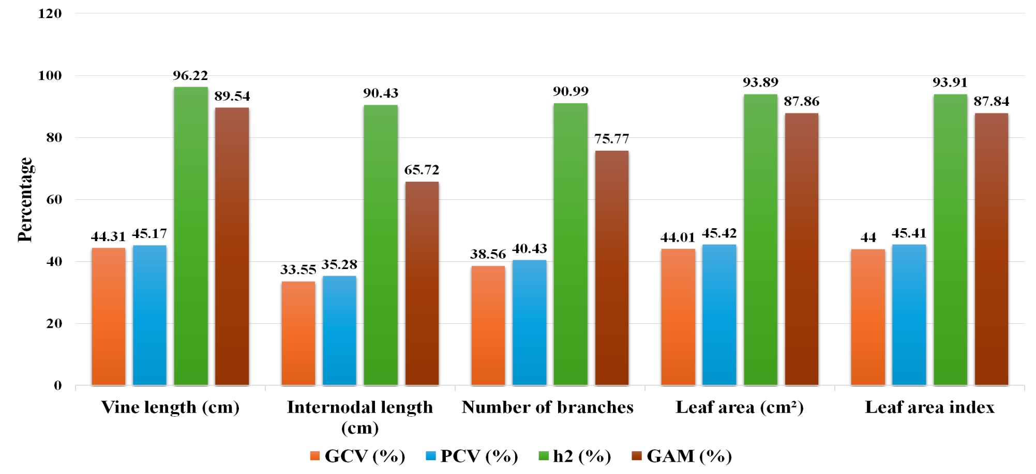
Fig 1. Mean performance of GCV, PCV, h² and genetic advance in per cent of growth parameters

Table 3. Estimation of genetic parameters for yield characters of sweet potato
S No | Characters | Range | SE(m) | GV | PV | GCV (%) | PCV (%) | h² (%) | GAM (%)
1 | Tuber length (cm) | 7.27-18.87 | 1.07 | 7.93 | 11.38 | 21.54 | 25.81 | 69.65 | 37.04
2 | Tuber diameter (cm) | 2.01-5.22 | 0.26 | 0.71 | 0.90 | 23.69 | 26.79 | 78.20 | 43.15
3 | Number of tubers vine ⁻¹ | 3.20-5.43 | 0.22 | 0.38 | 0.52 | 14.68 | 17.23 | 72.60 | 25.77
4 | Average weight of tuber vine ⁻¹ (g) | 34.09-98.75 | 6.45 | 263.26 | 387.86 | 27.67 | 33.59 | 67.90 | 46.96
5 | Tuber yield vine ⁻¹ (g) | 115.88-400.13 | 21.33 | 6030.44 | 7395.25 | 31.29 | 34.65 | 81.50 | 58.20
6 | Tuber yield per plot (kg/plot) | 5.91-25.45 | 1.09 | 15.69 | 19.24 | 31.29 | 34.65 | 81.50 | 58.20
7 | Tuber yield (t/ha) | 8.21-28.34 | 1.51 | 30.26 | 37.11 | 31.29 | 34.65 | 81.50 | 58.20
8 | Harvest index (%) | 49.23-83.44 | 2.41 | 73.83 | 91.25 | 12.98 | 14.43 | 80.91 | 24.05
9 | Pest incidence (%) | 0.93-1.85 | 0.16 | 0.07 | 0.14 | 16.73 | 24.45 | 46.81 | 23.58

GV - Genotypic variance PV – Phenotypic variance
GCV - Genotypic coefficient of variation PCV - Phenotypic coefficient of variation
h² – Broad sense heritability GA - Genetic advance

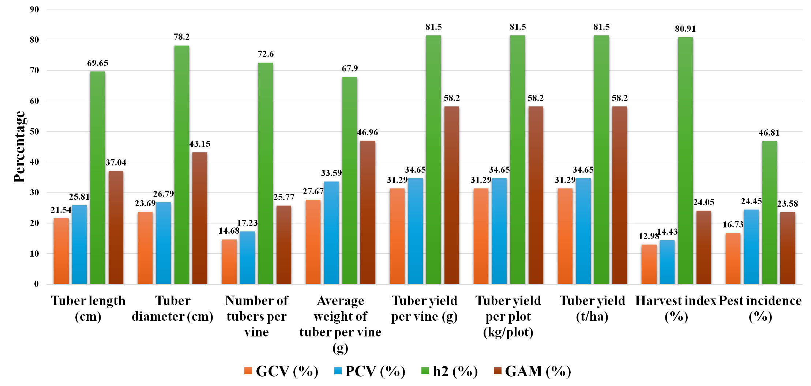
Fig 2: Mean performance of GCV, PCV, h² and genetic advance in per cent of yield parameters

Table 4: Estimation of genetic parameters for quality characters of sweet potato

S No | Characters | Range | SE(m) | GV | PV | GCV (%) | PCV (%) | h² (%) | GAM (%)
1 | Reducing sugar (%) | 3.19-6.81 | 0.15 | 0.85 | 0.92 | 18.34 | 19.07 | 92.50 | 36.33
2 | Non-reducing sugar (%) | 20.22-28.42 | 0.52 | 4.67 | 5.46 | 8.62 | 9.33 | 85.40 | 16.42
3 | Starch content (%) | 18.56-29.39 | 0.73 | 7.09 | 8.68 | 10.93 | 12.09 | 81.70 | 20.34
4 | Total sugar (%) | 3.20-7.80 | 0.08 | 1.99 | 2.01 | 25.30 | 25.42 | 99.02 | 51.85
5 | β-carotene content (mg 100g⁻¹ FW) | 0.13-9.60 | 0.23 | 13.60 | 13.76 | 94.46 | 95.02 | 98.80 | 193.46
6 | Anthocyanin content (mg 100g⁻¹ FW) | 2.16-137.11 | 0.57 | 934.40 | 935.37 | 169.59 | 169.68 | 99.90 | 349.18
7 | Dry matter content (%) | 17.41-32.02 | 0.86 | 11.42 | 13.66 | 12.48 | 13.65 | 83.60 | 23.51

GV - Genotypic variance PV – Phenotypic variance
GCV - Genotypic coefficient of variation PCV - Phenotypic coefficient of variation
h² – Broad sense heritability GA - Genetic advance

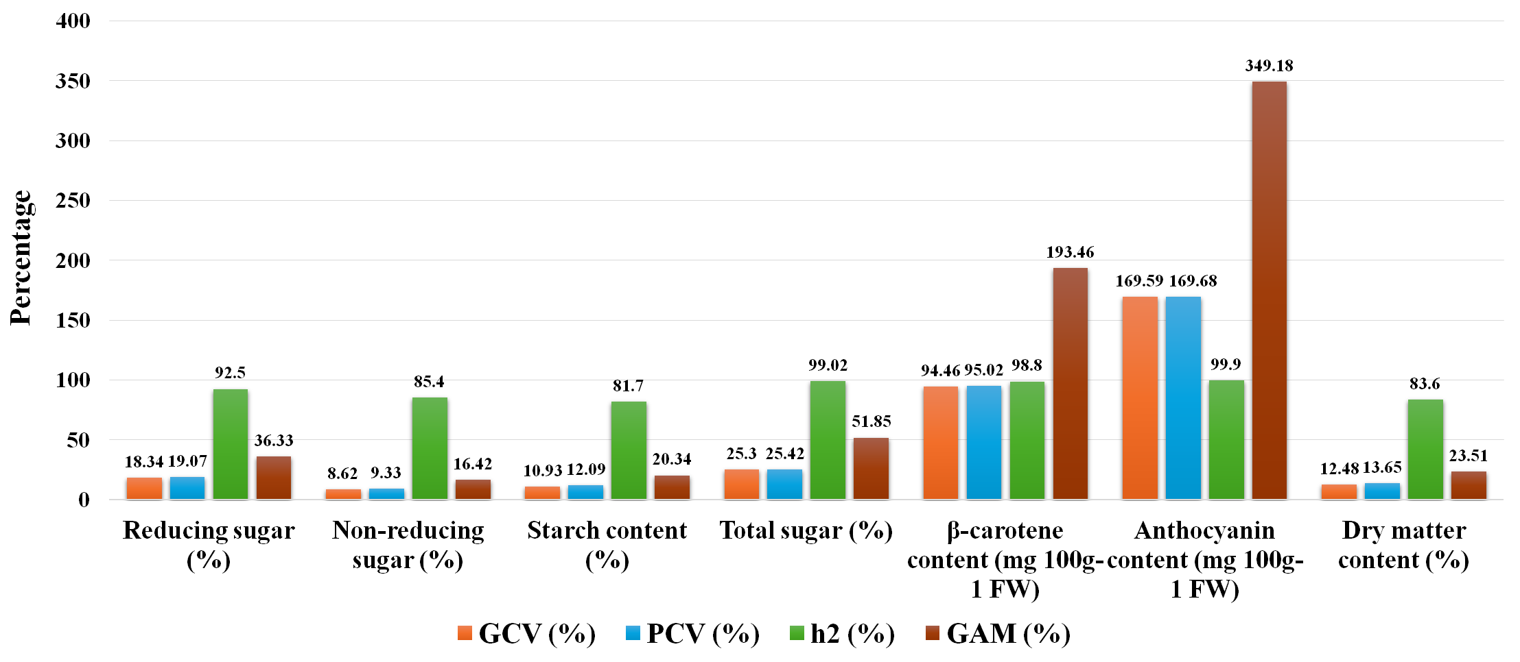
Fig 3. Mean performance of GCV, PCV, h² and genetic advance in per cent of quality parameters

References
Allard, R. W. (1960). Principles of Plant Breeding. John Wiley and Sons, New York. p. 485.
Badu, M., Ashok, P., Kiran Patro, T. S. K. K. and Sasikala, K. (2017). Studies on genetic variability, heritability and genetic advance for growth, yield and quality parameters among orange-fleshed sweet potato [Ipomoea batatas (L.) Lam.] genotypes. International Journal of Current Microbiology and Applied Sciences, 6(9), 1804–1903.
Bajrang, B. (2021). Studies on genetic variability of sweet potato [Ipomoea batatas (L.)] genotypes for tuber yield and yield components. Ph.D. Thesis, Indira Gandhi Krishi Vishwavidyalaya, Raipur.
Burton, G. W. and De Vane, D. E. (1953). Estimating heritability in tall fescue (Festuca arundinacea) from replicated clonal material. Agronomy Journal, 45, 478–481.
Darshan, S., Byregowda, M., Gowda, M. V. C. and Ramachandra, R. K. (2017). Genetic variability and heritability studies in sweet potato (Ipomoea batatas (L.) Lam.). International Journal of Pure and Applied Bioscience, 5(4), 680–686.
FAOSTAT. (2021). Food and Agriculture Organization of the United Nations. http://faostat.fao.org.
Gehan, A. (2019). Assessment of variability, correlation and response to selection in four cultivars of sweet potato. Asian Journal of Agricultural Sciences, 64(1), 21–31.
Gin, D. E., Laurie, S. M. and Faber, M. (2008). Sensory acceptability of sweet potato varieties by rural consumers in South Africa. African Journal of Food, Agriculture, Nutrition and Development, 8(4), 372–388.
Haque, M. E., Saito, T. and Yoshida, T. (2023). Polyploid GWAS reveals the basis of molecular marker development for complex breeding traits including starch content in the storage roots of sweet potato. Frontiers in Plant Science, 14, 1181909.
Hejjegar, I. S. M., Hiremath, S. M., Naik, K. R. and Kolur, S. M. (2023). Genetic variability, heritability and genetic advance in sweet potato (Ipomoea batatas (L.) Lam.) genotypes. International Journal of Environment, 13(9), 2791–2798.
Johnson, H. W., Robinson, H. F. and Comstock, R. E. (1955). Estimates of genetic and environmental variability in soybeans. Agronomy Journal, 47(7), 314–318.
Jones, A., Dukes, P. D. and Schalk, J. M. (1986). Sweet potato breeding. In M. J. Bassett (Ed.), Breeding Vegetable Crops. AVI Publishing Company, Westport, Connecticut. pp. 1–35.
Loebenstein, G. (2009). The taxonomy, evolution and genetic diversity of sweet potatoes and related wild species. In P. Gregory (Ed.), Exploration, Maintenance and Utilization of Sweet Potato Genetic Resources. CIP, Lima, Peru. pp. 27–60.
Madawal, S. I., Alloli, A., Madarakhandi, T. B. S. and Anand Narasannavar, A. N. (2015). Genetic variability study in sweet potato (Ipomoea batatas L.) genotypes. International Journal of Tropical Agriculture, 33(2), 279–282.
Mekonnen, B., Gedebo, A. and Gurmu, F. (2021). Genetic variability for yield and yield-related traits in orange-fleshed sweet potato genotypes evaluated at Hawassa, Ethiopia. Agricultural Technology, 10(1), 28–35.
Narasimhamurthy, P. N., Patel, N. B., Patel, A. I. and Koteswara Rao, G. (2018). Genetic variability, heritability and genetic advance for growth, yield and quality parameters among sweet potato [Ipomoea batatas (L.) Lam.] genotypes. International Journal of Chemical Studies, 6(4), 2410–2413.
Nasiruddin, M., Haydar, F. M. A., Islam, A. K. M. R. and Hossain, M. M. (2014). Study of genetic variability and correlation of potato (Solanum tuberosum L.) genotypes grown in Bangladesh. Plant Environment and Development, 3(2), 9–13.
Panse, V. G. and Sukhatme, P. V. (1957). Statistical Methods for Agricultural Workers. Indian Council of Agricultural Research, New Delhi.
Prajapati, D. R., Patel, R. N. and Gami, R. A. (2020). Study of genetic variability of tuber yield and storage-related traits in potato (Solanum tuberosum L.). International Journal of Chemical Studies, 8(3), 188–192.
Prarthana, M., Ashok, P., Rout, M. K. and Dash, R. K. (2015). Genetic variability for yield and yield attributing characters in sweet potato (Ipomoea batatas (L.) Lam.). Bioscience Trends, 8(9), 2426–2429.
Ramachandra, M. K. and Srinivasa, V. (2017). Variability, heritability and genetic advance for quantitative and qualitative traits in potato genotypes under hill zone of Karnataka. Green Farming, 8(6), 1250–1253.
Robinson, H. F., Comstock, R. E. and Harvey, P. H. (1949). Estimates of heritability and the degree of dominance in corn. Agronomy Journal, 41(8), 353–359.
Seid, E., Mohammed, W. and Abebe, T. (2020). Genetic variability, heritability and genetic advance in potato (Solanum tuberosum L.) for processing quality, yield and yield related traits. International Journal of Plant Breeding and Crop Science, 7(3), 928–936.
Sharavathi, M. B., Naik, K. R., Devaraju, K., Kolakar, S. S., Kanthraj, Y. and Srinivasa, V. (2018). Evaluation of sweet potato (Ipomoea batatas L.) genotypes under hill zone of Karnataka. International Journal of Chemical Studies, 6(5), 882–886.
Sharavathi, M. B., Srinivasa, V., Anusha, R. B. and Shubha, A. S. (2018). Genetic variability studies in sweet potato (Ipomoea batatas (L.) Lam) genotypes under hill zone of Karnataka, India. International Journal of Current Microbiology and Applied Sciences, 7(9), 850–858.
Sivasubramanian, J. and Madhavamenon, P. (1973). Genotypic and phenotypic variability in rice. Madras Agricultural Journal, 60(9–12), 15–16.
Tripathi, V., Deo, C., Ravi, S. and Singh, R. S. (2016). Genetic variability and association studies in sweet potato [Ipomoea batatas (L.) Lam.]. International Quarterly Journal of Life Sciences, 11(4), 3203–3206.
Vinod, P., Ashok, R. and Devi, L. S. (2024). Estimation of genetic variability and heritability for yield and its related components of orange-fleshed sweet potato (Ipomoea batatas L.) genotypes. Biochemical Journal, 8(12S), 3313–3322.
Wani, P. (2021). Evaluation of orange-fleshed sweet potato (Ipomoea batatas L.) genotypes. Ph.D. Thesis, University of Horticultural Sciences, Bagalkot, Karnataka.
Weber, C. R. and Moorthy, H. R. (1952). Heritable and non-heritable relationship and variability of oil content and agronomic characters in the F₂ generation of soybean crosses. Agronomy Journal, 44, 202–209.
Wu, X., Zhang, Y. and Li, T. (2025). Genetic diversity evaluation and selection methods of sweet potato hybrid F₁ population based on SSR markers and phenotypic detection. BMC Plant Biology, 25, 6166.
Zhang, L. and Zhao, Q. (2024). Genetic diversity in sweet potato: A review of global germplasm. Plant Genetic Resources and Breeding, 6(2), 45–57.

