Original Research Article
Identification of Promising Wheat Genotypes based on Different Stress Indices for Salinity Tolerance

ABSTRACT
The study investigated salt tolerance of wheat genotypes based on quantitative traits employing various stress indices. The experimental material included twenty two advance wheat genotypes, evaluated in two different environments under natural soil salinity patch having sandy loam texture with pH 8.1 and ECe 4.25 dsm⁻¹ during 2024-25 crop season at CCS Haryana Agricultural University, Hisar (Haryana). The genotypes WH 1355 and P 14335 were found with maximum and P 14426 was recorded with minimum grain yield under TSS and LSS conditions, respectively. The results revealed the reduction in mean grain yield by 31.38 per cent under LSS condition as compared with TSS. High heritability coupled with high genetic advance was observed for harvest index for both sowing conditions. Correlation among traits indicated significant positive association of grain yield with harvest index in both the environments, exhibiting the significance of this trait for deciding the selection criterion for yield enhancement under salinity. Based on overall rank of stress indices based on grain yield and SSI of different traits, KRL 210, P 14383, P 14154 and WH 1356 were identified salt tolerant genotypes accompanying heat stress. Correlation analysis exploring stress indices discerned significant negative association of grain yield (Ys) with SSI and RSI and significant positive correlation with STI, YSI, MP and MRP. These indices, therefore, could be considered as the best selection criteria for salinity breeding. PCA identified three components with eigenvalue exceeding one that cumulatively explained about 98.28 per cent of the total variation. PC 2 elucidated 35.63 per cent of the total variance and could be considered as salt tolerant component based on its strong correlation with Ys, Yp, STI and MP. The genotypes of cluster I portrayed better performance under salinity; hence the genotypes from this group could be utilized for salinity tolerance as elite breeding material.
Keywords: Wheat, salinity, stress indices

1. INTRODUCTION
Wheat (Triticum aestivum L.), one of the most important cereal crop grown worldwide, provides 20% of the calories and protein in the global human diet (Shewry and Hey, 2015). Globally, wheat crop has been under cultivation in 220.88 million hectares with annual production of 806.90 million tonnes (USDA, 2025). In India, wheat occupied 32.76 million hectares and produced 117.51 million tonnes with national average productivity of 35.87 quintals per hectare during 2024-25 crop season (ICAR-IIWBR, 2025).
Abiotic stresses significantly determine the agricultural production globally, with its severity escalating due to both natural and man-made factors, posing challenging to agricultural researchers. The challenge to fulfill the growing worldwide demand for food is intensified by abiotic factors considerably affecting the yield potential of crops including wheat, results seen in various physiological, biochemical, and molecular responses in plants (Ismail et al., 2025). Among these stresses, salinity is the most prevalent and injurious environmental stress limiting crop productivity worldwide (Khana et al., 2023). It is reported that about 900 million hectares of agricultural land is affected by salt stress globally (Butcher et al., 2016). In India, the salinity affected land witnessed about 6.74 million hectares (Kumar and Sharma, 2020). Salt stress impacts plants negatively as a consequence of osmotic stress, ion toxicity and disruption of mineral uptake (Hao et al., 2021). Salinity also impels deleterious effects on seed germination by decreasing gibberellic acid, increasing abscisic acid, altering membrane permeability and by reducing the water absorption in seeds as well (Atta et al., 2023). Hence, it is important to develop suitable strategies to enhance the yield potential for saline condition. There are many factors causing soil salinity such as climatic variation, geological and hydrological conditions and excessive water for irrigation mainly. As a result, the extent of salinized areas of land may continue to increase and their management is challenging (Ouhibi et al., 2014). It is estimated that about 840 million people may be at risk of hunger by 2030 and to feed them, it is essential to improve crop cultivation strategies (FAO, 2020).
Among cereals, bread wheat is a moderately tolerant crop to salinity (Saddiq et al., 2021); however, the losses in grain yield may exceed 60% under saline conditions (Khan et al., 2017). Hence, it necessitates to frame the most effective and feasible strategies to enhance the salt tolerance ability to minimize its deleterious effects on crop production (Luo et al., 2019). Wheat, also known a salt excluder, can mitigate salinity stress by excluding Na⁺ from the shoot as much as possible (Genc et al., 2016). Moreover, the improvement for salt tolerance is a complicated task for its being polygenic in nature and having influence of genetic makeup, environmental, and physiological factors. It is worthwhile to mention that a large number of marginal saline lands around the world, such as in coastal areas that have the potential for production, if engineered, salt tolerant wheat is feasible (Colmer et al., 2006). Though, the extensive research has been conducted towards genetic improvement of salt tolerance through screening and evaluation of wheat genotypes (Sabagh et al., 2021). Despite intensive efforts, little success has been achieved in breeding genotypes tolerant to saline conditions. Salt tolerance involves complex morphological and physiological factors in different tissues at the whole plant level (Liang et al., 2018), a comprehensive understanding is crucial based on multiple parameters to screen germplasm for breeding (Li et al., 2021).The lack of precise indices of physiological and agronomic traits related to salinity stress and the low genetic variability of currently available wheat germplasm are among the main reasons for the limited success in breeding salt tolerant wheat varieties (Miransari and Smith, 2019). Besides, multi-parameter analysis is accompanied by complex statistical methods that make the operation inconvenient and inefficient (Oyiga et al., 2016).
The objective of this study was to identify the salt tolerant wheat genotypes and to find out important characters and indices associated with salt tolerance to be employed as reliable indicators for selection and improvement for salt tolerance.
2. MATERIALS AND METHODS

The research encompassed a set of 22 advance wheat genotypes including two checks (KRL 210 and KRL 283). The genotypes listed in Table 2 were evaluated in Randomized Block Design with three replications. Each genotype was grown in 6 rows of 6.0 m each spaced at 20 cm, applying recommended agronomic practices. The study was carried out during 2024-25 crop season at Wheat Experimental Area of Department of Genetics and Plant Breeding, CCS Haryana Agricultural University, Hisar (Haryana).

The experimental material was screened in two environmental conditions under natural soil salinity patch having sandy loam texture with pH 8.1 and ECe 4.25 dsm⁻¹. Under timely sown salinity condition (TSS), the experiment was laid on 20th November, 2024 while, for late sown salinity (LSS), planted on 21st December, 2024. The observations were taken on eight quantitative traits comprising DH- Days to heading, DM- Days to maturity, PH- Plant height (cm), ETM- Effective tillers per meter row, TGW- 1000 grain weight (g), BY- Biological yield per plot (kg), HI- Harvest index (%) and GY- Grain yield per plot (kg). The recorded data was subjected to statistical analysis using R STUDIO software (2025.05.01+513).

The weather parameters for 2024-25 crop season (SMWs 44-17) revealed weekly mean maximum temperature from 15.2 to 40.5 ⁰C whereas, the weekly mean minimum temperature was between 2.7 and 21.6 ⁰C. Morning RH varied from 43.3 to 100% while evening RH was highly variable with a range from 12.4 to 77.4 %. Total rainfall received during the season was 59.3 mm.
3. RESULTS AND DISCUSSION
The study aimed to identify the salt tolerant genotypes availing nine stress indices, presented in Table 1. Various studies explored these indices for selection of elite genotypes for salinity tolerance, also investigated in wheat by Yassin et al. (2019), Ghonaim et al. (2021), Bakhshi et al. (2021) and Khatab et al. (2021). The findings of Arab et al. (2022) also highlighted the suitability of these indices for the purpose under study. The relative performance of the genotypes for both environments is provided in Table 2. It is evident from result that the genotypes performed with enough variation under TSS and LSS environments. The estimates of range were also found wide enough for the traits that offered score for selection of desirable plant types for saline conditions. The genotypes, in addition showed substantial reduction in the mean performance under LSS compared to TSS condition. Days to heading and maturity were reduced by 15.73 and 11.11 per cent while, plant height and effective tillers per meter exhibited 10.75 and 16.85 per cent reduction, respectively. Further, harvest index and biological yield showed a reduction of 14.90 and 19.40 per cent, respectively and 1000-grain weight declined by 18.39 per cent. The genotypes WH 1355 and P 14335 were found with maximum (44.44 and 29.17 q/ha) while, P 14426 was recorded with minimum (26.18 and 13.66 q/ha) grain yield under TSS and LSS conditions, respectively. The results also displayed the reduction in mean grain yield by 31.38 per cent under LSS condition as compared with TSS indicating the severe impact of salinity along with high temperature on grain yield of genotypes. Various quantitative characters were also studies by Singh et al. (2016) for screening of wheat genotypes for salt tolerance. Abd El-Hamid et al. (2020) also cited significant decrease in mean performance of genotypes under soil salinity for the characters studied.
The estimates of variance and genetic variability parameters calculated to determine the extent of variation pertaining to eight quantitative traits (Table 3). The mean sum of squares due to treatment (genotypes) indicated significant differences among the genotypes for all the studied traits for both environments, unveiling for their further investigation for genetic analysis. These results corroborate with the findings of Bafghi et al. (2017), Amer et al. (2021) and Moustafa et al. (2021). The results also showed higher phenotypic coefficient of variation (PCV) compared to the corresponding genotypic coefficient of variation (GCV) under both environments for all the characters, reflecting the impact of environment on the expression of traits. An appropriate breeding program can be framed to improve the trait depending on its genetic makeup and the degree of environmental effect on its expression. The perusal of data revealed low estimates of GCV and PCV for days to heading, maturity and plant height whereas, other traits exhibited low to moderate estimates of GCV and PCV, also corroborated in wheat by Moustafa et al. (2021). The information on heritability is quite essential for prediction of response to selection and to review the usefulness and precision of results from screening trials. Heritability in broad sense was found high for days to heading, 1000-grain weight and harvest index; while remaining characters possessed low to moderate heritability under both conditions. Similarly, among all the characters for both environments, harvest index was recorded with high genetic advance. The results are in line with observation of Darwish et al. (2017) and Yassin et al. (2019). Further, the association study at genotypic and phenotypic levels showed highly significant positive correlation of grain yield with harvest index for both environments.
The salt tolerance studies in general exploit the stress susceptibility index as a measure, therefore was calculated exploiting all the studied traits (Table 4). The grain yield recorded under TSS and LSS conditions are indicated as Yp and Ys, respectively. The genotypes were first ranked based on SSI values of individual trait, and further ranked using SSI of all the traits. The genotypes, P 14154, P 14383, KRL 210, P 14536 and WH 1356 revealed overall low estimates of SSI, exhibited high salt tolerance among twenty two genotypes screened. The genotypes, P 14426 and P 14357 though exhibited high rank but were not found desirable with respect to SSI of harvest index and grain yield. Hence, grain yield should be considered with low SSI of all the traits while selecting elite genotypes. SSI was also reported a useful selection criteria for screening the salt tolerance in terms of grain yield (Goudarzi and Pakniyat, 2008; Gadallah et al., 2017 and Ghonaim et al., 2021).
Though a lot of investigation on salt tolerance has been carried out in wheat, despite that efficient salt screening techniques based on quantitative traits are still lacking. Consequently, a set of nine stress indices were calculated using grain yield in order to select the salt tolerant genotypes. Among the indices explored, the higher SSI, TOL, SSPI, RSI, and RED reflected susceptibility of genotypes to salt while, elevated STI, YSI, MP and MRP indicated salt tolerance. Initially all the genotypes were ranked considering individual index and further based on ranks of all the indices together, all the genotypes were again ranked, indicated as overall rank (Table 5). The genotypes, KRL 210, P 14383, P 14541, P 14154 and WH 1356 showed higher overall rank and hence exhibited salt tolerance among the entries evaluated.
Correlation analysis was performed (Fig.1) among stress indices including grain yield (Yp and Ys). The finding showed negative association of grain yield (Ys) with SSI, SSPI, RSI and RED and significant positive correlation with STI, YSI, MP and MRP, signifying importance of these indices for salt tolerance under stress. Hence, lower SSI, SSPI, RSI and RED, and higher STI, YSI, MP and MRP could be regarded as the best selection indicators for salinity breeding. Likewise, among the stress indices, significant positive associations were observed for SSI with TOL and RSI; TOL with STI, RSI and MP; STI with MP; SSPI with RED; and YSI with MRP. The results also revealed significant negative association of SSI and TOL with YSI and MRP; YSI with RSI; and RSI with MRP. Similar findings were also cited by Sardouie-Nasab et al. (2014), Singh et al. (2015), Ravari et al. (2016), Darwish et al. (2017) and Yassin et al. (2019), Arab et al. (2022) for one or more indices in wheat.
Principal component analysis represents the association of traits at once through bilot technique and facilitates to reduce the number of variables explaining maximum variation of original dataset, is better criterion over correlation coefficient for sorting elite genotypes in different environments. PCA based on grain yield and various stress indices (Table 6) revealed first three components with eigenvalue exceeding one accounted for about 98.28 percent of the total variation of experimental material. PC 1 explained 47.77 percent of the total variance and exhibited strong correlation with SSI, TOL, YSI, RSI and MRP, therefore considered as salt susceptible component. Similarly, PC 2 accounted for 35.63 percent of the total variability and might be regarded as salt tolerant component consequent upon its strong association with Yp, Ys, STI and MP. Thus, the selection of genotypes with low PC 1 and high PC 2 are suitable for both environments.
In the biplot analysis, first two components were used (Fig. 2) for comparing relationship between genotypes and stress indices. The biplot displayed positive association of Ys with STI, MP, YSI and MRP, while negatively correlated with SSI, TOL, SSPI, RSI and RED as indicated by the acute and obtuse angles between their vectors, respectively. Likewise, STI, YSI, MP and MRP exhibited negative correlation with SSI, SSPI, RSI and RED and positively associated among themselves. Similar approach was also followed by Sardouie-Nasab et al. (2014), Arazmjoo and Amini Sefidab (2024) for identification of salt tolerant genotypes through association with stress indices. The genotypes P 14383, KRL 210, P 14541, P 14536, WH 1356, P 14154, WH 1354 and P 14404 were found with high PC 2 and low PC1 therefore, regarded as superior genotypes for both LSS and TSS conditions. The study based on PCA indicates STI and MP as good indicators of salt tolerance. Asadi et al. (2012), Amini et al. (2016), Amer et al. (2021), Arab et al. (2022) also reported STI and MP as suitable indices for salinity screening.
The cluster analysis based on stress indices and grain yield classified all the genotypes into three distinct clusters, findings are in Table 7 with their mean performance. The clustering profile identified cluster I with nine genotypes whereas, cluster II being largest one containing twelve genotypes. The lowest yielding genotype in both environments, P 14426 alone occupied their position in cluster III. The association in the form of dendrogram (Fig. 3) displaying the magnitude of genetic diversity of genotypes; the approach was also explored by Arab et al. (2022) in wheat. The mean performance of genotypes in relation to grain yield (Yp and Ys) and stress indices indicated cluster I with minimum SSI, TOL, SSPI, RSI and RED, and higher Ys, YSI and MRP. Similarly, cluster II was characterized by higher Yp, STI and MP. Hence, genotypes from cluster I might be considered for furtherance of genetic gain in yield while stepping up wheat breeding for stress tolerance. Similar to the current study, Kumar et al. (2024) also highlighted the performance of different clusters based on stress indices for sorting elite genotypes for salinity tolerance. The estimates of various stress indices were also used by Lamba et al. (2023) for clustering of genotypes evaluated under stress condition. The cluster analysis of 64 genotypes constituted four distinct classes in relation to salt tolerance in wheat, also substantiated by Mubushar et al. (2022).
4. CONCLUSION
The study concluded that the salinity impacts and substantially reduces the performance of genotypes. The genotypes, WH 1355 and P 14335 were found with maximum and P 14426 was recorded with minimum grain yield under TSS and LSS conditions, respectively. The study also observed harvest index as key trait based on its significant positive association with grain yield and its high heritability with high genetic advance. The genotypes, KRL 210, P 14383, P 14154 and WH 1356 were identified salt tolerant based on stress indices and SSI of all the characters studied. The association among stress indices reflected SSI, RSI, STI, YSI, MP and MRP as key indicators for salinity tolerance while, PCA study recognized STI and MP as best selection indicators for salinity breeding. The cluster analysis revealed grouping of salt tolerant genotypes in cluster 1 to be utilized for salinity tolerance as elite breeding material.

DISCLAIMER (ARTIFICIAL INTELLIGENCE)
Author(s) hereby declare that NO generative AI technologies such as Large Language Models (ChatGPT, COPILOT, etc.) and text-to-image generators have been used during writing or editing of this manuscript.
COMPETING INTERESTS
Authors have declared that no competing interests exist.
REFERENCES
Abd El-Hamid, E. A. M., El-Hawary, M. N. A., Khedr, R. A., & Shahein, A. M. E. A. (2020). Evaluation of some bread wheat genotypes under soil salinity conditions. Journal of Plant Production, 11 (2), 167 -177.
Amer, H., Dakroury, M.Z., El-Basyoni, I.S., & Abouzied, H.M. (2021). Phenotypic and physiological evaluation of wheat genotypes under non-saline and saline soil conditions. Asian Journal of Research in Crop Science, 6(1), 29-43.
Amini, A., Amirnia, R., & Ghazvini, H. A. (2016). Evaluation of salinity tolerance in bread wheat genotypes under field conditions. Seed and Plant Journal, 1 (31), 95-115.
Arab, S.A., Eissa, S.T., & Mohamed, M.M. (2022). Evaluation of wheat genotypes for salinity tolerance based on agronomic traits. Plant Cell Biotechnology and Molecular Biology, 23(5&6),1-14.
Arazmjoo, E., & Amini Sefidab, A. (2024). Investigation of agronomic traits, dry matter remobilization and stress indices in promising bread wheat genotypes under salinity stress. Journal of Central European Agriculture, 25(1), 94-109.
Asadi, M., Mohammadi-Nejad, G., Golkar, P., Naghavi, H., & Nakhoda, B. (2012). Assessment of salinity tolerance of different promising lines of bread wheat (Triticum aestivum L.). Advances in Applied Science Research, 3 (2), 1117-1121.
Atta, K., Mondal, S., Gorai, S., Singh, A.P., Kumari, A., Ghosh, T., Roy, A., Hembram, S., Gaikwad, D.J., Mondal, S., Bhattacharya, S., Jha, U.C., & Jespersen, D. (2023). Impacts of salinity stress on crop plants: Improving salt tolerance through genetic and molecular dissection. Frontiers in Plant Science, 14, 1241736.
Bafghi, R.M.H., Amin Baghizadeh, A., & Mohammadinezhad, G. (2017). Evaluation of salinity and drought stresses tolerance in wheat genotypes using tolerance indices. Journal of Crop Breeding, 9(23), 27-34.
Bakhshi, B., Tabatabaei, S.M.T., Rad, M.R.N., & Masoudi, B. (2021). Identification of salt tolerant genotypes in wheat using stress tolerance indices. bioRxiv, doi: https://doi.org/10.1101/2021.02.15.431202
Bouslama M., & Schapaugh W.T. (1984). Stress tolerance in soybeans. I. Evaluation of three screening techniques for heat and drought tolerance. Crop Science, 24(5), 933-937.
Butcher, K., Wick, A. F., DeSutter, T., Chatterjee, A., & Harmon, J. (2016). Soil salinity: A threat to global food security. Agronomy Journal, 108(6), 2189-2200.
Colmer, T.D., Flowers, T.J., & Munns, R. (2006). Use of wild relatives to improve salt tolerance in wheat. Journal of Experimental Botany, 57, 1059-1078.
Darwish, M. A. H., Fares, W. M., & Hussein, E.M.A. (2017). Evaluation of some bread wheat genotypes under saline soil conditions using tolerance indices and multivariate analysis. Journal of Plant Production, 8 (12), 1383-1394.
FAO; IFAD; UNICEF; WFP; WHO (2020). The State of Food Security and Nutrition in the World 2020. Available online: https: //www.unicef.org/reports/state-of-food-security-and-nutrition-2020 (accessed on 10 July 2020).
Farshadfar E., & Javadinia J. (2011). Evaluation of chickpea (Cicer arietinum L.) genotypes for drought tolerance. Seed and Plant Improvement Journal, 27(4), 517-537.
Fernandez G.C.J. (1992). Effective selection criteria for assessing plant stress tolerance. In: Proceeding of the International Symposium on Adaptation of Food Crop to Temperature and Water Stress. Publication, Taiwan, 257-270.
Fischer R., & Maurer R. (1978). Drought resistance in spring wheat cultivars. I. Grain yield responses. Australian Journal of Agricultural Research, 29, 897-912.
Fischer R.A., & Wood J.T. (1979). Drought resistance in spring wheat cultivars III. Yield association with morpho-physiological traits. Crop Pasture Science, 30, 1001-1020.
Gadallah, M.A., Milad, S.I., Mabrook, Y. M., Yossef, A.Y.A., & Gouda, M. A. (2017). Evaluation of some Egyptian bread wheat (Triticum aestivum) cultivars under salinity stress. Alexandria Science Exchange Journal, 38 (2), 259-270.
Genc, Y., Oldach, K., Taylor, J., & Lyons, G.H. (2016). Uncoupling of sodium and chloride to assist breeding for salinity tolerance in crops. New Phytologist, 210, 145-156.
Ghonaim, M.M., Mohamed, H.I., & Omran, A.A.A. (2021). Evaluation of wheat (Triticum aestivum L.) salt stress tolerance using physiological parameters and retrotransposon-based markers. Genetic Resource and Crop Evolution, 68, 227-242.
Goudarzi, M., & Pakniyat, H. (2008). Evaluation of wheat cultivars under salinity stress based on some agronomic and physiological traits. Journal of Agriculture and Social Sciences, 4, 35-38.
Hao, S., Wang, Y., Yan, Y., Liu, Y., Wang, J., & Chen, S. (2021). A review on plant responses to salt stress and their mechanisms of salt resistance. Horticulturae, 7(6), 132.
ICAR-IIWBR (2025). Directors report of AICRP on Wheat and Barley 2024-25, Ed: Ratan Tiwari, Sindhu Sareen, Dinesh Kumar, Anuj Kumar and CN Mishra, ICAR-Indian Institute of Wheat and Barley Research, Karnal, Haryana, India. P. 84.
Ismail, A.M., Singh, P.K., Krishna, H., Kumar, A., Kulshreshtha, N., Mahendra, C., & Kumar, K. (2025). Physiological and molecular analysis of salt tolerance in wheat (Triticum aestivum) recombinant inbred lines population (HD 2851 × Kharchia 65). Indian Journal of Agricultural Sciences, 95 (1), 3-9.
Khan, M. S., Rizvi, A., Saif, S., & Zaidi, A. (2017). Phosphate-solubilizing microorganisms in sustainable production of wheat: Current perspective. In: Probiotics in Agroecosystem, Eds. V. Kumar, M. Kumar, S. Sharma, and R. Prasad (Singapore: Springer), doi: 10.1007/978-981-10-4059-7_3.
Khana, W., Khan, A., Ullah, A., Ul Haq, S.I., Hassana, N., Iqbal, B., Ahmad, N., Mahmoud, E.A., & Elansary, H.O. (2023). Insights concerning advancing the agroecological sustainability of salinity tolerance through proteomics profiling of hexaploid wheat (Triticum aestivum L.). South African Journal of Botany, 158, 142-148.
Khatab, I.A., El-Mouhamady, A.B.A., & Mariey, S.A. (2021). Comprehensive selection criteria for high-yielding bread wheat (Triticum aestivum L.) hybrids under salinity stress. Egyptian Journal of Botany, 61 (3), 709-730.
Kumar, P., & Sharma, P. K. (2020). Soil salinity and food security in India. Frontiers in Sustainable Food Systems, 4, 533781.
Kumar, Y., Devi, S., Phougat, D., Chaurasia, H., & Choudhary, S. (2024). Assessment of barley genotypes for salinity tolerance based on various indices under field condition. Current Agriculture Research Journal, 12 (2), 586-598.
Lamba, K., Kumar, M., Singh, V., Chaudhary, L., Sharma, R., Yashveer, S., & Dalal M.S. (2023). Heat stress tolerance indices for identification of the heat tolerant wheat genotypes. Scientific Reports, 13(1), 10842.
Li, L., Peng, Z., Mao, X., Wang, J., Li, C., Chang, X., & Jing, R. (2021). Genetic insights into natural variation underlying salt tolerance in wheat. Journal of Experimental Botany, 72 (4), 1135-1150.
Liang, W., Ma, X., Wan, P., & Liu, L. (2018). Plant salt-tolerance mechanism: A review. Biochemical and Biophysical Research Communications, 495, 286-291.
Luo, Q., Teng, W., Fang, S., Li, H., Li, B., Chu, J., Li, Z., & Qi, Z. (2019). Transcriptome analysis of salt-stress response in three seedling tissues of common wheat. The Crop Journal, 7 (3), 378-392.
Miransari, M., & Smith, D. (2019). Sustainable wheat (Triticum aestivum L.) production in saline fields: A review. Critical Reviews in Biotechnology, 39, 999-1014.
Moosavi, S.S, Samadi, Y.B., Naghavi, M.R., Zali, A.A., Dashti, H., & Pourshahbazi, A. (2008). Introduction of new indices to identify relative drought tolerance and resistance in wheat genotypes. Desert, 12, 165-178.
Moustafa, E.S.A., Ali, M.M.A., Kamara, M.M., Awad, M.F., Hassanin, A.A., & Mansour, E. (2021). Field screening of wheat advanced lines for salinity tolerance. Agronomy, 11, 281.
Mubushar, M., El-Hendawy, S., Tahir, M.U., Alotaibi, M., Mohammed,N., Refay, Y., & Tola, E. (2022). Assessing the suitability of multivariate analysis for stress tolerance indices, biomass, and grain yield for detecting salt tolerance in advanced spring wheat lines irrigated with saline water under field conditions. Agronomy, 12, 3084.
Ouhibi, C., Attia, H., Rebah, F., Msilini, N., Chebbi, M., Aarrouf, J., Urban, L., & Lachaal, M. (2014). Salt stress mitigation by seed priming with UV-C in lettuce plants: Growth, antioxidant activity and phenolic compounds. Plant Physiology and Biochemistry, 83, 126-133.
Oyiga, B. C., Sharma, R. C., Shen, J., Baum, M., Ogbonnaya, F. C., Leon, J., & Ballvora, A. (2016). Identification and characterization of salt tolerance of wheat germplasm using a multivariable screening approach. Journal of Agronomy and Crop Science, 202, 472-485.
R Core Team (2025). R: A Language and Environment for Statistical Computing. R Foundation for Statistical Computing, Vienna, Austria.
Ramirez P., & Kelly J.D. (1998). Traits related to drought resistance in common bean. Euphytica, 99(2), 127-136.
Ravari, S.Z., Dehghani, H., & Naghavi, H. (2016). Assessment of salinity indices to identify Iranian wheat varieties using an artificial neural network. Annals of Applied Biology, 168, 185-194.
Rosielle A.A., & Hamblin J. (1981). Theoretical aspects of selection for yield in stress and non-stress environments. Crop Science, 21, 943-946.
Sabagh, A. E., Islam, M. S., Skalicky, M., Raza, M. A., Singh, K., Hossain, M. A., Hossain, A., Mahboob, W., Iqbal, M. A., Ratnasekera, D., Singhal, R. K., Ahmed, S., Kumari, A., Wasaya, A., Sytar, O., Brestic, M., Cig, F., Erman, M., Rahman, M. H. U., Ullah, N., & Arshad, A. (2021). Salinity stress in wheat (Triticum aestivum L.) in the changing climate: Adaptation and management strategies. Frontiers in Agronomy, 3, 661932.
Saddiq, M.S., Iqbal, S., Hafeez, M.B., Ibrahim, A.M.H., Raza, A., Fatima, E.M., Baloch, H., Jahanzaib; Woodrow, P., & Ciarmiello, L.F. (2021). Effect of salinity stress on physiological changes in winter and spring wheat. Agronomy, 11, 1193.
Sardouie-Nasab, S., Mohammadi-Nejad, G., & Nakhoda, B. (2014). Field screening of salinity tolerance in Iranian bread wheat lines. Crop Science, 54, 1489-1496.
Shewry, P.R., & Hey, S.J. (2015). The contribution of wheat to human diet and health. Food and Energy Security, 4, 178-202.
Singh, S., Sengar, R. S., Kulshreshtha, N., Datta, D., Tomar, R. S., Rao, V. P., Garg, D., & Ojha, A. (2015). Assessment of multiple tolerance indices for salinity stress in bread wheat (Triticum aestivum L.). Journal of Agricultural Science; 7 (3), 49-57.
Singh, S., Sengar, R.S., & Kulshreshta, N. (2016). Differential response of selected bread wheat (Triticum aestivum L.) genotypes for salt tolerance by using multiple parameters. Journal of Wheat Research, 8(1), 19-24.
USDA (2025). World Agricultural Production. Washington, DC, USA: United States Department of Agriculture, Foreign Agricultural Service. http://www.fas.usda.gov/data/world-agricultural-production
Yassin, M., Fara, S.A., Hossain, A., Saneoka, H., & El Sabagh, A. (2019). Assessment of salinity tolerance bread wheat genotypes: using stress tolerance indices. Fresenius Environmental Bulletin, 28 (5), 4199-4217.

Table 1. Stress indices used in the study
Sr. No. | Stress indices | Abbreviations | Formulae | References
1 | Stress susceptibility index | SSI | SSI = (1 - Xh/X)/(1 - Yh/Y) | Fischer and Maurer (1978)
2 | Stress tolerance | TOL | TOL = Yp – Ys | Rosielle and Hamblin (1981)
3 | Stress tolerance index | STI | STI = (Yp × Ys) / Xp² | Fernandez (1992)
4 | Stress susceptibility percentage index | SSPI | Yp -Ys  SSPI = ––––––––– × 100  2 (Xp) | Moosavi et al. (2008)
5 | Yield susceptibility index | YSI | YSI = Ys / Yp | Bouslama and Schapaugh (1984)
6 | Relative stress index | RSI | (Yp/Ys)  RSI = ––––––––––––  Xs/Xp | Fischer and Wood (1979)
7 | Mean productivity | MP | MP = (Yp + Ys) / 2 | Rosielle and Hamblin (1981)
8 | Mean relative performance | MRP | MRP = (Ys/Xs) + (Yp/Xp) | Ramirez and Kelly (1998)
9 | Reduction | RED | RED = (Yp – Ys) / Yp × 100 | Farshadfar and Javadinia (2011)
X = Grain yield of individual genotype under TSS condition; Y = Mean of all genotypes under TSS condition; Xh = Grain yield of individual genotype under LSS condition; Yh = Mean of all genotypes under LSS condition; Yp =Grain yield of genotype under TSS condition; Ys=Grain yield of genotype under LSS condition; Xp =Mean yield of all genotypes under TSS condition; Xs =Mean yield of all genotypes under LSS condition

Table 2. Performance of wheat genotypes for different traits under TSS and LSS conditions
Sr. No. | Genotypes | E | DH | DM | PH | ETM | TGW | BY | HI | GY
1 | P 14154 | TSS | 88 | 135 | 79 | 76 | 41.0 | 117.6 | 31.2 | 36.80
1 | P 14154 | LSS | 77 | 122 | 74 | 72 | 32.7 | 97.2 | 26.8 | 26.18
2 | P 14298 | TSS | 90 | 133 | 85 | 80 | 45.5 | 125.0 | 29.1 | 36.36
2 | P 14298 | LSS | 73 | 120 | 76 | 66 | 37.5 | 90.3 | 27.9 | 25.23
3 | P 14306 | TSS | 89 | 134 | 91 | 84 | 47.1 | 103.7 | 34.7 | 35.86
3 | P 14306 | LSS | 77 | 124 | 85 | 70 | 39.9 | 94.4 | 22.6 | 21.32
4 | P 14324 | TSS | 87 | 140 | 88 | 82 | 44.2 | 131.9 | 32.4 | 42.59
4 | P 14324 | LSS | 72 | 118 | 78 | 64 | 37.3 | 112.5 | 24.7 | 27.78
5 | P 14333 | TSS | 90 | 135 | 92 | 88 | 51.7 | 136.6 | 32.1 | 43.75
5 | P 14333 | LSS | 72 | 119 | 76 | 68 | 40.6 | 104.2 | 27.1 | 28.01
6 | P 14335 | TSS | 89 | 132 | 93 | 78 | 40.6 | 139.4 | 30.4 | 42.36
6 | P 14335 | LSS | 75 | 121 | 80 | 70 | 37.5 | 113.9 | 25.8 | 29.17
7 | P 14353 | TSS | 88 | 135 | 95 | 94 | 42.3 | 145.8 | 27.2 | 39.58
7 | P 14353 | LSS | 77 | 120 | 79 | 84 | 31.7 | 121.3 | 21.3 | 25.69
8 | P 14357 | TSS | 86 | 133 | 90 | 98 | 43.8 | 141.7 | 25.4 | 35.90
8 | P 14357 | LSS | 78 | 124 | 85 | 82 | 29.0 | 113.0 | 21.9 | 24.77
9 | P 14374 | TSS | 90 | 136 | 96 | 102 | 45.0 | 152.8 | 24.9 | 38.21
9 | P 14374 | LSS | 79 | 125 | 86 | 88 | 34.2 | 122.2 | 20.4 | 25.00
10 | P 14383 | TSS | 88 | 135 | 93 | 82 | 46.6 | 136.1 | 23.3 | 31.71
10 | P 14383 | LSS | 77 | 120 | 86 | 65 | 35.5 | 111.6 | 23.8 | 26.16
11 | P 14404 | TSS | 92 | 135 | 90 | 91 | 48.8 | 150.0 | 23.2 | 34.94
11 | P 14404 | LSS | 77 | 122 | 80 | 87 | 34.4 | 118.1 | 21.3 | 25.23
12 | P 14426 | TSS | 87 | 131 | 91 | 76 | 47.5 | 125.0 | 21.0 | 26.18
12 | P 14426 | LSS | 78 | 125 | 85 | 71 | 38.0 | 113.0 | 12.2 | 13.66
13 | P 14442 | TSS | 89 | 134 | 103 | 108 | 41.4 | 152.8 | 24.5 | 37.73
13 | P 14442 | LSS | 73 | 119 | 90 | 82 | 37.1 | 116.7 | 22.0 | 25.93
14 | P 14536 | TSS | 84 | 135 | 97 | 86 | 39.7 | 159.7 | 20.5 | 32.63
14 | P 14536 | LSS | 75 | 120 | 84 | 68 | 36.3 | 123.6 | 21.0 | 25.93
15 | P 14537 | TSS | 90 | 135 | 90 | 96 | 47.0 | 155.5 | 25.7 | 40.05
15 | P 14537 | LSS | 74 | 118 | 80 | 74 | 36.0 | 119.9 | 20.2 | 24.30
16 | P 14541 | TSS | 91 | 137 | 91 | 80 | 49.6 | 140.3 | 22.9 | 31.94
16 | P 14541 | LSS | 71 | 116 | 82 | 68 | 38.1 | 125.0 | 19.8 | 24.54
17 | WH 1353 | TSS | 92 | 136 | 96 | 86 | 45.6 | 131.9 | 29.4 | 38.67
17 | WH 1353 | LSS | 75 | 120 | 86 | 72 | 35.5 | 96.8 | 27.9 | 26.85
18 | WH 1354 | TSS | 88 | 138 | 94 | 102 | 34.1 | 147.2 | 23.0 | 34.03
18 | WH 1354 | LSS | 74 | 125 | 81 | 78 | 32.6 | 118.1 | 20.6 | 24.54
19 | WH 1355 | TSS | 93 | 137 | 98 | 99 | 47.0 | 132.4 | 34.0 | 44.44
19 | WH 1355 | LSS | 76 | 120 | 83 | 76 | 38.6 | 104.1 | 24.8 | 25.46
20 | WH 1356 | TSS | 89 | 135 | 93 | 104 | 34.4 | 166.2 | 21.7 | 36.08
20 | WH 1356 | LSS | 75 | 118 | 90 | 84 | 32.1 | 118.1 | 23.0 | 27.10
21 | KRL 210 | TSS | 90 | 134 | 94 | 80 | 36.6 | 131.7 | 26.7 | 35.19
21 | KRL 210 | LSS | 69 | 116 | 90 | 72 | 34.0 | 106.9 | 26.2 | 28.03
22 | KRL 283 | TSS | 90 | 133 | 102 | 92 | 33.9 | 118.1 | 22.9 | 27.08
22 | KRL 283 | LSS | 75 | 117 | 92 | 70 | 30.9 | 111.1 | 17.7 | 19.68
Mean |  | TSS | 89 | 135 | 93 | 89 | 43.5 | 138.2 | 26.65 | 36.46
 |  | LSS | 75 | 120 | 83 | 74 | 35.5 | 111.4 | 22.68 | 25.02
Min. |  | TSS | 84 | 131 | 79 | 76 | 33.8 | 103.7 | 20.47 | 26.18
 |  | LSS | 70 | 116 | 74 | 64 | 28.6 | 90.3 | 12.18 | 13.66
Max. |  | TSS | 93 | 140 | 103 | 108 | 52.0 | 166.2 | 34.68 | 44.44
 |  | LSS | 80 | 125 | 92 | 88 | 40.8 | 125.0 | 27.91 | 29.17
Reduction (%) |  |  | 15.73 | 11.11 | 10.75 | 16.85 | 18.39 | 19.40 | 14.90 | 31.38
E: Environment/condition, TSS: Timely sown salinity, LSS: Late sown salinity, DH: Days to heading, DM: Days to maturity, PH: Plant height, ETM: Number of effective tillers per meter, TGW: 1000-grain weight, BY: Biological yield (q/ha), HI: Harvest index (%), GY: Grain yield (q/ha)

Table 3. Estimates of variance and genetic parameters of different traits in wheat
Traits | E | DH | DM | PH | ETM | TGW | BY | HI | GY
Treatment  MSS | TSS | 13.06** | 11.88* | 82.57* | 291.12** | 78.90** | 3.55** | 56.89** | 0.36**
Treatment  MSS | LSS | 21.64** | 23.50** | 74.91** | 164.13** | 27.61** | 1.53** | 41.41** | 0.17**
PCV | TSS | 2.73 | 1.97 | 8.00 | 12.95 | 12.36 | 13.37 | 18.27 | 16.53
PCV | LSS | 3.87 | 2.73 | 8.04 | 12.12 | 9.49 | 11.93 | 19.34 | 17.31
GCV | TSS | 2.12 | 1.15 | 3.99 | 9.93 | 11.56 | 9.48 | 15.28 | 11.10
GCV | LSS | 3.42 | 2.10 | 4.68 | 8.71 | 8.06 | 6.91 | 14.68 | 10.49
h² (bs) | TSS | 0.60 | 0.34 | 0.25 | 0.59 | 0.88 | 0.50 | 0.70 | 0.45
h² (bs) | LSS | 0.78 | 0.59 | 0.34 | 0.52 | 0.72 | 0.34 | 0.60 | 0.37
GAM (%) | TSS | 3.40 | 1.38 | 4.09 | 15.70 | 22.28 | 13.86 | 26.32 | 15.36
GAM (%) | LSS | 6.23 | 3.32 | 5.61 | 12.88 | 14.11 | 8.25 | 22.95 | 13.09
Genotypic correlation  with GY | TSS | 0.352 | 0.588 ** | -0.334 | 0.180 | 0.361 | -0.023 | 0.752 **
Genotypic correlation  with GY | LSS | -0.498 * | -0.568 ** | -0.555 ** | -0.107 | 0.062 | -0.315 | 0.857 **
Phenotypic correlation  with GY | TSS | 0.213 | 0.256 * | 0.071 | 0.229 | 0.136 | 0.330 ** | 0.698 **
Phenotypic correlation  with GY | LSS | -0.239 | -0.218 | -0.034 | 0.160 | -0.101 | 0.210 | 0.772 **
*, ** Significance at p= 0.05 & 0.01, respectively

Table 4. Grain yield and stress susceptibility index (SSI) of wheat genotypes for different traits
Sr. No. | Genotypes | Yp | Ys | DH | DM | PH | ETM | TGW | BY | HI | GY | R
1 | P 14154 | 36.80 | 26.18 | 0.78 | 0.90 | 0.61 | 0.31 | 1.11 | 0.89 | 0.94 | 0.92 | 1
2 | P 14298 | 36.36 | 25.23 | 1.34 | 0.68 | 0.75 | 1.22 | 1.23 | 1.94 | 0.28 | 2.14 | 15
3 | P 14306 | 35.86 | 21.32 | 0.93 | 0.52 | 0.46 | 1.17 | 1.07 | 0.63 | 2.43 | 2.84 | 8
4 | P 14324 | 42.59 | 27.78 | 1.20 | 1.10 | 0.79 | 1.54 | 1.09 | 1.03 | 1.67 | 2.43 | 19
5 | P 14333 | 43.75 | 28.01 | 1.40 | 0.83 | 1.22 | 1.59 | 1.50 | 1.66 | 1.09 | 2.52 | 21
6 | P 14335 | 42.36 | 29.17 | 1.09 | 0.58 | 0.99 | 0.72 | 0.53 | 1.28 | 1.06 | 2.18 | 9
7 | P 14353 | 39.58 | 25.69 | 0.89 | 0.78 | 1.18 | 0.74 | 1.75 | 1.18 | 1.53 | 2.45 | 17
8 | P 14357 | 35.90 | 24.77 | 0.65 | 0.47 | 0.39 | 1.14 | 2.37 | 1.42 | 0.95 | 2.17 | 6
9 | P 14374 | 38.21 | 25.00 | 0.87 | 0.57 | 0.73 | 0.96 | 1.68 | 1.40 | 1.28 | 2.42 | 12
10 | P 14383 | 31.71 | 26.16 | 0.85 | 0.78 | 0.53 | 1.45 | 1.67 | 1.26 | -0.16 | 1.23 | 2
11 | P 14404 | 34.94 | 25.23 | 1.12 | 0.67 | 0.78 | 0.30 | 2.06 | 1.49 | 0.58 | 1.94 | 10
12 | P 14426 | 26.18 | 13.66 | 0.73 | 0.32 | 0.46 | 0.47 | 1.40 | 0.67 | 2.94 | 3.34 | 4
13 | P 14442 | 37.73 | 25.93 | 1.25 | 0.78 | 0.89 | 1.68 | 0.73 | 1.65 | 0.71 | 2.19 | 18
14 | P 14536 | 32.63 | 25.93 | 0.73 | 0.76 | 0.94 | 1.46 | 0.60 | 1.58 | -0.18 | 1.44 | 5
15 | P 14537 | 40.05 | 24.30 | 1.25 | 0.88 | 0.78 | 1.60 | 1.64 | 1.60 | 1.50 | 2.75 | 20
16 | P 14541 | 31.94 | 24.54 | 1.57 | 1.07 | 0.69 | 1.05 | 1.62 | 0.76 | 0.96 | 1.62 | 14
17 | WH 1353 | 38.67 | 26.85 | 1.26 | 0.82 | 0.73 | 1.14 | 1.55 | 1.86 | 0.37 | 2.14 | 16
18 | WH 1354 | 34.03 | 24.54 | 1.14 | 0.67 | 0.97 | 1.65 | 0.31 | 1.39 | 0.72 | 1.95 | 11
19 | WH 1355 | 44.44 | 25.46 | 1.25 | 0.87 | 1.07 | 1.62 | 1.25 | 1.49 | 1.89 | 2.99 | 22
20 | WH 1356 | 36.08 | 27.10 | 1.13 | 0.88 | 0.23 | 1.34 | 0.47 | 2.03 | -0.40 | 1.74 | 7
21 | KRL 210 | 35.19 | 28.03 | 1.61 | 0.94 | 0.30 | 0.70 | 0.50 | 1.31 | 0.14 | 1.42 | 3
22 | KRL 283 | 27.08 | 19.68 | 1.20 | 0.84 | 0.69 | 1.67 | 0.62 | 0.41 | 1.60 | 1.91 | 13
 | Mean | 36.46 | 25.02 | 1.10 | 0.76 | 0.73 | 1.16 | 1.22 | 1.32 | 0.99 | 2.12
 | Max. | 44.44 | 29.17 | 1.61 | 1.10 | 1.22 | 1.68 | 2.37 | 2.03 | 2.94 | 3.34
 | Min. | 26.18 | 13.66 | 0.65 | 0.32 | 0.23 | 0.30 | 0.31 | 0.41 | -0.40 | 0.92
Yp: Grain yield (q/ha) under TSS condition, Ys: Grain yield (q/ha) under LSS condition, DH: Days to heading, DM: Days to maturity, PH: Plant height, ETM: Number of effective tillers per meter, TGW: 1000-grain weight, BY: Biological yield, HI: Harvest index, R: Overall Rank

Table 5. Stress indices of wheat genotypes
Sr. No. | Genotypes | SSI | TOL | STI | SSPI | YSI | RSI | MP | MRP | RED | R
1 | P 14154 | 0.92 | 0.76 | 0.72 | 4.92 | 0.71 | 2.05 | 2.27 | 1.04 | 0.10 | 4
2 | P 14298 | 2.14 | 0.80 | 0.69 | 12.00 | 0.69 | 2.10 | 2.22 | 1.01 | 0.24 | 15
3 | P 14306 | 2.84 | 1.05 | 0.58 | 14.36 | 0.59 | 2.45 | 2.06 | 0.87 | 0.28 | 22
4 | P 14324 | 2.43 | 1.07 | 0.89 | 6.59 | 0.65 | 2.23 | 2.53 | 0.95 | 0.14 | 14
5 | P 14333 | 2.52 | 1.13 | 0.92 | 7.85 | 0.64 | 2.28 | 2.58 | 0.93 | 0.19 | 19
6 | P 14335 | 2.18 | 0.95 | 0.93 | 6.40 | 0.69 | 2.12 | 2.58 | 1.00 | 0.11 | 10
7 | P 14353 | 2.45 | 1.00 | 0.77 | 6.30 | 0.65 | 2.24 | 2.35 | 0.95 | 0.15 | 16
8 | P 14357 | 2.17 | 0.80 | 0.67 | 10.05 | 0.69 | 2.11 | 2.18 | 1.01 | 0.19 | 17
9 | P 14374 | 2.42 | 0.95 | 0.72 | 4.14 | 0.65 | 2.23 | 2.28 | 0.95 | 0.08 | 12
10 | P 14383 | 1.23 | 0.40 | 0.62 | 5.12 | 0.82 | 1.77 | 2.08 | 1.20 | 0.12 | 2
11 | P 14404 | 1.94 | 0.70 | 0.66 | 5.49 | 0.72 | 2.02 | 2.17 | 1.05 | 0.12 | 7
12 | P 14426 | 3.34 | 0.90 | 0.27 | 7.92 | 0.52 | 2.79 | 1.43 | 0.76 | 0.15 | 21
13 | P 14442 | 2.19 | 0.85 | 0.74 | 6.52 | 0.69 | 2.12 | 2.29 | 1.00 | 0.13 | 13
14 | P 14536 | 1.44 | 0.48 | 0.64 | 11.23 | 0.79 | 1.83 | 2.11 | 1.16 | 0.17 | 8
15 | P 14537 | 2.75 | 1.13 | 0.73 | 5.58 | 0.61 | 2.40 | 2.32 | 0.88 | 0.14 | 20
16 | P 14541 | 1.62 | 0.53 | 0.59 | 2.19 | 0.77 | 1.90 | 2.03 | 1.12 | 0.05 | 3
17 | WH 1353 | 2.14 | 0.85 | 0.78 | 9.20 | 0.69 | 2.10 | 2.36 | 1.01 | 0.17 | 11
18 | WH 1354 | 1.95 | 0.68 | 0.63 | 3.16 | 0.72 | 2.02 | 2.11 | 1.05 | 0.08 | 6
19 | WH 1355 | 2.99 | 1.37 | 0.85 | 5.20 | 0.57 | 2.54 | 2.52 | 0.83 | 0.11 | 18
20 | WH 1356 | 1.74 | 0.65 | 0.74 | 6.39 | 0.75 | 1.94 | 2.27 | 1.09 | 0.13 | 5
21 | KRL 210 | 1.42 | 0.52 | 0.74 | 2.80 | 0.80 | 1.83 | 2.28 | 1.16 | 0.06 | 1
22 | KRL 283 | 1.91 | 0.53 | 0.40 | 5.73 | 0.73 | 2.01 | 1.68 | 1.06 | 0.10 | 9
Mean |  | 2.12 | 0.82 | 0.69 | 6.78 | 0.69 | 2.14 | 2.21 | 1.00 | 0.14
Min. |  | 0.92 | 0.40 | 0.27 | 2.19 | 0.52 | 1.77 | 1.43 | 0.76 | 0.05
Max. |  | 3.34 | 1.37 | 0.93 | 14.36 | 0.82 | 2.79 | 2.58 | 1.20 | 0.28
SSI: Stress susceptibility index, TOL: Stress tolerance, STI: Stress tolerance index, SSPI: Stress susceptibility percentage index, YSI: Yield stability index, RSI: Relative stress index, MP: Mean productivity, MRP: Mean relative performance, RED: Reduction, R: Overall Rank

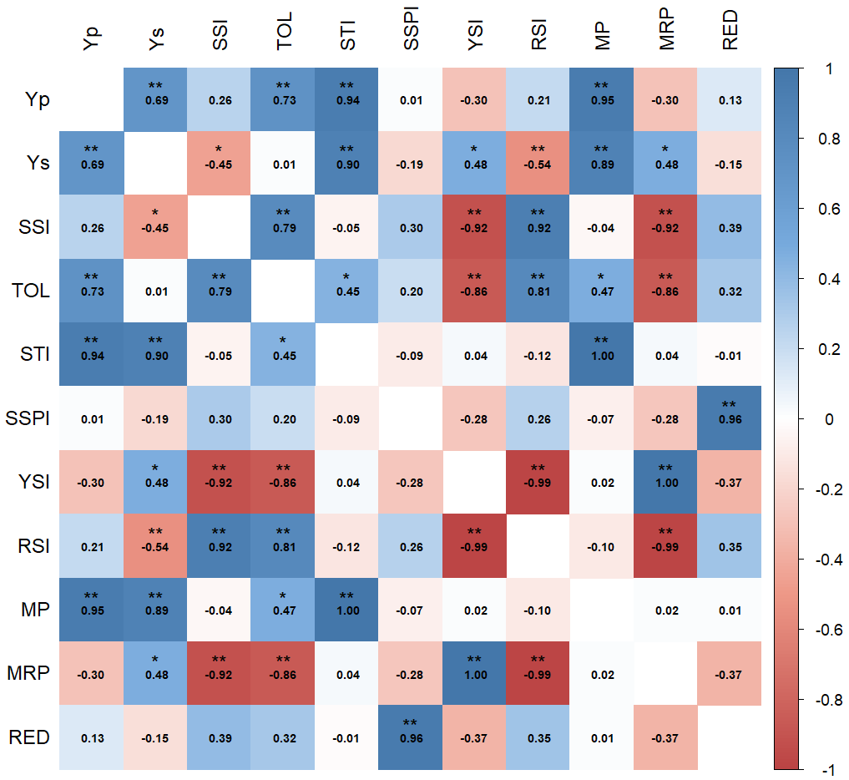 *, ** Significance at p= 0.05 & 0.01, respectively
Fig. 1. Correlation between grain yield (Yp and Ys) and stress indices of wheat genotypes

Table 6. Factor loading and variance explained by different PCs in wheat genotypes
Components | PC 1 | PC 2 | PC 3
Yp | 0.37 | 0.93 | -0.02
Ys | -0.40 | 0.91 | 0.12
SSI | 0.94 | -0.09 | -0.12
TOL | 0.89 | 0.43 | -0.14
STI | 0.04 | 0.99 | 0.03
SSPI | 0.43 | -0.13 | 0.88
YSI | -0.98 | 0.07 | 0.17
RSI | 0.96 | -0.15 | -0.19
MP | 0.06 | 0.99 | 0.04
MRP | -0.98 | 0.07 | 0.17
RED | 0.52 | -0.05 | 0.84
Eigenvalues | 5.25 | 3.92 | 1.64
Proportion of total variation (%) | 47.77 | 35.63 | 14.88
Cumulative percentage of variance | 47.77 | 83.40 | 98.28

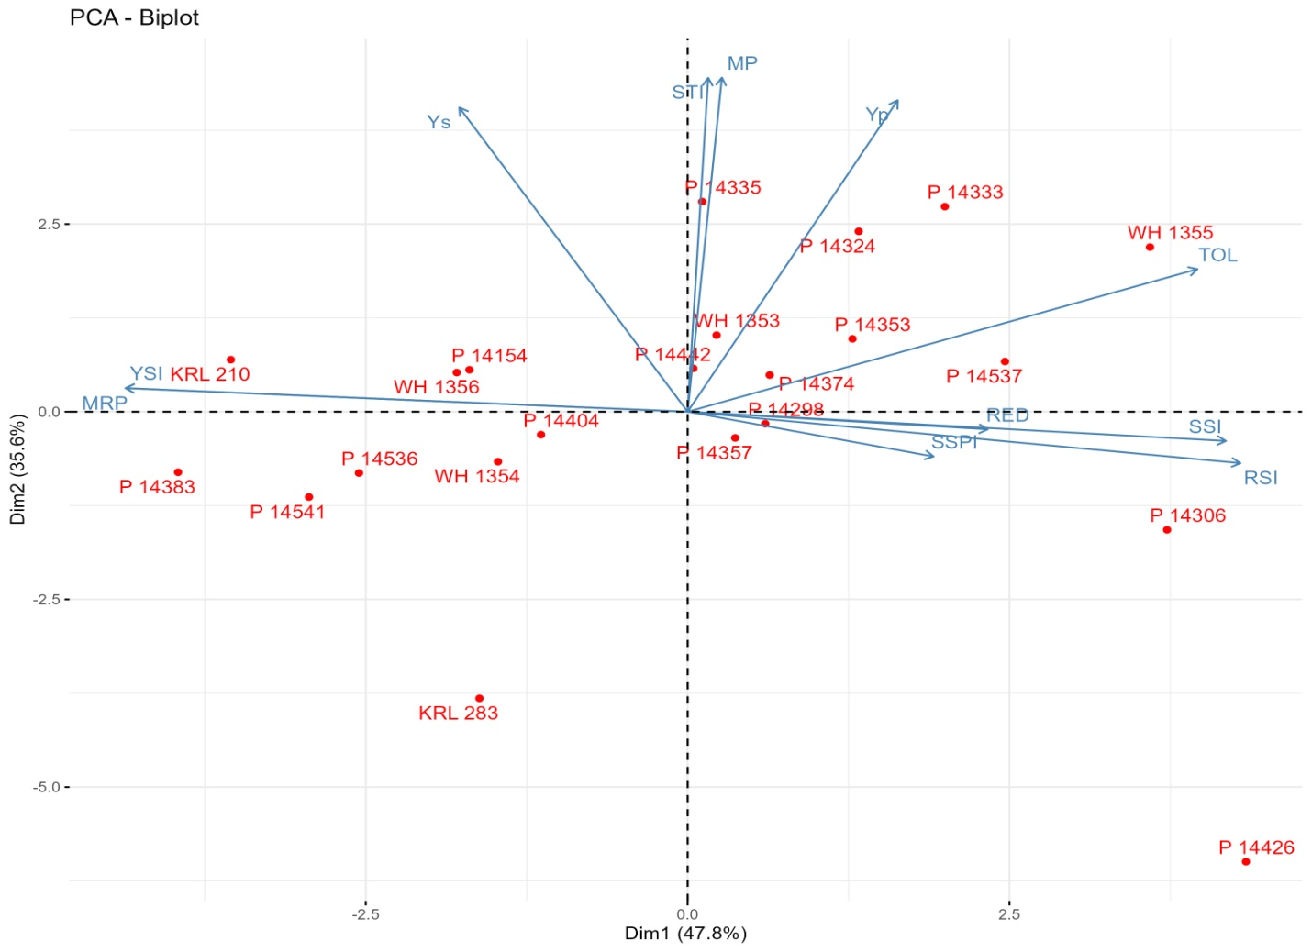
Fig. 2. Biplot of wheat genotypes vis-a-vis stress indices

Table 7. Clustering profile and performance of wheat genotypes based on stress indices
Cluster Members | Number of Genotypes | Clusters | Mean performance
Cluster Members | Number of Genotypes | Clusters | Yp | Ys | SSI | TOL | STI | SSPI | YSI | RSI | MP | MRP | RED
P 14154, P 14383, P 14404, P 14536, P 14541, WH 1354, WH 1356, KRL 210, KRL 283 | 9 | I | 2.40 | 1.82 | 1.57 | 0.58 | 0.64 | 5.23 | 0.76 | 1.93 | 2.11 | 1.10 | 0.10
P 14298, P 14306, P 14324, P 14333, P 14335, P 14353, P 14357, P 14374, P 14442, P 14537, WH 1353, WH 1355 | 12 | II | 2.85 | 1.81 | 2.43 | 1.00 | 0.77 | 7.85 | 0.65 | 2.24 | 2.35 | 0.95 | 0.16
P 14426 | 1 | III | 1.88 | 0.98 | 3.34 | 0.90 | 0.27 | 7.92 | 0.52 | 2.79 | 1.43 | 0.76 | 0.15

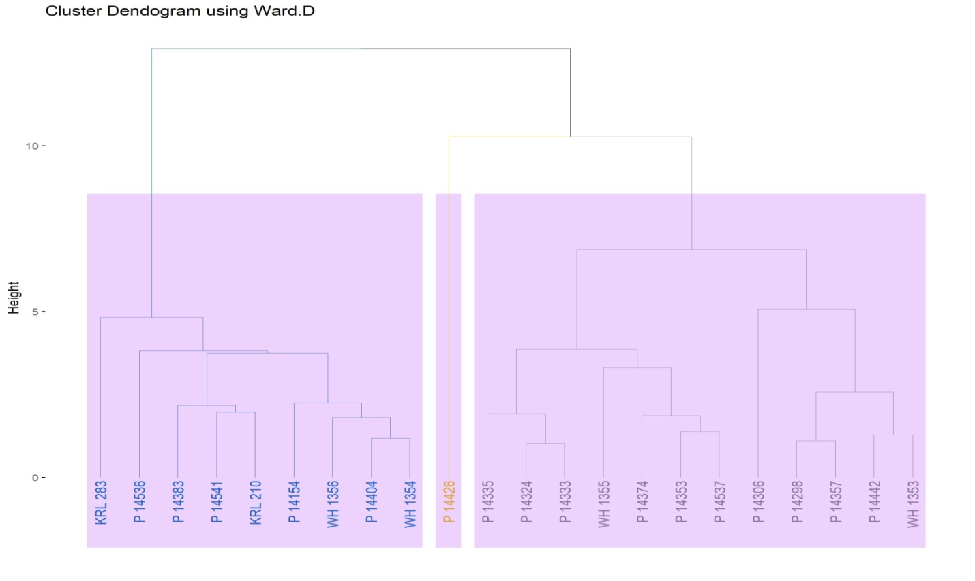
Fig. 3. Dendrogram portraying clustering pattern of wheat genotypes

