Original Research Article
Exploring the Potential of Metallic Nanoparticles for Seed Germination, Growth Enhancement and Disease Tolerance in Naga King Chilli (Capsicum chinense Jacq.)

ABSTRACT
Naga King Chilli, known for its extreme pungency and economic significance in the northeastern region of India, is facing a gradual decline in production due to increasing population pressure. Hence, there is an urgent need to implement modern technologies to enhance its yield. The use of metallic nanoparticles has emerged as a crucial area within the field of nanotechnology. In the present study, we report the evaluation of metallic nanoparticles and their effects on seed germination, growth and disease tolerance. Seeds were treated with different concentrations of silver nanoparticles (AgNPs), copper nanoparticles (CuNPs) and zinc nanoparticles (ZnNPs) to examine their influence on germination percentage, survivability, mean germination time and seed germination rate, leaf area, stem girth and resistance to major fruit rot pathogens under in vitro conditions. The results demonstrated that treatments with metallic nanoparticles significantly enhanced seed germination and early seedling growth compared to the untreated control. Among the treatments, higher concentrations of (Ag NPs @ 40 ppm) notably improved germination percentage, germination index, germination rate, leaf area, stem girth and disease tolerance, while a moderate concentration of AgNPs (20 ppm) resulted in the highest seedling survivability percentage. Meanwhile, the shortest mean germination time was observed in (ZnNPs @ 40 ppm). Overall, the findings suggest that the application of metallic nanoparticles effectively promotes seed germination in Naga King Chilli. Therefore, this study is valuable in highlighting the potential of metallic nanoparticles to enhance germination, growth and disease tolerance in naga king chilli.
Keywords: Capsicum chinense, Metallic nanoparticles, Seed germination, Leaf area, Disease tolerance, Nanotechnology.
INTRODUCTION
The Naga King Chilli (Capsicum chinense Jacq.), with chromosomal number 2n=24, is a member of the Solanaceae, also known as the Nightshade family (Bosland and Baral, 2007). It has historically been grown in Assam, Nagaland, and Manipur, as well as in limited amounts in a few other North Eastern Indian states. In Nagaland, the chilli goes by several names: Naga jolokia, Naga Morish, Raja Mirchi, and King Chilli (Kumar et al., 2011). It is primarily referred to as Bhutjolokia, Ghost Chilli, or Bihjolokia in Assam. According to (Verma et al.2013), the chilli is known as Umorok or Go-morok in Manipur. In addition to being grown in sections of Manipur (Tamenlong, Ukhrul, Senapati, and Churachanpur) and Assam (Golaghat & Tezpur districts), it is also grown in the districts of Kohima, Mon, and Peren in Nagaland.
The Naga King Chilli is the most well-known landrace in the world among the numerous varieties of chilli grown in the northeast. With a scoville heat unit (SHU) rating of 1,001,304, the Naga King Chilli is regarded as the hottest chili in India and was previously recognized as the hottest chili in the world (Bosland and Baral 2007). The Nagaland government was granted the Geographical Indication (GI) of Goods tag for Naga King Chilli in 2008 because to its significant commercial value (Registration and Protection Act, 1999). The two main components of capsaicinoids, capsaicin and hydroxyl capsaicin, are widely sought-after and necessary for use in food, medicine, and industry (Ochoa-alejo and Ramirez, 2001). The active ingredient in chillies that also gives them their medicinal qualities is capsaicin, which has anti-inflammatory, anti-arthritic, analgesic, antioxidant, and anti-cancer effects. The capsaicinoid concentration of Bhut Jolokia is exceptionally high, ranging from 2.45% (Sarwa et al., 2013) to 5.36% (Liu et al., 2010).
In contrast to conventional micronutrients, nanoparticles (NPs) are being assessed more and more as fertilizers for both quantitative and qualitative crop improvement (Dimkpa et al., 2019). NPs have emerged as promising alternative smart fertilizers to ensure high crop production and soil restoration (Zulfiqar et al., 2019). Compared to their traditional counter parts, NPs are more reactive and have the ability to have both positive and negative effects on plants. One of the key properties of NPs is their ability to penetrate plants, whether applied as afoliar spray or as soil additives. This increased reactivity is linked to materials at the nanoscale because they have a larger surface area than bulk materials (Dimkpa et al., 2017).
The application of nanoparticles at different concentrations bring out significant inhibition of spore germination and mycelial growth of fruit rot causing fungi, differing to maximum and minimum inhibition, depending on the type of fungal pathogens (Koka et al., 2019).
The recent advances in exponential approach of nanotechnology and its utilization in agriculture field have been explored tremendously. The information and extensive research work on Naga King Chilli with nano particles is very limited in published form which does not warrant a better understanding about the role of silver, copper and zinc nano particles on seed germination, plant growth and biochemical process. Use of green synthesised nanoparticles and metallic nanoparticles can play a significant role to combat the invasive plant pathogen as well as other plant physiological process.
MATERIALS AND METHODS
The study was conducted at the Instructional-cum-Research Farm of the Department of Horticulture, School of Agricultural Sciences, Nagaland University, Medziphema Campus, during the years 2022–23 and 2023–24. The experimental site is situated at the foothills of Nagaland, at an elevation of 304.8 meters above mean sea level, located at 25°45′43″ N latitude and 93°53′04″ E longitude. The area experiences a sub-humid, sub-tropical climate with moderate temperatures, ranging from 12°C in winter to 32°C in summer, and receives an average annual rainfall of 200 to 270 cm. The experiment followed a Randomized Block Design (RBD) with ten treatments, each replicated three times. The treatment details were: T0 – Control, T1 – AgNPs @ 10 ppm, T2 – AgNPs @ 20 ppm, T3 – AgNPs @ 40 ppm, T4 – CuNPs @ 10 ppm, T5 – CuNPs @ 20 ppm, T6 – CuNPs @ 40 ppm, T7 – ZnNPs @ 10 ppm, T8 – ZnNPs @ 20 ppm, and T9 – ZnNPs @ 40 ppm. Seedlings were raised in pro-trays and irrigated intermittently. Once ready, they were transplanted into well-prepared plots measuring 2 m × 1 m, with a spacing of 60 × 60 cm. The recommended doses of manure and fertilizers were applied 15 days prior to transplanting. Observations were taken on seed germination characteristics and disease tolerance in Naga King Chilli.
Source of seed material
The seeds were collected from healthy and diseases free local genotypes grown in Department of Horticulture, Vegetable Science, SAS, Nagaland University. Then the seeds were extracted from uniform healthy matured fruits.
Source of metallic nano particles
Metallic nanoparticles were procured from Sisco Research Laboratories Pvt. Ltd., Taloja, and Maharashtra India.
1. Germination percentage
The germination percentage of the King Chilli seeds treated with Ag,CuO and ZnO nanoparticles at different concentrations were observed and recorded. It was calculated using the formula (Hosseini et al., 2013).
$$Germination percentage=\frac{Σn}{N} X100$$
Where,
Σn ₌ the number of seeds germinated until the last day of the experiment and N ₌ the total number of seeds.
2. Seed germination Index
The seed germination index will be calculated by using the formula as suggested by (Roshani et al., 2020).
 | Number of germinated seeds |  | Number of germinated seeds
Germination Index= |  | +
 | Days of the first count |  | Days of the final count
3. Mean Germination time (Days)
The mean germination time of the King Chilli seeds treated with at different concentrations were observed and recorded. It was calculated using the formula given by Ellis and Roberts, 1981.
Mean Germination time = | Σ𝑛 × d
Mean Germination time = | N
Where n= number of seed germinated on each day, d= number of days from the beginning of the test and N= total number of seeds germinated at the termination of
4. Germination rate (seed/per day)
The germination rate was calculated using the formula (Hosseni et al., 2013)
Germination rate = | Σ𝑛 x d
Germination rate = | Σd𝑛

Where Σ𝑛 is the number of seeds germinated on the day, and Σd𝑛 is the number of days from the start of the experiment.
5. Survivability of seedlings (%)
The final survival count was taken 45 days after sowing which was the survival number of seedlings at 45 days after sowing and the percentage was computed.
6. Per cent Disease Index
The disease severity values will be converted to (PDI) per cent Disease index (wheeler, 1969). It will be assessed by recording the severity of disease in a locality by adopting the rating scales.
 | Sum of individual ratings |  | 100
PDI= |  | X
 | Total numbers of the plant observed |  | Maximum value used
Where, 0=free from infection, 1=25% infection, 2= 50% infection, 3=75% infection and 4=100% infection
7. In vitro evaluation of nanoparticles (Poison food technique)
Evaluation of Ag,CuO and ZnO nanoparticles was carried out at 10,20 and 40 ppm. The investigation was implemented with 3 replications for each treatment under Completely Randomized Design (CRD). The nanoparticles suspensions were added to the molten PDA media with 10,20 and 40 ppm concentrations. The poisoned media was then poured in sterilized petriplates under aseptic conditions. 4 mm mycelial discs was taken from 10 days old culture that were put in the center of each plate followed by incubation at 27 ± 1 C for 10 days. Observations on mycelial diameter of C. capsici were recorded after 7 days of incubation. The diameter of the mycelial colony was measured in (cm²). Growth inhibition (%) was calculated using the formula proposed by Pandey et al.(1982).
Per cent inhibition = | Growth in control − Growth in treatment | × 100
Per cent inhibition = | Growth in control | × 100

Statistical analysis:
The data of the experiment recorded during the course of investigation is to be evaluated statistically by the analysis of variance method (Gomez and Gomez, 2012). Significance of difference source of variation is to be tested by error mean square using Fisher Snedecor test of probability at 5 % per cent level of significance.
RESULT AND DISCUSSION
Germination parameters
The results presented in Table 1 and 2 revealed that metallic nanoparticles had a pronounced effect on seed germination parameters of Naga King Chilli. Across all intervals of observation, the highest germination was recorded with Ag NPs @ 40 ppm (72.00% at 56 DAS), while the lowest germination was observed in the control (1.33% at 14 DAS). This indicates that application of metallic nanoparticles, particularly silver at higher concentrations, markedly improved seed germination compared to the untreated control. The enhanced germination under Ag NPs treatments might be attributed to their role in accelerating metabolic activity, water uptake, and enzymatic processes during seedling emergence, which is in conformity with earlier reports in chilli and other crops (Chen and Arora, 2013). The seed germination index (SGI) was significantly enhanced by nanoparticle treatments, with the highest value recorded under Ag NPs @ 40 ppm (7.42), which was at par with Cu NPs @ 40 ppm (7.38). In contrast, the lowest SGI (4.33) was observed in the untreated control. The improvement in SGI with nanoparticles might be due to their role in enhancing water uptake and enzymatic activity, thereby accelerating the germination process, as also reported by (Hojjat and Hojjat 2015). The mean germination time (MGT) was reduced in all nanoparticle treatments compared to control (45.19 days), indicating faster germination. The minimum MGT was observed in Zn NPs @ 40 ppm (42.65 days), which remained statistically at par with Cu NPs @ 40 ppm (43.01 days) and Ag NPs @ 40 ppm (43.51 days). Early germination due to nanoparticles could be attributed to their ability to stimulate seed metabolism and respiration, similar to the findings of (Almutairi and Alharbi, 2015). A similar trend was evident in germination rate, where the maximum (2.23 seeds/day) was observed under Ag NPs @ 40 ppm, followed by Cu NPs @ 40 ppm (2.20 seeds/day) and Zn NPs @ 40 ppm (2.18 seeds/day), all of which were statistically at par. The minimum germination rate (1.33 seeds/day) was noted in control. Enhanced germination rate under nanoparticle treatments may be due to higher energy metabolism and efficient mobilization of seed reserves (Lei et al., 2008). With respect to the survivability of seedlings, Ag NPs @ 20 ppm recorded the highest value (100%), while Ag NPs @ 40 ppm, Cu NPs @ 40 ppm, and Zn NPs @ 40 ppm (88.89% each) were statistically comparable. The lowest survivability was found in control (72.22%). This suggests that nanoparticles not only improved germination but also enhanced seedling establishment, possibly due to their positive role in stress mitigation and vigor improvement Barche et al. (2008). Overall, it can be inferred that Ag NPs @ 40 ppm, Cu NPs @ 40 ppm, and Zn NPs @ 40 ppm were most effective in improving seed germination index, germination rate and reducing mean germination time, while Ag NPs @ 20 ppm proved superior in seedling survivability. These findings clearly demonstrate the beneficial role of metallic nanoparticles in improving germination and early establishment of Naga King Chilli.
Table 1: Effect of Metallic nano particles on seed germination percentage in progress of sowing time
Treatments | Seed germination percentage
Treatments | 14 DAS | 28 DAS | 42 DAS | 56 DAS
T0 | 1.33 | 13.00 | 39.00 | 53.00
T1 | 1.67 | 15.00 | 42.00 | 55.00
T2 | 1.67 | 28.00 | 50.00 | 70.00
T3 | 1.33 | 30.00 | 45.00 | 72.00
T4 | 1.67 | 18.00 | 40.00 | 67.00
T5 | 1.33 | 17.00 | 44.00 | 65.00
T6 | 1.67 | 35.00 | 50.00 | 68.00
T7 | 1.33 | 20.00 | 45.00 | 64.00
T8 | 1.67 | 27.00 | 53.00 | 66.00
T9 | 1.67 | 30.00 | 55.00 | 65.00
CD @ 5% | N/A | 0.86 | 2.32 | 3.30
SEm ± | 0.35 | 0.29 | 0.77 | 1.10
T0: Control; T₁: AgNO₃ @ 10ppm; T₂: AgNO₃ @ 20ppm; T₃: AgNO₃ @40ppm; T4: ZnO @10ppm; T5: ZnO @20ppm; T6: ZnO @40ppm; T7: CuO @10ppm; T8: CuO @20ppm; and T₉: CuO @40ppm
# DAS: Days after sowing

Table 2: Effect of metallic nanoparticles on seed germination parameters
Treatments | Seed germination index | Mean germination time (Days) | Germination rate (Seeds/day) | Serviability of seedling (%)
T0 | 4.33 | 45.19 | 1.33 | 72.22
T1 | 4.57 | 44.77 | 1.58 | 83.33
T2 | 6.29 | 43.86 | 2.14 | 100.00
T3 | 7.42 | 43.51 | 2.23 | 88.89
T4 | 5.63 | 44.56 | 1.95 | 77.78
T5 | 5.70 | 44.35 | 1.94 | 83.33
T6 | 7.38 | 43.01 | 2.20 | 88.89
T7 | 5.87 | 43.63 | 1.96 | 77.78
T8 | 6.50 | 43.44 | 2.08 | 83.33
T9 | 6.66 | 42.65 | 2.18 | 88.89
CD @ 5% | 1.01 | N/A | 0.07 | 5.00
SEm ± | 0.34 | 0.73 | 0.03 | 1.65
T0: Control; T₁: AgNO₃ @ 10ppm; T₂: AgNO₃ @ 20ppm; T₃: AgNO₃ @40ppm; T4: ZnO @10ppm; T5: ZnO @20ppm; T6: ZnO @40ppm; T7: CuO @10ppm; T8: CuO @20ppm; and T₉: CuO @40ppm

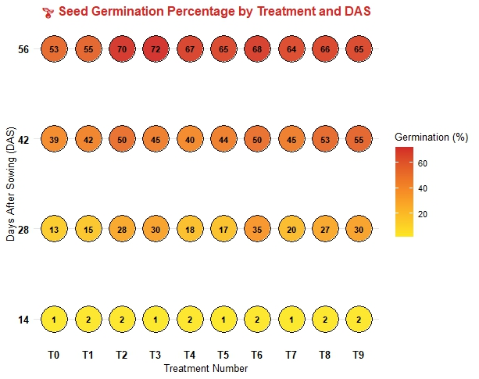

Fig. 1: Effect of metallic nano particles on seed germination percentage in progress of sowing time

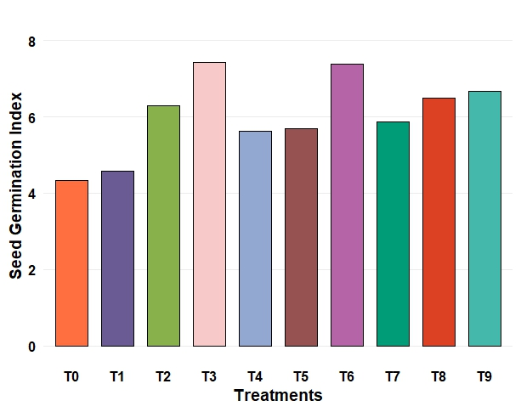
Fig. 2: Effect of metallic nanoparticles on seed germination index
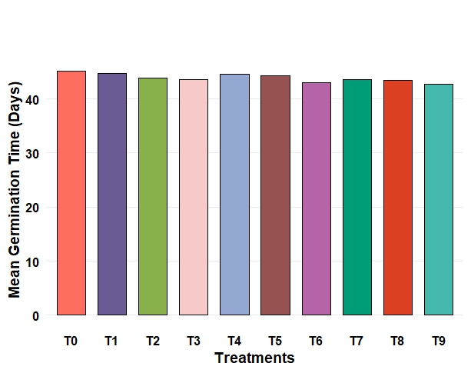
Fig. 3: Effect of metallic nanoparticles on mean germination time (MGT)
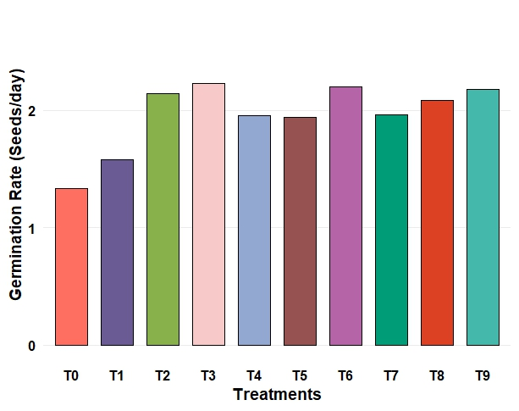
Fig. 4: Effect of metallic nanoparticles on germination rate (Seeds/day)
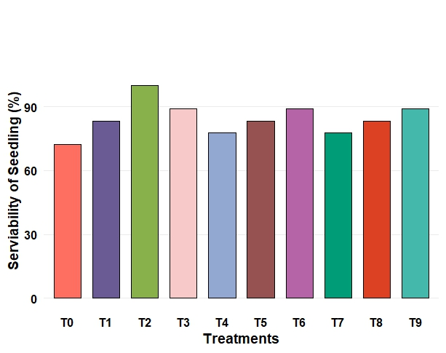
Fig. 5: Effect of metallic nanoparticles on serviability of seedling (%)
Growth parameters
The data presented in Table 3 revealed significant variation among different metallic nanoparticles on seedling vigour index, leaf area, and stem girth of naga king chilli. The highest seedling vigour index (1296.00) was recorded with Ag NPs @ 20 ppm (T2), which was statistically at par with Ag NPs @ 40 ppm (1274.00), while the lowest vigour index (614.80) was obtained in the control (T0). A substantial improvement in seedling vigour under silver nanoparticles may be attributed to enhanced enzymatic activity and better nutrient uptake, leading to improved seedling establishment. Similar reports of Ag NPs promoting vigour through improved physiological metabolism have been documented by Sabir et al. (2018). The maximum leaf area 49.60 cm² was noted in Zn NPs @ 40 ppm (T9), which was significantly superior to all other treatments. The minimum leaf area (35.33 cm²) was recorded under control (T0). Zinc is an essential micronutrient for auxin synthesis and chlorophyll formation, and its nanoparticle form likely enhanced photosynthetic activity and cell expansion, thereby increasing the leaf area. These findings corroborate the reports of earlier studies where Zn NPs application resulted in significant enhancement in leaf development and canopy spread (Baz et al., 2020). The maximum stem girth (1.45 cm) was also observed under Zn NPs @ 40 ppm (T9), which was significantly higher than all other treatments, while the minimum (0.91 cm) was noted in the control (T0). The increase in stem girth due to nanoparticles application might be due to the fact that nanoparticle application enhanced the rate of cell division and elongation of the stem portion. The results are in confirm with the findings of (Acharya et al., 2020) who observed that maximum growth in stem diameter and longer shoot of watermelon seedlings using Ag NPs with no discernable negative impact on the growth of seedlings.
Table 3: Effect of metallic nanoparticles on growth parameters
Treatments | Seedling vigour index | Leaf area (cm2) | Stem girth (cm)
T0 | 614.80 | 35.33 | 0.91
T1 | 704.00 | 39.53 | 1.22
T2 | 1296.00 | 47.57 | 1.12
T3 | 1274.00 | 41.17 | 1.07
T4 | 984.90 | 41.43 | 1.06
T5 | 1085.50 | 42.47 | 1.08
T6 | 1047.20 | 43.40 | 0.98
T7 | 1068.80 | 43.17 | 1.10
T8 | 1115.40 | 42.20 | 1.04
T9 | 1202.50 | 49.60 | 1.45
CD @ 5% | 91.23 | 4.31 | 0.22
SEm ± | 30.47 | 1.44 | 0.07
T0: Control; T₁: AgNO₃ @ 10ppm; T₂: AgNO₃ @ 20ppm; T₃: AgNO₃ @40ppm; T4: ZnO @10ppm; T5: ZnO @20ppm; T6: ZnO @40ppm; T7: CuO @10ppm; T8: CuO @20ppm; and T₉: CuO @40ppm
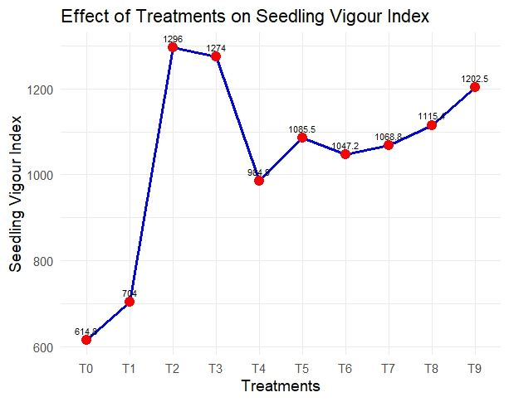
Fig.6: Effect of metallic nanoparticles on seedling vigour index
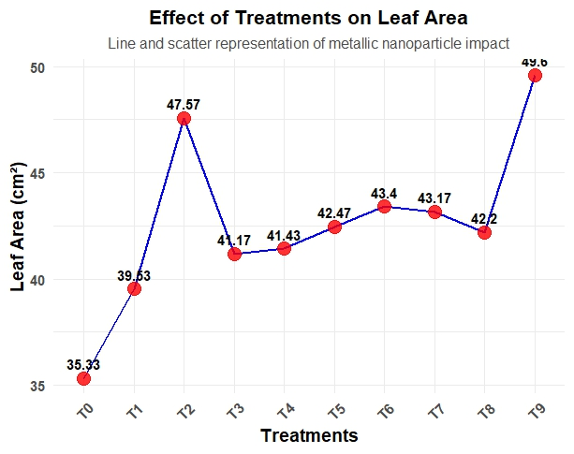
Fig.7: Effect of metallic nanoparticles on leaf area (cm²)
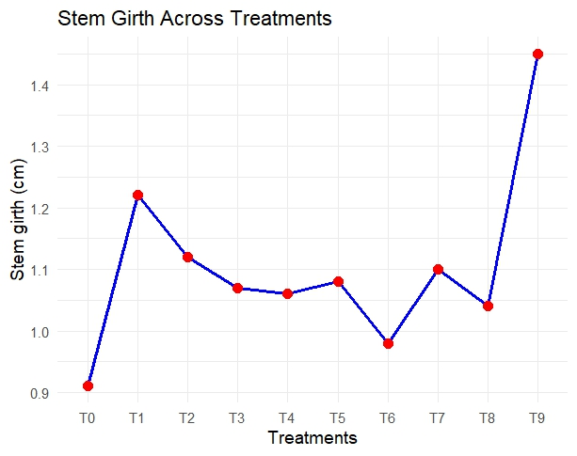
Fig.8: Effect of metallic nanoparticles on stem girth (cm)
Disease parameters
The data presented in Table 4 showed that application of metallic nanoparticles significantly influenced percentage disease index (PDI) in fruits as well as mycelial inhibition under the poison food technique. The lowest PDI (18.50%) was recorded with Ag NPs @ 40 ppm (T3), which was statistically at par with Zn NPs @ 40 ppm (19.00%) and Cu NPs @ 40 ppm (19.40%), while the highest PDI (43.52%) was observed in the untreated control (T0). This indicates that silver, zinc, and copper nanoparticles at higher concentrations were effective in suppressing fruit disease incidence, possibly due to their antimicrobial activity and ability to disrupt pathogen cell membranes. These findings are in conformity with earlier reports suggesting the strong antifungal properties of metallic nanoparticles (Chandrashekhara et al., 2021). The antifungal activity of the nanoparticles against Colletotrichum capsici was evaluated using the poisoned food technique. In terms of antifungal activity, the highest inhibition (67.41%) was recorded with Ag NPs @ 40 ppm (T3), followed by Ag NPs @ 20 ppm (59.41%) and Cu NPs @ 20 ppm (48.21%), while the lowest inhibition (17.22%) was noted in Zn NPs @ 10 ppm (T7). The control (T0) showed no inhibition (0.00%). Among the treatments, silver nanoparticles demonstrated superior antifungal efficacy in vitro compared to copper and zinc nanoparticles. This enhanced activity may be attributed to their nanoscale size, larger surface area, and higher reactivity, which facilitate interactions with microbial cells, ultimately leading to protein denaturation and disruption of cell membranes (Aguilar-Méndez et al., 2011).

Table 4: Effect of metallic nanoparticles on disease parameters
Treatments | PDI in fruits | Antifungal Activity
T0 | 43.52 | 0.00
T1 | 26.40 | 45.11
T2 | 24.30 | 59.41
T3 | 18.50 | 67.41
T4 | 35.20 | 34.06
T5 | 25.60 | 48.21
T6 | 19.40 | 39.52
T7 | 35.40 | 17.22
T8 | 25.60 | 19.13
T9 | 19.00 | 39.52
CD @ 5% | 2.18 | 18.06
SEm ± | 0.73 | 6.03
T0: Control; T₁: AgNO₃ @ 10ppm; T₂: AgNO₃ @ 20ppm; T₃: AgNO₃ @40ppm; T4: ZnO @10ppm; T5: ZnO @20ppm; T6: ZnO @40ppm; T7: CuO @10ppm; T8: CuO @20ppm; and T₉: CuO @40ppm
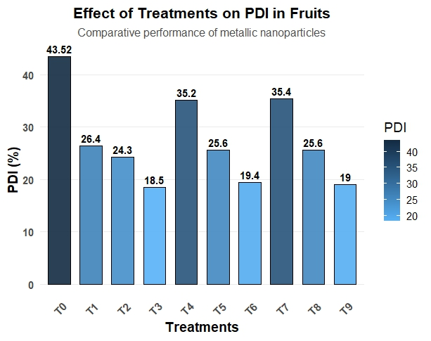
PDI: Percent disease index
Fig.9: Effect of metallic nanoparticles on PDI in fruits
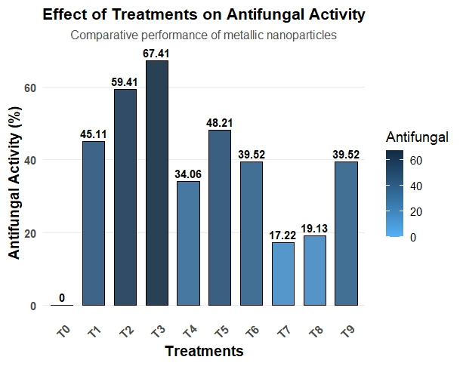
Fig.10: Effect of metallic nanoparticles on antifungal activity (%)
CONCLUSION
The present investigation clearly demonstrated the potential of metallic nanoparticles in enhancing seed germination, growth performance, and disease tolerance of Naga King Chilli (Capsicum chinense Jacq.). Among the treatments, silver nanoparticles, particularly at moderate concentrations, proved most effective in improving germination efficiency, seedling vigour, and disease resistance. Zinc nanoparticles at higher concentrations significantly contributed to vegetative growth by enhancing leaf area and stem girth, while copper nanoparticles exhibited moderate but consistent effects on both growth and pathogen suppression. The superior performance of silver nanoparticles can be attributed to their nanoscale properties, higher surface reactivity, and antimicrobial potential, which synergistically improved metabolic processes and pathogen inhibition. Overall, the study highlights that metallic nanoparticles, especially silver, hold substantial promise as multifunctional agents that act both as growth promoters and bioprotectants. Their integration into crop production systems could serve as an eco-friendly, sustainable, and innovative nanotechnological intervention for enhancing the productivity and resilience of Naga King Chilli.
REFERENCES
Acharya, P., Jayaprakasha, G. K., Crosby, K. M., Jifon, J. L. and Patil, B. S. (2020). Nanoparticle-mediated seed priming improves germination, growth, yield, and quality of watermelons (Citrullus lanatus) at multi-locations in Texas. Scientific reports.10: 1-16.
Aguilar-Méndez, M.A., San Martín-Martínez, E., Ortega-Arroyo, L., Cobián-Portillo, G., Sánchez Espíndola, E. (2011). Synthesis and characterization of silver nanoparticles: effect on phytopathogen Colletotrichum gloesporioides. Journal of Nanoparticle Research.13: 2525-2532. https://doi.org/10.1007/s11051-010-0145-6
Almutairi, Z.M. and Alharbi, A. (2015). Effect of silver nanoparticles on seed germination of crop plants. International Journal of Nuclear and Quantum Engineering.9: 689-693.
Barche, S., Singh Kirad, K. and Singh, D. B. (2008). Response of seed treatment on germination, growth, survivability and economics of different cultivars of papaya (Carica papaya L.). In II International Symposium on Papaya. 851:279-284
Baz, H., Creech, M., Chen, J., Gong, H., Bradford, K. and Huo, H. (202). Water-Soluble Carbon Nanoparticles Improve Seed Germination and Post-Germination Growth of Lettuce under Salinity Stress. Agronomy.10: 1192-97
Bosland, P. W. and Baral, J. B. (2007). ‘Bhut Jolokia’-The world's hottest known chile pepper is a putative naturally occurring interspecific hybrid. Hort Science. 42: 222-224.
Chandrashekhara V.D , Lokesh, S., Kavyashri V.V, Prasanna Kumar M.K . and Sanggonda. (2021). Potential Antifungal Activity of Biosynthesized Copper nanoparticles Against Colletotrichum Capsici In Chilly. International Journal of Biotech Trends and Technology.11: 1-7.
Chandrashekhara V.D , Lokesh, S., Kavyashri V.V, Prasanna Kumar M.K . and Sanggonda. (2021). Potential Antifungal Activity of Biosynthesized Copper nanoparticles Against Colletotrichum Capsici in Chilli. International Journal of Biotech Trends and Technology.11: 1-7.
Chen, K., and Arora, R. (2013). Priming memory invokes seed stress-tolerance. Environmental and Experimental Botany. 94: 33-45.
Dimkpa, C. O., Singh, U., Bindraban, P. S., Elmer, W. H., Gardea-Torresdey, J. L. and White, J. C. (2019). Zinc oxide nanoparticles alleviate drought-induced alterations in sorghum performance, nutrient acquisition, and grain fortification. Science of the Total Environment.688: 926-934.
Dimkpa, C. O., White, J. C., Elmer, W. H. and Gardea- Torresdey, J. (2017). Nanoparticle and ionic Zn promote nutrient loading of sorghum grain under low NPK fertilization. Journal of Agricultural and Food Chemistry. 65:8552-8559.
Ellis, R. A. and Roberts, E. H. (1981). The quantification of ageing and survival in orthodox seeds. Seed Science and Technology. 9: 373-409.
Gomez, K. A. and Gomez, A. A. (2012). Statistical procedure for Agricultural Research. 2nd Ed. Ar. Emm. International, New Delhi. ISBN: 978-81-265-2395-5
Hojjat, S. S., and Hojjat, H. (2015). Effect of nano silver on seed germination and seedling growth in Fenugreek seed. International Journal of Food Engineering.1:106-110.
Hosseini, H. R., Chehraz, M., Dehkourdi, E. H. and Hosseini, M. (2013). Application of anatase nanoparticles (TiO2) on strawberry seed germination (Fragaria ananassa L.). Advances in Horticultural Sciences. 27: 143-146.
Kumar, S., Kumar, R., Kumar, S., Kumar Singh, A., Singh, M., Bahadur Rai, A. and Rai, M. (2011). Incidence of leaf curl disease on Capsicum germplasm under field conditions. Indian Journal of Agricultural Sciences. 8: 187-89.
Liu, Y. and Nair, M.G. (2010). Capsaicinoids in the hotest pepper Bhut Jolokia and its antioxidant and anti-inflammatory activities. Natural Product Communications.5: 91-94.
Ochoa-Alejo, N. and Ramirez-Malagon, R. (2001). In vitro chili pepper biotechnology. In vitro Cellular & Developmental Biology-Plant.37: 701-729.
Pandey, D., Tripathi, N., Tripathi, R. and Dixit, S. (1982). Fungitoxic and Phytotoxicproperties of the essential oil of Hyptis suaveolens. Journal of Plant Diseases and Protection.89:344-349.
Roshani, Khan, A., Singh, A.V., Upadhayay, V. K. and Prasad, B. (2020). Development of potential microbial consortia and their assessment on wheat (Triticum aestivum) seed germination. Environment and Ecology. 38: 6-16.
Sabir, S., Arshad, M. and Satti, S. H. (2018).Effect of green synthesized silver nanoparticles on seed germination and seedling growth in wheat. International Journal of Agronomy and Agricultural Research.12:1–7.
Sarwa, K., Mazumder, B., Rudrapal, M., Debnath, M., Kumar, A., Verma, K.M. and Jangdey, S.M. (2013). Capsaicinoids content of some indigenous capsicum varieties of Assam, India. Journal of Natural Sciences Research.3: 112-116.
Verma, S., Dhiman, K. and Srivastava, D. K. (2013). Efficient in vitro regeneration from cotyledon explants in Bell pepper (Capsicum annuum L. cv. California Wonder). International Journal of Advanced Biotechnology and Research. 4: 391-396.
Wheeler, B. E. J. (1969). An introduction to plant disease. John Wiley and Sons. Ltd. London. pp.301
Zulfiqar, F., Navarro, M., Ashraf, M., Akram, N. A. and Munné-Bosch, S. (2019). Nano fertilizer use for sustainable agriculture: Advantages and limitations. Plant Science. 289:1-11.

