ASSESSMENT OF SAFETY AND ANTI-CANCER EFFICIENCY OF CHICKEN FEATHER KERATIN NANOPARTICLES ENCAPSULATED DOXORUBICIN IN CHICKEN CHORIOALANTOIC MEMBRANE (AN ALTERNATE TO ANIMAL MODEL) ASSAY

.
ABSTRACT

Nanoencapsulation of chemotherapeutic can improve the therapeutic index of chemotherapeutic like doxorubicin (dox) by reducing systematic toxicity and enhancing tumor targeting. This study reports on the synthesis,characterization and in vivo evaluation of a novel nanokeratin encapsulated doxorubicin (NKD). the formulation was tested against human breast cancer tumor cell line (MCF-7) using chorioallantoic membrane (CAM) of chicken embryo as an alternate model to animal experiments. NKD exhibited desirable physicochemical properties, including a particle size of 150 nm and a negative zeta potential. The in vivo CAM model demonstrated that NKD was not toxic to the embryo, showing a 100% survival rate. this stands in contrast to free doxorubicin, which induced moderate toxicity and a significant decrease in embryo survival. furthermore, real time pcr findings shows a significant upregulation of pro-apoptotic gene bax and p53 in nkd compared to dox. histopathological analysis shows reduced tumor cell density, increased apoptosis and signs of tumor architecture returning to normal compared to control group.these findings suggest that the nanokeratin based formulation is a safe and effective strategy for doxorubicin delivery, with significant potential for futher development in breast cancer therapy.

Keywords: CAM,MCF-7 cells, DOX, NKD, Nanokeratin, survival rate, cancer therapy

1. INTRODUCTION

Breast cancer is a major global cancer, with an estimated 20 million new cases annually. It has the highest morbidity and mortality rates (Brayet al.,2024), with a five-year mortality rate mainly due to metastasis and tumour recurrence. Over 90% of patients with metastatic illness experience treatment failure due to medication resistance. Nanotechnology-based therapy has shown promising approaches for treating tumoral cells without damaging healthy cells (Dessaleet al.,2022). Keratin, a natural and biodegradable protein, is an excellent candidate for developing nanocarriers due to its biocompatibility, low immunogeneicity, and complete biodegradability. Doxorubicin, a highly effective chemotherapeutic agent, is used for treating various cancers, including breast cancer, but its use is limited by dose-dependent cardiotoxicity and other adverse effects (Kciuket al.,2023). Nanoencapsulation has emerged as a promising strategy to improve Dox's safety and efficacy (Alrohaimiet al.,2025).. This study focuses on developing a novel nanokeratin encapsulated doxorubicin formulation and evaluating its therapeutic potential against human breast cancer tumors using the chorioallantoic membrane (CAM) chick embryo mode (Wang et al.,2025).

2. material and methods

2.1. Materials
Chicken feathers were sourced as waste material from a local poultry slaughter house. Doxorubicin hydrochloride (Dox. HCl) from TCI company,Japan. MCF-7 purchased from Translational Resarch Platform for Veterinary Biologicals (TRPVB), TANUVAS, Chennai-51.All other chemical and reagents were used in this study were of analytical grade.
2.2. Methods
2.2.1 Extraction of keratin from chicken feathers
Keratin from chicken feathers was extracted as per Nomura et al. (2007). Briefly, 10 g of the cleaned chopped chicken feathers was hydrolyzed with 300 ml of 0.3 NaOH solution and stirred for 48 h at room temperature. Then the extract was centrifuged at 4000 rpm for 15 min and then HCl (1N) was added to adjust the pH to 4.2 to precipitate keratin. It was then centrifuged at 4000 rpm for 20 min and the pellet was washed with distilled water thrice and then dried in an oven at 80°C overnight.
2.2.2. Preparation of chicken feather keratin nanoparticles
Chicken feather keratin power was dissolved in sterile distilled water at 1 mg/ml. Then it was dialyzed in 3.5 KDa bag against deionized water for 48 h to obtain colourless solution. Extracted solution was then sonicated for 2 min at a 40kHz range. The sonicated dialysate was lyophilized and stored at 4°C (Nomura et al.,2007).
2.2.3. Preparation of nanokeratin encapsulated doxorubicin
Doxorubicin was encapsulated by using chicken feather keratin nanoparticles (CFKNP) as described by Wang et al. (2020). CFKNP and doxorubicin hydrochloride were separately dissolved in distilled water at 1 mg/ml. Then 40 µl of triethylamine was added to the doxorubicin solution and agitated in the dark for three hours. Next, 5 ml of the CFKNP solution was added dropwise to the agitated doxorubicin mixture and then stirred for 12 hours at room temperature. The resulting nanokeratin encapsulated doxorubicin (NKD) was collected by centrifugation at 12,000 rpm for 30 minutes, followed by washing with double distilled water until the supernatant was clear. The purified NKD particles were then lyophilized and stored at 4ᵒC.
2.2.4. Physiochemical characterization of nanoformulations
The size distribution and zetapotential of nanokeratin and nanokeratin encapsulated doxorubicin was determined by the particle size analyser (Horiba SZ-100 Partica analyser). Nanoparticle were also analysed by transmission electron microscopy. To determine the entrapment efficiency and loading capacity of drug content is determined by UV spectroscopyby using following formula :
EE(%)=Total amount of drug – Amount of free drug/ Total amount of drug used x100
LC%= total amount of drug in nanoparticle (mg) /weight of nanoparticle (mg) x100
2.2.5. Cell lines and culture media
Human breast cancer cell line MCF-7 cells was used to study the effects of nanokeratin encapsulated anticancer drug. MCF-7 cells were cultured in DMEM with 10 % FBS and the media was supplemented with 1% antibiotics. MCF-7 cells were maintained at 37ᵒC and 5% CO₂ in a culture incubator (Abutaha et al.,2022).
2.2.6. Chicken embryo tumor model
Freshly fertilized chicken eggs were purchased from Poultry research station, TANUVAS, Chennai. Fertilized chicken eggs (25 nos) were incubated at 37°C with humidity. On inoculation day, a window was created on the egg shell to expose the chorioallantoicmembrane (CAM). On embryonic day 7, 25µl suspension of MCF-7 human breast cancer cells (2x10⁶ cells) was seeded onto the CAM. The eggs were then sealed and returned to the incubator. By embryonic day 10, when established tumors were visible and the embryos were randomly assigned to as Group I (6 eggs) treated with MCF-7 cell line, Group II (6 eggs) treated with the nanokeratin encapsulated doxorubicin (25 µg/ml) and Group III (6 eggs) treated with free doxorubicin hydrochloride (25 µg/ml). Six eggs were kept as normal untreated control (Group IV). Treatments were administered directly onto the tumor on the CAM (Mitrevska et al.,2023).
2.2.7. Evaluation of toxicity and efficacy
The toxicological effect of NKD and plain doxorubicin was assessed by monitoring the embryo survival and macroscopic appearance of the CAM (Alves et al.,2023, Raj et al.,2025). From the previous experiments, number of embryos survived, number of tumors formed and tumor size were assessed for Group I, II and III. On embryo development day of 17, eggs were opened and made observations. Then, the tumors and the CAM membranes were removed, cleaned with sterile PBS and immediately fixed in 10% phosphate buffered formalin. Paraffin blocks were cut into section of 5 µm for H & E staining. The stained slides were observed under an optical microscope to evaluate inflammation and tissue responses.
2.2.8. Quantitative real time PCR
Total RNA from control CAM membrane and tumor tissues from treated groups were isolated by using trizol method and cDNA was synthesized from RNA using cDNA synthesis kit (Fermentas,USA). Quantitative PCR was performed using SYBR green mastermix to amplify p53 and BAX genes using specific primers. GAPDH was used as reference gene. All samples were run in duplicate.
2.2.9. Statistical analysis
All experiments were performed in triplicates (n=3) and all quantitative data were presented as the mean ± standard deviation. Statistical analysis was conducted using Graphpad Prism.

3. results and discussion

3.1. Physiochemical properties of chicken feather keratin nanoparticles
The preparation of the nanocarrier began with the sustainable extraction of keratin from chicken feathers, a process that leverages a vast agro-industrial waste product. The selected method employs mild alkaline hydrolysis which is crucial for cleaving the numerous stabilizing disulfide bonds within the feather’s highly organized β-keratins structure (Dabrowska et al.,2022). The successful generation of the NK structure, which forms the core of the drug delivery vehicle is confirmed by the subsequent particle size analysis. The TEM analysis of nanokeratin showed spherical morphology and conglomeration due to their surface charges interaction between nanoparticles (Figure 1). The preparation of nanokeratin encapsulated doxorubicin utilized an ionic gelation for high encapsulation efficiency. Keratin being an amphoteric protein, contains numerous free carboxylic (COO-) and amine (NH3+) groups. The dropwise addition of the NK solution to the agitated DOX mixture promoted the simultaneous co-assembly of the keratin and the drug. Electrostatic attraction between the positively charged amino groups of the protonated DOX and the predominantly negatively charged carboxyl groups on the surface of the keratin biopolymer (Aluigi et al., 2018).
The nanokeratin extracted from chicken feather were characterized as having a suitable hydrodynamic diameter, typically in the range of 158.7nm. The nanokeratin encapsulated doxorubicin formulation showed desirable properties for tumor targeting, with an average particle size of 228.5 nm and the measurement of the zeta potential is standard for assessing the colloidal stability of a nanoparticle suspension. The NKD formulation yielded a highly negative zeta potential of -30.1mV. This size facilitates passive accumulation in tumor tissues throughttheenhanced permeability and retention (EPR) effect. This passive targeting mechanism maximizes the concentration of DOX specifically at the tumor site, drastically reducing systemic exposure and consequently, mitigating the risk of dose limiting toxicities. A high encapsulation efficiencyof 56.1% was achieved, ensuring effective drug delivery and loading capacity of 60% .
3.2.Tumor induction by MCF-7 cell line
The MCF-7 breast cancer cells successfully engrafted and demonstrated a robust tumorigenic potential on the chorioallantoic membrane (CAM) of the chicken embryo. By day 13 of incubation (three days post-transplantation), distinct, palpable tumor masses were clearly visible on all the embryos, confirming the rapid establishment of the xenograft. Macroscopic examination (Figure2), revealed solid, dense tumors that were extensively supplied by a dense network of newly formed blood vessels originating from the host CAM. This notable vascularization surrounding and infiltrating the tumor mass is indicative of cancer cell-induced angiogenesis, a critical hallmark of tumor growth necessary for sustained proliferation. The successful and rapid development of these tumors verifies the utility of the CAM model for in vivo studies and provides a reliable platform for evaluating potential anti-cancer or anti-angiogenic therapies (Liu et al.,2013).
3.3. Toxicological profile in the CAM model
The CAM study demonstrated the superior safety of nanokeratin doxorubicin compared to plain doxorubicin drug. The nanokeratin doxorubicin group showed no sign of toxicity, with a 100 % survival rate, normal embryo on the CAM. In case of free doxorubicin, out of 6, three embryos only were survived which showed that the high systematic toxicity resulting in only 50% embryo survival rate (Figure 3). This provides compelling evidence that the encapsulation of doxorubicin within the nanokeratin matrix successfully minimizes its systematic toxicity. The less embryo survival in the DOX group (Group III), the free drug likely diffused rapidly into the highly vascularized CAM, leading to high systematic concentrations and subsequent embryo demise due to toxicity to critical developing organs. In contrast, the NKD formulation, owing to its restricted extravasation and potential preferences for tumor accumulation (passive targeting) resulted in a significant lower systematic drug concentration in the host embryo’s circulation, thereby protecting the developing embryo. Alves et al.(2023) studied nanolip loaded with doxorubicin on CAM showed 100 % of survival rate till the end of experiment (Alves et al.,2023) similarly 100 % survival rate found on the PMO nanoparticle loaded doxorubicin on CAM membrane (Vu et al.,2018).
The antitumor efficacy was assessed by comparing the degree of tumor regression across the treatment groups. Tumors treated with the NKD formulations showed the most significant reduction in tumor size as 0.167±0.117cm³compared to both the MCF-7 control (0.680±0.708 cm³) and the free DOX (0.529±0.175cm³) (Figure 4). While free DOX did show some tumor inhibitory effect, the NKD group consistently outperformed it, achieving maximum tumor growth inhibition. This enhanced efficiency is a direct result of the nanoparticle formulation, leveraging the EPR effect for higher accumulation, the pH responsive release for effective and potentially enhanced cellular uptake.
3.4. Tumor histopathology
The histological examination of the tumor xenograft provided visual confirmation of the therapeutic superiority of NKD. Control MCF-7 induce tumor sections displayed high tumor cell density, clear signs of proliferation (high mitotic index) and intact cell morphology, characteristic of a rapidly growing malignant tumor. Where in DOX treated CAM tumor showed moderate areas of necrosis and reduced cell density compared to the control, but significant viable tumor tissue remained, suggesting incomplete therapeutic effect at the tolerated dose. In NKD treated CAM tumor exhibited massive, widespread areas of necrosis, significant tumor cell death, and low cell density. The cellular morphology was highly distorted, indicative of apoptosis and tissue damage, confirming the potent therapeutic effect and superior drug concentration achieved within the tumor environment (Figure 5). The successful local delivery of a high, effective dose to the tumor microenvironment explains the observed superior antitumor response despite the lower systemic toxicity (Mitrevska et al.,2023).
3.5. Gene expression analysis for apoptosis
To assess the beyond morphological assessment and confirm the underlying mechanism of NKD induced tumor cell death, gene expression analysis was conducted for key regulators of the intrinsic apoptotic pathway BAX and p53.
3.5.1 p53 expression
The NKD treatment resulted in a dramatic 14.24 fold increase in the expression of the p53 gene compared to the control. The p53 tumor suppressor protein is the master regular of cellular stress and damage response. Upon DNA damage, DOX is known to stabilize and activate p53. The extremely high p53 fold change suggest that the NKD formulation successfully delivered a highly potent concentration of DOX to the cell nucleus, maximizing the induction of DNA damage and the subsequent p53 mediated cellular signalling cascade (Figure 6) (Gan et al.,2021).
3.5.2. BAX expression
Concurrently, NKD treatment led to a 4.24 fold increase in the expression of the BAX gene. BAX is a key pro apoptotic effector protein regulated by p53. Upregulation of BAX leads to its oligomerization and translocation to the outer mitochondrial membrane where it induces mitochondrial outer membrane permeabilization (MOMP), release of cytochrome c and activation of the caspase cascade, ultimately resulting in programmed cell death (Pawlowski et al.,2000)(Figure 6).

4. Conclusion

In conclusion, this study successfully demonstrated the preparation and superior performance of nanokeratin nanoparticles derived from sustainable chicken feather waste. The NKD formulation exhibited minimal systemic toxicity, achieving a 100% embryo survival rate, which was significantly superior to the 50% survival observed in the free DOX treated group. Histopathology confirmed preserved architecture in the NKD group, highlighting the critical role of the keratin nanocarrier in protecting the host from drug induced damage. NKD demonstrated superior antitumor efficacy, leading to the greatest tumor regression and widespread necrosis in the MCF−7 xenografts compared to free DOX. Mechanistic analysis confirmed that the enhanced antitumor activity was driven by the significant activation of the intrinsic apoptotic pathway, evidenced by the dramatic upregulation of pro-apoptotic genes (BAX by 4.24-fold and p53 by 14.24-fold).These findings collectively suggest that NKD is a safe, cost-effective, and highly promising drug delivery system that successfully minimizes systemic toxicity while significantly enhancing drug delivery and therapeutic efficacy for breast cancer treatment. Nanokeratin encapsulated doxorubicin offers a viable path toward clinical translation as a safer, more effective chemotherapeutic alternative.

Consent (whereever applicable)

Not Applicable.

Ethical approval (whereever applicable)

Not applicable.

References

- Abutaha, N., Al-Mekhlafi, F., Alsayadi, A., & Wadaan, M. (2022). ROS-Dependent Apoptotic Effect of Washingtonia filifera H. Wendl. Extracts on Human Breast Cancer Cell MCF-7. Applied Biological Research, 24,175-183.
- Alrohaimi, A., Mostafa, M.A., Alnour, T.M.S., Alghamdi, S., Almuraikhi, N., Mirdad, D.S.A., Alghamdi, H. & Senbel, A.M., (2025). Enhancing drug efficacy through nanoparticle-based delivery systems: a study on targeted cancer therapy. International Journal of Surgery, 111(9),6023-6029.
- Aluigi, A., Ballestri, M., Guerrini, A., Sotgiu, G., Ferroni, C., Corticelli, F., Gariboldi, M. B., Monti, E., & Varchi, G. (2018). Organic solvent-free preparation of keratin nanoparticles as doxorubicin carriers for antitumour activity. Materials science & engineering. C, Materials for biological applications, 90,476–484.
- Alves, A.D.C.S., Dallemole, D.R., Ciocheta, T.M., Weber, A.F., da Silva Gündel, S., Visioli, F., Figueiró, F., Guterres, S.S., & Pohlmann, A.R. (2023). Chicken embryo model for in vivo acute toxicological and antitumor efficacy evaluation of lipid nanocarrier containing doxorubicin. International Journal of Pharmaceutics: X, 6,100193.
- Balke, M., Neumann, A., Kersting, C., Agelopoulos, K., Gebert, C., Gosheger, G., Buerger, H. & Hagedorn, M. (2010). Morphologic characterization of osteosarcoma growth on the chick chorioallantoic membrane. BMC research notes, 3(1):58.
- Bray, F., Laversanne, M., Sung, H., Ferlay, J., Siegel, R. L., Soerjomataram, I., & Jemal, A. (2024). Global cancer statistics 2022: GLOBOCAN estimates of incidence and mortality worldwide for 36 cancers in 185 countries. CA: a cancer journal for clinicians, 74(3),229-263.
- Dąbrowska, M., Sommer, A., Sinkiewicz, I., Taraszkiewicz, A., & Staroszczyk, H. (2022). An optimal designed experiment for the alkaline hydrolysis of feather keratin. Environmental science and pollution research international, 29(16), 24145–24154.
- Dessale, M., Mengistu, G., & Mengist, H. M. (2022). Nanotechnology: a promising approach for cancer diagnosis, therapeutics and theragnosis. International Journal of Nanomedicine, 17,3735-3749.
- Eckrich, J., Kugler, P., Buhr, C. R., Ernst, B. P., Mendler, S., Baumgart, J., Brieger, J., & Wiesmann, N. (2020). Monitoring of tumor growth and vascularization with repetitive ultrasonography in the chicken chorioallantoic-membrane-assay. Scientific reports, 10(1),18585.
- Gan, D., Chen, Y., Wu, Z., Luo, L., Yirga, S. K., Zhang, N., Ye, F., Chen, H., Hu, J., & Chen, Y. (2021). Doxorubicin/Nucleophosmin Binding Protein-Conjugated Nanoparticle Enhances Anti-leukemia Activity in Acute Lymphoblastic Leukemia Cells in vitro and in vivo. Frontiers in pharmacology, 12,607755.
- Giannelli, M., Guerrini, A., Ballestri, M., Aluigi, A., Zamboni, R., Sotgiu, G., & Posati, T. (2022). Bioactive keratin and fibroin nanoparticles: An overview of their preparation strategies. Nanomaterials, 12(9),1406.
- Kciuk, M., Gielecińska, A., Mujwar, S., Kołat, D., Kałuzińska-Kołat, Ż., Celik, I., & Kontek, R. (2023). Doxorubicin—an agent with multiple mechanisms of anticancer activity. Cells, 12(4), 659.
- Liu, M., Scanlon, C. S., Banerjee, R., Russo, N., Inglehart, R. C., Willis, A. L., Weiss, S. J., & D'Silva, N. J. (2013). The Histone Methyltransferase EZH2 Mediates Tumor Progression on the Chick Chorioallantoic Membrane Assay, a Novel Model of Head and Neck Squamous Cell Carcinoma. Translational oncology, 6(3),273–281.
- Mitrevska, K., Merlos Rodrigo, M. A., Cernei, N., Michalkova, H., Splichal, Z., Hynek, D., Zitka, O., Heger, Z., Kopel, P., Adam, V., & Milosavljevic, V. (2023). Chick chorioallantoic membrane (CAM) assay for the evaluation of the antitumor and antimetastatic activity of platinum-based drugs in association with the impact on the amino acid metabolism. Materials today. Bio, 19,100570.
- Nomura, Y., Aihara, M., Nakajima, D., Kenjou, S., Tsukuda, M., & Tsuda, Y. (2007). U.S. Patent Application No. 10/594,758.
- Pawlowski, J., & Kraft, A. S. (2000). Bax-induced apoptotic cell death. Proceedings of the National Academy of Sciences of the United States of America, 97(2),529–531.
- Raj,T.G., Lakshmanan, V.,Jayaseelan, N., & Kaliyamoorthi, K., (2025). Indirubin-loaded nanoliposomes mitigate daunorubicin- induced cardiotoxicity in albino wistar rats: evidence from biochemical and histopathological studies. Applied Biological Research, 27,155-164.
- Vu, B. T., Shahin, S. A., Croissant, J., Fatieiev, Y., Matsumoto, K., Le-Hoang Doan, T., & Tamanoi, F. (2018). Chick chorioallantoic membrane assay as an in vivo model to study the effect of nanoparticle-based anticancer drugs in ovarian cancer. Scientific reports, 8(1),8524.
- Wang, L., Du, J., Han, X., Dou, J., Shen, J., & Yuan, J. (2020). Self-cross linked keratin nanoparticles for pH and GSH dual responsive drug carriers. Journal of Biomaterials Science, 31(15), 1994-2006.
- Wang, Y., Xue, W., Pustovalova, M., Kuzmin, D.V., & Leonov, S. (2025). Chick Embryo Chorioallantoic Membrane (CAM) Model for Cancer Studies and Drug Evaluation. Frontiers in Bioscience-Landmark, 30(5),37456.

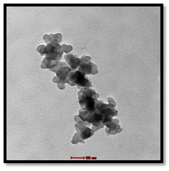
Figure 1: TEM analysis of chicken feather keratin nanoparticles

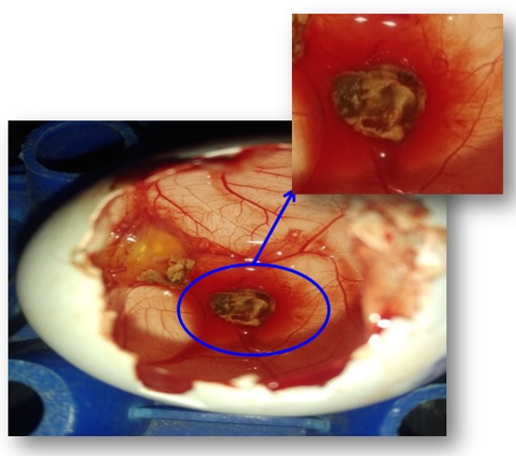
Figure 2: MCF-7 cells induced tumor formed on the chicken CAM membrane

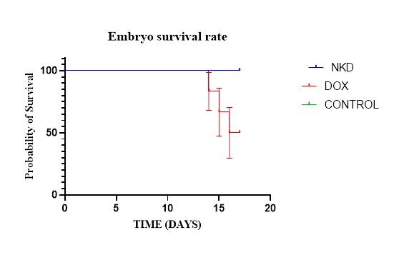
Figure 3(A): Tumors after treated with NKD
(B): Tumors after treated with DOX

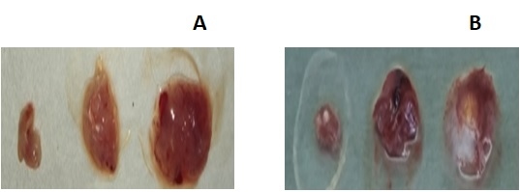

Figure 4: Embryo survival rate after the tumors treated with NKD and DOX.

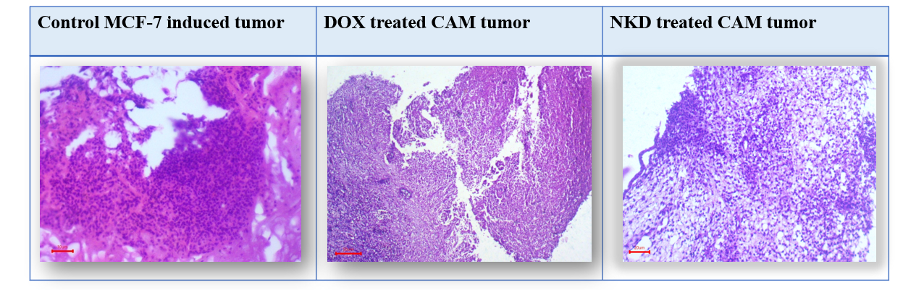

Figure 5: Histological images of hematoxylin and eosin stained tumor of control
MCF-7 group, DOX treated group and NKD treated group at 40x
magnification scale bar 50µm

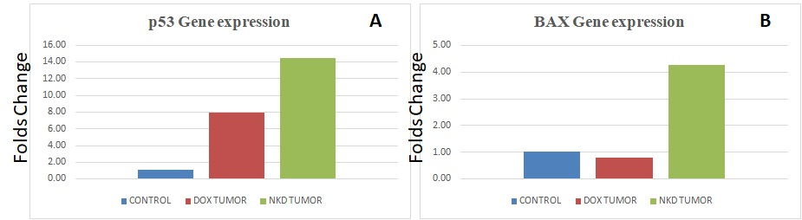

Figure 6 (A): Real-time RT-PCR for p53 gene expression of tumor cells of MCF-7
control, DOX and NKD .
(B): Real-time RT-PCR for BAX gene expression of tumor cells of MCF-7
control, DOX and NKD .

