Original Research Article
Preliminary study on the prevalence of parasites in ruminants at livestock markets in the city of Ouagadougou, Burkina Faso

Abstract:
A preliminary study was conducted from May to August 2022 to characterize gastrointestinal parasites and estimate their prevalence in three livestock markets in Ouagadougou, Burkina Faso. A total of 350 samples were collected and examined using direct observation combined with a concentration technique. These included 185 fecal samples from cattle, 146 fecal samples from sheep and 19 liquid waste samples. In total, twelve (12) parasite taxa were identified, including four (4) taxa of Protozoa and eight (8) taxa of Helminths (7 Nematoda and 1 Trematoda). The overall prevalence was 94.86%. Regarding prevalence, no significant differences were observed between animal types or between livestock markets. Among the collected parasites, Eimeria spp. (91.35%) and Oesophagostomum spp. (15.14%) were most common in cattle, while Haemonchus contortus (89.73%) and Toxara Vitulorum (76.03%) were predominant in sheep. This study also revealed that polyparasitism infections were common. These findings highlighted the important diversity and high prevalence of parasites in animals from livestock markets, posing potential health risks not only for animals but also to all stakeholders, from primary to secondary actors. Raising awareness and implementing strategic organic waste management measures are recommended to mitigate these risks.
Keywords: cattle, fecal sample, livestock market, prevalence, sheep, Ouagadougou

1. Introduction
Burkina Faso has significant animal resources, mainly in the livestock sector. These resources play a crucial role in providing various goods and services to the population by supporting the livelihoods of many people, notably through income and food (MAH, 2011; FAO, 2019 ; Zoma-Traoré et al., 2020). These resources are mobilized to finance health, education, and to fulfill traditional cultural practices (Zoma-Traoré et al., 2020).
Livestock markets (for sheep, cattle, and poultry) serve as meeting points for breeders from across the country. They represent key venues for livestock trade between pastoralists and traders, as well as among traders themselves. The main actors are local producers, collectors, traders, processors, brokers, transporters, Veterinary services and consumers. To these actors, it is necessary to join those people who play secondary roles (human’s food sellers, animals’ food sellers, drinking water sellers) in and around markets. These markets generate a significant amount of organic waste, mainly in the form of manure (a mixture of feces and urine).
However, livestock from Burkina Faso, mostly cattle and goats are heavily infected with numerous parasites including Cooperia, Haemonchus, Trichostrongylus, Bunostomum, Moniezia, Avitellina, Oesophagostomum, Trichuris, Cysticercus, Dicrocoelium, Gongylonema, Strongyloides, Gaigeria, Stilesia and Skrjabinema (Belem et al., 2001 ; Belem et al., 2005). Several parasite species from these genera are involved in zoonotic diseases (Squire et al., 2028 ). Infection can occur through the ingestion of parasite eggs or infective larvae on contaminated food, vegetation, water or soil, as well as through arthropod and gastropod intermediate hosts, skin penetration or transplacental transmission.
These parasites pose health risks when livestock are mixed with humans for rearing or in livestock markets. This risk related to the presence of parasites in the livestock in Burkina Faso constitutes a public health challenge. This concern is particularly heightened in livestock markets, due to the significant coexistence of humans and animals in these markets. It may pose a serious health threat since the mixture of humans and animals in these markets can facilitate the circulation of parasites between different hosts and humans, thereby contributing to the emergence of associated diseases.
Although a huge amont of studies have been conducted on parasite prevalence in livestock globally, few have specifically addressed their prevalence on livestock markets, where a high risk of zoonosis is expected due to the concentration of animals, poor sanitary conditions and human-animal interactions. More attention should be given to livestock market management, but it seems essential to first examine the profile of parasitic infections in these places. The objective of this study is to characterize the parasites and estimate their prevalence at the selected markets.

2. Materials and Methods
2.1 study site
The study was done in Ouagadougou, across three livestock markets (Figure 1). These markets, dedicated to the sale of sheeps, cattles as well as goats, donkeys and horses, are key meeting points for livestock producers from the region and the country. While their strategic position supports commercial exchanges, they face challenges related to illegal occupation and poor sanitation. The infrastructure is inadequate to handle the volume of animals and goods, posing hygiene and safety concerns. Despite these issues, they remain an important venue for transactions between pastoralists and traders. These markets are :
Tanghin Livestock Market located at 12°23’32.67’’N, 01°31’50.58’’W, in the northern part of Ouagadougou. It offers easy access for vehicles transporting animals from the Sahelian zone. Its proximity to the main roads facilitates movement for both sellers and buyers. Covering several hundred square meters, the market offers a wide range of livestock including cattle, sheep, and goats, suited to various budgets.
Tampouy Livestock Market : this market (12°23’24.69’’N, 01°35’00.94’’W), also located in District 4, is another key site for livestock trading. Positioned along the road Ouagadougou-Ouahigouya, it provides convenient access for pastoralists, traders and transporters. This spacious market hosts a large variety of animals.
Ouaga-Inter Livestock Market : this market (12°20’08.28’’N, 01°31’00.38’’W) is located near a central bus station in the southern part of Ouagadougou. This position offers easy access to pastoralists, traders and transporters from the South of the country.

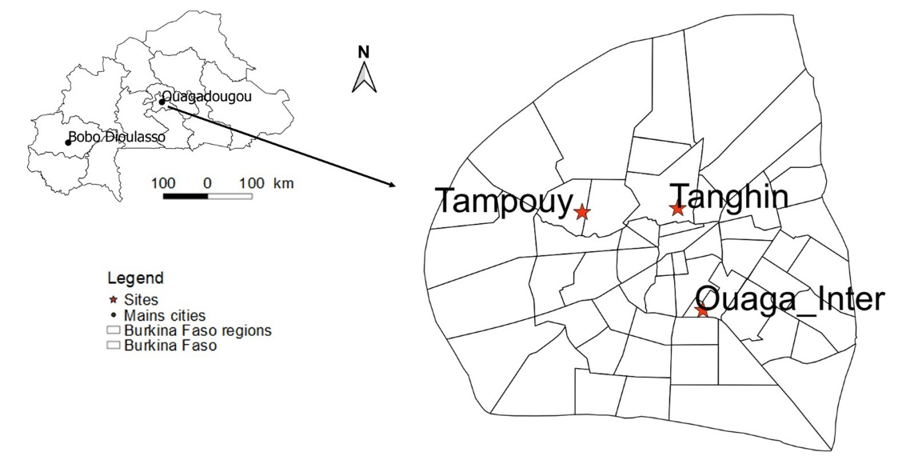
Figure 1: Map of sampling sites

2.2 Sample collection
Samples were collected from May to August 2022. Each market was visited once a week between 6 a.m. and 10 a.m. During these visits, water and manure samples were collected.
Approximately 100 g of fresh fecal sample was individually collected for each type of livestock using a sterile spatula, then stored in a sterile container. The samples were transported to the laboratory in a cooler at +4°C and processed within 6 hours of collection according to the protocols for each parasitological technique. When the transport time exceeded 6 hours, they were stored in 4% formalin according to the Wu method (2015). Each container was identified by a serial number, the type of effluent, the date, and the collection site.
2.3 Collection of parasites
In the laboratory, samples were firstly observed with the naked eye to assess the presence of adult worms. Then, a small part sample was mixed with physiological saline solution to create a homogeneous solution. This solution was observed under optical microscope to collect mobile vegetative forms, protozoan cysts and oocysts, and helminth eggs. Lastly, physico-chemical concentration was performed to collect the rare parasites. It involves bringing together two immiscible phases, one aqueous (acetoacetic) and the other organic (ether), after centrifugation. To perform this test, 10 g of feces was collected and mixed in 5 ml of acetoacetate buffer at pH 5, then filtered. An equal volume of ether was added to the filtrate, which was then centrifuged at 1,500 rpm for 3 minutes. The sediment obtained after centrifugation was mixed with physiological water and observed under an optical microscope. This technic allows almost all major groups of parasites (protozoa, helminths, arthropods) to be identified.
2.4 Identification of parasites
Identification of parasite egg was undertaken based on their size (large, small), shape (round, oval, elliptical, elongated, etc.), ornamentation (operculum, plug), shell or wall (thick, thin, smooth, transparent, striated, single, double, triple), internal organization (embryo, miracidium, vitelline cells, hooks, filaments, blastomeres), and color (colorless, brown).
Identification of parasite eggs to the species level was undertaken using identification keys such as "Les parasites des bovins", a guide prepared by Villeneuve (2013) for protozoa, along with previous works on helminth identification (Kabré, 1997 ; Belem et al., 2005 ; Martínez-Pérez et al., 2012 ; Buffaz, 2014 ; Perrin, 2017 ; Zajac et al., 2021).
2.5 Data analysis
All the collected data were entered into an Excel spreadsheet for further analysis. Parasite fauna is described using the basic parameters such as prevalence and species richness (Bush et al., 1997). Species richness refers to the total number of parasite species collected. The frequency was calculated to assess the occurrence of each parasite group in the samples. The diversity of the parasitic fauna was analyzed based on animal types and sampling sites. The Fisher Exact test was used to compare infection between sites and between hosts. A probability value less than 5% was considered significant for statistical analysis. SPSS version 25 was used for data processing and analysis. Graph were constructed using Excel and R4.4.1.
3. Results
3.1 Parasite community
The parasitic community was composed of twelve (12) taxa among which seven (7) were identified to species level and five (5) were identified according to their genera.
The community identified during the study comprised two parasitic groups: protozoa and Helminths. The Protozoan community consisted mainly by the members of the phylum Apicomplexa, with four (4) species recorded: Eimeria spp., Cryptosporidium spp., Entamoeba coli and Giardia intestinalis. Among these, Eimeria spp. exhibited the highest prevalence (48.28%).
The Helminths community consisted of Nematoda and Trematoda. Nematoda accounted for seven (7) species such as Nematodirus spp., Trichostrongylus spp., Oesophagostomum spp., Haemonchus contortus, Ostertagia ostertagi, Trichostrongylus colubriformis and Toxocara vitulorum. Among these Toxocara vitulorum and Haemonchus contortus exhibited the highest prevalences with respectively 33.71% and 38%. Only one species represented Trematoda (Fasciola hepatica).

3.2 Parasite prevalences
In the present study, 350 samples were examined, including 185 cattle fecal samples, 146 sheep fecal samples and 19 liquid waste samples. Parasitological examination revealed that 94.86% of samples were infected by at least one parasitic group. Prevalences were distributed as follows: 94.59% (175/185) for cattle, 94.52% (138/146) for sheep and 100% (19/19) for collected liquid waste samples (Table 1).
The relationship between animal type and parasite infection was analyzed using Fisher’s exact test (due to low frequencies in some cells). The results showed no significant difference among the animal categories regarding parasite infection (p = 0.851 > 0.05). A similar result was observed when considering the infection by site (p = 0.871> 0.05).
Table 1: Prevalence of parasite infection in animals according to sites
SITES | Cattle  N=185 | Sheep  N=146 | Liquid Waste  N=19
Tampouy livestock Market n=117 | 93.44% (57/61) | 93.87% (46/49) | 100% (7/7)
Tanghin livestock Market n=97 | 92.59% (50/54) | 97.43% (38/39) | 100% (4/4)
Ouaga-Inter livestock Market n=136 | 97.14% (68/70) | 93.10% (54/58) | 100% (8/8)
Total ( n=350) | 94.59% (175/185) | 94.52% (138/146) | 100% (19/19)
(N= number of samples by animal type ; n= number of samples by site)
One taxon (1), namely Fasciola hepatica was found in all the three sample types (cattle feces, sheep feces, and liquid waste) and one (1) taxon, Haemonchus contortus was shared between cattle and sheep. Four (4) parasites taxa—Eimeria spp., Nematodirus spp., Trichostrongylus spp., and Oesophagostomum spp. —were exclusively recorded in cattle. While three (3) taxa namely Ostertagia ostertagi, Trichostrongylus colubriformis, Toxocara vitulorum were exclusively found in sheep. Additionally, three other taxa—Entamoeba coli, Giardia intestinalis and Cryptosporidium spp. were exclusively identified in liquid waste (Figure 2).

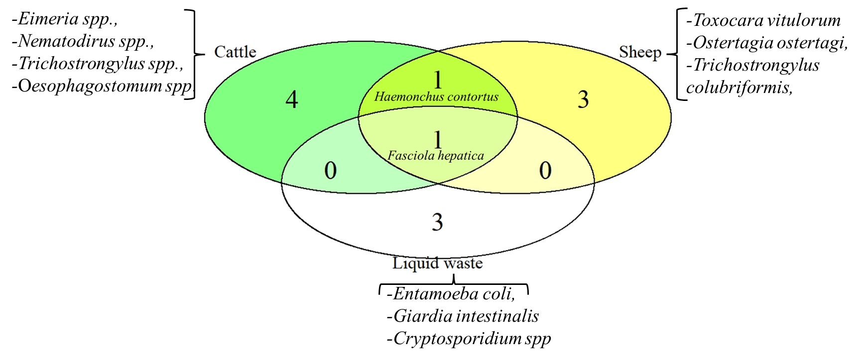
Figure 2 : Venn diagram summarizing parasite taxa richness according to sample types
and the number of common and exclusive taxa between them

3.3 Parasite frequency
In total, the protozoan Eimeria spp. was most frequently detected (48.28%; 169/350); followed by Haemonchus contortus (37.71%; 132/350), Toxocara vitulorum (31.71%; 111/350), Oesophagostomum spp. (8.00%; 28/350), Entamoeba coli (5.43%; 19/350), Trichostrongylus colubriformis (3.14%; 11/350), Giardia intestinalis (2.57%; 9/350), Trichostrongylus spp. (2.28%; 8/350), Fasciola hepatica (2.28%; 8/350), Nematodirus spp. (0.86%; 3/350), Ostertagia ostertagi (0.57%; 2/350) and Cryptosporidium spp. (0.57%; 2/350).
However, regarding the type of animals, Eimeria spp. were very frequently detected in cattle (91.35%; 169/185). Oesophagostomum spp. was the second frequently detected (15.13%; 28/185). Whereas Haemonchus contortus was very frequently detected in sheep (89.73%; 131/146) and Toxocara vitulorum (76.03%, 111/146). Liquid waste samples were fully infected by Entamoeba coli (100%) (Figure 3).
Regarding the whole sample, single infection was found highest (52.11%, 173/332) and multiple infections were least (47.89% 159/332). For cattle, the results also revealed that single infection (79.43%, 139/175) was higher than multiple infection (20.57%, 36/175). While for sheep and liquid waste multiple infections were higher than single ones (Table 2).
For cattle, the associations were: Eimeria spp. - Oesophagostomum spp. (75.00%, 27/36); Eimeria spp. - Nematodirus spp. (8.33%, 3/36); Eimeria spp. - Trichostrongylus spp. (8.33%, 3/36); Eimeria spp. - Haemonchus contortus (2.77%, 1/36); Eimeria spp. - Fasciola hepatica (2.77%, 1/36); Oesophagostomum spp. - Fasciola hepatica (2.77%, 1/36). Double infections represented all the multiple infections in cattle. While for sheep, double and triple infections were noted. The associations were: Haemonchus contortus - Ostertagia ostertagi - Toxocara vitulorum (0.9%, 1/112); Haemonchus contortus - Trichostrongylus colubriformis - Toxocara vitulorum (4.46%, 5/112); Haemonchus contortus - Fasciola hepatica - Toxocara vitulorum (0.9%, 1/112); Haemonchus contortus- Toxocara vitulorum (87.5%, 98/112) Trichostrongylus colubriformis - Toxocara vitulorum (4.46%, 5/112); Ostertagia ostertagi-Toxocara vitulorum (0.9%, 1/112); Haemonchus contortus-Fasciola hepatica (0.9%, 1/112).
For liquid waste, associations were triple and double infections: Entamoeba coli - Giardia intestinalis - Fasciola hepatica (27.27%, 3/11); Entamoeba coli - Fasciola hepatica - Cryptosporidium spp. (9.10%, 1/11); Entamoeba coli - Giardia intestinalis (54.54%, 6/11); Entamoeba coli - Cryptosporidium spp. (9.10%, 1/11).
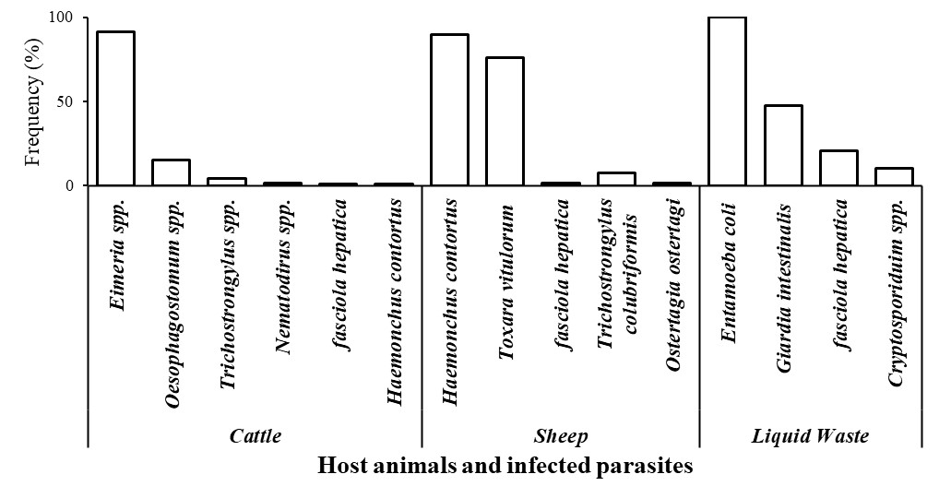
Figure 3 : Frequency of parasites according to host animals

Table 2 : Concurrency of parasite taxa in different sample types
Sample type | Single infection (%) | Double infection (%) | Triple infection (%)
Cattle | 79.43 | 20.57 | 0.00
Sheep | 18.84 | 76.09 | 5.07
Liquid waste | 42.11 | 36.84 | 21.05
Total | 52.11 | 44.58 | 3.31

4. Discussion
The present study was conducted in livestock markets, which serve as meeting points for animals from all four corners of Burkina Faso. It revealed the presence of heterogeneous parasitic community including twelve (12) taxa consisting of protozoan and helminth. In the present study, from the collected parasites, the protozoan Eimeria spp. had the highest occurrence (48.28%). The results are in line with previous findings in Burkina Faso (Belem et al., 2001). The predominance of Eimeria spp. may be linked to environmental contamination with resistant oocysts, particularly under conditions of poor hygiene and high stocking density. Cryptosporidium spp. and Giardia intestinalis recorded in the present study have both zoonotic potential. Moreover, Trichostrongylus and Fasciola collected from livestock have also been reported in humans (Squire et al., 2018), highlighting the need to improve surveillance and awareness of all actors (producers, collectors, traders, processors, brokers, transporters, Veterinary services, consumers…) as well as waste management in the livestock markets.
The helminths were the most diverse parasitic group, dominated by nematodes and represented by a single trematode species. The identified taxa reflected a typical gastrointestinal nematode fauna found in runimant across tropical regions (Komoin-Oka et al., 2000 ; Bastiaensen et al., 2003 ; Hussein et al., 2023 ; Cheptoo et al., 2025). The high occurrence of Haemonchus contortus (38%) from this group agrees with earlier studies (Belem et al., 2001). Their widespread can be attributed to their capacity to thrive in variable climate conditions. These findings confirm the widespread presence of these parasites in Burkina Faso, highlighting the need for improved surveillance, control measures, and awareness among livestock stakeholders to reduce their impact on animal health and productivity.
The overall prevalence of infection to parasite was found to be 94.86%. The infection rate reported in this study is higher than those recorded by previous studies from other parts of Africa (Dabasa et al., 2017; Abdul-Rahman et al., 2022) and other countries around the world (Memon et al., 2024). Regarding animal type-wise, the prevalence recorded for cattle in this study is relatively lower than the findings of Belem et al. (2001) and Belem et al. (2005) in earlier studies conducted in Burkina Faso. However, the higher prevalence (more than 90%) observed are consistent with their results. This higher prevalence of parasites revealed in the present study might be attributed to the feeding habit of the studied animals since cattle and sheep are frequently grazing from the ground where parasite eggs that represent the infective stage are found. So, as the animals are grazing they are exposed to contamination (Amanuel and Bekele, 2022; Kalacho and Kunta, 2024). The relative differences observed between this study and those previous studies conducted in Burkina Faso are likely due to the sampling methods. In those earlier studies, animals were slaughtered and their gastrointestinal tracts examined whereas in the present study only animal droppings were collected and observed to note the presence/absence of parasite eggs. Other reason could be the wide use of antihelminthics by livestock farmers in recent years.
The similar prevalence rates between cattle (94.59%) and sheep (94.52%), coupled with the absence of a significant statistical difference between animal types (p = 0.851 > 0.05), indicate that both animals are equally exposed to parasitic infection. This result is further supported by the lack of significant difference among sampling sites (p = 0.871 > 0.05). The very high overall prevalence of parasitic infection (94.86%) recorded in this study demonstrates that livestock markets constitute major hotspots for parasite transmission and environmental contamination. Furthermore, the poor hygiene, overcrowding and poor waste management observed across livestock markets represent favorable conditions for the persistence of parasite infective stages. The constant movement and mixing of animals from different geographical origins at livestock markets (Kamuanga et al., 2008 ; Valerio et al., 2020) create optimal conditions for the exchange and spread of a wide range of parasites. Such situations are common in West African livestock trade networks, where animals are gathered temporarily in confined enclosures with shared watering and feeding areas, often under limited sanitary management.
The detection of Fasciola hepatica in all sample types (cattle, sheep, and liquid waste) and the presence of Haemonchus contortus in both cattle and sheep reflects the widespread distribution of these parasites. These cross-infections can be due to the overlapping of grazing areas or trading patterns. The exclusive occurrence of certain taxa in specific hosts—such as Eimeria spp., Nematodirus spp., Trichostrongylus spp., and Oesophagostomum spp. in cattle, and Ostertagia ostertagi, Trichostrongylus colubriformis, and Toxocara vitulorum in sheep—suggests host-specific adaptation but also points to distinct infection according to sources. The detection of Entamoeba coli, Giardia intestinalis, and Cryptosporidium spp. exclusively in liquid waste samples further indicates that protozoan contamination is concentrated in the market environment, most likely through the accumulation of fecal matter and wastewater. These protozoa, some of which have zoonotic potential, pose an additional risk for both animals and stakeholders.
Some of the parasites identified in this study have already been observed in earlier studies in Burkina Faso for cattle (Belem et al., 2001) and goats (Belem et al., 2005). In contrast, Belem et al. (2001) reported other parasites for cattle (species belonging to the genera Bunostomum, Moniezia, Avitellina and Trichuris) that were not observed in the present study. This fact is likely attributed to the sampling method since it has been noted that those parasites were less represented, a thorough investigation is more likely to collect those parasites. Furthermore, more investigations are needed to determine the parasites infecting cattle in Burkina Faso. The same applies to sheep as well.
During the present study, multiple infections were observed. Similar observations were reported earlier for cattle and goat in Burkina Faso (Belem et al., 2001; Belem et al., 2005) ; for sheep and goats in Ghana (Abdul-Rahman et al., 2022) ; for cows, buffaloes, and goats in Nepal (Tamang and Sukupayo, 2022) ; for sheep and goats in Ethiopia (Dabasa et al., 2017). These multiple infestations appeared to be common, which should raise particular interest in studying the pathological impact of parasite associations on animals.

5. Conclusion
The Overall high prevalence of gastrointestinal parasites in the livestock markets is a serious health problem. The coexistence of protozoan and helminth underscores the need for integrated parasite management approaches that combine improved hygiene, regular veterinary inspection and awareness campaigns targeting traders, herders, and market authorities. In addition, the detection of zoonotic taxa such as Giardia, Cryptosporidium, Trichostrongylus and Fasciola highlights the importance of adopting a One Health perspective to reduce transmission risks between animals and humans.

References
Abdul-Rahman, I. I., Fuachie, P. I., and Tati, M. J. (2022). Gastrointestinal parasite infections in small ruminants relative to host sex, age and husbandry system under the guinea savannah vegetation. Biotechnology in Animal Husbandry 38 (2), 139-155. https://doi.org/10.2298/BAH2202139A
Amanuel, A., and Bekele, T. (2022). Prevalence and Associated Risk Factors of Major Gastrointestinal Nematodes of Cattle in Hawassa City. Int J Vet Sci Technol 7(1): 001–006.
Bastiaensen, P., Dorny, P., Batawui, K., Boukaya, A., Napala, A., Hendrickx, G., (2003). Parasitism of small ruminants in the peri-urban area of ​​Sokodé, Togo. I. Sheep. Revue Élev. Méd. vét. Pays trop., 2003, 56 (1-2): 43-50
Belem, A. M. G., Kaboré, A., and Bessin, R., (2005). Seasonal variations of gastrointestinal helminths in goats on the central plateau of Burkina Faso. Rev. D’élevage Médecine Vét. Pays Trop. 58, 37. https://doi.org/10.19182/remvt.9938
Belem, A. M. G., Ouédraogo, O. P., and Bessin, R., (2001). Gastrointestinal nematodes and cestodes of cattle in Burkina Faso. Volume 5 (2001), Issue 1, 17-21 URL: https://popups.uliege.be/1780-4507/index.php?id=14963
Buffaz, C., (2014). Parasitology and Practical Medical Mycology. De Boeck, Louvain-la-Neuve [Belgium].
Bush, A. O., Lafferty, K. D., Lotz, J. M., and Shostak, A. W., (1997). Parasitology Meets Ecology on Its Own Terms: Margolis et al. Revisited. The Journal of Parasitology, vol. 83, no. 4, 1997, pp. 575–83. JSTOR, https://doi.org/10.2307/3284227. Accessed Oct 13, 2025.
Cheptoo, S., Yalcindag, E., González-Gordon, L., Rukwaro, B., Kimatu, J. S., Wasonga, J., Karani, B. E., Ndambuki, G., Migeni, S., Kagai, J., Kiprotich, L. E., Saya, N., Vasoya, D., Nangekhe, G., Onguso, J., Mungai, G., Bronsvoort, B. M., and Cook, E. A. J., (2025). Species diversity and risk factors of gastrointestinal nematodes in smallholder dairy calves in Kenya. Forehead. Vet. Sci. 12:1588350. doi: 10.3389/fvets.2025.1588350
Dabasa, G., Shanko, T., Zewdei, W., Jilo, K., Gurmesa, G., and Abdela, N., (2017). Prevalence of small ruminant gastrointestinal parasites infections and associated risk factors in selected districts of Bale zone, south eastern Ethiopia. J. Parasitol. Vector Biol. Flight. 9(6), pp. 81-88, DOI: 10.5897/JPVB2017.0286
FAO, (2019). The future of livestock farming in Burkina Faso. Challenges and opportunities in the face of uncertainties. (Food and Agriculture Organization of the United Nations, Rome, Italy) Rome. 56 p. License: CC BY-NC-SA 3.0 IGO.
Gomgnimbou, A. P. K., Nacro, H. B., Sanon, O. H., Sieza, I., Kiendrebeogo, T., Sedogo, M. P., and Martinez, J., (2014). Animal manure management in the peri-urban area of ​​Bobo Dioulasso (Burkina Faso): structure of livestock farms, perception of their environmental and health impact, perspectives. Cah Agric 23: 393-402. doi: 10.1684/agr.2014.0724
Hussein, H. A., Abdi, S. M., Ahad, A. A., and Mohamed, A., (2023). Gastrointestinal nematodiasis of goats in Somali pastoral areas, Ethiopia. Parasite Epidemiol Control. 2023 Sep 7;23:e00324. doi: 10.1016/j.parepi.2023.e00324. PMID: 37701882; PMCID: PMC10493581.
Kabre, B. G., (1997). Fish Parasites of Burkina Faso: Faunistics, Ultrastructure, Biology. University of Ouagadougou, Burkina Faso.
Kalacho, N. D., and Kunta, G. D., (2022). Prevalence and Associated Risk Factors of Gastrointestinal Nematodes in Small Ruminants in Diguna Fango District, Wolaita Zone, Ethiopia. Am J Biomed Sci & Res. 2024 21(5) AJBSR.MS.ID.002889, DOI: 10.34297/ AJBSR.2024.21.002889
Kamuanga, M. J. B., Somda, J., Sanon, Y., and Kagoné, H., (2008). Livestock and regional market in the Sahel and West Africa: Potentials and challenges. SWAC-OECD/ECOWAS 2008 www.oecd.org/swac
Komoin-Oka, C., Zinsstag, J., Fofana, F., N’Depo, A., Pandey, V. S., (2000). Epidemiology of gastrointestinal nematodes in cattle in the central region of Côte d’Ivoire. Journal of Livestock and Veterinary Medicine. Pays trop., 2000, 53 (3): 257-262
MAH, (2011). General report of the Livestock module. Ministry of Animal and Fisheries Resources, Burkina Faso
Martínez-Pérez, J. M., Robles-Pérez, D., Rojo-Vázquez, F. A., and Martínez-Valladares, M., (2012). Comparison of three different techniques to diagnose Fasciola hepatica infection in experimentally and naturally infected sheep. Vet. Parasitol. 190, 80–86.
Memon, M. A., Gadahi, J. A., Panhwer, S. N., Tunio, S., Tariq, M., Laghari, Z. A., Memon, S., Solangi, H. M., Soomro, F., and Arijo, A., (2024). Prevalence, Associated Risk Factors of Gastrointestinal Parasite and Molecular Characterization of Haemonchus contortus in Small Ruminant. Pakistan J. Zool., pp 1-10, 2024. DOI: https://dx.doi.org/10.17582/journal.pjz/20231015102923
Perrin, R., (2017). Coproscopic atlas of carnivores in French zoos 105.
Squire, S.A., Yang, R., Robertson, I., Ayi, I., Squire, D.S., and Ryan, U., (2018). Gastrointestinal helminths in farmers and their ruminant livestock from the Coastal Savannah zone of Ghana. Parasitology Research (2018) 117:3183–3194 https://doi.org/10.1007/s00436-018-6017-1
Valerio, V. C., (2020), “The Structure of Livestock Trade in West Africa”, West African Papers, No. 29, OECD Publishing, Paris
Wu, X., (2015). Preliminary report on the intestinal parasites and their diversity in captive chínese alligators. Nutr. Hosp. 813–819. https://doi.org/10.3305/nh.2015.31.2.8190
Zajac, A. M., Conboy, G. A., Little, S. E., Reichard, M. V., (2021). Veterinary clinical parasitology, Ninth edition. ed. Wiley Blackwell, Chichester.
Zoma-Traoré, B., Soudré, A., Ouédraogo-Koné, S., Khayatzadeh, N., Probst, L., Sölkner, J., Mészáros, G., Burger, P. A., Traoré, A., Sanou, M., Ouédraogo, G. M. S., Traoré, L., Ouédraogo, D., Yougbaré, B., and Wurzinger, M., (2020). From farmers to livestock keepers: a typology of cattle production systems in south-western Burkina Faso. Tropical Animal Health and Production (2020) 52:2179–2189 https://doi.org/10.1007/s11250-020-02241-6

