Original Research Article
Effect of Colchicine on Morphological and Ornamental Traits of Gladiolus grandiflorus L.

ABSTRACT
Gladiolus is one of the most important lucrative cut flower crops that is cultivated globally, valued for its diverse spike shapes, sizes and vibrant colour combinations. Gladiolus, with its inherent heterozygosity, is well-suited for polyploid induction and the development of new genotypes. Colchicine serves as the most widely utilized antimitotic agent for inducing polyploidy by inhibiting spindle fibre formation. Owing to its high ornamental value, the present study was undertaken to induce colchicine in Gladiolus grandiflorus L. variety “Arka Amar” and to assess its effects through detailed observational analysis. The corms of this variety were treated by immersing them in colchicine solutions of different concentrations. The treatments consisted of four colchicine concentrations (0% as control, 0.1%, 0.2%, and 0.3%) in combination with three exposure durations of 24, 36, and 48 hours for the corms. Colchicine at 0.2% for 24 hrs enhanced the ornamental quality of gladiolus by increasing floret diameter, number of florets, floret length, spike length and field life. However, the increase in colchicine concentration or exposure duration resulted in reduced survival and flowering percentage of corms. Higher concentrations of colchicine were associated with a prolonged delay in corm sprouting, spike initiation and first floret opening. Compared to other treatments, 0.2% colchicine resulted in the highest measurements of plant height, number of leaves, sprouts per corm, rachis internodal length and leaf width. The findings of this study highlight the effectiveness of colchicine in promoting advantageous traits in gladiolus, offering opportunities for breeding new varieties with improved traits.
1. INTRODUCTION
Gladiolus (Gladiolus grandiflorus L.), a member of the Iridaceae family, is a valuable commercial cut flower crop widely acclaimed as the “Queen of bulbous ornamentals.” native to South Africa and popularly known as the “Sword Lily” (Sathyanarayana et al., 2019), it is renowned for its elegant spikes bearing vibrant florets of diverse colours. Its adaptability to varied agro-climatic conditions, profuse blooming, and long vase life have made it a preferred choice in the global floriculture market. Gladiolus is extensively used for decorative purposes, floral displays, and the preparation of high-quality bouquets (Vasanthakumar et al., 2015).
The genus Gladiolus comprises approximately 300 species, of which nearly 250 occur in the wild and about 50 have been domesticated for ornamental purposes (Dhakal et al., 2021). The species within this genus exhibit a wide ploidy variation ranging from 2n = 2x = 30 to 2n = 12x = 180 (Larson, 2012). While the majority of wild Gladiolus species are diploid, modern cultivated varieties have evolved from these wild progenitors and are predominantly tetraploid in nature (Kole, 2011; Ohri, 2013).
The expanding floriculture and tourism sectors have significantly increased the demand for cut flowers, particularly gladiolus, both in domestic and international markets. This surge in demand has transformed gladiolus cultivation into a profitable agri-business venture. Owing to its excellent transport durability and extended vase life, gladiolus ranks fifth among the most traded cut flowers globally. Consequently, the continuous development of new gladiolus varieties is essential to cater to the evolving preferences of consumers in the floriculture market (Bolagam and Natarajan, 2019).
The inherent heterozygosity in gladiolus makes them suitable candidates for polyploid induction and the generation of novel genotypes, facilitating targeted trait improvement without genome-wide alterations (Manzoor et al., 2018). Both polyploidy and hybridization are considered key mechanisms underlying the evolutionary diversification of the genus Gladiolus (Nemati et al., 2012).
Chromosome doubling is a well-established approach for generating varying ploidy levels in plants, typically achieved through the application of antimitotic agents such as colchicine, hexachloro-cyclohexane, veratrine and sulphanilamide (Kokate, 2011). Among these, colchicine has been consistently recognized as the most effective compound for inducing polyploidy due to its ability to disrupt spindle fibre formation during cell division. The successful standardization of polyploidization protocols necessitates multiple trials to determine the optimal chemical agent, concentration, and exposure duration specific to each plant species (Dhooghe et al., 2011).
2. MATERIALS AND METHODS
The present investigation was conducted at the Department of Genetics and Plant Breeding, College of Agriculture, Vellayani. The study was undertaken to induce colchicine in Gladiolus grandiflorus L. and to assess its effects through detailed observational analysis.
The experiment utilized corms of Gladiolus grandiflorus L. cultivar ‘Arka Amar’, distinguished by its red flowers with a golden central blotch and well-ruffled double-row spikes. The corms were treated by immersing them in colchicine solutions of different concentrations. Solutions of different concentrations were prepared by dissolving colchicine in sterile distilled water. The treatments consisted of four colchicine concentrations (0% as control, 0.1%, 0.2%, and 0.3%) in combination with three exposure durations of 24, 36, and 48 hours for the corms.
The experimental setup comprised 12 treatments in total. Among these, 9 treatments involved complete immersion of corms in colchicine solution for varying exposure periods under dark conditions. The remaining 3 treatments served as controls, where corms were soaked in sterile distilled water for 24, 36, and 48 hours. After each treatment, the corms were thoroughly washed under running tap water followed by rinsing with sterile distilled water to remove any traces of colchicine. These treatments were evaluated in factorial completely randomized design (FCRD) with three replications. The treated corms were subsequently planted in pots filled with a potting mixture of sand, soil, FYM, and coco peat in the ratio of 1:2:1:1. The plants were maintained under Department of Genetics and Plant Breeding, College of Agriculture, Vellayani. Management and intercultural operations were undertaken as per Package of Practices recommendations of Kerala Agricultural University (KAU, 2024).
The observations obtained from the experiments were subjected to one-way analysis of variance (ANOVA). The mean values were compared at a p < 0.05 significance level. The traits under study were percentage survival of corms, plant height (cm), number of leaves per plant, width of leaf (cm), days to first floret opening, diameter of the floret (cm), spike length (cm), number of florets per spike, field life (number of days), length of the floret (cm), days to sprouting, days to spike initiation, rachis-internodal length (cm), number of sprouts per corm, percentage flowering of corms and length of leaf (cm). Statistical analysis was performed using the software, GRAPES (Gopinath et al., 2020).

3. RESULTS AND DISCUSSION
Survival percentage (Table 1) showed a noticeable decline with increasing colchicine concentration and duration. Among different concentrations, the untreated control (0%) recorded the highest survival (100%), which remained statistically comparable with concentrations 0.1% and 0.2%. The lowest survival (77.67%) was recorded at 0.3% concentration, showing a significant reduction from other concentrations. Regarding exposure duration, the shortest period (24 hrs) resulted in the maximum survival (96.50%), comparable with 36 hrs (95.50%). However, prolonged exposure for 48 hrs led to the minimum survival (91.25%), which differed significantly from the other durations. In the combined effects of concentration and duration, 0% × 24 hrs showed the highest survival rate (100%), which remained statistically similar to 0% × 36 hrs, 0% × 48 hrs, 0.1% × 24 hrs, 0.1% × 36 hrs, 0.1% × 48 hrs, 0.2% × 24 hrs, 0.2% × 36 hrs and 0.2% × 48 hrs. The lowest survival (65%) was recorded in 0.3% × 48 hrs, which showed a significant decline compared to all other treatment combinations. The decline in survival rate can be attributed to the cytotoxic effects of colchicine, which was evident from tissue necrosis and browning during shoot formation. Similar trends have been reported by Mohammadi et al. (2021) in Dendrobium species.
Percentage flowering (Table 1) was markedly affected by colchicine concentration, exposure duration, and their interaction. A clear decline in flowering percentage was observed with increasing colchicine levels. Among concentrations, the control (0%) recorded complete flowering (100%), statistically comparable to 0.1%, while the least flowering (56.33%) was obtained at 0.3%, which differed significantly from all other concentrations. With respect to duration, the highest flowering (92.42%) was noted at 24 hrs, followed by 36 hrs (89.50%), whereas the lowest (80.33%) occurred at 48 hrs. Both differed significantly from the other durations. In terms of interaction, the treatment 0% × 24 hrs produced the highest flowering (100%), which was statistically on par with 0% × 36 hrs, 0% × 48 hrs, 0.1% × 24 hrs, 0.1% × 36 hrs, 0.1% × 48 hrs, 0.2% × 24 hrs, and 0.2% × 36 hrs. The lowest flowering (41.33%) was observed in 0.3% × 48 hrs, which was significantly different from all other combinations. A progressive decline in flowering percentage with increasing colchicine concentration in Gladiolus was also reported by Manzoor et al. (2018). Niu et al. stated that colchicine limits photosynthetic efficiency, retarding cellular and developmental functions, which in turn delays or suppresses flowering.
Colchicine concentration, duration of exposure, and their interaction significantly influenced leaf length (Table 2). The maximum leaf length (52.85 cm) was obtained at 0.1% colchicine, which was statistically on par with 0.2% (52.66 cm), while the lowest value (43.95 cm) was recorded at 0.3%, showing a significant difference from the other concentrations. With respect to duration, 24 hrs produced the longest leaves (50.81 cm), differing significantly from other durations. The shortest leaves (47.73 cm) were recorded after 48 hrs, which was also significantly different from all other durations. Considering interaction effects, the treatment 0.2% × 24 hrs resulted in the longest leaves (57.26 cm), significantly superior to all other treatment combinations, whereas 0.3% × 48 hrs produced the shortest leaves (42.09 cm). Kazemi and Kaviani (2020) found that Catasetum pileatum responded best to moderate colchicine concentrations and shorter exposure periods, producing longer leaves, while excessive doses and extended treatments led to shorter leaves.
Leaf width (Table 2) showed a significant response to varying colchicine concentrations. The greatest mean leaf width (2.59 cm) was recorded at 0.2%, which differed significantly from all other concentrations. The smallest leaf width (2.05 cm) was observed at 0.3%, which was statistically comparable with the control (0%) but significantly different from the remaining concentrations. The duration of exposure had no significant influence on this parameter. Regarding interaction effects, 0.2% × 24 hrs produced the wider leaves (2.90 cm), which was statistically similar to 0.1% × 48 hrs but significantly superior to all other treatment combinations. The narrowest leaves were recorded in 0% × 24 hrs; 1.97 cm, which was statistically comparable with 0% × 36 hrs. Similar findings were noticed by Nyam et al. (2024), where colchicine treatment in fonio grasses increased leaf width at optimal concentrations but caused a decline at elevated levels.
Colchicine concentration% | Percentage survival of corms |  |  |  | Percentage flowering of corms
Colchicine concentration% | 24 hr | 36 hr | 48 hr | Mean | 24 hr | 36 hr | 48 hr | Mean
0 | 100.00ª | 100.00ª | 100.00ª | 100.00ª | 100.00ª | 100.00ª | 100.00ª | 100.00ª
0.1 | 100.00ª | 100.00ª | 100.00ª | 100.00ª | 100.00ª | 100.00ª | 100.00ª | 100.00ª
0.2 | 100.00ª | 100.00ª | 100.00ª | 100.00ª | 100.00ª | 100.00ª | 80.00^{b} | 93.33^{b}
0.3 | 86.00^{b} | 82.00^{c} | 65.00^{d} | 77.67^{b} | 69.67^{c} | 58.00^{d} | 41.33e | 56.33^{c}
Mean | 96.50ª | 95.50ª | 91.25^{b} | 94.42 | 92.42ª | 89.50^{b} | 80.33^{c} | 87.42
 | S. E (m)  (Standard Error) | C. D (ɑ=0.05)  (Critical Difference) |  | CV (%) | S. E (m) | C. D (ɑ=0.05) |  | CV (%)
Concentration | 0.62 | 1.8 |  | 1.96 | 0.44 | 1.28 |  | 1.50
Duration | 0.53 | 1.56 |  | 1.96 | 0.38 | 1.11 |  | 1.50
Concentration x Duration | 1.07 | 3.11 |  | 1.96 | 0.76 | 2.21 |  | 1.50
Table 1. Effect of colchicine on percentage survival and percentage flowering of corms in gladiolus

Table 2. Effect of colchicine on length of leaf and width of leaf in gladiolus
Colchicine concentration% | Length of leaf (cm) |  |  |  | Width of leaf (cm)
Colchicine concentration% | 24 hr | 36 hr | 48 hr | Mean | 24 hr | 36 hr | 48 hr | Mean
0 | 49.34^{d} | 47.36e | 44.41^{f} | 47.04^{b} | 1.97^{g} | 2.16^{defg} | 2.05^{fg} | 2.06^{c}
0.1 | 50.05^{cd} | 53.67^{b} | 54.82^{b} | 52.85ª | 2.19^{def} | 2.37^{cd} | 2.70^{ab} | 2.42^{b}
0.2 | 57.26ª | 51.11^{c} | 49.60^{cd} | 52.66ª | 2.90ª | 2.54^{bc} | 2.31de | 2.59ª
0.3 | 46.60e | 43.15^{fg} | 42.09^{g} | 43.95^{c} | 2.14^{efg} | 2.04^{fg} | 1.98^{g} | 2.05^{c}
Mean | 50.81ª | 48.82^{b} | 47.73^{c} | 49.12 | 2.30 | 2.28 | 2.26 | 2.28
 | S. E (m) | C. D (ɑ=0.05) |  | CV (%) | S. E (m) | C. D (ɑ=0.05) |  | CV (%)
Concentration | 0.31 | 0.9 |  | 1.88 | 0.04 | 0.12 |  | 5.57
Duration | 0.27 | 0.78 |  | 1.88 | 0.04 | ns |  | 5.57
Concentration x Duration | 0.53 | 1.56 |  | 1.88 | 0.07 | 0.21 |  | 5.57

Table 3. Effect of colchicine on diameter of the floret and spike length in gladiolus
Colchicine concentration% | Diameter of the floret (cm) |  |  |  | Spike length (cm)
Colchicine concentration% | 24 hr | 36 hr | 48 hr | Mean | 24 hr | 36 hr | 48 hr | Mean
0 | 10.13^{i} | 10.42^{h} | 10.89^{f} | 10.48^{d} | 43.00^{d} | 43.27^{d} | 46.06^{d} | 44.11^{d}
0.1 | 10.63^{gh} | 11.20e | 11.97^{c} | 11.27^{b} | 58.94^{c} | 61.73^{bc} | 65.28^{b} | 61.98^{b}
0.2 | 13.35ª | 12.63^{b} | 11.96^{c} | 12.65ª | 75.05ª | 70.42ª | 63.30^{bc} | 69.59ª
0.3 | 11.50^{d} | 10.77^{fg} | 10.44^{h} | 10.91^{c} | 58.21^{c} | 45.60^{d} | 43.54^{d} | 49.11^{c}
Mean | 11.40ª | 11.26^{b} | 11.32^{ab} | 11.33 | 58.80ª | 55.25^{b} | 54.54^{b} | 56.20
 | S. E (m) | C. D (ɑ=0.05) |  | CV (%) | S. E (m) | C. D (ɑ=0.05) |  | CV (%)
Concentration | 0.04 | 0.12 |  | 1.11 | 1.01 | 2.96 |  | 5.41
Duration | 0.04 | 0.11 |  | 1.11 | 0.88 | 2.56 |  | 5.41
Concentration x Duration | 0.07 | 0.21 |  | 1.11 | 1.76 | 5.12 |  | 5.41

Floret diameter (Table 3) exhibited significant variation among the different colchicine concentrations. The highest mean floret diameter was observed at 0.2% colchicine (12.65 cm), which differed significantly from all other concentrations. The smallest mean diameter (10.48 cm) was recorded in the control (0%), which was also significantly distinct from the other treatments. With respect to exposure duration, 24 hrs resulted in the largest mean floret diameter (11.40 cm), followed closely by 48 hrs (11.32 cm), while the minimum value was recorded at 36 hrs (11.26 cm). Among the interaction effects, the treatment combination 0.2% × 24 hrs produced the largest florets (13.35 cm), which was significantly superior to all other treatment combinations. Conversely, the smallest floret diameter was observed in 0% × 24 hrs; 10.13 cm, which also showed a significant difference from the rest. A comparable trend was observed by Bhattarai et al. (2021) in gerbera daisy, where moderate colchicine doses increased floret diameter, while excessive concentrations or extended exposure led to toxicity and growth suppression.
Significant differences in spike length (Table 3) were observed among colchicine concentrations. The 0.2% colchicine recorded maximum spike length (69.59 cm), whereas the control (0%) produced the minimum (44.11 cm), both differing significantly from the other concentrations. Considering exposure duration, 24 hrs yielded the maximum spike length (58.80 cm), which was significantly superior to the other durations. The minimum spike length was observed at 48 hrs (54.54 cm), which remained statistically on par with 36 hrs. Interaction effects highlighted that 0.2% × 24 hrs yielded the longest spikes (75.05 cm), statistically similar to 0.2% × 36 hrs, while the lowest values occurred in the control 0% × 24 hrs; 43.00 cm, comparable to the other control durations. This agrees with Moustafa et al. (2018), where 0.2% colchicine enhanced spike length in Gladiolus grandiflorus, whereas elevated concentrations or longer treatments caused cytotoxicity and mitotic disturbances that reduced these beneficial effects.
The number of florets per spike (Table 4) varied significantly across colchicine concentrations. The 0.2% colchicine resulted in the maximum mean florets per spike (14.56), while the 0.3% concentration recorded the minimum (6.78), with both differing significantly from all other concentrations. With respect to exposure duration, corms treated for 24 hrs produced the highest number of florets (10.83), whereas those exposed for 48 hrs yielded the lowest (9.83), which was significantly different from the other durations. The interaction between concentration and duration showed that 0.2% × 24 hrs recorded the highest florets per spike (17.33), while 0.3% × 48 hrs recorded the least (5.33), with both being significantly distinct from all remaining treatments. A comparable observation was made by Manzoor et al. (2018) in colchicine-treated Gladiolus, where excessive concentrations reduced floret number, while moderate doses enhanced it through the colchicine-induced ‘gigas’ effect.
Significant differences were observed in rachis-internodal length (Table 4) among colchicine concentrations. Plants treated with 0.2% colchicine exhibited the greatest internodal length (4.41 cm), statistically similar to 0.3%, while the shortest internodes (3.54 cm) occurred in the control (0%), which differed significantly from other concentrations. Considering the duration of exposure, corms treated for 24 hrs produced the longest internodes (4.18 cm), which was on par with 36 hrs (4.12 cm), whereas the shortest internodes (3.96 cm) were observed at 48 hrs, which differed significantly from rest of the durations. Interaction analysis indicated that 0.2% × 24 hrs produced the maximum internode length (5.72 cm), significantly distinct from all other combinations. The shortest internodes were recorded in 0% × 24 hrs; 3.41 cm, which remained comparable with 0.1% × 24 hrs. Ridwan et al. (2025) similarly observed longer internodes in colchicine-induced chrysanthemum, while excessive colchicine concentrations caused marked reductions, likely due to cytotoxic effects of the chemical.
Days to spike initiation and days to first floret opening (Table 5) varied significantly depending on the colchicine concentration, duration and their interaction. The longest period for spike initiation was recorded at 0.3% colchicine (101.67 days, while the shortest was observed in the control (0%) at 70.22 days, with both values differing significantly from the others. Among durations, the longest period for spike initiation was recorded at 48 hrs (90.83 days), whereas 24 hrs treatment resulted in the earliest initiation (83.92 days), comparable to 36 hrs. The combined effect of concentration and duration revealed that 0.3% × 48 hrs showed the greatest delay (107.00 days) in spike initiation, whereas 0% × 36 hrs recorded the earliest (68.00 days). The 0.3% colchicine caused the maximum delay in floret opening (112.11 days), whereas the untreated control recorded the earliest opening (80.67 days). Both values were significantly different from all other treatments. Corms treated for 48 hrs required the longest time (101.83 days) to open the first floret, whereas exposure for 24 hrs resulted in the earliest opening (95.08 days), which was statistically similar to 36 hrs. Interaction analysis indicated that 0.3% × 48 hrs delayed floret opening most (116.33 days), followed by 0.3% × 36 hrs and 0.2% × 48 hrs. The shortest duration to first floret opening was recorded in 0% × 36 hrs; 78.67 days. Similar results were noted by Manzoor et al. (2018), where increasing colchicine concentrations markedly delayed flowering in the gladiolus cultivar ‘White Prosperity’, likely due to inhibited developmental processes and prolonged vegetative growth with continued leaf formation.
Plant height (Table 6) showed a significant variation across colchicine concentrations, exposure durations and their interactions. Among the concentrations, 0.2% colchicine resulted in the tallest plants (87.11 cm), significantly exceeding all other concentrations. While the control (0%) produced the shortest plants (60.71 cm), which differed significantly from all other concentrations. Regarding exposure time, plants treated for 24 hrs attained the maximum height (75.20 cm), which was statistically on par with those treated for 36 hrs (75.19 cm). Prolonged exposure for 48 hrs led to a reduction in height (71.67 cm), showing a significant difference from the other durations. For the interaction effect, 0.2% × 24 hrs produced the tallest plants (94.74 cm), significantly outperforming all other treatment combinations. It was followed by 0.2% × 36 hrs, which was comparable to 0.1% × 48 hrs and 0.1% × 36 hrs. The shortest plants (58.96 cm) were observed under 0% × 24 hrs and which were statistically at par with 0.3% × 48 hrs. Comparable results were obtained by Manzoor et al. (2018), with 0.3% colchicine treatment producing the shortest plants in gladiolus.
Significant variation in the number of leaves per plant (Table 6) was observed in response to different colchicine concentrations. The 0.2% colchicine produced the highest number of leaves (7.11), followed by those treated with 0.1% (6.67). The lowest number of leaves (5.67) was obtained under 0.3% colchicine, which was statistically inferior to all other concentrations. The effect of exposure duration and the interaction between concentration and duration, however, remained non-significant. Surson et al. (2025) observed a similar trend in Centella asiatica (L.), where colchicine treatments at 0.1% and 0.2% yielded the highest number of leaves. The subsequent decrease at higher doses was attributed to with reduced germination rates.
Field life (Table 7) exhibited significant differences among colchicine concentrations. The longest field life was recorded at 0.2% (17.56 days), whereas the shortest was observed in the control (0%; 10.56 days), with both values differing significantly from the remaining concentrations. Regarding exposure duration, 24 hrs recorded the maximum field life (14.42 days). The shortest duration of field life was recorded at 48 hrs (13.17 days), which was statistically on par with 36 hrs (13.67 days). The interaction between concentration and duration revealed that 0.2% × 24 hrs exhibited the greatest field life (20.33 days), which differed significantly from all other combinations. In contrast, T10 (0% × 24 hrs) recorded the minimum field life (10.00 days). According to Kushwah et al. (2018), polyploidy induction in Chrysanthemum carinatum led to an increase in flower lifespan.
Floret length (Table 7) showed significant variation in response to colchicine treatment. The highest mean floret length (10.92 cm) was obtained at 0.2% colchicine concentration, which differed significantly from all other concentrations. The lowest mean value (9.73 cm) was observed in the control (0%), which was statistically comparable to 0.3%. With respect to exposure duration, corms treated for 24 hrs produced the maximum (10.28 cm), showing a significant difference from the other durations. The minimum floret length (10.17 cm) was observed at 48 hrs, which was statistically on par with 36 hrs. Regarding interaction effects, the treatment combination 0.2% × 24 hrs recorded the maximum floret length 11.48 cm, which was significantly superior to all other combinations. In contrast, the shortest florets (9.51 cm) were produced under 0.3% × 48 hrs, which differed significantly from all remaining treatments. Vishnupandi et al. (2023) observed a similar response in Jasminum sambac, with moderate colchicine levels improving flower length and girth. This suggests that optimal cellular enlargement occurs at moderate colchicine concentrations.
Days to sprouting (Table 8) showed highly significant variation across colchicine concentrations. The longest mean sprouting period was recorded at 0.3% colchicine (17.22 days), which differed significantly from all other concentrations. The shortest sprouting time (7.89 days) was observed in the control (0%), which was also significantly different from the remaining treatments. With respect to duration, 48 hrs of exposure delayed sprouting the most (13.92 days), significantly differing from all other durations, while the earliest sprouting occurred at 24 hrs (12.25 days), which was statistically comparable to 36 hrs. Interaction effects indicated that 0.3% × 48 hrs resulted in the maximum sprouting duration 18.67 days, significantly higher than all other combinations. The minimum time to sprouting 7.33 days was noted in 0% × 36 hrs, which was statistically similar to 0% × 24 hrs.
Significant differences in the number of sprouts per corm (Table 8) were observed among colchicine concentrations. The 0.2% concentration produced the highest mean sprout number (3.11), on par with 0.1%, while the control (0%) recorded the minimum (1.78), which was statistically similar to 0.3%. The duration of exposure, however, had no significant influence on sprouting. With regard to the interaction between concentration and duration, 0.2% × 24 hrs resulted in a greater number of sprouts (3.67), closely followed by 0.1% × 48 hrs and 0.2% × 36 hrs. In contrast, 0% × 24 hrs; 1.33, resulted in least sprouting, which was comparable with 0.3% × 48 hrs. A comparable trend was reported by Manzoor et al. (2018), who observed a slight rise in sprout number among colchicine-induced polyploids of gladiolus. The improved sprouting observed at 0.2% and 0.3% concentrations could be linked to the stimulatory effects of polyploidization on cell division and bud initiation.
Colchicine concentration% | Number of florets per spike |  |  |  | Rachis-internodal length (cm)
Colchicine concentration% | 24 hr | 36 hr | 48 hr | Mean | 24 hr | 36 hr | 48 hr | Mean
0 | 8.33^{g} | 10.67e | 9.67^{f} | 9.56^{c} | 3.41^{g} | 3.69^{ef} | 3.53^{fg} | 3.54^{c}
0.1 | 9.33^{f} | 10.67e | 12.67^{c} | 10.89^{b} | 3.41^{g} | 3.77^{def} | 4.92^{b} | 4.03^{b}
0.2 | 17.33ª | 14.67^{b} | 11.67^{d} | 14.56ª | 5.72ª | 3.99^{cd} | 3.52^{fg} | 4.41ª
0.3 | 8.33^{g} | 6.67^{h} | 5.33^{i} | 6.78^{d} | 4.19^{c} | 5.03^{b} | 3.88de | 4.37ª
Mean | 10.83ª | 10.67ª | 9.83^{b} | 10.44 | 4.18ª | 4.12ª | 3.96^{b} | 4.09
 | S. E (m) | C. D (ɑ=0.05) |  | CV (%) | S. E (m) | C. D (ɑ=0.05) |  | CV (%)
Concentration | 0.19 | 0.56 |  | 5.53 | 0.05 | 0.15 |  | 3.72
Duration | 0.17 | 0.49 |  | 5.53 | 0.04 | 0.13 |  | 3.72
Concentration x Duration | 0.33 | 0.97 |  | 5.53 | 0.09 | 0.26 |  | 3.72

Table 4. Effect of colchicine on number of florets per spike and rachis-internodal length on gladiolus

Table 5. Effect of colchicine on days to spike initiation and days to first floret opening in gladiolus
Colchicine concentration% | Days to spike initiation |  |  |  | Days to first floret opening
Colchicine concentration% | 24 hr | 36 hr | 48 hr | Mean | 24 hr | 36 hr | 48 hr | Mean
0 | 70.67^{ij} | 68.00^{j} | 72.00^{i} | 70.22^{d} | 81.00^{gh} | 78.67^{h} | 82.33^{g} | 80.67^{d}
0.1 | 77.33^{h} | 81.33^{g} | 85.33^{f} | 81.33^{c} | 87.67^{f} | 92.67e | 97.33^{d} | 92.56^{c}
0.2 | 92.67^{d} | 89.00e | 99.00^{c} | 93.56^{b} | 105.33^{c} | 100.00^{d} | 111.33^{b} | 105.56^{b}
0.3 | 95.00^{d} | 103.00^{b} | 107.00ª | 101.67ª | 106.33^{c} | 113.67^{ab} | 116.33ª | 112.11ª
Mean | 83.92^{b} | 85.33^{b} | 90.83ª | 86.69 | 95.08^{b} | 96.25^{b} | 101.83ª | 97.72
 | S. E (m) | C. D (ɑ=0.05) |  | CV (%) | S. E (m) | C. D (ɑ=0.05) |  | CV (%)
Concentration | 0.72 | 2.1 |  | 2.48 | 0.71 | 2.07 |  | 2.18
Duration | 0.62 | 1.81 |  | 2.48 | 0.61 | 1.79 |  | 2.18
Concentration x Duration | 1.24 | 3.63 |  | 2.48 | 1.23 | 3.59 |  | 2.18
Colchicine concentration% | Plant height (cm) |  |  |  | Number of leaves per plant
Colchicine concentration% | 24 hr | 36 hr | 48 hr | Mean | 24 hr | 36 hr | 48 hr | Mean
0 | 58.96^{f} | 62.05^{ef} | 61.13^{ef} | 60.71^{d} | 6.67 | 6.33 | 6.00 | 6.33^{b}
0.1 | 74.81^{cd} | 84.01^{b} | 87.95^{b} | 82.26^{b} | 6.33 | 6.67 | 7.00 | 6.67^{ab}
0.2 | 94.74ª | 88.84^{b} | 77.75^{c} | 87.11ª | 7.67 | 7.00 | 6.67 | 7.11ª
0.3 | 72.29^{d} | 65.88e | 59.84^{f} | 66.00^{c} | 6.00 | 5.67 | 5.33 | 5.67^{c}
Mean | 75.20ª | 75.19ª | 71.67^{b} | 74.02 | 6.67 | 6.42 | 6.25 | 6.45
 | S. E (m) | C. D (ɑ=0.05) |  | CV (%) | S. E (m) | C. D (ɑ=0.05) |  | CV (%)
Concentration | 0.96 | 2.79 |  | 3.88 | 0.18 | 0.54 |  | 8.58
Duration | 0.83 | 2.42 |  | 3.88 | 0.16 | ns |  | 8.58
Concentration x Duration | 1.66 | 4.84 |  | 3.88 | 0.32 | ns |  | 8.58

Table 6. Effect of colchicine on plant height and number of leaves per plant in gladiolus

Table 7. Effect of colchicine on field life and length of the floret in gladiolus
Colchicine concentration% | Field life (number of days) |  |  |  | Length of the floret (cm)
Colchicine concentration% | 24 hr | 36 hr | 48 hr | Mean | 24 hr | 36 hr | 48 hr | Mean
0 | 10.00^{g} | 11.00^{fg} | 10.67^{g} | 10.56^{d} | 9.69^{f} | 9.73^{f} | 9.76^{f} | 9.73^{c}
0.1 | 13.67de | 14.00^{d} | 15.67^{c} | 14.44^{b} | 9.94e | 10.51^{d} | 10.92^{b} | 10.45^{b}
0.2 | 20.33ª | 17.33^{b} | 15.00^{cd} | 17.56ª | 11.48ª | 10.81^{c} | 10.48^{d} | 10.92ª
0.3 | 13.67de | 12.33^{ef} | 11.33^{fg} | 12.44^{c} | 10.02e | 9.78^{f} | 9.51^{g} | 9.77^{c}
Mean | 14.42ª | 13.67^{b} | 13.17^{b} | 13.75 | 10.28ª | 10.21^{b} | 10.17^{b} | 10.22
 | S. E (m) | C. D (ɑ=0.05) |  | CV (%) | S. E (m) | C. D (ɑ=0.05) |  | CV (%)
Concentration | 0.28 | 0.83 |  | 6.18 | 0.02 | 0.06 |  | 0.58
Duration | 0.25 | 0.72 |  | 6.18 | 0.02 | 0.05 |  | 0.58
Concentration x Duration | 0.49 | 1.43 |  | 6.18 | 0.03 | 0.24 |  | 0.58

Table 8. Effect of colchicine on days to sprouting and number of sprouts per corm in gladiolus
Colchicine concentration% | Days to sprouting |  |  |  | Number of sprouts per corm
Colchicine concentration% | 24 hr | 36 hr | 48 hr | Mean | 24 hr | 36 hr | 48 hr | Mean
0 | 7.67^{i} | 7.33^{i} | 8.67^{h} | 7.89^{d} | 1.33e | 1.67de | 2.33^{bcde} | 1.78^{b}
0.1 | 10.33^{g} | 10.67^{g} | 11.67^{f} | 10.89^{c} | 2.33^{bcde} | 2.67^{abcd} | 3.33^{ab} | 2.78ª
0.2 | 15.67^{d} | 13.33e | 16.67^{c} | 15.22^{b} | 3.67ª | 3.00^{abc} | 2.67^{abcd} | 3.11ª
0.3 | 15.33^{d} | 17.67^{b} | 18.67ª | 17.22ª | 2.33^{bcde} | 2.00^{cde} | 1.33e | 1.89^{b}
Mean | 12.25^{b} | 12.25^{b} | 13.92ª | 12.81 | 2.42 | 2.33 | 2.42 | 2.39
 | S. E (m) | C. D (ɑ=0.05) |  | CV (%) | S. E (m) | C. D (ɑ=0.05) |  | CV (%)
Concentration | 0.19 | 0.56 |  | 4.51 | 0.20 | 0.58 |  | 25.16
Duration | 0.17 | 0.49 |  | 4.51 | 0.17 | ns |  | 25.16
Concentration x Duration | 0.33 | 0.97 |  | 4.51 | 0.35 | 1.01 |  | 25.16

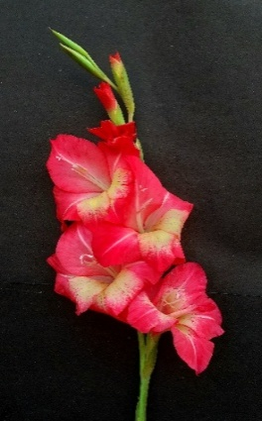
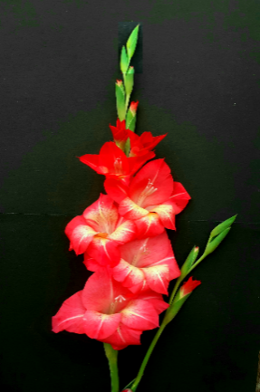
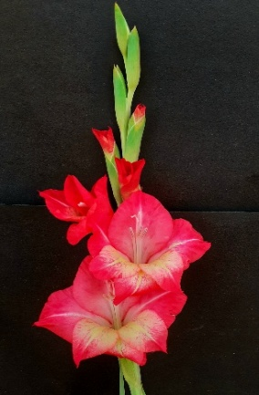
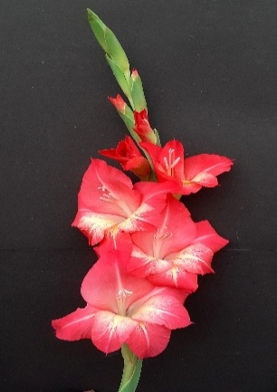
The predominant floral colour observed with Arka Aamr was red with a golden-yellow centre. However, plants treated with colchicine displayed a noticeable increase in colour and brightness compared to the control. Untreated ones, exhibited a light red perianth with a golden-yellow centre, whereas treatments 0.1% x 24 hrs, 0.2% x 48 hrs, 0.3% x 24 hrs, 0.3% x 36 hrs and 0.3% x 48 hrs developed moderate light red hue with golden yellow centre. Treatments 0.1% x 36 hrs, 0.1% x 48 hrs and 0.2% x 36 hrs further intensified pigmentation, producing florets with a moderate bright red colouration and golden yellow centre. Among all treatments, 0.2% x 24 hrs had the brightest florets characterized by a bright red perianth with a golden yellow centre. Comparable trends were reported by Osburn et al. (2003) in Rosa centifolia, where tetraploids displayed altered pigmentation due to chromosome doubling, which increased gene dosage and enzyme activity, thus modifying anthocyanin biosynthesis.
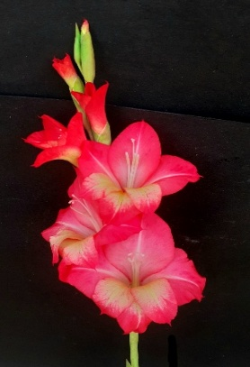
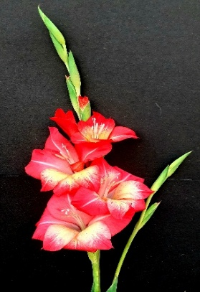
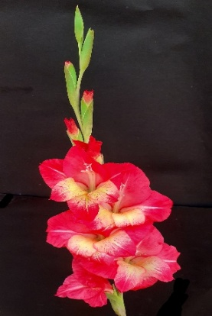
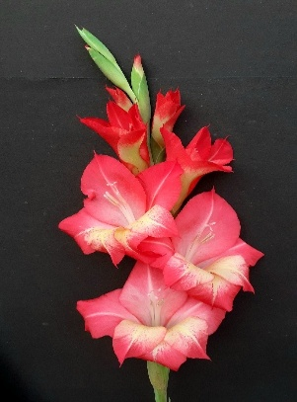
0 x 24 hrs (control 1) 0.1% x 24 hrs 0.2% x 24 hrs 0.3% x 24 hrs
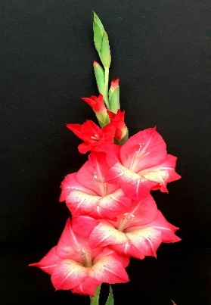
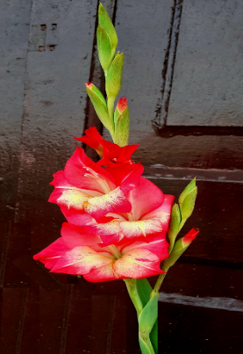
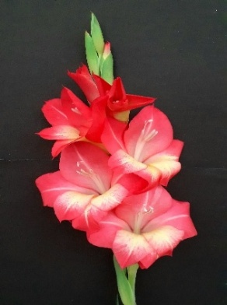
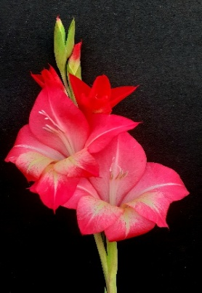
0 x 36 hrs (control 2) 0.1% x 36 hrs 0.2% x 36 hrs 0.3% x 36 hrs
0 x 48 hrs (control 3) 0.1% x 48 hrs 0.2% x 48 hrs 0.3% x 48 hrs

Fig. 1. Spikes of colchicine treated plants with controls
4. CONCLUSION
The present study demonstrated that colchicine treatment effectively enhanced the morphological and ornamental traits of Gladiolus grandiflorus L. variety “Arka Amar.” Treatment with 0.2% colchicine for 24 hours was found to be optimal, resulting in increased floret diameter, number of florets, floret length, spike length, plant height, rachis-internodal length and extended field life, thereby improving the overall aesthetic and horticultural value. This germplasm serves as a valuable resource to broaden genetic diversity in gladiolus and facilitate the development of new and improved varieties.
REFERENCES
Bhattarai, K., Kareem, A., & Deng, Z. (2021). In vivo induction and characterization of polyploids in gerbera daisy. Scientia Horticulturae, 282, 110054.
Bolagam, R., & Natarajan, S. (2019). Economics of cut gladiolus (Gladiolus grandiflorus L.) production with application biostimulants. J. Pharmacogn. Phytochem, 8(5), 1276-1279.
Dhakal, M., Poon, T. B., Adhikari, P., Pandey, S., & Bhattarai, S. (2021). Characterization of Gladiolus Genotypes under Khumaltar Condition of Nepal. Journal of Nepal Agricultural Research Council, 7, 22-29.
Dhooghe, E., Van Laere, K., Eeckhaut, T., Leus, L., & Van Huylenbroeck, J. (2011). Mitotic chromosome doubling of plant tissues in vitro. Plant Cell, Tissue and Organ Culture (PCTOC), 104(3), 359-373.
Gopinath, P. P., Parsad, R., Joseph, B., & Adarsh, V. S. (2020). GRAPES: General Rshiny Based Analysis Platform Empowered by Statistics. https://www.kaugrapes.com/home. Version 1.0.0. DOI: 10.5281/ zenodo.4923220.
Kazemi, M., & Kaviani, B. (2020). Anatomical, morphological, and physiological changes in colchicine-treated protocorm-like bodies of Catasetum pileatum Rchb. f. in vitro. Cogent Biology, 6(1), 1840708.
Kokate, C. (2011). Textbook of pharmaceutical biotechnology. Elsevier India.
Kole, C. (2011). Wild crop relatives: genomic and breeding resources.
Kushwah, K. S., Verma, R. C., Patel, S., & Jain, N. K. (2018). Colchicine induced polyploidy in Chrysanthemum carinatum L. Journal of Phylogenetics & Evolutionary Biology, 6(1), 2.
Larson, R. A. (Ed.). (2012). Introduction to floriculture. Elsevier.
Manzoor, A., Ahmad, T., Bashir, M. A., Baig, M. M. Q., Quresh, A. A., Shah, M. K. N., & Hafiz, I. A. (2018). Induction and identification of colchicine induced polyploidy in Gladiolus grandiflorus ‘White Prosperity’. Folia horticulturae, 30(2), 307-319.
Mohammadi, M., Kaviani, B., & Sedaghathoor, S. (2021). In vivo polyploidy induction of Phalaenopsis amabilis in a bubble bioreactor system using colchicine. Ornamental Horticulture, 27(2), 204-212.
Moustafa, S. M., Agina, E. A., Ghatas, Y. A. A., & El-Gazzar, Y. A. M. (2018). Effect of Gamma rays, Microwave and Colchicine on some Morphological and Cytological Characteristics of Gladiolus grandiflorus c v. White Prosperity. Middle East J. Agric. Res, 7(4), 1827-1839.
Nemati, Z., Zeinalabedini, M., Mardi, M., Pirseyediand, S. M., Marashi, S. H., & Khayam Nekoui, S. M. (2012). Isolation and characterization of a first set of polymorphic microsatellite markers in saffron, Crocus sativus (Iridaceae). American Journal of Botany, 99(9), 340-343.
Niu, L., Tao, Y. B., Chen, M. S., Fu, Q., Dong, Y., He, H., & Xu, Z. F. (2016). Identification and characterization of tetraploid and octoploid Jatropha curcas induced by colchicine. Caryologia, 69(1), 58-66.
Nyam, D. D., Gonzuk, N. S., Sila, M. D., Tumba, Y. C., Angyu, E. A., & Kwon-Ndung, E. H. (2024). Agro-morphological Growth Response of Acha (FONIO) (Digitaria exilis and Digitaria iburua [Kippist] Stapf.) Exposed to Colchicine: Germination, Plant Height and Leaf Number. Journal of Plant Science and Phytopathology, 8(2), 055-059.
Ohri, D. (2013). Cytogenetics of domestication and improvement of garden Gladiolus and Bougainvillea. The Nucleus, 56(3), 149-153.
Osborn, T. C., Pires, J. C., Birchler, J. A., Auger, D. L., Chen, Z. J., Lee, H. S., & Martienssen, R. A. (2003). Understanding mechanisms of novel gene expression in polyploids. Trends in genetics, 19(3), 141-147.
Ridwan, I., Farid, M., Mantja, K., & Dungga, N. E. (2025). Exploring in vitro polyploidization in chrysanthemum cultivars: Effects of colchicine concentrations on morphological and ploidy variations. SABRAO J. Breed. Genet, 57(1), 77-85.
Sathyanarayana, E., Sharma, G., Tirkey, T., Das, B. K., Divya, K., & Kumar, J. (2019). Studies of gamma irradiation on vegetative and floral characters of gladiolus (Gladiolus grandiflorus L.). Journal of Pharmacognosy and Phytochemistry, 8(5), 227-230.
Surson, S., Sitthaphanit, S., & Wongkerson, K. (2024). Effective colchicine-induced polyploid induction in Centella asiatica (L.) Urban. Plant Cell, Tissue and Organ Culture (PCTOC), 159(2), 33.
Vasanthakumar, K., Bezu, T., & Bekele, A. (2015). Response of varieties and planting dates on growth and flowering of gladiolus (Gladiolus grandiflorus Andrews) under the ecological conditions of Haramaya University, eastern Ethiopia. Journal of Horticulture and Forestry, 7(5), 112-117.
Vishnupandi, S., Ganga, M., Rajamani, K., Manonmani, S., & Boopathi, N. M. (2023). Effect of varying concentrations of colchicine on polyploid induction in Jasminum sambac (L.) Aiton. Electronic Journal of Plant Breeding, 14(2), 496-501.

