Pigeon pea Fusarium wilt: Effect of solid media, temperature and pH on growth and sporulation of Fusarium udum

Abstract
Fusarium udum is the causal agent of a wilt disease on pigion pea (Cajanus cajan (L.) Millsp.) and cause huge economical loss by destroying half or complete plant. An experiment was conducted to know effect of solid media, temperature and pH on growth of Fusarium udum. The result revealed that the best mycelial growth was observed in potato dextrose agar media (90.00 mm) while the minimum growth recorded in water agar media (22.98 mm), in case of temperature maximum growth is observed at 28°C (90.00 mm) while minimum at 45°C (8.14 mm) and in case of pH the best growth was recorded at pH 6.5 (90.00 mm) while minimum at pH 5.5 (31.00 mm).
Keywords: Fusarium wilt, Media, Mycelial growth, pH, Temperature
Introduction
Pigeon pea [Cajanus cajan (L.) Millap.] is a major grain legume crop, which belongs to the Leguminoseae family. Pigeon pea is known by a variety of names, including Guando in Brazil, Anglo pea in the United Kingdom, tropical green gram or Gungo pea in Jamaica, red-gram in Australia, and arhar and tur in India. Pigeon pea are renowned for their high-quality protein, ascorbic acid, vitamin B and carotene. Additionally, it can be used as green manure, fuelwood, animal feed and to improve soil fertility by biologically fixing nitrogen. The principal Pigeon pea-growing states in India include Maharashtra, Karnataka, Madhya Pradesh, Uttar Pradesh, Bihar, Telangana, Andhra Pradesh and Rajasthan. In India, it is grown in an area of 4.74 million hectares with the production of 4.22 million tonnes and productivity of 880 kg/ha (Anonymous, 2020). In Rajasthan, Pigeon pea occupies an area of 6020 hectares with a production of 5680 tonnes and productivity of 899 kg/ha (Anonymous, 2022). The pathogen Fusarium udum is the source of the common Pigeon pea wilt, which has grown to be a serious biotic threat to Pigeon pea farming in all growing zones (Choudhary et. al., 2023). Interveinal chlorosis and a decrease in leaf turgidity are among the first obious symptoms. The leaves exhibit mild chlorosis that can progress to bright yellow before eventually wilting (Hillocks et. al., 2000). In India annual loss due to this disease is estimated at US $71 million (Reddy et. al., 1993). About 4,70,000 tonnes of grain are lost economically in India and 30,000 tonnes in Africa due to Pigeon pea wilt (Joshi, 2001).
Material and methods
The present investigation was undertaken during 2023-24. The experiments were conducted in the laboratory of Department of Plant Pathology, College of Agriculture, Ummedganj, Kota.
Symptomatology
In the field, the disease’s most obvious signs were loss of turgidity, interveinal clearing, and leaf chlorosis. The disease’s distinctive sign, the appearance of brown to dark purple bands on the stem that grow upward from the plant’s base, was also detected. The infection induced vascular wilt, mycelial masses clogged the xylem vessels, resulting in typical browning and blacking of the tissues apparent when the main stem and major branches were cut apart. The disease’s usual symptoms in plants include slow or rapid withering and drying of green portions, akin to drought.

Media study and epidemiological study of the pathogen (temperature and pH)
Media study
To find out the best media for growth of the pathogen, cultural and morphological parameters viz., radial growth, colony, pigmentation, substrate colour, morphology of mycelium and sporulation i.e., number and size of spores and septation of spores of the pathogen under study i.e., Fusarium udum. A total of nine media including water agar as check were used to find out the best suitable media for growth of test pathogen and compare the cultural and morphological parameters of the pathogen on different media. 20 ml of media was poured each Petri plate. 5 mm discs were cut with the help of sterilized cork borer from the margin of a 4 days old culture grown on PDA. One disc of culture was placed in inverted position in the centre of each Petri plate. The three replications were maintained for each treatment and observations on radial growth of the test pathogen was recorded at 48 hrs interval and continued till the test pathogen covered full plate in any treatment.
Table 1: Detailes of media used
Name of the medium | Ingredients | Quantity
Carrot agar | Fresh carrot | 200g
Carrot agar | Agar | 15g
Carrot agar | Water | 1000 ml
Carrot agar | pH | 6.5±0.2
Czapek dox agar | Sucrose | 30g
Czapek dox agar | Sodium nitrate | 2g
Czapek dox agar | Dipotassium hydrogen phosphate | 1g
Czapek dox agar | Magnesium sulphate | 0.5g
Czapek dox agar | Potassium chloride | 0.5g
Czapek dox agar | Ferrous sulphate | 0.01g
Czapek dox agar | Agar | 15g
Czapek dox agar | Final pH (at 25ºC) | 7.3 ± 0.2
Oat meal agar | Oat meal | 60g
Oat meal agar | Agar | 12.5g
Oat meal agar | Final pH (at 25ºC) | 7.2 ± 0.2
- Potato dextrose agar (PDA) | Potatoes, infusion form | 200g
- Potato dextrose agar (PDA) | Dextrose (Glucose) | 20g
- Potato dextrose agar (PDA) | Agar | 15g
- Potato dextrose agar (PDA) | Final pH (at 25ºC) | 5.6 ± 0.2
Pigeon pea seed extract dextrose agar | Pigeonpea seeds | 200g
Pigeon pea seed extract dextrose agar | Agar | 20g
Pigeon pea seed extract dextrose agar | Dextrose | 20g
Pigeon pea seed extract dextrose agar | Distilled water | 1000ml
Pigeon pea root extract agar | Pigeonpea roots | 200g
Pigeon pea root extract agar | Agar | 20g
Pigeon pea root extract agar | Distilled water | 1000ml
V-8 juice agar | V-8 juice | 8.3 ml
V-8 juice agar | L-Asparagine | 10g
V-8 juice agar | Yeast extract | 2g
V-8 juice agar | Calcium carbonate | 2g
V-8 juice agar | Dextrose (Glucose) | 2g
V-8 juice agar | Agar | 20g
V-8 juice agar | Final pH (at 25ºC) | 5.7 ± 0.2
- Richard’s agar medium | Potassium nitrate | 10g
- Richard’s agar medium | Potassium dihydrogen phosphate | 5g
- Richard’s agar medium | Magnesium sulphate | 2.5g
- Richard’s agar medium | Ferric chloride | 0.02g
- Richard’s agar medium | Sucrose | 50g
- Richard’s agar medium | Agar | 15g
- Richard’s agar medium | Distilled water | 1000ml
Water agar | Agar | 2g

For 15 minutes, all of the media were sterilized at 121.6 °C and 15 psi of pressure. Twenty millilitres of each medium were added to each Petri plate in order to conduct the investigation. These Petri dishes were incubated at 27±1°C after being injected with a 5 mm disc removed from the edge of an active culture. There were three replications of each treatment. By taking regular measurements of the colony’s diameter in millimetres. The radial expansion of the colony was documented. A statistical analysis was performed on the collected data.
Effect of variable temperatures on growth of Fusarium udum in vitro
The fungal disc, which measured around 6 mm and was grown on PDA, was cut and put on top of the solidified medium (20 ml for each Petri plate) in an aseptic manner in order to measure the growth of the test pathogen, Fusarium udum, at various temperatures. For seven days, the infected plates were incubated at 20, 25, 28, 30, 35, 40 and 45°C. For every treatment, three replications were kept in separate BOD incubators. At regular intervals of 48 hours, the colony’s diameter was measured in millimetres to record its radial expansion. A statistical analysis was performed on the collected data.
Effect of variable pH on the growth of Fusarium udum in vitro
To determine optimum level of pH for mycelial growth of F. udum, 100 ml of medium was dispensed into six flasks of 250 ml capacity and different regimes of pH viz., 5.5, 6.0, 6.5, 7.0, 7.5 and 8.0 were adjusted with the help of digital pH mete by using N/10 HCL or N/10 NaOH solution prior to sterilization. A six mm mycelial disc from an active fungal culture was sliced and placed on top of the sterilized media (20 ml per Petri plate) under aseptic condition after the medium had solidified. Four replications were kept for every pH level treatment while the infected plates were incubated at 27 ± 1°C. By measuring the colony’s diameter in millimetres in various directions at regular intervals of 48 hours, the colony’s redial expansion was documented. By drawing two lines perpendicular to each other and intersecting at the centre of fungal growth on the back of each plate, the radial growth was measured. The dimeter of the colony was calculated by averaging the two lines. A statistical analysis was performed on the collected data.
Results and discussions
Effect of culture media on cultural characteristics
The pathogen isolate RSBU1 showed great variation in cultural characters when grown on different culture media (Table 2 and Figure 1&2). Colony colour was found to be white for Czapek dox agar, Oatmeal agar, Potato dextrose agar, V-8 juice agar and Richard’s agar, however, pink colour was found in carrot agar, Pigeon pea seed extract dextrose agar, Pigeon pea root extract agar and water agar medium. Fusarium udum isolate under study, showed fluffy colony pattern when grown on Carrot agar, Czapek dox agar, Oat meal agar, PDA, Pigeon pea seed extract dextrose agar, Pigeon pea root extract agar and Richard’s agar medium, whereas, appressed colony growth pattern on V-8 juice agar and water agar was observed. Fusarium udum isolate showed variation in pigmentation for all the medium used in present investigation. Further, the studies showed that Fusarium udum exhibited dark pink pigmentation on Carrot agar, Pigeon pea seed extract dextrose agar and Pigeon pea root extract agar, light pink on Richard’s agar and water agar, creamy on Czapek dox agar, Oatmeal agar and V-8 juice agar, whereas light yellow pigmentation was showed on Potato dextrose agar medium. The test fungi sporulated on all media tested, but maximum sporulation (>40 conidia / microscopic field) was observed on Potato dextrose agar medium. The micro conidia were 0-1 septate, hyaline, round to oval in shape irrespective of different media. However, the size of micro conidia varied from 3.99 – 4.37 × 1.48 – 1.76 μm. The macro conidia were hyaline, almost straight with hooked or curved apices and predominantly 3-4 septate. The size of macro conidia ranged from 12.72 - 13.30 × 1.38 – 1.55 μm (Table 3).
Table 2: Effect of different solid media on mycelial growth, cultural characteristics and sporulation of Fusarium udum (Isolate RSBU 1)
T. No. | Media | Radial mycelial growth in mm |  |  | Substrate colour | Morphology of mycelium | Colony colour | Pigmentation | Sporulation*
T. No. | Media | 48 HAI | 96 HAI | 144 HAI
T₁ | Carrot agar | 12.16 | 23.87 | 37.71 | Light pink | Fluffy | Pink | Dark pink | ++
T₂ | Czapek dox agar | 34.45 | 50.25 | 70.27 | Light yellow | Fluffy | White | Creamy | +++
T₃ | Oatmeal agar | 28.37 | 45.74 | 64.01 | Light yellow | Fluffy | White | Creamy | +++
T₄ | Potato dextrose agar | 42.56 | 62.05 | 90.00 | Light yellow | Fluffy | White | Light yellow | ++++
T₅ | Pigeon pea seed extract dextrose agar | 18.24 | 24.11 | 47.92 | Light pink | Fluffy | Pink | Dark pink | ++
T₆ | Pigeon pea root extract agar | 15.20 | 22.35 | 43.13 | Light pink | Fluffy | Pink | Dark pink | ++
T₇ | V-8 juice agar | 20.27 | 38.31 | 60.19 | Light yellow | Appressed | White | Creamy | +++
T₈ | Richard’s agar | 17.23 | 30.44 | 49.99 | Light yellow | Fluffy | White | Light pink | ++
T₉ | Water agar | 07.16 | 13.76 | 22.98 | Slightly white | Appressed | Pink | Light pink | +

Fig 1: Effect of different solid media on mycelial growth of Fusarium udum (HAI= hours after inoculation)
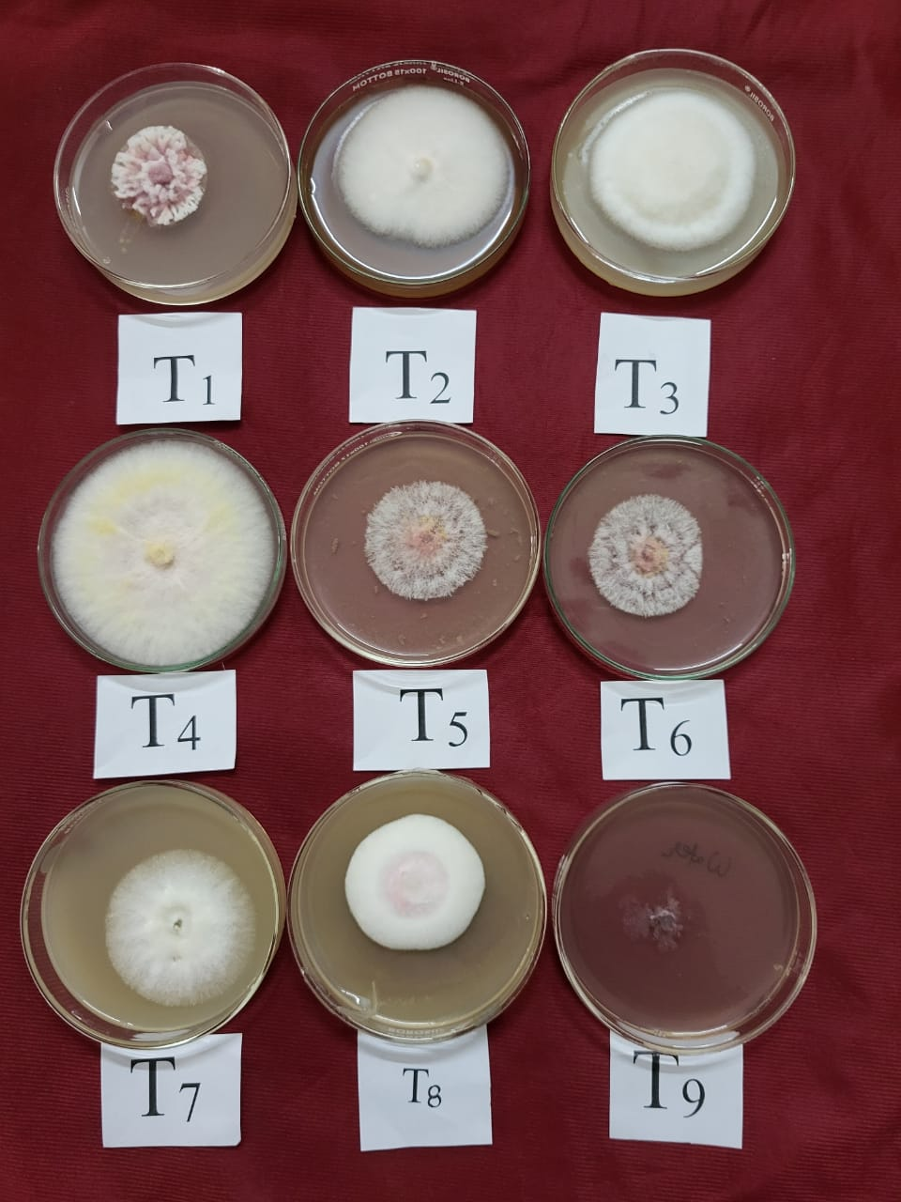
Fig 2: Effect of different solid media on mycelial growth and cultural characteristics of Fusarium udum (Isolate RSBU 1) after 144 hours of inoculation.
Table 3: Effect of different solid media on size of micro and macro conidia of Fusarium udum (Isolate RSBU 1)
T. No. | Media | Micro conidia |  | Macro conidia
T. No. | Media | Size (μm)*  Length and width | Septation | Size (μm)*  Length and width | Septation
T₁ | Carrot agar | 4.04 x 1.48 | 0-1 | 13.19 x 1.42 | 3-4
T₂ | Czapek dox agar | 3.99 x 1.51 | 0-1 | 12.72 x 1.49 | 3-4
T₃ | Oatmeal agar | 4.09 x 1.53 | 0-1 | 12.90 x 1.55 | 3-4
T₄ | Potato dextrose agar | 4.37 x 1.53 | 0-1 | 13.30 x 1.48 | 3-4
T₅ | Pigeon pea seed extract dextrose agar | 4.26 x 1.76 | 0-1 | 13.05 x 1.52 | 3-4
T₆ | Pigeon pea root extract agar | 4.28 x 1.72 | 0-1 | 13.10 x 1.43 | 3-4
T₇ | V-8 juice agar | 4.31 x 1.53 | 0-1 | 13.13 x 1.51 | 3-4
T₈ | Richard’s agar | 4.22 x 1.76 | 0-1 | 13.29 x 1.38 | 3-4
T₉ | Water agar | 4.09 x 1.53 | 0-1 | 13.09 x 1.53 | 3-4
*Mean of ten spores randomly
These results are in agreement with Sataraddi et. al., 2003; Reddy and Saifulla, 2006; Mishra and Dhar, 2007; Gangadhara et. al., 2004, who studied the effects of different culture media (Potato dextrose agar, Richard's agar, Czapeck dox agar, Brown's agar, Maizemeal agar, Oatmeal agar and Galactose nitrate agar) on the growth and morphology of Fusarium udum isolates and found that Potato dextrose agar, Richard's agar and Czapeck Dox agar were the most favourable for growth and sporulation.
Effect of temperature on mycelial growth of Fusarium udum
The examination was performed to find out the most suitable temperature for mycelial development of Fusarium udum. Table 4. indicates the impact of various temperatures viz. 20°C, 25°C, 28°C, 30°C, 35°C, 40°C and 45°C on mycelial growth of Fusarium udum. After regular observation up to 144 hours of inoculation it was noticed that there was significant variation in mycelial growth of the pathogen in response to different temperature condition. Maximum growth of 90.00 mm was noticed at 28 °C which was significantly superior to other treatments followed by 25°C, 30°C and 20°C which were 79.05 mm, 72.14 mm and 54.19 mm, respectively. The least growth was observed at 45 °C which was 8.14 mm (Table 4 and Figure 3&4).
Table 4: Effect of different temperature levels on mycelial growth of Fusarium udum (Isolate RSBU 1)
Temperature | Radial mycelial growth in mm
Temperature | 48 HAI | 96 HAI | 144 HAI
20°C | 16.11 | 27.52 | 54.19
25°C | 33.12 | 55.22 | 79.05
28°C | 41.87 | 61.12 | 90.00
30°C | 28.62 | 51.10 | 72.14
35°C | 10.24 | 20.14 | 30.12
40°C | 4.35 | 8.38 | 13.03
45°C | 2.17 | 4.61 | 8.14

Fig 3: Effect of temperature on mycelial growth of Fusarium udum (Isolate RSBU 1)
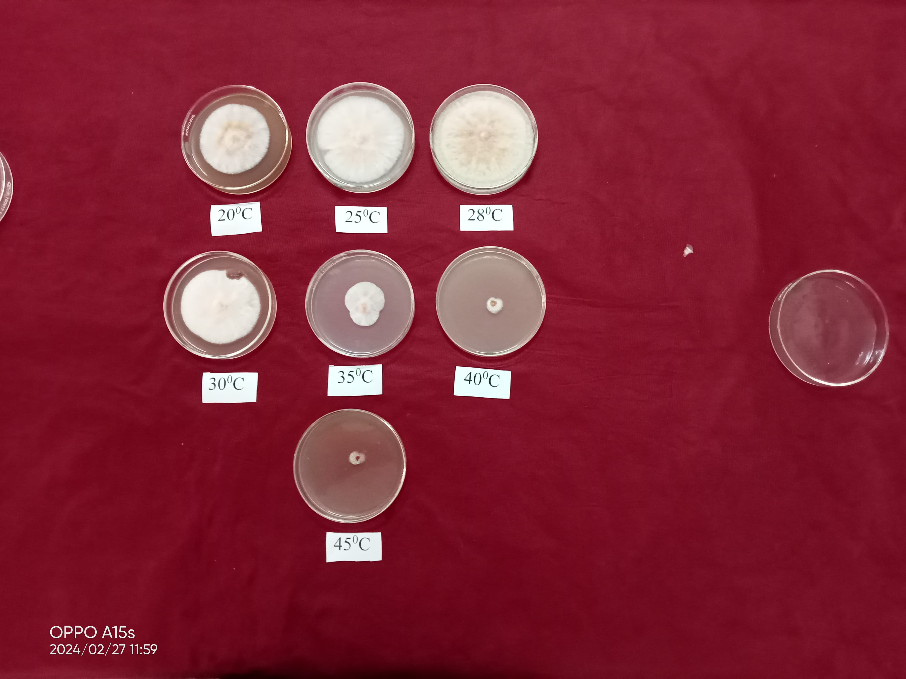
Fig 4: Effect of different temperature levels on mycelial growth of Fusarium udum (Isolate RSBU 1)
The results obtained during present investigations are in consonance with Mishra and Dhar, 2007; Mina and Dubey, 2010; Desai et. al., 2016 and Poorvasandhya et. al., 2020, who found that the optimum temperature for growth of Fusarium udum was 28±2°C.
Effect of pH on mycelial growth of Fusarium udum
Various levels of pH viz. 5.5, 6.0, 6.5, 7.0, 7.5 and 8.0 were tested for their effect on the growth of Fusarium udum and data were presented in Table 5, graphically illustrated in Figure 5&6. Significant difference among the treatments was observed. The maximum mycelial growth of 34.06, 50.54 and 90.00 mm was observed at pH value 6.5 after 48, 96 and 144 hours of incubation, respectively which was significantly higher compare to other treatments. This was followed by pH value 6.0 with the mycelial growth of 30.81, 42.25 and 82.47 mm after 48, 96 and 144 hours of incubation, respectively. Minimum radial growth of 10.13, 15.80, and 31.00 mm was found at pH value of 5.5 after 48, 96 and 144 hours of incubation.
Table 5: Effect of different pH levels on mycelial growth of Fusarium udum (Isolate RSBU 1)
pH | Radial mycelial growth in mm
pH | 48 HAI* | 96 HAI* | 144 HAI*
5.5 | 10.13 | 15.80 | 31.00
6.0 | 30.81 | 42.25 | 82.47
6.5 | 34.06 | 50.54 | 90.00
7.0 | 30.24 | 40.07 | 69.14
7.5 | 12.10 | 23.49 | 35.84
8.0 | 9.30 | 21.16 | 33.17

Fig 5: Effect of pH on mycelial growth of Fusarium udum (Isolate RSBU 1)

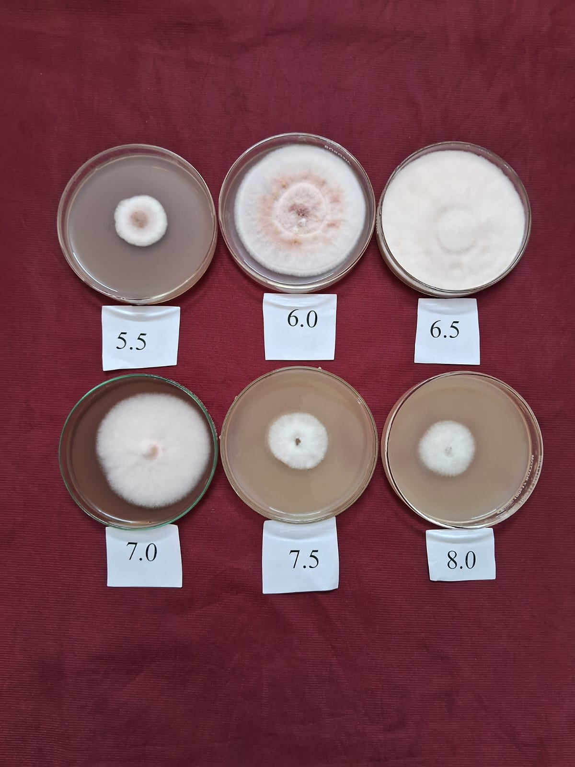
Fig 6: Effect of different pH levels on mycelial growth of Fusarium udum (Isolate RSBU 1)
The results obtained during the present study are in agreement with Sinha et. al., 2003; Gangadhara et. al., 2004; Mishra and Dhar, 2007; Jaruhar and Prasad, 2011 and Choudhary et. al., 2023, who found that the pH level of 6.0 was optimum for the growth of Fusarium udum.
Summary and conclusion
Fusarium udum isolate RSBU1 collected from Hindoli, Bundi was used to know the effect of different culture media on its growth and sporulation. Among the culture media, Potato dextrose agar was found to be the best which showed maximum mean radial growth of 42.56 mm, 62.05 mm and 90.00 mm at 48, 96 and 144 hours after incubation, respectively. Colony colour was found to be white for Czapek dox agar, Oatmeal agar, Potato dextrose agar, V-8 juice agar and Richard’s agar however pink colour was produced in Carrot agar, Pigeon pea seed extract dextrose agar, Pigeon pea root extract agar and Water agar medium. Fusarium udum isolate showed fluffy colony pattern when grown on Carrot agar, Czapek dox agar, Oatmeal agar, PDA, Pigeon pea seed extract dextrose agar, Pigeon pea root extract agar and Richard’s agar medium, whereas, appressed colony growth pattern on V-8 juice agar and Water agar. Fusarium udam exhibited variation in pigmentation when grow on different media. Maximum sporulation (>40 conidia / microscopic field) was observed on Potato dextrose agar medium. Variation of micro and macro conidia was observed in all media tested.
Among different temperatures viz. 20 °C, 25 °C, 28 °C, 30 °C, 35 °C, 40 °C and 45 °C the most suitable temperature was 28 °C which showed the maximum mycelial growth (90.00 mm) after 144 hours (6 days) of inoculation. Likewise, the best pH value for the growth of Fusarium udam was found 6.5.
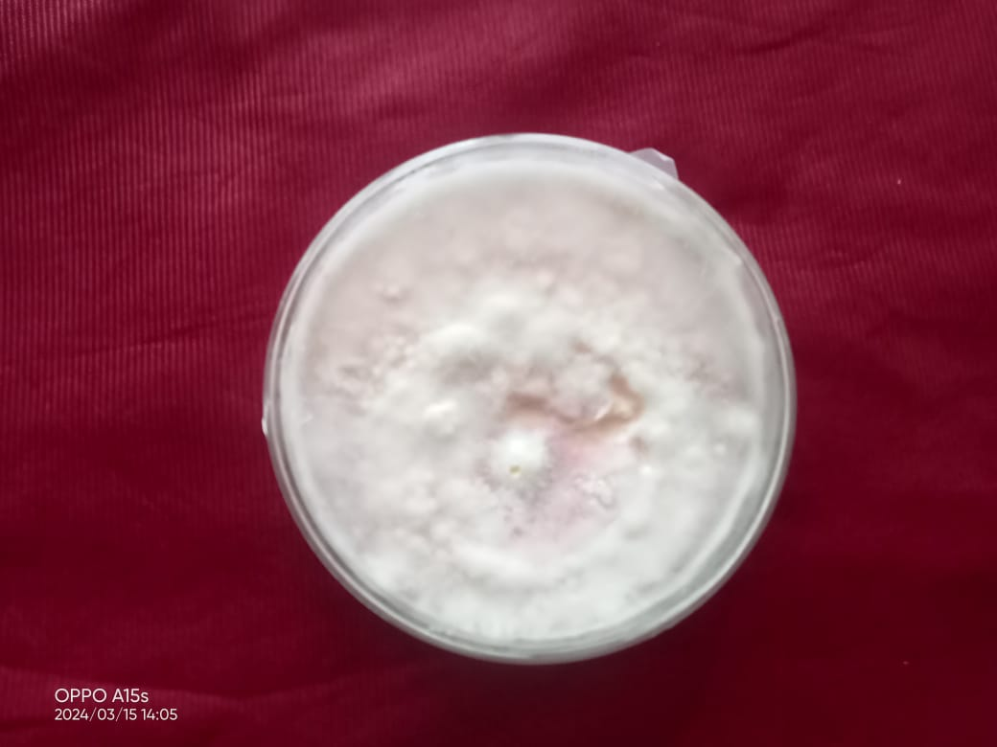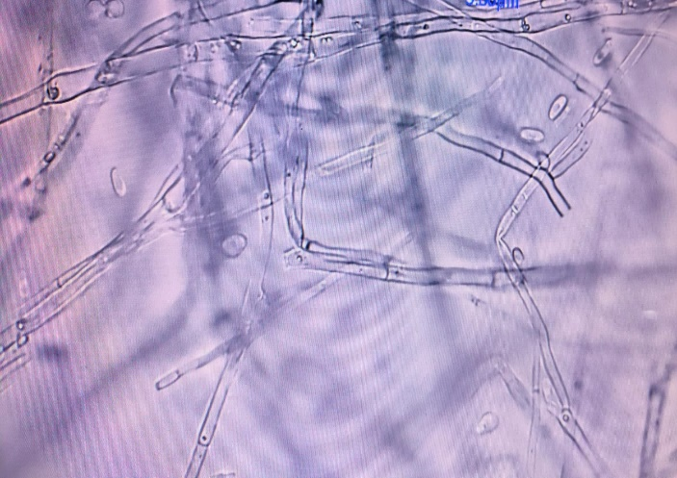
Fig 7: Pure culture and microscopic view of Fusarium udum
References
Anonymous. (2020). FAOSTAT (Food and Agriculture Organization Corporate Statistical database). http://www.fao.org/faosata/en/#data/QC.
Anonymous. (2022). Rajasthan agricultural statistics at a glance. Commissionerate of Agriculture, Rajasthan, Jaipur.
Choudhary, S., Bagri, R. K., Chaurasiya, D. K., Moond, V. and Choudhary, R. (2023). Physiological studies of the Fusarium oxysporum f. sp. lycopersici causing tomato Fusarium wilt. Biological Forum – An Int. J., 15(1): 582-587.
Desai, U. A., Andoji, Y. S. and Kamble, S. (2016). Influence of temperature and different culture media on growth of Fusarium udum (Butler) causal organism of wilt of Pigeon pea. Int. J. of Biological Res., 4(1): 42-45.
Gangadhara, N. B., Nagaraja, R., Basavaraja M. K. and Krishna, N. R. (2004). Variability studies of Fusarium oxysporum f. sp. vanillae isolates. Int. J. of Sci. and Nature, 1(1): 12-16.
Hillocks, R.J., Minja, E., Silim, S.N., Subrahmanyam, P. (2000). Diseases and pests of Pigeon pea in eastern Africa. Int. J. of Pest Management, 46: 7-18.
Jaruhar, H. B. and Prasad, A. (2011). Effect of different pH levels on the growth and sporulation of Fusarium oxysporum schlecht. f. sp. lentis (Vasudeva and Srinivasan) the causal organism of wilt disease of lentil. Bioscane, 6(1): 289-291.
Joshi, S. (2001). Pathogenic variability in Pigeon pea wilt pathogen Fusarium udum Butler in Nepal. Nepal Ag. Res. J., 4: 64-65.
Mina, U. and Dubey, S. C. (2010). Effect of environmental variables on development of fusarium wilt in chickpea (Cicer arietinum) cultivars. Indian J. of Agril. Sci., 80(3): 231-234.
Mishra, S. and Dhar, V. (2007). Influence of nutritional media, pH and temperature on mycelial growth and sporulation of Fusarium udum. J. of Food Legume, 20(2):192-195.
Poorvasandhya, R., Sinha, B. and Devi, P. H. S. (2020). Effect of media, temperature and pH on growth and sporulation of Fusarium oxysporum f. sp. udum under in vitro condition. Int. Microbiology and Applied Sci., 9: 2406-2412.
Reddy, B. A. and Saifulla, M. (2006). Variation in growth and morphology of Fusarium udum isolates. Karnataka J. of Agril. Sci., 19(2): 318-322.
Reddy, M. V., Raju, T. N., Sharma, S. B., Nene, Y. L. and McDonald, D. (1993). Handbook of Pigeon pea diseases, (In En. Summaries in En. Fr.). Information bulletin, 14. Institute of Int. Crops Res. for the Semi-Arid Tropics, Patancheru, Telangana, India: Pp. 64.
Sataraddi A., Srikant K. and Patil, M. B. (2003). Physiological variability in the isolates of Fusarium udum causing wilt in Pigeon pea. Annual meeting and symposium on recent developments in the diagnosis and management of plant diseases for meeting global challenges, held at Department of Plant Pathology, University of Agril. Sci., Dharwad, Pp. 24-25.
Sinha, P., Biswas, S. K. and Singh, C. P. (2003). Influence of soil environment on inoculum density of Fusarium udum causing Pigeon pea wilt. Farm Sci. J., 12(1): 29-32.

