In vitro evaluation of the compatibility between bactericides, bioagents with ARF (Alkaloid Rich Fractions) obtained from different parts of Prosopis juliflora against Xanthomonas axonopodis pv. punicae causing Bacterial blight of pomegranate

Abstract
The bacterial blight of pomegranate caused by Xanthomonas axonopodis pv. punicae has become a conceivably dangerous infection. Though, the chemical management is efficient, their hazardous effects restrict them for their usage. In this context use of different parts of Prosopis juliflora extract along with antibiotics has become the alternative strategy for management of disease. Detection of secondary metabolites from different parts of the P. juliflora using specific test indicated the presence of various secondary metabolites. However, leaf extract exhibited high concentration metabolites compared to green pod, yellow pod and inflorescence. Management of this disease utilizing plant extracts is an eco-friendly approach. Alkaloid rich fractions obtained from the different parts of Prosopis juliflora in combination with bactericides were found compatible. Leaf ARF with streptocycline @ 500 ppm showed maximum inhibition of 40.66 mm. Wherein combination with copper hydroxide @ 0.25% ppm and 2-bromo-2-nitro propane-1,3-diol @ 500 ppm showed inhibition of 25.00 mm and 36.98 mm whereas copper oxychloride @ 0.3% showed inhibition of 28.19 mm. These fundings can be used as an effective, eco friendly management strategy against the disease and a feasible solution for antibiotic resistance.
Keywords: Bacterial blight, Xanthomonas axonopodis pv. punicae, Prosopis juliflora Alkaloides, Comaptibitly.
Introduction
Pomegranate (Punica granatum L.) is an important fruit plant of tropical and subtropical regions and belongs to the Lythraceae (Punicaceae) family. Pomegranate fruit, peel and their extracts have high nutritional and medicinal value due to the presence of phytochemicals such as sterols, terpenoids, fatty acids, triglycerides, flavonoids, anthocyanins, catechins and procyanidins. The pomegranate has a beneficial effect against stomach and heart diseases, diabetes and prostate cancer etc. Pomegranate cultivation is now widespread all over the world and is extensively cultivated in Mediterranean countries such as Spain, Morocco, Egypt and in South Asian countries such as China, India, Afghanistan and Balochistan. Pomegranate acreage is growing worldwide due to its hardy nature, broader adaptability and drought tolerance, higher yield levels with excellent shelf life, and remunerative prices in both domestic and export markets (Chathalingath and Gunasekar, 2023).
Although the pomegranate provides important pathways to human well-being, it is susceptible to a number of diseases, including bacterial blight caused by Xanthomonas axonopodis pv. punicae is a serious problem and is causing a severe crisis in pomegranate production due to its high epidemic potential. The disease affects all aerial parts of plants, including flowers, leaves, branches, stems, buds and fruits, but is economically more destructive when fruits are infected (Manjunatha et al., 2023)
Use of botanicals is now emerging as one of the important means in protection of crop produce and the environment from pesticidal pollution, which is a global challenge. Awareness to reduce the usage of chemical pesticides by developing alternative strategies or technologies in order to manage plant diseases need to be promoted. Therefore, it has been a growing interest in research concerning the alternatives of chemical pesticides and antimicrobial active compounds, including the plant extracts and essential oils of aromatic plants (Labade and Surve, 2023). Plant extracts have played significant role in the inhibition of pathogens and in the improvement of quality and yield (Aruna, 2023).
Plants are considered to be excellent sources of new and biologically active compounds possessing antimicrobial activity for ecofriendly management of plant diseases. Currently, extensive research is being conducted worldwide to isolate, characterize and identify plant products with antimicrobial potential. It is required to create and standardize extraction procedures, as well as to devise a systematic approach to testing antimicrobial compounds against a wide range of pathogens in vitro, in order to achieve better characterization and identification of antimicrobial compounds. Plant compounds that have exhibited inhibitory effects against diverse microbes under in vitro conditions. In most cases, the use of botanicals leads in inconsistency in field performance. In such conditions, future testing of possible combinations of two or more botanicals with antimicrobial compounds for the consistent and successful management of plant diseases should be conducted (Košćak et al., 2023).
Material and methods
Isolation of the pathogen
Infected plant parts such as leaf, twig and fruit pericarp showing typical symptoms of bacterial blight were used to isolate the causal agent of bacterial blight. The diseased samples were washed thoroughly with tap water and air dried. The infected portion along with a bit of surrounding healthy part was cut into small pieces and were surface sterilized with 1:1000 mercuric chloride (HgCl2) solution for one minute and washed three times serially in sterile distilled water to remove the traces of mercuric chloride. The diseased bits were then suspended in a test tube containing 3 ml of sterile distilled water and squeezed gently with sterilized scalpel. When the water became slightly turbid due to oozing of bacterial cells, the suspension was serially diluted up to 10⁻³ dilutions in 9 ml sterile water blanks and then poured with 1 ml of diluted bacterial cell suspension into the sterilized Petri dish and over lagged with 20 ml sterilized molten luke warm nutrient agar (NA) medium. The plates were rotated gently in clockwise and anti-clockwise directions to allow the uniform distribution of bacterial cell suspension in the medium. The inoculated plates were incubated at 30 ⁰ C for 72 hour. Observations were made for the development of well separated, typical, light yellow-coloured bacterial colonies of Xanthomonas spp.
Molecular identification

The extraction of total genomic DNA was carried out by following a modified protocol as described by Adachi and Takashi (2002). 200 μl YPD broth (200 μl) grown culture was centrifuged for 5 min at 10,000 rpm and the bacterial cells were resuspended in 50 μl of proteinase K solution (50 μg ml-1 in 10 mM Tris-HCl, pH 7.5, 1 mM EDTA, pH 8.0) and kept at 56°C for 15 min, then at 80 °C for 15 min to denature the proteinase and placed on ice to cool the samples for 5 min. After centrifugation for 5 min at 13000 rpm, the supernatant was transferred to a new eppendorf tube. The supernatant was treated with RNase A (100 μg ml-1) for 30 min at 37°C followed by extraction with phenol: chloroform: isoamylalcohol (25:24:1) and precipitation by adding 0.1 volume of ammonium acetate and 2 volumes of chilled ethanol. The DNA pellet was washed with 70% ethanol and resuspended in 50 μl sterile water. The DNA samples were quantified using Nano-drop Spectrophotometer. The culture was deposited to NCBI for the accession number.
Collection of P. juliflora samples for extraction of biomolecules
Plant material (leaf, yellow pod, green pod and inflorescence) of P. juliflora were collected from their natural habitat in the surrounding regions of University of Horticultural Sciences Bagalkot, Karnataka, India, during months of June and July. The plant materials were washed thoroughly in running tap water, shade dried and powdered. The powdered material was hermetically sealed and stored at room temperature until use. Different parts viz., leaf, green pod (immature), yellow pod (matured) and inflorescence of P. juliflora were used for the investigation.
Preparation of plant sample for the aqueous extraction
Plant parts were washed thoroughly under tap water and then air dried under shade for a week and oven dried for 24 hours at 40 °C. The dried plant material was grounded to form fine powder and filtered through sieve of 345-micron pore size. The ground plant materials were stored in a refrigerator at 4 °C (Singh, 2012).
Phytochemical analysis of different parts of P. juliflora
Preparation of plant sample for the aqueous extraction
Plant parts were washed thoroughly under tap water and then air dried under shade for a week and oven dried for 24 hours at 40 °C. The dried plant material was grounded to form fine powder and filtered through sieve of 345-micron pore size. The ground plant materials were stored in a refrigerator at 4 °C (Singh, 2012).
Preparation of reagent
Dragondorff’s reagent preparation: 0.5 gm of bismuth nitrate was taken into an empty beaker, to this 10 ml of concentrated hydrochloric acid was added. 4 gm of potassium iodide was taken in another beaker containing little water and stirred until KI dissolved. The two solutions were mixed properly and observed the formation of dark solution.
Mayer’s reagent preparation: A solution was prepared by dissolving 1.36 gm of mercuric chloride in 60 ml of distilled water and added it to a solution of 5 gm potassium iodide in 20 ml distilled water made the final volume to 100 ml with distilled water
Wagener’s reagent: 1.25 gm of iodide and 2 gm of KI was added in 5 ml of water and made the volume to 100 ml with distilled water
Test for saponins- 300 mg of extract (Leaf, green pod, yellow pod and inflorescence) was boiled with 5 ml water for two minutes. The mixture was cooled and mixed vigorously and left for three minutes. The formation of frothing indicates the presence of saponins.
Test for tannins- To 5 ml of an aliquot of the extract (Leaf, yellow pod, green pod and inflorescence), sodium chloride was added to make it to 2% strength. The extract was filtered and mixed with 1 ml of 1% gelatine solution. Precipitation indicates the presence of tannins.
Test for Phlobatanins- 200 mg extract (Leaf, Green pod, Yellow pod and Inflorescence) were boiled in 1% aqueous hydrochloric acid. The deposition of a red precipitate indicates the presence of phlobatanins.
Test for phenolic compounds- 1% ferric chloride solution was added to the extracts (Leaf, Green pod, Yellow pod and Inflorescence) and observed the formation of intense green, purple, blue or black colour indicates the presence of phenol compounds.
Test for triterpenes- 300 mg of extracts (Leaf, Green pod, Yellow pod and Inflorescence) were mixed with 5 ml chloroform and warmed for 30 minutes. The chloroform solution was then treated with a small volume of concentrated sulphuric acid and mixed properly. The appearance of a red color indicates the presence of triterpenes.
Test for steroids- 200 mg plant extracts (Leaf, Green pod, Yellow pod and Inflorescence) were taken in 10 ml chloroform and then filtered. In 2 ml filtrate, 2 ml acetic anhydride and a small amount of H2SO4 was added, the appearance of the blue-green ring indicates the presence of steroids.
Test for alkaloids- 200 mg plant extracts (Leaf, Green pod, Yellow pod and Inflorescence) were dissolved in 10 ml methanol and then filtered. To 1 ml filtrate, 6 drops of Dragondorff's reagent was added. The appearance of an orange precipitate indicates the presence of alkaloids
Test for flavonoides- 1 ml of dilute ammonia solution was added to the 5 ml of extract (Leaf, green pod, yellow pod and inflorescence) followed by addition of few drops of concentrated sulphuric acid. The development of yellow colour indicates the presence of flavonoides.
Test for glycoside– 5 ml of extract (Leaf, green pod, yellow pod and inflorescence) were treated with 1 ml of glacial acetic acid containing 1 drop of ferric chloride solution. This was underlayed with 1 ml of concentrated sulphuric acid. A brown ring at the interface of the two liquids indicates the presence of deoxysugar characteristic of cardenolides.
Screening of organic solvents for the extraction of active components from the different parts of P. juliflora against X. axonopodis. pv. punicae
Plant samples (Leaf, green pod, yellow pod and inflorescence) were successively extracted with the help of various organic solvents (hexane, methanol, ethyl acetate, chloroform, acetone ethanol and petroleum ether) in the order of their increasing polarity and finally with distilled water. 10 grams of dry powder of each sample were taken in a centrifuge tube and 100 ml of hexane was added to it so that the plant material gets immersed in the solvent. This whole setup was kept for 48 hours with frequent shaking. It was first filtered with a muslin cloth, then with Whatman filter paper (No.1) and finally centrifuged at 5000 rpm for 5 mins. The whole process was repeated 3 times and supernatant were collected and pooled together. Plant material left after filtration was air-dried to evaporate the hexane completely. The above process was repeated and supernatant collected were concentrated to dryness with the help of a rotary evaporator (Buchi Rotavapor R-200/205) at 40 °C under different pressure conditions for the solvent. All the concentrated extracts were stored in an airtight bottle at 4°C (Singh, 2012).
In vitro evaluation of different part extract of P. juliflora against X. axonopodis pv. punicae
Antibacterial ability of aqueous and solvent extracts of different parts of the plant (Leaf, Green pod, Yellow pod and Inflorescence) were examined by following agar well diffusion method with standard antibiotic (Streptomycin sulphate) as a positive control and organic solvents as negative control.
Agar well diffusion method
The efficacy of extract was reconfirmed by agar well diffusion method (Holder and Boyse, 1994). The culture of X. axonopodis pv. punicae of (1×10⁶CFU/ml) added to 250 ml of nutrient medium and poured in to the Petri plate and allowed to solidify. The agar plates were punched aseptically with 6-mm sterilized cork borer to prepare wells. The wells were filled with 100 μl of botanical extracts. All plates were incubated at (30 °C) for 48h. After incubation, the diameters of any clear zones around the wells were measured in milli meter. The Streptocycline 0.5 g (500 ppm) + Copper Oxychloride 3 g (0.3%) per liter of water treated as positive control and sterile water filled in agar well considered as negative control.

Assessment of compatibility between bactericides and ARF (Alkaloid Rich Fractions) obtained from various parts of P. juliflora.
Using sterile distilled water, stock solutions of the required concentrations of each bactericide were prepared. Then, in a 1:1 ratio, each bactericide and bacterial bioagent filtrate was combined with ARF of leaf, green pod, yellow pod, and inflorescence. The entire mixture was then tested for compatibility against X. axonopodis pv. punicae using the agar well method with three replications each. The plates were then incubated for 24 hours at 32 ⁰C. The inhibition zone was measured in millimetres
Results and discussion
Symptoms on different parts of plant

The symptoms on leaves initially appeared as minute water-soaked lesions which later turned brown to dark brown surrounded by a diffused water-soaked margin or yellow halo. The collision of several such spots has been seen on a single leaf, which increased in size to form irregular lesions. Severely infected leaves became yellow, distorted and defoliated (Figure 1A). On main stems, twigs or branches, long narrow and elongated bluish-black coloured lesions were seen. Later, these lesions became rough, cankerous, appeared dark brown. With the advancement of the disease, bark cracked, dried and died (Figure 1 B). The symptoms on fruits first appeared as small-diffused oily lesions, later turned to brown surrounded by diffused water-soaked zones (Figure 1C). The lesions which were round in the beginning increased in size became irregular, brown to dark brown. The rind of affected fruits cracks in the middle of the lesion in the form of L, Y, or star shape. Later, affected fruits split opened longitudinally through the lesion exposing arils (Figure 1D).

Similar symptoms have been reported by the earlier workers from New Delhi (Hingorani and Singh, 1959), Tamil Nadu (Rangaswami, 1962), Himachal Pradesh (Sohi et al., 1964), Haryana (Kanwar, 1976) and Karnataka (Kishun, 1993). In Karnataka, Manjula (2002), Jalaraddi (2006), Basavaraj (2007), Kiran kumar (2007), Yenjerappa (2009) and Raju (2010) reported similar symptoms on leaves, twigs and fruits.
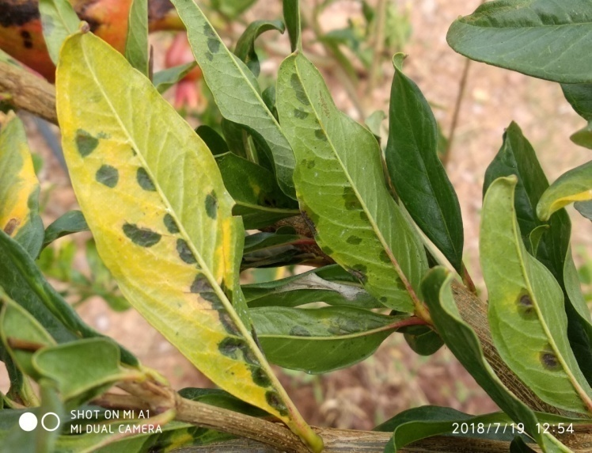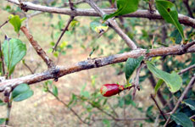
A B
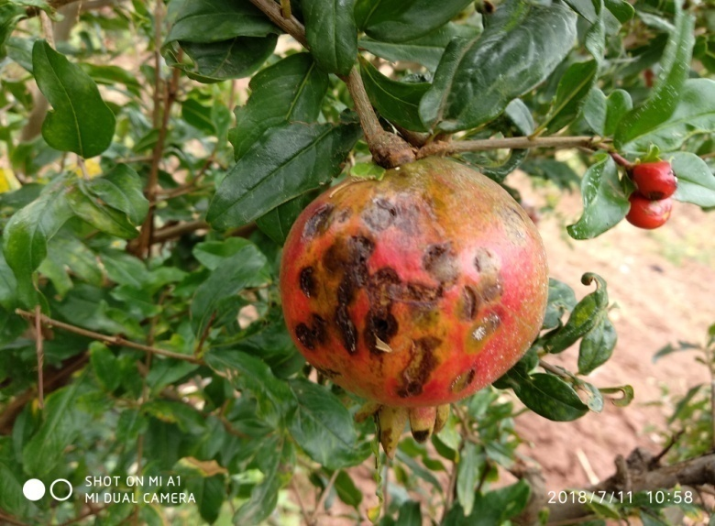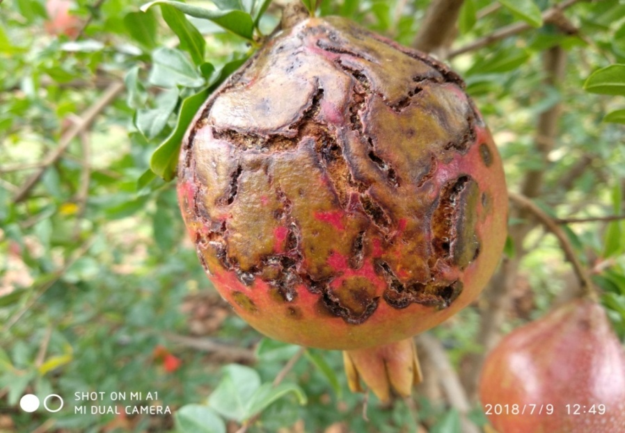
C D
Figure 1. Symptoms of bacterial blight of pomegranate on different parts of the plant. A) Minute water-soaked lesions on leaves B) Eelongated bluish-black coloured lesions on twigs C) Small-diffused oily lesions on fruits D) longitudinally splitting of fruits

Isolation of the causal organism
The causal organism was isolated from the infected parts of pomegranate plant viz., leaves, twigs and fruits on nutrient agar medium. The cultural characters of the bacterial colonies appeared pale yellow to dark yellow, raised, convex and glistening after 72 hr of incubation (Figure 2). The isolated colony which appeared as pale yellow to dark yellow after 72 hr incubation was picked and purified by single colony isolation technique on NA medium and suspended in polypropylene tubes containing sterile distilled water and preserved at 4⁰C.
In gram reaction, bacterial colonies slide was observed under the light microscope at 100X using oil immersion. The colonies showed to be gram negative, short rod-shaped and pinkish in color when stained with counter-stained by the safranin which was the indication for gram negative bacterium. After incubating the medium at 37ºC for 16 hours, a positive motility test was observed. The growth area was extending away from the line of inoculation which indicated the isolated bacteria were motile. The primer set, KKM-5 and KKM-6 was used to identify the X. axonopodis pv. punicae. The primer set gave product size of 491 bp, which is specific to only X. axonopodis pv. punicae (Figure 2). The culture was deposited at NCBI which received accession number MN971672 that can be used for further research.
The observations made pertaining to the isolation in the present investigation were in conformity with the work of Manjula (2002) and Kiran Kumar (2007) who obtained pure culture of the seven isolates of the pathogen from infected plant parts on nutrient agar medium by dilution plating technique. The bacterial colonies appeared as light yellow, raised, convex and glistering. The colonies were purified and preserved in distilled water taken in sterile polypropylene tubes at 4˚C.
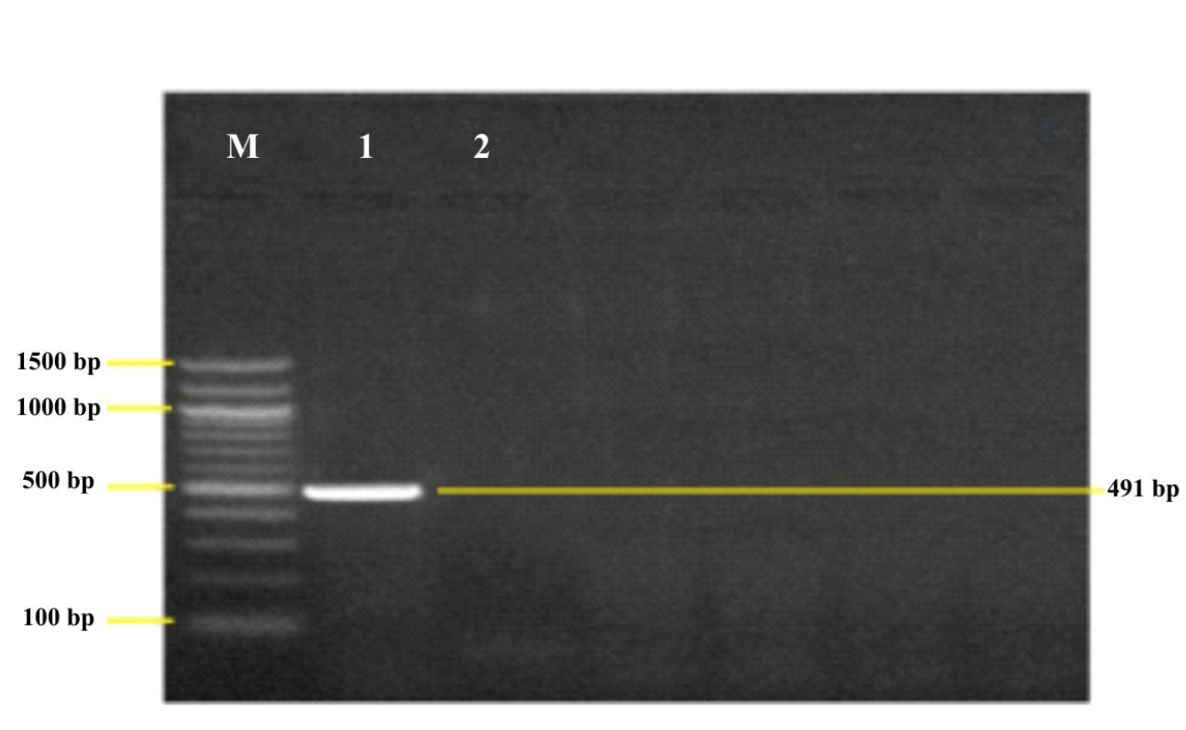
A B
Figure 2: A) Pure culture of Xanthomonas axanopodis pv. punicae on NGA, B) Amplification of Xanthomonas axanopodis pv. Punicae through gel electrophoresis
Detection of secondary metabolites from different parts of P. juliflora using specific tests
The phytochemical screening of different parts of P. juliflora indicated the presence of various secondary metabolites. However, their concentration varied in different parts of the plants viz., leaves, green pod, yellow pod and inflorescence. Phytochemical analysis of leaf extract revealed the presence of alkaloids, terpenoids, steroids, flavonoids, phenols, tannins and absence of phlobatannin. The inflorescence extract showed the presence of alkaloids, terpenoids, steroids, phenolics and flavonoids. Whereas yellow pod extract showed a presence of alkaloids, steroid cardiac glycosides, phenolics, flavonoids, terpenes and absence of phlobatannin. While the green pod extract showed similar chemical constituents as in leaf and inflorescence extract (Figure 3).
Qualitative detection of phytochemical in the aqueous extracts of different parts of P. juliflora

The qualitative detection of phytochemicals in crude aqueous extracts of different parts of P. juliflora, namely the leaf, green pod, yellow pod and inflorescence revealed the presence of a diverse range of secondary metabolites, as shown in table 1. Qualitative analyses of secondary metabolite revealed that higher concentrations of terpenoids in all four aqueous extracts used in the study, namely the leaf, green pod, yellow pod, and inflorescence extracts. The leaf contained higher concentrations of alkaloids (Mayer's reagent test, Wagener's reagent test and TLC method), flavonoids, steroids, cardiac glycosides (Kellar Killanis test), tannins, and phenols (5 per cent Ferric chloride test). Among the phytochemicals tested, the Liebermann Burchardant test revealed a lack of phlobatannin and cardiac glycosides in all four plant part extracts. Green pod, inflorescence and leaf extracts had higher concentrations of secondary metabolites, whereas yellow pod extracts had higher concentrations of terpenoids, moderate
concentrations of alkaloid for Mayer's reagent test, flavonoides, tannins and phenols for lead
acetate test, and 5 percent ferric chloride test. Wagner's reagent test and TLC method, on the
other hand, revealed lower alkaloids concentrations (Table 1, Figure 3).
These results are in line with Sathiya and Muthuchelian (2008) who conducted the preliminary phytochemical screening of the leaves and reported the presence of tannins, acids, glycosides, flavonoids and alkaloids. The inflorescence extract showed the presence of alkaloids, terpenoids, steroids, phenolics and flavonoids. Yellow pod extract showed the moderate concentration of secondary metabolites viz., alkaloids, steroid cardiac glycocides, phenolics, flavonoids, terpenes and absence of phlobatannin. While the green pod extract followed the similar pattern ofchemical constituents as in leaf and inflorescence extract. Present results in line with Singh (2012) who conducted a study on phytochemical analysis in different parts of P. juliflora extracts whose results revealed the presence of tannins, phenolics, flavonoids,
alkaloids, terpenes and steroids in most parts of P. juliflora.

Table 1: Qualitative detection of phytochemical in the aqueous extracts of different parts of P. juliflora
Sl.  No. | Phytochemical | Plant Parts
 |  | Leaf | Green Pod | Yellow Pod | Inflorescence
1 | Alkaloid
 | a. Mayer’s reagent test | + + + | + + + | + + | + + +
 | b. Wagener’s reagent test | + + + | + + + | + | + + +
 | _{C}. TLC method | + + + | + + + | + | + + +
2 | Steroids | + + + | + + + | + | + + +
3 | Cardiac glycoside
 | a. Kellar Killani's test | + + + | + + + | + | + + +
 | b. Liebermann Burchardant test | - | - | - | -
4 | Saponines | + + + | + + + | + | -
5 | Flavonoides | + + + | + + + | + + | + + +
6 | Tannins and Phenols
 | a. Lead acetate test | - | + + + | + + | +
 | b.5% Ferric chloride test | + + + | + + + | + + | + + +
 | c. Acetic acid solution test | - | - | - | -
7 | Terpenoides | + + + | + + + | + + + | + + +
8
 |  |  |  |  | + + +
 | Phlobatannin | - | - | -
 |  |  |  |  | + + +
 |  |  |  |  | + + +

+; low concentration, ++; moderate concentration, +++; high concentration, - ; absent

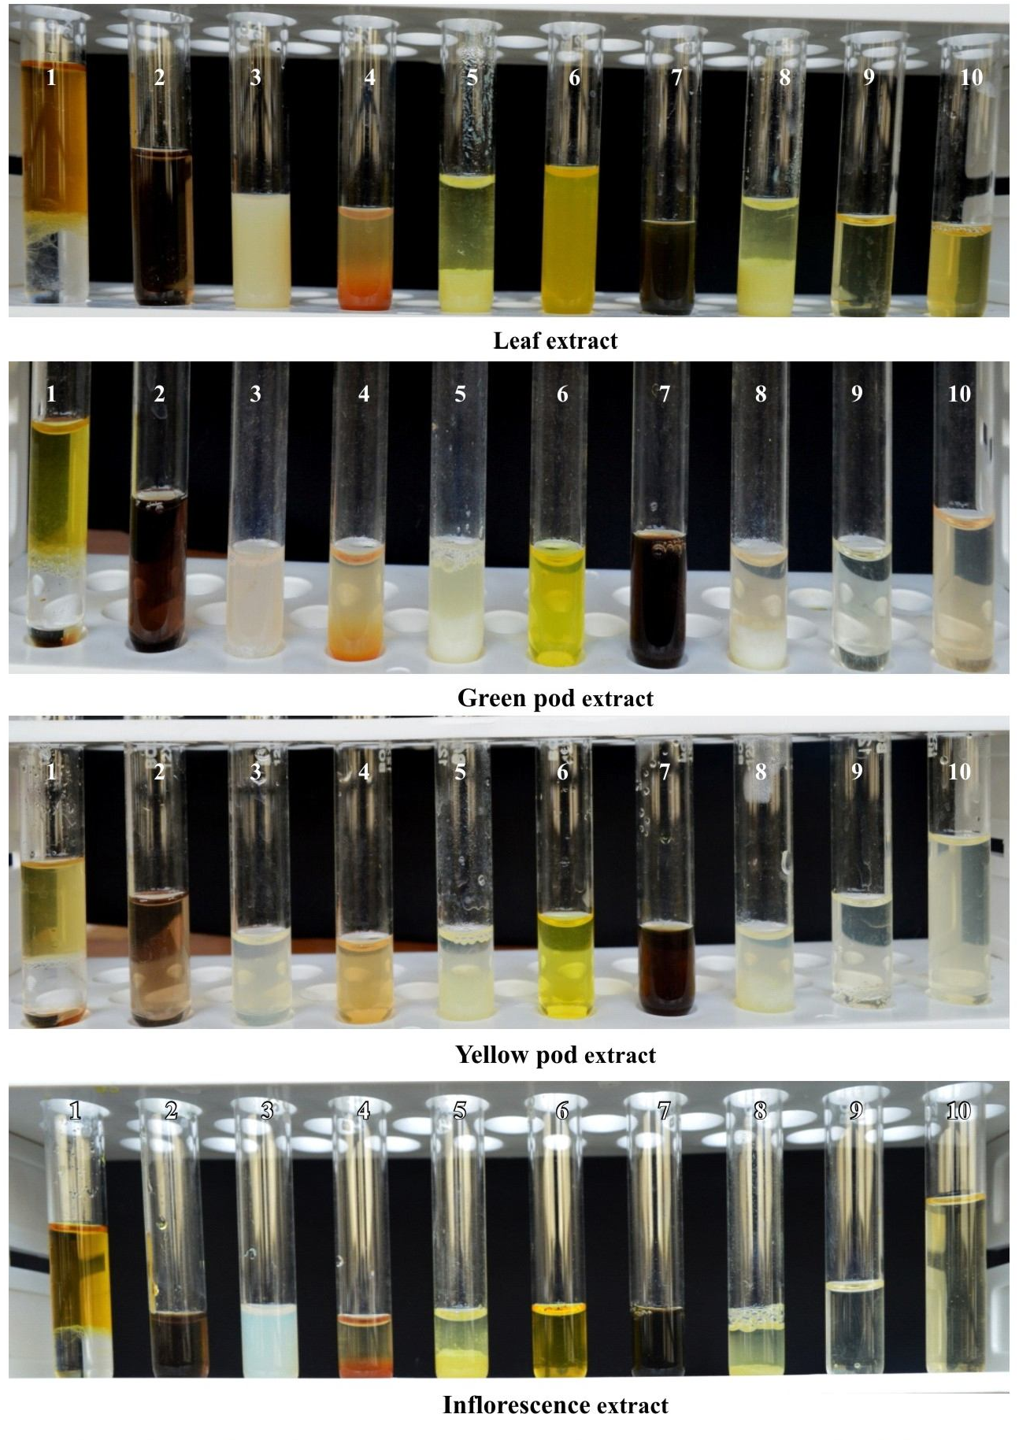
Figure 3. Phytochemical screening of secondary metabolites from various parts of P. juliflora (1. Steroid, 2. Glycosides, 3. Alkaloids (Mayer’s reagent test), 4. Alkaloids (Wagener’s reagent test), 5. Flavonoids (Lead acetate test), 6. Flavonoids (Alkaline reagent test), 7. Phenols and Tannins (Ferric chloride test), 8. Phenols and tannins (Lead acetate test, 10% solution), 9. Pthotannins, 10. Test sample (control)

Combination effect of bactericides and alkaloid rich fractions obtained from different parts of P. juliflora on growth of X. axonopodis pv. punicae
The results on the combination effect of ARF obtained from different parts of P. juliflora with bactericides commonly using against X. axonopodis pv. punicae are presented in table 2.
Combination with Streptocycline
The antibacterial antibiotic, streptocycline has been tested from 100 ppm to 500 ppm concentrations. The results revealed that among all parts tested, ARF from the leaf was recorded maximum inhibition in combination with streptocycline at all five concentrations (500,400,300, 200 and 100 ppm) i.e. 40.74 mm, 37.23 mm, 34.15 mm, 33.85 mm and 31.66 mm respectively. In control (Leaf ARF alone) 14.00 mm of inhibition zone has been observed. Wherein streptocycline @ 500 ppm alone recorded 31.45 mm of inhibition. However, ARF of inflorescence recorded maximum inhibition next to leaf ARF viz., 36.25 mm, 36.00 mm, 31.76 mm, 31.00 mm and 30.54 mm of inhibition orderly with concentrations mentioned. The ARF from green pod and yellow pod recorded similar trend of inhibition when tested in combination with streptocycline at all the concentrations. The ARF from green pod and yellow pod in combination with streptocycline @ 500 ppm recorded 35.33 mm and 33.82 mm of inhibition, while ARF alone from them recorded 11.00 mm and 8.00 mm respectively green pod alone recorded 31.45 mm (Table 2).

Inhibition zone has been observed. Wherein streptocycline @ 500 ppm alone recorded 31.45 mm of inhibition. However, ARF of inflorescence recorded maximum inhibition next to leaf ARF viz., 36.25 mm, 36.00 mm, 31.76 mm, 31.00 mm and 30.54 mm of inhibition orderly with concentrations mentioned. The ARF from green pod and yellow pod recorded similar trend of inhibition when tested in combination with streptocycline at all the concentrations. The ARF from green pod and yellow pod in combination with streptocycline @ 500 ppm recorded 35.33 mm and 33.82 mm of inhibition, while ARF alone from them recorded 11.00 mm and 8.00 mm respectively green pod alone recorded 31.45 mm.
Combination with copper hydroxide (CuOH)
Combination effect of copper hydroxide with ARF’s of P. juliflora has been evaluated @ 0.1 % to 0.25% concentrations (Table 2). The results showed that among all parts tested, ARF from the leaf showed maximum inhibition in combination with copper hydroxide at all four concentrations (0.1%, 0.15%, 0.2% and 0.25%) i.e. 20.33 mm, 22.52 mm, 23.65 mm and 25.00 mm respectively. In control (ARF leaf alone) 14.00 mm of inhibition was recorded. Wherein copper hydroxide @ 0.25% recorded 13.03 mm of inhibition. However, ARF from the inflorescence recorded highest zone of inhibition next to the leaf ARF. 15.00 mm, 15.68 mm, 17.00 mm and 24.66 mm of inhibition orderly with concentrations mentioned. The ARF from the green pod and yellow pod followed same trend of inhibition when tested in combination with copper hydroxide @ all the concentrations. The inhibition of 20.34 mm and 14.33 mm were recorded by green pod and yellow in combination with cooper hydroxide @ 0.25% whereas ARF alone from the same showed 11.00 mm and 8.00 mm respectively. From the above results it has been concluded that there are high synergistic interactions between the all the concentration of copper hydroxide and ARF of leaf which in turn resulted in higher zone of inhibition against test pathogen. The least synergistic interaction was recorded by ARF of yellow pod extract when compared to ARF from leaf, green pod and inflorescence.
Combination with 2-bromo-2-nitropropane-1, 3-diol (Bactinash-200)
The antibacterial antibiotic, 2-bromo-2-nitropropane-1,3-diolhas been tested at different concentrations viz., 250, 500, 750 and 1000 ppm. The results from the table 2

revealed that among all parts tested, ARF from leaf gave maximum inhibition in combination with 2-bromo-2-nitropropane-1,3-diolat all four concentrations i.e. 26.81mm, 28.99 mm, 33.82 mm and 36.98 mm respectively. 14.00 mm of inhibition zone was observed in control (ARF leaf alone) whereas 2-bromo-2-nitropropane-1,3-diol at 1000 ppm alone showed 31.52 mm of inhibition. Next to the ARF of leaf, inflorescence ARF exhibited the highest zone of inhibition i.e. 25.95 mm, 26.83 mm, 30.78 mm and 33.88 mm of inhibition orderly with concentration mentioned. At all the concentrations green pod and yellow pod ARF followed the same trend of inhibitory action when evaluated in combination with 2-bromo-2-nitropropane-1,3-diol. Green and yellow pod ARF’s @ 1000 ppm recorded 33.15 mm and 32.86 mm of inhibition in combination with 2-bromo-2-nitropropane-1,3-diolrespectively. From the above results it clearly showed that leaf and inflorescence ARF exhibited strong synergistic action whereas yellow pod ARF showed least synergistic action
Combination with Copper oxychloride (Blitox)
The combination effect of ARF and copper oxychloride has been tested under in vitro at four different concentrations (0.10%, 0.15%, 0.20%, 0.25% and 0.3%). The results are presented in the table 2 revealed that there is a synergistic interaction between the ARF’s with copper oxychloride. Among all parts tested leaf ARF exhibited highest zone of inhibition in combination copper oxychloride at all five concentrations i.e. 18.94 mm, 23.17 mm, 24.15 mm, 26.29 mm and 28.19 mm respectively and control (ARF leaf alone) recorded 14.00 mm of inhibition whereas copper oxychloride @ 0.3% alone showed 19.50 mm of inhibition. Next to the leaf ARF, highest inhibition zone was recorded by inflorescence ARF i.e.17.78 mm, 20.76 mm, 21.14 mm, 23.03 mm and 25.02 mm of inhibition. Green and yellow pod ARFs @ 0.10% showed 14.69 mm and 13.70 mm of inhibition and @ 0.3% recorded 22.58 mm and 20.63 mm of inhibition respectively. At all the concentrations green pod and yellow pod ARF followed the same trend of inhibitory action when tested in combination with copper Oxychloride whereas methanol recorded no inhibition.

Table 2: Combination effect of bacteriocides and alkaloid rich fractions obtained from different parts of P. juliflora on growth of X. axonopodis pv. punicae
Sl. No | Treatments | *Inhibition Zone (Diameter in mm) |  |  |  | Control  (Streptocycline) | Treatment details | *Inhibition Zone (Diameter in mm) |  |  |  | Control  (Copper  hydroxide) | Treatment details | *Inhibition Zone (Diameter in mm) |  |  |  | Control  (2-bromo-2-nitropropane-1,3-diol) | Treatment details | *Inhibition Zone (Diameter in mm) |  |  |  | Control  (COC)
Sl. No | Treatments | L | GP | YP | I | Control  (Streptocycline) | Treatment details | L | GP | YP | I | Control  (Copper  hydroxide) | Treatment details | L | GP | YP | I | Control  (2-bromo-2-nitropropane-1,3-diol) | Treatment details | L | GP | YP | I
1 | Streptocycline @ 100 ppm + ARF | 31.66  (5.71) | 26.25  (5.26) | 22.52  (4.86) | 30.54  (5.62) | 21.68  (4.76) | Copper hydroxide @ 0.1% + ARF | 20.33  (4.61) | 12.33  (3.65) | 12.00  (3.60) | 15.00  (4.00) | 7.71  (2.95) | 2-bromo-2-nitropropane-1,3-  diol @ 250 ppm+ ARF | 26.81  (5.27) | 25.59  (5.16) | 23.82  (4.88) | 25.95  (5.19) | 22.67  (5.07) | Copper Oxychloride @ 0.10 %+ ARF | 18.94  (25.78) | 14.69  (22.53) | 13.70  (21.72) | 17.78  (24.93) | 12.60  (20.79)
2 | Streptocycline @ 200 ppm + ARF | 33.85  (5.85) | 30.34  (5.59) | 23.96  (4.89) | 31.00  (5.65) | 23.52  (4.96) | Copper hydroxide @ 0.15 % + ARF | 22.52  (4.86) | 14.00  (3.87) | 12.46  (3.69) | 15.68  (4.08) | 10.21  (3.35) | 2-bromo-2- nitropropane-1,3-  diol @ 500 ppm+ ARF | 28.99  (5.48) | 27.83  (5.37) | 25.75  (5.09) | 26.83  (5.28) | 24.33  (5.13 | Copper Oxychloride @ 0.15 %+ ARF | 23.17  (28.76) | 17.38  (24.61) | 15.45  (23.13) | 20.76  (27.09) | 14.74  (22.57)
3 | Streptocycline @ 300 ppm + ARF | 34.15  (5.97) | 32.00  (5.74) | 27.83  (5.37) | 31.76  (5.71) | 26.34  (5.35) | Copper hydroxide @ 0.2 % + ARF | 23.65  (4.96) | 18.37  (4.397) | 13.62  (3.82) | 17.00  (4.24) | 11.93  (3.60) | 2-bromo-2- nitropropane-1,3-  diol @ 750 ppm+ ARF | 33.82  (5.90) | 29.78  (5.55) | 28.12  (5.28) | 30.78  (5.64) | 27.67  (5.45) | Copper Oxychloride @ 0.20 %+ ARF | 24.15  (29.42) | 18.46  (25.43) | 17.52  (24.12) | 21.14  (27.36) | 16.70  (24.11)
4 | Streptocycline @ 400 ppm + ARF | 37.23  (6.21) | 33.00  (5.83) | 29.78  (5.55) | 36.00  (6.08) | 28.33  (5.41) | Copper hydroxide @ 0.25 % + ARF | 25.00  (5.09) | 20.34  (4.61) | 14.33  (3.91) | 24.66  (5.06) | 13.03  (4.00) | 2-bromo-2- nitropropane-1,3-  diol @ 1000 ppm+ ARF | 36.98  (6.16) | 33.15  (5.63) | 32.86  (5.37) | 33.88  (5.91) | 31.52  (5.75) | Copper Oxychloride @ 0.25 %+ ARF | 26.29  (30.83) | 20.57  (26.96) | 18.48  (25.45) | 23.03  (28.67) | 17.68  (24.85)
5 | Streptocycline @ 500 ppm + ARF | 40.74  (6.45) | 35.33  (6.02) | 33.82  (5.90) | 36.25  (6.13) | 31.45  (5.68) | Control (ARF ) | 14.00  (4.12) | 11.00  (3.46) | 8.00  (3.00) | 14.00  (4.12) | - | Control (ARF ) | 14.00  (4.12) | 11.00  (3.46) | 8.00  (3.00) | 14.00  (4.12) | - | Copper Oxychloride @ 0.3% %+ ARF | 28.19  (32.06) | 22.58  (28.36) | 20.63  (27.01). | 25.02  (30.00) | 19.50  (26.19)
6 | Control (ARF ) | 14.00  (4.12) | 11.00  (3.46) | 8.00  (3.00) | 14.00  (4.12) | - | Methanol | 0.00  (1.00) | 0.00  (1.00) | 0.00  (1.00) | 0.00  (1.00) | - | Methanol | 0.00  (1.00) | 0.00  (1.00) | 0.00  (1.00) | 0.00  (1.00) | - | Control (ARF ) | 14.00  (4.12) | 11.00  (3.46) | 8.00  (3.00) | 14.00  (4.12) | 14.00  (4.12)
7 | SEm± | 0.41 | 0.21 | 0.03 | 0.30 | 0.42 | SEm± | 0.27 | 0.136 | 0.23 | 0.33 | - | SEm± | 0.20 | 0.30 | 0.83 | 0.13 | 0.40  (0.02) | SEm± | 0.23 | 0.32 | 0.12 | 0.31 | 0.63
 | CD @ 1% | 1.28 | 0.66 | 0.09 | 0.94 | 1.34 | CD @ 1% | 0.84 | 0.42 | 0.73 | 1.03 | - | CD @ 1% | 0.62 | 0.92 | 2.59 | 0.41 | 1.35  (0.09) | CD @ 1% | 0.71 | 1.01 | 0.40 | 0.97
*Mean of three replications, Note: ARF-Alkaloid rich fractions and treatments prepared in the ratio of 1:1 , Values in the parenthesis are square root transformed (√x+1)

Similar study was conducted by the Deepa et al., (2013) where in different concentration of alkaloid extract was added to different concentration of fungicides to study the synergistic effect on F. verticillioides. Alkaloid extract of P. juliflora (Sw.) DC was amended with all the chemical fungicides at 1.5 g L-1 and 1 g L-1. The combination of chemical fungicides at 0.5 g L-1amended with 1.5 g L-1 of alkaloid extract and chemical fungicides at 1 g L-1 amended with 1 g L-1 of alkaloid extract showed highly significant antifungal activity compared to chemical fungicides alone tested at the recommended dosage and also at 1 g L-1. The study strongly recommends the idea of amending the plant extracts with chemical fungicides which are generally used for seed treatment, so as to reduce the dosage of the chemical fungicides during the seed treatment strategies and to achieve significant inhibition of the seed mycoflora in general and toxigenic fungi in particular. P. juliflora (Sw.) DC. is known to possess several important biological activities (Raghavendra et al., 2009). Many alkaloids such as juliflorine, julifloricine and julifloridine (Ahmad et al., 1978), juliprosine (Daetwyler et al., 1981), juliprosinine and juliflorinine (Ahmad et al., 1989) are found to be responsible for the biological activity.

Conclusion
Bacterial blight of pomegranate is one of major destructive disease caused by the bacterium Xanthomonas axonopodis pv. Punicae. In this context use of different parts of Prosopis juliflora extract along with antibiotics can be utilized as an alternative strategy for management of disease. Among the different parts of P. juliflora leaf extract has been found more effective extract in possessing the antibacterial property. Alkaloid rich fractions obtained from the different parts of P. juliflora in combination with bactericides were found compatible. Leaf ARF with streptocycline @ 500 ppm showed maximum inhibition of 40.66 mm. Wherein combination with copper hydroxide @ 0.25% ppm and 2-bromo-2-nitro propane-1,3-diol @ 500 ppm showed inhibition of 25.00 mm and 36.98 mm respectively, whereas copper oxychloride @ 0.3% showed inhibition of 28.19 mm. Among all ARF tested, yellow pod ARF exhibited low synergism with all bactericides and resulted in lower inhibition with the all bactericides evaluated. The current research fundings can be an effective alternative management strategy for plant bacterial disease management.
Ethical statement: No ethical rules are violated while conducting this research work

References
Ahmad, A., Khursheed, A. K., Sabiha, Q. and Viqaruddin, A., 1989, Antifungal activity of some hydrosoluble Prosopis juliflora alkaloids, Fitoterapia.,60: 86-89.
Ahmad, V. U., Basha, A and Haque, W., 1978, New alkaloids from Prosopis juliflora, Z. Naturforsch. C. J. Biosci., 33: 347-348.
Aruna, G. L. (2023). Antibacterial Activity and Phytochemical Screening of Tagetus erecta L. and Pelargonium graveolens against Xanthomonas axonopodis pv. punicae. Current Agriculture Research Journal, 11(2).
Basavaraj, Y. B., 2007, Studies on toxin produced by X. axonopodis pv. punicae, causal agent of bacterial blight of pomegranate and its biological control. M.Sc (Agri) Thesis, Univ. Agri. Sci., Bengaluru. pp. 162.
Chathalingath, N., & Gunasekar, A. (2023). Elucidating the physiological and molecular characteristics of bacterial blight incitant Xanthomonas auxonopodis pv. punicae; a life threatening phytopathogen of pomegranate (Punica granatum. L) and assessment of H2O2 accumulation during host-pathogen interaction. Microbial Pathogenesis, 182, 106277.
Daetwyler, P., Ott-Longoni, R., Schöpp, E. and Hesse, M., 1981, Juliprosine, a further alkaloid from Prosopis juliflora A. DC, Helvetica Chimic. Acta., 64: 1959-63.
Deepa, N., Nayaka, S. C., Girish, K. and Raghavendra, M. P., 2013, Synergistic effect of Prosopis juliflora extract and chemical fungicides against seed borne toxigenic fungi. Int. J. Adv. Lif. Sci., 6: 312-317.
Hingorani, M. K. and Singh, J. N., 1959, Xanthomonas punicae sp. nov. on Punica granatum L. Indian J. Agri. Sci., 29: 45-48.
Holder, I. A. and Boyse, S. T., 1994, Agar well diffusion assay testing of bacterial susceptibility to various antimicrobials in concentrations non-toxic for human cells in culture Burns. Int. J. Org. Chem., 5: 426-429.
Jalaraddi, J. N., 2006, Bioiogical control of bacterial blight of pomegranate caused by X. axonopodis pv. punicae. M Sc. (Agri) Thesis, Univ. Agril. Sci., Bengaluru. p-126.
Kanwar, Z. S., 1976, A note on bacterial disease of pomegranate (Punica granatum L.) in Haryana. Haryana J. Hort. Sci., 5: 177-180.
Kiran Kumar, K. C., 2007, Molecular characterization of X. axonopodis pv.punicae causing bacterial blight of pomegranate, its epidemiology and integrated management. Ph.D (Agri) Thesis, Univ. Agri. Sci., Bengaluru, pp. 51-167.
Kishun, R., 1993, Bacterial disease of fruits. In: Advances in horticulture. Ed. Chand, K. L.and Pareek, O. P., Malhotra Publishing House, New Delhi, pp. 1398-1400
Košćak, L., Lamovšek, J., Đermić, E., Prgomet, I., & Godena, S. (2023). Microbial and Plant-Based Compounds as Alternatives for the Control of Phytopathogenic Bacteria. Horticulturae, 9(10), 1124.
Labade, G. B., & Surve, S. P. (2023). Studies on bacterial blight of pomegranate caused by Xanthomonas axonopodis PV. punicae. BIOINFOLET-A Quarterly Journal of Life Sciences, 20(2b), 292-296.
Manjula, C. P. and Khan, A. N. A., 2002, Incidence of bacterial blight of pomegranate (Punica granatum L.) in Karnataka. Paper presented In: the Ann. Meet.
Manjunatha, N., Sharma, J., Pokhare, S. S., Chakranarayan, M. G., Agarrwal, R., Gavande, B. S., ... & Marathe, R. A. (2023). Development of simple and quick DNA release protocol for conventional PCR based detection of Xanthomonas axonopodis pv. punicae causing bacterial blight in pomegranate. Archives of Phytopathology and Plant Protection, 1-14.
Raghavendra, M. P. Satish, S. and Raveesha, K. A. 2009, Alkaloid extracts of Prosopisjuliflora (Sw.) DC. (Mimosaceae) against Alternariaalternata. J. Biopestic., 2(1): 56-59.
Raju, J., 2010, Management of bacterial blight of pomegranate caused by X. axonopodis pv. punicae (Hingorani and Singh) Vauterin et al., 1995, Ph. D. Thesis, Univ. Agri. Sci.Dharwad (India).
Rangaswamy, G., 1962, Pomegranate. In: Bacterial plant diseases in India. Asia Publication House, Bombay, pp. 830.
Sathiya, M. and Muthuchelian, K., 2008, Investigation of phytochemical profile and antibacterial potential of ethanolic leaf extract of Prosopis juliflora DC. Ethnobotanical leaflets, 1:167.
Singh, S. and Verma, S. K., 2012, Study of the distribution profile of piperidine alkaloids in various parts of Prosopis juliflora by the application of direct analysis in real time mass spectrometry (DART-MS). Nat. Prod. Bioprospecting, 2(5): 206-209.
Sohi, H. S., Jain, S. S., Sharma, S. L. and Verma, B. R., 1964, New records of plant diseases from H. P. Indian Phytopathol., 17: 42-45. 163
Symp.Plant Disease Scenario in Southern India, Bangalore (India). December.19: 51-52.
Yenjerappa, S. T., 2009, Epidemiology and management of bacterial blight of pomegranate caused by Xanthomonas axonopodis pv. punicae

