Agathis robussta: Phytochemical Screening with Ethyl Acetate

Abstract
It is often recognized that India is home to a diverse range of biological species. For this study, Agathis robusta were employed. The present investigation aimed to determine the total phenolic and flavonoid contents of the selected plants and investigate the presence of phytochemicals. The leaves and stems of Agathis robusta were collected, dried, and ground into a fine powder. The powdered leaves were extracted using a Soxhlet method and ethyl acetate. The finished extract was concentrated while the pressure was decreased to produce a crude extract. To determine the amount of sugar, carotenoid, and total protein in the crude extract, a phytochemical screening was conducted using standard qualitative procedures. Agathis robusta leaf ethyl acetate extract showed the presence of several phytochemicals. Significant amounts of terpenoids, flavonoids, alkaloids, and tannins were found in the extract. These substances' existence suggests that they may have pharmacological effects, such as antibacterial, anti-inflammatory, and antioxidant capabilities. The ethyl acetate extract of Agathis robusta leaves revealed the presence of several phytochemicals. The extract included notable concentrations of tannins, alkaloids, flavonoids, and terpenoids. The presence of these compounds raises the possibility that they have pharmacological properties including antioxidant, anti-inflammatory, and antibacterial properties.
Introduction
One of the oldest coniferous trees in the Araucariaceae family, Agathis robusta (C. Moore ex F. Muell) Bailey 1883, is endemic to the Bismarck Archipelago, New Guinea, and Queensland. It is sometimes referred to as Kauri pine, Queensland Kauri, or smooth-barked Kauri (Boland et al. 1985). Primarily referred to by its popular names, Kauri pine or Queensland kauri, it is among the oldest living things on Earth. Still, just a few countries in the Southern Hemisphere still harbor it, including Australia, where it originated, India, Malaysia, and Papua New Guinea (Boland et al. 1985; Verma et al. 2016).

This monoecious evergreen plant has smooth bark and grows up to 50 meters tall, straight branches, and other distinguishing features from a botanical perspective. With no midrib, the leaves are elongated and wide, arranged in opposing pairs above the stem. It yields two distinct cones: the enormous, globose seed-producing female cones fracture to release the seeds when they reach maturity. Conversely, the pollen is made up of male cones that are quite tall and thick, with a cylindrical form (Whitmore 1980).
A. robusta has been the subject of several literary works. Their primary areas of interest ranged from botany (Whitmore 1980; Dragota & Riederer 2008) to the content of diterpenoids (Carman & Dennis 1964; Carman et al. 1973) and the makeup of essential oils (Brophy et al. 2000; Verma et al. 2016). Furthermore, some studies on the pharmacological characteristics of this species have reported that the ethanolic extract of the leaves has a good anti-inflammatory activity (Bisht et al. 2012), and that the essential oil has an intriguing antibacterial effect (Verma et al. 2016). This is also supported by the essential oil obtained from the leaves of another species in the genus, A. dammara (Lamb.) Rich (Zhifen et al. 2015).
Numerous phytochemical groups, including as fatty acids, tannins, phenolics, diterpenes, essential oils, and flavonoids—particularly the bioflavonoids—have been linked to Agathis species. Additionally, a number of bioactivities, including cytotoxic, antibacterial, and anti-inflammatory qualities, were discovered in the extracts and essential oils of the Agathis species. A limited number of investigations have also examined the biological activities of this species, and the results indicate that the essential oil has antibacterial properties and the leaf ethanolic extract has significant anti-inflammatory effects. Recent research has demonstrated the antiviral effectiveness of A. robusta's bark essential oil against SARS-CoV. Once more, when the leaf of an A. robusta plant growing in Australia was examined near the close of the 20th century, the predominant constituents were spathulenol (36.7%) and rimuene (5.6%). This tree yields excellent wood that was utilized for plywood, joinery, cabinetry, and framing, among other things. Because of this, it was intensively logged starting in the middle of the 19th century. In a recent investigation of the chemical compositions of resin and leaf EOs, A. robusta growing in India was found to have 34 ingredients, with isobornyl acetate (37.9%) and limonene (12.3%) serving as the two main constituents. Conversely, the leaf oil composition differed significantly, consisting of 43 elements in total, with two main compounds, rimuene (14.2%) and β-selinene (18.1%), found (Verma et al., 2016). According to Akindele and Adeyemi (2007), phytochemical screening is crucial for finding novel sources of chemicals that are significant for both medicine and industry, such as alkaloids, flavanoids, phenolic compounds, saponins, steroids, tannins, and terpenoids. The purpose of this study was to identify the phytochemical components of A. robusta.
Materials & methods
Collection and preparation of plant material
Fresh leaves and stem segments were gathered at the C.C.S. University Meerut campus's botany department. After cleaning the various portions of A. robusta to remove dirt and other contaminants, they were dried for 48 hours at 60°C in the oven and ground into a powder using an electronic blender. For the purpose of extracting the solvent from each sample, powder was sieved and then piled into a sealed container.
Moisture percentage analysis:
Using Digital Balance (OHAUS Adventure), the fresh weight (Wt.) and dry weight (Wt.) of various Agathis robusta (kauri pine) pieces were evaluated. Their moisture percent was then determined. First, all of the plant pieces that had been gathered were cleaned with water to get rid of any dust and then dried. determined their fresh weight and then placed them in paper envelopes with clear labels before storing them in the oven. For 48 hours, the material was dried at 60°C. To ensure dry weight stability, the dried plant pieces were once again dried in an oven for a full day before being weighed again. The method used to calculate moisture was (Fresh weight-Dry weight) × 100 / Fresh weight.
Biochemical Analysis:
Soxhlet extraction - 1 gm of each plant material was extracted with 250 ml of ethyl acetate for 10 hours at a temperature 77.1⁰C in a Soxhlet apparatus. The extract was concentrated to 55 ml and used for further study.
Estimation of Total Phenolic Content (Bray and Thorpe, 1954):
Using Folin & Ciocalteu's phenol reagent, the total phenolic content of extracts from various plant sections was ascertained. For the purpose of total phenolic content measurement, 5 ml plant extract samples (8 mg/ml) were utilized. (50.0 mg of dried material from the thimble was homogenized in a mortar and pestle with 5 ml of 80% ethanol for phenolic extraction, following extraction in ethyl acetate). After another centrifugation at 5,000 rpm, the supernatant was collected. For further examination, the residues were repeatedly extracted using 2.5 milliliters of 80% ethanol. All of the obtained supernatant or extract samples were dried out by evaporating them completely, and any leftover material was then dissolved in 5.0 milliliters of distilled water. Distilled water was used to dilute aliquots in various amounts (0.2, 0.4, 0.6, 0.8, and 1.0 ml) up to a maximum of 3 ml. Next, dilute 0.5 ml of Folin & Ciocalteu's phenol reagent with twice as much distilled water. 2 ml of 20% sodium carbonate (Na2CO3) was added after 3 minutes, and for 1 minute, it was completely mixed in a water bath. After cooling the test tubes, the absorbance was calculated at 650 nm. The blank is made up of 2.0 ml of 20% sodium carbonate (Na2CO3), 0.5 ml of Folin & Ciocalteu's phenol reagent, and 3.0 ml of D.W. According to the calibration curve of Gallic acid equivalent at mg/ml, the total phenolic content was reported in mg/g dry weight of tissue.
Determination of Reducing, Non-reducing and Total sugar:
A 50 mg sample of plant material was homogenized in 80% ethanol and left on a water bath until the alcohol was no longer odorous. To get clear supernatant, the extract was centrifuged. Drop by drop, 5.0 ml of saturated lead acetate was added to this in order to precipitate proteins, tannins, and other materials that could obstruct the measurement of sugars. Centrifugation was used to extract the precipitate, and 6.0 ml of saturated Na2HPO4 was added to the supernatant to eliminate any remaining lead. 3.0 ml of the clean supernatant that was left over after centrifugation was used to measure the amount of reducing sugars. This extract was produced to a volume of 10.0 ml (using DW). After 5.0 ml of extract and 1.0 ml of IN HCI were hydrolyzed and boiled for 20 minutes, the total amount of sugar was calculated. After cooling the hydrolysate and using IN NaOH to raise the pH to 7.0, 10.0 ml of distilled water was added to the volume. A mixture of 1.0 ml hydrolysate and 1.0 mb alkaline copper tartarate (CuSO4-4g Na,CO4-24g, Na-K Tartarate-12g, anhydrous Na-SO-18g, NaHCO3-16g) was combined, and the final volume was adjusted to 1.0 liter using DW. After 20 minutes in the water bath, the tubes were cooled, and 1.0 ml of arsenomolybdate (which was made up of 25g of ammonium molybdate, 3g of sodium arsenate, and 21.0 ml of sulfuric acid) was added. The mixture was then maintained at 48°C for 24 hours, during which time the clear solution was decanted and utilized. The material developed a blue hue, and its absorbance was measured at A660 nm. Nelson (1952) employed a 1.0 mg/ml stock solution of D-glucose (AR-Qualigens) for the standard curve.
Determination of Total Protein (Bradford, 1976):
Following homogenization of 100 mg of fresh tissue in 5.0 ml of tris buffer ph 7.0 (containing 3.025 tris, 0.507 g of MgCl2, and 0.273 g of EDTA in 500.0 ml of DW), the mixture was centrifuged at 5000 rpm at 400C. As a protein extract, the supernatant was used. In place of the plant protein extract, 1.0 milliliter of coomassie brilliant blue dye (made by combining 100 milliliters of coomassie brilliant blue R-250, 100 milliliters of 95% ethanol, and 100 milliliters of 80% orthophosphoric acid 595 nm) was added to 1.0 milliliter of the plant protein extract. Using casein (1.0 mg/ml) as the standard protein, a reference curve was created and represented as mg casein/gf.wt.
Estimation of Total Flavonoids (Chang et al., 2002):
The ammonium chloride colorimetric technique was slightly modified to determine the sample's total flavonoid concentration. In an ultrasonicator set to room temperature, 500 mg of sample were extracted using 10 ml of 80% methanol. Whatman No. 1 filter paper was used to filter the sample extract. Under the same circumstances, the residues were extracted again. On a water bath set at 60°C, the mixed filtrates were evaporated. A mixture of 1.0 ml of methanol, 0.1 ml of 10% aluminum chloride, 0.1 ml of 1M potassium acetate, and 1.0 ml of distilled water was combined with 1 ml of extract. The combination was left for forty-five minutes to stand at room temperature. Using a spectrophotometer, the mixture's absorbance was calculated at 415 nm. The blank was made using 1 milliliter of 80% methanol, 1 milliliter of methanol, 10% aluminum chloride, 1 milliliter of potassium acetate, and 1 milliliter of distilled water.The total quantity of quercetin was expressed as mg/gm fresh weight based on a calibration curve that was made with µg/ml of quercetin as the standard.
Estimation of Carotenoid content (Ikan, 1961):
Using a pinch of Na2CO3 in the medium, 50 mg of fresh leaf material was homogenized in 5.0 ml of cold 80% acetone (20 ml D.W + 80 ml acetone). The extract was centrifuged for five minutes at 5,000 rpm, and the supernatant was taken out. After 5.0 ml of final volume was created, absorbance was measured at 480 and 510 nm using 80% acetone as a blank. Following formula was used for calculation:- Carotenoid (mg/gmf.wt.)₌ 7.6(A₄₈₀)-1.49(A₅₁₀)×V/1000×W×α
Where, V= Final volume of Carotenoid content.
A- Absorbance at specific wavelength.
W-Fresh weight of tissue extracted.
Estimation of Chlorophyll content (Arnon, 1949):
50 mg fresh leaf material was homogenized in 5.0 ml of chilled 80% acetone (20 ml D.W. +80 ml acetone) using a pinch of Na₂CO₃ in the medium. The extract was centrifuged at 5,000 rpm for 5 min, and supernatant was collected Final volume was made to 5.0 ml and absorbance was read at 645nm and 663 nm against 80 % acetone as blank. Following formula was used for calculation:- Chla (mg/gmf.wt.)=12.7(A₆₆₀)-2.69(A₆₄₅)×V/1000X×W
Chlb (mg/gmf.wt.)=22.9(A₆₄₅)-4.89(A₆₆₃)×V/1000×W
Total Chl.(mg/gmf.wt.)=20.2(A645)+8.02(A663)×V/1000×W
Where- V- Final volume of Chlorophyll extract
A=Absorbance at specific wavelength
W= Fresh weight of tissue extracted
Result & discussion
Fig 1. Moisture Percentage in Different part of Agathis Robusta
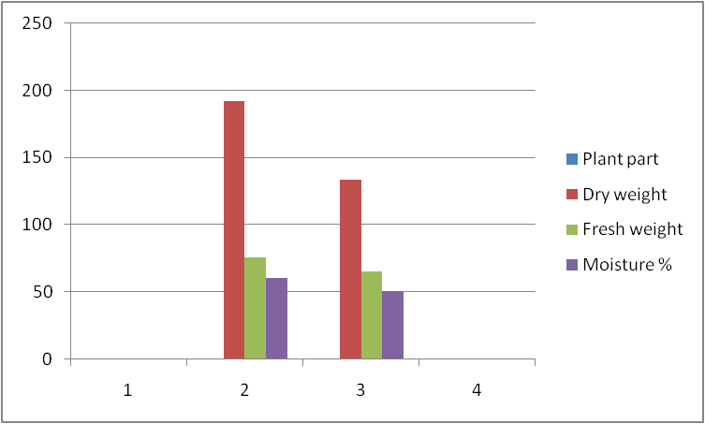
Maximum moisture percentage was recorded in Mature Leaf and minimum moisture percentage was retained by Mature stem.

Fig 2. Phenolic, Flavonoid, Reducing sugar and Total sugar in Different part of Agathis Robusta
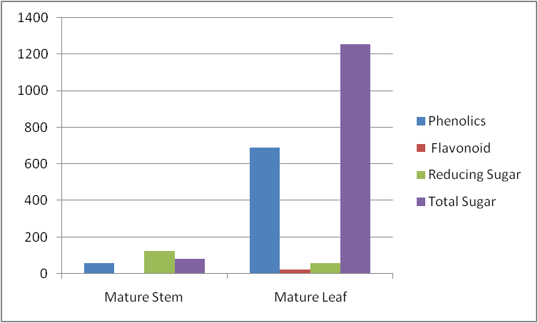
The mature leaves of Agathis robusta have the highest phenolic content, whereas the mature stem has the lowest. Mature leaves showed the highest level of flavonoids, whereas the mature stem held the lowest amount. Conversely, the mature stem of Agathis Robusta had the highest Reducing Sugar Content, while the mature leaf plant portion had the lowest.Finally, total sugar is lower in mature stems and higher in mature leaves. Phytochemicals such as phenols, tannins, flavonoids, saponins, glycosides, steroids, terpenoids, and alkaloids were found in the plant extracts after analysis. One of the biggest and most common classes of plant metabolites is comprised of phenolic chemicals (Singh et al 2007.). They have biological effects that include cardiovascular protection, improvement of endothelial function, antiapoptosis, antiaging, anticarcinogen, anti-inflammation, antiatherosclerosis, and suppression of angiogenesis and cell proliferation (Shen et al 2007).Numerous research works have delineated the antioxidative characteristics of therapeutic plants abundant in phenolic compounds (Brown 1998, Berger et al 2001). Flavonoids, phenolic acids, tocopherols, and other phenolic compounds found in plants are the primary source of natural antioxidants (Ali et al 2008). Plants produce flavonoids, which are hydroxylated phenolic compounds, in reaction to microbial infection. In vitro studies have shown that flavonoids have antibacterial activity against a broad spectrum of pathogens. Their capacity to form complexes with bacterial cell walls and extracellular, soluble proteins is most likely what drives their action (Marjorie et al 1996).Additionally, they have potent anticancer properties and are powerful antioxidants (Miller et al 1995, Del-Rio et al 1997). According to Rolland et al. (2002), reducing and nonreducing sugars are crucial to the central metabolic pathways and aid in the synthesis of secondary metabolites that improve the therapeutic qualities of plants.
Fig 3. Total Carotenoid Content
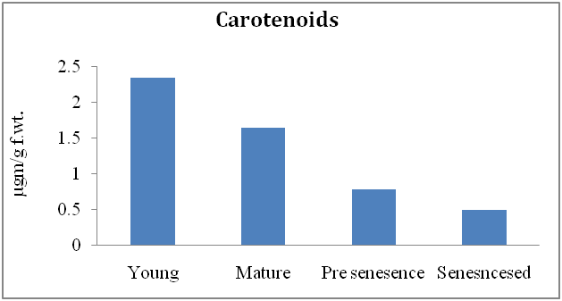
Young leaves had the highest reported carotenoid content, whereas mature leaves had the lowest. A class of phytochemicals known as carotenoids is what gives food its many hues. They are acknowledged as being crucial in preventing illnesses in people and preserving their health. Certain carotenoids are powerful antioxidants that also help the body produce vitamin A through food. The positive impact of phytochemicals in the prevention of several chronic illnesses is supported by scientific research. Carotenoids' chemistry has been thoroughly researched, but research on their bioavailability, metabolism, and biological roles is just now starting. The importance of lycopene to human health has drawn attention to carotenoids recently (Rao et al 2007).

Fig 4. Total Protein Content
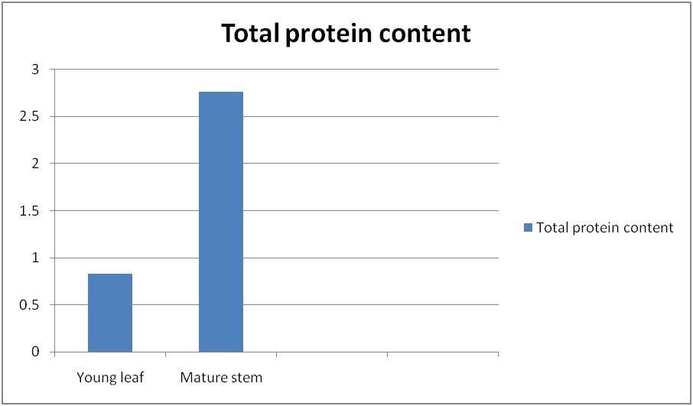
Highest Protein content observed in Mature Stem.
Fig 5. Total chlorophyll content in different parts of Agathis Robusta
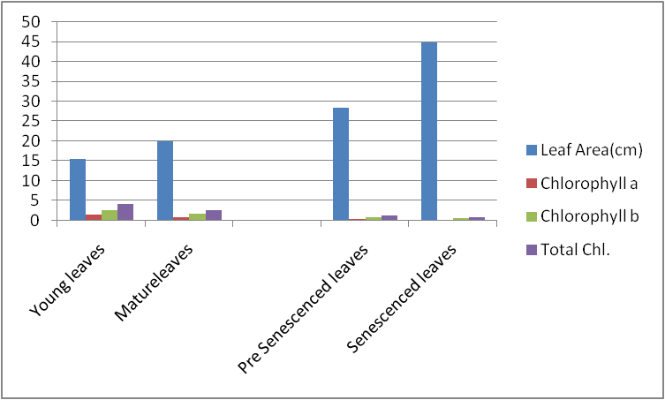
In above figure .Maximum leaf area observed in Pre Senescenced leaves and Minimum in Young leaves. High Chlorolphyll a is observed in Young leaves and least observed in senescenced leaves. While, Chlorophyll b Highly observed in young leaves and less in senescenced and total chlorophyll respectively.
Conclusion
Study confirmed the presence of these phytochemicals contribute medicinal as well as physiological properties to the plants studied in the treatment of different ailments. Therefore, extracts from these could be seen as a good source for useful drugs. The traditional medicine practice is recommended strongly for these plants as well as it is suggested that further work should be carried out to isolate, purify, and characterize the active constituents responsible for the activity of these plants. Also additional work is encouraged to elucidate the possible mechanism of action of these extracts.
References
A.V. Rao, L.G. Rao,2007 Carotenoids and human health,Pharmacological Research,ISSN 1043-6618,https://doi.org/10.1016/j.phrs.2007.01.012.
Agathis robusta subsp. nesophila Whitmore, T. C. 1980. Pl. Syst. Evol. 135: 64.
Akindele AJ, Adeyemi OO, Anti-inflammatory activity of the aqueous leaf extract of Byrosocarpuscoccineus. Fitoterapia. 2007; 78: 25-28.
Ali, S.S., Kasoju, N., Luthra, A., Singh, A., Sharanabasava, H., Sahuand, A., Bora, U. 2008. Indian medicinal herbs as source of antioxidants. Food Res. Int., 41: 1-15.
Bailey, Frederick Manson. 1883. A Synopsis of the Queensland Flora, p. 498.
Boland, D.J.; M.I.H. Brooker; G.M.Chippendale; N. Hall; B.P.M. Hyland; Johnston, R.D.; Kleinig, D.A. and Jurner, J.D. 1985. Forest trees of Australia. Melbourne: Nelson, CSIRO.
Dammara robusta C. Moore ex F. Muell., Quart. J. Trans. Pharm. Soc. Victoria 2: 174. 1860.In: Quart. J. Trans. Pharm. Soc. Victoria 2: 173. (1860).
Del-Rio, A., Obdululio, B.G., Casfillo, J., Main, F.G., Ortuno, A. 1997. Uses and properties of citrus flavonoids. J. Agric. Food Chem., 45: 4505-4515.
Han, X., Shen, T., Lou, H. 2007. Dietry polyphenols and their biological significance. Int. J. Mol. Sci., : 950-988.
Krings, U., Berger, R.G. 2001. Antioxidant activity of roasted foods. Food Chem., 72: 223-229.
Marjorie, C. 1996. Plant products as antimicrobial agents. Clincal Microbiol. Rev., 12: 564-582. Salah, N., Miller, N.J., Pagange, G., Tijburg, L., Bolwell, G.P, Rice, E., Evans, C. 1995. Polyphenolic flavonoids as scavenger of aqueous phase radicals as chai breaking antioxidant. Arc. Biochem. Broph., 2: 339-346.
Rolland F., Moore B., and Sheen J., Sugar sensing and signaling in plants, The Plant Cell. (2002) 14, no. Supplement 1, S185–S205, https://doi.org/10.1105/tpc.010455, 12045277
Singh, R., Singh, S.K., Arora, S. 2007. Evaluation of antioxidant potential of ethyl acetate extract/fractions of Acacia auriculiformis A. Cunn. Fod Chem. Toxicol., 45: 1216-1223.
Verma, R.S.; Padalia, R.C.; Goswami, P.; Verma, S.K.; Chauhan, A.; Darokar, M.P. Chemical composition and antibacterial activity of the essential oil of Kauri Pine [Agathis robusta (C. Moore ex F. Muell.) FM Bailey] from India. J. Wood Chem. Technol. 2016, 36, 270–277.

