Original Research Article

EPIDEMIOLOGICAL PROFILE AND ASSOCIATED RISK FACTORS IN HEAD AND NECK CANCER IN A NORTH INDIAN POPULATION: A CROSS-SECTIONAL OBSERVATIONAL STUDY

ABSTRACT

Aim: To evaluate the epidemiological profile of patients diagnosed with Head and Neck Squamous Cell Carcinoma (HNSCC) in North India by analysing demographic patterns, risk factor exposure, clinical presentation, and site-specific distribution of the disease.
Study design: A cross- sectional observational study.
Place and Duration of Study: Department of Surgical Oncology, ESI-PGIMSR and Model Hospital, New Delhi from January 2021 to December 2022.
Methodology: Following approval by the ethical committee of our institution, a total of 100 patients with HNSCC were enrolled in the study. Clinic-demographic data (like age, sex, religion, primary tumor site, family history, exposure to risk factors, clinical staging, treatment received and recurrence) was collected from patients with histologically confirmed HNSCC. All patients with clinically and histologically confirmed HNSCC from North India were included in this study.
Results: Most of the patients were aged between 41-50 years (39%). 90% of the patients were Hindu, 6% Muslim, 3% sikhs and 1% Christian. Most of the patients (45%) were tobacco chewers, 21% had no history of tobacco consumption. 24% of the patients had alcohol intake as a risk factor, whereas 76% patients did not. Most of the patients (49%) presented with growth as a main concern. 46% patients reported ulcer as their presenting complaint. 4% patients had pain and 1% came with trismus. In oral cavity carcinomas, buccal mucosa was found out to be the most common subsite (41%) followed by tongue which was present in 26% of the total patients. Most of the patients presented with cN+ (41%) followed by 31% with cT2, 13% with c T4, 10% with c T3 and only 5% presented with c T1. 94 underwent surgery (13 patients received NACT before the surgery), 4 received definitive CCRT and 2 were defaulter to treatment. Out of a total of 100 patients, 90 patients were followed up (mean 26.79 months) with clinical examination and radiological investigations (CECT, MRI, PET-CT scan), whereas 10 patients were lost to follow-up. Later on follow-up it was found that 26.2% patients developed locoregional recurrence and 8.3% patients developed systemic/ metastatic disease.

Conclusion The epidemiological profile of HNSCC in North India patients indicate a predominance of middle -age patients with smoking, tobacco chewing and alcohol as primary risk factors. With the rising incidence of head and neck squamous cell carcinoma (HNSCC) across Asia, particularly in India, comprehensive public health initiatives focusing on education and awareness—especially regarding modifiable risk factors such as tobacco use and alcohol consumption—are essential for effective prevention and reduction of disease burden. There is a need to implement strategies focused on prevention, early detection, and diagnosis of the disease.

Keywords: Head and Neck Squamous Cell Carcinoma, oral cavity, chemoradiotherapy, composite resection, modified radical neck dissection.

1. INTRODUCTION

Head and Neck Squamous Cell Carcinoma (HNSCC) accounts for a substantial proportion of cancer cases globally and represents a significant contributor to cancer-related morbidity and mortality, particularly in India. The global incidence of HNSCC is steadily increasing, with an estimated 900,000 new cases and approximately 400,000 deaths reported annually¹. Currently, HNSCC ranks as the sixth most common cancer worldwide, and projections indicate a 30% rise in incidence by 2030.²
These malignancies originate from the epithelial lining of the upper aerodigestive tract, including the oral cavity, pharynx, and larynx. The etiology of HNSCC is closely associated with modifiable risk factors such as tobacco use (both smoking and smokeless forms), alcohol consumption, and poor oral hygiene practices. The concurrent use of tobacco and alcohol is estimated to be responsible for approximately 72% of HNSCC cases, highlighting the significant synergistic effect of these risk factors in disease pathogenesis.³ Oral cavity cancer is one of the most commonly occurring cancer among men in India. In HNSCC, commonly involved subsites are buccal mucosa, tongue, lips, hypo pharynx, larynx.
The management of patients with locally advanced HNSCC typically involves a multimodal approach, including surgery, radiotherapy, and systemic therapies to achieve optimal disease control and improve survival outcomes.⁴ Oral cavity head and neck squamous cell carcinoma (HNSCC) is primarily managed through surgical resection, with adjuvant radiotherapy or concurrent chemoradiotherapy (CRT) considered based on pathological risk factors and disease stage. In contrast, CRT is generally the preferred primary treatment modality for tumors originating in the pharynx and larynx.⁵
We in our institute conducted a cross-sectional study to systematically examine and describe the demographic characteristics and associated risk factors of patients diagnosed with head and neck squamous cell carcinoma (HNSCC) in North Indian population.

2. material and methods

Aims and Objectives:
Aim:
To evaluate the epidemiological profile of patients diagnosed with Head and Neck Squamous Cell Carcinoma (HNSCC) in North India by analysing demographic patterns, risk factor exposure, clinical presentation, and site-specific distribution of the disease.

Primary objective:
To assess the epidemiological profile of patients with HNSCC in North India.
Secondary objective:
To test for any association of epidemiological profiles with the different anatomical sites and risk factors.

Materials and methods:
This is a cross-sectional observational study, conducted at the Department of Surgical Oncology, ESI-PGIMSR and Model Hospital, New Delhi from January 2021 to December 2022. Following approval by the ethical committee of our institution, a total of 100 patients with HNSCC were enrolled in the study. Informed consent was taken from all the patients participating in the study.
Sample size was not calculated for the study. All patients with clinically and histologically confirmed HNSCC from North India were included in this study.

Inclusion criteria:
- HNSCC arising from any sub-site
- Age> 18years
- Any stage (I-IV)

Exclusion criteria:
- All carcinomas other than HNSCC were excluded from this study.
A multidisciplinary team comprising medical, surgical, radiation oncologists and pathologists were involved, and a treatment plan was formulated.

Methodolgy

Chart 1- The flowchart presents the Management Pathway for HNSCC Patients

3. results and discussion

Results:
A total of 100 patients met the eligibility criteria and were enrolled in the study.
Demographic factors:
All patients aged between 21-80 years were included in the study. Most of the patients were aged between 41-50 years (39%). 90% of the patients were Hindu, 6% Muslim, 3% sikhs and 1% Christian.
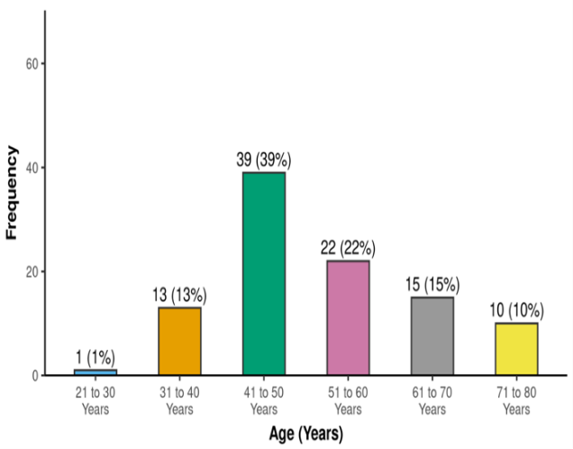
Figure 1: Distribution of patients based on age.

Risk factors:
The most common risk factors observed during the study were tobacco intake (chewer, smoker or both) and alcohol intake. Most of the patients (45%) were tobacco chewers, 21% had no history of tobacco consumption.

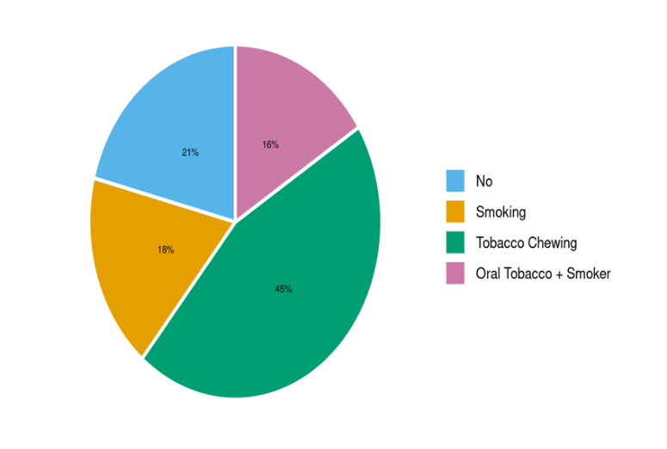
Figure 2: distribution of patients based on tobacco consumption

24% of the patients had alcohol intake as a risk factor, whereas 76% patients did not. Only one patient had a family history of malignancy, which signifies that HNSCC is not familial.

Presenting complaints:
Most of the patients (49%) presented with growth as a main concern. 46% patients reported ulcer as their presenting complaint. 4% patients had pain and 1% came with trismus.
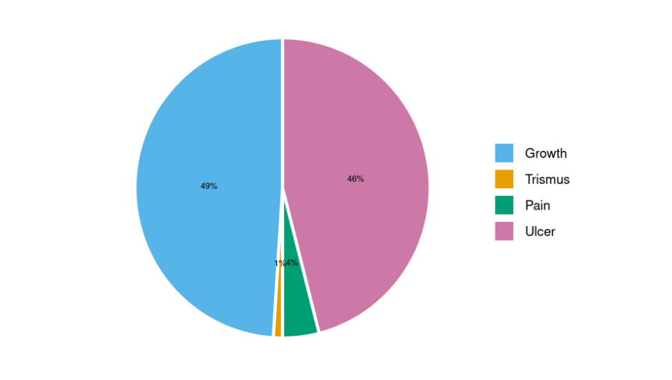
Figure 3: distribution of presenting complaints

Primary site of carcinoma:
Amongst HNSCC, oral cavity was the most common site. In oral cavity carcinomas, buccal mucosa was found out to be the most common subsite (41%) followed by tongue which was present in 26% of the total patients. Tumors arising from less common sites were hard palate(3%), central arch(2%), floor of mouth(2%), gingiva(1%) and mandible(1%).

Staging and treatment:
Most of the patients presented with cN+ (41%) followed by 31% with cT2, 13% with c T4, 10% with c T3 and only 5% presented with c T1. 87% patients were planned for upfront surgery, 11% for Neo-adjuvant chemotherapy (NACT), 1% for definitive CCRT and rest 1% for palliative CT/RT. But out of the total 100 patients, 94 underwent surgery (13 patients received NACT before the surgery), 4 received definitive CCRT and 2 were defaulter to treatment.

Cancer Subsite | Frequency | Percentage | 95% CI
Buccal Mucosa | 41 | 41.0% | 31.4% - 51.3%
Tongue | 26 | 26.0% | 18.0% - 35.9%
Lip | 12 | 12.0% | 6.6% - 20.4%
FOM | 2 | 2.0% | 0.3% - 7.7%
Alveolus | 11 | 11.0% | 5.9% - 19.2%
Mandible | 1 | 1.0% | 0.1% - 6.2%
Hard Palate | 3 | 3.0% | 0.8% - 9.2%
Central Arch | 2 | 2.0% | 0.3% - 7.7%
Neck | 1 | 1.0% | 0.1% - 6.2%
Gingiva | 1 | 1.0% | 0.1% - 6.2%
Table 1: Distribution based on cancer subsite.

Plan of Treatment/Therapy | Frequency | Percentage | 95% CI
Upfront Surgery | 87 | 87.0% | 78.4% - 92.6%
NACT | 11 | 11.0% | 5.9% - 19.2%
Definitive CCRT | 1 | 1.0% | 0.1% - 6.2%
Palliative CT/RT | 1 | 1.0% | 0.1% - 6.2%
Table 2: Distribution in terms of plan of treatment/ therapy

Type of Surgery | Frequency | Percentage | 95% CI
Composite Resection | 29 | 29.0% | 20.6% - 39.1%
WLE + SSG + MRND | 9 | 9.0% | 4.5% - 16.8%
WLE + Nasolabial + MRND | 8 | 8.0% | 3.8% - 15.6%
Partial Glossectomy + MRND | 25 | 25.0% | 17.1% - 34.8%
WLE + Karapazandzic + MRND | 5 | 5.0% | 1.9% - 11.8%
WLE + MM + MRND | 3 | 3.0% | 0.8% - 9.2%
Partial Maxillectomy | 4 | 4.0% | 1.3% - 10.5%
MRND | 1 | 1.0% | 0.1% - 6.2%
No Surgery | 5 | 5.0% | 1.9% - 11.8%
WLE +MRND | 11 | 11.0% | 5.9% - 19.2%
Table 3: Types of surgeries performed

As the most common subsite for oral cavity carcinoma was buccal mucosa hence, composite resection was performed for the maximum number of patients i.e. for 29 patients. Second most common subsite identified was tongue therefore, partial glossectomy + MRND was done for 25 patients.

Histopathological examination:
Out of total patients who underwent surgery (87 patients), 68 of them had margins <5mm as compared to >5mm for 22 patients. Tumors of 28% patients showed lymphovascular invasion and 19.4% patients had perineural invasion. 91.4% had underlying bone involvement and none of the patients had submandibular gland involvement.

Follow up and recurrence
Out of a total of 100 patients, 90 patients were followed up (mean 26.79 months) with clinical examination and radiological investigations (CECT, MRI, PET-CT scan), whereas 10 patients were lost to follow-up.
Later on follow-up it was found that 26.2% patients developed locoregional recurrence and 8.3% patients developed systemic/ metastatic disease.

Status | Frequency | Percentage | 95% CI
Alive & Disease Free | 53 | 53.0% | 42.8% - 63.0%
Stable Disease | 8 | 8.0% | 3.8% - 15.6%
Lost to Follow up | 10 | 10.0% | 5.2% - 18.0%
Dead | 29 | 29.0% | 20.6% - 39.1%
Table 4: Status of the patients post-treatment

Discussion:
As there is a constant rise in incidence and mortality of head and neck cancers, it has become a global health problem. Significant regional differences in prevalence have been observed, largely influenced by demographic factors such as age and sex, as well as tumor location and associated risk factors. In the indian subcontinent, the incidence of oral cancer among men has been estimated at approximately 20 cases per 100,000 individuals. In our study, majority of the patients were aged between 41-50 years (39%) which is in accordance with results of other studies conducted. In a study conducted by bagal sonali et al⁶. It was observed that incidence of HNSCCc was higher among population aged 40 years and above.
Tobacco consumption, whether through chewing or smoking, is a common practice in india.⁷ therefore, most common risk factor causing HNSCC as observed in our study was tobacco (chewing> smoking) followed by alcohol. Oral tobacco consumption exposes the oral mucosa to carcinogenic substances, increasing the risk of cancer developing at the site of contact. “extended retention of tobacco or betel quid in the buccal pouch (to maximize its effect) speeds up the absorption of these harmful substances, mixed with saliva, leading to irritation of the surrounding mucosa and tongue.”⁸
Buccal mucosa was the most common cancer subsite in our population (41%) similar to other studies conducted in india and worldwide. Goyal et al⁹ in their study reported that oral cavity and tongue are commonly affected sites in HNSCC.
In asian countries like india, epidemiological data revealed varied patterns of tobacco and alcohol use, both of which are recognized as significant risk factors in the development of head and neck squamous cell carcinoma (HNSCC).¹⁰ all the patients with history of alcohol intake also had taken tobacco in various forms and both of which showed synergistic effect on head and neck carcinogenesis. Yuan et al¹¹ in their study concluded that tobacco and alcohol are primary risk factors associated with HNSCC..
In india, patients usually present late with advanced disease and most common presenting complaints in HNSCC are growth and ulcer.

4. Conclusion

The epidemiological profile of HNSCC in north india patients indicate a predominance of middle -age patients with smoking, tobacco chewing and alcohol as primary risk factors. Tobacco and alcohol when consumed together have synergistic effect on head and neck carcinogenesis. Buccal mucosa and tongue are most commonly involved subsites.
With the rising incidence of head and neck squamous cell carcinoma (HNSCC) across asia, particularly in india, comprehensive public health initiatives focusing on education and awareness—especially regarding modifiable risk factors such as tobacco use and alcohol consumption—are essential for effective prevention and reduction of disease burden. There is a need to implement strategies focused on prevention, early detection, and diagnosis of head and neck squamous cell carcinoma (HNSCC), alongside promoting a tobacco-free environment to mitigate disease incidence. Also, the patients need to be followed-up post treatment with clinical and radiological examination to detect early recurrence.

Consent

written informed consent was taken from all the patients who participated in the study.

Ethical approval

Approval from ethical committee was taken for the given study.

References

- Global cancer observatory. International agency for research on cancer. World health organization. Available from: https://gco.iarc.fr/.
- Ferlay J, Colombet M, Soerjomataram I, Mathers C, Parkin DM, Piñeros M, et al. Estimating the global cancer incidence and mortality in 2018: GLOBOCAN sources and methods. Int J Cancer 2019;144:1941-53.
- Gormley M, Creaney G, Schache A, Ingarfield K, Conway DI. Reviewing the epidemiology of head and neck cancer: definitions, trends and risk factors. Br Dent J 2022;233:780–6.
- Orlandi E., Alfieri S., Simon C., Trama A., Licitra L., Hackl M., Van Eycken E., Henau K., Dimitrova N., Sekerija M., et al. Treatment challenges in and outside a network setting: Head and neck cancers. Eur. J. Surg. Oncol. 2019;45:40–45. doi: 10.1016/j.ejso.2018.02.007.
- Johnson D.E., Burtness B., Leemans C.R., Lui V.W.Y., Bauman J.E., Grandis J.R. Head and neck squamous cell carcinoma. Nat. Rev. Dis. Primers. 2020;6:92. doi: 10.1038/s41572-020-00224-3.
- Bagal S, Budukh A, Thakur JS, Dora T, Qayyumi B, Khanna D, Fernandes D, Chakravarti P, Singh R, Patil S, Dikshit R, Chaturvedi P. Head and neck cancer burden in India: an analysis from published data of 37 population-based cancer registries. Ecancermedicalscience. 2023 Sep 21;17:1603. doi: 10.3332/ecancer.2023.1603. PMID: 37799939; PMCID: PMC10550331.
- Rai B, Bramhankar M. Tobacco use among Indian states: Key findings from the latest demographic health survey 2019-2020. Tob Prev Cessat. 2021 Mar 9;7:19. doi: 10.18332/tpc/132466. PMID: 33709043; PMCID: PMC7942198.
- Michaelraj MJ, Kuttiappan K, Ramasamy S, Edwin Rodrigues FA, Govindaraj S. Demographic profile and risk factors of head-and-neck squamous cell carcinoma in west Tamil Nadu: A cross-sectional observational study. Cancer Res Stat Treat 2023;6:215-23.
- Goyal, A.K., Saini, J., Bakshi, J. et al. Prevalence, Incidence, and Mortality Trends of Head and Neck Cancers in India: A GLOBOCAN 2022 Statistics Analysis. Indian J Surg Oncol (2025). https://doi.org/10.1007/s13193-025-02264-1
- D’cruz A, Lin T, Anand AK, Atmakusuma D, Calaguas MJ, Chitapanarux I, et al. Consensus recommendations for management of head and neck cancer in Asian countries: A review of international guidelines. Oral Oncol 2013;49:872-7.
- Yuan, Y., Huang, J. wen, Cao, J. lin, Wu, J. hui, Wang, L. ling, Gan, H., … Ye, F. (2025). Tobacco and alcohol use are the risk factors responsible for the greatest

