Case Report

Incidental Ovarian Mass Leading to the Diagnosis of Krukenberg Tumor in a Young Woman Presenting with Bowel Obstruction

ABSTRACT
Krukenberg tumors are rare metastatic ovarian cancers, predominantly originating from stomach adenocarcinoma. They often show nonspecific gastrointestinal symptoms, which leads to a delayed diagnosis and a bad prognosis.
This case highlights diagnostic delays, challenges in differentiating metastatic from primary ovarian cancer, and limited therapeutic options in the advanced stages of the disease.
Case Presentation:
A 29-year-old woman was experiencing stomach pain and vomiting. Imaging revealed bilateral ovarian neoplasms associated with ascites and intestinal obstruction. An exploratory laparotomy uncovered fragile ovarian and omental tumors, which were subsequently excised. Histopathology confirmed metastatic signet-ring cell carcinoma originating from the stomach. Despite postoperative recovery and subsequent admission for treatment, the patient encountered recurrent obstruction and ultimately succumbed.
Discussion and Conclusion:
When young women have bilateral ovarian masses and gastrointestinal symptoms Krukenberg tumor should be a differential diagnosis. Timely diagnosis is warranted to facilitate prompt surgical and oncological intervention.

Keywords: Krukenberg tumor, ovarian cancer, colorectal cancer

INTRODUCTION

Krukenberg tumors (KTs) are metastatic signet ring cell (SRC) adenocarcinomas originating from the ovary.
The prognosis for Krukenberg tumors is unfavorable, and the lack of randomized controlled trials, optimum treatment techniques remain contentious. The reported incidence varies from 1% to 21%, with increased prevalence observed in Asian countries attributed to a higher occurrence of stomach cancer. These tumors are frequently bilateral and may display solid, cystic, or mixed features. Immunohistochemical staining is crucial for distinguishing Krukenberg tumors from primary ovarian cancers. Due to their typically ambiguous clinical manifestations, diagnosis is often postponed. Krukenberg tumors typically manifest in younger women relative to primary ovarian malignancies. Despite the generally unfavorable prognosis, numerous studies indicate that palliative surgical resection may confer a survival advantage in specific patients.

PRESENTATION OF CASE

A 29-year-old female, Gravida 1 Para 1, was admitted via the emergency department to the general surgery ward with complaints of stomach pain, increasing distension, vomiting, and constipation persisting for several days. She additionally noted a decrease in weight and appetite during the past 5 months. Her medical history includes an appendectomy in February 2025. No history of vaginal bleeding or atypical vaginal discharge was noted.
The patient presented with dehydration, a pulse rate of 113 beats per minute, blood pressure of 100/60 mmHg, and a temperature of 35°C. The abdomen exhibited distension, widespread discomfort, and silent bowel sounds, with no detectable organomegaly. A pelvis mass was palpated 20cm in size, non-tender . Adnexal mass was palpated during the vaginal examination.
Laboratory examinations revealed mild anemia (Hb 10.3 g/dL), leukocytosis (WBC 9,200/mm³), and a platelet count of 456 × 10⁹/L. Tumor markers indicated a little increase in CA-125 (60.6 U/mL) and CEA (4.37 ng/mL), although CA-19.9 (8.51 U/mL) and CA-15.3 were within normal ranges. Urine beta HCG : negative.
Imaging investigations abdominal xray revealed distended bowel loops indicative with intestinal blockage. Abdominal pelvis ultrasound anterior to the uterus focal hypoechoic lesion with irregular contours and heterogeneous echotexture due to isolated round anechoic structures with follicles. Mass measures approximately 13.92 cm x 8.51cm, involving the ovary and tubes extending into the cul-de-sac and Morrison space. Contrast-enhanced CT of the abdomen and pelvis demonstrated distended, fluid-filled small intestinal loops lacking a definitive transition point, likely attributable to tumor infiltration or external compression. Heterogeneous intraperitoneal pelvic tumors of 12.0 × 11.4 × 8.7 cm were present, accompanied by widespread metastases and ascites, indicative of ovarian malignancy or a primary gastrointestinal tumor. Moderate left hydronephrosis was observed due to extrinsic compression.
The patient underwent an exploratory laparotomy, during which 400 mL of serous peritoneal fluid was aspirated. During the operation, friable bilateral ovarian masses were observed—the right ovary measuring 10 × 14 cm and the left ovary 8 × 10 cm—accompanied by an omental mass (10 × 4 cm) adherent to the transverse colon, thicker bowel loops, nodular deposits on the diaphragm, and many peritoneal implants. The fallopian tubes were observed to be grossly normal. The procedures conducted comprised bilateral salpingo-oophorectomy, resection of the omental mass with partial omentectomy, and adhesiolysis.
Histopathological analysis confirmed metastatic signet ring cell adenocarcinoma, indicative of a Krukenberg tumor of gastric origin, subsequently validated by endoscopic biopsy. Postoperatively, the patient exhibited satisfactory recovery and was thereafter referred to the oncology section for systemic chemotherapy. Regrettably, she was readmitted with recurring intestinal obstruction and subsequently succumbed to illness progression.
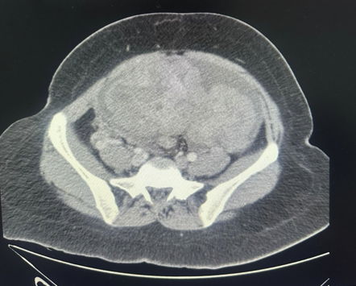
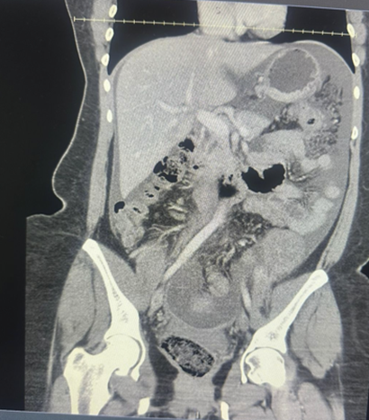
Fig 1-CT Scan of abdomen and Pelvis


Figure 2:Ovarian Mass with characteristic bosselated surface


Figure 3: Thickened , nodular omentum with multiple metastatic deposits

DISCUSSION
Krukenberg tumors are rare metastatic ovarian cancers, primarily arising from the gastrointestinal system, primarily the stomach , however additional origins may include the colon, appendix, breast, or gallbladder. They predominantly impact women in their reproductive age, differentiating them from primary epithelial ovarian malignancies, which are more prevalent in older women. The occurrence of Krukenberg tumors ranges from 1% to 21% of all ovarian cancers, with a greater frequency in Asian countries, indicative of the elevated incidence of gastric carcinoma in these areas.
The pathophysiology entails the transcoelomic, lymphatic, or hematogenous dissemination of malignant cells from the gastrointestinal tract to the ovaries. These metastatic tumors are frequently bilateral, as seen in the current instance, and may display solid, cystic, or mixed shape. Signet ring cells with intracytoplasmic mucin are a histopathological feature of Krukenberg tumors. Immunohistochemical analyses, encompassing CK7, CK20, and CDX2, assist in distinguishing metastatic Krukenberg tumors from original ovarian carcinomas, as tumors of gastric origin typically exhibit CK20 positivity and CK7 negativity.
Clinically, Krukenberg tumors present diagnostic challenges owing to their vague symptoms, including stomach pain, bloating, and menstrual irregularities. Tumors are frequently identified incidentally during assessments or surgical procedures for intestinal blockage or ascites. Imaging methods, including ultrasound and contrast-enhanced CT, are effective in detecting adnexal masses, ascites, and metastatic dissemination; however, they lack the reliability to differentiate between primary and metastatic ovarian cancers preoperatively.
The patient had bilateral ovarian masses, ascites, omental involvement, and intestinal obstruction, which heightened suspicion for malignancy, subsequently proven histopathologically as metastatic signet ring cell adenocarcinoma of gastric origin. The diagnosis was further confirmed by endoscopic biopsies of the stomach main lesion.
The prognosis for Krukenberg tumors is usally poor , mainly due to the fact that most cases are diagnosed at a late stage with extensive peritoneal involvement. The median survival after diagnosis generally spans from 6 to 14 months, although results may differ based on the underlying tumor location, illness severity, and therapeutic strategy. In the absence of randomized controlled studies, no conventional treatment plan is available; nevertheless, a multimodal strategy that integrates cytoreductive surgery with systemic chemotherapy has demonstrated small enhancements in survival and symptom alleviation. In specific patients with localized disease and favorable performance status and palliative oophorectomy may mitigate pain and gastrointestinal symptoms while improving quality of life.
Surgical cytoreduction in this case offered transient symptomatic relief; however, the disease swiftly advanced, resulting in repeated intestinal obstruction and subsequent mortality. This result illustrates the aggressive characteristics of Krukenberg tumors and the restricted treatment alternatives if significant peritoneal spread has transpired.

CONCLUSION

Krukenberg tumors are rare yet aggressive kind of metastatic ovarian cancer, predominantly originating from original gastric adenocarcinoma. Their symptoms are frequently non-specific, resulting in delayed diagnosis, with the majority of cases identified at an advanced stage. This case underscores the necessity of evaluating metastatic disease in reproductive-age women exhibiting bilateral ovarian tumors and gastrointestinal symptoms. Imaging, histology, and immunohistochemistry are all important tools for making an early and correct diagnosis that will aid with treatment. Even though the prognosis is poor surgery and systemic chemotherapy done on time may help with symptoms and somewhat improve survival. A multidisciplinary approach is essential to enhance patient outcomes and elevate quality of life, even in palliative contexts.

Declaration by Authors
Ethical Approval: Approved

REFERENCES
- Al-Agha, O. M., & Nicastri, A. D. (2006). An in-depth look at Krukenberg tumor: An overview. Archives of Pathology & Laboratory Medicine, 130(11), 1725–1730.
- Young, R. H. (2006). From Krukenberg to today: The ever-present problems posed by metastatic tumors in the ovary. Advances in Anatomic Pathology, 13(5), 205–227.
- Wu, F., Zhao, X., Mi, B., et al. (2015). Clinical characteristics and prognostic analysis of Krukenberg tumor. Molecular and Clinical Oncology, 3(6), 1323–1328.
- Rayson, D., Bouttell, E., Whiston, F., et al. (2000). Outcome after ovarian/adnexal metastectomy in metastatic colorectal carcinoma. Journal of Surgical Oncology, 75(1), 18–23.
- Young, R. H. (2007). Metastatic tumors involving the ovary: A review of recent developments. Advances in Anatomic Pathology, 14(3), 149–177. https://doi.org/10.1097/PAP.0b013e3180504abf
- Young, R. H. (2008). From Krukenberg to today: The ever present problems posed by metastatic tumors in the ovary. American Journal of Surgical Pathology, 32(9), 1373–1379. https://doi.org/10.1097/PAS.0b013e31816b18c1
- Scully, R. E., Young, R. H., & Clement, P. B. (1998). Tumors of the ovary, maldeveloped gonads, fallopian tube, and broad ligament: Atlas of tumor pathology (3rd series). Washington, DC: Armed Forces Institute of Pathology.

