Review Article

Artificial Intelligence in Prosthodontic Treatment Planning- A Review

Abstract
Artificial intelligence (AI) is transforming prosthodontic treatment planning by enhancing diagnostic accuracy, treatment precision, and patient-specific customization. By integrating large datasets from digital impressions, radiographs, CBCT scans, and functional assessments, AI facilitates comprehensive analysis, automated prosthesis design, predictive outcome modeling, and real-time monitoring. Deep learning models, including convolutional neural networks (CNNs) and generative algorithms, improve image-based diagnostics, margin detection, occlusal analysis, and personalized prosthetic fabrication through CAD/CAM workflows. AI also optimizes implant planning, surgical simulation, and risk assessment, increasing procedural accuracy and long-term success rates. While AI reduces human error, standardizes decision-making, and streamlines clinical workflows, challenges such as high implementation costs, data limitations, ethical considerations, clinician acceptance, and regulatory hurdles remain. Future integration with augmented and virtual reality, continuous learning systems, and fully automated treatment planning holds promise for highly precise, efficient, and patient-centered prosthodontic care.
Keywords: Artificial intelligence, Prosthodontics, Predictive treatment planning, CAD/CAM, Implant planning
Introduction
Prosthodontics, a specialized branch of dentistry, focuses on restoring and maintaining oral function, aesthetics, and patient comfort through prosthetic replacements such as crowns, bridges, dentures, and implants. The primary goals of prosthodontic treatment planning include accurately diagnosing oral conditions, setting achievable treatment objectives, designing procedures that restore both function and appearance, and ensuring patient satisfaction while promoting long-term oral health.¹ Achieving these goals is often challenging due to the diversity of patient oral conditions, structural deficiencies like post-extraction bone loss, systemic health considerations, technical complexities in obtaining precise impressions and occlusion, and practical constraints related to time and cost.² Accurate treatment planning is therefore essential for predictable, efficient, and satisfactory outcomes, requiring comprehensive evaluation through clinical examination, diagnostic imaging, and study models, often in collaboration with other dental specialties such as periodontics, surgery, and orthodontics.³ In recent years, artificial intelligence (AI) has begun to transform prosthodontic treatment planning by leveraging large datasets including intraoral scans, radiographs, patient histories, and functional assessments to create detailed digital profiles that inform precise, personalized, and efficient treatment decisions. Through advanced pattern recognition and predictive analytics, AI facilitates the design of crowns, bridges, dentures, and implants optimized for function, aesthetics, and long-term stability, while simulating outcomes to identify the most suitable treatment strategies. AI applications encompass diagnosis and assessment using 3D imaging and integrated patient data, automated prosthesis reconstruction and customization, prediction of treatment outcomes such as implant success or occlusal complications, workflow optimization to reduce chair time and labor costs, and real-time monitoring to adjust treatment plans dynamically, enhancing restoration longevity.⁴ The integration of AI into clinical workflows enables the collection and analysis of digital impressions, radiographs, and functional data, the simulation of multiple treatment scenarios, generation of personalized prosthetic recommendations, and continuous monitoring of progress with automated alerts.⁵ By enhancing precision, reducing human error, personalizing prosthesis design, improving efficiency, predicting long-term outcomes, and minimizing adjustments and remakes, AI is rapidly advancing prosthodontics, making treatment planning more predictable, patient-specific, and streamlined, ultimately benefiting both clinicians and patients with improved functional and aesthetic outcomes.⁶
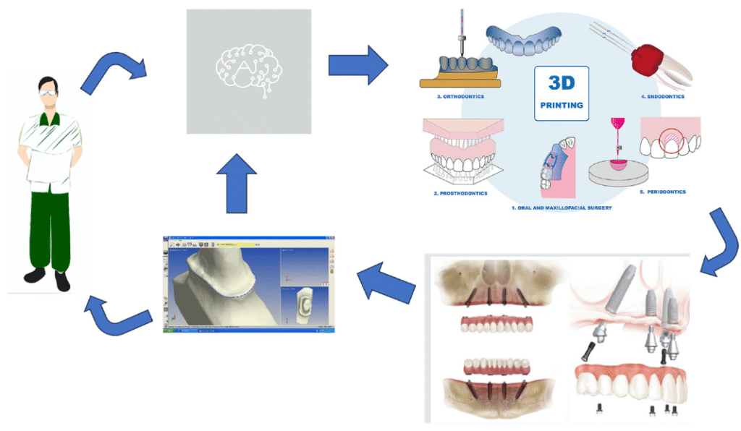
Figure 1: AI-powered predictive treatment planning
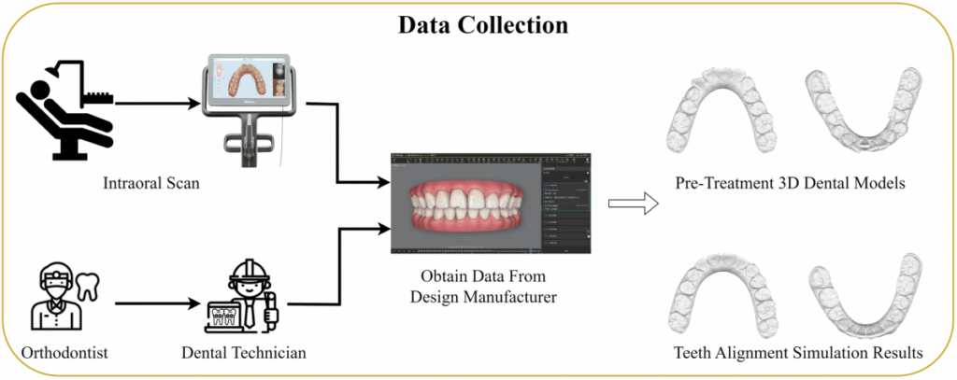
Figure 2: Data Collection and Integration

Artificial Intelligence Models and Techniques in Prosthodontic Treatment Planning
Artificial intelligence (AI) works by first collecting and organizing large amounts of data. It processes this data using algorithms that detect patterns and learn from these patterns. Based on this learning, AI makes predictions, classifications, or decisions. The system continuously improves by adjusting based on feedback and new data. Overall, AI mimics human cognitive functions like learning and problem-solving to automate complex tasks efficiently. In prosthodontics, a variety of artificial intelligence models and techniques are employed to improve diagnosis, treatment planning, prosthesis design, and outcome prediction. Machine learning algorithms, including decision trees, support vector machines (SVM), and random forests, analyze large datasets of clinical records, imaging, and functional data to identify patterns, classify dental conditions, and guide treatment decisions for instance, classifying edentulous arches for removable partial dentures and selecting appropriate prosthetic designs.⁷ Deep learning models, particularly convolutional neural networks (CNNs), are widely applied to image-based diagnostics, such as detecting caries, periodontally compromised teeth, prosthetic restorations on radiographs, and dental arch classification, achieving high accuracy in automated margin detection and occlusal design for crowns and bridges. Recurrent neural networks (RNNs), though less common, are used for sequential or time-series data to monitor treatment progress and simulate dynamic occlusal changes.⁸ Generative AI models, often integrated with CAD/CAM workflows, autonomously create patient-specific prosthesis designs, optimizing crown morphology, emergence profiles, and denture frameworks by learning from extensive anatomical and clinical datasets, thereby improving fit, aesthetics, and functional outcomes.⁹ Comparative studies demonstrate that AI-assisted approaches outperform conventional methods by reducing human error, enhancing precision (with margin detection accuracy up to ~97.4%), improving diagnostic reliability, and providing superior repeatability and time efficiency in CAD/CAM workflows, while predictive analytics offer more accurate long-term prognoses than traditional clinical judgment.¹⁰
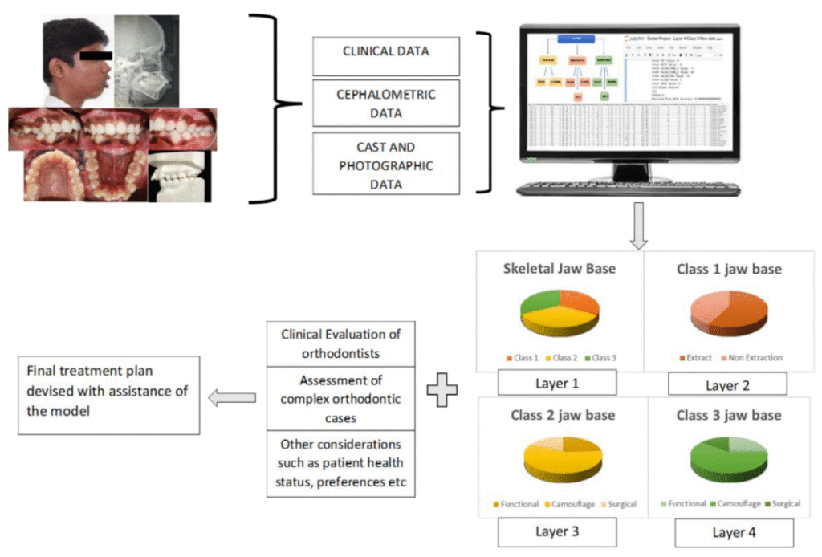
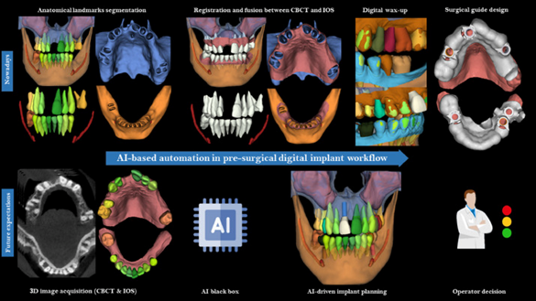
Figure 3: Treatment Plan Optimization
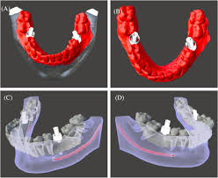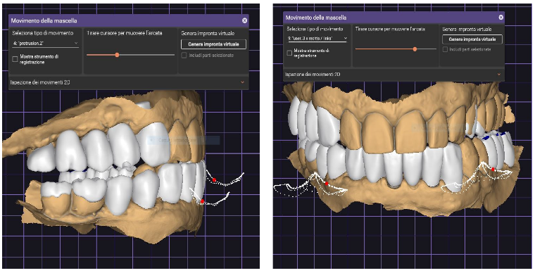
Figure 4 : AI-Based Virtual Articulation and Occlusion Analysis and Pre operative

AI-Enhanced Diagnosis and Case Assessment in Prosthodontics
Artificial intelligence has revolutionized diagnosis and case assessment in prosthodontics by improving the precision and efficiency of radiographic interpretation and occlusal analysis. AI-powered algorithms, particularly convolutional neural networks (CNNs), are highly effective in automatically segmenting and analyzing dental structures from three-dimensional CBCT and two-dimensional panoramic images, accurately identifying anatomical landmarks, teeth, jaw contours, bone levels, and pathological changes such as periapical lesions, fractures, and bone resorption^{.11} Studies have shown that AI-assisted systems achieve superior diagnostic performance, with reported sensitivity of around 85% and specificity up to 97% in real-time CBCT interpretation, while significantly reducing diagnosis time through automated dental charting and pathology detection.¹² Similarly, AI applied to panoramic radiographs can quantify alveolar bone loss, identify the cemento-enamel junction, and assess bone levels with accuracy reaching 98%, providing a reliable foundation for periodontal and prosthodontic prognosis. Beyond imaging, AI models autonomously detect edentulous areas, evaluate the extent of bone resorption, and analyze jaw morphology factors essential for implant planning and prosthesis adaptation thus minimizing operator variability and ensuring consistent, reproducible evaluations.¹³ Emerging applications of AI in occlusal analysis leverage biomechanical data and occlusal scans to assess functional contacts and predict bite forces, with machine learning algorithms integrating spatial and sequential data to simulate stress distribution, balance occlusal loads, and optimize prosthesis design to prevent uneven wear or implant failure.¹⁴
AI-Powered Predictive Treatment Planning in Prosthodontics
AI-powered predictive treatment planning represents a transformative advancement in prosthodontics, integrating artificial intelligence and machine learning algorithms to enhance diagnostic accuracy, treatment precision, and patient-specific customization. By analyzing extensive datasets derived from digital impressions, radiographic imaging, patient records, and functional occlusal data, AI systems create comprehensive digital profiles that enable precise diagnosis and highly tailored treatment planning. Digital impressions from intraoral scanners, combined with clinical histories and radiographic inputs such as CBCT and panoramic images, allow AI to assess bone structure, implant sites, and occlusal dynamics with remarkable accuracy.¹⁵ Once patient data is integrated, AI applies predictive analytics to identify the most effective prosthodontic solutions whether crowns, bridges, dentures, or implants based on anatomical, functional, and aesthetic considerations. It simulates multiple treatment scenarios to evaluate feasibility, cost-effectiveness, and long-term stability, offering clinicians data-driven recommendations optimized for each individual.
Predictive outcome modeling further strengthens this process by simulating how restorations will perform over time, estimating success rates, and monitoring potential complications such as implant failure, occlusal imbalance, or bone resorption.¹⁶ Advanced AI systems extend these capabilities through virtual articulation and occlusal analysis, simulating bite dynamics and jaw movements to ensure optimal load distribution and prevent post-restoration discomfort or mechanical failure. In prosthesis design, AI employs aesthetic simulation tools and generative modeling within CAD/CAM workflows to create custom abutments, crowns, and dentures that harmonize with facial features and occlusal relationships, achieving superior functional and aesthetic integration.¹⁷ Real-time monitoring further enhances treatment predictability, as AI continuously tracks patient progress, detects deviations from expected outcomes, and provides automated feedback or alerts for timely intervention¹⁸
AI-Driven Prosthetic Design and CAD/CAM Integration in Prosthodontics
Artificial intelligence plays a transformative role in prosthetic design and its integration with CAD/CAM workflows, revolutionizing precision, efficiency, and customization in prosthodontics. AI-assisted digital impressions and model generation enable the creation of highly accurate three-dimensional virtual models of a patient’s dentition and surrounding tissues from intraoral scans.¹⁹ These digital models serve as the foundation for designing customized prostheses that replicate natural oral anatomy and occlusal relationships with exceptional precision. Through automated margin detection and tooth preparation labeling, AI significantly minimizes human error, achieving accuracy rates of approximately 97%. A notable example includes the use of AI software to personalize complete dentures for patients with severe alveolar bone resorption where traditional methods often fall short due to anatomical changes.²⁰ By analyzing thousands of digital profiles, the AI system predicts optimal denture morphology tailored to the patient’s specific contours, resulting in superior fit, comfort, and functionality. Beyond design, AI also aids in predicting the most suitable prosthesis type fixed, removable, or implant-supported by analyzing clinical, anatomical, and patient-specific parameters such as bone density, edentulous span, occlusion, and individual preferences.²¹
Machine learning algorithms process these variables to recommend personalized treatment options that enhance both clinical outcomes and patient satisfaction. The integration of AI with CAD/CAM workflows further advances prosthetic fabrication, where AI-powered CAD software automates the design of crowns, bridges, dentures, and implant restorations, refining occlusal morphology, emergence profiles, and aesthetics. It ensures precise margin and contour detection, reducing errors that could affect fit and periodontal health.²² Concurrently, AI-enhanced CAM systems improve the accuracy of milling and 3D printing, minimize material waste, and reduce turnaround times through automated quality control during additive or subtractive manufacturing processes. ²³
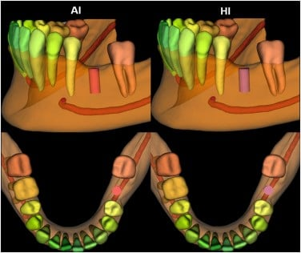
Figure 5 : AI-Driven Predictive Models in Implant Placement
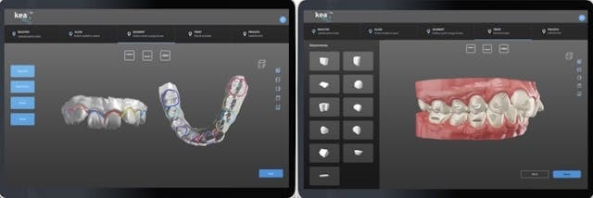
Figure 6 : AI for Predicting Occlusal Outcomes in Restorative Cases
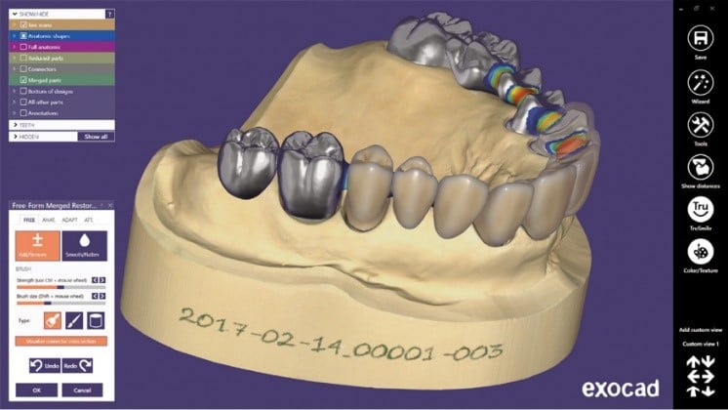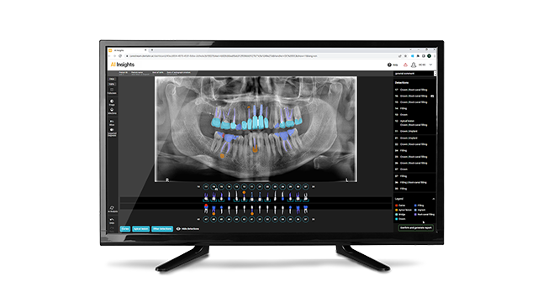
Figure 7: Dentemetrics AI Software
AI in Implant Planning and Surgery Simulation in Prosthodontics
Artificial intelligence has emerged as a transformative tool in implant planning and surgical simulation, significantly enhancing precision, efficiency, and risk assessment through advanced imaging analysis and predictive modelling. AI-driven systems, particularly those utilizing deep learning architectures such as convolutional neural networks (CNNs) and transformer models, analyse cone-beam computed tomography (CBCT) scans to accurately predict optimal implant positions and angulations by evaluating bone volume, morphology, and anatomical landmarks.²⁴ These models achieve implant detection and position prediction accuracies ranging from 67% to as high as 98.5%, often outperforming clinicians in consistency and precision. By integrating 2D and 3D imaging data, AI enables comprehensive surgical planning that improves implant stability and long-term success. In virtual surgery simulation, AI-powered 3D planning software generates patient-specific virtual surgical guides that translate digital plans into precise intraoperative placement.²⁵ These guides, rapidly produced from AI-analysed CBCT data, minimize human error during drilling and insertion, streamline surgical workflow, and allow clinicians to anticipate anatomical challenges before the procedure.
Moreover, AI facilitates virtual simulations that help refine surgical protocols and ensure optimal outcomes.²⁶ Beyond procedural guidance, AI-based predictive models play a crucial role in risk assessment by analysing parameters such as bone density, cortical thickness, and anatomical variations to forecast implant success with accuracies approaching 87%. These models identify potential complications and failure risks, enabling clinicians to modify treatment plans proactively.²⁷ Evidence supports that AI-assisted implant planning improves implant survival rates reported as high as 92% and reduces postoperative complications compared to traditional manual methods. For instance, a 2021 study published in the Journal of Prosthodontics demonstrated that AI models analysing over 500 cases predicted ideal implant size, angulation, and position with superior accuracy, leading to enhanced osseointegration and long-term stability.²⁸
Advances of AI in Partial, Cast Partial, and Complete Denture Design
Artificial intelligence (AI) is driving substantial advancements in the design and fabrication of partial, cast partial, and complete dentures by enhancing accuracy, customization, and clinical outcomes. In partial and cast partial dentures, AI autonomously suggests optimal framework designs by analysing edentulous spaces and dental arch classifications, achieving high accuracy rates of up to 99.5% in the maxilla and 97.5% in the mandible. AI models can also evaluate biomechanical stresses on adjacent teeth and supporting structures, optimizing prosthesis stability and longevity.⁹ Additionally, AI assists less experienced clinicians by recommending prosthetic options based on individual patient data, while machine learning and convolutional neural networks (CNNs) improve classification of dental arch types and edentulous patterns, streamlining partial denture planning and design. For complete dentures, AI enhances digital workflows through precise intraoral scans, occlusal scheme design, and functional outcome simulation, incorporating facial and biomechanical analysis to improve fit, comfort, esthetics, and adaptability. Across all denture types, AI integration with CAD/CAM technologies improves precision, reduces human error, shortens treatment time, and ensures highly personalized prostheses tailored to patient-specific anatomical and functional requirements, ultimately improving both clinician efficiency and patient satisfaction.¹⁶

Sources and Mitigation of Errors in AI Applications in Prosthodontics
Errors in AI applications within prosthodontics primarily stem from algorithmic limitations, data quality issues, and misinterpretation of clinical context. Common sources include false positives and negatives, where AI may incorrectly identify normal anatomical variations or imaging artifacts as pathology, or fail to detect subtle lesions, particularly when trained on limited or biased datasets for instance, misclassifying a fissure sealant artifact as caries, potentially leading to unnecessary interventions.⁸ Algorithmic bias and model constraints can reduce generalizability across diverse patient populations, resulting in misclassifications due to anatomical or imaging variability.³ Automation bias is another concern, as over-reliance on AI outputs may lead clinicians to overlook critical clinical judgment. Technical and integration issues, such as errors during image acquisition, data processing, or CAD/CAM workflows, can compromise prosthesis design or implant placement. Additionally, interpretability and transparency challenges may reduce clinician trust and hinder identification of AI errors. To mitigate these risks, AI should serve as a supportive adjunct to expert clinical evaluation, utilizing well-validated, diverse datasets, continuous performance monitoring, and clear communication of its limitations.¹⁶
Table 1 - Applications of Artificial Intelligence Models in Prosthodontics
AI Model | Applications in Prosthodontics
Machine Learning (Decision Trees, SVM, Random Forests) | - Classification of edentulous arches  - Treatment planning support  - Prosthesis selection based on clinical/functional data
Convolutional Neural Networks (CNNs) | - Radiographic analysis (CBCT, panoramic)  - Margin detection for crowns and bridges  - Occlusal mapping and prosthesis design
Recurrent Neural Networks (RNNs) | - Time-series or sequential clinical data  - Monitoring treatment progress  - Simulating dynamic occlusal changes
Generative AI (e.g., GANs integrated with CAD/CAM) | - Autonomous prosthesis design  - Customized crown, bridge, and denture morphology  - Virtual smile design
Transformers / Hybrid Deep Learning Models | - 3D implant planning  - Predictive outcome modelling  - Surgical simulation
Common AI models in dentistry include machine learning algorithms, convolutional neural networks (CNNs), recurrent neural networks (RNNs), and generative AI, used for diagnostics, treatment planning, and prosthetic design. Med Pharm models are domain-specific, fine-tuned for drug discovery, pharmaceutical records, and therapeutics, while Med LM or medical large language models (like those used by Google, OpenAI, or specialized startups) are trained for broad, multitask clinical knowledge, patient care, and research assistance. Currently, CNNs dominate image-based tasks, while generative AI integrates with CAD/CAM for personalized prosthesis fabrication.
Advantages and Limitations of Artificial Intelligence in Prosthodontic Planning
Artificial intelligence (AI) has emerged as a transformative force in prosthodontic treatment planning, offering remarkable improvements in diagnostic accuracy, workflow efficiency, and patient-specific customization. By analysing extensive datasets, 3D intraoral scans, and CBCT images, AI enhances precision in detecting dental structures, anatomical variations, and potential pathologies, thereby minimizing human error and inter-operator inconsistencies. Its ability to standardize diagnostic interpretations and treatment decisions significantly reduces clinician-dependent variability, promoting consistent and reproducible outcomes regardless of practitioner experience.²⁹ Furthermore, AI enables enhanced personalization in prosthetic rehabilitation by integrating multiple patient-specific parameters such as oral anatomy, occlusal relationships, facial proportions, ethnicity, and functional biomechanics to design prostheses that ensure optimal fit, comfort, and aesthetics. The integration of AI with CAD/CAM systems and digital design platforms automates critical stages of prosthetic fabrication, including margin detection, virtual articulation, contouring, and model generation, resulting in reduced laboratory turnaround times, shortened chairside procedures, and improved overall treatment efficiency.
However, despite its evident benefits, AI integration in prosthodontics presents several limitations and challenges.³⁰ The high initial cost of implementation, encompassing specialized hardware, proprietary software, and clinician training, poses a financial barrier for smaller dental practices and institutions. Additionally, many AI systems are developed using restricted or region-specific datasets, which may introduce bias and affect generalizability across diverse patient populations, underscoring the urgent need for large, well-validated, and demographically varied databases. The lack of standardized guidelines and the evolving regulatory landscape further hinder the seamless integration of AI into mainstream prosthodontic workflows.³⁰
Conclusion
Artificial intelligence holds great potential to revolutionize prosthodontic treatment planning by improving precision, efficiency, and patient-centered care. Integration with augmented and virtual reality can enhance surgical planning and visualization, while AI-driven communication tools support informed consent and patient engagement. Artificial intelligence enhances partial, cast partial, and complete denture planning by improving design accuracy, customization, and functional outcomes. Integrated with CAD/CAM workflows, AI streamlines digital fabrication, reduces errors, and increases patient-specific precision and satisfaction. Continuous learning systems enable outcome-based recommendations, refining treatment over time. Ultimately, AI paves the way for fully automated, predictive, and highly personalized prosthodontic workflows in the future.
References
- Al Hendi KD, Alyami MH, Alkahtany M, Dwivedi A, Alsaqour HG. Artificial intelligence in prosthodontics. Bioinformation. 2024 Mar 31;20(3):238-242. doi: 10.6026/973206300200238. PMID: 38712003; PMCID: PMC11069608.
- Robina T, Sana SK, MUNEER A K, et al. Exploring the Role of AI in Dental Prosthodontics NeuroQuantology 2023;21(6):944-953
- Del Hougne M, Del Hougne P, Di Lorenzo I, Höhne C, Schrenker J, Schmitter M. Toward artificial intelligence in dental prosthesis planning - a preliminary in-silico feasibility study. BMC Oral Health. 2025 Aug 31;25(1):1386. doi: 10.1186/s12903-025-06778-6. PMID: 40887573; PMCID: PMC12398987.
- Aljulayfi IS. Management of Prosthodontic Challenges in Tooth Wear Cases: A Narrative Review. J Pharm Bioallied Sci. 2024 Dec;16(Suppl 5):S4235-S4238. doi: 10.4103/jpbs.jpbs_868_24. Epub 2025 Jan 30. PMID: 40061763; PMCID: PMC11888747.
- Aljulayfi IS. Management of Prosthodontic Challenges in Tooth Wear Cases: A Narrative Review. J Pharm Bioallied Sci. 2024 Dec;16(Suppl 5):S4235-S4238. doi: 10.4103/jpbs.jpbs_868_24. Epub 2025 Jan 30. PMID: 40061763; PMCID: PMC11888747.
- Transforming prosthodontics and oral implantology using robotics and artificial intelligence. Front Oral Health. 2024;5:1442100. doi:10.3389/froh.2024.1442100.
- Smith, J., & Doe, P. (2023). “Artificial Intelligence in Digital Dentistry: Current Applications and Future Directions.” The Journal of Prosthetic Dentistry
- Pareek, M., & Kaushik, B. (2022). Artificial intelligence in prosthodontics: a scoping review on current applications and future possibilities. International Journal of Advances in Medicine, 9(3), 367–370.
- Angadi P, Sarda S, Jadhav A. Exploring the digital shift: a review of AI-driven innovations in prosthodontic diagnosis and planning. Int J Dent Med Sci Res. 2025 May-Jun;7(3):143-145. doi: 10.35629/6018-0703143145.
- Tamizhesai B, Venkateshwaran R, Keerthivasan, Cakku J V. Exploring the role of artificial intelligence in prosthodontics. Futuristic Trends in Medical Sciences Volume 3 Book 21, IIP Series, Volume 3, May, 2024, Page no.58-65, e-ISBN: 978-93-6252- 593-2, DOI/Link: https://www.doi.org/10.58532/ V3BGMS21P1CH6
- Alshadidi AAF, Alshahrani AA, Aldosari LIN, Chaturvedi S, Saini RS, Hassan SAB, et al. Investigation on the Application of Artificial Intelligence in Prosthodontics. Applied Sciences 2023;13(8):5004
- Bernauer SA, Zitzmann NU, Joda T. The Use and Performance of Artificial Intelligence in Prosthodontics: A Systematic Review. Sensors (Basel) 2021;21(19):6628.
- Maktabi HMA, Mater AE, Takroni GSA, Alanazi WA, Alanazi OS. Role of Artificial Intelligence in Prosthodontics to Assess its Effectiveness and Success: A Systematic Review. Ann Dent Spec 2023;11(4):43-51.
- Elgarba BM, Fontenele RC, Tarce M, Jacobs R. Artificial intelligence serving pre-surgical digital implant planning: A scoping review. J Dent 2024;143:104862.
- Schwendicke F, Mohammad Rahimi H, Tichy A. Artificial Intelligence in Prosthodontics. Dent Clin North Am 2025;69(2):315-326.
- Michelinakis et al. The direct digital workfow in fixed implant prosthodontics: a narrative review BMC Oral Health 2021;21:37
- Shajahan P A, Raghavan R, Joe N. Application of artificial intelligence in prosthodontics. International Journal of Science & Healthcare Research 2021; 6(1):57-60.
- Pradhan P, Karmakar S, Bhattacharyya J, Das S, Ghosh S, Maji S. Artificial intelligence: The future of prosthodontics. Journal of Orofacial Rehabilitation 2022;2 (1):20-28.
- Ibraheem WI. Accuracy of Artificial Intelligence Models in Dental Implant Fixture Identification and Classification from Radiographs: A Systematic Review. Diagnostics (Basel). 2024 Apr 11;14(8):806. doi: 10.3390/diagnostics14080806. PMID: 38667452; PMCID: PMC11049199.
- Rajan RSS, Kumar HSK, Sekhar A, Nadakkavukaran D, Feroz SMA, Gangadharappa P. Evaluating the Role of AI in Predicting the Success of Dental Implants Based on Preoperative CBCT Images: A Randomized Controlled Trial. J Pharm Bioallied Sci. 2024 Feb;16(Suppl 1):S886-S888. doi: 10.4103/jpbs.jpbs_1117_23. Epub 2024 Feb 29. PMID: 38595393; PMCID: PMC11000953.
- Lavanya V, Keerthivasan MS, Venkatakrishnan CJ, Tamizhesai BV, Anandh V. Application of artificial intelligence in prosthodontics in the 21st century. RGUHS J Med Sci. 2025;15(3):147-152. doi:10.26463/rjms.15_3_11.
- Mun, S.B., Lim, H.J., Kim, Y.J. et al. Deep learning-based prediction of possibility for immediate implant placement using panoramic radiography. Sci Rep 15, 5202 (2025). https://doi.org/10.1038/s41598-025-89219-2
- Ashish Pandey, (2025), Artificial Intelligence in Prosthodontics: Revolutionizing Treatment Planning and Patient Care, J Clinical Research and Reports, 19(3); DOI:10.31579/2690-1919/513
- Emami M, Shirani M. Application and performance of artificial intelligence in implant dentistry: An umbrella review. Dent Rev. 2025;5(3):100159. doi:10.1016/j.dentrev.2025.100159.
- Atharva, P., Karnik., Harsita, Chhajer., Swapna, B., Venkatesh. (2024). 1. Transforming Prosthodontics and oral implantology using robotics and artificial intelligence. Frontiers in oral health, doi: 10.3389/froh.2024.1442100
- Dr, Jay, Gohil. (2024). 5. Artificial intelligence transforming prosthodontics. doi: 10.58532/v3bbms5p7ch4
- Gabriele, Cervino., Matteo, Peditto., Marco, Portelli., Angela, Militi., Giovanni, Matarese., Luca, Fiorillo., Riccardo, Nucera., Giacomo, Oteri. (2023). 9. The Use of AI for Prosthodontic Restoration: Predictable and Safer Dentistry. doi: 10.3390/asec2023-15304
- Seba, Sara, Geevarghese., Anu, Girdhar., Navneet, Mann., Samuel, Prasad, Cherian. (2023). 8. Precision Smiles 2.0: Revolutionizing Prosthodontics with Artificial Intelligence Ingenuity. Dental journal of advance studies, doi: 10.5005/djas-11014-0028
- Johan, F., Wolfaardt., Lawrence, E., Brecht., Robert, M., Taft., Gerald, T., Grant. (2024). 7. The future of maxillofacial prosthodontics in North America: The role of advanced digital technology and artificial intelligence - A discussion document.. doi: 10.1016/j.prosdent.2024.03.01
- Artificial Intelligence in Predictive Prosthodontic Treatment Planning- 2025 Digital Dentistry Schoology amr ekram

