Interactive Effects of Calcium Chloride and Borax Foliar Applications on Biochemical Attributes of Guava (Psidium guajava L.) Fruit

ABSTRACT
This study evaluated the impact of pre-harvest foliar applications of calcium chloride and borax alone and in combinations on critical biochemical parameters of guava (Psidium guajava L.) cv. L-49. Nine treatment groups included various concentrations of calcium chloride and borax, both individually and in combination, with untreated controls for comparison. Analysis focused on total soluble solids (TSS), titratable acidity, ascorbic acid content, reducing sugar, non-reducing sugar, and total sugar contents. Results demonstrated significant improvements in fruit biochemical quality with combined applications, particularly at higher concentrations. The combination of calcium chloride 0.2% with borax 0.1% yielded the highest TSS, ascorbic acid, reducing, non-reducing, and total sugar contents, while also minimizing acidity. These enhancements in fruit quality are attributed to improved nutrient assimilation, enhanced cell wall stability, and favorable metabolic changes. These findings support the synergistic role of calcium and boron in improving not only yield but also the nutritional and organoleptic value of guava.
Keywords: Guava, Calcium Chloride, Borax, Biochemical Quality, Ascorbic Acid
INTRODUCTION
Guava (Psidium guajava L.) is one of the most economically important subtropical fruits cultivated in India and globally. Renowned for its rich ascorbic acid content, pleasant aroma, and unique taste, guava commands significant demand both for fresh consumption and for processing. Despite its adaptability and high productivity, the fruit is prone to rapid postharvest deterioration, which limits its marketability and export potential. Biochemical attributes such as total soluble solids (TSS), acidity, ascorbic acid, and sugar content are vital determinants of fruit quality and consumer acceptance (Deepthi et al., 2016).
Pre- and post-harvest nutritional strategies, especially involving micronutrients like calcium and boron, have shown promise for enhancing fruit quality, storability, and market value. Calcium, usually supplied as calcium chloride, is pivotal in reinforcing cell wall structure through the cross-linking of pectic substances, stabilizing membrane integrity, and delaying senescence. These cellular effects translate into improved texture, reduced postharvest losses, and longer shelf life. On the other hand, boron commonly applied as boric acid or borax functions in cell wall biosynthesis, sugar translocation, enzyme activation, and is often linked with improved fruit set, size, and quality traits (Sonkar et al., 2024). Studies have documented that foliar sprays of these nutrients improve guava fruit yield, shelf life, and biochemical constituents. For instance, combined applications were found superior in augmenting TSS, sugars, and ascorbic acid while minimizing undesirable acidity. These effects are likely a result of synergistic metabolic enhancements driven by improved nutrient allocation and the maintenance of cellular homeostasis (Poojan et al., 2020). India, particularly the Gangetic plains and regions such as Uttar Pradesh, is among the key producers of guava. Nevertheless, productivity is often constrained by suboptimal management of fruit quality parameters. Targeted foliar treatments with calcium and boron can offer growers practical solutions for maintaining fruit firmness and biochemical quality, thus enhancing consumer appeal and market returns (Shukla et al., 2024). Foliar sprays of calcium and boron in combination not only elevate critical quality traits like TSS and vitamin C but also reduce titratable acidity, generically leading to an improved TSS-acid ratio and organoleptic score. Enhanced sugar accumulation is attributed to calcium's role in carbohydrate metabolism and hydrolytic activity on fruit cell wall polysaccharides. Similarly, boron's involvement in ascorbic acid biosynthesis and sugar partitioning further accentuates the quality and nutritive composition of guava (Vani et al., 2020).
Thus, optimizing dose and method of application for these micronutrients is crucial for maximizing the quality and storability of guava. The present study investigates the effects of various concentrations and combinations of foliar calcium chloride and borax on the biochemical quality indices of guava under subtropical Indian conditions.
MATERIAL AND METHODS
Experimental cites
The experiment was conducted at Horticultural Research Farm Department of Horticulture, Babasaheb Bhimrao Ambedkar University, Lucknow on Twenty-one (21) years old guava cv. L-49. The experiment was consisting of 9 treatments and three replications.
Table 1. Experimental details
S.NO. | Treatment | Doses
T₀ | Control (Water spray) | -
T₁ | Calcium chloride | 0.1%
T₂ | Calcium chloride | 0.2%
T₃ | Borax | 0.1%
T₄ | Borax | 0.2%
T₅ | Calcium chloride + Borax | 0.1% + 0.1%
T₆ | Calcium chloride + Borax | 0.1% + 0.2%
T₇ | Calcium chloride + Borax | 0.2% + 0.1%
T₈ | Calcium chloride + Borax | 0.2% + 0.2 %

Observation recorded
Total soluble solids
Total Soluble Solids (TSS) content of the fruit was determined using a hand refractometer. For this, a small quantity of fruit juice was extracted and a few drops were placed on the prism surface of the refractometer. The reading was taken by observing through the eyepiece under adequate light conditions. The TSS values were expressed in degrees Brix (°Brix), which indicates the percentage of soluble sugars and other dissolved solids present in the juice, representing the sweetness level of the fruit. This method follows the procedure described by Islam et al. (2013).
Acidity
Acidity content was determined by titrating a known volume of fruit juice sample against standardized sodium hydroxide (NaOH) solution using phenolphthalein as an indicator, following the method described by Ranganna (1986). The appearance of a light pink color, which persisted for at least 30 seconds, was taken as the endpoint of the titration. The amount of NaOH required to neutralize the acids present in the juice was recorded, and the titratable acidity was calculated and expressed as a percentage of citric acid (or the predominant acid of the fruit) on a juice volume basis
Ascorbic acid
Ascorbic acid content was estimated using the 2, 6-dichlorophenol indophenol (DCPIP) dye titration method as described by Gill et al. (2016). In this method, a known quantity of fruit pulp was homogenized with 3% metaphosphoric acid to prevent oxidation of ascorbic acid. The extract was then filtered, and an aliquot of the filtrate was titrated against the standardized DCPIP dye solution until a light pink endpoint persisted for about 15 seconds. The amount of dye reduced during the titration is stoichiometrically equivalent to the amount of ascorbic acid present in the sample. The results were calculated and expressed as milligrams of ascorbic acid per 100 grams of pulp.
Reducing, non-reducing and total sugars
Sugar analysis, including the estimation of reducing sugar, non-reducing sugar, and total sugar content, was carried out using standard chemical procedures outlined by Ranganna (1986).
For reducing sugar, the Lane and Eynon method was employed, which is based on the titration of the sugar solution against Fehling’s solution using methylene blue as an internal indicator. The reducing sugars present in the sample reduce the cupric ions in Fehling’s solution to cuprous oxide under hot alkaline conditions, and the endpoint is indicated by the decolorization of methylene blue.
To determine total sugar, the sample was first subjected to acid hydrolysis using dilute hydrochloric acid to convert non-reducing sugars (mainly sucrose) into reducing sugars. The hydrolyzed solution was then neutralized and titrated against Fehling’s solution following the same procedure as for reducing sugars.
The non-reducing sugar content was calculated by subtracting the percentage of reducing sugar from the percentage of total sugar. The results were expressed as a percentage of total sugars present in the fruit pulp on a fresh weight basis.
Statistical analysis
The data were statistically analyzed and the significance of treatment effects was determined using the Critical Difference (CD) at 5% level. Standard Error of the mean (SEm) was also calculated to assess variation among replicates
RESULTS AND DISCUSSION
Total Soluble Solids (TSS)
The results indicate that TSS levels in guava fruits increased progressively with the combined application of calcium chloride and borax, reaching a maximum of (12.67 °Brix) 0.2% CaCl₂ + 0.1% borax, compared to (7.61 °Brix) in control fruits (Fig. 1). The enhancement in TSS due to these treatments can be linked to improved sugar accumulation and enzymatic activity promoting carbohydrate conversion during ripening. Both calcium and boron are known to facilitate sugar synthesis and transport within plant tissues, thereby enhancing TSS content (Pandey et al., 2015; Rahman et al., 2018). Similar observations have been documented in guava cultivar L-49 by Hada et al. (2018), who found that calcium and boron sprays significantly improved sugar metabolism and sweetness index in fruits.
Titratable Acidity (%)
Acidity content decreased with the application of calcium chloride and borax, with the lowest (0.46%) noted under 0.2% CaCl₂ + 0.1% borax treatment compared to 0.76% in control (Fig. 1). The reduction in acidity is likely due to the rapid conversion of organic acids to sugars during fruit ripening, a process enhanced by calcium’s role in cell wall stabilization and boron’s involvement in glycolytic enzyme activation (Romero-Aranda et al., 1998; Poojan et al., 2020). A similar trend was observed by Awasthi et al. (2009), where the combined foliar application of calcium and boron substantially lowered acid content in guava fruits.
Ascorbic Acid (mg/100g pulp)
Ascorbic acid content increased significantly with the interaction of calcium and boron treatments, reaching 177.34 mg/100g under 0.2% CaCl₂ + 0.1% borax compared to 155.46 mg/100g in control (Fig. 1). Boron stimulates the enzymatic synthesis of ascorbic acid, while calcium preserves cell integrity and reduces oxidative degradation during ripening (Bhardwaj et al., 2019; Hada et al., 2018). Similar findings were reported by Ravi et al. (2023), who noted that preharvest application of calcium chloride combined with boron enhanced vitamin C concentration by reducing oxidative stress and improving cell wall resilience.
Reducing Sugars (%)
The percentage of reducing sugars in guava fruit pulp showed a significant increase with the application of calcium chloride and borax treatments (Table 1). The highest reducing sugar content of 4.87% was observed under combined treatment of 0.2% calcium chloride + 0.1% borax, which was considerably higher than the 2.50% in control fruits. This increase can be attributed to the role of calcium in activating hydrolytic enzymes that catalyze the breakdown of starch into simpler sugars such as glucose and fructose, which are reducing sugars (Vani et al., 2020). Calcium facilitates enzyme activities involved in carbohydrate metabolism and helps maintain cell wall integrity, which indirectly supports sugar accumulation by preventing premature fruit spoilage and maintaining metabolic activity (Singh & Chauhan, 1982; Saha et al., 1993). Boron further enhances this process by facilitating the transmembrane transport of sugars, particularly through the formation of sugar–borate complexes, which enhance the mobility and distribution of sugars within fruit tissues (Awasthi, 2009). These complexes enhance phloem loading and unloading, making sugars more available for metabolic processes and storage, contributing to increased reducing sugar content (Bhardwaj et al., 2019).
Non-Reducing Sugars (%)
Non-reducing sugar content also improved significantly under calcium and boron treatments, reaching a maximum of 4.68% at 0.2% calcium chloride + 0.1% borax treatment compared to 2.88% in control (Table 1). Non-reducing sugars such as sucrose are vital for fruit sweetness and overall flavor quality, and their increase suggests enhanced sucrose synthesis and accumulation. Boron's function in sugar metabolism includes strengthening cellular membranes and participating in carbohydrate metabolism enzymes, thus facilitating sucrose synthesis and stability (Pandey et al., 2015). The synergy between calcium and boron likely results in improved sugar metabolism by stabilizing cell membranes and enhancing enzyme activities responsible for sugar accumulation (Yadav et al., 2018). Boron facilitates sugar transport by forming complexes that protect sucrose from hydrolysis during transport, allowing for higher accumulation of non-reducing sugars in fruit tissues.
Total Sugars (%)
Total sugar content displayed a marked effect, with maximum accumulation (8.55%) under 0.2% CaCl₂ + 0.1% borax, followed by 7.72% in 0.2% CaCl₂ + 0.2% borax, compared to 5.38% in control (Table 1). Both elements play complementary roles calcium enhances sugar translocation through membrane stabilization, while boron improves sugar metabolism through enzymatic activation (Pandey et al., 2015; Hada et al., 2018). Such positive interactions align with previous reports in guava where combined Ca and B sprays increased total sugars and enhanced fruit sweetness (Vani et al., 2020; Ravi et al., 2023).
Correlation analysis
The Pearson correlation heatmap illustrates the interrelationship among various fruit quality parameters, including total soluble solids (TSS), acidity, ascorbic acid, and different forms of sugars (reducing, non-reducing, and total sugars) (Fig. 2). The results reveal a clear pattern of association consistent with the natural biochemical changes that occur during fruit ripening.
A strong positive correlation was observed among TSS, total sugars, reducing sugars, non-reducing sugars, and ascorbic acid, indicating that as the fruit matures, these components increase simultaneously. This suggests that the accumulation of sugars and the synthesis of ascorbic acid contribute significantly to the enhancement of sweetness and nutritional value of the fruit. Higher TSS values, which represent the soluble sugar content, are therefore associated with improved taste and quality.
Conversely, acidity exhibited a negative correlation with TSS and all sugar components, implying that as the fruit ripens and sugar levels rise, the acidity decreases. This inverse relationship is a common characteristic of ripening fruits, where the conversion of organic acids into sugars leads to a sweeter and less tart flavor profile.
Overall, the correlation analysis highlights that fruit ripening is accompanied by an increase in sugars and vitamin C content and a reduction in acidity, which together contribute to better sensory quality and consumer acceptability. These findings confirm that the measured parameters are closely linked and play a crucial role in determining the overall chemical composition and quality of the fruit.
Conclusion
The interactive application of calcium chloride and borax significantly improved the biochemical properties of guava cv. L-49 fruits. Maximum enhancement in total soluble solids, ascorbic acid content, reducing and non-reducing sugars, and total sugars was recorded under the combined treatment of 0.2% calcium chloride + 0.1% borax. At the same time, acidity decreased, favoring better fruit quality. The synergistic effect of calcium and boron is attributed to their roles in carbohydrate metabolism, sugar transport, and cell wall stabilization, leading to superior fruit sweetness, nutritional quality, and marketability. Therefore, foliar sprays of calcium chloride combined with borax are recommended to improve guava fruit quality and biochemical composition for commercial cultivation under similar agro-climatic conditions.

Conflict of Interest
The authors declare that there is no conflict of interest regarding the publication of this research work. The study was conducted independently without any commercial or financial relationships that could be construed as a potential conflict.

COMPETING INTERESTS DISCLAIMER:
Authors have declared that they have no known competing financial interests OR non-financial interests OR personal relationships that could have appeared to influence the work reported in this paper.

REFEENCES
Awasthi, P. A. (2009). Effect of calcium, boron, and zinc foliar sprays on the yield and quality of guava (Psidium guajava L.). CAB International Digital Library, 5555/20103104872.
Bhardwaj, R. L., Yadav, S., & Singh, D. P. (2019). Improving fruit quality characteristics and yield of guava (Psidium guajava L.) with micronutrient management. Plant Archives, 19(2), 405–410.
Deepthi, V. P., Sekhar, R. C., Srihari, D. and Sankar, A. S. (2016). Guava fruit quality and storability as influenced by harvest maturity and postharvest application of calcium salts.
Hada, T. S., Singh, P., & Meena, R. S. (2018). Studies on the foliar feeding effect of nutrients on quality and biochemical parameters of guava. The Bioscan, 13(3), 1021–1026.
Islam, M. K., Khan, M. Z. H., Sarkar, M. A. R., Absar, N., & Sarkar, S. K. (2013). Changes in acidity, TSS, and sugar content at different storage periods of the postharvest mango (Mangifera indica L.) influenced by Bavistin DF. International Journal of Food Science, 2013(1), 939385.
Pandey, P., Sharma, S., & Kumar, R. (2015). Influence of foliar feeding of micronutrients on the phytochemical characteristics of guava. Annals of Phytomedicine, 4(1), 45–50.
Poojan, S., Pandey, D., Trivedi, A. K., Pandey, A. K. and Pandey, M. (2020). Efficacy of foliar application of nutrients on yield and quality of guava. Journal of Environmental Biology, 41(5), 1061-1067.
Poojan, S., Patel, R. P., & Pandya, H. V. (2020). Efficacy of foliar application of nutrients on yield and quality of guava cv. Allahabad Safeda. Journal of Environmental Biology, 41(5), 1120–1127.
Rahman, M. A., Islam, S. M., & Haque, M. A. (2018). Effect of zinc and boron on biochemical attributes of guava. International Journal of Current Microbiology and Applied Sciences, 7(4), 201–210.
Ranganna, S. (1986). Handbook of analysis and quality control for fruit and vegetable products. Tata McGraw-Hill Education.
Ravi, K., Suma, P. C., & Singh, T. (2023). Effect of foliar micronutrients on the phytochemical and antioxidant properties of guava. Annals of Phytomedicine, 12(1), 816–820. https://doi.org/10.54085/ap.2023.12.1.74
Romero-Aranda, R., Moya, J. L., & Cuartero, J. (1998). Boron and calcium effects on tomato fruit quality. Journal of Plant Physiology, 153(3), 403–408.
Shukla, U., Lata, R., Verma, R. S., Shekhawat, C., Yadav, S. and Singh, V. (2024). Efficacy of Foliar Application of Micronutrients on Bio-chemical Attributes of Guava (Psidium guajava L.) cv. Allahabad Safeda. Asian Journal of Soil Science and Plant Nutrition, 10(4), 562-568.
Vani, N. U., Bhagwan, A., Kumar, A. K. and Sreedhar, M. (2020). Effect of preharvest spray of different forms of calcium on postharvest quality of guava cv. Allahabad Safeda. International Journal of Current Microbiology and Applied Sciences, 9(7), 197-209.
Yadav, I. S., Kumar, D., & Rajkumar, M. (2018). Influence of zinc, calcium, and boron sprays on physical and chemical quality attributes in guava cv. Lalit. Journal of Agricultural Science and Practice, 3(4), 98–100.
Fig.1: Interactive Effects of Calcium Chloride and Borax on TSS, acidity and ascorbic acid content of guava cv. L-49

Treatments | Reducing sugar (%) | Non- reducing sugar (%) | Total sugar (%)
Control | 2.50 | 2.88 | 5.38
Calcium chloride 0.1% | 3.55 | 2.68 | 6.23
Calcium chloride 0.2% | 3.66 | 2.58 | 6.24
Borax 0.1% | 3.60 | 2.78 | 6.38
Borax 0.2% | 2.62 | 3.62 | 6.22
Calcium chloride 0.1% + Borax 0.1% | 3.62 | 2.76 | 6.39
Calcium chloride 0.1% + Borax 0.2% | 3.28 | 3.26 | 6.54
Calcium chloride 0.2% + Borax 0.1% | 4.87 | 4.68 | 8.55
Calcium chloride 0.2% + Borax 0.2% | 4.73 | 3.99 | 7.72
SEm ± | 0.12 | 0.12 | 0.17
CD 0.05 | 0.36 | 0.36 | 0.50
Table 2: Interactive Effects of Calcium Chloride and Borax on reducing, non-reducing and total sugars of guava cv. L-49.

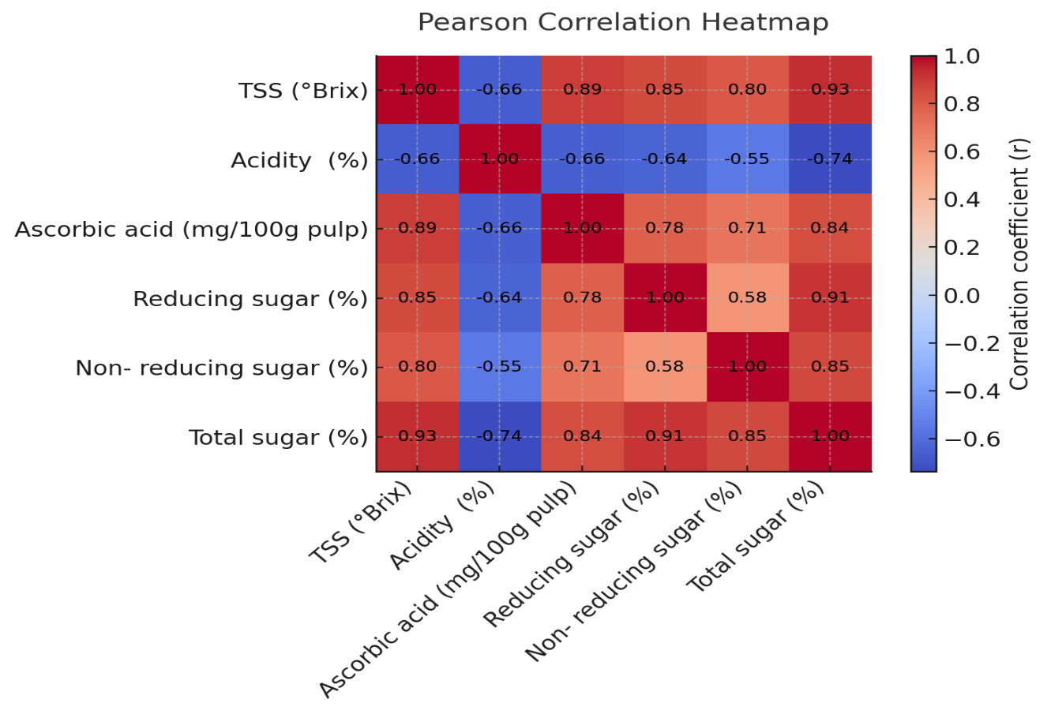

Fig. 2: Pearson correlation heat map for various biochemical parameters of guava cv. L-49.

