Case report

HALLUX VALGUS BURSITIS: CLINICAL PRESENTATION AND MANAGEMENT OF A RARE CASE

ABSTRACT
Hallux valgus is a common forefoot deformity characterized by lateral deviation and valgus rotation of the great toe, often associated with bunion formation. The condition usually develops due to medial deviation of the first metatarsal, lateral deviation or rotation of the hallux, and soft tissue hypertrophy over the first metatarsal head. This deformity is frequently seen in young women and can cause severe pain, gait disturbance, and progressive functional disability if left untreated. We report the case of a 25-year-old female who presented with severe pain over the right first metatarsophalangeal (MTP) joint for two months, associated with difficulty in walking and intermittent fever. Clinical evaluation confirmed hallux valgus deformity with bunion formation, resulting in significant restriction of daily activities. Considering the severity of deformity, degenerative changes of the MTP joint, and the alignment of the metatarsal and phalanges, corrective osteotomy was performed. The postoperative course was uneventful, with significant improvement in pain and mobility. This case highlights that hallux valgus is not merely a cosmetic concern but a disabling condition requiring timely management. Surgical correction, particularly osteotomy, provides effective relief in young symptomatic patients when conservative treatment fails. Early recognition, patient education, and appropriate treatment are essential to restore function, prevent disease progression or worsening of the deformity.

Key Words: Bunion bursitis, Corrective osteotomy, Hypermobility, Ligamentous laxity, Metatarsophalangeal joint.

INTRODUCTION
Hallux valgus (HV), generally known as a bunion, is a complex positional deformity of the first ray that causes progressive discomfort, dysfunction and changed joint mechanics, usually at the medial eminence of the first metatarsophalangeal (MTP) joint (Ray, J, et al., 2019). It is a most prevalent condition, with an estimated frequency of 23% in persons aged 18 - 65 and 35.7% in those over 65. Females have a higher incidence than males, with reported ratios ranging from as low as 2:1 to as high as 15:1 females affected for every male (Nix, S., Smith, M; Vicenzino, B. (2010). Sometimes mistakenly diagnosed and differential diagnosis is required for it from other arthritis related diseases which has more prevalent to cause depression (Goud, et al). Although the exact biomechanical aetiology of hallux vagus is unknown, the medial prominence or bunion is caused by both medial deviation of the first metatarsal and lateral deviation and pronation of the hallux. Numerous factors, such as female gender, increasing age, wearing restrictive footwear, and genetics, have been found to contribute to the development of hallux vagus due to variations in footwear, osseous structure, generalised ligamentous laxity, and first ray hypermobility, females are more likely to have hallux vagus (Nguyen, et al., 2010). It primarily affects the smaller toes, the inner side of the foot, and the bunion when loading beneath the foot (Wülker, N., & Mittag, F. (2012).
A physical examination is usually sufficient to diagnose hallux vagus deformity, and imaging is useful in determining whether the first MTP joint has been damaged (Aldridge, T., & Hu, J. (2010). Treatment focuses on non-surgical options such as wider shoes, use of orthotics, and night splinting Treatment depends on the severity of the condition. Mild cases are managed conservatively with bed rest (Parunandi, et al). If conservative treatment fails, surgical intervention Treatment and anti-inflammatory compounds is the next suggested course of action (Rohini, et al). Patients tolerate the surgery well, and bone union usually occurs around 6 to 7 weeks postoperatively. The choice of procedures depends on the severity and location of the deformity as well as surgeon preference (Kuhn, J., & Alvi, F. (2023).
CASE PRESENTATION
A 25-year-old female patient was brought to the orthopaedics department with the complaints of severe pain in her right foot, specifically at the metatarsophalangeal (MTP) joint, for the past 2 months. She also complained of fever (intermittent for 10 days) and difficulty in walking due to the pain. Also The patient had history of Bunion (one month back for which she was on medication tab Nucoxia 90mg and tab multivitamin , and there was no notable family history of major diseases
On physical examination, the patient weighed approximately 53 kg and had an elevated body temperature of 98.6°F. Tenderness and deformity were noted over the right MTP joint, with swelling observed around the first MTP joint, suggestive of bursitis due to hallux valgus (bunion deformity).
The initial diagnosis was Bunion bursitis, and treatment was initiated with Nucoxia 90 and multivitamins. Upon admission, an elevated WBC count and CRP levels were noted, indicating an inflammatory process. X-ray and USG studies revealed soft tissue swelling at the first MTP joint, likely caused by bursitis secondary to Hallux Valgus, along with mild degenerative changes in the joint
The patient was advised to strictly avoid wearing tight or high-heeled shoes, as they were identified as major risk factors for her condition. An orthopaedist who examined her recommended a corrective osteotomy plan. The patient was discharged with a prescription of antibiotics (Tab Monocef), an anti-inflammatory agent (Tab Neomal Spas), antacids (Tab Razo-D), and multivitamins.
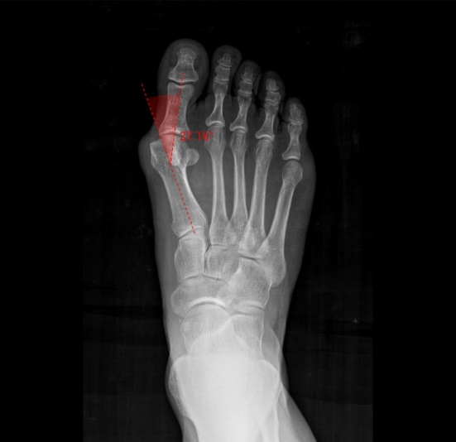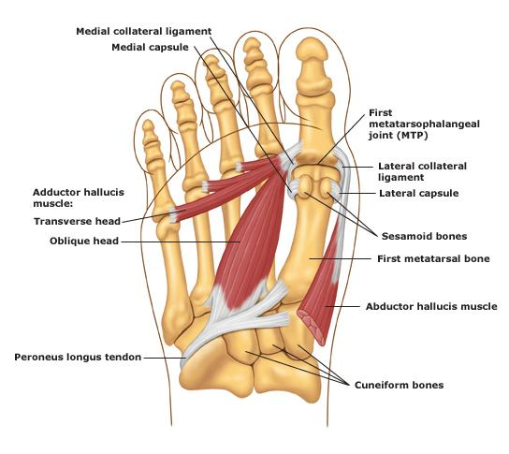
Fig 1 Clinical presentation of Hallux Valgus Bursitis (Lustosa, L. (2025); Mortka, K., & Lisiński, P. (2015).
DISCUSSION
The present case highlights a young female with severe pain and swelling over the right first metatarsophalangeal (MTP) joint, associated with fever and difficulty in walking. She also had a history of bunion deformity, which is a common condition where the big toe deviates laterally, often leading to pain, cosmetic concerns, and limitation of mobility.
On examination, the patient showed tenderness and deformity of the right MTP joint. The laboratory findings indicated raised inflammatory markers, leukocytosis, and mild thrombocytopenia, which suggested an underlying inflammatory or infective process. The elevated CRP and ultrasound findings of soft tissue swelling around the medial aspect of the first MTP joint further supported the possibility of bursitis or inflammation associated with the bunion deformity.
Bunions are often associated with local inflammation and, in some cases, may predispose to secondary infections or bursitis. In our patient, persistent symptoms and worsening pain despite medical management with NSAIDs (Etoricoxib) warranted surgical intervention. Corrective osteotomy was performed to realign the joint and relieve pain.
This case underlines the importance of timely diagnosis and management of bunions complicated by inflammation. While conservative treatment may provide relief in early stages, surgical correction becomes necessary when deformity and pain interfere with daily activities. The association of systemic features such as fever and raised inflammatory markers also reminds clinicians to evaluate for inflammatory complications
CONCLUSION
Bunion deformity, though often seen as minor, can cause serious complications if untreated. Early recognition and conservative measures (proper footwear, physiotherapy, anti-inflammatories) help in early stages, while surgery gives good long-term results in severe cases. Prognosis after surgery is generally favorable, but patient awareness and proper foot care are vital to prevent recurrence. This case highlights the importance of early interventions to improve outcomes and reduce long-term complications and Clinicians should evaluate bunion complaints early to improve outcomes and prevent disability.
CONSENT
As per international standards or university standards, patient written consent has been collected and preserved by the author(s).
ETHICAL APPROVAL
It is not applicable.

DISCLAIMER (ARTIFICIAL INTELLIGENCE)
The authors hereby certify that this work was not written or edited using any generative AI tools, including text-to-image generators and Large Language Models (Chat GPT, COPILOT, etc.).
COMPETING INTERESTS
Authors have declared that no competing interests exist.
REFERENCES
Ray, J. J., Friedmann, A. J., Hanselman, A. E., Vaida, J., & Davton, P. D. (2019). Hallux valgus: A review article. Foot and Ankle Orthopaedics, 4(2). https://doi.org/10.1177/2473011419838500
Nix, S., Smith, M., & Vicenzino, B. (2010). Prevalence of hallux valgus in the general population: A systematic review and meta-analysis. Journal of Foot and Ankle Research, 3, Article 21. https://doi.org/10.1186/1757-1146-3-21
Mitta, S. G., Kavya, G., Sridhar, O., & Aremanda, N. (2024). Prevalence of Depression in Rheumatoid Arthritis Patients in a Rheumatology Centre at Hanamkonda. Indian Journal of Pharmacy Practice, 17(4), 311-316.
Nguyen, U.-S. D. T., Hillstrom, H. J., Dufour, A. B., Kiel, D. P., Procter-Gray, E., Gagnon, M. M., & Hannan, M. T. (2010). Factors associated with hallux valgus in a population-based study of older women and men: The MOBILIZE Boston Study. Osteoarthritis and Cartilage, 18(1), 41-46. https://doi.org/10.1016/j.joca.2009.07.008
Wülker, N., & Mittag, F. (2012). The treatment of hallux valgus. Deutsches Ärzteblatt International, 109(49), 857-868. https://doi.org/10.3238/arztebl.2012.0857
Aldridge, T., & Hu, J. (2010). Hallux valgus: Diagnosis and management. American Family Physician, 82(8), 888-895. https://www.aafp.org/pubs/afp/issues/2010/1015/p888.html
Rohini, S. Chiranjit Das, Sandeep Goud Mitta (2024). A Case Report on Arthritis Induced Inflammatory Bowel Disease. Glob Acad J Med Sci, 6.
Kuhn, J., & Alvi, F. (2023). Hallux valgus. In StatPearls. StatPearls Publishing. https://www.ncbi.nlm.nih.gov/books/NBK553092/
Lustosa, L. (2025). Hallux valgus: Case study. Radiopaedia. https://doi.org/10.53347/rID-160356
Mortka, K., & Lisiński, P. (2015). Hallux valgus: A case for a physiotherapist or only for a surgeon? Literature review. Journal of Physical Therapy Science, 27(10), 3303-3307. https://doi.org/10.1589/jpts.27.3303
Parunandi, Y., Shenkeshi, S., Tanniru, S., & Mitta, S. G. (2025). A Case of Iliopsoas Hematoma in a Patient on Acenocoumarol. Indian Journal of Pharmacy Practice, 18(4), 451-454.

