Case report
A Case Report on Thyroid Nodule

ABSTRACT
Background:
Thyroid nodules are commonly encountered in clinical practice, especially in women, and require a structured evaluation to distinguish benign from malignant lesions. Ultrasound-based TI-RADS scoring and fine-needle aspiration cytology (FNAC) are essential tools in the diagnostic algorithm.
Case Presentation:
We report the case of a 27-year-old South Indian female patient from Ballari, Karnataka who presented with a painless, gradually progressive swelling on the left side of her neck for two months. Clinical examination and ultrasound revealed a heterogeneous, solitary thyroid nodule in the left lobe, measuring 3.5 × 1.5 cm. Based on TI-RADS scoring (TR3), FNAC was performed, which suggested a benign cystic lesion. However, due to the lesion’s size and uncertain cytological features, surgery was planned. Intraoperatively, the lesion was limited to the left lobe, and hemi-thyroidectomy was performed. Postoperative recovery was uneventful. The excised specimen was sent for histopathology to rule out follicular carcinoma.
Conclusion:
This case emphasizes the importance of integrating clinical, radiological, and cytological findings in managing thyroid nodules. While imaging and FNAC may suggest benignity, surgical excision may still be indicated in uncertain or large lesions. Histopathological confirmation remains the gold standard for diagnosis and planning definitive treatment.

KEYWORDS
Thyroid Nodule, TI-RADS, Hemi-thyroidectomy, FNAC, Follicular Adenoma, Solitary Neck Swelling, Cystic Thyroid Lesion, Thyroid Ultrasound, Histopathological Examination, Surgical Management

INTRODUCTION :

The American Thyroid Association (ATA) defines the thyroid nodule as a discrete lesion within the thyroid gland. It is radiologically distinct from the surrounding thyroid parenchyma. Nodules may be solitary, multiple, cystic, or solid.³ The reported prevalence of nodular thyroid disease depends on the population studied and the methods used to detect nodules. Nodule incidence increases with age, and is increased in women, in people with iodine deficiency, and after radiation exposure. Numerous studies suggest a prevalence of 2-6% with palpation, 19-35% with ultrasound, and 8-65% in autopsy data.⁵ The ATA guidelines, revised in 2009, begin by asking whether the patient has a history suggestive of a high risk for thyroid cancer. Risk factors include radiation exposure during childhood, rapid growth of a nodule, hoarseness, vocal cord paralysis, dysphagia, or a family history of thy roid cancer or multiple endocrine neoplasia syndrome. If the patient has a high-risk history, the recommendation is to obtain a biopsy specimen from any thyroid nodule larger than 5 mm in diameter with suspicious features.²

Table 1: Clinical and Pathological Classification of Thyroid Nodules⁴

CATEGORY | TYPES | SUBTYPES /EXAMPLES
NON NEOPLASTIC NODULES | 1)Hyperplastic  2)Inflammatory | : spontaneous  : compensatory after partial thyroidectomy  : acute bacterial thyroiditis  : subacute thyroiditis  : lymphocytic ( Hashimoto’s ) thyroiditis
BENIGN NEOPLASMS | 1)Non functioning  (cold nodules )  2)Functioning  ( Hot nodules ) | : solid ( or mixed) : adenoma  : cystic  : adenoma
MALIGNANT NEOPLASMS | 1)Primary carcinoma  2)Thyroid lymphoma  3)Thyroid metastasis from other primaries | : papillary carcinoma  : follicular carcinoma  : anaplastic carcinoma  : medullary carcinoma
EVALUATION OF A THYROID NODULE ¹
Clinical Presentation
- Typical Presentation:
  - A large palpable nodule in the neck
  - Incidental discovery on imaging for unrelated reasons
Malignancy Risk by Nodule Type
- Solitary nodule: Higher per-nodule malignancy risk (2.7–30%)
- Single nodule within a multinodular gland: Lower per-nodule risk (1.4–10%)
- Overall malignancy risk is similar between solitary and multinodular glands due to cumulative risk in the latter.
Historical Risk Factors for Malignancy
- Head and neck irradiation, especially in childhood
  - Relative risk = 8.7 per 1 Gy
- Rapid growth of the nodule
- Dysphagia (difficulty swallowing)
- Dysphonia (voice changes)
- Male gender
- Age extremes: <20 or >70 years
- Family history of:
  - Medullary thyroid carcinoma
  - Multiple endocrine neoplasia (MEN)
Physical Exam Findings Suggestive of Malignancy
- Nodule size > 4 cm (≈19.3% malignancy risk)
- Firmness on palpation
- Fixation to adjacent structures
- Cervical lymphadenopathy (>1 cm)
  - PPV = 100%
- Vocal fold immobility
  - PPV = 100%
Note: Voice quality alone is not a sensitive indicator of vocal fold immobility. Flexible laryngoscopy is essential for accurate evaluation.

LABORATORY STUDIES¹
- Initial Test – TSH: The first-line test for evaluating a solitary thyroid nodule is serum thyrotropin (TSH) to assess thyroid function.
- TSH Below Normal: If TSH is low, additional tests for free or total T4 and total T3 are required to assess for hyperthyroidism.
- Hyperfunctioning Nodules: About 10% of solitary nodules are associated with low TSH, indicating a likely benign hyperfunctioning adenoma.
- Hyperthyroidism Suggests Benignity: A hyperfunctioning nodule is generally considered less likely to be malignant.
- Calcitonin Testing Indication: Serum calcitonin should be measured in high-risk patients, particularly those with:
- A family history of medullary thyroid carcinoma (MTC)
- Multiple endocrine neoplasia (MEN) types 2A or 2B
- Pheochromocytoma
- Hyperparathyroidism
- Rarity of MTC: Only about 1 in 250 thyroid nodules turn out to be medullary thyroid carcinoma, making routine calcitonin screening unnecessary for most.
- Calcitonin Not Diagnostic Alone: Elevated calcitonin levels cannot reliably differentiate between benign and malignant thyroid disease.
- High Specificity Use: Because of its limited utility in general screening, calcitonin is reserved for targeted use in genetically predisposed individuals.
- TSH as a Triage Tool: The TSH level helps guide the diagnostic pathway—toward imaging or toward biochemical workup for hyperthyroidism.
- Euthyroid Majority: Most patients with a thyroid nodule will be euthyroid, reinforcing TSH as a cost-effective initial screening test.

EVALUATION OF SOLITORY THYROID NODULE EVALUATION.⁹
Chart 1 : SOLITORY THYROID NODULE
- TAKE HISTORY AND CLINICAL EXAMINATION
- GO FOR THYROID PROFILE ( T3/T4/TSH)

LOW TSH NORMAL TSH / HIGH TSH
HYPERTHYROIDISM EUTHYROID/HYPOTHYROIDISM
RADIOIDOINE SCAN
I¹²³/I¹³¹/Tc⁹⁹ CAPSULE
After 1HR/2HR/4HR of ingestion
USG was repeated
- ONLY THYOID NODULE TAKEN THE IODINE NOT THE GLAND = HOT NODULE = 1% RISK OF MALIGNANCY = TREATMENT : GIVE ANTITHYROID DRUGS FOR 6MONTHS

- BOTH THYROID NODULE AND GLAND TAKEN IODINE EQUALLY = WARM NODULE = 1-5% RISK OF MALIGNANCY
- THYROID GLAND TAKEN THE IODINE NOT THE THYROID NODULE = COLD NODULE = 15-20% RISK OF MALIGNANCY

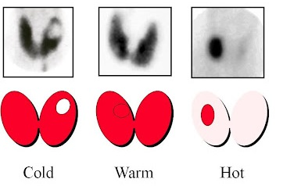

If the thyroid nodules are hot nodules the treatment is antithyroid drugs , The Thionamide drugs, i.e. carbimazole and its metabolite methimazole (MMI), and propylthiouracil (PTU) have extensively been used in the management of various forms of hyperthyroidism over the past eight decades.⁶ for warm and cold nodules further evaluation done as following
IMAGE 1 : COLD/WARM/HOT THYROID NODULE DIFFERENTIATION ¹⁰

FOR WARM NODULES/COLD NODULES/EUTHYROID/HYPOTHYROIDISM

SIZE OF NODULE : ≥ 1CM ≤ 1CM
FNAC 23G 27G (IOC) FOLLOW UP

BETHESDA SYSTEM FOR REPORTING THYROID CYTOPATHOLOGY⁷
Diagnostic category
Category 1: Nondiagnostic or unsatisfactory
Category 2: Benign
Category 3: Atypia of undetermined significance or follicular lesion of undetermined significance
Category 4: Follicular neoplasm or suspicious for a follicular neoplasm
Category 5: Suspicious for malignancy
Category 6: Malignant
- Non diagnostic ( thy 1 ) : Repeat FNAC USG Guided
- Benign ( thy 2) : follow up
- AUS /FLUS (thy3A) : follow up/ repeat FNAC /molecular markers , MM can be genetic/immune cytogenic/epigenetic ( mutations like BRAF in papillary thyroid cancer / RAS mutation in follicular thyroid cancer/ RET mutation in medullary thyroid cancer/p53 mutation in anaplastic thyroid cancer.
- Genetic : 1) BRAF in papillary thyroid cancer 2) RAS mutation in follicular thyroid cancer 3) RET mutation in medullary thyroid cancer 4) p53 mutation in anaplastic thyroid cancer
- immune cytogenic : 1)galectin 3 marker in FTC /PTC 2) HBME1 marker in PTC 3) cytokeratin 19 marker in PTC, cytokeratin 7/18 marker in MTC 4) VEGF marker lymph node metastasis
- epigenetic : DNA methylation / micro RNA
4. follicular neoplasm ( thy 3 f) : hemithyroidectomy = HPE = vascular invasion and capsular invasion
If vascular invasion and capsular invasion +present , it is Follicular carcinoma = complete thyroidectomy
If vascular invasion and capsular invasion – absent , it is Follicular adenoma = no further treatment
5. highly suspicious malignancy ( thy 4) : surgery = total/hemithyroidectomy
6. malignancy (thy 5) : surgery = total/hemithyroidectomy

OVERVIEW OF ACR TI-RADS ⁸
The ultrasound features in the ACR TI-RADS are categorized as benign, minimally suspicious, moderately suspicious, or highly suspicious for malignancy. Points are given for all the ultrasound features in a nodule, with more suspicious features being awarded additional points. Image 2

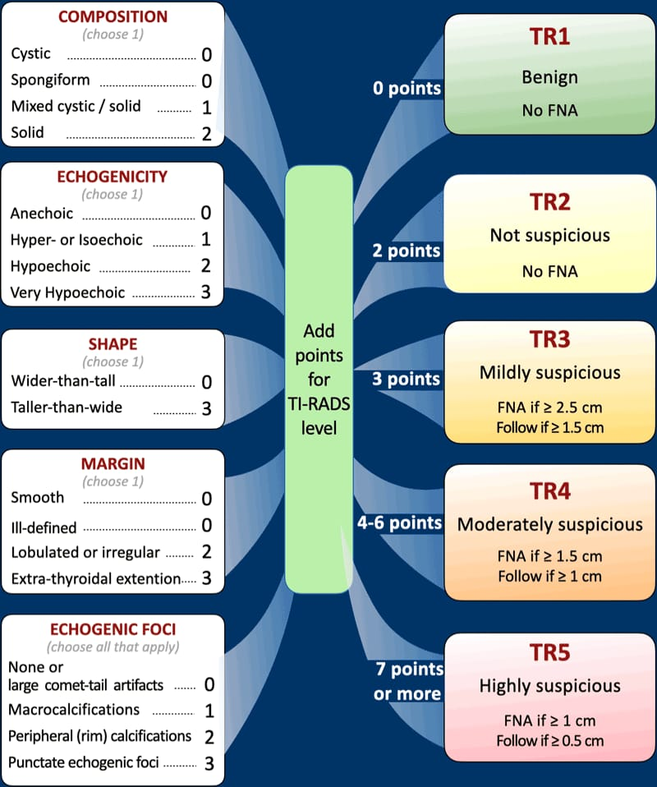

CASE REPORT :
A 27 year old female patient was admitted under surgery c unit in Ballari Medical College and Research Centre. With a chief complaint of : swelling in front of the neck region since 2 months.
HOPC : PWAN 2 months back then she developed swelling in the neck region which was insidious in onset and gradually progressive not associated with…
- Pain in the swelling
- Difficulty in swallow
- Difficulty in breathing
- Weight gain /weight loss
- Cough cold and throat pain
- No symptoms of hypo/hyperthyroidism
IMAGE : 2 . Chart showing five categories on the basis of the ACR Thyroid Imaging, Reporting and Data System (TI-RADS)

Past history
- No history of similar complaints in the past
- N/K/C/O T2DM/HTN/Hypo/Hyper-Thyroidism
On examination patient BP was 120/80mm/Hg , PR : 90bpm, Spo2 : 99% under RA and PICCLE was NEGATIVE
LOCAL EXAMINATION OF NECK
INSPECTION : Swelling present over left side of Neck , Moves with deglutition
PALPATION : Swelling over left lobe moves with deglutition , surface is smooth, firm and mobile.
No eye signs or any other signs of hypo/hyperthyroidism
On systemic examination : CVS : S1S2 heard no murmur, CNS : conscious and oriented , RS : B/L NVBS positive, P/A : soft non tender , no organomegaly.
List 1 : LABORATORY DATA
TERPARAMETERS | RESULTS | REFERENCE RANGE
Hemoglobin | 11.0 | 14 - 18 g/dl
RBC | 4.5 | 4.5-5.5million/cumm
WBC | 13920 | 4500 - 11,000 cells/cumm
Platelets | 3.29 | 1.5 – 4.5 lacs/cumm
Differential count  Neutrophils | 53% | 60-70%
Lymphocytes | 40% | 25-50%
Eosinophils | 03% | 0-4%
Monocytes | 04% | 2-10%
MCV | 75.7% | 80-100fl
Serum creatinine | 0.8mg% | 0.6 – 1.4 mg%g/dl
SERUM ELECTROLYTES  Sodium | 145mEq/L | 136-145mEq/L
Potassium | 5.3mEq/L | 3.4-5mEq/L
Chloride | 101mEq/L | 96-106mEq/L
SEROLOGY  HIV I and II  HbsAg  HCV | Non reactive  Negative  Negative
RBS | 98mg/dl | 70-140mg/dl
Serum creatinine | 0.8mg% | 0.6 – 1.4 mg%
SERUM ELECTROLYTES  Sodium | 145mEq/L | 136-145mEq/L
Potassium | 5.3mEq/L | 3.4-5mEq/L
Chloride | 101mEq/L | 96-106mEq/L
RBS | 98mg/dl | 70-140mg/dl
Thyroid profile  Free T3  Free T4  TSH | 2.45  0.92  0.33 | 2.02-4.43pg/ml  0.92-1.66ng/dl  0.27-4.2mlU/ml

OTHER SUPPORTING REPORTS
USG OF NECK :
Right lobe and Isthmus : normal in size and echotexture
Left lobe : Enlarged and shows heterogenous lesion of size 3.5 x 1.5 cm
B/L Parotid and submandibular glands : appear normal
IMPRESSION : BENIGN THYROID NODULE IN THE LEFT LOBE (TI-RADS 3)
ENT OPINION:
- Throat : oral cavity : mouth opening adequate
- Oropharynx : no abnormality detected
- Neck : right side –normal
left side shows solitary swelling 3 x 1.5cm , firm in consistency, non tender, mobile , move with deglutition , skin over the swelling normal

IMPRESSION : BENIGN THYROID NODULE IN THE LEFT LOBE

FNAC REPORT :

Microscopy Findings:
On aspiration, a blood-mixed aspirate was obtained . Cellular features observed : Follicular epithelial cells seen as repetitive follicles . Loose groups, disorganised clusters, cyst macrophages, and hemosiderin-laden macrophages in colloid background.
🧾 Impression (Diagnosis):Features are suggestive of a cystic lesion of the thyroid . A cystic lesion implies that the swelling is at least partly fluid-filled, and in this context, is likely benign. ( Bethesda Category 3: Atypia of undetermined significance or follicular lesion of undetermined significance ) so the surgeon was planned for the total thyroidectomy

A 27-year-old female presented with a gradually progressive, painless swelling over the left side of the neck for 2 months, without associated symptoms like difficulty in swallowing, breathing, weight change, or pain. On examination, the swelling was firm, smooth, mobile, and moved with deglutition—suggestive of thyroid origin. Vitals and systemic examination were within normal limits. Lab investigations revealed mild anemia (Hb 11 g/dL), leukocytosis (WBC 13,920 cells/cumm), and microcytosis (MCV 75.7 fL). Thyroid function tests were within normal limits. Ultrasound showed a heterogeneous lesion (3.5 × 1.5 cm) in the left thyroid lobe. FNAC revealed follicular epithelial cells and hemosiderin-laden macrophages in a colloid background, consistent with a benign cystic thyroid lesion. Overall, the findings are suggestive of a benign cystic thyroid nodule, so the surgeons were decided for the total thyroidectomy.

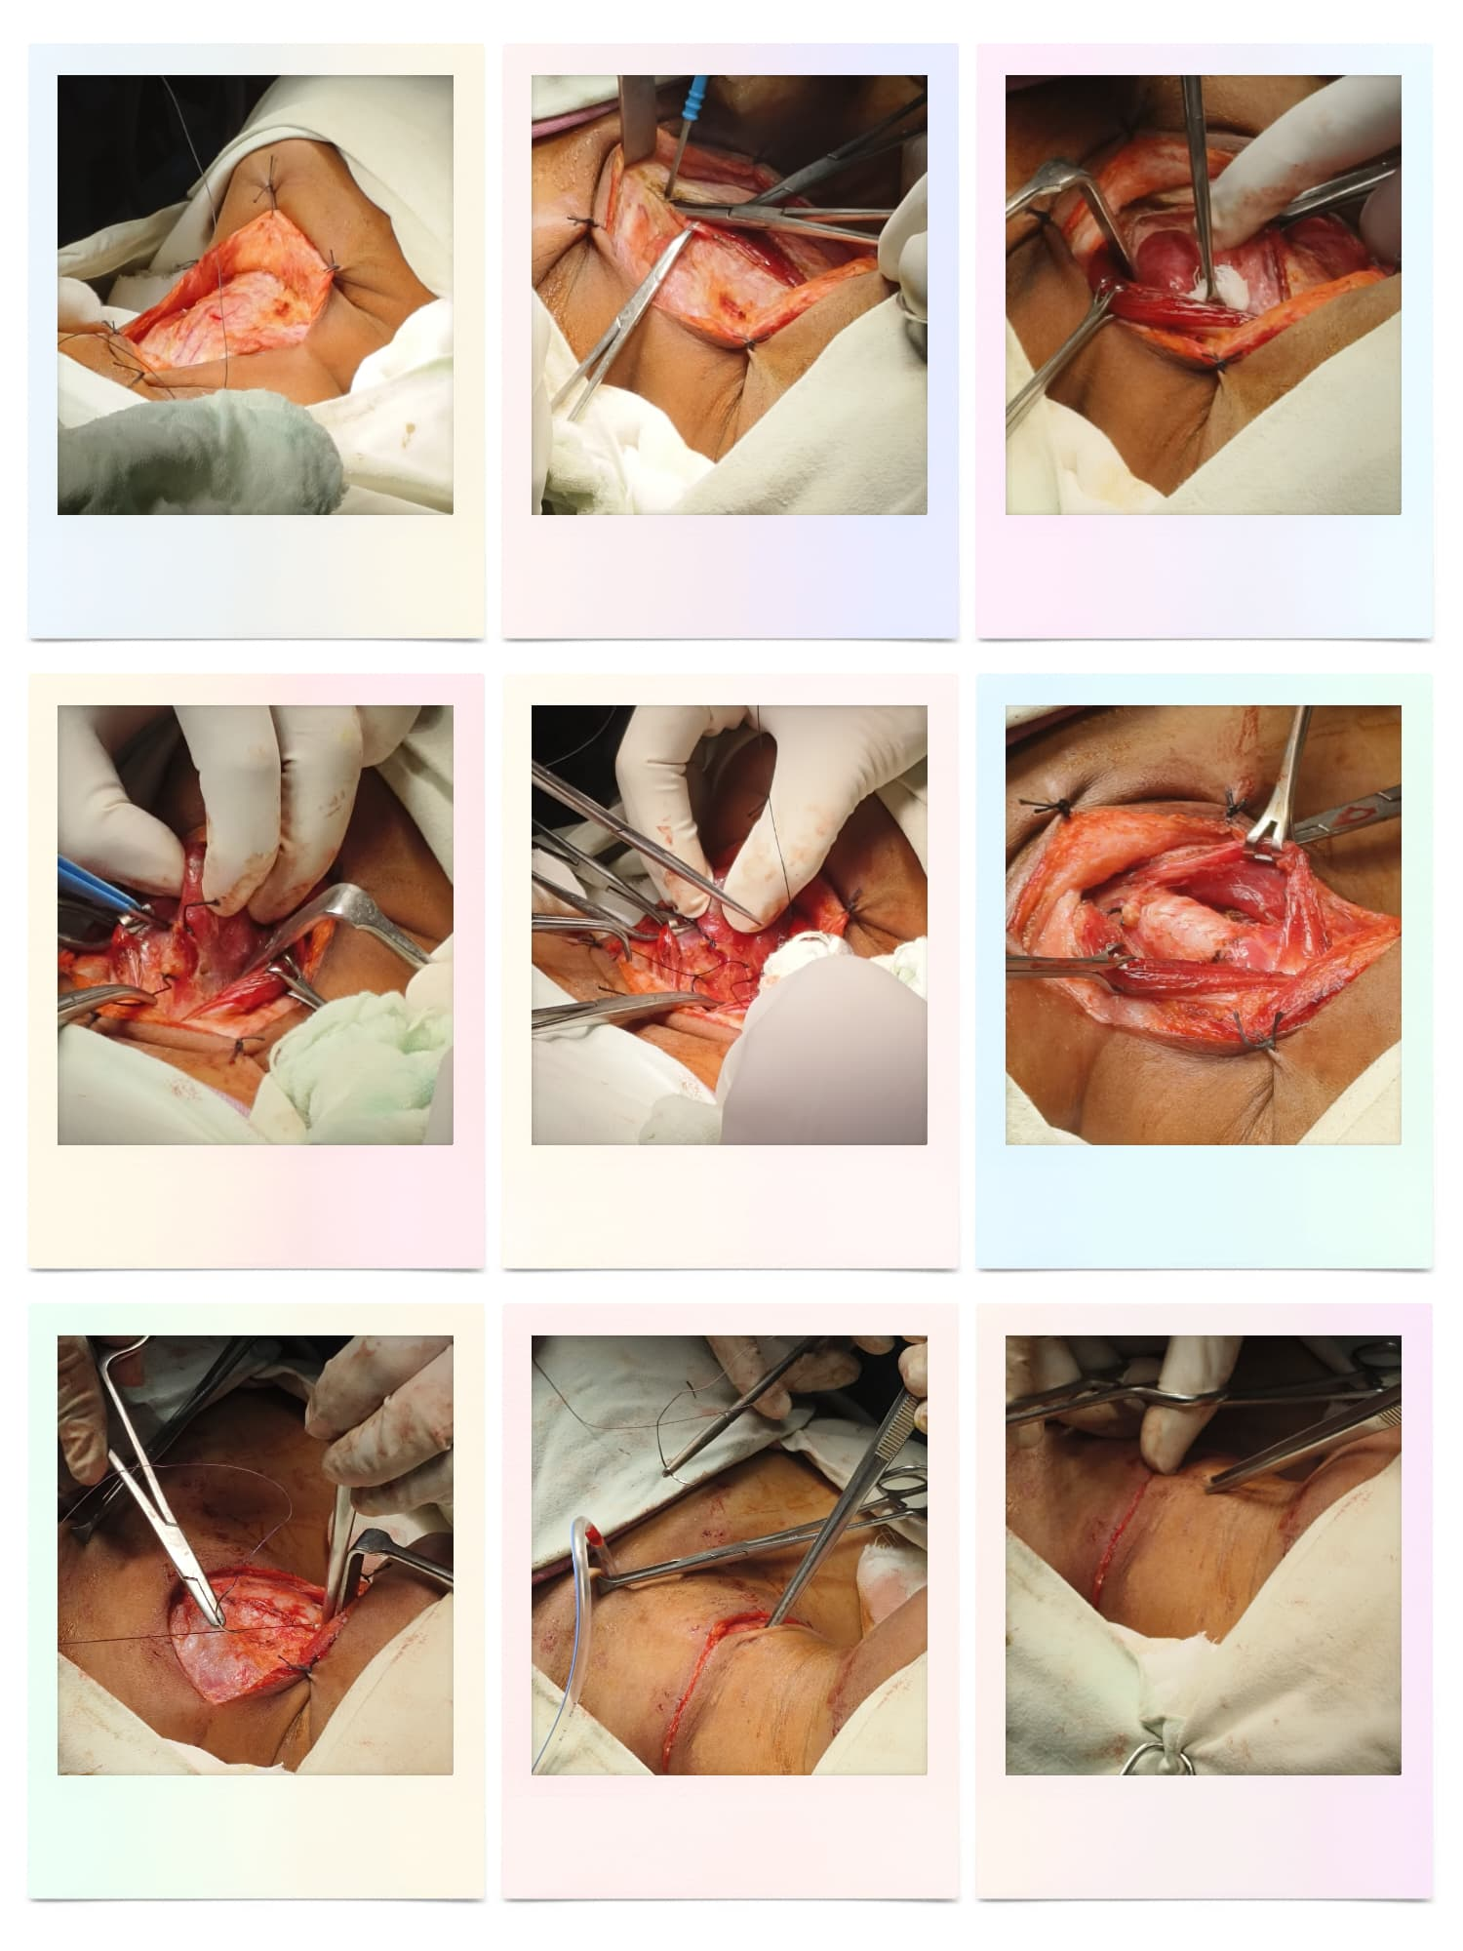
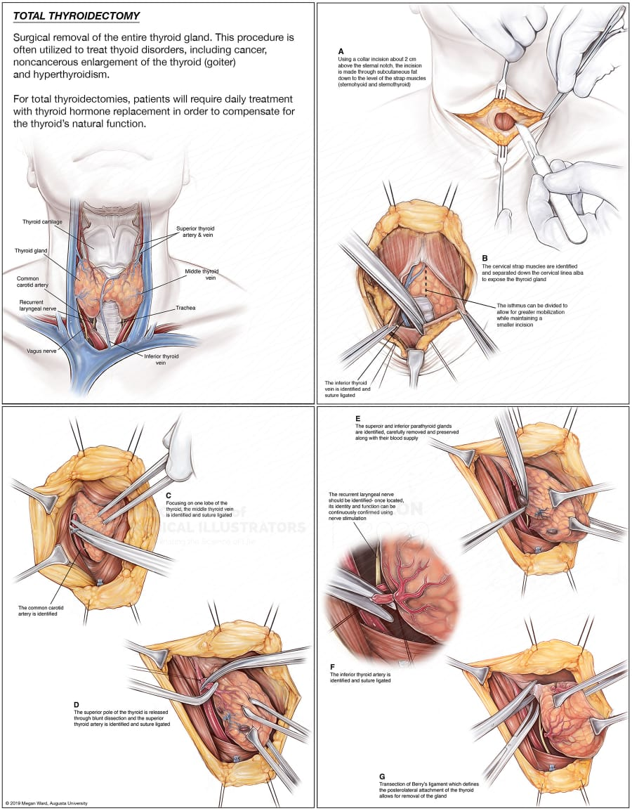
IMAGE : 03 THYROIDECTOMY PROCEDURE ¹¹
SURGICAL STEPS
A. Initial Incision and Exposure
- A collar incision is made ~2 cm above the sternal notch.
- Skin, subcutaneous tissue, and strap muscles (sternohyoid and sternothyroid) are dissected to expose the thyroid.
- Retractors are placed to maintain exposure.
B. Midline Separation and Isthmus Division
- Strap muscles are retracted laterally.
- The midline (linea alba) is opened.
- The isthmus (connects the two thyroid lobes) is divided for better access.
C. Middle Thyroid Vein Ligation
- One thyroid lobe is exposed.
- The middle thyroid vein is identified and ligated.
- The common carotid artery is used as a landmark.
D. Superior Pole Dissection
- The superior pole of the thyroid is mobilized.
- Superior thyroid vessels are identified and ligated carefully to avoid injury to the external branch of the superior laryngeal nerve.
E. Preservation of Parathyroid Glands and Nerves
- Superior and inferior parathyroid glands are identified and preserved along with their blood supply.
- This is critical to prevent hypocalcemia post-op.
- The recurrent laryngeal nerve (RLN) is carefully dissected and preserved.
F. Inferior Thyroid Artery Ligation
- The inferior thyroid artery is ligated.
- Great care is taken to preserve the RLN as it travels near this artery.
G. Final Mobilization and Gland Removal
- The Berry’s ligament (attaches thyroid to trachea) is divided.
- This allows the gland to be completely freed and removed.
This steps for the total thyroidectomy , but for this patient during surgery , the surgeon observed swelling in left lobe of the neck so they did LEFT HEMI THYROIDECTOMY. And the biopsy was sent for the histopathological examination.
List 2 : TREATMENT CHART
NAME OF MEDICATION | DOSE | ROUTE | FREQ | D1 | D2 | D3
PRE OP  REGULAR DIET |  |  |  | * | * | *
POST OP  NBM |  |  |  | * | *
IVF | 2pint RL  2pint NS  1pint DNS | IV | @100ml/hr | *
INJ AMOXICILLIN + CLAVULENIC ACID | 1.2g | IV | 1-0-1 | * | *
INJ METRONIDAZOLE | 500mg | IV | 1-1-1 | * | *
INJ PANTOPRAZOLE | 40mg | IV | 1-0-0 | * | *
INJ PARACETAMOL | 1gm | IV | 1-0-1 | * | *
INJ ONDANSETRON | 4mg | IV | SOS | * | *
INJ DICLOFENAC | 50mg in 100ml NS | Infusion | 1-0-1 | * | *

Following left hemi-thyroidectomy, the patient was placed NBM (nil by mouth) to prevent aspiration during the immediate post-operative period. Intravenous fluids including Ringer Lactate (RL), Normal Saline (NS), and Dextrose Normal Saline (DNS) were administered at 100 ml/hr to maintain hydration, electrolyte balance, and energy supply. Inj. Amoxicillin + Clavulanic Acid (1.2 g IV BID) was given as a broad-spectrum antibiotic to prevent surgical site infection; amoxicillin inhibits bacterial cell wall synthesis, while clavulanic acid inactivates beta-lactamase enzymes. Inj. Metronidazole (500 mg IV TID) was added to cover anaerobic organisms by disrupting DNA synthesis in bacteria. Inj. Pantoprazole (40 mg IV OD), a proton pump inhibitor, was prescribed to reduce gastric acid secretion and prevent stress-related mucosal damage or gastritis. Inj. Paracetamol (1 g IV BID) provided analgesia and antipyretic effect through central inhibition of prostaglandin synthesis. Inj. Ondansetron (4 mg IV SOS), a 5-HT3 receptor antagonist, was prescribed to manage postoperative nausea and vomiting by blocking serotonin receptors in the chemoreceptor trigger zone. Inj. Diclofenac (50 mg in 100 ml NS IV BID), a non-steroidal anti-inflammatory drug (NSAID), was administered via infusion to provide additional analgesia by inhibiting cyclooxygenase (COX) enzymes and reducing prostaglandin production, thereby alleviating pain and inflammation. Together, this regimen ensures optimal post-operative care, reduces the risk of complications, and supports smooth recovery.
Drain removed on 15/04/25 . Patient is hemodynamically stable symptomatically better hence being discharged with the following advice.
List 3 : DISCHARGE MEDICATION
Name of medication | Dose | Route | Frequency
Regular diet
TAB AMOXICLAV | 625mg | PO | 1-0-1 for 5 days
TAB PCT | 500mg | PO | 1-0-1 for 5 days
TAB PANTOP | 40mg | PO | 1-0-0 for 5 days
To review in surgery C unit on Wednesday OPD after 3weeks with TFT and Serum Calcium
To rule any hypothyroidism /hypocalcaemia

DISCUSSION
A 27-year-old female presented with a gradually progressive, painless swelling over the left side of the neck for 2 months, without associated symptoms like difficulty in swallowing, breathing, weight change, or pain. On examination, the swelling was firm, smooth, mobile, and moved with deglutition, so the surgeon was advised to take a report of thyroid profile , which was normal so advise for USG of Neck : which suggesting : BENIGN THYROID NODULE IN THE LEFT LOBE, Based on the ultrasound findings and applying the TI-RADS (Thyroid Imaging Reporting and Data System) criteria, the thyroid lesion in the left lobe measures 3.5 x 1.5 cm and appears heterogeneous in echotexture. This suggests a mixed cystic and solid composition (1 point) with likely hypoechoic echogenicity (2 points). The lesion shape is presumed wider-than-tall (0 points), with smooth margins (0 points), and no mention of echogenic foci (0 points). The total TI-RADS score is therefore 3, placing it in the TR3 category, which indicates a mildly suspicious nodule. According to TI-RADS guidelines, for a TR3 nodule measuring 2.5 cm or more, fine needle aspiration (FNA) is recommended. Given the lesion size of 3.5 cm, FNAC would be indicated in this case for further evaluation , so the surgeon advised the FNAC , impression was : Features are suggestive of a cystic lesion of the thyroid . A cystic lesion implies that the swelling is at least partly fluid-filled, and in this context, is likely benign. even the FNAC not confirmed the benign tumor , it given as query so the surgeons are decided to go for total thyroidectomy , but during surgery they observed swelling only left lobe of the thyroid gland so they did the Left hemithyroidectomy and sent this biopsy to pathology department for histopathological examination to see for vascular invasion and capsular invasion if it is present they which conclude follicular carcinoma and they call back the patient and perform total thyroidectomy if it is negative no further treatment , Following hemi-thyroidectomy, the patient was placed NBM (nil by mouth) to prevent aspiration during the immediate post-operative period. Intravenous fluids including Ringer Lactate (RL), Normal Saline (NS), and Dextrose Normal Saline (DNS) were administered at 100 ml/hr to maintain hydration, electrolyte balance, and energy supply. Inj. Amoxicillin + Clavulanic Acid (1.2 g IV BID) was given as a broad-spectrum antibiotic to prevent surgical site infection; amoxicillin inhibits bacterial cell wall synthesis, while clavulanic acid inactivates beta-lactamase enzymes. Inj. Metronidazole (500 mg IV TID) was added to cover anaerobic organisms by disrupting DNA synthesis in bacteria. Inj. Pantoprazole (40 mg IV OD), a proton pump inhibitor, was prescribed to reduce gastric acid secretion and prevent stress-related mucosal damage or gastritis. Inj. Paracetamol (1 g IV BID) provided analgesia and antipyretic effect through central inhibition of prostaglandin synthesis. Inj. Ondansetron (4 mg IV SOS), a 5-HT3 receptor antagonist, was prescribed to manage postoperative nausea and vomiting by blocking serotonin receptors in the chemoreceptor trigger zone. Inj. Diclofenac (50 mg in 100 ml NS IV BID), a non-steroidal anti-inflammatory drug (NSAID), was administered via infusion to provide additional analgesia by inhibiting cyclooxygenase (COX) enzymes and reducing prostaglandin production, thereby alleviating pain and inflammation. Together, this regimen ensures optimal post-operative care, reduces the risk of complications, and supports smooth recovery.
Drain removed on 15/04/25 . Patient is hemodynamically stable symptomatically better hence being discharged with the following advice.

CONCLUSION :
This case report presents a 27-year-old female with a solitary thyroid nodule in the left lobe of the thyroid gland, who underwent hemi-thyroidectomy after evaluation. Clinical examination, thyroid profile, and imaging (ultrasound) indicated a benign, heterogeneous lesion with a TI-RADS score of 3, warranting FNAC. Cytology suggested a cystic lesion, but due to inconclusive confirmation of benignity and the lesion size, surgery was advised. Intraoperatively, the swelling was confined to the left lobe, leading to hemi-thyroidectomy. Postoperative care was appropriately managed with antibiotics, analgesics, and supportive measures. Histopathology was sent for confirmation of malignancy or adenoma. This case highlights the role of TI-RADS and FNAC in guiding management, the importance of intraoperative judgment, and the need for histological correlation to establish a definitive diagnosis and guide further treatment if necessary.

DECLARATIONS
Ethics approval and consent to participate
Ethics approval was not required for this case report as per the institutional policy. Written informed consent for participation was obtained from the patient.

CONSENT FOR PUBLICATION
Written informed consent was obtained from the patient for publication of this case report and any accompanying clinical data and images. A copy of the signed consent form is available for review by the editorial office upon request.
AVAILABILITY OF DATA AND MATERIALS
All data generated or analysed during this case report are included in this published article.

FULL FORM OF THE ABBREVATIONS
HOPC : history of present complaints
PWAN : patient was apparently normal
N/K/C/O : Not a known case of
T2DM : type 2 diabetes mellitus
HTN : hypertension
PICCLE : pallor/icterus/clubbing/cyanosis/lymphadenopathy/oedema
BP : blood pressure
PR : pulse rate
Spo2 : saturation
CVS : cardiovascular system
CNS : central nervous system
RS : respiratory system
P/A : per abdomen
IOC : investigation of choice
FTC : follicular thyroid carcinoma1
PTC : papillary thyroid carcinoma
MTC : medullary thyroid carcinoma
ATC : anaplastic thyroid carcinoma
FNAC : fine needle aspiration cytology

REFERENCES :
      - Bomeli SR, LeBeau SO, Ferris RL. Evaluation of a thyroid nodule. Otolaryngologic Clinics of North America. 2010 Apr;43(2):229.
      - Levine RA. Current guidelines for the management of thyroid nodules. Endocrine Practice. 2012 Jul 1;18(4):596.
      - Bookshelf NC. A service of the national library of medicine, National Institutes of Health. Stat Pearls; Stat Pearls Publishing: Treasure Island, FL, USA. 2020.
      - Pemayun TG. Current diagnosis and management of thyroid nodules. Acta Med Indones. 2016 Jul 1;48(3):247-57.
      - Dean DS, Gharib H. Epidemiology of thyroid nodules. Best practice & research Clinical endocrinology & metabolism. 2008 Dec 1;22(6):901-11.
      - Abdi H, Amouzegar A, Azizi F. Antithyroid drugs. Iranian journal of pharmaceutical research: IJPR. 2019;18(Suppl1):1.
      - Tan H, Li Z, Li N, Qian J, Fan F, Zhong H, Feng J, Xu H, Li Z. Thyroid imaging reporting and data system combined with Bethesda classification in qualitative thyroid nodule diagnosis. Medicine. 2019 Dec 1;98(50):e18320.
      - Tessler FN, Middleton WD, Grant EG, Hoang JK, Berland LL, Teefey SA, Cronan JJ, Beland MD, Desser TS, Frates MC, Hammers LW. ACR thyroid imaging, reporting and data system (TI-RADS): white paper of the ACR TI-RADS committee. Journal of the American college of radiology. 2017 May 1;14(5):587-95.
      - Cooper DS, Doherty GM, Haugen BR, Kloos RT, Lee SL, Mandel SJ, Mazzaferri EL, McIver B, Sherman SI, Tuttle RM. Management guidelines for patients with thyroid nodules and differentiated thyroid cancer: The American Thyroid Association Guidelines Taskforce. Thyroid. 2006 Feb 1;16(2):109-42.
      - https://step1.medbullets.com/endocrine/109022/solitary-thyroid-nodule
      - https://meetingarchive.ami.org/2020/project/total-thyroidectomy/

