Case report

Isolated posterior atypical presentation of Vogt-Koyanagi-Harada syndrome in a young girl: a rare case report

Abstract
Background: Vogt-Koyanagi-Harada (VKH) disease is a rare autoimmune disorder affecting melanocyte-rich tissues, including the uvea, meninges, skin, and inner ear. Posterior involvement is typical, yet isolated posterior forms are exceptionally rare and diagnostically challenging.
We present a pediatric case of atypical isolated posterior VKH successfully managed with corticosteroid therapy.
Case Presentation: A 15-year-old girl presented with sudden bilateral visual loss following diffuse headaches. Fundus examination revealed serous retinal detachments in both eyes. Optical coherence tomography (OCT) showed multilobulated subretinal fluid and disruption of outer retinal layers. Fluorescein angiography demonstrated multiple pinpoint hyperfluorescent leaks and dye pooling, while indocyanine green angiography revealed delayed choroidal perfusion. Laboratory and imaging workup excluded other causes such as posterior scleritis, infectious choroiditis, and central serous chorioretinopathy. She was treated with intravenous methylprednisolone followed by oral tapering, leading to marked improvement in vision and anatomical resolution.
Conclusion: Isolated posterior atypical VKH is an uncommon presentation that may mimic several inflammatory or infectious choroidopathies. Early recognition and aggressive corticosteroid therapy are key to achieving favorable visual outcomes and preventing chronic evolution.
Keywords: Vogt-Koyanagi-Harada disease, posterior uveitis, corticosteroid therapy, pediatric uveitis, case report.

Introduction
Vogt-Koyanagi-Harada (VKH) disease is a multisystem autoimmune condition characterized by a granulomatous panuveitis associated with systemic findings such as meningismus, tinnitus, alopecia, and vitiligo. It primarily targets melanocyte-containing tissues, reflecting a T-cell-mediated immune response directed against melanocytic antigens. The estimated incidence varies geographically, being more prevalent among Asian, Middle Eastern, and Hispanic populations.
Typically, VKH presents with bilateral granulomatous uveitis involving both anterior and posterior segments. However, atypical or incomplete forms limited to the posterior segment have been infrequently described, especially in pediatric patients. Such presentations pose diagnostic challenges, as they can mimic conditions like sympathetic ophthalmia, posterior scleritis, or central serous chorioretinopathy.
Recent advances in multimodal imaging, including OCT and indocyanine green angiography (ICGA), have improved diagnostic precision by identifying distinctive features of choroidal inflammation. Early diagnosis and timely initiation of high-dose corticosteroid therapy are critical to achieving visual recovery and preventing progression to chronic, depigmenting stages.

Case Presentation
A 15-year-old girl with no significant medical history presented to the Ophthalmology Department with a three-day history of progressive bilateral visual loss, preceded by diffuse headache. She denied ocular trauma, surgery, or systemic symptoms such as fever, rash, or recent infection.
On ophthalmologic examination, best-corrected visual acuity was counting fingers at 1 meter in both eyes. Intraocular pressures were within normal limits. The anterior segments were quiet, without keratic precipitates, anterior chamber cells, or flare. Fundus examination showed loss of the foveal reflex and multiple localized serous retinal detachments at the posterior pole bilaterally.

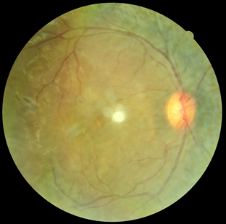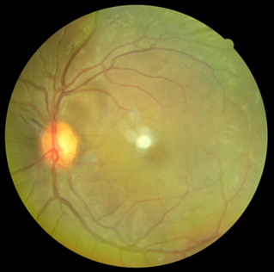
Fig .1 Spectral-domain optical coherence tomography (SD-OCT)
Spectral-domain optical coherence tomography (SD-OCT) revealed multilobulated serous retinal detachments with hyperreflective septa and outer retinal layer disruption, consistent with exudative detachment. Fluorescein angiography demonstrated multiple pinpoint hyperfluorescent leaks in the early phase, followed by pooling of dye in the subretinal space. Indocyanine green angiography showed delayed choroidal filling and late hypocyanescent spots suggestive of choroidal inflammation.

Fig.2 Spectral-domain optical coherence tomography (SD-OCT)

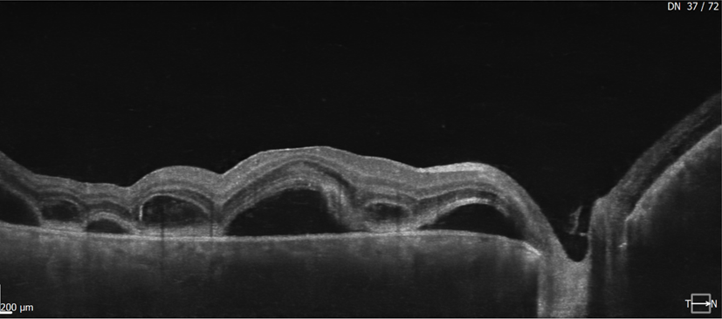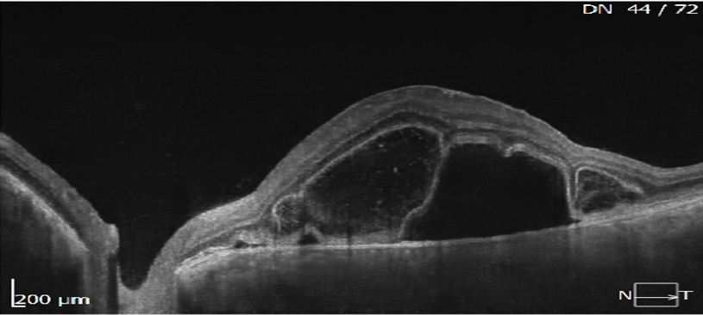

Fig.3 Fluorescein angiography
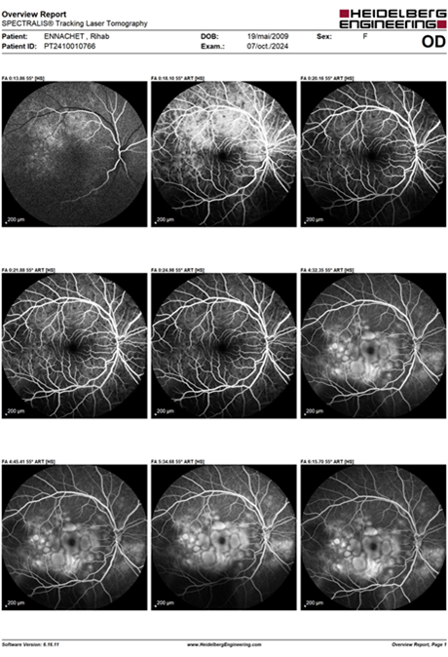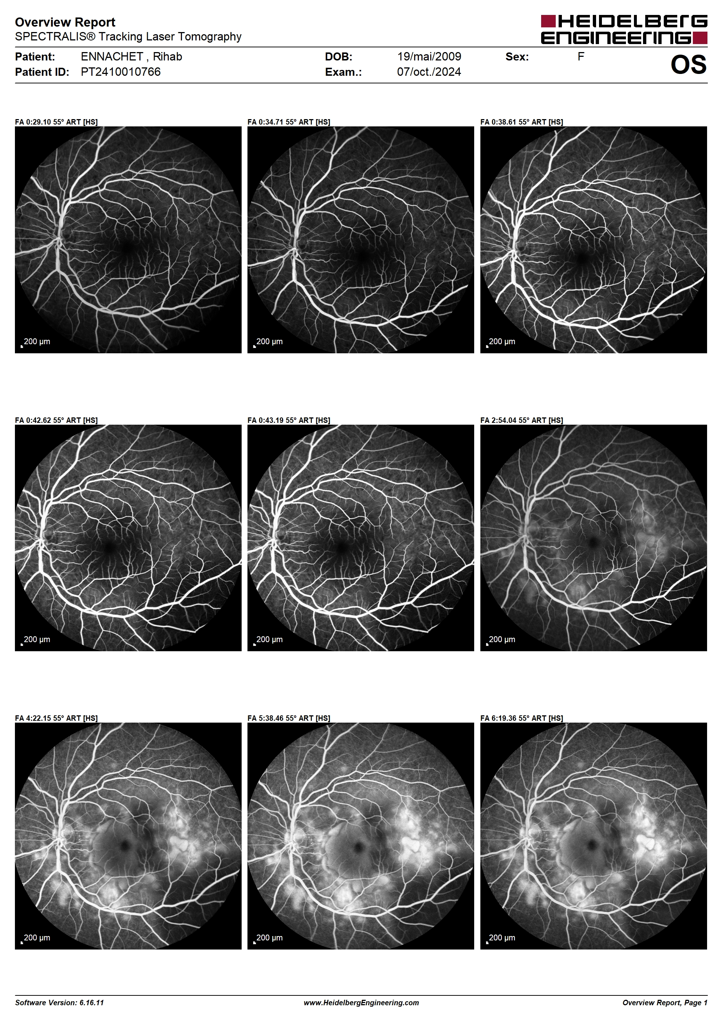

Fig.4 Indocyanine green angiography
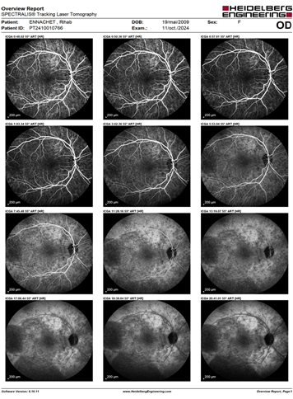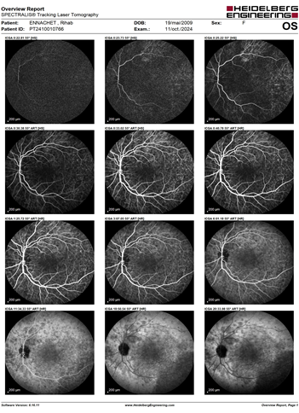

Extensive laboratory workup was conducted to exclude infectious and autoimmune etiologies, including tests for syphilis, tuberculosis, sarcoidosis, toxoplasmosis, and viral infections—all negative. Cerebrospinal fluid analysis showed normal cell count and protein levels, without pleocytosis. HLA typing identified positivity for HLA-DR4, supporting the diagnosis of VKH. Pure-tone audiometry revealed mild bilateral sensorineural hearing loss.
The patient was admitted and received intravenous methylprednisolone at 15 mg/kg/day for three consecutive days, followed by oral prednisolone at 1 mg/kg/day with calcium and potassium supplementation. Topical corticosteroids and cycloplegic drops were also administered. Visual acuity improved to 5/10 in the right eye and 8/10 in the left eye after one month. Follow-up OCT showed almost complete resolution of subretinal fluid and restoration of foveal contour. The corticosteroid dose was gradually tapered over three months without relapse.
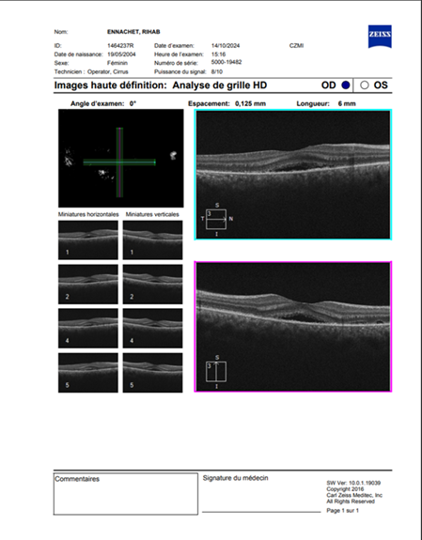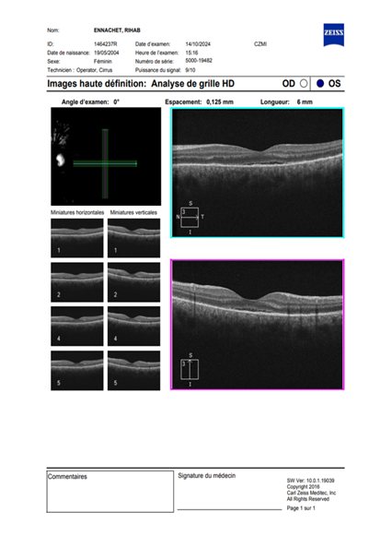
Fig.5 OCT (Optical Coherence Tomography) macular scan report

Discussion
VKH disease represents a T-cell-mediated autoimmune response targeting melanocytes, leading to diffuse granulomatous inflammation of the uveal tract. The disease course is classically divided into four stages: prodromal, acute uveitic, convalescent, and chronic recurrent. Our case corresponds to the acute uveitic stage, manifesting exclusively as posterior segment involvement without anterior inflammation.
The atypical posterior form of VKH is rarely reported, particularly in children. Isolated posterior involvement may delay diagnosis, as initial symptoms—such as headache and visual loss—can mimic other choroidal or retinal pathologies. Differentiation from sympathetic ophthalmia is crucial; however, the absence of ocular trauma or surgery rules out this possibility. Posterior scleritis may also present with serous retinal detachment but is typically associated with scleral thickening on ultrasonography and pain on ocular movement, which were absent here.
Multimodal imaging plays a pivotal role in establishing the diagnosis. OCT demonstrates multilobulated serous detachment and disruption of the photoreceptor layers, while ICGA detects choroidal hypoperfusion and inflammatory foci even before fundoscopic signs appear. These findings are highly suggestive of VKH and help differentiate it from central serous chorioretinopathy, which shows focal leakage and no choroidal inflammation.
High-dose systemic corticosteroids remain the cornerstone of therapy, particularly when initiated early during the acute phase. Several studies have shown that prompt corticosteroid treatment reduces recurrence rates and prevents chronic depigmenting complications such as “sunset-glow” fundus. In refractory or recurrent cases, immunosuppressive agents such as azathioprine, cyclosporine, or mycophenolate mofetil may be added. Biologic therapies targeting TNF-alpha have also shown efficacy in resistant VKH.
Our patient responded favorably to systemic corticosteroids alone, highlighting the effectiveness of early aggressive treatment. The absence of recurrence during follow-up further supports the importance of early recognition and sustained corticosteroid tapering. Pediatric VKH cases, although rare, tend to have better outcomes when treatment is initiated before chronicity sets in.
This case contributes to the limited literature on isolated posterior atypical VKH presentations in children and underscores the value of multimodal imaging in differentiating it from mimicking conditions. Awareness among clinicians is essential, as early diagnosis can prevent irreversible vision loss and reduce systemic morbidity.

Conclusion
Isolated posterior atypical VKH syndrome is an uncommon but important diagnostic consideration in young patients presenting with bilateral exudative retinal detachments and headache. Early multimodal imaging, exclusion of infectious causes, and prompt initiation of corticosteroid therapy are critical for visual recovery. Long-term follow-up is recommended to monitor for recurrence and ensure complete disease resolution.

References
1. Read RW, et al. Revised diagnostic criteria for Vogt-Koyanagi-Harada disease. Am J Ophthalmol. 2001;131(5):647-652.
2. Moorthy RS, et al. Vogt-Koyanagi-Harada syndrome. Surv Ophthalmol. 1995;39(4):265-292.
3. Yang P, et al. Clinical features and outcomes of Vogt-Koyanagi-Harada disease in Chinese patients. Ophthalmology. 2007;114(3):606-614.
4. Rao NA. Pathology of Vogt-Koyanagi-Harada disease. Int Ophthalmol. 2007;27(2-3):81-85.
5. Tabbara KF, et al. Vogt-Koyanagi-Harada disease in children. Retina. 2002;22(3):333-338.
6. Damico FM, et al. New insights into Vogt-Koyanagi-Harada disease. Arq Bras Oftalmol. 2009;72(3):413-420.
7. Chee SP, et al. Clinical features and treatment outcomes of Vogt-Koyanagi-Harada disease in a multiethnic Asian cohort. Br J Ophthalmol. 2014;98(1):150-155.
8. Yamanishi S, et al. Diagnostic utility of indocyanine green angiography in VKH. Ocul Immunol Inflamm. 2018;26(6):908-915.
9. Lavezzo MM, et al. Vogt-Koyanagi-Harada disease: review of a rare autoimmune disease targeting melanocytes. Orphanet J Rare Dis. 2016;11:29.
10. da Silva FT, et al. Prognostic factors in Vogt-Koyanagi-Harada disease. Am J Ophthalmol. 2009;147(6):1013-1018.
11. Gupta V, et al. Role of multimodal imaging in the management of VKH. Eye (Lond). 2021;35(5):1234-1242.
12. Ohno S, et al. Immunopathogenesis of VKH and sympathetic ophthalmia. Prog Retin Eye Res. 2019;73:100767.
13. Nakayama M, et al. Pediatric-onset Vogt-Koyanagi-Harada disease: clinical characteristics and outcomes. J Ophthalmic Inflamm Infect. 2020;10(1):7.
14. Abu El-Asrar AM, et al. Clinical significance of early corticosteroid therapy in acute VKH. Ocul Immunol Inflamm. 2017;25(6):846-855.
15. Herbort CP, et al. Vogt-Koyanagi-Harada disease: diagnostic and therapeutic update. Ocul Immunol Inflamm. 2023;31(1):18-29.

