Case report

Mixed Connective Tissue Disorder: A case report

ABSTRACT
Background:
Mixed Connective Tissue Disease (MCTD) is an autoimmune overlap syndrome first described by Sharp et al. in 1972, characterized by features of systemic lupus erythematosus, systemic sclerosis, and polymyositis, along with anti-U1RNP antibody positivity.
Case Presentation:
A 39-year-old female presented with fever, limb and small joint pain, exertional dyspnea, bluish discoloration of fingers on cold exposure (Raynaud’s phenomenon), and dysphagia. Examination was unremarkable. Investigations revealed anemia (Hb 8.4 g/dL), thrombocytopenia (0.80 lakhs/cumm), elevated troponin-T (29.11 pg/mL), and CPK (255 IU/L). ECG showed poor R-wave progression with T-wave inversion (V1–V4), and echocardiography revealed dilated right chambers with severe tricuspid regurgitation and pulmonary hypertension. ANA and anti-U1RNP were positive, along with anti-Scl-70; skin biopsy showed sclerosis.
Discussion:
The patient fulfilled both Alarcón-Segovia and Kasukawa diagnostic criteria for MCTD based on serology and clinical findings. Cardiac and pulmonary involvement underscored the disease’s systemic nature.
Conclusion:
Early recognition of overlapping autoimmune features and serological markers is vital for timely diagnosis and management of MCTD to prevent life-threatening complications.
Keywords: MCTD, anti-U1RNP, Raynaud’s phenomenon, pulmonary hypertension, autoimmune overlap syndrome.

INTRODUCTION
A group of acquired diseases known as connective tissue disorders is distinguished by chronic inflammation mediated by the immune system. autoreactive T cells or autoantibodies occur as a result of immunological dysregulation in various diseases. The immune components can cause a wide range of indications and symptoms by targeting different organs throughout the body ^{[1]}.
Mixed connective tissue disorder is an autoimmune disorder that was first described in 1972 by Sharp et al. as a disease syndrome with overlapping features of systemic sclerosis, systemic lupus erythematosus (SLE), and polymyositis ^{[2]}.
Mixed connective tissue disorder(MCTD) is a rare inflammatory autoimmune disorder that has symptoms and signs of several other disorders, including lupus, scleroderma, and polymyositis. Many people with MCTD also have rheumatoid arthritis and/or Sjogren's syndrome.
Symptoms of MCTD include the symptoms of different connective tissue disorders that typically occur over time, not all at once. MCTD symptoms may include :
Fatigue, low-grade fever, muscle pain, joint pain, and inflammation, Raynaud's phenomenon, swollen, puffy fingers^{[3]}.
Causes of MCTD
Researchers don’t know what exactly triggers mixed connective tissue disorder. It's not directly inherited, although some research shows that the disease may occur more often in people with a biological family history of connective tissue diseases. Exposure to certain viruses, chemicals, or materials, like polyvinyl chloride and silica, is another possible cause^{[3]}.
Risk factors for MCTD
MCTD occurs most often in females in their 20s and 30s. But people of all ages, including children, can develop this disease.
Complications of MCTD include:
Pulmonary hypertension, interstitial lung disease, heart disease, kidney damage, digestive tract damage, anemia, hearing loss, and nerve damage^{[3]}.
As a result, MCTD is occasionally referred to as an overlap disease. Non-specific symptoms, including swollen fingers, arthralgia, myalgia, muscle weakness, acid reflux or dysphagia, Raynaud’s phenomenon, shortness of breath when moving, and overall exhaustion, are common when patients first arrive. One or more of the three conditions predominates as the symptoms worsen, and there are elevated anti-U1RNP antibody titers. Although the exact cause of mixed connective tissue illness is unknown, it is an autoimmune condition that disproportionately affects women and tends to run in families. Diagnosing this rare illness is challenging due to its wide range of presentations and lack of causative connection.

We discovered one such case with fever, pain in limbs and small joints, with breathlessness as initial presentation that led to the diagnosis of MCTD with pulmonary hypertension.
Case Presentation
A 39-year-old female was admitted with complaints of fever, pain in limbs and small joints, with breathlessness on exertion, and the patient also gave a history of bluish discolouration of fingers when washing hands with cold water for 2 months, and dysphagia for one month.
On examination, her blood pressure was found to be normal, and she was moderately built and nourished. Systemic examination, such as CVS, CNS, RS, P/A, was normal.
On investigating her hemoglobin was 8.4g/dl with platlet count 0.80 lakhs/cumm, renal and liver function test were normal, troponin-T levels were raised (29.11pg/ml), and CPK levels of 255 IU/L and her ECG shows poor R wave progression, T-wave inversion in V1-V4 and two dimensional echocardiography shows dilated RA, RV with severe TR and severe pulmonary artery hypertension.
Serological examination showed that ANA screening was positive and ANA profile was anti-U1RNP positive, which has been considered as hallmark of MCTD, and anti-scl-70 was positive, with skin biopsy showing the features of sclerosis.
Our patient followed the Alarcon-Segovia diagnostic criteria (Table 5) with positive serology and two of the 5 clinical criteria, namely Raynaud's phenomenon and edema of the hands. Our patient also followed the Kasuwaka diagnostic criteria (Table 4) with the common symptoms of Raynaud's phenomenon, edematous hands with positive serology, and mixed findings of dysphagia, scleroderma, and high CPK values. Based on this, the diagnosis of MCTD was made.

Table 1: Treatment of the patient includes :
Name of the drug | Frequency | Route | Dose
Inj Amoxiclav | 1-0-0 | IV | 1.2g
Inj Furosemide | 1-1-0 | IV | 20mg
Inj Pantoprazole | 1-0-0 | IV | 40mg
Tab Azathioprine | 1-0-0 | Po | 50mg
Tab HCQ | 1-0-1 | Po | 200mg
Tab Cholecalciferol | Weekly once | Po | 60k IU
Tab Calcium | 0-1-0 | Po | 500mg
Tab Paracetamol | 1-1-1 | Po | 500mg
Tab Tadalafil | 0-0-1 | Po | 10mg

The above treatment was followed for 5days, and then the patient was discharged after the 5th day with tab calcium OD, tab tadalafil 10mg OD, tab azathioprine 50mg, tab HCQ 200mg OD, and was advised to review in OPD after 15 days.

Table 2: Laboratory examination of the patient
Hb | 8.4 g/dL
TLC | 4080 cells/cumm
MCV | 87.4 fL
MCH | 25.3 pg
Platlet count | 0.80 lakh/cumm
Serum creatinine | 0.8 mg/dL
Total CPK | 255 IU/L
Troponin-T | 29.11pg/mL
CK-MB | 7.9 ng/mL

Table 3: Serological examinations of the patient
Antibody | Result
ANA | Positive
Scl-70 | Positive
ss-b | Negative
Pm-scl | negative
Anti-U1 RNP | Positive (high titer)
Jo-1 | Negative
ds-DNA | Negative
Anti-histone | Negative
AMA-M2 | Negative

Table 4: Kasukawa diagnostic criteria for mixed connective tissue disorder
- Common Symptoms
Raynauds phenomenon
Swollen fingers or hands
- Presence Of Anti-U1 RNP
- Mixed findings
A) Systemic lupus erythematosus (SLE) like
Polyarthritis
Pericarditis
Lymphadenopathy
Facial erythema
Leucopenia/thrombocytopenia
B) Scleroderma-Like
Sclrodactyly
Pulmonary fibrosis
Esophageal dysmotility
C) Polymyositis-Like
Muscle weakness
High creatine phosphokinase
Myopathic electromyogram (EMG)
Requirement for diagnosis: at least one common symptom, with positive U1RNP antibodies, and one or more findings in at least two of the three categories A, B, and C.

Table 5: Alarcon-Segovia diagnostic criteria for mixed connective tissue disorder
Serologic criteria | Positive anti-U1 RNP at hemagglutination titer >1:1600
Clinical criteria | Edema of the hands  Synovitis  Myositis  Raynauds  Acrosclerosis

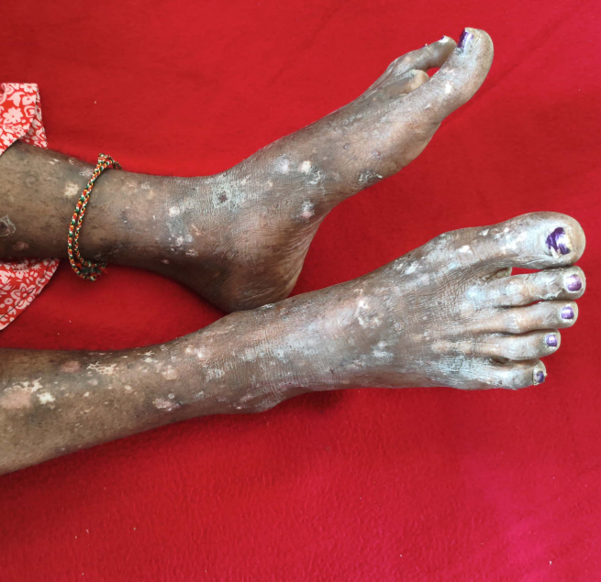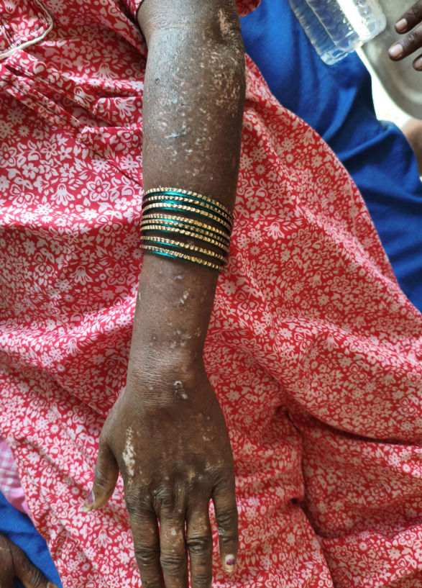
FIG 1: Cutaneous manifestations in a patient with mixed connective tissue disorder demonstrating multiple hypo-pigmented macules and plaques distributed over the extensor aspects of the forearms and legs consistent with scleroderma like skin changes.

DISCUSSION
Our laboratory and radiologic workup was driven by the initial history of Raynaud's phenomenon, which included generalized swelling and dysphagia, as well as physical examinations like acrosclerosis, which ultimately assisted us in making the diagnosis.
In 1972, Sharp and colleagues established the idea of mixed connective disease as a distinct immune-mediated connective tissue disease^{[4]}.
Although the cause of MCTD is uncertain, a small number of instances have been documented following vinyl chloride exposure and even following breast augmentation procedures^{[5]}. When compared to controls, there are known instances of MCTD with higher HLADR 4 instances.
According to a 2011 Norwegian study, the prevalence of MCTD in adults was 3.8 per 100,000, with an annual incidence of 2.1 per million^{[6]}. Over three-quarters of the patients were female, and the mean age of onset was 31.9 years^{[7]}. This validates a forecast for female sex and the disease's rarity.
When there are overlapping symptoms of autoimmune diseases, such as swollen fingers, arthritis, myalgia, or muscle weakness, acid reflex or dysphagia, Raynaud's phenomenon, or shortness of breath during activity, MCTD should be kept as a differential diagnosis. Numerous criteria have been described to classify MCTD ,Table(5) lists the Alacron-Segovia criteria, and Table(4) lists the Kasukawa diagnostic criteria for MCTD ^{[8]}.

With a positive serology and two of the five clinical criteria—Raymaud's phenomenon, hand edoema, and myositis, as indicated by a serum CPK value of 255 IU/l—our patient met the Alarcon-Segovia diagnostic criteria.
Our patient also met the Kasukawa diagnostic criteria, exhibiting mixed results for dysphagia, scleroderma, and high cpk values in addition to the typical Raynaud's phenomenon symptoms of edematous hands with positive serology. Although many individuals may have abnormal lung function tests, particularly the single breath diffusion capacity, only a tiny percentage of those patients are symptomatic. In the meantime, our patient experienced dyspnea since the presenting complaint, pulmonary artery hypertension, is uncommon in early mctd^{[9]}. Yet, two-dimensional echocardiography revealed that our patient had pulmonary artery hypertension.
The two most prevalent renal symptoms are mesangial proliferation and membranous glomerulopathy; diffuse proliferative glomerulonephritis and vascular or glomerular sclerosis are less frequent^{[10]}.Our patient's renal function test and urine examination were both normal.
A combination of medications, including NSAIDS like naproxen, COX 2 inhibitors like celecoxib, steroids like prednisolone, antimalarials like HCQ, and immunosuppressants like azathioprine, would be used to treat MCTD. Raynaud's phenomenon is treated with angiotensin receptor blockers like losartan, nitrates like nitroglycerin, and calcium channel blockers like nifedipine. For pulmonary artery hypertension, our patient was prescribed an immunosuppressant (azathioprine) and an antimalarial (HCQ). Therefore, different management will be needed for two different people with the same disease but different clinical manifestations^{[11]}.

CONCLUSION
Mixed connective tissue disorder(MCTD) is a rare inflammatory autoimmune disorder that has symptoms and signs of several other disorders, including lupus, scleroderma, and polymyositis. Many people with MCTD also have rheumatoid arthritis and/or Sjogren's syndrome.According to a 2011 Norwegian study, the prevalence of MCTD in adults was 3.8 per 100,000 with an annual incidence of 2.1 per million and more than three quarters of patients were females.When there are overlapping symptoms of autoimmune illnesses, MCTD should be taken into consideration as a differential diagnosis. The most often used diagnostic criteria for MCTD are the Kasukawa and Alarcon-Segovias criteria. A positive serelogy of anti-U1RNP in high titers is a characteristic of MCTD. Since MCTD is an autoimmune illness, there is no standard treatment for it; instead, it can be managed based on each patient's symptoms. For example, NSAIDS can be used to manage pain, antimalarial medications and immunosuppressants can be used to treat MCTD, and calcium channel blockers and nitrates can be used to treat Raynaud's phenomenon. In its early phases, pulmonary artery hypertension is less common and is treated with vasodilators like sildenafil and tadalafil.

REFERENCE
- Kumar TS, Aggarwal A. Approach to a patient with connective tissue disease. The Indian Journal of Pediatrics. 2010 Oct;77(10):1157-64.
- Sharp GC, Irvin WS, May CM, Holman HR, McDuffie FC, Hess EV, Schmid FR. Association of antibodies to ribonucleoprotein and Sm antigens with mixed connective-tissue disease, systemic lupus erythematosus and other rheumatic diseases. New England Journal of Medicine. 1976 Nov 18;295(21):1149-54.
- https://my.clevelandclinic.org/health/diseases/15039-mixed-connective-tissue-disease
- Gunnarsson R, Molberg Ø, Gilboe IM, Gran JT, PAHNOR1 Study Group. The prevalence and incidence of mixed connective tissue disease: a national multicentre survey of Norwegian patients. Annals of the rheumatic diseases. 2011 Jun 1;70(6):1047-51.
- Sunil P, Swathi H, Kauser M, Marulasreshta GD, Kumar SR, Prashanth G. Mixed Connective Tissue Disorder: A Rare Case Report. International Journal of Preclinical & Clinical Research. 2022 Dec 13;3(3):74-.
- Katewa R, Jakhar RS, Barala GL. Mixed connective tissue disorder: a case report. International Journal of Case Reports and Images (IJCRI). 2014 Sep 1;5(9):650-5.
- Hench PK, Edgington TS, Tan EM. EVOLVING CLINICAL SPECTRUM OF MIXED CONNECTIVE-TISSUE DISEASE (MCTD). InArthritis and Rheumatism 1975 Jan 1 (Vol. 18, No. 4, pp. 404-404). 227 EAST WASHINGTON SQ, PHILADELPHIA, PA 19106: LIPPINCOTT-RAVEN PUBL.
- Alarcon-Segovia D, Cardiel MH. Comparison between 3 diagnostic criteria for mixed connective tissue disease. Study of 593 patients. The Journal of rheumatology. 1989 Mar 1;16(3):328-34.
- Haroon N, Nisha RS, Chandran V, Bharadwaj A. Pulmonary hypertension not a major feature of early mixed connective tissue disease: A prospective clinicoserological study. Journal of Postgraduate Medicine. 2005 Apr 1;51(2):104-8.
- Maldonado ME, Perez M, Pignac-Kobinger J, Marx ET, Tozman EM, Greidinger EL, Hoffman RW. Clinical and immunologic manifestations of mixed connective tissue disease in a Miami population compared to a Midwestern US Caucasian population. The Journal of rheumatology. 2008 Mar 1;35(3):429-37.
- Maldonado ME, Perez M, Pignac-Kobinger J, Marx ET, Tozman EM, Greidinger EL, Hoffman RW. Clinical and immunologic manifestations of mixed connective tissue disease in a Miami population compared to a Midwestern US Caucasian population. The Journal of rheumatology. 2008 Mar 1;35(3):429-37.

