Case report

Decompensated Chronic Liver Disease with Portal Hypertensive Gastropathy in a Patient with Diabetic Nephropathy and Chronic Kidney Disease

Abstract
Portal hypertensive gastropathy (PHG) is an underdiagnosed, common complication of portal venous pressure increase and mucosal vascular congestion complicating decompensated chronic liver disease (CLD). The added presence of comorbid conditions, such as diabetic nephropathy and chronic kidney disease (CKD), adds complexity to therapeutic decisions, and drug safety is a concern. We report the case of a 48-year-old male patient who was a chronic alcoholic and a type 2 diabetic patient presenting with reduced urine output, vomiting, and fever. The patient at presentation was decompensated CLD with splenomegaly and ascites, and laboratory parameters of hepatic and renal failure on investigations. Laboratory tests for the diagnosis of hepatitis C virus infection (HCV RNA 1.47 × 10⁶ IU/mL) were positive. Abdominal US showed coarse hepatic echotexture with irregular margins and ascites, and upper GI endoscopy showed Grade II oesophageal varices with signs of PHG. The patient was conservatively treated with intravenous cefoperazone, pantoprazole, insulin, and supportive hepatoprotective medication like ursodeoxycholic acid and rifaximin. Propranolol was initiated to reduce portal pressure, and midodrine was used for orthostatic hypotension. Drotaverine resulted in symptomatic relief of abdominal pain. This case demonstrates the synergistic interaction of hepatic, renal, and metabolic derangements, known as the hepatorenal–metabolic axis. This interaction must be tightly controlled through dosing, the avoidance of nephrotoxic and hepatotoxic medications, and ongoing therapeutic monitoring to ensure patient safety. The case emphasises the need for a multidisciplinary, comprehensive management plan, in which the clinical pharmacist plays a crucial role in ensuring pharmacotherapy is maximally effective, making drugs safe, and providing counselling to prevent complications and enhance clinical outcomes in patients with portal hypertensive gastropathy and concomitant organ comorbidities.

Keywords: Hypotension, Diabetic Neuropathy, Portal Hypertensive Gastropathy, Chronic Kidney Disease

Introduction
Portal hypertensive gastropathy (PHG) is a cirrhotic or non-cirrhotic portal hypertensive complication. PHG is a significant condition as it may cause acute (and even massive) or occult blood loss. It is endoscopically defined as a classically described mucosal abnormality having a mosaic-like appearance, like the snake skin, with or without erythema. These lesions have been described earlier as inflammatory or erosive and considered to be a type of gastritis in cirrhotic and portal-hypertensive patients. The pathophysiology of PHG involves dilatation and congestion of gastric wall capillaries and submucosal veins due to increased portal hypertension pressure and reduced mucosal perfusion. These vascular changes disrupt the mucosa's integrity, making it susceptible to haemorrhage. [1]. PHG is said to be found in 20-80% of patients with portal hypertension and is more frequent in decompensated cirrhotic patients. Decompensated cirrhosis is an advanced stage of liver disease with the development of clinically apparent complications such as oesophageal or gastric varices, ascites, spontaneous bacterial peritonitis, hepatic encephalopathy, and coagulopathy. [2]. The development of PHG also contributes to the risk of upper GI bleeding, besides the already compromised hemodynamic status of such patients. Comorbid CKD and type 2 DM complicate the treatment of decompensated CLD. Diabetic nephropathy leads to end-stage renal failure with worsening renal function, affecting drug clearance and metabolism, and the patient is at risk for nephrotoxicity. [3]. CKD influences the pharmacokinetics of medications, necessitating dose adjustments. Antibiotics, diuretics, and other agents should be used cautiously. In addition, metabolic disturbances and insulin resistance of DM can exacerbate hepatic fibrosis and steatosis, thereby accelerating the development of CLD. [4]. Hepatorenal dysfunction has also been reported to be concomitant and developing a global disease called the hepatorenal–metabolic axis, being a part of the therapeutic challenge, but more particularly concerning maximisation of drug therapy and anticipation of side effects induced by drugs. [5]. The case is presented to demonstrate the clinical, diagnostic, and pharmacotherapeutic challenge of managing a patient with decompensated chronic liver disease complicated by portal hypertensive gastropathy, diabetic nephropathy, and chronic kidney disease. It emphasises the need for well-coordinated multidisciplinary care, with specific attention to the pharmacist's role in ensuring safe, individualised, and effective treatment for the patient in the context of multi-organ dysfunction.

Case Presentation
A 48-year-old male patient from Village Jhanda Bagga, Ferozepur District, with type 2 diabetes mellitus and secondary diabetic nephropathy secondary to chronic kidney disease, was admitted on October 1, 2025, in the medicine ward. The patient was a long-time tobacco and alcohol user. He was brought to the clinic with a history of decreased urine output for one day, two days of continuous vomiting, and intermittent high-grade fever lasting for 10–15 days with associated rigours and chills. In addition, black stools, a sign of gastrointestinal bleeding, along with diffuse weakness, poor oral intake, and increased fatigue, were also present. All these necessitated admission for assessment and treatment. The patient was an established case of type 2 diabetes mellitus (T2DM) for the past 2 years and was insulin-treated for sugar level management. He had chronic kidney disease (CKD), which was likely secondary to diabetic nephropathy, with increasingly deteriorating renal function over the years. Ischemic heart disease, bronchial asthma, or tuberculosis were never reported in the past. His past medical history included chronic alcohol consumption for more than 10 years, with daily consumption of local alcoholic drinks, and frequent consumption of tobacco, both of which are classic risk factors for liver injury. There was no history of illicit or hepatotoxic drug abuse by the patient. His family history was not significant for diabetes, hypertension, or liver disease. An ultrasonogram of the abdomen revealed coarse hepatic echotexture with a slightly irregular edge of the liver, as in chronic parenchymal liver disease. There was splenomegaly and moderate volume ascites, as in portal hypertension and decompensated liver disease [6]. The portal vein was patent without focal intrahepatic bile dilatation. The gallbladder was partially filled, with normal wall thickness and no calculi present. The two kidneys were bilaterally enlarged, with cortical echogenicity and thin corticomedullary differentiation, typical of diabetic nephropathy and chronic kidney disease. The urinary bladder was minimally distended without evidence of calculi or hydronephrosis. Haematological abnormalities included anaemia (haemoglobin 8.9 g/dL) and mild leukocytosis (WBC 12.8 × 10³/µL), but a normal platelet count. The liver function tests revealed elevated total bilirubin (2.8 mg/dL; direct 1.6 mg/dL), elevated transaminases (AST 55 U/L, ALT 62 U/L), and low albumin, all consistent with liver injury as seen in chronic liver disease. Renal function tests showed significant increases in urea (102 mg/dL) and serum creatinine (6.6 mg/dL), consistent with acute renal failure complicating chronic renal disease. It was experiencing hyponatremia (Na 131 mmol/L), mild hyperkalemia (K 5.0 mmol/L), and decreased chloride (Cl 96 mmol/L) [7]. Arterial blood gas was in keeping with mild respiratory alkalosis (pH 7.45, pCO₂ 29.2 mmHg) and normal oxygenation. Inflammatory markers were indicated by an elevated C-reactive protein of 47.6 mg/L, while a procalcitonin level of 0.45 ng/mL was not inappropriately elevated to rule out a serious bacterial infection. Serology confirmed Hepatitis C virus infection by HCV Tridot positivity and elevated viral load (HCV RNA 1.47 × 10⁶ IU/mL; 6.17 log IU/mL) on quantitative PCR, establishing active viral replication as the aetiology of liver disease [8]. Urine analysis showed proteinuria (2–3+), numerous pus cells (20–35 / hpf), and occasional RBCs, highlighting diabetic nephropathy with possible urinary infection. Ultrasonography of the abdomen revealed coarse hepatic echotexture with ill-defined margins, splenomegaly, and moderate ascites in keeping with portal hypertension and decompensated chronic liver disease. The kidneys were hyperechoic and enlarged with impaired corticomedullary differentiation in keeping with chronic diabetic nephropathy. Upper gastroscopy done on 7 October 2025 was reported to reveal Grade II oesophageal varices and portal hypertensive gastropathy, absolute evidence of clinically significant portal hypertension as a decompensated liver disease complication. He was started on cefoperazone 1 g IV twice a day as broad-spectrum antibiotic prophylaxis against or control of spontaneous bacterial peritonitis and sepsis. Inj. Human insulin (14-14-14 units subcutaneously) was also administered on a sliding scale for glycemic control. Pantoprazole 40 mg IV once a day was given for acid suppression and prevention of gastrointestinal bleeding. Intravenous normal saline at 60 mL/hr was continued for hydration and correction of electrolyte imbalance. Hepatoprotective and adjuvant treatment was Tab. Udihep-D (silymarin + ursodeoxycholic acid) daily once and Tab. Bacstun-DS (rifaximin) twice a day to inhibit ammonia-forming gut bacteria and prevent hepatic encephalopathy. Tab. Ultoford-SR 500 mg at bedtime once a day and Syp. Cuminific Plus 30 mL at night was given as an ancillary supplement to hepatic and metabolic functions. Treatment of portal hypertension and to prevent variceal bleed was done with Tab. Ciplar-LA 40 mg/day (propranolol) was initiated. For symptom control of orthostatic hypotension and renal perfusion, Tab. Midodrine 2.5 t.d.s. was initiated. For abdominal pain and smooth muscle spasm due to hepatic congestion and ascites, Inj. Drotin (drotaverine) was administered twice daily as an antispasmodic.For abdominal pain and smooth muscle spasm due to hepatic congestion and ascites, Inj. Drotin (drotaverine) was administered twice daily as an antispasmodic. Serial renal function tests, urine output, and fluid status were monitored closely in the patient. Dietary recommendation with a high-protein, low-sodium diet and alcohol abstinence was strongly advised.
Discussion
This case shows the pharmacotherapeutic and clinical complexity of managing a patient with decompensated CLD complicated by portal hypertensive gastropathy, diabetic nephropathy, and CKD. Portal hypertensive gastropathy is a microvascular complication of portal hypertension in end-stage CLD. Pathophysiology involves increased portal venous pressure, leading to gastric mucosal capillary and venular congestion and dilatation. This leads to the "snake-skin" or mosaic endoscopic pattern. Unlike variceal haemorrhage from rupture of dilated oesophageal or stomach submucosal veins and presentation in a traditional manner as acute massive haematemesis, bleeding in PHG is slow, diffuse, and chronic. It is more commonly presented as iron-deficiency anaemia rather than acute haematemesis. The concomitant hepatic, renal, and metabolic impairment in this patient specifies the interconnection known as the hepatorenal–metabolic axis. Systemic vasodilation and reduced adequate circulatory volume in severe liver disease lead to renal hypoperfusion and activation of the renin–angiotensin–aldosterone system, thereby contributing to hepatorenal dysfunction. Type 2 diabetes mellitus, a chronic disease, also contributes to the cause of glomerulosclerosis, endothelial damage and potentiation of renal damage. The additive effect is responsible for altered pharmacokinetics in the majority of drugs due to reduced hepatic metabolism and renal clearance, necessitating careful dose adjustment and therapeutic monitoring. Pharmacologic treatment of such patients should be individualised. Prophylactic antibiotics (e.g., cefoperazone) were used judiciously to prevent infection-induced decompensation, but need tracking due to their partial hepatic metabolism. [9]. Pantoprazole was appropriately used for gastroprotection in PHG.
In contrast, non-selective beta-blockers (propranolol) remain the gold standard for reducing portal hypertension and preventing variceal bleeding by reducing portal venous inflow [10]. Insulin therapy was adjusted to obtain glycemic control since part of the oral hypoglycemics is contraindicated in hepatic and renal failure. Drotaverine is effective for the symptomatic relief of smooth muscle spasm, undergoes minimal hepatic metabolism, and has less toxicity than anticholinergics. Ursodeoxycholic acid (Udihep) and rifaximin contributed significantly to hepatoprotection and prophylaxis against hepatic encephalopathy. In CKD and CLD, drug dosage needs to be adjusted for drugs that are either excreted (e.g., diuretics, antibiotics, insulin) or metabolised by the liver. Nephrotoxic agents such as NSAIDs, aminoglycosides, and contrast media should be strictly avoided [8]. Similarly, hepatotoxic agents (e.g., paracetamol at excessive doses, specific antivirals) should be used with caution. Where anaemia is a secondary finding of chronic bleeding from PHG, oral or intravenous iron is a consideration with close monitoring for tolerance, particularly in patients with impaired renal clearance. Several case series reported in the literature support this. For instance, Simbrunner et al. (2020) described a case of portal hypertensive gastropathy and chronic anaemia in decompensated HCV cirrhosis, which was managed successfully with beta-blockers and iron repletion [11]. Kumar et al. (2021) also described how chronic renal dysfunction in cirrhosis represents a key component of the hepatorenal spectrum, underscoring the interplay between renal and hepatic systems. The hospital pharmacist here plays a key role in maximising treatment, preventing drug-related complications, and monitoring patient compliance. Pharmacists can modify the dose according to renal and hepatic function, check for drug interactions, and educate patients regarding restriction of dietary sodium, abstinence from alcohol intake, and compliance with prolonged HCV therapy. Regular follow-up and counselling also prevent decompensation recurrence and hospital readmission.
Conclusion
This case demonstrated the clinical severity of the treatment of portal hypertensive gastropathy in a decompensated patient of chronic liver disease with diabetic nephropathy and chronic kidney disease. A multidisciplinary treatment approach, incorporating medical, nutritional, and pharmacological interventions, should be used to manage it effectively. The pharmacist's role is pivotal in maximising drug therapy to an optimum degree, preventing complications, and ensuring safety.
Ethics approval
Not applicable
Consent to publish
The authors approve of submitting the publication.
Consent to participate
Not applicable

Data Availability Statements

Data sharing does not apply to this article as no datasets were generated or analysed during the current study.
Declaration of competing interest
The authors declare that they have no known competing financial interests or personal relationships that could have influenced the work reported in this paper.

References
[1] Cubillas R, Rockey DC. Portal hypertensive gastropathy: a review. Liver International 2010;30:1094–102. https://doi.org/10.1111/J.1478-3231.2010.02286.X.
[2] D’Amico G, Bernardi M, Angeli P. Corrigendum to ‘Towards a new definition of decompensated cirrhosis’ [J Hepatol 76 (2022) 202–207] (Journal of Hepatology (2022) 76(1) (202–207), (S0168827821004384), (10.1016/j.jhep.2021.06.018)). J Hepatol 2022;76:757. https://doi.org/10.1016/j.jhep.2021.12.023.
[3] Dabla PK. Renal function in diabetic nephropathy. World J Diabetes 2010;1:48. https://doi.org/10.4239/WJD.V1.I2.48.
[4] Zhang W, Song WJ, Chen W, Pan Z, Zhang J, Fan L, et al. Metabolically-dysfunction-associated steatotic liver disease-related hepatic fibrosis increases the risk of insulin resistance, type 2 diabetes, and chronic kidney disease. Eur J Gastroenterol Hepatol 2024;36:802–10. https://doi.org/10.1097/MEG.0000000000002767.
[5] Buccics T, Krones E. Renal dysfunction in cirrhosis: acute kidney injury and the hepatorenal syndrome. Gastroenterol Rep (Oxf) 2017;5:127–37. https://doi.org/10.1093/GASTRO/GOX009.
[6] Rosselli M, Roccarina D, Grgurevic I. Ultrasound in Chronic Liver Disease. Liver Ultrasound: From Basics to Advanced Applications 2024:124 55. https://doi.org/10.1002/9781119612650.CH8.
[7] Thapa BR, Walia A. Liver function tests and their interpretation. Indian J Pediatr 2007;74:663–71. https://doi.org/10.1007/S12098-007-0118-7/METRICS.
[8] Morano JP, Zelenev A, Lombard A, Marcus R, Gibson BA, Altice FL. Strategies for Hepatitis C Testing and Linkage to Care for Vulnerable Populations: Point-of-Care and Standard HCV Testing in a Mobile Medical Clinic. J Community Health 2014;39:922–34. https://doi.org/10.1007/S10900-014-9932-9/METRICS.
[9] Zoratti C, Moretti R, Rebuzzi L, Albergati IV, Di Somma A, Decorti G, et al. Antibiotics and Liver Cirrhosis: What the Physicians Need to Know. Antibiotics 2022, Vol 11, Page 31 2021;11:31. https://doi.org/10.3390/ANTIBIOTICS11010031.
[10] Turco L, Reiberger T, Vitale G, La Mura V. Carvedilol as the new non-selective beta-blocker of choice in patients with cirrhosis and portal hypertension. Liver International 2023;43:1183–94. https://doi.org/10.1111/LIV.15559.
[11] Simbrunner B, Beer A, Wöran K, et al. Portal hypertensive gastropathy is associated with iron deficiency anaemia. Wien Klin Wochenschr. 2020;132(1-2):1-11. doi:10.1007/s00508-019-01593

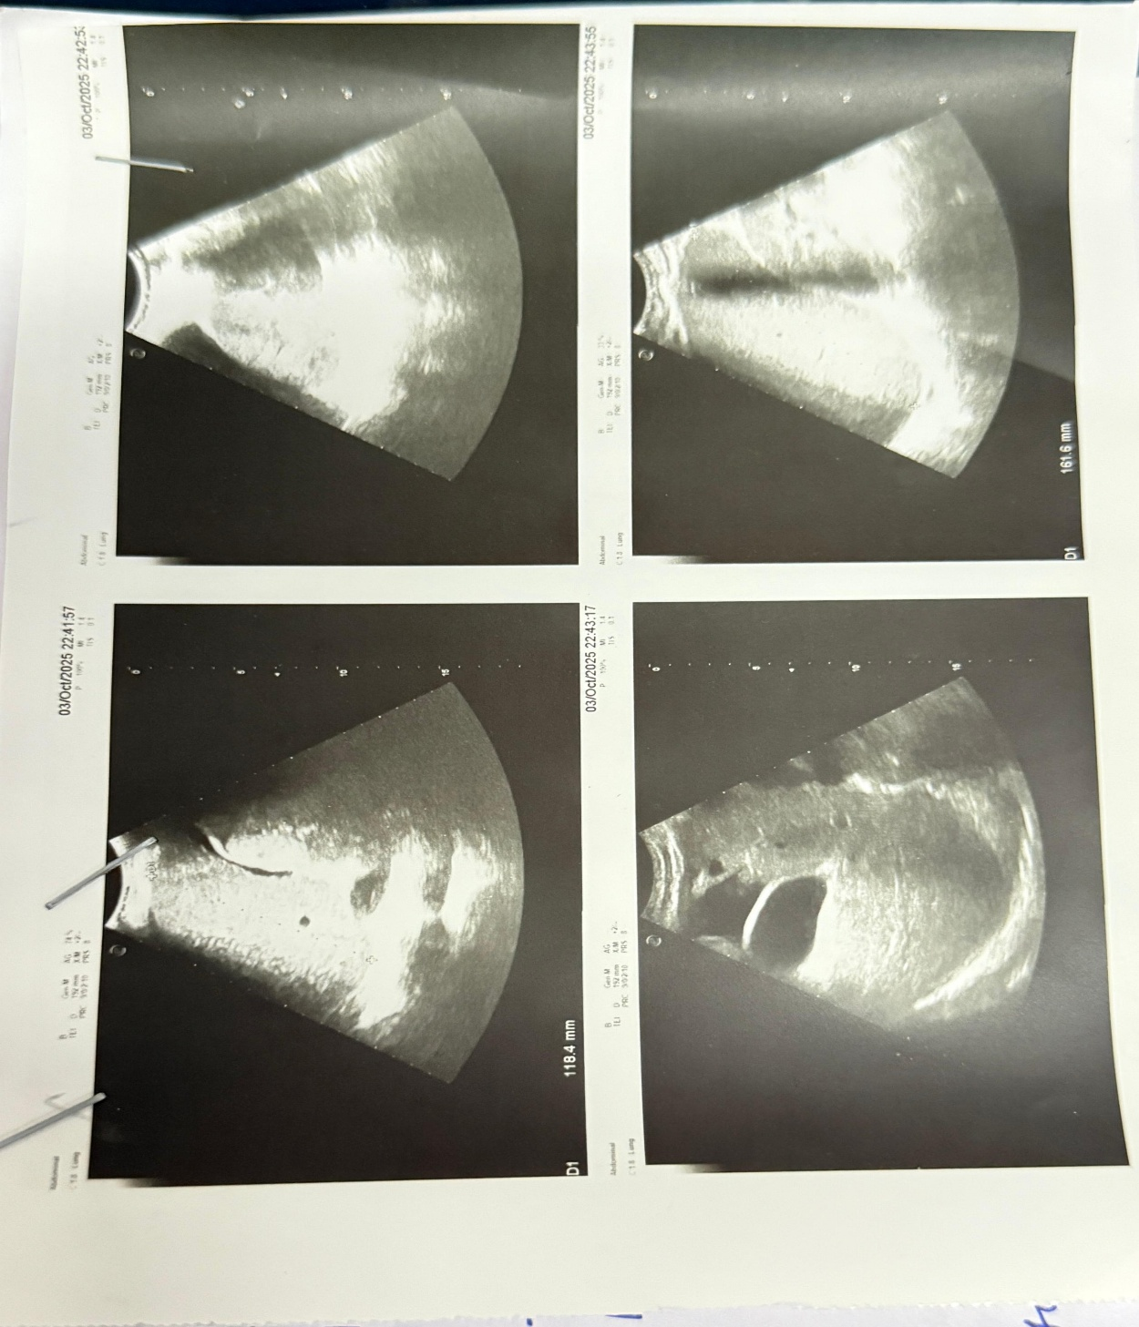
Fig .1 Abdominal Ultrasound Images

