U-NET Deep Learning-based downscaling to generate high-resolution seasonal forecasts for small watersheds: a case study of the Nouhao sub-basin, Burkina Faso

ABSTRACT
This study assesses raw seasonal forecasts of precipitation and temperature from three global models (ECMWF, Météo-France, and CMCC) and their ensemble mean (Ensmean) over Burkina Faso. Forecast skill was assessed against high-resolution reference datasets (CHIRPS for precipitation and CHIRTS for temperature) using standard statistical metrics (r, RMSE and MAE). The raw forecasts showed weak performance in representing spatial variability with biases above 20% for precipitation and more than 5 °C. To address this limitation, we developed a deep learning-based downscaling framework using the U-Net Convolutional Neural Network (CNN) architecture to transform coarse 1° (~100 km) forecasts into high-resolution 0.05° (~5 km) gridded data. While the initial application targeted the Nouhao sub-basin for drought modeling, the framework was extended to cover the entire country to make high-resolution data available for broader applications. The downscaled outputs, when evaluated using the same metrics, showed substantial improvements in skill compared to the raw forecasts, with gains of up to sixfold for precipitation and twenty-fold for temperature. A modified Taylor diagram incorporating these metrics was employed to identify ECMWF as the best-performing model for precipitation and METEO-FRANCE for temperature. By producing high-resolution seasonal precipitation and temperature datasets, this study demonstrates the added value of U-Net Deep Learning-based downscaling for Burkina Faso. The results underscore the potential of integrating these approaches into operational drought and flood prediction frameworks of Burkina Faso’s National Agency of Meteorology (ANAM) and the General Directorate of Water Resources (DGRE), extending their applicability across West Africa, and enhancing related areas such as hydrological modeling.
Keywords: Seasonal forecasts, Downscaling, U-NET Deep learning, Nouhao sub-basin, Burkina Faso.

1. INTRODUCTION
The impacts of climate change are increasingly evident worldwide, with severe droughts, extreme heatwaves, and destructive floods contributing to rising casualties across all regions [1]. In response, international institutions such as the World Meteorological Organization (WMO) and United Nations agencies for disaster risk management have undertaken significant efforts to develop and implement early warning systems, placing particular emphasis on supporting developing countries to promote inclusivity and equity in climate adaptation [2]. Seasonal climate-related hazards, including droughts and floods, demand accurate forecasts to enable effective preparedness and mitigation strategies; however, forecast reliability diminishes as the lead-time increases [3]. To address this challenge, major climate centers (ECMWF, UK Met, METEO FRANCE, CMCC...) produce seasonal forecasts extending up to (08) eight months in advance, providing an essential tool for strengthening national and regional capacities to anticipate, prepare for, and respond to climate-induced disasters [4][5]. However, the seasonal forecast data currently made freely available are generally produced at a coarse spatial resolution (often exceeding 100 km), particularly in regions such as Africa, which limits their direct applicability at finer spatial scales such as small watersheds or sub-basins. To enhance their utility for local decision-making and disaster preparedness, additional processing techniques, such as statistical adaptation and downscaling, are required to adjust these forecasts to the spatial dimensions relevant for local contexts. These processing techniques, however, are often computationally expensive and therefore remain largely inaccessible to many low-income countries [6]. Fortunately, recent advances in technology, particularly the emergence of artificial intelligence (AI) methods, offer promising opportunities to perform climate data downscaling more efficiently and at significantly lower cost, thereby enhancing accessibility for resource-constrained regions.
Recent advancements in Deep Learning (DL) have significantly enhanced the downscaling of coarse-resolution seasonal climate forecasts to high-resolution gridded data, a crucial step for localized climate impact assessments. Notably, architectures such as Super Resolution Generative Adversarial Networks (SRGAN) and Super Resolution Deep Residual Networks (SRDRN) have demonstrated efficacy in refining temperature and precipitation data from global models like ECMWF's SEAS5 and CMIP6, achieving resolutions as fine as 0.25° to 0.05° [7]. These methods outperform traditional statistical downscaling techniques, particularly in capturing spatial variability and extreme events. In the context of West Africa, DL-based downscaling has been applied to improve seasonal precipitation forecasts. For instance, studies have utilized convolutional neural networks (CNNs) to enhance the spatial resolution of seasonal forecasts, thereby providing more detailed and accurate climate information for the region [8]. Additionally, hybrid models combining DL with bias correction techniques have been developed to further refine forecast accuracy [9]. Several customized deep learning (DL) architectures have demonstrated strong performance in capturing high-resolution climate information, supporting the growing adoption of such approaches for high-resolution climate downscaling. DeepSD, for instance, has shown notable skill in reproducing rainfall amplitudes during the Indian summer monsoon [10]. This technique can be viewed as a generalized stacked super-resolution convolutional neural network (SRCNN) that extends the basic SRCNN framework, thereby improving its ability to represent climate variables at finer spatial scales [11]. Another prominent architecture is the U-Net, which has proven particularly effective for capturing spatially coherent seasonal climate features, enhancing the skill of seasonal forecasts. In particular, U-Net–based methods have been shown to significantly improve summer precipitation forecasts [12]. Therefore, the U-Net architecture can be considered a reliable and effective framework for conducting seasonal climate downscaling, owing to its strong ability to capture both large-scale circulation patterns and localized small-scale variability in key climate variables such as precipitation and temperature.
Despite these advancements, there remains a paucity of DL-based downscaling applications specifically targeting Burkina Faso. This gap underscores the necessity of developing tailored DL models to transform coarse-resolution seasonal forecasts into high-resolution climate data, thereby enhancing the precision of climate impact assessments and informing localized adaptation strategies in Burkina Faso.
Hence, this study aims to address these limitations by employing U-Net, a state-of-the-art deep learning architecture, to downscale seasonal forecasts data from 1° (~100 km) to 0.05° (~5 km) spatial resolution over Burkina Faso. Although, our primary focus is the Nouhao sub-basin in the east-central of Burkina Faso, the spatial domain has been extended to the entire country to generate high-resolution datasets that not only support watershed-scale drought prediction but also provide a valuable resource for the broader research community working on climate risk assessment and adaptation planning in Burkina Faso. To the best of our knowledge, this represents one of the first applications of Deep Learning for seasonal climate downscaling in Burkina Faso, thereby contributing both methodologically and nationally to the field of climate hazard modeling.
This paper is organized as follows: Section 2 provides an overview of the study area, details on the seasonal forecasts data, reanalysis data used for model training and validation and the methodology. Section 3 presents the results and discussion on the generated data and the model performance. Finally, Section 4 offers the conclusion.

2. MATERIALS AND METHODS

2.1 Study area
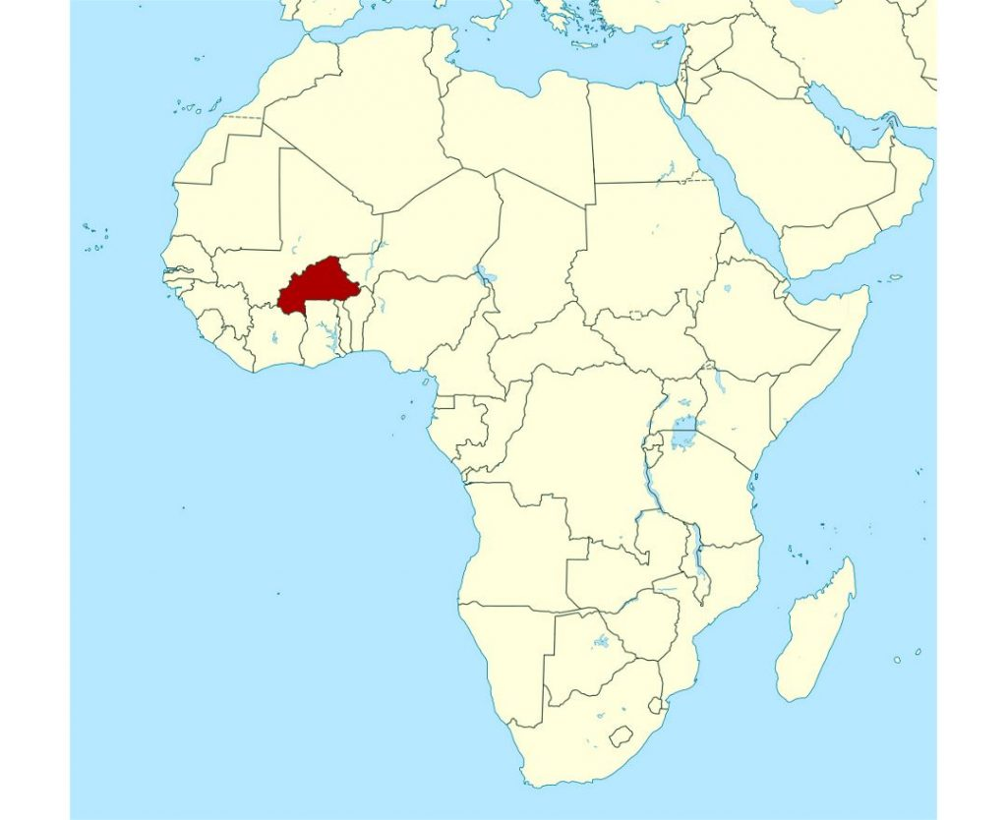
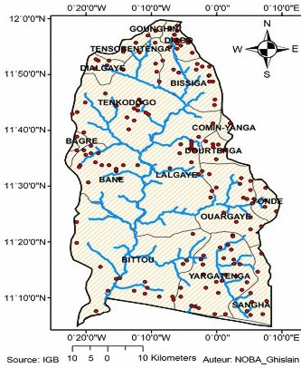
Burkina Faso, located in West Africa, experiences a tropical climate characterized by strong latitudinal gradients in both precipitation and temperature. Annual rainfall ranges from less than 500 mm in the arid Sahelian zone of the north to more than 1,000 mm in the humid Sudanian zone of the south. The rainy season, which extends from May to October, is governed by the dynamics of the West African monsoon. Variations in the intensity and north-south displacement of the monsoon determine the spatial and temporal distribution of rainfall across the country [13]. The Nouhao sub-basin (~4,261 km²), a sub-basin of the Nakambé national watershed located in the east-central of the country, exhibits pronounced intra-seasonal variability in precipitation and is recurrently affected by hydrometeorological extremes, including flash floods, agricultural droughts, and localized flooding. Due to its relatively small spatial extent, coarse-resolution climate forecasts (~1° or ~100 km) fail to adequately represent local hydroclimatic processes, as few or no grid points correspond directly to the basin area (Figure 1). Consequently, the application of spatial downscaling techniques, whether statistical or dynamical, is essential for producing operational climate forecasts at the spatial scale relevant to the basin’s hydrological and agricultural management.

Figure 1: Topographic elevation (m) of the study Area showing the Nouhao Sub-basin boundaries in red

2.2 Data
This study analyzes seasonal forecast data derived from three major climate centers models’ outputs: the European Centre for Medium-Range Weather Forecasts (ECMWF), Météo-France, and the Centro Euro-Mediterraneo sui Cambiamenti Climatici (CMCC). The datasets include two climate variables, precipitation and temperature, provided at a spatial resolution of 1° (~100 km). Since the aim is to downscale these data to a higher resolution of 0.05° (~5 km), we also incorporated historical high-resolution datasets: the Climate Hazards Group InfraRed Precipitation with Stations (CHIRPS) for precipitation and the Climate Hazards Group InfraRed Temperature with Stations (CHIRTS) for temperature, both available at 0.05° (~5 km). Both the seasonal forecasts and the historical datasets are provided in NetCDF format. Table 1 provides an overview of the datasets used in this study.

Table 1: Characteristics of data used
Type | Models | Country | Spatial Resolution | Temporal resolution | Temporal coverage
Seasonal forecasts | ECMWF | European  Union | 1° x 1° | Daily | 1981 to 2016 (hindcasts); 2017 to 2024 (forecasts)
Seasonal forecasts | METEO-FRANCE | France | 1° x 1° | Daily | 1993 to 2016 (hindcasts); 2017 to 2024 (forecasts)
Seasonal forecasts | CMCC | Italy | 1° x 1° | Daily | 1993 to 2016 (hindcasts); 2017 to 2024 (forecasts)
Historical | CHIRPS | USA | 0.05° x 0.05° | Daily | 1981 - 2024
Historical | CHIRTS | USA | 0.05° x 0.05° | Daily | 1981 - 2024

2.3 Methodology
In this work, we present a downscaling framework that utilizes U-NET deep learning techniques to transform coarse seasonal forecasts (approximately 1°) into high-resolution climate data (0.05°) over Burkina Faso, with a specific focus on the Nouhao sub-basin. The methodological framework consists of four stages: (i) data set preparation and harmonization; (ii) evaluating raw forecasts from models; (iii) statistically downscaling using U-net; and (iv) processing and evaluating skill of downscaled data.

2.3.1 Data Preparation and Pre-Processing
The ECMWF, Météo-France, and CMCC seasonal forecasts data are extracted at their native ~1° resolution for precipitation and 2-m temperature for this work. The data are regridded, temporally aligned, and normalized for model ingestion. Precipitation and temperature reference data are obtained from CHIRPS (0.05°) and CHIRTS (0.05°), respectively, for training and evaluation. Preprocess includes the following:
- Spatial harmonization: bilinear interpolation forecasts 1° grid and exact matching of the reference 0.05° grid;
- Temporal synchronization: forecasts are extracted for initializations in May and with lead times of June-November (1-6 months);
- Normalization: variable-wise standardization to faster convergence in deep learning;
- Domain extension: to facilitate training on the complete Burkina Faso domain, although the application domain is focused on the Nouhao basin, spatial robustness and adequate sample diversity can be ensured in the training and evaluation.

2.3.2. Evaluation of Raw Seasonal Forecasts
The raw models' inherent skill is assessed before downscaling to determine the accuracy and spatial coherency of biases. At each grid cell, three statistical metrics are calculated: Pearson Correlation Coefficient (r), Root-Mean-Square Error () and Mean Absolute Error ().
- The Pearson Correlation Coefficient () is a metric that quantifies the strength and the direction of a linear relationship between the raw data () and the reference data (), as described in equation 1. varies between and . When is close to , there is a strong positive linear relationship between x and y. When is close to, there is a strong negative linear relationship between x and y. And for close to , there is weak linear relationship between the two variables.

(1)
- The is a metric that measures the average magnitude of error between the raw () and the reference () data. It is computed with the following equation 2 and ranges from 0 to 1 too. A low RMSE (close to 0) means both data points are close to the regression line, indicating a good fit.
(2)
- The MAE is the average of the absolute errors between the raw () and the reference () data. It is computed through the following equation 3 and ranges from 0 to 1. A lower MAE indicates a better fitting between the raw and the reference data.

(3)

2.3.3 Deep Learning Downscaling Framework
The downscaling problem is formulated as a nonlinear mapping [14]. Let X denote the coarse-resolution predictors, consisting of C input variables (e.g., precipitation, temperature, geopotential height, topography), and let Y denote the high-resolution target field as described in equation 4.
(4)
In this equation, is a nonlinear function parameterized by the neural network weights; , and represents the residual error.

2.3.4. U-Net Architecture
As part of this study, the U-Net architecture is adopted to perform the downscaling of seasonal forecasts due, as shown above, to its proven capability to effectively capture both large-scale atmospheric circulation patterns and high-resolution spatial variability. This dual capacity makes U-Net particularly well-suited for climate and meteorological applications, where maintaining spatial detail while integrating broader contextual information is essential for improving predictive accuracy [15]. U-Net’s unique encoder-decoder structure with skip connections enables precise localization while preserving contextual information, which is essential for accurate high-resolution predictions (Figure 2). Originally developed as a CNN for biomedical image segmentation, U-Net has since been successfully applied to a wide range of image-to-image tasks, including climate data downscaling [16][17].
- Encoder (Feature Extraction):
The encoder progressively reduces the spatial resolution of the input while increasing the depth of feature maps. Each layer performs two convolutional operations followed by batch normalization and a nonlinear activation function , typically ReLU [18] as described in equation (5):
(5)
In this equation, denotes convolution, , are the learnable weights and biases, and . A max-pooling operation is applied after each block to reduce dimensionality.

Bottleneck (Latent Representation):
At the deepest layer, the network captures nonlinear combinations of the large-scale features through in equation (6) [18]:
(6)

Decoder (oversampling and reconstruction):
The decoder reconstructs the high-resolution field in equation 7 by progressively oversampling feature maps using transposed convolutions [18]:
(7)
In this equation, denotes the transposed convolution. Skip connections concatenate encoder features with decoder features (equation 8) [18]:
(8)
This equation allows high-resolution information lost during downsampling to be reintroduced. Finally, a 1×1 convolution maps the decoder output to the high-resolution prediction (equation 9) [18]:
(9)
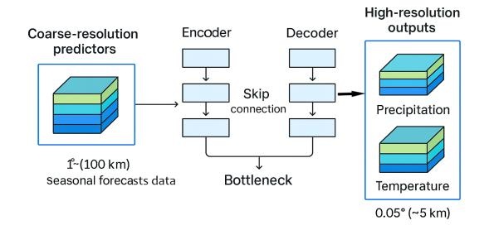

Figure 2: U-Net architecture for downscaling coarse-resolution seasonal forecast data to high-resolution precipitation and temperature data

2.3.5 Model Training and Hyperparameter Optimization

Training follows an 80/10/10 split for training/validation/testing, respectively. Hyperparameters tuned include learning rate, number of filters per layer, batch size, number of epochs and early-stopping criteria, kernel size and depth of the network. In practice, the downscaling process is carried out through a sequence of structured steps to ensure the effective application of the U-Net architecture to seasonal forecast data as described in Figure 3.
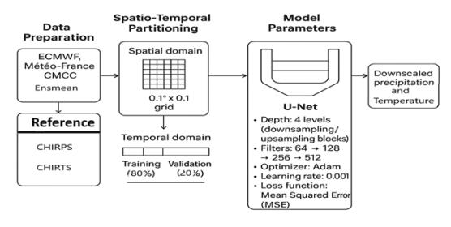
Figure 3: Downscaling Workflow Implementation
2.3.6 Evaluation of Downscaled Outputs
Downscaled forecasts are validated using the same metrics as the raw data (r, RMSE, MAE). Added value is quantified through: bias (downscaled – raw) for each model, spatial correlation improvement at the country scale, lead-time skill analysis (1–6 months), modified Taylor diagrams combining the three metrics. Indeed, to facilitate intercomparison, we further identify the best-performing model at each step using a modified Taylor diagram that jointly accounts for the three evaluation metrics. In this representation, the angular axis corresponds to the correlation coefficient (r), the radial axis to the root-mean-square error (RMSE), and the marker size to the mean absolute error (MAE). This combined visualization allows for a comprehensive assessment of model performance across multiple dimensions of forecast skill. Special attention is given to the spatial consistency of improvements and to the model’s ability to preserve seasonal dynamics across lead times. All results are reported both for the individual models and for the multi-model ensemble mean (Ensmean).
In summary, the primary objective of this study is to downscale seasonal forecast datasets from a spatial resolution of 1° (~100 km) to 0.05° (~5 km) over Burkina Faso, within which the Nouhao sub-basin is located. Since this study deals with gridded data, the following figures 4 illustrate the intended changes to the spatial grids resulting from the downscaling process both at the country and the sub-basin scale. At the scale of the Nouhao sub-basin (Figure 4 (c) ), it is visible that no grid point is located within the basin, reinforcing our initial observation that seasonal forecast data at native resolution are largely unusable for small watersheds. After the downscaling process, however, the situation changes substantially, with numerous grid points now available within the basin (Figure 4(d)), making the data suitable for local-scale applications.

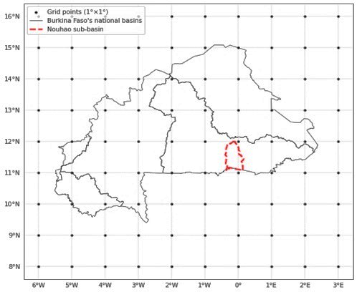
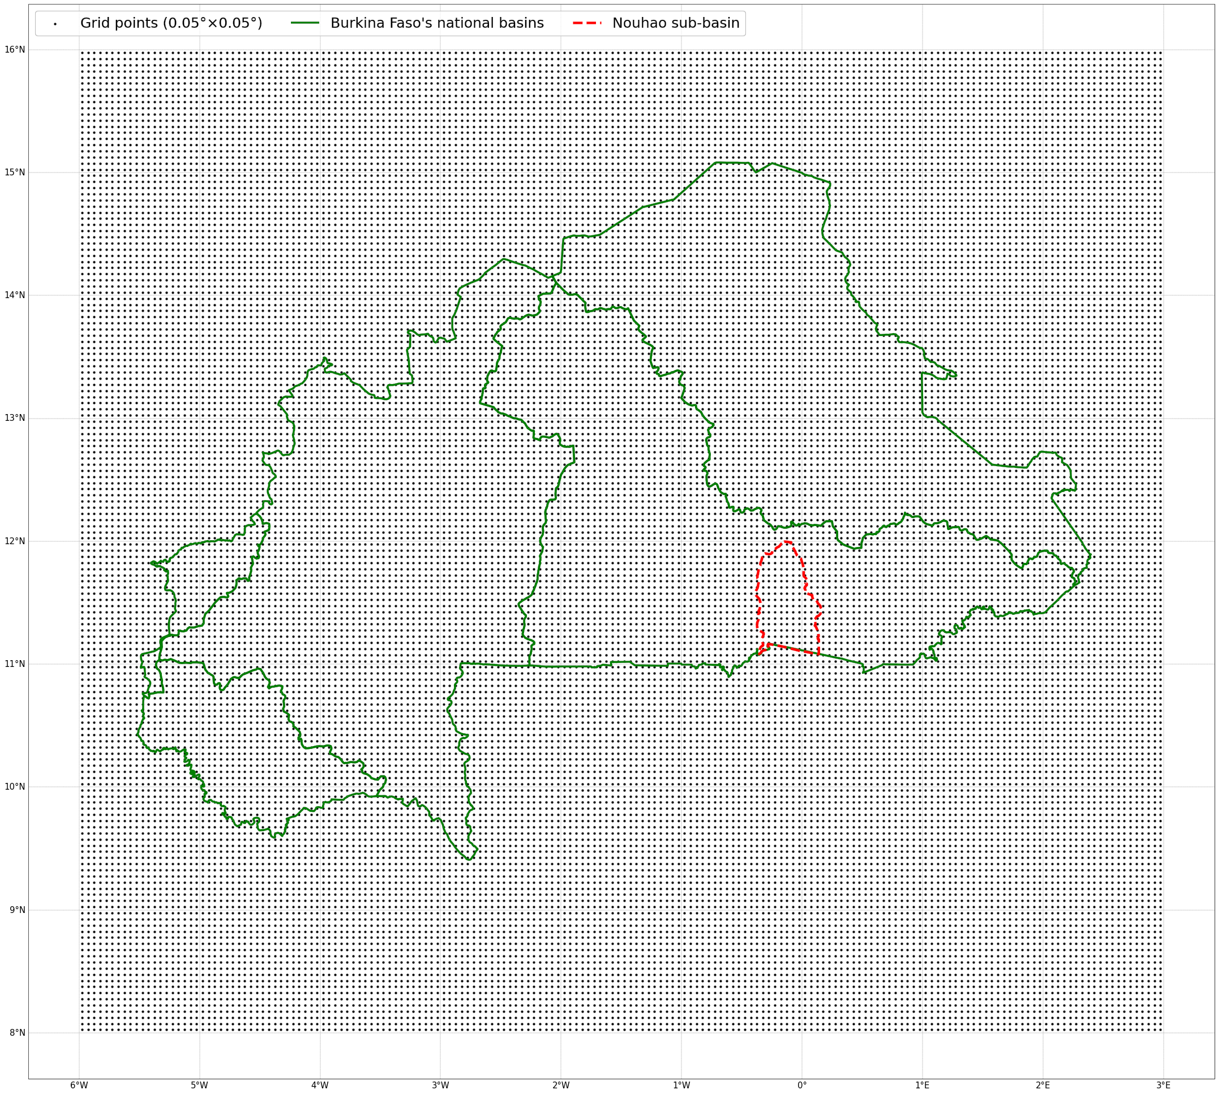
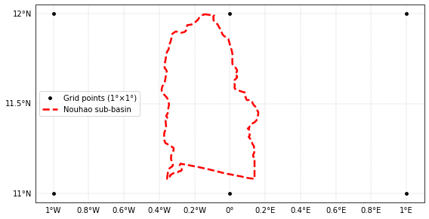
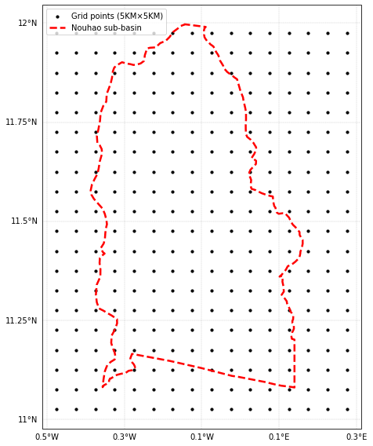
(b)
(a)

(c)
(d)

Figure 4: From 1° spatial grids (over Burkina Faso (a) and over the sub-basin (c)) to 0.05° spatial grids (over Burkina Faso (b) and over the sub-basin (d)), with grid points in black dots.

3. RESULTS AND DISCUSSION

This section presents and interprets the performance of the raw seasonal forecasts and the improvements brought by the U-Net downscaling approach over Burkina Faso, with a specific focus on the Nouhao sub-basin. The downscaling process yields monthly precipitation and temperature data for the entire country, as this temporal scale is particularly relevant for climate-sensitive sectors such as agriculture [19][20][21] especially during the rainy season. The analysis highlights (i) the intrinsic limitations of coarse-resolution forecasts, (ii) the added value of the deep-learning downscaled fields, (iii) spatial and temporal improvements, and (iv) the shortcomings of the study, in particular the U-NET architecture.

3.1. Skill of coarse-resolution versus high-resolution seasonal precipitation forecasts
Instead of evaluating forecast performance across the entire six-month period from June to November, we restrict the analysis to the three core months of the West African rainy season, July, August, and September (JAS) [22][23]. These months correspond to the peak of rainfall activity in the Sahel region and are therefore the most critical for assessing forecast skill.
Figure 5 presents how well the models capture the cumulative rainfall of July at coarse-resolution. Even though ECMWF and the ensemble mean (Ensmean) seem to stand out as the best-performing forecasts, all models struggle to reproduce cumulative July rainfall, with biases exceeding 20% in several areas, particularly across the northern part of the country. This result is consistent with numerous previous studies showing that ECMWF generally demonstrates strong skill in capturing rainfall variability over West Africa [24] [25].

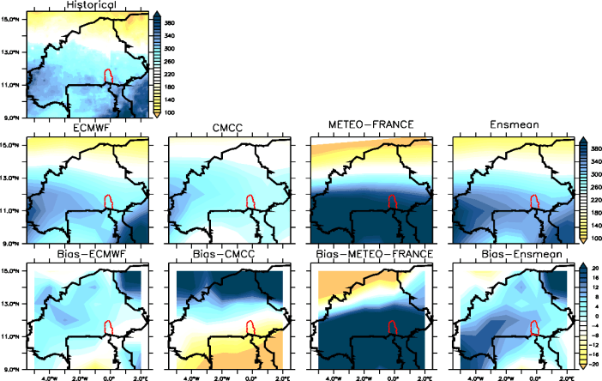
Figure 5: Coarse-resolution seasonal precipitation (in mm) forecasts skill for July (bias in %), averaged over 36 years (1981-2016).
After the downscaling process, Figure 6 illustrates the improved skill of the high-resolution precipitation forecasts. All models show enhanced ability to capture July rainfall patterns across the country, with biases reduced to less than 4 mm in absolute value. Even the rainfall magnitudes in the southern and northern parts of the country are well captured. This is particularly relevant, as several studies have highlighted the inability of climate models to reproduce rainfall magnitudes accurately, even when they perform reasonably well in capturing spatial patterns or variability [26].
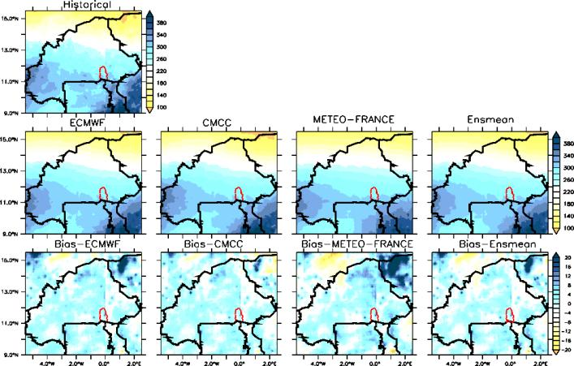
Figure 6: High-resolution seasonal precipitation (in mm) forecasts skill for July (biases in %), averaged over 36 years (1981-2016).
To identify the most skillful model among the available seasonal forecast outputs (ECMWF, METEO-FRANCE, CMCC and the Ensmean) before and after the downscaling, we employed a Taylor diagram.
- At coarse-resolution, the Taylor diagram identified ECMWF as the best performer (Figure 7 a), characterized by a high correlation (r = 0.9) along with the lowest RMSE (less than 20 mm) and MAE values. This suggests that, at coarse resolution, the ECMWF model demonstrates superior accuracy compared to the other forecasting systems, consistent with findings reported in previous studies [24] [25]. The comparatively low RMSE and MAE values indicate minimal deviation from observed data, while the high correlation coefficient underscores the model’s capability to effectively capture temporal variations and seasonal dynamics. Collectively, these results highlight the robustness and reliability of the ECMWF seasonal forecast system, confirming its strong potential as a baseline for subsequent downscaling applications using the U-Net architecture.
- After the downscaling, METEO FRANCE emerges as the best-performing model (Figure 7 b) for July, capturing precipitation patterns with the highest skill, as indicated by a correlation coefficient (r) close to 1 and an RMSE below 10 mm. Upon closer examination, METEO FRANCE slightly outperformed ECMWF, exhibiting marginally lower RMSE and MAE values. This subtle yet consistent improvement suggests that the METEO FRANCE forecasting system may be better adapted to capturing high-resolution spatial variability and localized climatic features, particularly in regions with complex topography or heterogeneous land-atmosphere interactions [27][28].
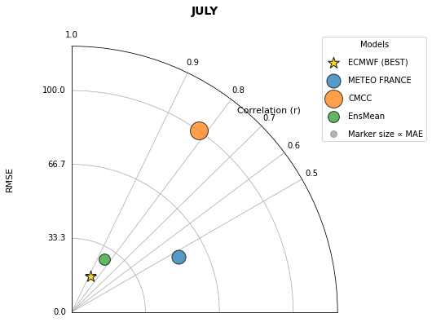
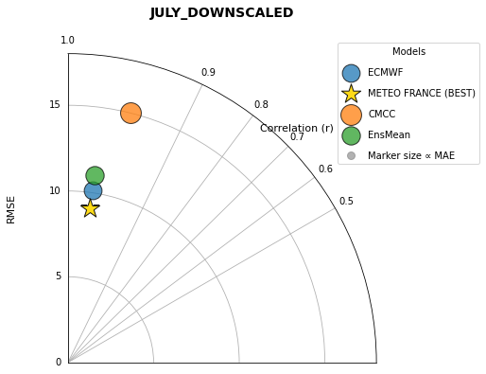
(a)
(b)

Figure 7: Modified Taylor diagram featuring the best model for July
(Coarse-resolution (a) and High-Resolution (b))
For the month of August, Figure 8 presents the skill of the coarse-resolution precipitation forecasts. Similar to July, the models struggle to reproduce observed rainfall, with biases exceeding 20% across both the southern half and the northern part of the country.
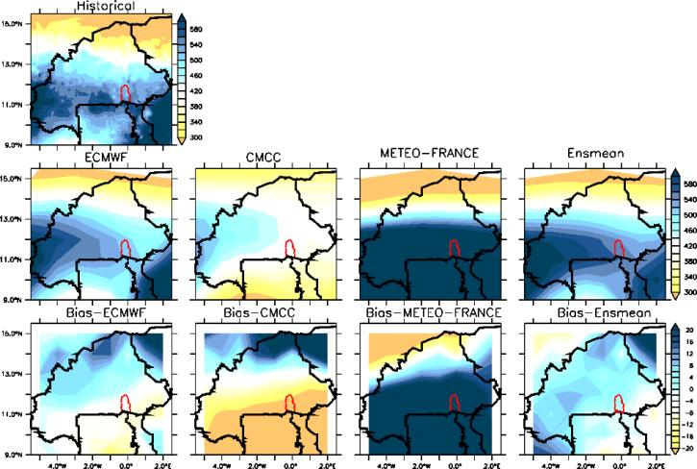
Figure 8: Coarse-resolution seasonal precipitation (in mm) forecasts skill for August (biases in %), averaged over 36 years (1981-2016).

Figure 9 illustrates the performance of the models after the downscaling process for the month of August. Following downscaling, all models are now able to capture nearly all the key features of August rainfall across the country, with biases reduced to values close to zero.

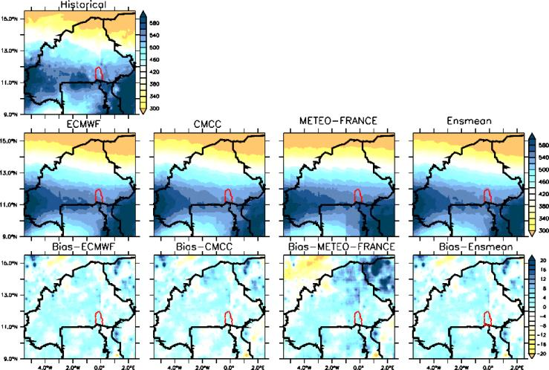
Figure 9: High-resolution seasonal precipitation (in mm) forecasts skill for August (biases in %), averaged over 36 years (1981-2016).

To identify the most skillful model for the month of August) before and after the downscaling, the Taylor diagram exhibits the following results.
- At coarse-resolution, theTaylor diagram highlights the multi-model ensemble (Ensmean) as the best-performing forecast for August, with a correlation of approximately 0.9 and an RMSE below 40 mm (Figure 10 (a)). Let us recall that the Ensmean, computed as the average of the three models (ECMWF, Météo-France, and CMCC), was also evaluated. The Ensmean effectively integrates the strengths of each constituent model, mitigating individual systematic biases and enhancing overall forecast robustness. This performance suggests a general agreement among the three forecasting systems, indicating that despite their structural and methodological differences, they capture similar large-scale climatic signals. The strong consistency observed in the ensemble output highlights the value of multi-model averaging as a means to improve the stability and reliability of seasonal forecasts. This aligns with previous findings emphasizing that ensemble approaches often outperform single-model forecasts by compensating for model-specific errors and better representing forecast uncertainty [29][30].
- At high-resolution, ECMWF emerges as the best-performing model for August, exhibiting a correlation of approximately 0.9 and an RMSE of about 15 mm (Figure 10 (b)). As stated previously, the ECMWF model generally exhibits superior performance compared to the other forecasting systems, primarily due to its larger ensemble systems size, comprising 51 members, compared to 9 for Météo-France and 35 for CMCC. A larger ensemble allows ECMWF to better represent the range of possible atmospheric states, thereby enhancing the statistical robustness and reliability of its probabilistic forecasts. Moreover, ECMWF’s advanced data assimilation system, which integrates an extensive suite of global satellite and in situ observations, contributes to more accurate initial conditions, a fundamental prerequisite for improved seasonal predictability. These methodological advantages collectively enhance ECMWF’s ability to capture both large-scale circulation features and temporal variability with higher fidelity than the other models [31].

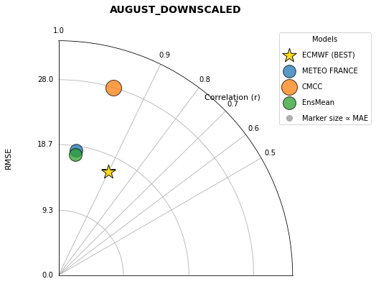
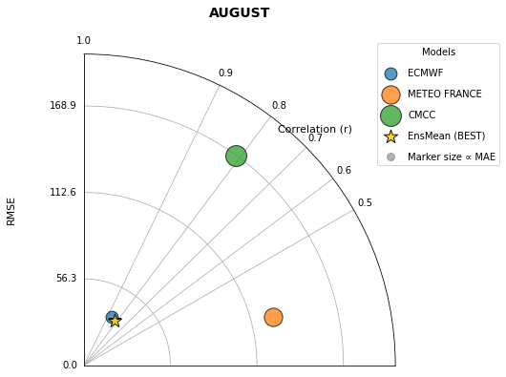
(b)
(a)

Figure 10: Modified Taylor diagram featuring the best model for August
(Coarse-resolution (a) and High-Resolution (b))

For the month of September, Figure 11 presents the skill of the coarse-resolution precipitation forecasts. While ECMWF and the ensemble mean (Ensmean) generally stand out, biases remain substantial, particularly in the northern part of the country, exceeding 20%.
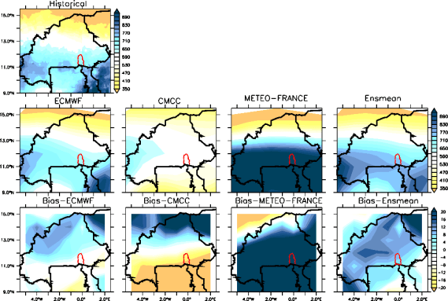
Figure 11: Coarse-resolution seasonal precipitation (in mm) forecasts skill for September (biases in %), averaged over 36 years (1981-2016).

The downscaling process markedly improves performance for September (Figure 12), with all models effectively capturing the spatial patterns of rainfall across Burkina Faso. Except for the northeastern region, the models exhibit strong skill, with biases close to zero across the remainder of the country.

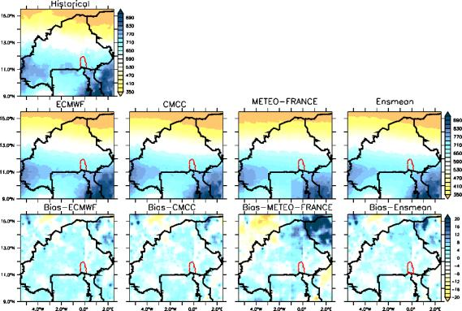
Figure 12: High-resolution seasonal precipitation (in mm) forecasts skill for September (biases in %), averaged over 36 years (1981-2016).

To distinguish the best-performing model between the two, before and after the downscaling, the Taylor diagram highlights ECMWF as the leading model at coarse-resolution, with a correlation close to 0.9 and an RMSE below 50 mm (Figure 13 (a)). After the downscaling, the Taylor diagram analysis shows that ECMWF emerges as the best model (Figure 13 (b)) with a correlation close to 1 and a RMSE less than 25 mm.
(a)
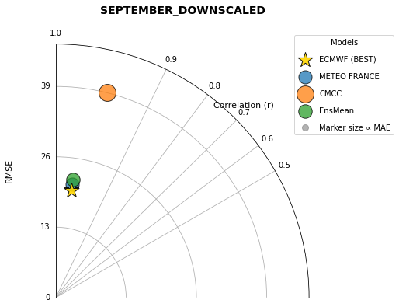
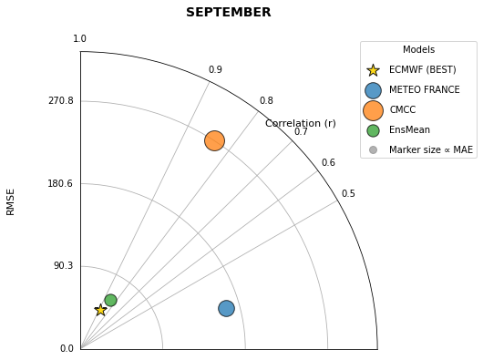
(b)

Figure 13: Modified Taylor diagram featuring the best model for September
(Coarse-resolution (a) and High-Resolution (b))

In summary, it is noticeable that forecast skill decreases as the lead-time increases. From July to August, performance steadily declines for both the raw coarse-resolution forecasts and the downscaled high-resolution outputs. This behavior is consistent with numerous findings in climate prediction research, which emphasize that the skill of climate models generally diminishes as the forecast horizon lengthens [3][32][33]. Moreover, beyond spatial resolution limitations, climate models generally struggle to simulate precipitation due to structural obstacles, primarily linked to parameterization schemes of convection, cloud processes, and related sub-grid phenomena. These limitations often result in poor skill in representing rainfall, particularly in regions with complex terrain [27] [28].
Regarding the best model identified through the Taylor diagrams, ECMWF was selected twice (for August and September) as the top performer after the downscaling process. This suggests that ECMWF is a particularly reliable model and could serve as a valuable resource for enhancing the forecasting capacity of national meteorological agencies in West Africa [34].

3.2. Skill of coarse-resolution versus high-resolution seasonal temperature forecasts
For mean temperature, we focus on the month of June, as it plays a critical role in triggering convection over the Sahel as part of the west African Monsoon onset [35] [36]. During this period, strong surface heating is necessary to establish the latitudinal temperature gradient between the Atlantic Ocean and the Sahel, which in turn drives the onset of the West African monsoon, the primary mechanism responsible for rainfall in the region [37] [38].
Figure 14 illustrates the ability of the models to capture mean June temperatures at coarse-resolution. No single model succeeds in capturing the full spatial pattern of temperature across Burkina Faso. METEO-FRANCE stands out for better representing temperatures in the northern part of the country, but it simultaneously over-cools other regions. As a result, all models exhibit an overall cooling bias of up to -5 °C at the national scale.
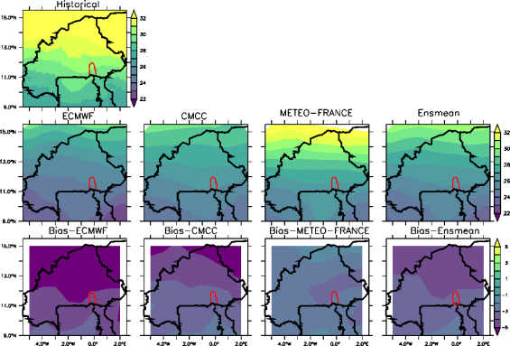
Figure 14: Coarse-resolution seasonal temperature (in °C) forecasts skill for June (biases in °C), averaged over 36 years (1981-2016).
After downscaling, Figure 15 illustrates the ability of all models to reproduce mean temperatures in September. Performance is notably improved, and although the models still exhibit a slight cooling tendency, biases are reduced to approximately 1 °C in absolute value across the country.

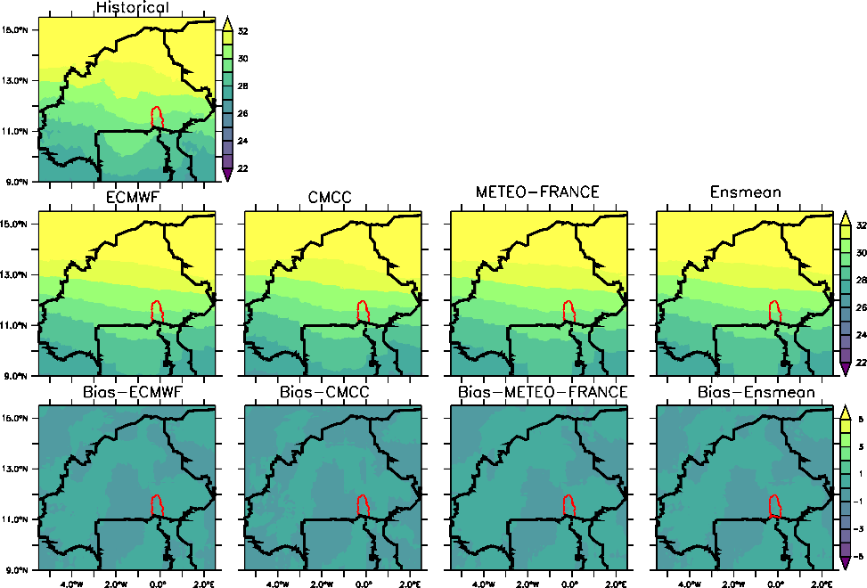
Figure 15: High-resolution seasonal temperature (in °C) forecasts skill for June (biases in °C), averaged over 36 years (1981-2016).

To select the most skillful model that best capture the temperatures for June, before and after the downscaling, the modified Taylor diagram gives these results.
- At coarse-resolution, CMCC emerges as the best-performing forecast for June temperatures at coarse resolution, with a correlation of approximately 0.9 and a RMSE below 3 °C (Figure 16 (a)). This finding is consistent with several studies that highlight the skill of the CMCC model in simulating temperature at the global scale [39]. Nevertheless, it is important to note that, unlike precipitation, climate models generally perform well in simulating temperature. This is because temperature is explicitly resolved by the dynamical core of the model through mathematical equations [40] [41], whereas precipitation relies heavily on parameterization [27]. The latter depends on the specific climate center that develops the model, with each center employing its own parameterization schemes for processes such as convection, clouds..., leading to variations in performance across models [42] [43].
- After the downscaling process, METEO-FRANCE exhibits the best performances for June temperatures, exhibiting a correlation of r = 1 and an RMSE below 0.2 °C (Figure 16 (b)). As previously observed for precipitation at high resolution, the METEO-FRANCE model also emerges as the best-performing system for temperature during the month of June. This superior performance may be attributed to the model’s enhanced ability to accurately reproduce the prevailing atmospheric conditions over West Africa, particularly the regional circulation patterns that govern temperature variability during the early monsoon period. The METEO-FRANCE model’s parameterization schemes and representation of surface-atmosphere interactions likely contribute to its skill in capturing both diurnal temperature cycles and mesoscale thermal contrasts across the region. These findings further emphasize the model’s adaptability to regional climatic features, reinforcing its suitability for high-resolution downscaling applications in West Africa [44] [45].
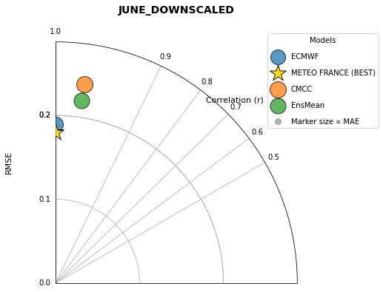
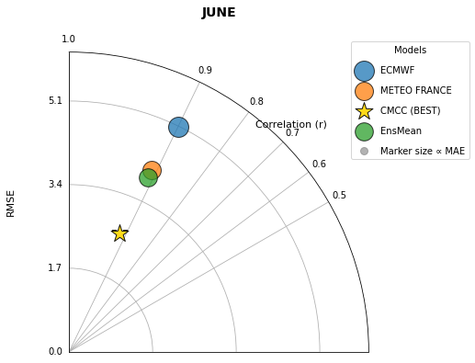
(b)
(a)

Figure 16: Modified Taylor diagram featuring the best model for June
(Coarse-resolution (a) and High-Resolution (b))

3.3 Summary and limitations of the study, particularly the U-Net architecture

The downscaling process substantially improved the performance of the seasonal precipitation and temperature forecasts compared to the raw coarse-resolution data. Analysis of the modified Taylor diagram clearly highlights these gains:
- for precipitation, the root-mean-square error (RMSE) was reduced by up to sixfold. Specifically, RMSE values decreased from 80 mm to 15 mm in July, from 170 mm to 30 mm in August, and from 275 mm to 40 mm in September;
- Temperature forecasts benefited even more from downscaling, with RMSE reduced by up to twentyfold, from about 5 °C in the coarse forecasts to just 0.25 °C after downscaling.
These results underscore the significant added value of the high-resolution downscaled forecasts (Figure 17), providing more reliable climate information for small watersheds and regional applications.

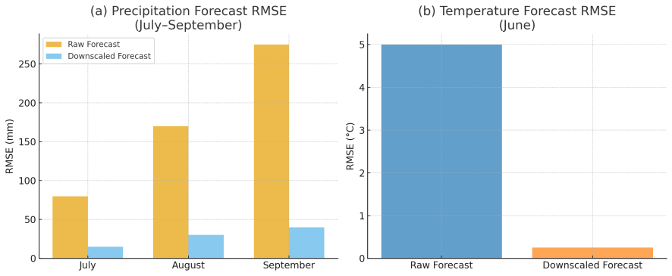
Figure 17: Improvement in forecast skill after U-NET Downscaling

These results align with several international studies that have leveraged the potential of U-Net–based downscaling to generate high-resolution climate information, often outperforming other deep learning architectures [46][12]. However, even though this architecture presents notable advantages in terms of reduced computational cost, model portability, and accessibility, particularly beneficial for researchers in low-income regions, it is important to acknowledge its inherent limitations. Among the most commonly reported limitations are:
- Lack of physical consistency [47]: The U-Net architecture is fully data-driven and does not explicitly account for physical conservation laws such as those governing energy, mass, or moisture balance. As a result, the downscaled outputs may violate key physical relationships between variables.
- Sensitivity to input data quality [48]: The accuracy and representativeness of the training data have a strong influence on model performance. In particular, datasets such as CHIRPS (precipitation) and CHIRTS (temperature) contain known biases [49], which can propagate through the model and lead to misrepresentations at the final high-resolution scale.
- Difficulty capturing temporal coherence [50]: Standard U-Net architectures are designed for spatial processing and do not explicitly model temporal dependencies. Consequently, the model may produce temporally inconsistent patterns, leading to unrealistic variability across consecutive months or seasons.
- Over-smoothing and loss of extremes [11]: Since U-Net models are often optimized with loss functions such as mean-squared error or mean-absolute error, they tend to underestimate extreme events. This limitation is especially evident for precipitation, where outputs can appear overly smoothed and fail to reproduce observed intensity distributions.
Nevertheless, these limitations demonstrate that U-NET deep learning-based downscaling must evolve toward hybrid architectures that combine the strengths of convolutional, generative, and physically constrained approaches. Indeed, the consistent improvements observed in both precipitation and temperature downscaling across diverse regions underscore the potential of these methods for enhancing sub-seasonal and seasonal forecasting capabilities. These findings highlight the relevance of adopting such advanced modeling approaches within national institutions, particularly Burkina Faso’s National Agency of Meteorology (ANAM) and the General Directorate of Water Resources (DGRE), to strengthen hydrological and meteorological forecasting frameworks. The integration of deep learning–based downscaling techniques, such as the U-Net architecture, could thus represent a significant step toward more accurate and spatially refined climate services in West Africa.

4. CONCLUSION

This study set out to generate high-resolution seasonal forecasts of precipitation and temperature over Burkina Faso in order to strengthen climate information services for sectors such as agriculture and water resources management, particularly in small watersheds where in situ observations remain sparse. Using seasonal forecasts from three global prediction systems (ECMWF, Météo-France, and CMCC), we first assessed the raw, coarse-resolution outputs against high-resolution reference datasets (CHIRPS for precipitation and CHIRTS for temperature). The evaluation, based on standard statistical measures including the correlation coefficient (r), root-mean-square error (RMSE), and mean absolute error (MAE), revealed limited skill of the raw forecasts at the country scale, consistent with known challenges of global seasonal systems in the Sahel region.
To address these limitations, we applied a deep learning–based downscaling approach to transform the ~1° coarse forecasts into 0.05° high-resolution gridded fields. The downscaled outputs demonstrated substantial improvements in predictive skill, with performance gains reaching up to threefold (precipitation) and tenfold (temperature) compared with the raw forecasts. These results highlight the capacity of modern machine learning methods to bridge the scale gap between global seasonal prediction systems and the high-resolution climate information required for local applications. The modified Taylor diagram, which jointly incorporated r, RMSE, and MAE, proved to be a useful diagnostic for identifying the best-performing model at each step of the analysis.
The findings demonstrate that deep learning-based downscaling can deliver more accurate and spatially detailed seasonal climate information over Burkina Faso. Such improvements are particularly relevant for agricultural decision-making, water resource planning, and risk management in regions where weather stations networks are limited. These downscaled datasets can support national institutions, such as Burkina Faso’s National Agency of Meteorology (ANAM) and the General Directorate of Water Resources (DGRE), as well as regional centers like AGRHYMET. Their use can enhance the refinement of seasonal forecasts through the early availability of high-resolution climate outlook and the integration of impact-based forecasting approaches tailored to the Sahelian context. Future research should explore the integration of these high-resolution forecasts into operational drought and flood prediction systems, extend the approach to other West African countries, and develop hybrid frameworks that combine deep learning with physical process constraints to enhance applications such as hydrological modeling.

REFERENCES

[1] K. Calvin et al., “IPCC, 2023: Climate Change 2023: Synthesis Report. Contribution of Working Groups I, II and III to the Sixth Assessment Report of the Intergovernmental Panel on Climate Change [Core Writing Team, H. Lee and J. Romero (eds.)]. IPCC, Geneva, Switzerland.,” Jul. 2023. doi: 10.59327/IPCC/AR6-9789291691647.
[2] “Global Status of Multi-Hazard Early Warning Systems 2023 UN Office for Disaster Risk Reduction,” 2023. [Online]. Available: www.public.wmo.int
[3] J. Cullmann et al., Lead authors and contributors (in alphabetical order): Report Editorial Board (WMO).
[4] R. Mena et al., “Global status of multi-hazard early warning systems Target G,” 2022.
[5] 2023 State of Climate Services: Health . United Nations, 2023.
[6] D. Labeurthre, A. Reffet, and A. Schrapffer, “An Overview of Statistical Downscaling Methods: Techniques, Applications, and Advances,” 2024.
[7] F. Wang, D. Tian, L. Lowe, L. Kalin, and J. Lehrter, “Deep Learning for Daily Precipitation and Temperature Downscaling,” Water Resour Res, vol. 57, no. 4, Apr. 2021, doi: 10.1029/2020WR029308.
[8] M. Waqas, U. W. Humphries, B. Chueasa, and A. Wangwongchai, “Artificial intelligence and numerical weather prediction models: A technical survey,” Natural Hazards Research, vol. 5, no. 2, pp. 306–320, Jun. 2025, doi: 10.1016/J.NHRES.2024.11.004.
[9] Z. Nikraftar, R. Mbuvha, M. Sadegh, and W. A. Landman, “Season-Net: A Deep Learning Framework Bias Correction of Seasonal Forecasting Models,” May 23, 2025. doi: 10.22541/essoar.174802850.04423299/v1.
[10] B. Kumar et al., “Deep-learning based down-scaling of summer monsoon rainfall data over Indian region”, doi: 10.48550/arXiv.2011.11313.
[11] T. Vandal, E. Kodra, S. Ganguly, A. Michaelis, R. Nemani, and A. R. Ganguly, “DeepSD: Generating High Resolution Climate Change Projections through Single Image Super-Resolution,” Mar. 2017, [Online]. Available: http://arxiv.org/abs/1703.03126
[12] Q. Deng, P. Lu, S. Zhao, and N. Yuan, “U-Net: A deep-learning method for improving summer precipitation forecasts in China,” Atmospheric and Oceanic Science Letters, vol. 16, no. 4, Jul. 2023, doi: 10.1016/j.aosl.2022.100322.
[13] A. Ma, R. González, A. Belemvire, C. Independientes, and S. Saulière, “Oxfam Research Reports climate change and women farmers in Burkina Faso IMPACT AND ADAPTATION POLICIES AND PRACTICES,” 2011. [Online]. Available: www.oxfam.org/grow
[14] S. Mendoza Paz and P. Willems, “The skill of statistical downscaling in future climate with high-resolution climate models as pseudo-reality,” J Hydrol Reg Stud, vol. 48, p. 101477, Aug. 2023, doi: 10.1016/J.EJRH.2023.101477.
[15] O. Ronneberger, P. Fischer, and T. Brox, “U-Net: Convolutional Networks for Biomedical Image Segmentation,” May 2015, [Online]. Available: http://arxiv.org/abs/1505.04597
[16] R. Azad et al., “Medical Image Segmentation Review: The success of U-Net,” Nov. 2022, [Online]. Available: http://arxiv.org/abs/2211.14830
[17] J. Mcglinchy, B. Johnson, B. Muller, M. Joseph, and J. Diaz, “Fully Convolutional Neural Network for Impervious Surface Segmentation in Mixed Urban Environment.”
[18] K. Kawaguchi, L. Zhang, and Z. Deng, “Understanding dynamics of nonlinear representation learning and its application,” Mar. 23, 2022, MIT Press Journals. doi: 10.1162/neco_a_01483.
[19] G. J. Kenny, W. Ye, T. Flux, and R. A. Warrick, “Climate variations and New Zealand agriculture: The CLIMPACTS system and issues of spatial and temporal scale,” Environ Int, vol. 27, no. 2–3, pp. 189–194, Sep. 2001, doi: 10.1016/S0160-4120(01)00081-2.
[20] T. T. Wahelo, D. A. Mengistu, and T. M. Merawi, “Spatiotemporal climate variability and its impact on local community livelihoods: A focus on crop production in Metekel Zone, Northwest Ethiopia,” J Agric Food Res, vol. 23, p. 102159, Oct. 2025, doi: 10.1016/J.JAFR.2025.102159.
[21] J. W. Hansen, B. M. Campbell, and P. K. Aggarwal, “Scaling up climate services for farmers: Mission Possible. Learning from good practice in Africa and South Asia,” 2014. [Online]. Available: https://www.researchgate.net/publication/285588667
[22] M. I. Lélé and P. J. Lamb, “Variability of the Intertropical Front (ITF) and rainfall over the West African Sudan-Sahel zone,” J Clim, vol. 23, no. 14, pp. 3984–4004, Jul. 2010, doi: 10.1175/2010JCLI3277.1.
[23] C. Okonkwo, B. Demoz, and S. Tesfai, “Characterization of West African jet streams and their association to ENSO events and rainfall in ERA-Interim 1979-2011,” Advances in Meteorology, vol. 2014, 2014, doi: 10.1155/2014/405617.
[24] R. Bodjrènou et al., “Analysis of current and future climate variability and drought recurrence in Benin, West Africa,” Journal of Water and Climate Change, vol. 16, no. 7, pp. 2297–2316, Jul. 2025, doi: 10.2166/wcc.2025.842.
[25] H. N. Nana, R. S. Tanessong, M. Gudoshava, and D. A. Vondou, “Assessing the ability of the ECMWF seasonal prediction model to forecast extreme September-to-November rainfall events over Equatorial Africa,” Aug. 25, 2025. doi: 10.5194/egusphere-2025-2656.
[26] S. M. Yimer, A. Bouanani, N. Kumar, B. Tischbein, and C. Borgemeister, “Assessment of Climate Models Performance and Associated Uncertainties in Rainfall Projection from CORDEX over the Eastern Nile Basin, Ethiopia,” Climate, vol. 10, no. 7, Jul. 2022, doi: 10.3390/cli10070095.
[27] F. Shah and A. Sharifi, “Climate models for predicting precipitation and temperature trends in cities: A systematic review,” Sustain Cities Soc, vol. 120, Feb. 2025, doi: 10.1016/j.scs.2025.106171.
[28] R. Blackport and J. C. Fyfe, “Climate models fail to capture strengthening wintertime North Atlantic jet and impacts on Europe,” 2022.
[29] F. J. Doblas-Reyes, J. García-Serrano, F. Lienert, A. P. Biescas, and L. R. L. Rodrigues, “Seasonal climate predictability and forecasting: Status and prospects,” Wiley Interdiscip Rev Clim Change, vol. 4, no. 4, pp. 245–268, 2013, doi: 10.1002/wcc.217.
[30] T. N. Palmer et al., “Development of a European multimodel ensemble system for seasonal-to-interannual prediction (DEMETER),” Bull Am Meteorol Soc, vol. 85, no. 6, pp. 853–872, Jun. 2004, doi: 10.1175/BAMS-85-6-853.
[31] F. Molteni and M. A. Balmaseda, “The new ECMWF seasonal forecast system (System 4),” 2011. [Online]. Available: http://www.ecmwf.int/publications/
[32] V. Nitha, S. K. Pramada, N. S. Praseed, and V. Sridhar, “Performance Evaluation of Numerical Weather Prediction Models in Forecasting Rainfall Events in Kerala, India,” Atmosphere (Basel), vol. 16, no. 4, Apr. 2025, doi: 10.3390/atmos16040372.
[33] U. S. Climate, “Climate Models An Assessment of Strengths and Limitations Synthesis and Assessment Product 3.1,” 2008. [Online]. Available: www.climatescience.gov.
[34] J. Frnda, M. Durica, J. Nedoma, S. Zabka, R. Martinek, and M. Kostelansky, “A weather forecast model accuracy analysis and ecmwf enhancement proposal by neural network,” Sensors (Switzerland), vol. 19, no. 23, Dec. 2019, doi: 10.3390/s19235144.
[35] S. E. Nicholson and D. Wang, “Review Article The West African Sahel: A Review of Recent Studies on the Rainfall Regime and Its Interannual Variability,” Hindawi Publishing Corporation ISRN Meteorology. [Online]. Available: http://dx.doi.org///.....////////////
[36] G. A. Torsah, M. A. Osei, J. N. A. Aryee, J. A. A. Oti, and L. K. Amekudzi, “Triggers of inland heavy rainfall inducing convective storms in West Africa : Case study of June, 2021,” Weather Clim Extrem, vol. 47, p. 100740, Mar. 2025, doi: 10.1016/J.WACE.2024.100740.
[37] H. Mutton et al., “The impact of a uniform ocean warming on the West African monsoon,” Clim Dyn, vol. 62, no. 1, pp. 103–122, Jan. 2024, doi: 10.1007/s00382-023-06898-1.
[38] A. T. Tamoffo et al., “West African Monsoon System’s Responses to Global Ocean-Regional Atmosphere Coupling”, doi: 10.1175/JCLI-D-23.
[39] D. Nicolì et al., “The Euro-Mediterranean Center on Climate Change (CMCC) decadal prediction system,” Geosci Model Dev, vol. 16, no. 1, pp. 179–197, Jan. 2023, doi: 10.5194/gmd-16-179-2023.
[40] D. L. Williamson, “The Evolution of Dynamical Cores for Global Atmospheric Models,” 2007.
[41] C. M. Maynard and D. N. Walters, “Mixed-precision arithmetic in the ENDGame dynamical core of the Unified Model, a numerical weather prediction and climate model code,” Comput Phys Commun, vol. 244, pp. 69–75, Nov. 2019, doi: 10.1016/J.CPC.2019.07.002.
[42] R. Forbes, C. Jakob, and M. Miller, “NUMERICAL MODELS | Parameterization of Physical Processes: Clouds,” Encyclopedia of Atmospheric Sciences: Second Edition, pp. 187–193, Jan. 2015, doi: 10.1016/B978-0-12-382225-3.00307-8.
[43] P. K. Pradhan, M. L. R. Liberato, J. A. Ferreira, S. Dasamsetti, and S. Vijaya Bhaskara Rao, “Characteristics of different convective parameterization schemes on the simulation of intensity and track of severe extratropical cyclones over North Atlantic,” Atmos Res, vol. 199, pp. 128–144, Jan. 2018, doi: 10.1016/J.ATMOSRES.2017.09.007.
[44] L. Batté, C. Ardilouze, and M. Déqué, “Forecasting West African Heat Waves at Subseasonal and Seasonal Time Scales”, doi: 10.1175/MWR-D-17.
[45] M. Sanchez Gomez, J. K. Lundquist, P. M. Klein, and T. M. Bell, “Turbulence dissipation rate estimated from lidar observations during the LAPSE-RATE field campaign,” Earth Syst Sci Data, vol. 13, no. 7, pp. 3539–3549, Jul. 2021, doi: 10.5194/essd-13-3539-2021.
[46] J. Liu et al., “Enhanced Wind Field Spatial Downscaling Method Using UNET Architecture and Dual Cross-Attention Mechanism,” Remote Sens (Basel), vol. 16, no. 11, Jun. 2024, doi: 10.3390/rs16111867.
[47] Q. Miao, B. Pan, H. Wang, K. Hsu, and S. Sorooshian, “Improving monsoon precipitation prediction using combined convolutional and long short term memory neural network,” Water (Switzerland), vol. 11, no. 5, May 2019, doi: 10.3390/w11050977.
[48] J. Baño-Medina, R. Manzanas, and J. M. Gutiérrez, “Configuration and Intercomparison of Deep Learning Neural Models for Statistical Downscaling,” Oct. 28, 2019. doi: 10.5194/gmd-2019-278.
[49] W. A. Atiah et al., “Bias correction and spatial disaggregation of satellite-based data for the detection of rainfall seasonality indices,” Heliyon, vol. 9, no. 7, p. e17604, Jul. 2023, doi: 10.1016/J.HELIYON.2023.E17604.
[50] A. Serifi, T. Günther, and N. Ban, “Spatio-Temporal Downscaling of Climate Data Using Convolutional and Error-Predicting Neural Networks,” Frontiers in Climate, vol. 3, Apr. 2021, doi: 10.3389/fclim.2021.656479.

