Original Research Article

Seasonal Assessment of Irrigation Water Quality of Karanja Reservoir, Bidar, Karnataka (India): A multivariate analysis

ABSTRACT:
The aim of the present study is to analyse the suitability of Karanja Reservoir water for irrigation purposes. The study was carried out in the period from January 2023 to December 2024. The surface and bottom water samples were collected seasonally and were evaluated for irrigation water indices such as Electrical Conductivity (EC), Total Hardness (TH), Sodium Adsorption Ratio (SAR), Soluble Sodium Percentage (SSP), Percentage Sodium (%Na), Residual Sodium Carbonate (RSC), Kelly's Ratio (KR), Magnesium Hazard (MH), Permeability Index (PI), Potential Salinity (PS), Irrigation Water Quality Index (IWQI), US Salinity Laboratory (USSL) diagram, Corrosivity Ratio (CR) and Chloro-Alkaline Indices (CAI1 and CAI2). From the results it was found that TH, CR, PS, Na% were found above the permissible limit across all the seasons. A high CR indicated that water should not be transported using metal pipes. Whereas EC, SAR, RSC, SSP, PI, CAI, KR, MH, USSL and IWQI remained below the limit across all the seasons. From the above study, it is concluded that the water sample is moderately suitable for irrigation purposes. Therefore, it is recommended that the water should be monitored to improve the water quality for sustainable development. The findings of the present study serve as a baseline reference for formulating water quality management strategies for the Karanja Reservoir.

Keywords: sustainable, water, indices, irrigation, IWQI, Karanja Reservoir, Bidar, Karnataka.

1. INTRODUCTION:
Now a days, water pollution has become a major problem worldwide, making it difficult to maintain good quality water for human needs because of the growing human population, expanding agricultural activities, rapid industrial growth and unplanned urbanization have led to a continuous rise in the demand for good-quality water (Abbott et al., 2019). The demand for water is steadily increasing in agriculture and other sectors; however, its quality is being negatively influenced by different environmental factors including poor land management, leads to environmental pollution (Mohammed, 2011).
In a lotic system, pollutants that settle in sediments during the non-monsoon period are often resuspended and transported downstream which increases the pollutant load near the reservoir or coastal areas leading to a decline in the water quality of reservoir (Sahu et al., 2023).
Various factors such as climatic conditions, soil characteristics, and the types of crops cultivated for irrigation depends on the water quality (Singh et al., 2018). Using poor-quality water for irrigation over a long period can cause reduce crop yields and affect crop productivity which in turn impacts the health of both consumers and farmers who come in contact with such poor water (Raji & Packialakshmi, 2022). Changes in the soil properties and crop growth are the clear indicators of water quality for irrigation (Jain et al., 2007; Etteieb et al., 2017). The suitability of water for irrigation mainly depends on the physico-chemical characteristics of water including TDS, EC and concentration of major ions such as Ca²⁺, Mg²⁺, Na⁺, K⁺, CO₃²⁻, HCO₃⁻, SO₄²⁻, Cl⁻ and NO₃⁻ (Acharya et al., 2020). When these parameters including ions are within acceptable limits, they help to maintain the soil permeability and support healthy growth of the crops. However, when these ions are in a higher concentration, they can cause problems in the soil by increasing salinity and sodicity (Kumari, 2017; Zaman et al., 2018; Acharya et al., 2020). Irrigation water with Na⁺ levels exceeding 60% can also damage the soil’s physical structure (Singh et al., 2018).
Farmers commonly use water for irrigation to reduce the damage caused by heat and drought conditions to protect their crops (Tack et al., 2017). However, changing climatic conditions, increasing demand of crops requires additional water. Due to decline of groundwater resources and rapid changes in the climate have created uncertainty in agricultural productivity. In addition, due to rapid industrialization, unplanned urbanization and human activities have become worsened for environmental conditions by increasing salinity levels in lakes, rivers and groundwater. In some regions, there is a severe groundwater depletion which caused conversion of irrigated area into barren land posing a serious threat to a sustainable development and food production (Deines et al., 2020). The physico-chemical parameters play a crucial role in determining the quality of water for both drinking and irrigation purposes. The characteristics of water are equally important, as they significantly influence ecological balance and contribute to economic development.
Karanja Reservoir located in Bidar, Karnataka (India) was mainly constructed to fulfil the scarcity of water in and around the Bidar district mainly for drinking and irrigation purposes. Several studies have been carried on Karanja Reservoir were on physico-chemical properties, faunal diversity and metal contamination (Majagi et al., 2008, Majagi & Vijaykumar, 2009; Kori, 2017; Lingesh et al., 2019). However, no study has been done to explore the water quality for irrigation purposes. Therefore, this study has been undertaken to evaluate the seasonal variations of water for its irrigation suitability and to understand the potential adverse effects on soil quality by using different water quality indices.

2. MATERIAL AND METHODS:
Study area: Karanja Reservoir is a manmade freshwater lake located near Byalhalli village in Bhalki Taluk, Bidar District of Karnataka (India). The reservoir lies at 17°51'00" N latitude and 77°20'00" E longitude. The total catchment area of the reservoir is 625.75 sq.km and maximum depth of the reservoir is 10 m. Seasonal water samples were collected from the Kamalpur location, situated at 17°52'57"N and 77°19'25"E (Fig. 1). This collection site is considered to be a potential source of pollution as it influenced by the agricultural runoff and industrial waste. The reservoir is primarily constructed for irrigation and potable water supply, it also facilitates several ecological activities, such as fisheries and aquatic biodiversity (Shaikh & Zodape, 2025).

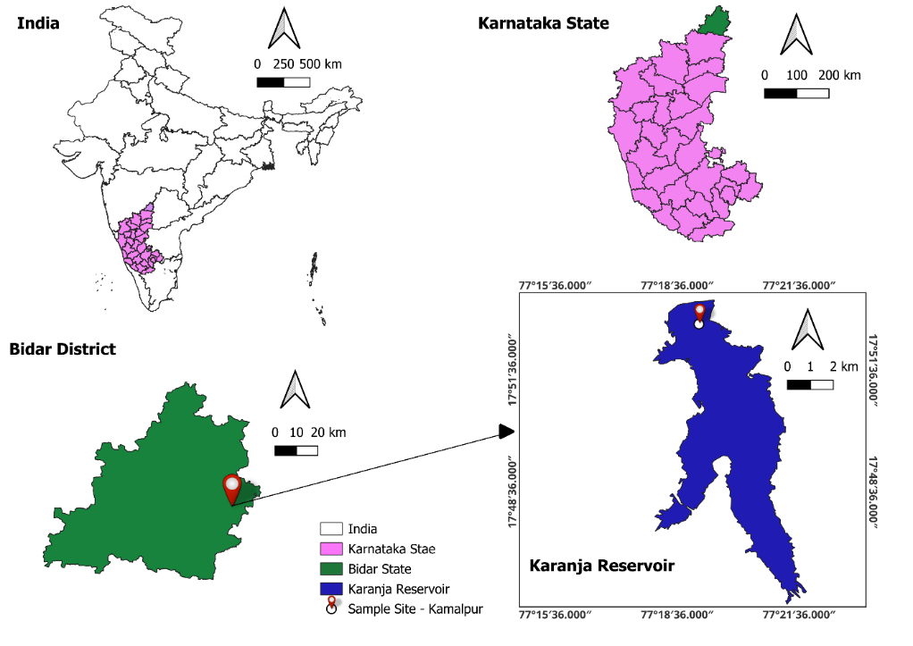
(Source: QGIS Software)
Figure 1: Map showing the location of the study area Karanja Reservoir, Bidar, Karnataka (India).

Collection of water samples: Five litres each of the water samples were collected seasonally from January 2023 to December 2024. The surface and bottom water were collected 10m away from the bank of the collection site of the reservoir. Bottom water was specifically collected from a depth of 8-10 m below the water surface. The water samples were collected in pre-cleaned polypropylene bottles and stored in an ice box at 4°C and transported to the laboratory for further analysis.

Water analysis: To check the suitability of water for irrigation, the physico-chemical analyses were performed for EC, Na⁺, Cl⁻, CO₃²⁻, HCO₃⁻, K⁺, Ca²⁺, Mg²⁺, NO₃⁻, SO₄²⁻ using standard methods suggested by (Trivedy & Goel, 1986; Eaton, 2005; APHA, 2017).

Evaluation of water for irrigation suitability:
i) Sodium Adsorption Ratio (SAR): SAR was calculated to evaluate the suitability of reservoir water for irrigation suggested by (Richards, 1954). Excess sodium can reduce soil permeability and affect crop productivity. SAR is calculated as:
$$SAR=\frac{Na^{+}}{\sqrt{\frac{Ca^{2+}+Mg^{2+}}{2}}}$$
According to SAR (meq/L) classification, <10 is considered as excellent, between 10-18 as good, between 18-26 as fair and >26 as poor (USDA, 1954; Afshan et al., 2022).

ii) Soluble Sodium Percentage (SSP):
SSP is an important parameter that is used to determine the quantity of water suitable for irrigation in terms of soil permeability. It is calculated using the formula suggested by (Wilcox, 1955):
$$SSP=\frac{{Na}^{+}+K^{+}}{{Ca}^{2+}+{Mg}^{2+}+{Na}^{+}+K^{+}}×100$$

Na⁺ is an important cation that degrades agricultural productivity and soil structure due to its high osmotic pressure. Higher Na⁺ concentrations relative to Ca²⁺ and Mg²⁺ can adversely affect soil structure and permeability leading to reduced water infiltration and aeration (Wilcox, 1955; Doneen, 1964). An SSP value is considered < 20 excellent; 20-40 good; 40-60 suitable; >80 unsuitable.
iii) Percentage Sodium (%Na):
The % Na is calculated using the following equation as suggested by (Wilcox, 1955). Na⁺ plays a key role in determining whether a water source is suitable for agricultural use.
$$\%Na =\frac{\left(Na^{+}× 100\right)}{({Ca}^{2+ }+ {Mg}^{2+ }+ {Na}^{+ }+ K^{+ })}$$

%Na is considered < 20% excellent, 20–40% good, 40–60% permissible, 60–80% doubtful and > 80% unsuitable.
iv) U.S. Salinity Laboratory (USSL) Classification of Irrigation Water:
The USSL diagram is used to classify reservoir water for irrigation based on salinity (EC dS/m) and SAR suggested by (USDA, 1954). The combination of salinity and sodium classes (Table 1) allows classification of irrigation water into different categories for agricultural use.
Table 1: Shows the US Salinity Laboratory (USSL) Classifications of irrigation water based on EC and SAR values (USDA, 1954)
Water Class | Water Quality | EC (dS/m)
C1 | Low-Salinity Water (Excellent for Irrigation) | < 0.25
C2 | Medium-Salinity Water (Good for Irrigation) | 0.25–0.75
C3 | High-Salinity Water (Permissible for Irrigation) | 0.75–2.25
C4 | Very High-Salinity Water (Unsuitable for Irrigation) | > 2.25
Water Class | Water Quality | SAR
S1 | Low Sodium Hazard (Excellent for Irrigation) | 0–10
S2 | Medium Sodium Hazard (Good for Irrigation) | 10–18
S3 | High Sodium Hazard (Permissible for Irrigation) | 18–26
S4 | Very High Sodium Hazard (Unsuitable for Irrigation) | > 26

v) Irrigation Water Quality Index (IWQI):
To calculate the IWQI the following parameters were selected: EC, Na⁺, Cl⁻, HCO₃⁻ and SAR. According to Meireles et al. (2010) these factors play an important role in deciding the water suitability for irrigation. It is calculated using the following steps:
- Each parameter is assigned weights (Wi) depending on their relative importance to irrigation water quality. The Wi is then normalised so that their sum equals to 1 (Table 2).

Table 2: Shows assigned weights of IWQI parameters (Meireles et al., 2010)
Parameters | Weight (Wi)
EC | 0.211
Na⁺ | 0.204
HCO₃⁻ | 0.202
Cl⁻ | 0.194
SAR | 0.189
Total | 1.0

- For each parameter Quality value (Qi) is calculated by (Ayers & Westcot, 1994) shown in (Table 3). A higher Qi indicates better water quality while a lower Qi suggests poor water quality. The Qi value is dimensionless and is calculated by using the formula:
$$Qi=qimax-\frac{xamp\left(xij-xinf\right)×qianp​}{xamp}$$
where: qimax: highest value of Qi in class; xamp: upper limit of last class; xij: observed value of parameter; xinf: lower limit of class.

Table 3: Shows classification limits applied in Qi calculation (Ayers & Westcot, 1994)
Qi Range | EC (µS/cm) | SAR (meq/L) | Na⁺ (meq/L) | Cl⁻ (meq/L) | HCO₃⁻ (meq/L)
85–100 | 200 ≤ EC < 750 | 2 ≤ SAR < 3 | 2 ≤ Na⁺ < 3 | 1 ≤ Cl⁻ < 4 | 1 ≤ HCO₃ < 1.5
60–85 | 750 ≤ EC < 1500 | 3 ≤ SAR < 6 | 3 ≤ Na⁺< 6 | 4 ≤ Cl⁻ < 7 | 1.5 ≤ HCO₃⁻ < 4.5
35–60 | 1500 ≤ EC < 3000 | 6 ≤ SAR < 12 | 6 ≤ Na⁺ < 9 | 7 ≤ Cl⁻ < 10 | 4.5 ≤ HCO₃⁻ < 8.5
0–35 | EC < 200 or ≥ 3000 | SAR < 2 or ≥ 12 | Na⁺ < 2 or ≥ 9 | Cl⁻< 1 or ≥ 10 | HCO₃⁻ < 1 or ≥ 8.5

- After evaluating the Qi, the IWQI for each parameter is calculated using the following formula:
$$IWQI=\sum_{i=1}^{n}{Qi }× Wi$$
The IWQI values ranges from 0 to 100. These values are classified into five categories of water for irrigation suitability as proposed by (Meireles et al., 2010) shown in (Table 4).

Table 4: Shows Irrigation Water Quality Index Characteristics (Meireles et al., 2010).
 |  | Recommendations
IWQI | Water use restrictions | Soil | Plant
85–100 | No restriction (NR) | May be used for most soils with low probability of causing salinity and sodicity problems. Leaching being recommended within irrigation practices, except for soils with extremely low permeability. | No toxicity risk for most plants
70–85 | Low restriction (LR) | Recommended for use in irrigated soils with light texture or moderate permeability. Salt leaching recommended. Soil sodicity in heavy texture soils may occur, being recommended to avoid its use in soils with high clay. | Avoid salt sensitive plants
55–70 | Moderate restriction (MR) | May be used in soils with moderate to high permeability values, moderate salt leaching suggested | Plants with moderate tolerance to salt may be grown
40–55 | High restriction (HR) | May be used in soils with high permeability without compact layers. High frequency irrigation schedule should be adopted for water with EC above 2000 µS/cm and SAR above 7.0 | Should be used for irrigation of plants with moderate to high tolerance to salts with special salinity control practices, except water with low Na^{+,} Cl⁻ and HCO₃⁻ values.
0–40 | Severe restriction (SR) | Should be avoided its use for irrigation under normal conditions. In special cases, it may be used occasionally. Water with low salt levels and high SAR requires gypsum application. In high saline water, soils must have high permeability and excess water should be applied to avoid salt accumulation. | Only plants with high salt tolerance, except for waters with extremely low values of Na^{+,} Cl⁻ and HCO₃⁻.

vi) Kelly’s Index / Kelly’s Ratio (KI /KR):
KR is calculated as suggested by (Kelly, 1940; Paliwal, 1967). It is to evaluate the suitability of water for irrigation based on the balance between Na⁺, Ca²⁺ and Mg²⁺ concentrations.
$$KR= \frac{{Na}^{+ }}{{Ca}^{2+ }+ {Mg}^{2+}}$$
A KR value ≤ 1 indicates water suitable for irrigation, whereas KR values > 1 indicates unsuitability.

vii) Magnesium Hazard or Magnesium Adsorption Ratio (MH or MAR):
MH is determined as suggested by (Szaboles & Darab, 1964). An excess of Mg²⁺ in relation to Ca²⁺ can adversely affect soil characteristics. It is calculated using the formula as:
$$MH= \frac{{Mg}^{2+}}{{Ca}^{2+ }+ {Mg}^{2+}} × 100$$
MH > 50% is considered unsafe while MH < 50% is considered safe for irrigation.

viii) Permeability Index (PI):
Doneen (1964) suggested the PI, it is the ability of soil which allows water to move through the soil layers and is strongly influenced by long-term use of the water containing high amounts of salts and by the presence of Na⁺, Ca²⁺, Mg²⁺ and HCO₃⁻ ions. It is calculated using the formula:
$$PI= \frac{{Na}^{+ }+\sqrt{{HCO}_{3}^{-}}}{{Ca}^{2+ }+ {Mg}^{2+}+ {Na}^{+ }} ×100$$

PI is classified into three categories: Class I (>75%, Suitable), Class II (25–75%, Good) and Class III (<25%, Unsuitable). Irrigation water falling under Class I and Class II is generally considered appropriate for agricultural use.

ix) Residual Sodium Carbonate (RSC) / Alkalinity Index (AI):
RSC measures the degree of alkali damage as proposed by (Richards, 1954). The continuous use of water with high the values for irrigation purposes can decrease vegetation growth (Vasanthavigar et al., 2010; Zaidi et al., 2015). If the concentration of carbonates exceeds the alkali earth, precipitation of Ca²⁺ and Mg²⁺ takes place and if the concentration of alkali earth exceeds, it means that residual NaCO₃ is absent in that area (Raghunath, 1987).
$$RSC= {(HCO}_{3}^{-}+{CO}_{3}^{2-}) - {(Ca}^{2+ }+ {Mg}^{2+})$$
A high value of RSC > 2.5 meq/L is unsuitable; RSC value between 1.25 and 2.5 meq/L is considered as a medium quality, while RSC value <1.5 meq/L is considered safe and suitable for irrigation.

x) Potential salinity (PS):
PS was determined as proposed by (Doneen, 1964) for categorization of water for agriculture use. It is calculated for different seasons using following formula:
$$\text{PS = }{Cl}^{- }+0.5 × {S0}_{4}^{2-}$$

PS < 3 is suitable for irrigation; PS > 3 is unsuitable for irrigation (Cl⁻ and SO₄²⁻ hazard).

xi) Chloro-alkaline Indices (CAI1 and CAI2):
CAI was calculated as suggested by (Schoeller, 1977). These indices reflect whether Na⁺ and K⁺ in water are exchanged with Ca²⁺ and Mg²⁺ in the rocks or vice versa. The indices were calculated using the following equations as:
$$CAI1=\frac{{Cl}^{- }\left(Na^{+}+ K^{+ }\right)}{{Cl}^{- }}$$

$$CAI2=\frac{{Cl}^{- }\left(Na^{+}+ K^{+ }\right)}{{({S0}_{4}^{2-}+HCO}_{3}^{-}+{CO}_{3}^{2-}+ {NO}_{3}^{-})}$$
​A positive value indicates a direct exchange, where Na⁺ and K⁺ in water are replaced by Ca²⁺ and Mg²⁺ from rocks. A negative value suggests a reverse exchange where Ca²⁺ and Mg²⁺ in water are substituted by Na⁺ and K⁺ from rocks.

xii) Corrosivity Ratio (CR):
CR was determined by as proposed by (Balasubramanian, 1986). The CR index mainly reflects the impact of Cl⁻ and SO₄²⁻ which promote corrosion, against the buffering effect of HCO₃⁻ and ${CO}_{3}^{2- }$ions. The rate of corrosion depends upon some physical parameters like pressure, temperature and rate of flow of water. The CR was used to assess the suitability of water for transport through pipelines. The CR was calculated using the following equation, where all ion concentrations are expressed in mg/L:
$$CR=\frac{\left(\frac{{Cl}^{- }}{35}\right)+2\left(\frac{{SO}_{4}^{2-}}{96}\right)}{\left(\frac{{CO}_{3}^{2- }+{HCO}_{3}^{-}}{100}\right)}$$

Water with a CR > 1 is considered safe for transportation through any type of pipes, while CR < 1 indicate a corrosive nature making unsuitability for metal pipe transportation.

xiii) Total Hardness (TH):
TH was evaluated as proposed by (Todd, 1980). Hardness of water mainly comes from the presence of divalent metallic ions, especially Ca²⁺ and Mg²⁺. It is generally expressed as the total concentration of Ca²⁺ and Mg²⁺ in mg/L of CaCO₃ equivalent. The formula used for calculation is:
$$TH={2.5 ×Ca}^{2+ }+ 4.1 ×{Mg}^{2+}$$
According to the USEPA (1986) TH is classified as: soft (0–60 mg/L), moderately hard (60–120 mg/L), hard (120–180 mg/L) and very hard (>180 mg/L).

Ion balancing: The concentrations of all the parameters were converted into meq/L from mg/L by using the following formula:
$$meq/L=\frac{\left(\frac{mg}{L}\right)× valence}{molecular weight}$$

3. RESULTS AND DISCUSSIONS:
Table 5: Shows the mean ± S.D. (n = 5) seasonal variations of physico-chemical characteristics of Surface and Bottom water collected from Karanja Reservoir, Bidar, Karnataka (India) (Jan. 2023 to Dec. 2024).
Season | Pre-Monsoon |  | Monsoon |  | Post-Monsoon |  | Pre-Monsoon |  | Monsoon |  |  | Post-Monsoon
Water | Surface | Bottom | Surface | Bottom | Surface | Bottom | Surface | Bottom | Surface | Bottom |  | Surface |  | Bottom
Parameters | Year 2023 |  |  |  |  |  | Year 2024
EC (µS/cm) | 337.40 ± 8.66 | 317.82 ± 18.16 | 345.18 ± 24.66 | 343.47 ± 26.52 | 326.73 ± 19.43 | 328.62 ±22.34 | 353.88 ± 5.34 | 355.23± 10.66 | 345.39 ± 36.46 | 343.46 ± 27.37 | 349.33 ± 23.36 |  | 352.11± 28.24
Na⁺ (meq/L) | 8.42 ± 9.79 | 8.33 ± 8.73 | 8.45 ± 5.94 | 8.58 ± 14.47 | 8.37 ± 9.09 | 8.45 ± 11.84 | 7.84 ± 2.78 | 7.94 ± 2.04 | 9.47 ± 46.55 | 8.32 ± 3.26 | 8.25 ± 4.55 |  | 8.10 ± 5.06
Cl⁻ (meq/L) | 5.80 ± 5.06 | 5.95 ± 5.57 | 6.83 ± 6.58 | 6.98 ± 5.0 | 6.56 ± 7.64 | 6.71 ± 6.05 | 5.62 ± 9.15 | 5.77 ± 4.40 | 6.34 ± 11.50 | 6.46 ± 10.09 | 6.52 ± 15.94 |  | 6.47 ± 17.41
CO₃²⁻ (meq/L) | 0.0049 ± 24.47 | 0.0051± 16.95 | 0.0057 ± 13.74 | 0.2540 ± 17.27 | 0.0037 ± 22.30 | 0.0053 ± 20.57 | 0.0080 ± 24.23 | 0.0054± 19.96 | 0.0065 ± 12.18 | 0.0280 ± 6.26 | 0.0056 ± 41.18 |  | 0.0156 ± 44.37
HCO₃⁻ (meq/L) | 2.94 ± 1.72 | 3.22 ± 1.39 | 1.88 ± 0.80 | 2.08 ± 1.00 | 2.20 ± 2.69 | 1.83 ± 1.87 | 2.83 ± 2.70 | 3.25 ±5 .96 | 1.76 ± 1.69 | 1.80 ± 6.86 | 2.21 ± 11.08 |  | 1.84 ± 12.63
K⁺ (meq/L) | 0.27 ± 1.01 | 0.29 ± 11.36 | 0.31 ± 1.37 | 0.29 ± 2.76 | 0.25 ± 1.13 | 0.25 ± 2.73 | 0.26 ± 1.65 | 0.29 ± 1.22 | 0.29 ± 1.30 | 0.30 ± 1.28 | 0.31 ± 1.15 |  | 0.30 ± 0.93
Ca²⁺ (meq/L) | 3.84 ± 15.34 | 3.70 ± 15.78 | 3.47±16.51 | 3.69 ± 15.30 | 3.76 ± 9.11 | 3.59 ± 9.22 | 5.36 ± 17.94 | 6.79 ± 19.10 | 6.00 ± 5.57 | 6.30 ± 28.41 | 5.00 ± 22.91 |  | 5.93 ± 30.50
Mg²⁺ (meq/L) | 4.19 ± 8.93 | 4.34 ± 7.27 | 4.10 ± 5.52 | 3.80 ± 11.48 | 3.99 ± 1.82 | 4.22 ± 4.99 | 5.13 ± 13.46 | 6.67 ± 8.03 | 4.62 ± 20.07 | 5.48 ± 18.68 | 4.92 ± 13.30 |  | 3.65 ± 11.60
NO₃⁻ (meq/L) | 0.37 ± 5.76 | 0.41 ± 7.29 | 0.5 ± 5.43 | 0.51 ± 2.68 | 0.51 ± 6.14 | 0.53 ± 3.44 | 0.38 ± 4.52 | 0.41 ± 5.05 | 0.44 ± 5.07 | 0.47 ± 3.76 | 0.52 ± 3.5` |  | 0.48 ± 5.06
SO₄²⁻ (meq/L) | 2.65 ± 4.43 | 2.75 ± 5.01 | 3.72 ± 5.21 | 3.82 ± 5.01 | 3.59 ± 11.04 | 3.64 ± 9.86 | 4.35 ± 6.21 | 4.44 ± 7.38 | 4.40 ± 15.73 | 4.59 ± 13.71 | 4.75 ± 5.09 |  | 4.84 ± 4.67

Table 6: Shows the mean ± S.D. (n = 5) seasonal variations in irrigation suitability of Surface and Bottom water collected from Karanja Reservoir, Bidar, Karnataka (India) (Jan. 2023 to Dec. 2024).
Seasons | Pre-Monsoon |  | Monsoon |  | Post-Monsoon |  | Pre-Monsoon |  | Monsoon |  | Post-Monsoon
Water | Surface | Bottom | Surface | Bottom | Surface | Bottom | Surface | Bottom | Surface | Bottom | Surface |  | Bottom
Parameters | Year 2023 |  |  |  |  |  | Year 2024
EC (dS/m) | 0.34 ± 8.66 | 0.32 ± 18.16 | 0.35 ± 24.66 | 0.34 ±  26.52 | 0.34 ±  19.43 | 0.33 ±  22.34 | 0.35 ±  5.34 | 0.36 ±  10.66 | 0.35 ±  36.46 | 0.34 ±  27.37 | 0.35 ±  23.36 | 0.35 ±  2.24
SAR (meq/L) | 4.21 ±  9.22 | 4.16 ±  7.67 | 4.34 ±  10.2 | 4.44 ±  10.7 | 4.25 ±  7.45 | 4.28 ±  8.33 | 3.43 ±  8.2 | 3.06 ±  6.25 | 4.11 ±  5.4 | 3.43 ±  6.6 | 3.70 ±  8.97 | 3.70 ±  9.0
MH / MAR | 52.18 ±  7.22 | 53.98 ±  7.01 | 54.16 ±  6.0 | 50.73 ±  9.8 | 51.48 ±  7.67 | 54.03 ±  5.34 | 48.90 ±  6.22 | 49.55 ±  7.21 | 43.50 ±  8.95 | 46.52 ±  10.2 | 49.60 ±  9.76 | 38.10 ±  7.32
KR / KI | 1.05 ±  1.0 | 1.04 ±  1.08 | 1.12 ±  1.01 | 1.15 ±  1.1 | 1.08 ±  0.99 | 1.08 ±  1.0 | 0.75 ±  0.77 | 0.59 ±  0.71 | 0.89 ±  0.51 | 0.71 ±  0.57 | 0.83 ±  0.19 | 0.85 ±  0.23
SSP | 52.00 ±  8.56 | 51.75 ±  8.98 | 53.65 ±  7.65 | 54.24 ±  8.1 | 52.64 ±  9.32 | 52.71 ±  10.77 | 43.60 ±  7.33 | 37.94 ±  6.21 | 47.88 ±  7.80 | 46.27 ±  7.12 | 46.32 ±  6.65 | 46.71 ±  6.0
Na% | 50.36 ±  9.23 | 50.00 ±  9.01 | 51.75 ±  10.33 | 52.44 ±  10.4 | 51.13 ±  8.12 | 51.18 ±  8.99 | 42.17 ±  7.06 | 36.61 ±  6.25 | 46.47 ±  9.01 | 40.78 ±  7.99 | 44.64 ±  8.05 | 45.05 ±  8.7
PI | 61.61 ±  9.96 | 61.85 ±  9.87 | 61.31 ±  10.6 | 62.37 ±  10.43 | 61.12 ±  8.95 | 60.29 ±  9.0 | 51.95 ±  8.01 | 45.53 ±  7.97 | 53.74 ±  8.65 | 48.07 ±  7.77 | 53.59 ±  9.54 | 53.49 ±  9.32
RSC/AI | -5.09 ±  3.2 | -4.81 ±  2.89 | -5.68 ±  3.8 | -5.16 ±  4.56 | -5.55 ±  5.1 | -5.97 ±  6.01 | -7.65 ±  6.2 | -10.20 ±  8.56 | -8.85 ±  7.2 | -9.95 ±  8.8 | -7.70 ±  5.3 | -7.72 ±  6.1
TH | 400.66 ±  33.4 | 401.58 ±  40.11 | 378.08 ± 30.21 | 374.09 ±  29.67 | 416.01 ± 40.2 | 435.41 ±  42.11 | 523.82 ± 46.23 | 672.22 ±  49.1 | 530.65 ±  45.12 | 588.23 ± 47.21 | 495.45 ±  31.23 | 478.65 ± 39.01
CAI1 | -0.50 ±  0.31 | -0.45 ±  0.29 | -0.28 ±  0.19 | -0.27 ±  0.22 | -0.31 ±  0.20 | -0.30 ±  0.17 | -0.44 ±  0.29 | -0.43 ±  0.27 | -0.54 ±  0.31 | -0.33 ±  0.21 | -0.31 ±  0.16 | -0.30 ±  0.22
CAI2 | -0.48 ±  0.29 | -0.42 ±  0.31 | -0.32 ±  0.19 | -0.28 ±  0.15 | -0.33 ±  0.21 | -0.33 ±  0.26 | -0.33 ±  0.27 | -0.30 ±  0.23 | -0.52 ±  0.39 | -0.31 ±  0.17 | -0.27 ±  0.18 | -0.27 ±  0.15
PS | 7.13 ±  4.23 | 7.33 ±  5.01 | 8.69 ±  8.01 | 8.89 ±  8.0 | 8.36 ±  7.6 | 8.53 ±  9.2 | 7.80 ±  5.99 | 7.99 ±  5.21 | 8.54 ±  6.8 | 8.76 ±  6.02 | 8.90 ±  6.34 | 8.89 ±  7.32
CR | 4.75 ±  3.76 | 5.09 ±  4.56 | 9.27 ±  8.32 | 10.14 ±  8.7 | 7.63 ±  6.32 | 7.80 ±  6.01 | 5.07 ±  4.21 | 5.18 ±  4.7 | 8.47 ±  7.6 | 10.26 ±  9.33 | 10.27 ±  9.04 | 10.20 ±  9.0

Table 7: Shows the mean ± S.D. (n = 5) seasonal variations in Irrigation Water Quality Index (IWQI) of Surface and Bottom water collected from Karanja Reservoir, Bidar, Karnataka (Jan. 2023 to Dec. 2024).
Seasons | Year | Surface water  IWQI / Class | Bottom water  IWQI / Class
Pre-Monsoon | 2023 | 70.91 ± 48.43  LR | 71.20 ± 47.12  LR
Pre-Monsoon | 2024 | 72.88 ± 46.21  LR | 78.86 ± 43.12  LR
Monsoon | 2023 | 70.71± 40.12  LR | 70.35± 39.9  LR
Monsoon | 2024 | 63.45 ± 31.09  MR | 73.16 ± 51.23  LR
Post-Monsoon | 2023 | 70.94 ± 39. 83  LR | 70.66 ± 47.21  LR
Post-Monsoon | 2024 | 72.64 ± 44.11  LR | 72.96 ± 46.11  LR
Note: Classification of IWQI values Meireles classes: No Restriction (NR) = 85-100; Low Restriction (LR) = 70–85; Moderate Restriction (MR) = 55–70; High Restriction (HR) = 40–55; Severe Restriction (SR) 0-40.

Assessment of irrigation water quality:
Table 5-7 shows the seasonal variations of physico-chemical characteristics, irrigation suitability and IWQI of surface and bottom water collected from Karanja Reservoir, Bidar, Karnataka (Jan. 2023 to Dec. 2024).

i) Sodium Adsorption Ratio (SAR):
SAR is the critical indicator that measures the amount of Na⁺ the soil will absorb and predicts the amount to which irrigation water will cause a cation-exchange reaction in the soil. If SAR value is high, the Na⁺ will replace the Ca²⁺ and Mg²⁺ that have been adsorbed which could lead to damage the structure of soils and plant roots. Using irrigation water with high SAR can cause soil’s Na⁺ levels to rise overtime making the soil less permeable (Kadyampakeni et al., 2018).
Table 6; Graph 1 shows the SAR value of surface and bottom water across the study period. The highest mean SAR (4.44 meq/L) was observed in bottom water during the monsoon season, likely because heavy rains might dilute the Ca²⁺ and Mg²⁺ more than Na⁺, while the lowest mean SAR (3.06 meq/L) occurred in bottom water during pre-monsoon season when water levels fall and divalent cations of Na⁺ are concentrated In the year 2023, the bottom water contained slightly more Na⁺ than the surface water; however, in the year 2024, the levels of Na⁺ in the surface and bottom water were found to be similar in the pre- and post-monsoon season. In the monsoon season high level of Na⁺ was observed showing an improved mixing of the water. Similar results were found by (Ahmed et al., 2024) where SAR ranged between 1.58 to 4.64 meq/L. Afshan et al. (2022) in their study found the SAR values were between 0.720 to 2.35 meq/L in pre-monsoon season and 0.6 to 1.9 in the post-monsoon season. In another study by (Abualhaija et al., 2020) observed the SAR values between 4.98 and 5.49 meq/L and they concluded that these values were found suitable for irrigation purposes. Tejashvini et al. (2024) reported SAR values between 4.66 to 20.87 across the rural, transition and urban in semi-arid N-transect region in Bangalore and found the elevated levels of SAR. They concluded that this could be due to the anthropogenic activities, industrial discharge and urban runoff.
In our present study, the SAR values in Karanja Reservoir were found well below the 10 meq/L permissible limit across the different seasons. Our results are found somewhat similar to those citied here and above literature except (Tejashvini et al., 2024). Thus, it confirms that the water quality was found to be under the ‘S1 class’ (Table1) and is considered ‘excellent’ for irrigation and poses little or no risk to the soil.
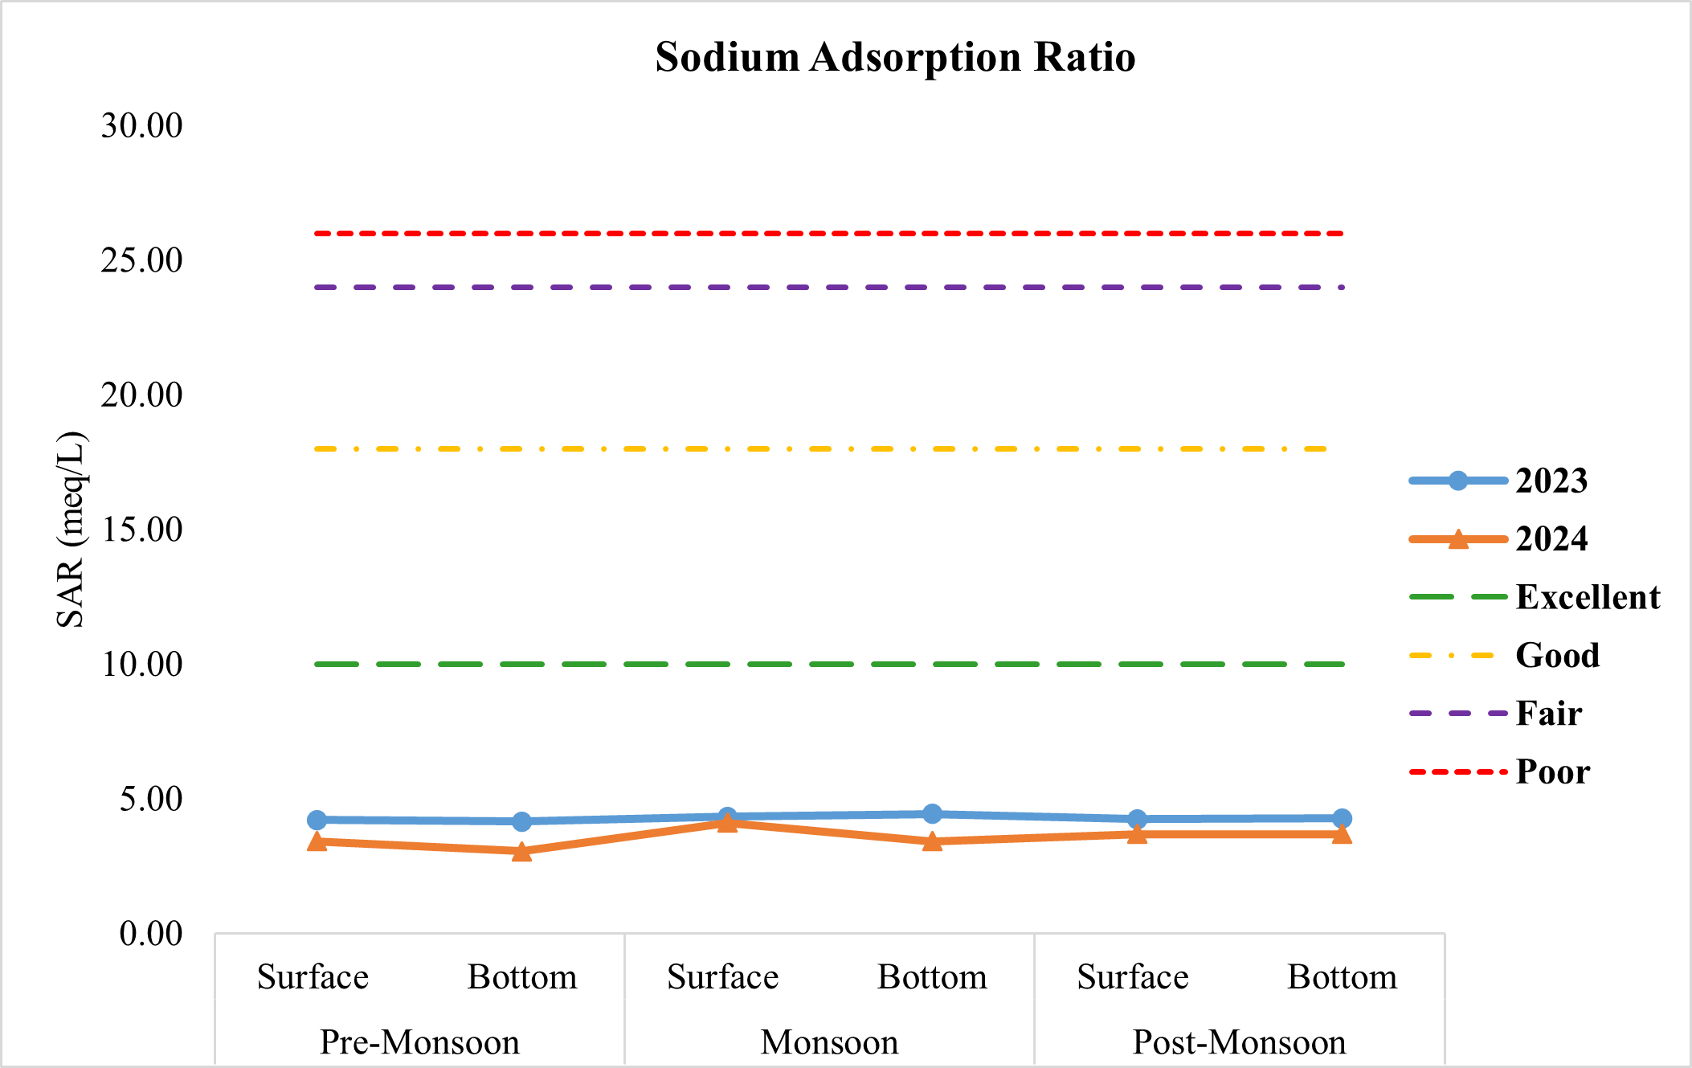
Graph 1: Assessment of surface and bottom water of Karanja Reservoir for sodicity hazard (SAR).
ii) Soluble Sodium Percentage (SSP):
Mg²⁺ and Ca²⁺ ions present in clay particles often exchange with Na⁺ ions from irrigation water. This ion exchange process can cause soil hardening, reduce permeability and restrict internal drainage, ultimately lowering soil quality and hindering seed germination (Tijani, 1994). Based on SSP values, irrigation water can be classified as safe or unsuitable for use (Adhikary et al., 2012; Boateng et al., 2016). Tejashvini et al. (2024) reported SSP values ranging between 27.75–60.70%, in rural, transition and urban areas respectively. They observed that majority of groundwater samples in these areas were suitable for irrigation, while the remaining samples were unsuitable.
In present study from (Table 6; Graph 2) the mean SSP values of surface and bottom water in the year 2023 ranged between 51.75 to 54.2 4% across all the three seasons which indicates the water of Karanja Reservoir falls under ‘permissible’ category which indicates moderate Na⁺ hazard. Whereas during the year 2024, the mean SSP values of surface and bottom water ranged between 37.94 to 47.88% across the seasons which indicates that the Karanja Reservoir water fall under the ‘good to permissible’ category which confirms the low Na⁺ hazard. The lowest SSP value was observed in bottom water during the pre-monsoon season. When compared with the findings of (Tejashvini et al., 2024) the SSP values of Karanja Reservoir are relatively similar, particularly with those reported for the rural and transition zones, both indicating generally safe to permissible levels for irrigation use.
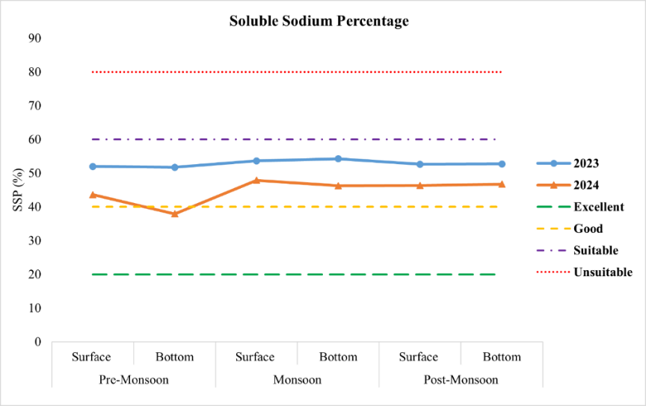
Graph 2: Assessment of surface and bottom water of Karanja Reservoir for SSP.
iii) Percentage Sodium (%Na):
%Na when present in higher concentrations, Na⁺ tends to bind with soil particles, reducing the soil’s ability to allow water to move through it (Ayers & Westcot, 1994). Na⁺ can react with CO₃²⁻ to develop alkaline soils, while its reaction with Cl⁻ leads to the formation of saline soils. Both types of sodium-affected soils restrict plant growth and reduce crop yield (Todd, 1980). Also, if Na⁺ concentration is higher in water it replaces essential Ca²⁺ and Mg²⁺ on the soil’s clay surface through a base-exchange process, leading to poor soil structure (Collins & Jenkins, 1996; Saleh et al., 1999). As a result, the movement of water through soil decreases and air circulation is restricted, especially during wet conditions and soils become compact and hard when it dries further affecting crop growth.
In our present study (Table 6; Graph 3) showed the %Na values of the surface and bottom water in the year 2023-2024. The mean %Na of surface and bottom water during the year 2023 ranged between 50.00% to 52.44% and during the year 2024 from 36.61% to 46.47%. From our results, it was found that the %Na in both the years in respect of surface and bottom water were falls under doubtful category (Class III) except the bottom water of pre-monsoon season in the year 2024 which falls under permissible category. The study carried out by (Ogunfowokan et al., 2013; Tekile, 2023; Ahmed et al., 2024) showed similar trends of %Na concentration. According to them the increased level of Na⁺ seeping into the water, making them unsuitable for irrigation. Because of increased Na⁺ leaching from the rock into the water and the release of industrial effluents, most of the water samples in the study area were unsuitable for irrigation.
From the results, it is confirm that the water sample is unsuitable for irrigation as %Na is higher in both the years that might be because of the leaching of Na⁺ ions through the weathering of rocks in the rainy season might be a discharge of industrial effluents containing Na⁺ may release into the reservoir which enhance the %Na in the water.
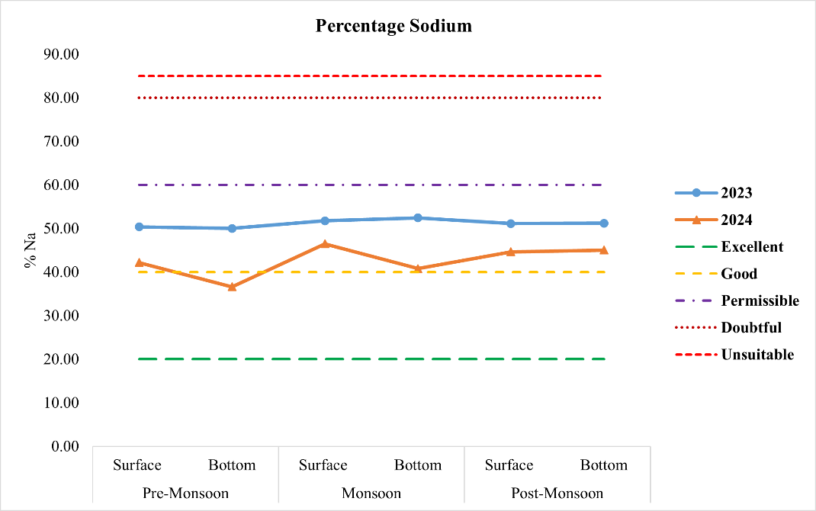
Graph 3: Assessment of surface and bottom water of Karanja Reservoir for %Na.
iv) US Salinity Laboratory Classification (USSL):
USSL diagram is also known as Wilcox diagram. Wilcox diagram is a plot drawn against SAR (on the Y-Axis) and EC (on X-axis) (Wilcox, 1955). Ahmed et al. (2024) in their study found all water samples fell into the C1-S1 category demonstrating low salinity and low alkali hazards and was suitable for most crops and soil where leaching predominates. In another study by (Tejashivni et al., 2024) they found that majority of groundwater samples were classified medium–high salinity hazards (C2-C3) and low alkalinity hazards (S1) suggesting permissible - excellent to water for irrigation. This increase was due to continuous precipitation, sewage wate infiltration and interaction of water with rock across time and location. Abualhaija et al. (2020), in their study, they classified the water samples as C3-S2 indicating high salinity and medium hazard suggesting permissible - good water for irrigation.
In our study (Table 6; Graph 4), SAR and EC were evaluated for both surface and bottom water samples across the pre-monsoon, monsoon and post-monsoon seasons for the years 2023 and 2024. The mean SAR values across all samples ranged from 3.06 to 4.44 meq/L while mean EC values remained within 0.32 to 0.36 dS/m. Based on the US Salinity Laboratory's (USSL) classification system, all water samples were categorised under C2–S1, indicating a medium salinity and low sodium hazard (Table 1). Similar result was found by (Moges & Dinka, 2023). In our study we found, all the water samples of Karanja Reservoir fall into ‘Good to Excellent’ quality for irrigation purposes and it was confirmed that the water is having low salinity and low Na⁺ hazard. This might be because of the drainage system around the location of reservoir is properly managed as well as the discharge of disposal waste is maintained and so that the water is found to be good for irrigation purposes with low Na⁺ hazard. We also reported that the socio-economic relations between the government agencies and the general population were found improved in and around the study area.
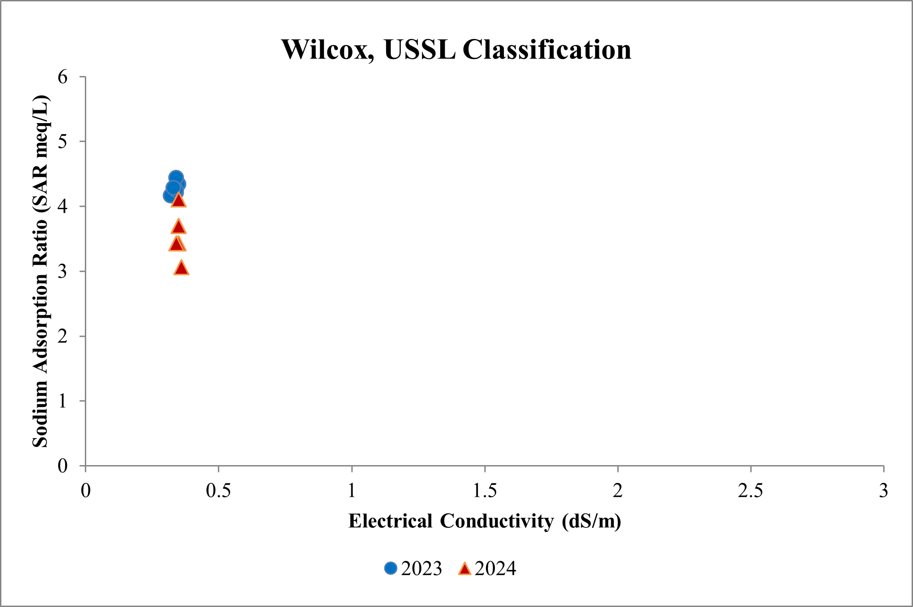
Graph 4: Assessment of surface and bottom water of Karanja Reservoir for USSL (Wilcox).

v) Irrigation Water Quality Index (IWQI):
The IWQI was calculated using the parameters as EC, Na⁺, Cl⁻ and HCO₃⁻ and SAR. The IWQI of the surface and bottom water samples of Karanja Reservoir during the year 2023 and 2024 across pre-monsoon, monsoon and post-monsoon seasons shown in (Table 7; Graph 5).
Across the study period, the mean IWQI was found to be (63.45 to 78.86) and the water samples were generally classified under the ‘low restriction’ category in all the three seasons. An exception was noted in the surface water during the year 2024 in monsoon season, which falls under the ‘moderate restriction’ category. These findings are consistent with the study by (Abualhaija et al., 2020). Their IWQI values of the water samples were classified under low restriction, indicating generally water was suitable for irrigation. According to them there is a minor need for water quality management. Nedjar et al. (2022) IWQI results showed that Site1 and Site3 water were in the moderate restriction category, while Site2 fell into the high restriction category, indicating the need for controlled irrigation and soil management. Tejashivni et al. (2024) reported a clear gradient of deterioration of groundwater. According to them, water in rural sites showed non-restricted category, whereas the urban water samples were in medium restriction category. Similarly, the study conducted by (Batarseh et al., 2020) showed the groundwater samples collected was classified into severe to high restriction category reflecting the harsh arid climate and baseline salinity.
Shrivastava & Kumar (2015) highlighted in their study that the surrounding environment influences the seasonal fluctuations in parameters such as EC, sodium concentrations and SAR. Excess sodium salts in the irrigation water can gradually increase soil salinity and sodicity. Such changes in soil quality may lead to reduced fertility, soil erosion, loss of organic matter, reduced nutrient release due to slower weathering and poor vegetation which may affect the crop productivity. In another study by (Mohanavelu et al., 2021; Ondrasek et al., 2021) they extensively studied the impacts of salinity and sodicity on various crop’s growth. Such as the crop like sugarcane requires favourable soil conditions and pH for growth, slight increase in salinity and sodicity conditions can decline the crop yield.
Overall, in the present study, the Karanja Reservoir water can be considered suitable for irrigation. However, it is recommended that farmers can use this water safely for light texture or moderate permeability soils, but precautionary measures should be taken to avoid salt sensitive plants by selecting moderately salt tolerant crops, applying leaching practices and regular monitoring of soil to ensure sustainable use (Table 4).

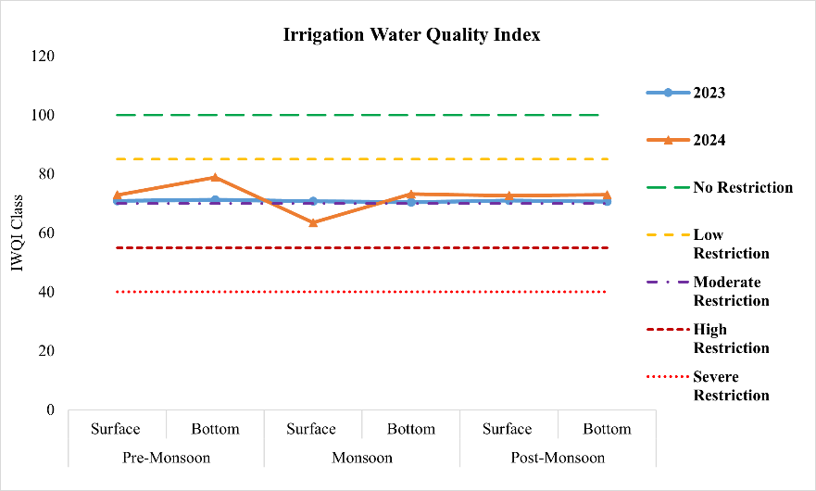
Graph 5: Assessment of surface and bottom water of Karanja Reservoir for IWQI.

vi) Kelly’s Index / Kelly’s Ratio (KI /KR):
In our study from (Table 6; Graph 6), the mean KR values of surface and bottom water during the year 2023 ranged from 1.04 to 1.15 across all three seasons which was slightly ≥ 1.0 which shows unsuitability for irrigation, this might be because of the greater concentrations of Na⁺ over Ca²⁺ and Mg²⁺ that suggests higher Na⁺ hazard which may be a potential hazard to the soil sodicity. Similar findings were reported by (Rawat et al., 2018; Mansour et al., 2022; Anuja et al., 2023). However, in the year 2024, the mean KR values in respect of both the surface and bottom water ranged from 0.59 to 0.89. These values showed the KR < 1.0 which indicates the water is ‘suitable’ for irrigation in all the three different seasons which suggests that there might be a lowering in the ionic balance between Na⁺ over Ca²⁺ and Mg²⁺. Our results are similar to those reported by (Ekbal & Khan, 2020; Giri et al., 2022; Tejashivni et al., 2024) who found most water samples suitable for irrigation during the pre-monsoon period.
This might be because of the heavy rainfall which diluted the Na⁺ by the dilution effect which reduced the salt input and improved the flushing of ions within the reservoir and it may also reduce the risk of soil degradation. There might be an accumulation/exposure of Gypsum which recommends that the KR is high to reduce the effect of the Na⁺ ion (Rawat et al., 2018; Xu et al., 2019).
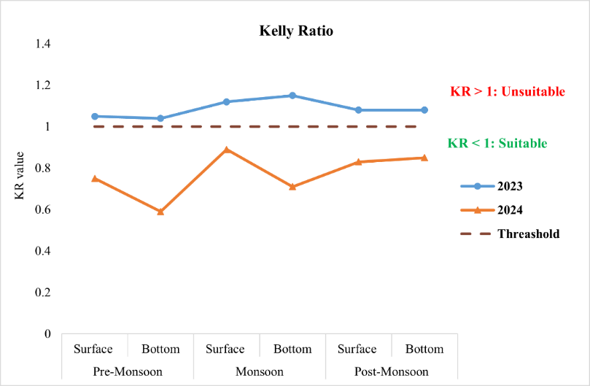
Graph 6: Assessment of surface and bottom water of Karanja Reservoir for KR.

vii) Magnesium Hazard or Magnesium Adsorption Ratio (MH or MAR):
From (Table 6; Graph 7), during the year 2023, mean MH values were above the permissible limit in all seasons. The monsoon season recorded the highest value in surface water (54.16%) and lowest (50.73%) in bottom water classifying the Karanja Reservoir water as ‘unsafe’ for irrigation. This indicated higher concentrations of Mg²⁺ suggesting minimal dilutions, inputs from anthropogenic activities thus making the water unsuitable for irrigation which could affect the soil permeability. A high concentration of Mg²⁺ in groundwater degrades soil quality, which has an impact on agricultural productivity (Ramesh & Elango, 2012). The higher value of MAR might be due to the movement of Mg²⁺salt along with the seepage or subsurface flow (Ekbal & Khan, 2022; Giri et al., 2022; Moges & Dinka, 2023).
With respect to the year 2024, all the mean MH values were within the permissible limit range between (38.10%) in bottom water to (49.60%) in surface water (post-monsoon). These were similar to the study reported by (Abualhaija et al., 2020). Thus, it confirms that the Karanja Reservoir water is ‘safe’ in the year 2024 indicating that the water is suitable for irrigation.

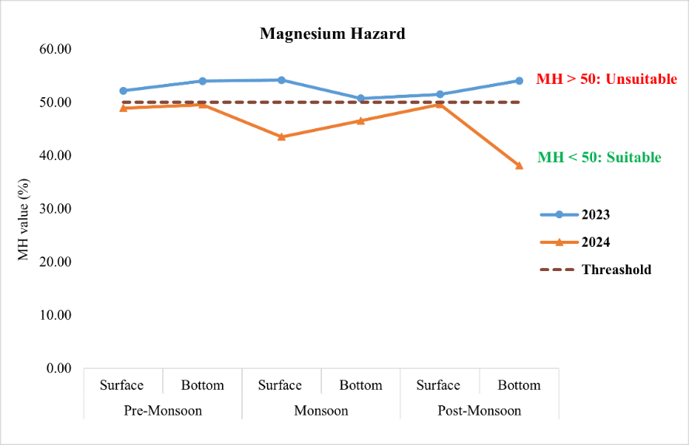
Graph 7: Assessment of surface and bottom water of Karanja Reservoir for MH.

viii) Permeability Index (PI):
Table 6; Graph 8 shows PI values of surface and bottom water for the years 2023 and 2024. Form our result, all the mean PI values ranged between 45.53 to 62.37% across all the three seasons. From the above result, it was found that all the values are placed under Class II, which is considered under ‘good’ category for irrigation purposes. The PI values recorded during the year 2023 indicate stable values across all seasons with no significant variation between surface and bottom water. However, in the year 2024, PI values showed a declining trend particularly in pre-monsoon and monsoon season in respect of bottom water samples. Our findings are found comparable to those studies conducted by (Rawat et al., 2018; Anuja et al., 2024; Tesjahvini et al., 2024) where most of their PI values were within the permissible limit. They further concluded that the water was ranged in a good quality indicating the use of water for agricultural purposes. This might be because of the seasonal rainfall may influence the PI values. They further stated that generally improved permeability in the post-monsoon season water samples my influence the dilution effect. In another study by (Gautam et al., 2015; Zaman et al., 2018) due to widespread irrigation water use, excessive concentrations of Na⁺, Ca²⁺, Mg²⁺ and HCO₃⁻ in irrigation water impact soil permeability.

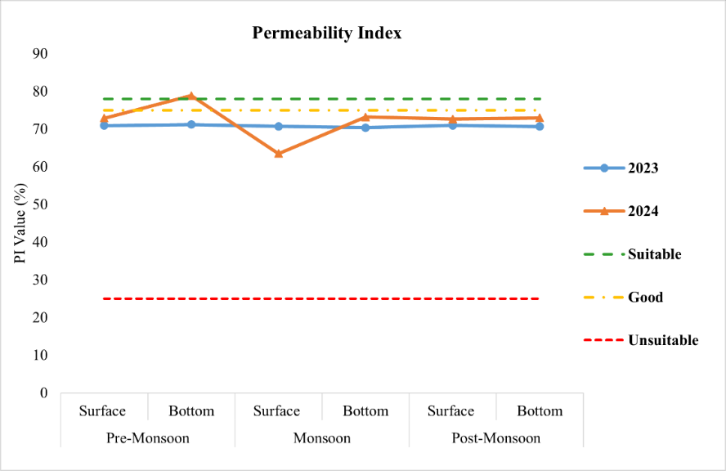
Graph 8: Assessment of surface and bottom water of Karanja Reservoir for PI.

ix) Residual Sodium Carbonate (RSC):
During the study period, the mean RSC values (Table 6) of surface and bottom water across the three seasons in the year 2023-2024 ranged between (–4.81 to –10.20 meq/L). Thus, it suggests an increased dominance of Ca²⁺ and Mg²⁺ ions in said years. This may be likely due to seasonal inflow and dilution processes. In both the years we found the seasonal variations are at minimal level showing the shift towards negative values thus it indicating the water is suitable for agriculture purpose. Our findings were similar to those reported by (Ekbal & Khan, 2022; Giri et al., 2022; Anuja et al. 2024). However, our results are contradicting with the study reported by (Moges & Dinka, 2023; Tekile, 2023; Ahmed et al., 2024; Tesjashivini et al., 2024) in their study they found that majority of the water samples have high RSC values classifying as unsuitable indicating irrigation hazard. A high RSC value in subsurface water indicates an increase in salt adsorption in the soil during irrigation (Eaton, 1950). According to (Moges & Dinka, 2023) RSC values usually affect the EC, pH and SAR of the irrigation water.
In the present study (Graph 9), the Karanja Reservoir water was classified in good-safe category for irrigation purposes as RSC < 1.25 meq/L (Eaton, 1950; Wilcox, 1995) across pre-monsoon, monsoon and post-monsoon seasons.
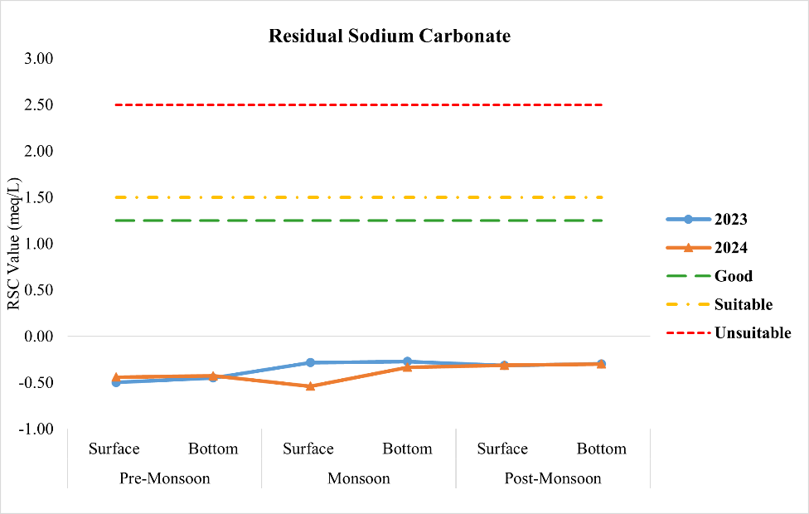
Graph 9: Assessment of surface and bottom water of Karanja Reservoir for RSC.

x) Potential salinity (PS):
The mean PS values of surface and bottom water (Table 6; Graph 10) across pre-monsoon, monsoon and post-monsoon seasons recorded during the year 2023–2024 ranged from 7.13 to 8.89, which were higher than the permissible limit of PS > 3. Our values are found higher to those of the study conducted by (Rawat et al., 2018; Ekbal & Khan, 2020). Most of their values in respect of all the water samples were PS < 3 falls under suitable category. During pre- and post-monsoon season they found few exceeding PS values above the threshold classifying most of the water samples were suitable for irrigation. In the present study, PS values were consistently above the suitability limit (PS < 3) indicating that the Karanja Reservoir water falls into the unsuitable category for irrigation. The higher PS values are attributed to the dominance of Cl⁻ and SO₄²⁻ ions, which increase salinity and reduce soil permeability, limiting the suitability of the water for irrigation.
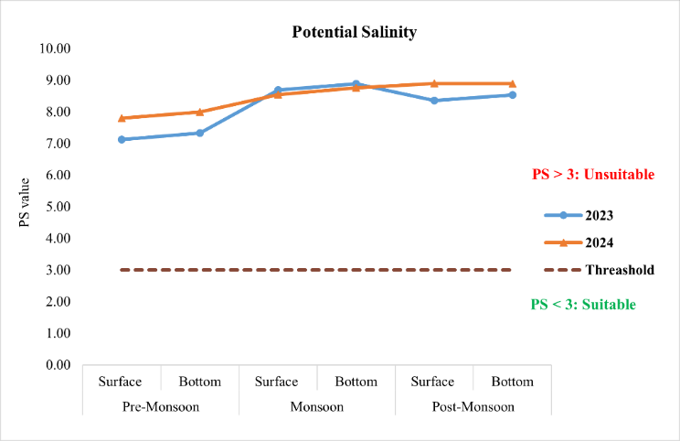
Graph 10: Assessment of surface and bottom water of Karanja Reservoir for PS.

xi) Chloro-alkaline Indices (CAI1 and CAI2):
From (Table 6; Graph 11 a & b) the mean surface and bottom water values of CAI1 (−0.54 to −0.27) and CAI2 (−0.52 to −0.27) in Karanja Reservoir were consistently negative during the years 2023–2024 across the three seasons, indicating a dominant reverse ion exchange process where Ca²⁺ and Mg²⁺ in water gets replaced by Na⁺ and K⁺ from the rock. More negative values were recorded in the monsoon season, reflecting enhanced recharge and leaching, while post-monsoon season showed dilution effects. Surface waters exhibited slightly stronger exchange than bottom waters, highlighting the influence of inflows and active recharge zones. Our findings were consistent to the earlier reported by (Balasubramanian, 1986; Mondal et al., 2016; Ekbal & Khan, 2020). This aligns with (More et al., 2020) who reported negative CAI values in nearly 70% of pre-monsoon and 69% of post-monsoon samples, reflecting cation–anion exchange reactions. Similarly in studies conducted by, (Bahukhandi et al., 2017; Rawat et al., 2018; Singh et al., 2020; Tejashvini et al., 2024) recorded both positive and negative CAI values, with negative indices indicating base ion exchange in discharge zones. Therefore, the results indicate that exchangeable cations (Na⁺ and K⁺) can be used to characterize the chemical composition of groundwater in the study area (Singh et al., 2020).

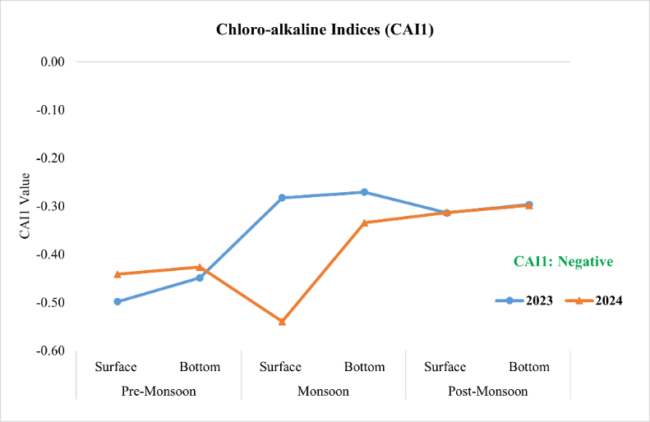
Graph 11a: Assessment of surface and bottom water of Karanja Reservoir for CAI1.

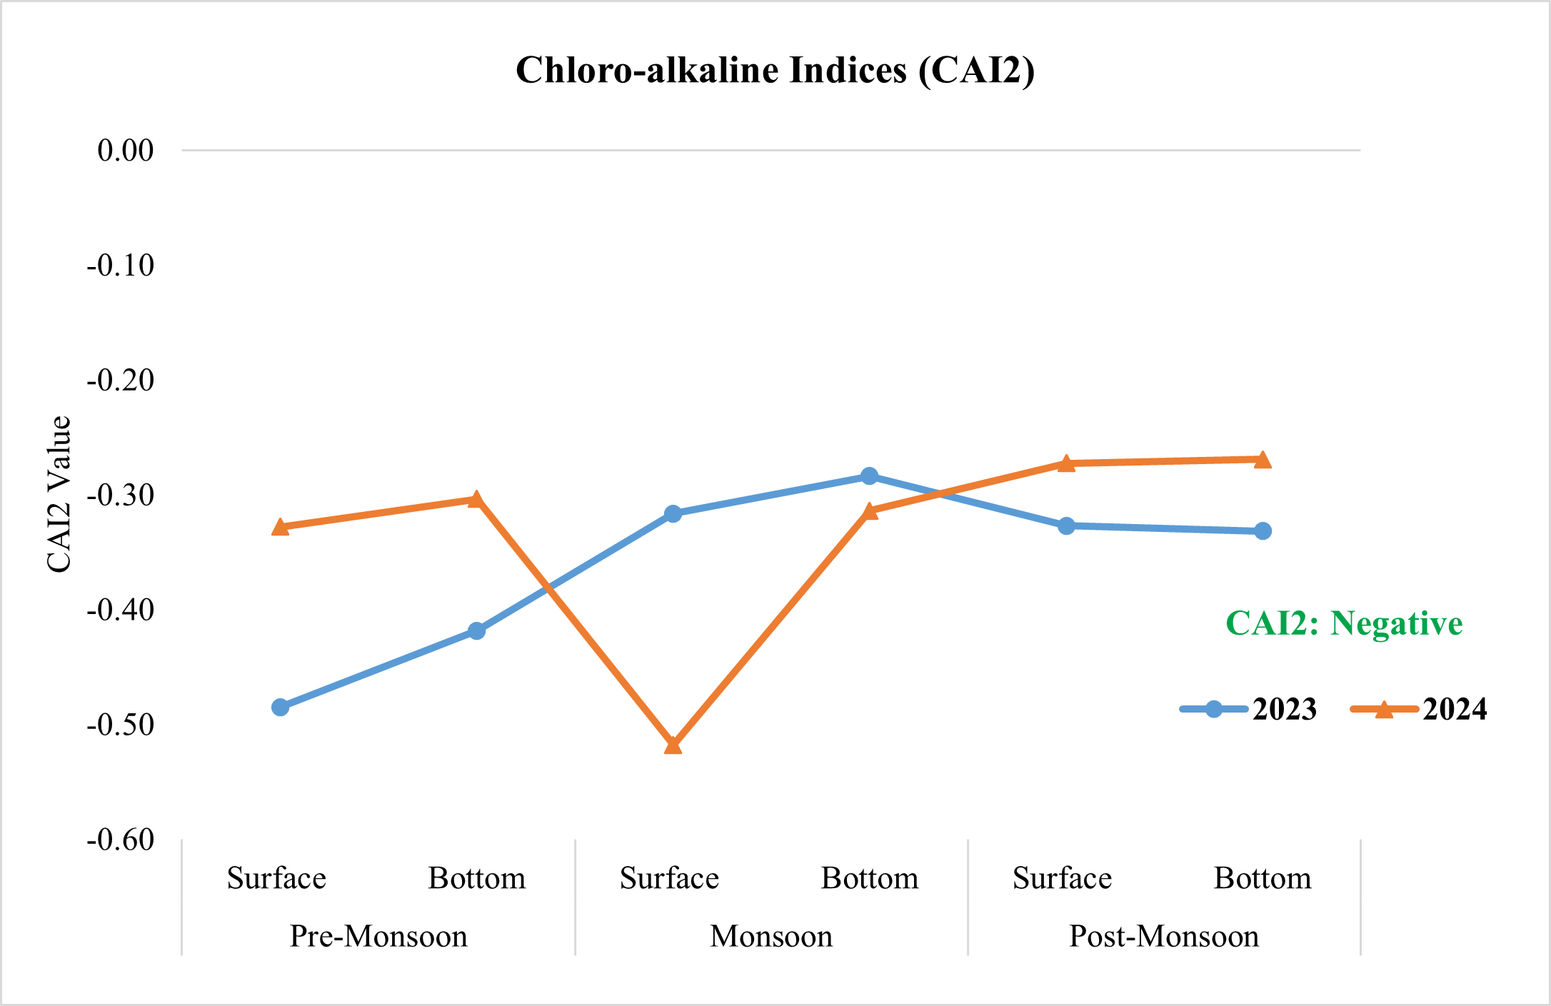
Graph 11b: Assessment of surface and bottom water of Karanja Reservoir for CAI2.

xii) Corrosion Ratio (CR):
CR can also serve as an economical index in irrigation water management, as it helps determine whether water should be transported through PVC plastic pipes (low cost, non-corrosive) or metallic pipes (cost-effective for certain conditions). This knowledge is particularly crucial when irrigation drainage systems are long or when open drainage poses risks of contamination (Rawat et al., 2018).
CR values showed seasonal variability in both years (Table 6; Graph 13). The mean CR values of surface and bottom water in the study area ranged between 4.75 and 10.27 across both years and seasons. The surface water recorded the lowest value during the pre-monsoon season and highest value during the post-monsoon season. Rawat et al. (2018) and Ekbal & Khan (2020) reported the CR values < 1. According to them, the water samples were suitable for transportation through metallic or PVC pipes. However, our results are found CR > 1 indicating the water of Karanja Reservoir was classified as corrosive. Similar result was found by (Giri et al., 2022). There might be a seasonal rise in Cl⁻ and SO₄²⁻ concentrations which contributes to enhanced corrosivity during runoff and recharge periods and thus indicate unsuitability for transportation through metal pipes.

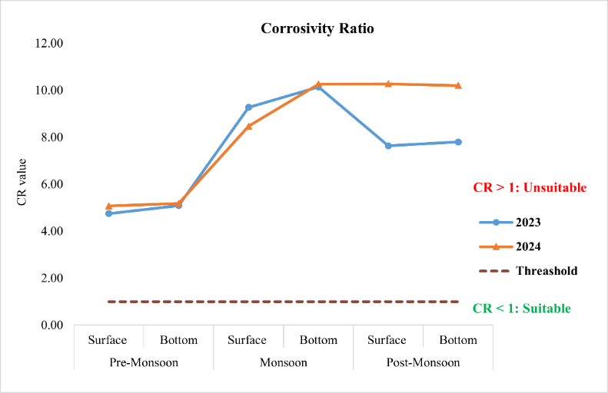
Graph 12: Assessment of surface and bottom water of Karanja Reservoir for CR.

xiii) Total Hardness (TH):
High hardness levels often lead to buildups and deposits in pipelines, which can affect water distribution. On the other hand, moderate hardness is beneficial since it protects plumbing systems from corrosion. A concentration of around 100 mg/L is usually considered desirable because it offers good protection against corrosion while still being within acceptable limits (Rawat et al., 2018).
In our study, mean TH values of surface and bottom water ranged between (374.09 to 672.22 mg/L) across both years and all seasons (Table 6 & Graph 14). According to (Rawat et al., 2018; Mansour et al., 2022; Tejashvini et al., 2024) they reported the values of TH > 300 mg/L and they concluded that the water is very hard. Our results are also consistent with the results cited by here and above. Thus, it confirms that the water in the Karanja Reservoir was classified as very hard and was unsuitable for irrigation.

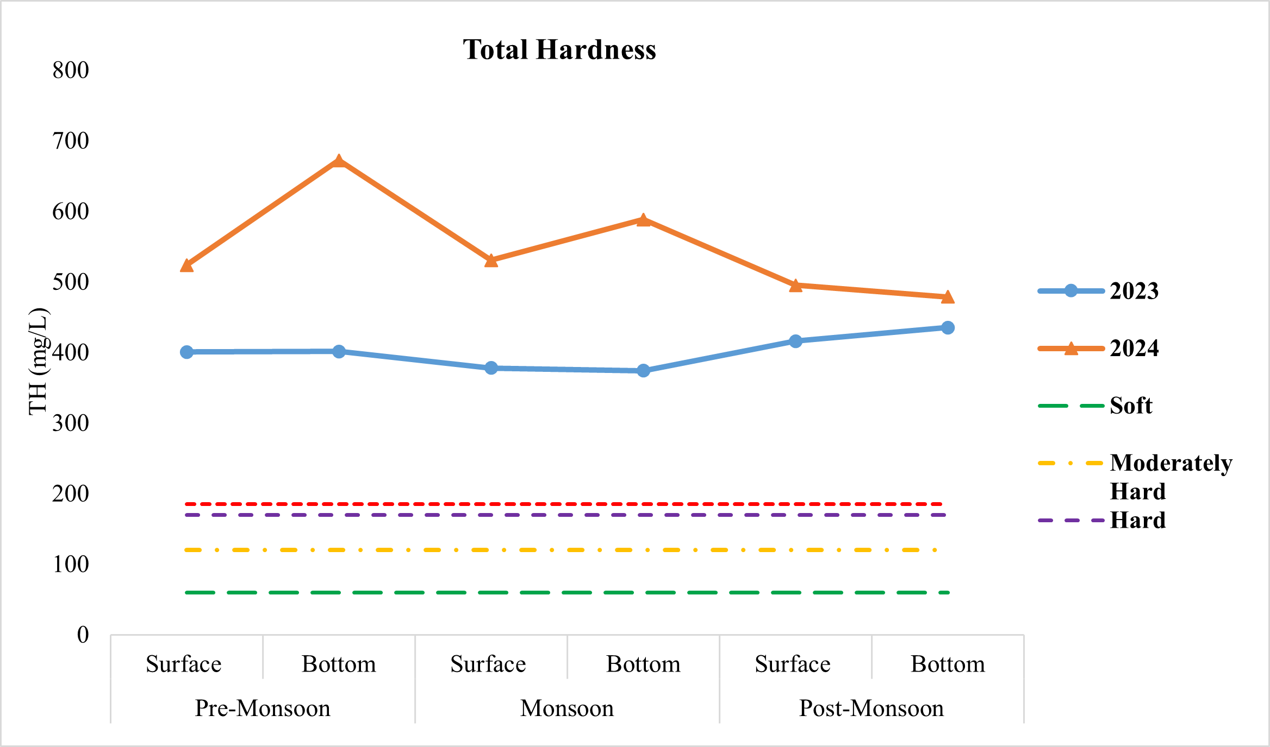
Graph 13: Assessment of surface and bottom water of Karanja Reservoir for TH.

4. CONCLUSION:
The water samples collected seasonally from Karanja Reservoir, Bidar, Karnataka (India) during the period of January 2023 to December 2024 was analysed for the irrigation parameters such as EC, TH, SAR, SSP, %Na, RSC, KR, MH, PI, PS, IWQI, USSL diagram, CAI and CR. Overall, the water quality of Karanja Reservoir with respect to %Na is generally doubtful for irrigation, but long-term monitoring and soil management practices (e.g., gypsum addition and crop rotation with salt-tolerant species) is recommended to prevent sodicity hazards and maintain soil fertility. Thus, it confirms that the water enhanced its suitability for irrigation purposes. While comparing the data of SSP of both the years, it found that there is an improved in the Na hazard in the year 2024 which suggests that the water could still be used for irrigation but long use without proper maintenance it may affect the soil permeability and crop productivity in the case of sodium-sensitive crop.
The study highlights that in the future, continuous monitoring of SAR could help to ensure the Karanja Reservoir water may remain a reliable source for sodium-sensitive crop irrigation. This study also concludes that farmers should use plastic pipes or rust-resistant metal pipes for irrigation practices. Overall, these findings suggest that the Karanja Reservoir’s water remains within permissible limit for irrigation but highlighting the need for careful crop and soil management practices and seasonal dilution. Monsoon plays a key role in regulating sodium levels and maintaining suitability of water for agricultural use. It is also recommended that, the continuous monitoring of Karanja Reservoir water should be initiated to maintain the good water quality for safe irrigation practices and reduce soil permeability which affects the crop production and prevent long-term problems. Also, the Government, semi-government and non-government organization (NGOs) assistance should be taken to design the artificial recharge structure for the improvement of the Karanja Reservoir.
DECLARATION OF COMPETING INTEREST:
The authors declare that they have no known competing financial interests that could have influence the work reported in this manuscript.
DATA AVAILABILITY STATEMENT: This statement does not apply to this article.
INFORMED CONSENT STATEMENT: This study did not involve human participants and therefore, informed consent was not required.
CLINICAL TRIAL REGISTRATION: This research does not involve any clinical trials.
PERMISSION TO REPRODUCE MATERIAL FROM OTHER SOURCES: Not Applicable.
REFERENCES:
Abbott, B. W., Bishop, K., Zarnetske, J. P., Minaudo, C., Chapin, F. S., Krause, S. and Plont, S. (2019). Human domination of the global water cycle absent from depictions and perceptions. Nature Geoscience, 12(7), 533–540. [DOI]

Abualhaija, M. M., Abu Hilal, A. H., Shammout, M. W. and Alsharifa-Hind, M. (2020). Assessment of reservoir water quality using water quality indices: A case study from Jordan. International Journal of Engineering Research and Technology, 13(3), 397–406. [DOI]

Acharya, A., Sharma, M. L. and Bishwakarma, K. (2020). Chemical characteristics of the Karmanasha River water and its appropriateness for irrigational usage. Journal of Nepal Chemical Society, 41, 94–102. [DOI]

Adhikary, P. P., Dash, C. J., Chandrasekharan, H., Rajput, T. B. S. and Dubey, S. K. (2012). Evaluation of groundwater quality for irrigation and drinking using GIS and geostatistics in a peri-urban area of Delhi, India. Arabian Journal of Geosciences, 5(6), 1423–1434. [DOI]

Afshan, N., Nagaraju, D., Bhanuprakash, H. M. and Deep, P. G. (2022). Seasonal analysis of groundwater samples to identify water quality index and comparative statistical analysis of Hunsur Taluk, Mysuru, Karnataka, India. SN Applied Sciences, 4(210). [DOI]

Ahmed, S. N., Sahoo, S. K. and Baitharu, I. (2024). Assessment of irrigation suitability of water in Hirakud reservoir and Bargarh main canal, Odisha, India: A multivariate analysis. Water Supply, 24(6), 2009–2023. [DOI]

Anuja, S. A., Kavitha, P., Jothi, C. H. and Jemila R. R. (2024). Seasonal assessment of water quality for irrigation using multiple indices in Thamirabarani River, Kanyakumari District, India. Desalination and Water Treatment, 317, 100206. [DOI]

APHA. (2017). Standard methods for the examination of water and wastewater (23rd ed.). American Public Health Association, American Water Works Association, Water Environment Federation, Washington, D.C., USA.

Ayers, R. S. and Westcot, D. W. (1994). Water quality for agriculture FAO irrigation and drainage. FAO Irrigation and Drainage Paper No, 29(1),174.

Bahukhandi, K. D., Bartarya, S. K. and Siddiqui, N. A. (2017). Assessment of surface and ground water quality of Haridwar district of Uttarakhand. International Journal of ChemTech Research, 10(10), 95–118.

Balasubramanian, A. (1986). Hydrogeochemistry of groundwater in parts of the Madras city. Journal of Geological Society of India, 27, 28–35.

Batarseh, M., Imreizeeq, E., Suleiman, W., Tilev, S., Al Alaween, M., Al Remeithi, A. M., Al Tamimi, M. K. and Al Alawneh, M. (2021). Assessment of groundwater quality for irrigation in the arid regions using irrigation water quality index (IWQI) and GIS-zoning maps: Case study from Abu Dhabi Emirate, UAE. Groundwater for Sustainable Development, 14, 100611. [DOI]

Boateng, T. K., Opoku, F., Acquaah, S. O. and Akoto, O. (2016). Groundwater quality assessment using statistical approach and water quality index in Ejisu-Juaben Municipality, Ghana. Environmental Earth Sciences, 75 (6), 489. [DOI]

Collins, R. and Jenkins, A. (1996). The impact of agricultural land use on stream chemistry in the middle hills of the Himalayas, Nepal. Journal of Hydrology, 185(1–4), 71–86. [DOI]

Deines, J. M., Schipanski, M. E., Golden, B., Zipper, S. C., Nozari, S., Rottler, C., Guerrero, B. and Sharda, V. (2020). Transitions from irrigated to dryland agriculture in the Ogallala Aquifer: Land use suitability and regional economic impacts. Agricultural Water Management, 233, 106061. [DOI]

Doneen, L. D. (1964). Notes on water quality in agriculture. Water science and engineering (Paper 4001). Department of Water Science and Engineering, University of California, Davis, USA.

Eaton, A. D. (2005). Standard methods for the examination of water and wastewater. American Public Health Association (APHA), Washington, D.C., USA.

Eaton, F. M. (1950). Significance of carbonates in irrigation waters. Soil Science, 69, 123–133. [DOI]

Ekbal, E. and Khan, T. A. (2020). Hydrogeochemical characterization of groundwater quality in parts of Amroha District, Western Uttar Pradesh, India. Groundwater for Sustainable Development, 10, 100346. [DOI]

Etteieb, S., Cherif, S. and Tarhouni, J. (2017). Hydrochemical assessment of water quality for irrigation: A case study of the Medjerda River in Tunisia. Applied Water Science, 7(1), 469–480. [DOI]

Gautam, S. K., Maharana, C., Sharma, D., Singh, A. K., Tripathi, J. K. and Singh, S. K. (2015). Evaluation of groundwater quality in the Chotanagpur Plateau region of the Subarnarekha River Basin, Jharkhand state, India. Sustainability of Water Quality and Ecology, 6, 57–74. [DOI]

Giri, A., Kumar, K., Bharti, V. K., Khansu, M. and Kalia, S. (2022). Hydrochemical and quality assessment of irrigation water at the trans-Himalayan high-altitude regions of Leh, Ladakh, India. Applied Water Science, 12, 197. [DOI]

Jain, S. K., Agarwal, P. K. and Singh, V. P. (2007). Hydrology and water resources of India (p. 57). Springer Science & Business Media.

Kadyampakeni, D., Appoh, R., Barron, J. and Boakye-Acheampong, E. (2018). Analysis of water quality of selected irrigation water sources in Northern Ghana. Water Science and Technology: Water Supply, 18(5), 1671–1683. [DOI]

Kelly, W. P. (1963). Use of saline irrigation water. Soil Science, 95(4), 355–391.

Khodapanah, L., Sulaiman, W. N. A. And Khodapanah, D. N. (2006). Groundwater quality assessment for different purposes in Eshtehard District, Tehran, Iran. European Journal of Scientific Research, 36(4), 543–553.

Kori, B. B. (2017). Multiple regression analysis study among physico-chemical and biological characteristics of Karanja Reservoir water. International Journal for Scientific Research & Development, 5(3), 1190–1191.

Kumari, P. (2017). Irrigation water quality based on hydrochemical analysis of Ganga-Sone divide region of Bihar. Asian Journal of Water, Environment, and Pollution, 14(3), 75–83. [DOI]

Lingesh, G., Reddy, H. R. V., Narshivudu, D., Muthappa, K. and Padmanabha, A. (2019). Seasonal phyto- and zooplankton dynamics in Karanja Reservoir, Bidar. Journal of Entomology and Zoology Studies, 7(4), 275–278.

Majagi, S. H., Vijaykumar, K. and Vasanthkumar, B. (2008). Concentration of heavy metals in Karanja Reservoir, Bidar District, Karnataka, India. Environmental Monitoring and Assessment, 138(1–3), 273–279. [DOI]

Majagi, S. and Vijaykumar, K. (2009). Ecology and abundance of zooplankton in Karanja Reservoir. Environmental Monitoring and Assessment, 152(1–4), 451–458. [DOI]
Mansour, H., Ahmed, S. A., Zaghloul, A., Kabary, H. and Nassar, H. F. (2022). Seasonal variation effect on water quality and sediments criteria and its influence on soil pollution: Fayoum Governorate, Egypt. Environmental Science and Pollution Research, 29(9), 13344–13358. [DOI]

Meireles, A. C. M., Andrade, E. M. D., Chaves, L. C. G., Frischkorn, H. and Crisostomo, L. A. (2010). A new proposal of the classification of irrigation water. Revista Ciência Agronômica, 41(3), 349–357. [DOI]

Moges, S. S. and Dinka, M. O. (2023). Evaluation of shallow groundwater suitability for irrigation purposes: A case study from Doornfontein area, South Africa. Journal of Water and Land Development, 58(3), 155–167. [DOI]

Mohammed, N. M. (2011). Quality assessment of Tigris River by using water quality index for irrigation purpose. European Journal of Scientific Research, 57(1), 15–28.

Mohanavelu, A., Naganna, S. R. and Al-Ansari, N. (2021). Irrigation induced salinity and sodicity hazards on soil and groundwater: An overview of its causes, impacts and mitigation strategies. Agriculture, 11(10), 983. [DOI]

Mondal, N. C., Singh, V. S., Saxena, V. K. and Ahmed, S. (2016). Assessment of groundwater quality in coastal aquifers of West Bengal, India. Environmental Earth Sciences, 75(1), 54. [DOI]

More, S., Dhakate, R., Ratnalu, G. V. and Machender, G. (2021). Hydrogeochemistry and health risk assessment of groundwater and surface water in fluoride-affected area of Yadadri-Bhuvanagiri District, Telangana State, India. Environmental Earth Sciences, 80, 262. [DOI]

Nedjar, Y., Ouldjaoui, A. and Boulahbel, S. (2022). Water quality assessment for irrigation purposes in a semi-arid region: Wadi Baghai (North East of Algeria). Egyptian Journal of Aquatic Biology and Fisheries, 26(5), 1289–1302. [DOI]

Ogunfowokan, A. O., Obisanya, J. F. and Ogunkoya, O. O. (2013). Salinity and sodium hazards of three streams of different agricultural land use systems in Ile-Ife, Nigeria. Applied Water Science, 3(1), 19–28. [DOI]

Ondrasek, G., Rengel, Z. and Veres, S. (2021). Soil salinisation and salt stress in crop production. Abiotic stress in plants— mechanisms and Adaptations; Intech open. [DOI]

Paliwal, K. V. (1967). Effect of gypsum application on the quality of irrigation water. Madras Agricultural Journal, 59, 646–647

Raghunath, H. M. (1987). Groundwater (2nd ed., p. 353). Wiley, New Delhi.

Raji, V. R. and Packialakshmi, S. (2022). Assessing the wastewater pollutants retaining for a soil aquifer treatment using batch column experiments. Civil Engineering Journal, 8(7), 1482–1494. [DOI]

Ramesh, K. and Elango, L. (2012). Groundwater quality and its suitability for domestic and agricultural use in Tondiar River Basin, Tamil Nadu, India. Environmental Monitoring and Assessment, 184(6), 3887–3899.

Rawat, K. S., Singh, S. K. and Gautam, S. K. (2018). Assessment of groundwater quality for irrigation use: A peninsular case study. Applied Water Science, 8, 233. [DOI]

Richards, L. A. (1954). Diagnosis and improvement of saline and alkali soils. Agriculture Handbook No. 60. U.S. Department of Agriculture. [URL]

Sahu, A. K., Dundung, M. S., Sahoo, S. K., Mir, S. A., Nayak, B. and Baitharu, I. (2023). Ecological and human health risk associated with heavy metals in sediments and bioaccumulation in some commercially important fishes in Mahanadi River, Odisha, India. Environmental Chemistry and Ecotoxicology, 5, 168–177. [DOI]

Saleh, A., Srinivasula, S. M., Acharya, S., Fishel, R. and Alnemri, E. S. (1999). Cytochrome c and dATP-mediated oligomerization of Apaf-1 is a prerequisite for procaspase-9 activation. Journal of Biological Chemistry, 274(25), 17941–17945. [DOI]

Sarkar, U. K., Sharma, J. and Mahapatra, B. K. (2015). Review on the fish communities in the Indian reservoirs and enhancement of fisheries and aquatic environment. World Journal of Aquaculture Research & Development, 6, 297. [DOI]

Schoeller, H. (1977). Geochemistry of groundwater. Groundwater studies—an international guide for research and practice (Vol. 15, pp. 1–18). UNESCO.
Shaikh S. S. and Zodape, G. V. (2025). Exploring Seasonal Nutrient Variability in Selected Freshwater Fish Species from Karanja Reservoir, Bidar, Karnataka, India. Uttar Pradesh Journal of Zoology, 46(9), 367-87. [DOI].
Shrivastava, P. and Kumar, R. (2015). Soil salinity: A serious environmental issue and plant growth promoting bacteria as one of the tools for its alleviation. Saudi Journal of Biological Sciences, 22(2), 123–131. [DOI]

Singh, K. K., Tewari, G. and Kumar, S. (2020). Evaluation of groundwater quality for suitability of irrigation purposes: A case study in Udham Singh Nagar, Uttarakhand. Journal of Environmental and Public Health, 2020, 6924026. [DOI]

Singh, S., Ghosh, N. C. and Gurjar, S. (2018). Index-based assessment of the suitability of water quality for irrigation purpose under Indian conditions. Environmental Monitoring and Assessment, 190(1). [DOI]

Szaboles, I. and Darab, C. (1964). The influence of irrigation water of high sodium carbonate content on soils. Proceedings of the 8th International Congress of ISSS, Trans. II (pp. 803–812).

Tijani, M. N. (1994). Hydrogeochemical assessment of groundwater in moro area, Kwara state, Nigeria. Environmental Geology, 24(3), 194–202. [DOI]

Tack, J., Barkley, A. and Hendricks, N. (2017). Irrigation offsets wheat yield reductions from warming temperatures. Environmental Research Letters, 12(11), 114027. [DOI]

Tejashvini, A., Subbarayappa, C. T., Mudalagiriyappa, M., Chowdappa, H. D. and Ramamurthy, V. (2024). Assessment of irrigation water quality for groundwater in a semi-arid region, Bangalore, Karnataka. Water Science, 38(1), 548–568. [DOI]

Tekile, A. K. (2023). Suitability assessment of surface water quality for irrigation: A case study of Modjo River, Ethiopia. Journal of Environmental and Public Health, 2023, Article 1482229, 1–12. [DOI]

Todd, D. K. (1980). Groundwater hydrology (2nd ed.). Wiley.

Trivedy, R. K. and Goel, P. K. (1986). Chemical and biological methods for water pollution studies. Environmental Publications, Karad, India.

USDA (1954). Diagnosis and Improvement of Saline and Alkali Soils. United States Salinity Laboratory, Washington, p. 160. Agriculture Handbook, 60.

USEPA (1986). Quality criteria for water 1986, 1 May 1986, EPA 440/5-86-001. United States Environmental Protection Agency,

Vasanthavigar, M., Srinivasamoorthy, K., Vijayaragavan, K., Ganthi, R. R., Chidambaram, S., Anandhan, P. and Vasudevan, S. (2010). Application of water quality index for groundwater quality assessment: Thirumanimuttar sub-basin, Tamil Nadu, India. Environmental Monitoring and Assessment, 171, 595–609. [DOI]

Wilcox, L. V. (1955). Classification and use of the irrigation waters (U.S. Department of Agriculture Circular No. 969, p. 19). U.S. Department of Agriculture.

Xu, P., Feng, W., Qian, H. and Zhang, Q. (2019). Hydrogeochemical characterization and irrigation quality assessment of shallow groundwater in the central-western Guanzhong basin, China. International Journal of Environmental Research and Public Health, 16(9), 1492. [DOI]

Zaidi, A., Ahmad, E., Khan, M. S., Saif, S. and Rizvi, A. (2015). Role of plant growth promoting rhizobacteria in sustainable production of vegetables: Current perspective. Scientia Horticulturae, 193, 231–239. [DOI]

Zaman, M., Shahid, S. A. and Heng, L. (2018) . Guideline for salinity assessment, mitigation and adaptation using nuclear and related techniques. Springer International Publishing. [DOI]

