Study on phenological characteristics of Abies pindrow Royle in different sites of Kashmir Himalayas

Abstract
Phenology refers to the timing of recurring biological events in a species life cycle and is a crucial aspect of life history for both flora and fauna. Studying phenology plays a vital role in identifying regeneration challenges in plant species. It involves observing seasonal biological activities such as flowering, budburst, seed development, dispersal, and leaf shedding in relation to climatic factors. The present research focused on the phenological patterns of Abies pindrow in the Kashmir Himalayas. Three sites within the Srinagar Forest Circle were chosen for this study. Specifically, three trees were monitored in the Pir Panchal Forest Division (2500–2700 m elevation) and Tangmarg Forest Division (2200–2400 m), while two trees were observed in the Sindh Forest Division (2000–2200 m). Among the three sites, the Sindh Forest Division, being at the lowest elevation, exhibited earlier onset of all phenological stages such as needle initiation and development, emergence of male and female strobili, needle senescence, cone colour /seed maturation, and seed dispersal compared to the higher elevation sites. This pattern suggests that trees at lower altitudes begin their seasonal development earlier, likely due to an earlier onset of spring and associated environmental conditions.
Keywords: phenology, Kashmir, Himalayas, Abies pindrow,
Introduction
Phenology, which involves the study of seasonal and annual biological events in plant life cycles, offers critical insights into how climatic fluctuations and environmental factors such as altitude influence the timing of growth and reproduction in plants. These variations in phenological patterns significantly impact the composition and functioning of ecosystems, influencing vegetation dynamics. Understanding the timing of these biological stages—particularly in woody plants like trees and shrubs—is essential, as they directly affect forest ecosystem productivity. Vegetative phenology refers to processes like leaf and stem development, while reproductive phenology includes flowering, fruiting, and seed dispersal, all of which are crucial for forest regeneration (Humberto et al., 2014).
Phenological monitoring plays a key role in identifying regeneration issues and encompasses observing periodic biological events such as flowering, budburst, seed development, dispersal, and leaf fall in relation to climatic variables (Davi et al., 2011). Both the European Environmental Agency and the Intergovernmental Panel on Climate Change (IPCC, 2007) recognize plant phenology as a sensitive indicator of climate variation and global environmental change. Long-term phenological records in trees have shown that rising global temperatures often result in earlier spring events like leaf emergence (Menzel et al., 2006; Doi and Katano, 2008; Chen and Xu, 2012).
Phenology reflects a plant’s adaptive response to environmental cues, governing the timing of growth and reproduction from the level of individual organisms to entire ecosystems (Forrest et al., 2010). As such, phenological data have gained increased importance in recent decades, as shifts in timing often signal broader environmental changes (Menzel et al., 2006; Anderson et al., 2013) or potential mismatches between interdependent species within ecosystems (Johnson et al., 2010). In plants, phenological timing is shaped by the balance between environmental constraints and resource availability, determining when growth and resource utilization occur (Nord and Lynch, 2009).Moreover, plant phenology provides foundational knowledge for managing forests and wildlife reserves (Kramer, 1997), guiding agroforestry practices, promoting sustainable use of forest resources, and supporting breeding and improvement programs especially since the timing of phenological phases such as flushing, flowering, and fruiting affects the quantity of seeds that can be harvested.
In mountainous regions, phenology varies with elevation; plant species at lower altitudes typically flower earlier than those at higher elevations. At high elevations, phenological cycles are influenced by soil thawing, snowmelt, and chilling, making them highly susceptible to the effects of climate change (Bertiller et al., 1990; Körner, 2003). In such temperature-limited environments, the growing season is a trade-off between avoiding frost damage and maximizing photosynthetic productivity (Chuine, 2010). Spring events like budburst and flowering tend to occur earlier due to warming climates (Parmesan, 2006), with extensive research showing that increased temperatures alter both the timing and duration of phenological activities (e.g. Menzel et al., 2003; Shah et al., 2014; Kumar et al., 2017). In high-altitude environments, snowmelt alongside air temperature is a critical factor affecting phenology (Bliss, 1971; Inouye, 2008; Hülber et al., 2010; Wipf, 2010). Phenological studies are therefore essential for developing effective forest management strategies and for enhancing our understanding of the regenerative capabilities of natural forests (Fox, 1976). The current study was undertaken to observe and analyze the phenological traits of Abies pindrow across different locations in Kashmir, with a focus on how seasonal climatic changes may affect these biological cycles
Materials and Methods
Study area: The current study was conducted in Kashmir, which lies in the northwestern part of India, positioned at approximately 33° North latitude and 75° East longitude. The valley is located in the northern region of the country, holding a nearly central position within the Asian continent. Its elevation varies between 1,500 and 2,300 meters above sea level. Geographically, Kashmir spans an area of 15,520.30 square kilometers.
Methodology:
An exhaustive survey was conducted across three Divisions of Jammu and Kashmir Forest Department, within the Srinagar Circle. These divisions include the Pir Panchal Forest Division, Tangmarg Forest Division and Sindh Forest Division. The altitudinal range of all the three sites varies between 2000- 3000 m above msl. The latitudinal and longitudinal ranges of all the sites have been given in Table 1, which were collected from said sites with the help of GPS. Through purposive sampling, a total of eight trees were identified for assessment. Each tree, which represents a source these trees were tagged, and their geographic coordinates were recorded. The selected sites were visited fortnightly, spanning from February 2024 to November 2024. During these visits, following observations were made regarding the progression of phenological events, commencing from the onset of spring until the culmination of the growing season.
Needle initiation: It is a process by which a plant’s shoot apical meristem begins the development of leaf primordia: small structures that eventually give rise to new leaf flush.
Needle formation: It was recorded when leaf primordia is transformed fully into mature acicular leaf.
Male and Female strobili appearance: Observations with regard to the appearance of Male and Female cones were initiated from last week of March till their appearance.
Leaf senescence: Leaf/needle senescence was recorded when the leaves/needles show the signs of senescence; leaf/needle colour changed from green to yellowish brown and fresh fallen leaves/needles were seen on the ground.
Cone colour /Seed maturation: The cone colour was observed by ocular estimation and change in cone colour to different shades was recorded by using colour chart. Seed maturation was recorded when the cones were fully developed and the seeds within them were fully ripened.
Seed dispersal: The dispersal of seeds were recorded when the cones shed the scales and release the seeds.
Climate
The Kashmir Valley experiences a temperate climate characterized by four distinct seasons: a severe winter from December to February, a mild and pleasant spring from March to May, a moderate summer spanning June to August, and a comfortable autumn from September to November. The region receives an average annual precipitation of 690 mm, primarily occurring as rain and snow between December and April. Temperatures range from lows of around -8°C during winter to average highs of 33°C in the summer months.
Results and Discussion
In current study, phenological studies were carried out in three sites viz Pir Panchal , Tangmarg Forest division and Sindh Forest division. Three trees were selected under each Pir Panchal, Tangmarg Forest division and two trees under Sindh forest division. Leaf initiation in Abies pindrow varied in all the three selected divisions. In Pir Panchal Forest division needle initiation was recorded in 1st week of May 2024. In Tangmarg and Sindh forest division needle initiation was recorded in last week of April and 2nd week of April 2024 respectively. Leaf formation was completed in 1st week of June 2024 in Pir Panchal division. In Tangmarg and Sindh forest division needle formation was completed in Last week of May and 2nd week of May 2024 respectively. Appearance of male strobili varied in all the three selected divisions. It was recorded in 1st week of May 2024 and development was observed from 2nd week of May 2024 and completed till last week of June 2024 in Pir Panchal forest division however, termination of male strobili was observed in 1st week of July 2024. In Tangmarg division male strobili appeared in last week of April 2024 and development initiated from 1st week of May 2024 till 2nd week of June 2024, termination of male strobili was observed in last week of June 2024. Sindh Forest division recorded male strobili appearance in 2nd week of April 2024 and matured from last week of April 2024 to 1st week of June 2024. However, male strobili terminated in 2nd week of June 2024. The development of male strobili was evident from the change in colour from reddish pink to yellowish and finally to brown colour.
It is evident from Table-02 that female cones started to appear in 2nd week of July 2024 and developed from last week of July 2024 to last week of October 2024 in Pir Panchal forest division whereas in Tangmarg forest division female cones started to appear in 1st week of July 2024 and matured from 2nd week of July 204 till 2nd week of October 2024 .In Sindh forest division females cones started to appear in last week of June 2024 and development was observed from 1st week of July 2024 till 1st week of October 2024. The development of female cone was evident from the change in size and colour of female cones from dark purple to bluish grey and finally chocolate brown. In Pir Panchal forest division leaf senescence was observed in 1st week of November whereas in Tangmarg and Sindh forest division it was observed in last week of October and 1st week of October respectively.
Seed matured in Last week of October 2024 in Pir Panchal forest division whereas in Tangmarg and Sindh forest divisions seed maturation was observed in 2nd week of October and 1st week of October 2024 respectively. Seed maturation was evident from the change in cone colour from dark purple to chocolate brown and seed colour from light purple to light chocolate with purplish wings and finally chocolate brown. Similar trend was observed in seed dispersal which differed in all the three selected divisions. In Pir Panchal forest division seed dispersal was recorded from 1st week of November to last week of November. In Tangmarg and Sindh forest division, seed dispersal was recorded from last week of October to 2nd week of November and 2nd week of October to 1st week of November respectively.
In the present study the active growing period of Abies pindrow for vegetative phenophases fell between early May 2024 to late November 2024.The vegetative phenophases of Abies pindrow differed from site to site and the total observation period of different vegetative phenophases from initiation of needle (May 2024) to leaf senescence and seed dispersal (November 2024) at the three study sites lasted for 28 weeks. In this study, the vegetative phenophases of Abies pindrow trees at Sindh division started earlier than those at Tangmarg and Pir panchal forest division. At the lower elevation i.e Sindh division, the beginning of growing season in vegetative phenophases of Abies pindrow showed a trend of advanced by one week ahead than Tangmarg forest division and advanced by two weeks ahead than Pir Panchal division. The length of the growing season in all the three sites differed, least growing period was observed in Pir Panchal forest division (higher elevation) 28 weeks while as growing period in Tangmarg forest division was 31 weeks. Highest growing period of 32 weeks was observed in Sindh forest division (lower elevation). Trees under study from Pir Panchal and Tangmarg forest division (higher elevation) flushed later as compared to trees studied in Sindh forest division (lower elevation). The growing season of species from low elevations flushed earlier than those from high elevations. Zhao et al. (2018) reported findings that align with the results of the present study. This similarity may be attributed to the limited heat availability at higher altitudes. Elevation appears to play a significant role in influencing vegetative phenology due to the varying thermal conditions across different altitudes. The observed variation might be due to the earlier onset of spring and subsequent early growth in trees located at lower elevations. Conversely, other studies have suggested that early snowmelt could increase the likelihood of frost damage in early-flowering species (Inouye, 2008). Therefore, plants at higher elevations may exhibit delayed phenological events compared to those at lower elevations as a strategy to avoid frost damage (Defila and Clot, 2005; Wipf, 2010).Similarly, the reproductive phenophases fell between Early May 2024 to late October 2024 in case of male strobili and Mid June2024 to Early October 2024 at the three study sites. The reproductive phenophases differed from site to site in the present study. Trees studied from Pir Panchal and Tangmarg forest division (higher elevations) flushed later than those in Sindh forest division (lower elevations). The lower elevation (Sindh forest division) showed a trend of advanced by one week ahead than Tangmarg forest division and advanced by two weeks ahead than Pir Panchal division. The length of the observation period in reproductive phenophases for Abies pindrow differed among the sites. In higher elevation (Pir Panchal and Tangmarg forest division), it lasted for 9 weeks for male strobili and 13 weeks for female strobili, while as in lower elevation i.e Sindh forest division, it lasted for 8 weeks for male strobili and 14 weeks for female strobili.
In Sindh forest division (lower elevation) all vegetative and reproductive phenophases in Abies pindrow showed great prominence and occurred earlier. However, as the elevation increased at Tangmarg forest division and Pir panchal forest division (higher elevation), the vegetative and reproductive phenophases were observed to be delayed. These variations in phenological traits in Abies pindrow could be attributed to differences in altitude, temperature and other climatic factors.
Our results are consistent with the findings of Singh and Negi (2018) who studied treeline species phenology in Abies spectabilis, Betula utilis, Quercus semecarpifolia and Rhododendron arboretum and reported this pattern , stating that as the elevation declined, the beginning and the end of growing season showed a trend of advance and delay, respectively, and the length of growing season increased. Similarly, in our recent study, all the phenological events occurred earlier at the Sindh forest division (lower elevation) and were delayed in Pir Panchal and Tangmarg forest division (higher elevation). This may be because every character of the tree needs a particular set of temperatures for its growth and development. This has also been put forward by Singh et al. (2015) as optimum set of temperatures in the phenology of Rhododendron arboretum is met early at low elevation and later as elevation increases. Zhao et al. (2018) reported this pattern as well, stating that as the elevation declined, the beginning and the end of growing season showed a trend of advance and delay, respectively, and the length of growing season increased. The variations in the phenophases in our study can also be attributed to differences in altitude, temperature and other climatic factors. Our results are also consistent with the findings of Masoodi et al., 2018 in Abies pindrow, Mir et al., 2016 in Betula utilis . Bhat et al.(2017) reported early appearance of male and female cones in Abies pindrow in lower elevations and delayed appearance with increasing altitude. Moreover, similar findings have been reported by Zargar (2012) in Cupressus torulosa, Sailo et al. (2017) in Platanus orientalis, Lone (2018) in Aesculus indica and Ulmus villosa.
Sites | GPS location | Altitude | Aspect | Leaf  initiation | Needle formation | Leaf senescence
Pir Panchal  Forest  Division | 33.874574  74.57919 | 2500-2700 m | NW | 1st week of May (2024) | 1st week of June (2024) | First week of November (2024)
Tangmarg  Forest Division | 34.023101  74.461295 | 2200- 2400 m | NW | Last week of April (2024) | Last week of May (2024) | Last week of October (2024)
Sindh Forest Division | 34.214247  74.998057 | 2000-2200 m | NE | 2nd week of April (2024) | 2nd week of May (2024) | First week of October (2024)
Table 01: Vegetative phenophases of Abies pindrow Royle
Conclusion:
The findings of this study indicate a clear seasonal pattern in the phenology of Abies pindrow within the temperate forests of the Kashmir Himalayas. Both spatial and temporal variations in the species' phenological behavior contribute to maintaining a dynamic and productive forest ecosystem. Among the study sites, the Sindh Forest Division exhibited the earliest onset of all observed phenological stages including needle initiation and development, emergence of male and female strobili, needle senescence, cone coloration/seed maturation, and seed dispersal compared to the other two locations. Phenological events consistently began earlier at lower elevations than at higher ones, suggesting that elevation significantly influences vegetative development due to varying thermal conditions. The earlier onset of spring and subsequent growth at lower altitudes likely explains the differences in timing. Overall, the observed variation in phenological traits in Abies pindrow appears to be closely linked to changes in elevation, temperature, and other climatic factors.
Acknowledgement
The authors are highly thankful to the Forest department of Pir Panchal, Sindh and Tangmarg for giving permission to carry out this work in their divisions.
Conflict of interest
There is no conflict of interest

Sites | GPS location | Altitude | Aspect | Appearance of male strobili | Development of male strobili | Termination of male strobili | Appearance of female cone | Development of female cone | Change in Cone Colour/  Seed maturation | Seed dispersal
Pir Panchal  Forest  Division | 33.874574  74.57919 | 2500-2700 m | NW | 1st week of May (2024) | 2nd week of May to Last week of June (2024) | 1st week of July (2024) | 2nd week of July (2024) | Last week of July to Last week of October (2024) | Last week of October (2024) | 1st week to last week of November (2024)
Tangmarg  Forest Division | 34.023101  74.461295 | 2200- 2400 m | NW | Last week of April (2024) | 1st week of May to 2nd week of June (2024) | Last week of June (2024) | 1st week of July (2024) | 2nd week of July to 2nd week of October (2024) | 2nd week of October (2024) | Last week of October to 2nd week of November (2024)
Sindh Forest Division | 34.214247  74.998057 | 2000-2200 m | NE | 2nd week of April (2024) | Last week of April to 1st week of June (2024) | 2nd week of June (2024) | Last week of June (2024) | 1st week of July to 1st week of October (2024) | 1st week of October (2024) | 2nd week of  October to 1st week of Nov (2024)
Table 02: Reproductive phenophases of Abies pindrow Royle

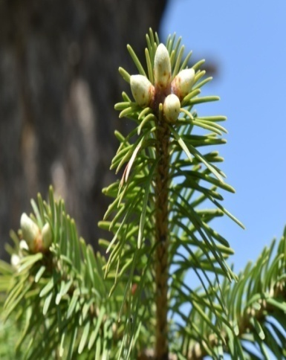 |  | 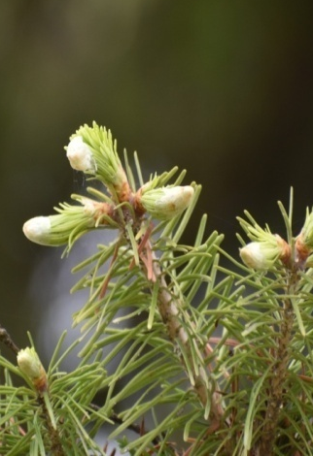 |  | 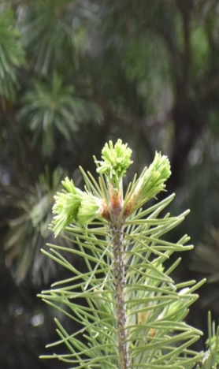
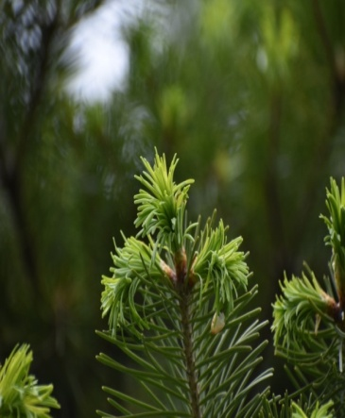 |  | 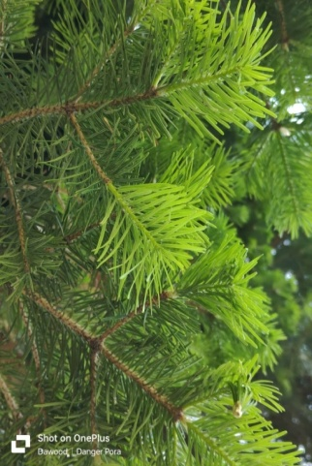 |  | 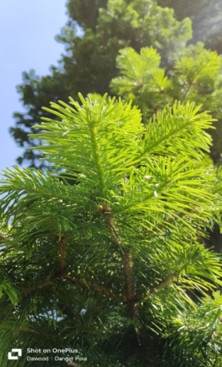
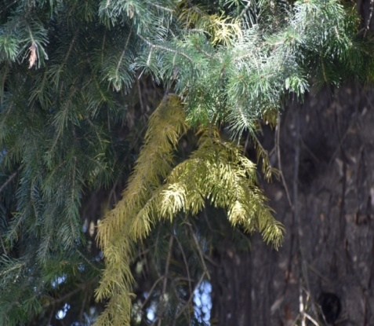 |  | 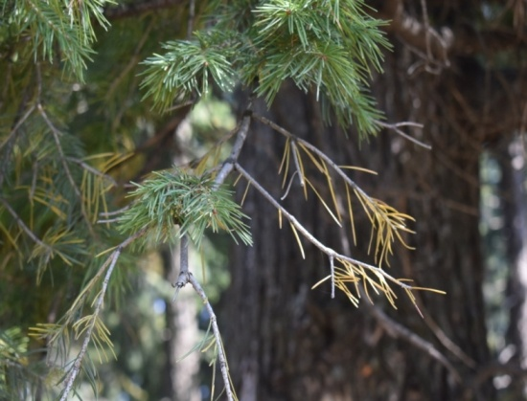
Fig 1-Vegetative phenophases of Abies pindrow Royle.

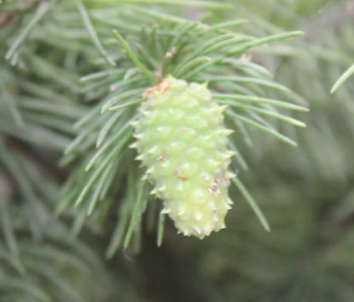 |  | 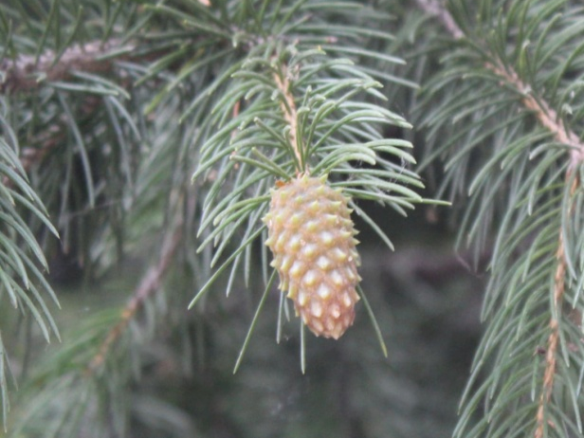
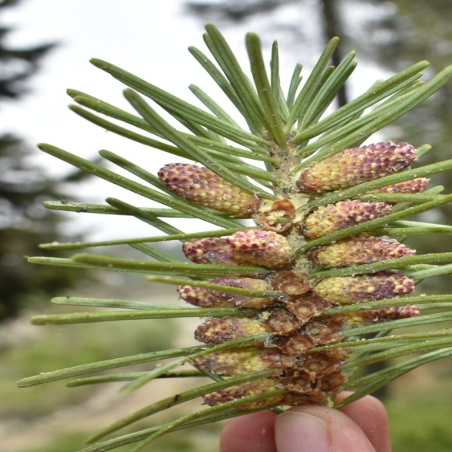 |  | 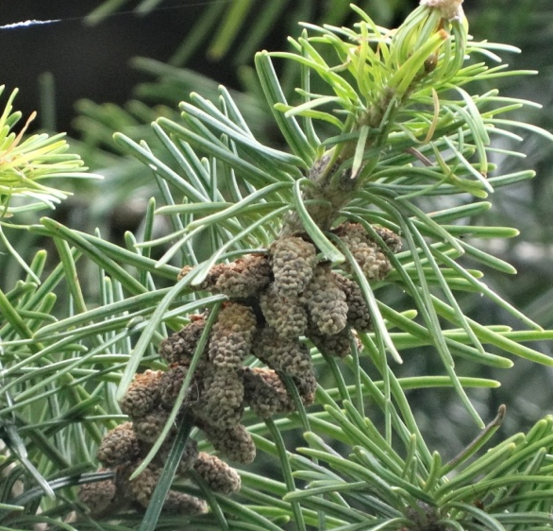
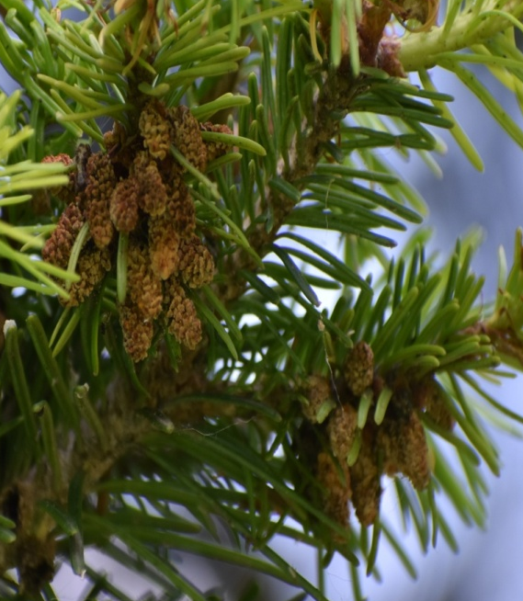 |  | 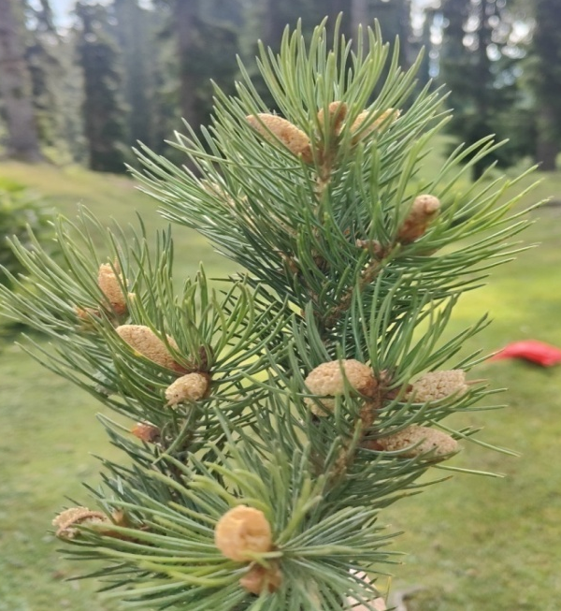
Fig 2-Reproductive phenophases of male strobili

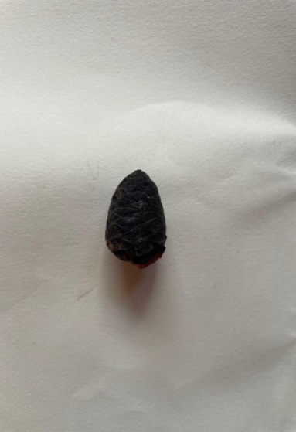 |  | 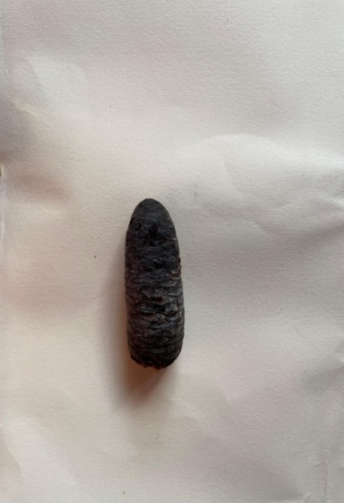 |  | 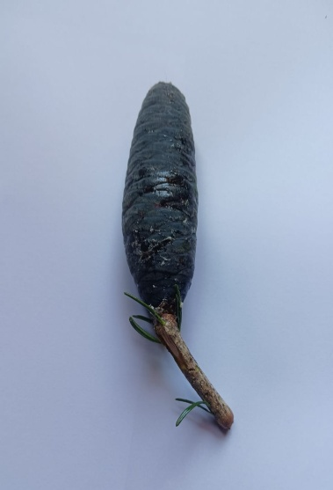
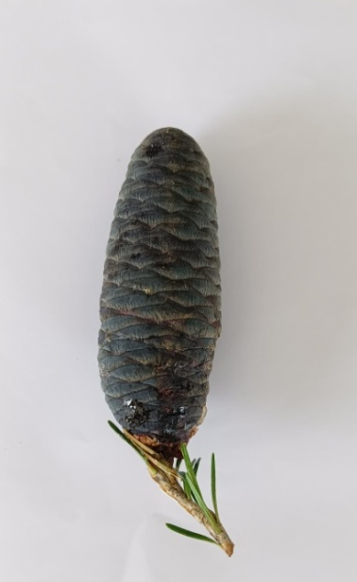 |  | 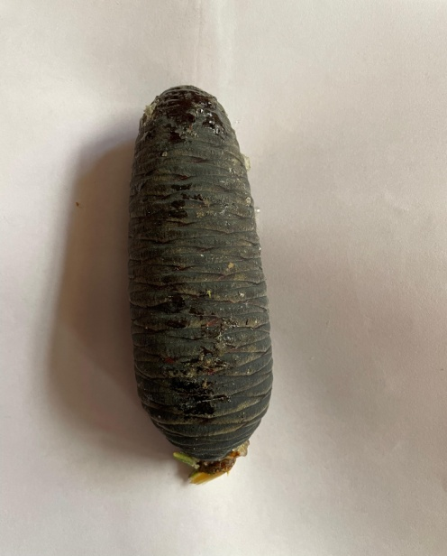 |  | 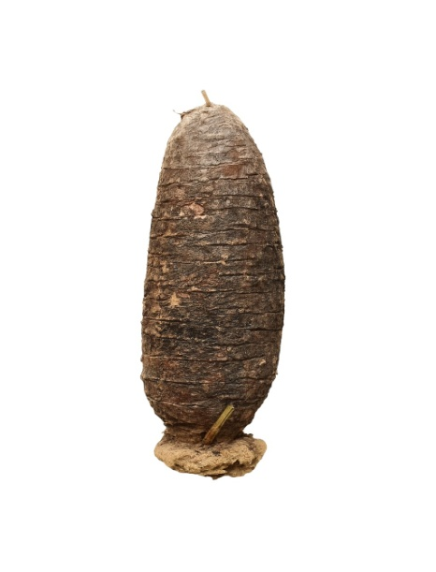
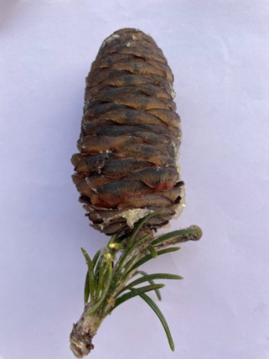 |  | 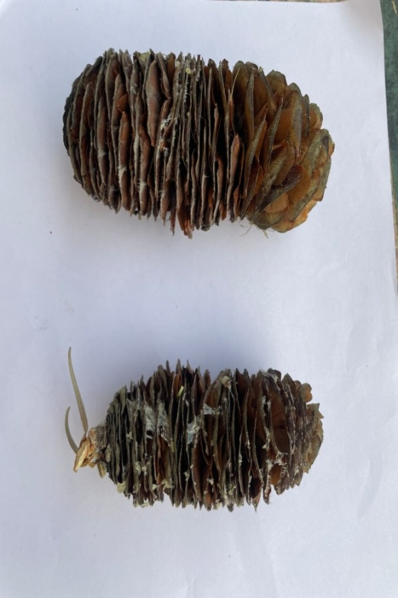
Fig 3-Reproductive phenophases of female cone

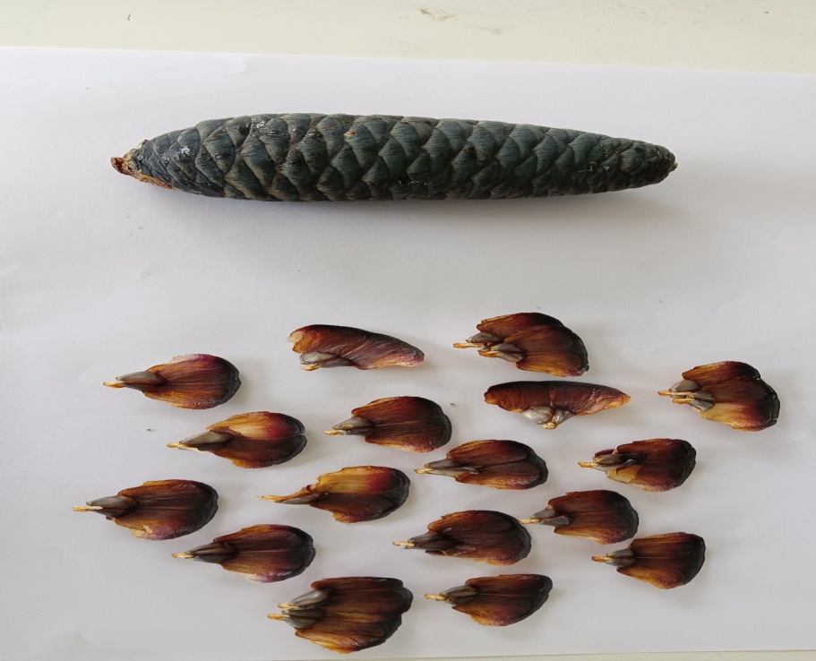 |  | 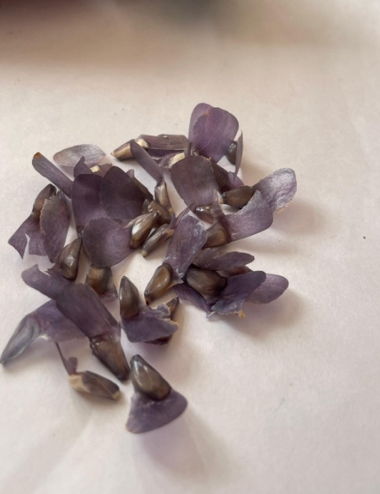
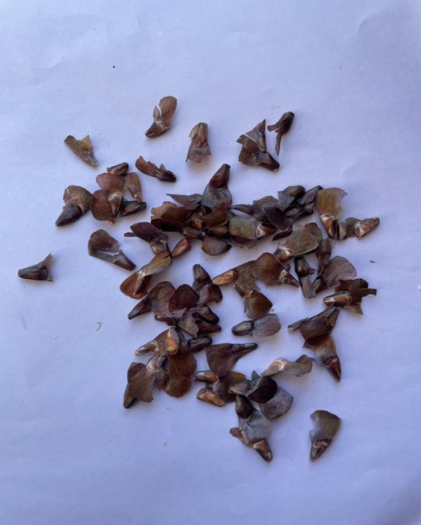 |  | 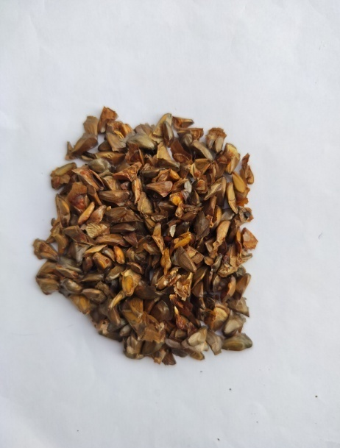
Fig 4-Seed maturation stages of Abies pindrow Royle

References
Anderson, D.M., Mauk, E.M., Wahl, E.R., Morrill, C., Wagner, A.J., Easterling, D. and Rutishauser, T. 2013. Global warming in an independent record of the past 130 years. Geophysical Research Letters 40: 1-4.
Bertiller, M. B., Irisarri, M. P. and Ares, J. O. 1990. Phenology of Festuca allescens in relation to topography in North-western Patagonia. Journal of Vegetable Science 1: 579-584.
Bhat, H. A. 2017.Altitudinal Variation in Phenology, Seedling Characteristics & Natural Regeneration of Abies pindrow Spach. Ph. D Thesis. Sher-e-Kashmir University of Agricultural Sciences & Technology of Kashmir. India. 100p.
Bliss, L.C. 1971. Arctic and alpine plant life cycles. Ann. Rev. Ecol. Syst 2: 405–438.
Chen, X. and Xu, L. 2012. Temperature controls on the spatial pattern of tree phenology in China’s temperate zone. Agr. Forest Meteorol 154–155: 195–202.
Chen, X., Hu, B. and Yu, R. 2005. Spatial and temporal variation of phenological growing season and climate change impacts in temperate eastern China. Glob Change Biol , 11: 1-13.
Chmielewski, F.M. and Rotzer, T. 2001. Response of tree phenology to climate change across Europe. Agricultural and Forest Meteorology 108: 101-112.
Chmielewski, F.M., Muller, A. and Bruns, E. 2004. Climate changes and trends in phenology of fruit trees and field crops in Germany, 1961–2000. Agric. For. Meteorol 121: 69–78.
Cleland, E.E., Chuine, I., Menzel, A., Mooney, A. and Schwartz, M.D. 2007. Shifting plant phenology in response to global change. Trends in Ecology & Evolution 22(7): 357-365.
Chuine, I. 2010. Why does phenology drive species distribution? Philosophical Transactions of the Royal Society B. Biological Sciences 365: 3149–3160.
Davi, H., Gillmann, M. and Ibanez, T. 2011. Diversity of leaf unfolding dynamics among tree species: new insights from a study along an altitudinal gradient. Agr. Forest. Meteorol 151: 1504–1513.
Defila, C. and Clot, B. 2005. Phytophenological trends in the Swiss Alps, 1951–2002. Meteorol. Z 14: 191–196
Doi, H. and Katano, I. 2008. Phenological timings of leaf bud burst with climate change in Japan. Agr. Forest. Meteorol 148: 512–516.
Forrest, J., Inouye, D.W. and Thomson, J.D. 2010. Flowering phenology in subalpine meadows: does climate variation influence community co-flowering patterns? Ecology 91: 431–440.
Fox, J. E. D. 1976. Constraints on the natural regeneration of tropical moist forests. Forest Ecology and Management 1: 37-65
Hulber, K., Winkler, M. and Grabherr, G. 2010. Intra pack, frost, and La Niña, in the context of climate change. Oecologia 130: 543-550.
Humberto, G. R., Ratikanta, M. and Sarkar, N. C. 2014. Phenology of woody species: a Review. International Journal of Bio- resource and Stress Management 5(3): 436-443.
Inouye, D.W. 2008. Effects of climate change on phenology, frost damage, and floral abundance of montane wildflowers. Ecology 89: 353-362.
Johnson, D.M., Buntgen, U. and Frank, D.C. 2010.Climatic warming disrupts recurrent Alpine insect outbreaks. Proceedings of the National Academy of Sciences, USA 107, 20576–20581 pp
Inouye, D.W. 2008. Effects of climate change on phenology, frost damage, and floral abundance of montane wildflowers. Ecology 89: 353-362.
IPCC. 2007. Contribution of working group I to the fourth assessment report of the intergovernmental panel on climate change. In: Solomon, S. The Physical Science Basis. Cambridge University Press, Cambridge, UK, 996p.
Kramer, K. 1995. Phenotypic plasticity of the phenology of seven European tree species in relation to climate warming. Plant Cell Environ 18: 93–104.
Kramer, K. 1997. Phenology and growth of European trees in relation to climate change. In: Phenology in Seasonal Climates. [Eds. H. Lieth and M.D. Schwartz] 1: 39-51
Korner, C. 2003. Alpine plant life: functional plant ecology of high mountain ecosystems. Springer, New York, 2nd Edition. P. 344.
Kumar S., Chopra N. and Al-Tawaha A. R. M. S. 2017. Phenological variations in tree and shrub species of a banj oak (Quercus leucotrichophora A. Camus) dominated forest in Kumaun, Central Himalaya. Advances in Environmental Biology 11(5): 35-43
Lone, A. H. 2018. Reproductive biology and conservation for Aesculus indica Colebr and Ulmus villosa Brandis ex gambles of Kashmir. Department of Biological Sciences, Sam Higginbottom University of Agriculture, Technology and Sciences, Allahabad.
Masoodi, U. R., Rana, D., Thapliyal, M. and Singh, V. R. R. 2018. A study on phenological traits of Abies pindrow (Royle) in different sites of Garhwal Himalayas.Journal of Applied and Natural Science 10 (1) 178-184.
Menzel, A. 2003. Plant phenological anomalies in Germany and their relation to air temperature and NAO. Clim. Change 57: 243–263
Menzel, A., Sparks, T.H. and Estrella, N. 2006. European phenological response to climate change matches the warming pattern. Global Change Biology 12: 1969– 1976.
Menzel, A., Estrella, N. and Schleip, C. 2008. Impacts of climate variability, trends and NAO on 20th century European plant phenology
Mir, N. A., Masoodi, T. H., Mir, A. A., Khan, H., Sofi, P. A., Wani, F. J. and Hameed, O. B. 2016. Phenology and growth performance of Himalayan birch (Betula utilis) in Kashmir Western Himalayas along the different altitudinal gradients. Indian Journal of Agricultural Sciences 86(8): 122-127
Nord, E.A. and Lynch, J.P. 2009. Plant phenology: a critical controller of soil resource acquisition. Journal of Experimental Biology 60: 1927–1937.
Nordli, O., Wielgolaski, F.E. and Bakken, A.K. 2008. Regional trends for bud burst and flowering of woody plants in Nor way as related to climate change. Int. J. Biometeorol 52: 625–639.
Parmesan, C. 2006. Ecological and evolutionary responses to recent climate change. Annual Review of Ecology, Evolution, and Systematics 37: 637-669.
Sailo, L. 2017.Phenology, reproductive system and seed characteristics of chinar (Platanus orientalis) in Kashmir. M.sc Thesis. Sher-e-Kashmir University of Agricultural Sciences & Technology of Kashmir. India. P.5.
Scheifinger, H., Menzel, A., Koch, E., Peter, C. and Ahas, R. 2002. Atmospheric mechanisms governing the spatial and temporal variability of phenological phases in Central Europe. Int. J. Climatol 22: 1739–1755.
Shah S., Verma A. and Tewari A. 2014. Timing of Shifts in Phenological Events in Rhododendron arboreum Smith. Influenced by Climatic Irregularities in Kumaun Regions of Central Himalaya. Global Journal of Scientific Researches 2(2):56-59
Singh, N., Ram, J., Tewari, A. and Yadav, R. P. 2015. Phenological events along the elevation gradient and effect of climate change on Rhododendron arboretum Sm. In Kumaun Himalaya. Current Science 108: 106-110.
Singh, P. and Negi, G. C. S. 2018. Treeline species phenology: shoot growth, leaf characteristics and nutrient dynamics. Tropical Ecology 59(2): 297-311.
Wipf, S.2010. Phenology, growth and fecundity of eight subarctic tundra species in response to snowmelt manipulations. Plant Ecol 207:53–66.
Zargar, I. H. 2012.Maturity Indices and Standardization of Pretreatments in Cupressus torulosa (Don.) for Dormancy Break in Seeds. M.Sc.Thesis. Sher-e-Kashmir University of Agricultural Sciences & Technology of Kashmir. India.p.7.
Zhao, Y., Liu, X., Li, G., Wang, S., Zhao, W. and Ma, J. 2018. Phenology of five shrub communities along an elevation gradient in the Qilian mountains, China. Forests 9:58.

