DIACHRONIC STUDY OF THE IMPACT OF RAINFALL VARIABILITY ON LAKE ONO (SOUTH-EAST OF CÔTE D'IVOIRE) USING THE SUPERVISED CLASSIFICATION METHOD

Abstact
This study examines the spatio-temporal evolution of Lake Ono, located in southeastern Côte d’Ivoire, between 1986 and 2016, to evaluate the combined impacts of climate variability and anthropogenic pressures on local ecosystems. The methodology involved processing Landsat TM+ and ETM+ satellite images, performing supervised classification using the maximum likelihood algorithm, and validating the results through confusion matrices and the Kappa index. Rainfall, topographic, and field data were integrated to interpret the observed changes. The analysis reveals a significant reduction in the surface area of Lake Ono, estimated at approximately 25% over thirty years, reflecting a retreat of water bodies associated with the decline in rainfall since the 1970s. Indeed, the results obtained with the second-order Hanning method show a period of excess rainfall from 1960 to 1976 (12.64 to 15.15%) and a period of rainfall deficit from 1977 to 2014 (-11.72 to -6.75%) in the region. Concurrently, dense forests and wetlands have substantially decreased, while croplands, bare soils, and settlements have expanded. These transformations reflect an environmental dynamic driven by climate variability, population growth, and unplanned urbanization. The landscape changes have disrupted the local hydrological regime, increased runoff and sedimentation, and initiated eutrophication in the lake. The results, validated by accuracy indices exceeding 98%, confirm the robustness of the analysis. Overall, the study highlights the progressive degradation of the Lake Ono watershed and underscores the necessity for integrated and sustainable natural resource management, including reforestation, wetland protection, and strategic spatial planning, to strengthen the ecological and socio-economic resilience of the region against the impacts of climate change.

Keywords: Climate variability, satellite imagery, supervised classification, Lake Ono, Côte d’Ivoire.

INTRODUCTION
Climate change is profoundly affecting ecosystems and human societies around the world. It is resulting in a global increase in temperatures, greater variability in precipitation, and more extreme events such as droughts and floods (Adeyeri et al., 2024; Obuobie et al., 2025). In West Africa, this change manifests itself in an apparent duality: on the one hand, the frequency and amplitude of floods are set to increase as a result of global warming, compromising hydrological security and the sustainability of water infrastructure (Diop et al., 2025; Nka et al., 2015); on the other hand, seasonal rainfall deficits and changes in runoff cycles are being observed, leading to a reduction in the availability and regulation of water resources (Kodja et al., 2024; Sambieni et al., 2024). These disturbances reflect the intensification of the regional hydrological cycle, accentuated by interactions between climate variability and changes in land use (Houngue et al., 2023; Cheikh, 2018).
These developments pose significant challenges for integrated water resource management, rain-fed agriculture, and the resilience of rural populations dependent on these systems. The systematic integration of hydrological and climatic considerations into development policies now appears essential in order to limit the social, economic, and environmental impacts of climate change (Fofana et al., 2023; Adeyeri et al., 2024).
In Côte d'Ivoire, the effects of climate change are already noticeable. Several studies have highlighted rainfall disruptions and significant changes in river flows. In the N'Zi-Bandama basin, populations have been experiencing increased water stress since the 1990s, particularly during the dry season (Kouassi et al., 2008). Similarly, in the humid tropical zone of the Bocanda department, a rainfall disruption observed around 1968 resulted in an average annual decrease in rainfall of about 10% and a temperature increase of about 0.6°C (Soro et al., 2013). These changes affect not only the availability of surface water resources, but also groundwater recharge and groundwater quality, thereby compromising sustainable development goals (Kouadio et al., 2024; Soro et al., 2014).
The effects of climate change on water resources result from a combination of several factors, including reduced precipitation, decreased runoff, increased evapotranspiration, and decreased groundwater recharge (Bodjrenou et al., 2024; Obuobie et al., 2025). In the transboundary Sassandra basin, for example, models based on RCP 4.5 and RCP 8.5 scenarios project a sharp decline in natural flows toward the end of the century, linked to a combination of lower precipitation and higher potential evapotranspiration (Kouadio et al., 2024). More broadly, at the regional level, the combined effects of climate change and land use could profoundly alter hydrological flows, precipitation, and water balances (Kodja et al., 2024; Zuéli, 2009). This widespread deterioration in hydrological conditions increases the vulnerability of aquatic systems and reduces their resilience to climate hazards (Faye & Mendy, 2018; Sambieni et al., 2024).
Lake ONO, located in the Bonoua region, is a prime example of these climatic and hydrological dynamics. Subject to the combined effects of declining rainfall, increased evaporation, and growing anthropogenic pressures, this lake is likely to experience a drop in water levels. The aim of this study is to analyze the extent and intensity of the effects of climate change and anthropogenic pressures on Lake ONO, within the framework of sustainable water resource management in Côte d'Ivoire.
I- Presentation of the study area
The Ono lagoon or lake is located in southeastern Côte d'Ivoire, northeast of the sub-prefecture of Bonoua, in the South Comoé region (Figure 1). It extends between 3°32' and 3°36' west longitude and 5°21' and 5°23' north latitude, approximately 49 km east of Abidjan. Covering an area of approximately 400 hectares, Lake Ono plays a major hydrological role in regulating surface water flows, recharging the water table, and maintaining aquatic and riparian biodiversity (Bricquet et al., 1997; Global Water Partnership, 2010). The region has a transitional equatorial climate, marked by two rainy seasons (April–July and September–November) and two dry seasons (December–March and August). Average annual rainfall ranges from 1,200 to 1,800 mm, with significant interannual variations (Kpan, 2017). Geomorphologically, the Lake Ono basin is part of a gently undulating coastal plain consisting of ferralitic and hydromorphic soils derived from Quaternary sedimentary formations (Adéchina et al., 2018). These soils, often sandy loam and rich in organic matter in wetlands, promote the formation of swamps and floodplains during the rainy season. Lake Ono is fed mainly by local rainfall and surface runoff. It has little connection to other bodies of water in the Ivorian lagoon system, which increases its dependence on local rainfall conditions.

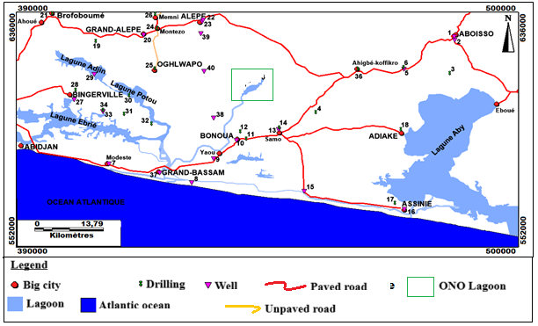
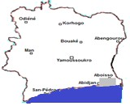
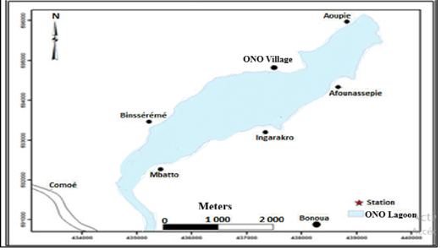

Figure 1: Location of the study area
II- MATERIALS AND METHODS
II-1 MATERIALS
The data used for this study come from several complementary sources combining satellite imagery, topographic maps, and field information.
II-1-1. Satellite data
The main data used came from Landsat TM+ (1986) and Landsat ETM+ (2000 and 2016) satellites, corresponding to scene 195-056. These images were downloaded from the official USGS (United States Geological Survey) platform at http://earthexplorer.usgs.gov/. Before use, they underwent geometric correction according to the UTM WGS 84 projection system, zone 30 North, to ensure perfect spatial correspondence between the different acquisition dates. The TM+ and ETM+ sensors, equipped with seven spectral bands ranging from visible to thermal infrared, offer excellent discrimination between land cover classes. This spectral richness made it possible to test several color combinations to improve visual readability and classification accuracy. The RGB combination (bands 3-4-5) was chosen for its ability to clearly differentiate between forest, aquatic, and anthropized environments (Soro, 2013).
II-1-2. Cartographic and geographical data
Topographic maps at a scale of 1/200,000 from the National Geographic Institute (IGN-CI) served as a reference for location, validation of geographical boundaries, and recognition of landscape units. These resources made it possible to better understand the morphology of the watershed and to establish correspondences between the entities visible on the satellite images and the reality of the terrain.
II-1-3. Climatological data
The rainfall series used, covering the period 1960–2014, was provided by the National Meteorological Directorate (DMN) of Côte d'Ivoire. According to Kouao et al. (2024), the period from 1960 to 1983 corresponds to a period of excess rainfall, while the period from 1984 to 2014 marks a period of drought and water deficit. This temporal distinction served as the basis for the diachronic analysis of satellite images and the interpretation of the observed hydrological changes.
II-1-4. Field Data and Surveys Field surveys
Prospecting and validation missions were carried out in the field between December 2013 and September 2014, including: • hydrological and physicochemical sampling campaigns, • direct observations of vegetation, land use, and the state of the lake, • as well as socio-economic surveys of riparian communities to document changes in agricultural practices and water use. This fieldwork played an essential role in the selection of the training areas used for supervised classification and in the validation of the results using the confusion matrix and the Kappa index.

II-2 METHODS
II-2-1. Hanning second-order low-pass filter climate method
Four weather stations (Abidjan, Adiaké, Alépé, and Bingerville) were analyzed using the second-order non-recursive Hanning low-pass filter method on data from 1960 to 2014. This method of characterizing climate variability allows for a clear division of the hydroclimatic series to which it is applied.
II-2-2. Methods for the diachronic study of the evolution of Lake ONO
The diachronic classification comparison method was used (Mas, 2000; Lu et al., 2004) in Hoang et al. (2008) to detect changes in land use. Their use in this work is motivated by the interesting results obtained in Côte d'Ivoire by authors such as Soro (2010) and Soro (2014) in this field. The principle of this method is based on the classification of a scene acquired on different dates. The main steps are the geometric correction of the images, the improvement of their quality, and the classification itself.
• Geometric correction
The Landsat TM and ETM+ images have already been corrected according to the UTM WGS (84) Zone 30 North projection system. These corrections were made by NASA before the images were posted online at http://earthexplorer.usgs.gov/.
• Improved image contrast
A single image scene covers the entire study area. This is scene 195-056, and the years selected are 1986, 2000, and 2016. This scene lies between longitudes 4°15' and
2°30' west and latitudes 5°00' and 6°00' north.
Principal component analysis (PCA) and the normalized difference vegetation index (NDVI) were used to select the best neochannels on the one hand and increase the ground-vegetation contrast on the other. To optimize visual analysis and adapt tone variations to the human system, several conversion tables are used, such as Red Green Blue (RGB), Intensity Hue Saturation (ITS), and Martin Taylor (MT) (Kouamé, 1999). The Red Green Blue (RGB) system was chosen because it allows for better distinction between the different components of the environment (forest, water, habitat, etc.). Several color compositions were created with the aim of combining the channels that convey the maximum amount of information. The TM and ETM+ sensors have seven spectral bands, ranging from visible to thermal infrared (Ahoussi, 2008; Soro, 2010; Gnamba, 2014; Soro, 2014). This large number of channels allows multiple combinations of three (3) channels to be tried in order to obtain additive color syntheses highlighting different themes. For all these images, the color composition from channels 3, 4, and 5 was selected. Channel 3 highlights the color red, channel 4 corresponds to the color green, and channel 5 gives the color blue. These channels are most often used for TM + and ETM + images (Soro, 2010; Soro, 2014). The mosaic resulting from the combination of these channels makes it possible to distinguish between land cover classes.

• Classification
➢ Selection of training plots
Six land use classes have been defined. The water class includes watercourses and large bodies of water, such as lagoons, lakes, and the Comoé River. The habitat class is easily identifiable and appears in pink on the color composition. The bare soil class includes areas devoid of vegetation, as well as coastal savannas, rocky outcrops, and quarries. The crop areas class includes pineapple, cassava, rice, and banana plantations. The dense forests class includes classified forests and gallery forests along watercourses, which are marked on the color compositions to accurately reflect the reality on the ground. Finally, the swamp areas class corresponds to flooded or flood-prone areas in the region. The quality of the training plot classification was verified using the confusion matrix, with plots considered correctly classified when the percentage of correlation between them was greater than or equal to 70% (Soro, 2014).
➢ Choice of supervised classification
Image classification can be performed using two main methods: supervised or unsupervised (Kouassi, 2007; Soro, 2010). The unsupervised method consists of automatically grouping pixels with similar radiometric characteristics. Supervised classification assigns pixels to classes based on training patches, which are considered representative of the entire class.
Among the supervised methods, the maximum likelihood algorithm was chosen because of its proven reliability in several previous studies (N'guessan, 1990; Bigot et al., 2005; Koné et al., 2007; Kouamé et al., 2007; Kouassi, 2007; Hoang et al., 2008; Soro, 2010; Tapboda and Fotsin, 2010; Diallo et al., 2011; Soro, 2014). This approach classifies pixels according to the digital profiles of the training plots and estimates the probability of belonging to each class. In this study, satellite images from 1986 (TM+), 2000, and 2016 (ETM+) were classified using supervised classification with ENVI 4.3 software.
The classifications were validated using a confusion matrix and Kappa index, supplemented by field checks. Prospecting missions (December 2013, February-March 2014), sampling campaigns (February-March and June 2014) and the socio-economic survey (August-September 2014) provided comprehensive and detailed knowledge of the terrain.
The Kappa index (k) is used to validate and evaluate the accuracy of vegetation classifications (Pontius, 2000). The mathematical definition of this index is presented in equation 1:
$k=\frac{P_{o}-P_{c}}{P_{p}-P_{c}}$ (Eq. 1)
In this equation, P₀ represents the actual percentage of correctly classified pixels. It is calculated by dividing the sum of the values on the diagonal of the confusion matrix by the total number of observations. Pc corresponds to the estimated probability of obtaining a correct classification by chance. To calculate it, the marginal products of the column and row values are determined for each cell of the matrix, then the sum of the diagonal values is divided by the total marginal products. In a reliable classification, P_{c} is generally lower than P₀. P_{p} represents the percentage obtained for a perfect classification, i.e., 100% accuracy. According to Califaux et al. (2006, in Soro, 2014), the Kappa index can be interpreted according to five categories: very weak agreement (0–0.20), weak agreement (0.21–0.40), moderate agreement (0.41–0.60), substantial agreement (0.61–0.80), and almost perfect agreement (0.81–1).
Following the classification of the images, a statistical analysis is performed to study the dynamics of the different land cover classes. Subsequently, the degree of degradation of vegetation cover in the southeastern coastal region, in relation to anthropogenic activities, is assessed using the retention coefficient calculation.
II-2-2. Statistical analysis of land use dynamics
The calculation of variations was supplemented by an assessment of the average annual rate of spatial expansion (E), using the formula presented in equation 3 and applied by Mama and Oloukoi (2003), in order to analyze land use dynamics.
$E= \frac{V_{i2}-V_{i1}}{100XP}$ (Eq. 2)
Where V_{i2} represents the value of the statistic for stratum i in the observation year; Vi1 is the value of the statistics for stratum “i” in the reference year; and P is the length of the observation period between the observation year and the reference year. This formula allows for a diachronic analysis of land use dynamics in the study area.
III. RESULTS AND DISCUSSION
III-1. RESULTS
III-1-1. Results of applying Hanning's second-order low-pass filter method
The analysis of climatic periods using Hanning's second-order low-pass filter method or weighted index yielded the results shown in Table I and Figure 2.
In general, after applying the second-order Hanning low-pass filter, all stations show two rainfall periods, namely a wet period and a dry period.
Thus, at the Abidjan airport station, the wet period runs from 1960 to 1982 and the dry period covers the years 1983 to 2014 (Figure 2a). The average rainfall for these two periods is 2,051.36 mm and 1,595.52 mm, respectively, with a chronological average (1960-2014) of 1,786.14 mm. The dry period is the longest and has a deficit of 190.62 mm (10.62%) compared to the average interannual rainfall for the entire period. The wet period is marked by a surplus of 265.22 mm (14.85%). The Adiaké and Bingerville stations show almost the same periodic rainfall distribution (Figures 2b and d). The rainfall surpluses observed during the wet period (1960 to 1983) were 15.13% (273.32 mm) in Adiaké and 12.64% (231.18 mm) in Bingerville. The years 1984 to 2014, which represent the dry period, resulted in rainfall deficits of 11.72% or 211.60 mm in Adiaké and 9.77% or 178.58 mm in Bingerville. At the Alépé station (Figure 2 c), the dry period is very long (1977 to 2014) and shows a rainfall deficit of 108.79 mm (6.75%). The wet period (1960 to 1976) recorded a rainfall surplus of 243.17 mm (15.15%). The average for the period 1960 to 2014 is 1605.66 mm.

Table I: Results of the second-order Hanning low-pass filter
Stations | Study period | Wet period | Surplus (mm) | Percentage (%) | Dry period | Deficit | Percentage (%)
Abidjan Airport | 1960-2014 | 1960-1982 | 256,22 | 14,85 | 1983-2014 | -190,62 | 10,62
Adiaké | 1960-2014 | 1960-1983 | 273,32 | 15,13 | 1984-2014 | -211,60 | 11,72
Alépé | 1960-2014 | 1960-1976 | 243,17 | 15,15 | 1977-2014 | -108,79 | 6,75
Bingerville | 1960-2014 | 1960-1983 | 231,18 | 12,64 | 1984-2014 | -178,58 | 9,77

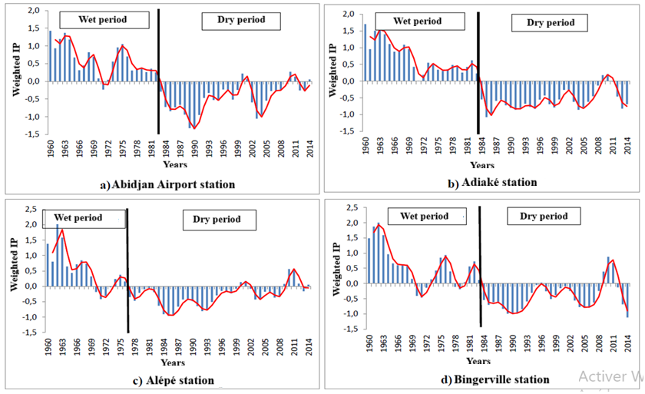

Figure 2: Variation in the weighted rainfall index at stations in the Abidjan-Aboisso region
III-1-2. Results of the study of land use dynamics for the assessment of environmental changes
III-1-2-1. Assessment of supervised classification
Table II presents the results of the supervised classification of the different land use classes. The rows correspond to the actual classes, while the columns represent the classes assigned by the classification. The values indicate the percentage of pixels correctly or incorrectly classified for each category. The Residential class has a very high accuracy, with 99.82% of pixels correctly classified. Errors are very limited, with only 0.16% of pixels confused with the cropland area, 0.19% with water, and 0.44% with bare soil. The Dense Forest class is also well discriminated, with 99.18% of pixels correctly identified and low confusion with the cropland (0.30%) and water (0.21%) classes. The Cropland class shows an accuracy of 99.54%. Incorrectly classified pixels are 0.82% with dense forest and 0.41% with water. The Water class is very well identified, with 99.19% accuracy and virtually no confusion with other classes. The Bare Land class achieves 99.56% accuracy, with only 0.18% of pixels confused with dwellings. The Swampy Area class has the lowest accuracy, with 96.39% of pixels correctly classified.
Table II: Confusion matrix for classes in 1986
Classes | Housing | Dense forest | Cropland | Water | Bare land | Swamp area
Housing | 99.82 | 0 | 0.16 | 0.19 | 0.44 | 0.52
Dense forest | 0 | 99.18 | 0.82 | 0 | 0 | 0
Cropland | 0 | 0.82 | 99.54 | 0.41 | 0 | 3.09
Water | 0 | 0 | 0 | 99.19 | 0 | 0
Bare land | 0.18 | 0 | 0 | 0 | 99.56 | 0
Swamp area | 0 | 0 | 0 | 0 | 0 | 96.39
Total | 100 | 100 | 100 | 100 | 100 | 100
Table III presents the confusion matrix for supervised classification for the year 2000, applied to five land cover classes: dwellings, dense forest, cropland, water, and bare soil. The values are expressed as percentages and can be used to assess the accuracy of each class. For the year 2000, the residential class is correctly identified in 98.24% of cases, with a low proportion of 2.84% of pixels confused with bare ground. The dense forest class has an accuracy of 98.88%, with only 1.16% of pixels incorrectly classified as water. The cropland class is almost perfectly discriminated, with 100% of pixels correctly identified, although there is very slight confusion with dense forest (1.12%) and water (0.41%). The water class is recognized with 98.84% accuracy, confirming the good distinction of this category thanks to its specific spectral characteristics. The bare ground class achieves 97.16% accuracy, with 1.76% of pixels confused with dwellings.
Table III: Confusion matrix for classes in 2000
Classes | Housing |  | Dense forest |  | Cropland |  | Water |  | Bare land
Housing | 98.24 |  | 0 |  | 0 |  | 0 |  | 2.84
Dense forest | 0 |  | 98.88 |  | 0 |  | 1.16 |  | 0
Cropland | 0 |  | 1.12 |  | 100 |  | 0.41 |  | 0
Water | 0 |  | 0 |  | 0 |  | 98.84 |  | 0
Bare land | 1.76 |  | 0 |  | 0 |  | 0 |  | 97.16
Total | 100 |  | 100 |  | 100 |  | 100 |  | 100
Analysis of the confusion matrix for supervised classification for 2016, covering five land cover classes, shows that the residential class is correctly identified in 96.85% of cases (Table IV). However, 5.77% of pixels were confused with bare land and 0.94% with cropland, indicating a slight increase in errors compared to 2000. The dense forest class is very well discriminated, with 99.07% accuracy and a very low proportion of pixels misclassified as cropland (0.16%) or water (0.67%). The crop land class has an accuracy of 98.86%, with minor confusion with dense forest (0.93%) and water (0.81%). The water class is correctly identified 98.47% of the time, confirming that water pixels are easily recognizable thanks to their distinct spectral signatures. The bare land class achieves 94.23% accuracy, with 3.13% of pixels confused with dwellings and very low proportions with other classes, reflecting a slight decrease in accuracy compared to 2000.
Table IV: Confusion matrix for classes in 2016
Classes | Housing | Dense forest | Cropland | Water | Bare land
Housing | 96.85 | 0 | 0.94 | 0.03 | 5.77
Dense forest | 0 | 99.07 | 0.16 | 0.67 | 0
Cropland | 0.01 | 0.93 | 98.86 | 0.81 | 0
Water | 0 | 0 | 0 | 98.47 | 0
Bare soil | 3.13 | 0 | 0.04 | 0.02 | 94.23
Total | 100 | 100 | 100 | 100 | 100
III-1-2-2. Land use dynamics from 1986 to 2016
Table V shows the evolution of different land use classes in the Abidjan-Aboisso region over the period 1986-2016. shows that the residential category increased significantly during this period, from 11.09% in 1986 to 12.25% in 2000, reaching 18.80% in 2016. This trend reflects growing urbanization and expansion of built-up areas in the region. The dense forest class shows a sharp decline, from 16.94% in 1986 to 14.86% in 2000, then to only 7.56% in 2016. This significant reduction reflects deforestation and anthropogenic pressure, linked in particular to agriculture and urbanization. Cultivated areas increased slightly from 38.01% in 1986 to 41.02% in 2000, stabilizing at 38.40% in 2016. This trend suggests that, despite urban expansion, cultivated areas remain relatively constant, perhaps due to the conversion of some forest land to agricultural use. The water class remains broadly stable, falling from 31.11% in 1986 to 30.99% in 2000 and 30.82% in 2016, indicating that large bodies of water and watercourses have not undergone any major changes. Bare land increased significantly, from 0.16% in 1986 to 0.88% in 2000 and 4.42% in 2016. This growth reflects soil degradation linked to erosion, abandoned areas, and the expansion of urban areas without vegetation. Finally, wetlands accounted for 2.69% of the total area in 1986, but are no longer distinguished separately in the 2000 and 2016 data, which could indicate their decline or their integration into other classes, such as bare land or cultivated areas.
Table V: Changes in land use (in %) in the Abidjan-Aboisso region (1986-2016)
Classes | 1986 | 2000 | 2016
Housing | 11.09 | 12.25 | 18.80
Dense forest | 16.94 | 14.86 | 7.56
Cropland | 38.01 | 41.02 | 38.40
Water | 31.11 | 30.99 | 30.82
Bare land | 0.16 | 0.88 | 4.42
Swamp area | 2.69 | -
Total | 100 | 100 | 100

III-1-2-3. Changes in Lake ONO and its surroundings from 1986 to 2016
Figure 3 illustrates the spatial and temporal evolution of the Ono lagoon between 1986 and 2016, distinguishing between the main land use categories. Residential areas are shown in red, dense forests in dark green, cultivated areas in light green, marshy areas in light blue (cyan), and bodies of water in dark blue. Bare soil is not explicitly visible in this figure. Spatial analysis reveals a gradual increase in the areas occupied by settlements, cultivated areas, and bare soil during the period studied. This expansion has mainly been at the expense of dense forests, bodies of water, and marshlands. Between 1986 and 2000, marshlands almost completely disappeared, replaced by cultivated areas, while dense forests and the edges of the lagoon, which were initially flooded, were gradually converted into built-up areas. This phenomenon reflects growing anthropogenic pressure, which is leading to the displacement of natural spaces for human use. The expansion of residential areas into previously forested and wetland areas demonstrates how populations in the southeastern coastal region are adapting to environmental changes, particularly those related to climate variability. Furthermore, the conversion of marshlands into agricultural land, particularly for rice cultivation, reflects a shift in agricultural practices. Areas that were initially inaccessible due to their humidity are now being exploited, reflecting a spatial reorganization of agricultural activities in response to hydrological and climatic constraints.
Analysis of lakes and waterways reveals a slight decrease in the surface area of certain lakes and lagoons, reflecting a decline in aquatic areas. The Ono lagoon is a particularly good example of this phenomenon. Its spatial and temporal evolution has been studied using satellite images from 1986, 2000, and 2016 (Figure 3). The 1986 image shows a lake surrounded by marshy areas to the east, west, and north, covering an area of approximately 7 km². A separate water reservoir can also be observed in the northern part. In 2000, the disappearance of the marshlands and this water reservoir around the Ono lagoon bore witness to the effects of the drought that affected the region between 1980 and 1999, leading to a reduction in the lake's surface area to 6.44 km². The return to more favorable rainfall between 2000 and 2014 has encouraged the partial restoration of the marshlands. However, field observations have revealed a gradual colonization of the water body by tufts of grass characteristic of dry land, in a strip approximately 30 meters wide from the shore to the shallow waters. This phenomenon reflects a retreat of the waters in favor of the expansion of dry land. In addition, a process of eutrophication is beginning, reducing the area of the lagoon to 5.24 km² in 2016. Thus, the Ono lagoon lost about 25% of its surface area between 1986 and 2016.

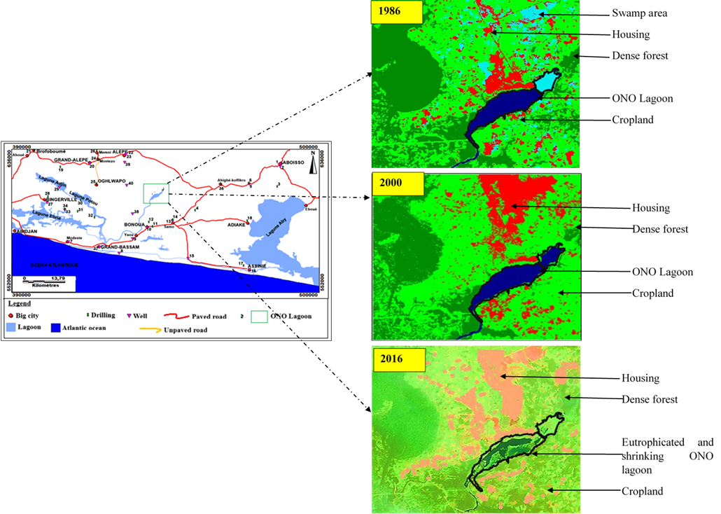
430000
600000
585000
400000


Figure 3: Spatio-temporal evolution of the Ono lagoon from 1986 to 2016
III-2. DISCUSSION
Classification accuracy and reliability of results
Analysis of the confusion matrices obtained for 1986, 2000, and 2016 shows that supervised classification of satellite images is generally reliable. The classes Habitation, Dense Forest, Cropland, and Water have accuracies greater than 96%, reflecting excellent spectral discrimination between land cover categories. The Bare Land class, which is slightly less accurate in 2016 (94.23%), remains correctly identified, while the Swamp Area class, which is absent from classifications after 1986, shows slightly lower accuracy (96.39%).
Kappa indices above 0.98 confirm the robustness of the supervised classification method used, in line with the results of N'Guessan (1990) and Bigot et al. (2005), who demonstrated the reliability of maximum likelihood classification in environmental studies. The partial confusion observed between the Habitations and Bare Land classes (2.8 to 5.7%) can be explained by the radiometric similarity of these highly mineralized surfaces (Kouamé, 1999). All of these indicators guarantee a reliable interpretation of land use dynamics in the Abidjan-Aboisso region.
Spatio-temporal evolution of land use (1986–2016)
The results reveal a marked transformation of natural landscapes in favor of anthropized areas. The area occupied by dwellings has almost doubled in thirty years (from 11.09% in 1986 to 18.80% in 2016), reflecting rapid and often unplanned urbanization, typical of Ivorian peri-urban areas (Kouassi, 2007). This expansion has been accompanied by a significant reduction in dense forest (16.94% → 7.56%), confirming anthropogenic pressure and excessive exploitation of natural resources (Hoang et al., 2008; Gnamba, 2014).
The area of agricultural land has remained relatively stable (38.01% → 38.40%), suggesting that agricultural expansion has mainly taken place at the expense of forests and wetlands rather than through the opening up of new arable land. At the same time, the sharp increase in bare land (0.16% → 4.42%) reflects soil degradation, increased land abandonment, and the expansion of urban areas without vegetation cover. Finally, the total disappearance of wetlands between 1986 and 2016 reflects their conversion to cultivated or built-up land, a direct consequence of climate variability and growing demographic pressure (Soro, 2014).
Environmental dynamics and study of Lake Ono
A diachronic analysis of Lake Ono reveals a gradual degradation of aquatic and forest ecosystems. Between 1986 and 2016, the surface area of the lake decreased from 7 km² to 5.24 km², a reduction of 25%. This decline can be explained by a combination of the prolonged drought observed between 1980 and 1999, highlighted by Hubert et al. (1989) and Vischel (2006), and the increasing occupation of the shores by human populations. The partial reappearance of wetlands after 2000, linked to an increase in rainfall, was not enough to offset the effects of eutrophication and sedimentation.
The invasion of the banks by herbaceous and aquatic vegetation observed in 2016 reflects a high nutrient load, a direct consequence of agricultural runoff and the destruction of vegetation cover. This phenomenon, already reported by Bricquet et al. (1997) and Paturel et al. (1997) in other wetlands in West Africa, illustrates the close correlation between rainfall variability, extensive agricultural practices, and reduced water volumes.
Regional comparisons and consistency of observed dynamics
The changes observed in the Abidjan-Aboisso region are part of a general pattern already seen in other regions of Côte d'Ivoire and West Africa. In the Bondoukou region (northeast), studies have shown an increase in built-up and cultivated areas, accompanied by a marked decline in dense forest between 1964 and 2020 (revuegeovision.laboraddys.org). Similarly, in the Bembela area, the spread of cultivated areas and the reduction of forests on the outskirts of villages confirm that the conversion of forest areas into agricultural land is a recurring process in rural areas of Côte d'Ivoire (DALOGÉO).
At the West African regional level, studies conducted in Ghana, Nigeria, and Burkina Faso report similar developments: rapid urbanization, conversion of forest and wetland areas into arable land, increase in bare soil, and progressive degradation of natural ecosystems. These trends are generally attributed to population growth, agricultural pressure, and uncontrolled land use, which are recurring factors in West African land use dynamics.
CONCLUSION AND OUTLOOK
The study conducted on Lake Ono confirmed, based on diachronic analyses of satellite images and climate data, the extent of the transformation of the region's ecosystems over the period 1986–2016. It shows that the approximately 25% reduction in the lake's surface area, the disappearance of marshlands, and the decline of dense forests are the result of both climate fluctuations and increasing pressure from human activities. These changes have led to the artificialization of the environment, disruption of the hydrological regime, and the onset of eutrophication. The originality of this study lies in its use of satellite imagery to highlight the interaction between land use dynamics and local hydrological changes, providing concrete insights into environmental degradation in southeastern Côte d'Ivoire. The results confirm the robustness of the supervised classification applied and the relevance of the integrated approach used. They pave the way for reflection on the sustainable management of the Lake Ono watershed, emphasizing the restoration of wetlands, control of urbanization, and the revitalization of agricultural practices. Thus, beyond the observation of degradation, this work proposes concrete avenues for adaptation and resilience in the face of the effects of climate change.
REFERENCES
Adéchina, O., Ouattara, A., & N’Ganzoua, K. R. (2018). Morphological and physicochemical characteristics of savanna soils along toposequences in Gogbala in northern Côte d’Ivoire. International Journal of Innovation and Applied Studies, 25(1), 437–445.
Adeyeri, O. E., Folorunsho, A. H., Adeliyi, T. E., Ayegbusi, K. I., Akinsanola, A. A., Ndehedehe, C. E., & Babalola, T. E. (2024). Climate change is intensifying rainfall erosivity and soil erosion in West Africa. Science of The Total Environment, 955, 177174. https://doi.org/10.1016/j.scitotenv.2024.177174
Ahoussi K. E. (2008). Quantitative and qualitative assessment of water resources in southern Côte d'Ivoire. Application of hydrochemistry and environmental isotopes to the study of continuous and discontinuous aquifers in the Abidjan-Agboville region. Doctoral thesis, University of Cocody-Abidjan (Côte d'Ivoire), 270 p.
Bigot, S., Kouamé, F., & Kouassi, A. M. (2005). Study of land use dynamics in forest areas of Côte d'Ivoire using remote sensing. Revue de Géographie Tropicale, 45(2), 23–38.
Bodjrenou, R., Sintondji, L. O., M’Po N’Tcha, Y., Germain, D., Azonwade, F. E., Bossa, A. Y., & Kpognin, A. F. S. (2024). Assessment of hydrology estimates from ERA5 reanalyses in Benin (West Africa). Hydrology and Earth System Sciences Discussions, 1–23. https://doi.org/10.5194/hess-2023-311
Bricquet, J. P., Mahé, G., & Olivry, J. C. (1997). Climate and hydrological variability in West and Central Africa. Sécheresse, 8(1), 37–44.
Cheikh, F. (2018). Climatic variability and hydrological impacts in West Africa: Case of the Gambia Watershed (Senegal). Environmental Water Sciences, Public Health and Territorial Intelligence Journal, 2(1), 54–66.
Diop, S. B., Ekolu, J., Tramblay, Y., Dieppois, B., Grimaldi, S., Bodian, A., & Sultan, B. (2025). Climate change impacts on floods in West Africa: New insight from two large-scale hydrological models. Natural Hazards and Earth System Sciences, 25(9), 3161–3184. https://doi.org/10.5194/nhess-25-3161-2025
Faye, C., & Mendy, A. (2018). Climatic variability and hydrological impacts in West Africa: Case of the Gambia Watershed (Senegal). EWASH & TI Journal, 2(1), 54–66.
Fofana, M., Adounkpe, J., Dotse, S.-Q., Bokar, H., Limantol, A. M., Hounkpe, J., & Toure, A. (2023). Flood forecasting and warning system: A survey of models and their applications in West Africa. American Journal of Climate Change, 12(1), 1–20. https://doi.org/10.4236/ajcc.2023.121001
Global Water Partnership (2010). Integrated Water Resources Management in Africa. Technical Report, 78 p.
Gnamba, I. J. (2014). Spatio-temporal analysis of land use dynamics in the Bandama basin. Doctoral thesis, Félix Houphouët-Boigny University, Abidjan. 165 p.
Hoang, C. T., Mas, J. F., & Lu, D. (2008). Comparison of supervised classification methods in mapping land-use change. International Journal of Remote Sensing, 29(3), 563–578.
Houngue, N. R., Almoradie, A. D. S., Thiam, S., Komi, K., Adounkpè, J. G., Begedou, K., & Evers, M. (2023). Climate and land-use change impacts on flood hazards in the Mono River Catchment of Benin and Togo. Sustainability, 15(7), 5862. https://doi.org/10.3390/su15075862
Kodja, D. J., Quenum, G. M. L. D., Koubodana, H. D. N., Amoussou, E., Akoteyon, I. S., Akognongbé, A. S. J., & Vissin, E. W. (2024). Investigation of drought and flooding areas in coastal countries of West Africa in the context of global warming. Proceedings of IAHS, 385, 359–364. https://doi.org/10.5194/piahs-385-359-2024
Kouadio, K. C. A., Silué, S., Amoussou, E., Kouassi, K. L., Diedhiou, A., Coulibaly, T. J. H., & Coulibaly, H. S. J. (2024). Using of hydrological model and geospatial tool to assess climate change impact on the hydropower potential of the White Bandama watershed in Côte d'Ivoire (West Africa). Proceedings of IAHS, 385, 39–45. https://doi.org/10.5194/piahs-385-39-2024
Kouamé, F. (1999). Remote sensing applied to mapping forest ecosystems in Côte d'Ivoire. DEA thesis, University of Cocody, Abidjan. 54 p.
Kouassi, A. M. (2007). Study of climatic and hydrological variability in the N'Zi basin (central-eastern Côte d'Ivoire). Doctoral thesis, University of Cocody, Abidjan. 161 p.
Kouassi, A. M., Kouamé, K. F., Goula, A., Bi Tié, Lasm, T., Paturel, J. E., & Biémi, J. J. (2008). Influence of climate variability and land use change on the rainfall-runoff relationship based on a global model of the N'Zi (Bandama) watershed in Côte d'Ivoire. Revue Ivoirienne des Sciences et Technologie, 11, 207–229.
Lu, D., Mausel, P., Brondízio, E., & Moran, E. (2004). Change detection techniques. International Journal of Remote Sensing, 25(12), 2365–2401.
Mas, J. F. (2000). Monitoring land-cover changes: a comparison of change detection techniques. International Journal of Remote Sensing, 20(1), 139–152.
Nka, B. N., Oudin, L., Karambiri, H., Paturel, J.-E., & Ribstein, P. (2015). Trends in floods in West Africa: Analysis based on 11 catchments in the region. Hydrology and Earth System Sciences, 19(11), 4707–4719. https://doi.org/10.5194/hess-19-4707-2015
Obuobie, E., Agyekum, J., Osei, M. A., & Addi, M. (2025). Changes in extreme precipitation events in the Volta River Basin under 1.5°C, 2°C and 3°C global warming levels. Theoretical and Applied Climatology, 156(7), 1–17. https://doi.org/10.1007/s00704-025-05639-0
Paturel, J. E., Servat, E., & Delattre, M. O. (1997). Analysis of rainfall variability in West Africa. Sécheresse, 8(1), 23–29.
Sambieni, K. S., Hountondji, F. C., Sintondji, L. O., Fohrer, N., Biaou, S., & Sossa, C. L. G. (2024). Climate and land use/land cover changes within the Sota catchment (Benin, West Africa). Hydrology and Earth System Sciences, 11(3), 30.
Soro, G. (2010). Study of the spatio-temporal dynamics of land use in the Bandama watershed using Landsat satellite images. Doctoral thesis, University of Cocody, Abidjan. 156 p.
Soro, G. (2014). Vegetation cover dynamics and sustainable natural resource management in the southern forest region of Côte d'Ivoire. Revue de Géographie Tropicale, 61(2), 45–63.
Soro, G., Ahoussi, E. K., Kouadio, E. K., Soro, T. D., Oulare, S., Saley, M. B., & Biemi, J. (2014). Contribution of remote sensing to mapping the spatio-temporal evolution of land use dynamics in the Lakes region (central Côte d'Ivoire). Afrique Science: Revue Internationale des Sciences et Technologie, 10(3).
Soro, T. D., Kouakou, B. D., Kouassi, E. A., Soro, G., Kouassi, A. M., Kouadio, K. E., & Soro, N. (2013). Hydroclimatology and land use dynamics in the Upper Bandama watershed in Tortiya (northern Ivory Coast). VertigO – the electronic journal of environmental sciences, 13(3). https://doi.org/10.4000/vertigo.14468
Vischel, T. (2006). Hydrological and climatic variability in West Africa: multi-scale approaches and modeling. Doctoral thesis, University of Montpellier II, France. 154 p.
Zuéli, K. B. (2009). Land use dynamics and socio-spatial changes in the Éhotilé region of Assinie on the eastern coast of Côte d'Ivoire. Revue Géotrope, 2, 3–19.

