Review Article

Fast-Growing, Eco-Friendly, and Versatile: Why Bamboo is the Future- A REVIEW

ABSTRACT
Review and conclusion: Bamboo, a fast-growing and renewable grass, is gaining global recognition for its vital role in addressing environmental challenges such as climate change, deforestation, and land degradation. Its rapid growth—maturing within 3 to 5 years—and natural regeneration through underground rhizomes enable sustainable harvesting without replanting, thereby preserving soil health and ensuring a continuous biomass supply. With a remarkable carbon sequestration capacity of up to 400 tonnes per hectare over decades, and applications in long-lasting products, bamboo serves as an effective tool for climate change mitigation and green development. Being very versatile and tolerant to various climates/soils, such as degraded and marginal soils, bamboo does not need a lot of water and requires minimal management, which makes it highly suitable in climate-smart agriculture and ecosystem restoration. It has a very thick root system which prevents soil erosion, stabilizes the ground and increases the soil fertility and water retention. Bamboo forests also contribute to the biodiversity of the ecosystems through habitat provision and ecosystem connectivity especially where deforestation has occurred. Bamboo supports rural communities economically and also creates green jobs by increasing value chains within the construction, textile sector, packaging, and food industries. It promotes circular economies by giving renewable and biodegradable forms of plastic, timber and synthetic materials. New technologies, including engineered bamboo composite and bio plastics, also improve its industry potential. However, there remain other difficulties, such as risks of monoculture, insufficient processing standards, insufficient research in the field of genetics and missing gaps in the policy that need to be resolved in order to unlock the full of bamboo environmental and economic potential. Further research, innovation and favourable policies in place would lead to bamboo being a strategic resource to sustainable development, climate resilience, and nature-based solutions in the world.

Keywords: Climate Change, Natural Regeneration, Carbon Sequestration, Bamboo Forests, Rural Livelihoods, Climate Resilience

- Introduction
The Bamboo plant is an excellent species of perennial grasses with the family Poaceae and is a world-worshiped plant (Ahmad et al., 2021; Yu, 2008; Choudhary et al., 2025). It is a recognized powerful and flexible substance that was applied centuries ago in traditional building, crafts, medicine, and food (Samdin et al., 2024; Amjad, 2024). Bamboo is a symbol of Asian culture in the world of resilience, humility, and acceptance of nature that is widespread in art and literature, as well as folklore (Le Duc, 2025; Haijun et al., 2024). The significance of bamboo can also be expressed by the fact that some local population of Africa and South America use it in their homes, equipment, and daily necessity (Bredenoord, 2024; De Araujo et al., 2023).Over the last several decades, bamboo has been revived in the context of its traditional importance but also regarding its capabilities of adopting an approach to solving urgent environmental and economic issues (Dutta et al., 2025; Rathour et al., 2022; Das and Sarma, 2025). With the world facing the growing effects of climate change, deforestation, and resource depletion, bamboo is a promising alternative to traditional materials since it can grow very fast, is environment-friendly, and has many applications (Sapovadia, 2025; Godoy Júnior, 2024). Its ability to regenerate fast owing to the fact that it does not need to be replanted, capture big proportions of carbon, and grow on eroded soil, classifies it as an important resource to sustainable growth (Singh et al.,2020). This review is the reflection of the increasing role of bamboo today, whether in green buildings or eco-friendly garment or in restoring the ecosystem and preventing climate change. Through the analysis of its ecological, economical and industrial prospects, we emphasize the reasons why bamboo is being looked upon as a strategic solution towards people and planet (Fig.1).
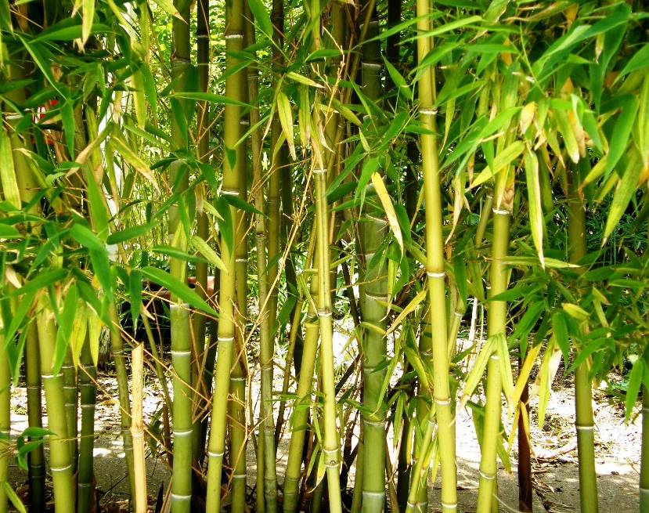
Fig.1. Bamboo

- METHODOLOGY ADOPTED FOR LITERATURE
The review was done through a structured search and critical appraisal of scientific literature from major databases such as Google Scholar, ResearchGate, Scopus, and Web of Science. The studies from 1992 to 2025 were retrieved from these platforms for review.

CURRENT TRENDS AND KEY INSIGHTS
Why Bamboo Is Gaining Attention Now
Another reason that caused bamboo to have become a topic of substantial international concern over the past few years is its correspondence to the notion of sustainability and its ability to overcome urgent environmental issues (Binfield et al., 2022; Montaño and van Dam, 2021). Bamboo, as a renewable, biodegradable, and immensely versatile natural resource, is one of the options of alternative to the resource-intensive materials and practices which are not sustainable (Yang et al., 2024; Ning et al., 2022). One of the main factors that have made bamboo gain more and more popularity is its outstandingly high growth rate some species can even grow one meter a day, which is why bamboo is one of the most rapidly growing plants on the planet (Tripathi et al., 2024). Bamboo can be harvested within 3-5 years compared to hardwood trees, which take decades to mature, and its regeneration capability, as an amenity that removes the need to replenish the plant collapses, further boosts the sustainability of using bamboo for commercial and environmental purposes (Dessalegn et al., 2022; Rathour et al., 2022; Zhan et al., 2022). Bamboo is also increasing in the reduction of climate change (Nath et al.,2020). It has an extensive root system which prevents soil erosion and it has high biomass productivity that enables it to capture carbon efficiently it removes more CO₂ than the majority of tree species (Fan et al., 2025; Pan et al., 2023). Bamboo possesses the following and has been used especially in reforestation, land recovery and carbon credits programs. In addition, another reason to believe that bamboo is a more friendly material to build with is its recognition as an environmentally friendly material (Yadav et al., 2021; Goh et al., 2020). The tensile strength, lightweight nature of it, and its natural beauty make it applicable in sustainable infrastructure and buildings (Madhushan et al., 2023; Aduldejcharas 2024). New engineers and architects are also using bamboo in the design and construction standards of buildings especially in areas prone to earthquakes and other natural calamities (Galmarini et al., 2022). With the coming together of environmental consciousness, technological development, and market demand of sustainable products, bamboo is increasingly becoming a resource not of the past only, but also of the future - potentially of the future, supporting a circular economy, lessening dependence on plastics and timber, and enabling low-carbon developments opportunities (Fig.2).
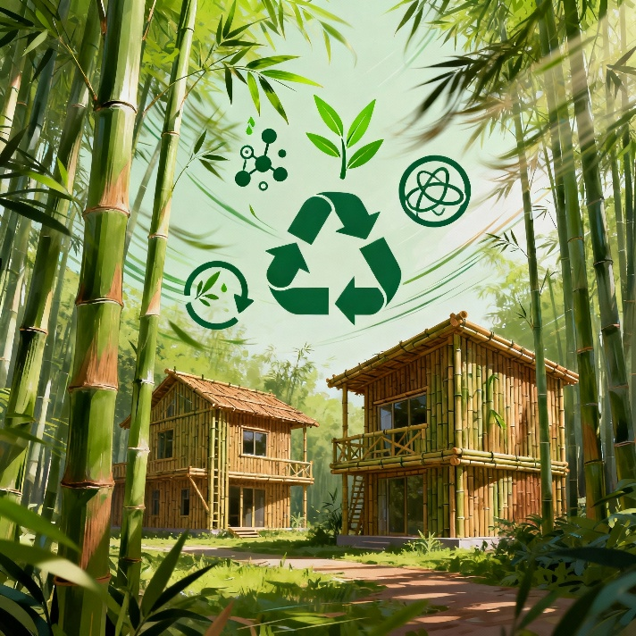
Fig. 2. Sustainable Future with Bamboo: Climate Solutions, Green Construction, and Circular Economy

Purpose of the Review: Exploring Bamboo’s Potential in a Modern Context
Although the cultural and practical importance of bamboo is long-standing and established, the full potential of the substance has not been fully exploited in most parts of the world (Dlamini et al., 2022). As the environmental demands grow and people are urgently seeking alternative sustainable ways to substitute the traditional resources, it is evident that it is possible to reconsider and increase the purpose of bamboo in modern-day production and green solutions (Chen et al., 2025). It is the review which gives a deep insight into the various capabilities which are possessed by bamboo as well as its applicability in the present global context. Through examination of its biological property, environmental advantages, economic benefits and multi-purpose use, we intend on proving how bamboo can make a significant contribution to sustainable development, green innovation, and climate resilience.
Growth Characteristics of Bamboo: Fast Growth Compared to Traditional Timber
It is well known that bamboo has a very high growth rate, which is therefore one of the most sustainable and cost-effective alternatives to timber (Sapovadia, 2025) (Fig.3). Some species, e.g., Dendrocalamus asper or Bambusa balcooa, can gain one meter within a day in the ideal environmental conditions (Getachew et al., 2021). Bamboo takes 3 to 5 years to mature, compared to 15 to 30 years in conventional hardwood trees such as teak, sal, or mahogany (Forero-Montaña et al., 2021; Medhi, and Ahmed, 2009; Bhat et al., 2001; Dessalegn et al., 2022). Such an accelerated growth cycle allows them to gain returns in a shorter time and to conduct harvesting more often without long wait times (Lobovikova et al., 2012). The other significant benefit of bamboo is its special regeneration capacity (Singh et al.,2013). Bamboo just grows through its underground rhizomatous system after harvesting and does not require replanting (Akinlabi et al., 2017). This lowers the cost of planting and labour, preserves the soil structure and reduces soil erosion (Tardio et al., 2017). On the contrary, the conventional timber species can only be replanted once harvested and this means that there are more land preparation and more time taken to grow the species (Evans, 1992). Moreover, bamboo is highly productive in the production of biomass per unit area as compared to most hardwood species, which makes it perfect in the management of sustainable resources (Kuehl, 2015). Bamboo is one of the most renewable, quick-growing, and easy-to-manage crops in terms of the environmental and economic aspects (Singh et al., 2025). This cycle of harvesting is very short, and it can regenerate much faster without the need to replant again, hence, it is efficient compared to the conventional timber. These attributes have motivated increased attention to the cultivation of bamboo all over the globe especially in the agro forestry, furniture and construction sectors where there is need to have reliable and sustainable supply of raw materials (Obiri et al., 2020; van Dam et al., 2018).
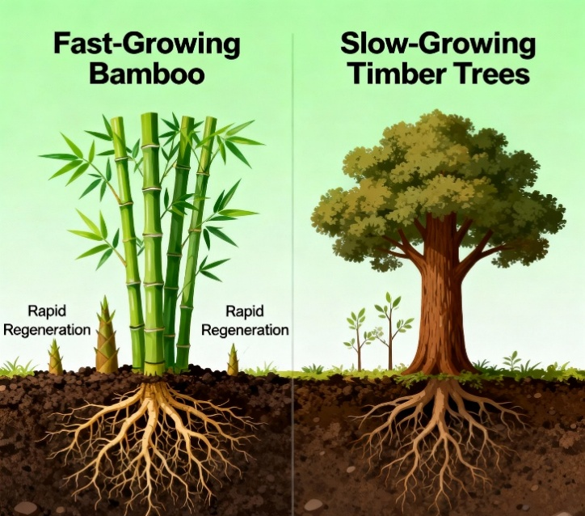
Fig. 3. Bamboo Vs Timber: Fast Growth, Regeneration, and Sustainability

Regenerative Nature of Bamboo: No Need for Replanting
The natural regeneration property of bamboo stands out as one of its most stunning characteristics and is the reason why bamboo is superior to traditional timber species and most farm crops (Toensmeier, 2016). Bamboo is a grass; therefore, it propagates via a large underground rhizomatic system (root-like stems) (Gu et al., 2021). Once harvesting of mature bamboo culms (stems), the plant is not killed, and new shoots will constantly grow out of the existing root system (Akinlabi et al., 2017). This is a distinct feature that enables bamboo to regenerate without the need to replant it and therefore makes it a very sustainable and low maintenance crop. By contrast, the traditional timber trees like teak, sal or mahogany have to be replenished after every harvest, which involves heavy land preparation, care about the seedlings and a growth period of 15-30 years (Forero-Montana et al., 2021; Medhi, and Ahmed, 2009; Bhat et al., 2001). The average time of harvesting bamboo is 3-5 years, whereas the root system will yield 20-40 years and more (Dessalegn et al., 2022; Aizuddin et al., 2023). This saves a lot of labour and input expenses in the long-term and minimizes soil disruption hence conserving the soil fertility and erosion (Shen et al., 2025). The regenerative nature of bamboo leads to sustainable land use and is especially beneficial to the degraded or marginal lands where the traditional crop species might not perform well (Solomon et al., 2021). In addition, since bamboo requires new shoots once every year, it provides a steady supply of the raw material without further planting seasons (Li et al., 1998). This makes the cultivation of bamboo very efficient, eco-friendly and cost effective, particularly to the smallholder farmers, entrepreneurs and industries that rely on the constant supply of biomass (Appiah-Yeboah, 2018; Chang et al., 2018; Manandhar et al., 2019). In general, the natural regenerative potential of bamboo significantly increases its suitability as a green, renewable material, which is in line with the modern goals of climate resilience, resource efficiency, and sustainable development.

Carbon Sequestration Capacity of Bamboo
Bamboo has a great role in countering climate change as it has an outstanding carbon sequestration ability (Yiping et al., 2010; Song et al., 2011). Bamboo presents an excellent source of carbon dioxide (CO₂) because as a perennial grass, it grows rapidly over a short period of time, and its biomass is high (Emamverdian et al., 2020; Manasa et al., 2025). Research points out that bamboo is able to sequester 100-400 tonnes of carbon per hectare each 30-40 years, based on species, method of utilization and the environment (Prasad et al., 2012). This rate is relatively similar, and sometimes higher than the rate of the traditional hardwood forests.
The main positive side of bamboo is that it is able to cycle carbon (Vogtländer et al., 2014). As bamboo is a natural regenerative crop, the root system can live, continue photosynthesizing, and absorb carbon even when mature culms have been cut and new shoots grow, which means that every harvest does not require replacement by new planting (Kuehl, et al., 2013). Bamboo plantations keep their carbon-sequestration activity during their lifecycle, unlike timber trees that lose it after they are felled (Webster et al., 2020). Moreover, carbon is stored in harvested bamboo products, including furniture, construction materials, and flooring, over a long time, and these products help in long-term carbon capture (Shen-xue et al., 2002; Boran et al., 2013; Huang et al., 2025). When used in a sustainable way, bamboo plantations have twofold advantages since besides eliminating atmospheric CO 2, they can be used to obtain renewable raw materials that can replace carbon-intensive products that include plastic, steel, and cement (Zhang et al., 2025; Liu, 2024). In addition to its carbon sequestration, bamboo positively influences the soil health, biodiversity, and water conservation, which is why it would be a perfect addition to climate-smart agricultural and reforestation projects (Sahoo and Prasad, 2024; Bhattacharya, 2024). Its ability to reduce the emission of greenhouse gases and to enhance economic growth makes bamboo an important tool in ensuring environmental sustainability across the world (De Araujo et al., 2026; Rodriguez-Peña et al., 2025).

Adaptability to Various Climates and Soils
Bamboo is a highly versatile plant that can grow in a vast variety of climatic conditions and soils, and thus, it can be grown in different regions (Nfornkah et al., 2023; Basumatary et al., 2015) (Fig.4). It is found naturally in tropical and subtropical as well as some temperate areas and a number of them can withstand temperatures ranging between -5C and 40C (Gratani et al., 2008; Maoyi and Banik, 1995). This wide flexibility allows growing bamboo in regions with high rain levels, moderate humidity, and even semi-arid regions, depending on the kind of specific species chosen (Paudyal et al.,2022; Langat et al., 2012). Bamboo is not very demanding as far as soil preferences are concerned. It thrives in moderately degraded or low-fertility soils and loamy, sandy-loam or alluvial soils when there is adequate drainage (Osman, 2018; Osman, 2012). Although bamboo is typically sensitive to acidic and neutral pH (between 5.5 and 6.5), most varieties can be used within a broader pH range (Ouyang, et al., 2022). Bamboo roots help in binding soil, structural enrichment and adding organic matter and it makes it more suitable in soil restoration and erosion control (Singh et al.,2020). It is such adaptability that allows bamboo to be adopted as a great alternative in marginal lands, river banks, hillsides, and wastelands where other crops or trees might not grow well (Maina, 2023; Jinger et al.,2023). The resilience of bamboo and low input requirement can offer farmers and communities in these areas an alternative to generate income and this opportunity is especially valuable during the times when these areas are either stressed by climate or resource shortage (Lobovikov et al.,2012; Son, 2025). Further, since the various species of bamboo can be adapted to different climates and soils, farming can be adapted to the local agro-ecological factors. This adaptability, together with the quick growth, regeneration and sustainability of bamboo makes it a strategic crop of future climate resilient agriculture, land reclamation and rural development projects, not only in India but also in other regions of the world.
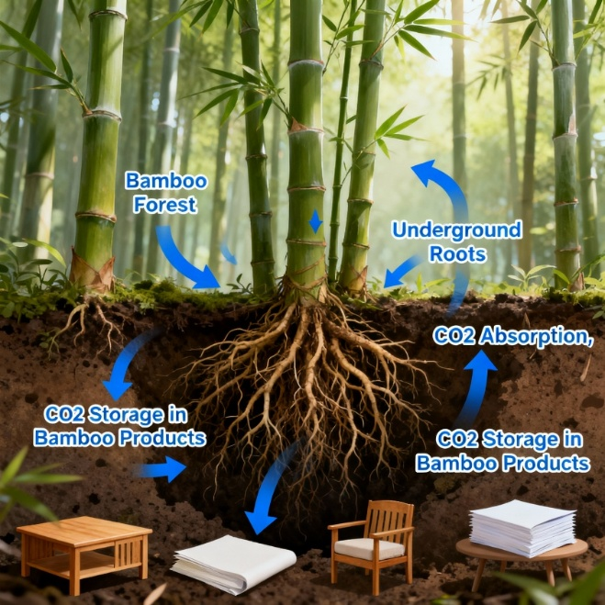
Fig. 4. Bamboo Adaptability: Thriving Across Diverse Climates and Soils

Environmental Benefits of Bamboo: Low Water Requirements
Among the most significant environmental sustain abilities of bamboo is the fact that it does not need much water and is consequently a good crop to grow in areas where there is a shortage of water or seasonal rainfall (Sarvade et al., 2019; Sharma et al., 2023). Bamboo does not need a high rate of watering to survive unlike many of the conventional crops and timber species that need regular watering and constant water supply (Kigomo, 2007). Bamboo species require frequent moisture within the first 612 months of establishment, and then they establish deep root systems that allow the plants to tap into soil moisture and survive with minimal supplemental water (Mulatu et al., 2016).
The given feature is particularly beneficial in semi-arid and drought-affected regions, where it is particularly important to conserve water (Xing and Wang, 2024). Bamboo requires much less water compared to crops that need a lot of water like sugarcane or rice and still yields high biomass (Zhang, 2013). Besides, its thick foliage and network of rhizomes increase the moisture content of the soil, decrease the amount of surface evaporation, and increase the recharge speed of the groundwater (Chen et al., 2020). Moreover, the number of waters required by bamboo is also very low, which is in line with climate-sensitive farming (Waite, 2009). With the occurrences of extreme weather patterns and water shortage, especially caused by climate change, crops that use less water but have environmental advantage will become part of sustainable development. Bamboo plays this role by making less water demands and soil conservation, carbon sequestration, and the improvement of biodiversity (Singh et al.,2020). Planting bamboo in agroforests or on poor soils allows farmers and agricultural administrators to lower the reliance on irrigation significantly and re-establish ecological equilibrium (Kumar et al., 2024; Dinesha et al., 2023). Therefore, bamboo is potentially an effective economic crop as well as a potent water-saving, eco-friendly land use (Singh et al., 2025).
Soil Erosion Control and Land Rehabilitation with Bamboo
Bamboo is very useful with erosion of the land as well as aiding its rehabilitation especially at the ecologically weak or degraded sites (Mishra eta l., 2014). It has a distinctive root system, which consists of dense and fibrous rhizomes, which is a natural underground network that makes soil particles connected thus preventing excessive surface runoff and topsoil erosion during heavy rains (Islam, 2021) (Fig.5). This feature renders bamboo of particular use in steep slopes, bank areas, eroded hillsides, and marginal lands (Kala et al., 2019; Gidon and Sahoo, 2020). Bamboo is gratifyingly a continuous ground cover with mass foliage as opposed to shallow-rooted crops or sparsely spaced trees and the root mat grows fast (Furley, 2007). Such properties reduce water velocity, increase permeability, and minimize soil erosion, and stabilize land in the long run. Many watershed development initiatives and forest planting in Asia and Africa have been able to use bamboo to stabilize the slope and reclaim the land (Chimi and Mezafack, 2023). Moreover, bamboo aids in soil restoration by enhancing its organic matter due to the litter and natural mulching of the soil (Sileshi et al., 2020; Akoto et al., 2020). With time, this organic layer enhances soil fertility, activity of microbes and soil moisture levels making it possible to revive the degraded soils and thus making them more adaptive to further agricultural or forestry applications. The fact that bamboo can grow in poor soil types and with the minimum input also contributes to the importance of the plant in the recovery of wastelands and old mining fields (Fritsche et al., 2017). All in all, bamboo offers a solution, which is cost effective and environmentally friendly, to revive the degraded scenery, at the same time creating economic gains by selling the poles, shoots and value-added products. Its two purposes of preserving the environment and boosting livelihoods make bamboo a strategic resource of sustainable land management and rural growth.
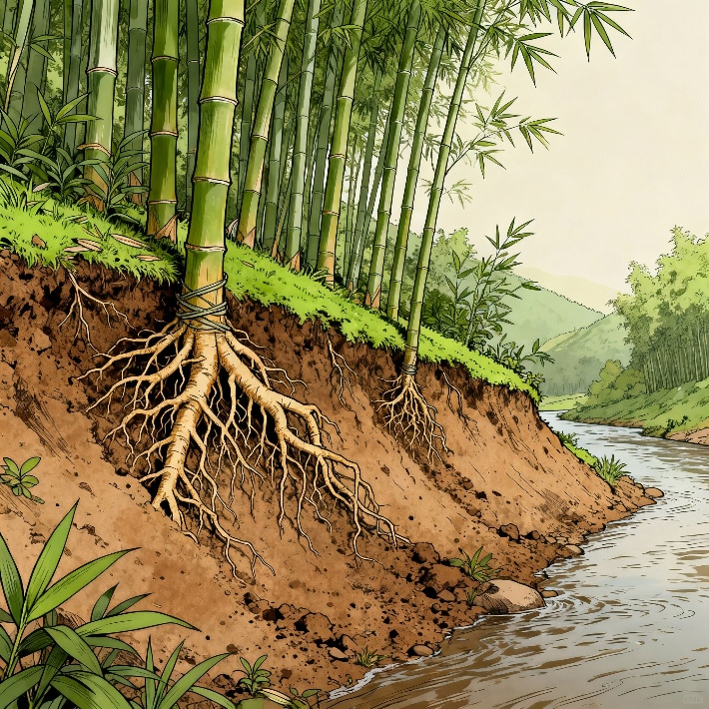
Fig. 5. Bamboo Root System enables: Soil Stabilization and Erosion Control

Biodiversity Support in Bamboo Forests
Bamboo forests also play a significant role in supporting and encouraging the existence of biodiversity in different ecosystems (Kaam et al., 2023). They provide an essential supply of population, food, and shelter to a huge variety of flora and fauna due to their high population and year-long leaf cover (Fig.6). Some of the animal species that have relied on bamboo as their primary source of food and shelter include the giant panda and many more species of animals; these are endangered species (Wei et al., 2015). Moreover, bamboo also serves many species of birds, insects, small mammals, and reptiles and contributes to the formation of powerful and diverse ecological communities (Lucas, 2024). Moreover, bamboo forest can ensure the health of the soil through the maintenance of soil microorganisms and enhancement of the soil ecosystem by littering the soil and depositing organic matter (Kumar et al., 2022). These microbes are critical to the cycle of nutrients, to increase soil fertility, and plant growth (Basu et al., 2021). Adaptations to degraded or marginal lands result in the fact that bamboo is an effective tool to rebuild the biodiversity in problematic habitats (Singh et al., 2021). Bamboo forests have high structural variety, which creates numerous microhabitats that contribute to the abundance of species (Caccia et al., 2009). The rapid growth and natural regeneration of bamboo allow this to offer green cover to the landscapes which is particularly highly demanded in deforestation and habitat fragmentation regions (Shoyama et al., 2011). These ecology of bamboo forest has resulted into linkage of landscapes by corridors or buffer zones that assist animal to enter and leave fragmented habitat and also exchange genetic materials amongst themselves (Coggins, 2000). This is necessary due to the maintenance of healthy populations as well as preventing isolation of species. To conclude, bamboo forests have a great number of economic and environmental advantages and perform great biodiversity hotspots. They should be conserved and managed in a sustainable manner to ensure equilibrium in the ecosystem and ensure wildlife diversity across the world.

Fig. 6. Bamboo forest supporting Biodiversity

Bamboo’s Role in Carbon Storage and Climate Change Mitigation
Bamboo is an essential factor in the processes of carbon storage and climate change reduction because it grows fast and accumulates biomass well (Xu et al., 2022). Bamboo being one of the fastest growing plants, captures carbon dioxide (CO 2) in the atmosphere at a significantly higher rate compared to most common tree species (Zachariah et al., 2016). Mature bamboo forests are capable of capturing lots of carbon- typically of the same quantity or more than a slower forest- and bamboo is a strong natural carbon sink (Chilton et al., 2025). One of the strengths of bamboo is that it goes through a continuous growth process without the need of planting trees and this is made easy by its rhizome system rooted on the ground. This allows bamboo plantations that have been harvested to continue to play a productive role in removing carbon into the atmosphere over the years (Chongtham et al., 2020). Bamboo plantations also continue to sequester, unlike traditional timber forests, which lose their ability to store carbon when trees are cut down, which makes them remain in an active carbon sequestration state. In addition, products derived by harvested bamboo like furniture, flooring, and building materials serve as the long-term storage of carbon in solid biomass, trapping carbon in the solid biomass and eliminating the use of materials with high carbon contents, such as steel and concrete (Iroegbu and Ray, 2021). This substitution effect also makes bamboo more beneficial to the climate mitigation effect by lowering the concentration of greenhouse gases at the different industries. Soil conservation, erosion control, water retention and carbon sequestration are some of the benefits associated with bamboo farming besides enhancing the resilience of a given ecosystem to a changed climatic condition. The fact that it can be used on substandard and marginal lands is critical in the rehabilitation process that can reverse environmental degradation and provide livelihoods to the locals. Overall, the incredible capacity of bamboo to multiply fast and being a renewable biomass when it is combined with the ability to store carbon is a powerful means in an entire life of the global community to reduce the impact of climate changes and sustainable land management.

Economic Potential
Bamboo economy has been achieved considerably in the last ten years, and a number of countries turn to be the main producers and exporters (Lee et al., 2023). The leader of the market is China, which is over 60 per cent of the world in terms of bamboo production and exports, and the estimated value of the industry is USD 35 39 billion as of 2024 (Safdar et al., 2024; Barbu and Tudor, 2022). India is the second largest producer and has a huge potential to be harnessed, particularly in the northeast of the country, with the help of activities like the National Bamboo Mission (Arjumand and Rani, 2023; Alexander, 2022). Other prominent producers include Indonesia, Vietnam, the Philippines, and Thailand in Asia, alongside Brazil and Ethiopia in the Global South (Lee et al., 2023). Vietnam has developed a strong bamboo handicraft and furniture export sector, while Ethiopia is emerging strategically due to extensive bamboo forests and government-backed agroforestry programs (Kyaw, 2025). Major exporters include China, Vietnam, Thailand, and the Netherlands, whereas leading importers are the United States, Turkey, Bangladesh, and China itself (Lee et al., 2023). Bamboo cultivation and its value chains significantly drive rural and tribal employment (Belcher, 1999). Due to bamboo’s rapid growth and regenerative ability without replanting, frequent harvesting provides a consistent income for smallholder farmers and forest communities (Tinsley, 2015). Bamboo-related activities—from plantation and harvesting to processing and handicraft production—generate jobs across Asia, Africa, and Latin America. For example, Vietnam engages over 340,000 farmers in bamboo and rattan crafts, contributing hundreds of millions of dollars annually to rural economies (Mekonnen et al., 2014; Wang et al., 2021). In India, tribal communities like those in Pachgaon village, Maharashtra, have secured forest rights and developed bamboo enterprises, creating employment, reducing migration, and reinvesting earnings into local development (Iyer, 2019; Das and Tyagi, 2019). Ethiopia’s large-scale bamboo agroforestry initiative, spanning over a million hectares, is projected to generate USD 5 billion annually and create up to 3 million green jobs by 2035 (Habte-Selassie and Hurri, 2025). As a renewable and biodegradable resource, bamboo is integral to circular economy development (Kaur et al., 2022). Unlike conventional timber, bamboo matures rapidly (3–5 years) and naturally regenerates post-harvest, lowering replanting needs and soil degradation. Bamboo’s low carbon footprint compared to steel or plastic underpins its environmental credentials (Fuqaha et al., 2025). It is being used more in the packaging, construction, textile, and consumer goods sectors (Borowski et al., 2022). Bamboo is another single-use plastic that governments and companies are advocating as an alternative to plastics, as the issue of plastic pollution continues to rise (Raghunathan et al., 2025). Bamboo has a positive life cycle, including growth and disposal, has facilitated circularity concepts, such as reuse, recyclability, and biodegradability, which means it is the material strategy to low-carbon and circular supply chains. The market trends indicate a high growth of the bamboo-based industries (Ahmad et al., 2025). The global bamboo market is estimated to be USD 65.8 billion in 2024, which is expected to grow to USD 99.8 billion in 20302031 (Safdar et al., 2024). The significant industry expansion is bamboo furniture, which is projected to hit USD 18.2 billion in 2030 and bamboo packaging, which is envisaged to exceed USD 827 million in 2032. Asia-Pacific is the leader with sufficient bamboo materials and production with South Asia taking a big portion with India and Vietnam leading in handicrafts and furniture production (Hansda, 2009). The Western markets, including the U.S. and Brazil, are expanding fast due to the need to build with a green mindset, consume home products and lifestyle items (Bredenoord, 2024). This continues to be the positive growth pattern that proves the use of bamboo as an ecological solution and a strong economic engine with wide prospects towards sustainable development and growth of green employment.
Versatile Applications
The versatility of bamboo means that it is a valuable resource in a variety of industries, both the conventional and novel product industries (Borowski et al., 2022). Bamboo is a highly strong material with a high strength to weight ratio, flexibility, and the ability to withstand tension and compression, which finds application in construction and architecture (Madhushan et al., 2023; Shu et al., 2020). It is an environmentally friendly substitute of traditional materials as poles, beams and panels that are commonly applied in the field of eco-friendly architecture and low-carbon housing (Abera, 2024). Bamboo is also used in floors, wall cladding, roofing and scaffolding, especially in China, India and Southeast Asia (Zea Escamilla et al., 2019) (Fig.7). Advances in treatment methods have enabled engineered bamboo products like laminated bamboo and bamboo-based composites to be incorporated into modern infrastructure, such as bridges, pavilions, and modular housing systems (Lou et al., 2023). In textiles and fashion, bamboo has gained traction as a sustainable substitute for synthetic and conventional natural fibers (Amjad, 2024). Bamboo fiber—extracted through mechanical or chemical means—is valued for its softness, breathability, and antibacterial properties (Imadi, et al., 2014). It is used in eco-friendly clothing, undergarments, towels, and bed linens (Adnan Ali and Imran Sarwar, 2010).
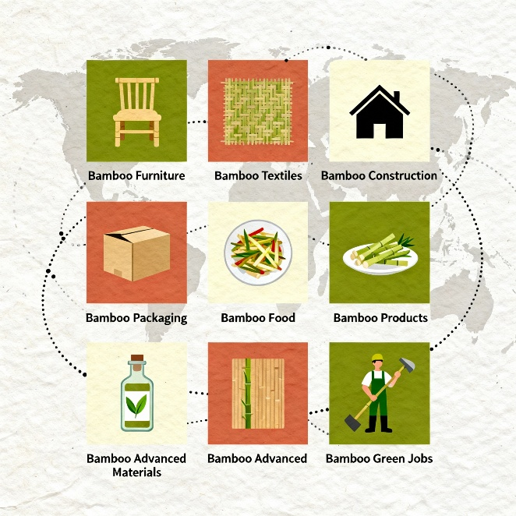
Fig. 7. Global Bamboo Economy and Diverse Industrial Applications

Challenges and Limitations
Although bamboo has numerous ecological and economic benefits, there are a number of obstacles that limit the ability of this material to scale sustainably and achieve full potential. The main issue in the large-scale planting of bamboo is predominance of monocultures which may cause degradation of soil, low biodiversity and increase susceptibility to pests and diseases (Sawyer, 1993). Monocultures of bamboo do not always achieve an ecological balance, unlike the natural bamboo forests, as they may require intensive management (irrigation, fertilization, pest control, etc.) which increases the cost of production, and bamboo may even lose its environmental friendliness. Lack of standardization in the processing and quality of the product is also another major constraint in bamboo processing (Ahmad et al., 2025). Unlike established timber or textile industries, bamboo sectors—especially in developing countries—often function informally or semi-formally. Wide disparities in product specifications, treatment methods, grading systems, and durability hinder international trade and reduce consumer confidence. The lack of harmonized standards and certifications restricts small producers’ access to premium markets and export opportunities, leading to economic losses. Research on bamboo genetics, breeding, and disease resistance is relatively limited compared to other major crops (Sun et al., 2023). Although over 1,600 bamboo species exist globally, only a small subset has been extensively studied regarding growth traits, adaptability, or industrial suitability. Early-stage genetic improvement programs constrain development of high-yielding, pest-resistant, and climate-resilient varieties (Kumar et al., 2024). Insufficient investment in biotechnology, tissue culture, and germplasm conservation further impedes scientific progress in bamboo cultivation (Singh et al., 2013). Policy and regulatory gaps persist across many regions, notably in Africa, South Asia, and Latin America. While some countries have national bamboo missions or supportive forestry policies, others lack clear regulations governing bamboo harvesting, land tenure, and trade. Additionally, bamboo’s classification as a tree rather than a grass under restrictive forestry laws in certain countries limits harvesting and transport activities. Such legal and administrative inconsistencies create barriers for growers, processors, and entrepreneurs in the bamboo value chain. Without coherent and enabling policy frameworks, bamboo’s sustainable expansion remains inconsistent and underexploited.

Future Prospects
Bamboo holds immense potential as a strategic resource in the global transition toward sustainable development and climate resilience (Dutta et al., 2025). In green architecture, bamboo is increasingly recognized for its role in sustainable construction and alignment with certification systems such as LEED (Leadership in Energy and Environmental Design) (Rehman, 2024). As a rapidly renewable material with a low carbon footprint and natural aesthetic appeal, bamboo contributes crucial credits toward green building certifications, including material reuse, indoor environmental quality, and design innovation (Nayem et al., 2023). Its applications in structural elements, flooring, insulation, and finishing adhere to eco-friendly construction principles, particularly suited to tropical and subtropical regions. Bamboo’s multifunctionality strongly supports the United Nations Sustainable Development Goals (SDGs), contributing directly to SDG 1 (No Poverty), SDG 7 (Affordable and Clean Energy), SDG 11 (Sustainable Cities and Communities), SDG 12 (Responsible Consumption and Production), SDG 13 (Climate Action), and SDG 15 (Life on Land) (Rathour et al., 2022). By providing income for rural communities, serving as a substitute for fossil-fuel-based materials, and sequestering significant carbon, bamboo aligns with integrated sustainability objectives at national and global scales. The future study and innovation are key towards achieving the potential of bamboo. Biotechnology provides genetic enhancement opportunities, such as the creation of varieties that have a high yield, are resistant to pests, and are resistant to climate changes (Waske et al., 2024). The use of improvements in tissue culture and genome sequencing may result in increased propagation efficiency and species-specific applications (Wang et al., 2025). Meanwhile the product development is moving into the high-value product categories like engineered bamboo composites, bioplastics, pharmaceuticals and high value textiles (Ahmad et al., 2025). The innovations will help make bamboo more of an industrial commodity as opposed to a traditional rural product that is used in rural regions of the world. There is also the crucial role of a sound policy; the governments should include bamboo in their foresting, agricultural and industrial development strategies, provide incentives to ensure sustainable management, processing facilities and access to markets. The benefits of bamboo in climate-smart farming and disaster-proofing is becoming more evident. It is native to the land, extensive in root systems and grows swiftly, therefore, making it suitable in restoring land, controlling erosion, and stabilizing slopes of some fragile ecosystems (Tardio et al., 2017). In the agro forestry system, bamboo promotes biodiversity, improves soil wellbeing, and offers wind and shade to companion crops (Dissanayaka et al., 2024). Bamboo has strength against severe weather conditions, as well as the ability to regenerate following disturbance, which makes it a prominent component of climate-resilient landscapes and livelihoods (Dutta et al., 2025). Bamboo can provide the much-needed element of a natural solution and adaptation to both rural and urban communities, as the climate issues will be increasing.
Conclusion
Bamboo has been a desirable combination of environmental sustainability, financial sustainability, and social inclusivity, and as such, it is a key asset in the worldwide transition to sustainability. The key to bamboo as a resource in reducing climate, rehabilitation and protection of biodiversity is the ability to multiply rapidly, regenerate naturally, and the high rates of carbon sequestration. Simultaneously, the fact that bamboo can be used in the construction industry, textile, packaging, and other products means that it could be applied in favour of the circular economy and non-renewable resource-based energy consumption. More significantly, bamboo fosters the rural growth especially among the poorly economically conveyed regions because its utilization and livelihood have the effects. As the issue of low-impact, regenerative materials has become a central issue of concern, bamboo is uniquely positioned to contribute to the strategic role of achieving world sustainability, including the UN Sustainable Development Goals (SDGs). To realise this potential, co-ordination of policy frameworks will be necessary, increased investment will be made in research and innovation and efforts made to harmonize cultivation and processing practices. Being ready and planned, it could be noted that bamboo will not just be a symbol of sustainability as a symbol of sustainability but a fact, a scalable, low-carbon solution to a resilient, and equitable development.

DIACLAIMER
Some of the illustrative images in this review were generated using artificial intelligence tools. These images are conceptual and for visualization purposes only; they do not represent data from actual experiments.
COMPETING INTERESTS
The authors have no competing interest to declare.
REFERENCES
Abera, Y. A. (2024). Sustainable building materials: A comprehensive study on eco-friendly alternatives for construction. Composites and Advanced Materials, 33, 26349833241255957. https://doi.org/10.1177/26349833241255957
ADNAN ALI, M.U.H.A.M.M.A.D. and IMRAN SARWAR, M.U.H.A.M.M.A.D., 2010. Sustainable and environmental freindly fibers in textile fashion (a study of organic cotton and bamboo fibers).
Aduldejcharas, R. (2024). Bamboo (Dendrocalamus Asper) as an Eco-Friendly Sustainable Material: Optimising Mechanical Properties and Enhancing Load-Bearing Capacity for Environmental Architectural Design. Nakhara: Journal of Environmental Design and Planning, 23(2), 414-414. https://doi.org/10.54028/NJ202423414
Ahmad, M. I., Farooq, S., & Zhang, H. (2022). Recent advances in the fabrication, health benefits, and food applications of bamboo cellulose. Food Hydrocolloids for Health, 2, 100103. https://doi.org/10.1016/j.fhfh.2022.100103
Ahmad, Z., Kumari, R., Mir, B., Saeed, T., Firdaus, F., Vijayakanth, V., ... & Wei, Q. (2025). Bamboo for the Future: From Traditional Use to Industry 5.0 Applications. Plants, 14(19), 3019. https://doi.org/10.3390/plants14193019
Ahmad, Z., Upadhyay, A., Ding, Y., Emamverdian, A., & Shahzad, A. (2021). Bamboo: Origin, habitat, distributions and global prospective. In Biotechnological Advances in Bamboo: The “Green Gold” on the Earth (pp. 1-31). Singapore: Springer Singapore. https://doi.org/10.1007/978-981-16-1310-4_1
Aizuddin, K. N. A. K., Lai, K. S., Baharum, N. A., Yong, W. T. L., Hoon, L. N., Hamid, M. Z. A., ... & Abdullah, J. O. (2023). Bamboo for biomass energy production. Bioresources, 18, 2386-2407.
Akinlabi, E. T., Anane-Fenin, K., & Akwada, D. R. (2017). Regeneration, cultivation, and sustenance of bamboo. In Bamboo: the multipurpose plant (pp. 39-86). Cham: Springer International Publishing. https://doi.org/10.1007/978-3-319-56808-9_2
Akoto, D. S., Partey, S. T., Denich, M., Kwaku, M., Borgemeister, C., & Schmitt, C. B. (2020). Towards bamboo agroforestry development in Ghana: evaluation of crop performance, soil properties and economic benefit. Agroforestry Systems, 94(5), 1759-1780. https://doi.org/10.1007/s10457-020-00493-7
Alexander, R. (2022). Governance Needs for promoting green employment in India’s artisanal bamboo industry.
Amjad, A. I. (2024). Bamboo fibre: A sustainable solution for textile manufacturing. Advances in Bamboo Science, 7, 100088. https://doi.org/10.1016/j.bamboo.2024.100088
Appiah-Yeboah, J. O. S. E. P. H. (2018). The potentials of Bambusa V. Vulgaris (bamboo) biomass as feedstock to produce biofuels (Doctoral dissertation, University of Education Winneba).
Arjumand, T., & Rani, B. R. (2023). The Case study on Bamboo farming, Centre for Climate Change and Adaptation (CCA), National Institute of Agricultural Extension Management (MANAGE), Hyderabad, India.
Barbu, M. C., & Tudor, E. M. (2022). State of the art of the Chinese forestry, wood industry and its markets. Wood Material Science & Engineering, 17(6), 1030-1039. https://doi.org/10.1080/17480272.2021.1891457
Basu, S., Kumar, G., Chhabra, S., & Prasad, R. (2021). Role of soil microbes in biogeochemical cycle for enhancing soil fertility. In New and future developments in microbial biotechnology and bioengineering (pp. 149-157). Elsevier. https://doi.org/10.1016/B978-0-444-64325-4.00013-4
Basumatary, A., Middha, S. K., Usha, T., Brahma, B. K., & Goyal, A. K. (2015). Bamboo, as potential sources of food security, economic prosperity and ecological security in North-East India: an overview. Research in Plant Biology, 5(2).
Belcher, B. M. (1999). The Bamboo and Rattan Sectors in Asia: an Analysis of Production-to-Consumption Systems. International Network for Bamboo and Rattan.
Bhat, K. M., Priya, P. B., & Rugmini, P. (2001). Characterisation of juvenile wood in teak. Wood Science and Technology, 34(6), 517-532.
Bhattacharya, S. (2024). Agroforestry: A key technique for achieving the sustainable development goals. In Agroforestry to Combat Global Challenges: Current Prospects and Future Challenges (pp. 479-502). Singapore: Springer Nature Singapore. https://doi.org/10.1007/978-981-99-7282-1_23
Binfield, L., Britton, T. L., Dai, C., & Innes, J. (2022). Evidence on the social, economic, and environmental impact of interventions that facilitate bamboo industry development for sustainable livelihoods: a systematic map protocol. Environmental Evidence, 11(1), 33. https://doi.org/10.1186/s13750-022-00286-8
Boran, S., DÖNMEZ ÇAVDAR, A., & Barbu, M. C. (2013). Evaluation of bamboo as furniture material and its furniture designs. Pro Ligno, 9(4).
Borowski, P. F., Patuk, I., & Bandala, E. R. (2022). Innovative industrial use of bamboo as key “Green” material. Sustainability, 14(4), 1955. https://doi.org/10.3390/su14041955
Bredenoord, J. (2024). Bamboo as a sustainable building material for innovative, low-cost housing construction. Sustainability, 16(6), 2347. https://doi.org/10.3390/su16062347
Caccia, F. D., Chaneton, E. J., & Kitzberger, T. (2009). Direct and indirect effects of understorey bamboo shape tree regeneration niches in a mixed temperate forest. Oecologia, 161(4), 771-780. https://doi.org/10.1007/s00442-009-1412-z
Chang, F. C., Chen, K. S., Yang, P. Y., & Ko, C. H. (2018). Environmental benefit of utilizing bamboo material based on life cycle assessment. Journal of Cleaner Production, 204, 60-69. https://doi.org/10.1016/j.jclepro.2018.08.248
Chen, G., Tang, X., Cai, C., Fan, S., Sun, L., Yang, F., & Liu, H. (2020). Air moisture and soil texture are crucial for the water dynamics of riparian bamboo in a subtropical region. Plant and Soil, 455(1), 381-395. https://doi.org/10.1007/s11104-020-04696-w
Chen, Y. T., Wang, P. J., Cheng, C. K., & Chang, C. T. (2025). An appropriate combination of a thinning schedule and subsidies to realize sustainable Makino bamboo forest management. Journal of Forest Research, 30(1), 22-34. https://doi.org/10.1080/13416979.2024.2388922
Chilton, K., Kadivar, M., & Hinkle, H. (2025). The Promise, Problem and Possibility of Timber Bamboo as a Sustainable Building Fiber.
Chimi, C. D., & Mezafack, K. L. (2023). Bamboo based forest landscape restoration: practical lessions and Initiatives to Upscale in Africa. Bamboo Science and Technology, 329.
Chongtham, N., & Bisht, M. S. (2020). Bamboo shoot: superfood for nutrition, health and medicine. CRC Press.
Choudhary, A. K., Kumar, A., Kumari, P., Kumari, S., Kumar, R., Ranjan, R., & Khan, I. (2025). Bamboo: A Symbol of Tradition, Faith and Climate Resilience. Applied Sciences Research Periodicals, 3(04), 192-214. https://doi.org/10.63002/asrp.304.1051
Clara Manasa, P. A., Salimath, S. K., Hegde, R., & Gooli, M. (2025). Harnessing Bamboo: The Green Revolution in Climate Change Mitigation and Adaptation. The PLANTA Research Book Series, 6(1), 1694-1711.
Coggins, C. R. (2000). Wildlife conservation and bamboo management in China's southeast uplands. Geographical Review, 90(1), 83-111. https://doi.org/10.1111/j.1931-0846.2000.tb00323.x
Das, A., & Sarma, A. K. (2025). Unlocking the Potential Applications of Bamboo, as an Energy Resource and Bamboo-Based Activated Carbon: A Comprehensive Review. BioEnergy Research, 18(1), 77. https://doi.org/10.1007/s12155-025-10874-4
Das, S., & Tyagi, N. (2019). Pathways to institution and resource sustainability: lessons from the Forest Rights Act implementation in India. International Forestry Review, 21(3), 279-294. https://doi.org/10.1505/146554819827293204
De Araujo, V. A., Colauto, L. R., Abel, L. G. C., do Rosário, F. S., Vasconcelos, J. S., Morales, E. A. M., ... & Christoforo, A. L. (2023). Bamboo construction: Main building techniques and their resources, sustainability, history, uses, and classification. In Bamboo and Sustainable Construction (pp. 25-60). Singapore: Springer Nature Singapore. https://doi.org/10.1007/978-981-99-0232-3_2
De Araujo, V., Mascarenhas, F., Laleicke, F., Kutnar, A., Dias, A., van de Kuilen, J., ... & Christoforo, A. (2026). Biocities with wood and bamboo: A path to low-carbon urbanization for greener societies. Renewable and Sustainable Energy Reviews, 226, 116257. https://doi.org/10.1016/j.rser.2025.116257
Dessalegn, Y., Singh, B., van Vuure, A. W., Rajhi, A. A., Ahmed, G. M. S., & Hossain, N. (2022). Influence of age and harvesting season on the tensile strength of bamboo-fibre-reinforced epoxy composites. Materials, 15(12), 4144. https://doi.org/10.3390/ma15124144
Dinesha, S., Hosur, S. R., Toushif, P. K., Bodiga, D., Deepthi Dechamma, N. L., Ashwath, M. N., & Pradhan, D. (2023). Sustaino‐resilient agroforestry for climate resilience, food security and land degradation neutrality. Land and environmental management through forestry, 217-245. https://doi.org/10.1002/9781119910527.ch9
Dissanayaka, D. M. N. S., Udumann, S. S., & Atapattu, A. J. (2024). Synergies between tree crops and ecosystems in tropical agroforestry. Agroforestry, 49-87. https://doi.org/10.1002/9781394231164.ch3
Dlamini, L. C., Fakudze, S., Makombe, G. G., Muse, S., & Zhu, J. A. (2022). Bamboo as a valuable resource and its utilization in historical and modern-day China. BioResources, 17(1), 1926-1938.
Dutta, S., Gorain, S., Roy, J., Das, R., Banerjee, S., Gorai, S. K., ... & Das, S. (2025). Bamboo for global sustainability: A systematic review of its environmental and ecological implications, climate action, and biodiversity contributions. Environmental Reviews, (ja). https://doi.org/10.1139/er-2025-0032
Emamverdian, A., Ding, Y., Ranaei, F., & Ahmad, Z. (2020). Application of bamboo plants in nine aspects. The Scientific World Journal, 2020(1), 7284203. https://doi.org/10.1155/2020/7284203
Evans, J. (1992). Plantation forestry in the tropics: tree planting for industrial, social, environmental, and agroforestry purposes. Oxford University Press, USA.
Fan, C. C., Chen, C. H., & Chen, C. (2025). Exploring the Root–Soil Anchoring Dynamics of Bambusa pachinensis (Pachi Bamboo) Root System. Forests, 16(5), 832. https://doi.org/10.3390/f16050832
Favero, A., Thomas, V. M., & Luettgen, C. (2017). Life cycle and market review of the major alternative fibers for paper production. Georgia Institute of Technology, Atlanta.
Forero-Montaña, J., Zimmerman, J. K., González, E., Wadsworth, F., Ward, S., Ackerman, E. J. M., ... & Lee, C. A. (2021). Developing a growth and yield model for planted big-leaf mahogany (Swietenia macrophylla King) at advanced age in subtropical moist forest in Puerto Rico. Trees, Forests and People, 5, 100113. https://doi.org/10.1016/j.tfp.2021.100113
Fritsche, U. R., Berndes, G., Cowie, A. L., Dale, V. H., Kline, K. L., Johnson, F. X., ... & Woods, J. (2017). Energy and land use. Work. Pap. Glob. L. Outlook, 14-15.
Fuqaha, S., Zakib, A., & Nugrohoc, G. (2025). Bamboo in construction: Mapping global trends, strategic clusters, and future research pathways. http://dx.doi.org/10.17515/resm2025-825ma0418rs
Furley, P. A. (2007). Tropical forests of the lowlands. The physical geography of South America, 7, 135.
Galmarini, B., Costa, P., & Chiesi, L. (2022). Natural building materials and social representations in informal settlements: how perceptions of bamboo interfere with sustainable, affordable, and quality housing. Sustainability, 14(19), 12252. https://doi.org/10.3390/su141912252
Getachew, G., Wudu, D., Alamire, G., Kasahun, H., Ayalew, A., Redae, T., & Wudu, M. (2021). Adaptability and growth performance of introduced bamboo species in North East Ethiopia. Abyssinia Journal of Science and Technology, 6(1), 1-5.
Gidon, J. S., & Sahoo, S. (2020). Rainfall-induced slope failures and use of bamboo as a remedial measure: A review. Indian Geotechnical Journal, 50(5), 766-783. https://doi.org/10.1007/s40098-020-00409-3
Godoy Júnior, A. L. P. D. (2024). Effects of alkali pretreatment and drying methods on densification process of bamboo (Doctoral dissertation, Universidade de São Paulo). https://doi.org/10.11606/D.74.2024.tde-29072024-092748
Goh, Y., Yap, S. P., & Tong, T. Y. (2020). Bamboo: the emerging renewable material for sustainable construction. Encyclopedia of Renewable and Sustainable Materials, 2(3), 365-376.
Gratani, L., Crescente, M. F., Varone, L., Fabrini, G., & Digiulio, E. (2008). Growth pattern and photosynthetic activity of different bamboo species growing in the Botanical Garden of Rome. Flora-Morphology, Distribution, Functional Ecology of Plants, 203(1), 77-84. https://doi.org/10.1016/j.flora.2007.11.002
Gu, H. J., Zhang, C. C., Chen, F. S., Huang, J. H., Wang, J. S., Bruelheide, H., ... & Bu, W. S. (2021). The bamboo rhizome evolution in China is driven by geographical isolation and trait differentiation. Forests, 12(9), 1280. https://doi.org/10.3390/f12091280
Habte-Selassie, D., & Hurri, S. (2025). Republic of Rwanda Country strategic opportunities programme.
Haijun, S. H. E. N., Chandhasa, R., & Puntien, P. (2024). CULTURAL IDENTITY OF WUXI, CHINA: EXPLORING AESTHETIC EXPRESSIONS THROUGH LIFESTYLE AND ARCHITURAL HERITAGE FOR TOURISM PRODUCT DESIGN. Procedia of Multidisciplinary Research, 2(12), 15-15.
Hansda, R. (2009). The outlook for non-wood forest products in Asia and the Pacific. Asia-Pacific Forestry Sector Outlook Study II Working Paper Series, 89.
Huang, Y. P., Chen, C. I., Shen, C. P., Shen, J. Y., Chen, W. C., Liou, Y. H., ... & Wang, C. W. (2025). GHG Emissions and Carbon Sequestration in Coastal Bambusa edulis Shelterbelts with Biochar and Organic Fertilizer.
Imadi, S. R., Mahmood, I., & Kazi, A. G. (2014). Bamboo fiber processing, properties, and applications. In Biomass and bioenergy: processing and properties (pp. 27-46). Cham: Springer International Publishing. https://doi.org/10.1007/978-3-319-07641-6_2
Iroegbu, A. O. C., & Ray, S. S. (2021). Bamboos: from bioresource to sustainable materials and chemicals. Sustainability, 13(21), 12200. https://doi.org/10.3390/su132112200
Islam, T. (2021). Performance of ecological revetment in Haor areas of Bangladesh.
Iyer, R. (2019). Sustainability-based evaluation of bamboo harvest in Pachgaon, Chandrapur, Maharashtra, India (Doctoral dissertation). http://dr.iiserpune.ac.in:8080/xmlui/handle/123456789/3018
Jinger, D., Kaushal, R., Kumar, R., Paramesh, V., Verma, A., Shukla, M., ... & Kumawat, S. (2023). Degraded land rehabilitation through agroforestry in India: Achievements, current understanding, and future prospectives. Frontiers in Ecology and Evolution, 11, 1088796. https://doi.org/10.3389/fevo.2023.1088796
Kaam, R., Nfornkah, B. N., Chimi, C. D., Nguefack, J. A., Tchamba, M., & Zapfack, L. (2023). Bamboo biomass: a strategy for climate change mitigation and adaptation, and forest landscape restoration (FLR) in Cameroon. In Bamboo science and technology (pp. 397-428). Singapore: Springer Nature Singapore. https://doi.org/10.1007/978-981-99-0015-2_14
Kala, S., Singh, A. K., Rao, B. K., Meena, H. R., Rashmi, I., & Singh, R. K. (2019). Bamboo-based technology for resource conservation and management of Gullied Lands in Central India. In Gully Erosion Studies from India and Surrounding Regions (pp. 307-319). Cham: Springer International Publishing. https://doi.org/10.1007/978-3-030-23243-6_19
Kaur, P. J., Yadav, P., Gupta, M., Khandegar, V., & Jain, A. (2022). Bamboo as a Source for Value Added Products: Paving Way to Global Circular Economy. BioResources, 17(3). https://doi.org/10.15376/biores.17.3.Kaur
Kigomo, B. (2007). Guidelines for growing bamboo. Nairobi, Kenya: Kenya Forestry Research Institute.
Kuehl, Y. (2015). Resources, yield, and volume of bamboos. Bamboo: The plant and its uses, 91-111. https://doi.org/10.1007/978-3-319-14133-6_4
Kuehl, Y., Li, Y., & Henley, G. (2013). Impacts of selective harvest on the carbon sequestration potential in Moso bamboo (Phyllostachys pubescens) plantations. Forests, Trees and Livelihoods, 22(1), 1-18. https://doi.org/10.1080/14728028.2013.773652
Kumar, D., Yadav, R. S., & Kadam, D. M. (2024). Agroforestry Practices: A Possible Way to Achieve Land Degradation Neutrality. Agroforestry Solutions for Climate Change and Environmental Restoration, 373-391. https://doi.org/10.1007/978-981-97-5004-7_17
Kumar, P. S., Shukla, G., Nath, A. J., & Chakravarty, S. (2022). Soil properties, litter dynamics and biomass carbon storage in three-bamboo species of Sub-Himalayan region of Eastern India. Water, Air, & Soil Pollution, 233(1), 12. https://doi.org/10.1007/s11270-021-05477-6
Kumar, R. K., Senthamizhkumaran, V. R., Alagendran, S., Chitra, M., Kumar, K. R., Tyagi, T., & Tyagi, A. (2024). Advances in agricultural biotechnology: Enhancing productivity and sustainability in India: A review. Journal of Scientific Research and Reports, 30(7), 366-383. https://doi.org/10.9734/jsrr/2024/v30i72154
Kumar, T., Ansari, S. A., Sawarkar, R., Agashe, A., Singh, L., & Nidheesh, P. V. (2025). Bamboo biochar: a multifunctional material for environmental sustainability. Biomass Conversion and Biorefinery, 1-25. https://doi.org/10.1007/s13399-025-06608-3
Kyaw, H. H. (2025). A Study on the Strength and Weakness of Bamboo-Based Enterprises in Nay Pyi Taw (Htet Htet Kyaw, 2025) (Doctoral dissertation, MERAL Portal).
Langat, D., Ongugo, P. O., & Musila, W. (2012). Ecological and socio-economic study on bamboo farming in the western mt. Kenya region.
Le Duc, A. (2025). Vietnamese Traditional Narratives as Ecological Parables Promoting an Ecological Ethos. Studia Ecologiae et Bioethicae, 23(3), 19-33. http://doi.org/10.21697/seb.5859
Lee, S. H., Md Tahir, P., Osman Al-Edrus, S. S., & Uyup, M. K. A. (2023). Bamboo resources, trade, and utilisation. In Multifaceted bamboo: Engineered products and other applications (pp. 1-14). Singapore: Springer Nature Singapore. https://doi.org/10.1007/978-981-19-9327-5_1
Li, R., Werger, M. J. A., During, H. J., & Zhong, Z. C. (1998). Biennial variation in production of new shoots in groves of the giant bamboo Phyllostachys pubescens in Sichuan, China. Plant Ecology, 135(1), 103-112. https://doi.org/10.1023/A:1009761428401
Liu, C., Luan, P., Li, Q., Cheng, Z., Sun, X., Cao, D., & Zhu, H. (2020). Biodegradable, hygienic, and compostable tableware from hybrid sugarcane and bamboo fibers as plastic alternative. Matter, 3(6), 2066-2079. https://doi.org/10.1016/j.matt.2020.10.004
Liu, X. (2024). Carbon footprint analyses of structural bamboo products (Doctoral dissertation, University of British Columbia). https://doi.org/10.14288/1.0445323
Lobovikov, M., Schoene, D., & Yping, L. (2012). Bamboo in climate change and rural livelihoods. Mitigation and Adaptation Strategies for Global Change, 17(3), 261-276. https://doi.org/10.1007/s11027-011-9324-8
Lou, Z., Zheng, Z., Yan, N., Jiang, X., Zhang, X., Chen, S., ... & Xu, L. (2023). Modification and application of bamboo-based materials: a review—Part II: application of bamboo-based materials. Forests, 14(11), 2266. https://doi.org/10.3390/f14112266
Lucas, S. (2024). Bamboo. Reaktion Books.
Madhushan, S., Buddika, S., Bandara, S., Navaratnam, S., & Abeysuriya, N. (2023). Uses of bamboo for sustainable construction—a structural and durability perspective—a review. Sustainability, 15(14), 11137. https://doi.org/10.3390/su151411137
Maina, J. W. (2023). Adoption of Sustainable Bamboo Farming to Mitigate the Effects of Soil Degradation and to Improve Livelihood in Kinale, Kiambu County, Kenya (Doctoral dissertation, Kenyatta University).
Manandhar, R., Kim, J. H., & Kim, J. T. (2019). Environmental, social and economic sustainability of bamboo and bamboo-based construction materials in buildings. Journal of Asian Architecture and Building Engineering, 18(2), 49-59. https://doi.org/10.1080/13467581.2019.1595629
Maoyi, F., & Banik, R. L. (1995, June). Bamboo production systems and their management. In 5 International Bamboo Workshop and the 4 International Bamboo Congress: propagation and Management. Bali: INBAR (pp. 18-33).
Medhi, D., & Ahmed, M. (2009). Silvicultural practices on sal and teak plantation areas of Goalpara district (Assam), India.
Mekonnen, Z., Worku, A., Yohannes, T., Alebachew, M., & Kassa, H. (2014). Bamboo Resources in Ethiopia: Their value chain and contribution to livelihoods. Ethnobotany Research and Applications, 12, 511-524. https://ethnobotanyjournal.org/index.php/era/article/view/923
Mishra, G., Giri, K., Panday, S., Kumar, R., & Bisht, N. S. (2014). Bamboo: potential resource for eco-restoration of degraded lands. Journal of Biology and Earth Sciences, 4(2), B130-B136.
Mohanty, A. K., Misra, M., Drzal, L. T., Selke, S. E., Harte, B. R., & Hinrichsen, G. (2005). Natural fibers, biopolymers, and biocomposites: an introduction. In Natural fibers, biopolymers, and biocomposites (pp. 17-51). CRC press.
Montaño, C. D., & van Dam, J. (2021). Potential of bamboo for renewable energy: Main issues and technology options. Beijing: International Bamboo and Rattan Organisation (INBAR).
Mulatu, Y., Alemayehu, A., & Tadesse, Z. (2016). Bamboo Species Introduced in Ethiopia. Ethiopian Environment and Forest Research Institute (EEFRI), Addis Ababa.
Naimul Haque Nayem. The Potential of Sustainable Materials for Green Building Practices. American Journal of Civil Engineering. Vol. 11, No. 3, 2023, pp. 30-35. https://doi/ 10.11648/j.ajce.20231103.11
Nath, A. J., Sileshi, G. W., & Das, A. K. (2020). Bamboo: climate change adaptation and mitigation. Apple Academic Press. https://doi.org/10.1201/9780429297311
Nfornkah, B. N., Nath, A. J., Kaam, R., Chimi, C. D., & Mezafack, K. L. (2023). Bamboo-based Forest landscape restoration: practical lessons and initiatives to upscale in Africa. In Bamboo Science and Technology (pp. 329-356). Singapore: Springer Nature Singapore. https://doi.org/10.1007/978-981-99-0015-2_12
Ning, L., Lei, W., Yanxia, L., & Long, T. T. (2022). The Impacts of Bamboo Forests, Products and Trade on Biodiversity in China.
Nongdam, P., & Tikendra, L. (2014). The nutritional facts of bamboo shoots and their usage as important traditional foods of northeast India. International scholarly research notices, 2014(1), 679073. https://doi.org/10.1155/2014/679073
Noremylia, M. B., Aufa, A. N., Ismail, Z., & Hassan, M. Z. (2023). An overview of the potential usage of bamboo plants in medical field. Bamboo Science and Technology, 55-66. https://doi.org/10.1007/978-981-99-0015-2_3
Obiri, B. D., Oduro, K. A., Obeng, E. A., Pentsil, S., & Appiah-Kubi, E. (2020). Bamboo Value Chain Study. INBAR Working Paper. IFAD. Retrieved from:< https://www. researchgate. net/publication/346961220_Bamboo_value_chain_study_-_Ghana.
Osman, K. T. (2012). Forest soils. In Soils: Principles, properties and management (pp. 229-251). Dordrecht: Springer Netherlands. https://doi.org/10.1007/978-94-007-5663-2_14
Osman, K. T. (2018). Management of soil problems (Vol. 448). Cham, Switzerland: Springer International Publishing. https://doi.org/10.1007/978-3-319-75527-4_1
Ouyang, M., Tian, D., Pan, J., Chen, G., Su, H., Yan, Z., ... & Fang, J. (2022). Moso bamboo (Phyllostachys edulis) invasion increases forest soil pH in subtropical China. Catena, 215, 106339. https://doi.org/10.1016/j.catena.2022.106339
Pan, C., Zhou, G., Shrestha, A. K., Chen, J., Kozak, R., Li, N., ... & Wang, G. (2023). Bamboo as a nature-based solution (NbS) for climate change mitigation: biomass, products, and carbon credits. Climate, 11(9), 175. https://doi.org/10.3390/cli11090175
Paudyal, K., Yanxia, L., Long, T. T., Adhikari, S., Lama, S., & Bhatta, K. P. (2022). Ecosystem services from bamboo forests: key findings, lessons learnt and call for actions from global synthesis. Beijing. INBAR.
Prasad, K., & VISHWAVIDYALAYA, I. G. K. (2012). A STUDY ON THE BIOMASS AND CARBON STORAGE IN AN AGE SERIES OF TEAK PLANTATION IN TROPICAL ENVIRONMENT (Doctoral dissertation, Indira Gandhi Krishi Vishwavidyalaya, Raipur).
Raghunathan, R., Nelluri, P., Rajendran, D., Pandiselvam, R., Thulasiraman, V., Sahoo, S. K., ... & Kothakota, A. (2025). Biodegradable products from renewable sources: impact on replacing single-use plastic for protecting the environment. International Journal of Environmental Science and Technology, 22(7), 6181-6208. https://doi.org/10.1007/s13762-024-06104-7
Rathour, R., Kumar, H., Prasad, K., Anerao, P., Kumar, M., Kapley, A., ... & Singh, L. (2022). Multifunctional applications of bamboo crop beyond environmental management: an Indian prospective. Bioengineered, 13(4), 8893-8914. https://doi.org/10.1080/21655979.2022.2056689
Rehman, M. S. (2024). THE FUTURE OF GREEN BUILDING: ADVANCEMENTS IN MATERIALS, METHODS, AND TECHNOLOGIES FOR SUSTAINABLE CONSTRUCTION. Insights Sustainable Engineering Practices, 1(01), 33-48.
Rodríguez-Peña, M. P., Maldonado-Pedroza, C., & Macias-Jamaica, R. E. (2025, March). Sustainable Bamboo Greenhouse with Integrated Rainwater Harvesting System. In 2025 IEEE Green Technologies Conference (GreenTech) (pp. 36-40). IEEE. https://10.1109/GreenTech62170.2025.10977705
Safdar, S., Tefera, B. E., & Gatwaza, O. C. (2024). Value Chain Analysis of Bamboo in Pakistan.
Sahoo, S., & Prasad, S. M. (2024). Rethinking environmental restoration through climate-smart agroforestry. In Agroforestry Solutions for Climate Change and Environmental Restoration (pp. 393-414). Singapore: Springer Nature Singapore. https://doi.org/10.1007/978-981-97-5004-7_18
Samdin, Z., Abdullah Zawawi, N. I., Saadun, N., & Kamaruddin, N. (2024). A Review of the Potential Socioeconomic Impacts of Bamboo Plantation on Local Community. Pertanika Journal of Science & Technology, 32. https://doi.org/10.47836/pjst.32.S4.05
Sapovadia, V. K. (2025). Unlocking Bamboo's Potential: Diversifying Products and Driving Sustainable Development Through Innovation. Available at SSRN 5285960. https://doi.org/10.3390/su132112200
Sarvade, S., Upadhyay, V. B., Kumar, M., & Imran Khan, M. (2019). Soil and water conservation techniques for sustainable agriculture. In Sustainable agriculture, forest and environmental management (pp. 133-188). Singapore: Springer Singapore. https://doi.org/10.1007/978-981-13-6830-1_5
Sawyer, J. (1993). Plantations in the tropics: environmental concerns (Vol. 11). IUCN.
Sharma, U. C., Datta, M., & Sharma, V. (2023). Land use and management. In Soils in the Hindu Kush Himalayas: Management for Agricultural Land Use (pp. 295-462). Cham: Springer International Publishing. https://doi.org/10.1007/978-3-031-11458-8_7
Shen, J., Zeng, X., Fan, S., & Liu, G. (2025). Impacts of Intensive Management Practices on the Long-Term Sustainability of Soil and Water Conservation Functions in Bamboo Forests: A Mechanistic Review from Silvicultural Perspectives. Forests, 16(5), 787. https://doi.org/10.3390/f16050787
Shen-xue, J., Qi-sheng, Z., & Shu-hai, J. (2002). On Structure, production, and market of bamboo-based panels in China. Journal of Forestry Research, 13(2), 151-156. https://doi.org/10.1007/BF02857243
Shoyama, K., & Braimoh, A. K. (2011). Analyzing about sixty years of land-cover change and associated landscape fragmentation in Shiretoko Peninsula, Northern Japan. Landscape and Urban Planning, 101(1), 22-29. https://doi.org/10.1016/j.landurbplan.2010.12.016
Shu, B., Xiao, Z., Hong, L., Zhang, S., Li, C., Fu, N., & Lu, X. (2020). Review on the application of bamboo-based materials in construction engineering. Journal of Renewable Materials, 8(10), 1215-1242. https://doi.org/10.32604/jrm.2020.011263
Sileshi, G. W., Mafongoya, P. L., & Nath, A. J. (2020). Agroforestry systems for improving nutrient recycling and soil fertility on degraded lands. In Agroforestry for Degraded Landscapes: Recent Advances and Emerging Challenges-Vol. 1 (pp. 225-253). Singapore: Springer Singapore. https://doi.org/10.1007/978-981-15-4136-0_8
Singh, A., Kaur, S., Thakur, H., Rashi, Kashyap, S., Lyudmila, A., & Mudgal, G. (2025). Unveiling the transformative power of smart cellulosic nanomaterials: revisiting potential promises to sustainable future. In Functionalized Cellulose Materials: Sustainable Manufacturing and Applications (pp. 1-42). Cham: Springer Nature Switzerland. https://doi.org/10.1007/978-3-031-76953-5_1
Singh, L., Sridharan, S., Thul, S. T., Kokate, P., Kumar, P., Kumar, S., & Kumar, R. (2020). Eco-rejuvenation of degraded land by microbe assisted bamboo plantation. Industrial Crops and Products, 155, 112795. https://doi.org/10.1016/j.indcrop.2020.112795
Singh, L., Sridharan, S., Thul, S. T., Kokate, P., Kumar, P., Kumar, S., & Kumar, R. (2020). Eco-rejuvenation of degraded land by microbe assisted bamboo plantation. Industrial Crops and Products, 155, 112795. https://doi.org/10.1016/j.indcrop.2020.112795
Singh, L., Thul, S. T., & Manu, T. M. (2021). Development of bamboo biodiversity on mining degraded lands: A sustainable solution for climate change mitigation. In Phytorestoration of abandoned mining and oil drilling sites (pp. 439-451). Elsevier. https://doi.org/10.1016/B978-0-12-821200-4.00002-9
SINGH, N., BALI, R., THAKUR, P., & LAL, P. (2025). CHAPTER SIX POTENTIALS OF BAMBOO-BASED AGROFORESTRY SYSTEMS FOR CLIMATE CHANGE AND INCOME GENERATION. Agroforestry as a Nature-Based Solution: A Holistic Approach to Food Security and Climate Change, 108.
Singh, S. R., Singh, R., Kalia, S., Dalal, S., Dhawan, A. K., & Kalia, R. K. (2013). Limitations, progress and prospects of application of biotechnological tools in improvement of bamboo—a plant with extraordinary qualities. Physiology and Molecular Biology of Plants, 19(1), 21-41. https://doi.org/10.1007/s12298-012-0147-1
Solomon, T., Moon, H., Abebe, S., Minale, A. S., & Teketay, D. (2021). Promoting bamboo-based agroforestry for enhancing ecosystem services from degraded lands. In Agroforestry for Degraded Landscapes: Recent Advances and Emerging Challenges-Vol. 2 (pp. 423-444). Singapore: Springer Singapore. https://doi.org/10.1007/978-981-15-6807-7_16
Son, T. (2025). Sustainability Investing in Bamboo Industry.
Song, X., Zhou, G., Jiang, H., Yu, S., Fu, J., Li, W., ... & Peng, C. (2011). Carbon sequestration by Chinese bamboo forests and their ecological benefits: assessment of potential, problems, and future challenges. Environmental Reviews, 19(NA), 418-428. https://doi.org/10.1139/a11-015
Suhaily, S. S., Khalil, H. A., Nadirah, W. W., & Jawaid, M. (2013). Bamboo based biocomposites material, design and applications. In Materials science-advanced topics. IntechOpen. https://doi.org/10.5772/56057
Sun, H., Wang, J., Li, H., Li, T., & Gao, Z. (2023). Advancements and challenges in bamboo breeding for sustainable development. Tree Physiology, 43(10), 1705-1717. https://doi.org/10.1093/treephys/tpad086
Tardio, G., Mickovski, S. B., Stokes, A., & Devkota, S. (2017). Bamboo structures as a resilient erosion control measure. Proceedings of the Institution of Civil Engineers-Forensic Engineering, 170(2), 72-83. https://doi.org/10.1680/jfoen.16.00033
Tinsley, B. L. (2015). Bamboo harvesting for household income generation in the Ethiopian highlands: Current conditions and management challenges.
Toensmeier, E. (2016). The carbon farming solution: A global toolkit of perennial crops and regenerative agriculture practices for climate change mitigation and food security. Chelsea Green Publishing.
Tripathi, A., Yadav, S., Nishtha, Nkengnamai, M., & Thakur, A. (2024). Bamboo: A Fast-Growing Species to Mitigate Carbon Footprint. In Forests and Climate Change: Biological Perspectives on Impact, Adaptation, and Mitigation Strategies (pp. 469-487). Singapore: Springer Nature Singapore. https://doi.org/10.1007/978-981-97-3905-9_23
van Dam, J. E., Elbersen, H. W., & Montaño, C. M. D. (2018). Bamboo production for industrial utilization. Perennial grasses for bioenergy and bioproducts, 175-216. https://doi.org/10.1016/B978-0-12-812900-5.00006-0
Vogtländer, J. G., van der Velden, N. M., & van der Lugt, P. (2014). Carbon sequestration in LCA, a proposal for a new approach based on the global carbon cycle; cases on wood and on bamboo. The International Journal of Life Cycle Assessment, 19(1), 13-23. https://doi.org/10.1007/s11367-013-0629-6
Waite, M. (2009). Sustainable textiles: the role of bamboo and a comparison of bamboo textile properties-Part 1. Journal of Textile and Apparel, Technology and Management, 6(2).
Wang, R., Guo, Z., Cai, C., Zhang, J., Bian, F., Sun, S., & Wang, Q. (2021). Practices and roles of bamboo industry development for alleviating poverty in China. Clean Technologies and Environmental Policy, 23(6), 1687-1699. https://doi.org/10.1007/s10098-021-02074-3
Wang, W., Wu, Q., Wang, N., Ye, S., Wang, Y., Zhang, J., ... & Zhu, Q. (2025). Advances in bamboo genomics: Growth and development, stress tolerance, and genetic engineering. Journal of Integrative Plant Biology. https://doi.org/10.1111/jipb.13909
Waske, S. A., Thakar, M. P. K., Bhavya, N., & Singh, A. (Eds.). (2024). Advances in Agriculture Sciences Volume IV. landscape, 101.
Webster, M. D., Arehart, J., Ruthwik, C., Aloisio, J., Karineh, G., Gryniuk, M., ... & Kestner, D. (2020). Achieving net zero embodied carbon in structural materials by 2050. American Society of Civil Engineers: Reston, VA, USA.
Wei, F., Swaisgood, R., Hu, Y., Nie, Y., Yan, L., Zhang, Z., ... & Zhu, L. (2015). Progress in the ecology and conservation of giant pandas. Conservation Biology, 29(6), 1497-1507. https://doi.org/10.1111/cobi.12582
Xing, Y., & Wang, X. (2024). Precision agriculture and water conservation strategies for sustainable crop production in arid regions. Plants, 13(22), 3184. https://doi.org/10.3390/plants13223184
Xu, X., Xu, P., Zhu, J., Li, H., & Xiong, Z. (2022). Bamboo construction materials: Carbon storage and potential to reduce associated CO2 emissions. Science of the total environment, 814, 152697. https://doi.org/10.1016/j.scitotenv.2021.152697
Yadav, M., & Mathur, A. (2021). Bamboo as a sustainable material in the construction industry: An overview. Materials today: proceedings, 43, 2872-2876.https://doi.org/10.1016/j.matpr.2021.01.125
Yang, B., Wang, Q., & Man, S. S. (2024). Sustainable material innovation design for building construction: Exploring bio-based alternatives. In Design Studies and Intelligence Engineering (pp. 81-87). IOS Press.
Yiping, L., Yanxia, L., Buckingham, K., Henley, G., & Guomo, Z. (2010). Bamboo and Climate Change Mitigation: a comparative analysis of carbon sequestration. International Network for Bamboo and Rattan, 30, 1-47.
Yu, X. (2008). Bamboo: structure and culture: utilizing bamboo in the industrial context with reference to its structural and cultural dimensions (Doctoral dissertation, Duisburg, Essen, Univ., Diss., 2007).
Zachariah, E. J., Sabulal, B., Nair, D. N. K., Johnson, A. J., & Kumar, C. S. P. (2016). Carbon dioxide emission from bamboo culms. Plant Biology, 18(3), 400-405. https://doi.org/10.1111/plb.12435
Zea Escamilla, E., Archilla, H., Nuramo, D. A., & Trujillo, D. (2019). Bamboo: An engineered alternative for buildings in the global south. In Bioclimatic Architecture in Warm Climates: A Guide for Best Practices in Africa (pp. 397-414). Cham: Springer International Publishing. https://doi.org/10.1007/978-3-030-12036-8_15
Zhan, H., He, W., Li, M., Yu, L., Li, J., Wang, C., & Wang, S. (2022). The dynamics of non-structural carbohydrates in different types of bamboo in response to their phenological variations: Implications for managing bamboo plantations. Forests, 13(8), 1218. https://doi.org/10.3390/f13081218
Zhang, M., Zhou, G., & Gu, L. (2025). Carbon footprint and climate mitigation potential of bamboo products in China. Environmental Impact Assessment Review, 114, 107958. https://doi.org/10.1016/j.eiar.2025.107958
Zhang, Y. H. P. (2013). Next generation biorefineries will solve the food, biofuels, and environmental trilemma in the energy–food–water nexus. Energy Science & Engineering, 1(1), 27-41. https://doi.org/10.1002/ese3.2

