FLOOD DISASTERS IN GHANA: WHISPERS OF SYSTEMIC FAILURE OR INGRAINED CULTURE OF IRRESPONSIBILITY

ABSTRACT
Flooding is becoming one of the most challenging environmental problems confronting Ghana and increasingly it has become difficult for the government to control, because certain activities are deeply ingrained in the socio-cultural and economic systems of the people. The effects of flooding on livelihoods and on the ecosystem in Ghana are extensive and damaging. As a result, the study sought to outline pre-disaster, disaster and post-disaster flooding strategies that would help residents to mitigate or prevent the occurrence of flooding in Ghana. Using a thematic analysis and desktop review, the study reviewed academic studies on flood disasters in Ghana. The study revealed that human induced factors account for the most incidence. Additionally, the social and economic effects were not found to be limited to victims alone but to the ecosystem as well. The study recommends the use of GIS & Remote Sensing techniques, as well as collaboration between and/among state agencies like National Disaster Management Organisation (NADMO), Ghana Meteorological Agency (GMET), the various Metropolitan, Municipal and District Assemblies (MMDAs), and managers of the Bagre Dam to reduce the impact of flooding in Ghana.

Key words: Catchment characteristics, disasters, edaphic factors, environment, flooding, hydrological dynamics, GIS & Remote Sensing, geodetic engineering.

1.0 Introduction
Flooding is a natural phenomenon that occurs in many parts of the world. It has many devastating effects on the lives and properties of its victims. Human beings in the pursuit of development disturb the natural system in order to create a built-up environment. Though flooding is a natural phenomenon, anthropogenic activities further exacerbate the effects of flooding in both rural and urban areas (Laar, 2025). The United Nations Framework Convention on Climate Change (2007) intimates that flooding has undesirable socio-economic impacts on the general wellbeing and livelihoods of flood prone communities. Huge populations get displaced, buildings collapse, lives are lost and people migrate as a result of severe floods. The United Nations further echoes that flooding has critical effects on the social, economic, environmental, physical and psychological wellbeing of people. Furthermore, Braimah et al., (2014) together with Mensah & Ahadzie (2020) have explained that, though flooding is one of the most hazardous, frequent and widespread disasters, it seems to be part of the lives of some communities in the world including coastal communities in the Greater Accra and Central regions, but also inland areas of Northern and Upper Regions of Ghana.
Ghana has experienced flooding over the years especially in Accra and Cape Coast. Asumadu-Sarkodie et al., (2015) expounds that flooding problems in Accra and Cape Coast date back to the late 1930s when the cities started to expand and even till now, flooding has become a perennial issue. Studies by Nyarko (2000) and Owusu & Waylen, 2009) show a link between climate change and flooding but the consequences of these flooding are further worsened by indiscriminate human activities like encroachment on wetlands, construction of buildings in flood-prone areas as well as poor execution of city development plans. Additionally, other factors include the absence of storm drains and proper waste disposal practices. Attipoe (2014) also purports that the failure on the part of state agencies like NADMO and various District Assemblies are to be blamed for the recurrence of flooding since these agencies have failed to execute their task to the latter. Nonetheless, the effect of the famous June 3rd disaster has given cause for the nation to focus on measures to control flooding or mitigate its effects in various cities across the country. Principal among these measures is educational campaigns that target flood prone areas. Additionally, some engineering solutions like dredging of rivers or gutters and storm drain construction have also been seen in areas like the Kwame Nkrumah Circle in Accra as well as Apewosika in the Cape Coast Metropolis. In the midst of all these measures, Ahadzie & Proverbs (2010) purports that the best approach to reducing the menace of flooding is through a change in anthropogenic factors hence the need for a rigorous educational plan for country since records from NADMO identified these areas to be the topmost flood prone areas in Ghana.
The paper stands to contribute to practice and literature relating to the reduction of the incidence of flooding through an educational approach. The study deviates from previous studies that focus on engineering and review of losses that accrue to victims of floods and also focus on the Greater Accra and Central Regions on one hand, and the Northern, Savannah, North-East as well as the Upper East and Upper West Regions which have not received as much attention as Accra. This puts the paper in a unique characteristic position to be a good source of literature to both student researchers and policy makers.

1.1 METHODOLOGY

1.1.1 Data search approach
The search for literature on flood disasters in Ghana began with the review of research articles, published and unpublished journals as well as other verified sources. While starting with online searches, the study first began with known publishers like Science Direct, Taylor and Francis, Sage and Wiley. This was deemed necessary since these journals were peer reviewed and also had high impact scores. By this analogy, the search results used in soliciting materials included ‘floods’, and ‘disasters’. The search results from these queries offered an array of materials of which some were deemed irrelevant to the study. An observation from the search words reveals the absence of a definite location since this would have narrowed the search and also offered better results. This was deliberately done to expand the scope of knowledge on the issues of flood disasters. Having derived enough information from the study, ‘Ghana’ was also included to the search results as a way of obtaining information on Ghana. The result from this new query offered an array of results and materials ranging from original papers, review articles and books. In the quest to obtain current information for the study, all materials that were published before 1990 were excluded from the study, since the past 30 years was deemed significant to witness a change in both spatial and physical arrangements. With very little success in the use of these journals, the study focused on Research Gate as an alternative source of information. Fortunately, results from research gate ranged from the causes of floods, managing or coping mechanism as well as preventive measures adopted by various flood victims.
1.2 SELECTED FLOOD DISASTER PROFILING IN GHANA
1.2.0 The 2007 & 2020 Northern Flood Disasters
1.2.1 Causes of the Flood Disaster
Prior to the 2007 flood disaster, the three northern regions namely: Northern, Savannah and North-East; as well as the Upper East & Upper West Regions were facing the brunt of drought conditions which had already impacted negatively on agricultural produce (Laar, 2025; UNDP, 2009; Laar & Dujin, 2025). But following three days of high intensity rainfall of an estimated 30mm, the effects were devastating and prompted a humanitarian crisis of some magnitude (UNDP, 2009). It is quite obvious that the ensuing cumulative effect of the dry spell coupled with the excessive rainfall reached a threshold that the local communities could and would normally cope with (UNDP, 2009; Oteng-Ababio, 2013; & Pelling, 2003).
In like manner, three days of torrential rains in September, 2020 left its mark on the residence of entire northern Ghana, most especially those that reside in and around the catchment areas of the Black/White Volta and Oti Rivers and its tributaries. The situation was worsened following the spillage of the Bagre Dam. An estimated 15,000 people were directly affected by the flood disaster which also saw at least 10 persons losing their lives (GNA, 2020). In addition, people’s homes and farms were submerged leading to further losses (see fig.1). Most of these losses were recorded in the North-East and Upper East Regions. In furtherance, critical economic infrastructure including roads & highways, bridges, among others suffered various degrees of structural damages. Portions of the Bolga-Bawku Highway for instance were washed away thus disconnecting the region from the rest of Ghana. The Bagre Dam spillages in particular continue to be an issue since public awareness through education and information dissemination always come a little too late.

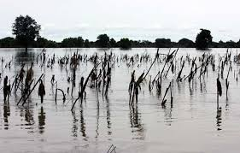
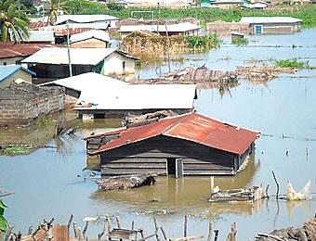
Figure 1: The 2007 & 2020 northern Ghana flood disaster in pictures
Source: GNA, 2020.

1.2.2 Planning and Prevention
In developing any recovery project, it is essential that stakeholders take into account the everyday risks situation and pre-existing vulnerabilities so as to stop the disaster from repeating itself (Oteng-Ababio, 2012). This could be achieved mainly through conduction of comprehensive risk & vulnerability assessment to uncover the underlying factors so that the ultimate goal of Disaster Planning (DP) is better achieved (Oteng-Ababio, 2011; Pelling, 2003). But it appears the concept of environmental justice is still remote to development planners in Ghana and indeed in most third world countries (Oteng-Ababio, 2012). This is because little has been achieved in our quest to address the issues of Annual Exceedance Probability of flooding in the north though a bit of some non-structural flood measures such as efficient sharing of information and integrated flood management approaches could suffice (Okyere et al, 2012; UNDP, 2012; Oteng-Ababio, 2012). Until the everyday risks are identified and dealt with in their formative stages by disaster managers in Ghana, flood disasters are expected to remain cyclical and cause continuous destruction to lives and property especially so when climate change impacts are expected to disproportionately affect people and places (Laar, 2025; Nyarko, 2000; Laar & Dujin, 2025; Owusu et al, 2014; Owusu & Waylen, 2009). Perhaps the construction of the Pwalugu Multi-purpose Irrigation Dam in the Upper East region is expected to harvest excess water emanating from the Bagre Dam spillages. However, this project that has already been stalled due to funding issues by the Government of Ghana and which is expected to cost up to US$993 million in total is a cause for concern. When fully completed though, the project is expected to stimulate agricultural, industrial and other economic activities in the area, whilst also serving as the game changer in the fight against flood disasters in northern Ghana.
1.3 The 2010 Flooding & June 3 2015 Twin Disasters in Accra.
1.3.0 Causes of the Flood Disasters
Flooding in the city of Accra like most cities in Sub-Saharan Africa are a perennial problem that leaves city authorities with more questions to answer than they would normally have anticipated. Country philosophers and social commentators alike, attribute this to several factors some of which include; edaphic and hydrological dynamics of Accra, lack of drainage facilities, lack of political will/commitment to deal with the issue once and for all, among others (UNDP, 2012; Okyere et al, 2012 & Oteng-Ababio, 2013). But the discourse also centers on mitigation efforts since that represents the better way forward from the modern disaster management perspective. The post-independence era of Ghana has been characterized by economic crisis as successive governments struggle to bring economic stability to an otherwise promising nation with huge prospects of socio-economic success. This has led to infrastructural deficit which seem to lure political leaders into the acquisition of loans from bilateral and multilateral agencies in their bid to ‘bridge the development gap’. The city of Accra seems to be caught up in a complex web of creating sustainable growth and development in the midst of an ever-increasing population (Oteng-Ababio, 2013). As such, pre-disaster plans/preparedness is often complicated by financial constraints which have also reduced NADMO to a relief-oriented body (Oteng-Ababio, 2013). Nevertheless, NADMO in collaboration with MMDAs and other state institutions have over the years been able to sensitize Ghanaians about the need to be aware of both the man-made and natural hazards that we live with. Yet such steps were always never going to be enough considering the magnitude of losses that continue to overwhelm the country during and after flood disasters.
The flooding of cities in developing countries most especially in sub-Saharan Africa is almost ubiquitous and are characterised by recurrence, and Annual Return Intervals (Oteng-Ababio, 2013). This is partly a consequence of climate change impacts which has altered the patterns and intensity of rain storms and partly a function of improper land use planning, agglomeration of industrial and economic activities, edaphic & catchment characteristics as well as hydrological dynamics, and urbanization (Laar, 2025; Owusu et al, 2014; Laar & Dujin, 2025; UNDP, 2009). In most cities across sub-Saharan Africa, development usually do not correspond with the population dynamics which creates a deficit in infrastructure as available facilities are overly stretched (Oteng-Ababio, 2013). As a consequence, rainstorms of a slightly higher than normal intensity can trigger flooding of some magnitude since the available structures usually ‘collapse’ in the midst of choked storm drains and gutters. The results of these flooding most of the time leaves much to be desired as lives and properties are lost. But it also means sources of livelihoods are severely compromised thus putting a strain in the fight towards reducing extreme poverty and hunger through sustaining livelihood (Laar, 2025).
On June 20, 2010, 2 days of heavy down pour led to the flooding of the Ghanaian capital city of Accra (GNA, 2010; Oteng-Ababio, 2013). The after mouth of the flood disaster did not only leave people bitter about the catastrophe but also there was a cataclysm of some sort – 35 persons dead and many sources of livelihoods lost. Roads and bridges including the Ring Road in Accra were washed away in the flooding in much the same way as houses, schools, utility delivery systems and businesses. The flooding also left many suburbs like Odawna, Weija, Santa Maria, Hatso, Nima, Gbawe, Alajo, Mallam, and others without electricity and potable water for up to 5 days and caused serious disruption to economic and local industrial activities. An estimated 33,602 people were directly affected whilst an additional 15,000 people were displaced (UNDP, 2012).
In like manner, 3 days of torrential rains in Accra on June 3, 2015 left many parts of the city flooded (Myjoyonline.com, 2015). To put this into perspective, the issue of flooding in Accra is cyclical and is complicated by edaphic, as well as the hydrological dynamics of the city. The general soil characteristics favour water-logging other than infiltration. Thus, a slightly higher than normal rainfall easily triggers surface runoff. As a consequence, areas in and around the Odaw River were particularly affected by the flood disaster. Of outmost interest of this paper is the terrible multiple disaster that is better described as ‘the day flood water catches fire’ (Oteng-Ababio, 2015). An explosion of a nearby fuel filling station at the Kwame Nkrumah Circle led to the gruesome killing of an estimated 150 people who were trapped by inundation of water and garbage from the heavily polluted Odaw River. But properties worth an estimated US dollars 12 million were consumed by the flooding and fire (NADMO, 2015). Particularly hit was the automobile and finance industries. Many car assembling industries and forex bureaus close to the area were either submerged in water or blazed down by the resulting inferno from the fuel station explosion (see figure 2). Many people also lost their businesses through the disaster.
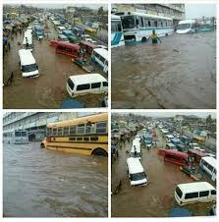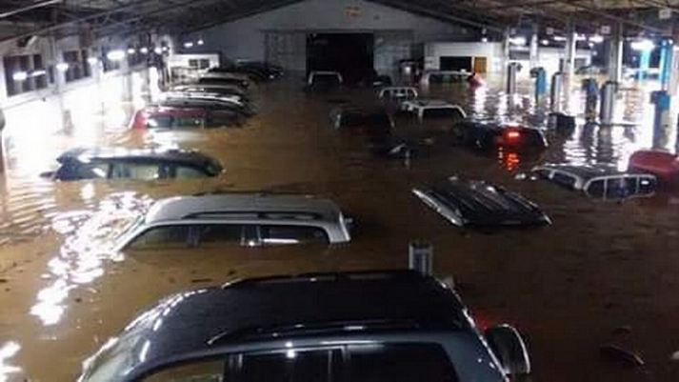
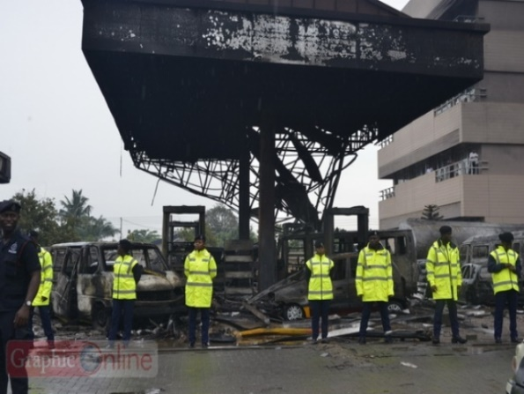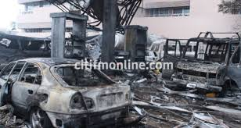

Figure 2: The June 3, 2015 twin disaster in Accra in pictures
Source: Graphiconline.com & Citifmonline.com
1.3.1 Planning and Prevention
Prior to the recent flood disasters in 2010 and 2015 there had been minimal efforts and planning to help reduce flood risk in the national capital. Taking action or steps to reducing exposure and probable future damages represent the more pragmatic modern paradigm to DP (Oteng-Ababio, 2011; 2012; 2013a & 2013b). The approval and take-off of the Conti project which would see the injection of some US$660million into the construction of a proper drainage system for Accra by the Government of Ghana in partnership with the Conti Group of Companies of Germany is thus a step in the right direction (GNA, 2015). Thus, to better address the issue of flooding in Accra and indeed, most of the major cities in Ghana, the author recommends the construction of closed storm drain systems. This will likely prevent people from discharging solid waste materials that chokes up the drains and will go a long way to reducing the negative impacts of these disasters on lives and properties.

1.4 Conclusion
Just like any disaster, flooding disrupts family and business activities and it is in this view that this paper outlines pre-disaster, disaster and post-disaster flooding strategies that would help residents to mitigate or prevent the occurrence of flooding. Thus, an interplay of chronic anthropogenic and demographic factors; and virtual institutional collapse of state agencies, coupled with edaphic and hydrological dynamics of many of the country’s flood prone areas have been the bane behind Ghana’s age-old flood disaster profile. You would imagine then, that further research is needed to explore into flood disaster management using remote sensing & GIS techniques which incorporates geodetic engineering into National Development Planning (NDP) and foster the liberal management of flood disasters in Ghana. It is the expectations of this paper that the adoption and use of the recommendations and plans outlined would result in a smooth operation of activities geared toward reducing flood disasters in Ghana.

References
Ahadzie, D. K., & Proverbs, D. G. (2010). Flooding and post flooding response strategies in Ghana. WIT Transactions on Ecology and the Environment, 133, 281–291. https://doi.org/10.2495/FRIAR100241
Asumadu-Sarkodie, S., Owusu, P. A., & Rufangura, P. (2015). Thermochemical processing and utilization of heavy-metal(loid)-contaminated biomass resulting from phytoextraction View project construction project management View project. Pelagia Research Library, 6(October), 53–78. https://doi.org/10.6084/M9.FIGSHARE.3381460
Asumadu-Sarkodie, S., Owusu Phebe, A., & Jayaweera Herath M P, C. (2015). Flood risk management in Ghana: A case study in Accra. Advances in Applied Science Research, 6(4), 196–201. www.pelagiaresearchlibrary.com
Attipoe, S. K. (2014). An Assessment of Flood Mitigation Measures in Accra, Ghana. Kwame Nkrumah University of Science and Technology.
Braimah, M. M., Abdul-Rahaman, I., Oppong-Sekyere, D., Momori, P. H., Abdul-Mohammed, A., & Dordah, G. A. (2014). A Study into the Causes of Floods and its Socio-economic Effects on the People of Sawaba in the Bolgatanga Municipality, Upper East, Ghana. International Journal of Pure and Applied Bioscience, 2(1), 189–195. www.ijpab.com
David Baaman Laar & Barma Laribick Dujin. (2025). Climate Change and Food Security: Whispers from a Developing Country. Current Research on Geography, Earth Science and Environment Vol. 3, 152–167. https://doi.org/10.9734/bpi/crgese/v3/6415
https://doi.org/10.9734/bpi/crgese/v3/6415
GNA, (2010). Ghana News Agency. Heavy rains cause havoc in Accra, local news item. GNA,
Accra. Date accessed; October 21, 2025.
GNA, (2012). Ghana News Agency. EDITORIAL: AMA Building Inspectors Have Questions to Answer. GNA, Accra – Ghana; accessed on October 19, 2025.
GNA, (2013). Ghana News Agency. The Blazing End of a Commercial Nerve Center – Katamanto. Local news item; accessed on October 19, 2025.
GNA, (2020). Ghana News Agency; news archives. GNA, Accra – Ghana. Available at www.ghanaweb.com, accessed on October 14, 2025.
GNA, (2015). Ghana News Agency; news archives. GNA, Accra – Ghana. Available at www.ghanaweb.com, accessed on October 20, 2025.
IFRC, (2014). International Federation of Red Cross and Red Crescent Society. DREF Final Report: Emergency Plan of Action (EPoA) Ghana: Cholera Outbreak Response; Accra, Ghana. Available at www.ifrc.org; accessed on October 15, 2025.
Laar, D. B. (2025). Causes and Impacts of Drought Hazards on Crop Production
and Food Security in Ghana’s Northern Savanna Ecosystem: A Cause-
Effect Analysis. International Journal of Environment and Climate
Change, 15(9), 137-146
WWW.graphiconline.com, (2015). Flood Disaster Profile in Ghana since 1968. Date accessed; October 20, 2025.
WWW.gbcghana.com, (2015). NADMO Overwhelmed by the number of people affected by the June 3 Twin Disaster in Accra. In news item; accessed on October 10, 2025.
NADMO, (2015). National Disaster Management Organization Archives. Available at www.nadmo.gov.gh.
Mensah, H., & Ahadzie, D. K. (2020). Causes, impacts and coping strategies of floods in Ghana: a systematic review. SN Applied Sciences, 2(5), 1–13. https://doi.org/10.1007/s42452-020-2548-z
Nyarko, B. K. (2000). Flood risk zoning of Ghana: Accra experience. International Archives of the Photogrammetry, Remote Sensing and Spatial Information Sciences - ISPRS Archives, 33, 1039–1050.
Odame, P. K. (2017). Road transport infrastructure and mobility : Views of students with physcial disability in the University of Cape Coast [University of Cape Coast]. https://erl.ucc.edu.gh/jspui/handle/123456789/3211
Okyere, C. Y., Yacoba, Y., & Gilgenbach, D. (2013). The problem of annual occurrences of floods in Accra: An integration of hydrological, economic and political perspectives. Theoretical and Empirical Researches in Urban Management, 8(2), 45–79.
Oteng-Ababio, M. (2011). Neglected Vulnerabilities in a rapidly urbanizing city: reflections on
earthquake risks in Accra. Journal of Housing and the Built Environment. Vol. 27 No. 2 pp.187 - 205
Oteng-Ababio, M. (2012). (In) justice: Unequal exposure to ecological hazards in Metropolitan
Accra. International Journal of Environment and Planning A (In Press)
Oteng-Ababio, M. (2012). Integrated Environmental Health and Disaster Risk Reduction. ICDE,
Legon. Accra, Ghana.
Oteng-Ababio, M. (2013). Unscripted (In) justice: Unequal exposure to ecological hazards in
Metropolitan Accra, International Journal of Environment and Planning A, Vol. 45 No. 5 pp.
1199 - 1218
Oteng-Ababio, M. (2013). Prevention is Better than Cure:Assessing Ghana's Preparedness (Capacity) for Disaster Management. Jamba: Journal of Disaster Risk Studies 5 (2), Art. #75, pp1-11. http://www.dx.doi.org/10.42102/jamba.v5i2.75, 1-11.
Oteng-Ababio, M., K. Sarfo & E. Owusu-Sekyere (2015). Exploring the Realities of Resilience:
Case study of the Katamanto market fire in Accra, Ghana. International Journal of Disaster
Risk Reduction 12(2015) 311 - 318
Oteng-Ababio, M. (2014). More rhetoric or less action: digging into urban health vulnerabilities -insights from urbanizing Accra, Geo Journal (2014). http//dx.doi.org/10.1007/s10708-013-9498-
6
Oteng-Ababio, M. & K. Sarpong (2015). Reducing fire threats to markets: piloting community-
based fire risk assessment in Accra, Disaster (2015).
Owusu, K., P. Obour & S. Asare-Baffour (2014). Climate Variability and Climate Change Impacts on Small-holder Farmers in the Akuapem North District, Ghana. Handbook on Climate Change Adaptation, 1 - 13.
Owusu, K. & P. Waylen (2009). Trends in Spatio-Temporal Rainfall Variability in Ghana (1951-2000). Weather, 64(5); 115 - 120.
Potter, R., T. Binns, J. Elliot & D. Smith. (2008). Geographies of Development: An Introduction
to Development Studies. Pearson/Prentice Hall, London/New York.
WWW.tv3network.com. Cause of GOIL fire revealed as death in twin disaster hits 200, in news
item. Date accessed; October 21, 2025.
Pelling, M. (2003). The Vulnerability of Cities: Natural Disaters and Social Resilience. London: Earthscan.
Robinson, P. & A. Henderson-Sellers (1999).Contemporary Climatology. Harlow, UK: Longman
UNDP. (2009). UNDP's Response to Crisis Prevention and Recovery in Northern Ghana: Recovery Programming Support for Northern Ghana. Accra: UNDP.
UNDP. (2012). Community Resilience through Early Warning: Project Document. Accra, Ghana.
UNISDR (United Nations International Strategy for Disaster Reduction), How to make cities
more resilient: A handbook for local government leaders, United Nations, Geneva, 2009. page 102
Wisner, M. P. (2008). Disater Risk Reduction Cases of Urban Africa. London: Earthscan.
WWW.citifmonline.com, (2015). June 3 Ridge Hospital Nurses to be buried on July 10. In news
item; accessed on October 20, 2025.
WWW.graphiconline.com, (2013). Melcom Disaster: Psychological Association offers to help
victims overcome trauma; news item: accessed on October 21, 2025.
WWW.myjoyonline.com, (2012). Bureaucracy, probable cause of Melcom Disaster - Kwabena
Agyapong. Local news item; accessed on October 15, 2025.
WWW.myjoyonline.com, (2013; 2014). 65 Killed in Fire Disasters in 2013. Local news item;
accessed on October 10, 2025.
WWW.myjoyonline.com, (2015). Joy FM, Mobile Water donates 2,000 bags of sachet water to
disaster victims. Local news item; accessed on October 13, 2025.
Owusu, K. & P. Waylen (2009). Trends in spatio-temporal variability in annual rainfall in Ghana (1951-2000). Weather, 64(5), 115-120.

