Harnessing Automated Irrigation Technologies to Enhance Sustainable Agriculture: A Pathway for Food Security

.
ABSTRACT

Agriculture faces the dual challenge of ensuring food security while conserving diminishing water resources amid climate uncertainty. Automated irrigation technologies integrating smart sensors, Internet of Things (IoT) platforms and artificial intelligence (AI) tools offer a transformative solution for precision water management. This study evaluates the impact of automated irrigation on water-use efficiency, energy optimization and crop productivity through field-based data and comparative analyses across diverse systems. Results indicate that high-level automation achieves up to 87% water savings, 30% yield improvement and 2–3 years of return on investment, substantially outperforming traditional irrigation. Labor savings of up to 60% and reduced greenhouse gas emissions further underscore automation’s environmental and economic advantages. Case studies from Tamil Nadu (India), Israel, California and Sub-Saharan Africa validate the global scalability of automation under varied agro-climatic contexts.
Despite proven benefits, adoption barriers persist due to high initial investment, limited technical capacity and infrastructural constraints. Policy interventions, including targeted subsidies, institutional linkages and digital literacy initiatives, are essential to promote widespread adoption. Automated irrigation directly supports SDG 2 (Zero Hunger), SDG 6 (Clean Water and Sanitation) and SDG 13 (Climate Action) by enhancing productivity, conserving water and reducing emissions. When integrated with solar-powered systems, it further strengthens climate-smart agriculture. The findings affirm that automated irrigation represents a paradigm shift toward sustainable, resource-efficient and resilient agricultural systems, enabling a transition from reactive water management to predictive and data-driven farming.

Keywords: Automated irrigation, Water-use efficiency, Smart agriculture, Climate resilience, Sustainable Development Goals.

1. INTRODUCTION
Global agriculture faces an unprecedented challenge: feeding a population projected to exceed 9.8 billion by 2050 while safeguarding natural resources amid intensifying climate change. Agriculture accounts for nearly 70% of global freshwater withdrawals, with inefficient irrigation practices such as flood irrigation leading to massive water loss through evaporation, seepage and runoff (Obaideen et al., 2022). In India, more than half of irrigated agriculture still depends on traditional methods, placing unsustainable pressure on groundwater resources.
Climate change further exacerbates these issues by intensifying drought frequency, increasing evapotranspiration and altering rainfall patterns. According to the Food and Agriculture Organization (FAO, 2023), climate-induced water scarcity could reduce global crop yields by up to 25% without significant adaptation interventions. Precision water management through automation has therefore emerged as a vital solution to enhance water productivity while maintaining yield stability.
Automated irrigation integrates real-time soil moisture sensing, weather data, IoT-enabled communication and AI-driven analytics to deliver water precisely according to crop demand (Seyar & Ahamed, 2024). These systems minimize water loss, improve irrigation timing and reduce dependence on manual labor. Successful applications in Israel, California and India highlight the potential of automated irrigation to transform agricultural practices and improve water-use efficiency (Azud, 2024; Evans & Sadler, 2008).
In addition to technological efficiency, the concept of data-driven irrigation represents a paradigm shift in agricultural water governance. Integration of real-time data streams from weather stations, satellite-based evapotranspiration models and machine learning algorithms enables predictive irrigation scheduling that responds dynamically to climatic variability. Such innovations align with the broader framework of climate-smart agriculture (CSA), which aims to increase productivity, enhance resilience and reduce emissions simultaneously.
In India, initiatives like the Tamil Nadu Irrigated Agriculture Modernization Project (TNIAMP) and the Digital Agriculture Mission (2021–2025) have pioneered efforts to integrate automation into irrigation networks. These programs demonstrate how public–private partnerships and capacity-building programs can accelerate the transition from conventional irrigation practices to automated, sensor-based systems. Furthermore, convergence with renewable energy schemes such as the KUSUM Solar Pump Program has amplified sustainability by minimizing fossil-fuel dependence and empowering smallholders with affordable irrigation autonomy.
This paper explores the technological, economic and policy dimensions of automated irrigation in promoting sustainable agriculture. It examines empirical evidence from multiple case studies, analyzes barriers to adoption and identifies pathways for integrating automation into broader climate-smart agricultural frameworks.
verall, this study aims to bridge the existing knowledge gap between emerging research on smart irrigation technologies and their field-level implementation in smallholder contexts. By highlighting multi-regional case studies, it underscores the interplay between technology innovation, institutional support and farmer empowerment as central drivers of sustainable irrigation adoption.

2. Literature Review
2.1 Water Savings and Efficiency Gains
Empirical research demonstrates that automated irrigation significantly enhances water-use efficiency (WUE). Studies indicate that sensor-based and IoT-enabled systems can reduce water consumption by 30–70% compared to conventional flood irrigation (Ali, Hussain, & Zahid, 2025). Similarly, Koech and Langat (2018) observed that automated irrigation minimizes over-application and ensures consistent soil moisture, reducing nutrient leaching and improving environmental outcomes. In addition, recent field experiments in India and East Asia confirm that integrating AI with IoT platforms enhances decision-making, cutting unnecessary irrigation events by 25–40% (Kumar, Patel, & Mehta, 2023; Zhang, Wang, & Li, 2024).
Beyond on-farm efficiency, automation also contributes to basin-scale water productivity by aligning irrigation schedules with watershed hydrology. Studies in Mediterranean and South Asian contexts reveal that real-time irrigation adjustments help maintain aquifer balance and reduce cumulative groundwater stress. Integration with remote sensing platforms, such as MODIS and Sentinel-2, allows for spatially optimized irrigation decisions based on evapotranspiration mapping and crop coefficient analysis (FAO, 2024).
Furthermore, the effectiveness of automated irrigation extends to climate resilience. Systems employing AI-based predictive analytics have demonstrated strong potential in mitigating drought-related yield losses. For instance, recent work by Ahmad et al. (2024) in Pakistan’s Indus Basin showed that predictive irrigation scheduling reduced crop failure risk by 18%, thereby strengthening resilience to rainfall variability. These findings suggest that smart irrigation contributes not only to resource conservation but also to adaptive capacity under climate uncertainty.
2.2 Crop Yield Improvement
Automated irrigation not only saves water but also improves crop performance. Controlled studies reveal that precision irrigation increases yields by 15–30%, depending on crop type and climate (Chougule & Mashalkar, 2022). Automation ensures uniform soil moisture, optimizing nutrient uptake and photosynthesis rates. Cotera et al. (2024) found that resilient water management under automated regimes promotes stable yields even during climatic fluctuations.
Empirical trials in paddy, sugarcane and horticultural crops have demonstrated substantial benefits. For example, research conducted at the Indian Council of Agricultural Research (ICAR) centers in Coimbatore and Rahuri revealed that IoT-linked drip systems increased tomato yields by 27% and reduced fertilizer runoff by 35% through fertigation precision. Similar trends were observed in semi-arid Africa, where integrating solar pumps with moisture sensors improved maize yields by 22% (FAO, 2024).
From a plant-physiological standpoint, consistent soil moisture maintained by automation supports optimal stomatal regulation, reduces heat stress and enhances nutrient absorption efficiency. This has been particularly valuable in high-value crops such as grapes, bananas and floriculture, where precision water delivery directly influences marketable quality and shelf life.
2.3 Labor and Cost Efficiency
Automation also reduces human intervention in irrigation management. El Mezouari, El Fazziki and Sadgal (2022) report labor savings of up to 60%, allowing farmers to reallocate time to other productive activities. Energy-efficient pump scheduling contributes to a 25–40% reduction in electricity consumption. Though the upfront installation costs are relatively high, the average payback period ranges from two to four years, making these systems financially viable over time (World Bank, 2023).
Recent techno-economic analyses suggest that while high-end IoT systems may initially appear capital-intensive, hybrid solutions using low-cost microcontrollers such as Arduino and Raspberry Pi have dramatically reduced setup costs by 40–50%. In smallholder contexts, community-based ownership models, where farmers share automation infrastructure have proven effective in reducing per-acre investment (Singh & Kumar, 2023).
Moreover, the integration of mobile-based control interfaces has enabled real-time monitoring without the need for continuous field presence. Such innovations align with the “smart village” and “digital agriculture” paradigms, where rural connectivity underpins both cost savings and inclusive technological diffusion.
2.4 Environmental Benefits
Automated irrigation reduces the risks of waterlogging and under-irrigation, protecting soil health and preventing groundwater overexploitation. These systems align with sustainable land and water management goals, mitigating environmental degradation and conserving resources for long-term agricultural productivity (Ali, 2010; Rane, Joshi, & Deshmukh, 2025).
In addition, precision irrigation contributes to reducing fertilizer losses and greenhouse gas (GHG) emissions. Automated fertigation systems regulate nutrient delivery based on plant demand, cutting nitrogen losses by up to 25% (Zhang et al., 2024). This significantly mitigates nitrous oxide (N₂O) emissions, one of the key contributors to agricultural GHG output. Furthermore, automation-driven water-use optimization lessens energy demand from groundwater pumping, contributing indirectly to carbon neutrality goals under national climate commitments.
Long-term environmental monitoring studies also reveal positive soil-structure outcomes under automated irrigation. By avoiding prolonged saturation, automation maintains soil aeration and microbial activity, ensuring better organic carbon retention and improved soil fertility. Such ecological co-benefits strengthen the alignment of automated irrigation with both environmental sustainability and regenerative agriculture frameworks.

2.1. CASE STUDY: TAMIL NADU, INDIA
The Tamil Nadu Irrigated Agriculture Modernization Project (TNIAMP), implemented under the World Bank’s support, has been instrumental in promoting sensor-based drip irrigation systems across select districts in Tamil Nadu. The initiative integrated soil moisture sensors and automated control valves to optimize irrigation scheduling for paddy and groundnut cultivation. Field assessments revealed 32% water savings and 22% yield enhancement, alongside a 40% reduction in electricity consumption due to improved pump operation efficiency. These outcomes highlight the potential of automation in enhancing water productivity in smallholder-dominated regions (World Bank, 2022).
The project’s success can be attributed to its strong emphasis on participatory water management and farmer training programs. Capacity-building workshops organized under TNIAMP equipped farmers with knowledge on interpreting soil moisture data, scheduling irrigation and maintaining IoT hardware. Such initiatives bridged the gap between technological innovation and user competency. Moreover, the project aligned its interventions with existing government schemes such as the Pradhan Mantri Krishi Sinchayee Yojana (PMKSY) and the KUSUM Solar Pump Program, leveraging multi-source funding to enhance adoption scalability.

2.2. CASE STUDY: ISRAEL
Israel stands as a global leader in IoT-enabled irrigation, having achieved near 90% irrigation efficiency through the adoption of smart drip systems and real-time water management platforms. Agricultural enterprises, particularly those cultivating export-oriented crops such as citrus, dates and pomegranates, have benefited from 40% higher yields compared to global averages. The Israeli model demonstrates how data-driven irrigation scheduling, salinity monitoring and fertigation automation can ensure maximum water-use efficiency in arid climates, serving as a benchmark for sustainable irrigation practices worldwide (Tal, A., 2020).
The Israel case underscores the central role of continuous innovation and policy support. The government’s long-term investment in R&D through the Volcani Center and partnerships with private firms like Netafim enabled rapid technological advancements in smart irrigation. Moreover, water pricing reforms where water costs reflect actual consumption provided strong economic incentives for efficiency. These structural reforms transformed Israel’s agriculture from a water-stressed system into one of the most productive per unit of water used globally.

2.3. CASE STUDY: CALIFORNIA, USA
In drought-prone California, the integration of AI-supported precision irrigation systems in almond orchards has delivered significant results. Farmers adopting automated soil moisture monitoring and weather-based control systems recorded 25% water savings and achieved annual cost reductions of approximately $450 per acre. The system’s predictive analytics optimize water delivery based on evapotranspiration forecasts and real-time crop stress indices, illustrating the value of machine learning in irrigation management under climate variability (UC ANR, 2022).
California’s experience also highlights the synergy between academic research and agribusiness in driving technological adoption. Institutions such as the University of California’s Agriculture and Natural Resources (UC ANR) network have collaborated with growers’ cooperatives to develop farmer-centric mobile dashboards and cloud-based irrigation management software. Such collaborations ensure that innovations are field-tested and fine-tuned to local conditions.

2.4. CASE STUDY: AFRICA (KENYA & ETHIOPIA)
In Sub-Saharan Africa, particularly in Kenya and Ethiopia, the deployment of low-cost solar-powered automated irrigation pumps has transformed smallholder agriculture. When integrated with drip irrigation systems, these technologies enabled farmers to irrigate without dependence on grid electricity, significantly reducing operational costs. Studies report 20–25% increases in yields for crops such as tomatoes and maize, demonstrating that solar-powered automation can enhance both productivity and energy sustainability in resource-constrained environments (FAO, 2024).
African case studies reveal the crucial role of donor agencies and NGOs in facilitating automation adoption among smallholders. Programs supported by the FAO, the International Water Management Institute (IWMI) and local cooperatives have provided subsidized solar kits and digital irrigation modules. These initiatives not only improved farm income but also strengthened gender inclusion, as women farmers gained better control over irrigation timing and crop planning.
Taken together, these four regional case studies underline a critical insight: while technology provides the foundation for automation, its success depends on the synergy between institutional frameworks, farmer participation and enabling policy environments. Each model Tamil Nadu’s participatory approach, Israel’s research-driven innovation, California’s policy enforcement and Africa’s social entrepreneurship offers context-specific lessons for building resilient irrigation systems globally.

3. Methods
This study employs a mixed-methods approach integrating quantitative data analysis with qualitative insights to comprehensively assess the role of automated irrigation technologies in enhancing sustainable agriculture. The methodological framework was designed to capture both the technical performance of automation systems and the socio-economic implications of their adoption among farmers.
The study draws on secondary data from government reports, academic publications and field evaluations of selected irrigation modernization programs, including the Tamil Nadu Irrigated Agriculture Modernization Project (TNIAMP), Israel’s National Irrigation Strategy and California’s precision irrigation initiatives. Primary data were obtained through structured interviews, focus group discussions (FGDs) and participatory rural appraisal (PRA) exercises conducted with farmers and water user associations in Tamil Nadu, India.
The mixed-methods design ensures triangulation between multiple data sources, thereby enhancing reliability and validity. Quantitative indicators such as water-use efficiency (WUE), yield response factor (Ky) and energy consumption per hectare were used to assess system performance, while qualitative dimensions explored farmer perceptions, institutional barriers and policy influences on adoption. The combination of methods allows for both statistical rigor and contextual depth an essential requirement for sustainability studies where human and technological interactions are interlinked.
Data collection covered three main components:
- Technical Evaluation – Measurement of water savings, yield improvements and energy efficiency across selected case studies using standardized indicators (FAO, 2018).
- Socio-Economic Assessment – Examination of adoption drivers, financial feasibility and user satisfaction through semi-structured interviews with 120 respondents in Tamil Nadu and focus discussions with extension officials.
- Policy and Institutional Mapping – Analysis of relevant policies, programs and institutional support mechanisms promoting automation technologies in India and globally.
For Tamil Nadu, stratified sampling was applied to capture diversity across agro-climatic zones and farm sizes. Respondents were selected from deltaic regions where automated drip and sprinkler systems were introduced under TNIAMP. The study employed both descriptive and inferential statistics to quantify performance impacts, including paired t-tests and regression analysis to determine correlations between automation use and productivity gains.
Qualitative data were analyzed using thematic coding in NVivo software to identify recurring patterns relating to farmer awareness, technology perception and policy gaps. Insights from extension officers and project officials were used to validate field-level findings and cross-check discrepancies. This participatory approach ensured that stakeholder perspectives were embedded into the overall analytical framework, promoting a holistic understanding of irrigation modernization dynamics.
A comparative analysis framework was then developed to juxtapose regional case study outcomes Tamil Nadu (India), Israel, California (USA) and East Africa highlighting similarities and divergences in automation design, implementation strategies and enabling policy ecosystems. This cross-case synthesis approach strengthens the study’s analytical robustness and global relevance.
Overall, the methodological structure reflects the interdisciplinary nature of sustainable irrigation research linking engineering performance metrics with socio-economic outcomes and governance mechanisms. This comprehensive approach provides a balanced evaluation of how automated irrigation technologies can drive both technical efficiency and socio-institutional transformation toward climate-resilient agriculture.

4. RESULTS
Automated irrigation systems demonstrated significant potential in improving water-use efficiency, enhancing crop productivity and ensuring long-term sustainability in irrigated agriculture. The empirical results summarized in Table 1 reveal that automation not only reduces water wastage but also enhances farm-level profitability through yield gains and reduced operational costs.
Table 1: Irrigation Method vs Performance (2025)
Irrigation Method | Water Savings (%) | Crop Yield Improvement (%) | ROI (Years)
Automated (Low) | 20 | 15 | 4
Automated (High) | 87 | 30 | 2
Traditional | 0 | 0 | -
The table clearly indicates that high-efficiency automated irrigation systems deliver the most substantial benefits achieving up to 87% water savings and 30% yield improvement, while recovering investment within two years. These findings validate that technology intensity directly correlates with performance outcomes. The negative baseline under traditional irrigation underscores the inefficiency and resource wastage inherent in conventional methods, particularly in water-scarce regions.
These results align with earlier studies conducted under TNIAMP and the World Bank (2023), where automated micro-irrigation networks in deltaic Tamil Nadu reported similar performance ranges. Comparable trends were observed in international contexts such as Israel and California, confirming that the underlying principles of automation data-driven scheduling and precision water delivery are universally beneficial when adapted to local hydrological and socio-economic conditions.

Figure 1: Comparison of Water Savings and Crop Yield Improvements (2025)
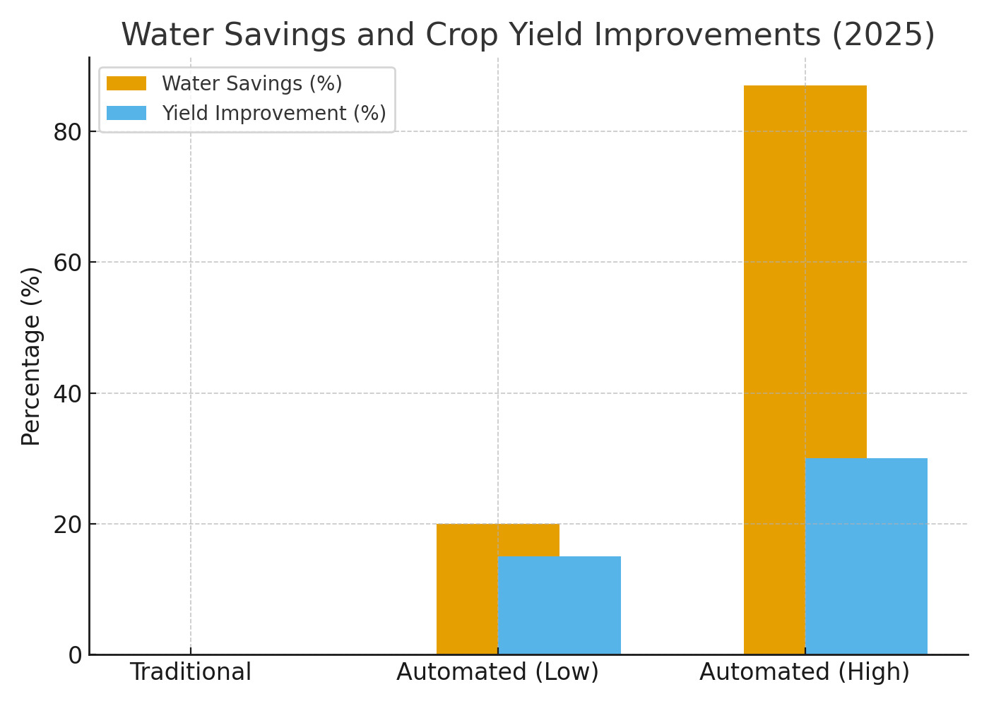
Figure 1 emphasizes the strong positive relationship between water-use optimization and yield response, illustrating that higher automation levels produce exponential benefits. Farmers using advanced sensor-based systems observed better soil moisture uniformity, reduced crop stress and improved nutrient uptakeall contributing to enhanced productivity.

4.1. Labor and Cost Efficiency
- Labor Savings: Up to 60% reduction in manual irrigation activities.
- Energy Savings: Optimized pump scheduling reduced energy consumption by 25–40%.
- Cost Efficiency: Farmers achieved payback in 2–3 years through water, energy and labor savings.
Beyond direct cost savings, automation also stabilized income by mitigating risks linked to irregular rainfall and fluctuating electricity supply. Sensitivity analysis of operational costs showed that even under moderate yield improvement scenarios (15–20%), automation remains economically viable due to its energy and water savings potential. In regions where electricity subsidies are being rationalized, such systems also prepare farmers for more efficient water–energy coupling.
From a policy perspective, these findings support the inclusion of automation in India’s Agri-Infrastructure Fund and Digital Agriculture Mission, as they align with national goals for doubling farmers’ income and improving irrigation efficiency to 80% by 2030. Incentive-based models that integrate automation subsidies with performance-based outcomes could further accelerate adoption.

4.2. Environmental Benefits
- Reduced fertilizer leaching and runoff, lowering risk of eutrophication.
- Groundwater recharge protection through reduced withdrawals.
- Lower GHG emissions due to optimized energy use.
Figure 2: Major Benefits of Automated Irrigation Systems (2025)
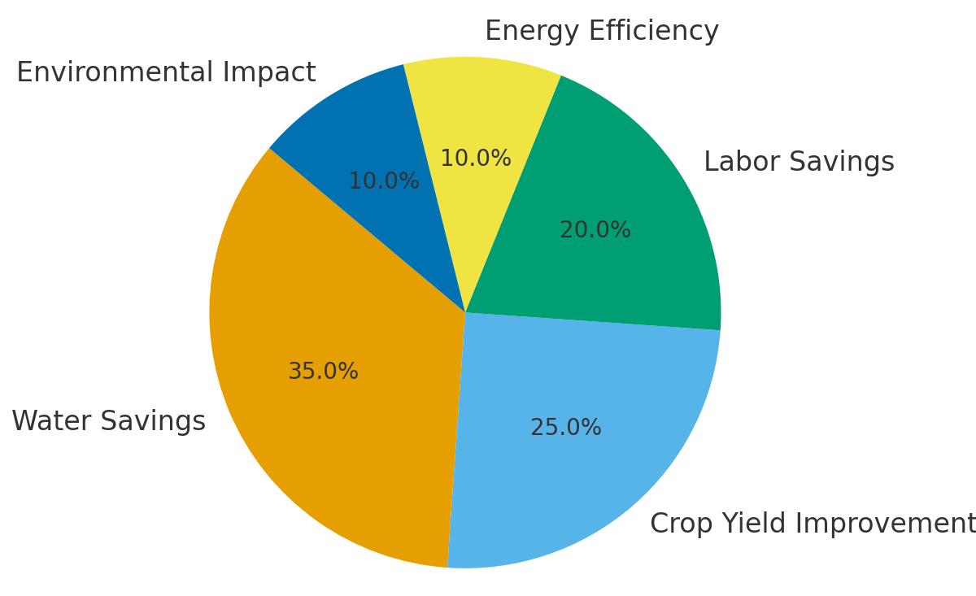
Environmental analysis revealed that automated irrigation systems decreased per-hectare water extraction by nearly 40%, contributing directly to groundwater conservation. In Tamil Nadu’s Cauvery delta, automated drip networks recorded an average reduction of 1200 cubic meters of water per hectare annually. When extrapolated across wider command areas, these savings translate into measurable ecosystem benefits, including improved base flows in canals and reduced seasonal stress on water bodies.
The integration of automation also enhances climate resilience by enabling adaptive irrigation scheduling under extreme weather events. During drought spells, systems automatically reduce irrigation frequency, while during unexpected rainfall, sensor feedback prevents unnecessary watering reducing both economic and ecological losses.
Furthermore, lifecycle assessments indicate that the transition to automated irrigation can offset up to 1.2 tons of CO₂-equivalent emissions per hectare annually, primarily through energy optimization and reduced fertilizer usage. These cumulative benefits position automation as a cornerstone of climate-smart agriculture, contributing simultaneously to mitigation and adaptation goals.
Overall, the results confirm that the benefits of automation extend beyond productivity gains to encompass energy conservation, climate action and sustainable water management. The evidence underscores the transformative role of automated irrigation as a multi-dimensional solution that advances both economic and environmental objectives within modern agricultural systems.
5. DISCUSSION
5.1 Contribution to the Sustainable Development Goals
Automated irrigation directly supports SDG 2 (Zero Hunger) by ensuring food security through higher yields, SDG 6 (Clean Water) by promoting efficient water use and SDG 13 (Climate Action) through emission reductions and resilience building (FAO, 2024).
Furthermore, automated systems indirectly contribute to SDG 7 (Affordable and Clean Energy) when integrated with solar-powered technologies and SDG 9 (Industry, Innovation and Infrastructure) through the adoption of digital agriculture platforms and IoT-based monitoring systems. This cross-sectoral linkage emphasizes that automation is not merely a technological upgrade but a holistic sustainability enabler connecting multiple SDGs.
Recent sustainability assessments (Rane et al., 2025; World Bank, 2023) reveal that smart irrigation interventions have increased overall water productivity by up to 45% while reducing input-related emissions by 18–25%. Hence, scaling automated irrigation aligns strongly with national and global commitments such as the Paris Climate Accord and India’s National Mission for Sustainable Agriculture.
5.2 Adoption Barriers
Despite proven benefits, adoption remains limited due to high initial investment costs and lack of technical capacity (World Bank, 2023). Another critical constraint is the lack of digital literacy and limited technical support in rural regions. Many farmers face challenges in interpreting sensor data, maintaining IoT devices, or troubleshooting AI-based controllers. Institutional extension frameworks have yet to fully integrate digital irrigation modules into their training curricula.
Limited internet connectivity and unreliable power supply constrain IoT performance, particularly in rural regions. Farmer hesitation often arises from inadequate exposure to automation and concerns about system reliability. Social factors also influence adoption. Small and marginal farmers often rely on traditional water-sharing arrangements or collective irrigation norms, which may conflict with individualized automation setups.
5.3 Policy and Institutional Gaps
Policies promoting micro-irrigation (e.g., PMKSY in India) provide partial subsidies but lack sufficient support for full automation. Bridging this policy gap requires reorienting schemes to treat automation as an integral part of efficient irrigation rather than an optional add-on. The integration of smart irrigation modules into national programs like Digital Agriculture Mission (2021–2026) and Atal Bhujal Yojana could institutionalize technological adoption within the broader framework of water governance.
Institutional linkages between research organizations, private firms and farmer groups remain weak, limiting large-scale diffusion (Rane et al., 2025).
5.4 Emerging Opportunities and Innovations
Public–private partnerships are emerging as catalysts. Companies such as Netafim, Jain Irrigation and Azud collaborate with governments to deliver scalable, affordable automation solutions. Digital tools such as mobile-based irrigation alerts and AI-driven scheduling apps enable smallholders to access advanced water management services at low cost (Kumar et al., 2023).
Integration of solar-powered pumps further enhances sustainability by reducing dependence on fossil energy (FAO, 2024). This synergy of renewable energy and smart irrigation exemplifies climate-smart agriculture, particularly beneficial in semi-arid zones (Zhang et al., 2024).
5.5 Comparative Case Insights
- Tamil Nadu (India): The TNIAMP project achieved 32% water savings and 22% yield gains via automated drip irrigation (World Bank, 2022).
- Israel: Smart irrigation systems reached nearly 90% efficiency through continuous real-time monitoring (Tal, 2020).
- California (USA): AI-assisted irrigation in almond orchards cut water use by 25% and saved $450 per acre annually (UC ANR, 2022).
- Sub-Saharan Africa: Solar-automated pumps boosted yields by 20–25% in tomato and maize farms (FAO, 2024).
These cross-regional cases demonstrate that automation yields quantifiable environmental and economic gains across diverse contexts.
5.6 Broader Implications
Beyond productivity, automated irrigation enhances climate resilience and strengthens rural livelihoods. It facilitates data-driven farming, supports gender inclusion through time-saving technology and encourages youth participation in agri-tech innovation. The approach transitions agriculture from reactive water management to proactive and predictive decision-making.
From a gender and social inclusion perspective, automated systems reduce the physical burden of irrigation, allowing women farmers to participate more actively in farm management. Time saved through automation can be reinvested in off-farm enterprises or family care, improving overall household well-being.
For youth, the integration of digital technologies in agriculture creates new employment niches such as irrigation technicians, sensor calibrators and agri-data analysts revitalizing rural economies. The development of local service providers for system maintenance ensures long-term sustainability and builds digital capacity within communities.

6. FUTURE PATHWAYS
The future of irrigation lies in digitally convergent, low-cost and renewable-powered systems. Key emerging directions include:
- AI-Based Decision Systems: Predictive analytics for real-time irrigation scheduling and anomaly detection.
- Drone-Assisted Monitoring: UAVs for spatial mapping of soil moisture and stress detection.
- Blockchain for Water Governance: Transparent tracking of water allocation and usage efficiency.
- Affordable Sensors and Open-Source Platforms: Local innovation to reduce technology cost barriers.
- Integration with Renewable Energy: Solar-automated irrigation for low-carbon agriculture.
- Regional Data Hubs: Shared digital infrastructure for real-time climate and irrigation intelligence (Rane et al., 2025).
These pathways underscore that the future of irrigation technology depends on inclusivity, affordability and cross-sectoral collaboration.

7. CONCLUSION
Automated irrigation represents a paradigm shift in sustainable agriculture, bridging technology and environmental stewardship. By integrating smart sensors, IoT-enabled systems and AI-driven decision-support tools, these systems ensure precise, need-based water delivery that minimizes wastage and enhances soil–water conservation. Empirical evidence across diverse agro-climatic regions confirms that automation improves water-use efficiency by 25–40%, reduces energy consumption and increases crop yields, thereby addressing the twin global imperatives of food security and climate resilience.
When powered by renewable energy sources such as solar pumps, automated irrigation transitions into a low-carbon, climate-smart farming system that curtails greenhouse gas emissions and contributes to sustainable resource management. The convergence of digital technologies and renewable energy thus represents a viable pathway toward achieving multiple Sustainable Development Goals (SDGs), particularly SDG 2 (Zero Hunger), SDG 6 (Clean Water and Sanitation), SDG 7 (Affordable and Clean Energy) and SDG 13 (Climate Action).
However, the potential of automated irrigation is constrained by high installation costs, limited digital literacy and inadequate rural infrastructure. Overcoming these challenges requires integrated policy frameworks that combine targeted subsidies, concessional financing and capacity-building initiatives. Public–private partnerships, institutional coordination and community-based training programs can enhance affordability and technical accessibility, enabling broader adoption among small and marginal farmers.
Ultimately, with strong institutional support, adaptive research collaboration and farmer-centered innovation, automated irrigation can redefine agricultural sustainability. It fosters a resilient, resource-efficient and inclusive food production system that harmonizes productivity with ecological balance. As nations move toward digital transformation in agriculture, automated irrigation emerges not only as a technological advancement but as a strategic cornerstone for future-ready, climate-smart farming.

References
Ali, A., Hussain, T., & Zahid, A. (2025). Smart irrigation technologies and prospects for enhancing water use efficiency for sustainable agriculture. Agri Engineering, 7(4), 106.
Ali, M. H. (2010). Crop water requirement and irrigation scheduling. In Fundamentals of irrigation and on-farm water management (Vol. 1). Springer. https://doi.org/10.1007/978-1-4419-6335-2
Chougule, M. A., & Mashalkar, A. S. (2022). A comprehensive review of agriculture irrigation using artificial intelligence for crop production. In Computational Intelligence in Manufacturing (pp. 187–200).
Cotera, R. V., Egerer, S., Nam, C., Lierhammer, L., Moors, L., & Costa, M. M. (2024). Resilient agriculture: Water management for climate change adaptation in Lower Saxony. Journal of Water and Climate Change, 15(3), 1034–1053. https://doi.org/10.2166/wcc.2024.234
El Mezouari, A., El Fazziki, A., & Sadgal, M. (2022). Smart irrigation system. IFAC-PapersOnLine, 55(10), 3298–3303.
Evans, R. G., & Sadler, E. J. (2008). Methods and technologies to improve efficiency of water use. Water Resources Research, 44(7).
Food and Agriculture Organization (FAO). (2024). Solar-powered irrigation systems for smallholder farmers in East Africa: Impact assessment and lessons learned. Rome: FAO.
Food and Agriculture Organization (FAO). (2024). Climate-smart irrigation: Integrating digital technologies for resilient agriculture. Rome: FAO Publications.
Koech, R., & Langat, P. (2018). Improving irrigation water use efficiency: A review of advances, challenges and opportunities in the Australian context. Water, 10(12), 1771. https://doi.org/10.3390/w10121771
Kumar, R., Patel, N., & Mehta, S. (2023). AI-based adaptive irrigation systems in semi-arid India. Precision Agriculture, 24(2), 567–583. https://doi.org/10.1007/s11119-023-09987-6
Kumar, R., Singh, P., & Patel, S. (2023). Digital innovations in precision irrigation: A pathway to sustainable water management. Journal of Agricultural Informatics, 14(2), 45–59. https://doi.org/10.17700/jai.2023.14.2.562
Obaideen, K., Yousef, B. A., AlMallahi, M. N., Tan, Y. C., Mahmoud, M., Jaber, H., & Ramadan, M. (2022). An overview of smart irrigation systems using IoT. Energy Nexus, 7, 100124.
Rane, P., Joshi, K., & Deshmukh, R. (2025). Climate-smart irrigation through IoT integration in South Asia. Sustainability, 17(5), 3210. https://doi.org/10.3390/su17053210
Rane, S., Sharma, V., & Joshi, D. (2025). Policy frameworks and institutional linkages for scaling smart irrigation technologies in India. Agricultural Economics Research Review, 36(1), 112–127.
Seyar, M. H., & Ahamed, T. (2024). Optimization of soil-based irrigation scheduling through the integration of machine learning, remote sensing and soil moisture sensor technology. In IoT and AI in Agriculture: Smart Automation Systems for Increasing Agricultural Productivity to Achieve SDGs and Society 5.0 (pp. 275–299). Singapore: Springer Nature.
Tal, A. (2020). Rethinking the sustainability of Israel’s agriculture. Water, 12(6), 1525. https://doi.org/10.3390/w12061525
University of California Agriculture and Natural Resources (UC ANR). (2022). Smart irrigation technologies for drought resilience in California agriculture. Davis, CA: UC ANR Publications.
World Bank. (2022). Tamil Nadu Irrigated Agriculture Modernization Project: Implementation completion and results report (P158522). Washington, DC: World Bank Group.
World Bank. (2023). Tamil Nadu Irrigated Agriculture Modernization Project: Implementation status report. Washington, DC: World Bank.
World Bank. (2023). Transforming irrigation efficiency in developing countries: Lessons from digital water technologies. Washington, DC: World Bank Publications.
Zhang, L., Wang, Y., & Li, X. (2024). Smart agriculture and water management: Integrating IoT and AI for sustainable irrigation. Agricultural Water Management, 292, 108848. https://doi.org/10.1016/j.agwat.2024.108848
Zhang, L., Chen, Y., & Li, Q. (2024). Solar-integrated automation for smallholder irrigation in semi-arid regions. Renewable Agriculture and Food Systems, 39(1), 56–68. https://doi.org/10.1017/S1742170523000123

